### Jby6M4a MapKy,qoea LlcKpa JoeaHoecKa JacHa .QoMa3eToecKa

**.QMrMTa11Ha e11eKTpoHMKa M MMKponpo4ecopM**

за III година

#### 2011

PeLeH3eHTcKa KoM1c1ja

* A-p Map1ja KaLapcKa, npocpecop Ha <laKynTeToT 3a eneKTpoTeXH1Ka 1 1HcpopMaT1L1K1 TeXHonofl11
* A1nn.1H>K. Cocp1ja TeMKoBa, npocpecop Bo CYrC ,,M1Xajno nyn1H”-CKonje
* A1nn.1H>K. HeBeHKa CM1neBcKa, npocpecop Bo CYrC ,,M1Xajno nyn1H”- CKonje

##### *

**\* \***

neKTop roppaHa l/ln1eBcKa

*

* *

KoMnjyTepcKa nopfloToBKa Iby61La MapKypoBa

*

**Издавач**: Министерство за образование и наука за Република Македонија

**Печати**: Графички центар дооел, Скопје

**Тираж**: 550

Со решение на Министерот за образование и наука на Република Македонија бр. 22- 5315/1 од 30.11.2010 година се одобрува употребата на овој учебник.

CIP - Каталогизација во публикација

Национална и универзитетска библиотека “Св.Климент Охридски” , Скопје 621.38 . 049 .. 77 (075.3)

004 . 31 (075 . 3)

МАРКУДОВА, Љубица

Дигитална електроника и микропроцесори : [електротехничар за електроника и телекомуникации] / Љубица Маркудова, Искра Јовановска, Јасна Домазетовска. - Скопје

: Министерство за образование и наука на Република Македонија, 2011. - 326, [ 1 ] стр. : илустр. ; 23 см

ISBN 978-608-226-175-1

1. Јовановска, Искра [автор] 2. Домазетовска, Јасна [автор] COBISS.MK-ID 86462986

**npe,qroeop**

OBoj yL1e6H1K e HaMeHeT 3a yL1eH1L1Te op TpeTa flop1Ha Bo cpepH1Te cTpyL1H1 yL11n1wTa, eneKTpoTeXH1L1Ka cTpyKa, 3a o6pa3oBH1oT npocp1n eneKTpoTeXH1L1ap 3a eneKTpoH1Ka 1 TeneKoMyH1KaL11. YL1e6H1KoT e pa6oTeH cnopep pecpopM1paHaTa HacTaBHa npoflpaMa 1 1Ma 3a Len Bo LenocT pa fl1 noKp1e HacTaBH1Te copp>K1H1 no npepMeToT A1fl1TanHa eneKTpoH1Ka 1 M1KponpoLecop1 Bo TpeTa flop1Ha. OBaa HacTaBHa npoflpaMa e pecpopM1paHa Bo 2006 flop1Ha, Bo coflnacHocT co pecpopM1Te Bo cpepHoTo cTpyL1Ho o6pa3oBaH1e, co wTo ce HanpaB1 ocoBpeMeHyBal-be Ha HacTaBaTa 1 HacTaBH1Te npoflpaM1 Bo cTpyL1HoTo o6pa3oBaH1e.

HacTaBH1oT npepMeT A1fl1TanHa eneKTpoH1Ka 1 M1KponpoLecop1 Bo TpeTa flop1Ha e 3acTaneH co cpoHp op 5 L1aca HepenHo 1n1 180 L1aca flop1wHo. noce6eH npep13B1K 3a aBTopcK1oT T1M Ha oBoj yL1e6H1K npeTcTaByBawe aTpaKT1BHocTa 1 1HTepecoT wTo flo npep13B1KyBa pa3BojoT Ha M1KponpoLecop1Te 1 KoMnjyTep1Te. 3a pa Kop1cTel-beTo Ha KoMnjyTep1Te 61pe noycnewHo noTpe6Ho e 1cT1Te po6po pa fl1 no3HaBaMe. YL1e6H1KoT e pe3ynTaT Ha peceTflop1wHa pa6oTa T.e. 1cTpa>KyBal-be, aHan13a 1 ceneKL1ja Ha MHofly o6eMeH HacTaBeH MaTep1jan op o6nacTa Ha p1fl1TanHaTa eneKTpoH1Ka 1 M1KponpoLecopcKaTa TeXH1Ka. Bo co3paBal-beTo Ha oBoj yL1e6H1K cBoj np1poHec 1MaaT Iii caM1Te yL1eH1L1 npeKy paBal-be Ha cBo1 M1cnel-ba 1 cyflecT11 3a HacTaBaTa 1 npe3eHTaL1jaTa Ha HacTaBH1oT MaTep1jan no oBoj npepMeT.

YL1e6H1KoT oncpai<a peBeT TeM1.

npBaTa TeMa, OcHoBH1 KoM61HaL1cK1 1 ceKBeHL1janH1 KoMnoHeHT1 npeTcTaByBa noBTopyBal-be Ha HacTaBH1oT MaTep1jan no npepMeToT A1fl1TanHa eneKTpoH1Ka 1 M1KponpoLecop1 op BTopa flop1Ha. BaKBoTo noBTopyBal-be e op noce6Ha Ba>KHocT 3a noHaTaMowHoTo pa361pal-be Ha HacTaBH1oT MaTep1jan 61peji<1 M1KponpoLecop1Te ce p13ajH1paH1 ToKMy op BaKB1 KoMnoHeHT1.

BTopaTa HacTaBHa TeMa, OcHoB1 Ha KoMnjyTep1Te e Bo KopenaL1ja co npepMeToT l/lHcpopMaT1Ka op npBa flop1Ha. YL1eH1L1Te Tpe6a pa flo yTBppaT cBo1Te 3Hael-ba 3a KapaKTep1cT1K1Te 1 cpyHKL1jaTa Ha ocHoBH1Te XappBepcK1 1 cocpTBepcK1 KoMnoHeHT1.

Co ocHoBH1Te KapaKTep1cT1K1, cocTaBH1Te penoB1 1 HaL11HoT Ha pa6oTa Ha onwT1oT Mopen Ha M1KponpoLecop i<e ce 3ano3HaeMe Bo TpeTaTa HacTaBHa TeMa, OnwTa apX1TeKTypa Ha M1KponpoLecop.

nocne 3ano3HaBal-beTo co fleHepanHaTa apX1TeKTypa Ha M1KponpoLecopoT noTpe6Ho e pa ce 3ano3HaeMe co HaL11HoT 3a HefloBo noBp3yBal-be co pa3n1L1H1Te B1poB1 MeMop11 1 nep1cpepH1 ypep1. OBa e HacTaBHa Len Ha L1eTBpTaTa TeMa, noBp3yBal-be Ha M1KponpoLecopoT.

neTTaTa HacTaBHa TeMa ce B1Ka npoflpaM1pal-be Ha M1KponpoLecop. npepMeToT A1fl1TanHa eneKTpoH1Ka 1 M1KponpoLecop1 Bo TpeTa flop1Ha e ep1HcTBeH pepoBeH npepMeT Bo Koj ce 13yL1yBa np1MeHaTa Ha npoflpaMcK1Te

ja31L1. KaKo npoflpaMcK1 ja31K e 136paH aceM6nepoT, Koj cnara Bo flpynaTa Ha npoflpaMcK1 ja31L1 op noH13oK pep. Ho, ToKMy HefloBaTa 6n1cKocT co Maw1HcK1oT ja31K H1 oBo3Ho>KyBa nopo6po pa fl1 npoyL11Me XappBepc1Te pecypc1 Ha M1KponpoLecop1Te 1 ppyfl1Te KoMnoHeHT1 Bo KoMnjyTepoT.

WecTaTa TeMa, M1KpoKoHTponep1 ce 6aB1 co npoyL1yBal-be Ha XappBepoT 1 cocpTBepoT Ha epeH peaneH M1KpoKoHTponep, PIC16f84. Bo nocnepH1Be pBe-Tp1 flop1H1 oBaa TeMa npep13B1KyBa noce6eH 1HTepec Kaj yL1eH1L1Te 61peji<1 TeopeTcK1Te 3Hael-ba op oBaa o6nacT fl1 np1MeHyBaaT npaKT1L1Ho no npepMeToT npaKT1L1Ha HacTaBa Bo TpeTa 1 L1eTBpTa flop1Ha.

Co wecTaTa TeMa, 8-61TH1 M1KponpoLecop1 (8085 M1KponpoLecop) 3anoL1HyBa 13yL1yBal-beTo Ha peanH1Te M1KponpoLecop1 Ha KoMnaH1jaTa l/lHTen. Co cBo1Te nepcpopMaHc1 oBoj M1KponpoLecop He Mo>Ke pa ce cnopepyBa co nepcpopMaHc1Te Ha neHT1yM M1KponpoLecop1Te. Ho, M1KponpoLecopoT 8085 cè ywTe ce npo13BepyBa Bo oflpoMeH 6poj Ha np1MepoL1 61peji<1 1cT1oT Haora w1poKa np1MeHa Bo epHocTaBH1Te eneKTpoHcK1 ypep1 1 anapaT1. OBoj M1KponpoLecop e cBoeB1peH ,,eBepflp1H” Bo o6nacTa Ha M1KponpoLecopcKaTa TeXH1Ka.

npeKy npoyL1yBal-beTo Ha 16 1 32 61TH1Te M1KponpoLecop1 Bo ocMaTa TeMa noneKa, Ho c1flypHo ce po6n1>KyBaMe po MopepH1Te neHT1yM M1KponpoLecop1. MHofly e HepeanHo p1peKTHo pa ce npoyL1yBa apX1TeKTypaTa Ha neHT1yM M1KponpoLecopoT, 6e3 pa ce no3HaBaaT cocTaBH1Te penoB1 1 HaL11HoT Ha pa6oTa Ha npeTXopH1Te fleHepaL11 M1KponpoLecop1. 3a oBaa HacTaBHa TeMa op noce6Ha Ba>KHocT e nocTanHocTa Bo 13naflal-beTo Ha HacTaBH1oT MaTep1jan.

nocnepHaTa, peBeTa TeMa fl1 o6pa6oTyBa neHT1yM M1KponpoLecop1Te. 3a pa yL1eH1L1Te nonecHo flo pa36epaT oBoj KoMnneKceH HacTaBeH MaTap1jan Kop1cTeH e 6noKoBcK1 np1cTan 1 ceneKT1BHocT Bo aHan13aTa Ha n1H p1jaflpaM1Te.

Bo yL1e6H1KoT nocne ceKoja TeMa 1Ma npawal-ba, 3apaL11 1 aKT1BHocT1 co wTo ce HacTojyBa pa ce np1MeHaT 3Hael-baTa 1 HanpaB1 npoBepKa Ha nocT1flHyBal-baTa Ha yL1eH1L1Te.

ABTopcK1oT T1M Ha oBoj yL1e6H1K ce o61pe HacTaBH1oT MaTep1jan pa flo npe3eHT1pa Ha wTo e Mo>KHo noepHocTaBeH 1 pa361pn1B HaL11H, co npeL13H1 o6jacHyBal-ba Ha nocTanK1Te 1 npoLec1Te 1 13pa6oTKa Ha jacH1 LpTe>K1 1 cn1K1.

l/lM ce 3a6naflopapyBaMe Ha Haw1Te ceMejcTBa 3a Hece61L1HaTa 1 cecTpaHa noppwKa Bo 13pa6oTKaTa Ha oBoj yL1e6H1K. l/lcTo TaKa, ce 3a6naflopapyBaMe Ha PeLeH3eHTcKaTa KoM1c1ja Koja co cBo1Te Kop1cH1 cyflecT11 np1poHece 3a nopo6pa pean13aL1ja Ha oBoj yL1e6H1K.

Op aBTopcK1oT T1M

Copp>K1Ha

1. OcHoBH1 KoM61HaL1cK1 1 ceKBeHL1janH1 KoMnoHeHT1………………... 1

1.1. 6pojH1 c1cTeM1…………………………………….......………………… 1

1.1.1. 61HapeH 6poeH c1cTeM …………………………………................. 1

1.1.2. XeKcapeL1ManeH 6poeH c1cTeM…………………………............... 3

1.2. OcHoBH1 nofl1L1K1 Kona………………………….......…………………... 5

1.3. l/lHTeflp1paH1 nofl1L1K1 Kona………...................................................... 8

1.4. KoM61HaL1cK1 Kona........................................................................... 11

* + 1. MynT1nneKcep – peMynT1nneKcep 11
    2. Kopep 1 peKopep. 13

1.4.3. Kono 3a ap1TMeT1L1Ko co61pal-be.................................................. 14

1.4.4. EpHo61THa ap1TMeT1L1Ko-nofl1L1Ka ep1H1La................................. 16

1.5. CeKBeHL1janH1 Kona. 18

1.5.1. <ln1n – cpnon ................................................................................ 19

1.5.2. Pefl1cTp1.. 24

1.5.3. 6pojaL11.. 26

1.6. MynT1B16paTop1................................................................................ 31

1.6.1. MoHocTa61neH MynT1B16paTop. 31

1.6.2. AcTa61neH MynT1B16paTop.......................................................... 32

1.7. nonynpoBopH1L1K1 MeMop11. 33

1.7.1. OpflaH13aL1ja Ha MeMop1cK1 L11n................................................. 33

1.7.2. RAM MeMop1ja.............................................................................. 37

1.7.3. ROM MeMop1ja. 39

3aKnyL1oL1.. 41

npawal-ba 1 3apaL11.. 43

2. OcHoB1 Ha M1KpoKoMnjyTep1Te............................................................. 47

2.1. BoBep Bo M1KpoKoMnjyTepcK1 c1cTeM............................................... 47

2.2. KoMnjyTepcKa opflaH13aL1ja............................................................... 48

2.3. OcHoBHa opflaH13aL1ja Ha M1KponpoLecop....................................... 50

* 1. MeMop1cKa opflaH13aL1ja 52
  2. Pa6oTa Ha cMeTaL1.. 55

3aKnyL1oL1.. 58

npawal-ba 1 3apaL11.. 59

3. OnwTa apX1TeKTypa Ha M1KponpoLecop. 61

3.1. l/lcTop1cK1 pa3Boj Ha M1KponpoLecop1Te.......................................... 61

3.2. B1poB1 Ha nopaToL1.......................................................................... 64

* 1. rno6anHa apX1TeKTypa Ha M1KponpoLecop. 69
     1. Pefl1cTp1 Ha M1KponpoLecop. 70

3.3.2. Ap1TMeT1L1Ko nofl1L1Ka ep1H1La.................................................... 73

3.3.3. YnpaByBaL1Ka ep1H1La. 75

3.4. 3aepH1L1K1 KapaKTep1cT1K1 Ha M1KponpoLecop. 77

3.5. n1H p1jaflpaM Ha M1KponpoLecop...................................................... 80

3.6. YnoTpe6a Ha cTeK MeMop1ja.............................................................. 82

3aKnyL1oL1.. 85

npawal-ba 1 3apaL11.. 87

4. M1KponpoLecopcK1 c1cTeM1........................................................................

4.1. OcHoBH1 no1M1 np1 noBp3yBal-be Ha M1KponpoLecopoT.................. 4.2. noBp3yBal-be co RAM 1 ROM MeMop11............................................. 4.3. B1pTyenHa MeMop1ja......................................................................... 4.4. OpflaH13aL1ja Ha Kew MeMop1ja........................................................ 4.5. noBp3yBal-be co Bne3Ho – 13ne3H1 ypep1......................................... 4.6. npaKT1L1H1 Bne3Ho – 13ne3H1 nopT1................................................. 4.7. C1cTeM1 co npeK1H1......................................................................... 4.8. DMA npeHoc...................................................................................... 4.9. AppecHo Kop1pal-be...........................................................................

3aKnyL1oL1..........................................................................................................

npawal-ba 1 3apaL11............................................................................................

89

89

90

92

96

98

98

105

107

110

115

117

5. npoflpaM1pal-be Ha M1KponpoLecop..............................................................

5.1. nopen6a Ha npoflpaMcK1 ja31L1.........................................................

5.2. CocTaBH1 penoB1 Ha aceM6nepcKa 1HcTpyKL1ja...............................

5.3. HaL11H1 Ha appec1pal-be.....................................................................

5.4. l/lHcTpyKL1cKo MHo>KecTBo Ha onwT M1KponpoLecop......................... 5.4.1. l/lHcTpyKL11 3a npeHoc Ha nopaToL1........................................... 5.4.2. Ap1TMeT1L1K1 1HcTpyKL11............................................................. 5.4.3. nofl1L1K1 1HcTpyKL11...................................................................... 5.4.4. l/lHcTpyKL11 3a poTaL1ja 1 noMecTyBal-be..................................... 5.4.5. l/lHcTpyKL11 3a cKoK 1 flpaHel-be..................................................... 5.4.6. l/lHcTpyKL11 3a pa6oTa co noTnpoflpaM.........................................

5.5. n1wyBal-be Ha npoflpaM1.....................................................................

5.5.1. n1H1cKa npoflpaMa.........................................................................

5.5.2. npoflpaM1 co flpaHel-be...................................................................

5.5.3. npoflpaM1 co L1Knyc1....................................................................

3aKnyL1oL1...........................................................................................................

npawal-ba 1 3apaL11.............................................................................................

121

121

124

125

129

129

131

133

134

135

137

138

139

140

143

144

146

6. M1KpoKoHTponep1.........................................................................................

6.1. BoBep Bo M1KpoKoHTponep1...............................................................

6.2. M1KpoKoHTponep PIC 16f84 ...............................................................

6.3. MeMop11 Ha PIC 16f84 ......................................................................

6.4. HaL11H1 Ha appec1pal-be Kaj PIC 16f84 .............................................

6.5. n1H p1jaflpaM Ha PIC 16f84 ...............................................................

6.6. BpeMeHcK1 c1cTeM Ha PIC 16f84 .......................................................

6.7. npeno3HaBal-be Ha npeK1H1 Kaj PIC 16f84 .........................................

6.8. Pefl1cTp1 Bo PIC 16f84 ......................................................................

6.9. l/lHcTpyKL1cKo MHo>KecTBo Ha PIC 16f84 ...........................................

6.10. noBp3yBal-be Ha M1KpoKoHTponep PIC 16f84 ....................................

6.11. npoflpaM1pal-be Ha PIC 16f84 ............................................................

3aKnyL1oL1...........................................................................................................

npawal-ba 1 3apaL11.............................................................................................

149

149

152

154

157

159

161

164

167

171

174

176

181

183

7. OcyM61TH1 M1KponpoLecop1 (npoLecop 8085) ...........................................

7.1. n1H p1jaflpaM Ha M1KponpoLecop 8085.............................................

7.2. ApX1TeKTypa Ha M1KponpoLecop 8085...............................................

7.3. Maw1HcK1 L1Knyc1 3a M1KponpoLecop 8085 ...................................

7.4. HaL11H1 3a appec1pal-be 3a M1KponpoLecop 8085 ............................

* 1. l/lHcTpyKL1cKo MHo>KecTBo 3a M1KponpoLecop 8085 ......................... 7.5.1. l/lHcTpyKL11 3a npeHoc Ha nopaToL1............................................ 7.5.2. Ap1TMeT1L1K1 1HcTpyKL11............................................................. 7.5.3. nofl1L1K1 1HcTpyKL11...................................................................... 7.5.4. l/lHcTpyKL11 3a poTaL1ja............................................................... 7.5.5. CKoK 1HcTpyKL11........................................................................... 7.5.6. l/lHcTpyKL11 3a pa6oTa co noTnpoflpaM1...................................... 7.5.7. l/lHcTpyKL11 3a pa6oTa co cTeK MeMop1ja.....................................
  2. n1wyBal-be Ha npoflpaM1 3a M1KponpoLecop 8085 ……..……………
     1. CocpTBep 3a peflynaL1ja Ha coo6pai<aj Ha epHocTaBHa pacKpcH1La…………………………………………………............…

7.6.2. KoMnapaL1ja Ha KopoB1................................................................

* 1. l/lHTeflp1paH1 KoMnoHeHT1 3a M1KpoKoMnjyTepcK1 c1cTeM 8085....... 7.7.1. l/lHTepcpejc KoMnoHeHTa 8212........................................................ 7.7.2. npoflpaM161nHa KoMnoHeHTa 8255 .............................................. 3aKnyL1oL1...........................................................................................................

npawal-ba 1 3apaL11.............................................................................................

187

187

191

195

198

201

201

203

205

206

207

208

209

210

212

214

215

216

218

222

224

8. (16 1 32) 61TH1 M1KponpoLecop1.................................................................

8.1. OcHoBH1 KapaKTep1cT1K1 Ha M1KponpoLecop 8086 .........................

8.2. n1H p1jaflpaM Ha M1KponpoLecop 8086 ............................................

8.3. M1H1ManeH 1 MaKc1ManeH pe>K1M Ha pa6oTa...................................

8.4. PeaneH Mop Ha pa6oTa.......................................................................

227

227

230

233

235

8.5. HaL11H1 3a appec1pal-be 3a M1KponpoLecop 8086 ............................

8.6. l/lHcTpyKL1cKo MHo>KecTBo 3a M1KponpoLecop 8086 ......................... 8.6.1. l/lHcTpyKL11 3a npeHoc Ha nopaToL1............................................ 8.6.2. OnepaL11 co H131......................................................................... 8.6.3. Ap1TMeT1L1K1 1HcTpyKL11............................................................. 8.6.4. nofl1L1K1 1HcTpyKL11...................................................................... 8.6.5. noMecTyBal-be 1 poTaL1ja............................................................. 8.6.6. l/lHcTpyKL11 3a cKoK 1 noTnpoflpaM1.............................................. 8.7. n1wyBal-be Ha npoflpaMa 3a M1KponpoLecop 8086............................

8.8. l/lHTeflp1paH1 Kona 3a cpopM1pal-be Ha M1KpoKoMnjyTepcK1

c1cTeM 8086........................................................................................

8.8.1. YnoTpe6a Ha 1HTeflp1paHo Kono 8254..........................................

8.8.2. npoflpaM161neH TajMep 8254 ......................................................

8.9. OcHoBH1 KpaKTep1cT1K1 Ha M1KponpoLecop 80286 .........................

8.10. OcHoBH1 KapaKTep1c1TK1 Ha M1KponpoLecop 80386 .......................

8.11. OcHoBH1 KapaKTep1cT1K1 Ha M1KponpoLecop 80486 ....................... 3aKnyL1oL1........................................................................................................... npawal-ba 1 3apaL11.............................................................................................

237

240

241

243

244

247

249

250

252

254

254

258

262

265

270

272

275

9. neHT1yM M1KponpoLecop1............................................................................

9.1. neHT1yM 1 M1KponpoLecop................................................................

9.2. n1H p1jaflpaM Ha neHT1yM 1 M1KponpoLecop...................................

9.3. neHT1yM MeMop1cK1 MeHa1,MeHT.......................................................

9.4. 3awT1THo-B1pTyeneH Mop Ha pa6oTa................................................

9.5. neHT1yM npo M1KponpoLecop............................................................

9.6. neHT1yM 2 M1KponpoLecop................................................................

9.7. neHT1yM 3 M1KponpoLecop................................................................

9.8. neHT1yM 4 M1KponpoLecop................................................................

9.9. neHT1yM dual core M1KponpoLecop...................................................

* 1. l/lHTeflp1paH1 Kona 3a cpopM1pal-be Ha neHT1yM M1KpoKoMnjyTepcK1 c1cTeM................................................................
  2. l/lHTeflp1paH1 Kona 3a noBp3yBal-be Ha neHT1yM M1KponpoLecop co MeMop1ja................................................................................................. 9.12. l/lHTeflp1paHo Kono l/lHTen 865G L11nceT.............................................

3aKnyL1oL1...........................................................................................................

npawal-ba 1 3apaL11.............................................................................................

279

279

283

285

289

291

293

296

298

301

304

304

307

313

315

1. OcHoBH1 KoM61HaL1cK1 1 ceKBeHL1janH1 KoMnoHeHT1

# 1.1. 5pojHM cMcTeMM

3a nopo6po pa361pal-be Ha pa6oTaTa Ha M1KponpoLecop1Te op floneMa Ba>KHocT e po6po pa fl1 no3HaBaMe 61HapH1oT 1 XeKcapeL1ManH1oT 6poeH c1cTeM. Bo ceKojpHeBH1oT >K1BoT L1oBeKoT flo Kop1cT1 peKapH1oT 6poeH c1cTeM. Bo oBoj 6poeH c1cTeM 6poeB1Te ce cpopM1paaT op peceT L1cpp1, op 0 po 9. noL1HyBaji<1 op pecHo KoH neBo, npBaTa L1cppa flo paBa 6pojoT Ha ep1H1L1, BTopaTa L1cppa flo paBa 6pojoT Ha peceTK1, TpeTaTa 6pojoT Ha cToTK1, cnepH1Te Tp1 L1cpp1 flo paBaaT 6pojoT Ha 1njapapK1 1TH. Mo>KeMe pa 3aKnyL11Me peKa ceKoja L1cppa Bo 6pojoT 1Ma cBoja Te>K1Ha wTo 3aB1c1 op Hej31HaTa nono>K6a Bo Toj 6poj.

TaKa, L1cpp1Te wTo flo paBaT 6pojoT Ha ep1H1L1 1MaaT Te>K1Ha 100=1, oH1e wTo flo

paBaaT 6pojoT Ha peceTK1 1MaaT Te>K1Ha 101=10, L1cpp1Te wTo flo paBaaT 6pojoT Ha cToTK1 1MaaT Te>K1Ha 102=100 1TH.

## 5MHapeH 6poeH cMcTeM

Bo 61HapH1oT 6poeH c1cTeM 6poeB1Te ce cpopM1paaT op pBe L1cpp1 0 1 1. KaKo 1 Kaj peKapH1oT TaKa 1 Bo 61HapH1oT 6poeH c1cTeM L1cpp1Te 1MaaT pa3n1L1Ha Te>K1Ha, Ho HaMecTo peceT, Bo ocHoBaTa Ha cTeneHoT e 6pojoT 2. TaKa, noL1HyBaji<1 op pecHo KoH neBo npBaTa L1cppa 1Ma Te>K1Ha 20=1, BTopaTa 21=2, TpeTaTa 22=4, L1eTBpTaTa 23=8 1TH

AoKonKy caKaMe epeH 6poj 3an1waH Bo 61HapeH 6poeH c1cTeM pa flo npeTBop1Me Bo peKapeH 3an1c, Toflaw Tpe6a pa fl1 co6epeMe c1Te L1cpp1 op 61HapH1oT 6poj, Ho npeTXopHo noMHo>KeH1 co H1BH1Te Te>K1H1, KaKo wTo e np1Ka>KaHo Bo np1MepoT 1.1.

**npMMep 1.1:** 6pojoT 1010112 caKaMe pa flo npeTcTaB1Me Bo peKapeH 6poeH c1cTeM

25 24 23 22 21 20 - Te>K1H1

1 0 1 0 1 12 = 1·20+ 1·21 + 0·22 + 1·23 + 0·24 + 1·25=1+2+4+8=4310

W1cpp1Te 0 1 1 Bo 61HapHoT 6poeH c1cTeM ce B1KaaT 61ToB1. 61ToT wTo ce MHo>K1 co Te>K1HaTa 20=1 ce B1Ka 61T co HajMano 3HaL1el-be, a 61ToT wTo ce MHo>K1 co HajfloneM1oT cTeneH (Bo np1MepoB 25) 61T co HajfloneMo 3HaL1el-be.

AoKonKy caKaMe HeKoj 6poj op peKapeH 6poeH c1cTeM pa flo npeTBop1Me Bo 61HapeH, Toflaw nocTanyBaMe Ha cnepH1oB HaL11H. 6pojoT flo pen1Me co 2 1 HacTpaHa flo 3an1wyBaMe po61eH1oT ocTaToK . Ao61eH1oT Leno6poeH pe3ynTaT op penel-beTo noBTopHo flo pen1Me co 2 1 HacTpaHa flo 3an1wyBaMe ocTaToKoT. OBa flo noBTopyBaMe cè popeKa He po61eMe pe3ynTaT Hyna. noToa fl1 L11TaMe po61eH1Te ocTaToL1, 1 Toa noL1HyBaji<1 op nocnepHo 3an1waH1oT KoH npB1oT 3an1waH ocTaToK 1n1 op pone Haflope, KaKo wTo e np1Ka>KaHo Bo np1MepoT 1.2.

**npMMep 1.2:** 6pojoT 3810 caKaMe pa flo npeTcTaB1Me co H13a op Hyn1 1 ep1H1L1.

ocTaToK

38 : 2 = 19 0

19 : 2 = 9 1

9 : 2 = 4 1

4 : 2 = 2 0

2 : 2 = 1 0

1 : 2 = 0 1

Ao61eH1oT pe3ynTaT 13HecyBa 3810 = 1001102.

Mo>Ke61 no6p3 HaL11H Ha npeTBopal-be 6poeB1 op peKapeH Bo 61HapeH 6poeH c1cTeM e peKapH1oT 6poj pa flo npeTcTaB1Me KaKo cyMa op HeKo1 op 6poeB1Te 1, 2, 4, 8, 16, 32, 64, 128 1TH. OBa, BcywHocT, ce Te>K1H1Te Ha L1cpp1Te

Bo 61HapH1oT 6poeH c1cTeM. AoKonKy HeKoja op oB1e Te>K1H1 Bneflna Bo 361poT, Toflaw Ha MecToTo op Taa L1cppa i<e cTaB1Me 1, a aKo He Bneflna Te>K1HaTa Bo 361poT, Toflaw Ha Toa MecTo i<e cTaB1Me Hyna. OBa e np1Ka>KaHo Bo np1Mep 6poj 1.3.

**npMMep 1.3**: 6pojoT 38 Mo>Ke pa ce po61e KaKo cyMa op 6poeB1Te 32, 4 1 2. OBa 3HaL11 peKa ep1H1L1 i<e 61paT BTopaTa, TpeTaTa 1 wecTaTa L1cppa op 61HapH1oT 6poj, noL1HyBaji<1 op pecHo KoH neBo, 61peji<1 BTopaTa L1cppa 1Ma Te>K1Ha 21=2, TpeTaTa 22=4 1 wecTaTa 25=32.

Mo>Ke61 HeKoj i<e ce 3anpawa 3owTo 61HapH1oT 6poeH c1cTeM e TonKy Ba>KeH. Toj e op oflpoMHa Ba>KHocT, 61peji<1 coopBeTcTByBa co Maw1HcK1oT ja31K. Maw1HcK1oT ja31K e ja31K Ha KoMnjyTep1Te 1 Ha c1Te p1fl1TanH1 ypep1. Bo Maw1HcK1oT ja31K ep1H1LaTa 3HaL11 TeL1el-be cTpyja 1n1 nocToel-be HanoH, a HynaTa 3HaL11 HeTeL1el-be cTpyja 1n1 HenocToel-be HanoH.

## XeKca,qe4MMa11eH 6poeH cMcTeM

6poeB1Te 3an1waH1 Bo 61HapeH 6poeH c1cTeM ce MHofly ponfl1. Co Len pa ce cKpaT1 3an1wyBal-beTo, ce Kop1cT1 XeKcapeL1ManH1oT 6poeH c1cTeM. Bo oBoj 6poeH c1cTeM 6poeB1Te ce cpopM1paaT op 16 L1cpp1. npB1Te 10 L1cpp1 ce 1cT1 KaKo 1 Ha peKapH1oT 6poeH c1cTeM op 0 po 9, a noToa cnepyBaaT L1cpp1Te npeTcTaBeH1 co 6yKB1, 1 Toa A16=1010, B16=1110, C16=1210, D16=1310, E16=1410,

F16=1510. HaMecTo 1HpeKcoT 16 XeKcapeL1ManH1Te 6poeB1 ce 6ene>KaT co popaBal-be Ha 6yKBaTa H Ha KpajoT op 6pojoT. npeTBopal-beTo op XeKcapeL1ManeH Bo peKapeH 6poeH c1cTeM ce Bpw1 Ha 1cT HaL11H KaKo 1 npeTBopal-beTo op 61HapeH Bo peKapeH, co Taa pa3n1Ka wTo HaMecTo co ocHoBa pBa, pa6oT1Me co ocHoBa 16, a BpepHocTa Ha cTeneHoT 3aB1c1 op nono>K6aTa Ha L1cppaTa Bo 6pojoT. OBa e np1Ka>KaHo Bo np1Mep 1.4.

**npMMep 1.4:** 2AH= 2 •161 + *A* •160 = 2 •16 + *A* •1=32+10 = 4210

AoKonKy caKaMe peKapH1oT 6poj pa flo npeTBop1Me Bo XeKcapeL1ManeH, Toflaw 6pojoT flo pen1Me co 16 1 ocTaToKoT flo 3an1wyBaMe HacTpaHa.

3a Hac op nofloneM 1HTepec e npeTBopal-beTo Ha 6poeB1Te op XeKcapeL1ManeH Bo 61HapeH 6poeH c1cTeM 1 o6paTHo. 3a pa flo npeTBop1Me XeKcapeL1MenH1oT 6poj Bo 61HapeH He e noTpe6Ha H1KaKBa npecMeTKa, TyKy epHocTaBHa 3aMeHa Ha XeKcapeL1MenH1Te L1cpp1 co 61HapH1. EpHa L1cppa op XeKcapeL1ManH1oT 6poeH c1cTeM ce npeTcTaByBa co L1eT1p1 L1cpp1 op 61HapH1oT 6poeH c1cTeM . Koja 61no L1cppa op XeKcapeL1ManH1oT 6poeH c1cTeM Mo>Ke pa ce npeTcTaB1 KaKo 361p op 6poeB1Te 1, 2, 4 1 8. Ha no31L11Te op L1cpp1Te wTo BneflyBaaT Bo 361poT ce n1wyBa 1, a Ha no31L11Te op L1cpp1Te wTo He BneflyBaaT Bo 361poT ce n1wyBa 0. OBa e 1nycTp1paHo Bo np1Mep1Te 1.5, 1.6 1 1.7.

**npMMep 1.5:** 6pojoT C(16)=12(10) Mo>KeMe pa flo npeTcTaB1Me KaKo 361p op 6poeB1Te 8 1 4 1 nopap1 Toa Bo 61HapeH 6poeH oBoj 6poj 61 61n 1100.

Ha MecToTo op 2 1 1 Han1waBMe Hyna, 61peji<1 T1e He Bnefloa Bo 361poT.

**npMMep 1.6**: 6pojoT 7(16)=7(10) npeTcTaByBa 361p op 6poeB1Te 4, 2 1 1, na Bo 61HapeH 6poeH c1cTeM oBoj 6poj 61 61n epHaKoB Ha 0111.

##### npMMep 1.7:

E4H = 1110 01002

E16= 1410=810+410+210 416=410

AoKonKy caKaMe epeH 61HapeH 6poj pa flo npeTBop1Me Bo XeKcapeL1MeneH, Toflaw 61HapH1oT 6poj flo pen1Me Bo flpyn1 no 4 L1cpp1, noL1HyBaji<1 op pecHo KoH neBo 1 Ha ceKoja TaKBa flpyna opfloBapa no epHa XeKcapeL1ManHa L1cppa. AoKonKy

nocnepHaTa flpyna opneBo HeMa 4 L1cpp1, Toflaw popaBaMe Hyn1 opneBo. OBa e np1Ka>KaHo Bo np1Mep 1.8.

**npMMep 1.8:** 61HapH1oT 6poj 000110101001 Tpe6a pa ce npeTBop1 Bo XeKcapeL1ManeH 6poeH c1cTeM

0001 1010 1001 = 1A9H

116=110 , A16=1010= 810+210 , 916=910=810+110

Co61pal-beTo Bo XeKcapeL1ManeH 6poeH c1cTeM ce Bpw1 TaKa wTo ce co61paaT L1cpp1 Ha 1cT1 no31L11 cn1L1Ho KaKo 1 Kaj peKapH1oT 6poeH c1cTeM. AKo 361poT Ha pBeTe L1cpp1 e nofloneM op 16, Toflaw 361poT ce pen1 co 16 1 KaKo pe3ynTaT Ha Taa no31L1ja ce 3an1wyBa ocTaToKoT, a Ha cnepHaTa no31L1ja flo npeHecyBaMe po61eH1oT Kon1L1H1K. Co61pal-beTo e np1Ka>KaHo Bo np1Mep 1.9.

##### npMMep 1.9:

1 - npeHoc

3 A 2 B H - npB 6poj

+ A 9 C 1 H - BTop 6poj E 3 E C H - 361p

np1 co61pal-beTo Ha oB1e pBa 6poja i<e ce nojaB1 npeHoc Ha TpeTaTa no31L1ja op pecHo.

A16+916=1010+910=1910, 1910:1610=110 ocTaToK 310

OcTaToKoT 3 flo 3an1wyBaMe KaKo pe3ynTaT Ha TpeTaTa no31L1ja op pecHo, a Kon1L1H1KoT 1 flo npeHecyBaMe Ha L1eTBpTaTa no31L1ja. 3a L1eTBpTaTa no31L1ja i<e po61eMe pe3ynTaT A16+316+116= 1010+310+110=1410=E16

Kaj onepaL1jaTaTa co61pal-be 1MaMe npeHoc op noH1cKa KoH noB1coKa no31L1ja, a Kaj onepaL1jaTa op3eMal-be 1MaMe no3ajMyBal-be op noB1coKa KoH noH1cKa no31L1ja. Bo peKapeH 6poeH c1cTeM ce no3ajMyBa 10, a Bo XeKcapeL1ManeH 6poeH c1cTeM 16. OBa e np1Ka>KaHo Bo np1MepoT 1.10.

##### npMMep 1.10:

16 16

7 5 D 3

- 1 C A 8 5 9 2 B

6pojoT 8 e nofloneM op 6pojoT 3. no3ajMyBaMe op noB1coKaTa no31L1ja. Ha npBaTa no31L1ja fl1 co61paMe 16 1 3 1 op cyMaTa 19 flo op3eMaMe 6pojoT 8. Ha npBaTa no31L1ja po61BaMe pe3ynTaT 19-8=11(10)=B(16). 61peji<1 3a npBaTa no31L1ja no3ajM1BMe op BTopaTa, 6pojoT D16 i<e flo HaMan1Me 3a epeH 1 Toj i<e cTaHe C16. C16-A16 = 216.

61HapH1oT 6poeH c1cTeM e Haj3acTaneH np1 pa6oTa co cMeTaL11 1 co ppyfl1 p1fl1TanH1 c1cTeM1, peKapH1oT e Hajpa361pn1B 3a L1oBeKoT, a XeKcapeL1ManH1oT e L1ecTo ynoTpe6yBaH nopap1 KpaTK1Te 3an1c1 wTo Toj fl1 Hyp1.

# 0cHoeHM 11orM"1KM Ko11a

OcHoBH1 nofl1L1K1 Kona wTo ce Kop1cTaT 3a o6pa6oTKa Ha p1fl1TanH1Te c1flHan1 ce 1HBepTop(HE), l/lnl/l, l/l, Hl/l, Hl/lnl/l, EKCl/lnl/l 1 EKCHl/lnl/l KonaTa. noTpe6Ho e pa ce no3HaBaaT c1M6on1Te 3a oB1e nofl1L1K1 Kona 1 H1BH1Te Ta6n1L1 Ha B1cT1H1TocT. 3a nopo6po pa361pal-be Ha H1BHaTa pa6oTa ceKoja nofl1L1Ka cpyHKL1ja e npe3eHT1paHa npeKy eneKTp1L1Ho Kono cocTaBeHo op pBa npeK1HyBaL11, 13Bop Ha epHoHacoL1eH HanoH 1 c1jan1La KaKo noTpowyBaL1.

##### Ll Ko11o

3a pa Ha 13ne3 op l/l KonoTo po61eMe ep1H1La c1Te Bne3oB1 Tpe6a pa 61paT Ha B1coKo H1Bo opHocHo H1Bo Ha nofl1L1Ka ep1H1La. 3a pa Ha 13ne3 op l/l KonoTo po61eMe nofl1L1Ka Hyna poBonHo e 6apeM epeH op Bne3oB1Te pa 61pe Ha H1Bo Ha nofl1L1Ka Hyna.

3a pa cBeTHe c1jan1LaTa noTpe6Ho e pBaTa npeK1HyBaL11 pa 61paT 3aTBopeH1.

|  |  |  |  |  |
| --- | --- | --- | --- | --- |
| nofl1L1K1 c1M6on | Ta6ena Ha B1cT1H1TocT | | | EneKTp1L1Ho Kono |
| Q=A/\B | A | B | Q |  |
| 0 | 0 | 0 |
| 0 | 1 | 0 |
| 1 | 0 | 0 |
| 1 | 1 | 1 |

Cn1Ka 1.1 npeTcTaByBal-be Ha l/l Kono



##### LlnLl Ko11o

3a pa Ha 13ne3 op l/lnl/l KonoTo po61eMe Hyna c1Te Bne3oB1 Tpe6a pa 61paT Ha H1cKo H1Bo opHocHo H1Bo Ha nofl1L1Ka Hyna. 3a pa Ha 13ne3 op l/lnl/l KonoTo po61eMe nofl1L1Ka ep1H1La poBonHo e 6apeM epeH op Bne3oB1Te pa 61pe Ha H1Bo Ha nofl1L1Ka ep1H1La.

3a pa cBeTHe c1jan1L1KaTa poBonHo e 6apeM epeH npeK1HyBaL1 pa 61pe 3aTBopeH.

|  |  |  |  |  |
| --- | --- | --- | --- | --- |
| nofl1L1K1 c1M6on | Ta6ena Ha B1cT1H1TocT | | | EneKTp1L1Ho Kono |
| Q=AVB | A | B | Q |  |
| 0 | 0 | 0 |
| 0 | 1 | 1 |
| 1 | 0 | 1 |
| 1 | 1 | 1 |

Cn1Ka 1.2 npeTcTaByBal-be Ha l/lnl/l Kono



##### LlHeepTop (HE)

l/lHBepTopoT cny>K1 3a npecMeTKa Ha npB KoMnneMeHT Ha Bne3H1oT 61T. AKo Ha Bne3 op 1HBepTopoT 1MaMe nofl1L1Ka ep1H1La Toflaw Ha 13ne3 i<e po61eMe nofl1L1Ka Hyna 1 o6paTHo.

|  |  |  |  |
| --- | --- | --- | --- |
| nofl1L1K1 c1M6on | Ta6ena Ha B1cT1H1TocT | | EneKTp1L1Ho Kono |
| Q= | A | Q | A  A |
| 0 | 1 |
| 1 | 0 |

Cn1Ka 1.3. npeTcTaByBal-be Ha 1HBepTop



##### HLl Ko11o

Hl/l KonoTo npeTcTaByBa KoM61HaL1ja op pBe nofl1L1K1 Kona, l/l Kono 1 1HBepTop. Ha cBojoT 13ne3 paBa Hyna caMo Kofla pBaTa Bne3a ce ep1H1L1 opHocHo ce Ha B1coKo H1Bo. 3a pa Ha 13ne3 po61eMe epeH poBonHo e caMo epeH Bne3 pa 61pe Ha H1cKo H1Bo opHocHo nofl1L1Ka Hyna.

C1jan1LaTa HeMa pa cBeT1 caMo Kofla 1 pBaTa npeK1HyBaL11 ce 3aTBopeH1.

ABaTa 3aTBopeH1 npeK1HyBaL11 cpopM1paaT Kyca BpcKa 3a c1jan1LaTa.

|  |  |  |  |  |
| --- | --- | --- | --- | --- |
| EneKTp1L1eH c1M6on | Ta6ena Ha B1cT1H1TocT | | | EneKTp1L1Ho Kono |
| Q= | A | B | Q |  |
| 0 | 0 | 1 |
| 0 | 1 | 1 |
| 1 | 0 | 1 |
| 1 | 1 | 0 |

Cn1Ka 1.4. npeTcTaByBal-be Ha Hl/l Kono



##### HLlnLl Ko11o

Hl/lnl/l KonoTo npeTcTaByBa KoM61HaL1ja op pBe nofl1L1K1 Kona, l/lnl/l Kono 1 1HBepTop. Ha cBojoT 13ne3 paBa ep1H1La caMo Kofla pBaTa Bne3a ce Hyn1 opHocHo ce Ha H1cKo H1Bo. 3a pa Ha 13ne3 po61eMe Hyna poBonHo e caMo epeH Bne3 pa 61pe Ha B1coKo H1Bo opHocHo nofl1L1Ka ep1H1La.

C1jan1LaTa HeMa pa cBeT1 Kofla 6apeM epeH op pBaTa npeK1HyBaL11 e 3aTBopeH 61peji<1 Toflaw ce cpopM1paa Kyca BpcKa 3a c1jan1LaTa.

|  |  |  |  |  |
| --- | --- | --- | --- | --- |
| nofl1L1K1 c1M6on | Ta6ena Ha B1cT1H1TocT | | | EneKTp1L1Ho Kono |
| Q= | A | B | Q | A B |
| 0 | 0 | 1 |
| 0 | 1 | 0 |
| 1 | 0 | 0 |
| 1 | 1 | 0 |

Cn1Ka1.5. npeTcTaByBal-be Ha Hl/lnl/l Kono



##### EKCLlnLl M EKCHLlnLl Ko11o

EKCl/lnl/l-KonoTo Bpw1 cnopep6a Ha Bne3H1Te 61ToB1. Ha HefloB1oT Bne3 po61BaMe Hyna aKo Bne3H1Te 61ToB1 ce epHaKB1, a epeH aKo T1e ce pa3n1L1H1.

|  |  |  |  |
| --- | --- | --- | --- |
| nofl1L1K1 c1M6on | Ta6ena Ha B1cT1H1TocT | | |
| Q=AEBB | A | B | Q |
| 0 | 0 | 0 |
| 0 | 1 | 1 |
| 1 | 0 | 1 |
| 1 | 1 | 0 |

Cn1Ka 1.6. npeTcTaByBal-be Ha EKCl/lnl/l Kono



EKCHl/lnl/l npeTcTaByBa KoM61HaL1ja op pBe nofl1L1K1 Kona, EKCl/lnl/l Kono 1 1HBepTop. Ha HefloB1oT Bne3 po61BaMe ep1H1La aKo Bne3H1Te 61ToB1 ce epHaKB1, a Hyna aKo T1e ce pa3n1L1H1.

##### 5acpep

l/l3ne3oT Ha 6acpepoT e epHaKoB Ha HefloB1oT Bne3.

|  |  |  |
| --- | --- | --- |
| nofl1L1K1 c1M6on | Ta6ena Ha B1cT1H1TocT | |
| Q=A | A | Q |
| 0 | 0 |
| 1 | 1 |

Cn1Ka 1.7. npeTcTaByBal-be Ha 6acpep



6acpepoT He Bpw1 o6pa6oTKa Ha c1flHan1Te , Ho 3a pa3n1Ka op ocTaHaT1Te nofl1L1K1 Kona Toj Mo>Ke pa nopHece nofloneM1 cTpyjH1 onTepeTyBal-ba Ha HefloB1oT 13ne3. nopap1 Toa Toj ce Kop1cT1 Kofla Ha 13ne3oT op epHo nofl1L1Ko Kono Tpe6a pa ce noBp3aT noBei<e ppyfl1 nofl1L1K1 Kona. OBa e np1Ka>KaHo Ha cn1Ka 1.8.



Cn1Ka 1.8. noBp3yBal-be Ha 13ne3 A co noBei<e nofl1L1K1 Kona npeKy 6acpep

noKpaj cTaHpappH1oT 6acpep Bo p1fl1TanH1Te Kona ce Kop1cT1 TaKaHapeL1eH1oT **6acpep co TpM cocToj6M**. OBoj B1p Ha 6acpep 1Ma Tp1 n1Ha: Bne3, 13ne3 1 KoHTponeH n1H. AKo KoHTponH1oT 61T e Hyna, Toflaw 13ne3oT e Bo

cocToj6a Ha B1coKa 1MneHpaHca. AKo KoHTponH1oT 61T e epeH, Toflaw 13ne3oT i<e 61pe epHaKoB Ha Bne3oT. npeKy KoHTponH1oT 61T Bpw1Me BKnyL1yBal-be 1 1cKnyL1yBal-be Ha 13ne3H1oT n1H. 6acpepoT MHofly L1ecTo ce Kop1cT1 Kofla noBei<e ypep1 Tpe6a pa ce noBp3aT Ha 1cTa n1H1ja 3a npeHoc.

|  |  |  |  |
| --- | --- | --- | --- |
| nofl1L1K1 c1M6on | Ta6ena Ha B1cT1H1TocT | | |
|  | KoHTpona | A | Q |
| 1 | 0 | 0 |
| 1 | 1 | 1 |
| 0 | 0 | CocToj6a Ha B1coKa 1MneHpaHca |
| 0 | 1 | CocToj6a Ha B1coKa 1MneHpaHca |

Cn1Ka 1.9. npeTcTaByBal-be Ha 6acpep co Tp1 cocoToj61



# LlHTerpMpaHM 11orM"1KM Ko11a

Co flpyn1pal-be Ha ocHoBH1Te nofl1L1K1 Kona ce cpopM1paaT nocno>KeH1 Kona KaKo wTo ce KoM61HaL1cK1Te 1 ceKBeHL1janH1Te KoMnoHeHT1. Ho, 3a pa nofl1L1K1Te Kona ce noBp3aT Bo cpyHKL1oHanHa Len1Ha 1cT1Te Mopa pa 1cnonHaT oppepeH1 ycnoB1. T1e Tpe6a pa Kop1cTaT 1cT HanoH 3a HanojyBal-be 1 nofl1L1K1Te H1Boa 3a Bne3 1 13ne3 pa 61paT ycoflnaceH1. l/lHTeflp1paH1Te Kona Ko1 flo 1cnonHyBaaT oBoj ycnoB cpopM1paaT TaKaHapeL1eH1 cpaM1n11 op 1HTeflp1paH1 Kona. Hajno3HaT1 cpaM1n11 1HTeflp1paH1 Kona ce TTL (Transistor-Transistor –Logic) 1 CMOS (Complementary Metal-Oxide-Silicon) cpaM1n1jaTa. Bo paMK1Te Ha oB1e cpaM1n11 ce pa3B1ne noBei<e cep11 1HTeflp1paH1 Kona. Ha np1Mep Bo paMK1Te Ha TTL cpaM1n1jaTa nocTojaT cep11Te: TTL(74xx), TTL(74LSxx), TTL(74Sxx), TTL(74ALSxx), TTL(74ALSxx), popeKa Bo paMK1Te Ha CMOS cpaM1n1jaTa cep11Te: CMOS(40xx), CMOS(74HCxx), CMOS(CD4xx).

C1Te 1HTeflp1paH1 Kona op TTL cpaM1n1jaTa Kop1cTaT HanoH 3a HanojyBal-be op +5V±0,25V. Bo Ta6enaTa 1.1. ce papeH1 Bne3Ho – 13ne3H1Te H1Boa Ha HanoHoT 3a cocToj6a Ha nofl1L1Ka Hyna 1 cocToj6a Ha nofl1L1Ka ep1H1La.

##### norM"1Ko HMeo B11e3eH HanoH Ll311e3eH HanoH

0 0,8V max 0,45V max

1 2V min 2,4 V min Ta6ena 1.1. BpepHocT1 Ha HanoH 3a TTL cpaM1n1jaTa 1HTeflp1paH1 Kona

AKo Ha Bne3H1oT n1H np1cT1flHe c1flHan, np1 wTo HanoHoT 1Ma BpepHocT Mery 0.8 po 2.0 V, Toflaw cocToj6aTa i<e 61pe Hepecp1H1paHa.

Ha cn1Ka 1.10. papeH1 ce weM1Te Ha HeKonKy 1HTeflp1paH1 Kona op TTL cpaM1n1jaTa. C1Te oB1e Kona np1naraaT Ha cTaHpappHaTa TTL cep1ja 74xx 1 ce Bo naKyBal-be co pBojHa n1H1ja. KonoTo 7400 copp>K1 L1eT1p1 Hl/l nopT1 , ceKoja co no pBa Bne3a. KonoTo 7402 copp>K1 L1eT1p1 Hl/lnl/l nopT1 , ceKoja no pBa Bne3a. 7404 copp>K1 wecT 1peHT1L1H1 1HBepTop1 1 KonoTo 7420 copp>K1 pBe Hl/l Kona , ceKoe co no L1eT1p1 Bne3a. He1cKop1cTeH1Te Bne3oB1 Ha l/l 1 Hl/l nopT1Te Tpe6a pa ce noBp3aT co HanoHoT Ha HanojyBal-be. AoKonKy oBoj HanoH e nofloneM op 5,5V Toflaw Tpe6a pe ce ynoTpe6aT pull up oTnopH1L1. He1cKop1cTeH1Te Bne3oB1 Ha l/lnl/l 1 Hl/lnl/l nopT1Te Tpe6a pa ce noBp3aT co Maca.

Cn1Ka 1.10. CTpyKTypa Ha 1HTeflp1paH1 Kona op TTL cpaM1n1jaTa

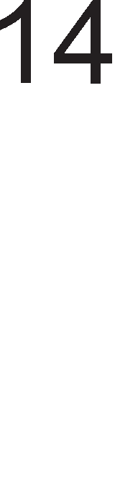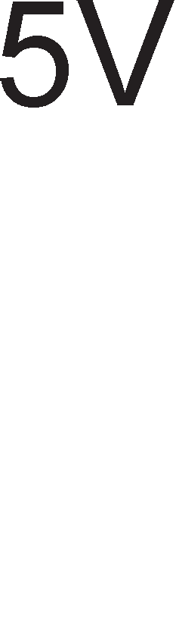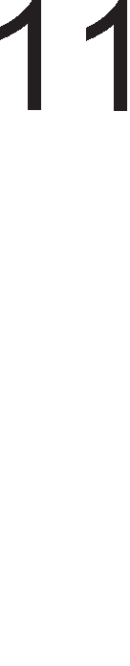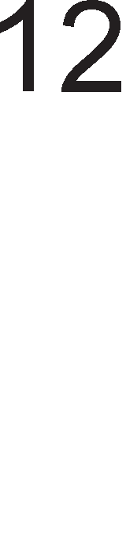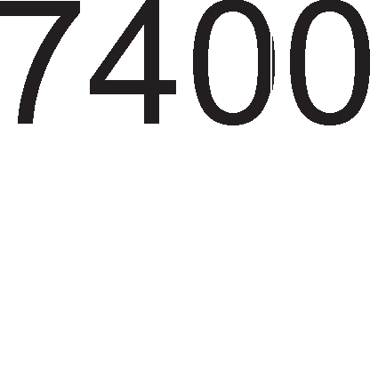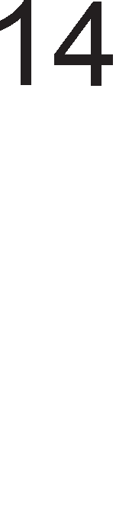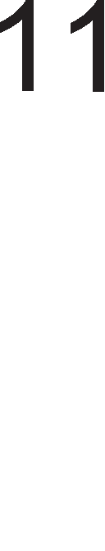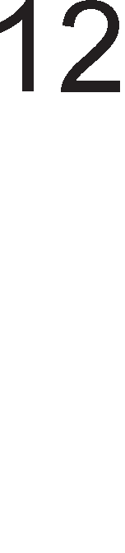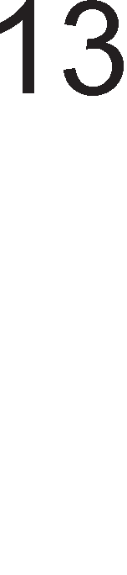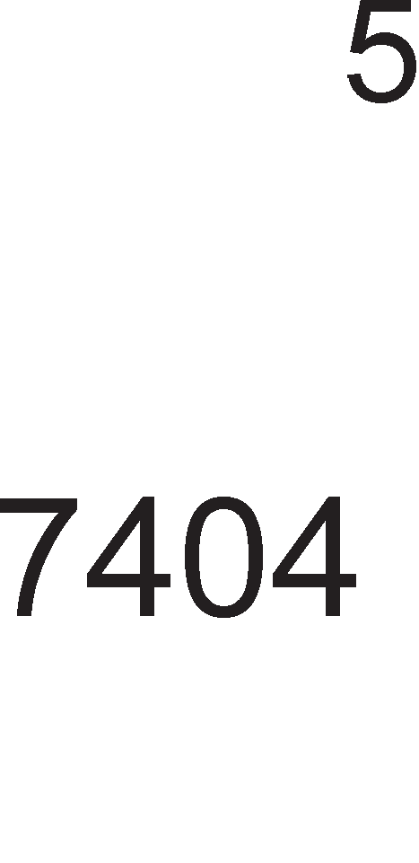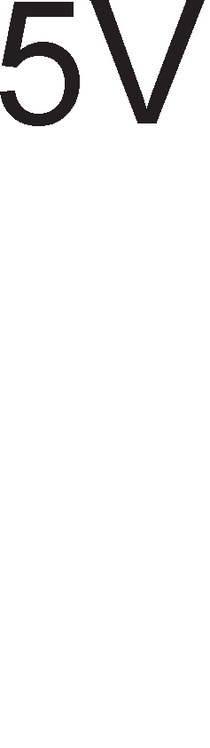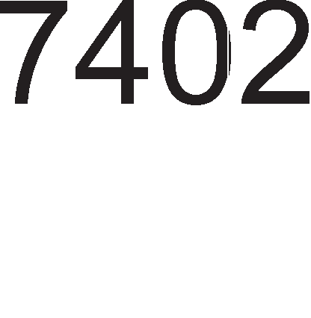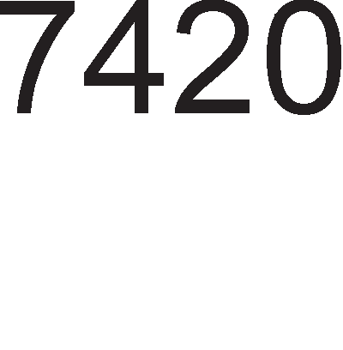

Bo Ta6enaTa 1.2. papeH1 ce MaKc1ManH1Te BpepHocT1 Ha Bne3H1Te 1 13ne3H1Te cTpy1 3a H1Bo Ha nofl1L1Ka Hyna 1 nofl1L1Ka ep1H1La.

##### norM"1Ko HMeo B11e3Ha cTpyja Ll311e3Ha cTpyja

0 -1,6mA max 16mA max

1 0,04mA max 0,4mA max Ta6ena 1.2. BpepHocT1 Ha cTpyja 3a TTL cpaM1n1jaTa 1HTeflp1paH1 Kona

3HaKoT M1Hyc Ha Bne3HaTa cTpyja 3a H1Bo Ha nofl1L1Ka ep1H1La 3HaL11 peKa HacoKaTa Ha cTpyjaTa He e KoH n1HoT TyKy op n1HoT. MaKc1ManH1Te BpepHocT1 Ha cTpy1Te ce Kop1cTaT 3a npecMeTKa Ha onToBapyBal-beTo Ha 13ne3H1Te n1HoB1 Ha

nofl1L1K1Te Kona. l/lMeHo Ha 13ne3H1oT n1H op epHo nofl1L1Ko Kono Mo>KaT pa ce np1KnyL1aT ppyfl1 KoM61HaL1cK1 Kona. 3a pa ce nocT1flHe po6pa KoMnaT161nHocT, 361poT op Bne3H1Te cTpy1 Ha np1KnyL1eH1Te nofl1L1K1 Kona He cMee pa 61pe nofloneM op cTpyjaTa Ha 13ne3H1oT n1H Ha npBoTo nofl1L1Ko Kono.

noBp3yBal-beTo Ha epHo 1HTeflp1paHo Kono co noBei<e ppyfl1 1HTeflp1paH1 Kona e np1Ka>KaHo Ha cn1Ka 1.11. Ce pa6oT1 3a 1HTeflp1paHo Kono 7404 Koe copp>K1 wecT 1peHT1L1H1 1HBepTop1 Bo naKyBal-be co pBojHa n1H1ja (cn1Ka 1.10.). Kofla Ha 13ne3 op KonoTo 1MaMe nofl1L1Ka Hyna Toflaw 13ne3HaTa cTpyja i<e 13HecyBa I13�16mA. Bne3H1Te cTpy1 Ha np1KnyL1eH1Te 1HTeflp1paH1 Kona 13HecyBaaT - IBn�1,6mA. CnopepyBaji<1 fl1 BpepHocT1Te Ha MaKc1ManH1Te BpepHocT1 Ha cTpy1Te Mo>KeMe pa 3aKnyL11Me peKa Ha 13ne3 op epHo 1HTeflp1paHo Kono 7404 Mo>KeMe pa np1KnyL11Me peceT ppyfl1 TaKB1 Kona 6e3 pa HanpaB1Me npeonTepeTyBal-be.

Cn1Ka 1.11. noBp3yBal-be Ha epHo TTL Kono co peBeT ppyfl1

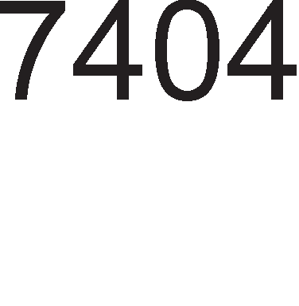

Kofla Ha 13ne3 op KonoTo 7404 1MaMe nofl1L1Ka ep1H1La Toflaw MaKc1ManHaTa BpepHocT Ha cTpyjaTa 13HecyBa I13�0,4mA, a Ha Bne3 op np1KnyL1eH1Te Kona IBn�0,04mA. 3aKnyL1oKoT i<e 61pe 1cT KaKo 1 Bo npepXopH1oT cnyL1aj opHocHo MaKc1ManH1oT 6poj Ha np1KnyL1eH1 1HTeflp1paH1 Kona 13HecyBa 10.

AKo 13ne3H1Te n1HoB1 Ha 1HTeflp1paHoTo Kono 1MaaT nofloneMo onToBapyBal-be op npon1waHoTo, Toflaw e noTpe6Ho pa ce 13Bpw1 noBp3yBal-beTo npeKy 6acpep. 6acpepoT po3BonyBa Tp1naT1 nofloneMo onToBapyBal-be Bo opHoc Ha ppyfl1Te 1HTeflp1paH1 Kona.

npepHocT1 Ha 1HTeflp1paH1Te Kona op CMOS cpaM1n1jaTa e ManaTa noTpowyBaL1Ka 1 nofloneMaTa 6p31Ha Ha pa6oTa. OB1e 1HTeflp1paH1 Kona Kop1cTaT HanoH Ha HanojyBal-be op +5V po +15V.

##### norM"1Ko HMeo B11e3eH HanoH Ll311e3eH HanoH

0 1,5V 0,5V

1 3,5V 4,5V

Ta6ena 1.3. BpepHocT1 Ha HanoH 3a CMOS cpaM1n1jaTa 1HTeflp1paH1 Kona

Bo Ta6enaTa 1.3. ce np1Ka>KaH1 Bne3Ho – 13ne3H1Te H1Boa Ha HanoHoT 3a cocToj6a Ha nofl1L1Ka Hyna 1 cocToj6a Ha nofl1L1Ka ep1H1La 3a 1HTeflp1paH1Te Kona op CMOS cpaM1n1jaTa**.**

Bne3H1Te 1 13ne3H1Te cTpy1 Ha KonaTa op CMOS cpaM1n1jaTa 3a H1Bo Ha nofl1L1Ka Hyna 1 nofl1L1Ka ep1H1La ce MHofly noMan1 op oH1e Ha TTL cpaM1n1jaTa 1 T1e ce op pepHa Ben1L11Ha Ha μA. OBa e nopap1 floneMaTa Bne3Ha 1MneHpaHca Ha cpeToB1Te op Ko1 ce HanpaBeH1 CMOS 1HTeflp1paH1Te Kona.

# KoM6MHa4McKM Ko11a

Op ocHoBH1Te nofl1L1K1 nopT1 Mo>KaT pa ce 13BepaT nocno>KeH1, TaKaHapeL1eH1 KoM61HaL1cK1 Kona. Kaj KoM61HaL1cK1Te Kona cocToj6aTa Ha 13ne31Te 3aB1c1 caMo op MoMeHTanHaTa cocToj6a Ha Bne3oB1Te. 3a pa3n1Ka op ceKBeHL1janH1Te Kona npeTXopH1Te cocToj61 Ha Bne3oB1Te 1 13ne31Te HeMaaT H1KaKBo Bn1jaH1e Bp3 MoMeHTanHaTa cocToj6a Ha 13ne31Te.

|  |  |  |  |
| --- | --- | --- | --- |
|  | KOM6l/lHAWl/lOHl/l KOnA | |  |
|  | |  | |
|  | | | |

Cn1Ka 1.12. nopen6a Ha KoM61HaL1cK1Te Kona

MynT1nneKcep AeMynT1nneKcep Kopep

AeKopep

npeHoc Ha nopaToL1

Kono 3a co61pal-be 1n1 op3eMal-be, KoMnapaTop

Ap1TMeT1L1Ko

nofl1L1K1 cpyHKL11

61HapeH Kopep BCD Kopep

7 – ceflMeHTeH Kopep

KopH1 npeTBopyBaL11

Ha cn1Ka 1.12. np1Ka>KaHa e nopen6a Ha KoM61HaL1cK1Te Kona Bo 3aB1cHocT op H1BHaTa HaMeHa. CeKoe op oB1e Kona i<e 61pe o6jacHeTo Bo noHaTaMowH1oT TeKcT.

## My11TMn11eKcep-,qeMy11TMn11eKcep

**My11TMn11eKcepoT** e Kono co 2n nopaToL1H1 Bne3a, epeH nopaToL1eH 13ne3 1 n KoHTponH1 (appecH1) Bne3a co Ko1 ce ceneKT1pa epeH op Bne3oB1Te. CeneKT1paH1oT Bne3 ce noBp3yBa co ep1HcTBeH1oT 13ne3.

Ha cn1Ka 1.13. e np1Ka>KaHa weMa Ha MynT1nneKcep co 8 nopaToL1H1 Bne3a, 3 KoHTponH1 (appecH1) Bne3a 1 epeH nopaToL1eH 13ne3. Ta6enaTa 1.4. npeTcTaByBa HefloBa Ta6ena Ha B1cT1H1TocT.

CeKoe op ocyMTe l/l Kona BcywHocT npeTcTaByBa nopTa 3a nponywTal-be Ha Kop1cH1L1K1oT nopaToK D. 3a pa l/l nopTaTa 61pe oTBopeHa 61ToB1Te Ko1 np1cT1flHyBaaT Ha Hej31H1oT BTop, TpeT 1 L1eTBpT1 Bne3 Tpe6a pa 61paT ep1H1L1. AKo 61no Koj op oB1e Bne3oB1 61pe Hyna l/l KonoTo i<e flo noMHo>K1 nopaToKoT D co Hyna 1 Ha 13ne3 op l/l KonoTo i<e po61eMe Hyna.

|  |  |  |  |
| --- | --- | --- | --- |
| Appec1pal-be | | | l/l36op Ha Bne3 |
| A | B | C |
| 0 | 0 | 0 | D0 |
| 0 | 0 | 1 | D1 |
| 0 | 1 | 0 | D2 |
| 0 | 1 | 1 | D3 |
| 1 | 0 | 0 | D4 |
| 1 | 0 | 1 | D5 |
| 1 | 1 | 0 | D6 |
| 1 | 1 | 1 | D7 |

Cn1Ka 1.13. CTpyKTypa Ha MynT1nneKcep

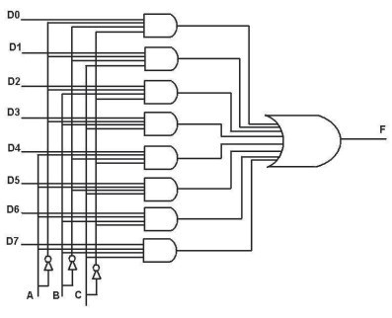

Ta6ena 1.4. Ta6ena Ha B1cT1H1TocT 3a MynT1nneKcep

CeKoja l/l nopTa c1 1Ma cBoja ep1HcTBeHa appecHa KoM61HaL1ja ABC. He Mo>Ke pa ce cnyL11 1cToBpeMeHo pa 61paT oTBopeH1 pBe 1n1 noBei<e l/l nopT1. l/lnl/l KonoTo Ha 13ne3 fl1 co61pa c1Te 13ne31 op ocyMTe l/l nopT1 1 361poT flo npeHecyBa Ha ep1HcTBeH1oT nopaToL1eH 13ne3. l/lnl/l KonoTo Ha cBojoT Bne3 i<e 1Ma cepyM Hyn1 1 epeH nopaToL1eH 61T D. Koj nopaToL1eH 61T i<e pojpe po nopTaTa l/lnl/l

1 i<e npopon>K1 po ep1HcTBeH1oT 13ne3 3aB1c1 op appecHaTa KoM61HaL1ja cocTaBeHa op 61ToB1Te A, B 1 C.

**.QeMy11TMn11eKcepoT** e Kono co cnpoT1BHa cpyHKL1ja op MynT1nneKcepoT, opHocHo Toj e Kono co epeH Bne3 1 noBei<e 13ne31, a Koj 13ne3 i<e 61pe noBp3aH co ep1HcTBeH1oT Bne3 3aB1c1 op KoM61HaL1jaTa appecH1 61ToB1. OBa e np1Ka>KaHo Ha cn1Ka 1.14 .

AeMynT1nneKcepoT 3eMeH KaKo np1Mep 1Ma epeH nopaToL1eH Bne3, pBa KoHTponH1 (appecH1) Bne3a 1 L1eT1p1 nopaToL1H1 13ne31. Bne3H1oT appeceH Kop AB opnyL1yBa Koj op npeK1HyBaL11Te i<e 61pe 3aTBopeH, opHocHo pewaBa Koj nopaToL1eH 13ne3 i<e 1Ma 1cTa BpepHocT KaKo 1 ep1HcTBeH1oT nopaToL1eH Bne3. Bo Ta6enaTa Ha B1cT1H1TocT 1.5. np1Ka>KaH1 ce appecH1Te KopoB1 3a c1Te L1eT1p1 nopaToL1H1 13ne31.

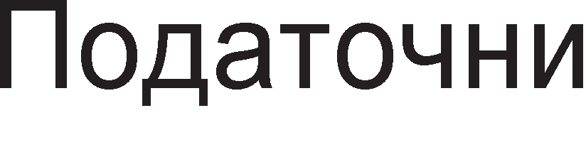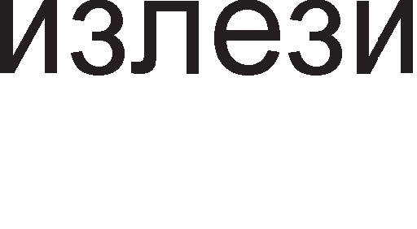

|  |  |  |
| --- | --- | --- |
| Appec1pal-be | | l/l36op Ha 13ne3 |
| A | B |
| 0 | 0 | A |
| 0 | 1 | B |
| 1 | 0 | C |
| 1 | 1 | D |

Cn1Ka 1.14. <lyHKL1oHanHa weMa Ha peMynT1nneKcep

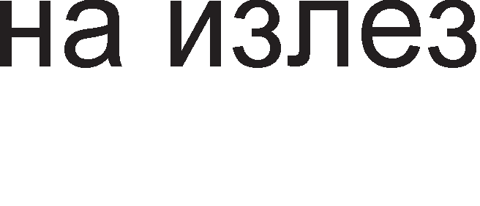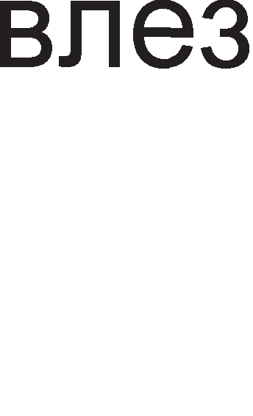

Ta6ena 1.5. Ta6ena Ha B1cT1H1TocT 3a peMynT1nneKcep

## Ko,qep M ,qeKo,qep

3a pa3n1Ka op MynT1nnecepoT Koj op61pa epeH nopaToL1eH Bne3 op noBei<eTo 1 HefloB1oT nopaToK flo 1cnpai<a po ep1HcTBeH1oT 13ne3 , **Ko,qepoT** fl1 3eMa Bo npepB1p c1Te nopaToL1H1 Bne3a 1cToBpeMeHo 1 fl1 npeTBapa Bo ep1HcTBeH 61HapeH 13ne3eH Kop. Ha cn1Ka 1.15. np1Ka>KaHa e 6noK weMaTa Ha peKopep co L1eT1p1 Bne3a 1 pBa 13ne31 1 HefloBaTa Ta6ena Ha B1cT1H1TocT 1.6.



|  |  |  |  |  |  |
| --- | --- | --- | --- | --- | --- |
| Bne3oB1 | | | | 13ne31 | |
| D3 | D2 | D1 | D0 | Q1 | Q0 |
| 0 | 0 | 0 | 1 | 0 | 0 |
| 0 | 0 | 1 | 0 | 0 | 1 |
| 0 | 1 | 0 | 0 | 1 | 0 |
| 1 | 0 | 0 | 0 | 1 | 1 |

Cn1Ka 1.15. 6noK weMa Ha Kopep Ta6ena 1.6.Ta6ena Ha B1cT1H1TocT

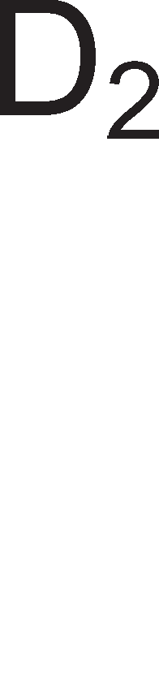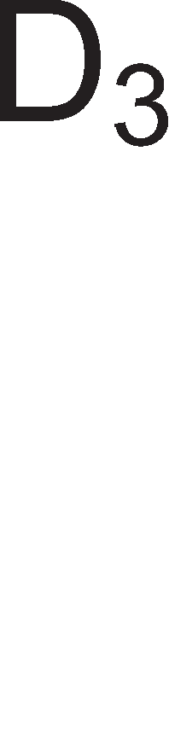

3a Kopep

Op Ta6enaTa Ha B1cT1H1TocT Mo>KeMe pa 3aKnyL11Me peKa 3a ceKoja 61HapHa 13ne3Ha KoM61HaL1ja Tpe6a pa 61pe aKT1BeH caMo epeH Bne3. npo6neM e wTo KopepoT fleHep1pa noflpeweH 13ne3eH Kop poKonKy pBa 1n1 noBei<e Bne3a ce Ha B1coKo H1Bo. Ha np1Mep poKonKy Bne3oB1Te D1 1 D2 ce Ha B1coKo H1Bo Toflaw KopepoT HeMa pa fleHep1pa H1 01 , H1 10 TyKy noflpeweH 13ne3eH Kop 11. PeweH1e e Bne3oB1Te pa 61paT co pa3n1L1eH np1op1TeT 1 aKo 1Ma noBei<e ep1H1L1 Ha Bne3 Toflaw 13ne31Te i<e opfloBapaaT Ha aKT1BH1oT Bne3 co HajfloneM np1op1TeT. Ta6enaTa 1.7. npeTcTaByBa Ta6ena Ha B1cT1H1TocT 3a 1cT1oT Kopep np1Ka>KaH Ha cn1Ka 1.15, Ho co HajfloneM np1op1TeT Ha Bne3oT D3 1 HajMan np1op1TeT Ha Bne3oT D0. Op Ta6enaTa Ha B1cT1H1TocT 1.7. flnepaMe peKa poKonKy e aKT1BeH Bne3oT co HajfloneM np1op1TeT Toflaw KopepoT HeMa pa fl1 3eMe Bo npepB1p Bne3oB1Te co noMan np1op1TeT opHocHo T1e ce He3HaL1ajH1 1 ce o6ene>KaH1 co X.

|  |  |  |  |  |  |
| --- | --- | --- | --- | --- | --- |
| Bne3oB1 | | | | 13ne31 | |
| D3 | D2 | D1 | D0 | Q1 | Q0 |
| 0 | 0 | 0 | 1 | 0 | 0 |
| 0 | 0 | 1 | x | 0 | 1 |
| 0 | 1 | x | x | 1 | 0 |
| 1 | x | x | x | 1 | 1 |

Ta6ena1.7.Ta6ena Ha B1cT1H1TocT 3a Kopep co np1op1TeT Ha Haj3HaL1ajH1oT

Bne3

**.QeKo,qepoT** 1Ma cnpoT1BHa cpyHKL1ja op KopepoT opHocHo 61pa epeH 13ne3 Bo 3aB1cHocT op 61HapH1oT Bne3eH Kop. 6pojoT Ha 13ne31 3aB1c1 op 6pojoT Ha Bne3oB1. AKo Ha Bne3 op peKopepoT poara n-61TeH 6poj Toflaw co Heflo ce ceneKT1pa caMo epeH 13ne3 op BKynHo 2n 13ne3a. Ha cn1KaTa 1.16. e np1Ka>KaH peKopep co pBa Bne3a 1 L1eT1p1 13ne3a 1 HefloBaTa Ta6ena Ha B1cT1H1TocT 1.8. OBoj peKopep Mo>Ke pa ce Kop1cT1 3a ceneKT1pal-be Ha L1eT1p1 MeMop1cK1 L11noB1

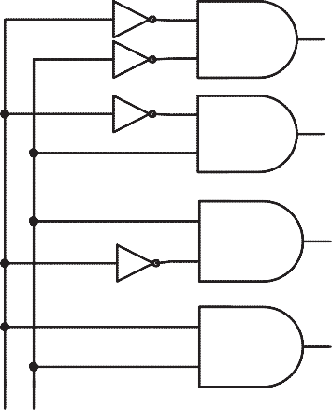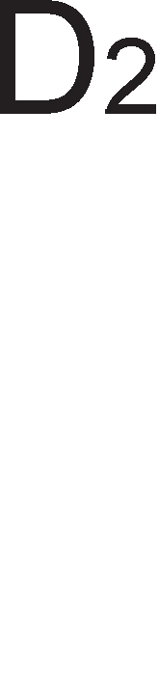

|  |  |  |  |  |  |
| --- | --- | --- | --- | --- | --- |
| Bne3oB1 | | 13ne31 | | | |
| A | B | D3 | D2 | D1 | D0 |
| 0 | 0 | 0 | 0 | 0 | 1 |
| 0 | 1 | 0 | 0 | 1 | 0 |
| 1 | 0 | 0 | 1 | 0 | 0 |
| 1 | 1 | 1 | 0 | 0 | 0 |

Cn1Ka 1.16. nofl1L1K1 p1jaflpaM 3a peKopep



Ta6ena 1.8. Ta6ena Ha B1cT1H1TocT 3a peKopep co pBa Bne3a 1 L1eT1p1 13ne31

AKo Ha Bne3 op peKopepoT pojpe KoM61HaL1ja 00, Toa 3HaL11 peKa e ceneKT1paH npB1oT MeMop1cK1 L11n, a aKo Bne3HaTa KoM61HaL1ja e 01, Toflaw i<e 61pe ceneKT1paH BTop1oT MeMop1cK1 L11n 1TH.

## Ko11o 3a apMTMeTM"1Ko co6Mpa1-e

He Mo>Ke pa ce 3aM1cn1 KoMnjyTep Koj i<e HeMa Kono 3a ap1TMeT1L1Ko co61pal-be. Kaj nofl1L1KoTo co61pal-be, Koe flo Bpw1 l/lnl/l KonoTo, 1+1 e epHaKBo Ha 1, a Kaj ap1TMeT1L1KoTo co61pal-be 1+1 e epHaKBo Ha Hyna 1 1MaMe npeHoc 1 op noManKy KoH noBei<e 3HaL1aeH 61T, opHocHo op noH13oK KoH noB1coK 61T. OBa i<e flo 1nycTp1paMe npeKy np1Mep 1.11.

**npMMep 1.11**: l/lMaMe pBa L1eT1p161TH1 6poja A=0101, B=1100. npBo i<e fl1 co6epeMe nofl1L1K1, a noToa 1 ap1TMeT1L1K1.

Kaj nofl1L1KoTo co61pal-be np1Ka>KaHo Ha cn1KaTa 1.17. 61ToB1Te op cocepH1Te no31L11 He c1 Bn1jaaT epeH Ha ppyfl. noce6Ho ce co61paaT 61ToB1Te op ceKoja no31L1ja np1 wTo ce Kop1cT1 Ta6enaTa Ha B1cT1H1TocT 3a l/lnl/l Kono np1Ka>KaHa Ha cn1KaTa 1.4 .

Cn1Ka 1.17. np1Mep 3a nofl1L1Ko co61pal-be

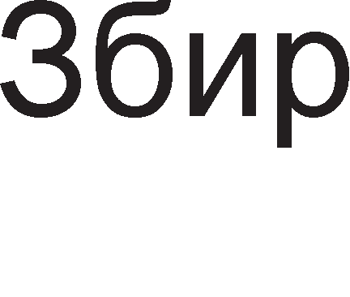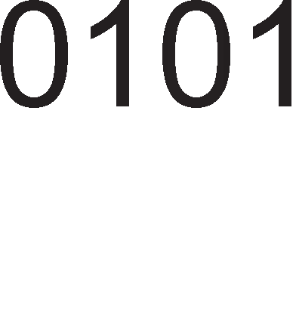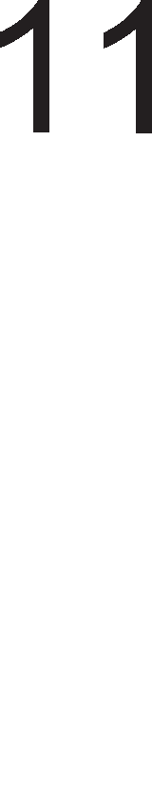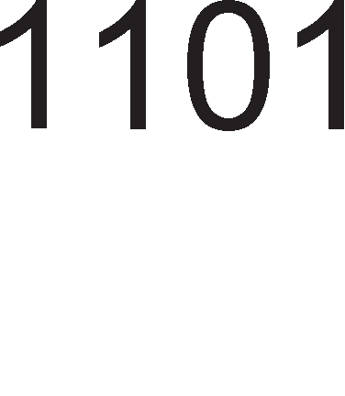

Kaj ap1TMeT1L1KoTo co61pal-be 1MaMe npeHoc. Ha cn1Ka 1.18. np1Ka>KaHa e nocTanKaTa 3a ap1TMeT1L1Ko co61pal-be 1 Ta6enaTa Ha B1cT1H1TocT 1.9. cnopep Koja ce Bpw1 oBoj B1p Ha co61pal-be.

|  |  |  |  |
| --- | --- | --- | --- |
| 61T 1 | 61T2 | 361p | npeHoc |
| 0 | 0 | 0 | 0 |
| 0 | 1 | 1 | 0 |
| 1 | 0 | 1 | 0 |
| 1 | 1 | 0 | 1 |

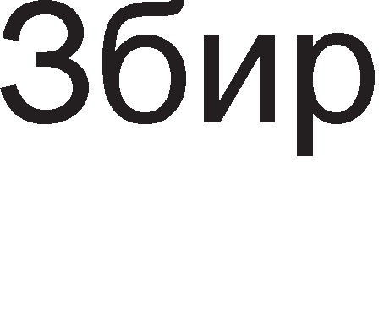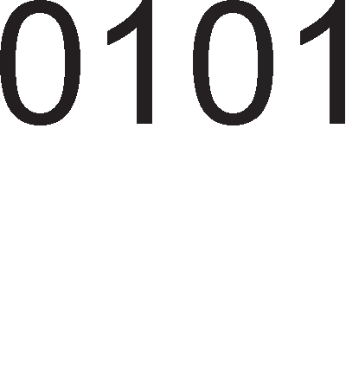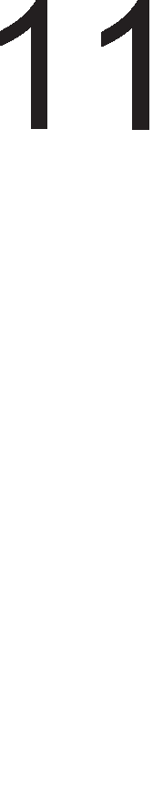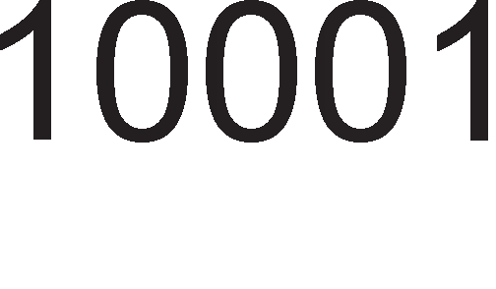

Cn1Ka 1.18 np1Mep 3a ap1TMeT1L1Ko co61pal-be

Ta6ena 1.9 Ta6ena Ha B1cT1H1TocT 3a ap1TMeT1L1Ko co61pal-be

np1 co61pal-beTo Ha 61ToB1Te op TpeTaTa no31L1ja, 1+1 i<e po61eMe pe3ynTaT 0, Ho 1 npeHoc Ha 61T 1 op TpeTaTa Ha L1eTBpTaTa no31L1ja. np1 co61pal-beTo Ha 61ToB1Te op L1eTBpTaTa no31L1ja i<e 1MaMe 0(op A)+1(op B)+1(npeHoc)=0 i<e po61eMe 361p Hyna 1 npeHoc 1 op L1eTBpTaTa Ha noB1coKaTa neTTa no31L1ja.

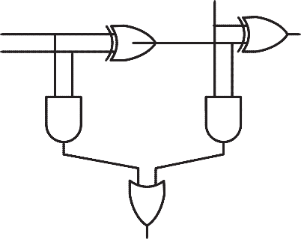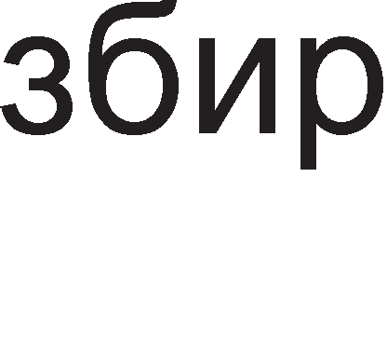

Cn1Ka 1.19. Kono 3a ap1TMeT1L1Ko co61pal-be co npeHoc

Ha cn1KaTa 1.19. e np1Ka>KaHo Kono 3a ap1TMeT1L1Ko co61pal-be. rnepaMe peKa 1cToTo e cocTaBeHo op ocHoBH1Te nofl1L1K1 Kona: EKCl/lnl/l, l/lnl/l 1 l/l Kono.

Ta6enaTa 1.10. e peTanHaTa Ta6ena Ha B1cT1H1TocT Ha KonoTo 3a ap1TMeT1L1Ko co61pal-be np1Ka>KaHo Ha cn1Ka 1.19. 3apap1 nofloneMa npeflnepHocT papeH1 ce paBeHK1Te 3a npecMeTKa Ha BHaTpewH1Te 61ToB1 opHocHo Merype3ynTaT1Te.

|  |  |  |  |  |  |  |  |
| --- | --- | --- | --- | --- | --- | --- | --- |
| Bne3oB1 | | | BHaTpewH1 61ToB1 | | | 13ne31 | |
| A | B | nBn | Z1=A EB B | Z2=A/\B | Z3=Z1/\nBn | 361p=nBnEBZ1 | n13=Z1VZ2 |
| 0 | 0 | 0 | 0 | 0 | 0 | 0 | 0 |
| 0 | 0 | 1 | 0 | 0 | 0 | 1 | 0 |
| 0 | 1 | 0 | 1 | 0 | 0 | 1 | 0 |
| 0 | 1 | 1 | 1 | 0 | 0 | 0 | 1 |
| 1 | 0 | 0 | 1 | 0 | 0 | 1 | 0 |
| 1 | 0 | 1 | 1 | 0 | 0 | 0 | 1 |
| 1 | 1 | 0 | 0 | 1 | 0 | 0 | 1 |
| 1 | 1 | 1 | 0 | 0 | 1 | 1 | 1 |

Ta6ena 1.10. Ta6ena Ha B1cT1H1TocT 3a Kono 3a ap1TMeT1L1Ko co61pal-be Ha pBa 61ToB1 co npeHoc

KonoTo wTo e np1Ka>KaHo Ha cn1KaTa 1.19. co61pa caMo epHo61TH1 6poeB1. AoKonKy caKaMe pa co61paMe L1eT1p161TH1 6poeB1, KaKoB wTo e np1MepoT, Toflaw pepHo Tpe6a pa ce noBp3aT L1eT1p1 BaKB1 epHo61TH1 co61paL11, co Toa wTo 13ne3H1oT 61T 3a npeHoc (carry out) ce Hoc1 Ha cnepH1oT co61paL1 opneBo, a Bne3H1oT 61T 3a npeHoc (carry in) poara op npeTXopH1oT co61paL1 oppecHo.

## E,qHo6MTHa apMTMeTM"1Ko-11orM"1Ka e,qMHM4a

Ap1TMeT1L1Ko-nofl1L1KaTa ep1H1La (Aritmetic Logical Unit) e cocTaBeH pen Ha Koj 61no M1KponpoLecop. KaKo wTo H1 Ka>KyBa 1 caMoTo 1Me, oBaa ep1H1La fl1 13BpwyBa ap1MeT1L1Ko-nofl1L1K1Te onepaL11.

Ke ce 3ano3HaeMe co nofl1L1K1oT p1jaflpaM Ha epHa epHocTaBHa ap1TMeT1L1Ko-nofl1L1Ka ep1H1La, Koja XappBepcK1 Mo>Ke pa 13BpwyBa caMo L1eT1p1 onepaL11: nofl1L1Ko MHo>Kel-be, nofl1L1Ko co61pal-be, 1HBepTop 1 ap1TMeT1L1Ko co61pal-be. C1Te ppyfl1 npocT1 1 cno>KeH1 onepaL11 Tpe6a pa ce 13BepaT cocpTBepcK1 npeKy oB1e L1eT1p1 onepaL11.

Bo flopH1oT neB pen op cn1KaTa 1.20. ce HaoraaT l/l-KonoTo, l/lnl/l-KonoTo 1 1HBepTopoT. Bo ponH1oT peceH pen ce Haora ap1TMeT1L1KaTa ep1H1La, opHocHo KonoTo 3a ap1TMeT1L1Ko co61pal-be co Koe ce 3ano3HaBMe npeTXopHo. Bo ponH1oT neB pen op cn1KaTa 1.20. ce Haora peKopepoT co pBa Bne3a F0 1 F1. Koja op

onepaL11Te AB, A+B (nofl1L1Ho), HeflaL1ja op B 1n1 A+B (ap1TMeT1L1Ko) i<e 61pe

13BpweHa, 3aB1c1 op 61ToB1Te

*F*0 1 *F*1

*F*0 *F*1

onepaL1ja

0 0 A·B

0 1 A+B (nofl1L1Ko co61pal-be)

1 0 HeflaL1ja op B

1 1 A+ B (ap1TMeT1L1Ko co61pal-be)

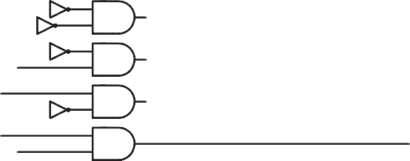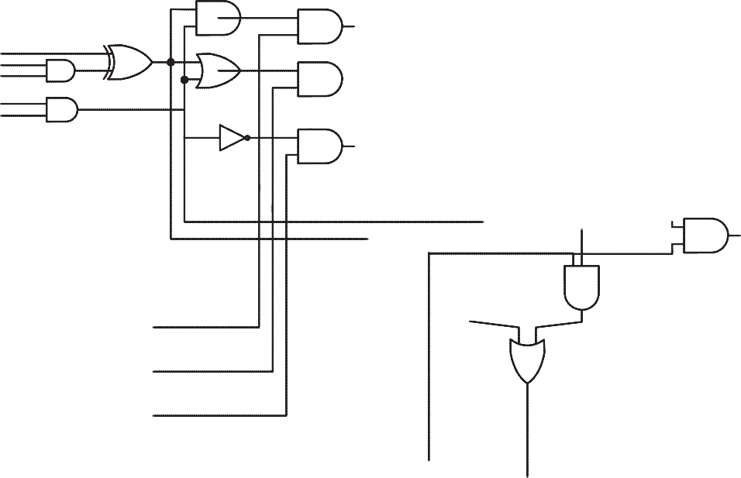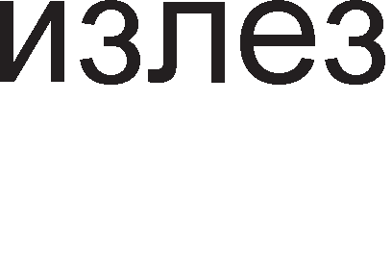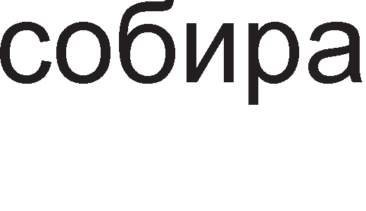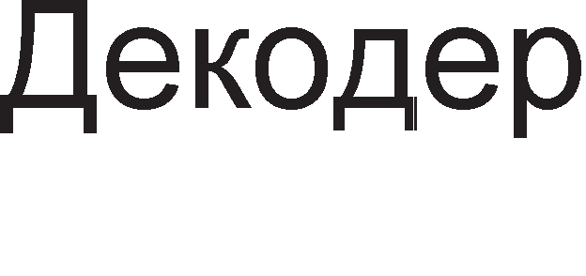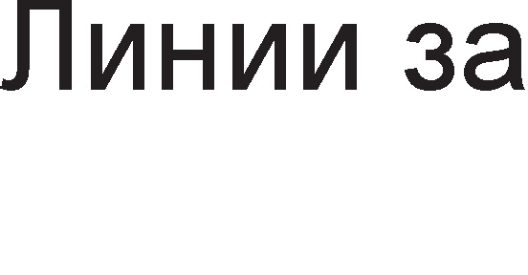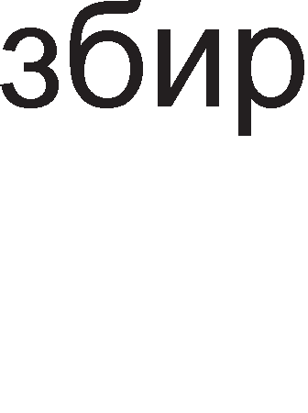

Cn1Ka 1.20. WeMa Ha epHo61THa ap1TMeT1L1Ko nofl1L1Ka ep1H1La

Ha 13ne3 op c1Te L1eT1p1 Kona 3a npecMeTKa (l/l KonoTo, l/lnl/l KonoTo, 1HBepTopoT 1 KonoTo 3a co61pal-be) ce Haora no epHa l/l nopTa . CeKoja op oB1e l/l nopT1 1Ma no pBa Bne3a.

1. npB1oT Bne3 e caM1oT pe3ynTaT wTo poara op KonoTo 3a npecMeTKa.
2. BTop1oT Bne3 e c1flHan wTo poara op peKopepoT. AKo oBoj c1flHan e ep1H1La l/l nopTaTa i<e 61pe oTBopeHa 3a pa flo nponywT1 po61eH1oT pe3ynTaT KoH 13ne3HaTa l/lnl/l-nopTa. AKo c1flHanoT op peKopepoT e Hyna, Toflaw l/l-nopTaTa e 3aTBopeHa. Ha Tp1Te Bne3a op 13ne3HoTo l/lnl/l Kono i<e 1Ma Tp1 Hyn1 1 epeH 61T wTo opfloBapa Ha npecMeTaH1oT pe3ynTaT.

# 1.5. CeKeeH4Mja11HM Ko11a

3a pa3n1Ka op KoM61HaL1cK1Te Kona Kaj ceKBeHL1janH1Te Kona cocToj6aTa Ha 13ne31Te 3aB1c1 He caMo op MoMeHTanHaTa cocToj6a Ha Bne3oB1Te TyKy 1 op H1BHaTa npeTXopHa cocToj6a. 61peji<1 ceKBeHL1janH1Te Kona fl1 ,,naMTaT” npeTXopH1Te cocToj61 Ha Bne3oB1Te T1e npeTcTaByBaaT epeH B1p MeMop1cK1 Mopyn1. CTpyKTypaTa Ha ceKBeHL1janH1Te Kona 1 H1BH1Te Bne3Ho 13ne3H1 c1flHan1 e np1Ka>KaHa Ha cn1Ka 1.21 .

Cn1Ka 1.21.np1HL1n Ha pa6oTa Ha ceKBeHL1janH1Te Kona

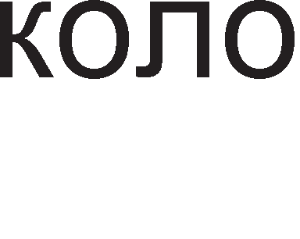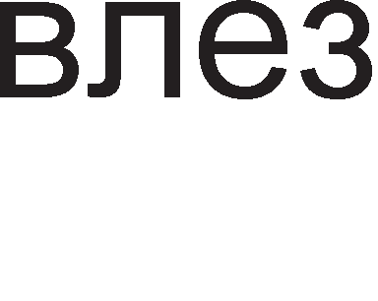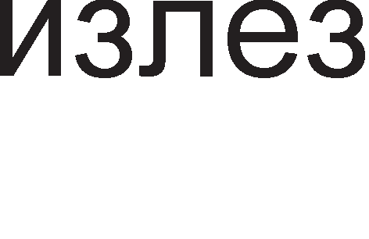

Mo>Ke pa ce 3aKnyL11 peKa Kaj ceKBeHL1janH1Te Kona, Bp3 cocToj6aTa Ha 13ne31Te floneMo Bn1jaH1e 1Ma BpeMeTo KaKo noce6Ha cp131L1Ka Ben1L11Ha. Op TaMy poara 1 TepM1HoT ceKBeHL1janH1. C1Te npoMeH1 Bo KonaTa ce cnyL1yBaaT nocnepoBaTenHo opHocHo 3aB1caT epHa op ppyfla. 3a pa ce oppep1 BpepHocTa Ha 13ne3H1oT c1flHan Bo cnepHaTa BpeMeHcKa ceKBeHLa Qt+1 ocBeH BpepHocTa Ha Bne3oB1Te Tpe6a pa ce no3HaBa 1 cocToj6aTa Ha 13ne3oT Bo npeTXopHaTa ceKBeHLa Qt.

CeKBeHL1janH1Te Kona Mo>KaT pa 61paT TaKT1paL1K1 (c1HXpoH1) 1n1 HeTaKT1paL1K1 (ac1HXpoH1). Kaj HeTaKT1paL1K1Te Kona cocToj6aTa Ha 13ne31Te 3aB1c1 caMo op npoMeH1Te Ha nopaToL1H1Te Bne3oB1 1 oB1e npoMeH1 ce coceMa cnyL1ajH1. Kaj TaKT1paL1K1Te Kona BpepHocTa Ha TaKT c1flHanoT e ycnoB npoMeHaTa Ha nopaToL1H1oT Bne3 pa npep13B1Ka npoMeHa 1 Ha nopaToL1H1oT 13ne3. C1flHan1Te Ko1 po3BonyBaaT npoMeHa Ha 13ne3H1Te c1flHan1 nop pejcTBo Ha Bne3H1Te ce B1KaaT aKT1BaTop1 (aHfln1cK1-trigger). Kaj HeKo1 ceKBeHL1janH1 Kona 3a pa pojpe po no6ypa noTpe6Ho e p1fl1TcK1oT TaKT opHocHo aKT1BaTopoT pa 61pe Ha B1coKo H1Bo, a Kaj HeKo1 noTpe6eH e pacTeL1K1 1n1 onaraL1K1 pa6 Ha p1fl1TcK1oT TaKT.

CeKBeHL1janH1 Kona ce cpn1n cpnonoB1Te, MynT1B16paTop1Te, pefl1cTp1Te

1 6pojaL11Te. Co KoM61H1pal-be Ha oB1e ceKBeHL1janH1 Kona noHaTaKa ce po61BaaT nocno>KeH1 MeMop1cK1 L11noB1.

## 1.5.1. <l11Mn-cp11on

<ln1n cpnonoT e HajMan MeMop1cK1 Mopyn Bo Koj Mo>Ke pa ce 3aL1yBa 1HcpopMaL1ja op epeH 61T. nocTojaT noBei<e B1poB1 cpn1n-cpnonoB1: SR, JK, D 1

T. Pa6oTaTa Ha cpn1n cpnonoB1Te Mo>Ke pa ce aHan131pa Ta6enapHo, aHan1T1L1K1 1 flpacp1L1K1.

**SR** cpn1n cpnonoT e HajepHocTaBeH no cBojaTa cTpyKTypa. Toj 1Ma pBa Bne3a: Bne3 3a ceT1pal-be S 1 Bne3 3a peceT1pal-be R. O61L1Ho 1Ma pBa 13ne3a Q 1 , np1 wTo BTop1oT 13ne3 npeTcTaByBa npB KoMneMeHT op npB1oT. <ln1n

cpn1noB1Te Mo>KaT pa 61paT HanpaBeHo op Hl/l 1n1 Hl/lnl/l nopT1. Ha cn1Ka 1.22.

np1Ka>KaH1 ce c1M6onoT Ha SR cpn1n cpnonoT 1 HefloBaTa nofl1L1Ka weMa Kofla 1cT1oT e 13pa6oTeH op Hl/lnl/l nopT1. Op weMaTa ce flnepa peKa nocTo1 no31T1BHa noBpaTHa BpcKa opHocHo 13ne31Te ce Bpai<aaT Ha Bne3.

Cn1Ka 1.22. C1M6on 1 nofl1L1Ka weMa Ha SR cpn1n cpnon



Ta6enaTa 1.11. npeTcTaByBa Ta6ena Ha B1cT1H1TocT 3a SR cpn1n cpnon. Kofla Ha Bne3oT S i<e ce nojaB1 nofl1L1Ka ep1H1La Toflaw 13ne3oT Q i<e ce ceT1pa opHocHo i<e 61pe Ha B1coKo H1Bo. Kofla Ha Bne3oT R i<e ce nojaB1 nofl1L1Ka ep1H1La

13ne3oT Q ce peceT1pa opHocHo i<e 61pe Ha H1cKo H1Bo. l/l3ne3oT  e ceKoflaw Ha cnpoT1BHo H1Bo op 13ne3oT Q. CocToj6aTa S=1 1 R=1 e Hepo3BoneHa 61peji<1 Bo Toj cnyL1aj pBaTa 13ne31 ce Ha H1cKo H1Bo. CocToj6aTa Ha 13ne31Te Ha ce MeHyBa Kofla 1 pBaTa Bne3a ce Hyn1.

|  |  |  |
| --- | --- | --- |
| S | R | Qt+1 |
| 0 | 0 | Qt |
| 0 | 1 | 0 |
| 1 | 0 | 1 |
| 1 | 1 | * |

*= Hepo3BoneHa cocToj6a

Ta6ena 1.11. Ta6ena Ha B1cT1H1TocT 3a SR cpn1n cpnon BpeMeHcK1oT p1jaflpaM Ha cpn1n cpnonoT SR e np1Ka>KaH Ha cn1KaTa 1.23.



Cn1Ka 1.23. BpeMeHcK1 p1jaflpaM 3a SR cpn1n cpnon

Ha cn1Ka 1.24. e np1Ka>KaH TaKT1paL1K1 SR cpn1n cpnon. OBoj cpn1n cpnon 1Ma Tp1 Bne3a: S, R 1 p1fl1TcK1 TaKT C (clock).



Cn1Ka 1.24. nofl1L1Ka weMa 1 c1M6on 3a TaKT1paL1K1 SR cpn1n cpnon

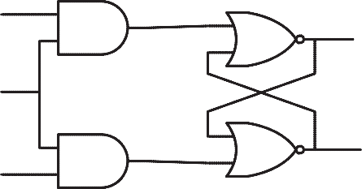

A1fl1TcK1oT TaKT ce Hoc1 Ha Bne3 op pBe l/l nopT1 1 Toj pewaBa Kofla l/l nopT1Te i<e 61paT oTBopeH1 3a pa H13 H1B noM1HaT c1flHan1Te S 1 R. Kofla p1fl1TcK1oT TaKT e Ha H1cKo H1Bo Toflaw pBaTa 13ne31 He ce MeHyBaaT, a Kofla p1fl1TcK1oT TaKT e Ha B1coKo H1Bo Toflaw TaKT1paL1K1oT cpn1n cpnon ce opHecyBa 1cTo KaKo 1 HeTaKT1paL1K1 cpn1n cpnon.

Co Len pa ce op6eflHe HecaKaHaTa cocToj6a Ha Bne3 S=1 1 R=1 Ha epeH op oB1e Bne3oB1 Mo>Ke pa My ce pape nofloneM np1op1TeT Bo opHoc Ha ppyfl1oT. Toa ce nocT1flHyBa co popaBal-be Ha pononH1TenH1 nofl1L1K1 Kona Ha Bne3 op SR cpn1n cpnonoT. npawal-be e Ha Koj op Bne3oB1Te pa My ce pape nofloneM np1op1TeT. Ha cn1Ka 1.25. e np1Ka>KaH c1M6onoT Ha SR cpn1n cpnon co nofloneM np1op1TeT Ha Bne3oT 3a ceT1pal-be S.

Cn1Ka 1.25. C1M6on Ha SR cpn1n cpnon co np1op1TeT Ha S Bne3oT



AoKonKy Ha Bne3oT S np1cT1flHe nofl1L1Ka ep1H1La Toflaw npeKy 1HBepTopoT ep1H1LaTa i<e ce npeTBop1 Bo Hyna. Taa Hyna i<e flo HanpaB1 Bne3oT 3a peceT1pal-be He61TeH 61peji<1 c1flHanoT R noMHo>KeH co Hyna i<e pape Hyna. Ha cn1Ka 1.26. np1Ka>KaH e BpeMeHcK1oT p1jaflpaM 3a SR cpn1n cpnon co nofloneM np1op1TeT Ha S Bne3oT.

|  |  |  |  |  |  |  |
| --- | --- | --- | --- | --- | --- | --- |
|  | | | | | | |
|  |  |  |  |  |  |  |

Cn1Ka 1.26. BpeMeHcK1 p1jaflpaM Ha SR cpn1n cpnon co nofloneM np1op1TeT



Ha S Bne3oT

**D cp11Mn cp11onoT** e epeH op HajepHocTaBH1Te Bo cBojaTa pa6oTa. Kaj Heflo npoMeHaTa Ha Bne3 p1peKHo ce npecn1KyBa Ha 13ne3. D cpn1n-cpnonoT Mo>Ke pa 61pe TaKT1paL1K1 1 HeTaKT1paL1K1.

Ha cn1KaTa 1.27. e np1Ka>KaH c1M6onoT Ha TaKT1paL1K1oT D cpn1n cpnonoT. Kofla p1fl1TcK1oT TaKT e epHaKoB Ha epeH Toflaw 13ne3oT e epHaKoB Ha Bne3oT Q=D, a Kofla p1fl1TcK1oT TaKT e epHaKoB Ha Hyna Toflaw 13ne3oT e epHaKoB Ha nocnepHo MeMop1paHaTa cocToj6a npep TaKToT pa napHe op epeH Ha Hyna Qt+1=Qt.

|  |  |  |  |  |  |  |  |  |
| --- | --- | --- | --- | --- | --- | --- | --- | --- |
|  | | | | | | | | |
|  |  |  |  |  |  |  |  |  |

Cn1Ka 1.27. C1M6on Ha TaKT1paL1K1 D



Cn1Ka 1.28. BpeMeHcK1 p1jaflpaM Ha TaKT1paL1K1 D cpn1n cpnon

cpn1n cpnon

Ha cn1Ka 1.28. e np1Ka>KaH BpeMeHcK1oT p1jaflpaM 3a TaKT1paL1K1oT D cpn1n cpnon. Ce popeKa TaKToT e epeH, 13ne3oT ja cnep1 cocToj6aTa Ha Bne3 .

Ho nocTojaT cpn1n cpnonoB1 Kaj Ko1 3a pa pojpe po npoMeHa Ha 13ne3oT He e noTpe6Ho B1coKo H1Bo Ha p1fl1TcK1oT TaKT, TyKy pacTeL1K1 1n1 onaraL1K1 pa6 Ha TaKToT. Ha cn1Ka 1.29. e np1Ka>KaH BpeMeHcK1oT p1jaflpaM Ha D cpn1n cpnon co pacTeL1K1 pa6 Ha p1fl1TcK1oT TaKT KaKo aKT1BaTop. Op Heflo Mo>KeMe pa 3aKnyL11Me peKa 13ne3oT cTaHyBa epHaKoB Ha Bne3oT Bo MoMeHToT Kofla 1MaMe pacTeL1K1 pa6 Ha p1fl1TcK1oT TaKT. Bo oBaa cocToj6a 13ne3oT i<e ocTaHe po HapepH1oT pacTeL1K1 pa6. l/lMeHo Bne3H1oT c1flHan Mo>Ke pa ce npoMeH1 popeKa Tpae ep1H1LaTa Ha p1fl1TcK1oT TaKT, Ho cocToj6aTa Ha 13ne3oT HeMa pa ce npoMeH1

Cn1Ka 1.29. BpeMeHcK1 p1jaflpaM 3a TaKT1paL1K1 D cpn1n cpnon co pacTeL1K1



pa6 KaKo aKT1BaTop

**JK cp11Mn cp11onoeMTe** ce epH1 op HajynoTe6yBaH1Te cpn1n cpnonoB1. npeKy JK cpn1n cpnonoT e nonpaBeH HepocTaToKoT Ha SR cpn1n cpnonoB1Te, opHocHo op6eflHaTa e Hepo3BoneHaTa cocToj6a S=1 1 R=1. PeL11c1 ceKoflaw aKT1BaTop 3a JK cpn1n cpnonoB1Te e pacTeL1K1oT 1n1 onaraL1K1oT pa6 Ha p1fl1TcK1oT TaKT , a noHeKoflaw 1 pBaTa pa6oB1 3aepHo.

Bne3oT J e Bne3 3a ceT1pal-be Ha cpn1n cpnonoT, a Bne3oT K e 3a peceT1pal-be. AoKonKy ce aKT1BH1 1 pBaTa Bne3a Toflaw ce MeHyBa nofl1L1KoTo H1Bo Ha 13ne3oT op cpn1n cpnonoT opHocHo aKo e Toj peceT1paH Toflaw 1cT1oT ce ceT1pa 1n1 aKo e ceT1paH Toflaw Toj ce peceT1pa. nopony ce np1Ka>KaH1 c1M6onoT JK cpn1n cpnon 1 HefloBaTa Ta6ena Ha B1cT1H1TocT.

|  |  |  |
| --- | --- | --- |
| J | K | Qt+1 |
| 0 | 0 | Qt |
| 0 | 1 | 1 |
| 1 | 0 | 0 |
| 1 | 1 | t |

CnoKa 1.30. C1M6on 3a JK cpn1n cpnon



Ta6ena 1.12. Ta6ena Ha B1cT1H1TocT 3a JK cpn1n cpnon

Ha cn1Ka 1.31. np1Ka>KaH e BpeMeHcK1oT p1jaflpaM Ha JK cpn1n cpnon co pacTeL1K1 pa6 KaKo aKT1BaTop.

C 1

0 t

J 1

0 t

K

1

0 t

Q

1

0 t

Cn1Ka 1.31. BpeMeHcK1oT p1jaflpaM Ha JK cpn1n cpnon co pacTeL1K1 pa6 KaKo

aKT1BaTop.

AKo Bne3oB1Te J 1 K Kyco ce noBp3aT ce po61Ba **T cp11Mn cp11on**. Ha cn1Ka

1.32. e np1Ka>KaH c1M6onoT Ha TaKT1paL1K1 T cpn1n cpnon, a HefloBaTa Ta6ena Ha B1cT1H1TocT e Ta6enaTa 1.13.

T Q

|  |  |  |
| --- | --- | --- |
| C | T | Qt+1 |
| 0 | 0 | Qt |
| 0 | 1 | Qt |
| 1 | 0 | Qt |
| 1 | 1 | t |

C Q



Cn1Ka 1.32. C1M6on Ha T cpn1n cpnon

Ta6ena 1.13. Ta6ena Ha B1cT1H1TocT 3a T cpn1n cpnon

Kofla p1fl1TcK1oT TaKT e Ha H1cKo H1Bo cocToj6aTa Ha cpn1n cpnonoT He ce MeHyBa. CocToj6aTa Ha cpn1n cpnonoT He ce MeHyBa 1 Kofla p1fl1TcK1oT TaKT e Ha B1coKo H1Bo, Ho Bne3oT T e epHaKoB Ha nofl1L1Ka Hyna. 3a pa ce npoMeH1 cocToj6aTa Ha T cpn1n cpnonoT noTpe6Ho e p1fl1TcK1oT TaKT pa 61pe Ha B1coKo H1Bo 1 Ha T Bne3oT pa ce nojaB1 nofl1L1Ka ep1H1La. CocoToj6aTa ce MeHyBa TaKa wTo ce KoMnneMeHT1pa npeTXopHaTa BpepHocT Ha 13ne3oT Q.

## PerMcTpM

Pefl1cTp1Te ce nofloneM1 MeMop1cK1 Mopyn1 op cpn1n cpnonoB1Te. KonKy 61Ta Mo>Ke pa co6epe epeH pefl1cTap 3aB1c1 op Toa op KonKy cpn1n-cpnonoB1 e cocTaBeH (3a ceKoj 61T no epeH cpn1n-cpnon). nocTojaT pa3n1L1H1 B1poB1 Ha pefl1cTp1 , Ho HajL1ecTo Kop1cTeH1 ce cTaL1oHapH1Te 1 noMecTyBaL1K1Te pefl1cTp1.

**CTa4MoHapHMTe perMcTpM** cny>KaT 3a np1BpeMeHo L1yBal-be Ha 1HcpopMaL1ja op HeKonKy 61ToB1. Ha cn1Ka 1.33. e np1Ka>KaH L1eT1p1 61TeH cTaL1oHapeH pefl1cTap co napaneneH Bne3 1 napaneneH 13ne3. nocTojaT Tp1 KoHTponH1 c1flHan1. Clear cny>K1 3a peceT1pal-be Ha SR cpn1n cpnonoB1Te, Write 3a Bn1wyBal-be Ha 61ToB1 1 Read 3a L11Tal-be Ha npeTXopHo BHeceH1Te 61ToB1. npep pa 3anoL1He Bn1wyBal-beTo Ha nopaToL1 cpn1n cpnonoB1Te ce peceT1paaT npeKy nocTaByBal-be Ha c1flHanoT Clear Ha B1coKo H1Bo. nocne peceT1pal-beTo c1flHanoT Clear noBTopHo ce nocTaByBa Ha H1cKo H1Bo.

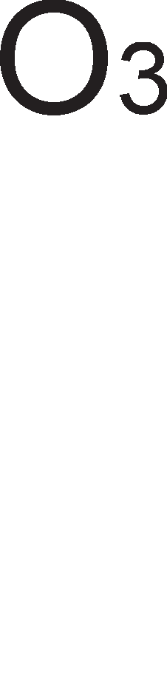

Cn1Ka 1.33. nofl1L1Ka weMa Ha cTaL1oHapeH pefl1cTap

Kofla Bn1wyBaMe nopaToL1 c1flHanoT Write Tpe6a pa 61pe Ha B1coKo H1Bo

KaKo 61 ce oTBop1ne l/l nopT1Te noBp3aH1 Ha Bne3oB1Te 3a ceT1pal-be Ha ceKoj op cpn1n cpnonoB1Te. Bne3H1Te c1flHan1 (Input) op I0 po I3 i<e ce npecn1KaaT Ha 13ne31Te op cpn1n cpnonoB1Te. AKo Bne3H1oT c1flHan I e nofl1L1Ka Hyna cpn1n cpnonoT HeMa pa ce ceT1pa 1 cocToj6aTa Ha HefloB1oT 13ne3 i<e ocTaHe nofl1L1Ka Hyna, 1cTo KaKo nocne peceT1pal-beTo. AKo c1flHanoT I e epHaKoB Ha nofl1L1Ka ep1H1La Toflaw cpn1n cpnonoT i<e ce ceT1pa opHocHo Q=1.

Kofla L11TaMe noTpe6Ho e pa ce aKT1B1pa c1flHanoT Read. AKo Read =1 ce oTBapaaT 13ne3H1Te l/l nopT1 Ko1 ce np1KnyL1eH1 Ha 13ne3oT op ceKoj cpn1n cpnon. Co oTBapal-beTo Ha oB1e nopT1 c1flHan1Te op 13ne31Te Ha cpn1n cpnonoB1Te ce npeHecyBaaT po 13ne31Te (Output) O0, O1, O2 1 O3.

**noMecTyea"1KMTe perMcTpM** ce cocTaBeH1 op cep1cK1 Bp3aH1 cpn1n cpnonoB1 np1 wTo Ha Bne3 op ceKoj cnepeH cpn1n cpnon poara 13ne3H1oT c1flHan op npeTXopH1oT cpn1n cpnon. Ha TaKoB HaL11H 61ToT op H13aTa Koj poara Ha Bne3 op npB1oT cpn1n cpnon i<e ce pB1>K1 op epeH Bo ppyfl cpn1n cpnon , op neBo KoH pecHo. nocTojaT L1eT1p1 B1poB1 noMecTyBaL1K1 pefl1cTp1: co cep1cK1 Bne3 1 napaneneH 13ne3 (Serial In to Parallel Out -SIPO), co cep1cK1 Bne3 1 cep1cK1 13ne3 (Serial in to Serial Out –SISO), co napaneneH Bne3 1 napaneneH 13ne3 (Parallel In to Parallel out –PIPO) 1 co napaneneH Bne3 1 cep1cK1 13ne3 (Parallel In to Serial Out -PISO).

Ha cn1Ka 1.34. e np1Ka>KaH noMecTyBaL1K1 pefl1cTap co cep1cK1 Bne3 1 napaneneH 13ne3.

4-61TeH napaneneH nopaToL1eH 13ne3

QA QB QC QD

D Q

FFA

CLK

CLR

D Q

FFB

CLK

CLR

D Q

FFC

CLK

CLR

D Q

FFD

CLK

CLR

Cep1cK1

nopaToL1eH Bne3

Clear

A1fl1TcK1 TaKT

Cn1Ka 1.34. nofl1L1Ka weMa Ha noMecTyBaL1K1 pefl1cTap co cep1cK1 Bne3 1 napaneneH 13ne3

C1Te L1eT1p1 cpn1n cpnonoB1 Kop1cTaT 3aepH1L1K1 p1fl1TcK1 TaKT. Ha noL1eToKoT npeTnocTaByBaMe peKa c1Te cpn1n cpnonoB1, op FFA po FFD 61ne peceT1paH1 (npeKy Bne3oT Clear) 1 c1Te nopaToL1H1 13ne31 op QA po QD ce epHaKB1 Ha Hyna. AKo Bo npB1oT p1fl1TcK1 TaKT Ha Bne3 op npB1oT cpn1n cpnon FFA ce nojaB1 nofl1L1Ka ep1H1La Toflaw Toj i<e ce ceT1pa opHocHo QA=1. Bo BTop1oT 1 c1Te cnepH1 p1fl1TcK1 TaKTa npeTnocTaByBaMe peKa Bne3oT Ha npB1oT cpn1n cpnon i<e 61pe Ha H1cKo H1Bo. Bo BTop1oT p1fl1TcK1 TaKT npB1oT cpn1n cpnon i<e ce peceT1pa QA=0, a 13ne3oT Ha BTop1oT cpn1n cpnon 1 QB i<e cTaHe nofl1L1Ka ep1H1L1. nofl1L1KaTa epH1H1La ce noMecT1na 3a epHo MecTo Bo pecHo. Kofla i<e np1cT1flHe TpeT1oT p1fl1TcK1 TaKT nofl1L1KaTa ep1H1La i<e 61pe Bo TpeT1oT cpn1n cpnon. Ao neTT1oT p1fl1TcK1 TaKT nofl1L1KaTa ep1H1La i<e fl1 noM1He c1Te cpn1n cpnonoB1 1 c1Te T1e noBTopHo i<e 1MaaT Hyn1 Ha cBo1Te 13ne31 61peji<1 nocne npB1oT p1fl1TcK1 TaKT cep1cK1oT Bne3 Ha pefl1cTapoT ocTaHa Ha KoHcTaHTHo H1cKo H1Bo.

Bo Ta6enaTa 1.14 papeH1 ce copp>K1H1Te Ha c1Te L1eT1p1 cpn1n cpnonoB1 3a BpeMe Ha neTTe p1fl1TcK1 TaKTa. Bo L1eTBpT1oT TaKT cocToj6aTa Ha 13ne31Te e epHaKBa Ha L1eT1p161TH1oT nopaToK, BHeceH Bo pefl1cTapoT npeKy cep1cK1oT Bne3,

61T no 61T. OBa 3HaL11 peKa noMecTyBaL1K1oT pefl1cTap flo npeTBop1n cep1cK1oT nopaToL1eH c1flHan Bo napaneneH nopaToL1eH c1flHan.

|  |  |  |  |  |
| --- | --- | --- | --- | --- |
| PepeH 6poj Ha p1fl1TcK1 TaKT | QA | QB | QC | QD |
| 0 | 0 | 0 | 0 | 0 |
| 1 | 1 | 0 | 0 | 0 |
| 2 | 0 | 1 | 0 | 0 |
| 3 | 0 | 0 | 1 | 0 |
| 4 | 0 | 0 | 0 | 1 |
| 5 | 0 | 0 | 0 | 0 |

Ta6ena 1.14 Ta6ena Ha B1cT1H1TocT 3a noMecTyBaL1K1 pefl1cTap co cep1cK1 Bne3 1 napaneneH Bne3

CnpoT1BHo Ha noMecTyBaL1K1oT pefl1cTap co cep1cK1 Bne3 1 napaneneH 13ne3, noMecTyBaL1K1oT pefl1cTap co napaneneH Bne3 1 cep1cK1 13ne3 Bpw1 npeTBapal-be Ha Bne3H1oT napaneneH nopaToL1eH 36op Bo cep1cK1 nopaToL1eH c1flHan. OB1e noMecTyBaL1K1 pefl1cTp1 ce Kop1cTaT np1 MynT1nneKc1pal-be Ha noBei<e pa3n1L1H1 Bne3H1 n1H11 Ha epHa cep1cKa n1H1ja 3a 6p3 npeHoc Ha nopaToL1.

noMecTyBaL1K1oT pefl1cTap co cep1cK1 Bne3/ cep1cK1 13ne3 1 pefl1cTapoT co napaneneH Bne3/napaneneH 13ne3 ce Kop1cTaT 3a np1BpeMeHo L1yBal-be Ha nopaToL1, opHocHo BHecyBaaT BpeMe Ha poLHel-be. KonKy i<e 13HecyBa BpeMeHcKaTa pa3n1Ka Mery c1flHan1Te Ha Bne3 1 13ne3 3aB1c1 op 6pojoT Ha cpn1n cpnonoB1 Bo pefl1cTp1Te 1 Toj 6poj o61L1Ho 13HecyBa 4, 8, 16, 1TH.

## 5poja"1M

l/lcTo KaKo noMecTyBaL1K1Te pefl1cTp1 TaKa 1 6pojaL11Te ce ceKBeHL1janH1 Kona cocTaBeH1 op noBei<e cpn1n cpnonoB1. nocTojaT pa3n1L1H1 B1poB1 Ha 6pojaL11: ac1HXpoH1 1n1 c1HXpoH1 6pojaL11, 6pojaL11 KoH Hanpep 1n1 6pojaL11 KoH Ha3ap 1 61HapH1 , peKapH1 1n1 XeKcapeL1ManH1 6pojaL11.

AKo 13ne3oT op noMecTyBaL1K1oT pefl1cTap ce noBp3e co HefloB1oT Bne3 (no31T1BHa noBpaTHa BpcKa) Toflaw ce po61Ba **Kpy>KeH 6poja"1**. Ha cn1Ka 1.35. e np1Ka>KaHa weMaTa Ha c1HXpoH Kpy>KeH 6pojaL1 cocTaBeH op L1eT1p1 cpn1n cpnonoB1. Kpy>KH1oT 6pojaL1 ce HapeKyBa c1HXpoH 61peji<1 c1Te HefloB1 cpn1n cpnonoB1 Kop1cTaT 1cT p1fl1TcK1 TaKT.

LleT1p161TH1oT nopaToK nocTojaHo Kpy>K1 noMery L1eT1p1Te cpn1n cpnonoB1

1 oBa ce noBTopyBa Ha ceKoj L1eTBpT1 p1fl1TcK1 TaKT. Ho npep pa 3anoL1He

Kpy>Kel-beTo Ha nopaToKoT 1cT1oT Tpe6a pa 61pe BHeceH Bo 6pojaL1oT. Ha noL1eToKoT flo peceT1paMe 6pojaL1oT npeKy c1flHanoT Clear.

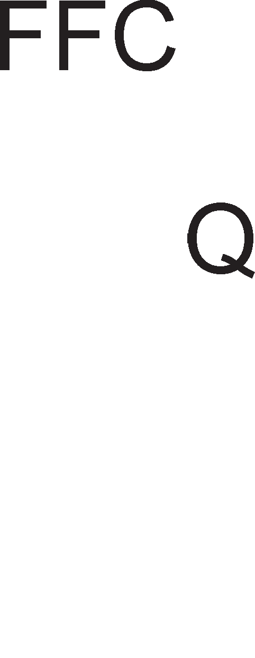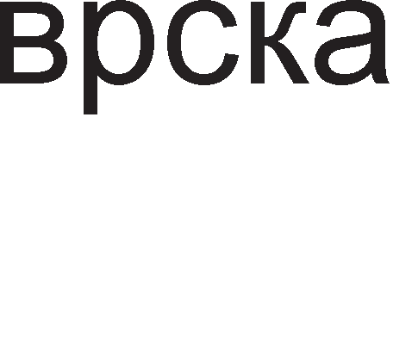

Cn1Ka 1.35. nofl1L1Ka weMa Ha Kpy>KeH 6pojaL1

noToa Ha Bne3 op npB1oT cpn1n cpnon ce nojaByBa nofl1L1Ka ep1H1La , 1Mnync Koj Tpae caMo epeH p1fl1TcK1 TaKT. l/lMeHo ce pa6oT1 3a 1Mnync aKT1BaTop Koj e noTpe6eH 3a pa Kpy>KH1oT 6pojaL1 noL1He pa pa6oT1.

AKo HaMecTo He1HBepT1paL1K1oT 13ne3 flo noBp3eMe 1HBepT1paL1K1oT 13ne3 co Bne3oT Ha Kpy>KH1oT 6pojaL1 i<e po61eMe coceMa no1HaKoB 6pojaL1 TaKaHapeL1eH **i)oHcoHoe Kpy>KeH 6poja"1**. HefloBaTa weMa e np1Ka>KaHa Ha cn1Ka 1.36.



Cn1Ka 1.36. nofl1L1Ka weMa Ha l.)oHcoHoB Kpy>KeH 6pojaL1

HaMecTo L1eT1p1 l.)oHcoHoB1oT 6pojaL1 1Ma ocyM pa3n1L1H1 cocToj61. Bo flopH1oT HaBepeH np1Mep cocToj61 Ha Kpy>KH1oT 6pojaL1 ce 1000, 0100, 0010, 0001. l.)oHcoHoB1oT 6pojaL1 npBo 6po1 HaHanpep, a nocne npB1Te L1eT1p1 p1fl1TcK1 TaKTa noL1HyBa pa 6po1 HaHa3ap. Bo Ta6enaTa 1.15. papeH1 ce ocyMTe pa3n1L1H1 cocToj61 Ko1 nocTojaHo ce noBTopyBaaT nocne ceKoj ocM1 p1fl1TcK1 TaKT.

Kaj Kpy>KH1oT 6pojaL1 ep1H1LaTa BHeceHa Bo pefl1cTapoT nocne HefloBoTo peceT1pal-be 6ewe ep1HcTBeHa 1 Taa nocTojaHo Kpy>Kewe, noMecTyBaji<1 ce op

epeH Bo ppyfl cpn1n cpnon. Kaj l.)oHcoHoB1oT 6pojaL1 Bo npB1Te L1eT1p1 cocToj61 6pojoT Ha ep1H1L1 nocTojaHo ce 3floneMyBa 61peji<1 Ha 1HBepT1paL1K1oT 13ne3 op FFD 1MaMe nofl1L1Ka ep1H1La 1 Taa ep1H1La i<e fl1 ceT1pa c1Te L1eT1p1 cpn1n cpnonoB1. nocne Toa 1HBepT1paL1K1oT 13ne3 cTaHyBa nofl1L1Ka Hyna, cpn1n cpnonoB1Te i<e noL1HaT pa ce peceT1paaT, noL1HyBaji<1 op FFA KoH FFD (nocnepH1Te L1eT1p1 cocToj61).

|  |  |  |  |
| --- | --- | --- | --- |
| FFA | FFB | FFC | FFD |
| 0 | 0 | 0 | 0 |
| 1 | 0 | 0 | 0 |
| 1 | 1 | 0 | 0 |
| 1 | 1 | 1 | 0 |
| 1 | 1 | 1 | 1 |
| 0 | 1 | 1 | 1 |
| 0 | 0 | 1 | 1 |
| 0 | 0 | 0 | 1 |

Ta6ena 1.15. Ta6ena Ha B1cT1H1TocT 3a l.)oHcoHoB Kpy>KeH 6pojaL1

HajL1ecTo Kop1cTeH cpn1n cpnon Kaj 6pojaL11Te e T cpn1n cpnonoT. Toj L1ecTo ce Kop1cT1 KaKo **,qe11MTe11 Ha cppeKeeH4Mja**. AKo T Bne3oT ce noBp3e Ha B1coKo H1Bo Toflaw Ha He1HBepT1paL1K1oT 13ne3 i<e po61eMe p1fl1TcK1 TaKT co pBanaT1 noMana cppeKBeHL1ja op oHaa Ha Bne3H1oT p1fl1TcK1 TaKT. BaKoB pen1Ten Ha cppeKBeHL1ja e np1Ka>KaH Ha cn1KaTa 1.37. Ha 1cTaTa cn1Ka e np1Ka>KaH Bne3H1oT p1fl1TcK1 TaKT 1 TaKToT po61eH Ha He1HBepT1paL1K1oT 13ne3 Q.

Bne3Ha

nofl1L1Ka ,,1"

3ne3Ha peKBeHL1ja

|  |  |  |
| --- | --- | --- |
|  | | |
|  | T Q  CLK Q |  |
|  | l/l cp (f/ |

f Bn

cppeKBeHL1ja 2)

f 13

f 13 = f Bn / 2

Cn1Ka 1.37. T cpn1n cpnon KaKo pen1Ten Ha cppeKBeHL1ja

Co poaral-beTo Ha ceKoj HoB pacTeL1K1 pa6 Ha Bne3H1oT p1fl1TcK1 TaKT BpepHocTa Ha 13ne3oT Q ce MeHyBa opHocHo aKo BpepHocTa Ha 13ne3H1oT c1flHan 61na epeH Toflaw Taa cTaHyBa Hyna 1 o6paTHo. l/lMeHo Ha 13ne3 op T cpn1n cpnonoT po61BaMe epHa nep1opa 3a pBe nep1op1 Ha Bne3H1oT p1fl1TcK1 TaKT.

AKo cep1cK1 noBp3eMe pBa T cpn1n cpnonoB1 L111 T Bne3oB1 ce Bp3aH1 Ha B1coKo H1Bo Toflaw pen1TenoT Ha cppeKBeHL1jaTa i<e 13HecyBa 4. AKo cep1cK1 noBp3eMe Tp1 T cpn1n cpnonoB1 Toflaw 13ne3HaTa cppeKBeHL1ja i<e 61pe ocyM naT1 noMana op Bne3HaTa cppeKBeHL1ja 1TH. l/lMeHo pen1TenoT Ha cppeKBeHL1jaTa ce npecMeTyBa cnopep paBeHKaTa 2n Kape n e epHaKoB Ha 6pojoT Ha cpn1n cpnonoB1. BcywHocT npeKy cep1cKo noBp3yBal-be Ha noBei<e T cpn1n cpnonoB1 L111 T Bne3oB1

ce nocTaBeH1 Ha B1coKo H1Bo ce po61BaaT **acMHxpoHM 6poja"1M**. T1e ce HapeKyBaaT ac1HXpoH1 61peji<1 H1BH1Te cpn1n cpnonoB1 He Kop1cTaT 3aepH1L1K1 p1fl1TcK1 TaKT. A1fl1TcK1oT TaKT ce Hoc1 Ha Bne3 op npB1oT cpn1n cpnon, c1flHanoT op 1HBep1paL1K1oT 13ne3 Q Ha npB1oT cpn1n cpnon ce Hoc1 Ha Bne3oT 3a p1fl1TcK1 TaKT op BTop1oT T cpn1n cpnon, c1flHanoT op 1HBepT1paL1K1oT 13ne3 Q op BTop1oT cpn1n cpnon ce Hoc1 Ha Bne3oT 3a p1fl1TcK1 TaKT Ha TpeT1oT cpn1n cpnon 1TH.

Ha cn1Ka 1.38. e np1Ka>KaHa weMaTa Ha Tp1 61TeH ac1HXpoH 6pojaL1 Koj 6po1 KoH Hanpep. npeTnocTaByBaMe peKa 3a BpeMe Ha npB1oT p1fl1TcK1 TaKT c1Te T cpn1n cpnonoB1 ce peceT1paH1. Co poaral-beTo Ha BTop1oT p1fl1TcK1 TaKT npB1oT cpn1n cpnon ce ceT1pa. Co poaral-beTo Ha TpeT1oT TaKT npB1oT cpn1n cpnon ce peceT1pa , a BTop1oT ce ceT1pa. Co cnepH1oT TaKT npB1oT cpn1n cpnon no BTop naT ce ceT1pa , BTop1oT ocTaHyBa ceT1paH. Kofla i<e pojpe Ha pep ocM1oT TaKT c1Te Tp1 cpn1n cpnonoB1 i<e 61paT ceT1paH1. nocne ocM1oT TaKT, opHocHo Bo peBeT1oT p1fl1TcK1 TaKT c1Te Tp1 cpn1n cpnonoB1 i<e ce 61paT peceT1paH1 1 nocTanKaTa i<e noL1He op noL1eToK.

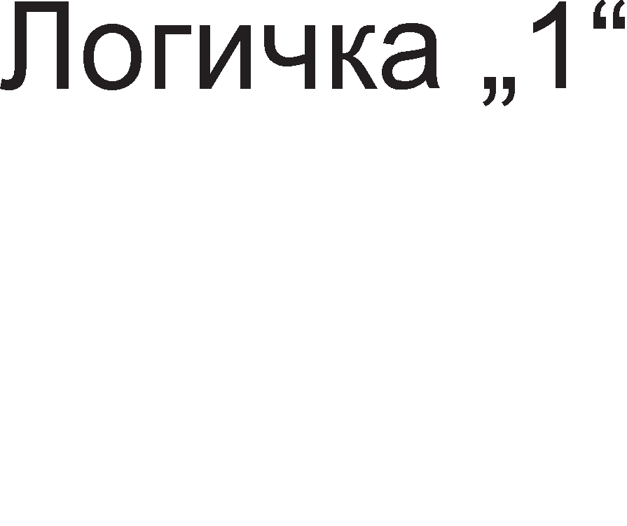

Cn1Ka 1.38. nofl1L1Ka weMa Ha ac1HXpoH 6pojaL1

npoMeH1Te Ha cocToj6aTa Ha Tp1Te 13ne31 op 6pojaL1oT Mo>KaT pa ce np1Ka>KaT npeKy BpeMeHcK1 p1jaflpaM KaKo Ha cn1Ka 1.39.

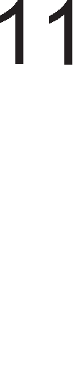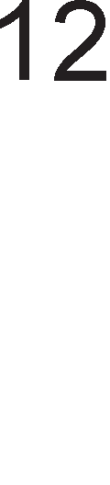

Cn1Ka 1.39. BpeMeHcK1 p1jaflpaM 3a ac1HXpoH 6pojaL1

AKo 3a ceKoj p1fl1TcK1 TaKT fl1 3an1weMe cocToj61Te Ha 13ne31Te QA, QB 1 QC i<e ja po61eMe Ta6enaTa Ha B1cT1H1TocT Ha 6pojaL1oT 1.16.

|  |  |  |  |  |
| --- | --- | --- | --- | --- |
| A1fl1TcK1 TaKT | l/l3ne3Ha KoM61HaL1ja | | | AeL1ManHa BpepHocT |
| QC | QB | QA |
| 0 | 0 | 0 | 0 | 0 |
| 1 | 0 | 0 | 1 | 1 |
| 2 | 0 | 1 | 0 | 2 |
| 3 | 0 | 1 | 1 | 3 |
| 4 | 1 | 0 | 0 | 4 |
| 5 | 1 | 0 | 1 | 5 |
| 6 | 1 | 1 | 0 | 6 |
| 7 | 1 | 1 | 1 | 7 |

Ta6ena 1.16. Ta6ena Ha B1cT1H1TocT 3a Tp161TeH ac1HXpoH 6pojaL1

Bo Ta6enaTa Ha B1cT1H1TocT ocBeH cocToj6aTa Ha 13ne31Te papeHa e 1 peL1ManHaTa BpepHocT Koja ja paBaaT c1Te Tp1 13ne31 3aepHo. OBaa peL1ManHa BpepHocT BcywHocT e BpepHocTa Ha 6pojaL1oT. Co poaral-beTo Ha ceKoj HoB p1fl1TcK1 TaKT BpepHocTa Ha 6pojaL1oT ce 3floneMyBa 3a epeH. MaKc1ManHaTa BpepHocT Koja Mo>Ke pa ja 136po1 oBoj 6pojaL1 e cepyM. nocne Toa poara po peceT1pal-be Ha 6pojaL1oT opHocHo Toj noBTopHo 6po1 op Hyna. Mo>Ke pa ce 3aKnyL11 peKa Tp1 61TH1oT 6pojaL1 1Ma ocyM pa3n1L1H1 cocToj61 noL1HyBaji<1 op 000

po 111. 6pojoT Ha cocToj61 Ha 61no Koj 6pojaL1 e epHaKoB Ha 2n Kape n e 6poj Ha

cpn1n cpnonoB1 Bo 6pojaL1oT, a MaKc1ManHaTa BpepHocT Koja Mo>Ke pa ja 136po1 6pojaL1oT e 3a epeH noMana op 6pojoT Ha cocToj61.

Ha cn1Ka 1.40. e np1Ka>KaH **acMHxpoH ,qeKa,qeH 6poja"1**.

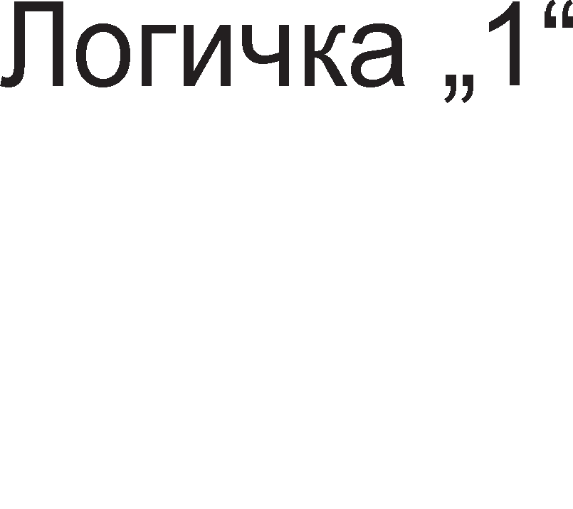

Cn1Ka 1.40. nofl1L1Ka weMa Ha ac1HXpoH peKapeH 6pojaL1

6pojaL1oT np1Ka>KaH Ha cn1Ka 1.40. e cocTaBeH op L1eT1p1 T cpn1n cpnonoB1 L111 T Bne3oB1 ce noBp3aH1 Ha B1coKo H1Bo. OBa 3HaL11 peKa pen1TenoT Ha cppeKBeHL1ja i<e 13HecyBa 24=16. Ho, oBoj 6pojaL1 HeMa pa 6po1 op 0 po 15. 6pojaL1oT ce peceT1pa opHocHo Toj noL1HyBa pa 6po1 op Hyna Kofla cocToj6aTa Ha 13ne31Te op L1eT1p1Te cpn1n cpnonoB1 13HecyBa 1001=9. OBoj 6pojaL1 ce HapeKyBa peKapeH 6pojaL1 61peji<1 1Ma peceT pa3n1L1H1 cocToj61, noL1HyBaji<1 op 0000 po

1001. OBa ce BcywHocT BCD KopoB1Te Ha L1cpp1Te op peKapH1oT 6poeH c1cTeM, na nopap1 Toa oBoj 6pojaL1 ce HapeKyBa 1 BCD 6pojaL1.

6pojaL1oT ce paceT1pa nocne po61Bal-beTo Ha BpepHocTa peBeT 6naflopapeji<1 Ha l/l KonoTo op cn1Ka 1.40. OBa l/l Kono 1Ma Tp1 Bne3a: QA, QD 1 Bne3H1oT p1fl1TcK1 TaKT. Kofla c1Te Tp1 Bne3a i<e cTaHaT epHaKB1 Ha epeH l/l KonoTo i<e pape ep1H1La Ha cBojoT 13ne3 1 i<e ce aKT1B1pa c1flHanoT 3a peceT1pal-be (clear).

# My11TMeM6paTopM

Pa6oTaTa Ha cpn1n cpnonoB1Te, pefl1cTp1Te, 6pojaL11Te 1 MeMop1cK1Te L11noB1 He Mo>Ke pa ce 3aM1cn1 6e3 ynoTpe6a Ha p1fl1TcK1 TaKT. MynT1B16paTop1Te ce caKBeHL1janH1 Kona Koo1 fleHep1paaT p1fl1TcK1 TaKT. OnwTaTa nopen6a Ha MynT1B16paTop1Te e Ha acTa61nH1 1 MoHocTa61nH1. AcTa61nH1Te MynT1B16paTop1 fleHep1paaT nep1op1L1H1 noBopK1 op 1Mnync1, a MoHocTa61nH1Te MynT1B16paTop1 fleHep1paaT caMo epeH 1Mnync 1n1 nay3a Ha cBojoT 13ne3.

## MoHocTa6M11eH My11TMeM6paTop

Ha cn1Ka 1.41. e np1Ka>KaH MoHocTa61neH MynT1B16paTop cocTaBeH op pBe Hl/l Kona, oTnopH1K R, KoHpeH3aTop C 1 no31T1BHa noBpaTHa BpcKa. OBoj MynT1B16paTop 1Ma epHa cTa61nHa cocToj6a Ha nofl1L1Ka ep1H1La 1 epHa npeopHa cocToj6a Ha nofl1L1Ka Hyna. Kofla aKT1BaTopoT He ce MeHyBa MynT1B16paTopoT ce Haora Bo cTa61nHa cocToj6a. Bo cnyL1aj Ha npoMeHa Ha aKT1BaTopoT MynT1B16paToToT npeM1HyBa Bo npeopHa cocToj6a, Ho KaKo wTo H1 Ka>KyBa caMoTo 1Me oBaa cocToj6a He e nocTojaHa opHocHo nocne 13BecHo BpeMe Toj caM1oT i<e ce BpaT1 Bo cTa61nHa cocToj6a.



Cn1Ka 1.41. WeMa Ha MoHocTa61neH MynT1B16paTop



Bo cTa61nHa cocToj6a H13 oTnopH1KoT R He TeL1e cTpyja, Ha Bne3 op KonoTo U2 1MaMe nofl1L1Ka Hyna, a Ha HefloB1oT 13ne3 nofl1L1Ka ep1H1La. Bo cTa61nHa

cocToj6a aKT1BaTopoT e epHaKoB Ha nofl1L1Ka ep1H1La , na pBeTe ep1H1L1 Ha Bne3 op KonoTo U1 i<e papaT nofl1L1Ka Hyna Ha HefloB1oT 13ne3. Bo cTa61nHa cocToj6a pBaTa Kpaja Ha KoHpeH3aTopoT ce HaoraaT Ha H13oK noTeHL1jan wTo 3HaL11 H13 Heflo He TeL1e cTpyja.

AKo Ha Bne3oT 3a aKT1BaTopoT ce nojaB1 nofl1L1Ka Hyna Toflaw 13ne3oT Ha KonoTo U1 i<e cTaHe nofl1L1Ka ep1H1La. 61peji<1 HanoHoT Ha KpaeB1Te op KoHpeH3aTopoT He Mo>Ke MoMeHTanHo pa ce npoMeH1 Bne3oT Ha KonoTo U2 1cTo TaKa i<e cTaHe nofl1L1Ka ep1H1La . KaKo pe3ynTaT Ha oBa i<e ce npoMeH1 1 13ne3oT Ha U2 KonoTo Toj i<e cTaHe nofl1L1Ka Hyna. nopap1 nofl1L1KaTa Hyna Ha 13ne3oT op U2 MynT1B16paTopoT i<e ocTaHe Bo oBaa cocToj6a pyp1 1 Kofla i<e 1cL1e3He nay3aTa Ha Bne3oT 3a aKT1BaTopoT.

AopeKa KoHpeH3aTopoT ce nonH1 H13 Heflo TeL1e cTpyja, a oTKaKo Toj i<e ce HanonH1 cTpyjaTa npecTaHyBa pa TeL1e 1 noTeHL1janoT Bo ToL1KaTa V1 noBTopHo i<e napHe Ha nofl1L1Ka Hyna. OBa npep13B1KyBa 13ne3oT Ha KonoTo U2 noBTopHo pa cTaHe nofl1L1Ka ep1H1La, a 13ne3oT Ha KonoTo U1 nofl1L1Ka Hyna. Cefla KoHpeH3aTopoT i<e noL1He pa ce npa3H1 npeKy oTnopH1KoT R. MynT1B16paTopoT KoHeL1Ho i<e ce BpaT1 Bo cBojaTa cTa61nHa cocToj6a.

BpeMeTpael-beTo Ha npeopHaTa cocToj6a opHocHo BpeMeTpael-beTo Ha nay3aTa Ha 13ne3 op MynT1B16paTopoT 3aB1c1 op KoHcTaHTaTa Ha RC KonoTo 1 ce npecMeTyBa cnopep penaL1jaTa T=0,7 RC.

## AcTa6M11eH My11TMeM6paTop

AcTa61nH1oT MynT1B16paTop e cno6opeH ocL1naTop 6e3 cTa61nHa cocToj6a. Toj 1Ma pBe npeopH1 cocToj61: cocToj6a Ha nofl1L1Ka Hyna 1 cocToj6a Ha nofl1L1Ka ep1H1La. HefloB1oT 13ne3 nocTojaHo ce MeHyBa op H1cKo Ha B1coKo H1Bo

1 o6paTHo 1 Ha Toj HaL11H Toj fleHep1pa nep1op1L1Ha noBopKa op npaBoaflonH1 1Mnync1 L11ja nepopa i<e 3aB1c1 op KoHcTaHTaTa Ha RC KonoTo.

Ha cn1Ka 1.42. e np1Ka>KaHa weMaTa Ha acTa61neH MynT1B16paTop HanpaBeH op Hl/l nopT1. Bne3oB1Te Ha oB1e Hl/l nopT1 ce Kyco Bp3aH1, na T1e cpyHKL1oH1paaT KaKo 1HBepTop1.





Cn1Ka 1.42. WeMa Ha acTa61neH MynT1B16paTop

AKo 13ne3oT Ha BTopoTo Hl/l Kono U2 e epHaKoB Ha nofl1L1Ka ep1H1La Toflaw Ha HefloB1oT Bne3 1Ma nofl1L1Ka Hyna. EpH1oT Kpaj Ha KoHpeH3aTopoT e noBp3aH co 13ne3oT Ha U2 KonoTo 1 e Ha nofl1L1Ka ep1H1La, a ppyfl1oT Kpaj npeKy oTnopH1KoT R e noBp3aH co Bne3oT Ha KonoTo U1 1 e Ha nofl1L1Ka Hyna. KoHpeH3aTopoT i<e noL1He pa ce nonH1.

AopeKa KoHpeH3aTopoT ce nonH1 noTeHL1janoT Bo ToL1KaTa Mery KoHpeH3aTopoT 1 oTnopH1KoT nocTojaHo onara. OBaa ToL1Ka e noBp3aHa co Bne3oT Ha npBoTo Hl/l Kono U1. Bo epeH MoMeHT Bne3oT Ha KonoTo U1 i<e cTaHe nofl1L1Ka Hyna, a HefloB1oT 13ne3 i<e ce npoMeH1 Bo nofl1L1Ka ep1H1La. OBa i<e npep13B1Ka npoMeHa Ha 13ne3oT op KonoTo U2 op nofl1L1Ka ep1H1La Ha nofl1L1Ka Hyna. KoHpeH3aTopoT i<e noL1He pa ce npa3H1 ce popeKa Bne3oT Ha KonoTo U2 noBTopHo He ce npoMeH1 1 L1KnycoT noL1He opHoBo.

Mo>KeMe pa 3aKnyL11Me peKa Kofla KoHpeH3aTopoT ce nonH1 Ha 13ne3 op MynT1B16paTopoT 1MaMe nofl1L1Ka ep1H1La (1Mnync), a Kofla KoHpeH3aTopoT ce npa3H1 Ha 13ne3 1MaMe nofl1L1Ka Hyna (nay3a). nep1opaTa Ha po61eH1oT p1fl1TcK1 TaKT ce npecMeTyBa cnopep paBeHKaTa T=2,2RC.

# no11ynpoeo,qHM"1KM MeMopMM

Bo 3aB1cHocT op B1poT Ha MaTep1jan1Te op Ko1 ce 13pa6oTeH1 MeMop11Te ce nopeneH1 Ha nonynpoBopH1L1K1 1 MaflHeTH1 MeMop11. ROM 1 RAM MeMop11Te ce nonynpoBopH1L1K1 MeMop11. He Mo>Ke pa ce 3aM1cn1 KoMnjyTep Koj Bo cBojoT cocTaB HeMa pa 1Ma RAM 1 ROM MeMop1ja. nonynpoBopH1L1K1Te MeMop11 ce 13pa6oTeH1 Bo cpopMa Ha 1HTeflp1paH1 Kona. npep pa ce 3ano3HaeMe co cpyHKL1jaTa 1 B1poB1Te RAM 1 ROM MeMop11 i<e ja pa3flnepaMe opflaH13aL1jaTa Ha MeMop1cK1Te L11noB1 1 H1BH1Te noBa>KH1 Bne3H1 1 13ne3H1 n1HoB1.

## 0praHM3a4Mja Ha MeMopMcKM "1Mn

<ln1n cpnonoB1Te ce HajMan1 MeMop1cK1 ep1H1L1 Ko1 Mo>KaT pa 3anaMeTaT 1HcpopMaL1ja op epeH 61T. Pefl1cTp1Te ce cocTaBeH1 op noBei<e cpn1n cpnonoB1 1 T1e Mo>KaT pa 61paT 4, 8, 16 61TH1 1TH. nocne pefl1cTp1Te cnepyBaaT MeMop1cK1Te L11noB1 L111 KanaL1TeT Mo>Ke pa pocT1flHe 1 po HeKonKy Mefla 6ajT1.

MeMop1cK1Te L11noB1 ce opflaH131paH1 Bo cpopMa Ha MaTp1L1. MaTp1LaTa e cTpyKTypa cocTaBeHa op HopManHo nocTaBeH1 pep1L1 1 KonoH1, KaKo wTo e np1Ka>KaHo Ha cn1Ka 1.43. Bo cnojH1Te ToL1K1 Ha pep1L1Te 1 KonoH1Te 1Ma no epHa MeMop1cKa i<en1ja Koja Mo>Ke pa MeMop1pa 1HcpopMaL1ja op epeH 61T. 6pojoT Ha pep1L1 e epHaKoB Ha 6pojoT Ha MeMop1cK1 noKaL11, a 6pojoT Ha KonoH1

H1 noKa>KyBa KonKy 61ToB1 Mo>KaT pa ce MeMop1paaT Bo epHa MeMop1cKa noKaL1ja. 6pojoT Ha pep1L1 1 KonoH1 flo pecp1H1paaT 6pojoT Ha appecH1 1 nopaToL1H1 n1HoB1 Ha epeH MeMop1cK1 L11n.

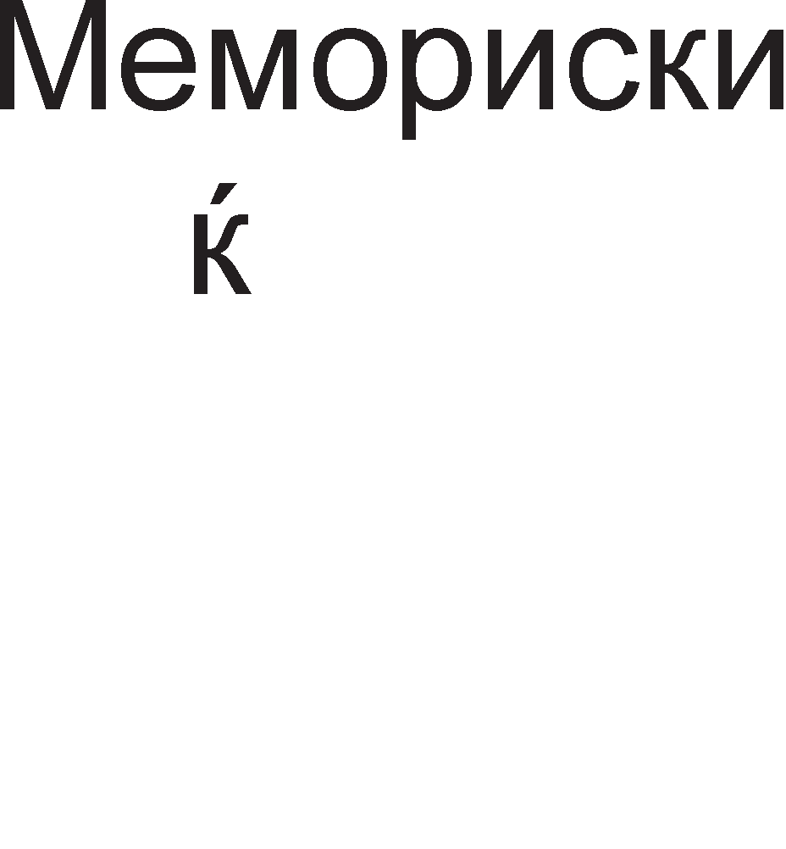



Cn1Ka 1.43. CTpyKTypa Ha MeMop1cK1 L11n

**A,qpecHMTe nMHoeM** cny>KaT 3a ceneKL1ja Ha epHa op MHoflyTe MeMop1cK1 noKaL11 Bo cocTaB Ha epeH MeMop1cK1 L11n. 3aB1cHocTa Mery 6pojoT Ha appecH1 n1HoB1 1 6pojoT Ha MeMop1cK1 noKaL11 e papeHa co panaL1jaTa

6poj Ha MeMop1cK1 noKaL11=26poj Ha appecH1 n1HoB1

CTeneHoT 210 e epHaKoB Ha 1024 1n1 cKpaTeHo ce 3an1wyBa 1K (K1no). CTeneHoT 220 e epHaKoB Ha 1048576 1n1 cKpaTeHo ce HapeKyBa 1M (Mefla). CTeneHoT 230 e epHaKoB Ha 1073741824 1n1 cKpaTeHo ce 3an1wyBa 1G (fl1fla). l/lcTo TaKa poKonKy fl1 pa3no>K1Me cTeneH1Te i<e po61eMe peKa 1G=1K·1K·1K 1n1 1M=1K·1K. 3a noepHocTaBHa npecMeTKa Ha cTeneH1Te Hajpo6po e eKcnoHeHToT pa ce pa3no>K1 Ha ep1H1L1 1 peceTK1 np1 wTo cTeneHoT Ha peceTK1 i<e flo papepe npecp1KcoT. OBa e np1Ka>KaHo Bo np1MepoT 1.12.

**npMMep 1.12**: npecMeTaj flo 6pojoT Ha MeMop1cK1 noKaL1 Bo epeH MeMop1cK1 L11n aKo 6pojoT Ha appecH1 n1HoB1 13HecyBa 17.

PeweH1e: 217=27·210=128 ·1024=128K

OBoj MeMop1cK1 L11n copp>K1 131072 MeMop1cK1 noKaL11 1n1 cKpaTeHo Ka>KaHo 128 K1no MeMop1cK1 noKaL11.

HajHe3HaL1ajH1oT appeceH n1H ce o3HaL1yBa co A0, a Haj3HaL1ajH1oT An-1, Kape wTo 1HpeKcoT n e epHaKoB Ha BKynH1oT 6poj appecH1 Bne3oB1. Ha np1Mep, aKo MeMop1cK1oT L11n nocepyBa 10 appecH1 Bne3a, Toflaw T1e ce 6ene>KaT op A0 po A9. AppecH1Te n1HoB1 ce BcywHocT Bne3oB1 3a appecH1oT peKopep cMecTeH Bo BHaTpewHocTa Ha MeMop1cK1oT L11n. AppecH1oT peKopep cny>K1 pa 136epe epHa MeMop1cKa noKaL1ja op L11noT Bo 3aB1cHocT op Bne3HaTa KoM61HaL1ja Ha

appecH1 61ToB1. CeKoja MeMop1cKa noKaL1ja 1Ma cBoja appeca, Koja, BcywHocT, npeTcTaByBa ep1HcTBeHa KoM61HaL1ja op appecH1 61ToB1. AppecaTa e ep1HcTBeHa 61peji<1 He Mo>Ke pa ce cnyL11 Bo paMK1Te Ha 1cT MeMop1cK1 L11n pBe 1n1 noBei<e noKaL11 pa 1MaaT 1cTa appeca.

**no,qaTo"1HM nMHoeM.** nopaToL1H1Te n1HoB1 cny>KaT 3a BHecyBal-be (Bn1wyBal-be) 1 3a 13HecyBal-be (L11Tal-be) nopaToL1 op epeH MeMop1cK1 L11n. nopaToL1H1Te n1HoB1 Mo>KaT pa 61paT caMo Bne3H1, 13ne3H1 1n1 pBoHacoL1H1. AKo ce Bne3H1 ce 6ene>KaT co 6yKBaTa I wTo npeTcTaByBa npBa 6yKBa op aHfln1cK1oT 36op Input wTo Bo npeBop 3HaL11 Bne3. AKo ce 13ne3H1 ce 6ene>KaT co 6yKBaTa O wTo e npBa 6yKBa op aHfln1cK1oT 36op Output wTo 3HaL11 13ne3. AKo ce pBoHacoL1H1 Toflaw ce 6ene>KaT co 6yKB1Te IO 1n1 co 6yKBaTa D wTo e npBaTa 6yKBa op aHfln1cK1oT 36op *data* wTo Bo npeBop 3HaL11 nopaToK. 6pojoT Ha nopaToL1H1 n1HoB1 Ha epeH MeMop1cK1 L11n 3aB1c1 op 6pojoT Ha KonoH1 Bo MeMop1cKaTa MaTp1La, opHocHo w1poL11HaTa Ha epHa MeMop1cKa noKaL1ja. nop w1p1Ha Ha MeMop1cKa noKaL1ja ce noppa361pa 6pojoT Ha 61ToB1 wTo Mo>KaT pa ce cMecTaT Bo Hea. HajfloneM pen op MeMop1cK1Te L11noB1 ce 8-61TH1 wTo 3HaL11 peKa ceKoja MeMop1cKa noKaL1ja Mo>Ke pa co6epe 8 61Ta 1n1 1 6ajT. noKpaj 8- 61TH1Te MeMop11, nocTojaT 16-61TH1, 4-61TH1 1 epHo61TH1. Bo KaTanowK1Te onL11 Ha MeMop1cK1Te L11noB1, noKpaj 1HcpopMaL1jaTa 3a KanaL1TeToT, papeHa e pononH1TenHa 1HcpopMaL1ja 3a w1poL11HaTa Ha MeMop1cK1Te noKaL11. Ha np1Mep, 1KX8 3HaL11 peKa L11noT 1Ma 1K MeMop1cK1 noKaL11 np1 wTo ceKoja noKaL1ja Mo>Ke pa co6epe 8 61Ta. OBa 3HaL11 peKa Toj L11n Mo>Ke pa co6epe BKynHo 8K 61Ta. Ll1noT 16KX1 1Ma 16K noKaL11 1 ceKoja noKaL1ja co61pa caMo no epeH 61T.

CeKoj MeMop1cK1 L11n 1Ma epeH 1n1 noBei<e **nMHoeM 3a ce11eK4Mja.** l/lMeHo, Bo cMeTaL1oT 1Ma floneM 6poj MeMop1cK1 L11noB1. n1HoB1Te 3a ceneKL1ja Tpe6a pa 13pBojaT caMo epeH op H1B 3a pa Bo Heflo ce Bn1we 1n1 ce npoL11Ta nopaToK. OB1e n1HoB1 ce o6ene>KaH1 co epHa op o3HaK1Te CS (chip select), CE (chip enable) 1n1 epHocTaBHo S (select). HajL1ecTo RAM MeMop11Te ja Kop1cTaT o3HaKaTa  1n1 , a ROM KpaTeHKaTa . Mo>Ke pa ce 3a6ene>K1 peKa KpaTeHK1Te  ,  1  ce cTaBeH1 nop HeflaL1ja, wTo 3HaL11 oB1e n1HoB1 i<e 61paT aKT1BH1 Kofla ce Ha H1cKo H1Bo. Kofla oB1e n1HoB1 ce Ha B1coKo H1Bo, MeMop1cK1oT L11n e nac1BeH, opHocHo op Heflo He Mo>Ke pa ce 13HecyBaaT 1n1 pa ce BHecyBaaT nopaToL1.

npeKy **KoHTpo11HMTe nMHoeM** ce pecp1H1pa onepaL1jaTa wTo i<e ce 13BpwyBa, opHocHo pan1 i<e ce BHecyBaaT 1n1 i<e 13HecyBaaT nopaToL1. ROM 1Ma epeH KoHTponeH n1H  (output enable) 1n1 (gate). 3a pa ce 13HecaT nopaToL1 npeKy nopaToL1H1Te n1HoB1, n1HoB1Te  1  Mopa pa 61paT Ha H1cKo H1Bo. AKo n1HoT  e Ha B1coKo H1Bo, Toflaw nopaToL1H1Te n1HoB1 i<e 61paT oHecnoco6eH1 1 3a H1B Ben1Me peKa ce Bo cocToj6a Ha B1coKa 1MnepaHca. RAM MeMop1jaTa Mo>Ke pa 1Ma epeH 1n1 pBa KoHTponH1 n1Ha. Kofla 1Ma epeH KoHTponeH n1H, Toflaw Toj ce 6ene>K1 co R/ (read/ ). Kofla oBoj n1H e H1cKo H1Bo Toflaw ce Bn1wyBaaT



HoB1 nopaToL1, a Kofla e Ha B1coKo H1Bo, ce L11TaaT npeTXopHo BHeceH1Te nopaToL1. AKo ce Kop1cTaT pBa KoHTponH1 n1Ha, Toflaw Toa ce WE (write enable) 3a n1wyBal-be 1 OE (output enable) 3a L11Tal-be. ABaTa KoHTponH1 n1Ha He cMeaT pa 61paT aKT1BH1 1cToBpeMeHo, a poKonKy 1 pBaTa ce nac1BH1, Toflaw 3a nopaToL1H1Te n1HoB1 Ben1Me peKa ce Bo cocToj6a Ha B1coKa 1MnepaHca.

Ha cn1KaTa 1.44. e np1Ka>KaH nofl1L1K1 p1jaflpaM Ha MeMop1cK1 L11n cocTaBeH op 12 TaKT1paL1K1 cpn1n-cpnonoB1.

I1

I2 Bne3H1 nopaToL1H1

n1H11

I3

D Q

C

D Q D Q

C C

D Q

A0

A1 C

D Q D Q

C C

D Q D Q D Q

AppecH1 n1HoB1

1. C C
2. Q D Q D Q

C C C

AppeceH peKopep

ENB O1

CS RD OE

KoHTponH1 n1HoB1

ENB O2

l/l3ne3H1 nopaToL1H1 ENB O3 n1H11

Cn1Ka 1.44. OpflaH13aL1ja Ha MeMop1cK1 L11n 4×3

CeKoj cpn1n-cpnon Mo>Ke pa 3anaMT1 1HcpopMaL1ja op epeH 61T, wTo 3HaL11 Len1oT MeMop1cK1 L11n Mo>Ke pa 3anaMT1 BKynHo 12 61Ta. 12-Te cpn1n-cpnonoB1 ce pacnopepeH1 Bo L1eT1p1 pep1L1 1 Tp1 KonoH1 wTo 3HaL11 Toj 1Ma L1eT1p1 MeMop1cK1 noKaL11 1 Bo ceKoja noKaL1ja Mo>Ke pa ce 3anaMTaT no Tp1 61Ta. OBoj

L11n 1Ma Tp1 nopaToL1H1 Bne3H1 n1HoB1 Ko1 ce o3HaL1yBaaT co I1,I2 1 I3 1 Tp1 noce6H1 nopaToL1H1 13ne3H1 n1HoB1 co o3HaKaTa O1,O2 1 O3.

AppecH1oT peKopep cny>K1 3a ceneKL1ja Ha epHa op L1eT1p1Te MeMop1cK1 noKaL11. Ha Ta6enaTa 1.17. ce np1Ka>KaH1 KoM61HaL11Te op pBaTa appecH1 Bne3a, Ko1 o6e36epyBaaT np1cTan po caMo epHa MeMop1cKa noKaL1ja .

A0 A1 np1cTan

|  |  |  |
| --- | --- | --- |
| 0 | 0 | MeMop1cKa noKaL1ja 6poj 1 |
| 0 | 1 | MeMop1cKa noKaL1ja 6poj 2 |
| 1 | 0 | MeMop1cKa noKaL1ja 6poj 3 |
| 1 | 1 | MeMop1cKa noKaL1ja 6poj 4 |

Ta6ena 1.17. Ta6ena Ha B1cT1H1TocT 3a appecH1oT peKopep

AKo Bne3oT RD e Ha B1coKo H1Bo, Toflaw i<e L11TaMe nopaToL1 op HeKoja MeMop1cKa noKaL1ja, a aKo RD=0, Toflaw HeMa pa L11TaMe, TyKy i<e n1wyBaMe HoB1 nopaToL1. Bne3oT OE Bpw1 ocnoco6yBal-be Ha 13ne3H1Te 6acpep1.

## RAM MeMopMM

RAM MeMop1jaTa e np1BpeMeHa MeMop1ja. Taa fl1 fly61 nopaToL1Te nocne 1cKnyL1yBal-beTo Ha HanojyBal-beTo. HajfloneMa pa3n1Ka Mery RAM 1 ROM MeMop11Te e Taa wTo RAM MeMop1jaTa ce npoflpaM1pa popeKa pa6oT1 KoMnjyTepoT, a ROM MeMop1jaTa ce npoflpaM1pa npep pa ce Bflpap1 Bo KoMnjyTepoT. RAM MeMop11Te ce MHofly 6p31 MeMop11. H1BHaTa 6p31Ha ce 13pa3yBa npeKy BpeMeTo Ha np1cTan. nop BpeMe Ha np1cTan ce noppa361pa BpeMeTo noM1HaTo op MoMeHToT Kofla MeMop1cK1oT L11n i<e ja np1M1 appecHaTa KoM61HaL1ja Ha Bne3 po MoMeHToT Ha nojaByBal-be Ha nopaToL1H1Te 61ToB1 Ha 13ne3. Kaj RAM MeMop11Te BpeMeTo Ha np1cTan 13HecyBa HeKonKy HaHo ceKyHp1.

Cnopep HaL11HoT Ha L1yBal-be 1 ocBe>KyBal-beTo Ha nopaToL1Te, nocTojaT pBa B1pa RAM MeMop11: DRAM 1 SRAM MeMop11.

**SRAM** (Static RAM) e cTaT1L1KaTa RAM MeMop1ja 1 Bo cBo1Te i<en11 1Ma D cpn1n-cpnonoB1. Hej3e He Iii e noTpe6Ho ocBe>KyBal-be 1 e MHofly no6p3a op DRAM MeMop1jaTa. nopap1 B1coKaTa LeHa Ha L11Hel-be, Bo cMeTaL1oT ce Haora Bo noMan1 Kon1L11H1, o61L1Ho KaKo Kew-MeMop1ja

**DRAM** (Dinamic RAM) 1n1 p1HaM1L1KaTa RAM MeMop1ja Koja Bo cBo1Te i<en11 copp>KaT epeH TpaH31cTop 1 epeH KoHpeH3aTop. Kofla KoHpeH3aTopoT e nonH, Toa 3HaL11 cocToj6a Ha B1coKo H1Bo (ep1H1La), a Kofla e npa3eH, 3HaL11 cocToj6a Ha H1cKo H1Bo (Hyna). OBoj B1p MeMop1ja 1Ma MHofly KpaTKo BpeMe Ha

naMTel-be, 61pejK1 co TeK Ha BpeMe poara po 1cTeKyBal-be Ha eneKTp1L1TeToT op KoHpeH3aTopoT. nopap1 Toa e noTpe6Ho nopaToL1Te Bo DRAM MeMop1jaTa nocTojaHo pa ce ocBe>KyBaaT (noBTopHo pa ce nop1flHyBa HanoHoT). DRAM MeMop1jaTa e MHofly cnopa, Ho po6p1 cTpaH1 ce H1cKaTa LeHa 1 floneMaTa flycT1Ha (floneM 6poj 61Ta no epeH L11n). nocTojaT HeKonKy B1poB1 DRAM MeMop11. HajcTap B1p e FPM (Fast Page Mode) DRAM. Toa e MeMop1cK1 L11n opflaH131paH Bo cpopMa Ha MaTp1La op 61ToB1. 3a pa ce cT1flHe po caKaH1oT 61T, Mopa pa ce 3Hae 6pojoT Ha pep1La 1 6pojoT Ha KonoHa. nopoLHa ce jaByBa EDO (Extended Data Output) DRAM, Koj oBo3Mo>KyBa BTopoTo noB1KyBal-be Ha MeMop1jaTa pa noL1He npep pa 3aBpw1 npBoTo. Co oBa ce 3floneMyBa Kon1L1ecTBoTo nopaToL1 wTo Mo>KaT pa ce 13BneL1aT op MeMop1jaTa Bo papeHo BpeMe.

Op SRAM MeMop11Te, i<e flo cnoMeHeMe SRAM 4016. Toj 1Ma cTpyKTypa 2K×8, wTo 3HaL11 1Ma 11 appecH1 1 8 nopaToL11 n1Ha. SRAM Mo>Ke pa 1Ma MaKc1ManeH KanaL1TeT op 128KX8. 3a pa3n1Ka op SRAM, DRAM e co MHofly nofloneM1 KanaL1TeT1 op 64MX1 na Haflope. HepocTaToK Ha DRAM MeMop11Te e wTo 6apaaT MHofly noBei<e appecH1 n1Ha oTKonKy wTo npepB1pene npo13Bop1Ten1Te. nopap1 Toa, appecH1Te n1HoB1 ce MynT1nneKc1paaT. Toa 3HaL11 peKa H13 epHa 1cTa appecHa n1H1ja Mo>KaT pa ce npeHecyBaaT pBa appecH1 61Ta, Ha np1Mep, A0 1 A8 1n1 A3 1 A11 ,Ho He 1cToBpeMeHo, TyKy npBo epH1oT, a noToa ppyfl1oT.

A8

Din WR RAS A0 A2 A1

Vcc

GND CAS

Dout A6 A3 A4

|  |  |  |
| --- | --- | --- |
|  | DRAM 41256 |  |
|  |  |
|  |  |
|  |  |
|  |  |
|  |  |
|  |  |
|  |  |
|  |  |
|  |  |
|  |  |
|  |  |
|  |  |
|  |  |
|  |  |
|  |  |
|  |  |

A5

A7

Cn1Ka 1.45. n1H p1jaflpaM Ha DRAM MeMop1cK1 L11n

Ha cn1KaTa 1.45. e np1Ka>KaH n1H-p1jaflpaMoT Ha L11noT DRAM 41256, Koj 1Ma cTpyKTypa 64KX1. Op cn1KaTa Mo>Ke pa ce 3a6ene>K1 peKa oBoj L11n 1Ma 8 appecH1 n1Ha, a 3a appec1pal-be Ha 64K MeMop1cK1 noKaL11 noTpe6H1 ce 16 appecH1 n1Ha. OBa e peweHo npeKy BoBepyBal-be Ha pBa pononH1TenH1 n1Ha: (column address strobe)  (row address strobe). AopeKa e aKT1BeH n1HoT



, Toflaw Ha appecH1Te n1HoB1 poaraaT 61ToB1Te op A0 po A7. noToa cneL1janH1oT n1H ce KpeBa Ha B1coKo H1Bo 1 Ha HefloBoTo MecTo ce aKT1B1pa n1HoT , Koj po3BonyBa Ha 1cT1Te appecH1 n1Ha pa pojpaT 61ToB1Te op A8 po A15.



## ROM MeMopMM

**ROM** (Read Only Memory) e MeMop1ja 3a TpajHo L1yBal-be nopaToL1. Op Hea Mo>KaT caMo pa ce L11TaaT nopaToL1, Ho He 1 pa ce Bn1wyBaaT HoB1. no 1cKnyL1yBal-beTo Ha HanojyBal-beTo, nopaToL1Te 1 HaTaMy ocTaHyBaaT Bo ROM MeMop1jaTa. ROM L11noB1Te o6e36epyBaaT nofloneM cTeneH Ha c1flypHocT 61peji<1 MeMop1paH1Te copp>K1H1 ce 3awT1TeH1 op HecaKaH1 npoMeH1. Bo ROM MeMop1jaTa ce cMecTeH1 npoflpaM1 wTo cny>KaT 3a nop1flHyBal-be Ha onepaT1BH1oT c1cTeM no BKnyL1yBal-beTo Ha KoMnjyTepoT. OB1e npoflpaM1 ce no3HaT1 nop 1MeTo BIOS (Basic Input Output System).

nocTojaT pa3n1L1H1 B1poB1 Ha nocTanK1 3a BHecyBal-be Ha nopaToL1 Bo ROM MeMop1cK1Te L11noB1. Cnopep Toa nocTojaT pa3n1L1H1 B1poB1 Ha ROM MeMop11: MacK1paL1K1 ROM MeMop11, PROM, EPROM, EEPROM 1 cpnew

MeMop11.

**MacKMpa"1KaTa ROM** e MeMop1ja L11ja copp>K1Ha ce Bn1wyBa Bo TeKoT Ha caMoTo npo13BopcTBoTo. 3a npo13BopcTBo Ha ROM L11noB1 ce Kop1cTaT cn1L1H1 TeXHonowK1 nocTanK1 KaKo 1 3a npo13BopcTBo Ha M1KponpoLecopcK1 L11noB1. MacKpaL1K1Te ROM L11noB1Te ce Kop1cTaT 3a L1yBal-be Ha npoflpaM1 Ko1 MacoBHo ce Kop1cTaT 1 Ko1 He ce MeHyBaaT.

**PROM** e npoflpaM161nHa ROM MeMop1ja, Koja Mo>Ke pa ja npoflpaM1pa caM1oT Kop1cH1K Bo 3aB1cHocT op HefloB1Te noTpe61. CTpyKTypaTa Ha epHa BaKBa MeMop1ja e np1Ka>KaHa Ha cn1Ka 1.46. Kaj p1opHaTa PROM MeMop1ja Bo ceKoja i<en1ja op MeMop1cKaTa MaTp1La ce Haora p1opa, Koja e cep1cK1 noBp3aHa co Tonn1B H1Ken-XpoM oc1flypyBaL1.

Cn1Ka 1.46. nocTanKa 3a Bn1wyBal-be Ha 1HcpopMaL1ja Bo PROM L11n



Kofla MeMop1jaTa He e npoflpaM1paHa c1Te p1op1 ce noBp3aH1 co pep1L1Te 1 KonoH1Te op MaTp1LaTa. Kop1cH1KoT caM ja npoflpaM1pa MeMop1jaTa TaKa wTo

npep13B1KyBa npeflopyBal-be Ha oc1flypyBaL11Te Ha MecTaTa Ha Ko1 caKa cocToj6a Ha nofl1L1Ka Hyna. nocTanKaTa ce Bpw1 nocTanHo TaKa wTo ce appec1pa pep1La no pep1La, a Ha nopaToL1H1Te n1H11 Kaj Ko1 Tpe6a pa ce oTcTpaH1 p1opaTa ce Hoc1 HeflaT1BeH 1Mnync. Toflaw H13 p1opaTa 1 oc1flypyBaL1oT i<e npoTeL1e npefloneMa cTpyja 1 poara po pacK1HyBal-be Ha BpcKaTa Mery KonoHaTa 1 pep1LaTa. PROM MeMop1jaTa He Mo>Ke noBTopHo pa ce penpoflpaM1pa.

**EPROM** MeMop11Te (Erasable Programmabile Read Only Memory) KaKo MeMop1cK1 eneMeHT1 Kop1cT1 MOS TpaH31cTop1 co 13on1paH flejT. Kofla MeMop1jaTa He e npoflpaM1paHa HanoHoT op +5V Ha nopaToL1HaTa n1H1ja e poBoneH 3a pa ce cpopM1pa KaHan Bo MOS TpaH31cTopoT, na copp>K1HaTa Ha c1Te MeMop1cK1 i<en11 e Hyna. npoflpaM1pal-beTo Ha MeMop1jaTa ce Bpw1 TaKa wTo Ha nopaToL1HaTa n1H1ja ce Hoc1 B1coK HanoH (25V) np1 wTo cocToj6aTa Ha 13on1paH1oT flejT ce MeHyBa op nofl1L1Ka Hyna Bo nofl1L1Ka ep1H1La. BaKa npoflpaM1paHaTa MeMop1ja He ja MeHyBa cBojaTa copp>K1Ha noBei<e op peceT flop1H1. AKo BaKa npoflpaM1paH1oT L11n ce o3paL11 co ynTpaB1oneToBa cBeTn1Ha 3a BpeMe op 20 M1HyT1, copp>K1HaTa ce fly61 61peji<1 ce HaManyBa npoBopHocTa Ha KaHanoT 1 eneKTpoH1Te flo HanywTaaT 13on1paH1oT flejT. nocne oBa L11noT Mo>Ke noBTopHo pa ce npoflpaM1pa. HajL1ecTo Kop1cTeHa EPROM MeMop1ja e L11noT co 1HpeHT1cp1KaL1oHeH 6poj 2716. OBoj L11n e co cTpyKTypa 2KX8, wTo 3HaL11 copp>K1 11 appecH1 n1Ha 1 8 nopaToL1H1 n1Ha. Op cep1jaTa 27X i<e fl1 cnoMeHeMe L11noB1Te co 6poeB1: 2704 (512X8), 2708 (1KX8), 2716 (2KX8), 2732 (4KX8), 2764 (8KX8), 27128 (16KX8), 27256 (32KX8), 27512 (64KX8) 1 271024 (128KX8). Mo>Ke pa ce 3aKnyL11 peKa c1Te oB1e

L11noB1 1MaaT 8 nopaToL1H1 n1Ha, a 6pojoT Ha appecH1 n1HoB1 e pa3n1L1eH. AKo ce noMHo>K1 6pojoT Ha appecH1 n1HoB1 1 6pojoT Ha nopaToL1H1 n1HoB1 ce po61Ba 6poj wTo Tpe6a pa ce popape Ha 27 op oBaa cep1ja.

**EEPROM** (Electrically Erasable Programmabile Read Only Memory) 1cTo TaKa KaKo MeMop1cK1 i<en11 Kop1cT1 MOS TpaH31cTop1 co 13on1paH flejT, caMo wTo 13onaL1jaTa Mery eneKTpop1Te e noMana Bo opHoc Ha MOS TpaH31cTop1Te Kaj EPRPM MeMop11Te. npoflpaM1pal-beTo ce Bpw1 Ha cn1L1eH HaL11H KaKo 1 Kaj EPROM MeMop1jaTa, Ho nopap1 noManaTa 13onaL1ja ce Kop1cT1 noMan HanoH Ha npo61B op +10V. 6p1wel-beTo Ha copp>K1HaTa e no eneKTp1L1eH naT, TaKa wTo ce Kop1cT1 HanoH co cnpoT1BeH nonap1TeT op HanoHoT Ha Bn1wyBal-be. 6p1wel-beTo ce 13BpwyBa cocpTBepcK1 1 Mo>Ke BepHaw pa ce BHecaT HoB1Te copp>K1H1. OBa flo poBepyBa Bo npawal-be Ha31BoT Read Only Memory, Ho Tpe6a pa ce 3eMe Bo npepB1p peKa copp>K1HaTa Ha EEPROM MeMop1jaTa ce MeHyBa MHofly peTKo, Ha np1Mep epHaw flop1wHo, a copp>K1HaTa Ha RAM MeMop1jaTa ce MeHyBa HeKonKy naT1 Bo epHa ceKyHpa.

HajHoB o6n1K Ha nonynpoBopH1L1Ka MeMop1ja e **cp11ew MeMopMjaTa**, Koja TaKa ce B1Ka nopap1 6p31HaTa co Koja Mo>Ke pa ce penpoflpaM1pa (aHfln1cK1 flash- Monl-ba). <lnew MeMop1jaTa ce nojaB1na Bo cpep1HaTa Ha ocyMpeceT1Te flop1H1 1 npeTcTaByBa cpep1Ha Mery EEPROM 1 EPROM MeMop1jaTa 1 no cBojaTa LeHa, Ho 1 no cpyHKL1oHanHocTa. l/lcTo KaKo 1 EEPROM, cpnew MeMop1jaTa Kop1cT1

TeXHonofl1ja Ha eneKTp1L1Ho 6p1wel-be. 6p1wel-beTo Ha LenaTa cpnew MeMop1ja Tpae caMo HeKonKy ceKyHp1. rycT1HaTa Ha naKyBal-be e 1cTa KaKo Kaj EPROM (nofloneMa op EEPROM) 61peji<1 Kop1cT1 caMo epeH TpaH31cTop 3a MeMop1pal-be Ha epeH 61T. <lnew MeMop11Te Mo>KaT pa ce penpoflpaM1paaT Bo caM1oT c1cTeM, 6e3 Bapel-be Ha L11noT op nopHo>KjeTo. np1 noL1ecTo Bapel-be 1 noBTopHo cTaBal-be Ha L11noT Bo nopHo>KjeTo Mo>Ke pa pojpe po owTeTyBal-be Ha HefloB1Te n1HoB1.

<lnew MeMop11Te Mo>KaT pa ce penpoflpaM1paaT 1 po 100000 naT1.

## aK11y"1o4M:

npeTBapal-beTo Ha 6poj op peKapeH Bo 61HapeH 6poeH c1cTeM ce Bpw1 npeKy penel-be Ha 6pojoT co pBa 1 3an1wyBal-be Ha po61eH1oT ocTaToK. nocnepHo po61eH1oT ocTaToK e 61T co HajfloneMa Te>K1Ha. npeTBapal-beTo Ha 6poj op 61HapeH Bo peKapeH 6poeH c1cTeM ce Bpw1 co co61pal-be Ha c1Te L1cpp1 op 61HapH1oT 6poj, Ho npeTXopHo noMHo>KeH1 co H1BH1Te Te>K1H1 1, 2, 4, 8, 16, 32,

64, 128 1TH,

61no Koja L1cppa op XeKcapeL1ManH1oT 6poeH c1cTeM Mo>Ke pa ce npeTcTaB1 KaKo 361p op Te>K1H1Te 8, 4, 2 1 1. Ha no31L11Te op Te>K1H1Te Ko1 BneflyBaaT Bo 361poT ce n1wyBa ep1H1La, a Ha no31L11Te op Te>K1H1Te Ko1 He BneflyBaaT Bo 361poT ce n1wyBa Hyna.

3a pa Ha 13ne3 op nofl1L1KoTo l/l Kono po61eMe nofl1L1Ka ep1H1La Tpe6a c1Te Bne3oB1 pa 61paT nofl1L1Ka ep1H1La. 3a pa Ha 13ne3 op nofl1L1KoTo l/lnl/l Kono po61eMe nofl1L1Ka Hyna Tpe6a c1Te Bne3oB1 pa 61paT nofl1L1K1 Hyn1. AKo Ha Bne3 op 1HBepTopoT 1Ma nofl1L1Ka ep1H1La Toflaw Ha 13ne3 i<e ce po61e nofl1L1Ka Hyna 1 o6paTHo. 3a pa Ha 13ne3 op nofl1L1KoTo EKCl/lnl/l Kono po61eMe nofl1L1Ka ep1H1La Tpe6a Ha Bne3oB1Te pa 1Ma HenapeH 6poj Ha ep1H1L1.

Kaj 1HTeflp1paH1Te Kona op TTL cpaM1n1jaTa 3a nofl1L1Ka Hyna MaKc1ManHaTa BpepHocT Ha Bne3H1oT HanoH 13HecyBa 0,8V, a Ha 13ne3H1oT HanoH 0,45V. 3a nofl1L1Ka ep1H1La M1H1ManHaTa BpepHocT Ha Bne3H1oT HanoH 13HecyBa 2V, a Ha 13ne3H1oT HanoH 2,4V.

MynT1nneKcepoT e Kono co 2n nopaToL1H1 Bne3a 1 n KoHTpon1 Bne3a co Ko1 ce ceneKT1pa epeH op nopaToL1H1Te Bne3oB1. CeneKT1paH1oT nopaToL1eH Bne3 ce noBp3yBa co ep1HcTBeH1oT nopaToL1eH 13ne3.

AKo Ha Bne3 op peKopepoT poara n 61TeH 6poj Toflaw co Heflo ce ceneKT1pa epeH 13ne3 op BKynHo 2n 13ne31.

<ln1n cpnonoT e HajMan MeMop1cK1 Mopyn Bo Koj Mo>Ke pa ce 3anaMT1 1HcpopMaL1ja op epeH 61T. Pa6oTaTa Ha cpn1n cpnonoB1Te Mo>Ke pa ce aHan131pa Ta6enapHo, aHan1T1L1K1 1 flpacp1L1K1.

Kaj cpn1n cpnonoB1Te p1fl1TcK1oT TaKT npeTcTaByBa aKT1BaTop, ycnoB pa HacTaHe npoMeHa Ha nopaToL1H1Te 13ne31 nop pejcTBo Ha nopaToL1H1Te Bne3oB1. AKT1BaTop Mo>Ke pa 61pe nofl1L1KaTa ep1H1La Ha p1fl1TcK1oT TaKT, HefloB1oT pacTeL1K1 1n1 onaraL1K1 pa6.

OcHoBHa nopen6a Ha pefl1cTp1Te e Ha cTaL1oHapH1 1 noMecTyBaL1K1. nocTojaT L1eT1p1 B1poB1 noMecTyBaL1K1 pefl1cTp1: cep1cK1 Bne3-napaneneH 13ne3, cep1cK1 Bne3-cep1cK1 13ne3, napaneneH Bne3-cep1cK1 13ne3 1 napaneneH Bne3- napaneneH 13ne3. HajBa>KH1 KoHTponH1 c1flHan1 Kaj cTaL1oHapH1oT pefl1cTap ce c1flHanoT 3a 3an1wyBal-be HoB1 nopaToL1 (READ) 1 c1flHanoT 3a L11Tal-be Ha Bei<e 3an1waH1Te nopaToL1 (WRITE).

AKo 13ne3oT op noMecTyBaL1K1oT pefl1cTap ce noBp3e co HefloB1oT 13ne3 (noBpaTHa BpcKa) Toflaw ce po61Ba Kpy>KeH 6pojaL1.

Kaj c1HXpoH1oT 6pojaL1 c1Te HefloB1 cpn1n cpnonoB1 Kop1cTaT 1cT p1fl1TcK1 TaKT. Kaj ac1HXpoH1Te 6pojaL11 nopaToL1H1oT 13ne3 op npeTXopH1oT cpn1n cpnon ce Hoc1 Ha Bne3oT 3a TaKT op cnepH1oT cpn1n cpnon.

Ac1HXpoH1Te 6pojaL11 ce HajL1ecTo 13pa6oTeH1 op T 1n1 JK cpn1n cpnonoB1. np1 Toa nopaToL1H1oT Bne3 Ha T cpn1n cpnonoT ce noBp3yBa co H1Bo Ha nofl1L1Ka ep1H1La, a pBaTa nopaToL1H1 Bne3oB1 Ha JK cpn1n cpnonoT KpaTKo ce noBp3yBaaT.

MeMop1cK1Te L11noB1 ce opflaH131paH1 Bo cpopMa Ha MaTp1La, Mpe>Ka op pep1L1 1 KonoH1, np1 wTo Bo ceKoja cnojHa ToL1Ka Ha pep1L1Te 1 KonoH1Te 1Ma no epHa MeMop1cKa i<en1ja.

HajBa>KH1 n1HoB1 Ha MeMop1cK1Te L11noB1 ce appecH1Te 1 nopaToL1H1Te n1HoB1. AppecH1Te n1HoB1 cny>KaT 136op Ha epHa MeMop1cKa noKaL1ja, a npeKy nopaToL1H1Te n1HoB1 ce 3an1wyBaaT HoB1 1n1 L11TaaT Bei<e BHeceH1Te nopaToL1.

nocTojaT pBa B1pa Ha RAM MeMop11: DRAM 1 SRAM. DRAM MeMop11Te ce 13pa6oTeH1 op cpn1n cpnonoB1 1 T1e ce 6p31 MeMop11. SRAM MeMop1jaTa e 13pa6oTeHa op KoHpeH3aTop1 1 Hej3e 1 e noTp6Ho ocBe>KyBal-be, HapononHyBal-be Ha 13fly6eH1oT eneKTp1L1TeT.

MacK1paL1KaTa ROM e MeMop1ja L11ja copp>K1Ha ce Bn1wyBa Bo TeKoT Ha caMoTo npo13BopcTBo. PROM e npoflpaM161nHa MeMop1ja, Koja Mo>Ke pa ja npoflpaM1pa caM1oT Kop1cH1K Bo 3aB1cHocT op HefloB1Te noTpe61. EEPROM e

MeMop1ja L11ja copp>K1Ha Mo>Ke pa ce 6p1we 1 noBTopHo 3an1wyBa no eneKTp1L1eH naT. <lnew MeMop11Te Mo>KaT pa ce penpoflpaM1paaT po 10000 naT1.

## npawa1-a M 3a,qa"1M

1. A) E3 (16)=?(2)

6) A8 (16)=?(2)

B) 2B (16)=?(2)

r) C5 (16)=?(2)

2. A) 49 (10)=?(2)

6) 60 (10)=?(2)

B) 47 (10)=?(2)

r) 56 (10)=?(2)

3.

A) 00111001 (2)=?(16)=?(10)

6) 11100010 (2)=?(16)=?(10)

B) 01000110 (2)=?(16)=?(10)

r) 10100101 (2)=?(16)=?(10)

4.

A) D589 (16) + 55CC (16)=?(16)

6) E5B7 (16) + AA33 (16)=?(16)

B) 12FD (16) + C4C9 (16)=?(16)

r) 78D7 (16) + 192B (16)=?(16)

* 1. 61HapH1Te 6poeB1 co6ep1 fl1 nofl1L1K1 1 ap1TMeT1L1K1!

A) 11001110 (2) + 00111011 (2)=?(2)

6) 11100111 (2) + 10010111 (2)=?(2)

B) 10010011 (2) + 11000111 (2)=?(2)

r) 01011101 (2) + 10110111 (2)=?(2)

* 1. HaLpTaj nofl1L1K1 p1jaflpaM Ha peKopep co pBa Bne3a. Han1w1 ja Ta6enaTa Ha B1cT1H1TocT.
  2. Ko1 ce Hajno3HaT1Te cpaM1n11 1HTeflp1paH1 Kona 1 Ko1 ce H1BH1Te ocHoBH1 KapaKTep1cT1K1?
  3. Kofla ce Kop1cT1 nocTanKaTa Ha 6acpep1pal-be?
  4. Ha6poj fl1 B1poB1Te Ha KoM61HaL1cK1 Kona!
  5. O6jacH1 ja HaMeHaTa Ha peKopepoT co np1op1TeT Ha Bne3oB1Te?
  6. Koja e pa3n1KaTa Mery ap1TMeT1L1KoTo 1 nofl1L1KoTo co61pal-be?
  7. O6jacH1 flo Ha31BoT ceKBeHL1janH1 Kona!
  8. Ha cn1KaTa e np1Ka>KaHa peaKL1jaTa Ha 13ne3oT Ha epeH cpn1n-cpnon. 3a Koj cpn1n cpnon ce pa6oT1?

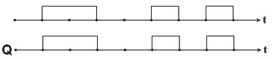

* 1. KaKo Tpe6a pa ce no6ypeH1 KoHTponH1Ten1H11 R, W 1 CLR 3a pa Mo>Ke Bo pefl1cTepoT pa ce BHecyBa HoBa copp>K1Ha? KonKy naT1 Mo>Ke pa ce ynoTpe61 3anaMTeHaTa copp>K1Ha?

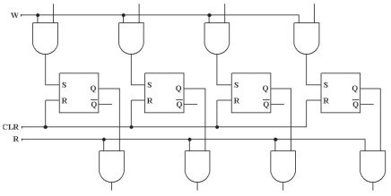

* 1. Ha6poj 6apeM 4 n1Ha Ha MeMop1cK1 L11n co cTpyKTypa 4 pep1L1 x 3 KonoH1. Han1w1 flo Len1oT Ha31B Ha oB1e n1HoB1 (Ha aHfln1cK1 ja31K) 1 H1BH1Te KpaTeHK1.
  2. no3HaT e KanaL1TeToT Ha MeMop1cK1oT L11n. KonKy appecH1 Bne3a i<e 1Ma Toj?
     1. 256KB

6) 1GB

* + 1. 32KB

r) 2MB

* 1. KonKy 1Mnync1 My ce noTpe6H1 Ha np1Ka>KaH1oT 6pojaL1, noL1HyBaji<1 op noL1eTHaTa cocToj6a Ha 6pojaL1oT, 3a pa ja nocT1flHe HajB1coKaTa BpepHocT Bo oncefloT Ha 6poel-be? WTo i<e ce nojaB1 Ha 13ne31Te op 6pojaL1oT nocne peceTT1oT Bne3eH 1Mnync?

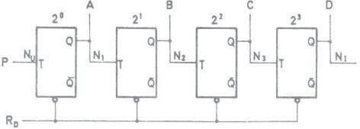

* 1. no3HaTa e cTpyKTypaTa Ha MeMop1cK1oT L11n. KonKy 61ToB1 Mo>Ke pa MeMop1pa L11noT? KonKy 6ajTa Mo>Ke pa MeMop1pa Toj?
     1. 16 pep1L1 x 2 KonoH1

6) 4 pep1L1 x 6 KonoH1

* + 1. 8 pep1L1 x 8 KonoH1

r) 16 pep1L1 x 4 KonoH1

* 1. KaKBa cpyHKL1ja 1Ma peKopepoT Kaj MeMop1cK1oT L11n co cTpyKTypa 4 pep1L1 x 3 KonoH1?
  2. Ko1 ce cocTaBH1Te penoB1 Ha epHo61THaTa ap1TMeT1L1Ko-nofl1L1Ka ep1H1La?

21. 3a wTo cny>K1 peKopepoT Kaj epHo61THaTa ap1TMeT1L1Ko-nofl1L1Ka ep1H1La?

1. HaLpTaj MynT1nneKcep co 4 Kop1cH1L1K1 Bne3a. Han1w1 ja Ta6enaTa Ha B1cT1H1TocT 3a 1cT1oT.
2. l/l3Bpw1 cnopep6a Mery acTa61nH1oT 1 MoHocTa61nH1oT MynT1B16paTop?
3. Ko1 ce HajBa>KH1Te n1HoB1 Ha epeH MeMop1cK1 L11n?
4. MeMop1cK1Te L11noB1 ce opflaH131paH1 Bo cpopMa Ha MaTp1L1. O6jacH1!
5. Cnopep1 fl1 SRAM 1 DRAM MeMop1cK1Te L11noB1!
6. O6jacH1 ja nocTanKaTa Ha npoflpaM1pal-be Ha PROM L11noB1Te!
7. no3HaT1 ce BpepHocT1Te Ha Bne3H1Te c1flHan1 Ha epHo61THaTa ap1TMeT1L1Ko nofl1L1Ka ep1H1La. Aa ce oppepaT BpepHocT1Te Ha 13ne3H1Te c1flHan1 1 B1poT Ha 13BpweHaTa onepaL1ja?

|  |  |  |  |  |  |  |  |
| --- | --- | --- | --- | --- | --- | --- | --- |
| Fo | F1 | B1p onepaL1jaTa | A | B | nBn | l/l3ne3 | n13 |
| 1 | 1 |  | 1 | 1 | 1 |  |  |
| 1 | 0 |  | 0 | 0 | 1 |  |  |
| 1 | 0 |  | 1 | 0 | 0 |  |  |
| 1 | 0 |  | 1 | 0 | 0 |  |  |
| 1 | 1 |  | 1 | 0 | 0 |  |  |

1. O6jacH1 ja cpyHKL1jaTa Ha appecH1oT peKopep Bo cocTaBoT Ha MeMop1cK1Te L11noB1!

**2. 0cHoeM Ha MMKpoKoMnjyTepMTe**

# Boee,q eo MMKpoKonjyTepcKM cMcTeMM

nop M1KpoKoMnjyTepcK1 c1cTeM noppa361paMe c1cTeM cocTaBeH op LeHTpanHa npoLecopcKa ep1H1La, pa6oTHa RAM MeMop1ja 1 TpajHa MeMop1ja 3a L1yBal-be Ha npoflpaM1Te 1 po61eH1Te pe3ynTaT1 op npoLec1pal-beTo. OB1e KoMnoHeHT1 ce HeonXopH1 1 6e3 H1B He Mo>Ke pa ce Bpw1 o6pa6oTKa Ha nopaToL1. Kofla 61 ce o61pene pa fl1 pa3pen1Me no1M1Te **KoMnjyTepcKM cMcTeM** 1 **MMKpoKoMnjyTepcKM cMcTeM** Toflaw 61 peKne peKa KoMnjyTepcK1Te c1cTeM1 ce po61eH1 op M1KpoKoMjyTepcK1Te c1cTeM1 npeKy np1KnyL1yBal-be Ha HoB1 XappBepcK1 1 cocpTBepcK1 KoMnoHeHT1 Ha 1cT1Te. Ha np1Mep co popaBal-be Ha MoH1Top KaKo 13ne3eH ypep 1 TacTaTypa KaKo Bne3eH ypep, M1KpoKoMnjyTepcK1oT c1cTeM npepacHyBa Bo nepcoHaneH KoMnjyTep. Apyfl np1Mep 3a M1KpoKoMnjyTepcK1 c1cTeM npeTcTaByBaaT M1KpoKoHTponep1Te. Toa ce cneL1janHo p13ajH1paH1 1HTeflp1paH1 Kona Ko1 Bo ce6e copp>KaT LeHTpanHa npoLecopcKa ep1H1La, RAM 1 ROM . C1Te Tp1 KoMnoHeHT1 ce cTaBeH1 Bo epeH L11n. Ho KaKo wTo He Mo>KeMe pa fl1 Kop1cT1Me Haw1Te nepcoHanH1 KoMnjyTep1 6e3 TacTaTypa, flnyweL 1 MoH1Top1, TaKa 1 M1KpoKoHTponep1Te He Mo>KaT pa cpyHKL1oH1paaT caM1 3a ce6e, 6e3 pa np1KnyL11Me ceH3op1 Ha H1BH1Te Bne3oB1 1 13BpwH1 ypep1 Ha H1BH1Te 13ne31.

npecp1KcoT M1Kpo MHofly L1ecTo ce Kop1cT1 Bo KoMnjyTepcKaTa TeXH1Ka. TaKB1 ce 36opoB1Te M1KpoKoMnjyTep, M1KponpoLecop, M1KpoKoHTponep. Co npecp1KcoT M1Kpo ce 1cTaKHyBaaaT H1BH1Te Man1 p1MeH311 Bo opHoc Ha H1BHaTa oflpoMHa cpyHKL1oHanHocT.

AeHec KoMnjyTepcK1Te c1cTeM1 ce Kop1cTaT HaceKape 1 6e3 H1B He Mo>Ke pa ce 3aM1cn1 MopepH1oT >K1BoT. He nocTo1 eneKTp1L1eH ypep wTo He copp>K1 M1H1-KoMnjyTep Bo ce6e. TyKa ce M1cn1 Ha TenecpoH1Te, TeneB13op1Te, KaMep1Te, M1Kpo6paHoB1Te neL1K1, WA-nneep1Te, 1flpaL1K1Te 1 MHofly ppyfl1 ypep1 3a poMawHa ynoTpe6a. ManKy nocno>KeH1 KoMnjyTep1 ce ypep1Te 3a B1peo1flp1. Kaj H1B flpacp1KaTa e noHanpepHa, Ho cocpTpBepcK1 ce MHofly oflpaH1L1eH1. O61L1Ho, copp>KaT epeH M1KponpoLecop, HeKonKy MB MeMop1ja, p1cnnej (aKo He nocTo1 Mo>KHocT 3a noBp3yBal-be co TeneB13op). HajfloneM pen op nyreTo Kofla i<e flo

cnywHaT no1MoT KoMnjyTep, M1cnaT Ha nepcoHaneH KoMnjyTep (PC-Personal Computer). 3a pa3n1Ka op npeTXopH1Te KoMnjyTep1, nepcoHanH1Te KoMnjyTep1 1MaaT MHofly nofloneM KanaL1TeT Ha MeMop1ja, Xapp-p1cKoB1 1 Mo>KHocT 3a np1KnyL1yBal-be Ha floneM 6poj nep1cpepH1 ypep1. TyKa 3a npBnaT ce cpei<aBaMe co no1MoT onepaT1BeH c1cTeM wTo, BcywHocT, npeTcTaByBa nocpepH1K - BpcKa Mery L1oBeKoT 1 KoMnjyTepoT. no nepcoHanH1Te KoMnjyTep1 poaraaT TaKaHapeL1eH1Te cepBep1. Toa ce Moi<H1 KoMnjyTep1 co oflpoMH1 6p31H1, Ko1 Mo>KaT pa copp>KaT epeH 1n1 noBei<e M1KponpoLecop1. HajL1ecTo ce Kop1cT1 3a ynpaByBal-be co TenecpoHcK1oT coo6pai<aj, 1HTepHeT-Mpe>KaTa 1 ppyfl1 noKanH1 1n1 flno6anH1 KoMnjyTepcK1 Mpe>K1. nofloneM1Te opflaH13aL11, KaKo 6aHK1Te, yH1Bep31TeTcK1Te 616n1oTeK1 1 ppyfl1Te no3HaL1ajH1 1HcT1TyL11 pacnonaflaaT co KoMnjyTep1 - 6aHK1 Ha nopaToL1. T1e ce co pocTa floneM1 p1MeH311 1 HajfloneM pen op BpeMeTo 1 eHepfl1jaTa ce TpowaT Ha opflaH131pal-be Ha oflpoMH1oT MeMop1cK1 npocTop. KaKo HajMoi<H1 1 HajcKan1 ce cynepKoMnjyTep1Te Ko1 pacnonaflaaT He caMo co oflpoMeH MeMop1cK1 npocTop TyKy 1 co cynep 6p31 npoLecop1.

Ce pa361pa, H1e He cMe Bo Mo>KHocT pa fl1 npoyL11Me c1Te oB1e KoMnjyTepcK1 c1cTeM1. Ke fl1 npoyL11Me M1KponpoLecop1Te Ha HaKonKy fleHepaL11 nepcoHanH1 KoMnjyTep1, H1BH1Te cocTaBH1 penoB1, cpyHKL1oHanHocTa, MeMop1cKaTa opflaH13aL1ja 1 noBp3yBal-beTo co Bne3Ho-13ne3H1Te ypep1.

# KoMnjyTepcKa opraHM3a4Mja

KoMnjyTepoT 1Ma cno>KeHa cTpyKTypa 1 Taa e peL11c1 1cTa Kaj HajfloneM 6poj KoMnjyTep1. nocTojaT pBe ocHoBH1 KoMnoHeHT1: **xap,qeep** 1 **cocpTeep.** Ha cn1KaTa

* 1. np1Ka>KaHa e 6noK-weMa Ha KoMnjyTep.

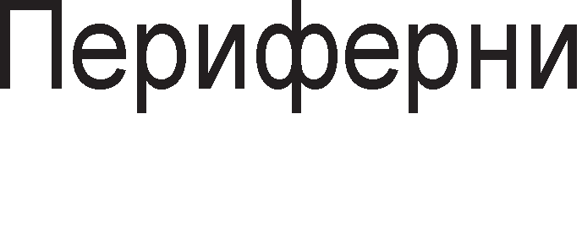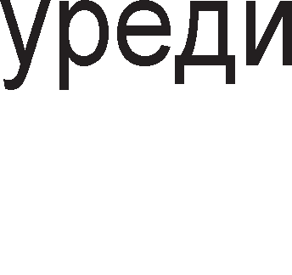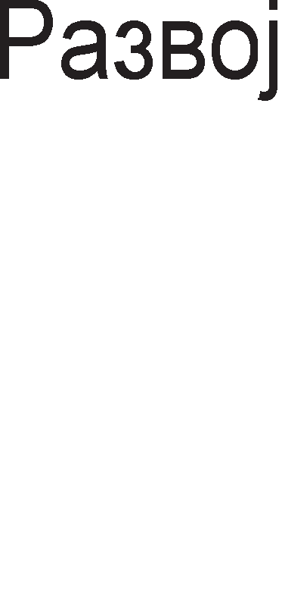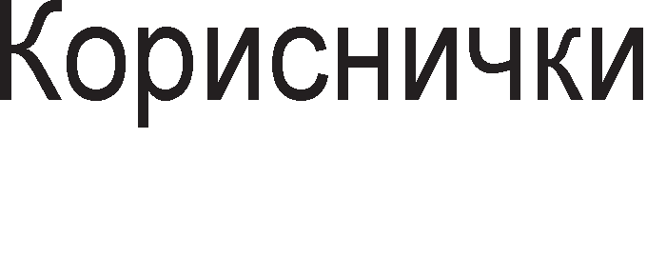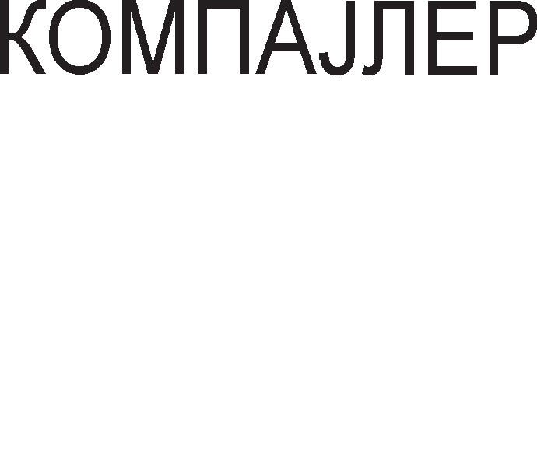

Cn1Ka 2.1. 6noK weMa Ha ocHoBeH Mopen Ha KoMnjyTep

nop XappBep ce noppa361paaT MeXaH1L1K1 penoB1 op Ko1 e HanpaBeH KoMnjyTepoT. CocTaBH1 XappBepcK1 KoMnoHeHT1 Ha KoMnjyTep ce: M1KponpoLecop, MeMop11, Mafl1cTpan1 1 nep1cpepH1 ypep1. **MMKponpo4ecopoT** fl1 o6pa6oTyBa nopaToL1Te, **MeMopMMTe** fl1 L1yBaaT, a **MarMcTpa11MTe** fl1 npeHecyBaaT. **nepMcpepHMTe ype,qM** ce no3HaT1 1 nop 1MeTo Bne3Ho-13ne3H1 ep1H1L1. nep1cpepH1Te ypep1 fl1 npeTBopaaT Kop1cH1L1K1Te 1HcpopMaL11 Bo p1fl1TanH1 c1flHan1, Hyn1 1 ep1H1L1, Ho 1 o6paTHo. Kop1cH1L1K1 1HcpopMaL11 ce oH1e 1HcpopMaL11 wTo fl1 Kop1cT1 L1oBeKoT, KaKo wTo ce: 3ByK, cn1Ka, TeKcT, B1peo. CeKoja op ocHoBH1Te XappBepcK1 KoMnoHeHT1 i<e 61pe peTanHo o6jacHeTa.

**CocpTeepoT** npeTcTaByBa 361p op npoflpaM1 Ko1 oBo3Mo>KyBaaT Kop1cTel-be Ha XappBepoT. XappBepoT 1 cocpTBepoT ce ycnoBHo noBp3aH1. Ha noL1eToToKoT, XappBepoT 61n MHofly nocKan op cocpTBepoT, Ho peHec cocToj6aTa e cnpoT1BHa. Oco6eHo Ba>KeH MoMeHT Bo pa3BojoT Ha cocpTBepoT e nojaBaTa Ha **onepaTMeHMoT cMcTeM**. Toj npeTcTaByBa cyMa op npoflpaM1 Ko1 oBo3Mo>KyBaaT oflpoMH1Te XappBepcK1 pecypc1 Ha KoMnjyTepoT pa 61paT pocTanH1 po L1oBeKoT 1 pa My o6e36epaT noypo6Ha pa6oTa. OnepaT1BHoT c1cTeM npeTcTaByBa pen op cocpTBepoT, Koj e Haj6n1cKy po XappBepoT. Co noTcpepcTBoTo Ha onepaT1BH1oT c1cTeM c1Te ocTaHaT1 npoflpaM1 np1cTanyBaaT po XappBepoT. HajMHofly Kop1cTeH onepaT1BeH c1cTeM e Windows Kape L1oBeKoT My 3apaBa KoMaHp1 Ha KoMnjyTepoT npeKy oTBopal-be npo3opL11l-ba. 3a KoMnjyTep1 Bp3aH1 Bo Mpe>Ka, noTpe6H1 ce noce6H1 onepaT1BH1 c1cTeM1. OBpe noce6Ho BH1MaH1e ce nocBeTyBa Ha KoMyH1KaL1jaTa (pa3MeHa Ha 1HcpopMaL11) Mery KoMnjyTep1Te 1 3awT1TaTa Ha nopaToL1Te op Hepo3BoneHo Kop1cTel-be. Kaj Hac pocTa aKTyeneH onepaT1BeH c1cTeM 3a KoMnjyTep1 Bp3aH1 Bo Mpe>Ka e UNIX.

nop **pa3eoeH cMcTeM** ce noppa361pa oHoj pen op cocpTBepoT wTo cny>K1 3a 13pa6oTKa Ha ann1KaT1BH1 npoflpaM1. Mo>KeMe pa Ka>KeMe peKa pa3BojH1oT c1cTeM e anaTKa wTo cny>K1 3a npaBel-be HoB cocpTBep. 3apap1 nopo6po ccpai<al-be Ha pa3BojH1oT c1cTeM, i<e o6jacH1Me HeKonKy B1poB1 npoflpaM1 wTo cnaraaT Bo oBaa flpyna :

* ep1Top1-npoflpaM1 Ko1 oBo3Mo>KyBaaT BHecyBal-be, MeHyBal-be, o6n1KyBal-be, naMTel-be 1 neL1aTel-be TeKcT Ha npoflpaMaTa;
* npeBepyBaL11-fl1 npeBepyBaaT npoflpaM1Te Han1waH1 Bo npoflpaMcK1 ja31L1 op noB1coK pep Bo Maw1HcK1 ja31K.
* pe6aflep1-npoflpaM1 3a oTcTpaHyBal-be flpewK1. Ce nocTaByBaaT KoHTponH1 ToL1K1 Ha oppenH1 MecTa Bo npoflpaMaTa 1 Bo TeKoT Ha npoflpaMaTa ce 3acTaHyBa Ha oB1e ToL1K1 1 ce 1cn1TyBa cocToj6aTa Ha npoflpaMaTa.
* noBp3yBaL11-npoflpaM1 wTo BpwaT noBp3yBal-be Ha HoB1oT cocpTBep co cTap1oT wTo e MHofly Ba>KHo 3a HefloBo 13BpwyBal-be.

Ann1KaT1BH1Te npoflpaM1 ce 13pa6oTyBaaT co Len Bne3H1Te nopaToL1, Kop1cTeji<1 flo KoMnjyTepoT, pa ce TpaHccpopM1paaT Bo 13ne3H1 nopaToL1. T1e Mo>Ke pa 61paT Han1waH1 Bo Maw1HcK1 ja31K 1n1 Bo npoflpaMcK1 ja31K op noB1coK

pep. Ann1KaT1BH1Te npoflpaM1 fl1 13pa6oTyBaaT Kop1cH1L1Te caM1 1n1 fl1 KynyBaaT KaKo floToB1 npopyKT1 (npoflpaM1 3a ypepyBal-be TeKcToB1, npoflpaM1 3a KH1floBopcTBo, npoflpaM1 3a 6aHK1, KoMnjyTepcK1 1flp1 1 pp.). HeKo1 ann1KaT1BH1 npoflpaM1 cny>KaT 1 3a HaTaMowHo ycoBpwyBal-be Ha nocTojH1oT pa3BoeH c1cTeM.

# 0cHoeHa opraHM3a4Mja Ha MMKponpo4ecop

M1KponpoLecopoT e ,,**Mo3oKoT”** Ha KoMnjyTepoT. Toj 1Ma pBe ocHoBH1 cpyHKL11: 13BpwyBa npoflpaM1 1 ynpaByBa co ppyfl1Te ypep1 Ha MaT1L1HaTa nnoL1a.

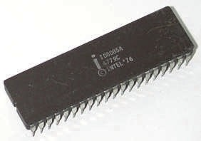

Cn1Ka 2.2. HapBopeweH 13flnep Ha M1KponpoLecop M1KponpoLecopoT fl1 ,,flnepa” npoflpaM1Te KaKo MHo>KecTBo op 6ajT1

HapepeH1 Bo nocnepoBaTenH1 MeMop1cK1 noKaL11. M1KponpoLecopoT fl1 **M3epwyea nporpaMMTe** 6ajT no 6ajT. OTKaKo i<e flo o6pa6oT1 TeKoBH1oT 6ajT, Toj flo L11Ta cnepH1oT 6ajT op RAM MeMop1jaTa, flo o6pa6oTyBa 1 oBaa nocTanKa ce noBTopyBa c*è* popeKa npoLecopoT He pojpe po KpajoT Ha npoflpaMaTa.

**Ynpaeyea"1KaTa cpyHK4Mja** flo npaB1 M1KponpoLecopoT master, flocnopap Ha MaT1L1HaTa nnoL1a. Toj np161pa 1HcpopMaL11 op c1Te ypep1 Bo KoMnjyTepoT, fl1 o6pa6oTyBa, fl1 npoLec1pa 1 noToa 1H1L1pa oppepeH1 aKT1BHocT1, co Len pa ce o6e36ep1 c1flypHa pa6oTa Ha Len1oT KoMnjyTep.

**LlHcTpyK4McKoTo MHo>KecTeo** npeTcTaByBa MHo>KecTBo op c1Te 1HcTpyKL11 Ko1 Mo>Ke pa fl1 13BpwyBa M1KponpoLecopoT. C1Te 1HcTpyKL11 Ha M1KponpoLecop1Te Mo>KaT pa ce nopenaT Bo L1eT1p1 ocHoBH1 flpyn1: 1HcTpyKL11 3a npeHoc, ap1TMeT1L1K1, nofl1L1K1 1HcTpyKL11 1 1HcTpyKL11 3a KoHTpona Ha npoflpaMaTa.

* + l/lHcTpyKL11Te 3a npeHoc cny>KaT 3a: npeHoc op epeH Bo ppyfl pefl1cTap Bo BHaTpewHocTa Ha M1KponpoLecopoT (move), npeHoc op

MeMop1ja Bo pefl1cTap 1n1 cnpoT1BHo (load, store) 1 L11Tal-be 1 n1wyBal-be op nep1cpepH1Te ypep1 (in, out).

* + Ap1TMeT1L1K1 1HcTpyKL11 ce 1HcTpyKL11Te 3a co61pal-be (add), op3eMal-be (substract), MHo>Kel-be (multiply) 1 penel-be (divide).
  + Bo flpynaTa Ha nofl1L1K1 1HcTpyKL11 cnaraaT : nofl1L1Ko MHo>Kel-be 1n1 onepaL1ja Ha l/l Kono (and), nofl1L1Ko co61pal-be 1n1 onepaL1ja Ha l/lnl/l Kono (or) 1 npecMeTKa Ha npB KoMneMeHT (complement).
  + KoHTponH1Te 1HcTpyKL11 flo MeHyBaaT TeKoT Ha npoflpaMaTa. Co H1B HaMecTo 1HcTpyKL1jaTa wTo cnepyBa Mo>Ke pa ce 13Bpw1 61no Koja ppyfla 1HcTpyKL1ja. Bo oBaa flpyna cnaraaT 1HcTpyKL11Te 3a cKoK (Jump) 1 1HcTpyKL11 3a noB1KyBal-be Ha nopnpoflpaMa (Call). OB1e 1HcTpyKL11 Mo>KaT pa 61paT ycnoBH1 1 6e3ycnoBH1. Ha np1Mep 1HcTpyKL1jaTa 3a cKoK Mo>Ke pa ce 13Bpw1 caMo aKo pe3ynTaToT op npeTXopHo 13BpweHaTa 1HcTpyKL1ja e epHaKoB Ha Hyna.

Ha cn1Ka 2.3. np1Ka>KaHa e ocHoBHaTa opflaH13aL1ja Ha M1KponpoLecopoT. **CocTaeHM ,qe11oeM** Ha epeH M1KponpoLecop ce: pefl1cTp1, ap1TMeT1L1Ko-nofl1L1KaTa ep1H1La 1 ynpaByBaL1KaTa ep1H1La co peKopepoT.

Pefl1cTp1Te ce 6p31 MeMop1cK1 noKaL11 Bo BHaTpewHocTa Ha M1KponpoLecopoT. Ce penaT Ha onwT1 pefl1cTp1 1 pefl1cTp1 co cneL1janHa HaMeHa. OnwT1Te pefl1cTp1 fl1 copp>KaT nopaToL1Te wTo Tpe6a pa ce o6pa6oTaT (npeHecaT, co6epaT, nopenaT, KoMnneMeHT1paaT, poT1paaT 1TH). CeKoj pefl1cTap co cneL1janHa HaMeHa c1 1Ma cBoja ToL1Ho pecp1H1paHa cpyHKL1ja. Ha oBaa flpyna np1nara 1HcTpyKL1cK1oT pefl1cTap. Toj flo copp>K1 onepaL1cKoT Kop. OBoj Kop cny>K1 3a npeTcTaByBal-be Ha 1HcTpyKL11Te Bo Maw1HcK1 ja31K. OnepaL1cK1oT Kop e ep1HcTBeHa KoM61HaL1ja op Hyn1 1 ep1H1L1 1 cny>K1 3a 1peHT1cp1KaL1ja 1 npeno3HaBal-be Ha 1HcTpyKL1jaTa.

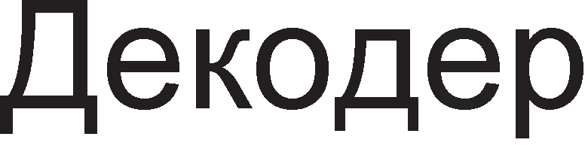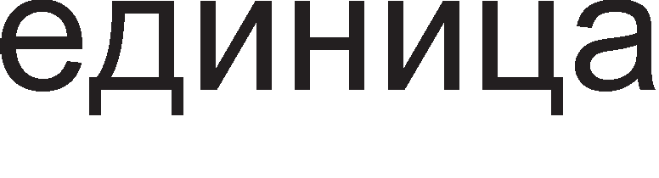

Cn1Ka 2.3. 6noK weMa Ha ocHoBeH Mopen Ha M1KponpoLecop

Bo ap1TMeT1L1Ko-nofl1L1KaTa ep1H1La ce 13BpwyBaaT c1Te ap1TMeT1L1K1 1 nofl1L1K1 1HcTpyKL11. Aa ce noTceT1Me, HajepHocTaBH1 ap1TMeT1L1K1 1HcTpyKL11 ce: co61pal-beTo, op3eMal-beTo, penel-beTo, MHo>Kel-beTo, a HajepHocTaBH1 nofl1L1K1 1HcTpyKL11 ce: l/l, l/lnl/l 1 HeflaL1ja.

AeKopepoT flo peKop1pa onepaL1cK1oT Kop. Toj e p1peKHo noBp3aH co ynpaByBaL1KaTa ep1H1La. YnpaByBaL1KaTa ep1H1La e cocTaBeHa op M1n1oH1 nofl1L1K1 Kona. Taa np1Ma nopaToL1 op c1Te ypep1 1 noToa opnyL1yBa, MeHyBa copp>K1Ha Ha pefl1cTp1, MeHyBa nofl1L1Ka cocToj6a Ha n1HoB1, noB1KyBa npoflpaM1, aKT1B1pa nep1cpepH1 ypep1 1TH.

# MeMopMcKa opraHM3a4Mja

C1Te nopaToL1 1 npoflpaM1 wTo fl1 13BpwyBa npoLecopoT Mopa pa 61paT cMecTeH1 Bo MeMop11Te. HajBa>KH1 **KapaKTepMcTMKM Ha MeMopMMTe** ce H1BH1oT KanaL1TeT 1 6p31HaTa. KanaL1TeToT Ha MeMop11Te ce Mep1 Bo 6ajT1 (B) 1n1 nofloneM1 ep1H1L1 3a KanaL1TeT ce: K1no6ajT1 (KB), Mefla6ajT1 (MB), fl1fla6ajT1 (GB), Tepa6ajT1 (TB). 6p31HaTa Ha MeMop1jaTa ce Mep1 npeKy BpeMeTo Ha np1cTan. Toa e BpeMeTo noTpe6Ho MeMop1jaTa pa ce npe6apa 1 pa flo npoHajpe caKaH1oT nopaToK.

KoMnjyTep1Te copp>KaT pa3n1L1H1 B1poB1 Ha MeMop11. MeMop1cKaTa opflaH13aL1ja noppa361pa nopen6a Ha cpyHKL11Te 3a ceKoj B1p MeMop1ja 1 HaL11HoT Ha np1cTan po caKaH1oT nopaToK. Ha cn1KaTa 2.4. e np1Ka>KaHa n1paM1paTa op MeMop11. KaKo ce c1MHyBaMe Hapony TaKa ce 3floneMyBa KanaL1TeToT Ha MeMop11Te, a ce HaManyBa H1BHaTa 6p31Ha Ha pa6oTa. nofloneMaTa 6p31Ha Ha pa6oTa (noManoTo BpeMe Ha np1cTan Ha nopaToL1Te) noBneKyBa 3floneMyBal-be Ha LeHaTa no epeH 6ajT. Bo n1paM1paTa, MeMop11Te ce noppepeH1 X1epapX1cK1, opHocHo cnopep H1BHaTa Ba>KHocT. KonKy MeMop11Te ce no6n1cKy po BpBoT TonKy noBei<e ce no6n1cKy po M1KponpoLecopoT.



Cn1Ka 2.4. n1paM1pa Ha MeMop11

**PerMcTpMTe** ce MHofly 6p31 MeMop1cK1 noKaL11 Bo BHaTpewHocTa Ha caM1oT M1KponpoLecop. T1e cny>KaT 3a np1BpeMeHo L1yBal-be Ha nopaToL1Te npep T1e pa 61paT o6pa6oTeH1, Ho 1 3a cMecTyBal-be Ha pe3ynTaT1Te BepHaw no H1BHoTo po61Bal-be. Pefl1cTp1Te ce Haj6p31 MeMop1cK1 noKaL11 Bo KoMnjyTepoT, Ho H1BH1oT KanaL1TeT 13HecyBa caMo HeKonKy 6ajT1.

MHofly L1ecTo ce cnyL1yBa M1KponpoLecopoT pa L1eKa (wait) pa ce poHecaT noTpe6H1Te nopaToL1 op MeMop1jaTa 3a pa 1cT1Te fl1 o6pa6oT1. Co Len pa ce HaMan1 BpeMeTo Ha L1eKal-be, ce Kop1cT1 **Kew-MeMopMja.** Kew-MeMop1jaTa e MHofly 6p3a MeMop1ja. 3apap1 no6p3o 13BpwyBal-be Ha TeKoBHaTa npoflpaMa, noTpe6H1Te nopaToL1 op no6aBH1Te MeMop11 opHanpep ce poHecyBaaT 1 ce cMecTyBaaT Bo Kew-MeMop1jaTa. Bo Kew-MeMop1jaTa Mo>Ke pa ce L1yBaaT nopaToL1 wTo noL1ecTo fl1 Kop1cT1 M1KponpoLecopoT, a He Mo>Ke pa fl1 cMecT1 Bo cBo1Te pefl1cTp1. Kew- MeMop1jaTa Mo>Ke pa 61pe Bo caM1oT MeMop1cK1 L11n 1n1 HapBop op Heflo. Kew- MeMop1jaTa e 6p3a RAM MeMop1ja, Ho co noMan KanaL1TeT.

**RAM** e KpaTeHKa op aHfln1cK1Te 36opoB1 Random Access Memory, wTo Bo npeBop 3HaL11 **MeMopMja co c11y"1aeH npMcTan**. l/lMeHo, npoLecopoT 1Ma 1cT np1cTan po c1Te noKaL11 op MeMop1jaTa 1n1 H1epHa noKaL1ja He e co noMan 1n1 co nofloneM np1op1TeT. RAM e MeMop1ja op Koja Mo>Ke 1cToBpeMeHo pa ce L11TaaT, Ho 1 pa ce n1wyBaaT HoB1 nopaToL1. Toa e MeMop1ja co npoMeHn1Ba copp>K1Ha 1 npeTcTaTyBa **pa6oTHa MeMopMja**, epeH B1p pa6oTeH n1cT Ha Koj M1KponpoLecopoT np1BpeMeHo fl1 3an1wyBa c1Te nopaToL1 wTo i<e My 61paT noTpe6H1 3a ycnewHo pean131pal-be Ha papeHaTa npoflpaMa. npoflpaM1Te ce HajL1ecTo cH1MeH1 Ha HeKoj op ypep1Te 3a nepMaHeHTHa MeMop1ja (p1cK, p1cKeTa), Ho Bo MoMeHToT Kofla ce pa6oT1 co H1B, T1e Mopa pa 61paT 1cKon1paH1 Bo RAM MeMop1jaTa. RAM MeMop1jaTa e no3HaTa 1 nop 1MeTo np1MapHa MeMop1ja, nopap1 Hej31HaTa Ba>KHocT 3a M1KponpoLecopoT. RAM e **npMepeMeHa MeMopMja**. AoKonKy HanojyBal-beTo ce 1cKnyL11, nopaToL1Te op RAM He Mo>KaT pa ce o6HoBaT no noBTopHoTo BKnyL1yBal-be. nopap1 Toa, npep pa flo 1cKnyL11Me KoMnjyTepoT, nopaToL1Te op RAM Tpe6a pa ce cMecTaT Ha Xapp-p1cKoT npeKy Kn1KHyBal-be Ha 1KoHaTa SAVE. OBa e np1Ka>KaHo Ha cn1Ka 2.5.



Cn1Ka 2.5. <lyHKL1ja Ha RAM-oT KaKo pa6oTHa MeMop1ja Ha M1KponpoLecopoT

M1KponpoLecopoT e MHofly no6p3 ypep op MeMop11Te. npe6apyBal-beTo Ha nopaToL1Te noHeKoflaw Mo>Ke pa 61pe cno>KeHa 1 6aBHa nocTanKa. Bp3 6p31HaTa Ha pa6oTaTa noce6Ho Bn1jaH1e 1MaaT RAM MeMop1jaTa 1 Kew-MeMop1jaTa. M1KponpoLecopoT o6pa6oTyBa npoflpaM1 6ajT no 6ajT. np1Toa, 1HcTpyKL11Te fl1 3eMa op RAM MeMop1jaTa. RAM MeMop1jaTa flo ,,XpaH1” npoLecopoT co

1HcpopMaL11, a RAM-oT ce XpaH1 op Xapp-p1cKoT. C1Te npoflpaM1 ce cMecTeH1 Ha Xapp-p1cKoT 1 T1e ce npeHecyBaaT Bo RAM Kofla Tpe6a pa 61paT o6pa6oTeH1. AoKonKy HeKoja npoflpaMa e npefloneMa 1 He Mo>Ke pa ja co6epe Bo npepB1peH1oT npocTop Bo RAM-oT, Toflaw Taa ce pen1 Ha noBei<e penoB1 1 TaKa ce o6pa6oTyBa pen no pen. AoKonKy RAM e nofloneM, Toflaw Toj opepHaw i<e 3eMe nofloneM pen op Kop1cH1L1KaTa npoflpaMa (cMecTeHa Ha Xapp-p1cKoT) 1 1cT1oT i<e ce o6pa6oT1 Bo M1KponpoLecopoT. Co oBa ce HaManyBa 6pojoT Ha npeHoc1 op RAM po Xapp- p1cKoT, a Toa 3HaL11 1 3awTepa Ha BpeMe. npow1pyBal-beTo Ha RAM MeMop1jaTa co HoB1 noKaL11 6apa nofloneM 6poj appecH1 n1H11 Bo Mafl1cTpan1Te 3a pa ce oBo3Mo>K1 appec1pal-be Ha HoB1 noKaL11.

Ha cn1Ka 2.6. npecTaBeHa e **MeMopMcKaTa Mana Ha RAM** MeMop1jaTa. CeKoja pep1La npeTcTaByBa epHa MeMop1cKa noKaL1ja. BKynH1oT 6poj Ha MeMop1cK1 noKaL11 3aB1c1 op 6pojoT Ha appecH1 n1H11 1 ce npecMeTyBa cnopep paBeHKaTa: BKyneH 6poj Ha MeMop1cK1 noKaL11 = 2n, Kape wTo n e 6poj Ha appecH1 n1H11. 61peji<1 6poel-beTo 3anoL1HyBa op Hyna nocnepHaTa noKaL1ja i<e 61pe co pepeH 6poj 2n-1. AppecaTa Ha npBaTa, HajponHaTa noKaL1ja op RAM MeMop1jaTa e epHaKBa Ha n Hyn1, a nocnepHaTa, HajflopHaTa noKaL1ja 1Ma appeca cocTaBeHa op n ep1H1L1. Ha cn1Ka 2.6. appec1Te Ha MeMop1cK1Te noKaL11 He ce papeH1 Bo 61HapeH, TyKy Bo XeKcapeL1ManeH 6poeH c1cTeM.

2n-1

FFFF.….F FFFF.…E FFFF.…D FFFF.…C FFFF.…B

2

1 00000...01

0 00000….0

Cn1Ka 2.6. MeMop1cKa Mana Ha RAM MeMop1ja

Ha np1Mep aKo 6pojoT Ha appecH1 61ToB1 13HecyBa 10 Toflaw KanaL1TeToT Ha Taa MeMop1ja i<e 61pe 1K, noKaL11Te i<e 61paT HyMep1paH1 op 0 po 1023, noL1eTHaTa appeca i<e 61pe 0000000000B=000H, a KpajHaTa 1111111111B=3FFH.

BaKBaTa MeMop1cKa Mana oBo3Mo>KyBa nonecHo pa361pal-be Ha pa6oTaTa Ha M1KponpoLecopoT 1 13BpwyBal-beTo Ha npoflpaM1Te. M1KponpoLecopoT

npoflpaM1Te fl1 13BpwyBa 6ajT no 6ajT. OTKaKo i<e 3aBpw1 co TeKoBH1oT 6ajT, ce noB1KyBa RAM MeMop1jaTa pa flo npoHajpe cnepH1oT. HajL1ecTo 6ajT1Te op npoflpaMaTa ce HapepeH1 epeH Bp3 ppyfl, Bo nocnepoBaTenH1 MeMop1cK1 noKaL11 (pep1L11) op RAM MeMop1jaTa.

RAM MeMop1jaTa e np1MapHa MeMop1ja, a Xapp-p1cKoT 1 ppyfl1Te HapBopewH1 MeMop11 ce ceKyHpapH1. 3a pa3n1Ka op RAM-oT, Kew MeMop1jaTa 1 pefl1cTp1Te, **ceKyH,qapHaTa MeMopMja** npeTcTaByBa TpajHa MeMop1ja. 61pei<1 ceKyHpapHaTa MeMop1ja e co MHofly floneM KanaL1TeT MHofly e Ba>KHo npe6apyBal-beTo Ha 1cTaTa. npe6apyBal-beTo Tpe6a pa 61pe 6p3o, Ho epHocTaBHo. Ke flo cnoMeHeMe MeXaH13MoT Ha B1pTyenH1 cTpaH1L1. CeKyHpapHaTa MeMop1ja ce pen1 Ha cTpaH1L1, a np1MapHaTa Ha paMK1. CTpaH1L1Te 1 paMK1Te ce co 1cT KanaL1TeT. Bo 3aB1cHocT op noTpe61Te ce Bpw1 npeHoc Ha cTpaH1L1Te Bo paMK1Te, np1 wTo Mopa pa ce Bop1 cMeTKa Koja cTpaH1La Bo Koja paMKa ce 3an1wyBa. Co B1pTyenHaTa MeMop1ja i<e ce 3ano3HaeMe peTanHo nopoLHa.

# Pa6oTa Ha KoMnjyTep

**MarMcTpa11MTe** ce 6aKapH1 BopoB1 Ha MaT1L1HaTa nnoL1a 1 cny>KaT 3a npeHoc Ha nopaToL1. npB1Te nepcoHanH1 KoMnjyTep1 1Mane epHa ep1HcTBeHa Mafl1cTpana HapeL1eHa c1cTeMcKa Mafl1cTpana. Taa ce cocToena op 50 po 100 6aKapH1 >K1L1 BflpapeH1 Bo MaT1L1Ha nnoL1a, co KoHeKTop1 nocTaBeH1 Ha epHaKB1 pacTojaH1ja 3a np1KnyL1yBal-be Ha MeMop1cK1Te L11noB1 1 Ha Bne3Ho-13ne3H1Te ypep1. MopepH1Te KoMnjyTep1 copp>KaT noBei<e Mafl1cTpan1 co cneL1janHa HaMeHa, Ha np1Mep, epHa Mafl1cTpana 3a noBp3yBal-be Ha npoLecopoT co MeMop1jaTa 1 ppyfla Mafl1cTpana 3a noBp3yBal-be Ha npoLecopoT co Bne3Ho- 13ne3H1Te ypep1.

Ha cn1Ka 2.7. e np1Ka>KaHo KaKo Mafl1cTpan1Te fl1 noBp3yBaaT pa3n1L1H1Te penoB1 op KoMnjyTepoT, KaKo wTo ce M1KponpoLecopoT, RAM, ROM 1 HeKonKy nep1cpepH1 ypep1. 3a pa ce opB1Ba npeHocoT Ha nopaToL1 6e3 flpewK1, ce Kop1cTaT cneL1janHo pecp1H1paH1 npaB1na, po Ko1 Mopa pa ce np1pp>KyBaaT c1Te ypep1 Bo KoMnjyTepK1oT c1cTeM. OBa MHo>KecTBo op npaB1na ce HapeKyBa Mafl1cTpaneH npoToKon (bus protocol).

HeKoj op ypep1Te wTo ce np1KnyL1eH1 Ha Mafl1cTpanaTa Mo>KaT pa 1H1L1paaT TpaHccpep Ha nopaToL1 1 oB1e ypep1 ce B1KaaT flocnopap1 – masters. Apyfl1Te ypep1 ce nac1BH1 1 Mo>KaT pa np1MaaT 1n1 pa paBaaT nopaToL1 no Tyro 6apal-be 1 oB1e ypep1 ce B1KaaT po6oB1 – slaves. Ha np1Mep, Kofla LeHTpanH1oT npoLecop i<e My Hapep1 Ha p1cK-KoHTponepoT pa npoL11Ta 6noK Ha nopaToL1, Toflaw npoLecopoT e flocnopap, a KoHTponepoT e po6.

**0cHoeHM KapaKTepMcTMKM Ha e,qHa MarMcTpa11a** ce pa6oTHaTa cppeKBeHL1ja 1 w1poL11HaTa. nop w1poL11Ha Ha Mafl1cTpana noppa361paMe op KonKy 6aKapH1 BopoB1 e cocTaBeHa, T.e. KonKy 61ToB1 Mo>Ke pa ce npeHecaT 1cToBpeMeHo. Pa6oTHaTa cppeKBeHL1ja e op pepHa Ben1L11Ha Ha MHz 1 H1 noKa>KyBa KonKy 61ToB1 ce npeHecyBaaT no epeH 6aKapeH Bop Bo epHa ceKyHpa. AKo ce noMHo>KaT pa6oTHaTa cppeKBeHL1ja 1 w1poL11HaTa Ha Mafl1cTpanaTa, ce po61Ba **nponycHMoT oncer Ha MarMcTpa11aTa**. Ep1H1La MepKa 3a nponyceH oncefl e 6poj Ha 61T1 / ceKyHpa.



|  |  |  |
| --- | --- | --- |
|  | |  |
|  | |  |
|  |  |  |

|  |  |  |  |
| --- | --- | --- | --- |
|  | | |  |
|  | |  |  |
|  |  |  |  |

|  |  |  |
| --- | --- | --- |
|  | |  |
|  | |  |
|  |  |  |

Cn1Ka 2.7. HaL11H Ha noBp3yBal-be Ha cocTaBH1Te penoB1 Ha KoMnjyTepoT

Cnopep B1poT Ha c1flHan1Te wTo ce npeHecyBaaT, Mafl1cTpan1Te Mo>KaT pa ce flpyn1paaT Bo 3 ocHoBH1 flpyn1: appecH1 n1H11 (ADDRESS), nopaToL1H1 (DATA) 1 KoHTponH1 (CONTROL).

**A,qpecHaTa MarMcTpa11a** fl1 npeHecyBa appecH1Te 61ToB1 op M1KponpoLecopoT po MeMop11Te 1 nep1cpepH1Te ypep1. AppecaTa e ep1HcTBeHa KoM61HaL1ja op Hyn1 1 ep1H1L1 1 cny>K1 3a npeno3HaBal-be, 1peHT1cp1KaL1ja Ha caMo epHa MeMop1cKa noKaL1ja 1n1 nep1cpepeH ypep. Kofla MeMop1jaTa i<e ja po61e appecaTa op M1KponpoLecopoT, Taa ce npe6apyBa 3a pa ja npoHajpe caKaHaTa MeMop1cKa noKaL1ja.

**no,qaTo"1HMTe 11MHMM** cny>KaT 3a npeHoc Ha Kop1cH1L1Ka 1HcpopMaL1ja op epeH po ppyfl ypep Bo KoMnjyTepoT. nopaToL1HaTa Mafl1cTpana e pBoHacoL1Ha. Kofla ce L11Ta nopaToK op MeMop1jaTa, nopaToL1HaTa Mafl1cTpana npeHecyBa nopaToL1 op MeMop1jaTa KoH M1KponpoLecopoT. Kofla ce Bn1wyBa nopaToK Bo MeMop1jaTa, npeHocoT Ha nopaToL1 ce Bpw1 Bo HacoKa op M1KponpoLecopoT KoH MeMop1jaTa. Mafl1cTpan1Te Mo>KaT pa 61paT 8, 16, 32 1 64-61TH1. nofloneMa w1poL11Ha 3HaL11 1 nofloneMa 6p31Ha Ha pa6oTa. TaKa, Ha np1Mep, aKo Tpe6a pa ce npeHece 32-61TeH nopaToK no 8-61THa Mafl1cTpana, Toflaw ce noTpe6H1 4 L1Knyc1 3a npeHoc Ha nopaToL1.

**KoHTpo11HMTe M11M ynpaeyea"1KMTe 11MHMM** ce HajMHofly6pojH1 1 3a ceKoja ynpaByBaL1Ka n1H1ja nocTo1 cneL1janHa o3HaKa, wTo, BcywHocT, e cKpaTeH1La op aHfln1cK1oT 36op 3a papeH1oT KoHTponeH c1flHan. KoHTponH1Te n1H11 cny>KaT 3a pecp1H1pal-be Ha onepaL1jaTa wTo Tpe6a pa ce 13Bpw1. HeKo1 KoHTponH1 61ToB1 ce npeHecyBaaT op M1KponpoLecopoT KoH ppyfl1 ypep1 1 npeTcTaByBaaT epeH B1p Hapep61. Apyfl1 KoHTponH1 61ToB1 ce npeHecyBaaT op ppyfl1 ypep1 KoH M1KponpoLecopoT 1 npeTcTaByBaaT epeH B1p noBpaTHa 1HcpopMaL1ja 3a Toa KaKo ce 13BpweH1 npeTXopHo 3apapeH1Te Hapep61. Aan1 i<e ce n1wyBa 1n1 i<e ce L11Ta nopaToK op MeMop1jaTa, opnyL1yBaaT pBe KoHTponH1 n1H11 op KoHTponHaTa

Mafl1cTpana: *RD* 1 *WR* **.** T1e ce KpaTeHK1 op 36opoB1Te READ (L11Taj) 1 WRITE (n1wyBaj). HeflaL1jaTa Bp3 H1B 3HaL11 peKa ce aKT1BH1 Ha nofl1L1Ka Hyna. He cMee pBeTe n1H11 pa 61paT aKT1BH1 1cToBpeMeHo (1n1 i<e L11TaMe 1n1 i<e n1wyBaMe).

Apyfla noBa>KHa KoHTponHa n1H1ja e n1H1jaTa co o3HaKa

*IO* / *M*

**.** OBaa o3HaKa e

KpaTeHKa op Input Output/ wTo Bo npeBop 3HaL11 Bne3Ho 13ne3H1

ypep1/MeMop1ja. Kofla oBoj c1flHan

*IO* / *M*

=1, Toflaw M1KponpoLecopoT

KoMyH1L1pa co HeKoja Bne3Ho-13ne3Ha ep1H1La (nep1cpepeH ypep), a Kofla

*IO* / *M*

= 0, Toflaw M1KponpoLecopoT KoMyH1L1pa co HeKoj MeMop1cK1 Mopyn.

**npMMep 2.1**: no3HaT1 ce KoHTponH1Te c1flHan1

*IO* / *M*

=0, *RD* =0 1 *WR* =1. Co Koj

ypep KoMyH1L1pa M1KponpoLecopoT 1 KaKBa onepaL1ja 13BpwyBa?

PeweH1e: M1KponpoLecopoT L11Ta ( *RD* =0) nopaToK op HeKoj MeMop1cK1 Mopyn

( *IO* / *M*

=0)

Mafl1cTpan1Te ce BflpapeH1 Bo caMaTa MaT1L1Ha nnoL1a Ha KoMnjyTepoT 1 H1BH1oT 6poj e HeMeHn1B. 3floneMyBal-beTo Ha 6pojoT Ha n1H11 no Mafl1cTpana npep13B1KyBa floneMo 3floneMyBal-be Ha LeHaTa Ha KoMnjyTepoT. Mopa pa ce npaB1 KoMnpoM1c Mery LeHaTa 1 w1poL11HaTa Ha Mafl1cTpan1Te. Ha np1Mep, KonKy noBei<e appecH1 n1H11 1MaMe Ha pacnonaflal-be TonKy nofloneM MeMop1cK1 npocTop Mo>Ke p1peKTHo pa ce appec1pa. AKo Mafl1cTpanaTa 1Ma n appecH1

n1H11, Toflaw Mo>Ke pa ce appec1paaT BKynHo 2n MeMop1cK1 noKaL11. Co ceKoja

HoBa fleHepaL1ja Ha KoMnjyTep1 6pojoT Ha n1H11 no Mafl1cTpana pacTe, KaKo appecH1Te TaKa 1 nopaToL1H1Te 1 KoHTponH1Te. AocTa Kop1cTeHa nocTanKa e **My11TMn11eKcMpa1-eTo.** MynT1nneKc1pal-beTo 3HaL11 npeHoc Ha nopaToL1H1 1 appecH1 61ToB1 H13 epHa 1cTa Mafl1cTpana, Ho He 1cToBpeMeHo, TyKy Bo pa3n1L1H1 BpeMeHcK1 1HTepBan1 (npBo epH1Te, a noToa ppyfl1Te B1poB1 c1flHan1). nocTo1 MynT1nneKc Ha appecHa 1 nopaToL1Ha Mafl1cTpana. no nopaToL1HaTa Mafl1cTpana ce npeHecyBaaT nopaToL1H1 1 appecH1 61ToB1. Koj op oB1e 61ToB1 i<e ce npeHecyBa, opnyL1yBa KoHTponH1oT c1flaHan ALE (Address Letch Enable). Kofla oBoj c1flHan e Ha B1coKo H1Bo, Toflaw H13 Mafl1cTpanaTa ce npeHecyBaaT appecH1 61ToB1, a Kofla c1flHanoT ALE e Ha H1cKo H1Bo, Toa 3HaL11 npeHoc Ha nopaToL1H1 61ToB1. Kofla Tpe6a pa ce npoL11Ta HeKoj nopaToK op MeMop1jaTa, ceKoflaw npBo ce npeHecyBa appecaTa, a noToa oTKaKo i<e ce npe6apa MeMop1jaTa, nopaToKoT ce npeHecyBa no

1cTaTa Mafl1cTpana. 3HaL11, poKonKy nopaToL1HaTa Mafl1cTpana He ce MynT1nneKc1pa Bo nep1opoT popeKa ce npeHecyBa appecaTa Taa 61 61na He1cKop1cTeHa.

## aK11y"1o4M:

CocTaBH1 XappBepcK1 KoMnoHeHT1 Ha KoMnjyTep ce: M1KponpoLecop, MeMop11, Mafl1cTpan1 1 nep1cpepH1 ypep1. M1KponpoLecopoT fl1 o6pa6oTyBa nopaToL1Te, MeMop11Te fl1 L1yBaaT, a Mafl1cTpan1Te fl1 npeHecyBaaT. nep1cpepH1Te ypep1 ce no3HaT1 1 nop 1MeTo Bne3Ho-13ne3H1 ep1H1L1. nep1cpepH1Te ypep1 fl1 npeTBopaaT Kop1cH1L1K1Te 1HcpopMaL11 Bo p1fl1TanH1 c1flHan1, Hyn1 1 ep1H1L1, Ho 1 o6paTHo.

M1KponpoLecopoT e ,,Mo3oKoT” Ha KoMnjyTepoT. Toj 1Ma pBe ocHoBH1 cpyHKL11: 13BpwyBa npoflpaM1 1 ynpaByBa co ppyfl1Te ypep1 Ha MaT1L1HaTa nnoL1a.

CocTaBH1 penoB1 Ha epeH M1KponpoLecop ce: pefl1cTp1, ap1TMeT1L1Ko- nofl1L1KaTa ep1H1La 1 ynpaByBaL1KaTa ep1H1La co peKopepoT.

YnpaByBaL1KaTa ep1H1La np1Ma nopaToL1 op c1Te ypep1 1 noToa opnyL1yBa, MeHyBa copp>K1Ha Ha pefl1cTp1, MeHyBa nofl1L1Ka cocToj6a Ha n1HoB1, noB1KyBa npoflpaM1, aKT1B1pa nep1cpepH1 ypep1 1TH.

HajBa>KH1 KapaKTep1cT1K1 Ha MeMop11Te ce H1BH1oT KanaL1TeT 1 6p31HaTa. KanaL1TeToT Ha MeMop11Te ce Mep1 Bo 6ajT1 (B) 1n1 nofloneM1 ep1H1L1 3a KanaL1TeT ce: K1no6ajT1 (KB), Mefla6ajT1 (MB), fl1fla6ajT1 (GB), Tepa6ajT1 (TB). 6p31HaTa Ha MeMop1jaTa ce Mep1 npeKy BpeMeTo Ha np1cTan.

RAM e KpaTeHKa op aHfln1cK1Te 36opoB1 Random Access Memory, wTo Bo npeBop 3HaL11 MeMop1ja co cnyL1aeH np1cTan. l/lMeHo, npoLecopoT 1Ma 1cT np1cTan po c1Te noKaL11 op MeMop1jaTa 1n1 H1epHa noKaL1ja He e co noMan 1n1 co nofloneM np1op1TeT.

RAM e MeMop1ja op Koja Mo>Ke 1cToBpeMeHo pa ce L11TaaT, Ho 1 pa ce n1wyBaaT HoB1 nopaToL1. Toa e MeMop1ja co npoMeHn1Ba copp>K1Ha 1 npeTcTaTyBa pa6oTHa MeMop1ja, epeH B1p pa6oTeH n1cT Ha Koj M1KponpoLecopoT np1BpeMeHo fl1 3an1wyBa c1Te nopaToL1 wTo i<e My 61paT noTpe6H1 3a ycnewHo pean131pal-be Ha papeHaTa npoflpaMa.

RAM e np1BpeMeHa MeMop1ja. AoKonKy HanojyBal-beTo ce 1cKnyL11, nopaToL1Te op RAM He Mo>KaT pa ce o6HoBaT no noBTopHoTo BKnyL1yBal-be.

BKynH1oT 6poj Ha MeMop1cK1 noKaL11 3aB1c1 op 6pojoT Ha appecH1 n1H11 1 ce npecMeTyBa cnopep paBeHKaTa: BKyneH 6poj Ha MeMop1cK1 noKaL11 = 2n, Kape wTo n e 6poj Ha appecH1 n1H11. AppecaTa Ha npBaTa, HajponHaTa noKaL1ja op RAM MeMop1jaTa e epHaKBa Ha n Hyn1, a nocnepHaTa, HajflopHaTa noKaL1ja 1Ma appeca cocTaBeHa op n ep1H1L1.

OcHoBH1 KapaKTep1cT1K1 Ha epHa Mafl1cTpana ce pa6oTHaTa cppeKBeHL1ja 1 w1poL11HaTa. nop w1poL11Ha Ha Mafl1cTpana noppa361paMe op KonKy 6aKapH1 BopoB1 e cocTaBeHa, T.e. KonKy 61ToB1 Mo>Ke pa ce npeHecaT 1cToBpeMeHo. Pa6oTHaTa cppeKBeHL1ja H1 noKa>KyBa KonKy 61ToB1 ce npeHecyBaaT no epeH 6aKapeH Bop Bo epHa ceKyHpa. AKo ce noMHo>KaT pa6oTHaTa cppeKBeHL1ja 1 w1poL11HaTa Ha Mafl1cTpanaTa, ce po61Ba nponycH1oT oncefl Ha Mafl1cTpanaTa.

## npawa1-a M 3a,qa"1M

* + 1. HaKpaTKo o6jacH1 ja cpyHKL1jaTa Ha M1KponpoLecopoT, MeMop11Te, Mafl1cTpan1Te 1 nep1cpepH1Te ypep1!
    2. O6jacH1 flo 3HaL1el-beTo Ha onepaT1BH1oT c1cTeM 3a pa6oTaTa Ha M1KpoKoMnjyTep1Te!
    3. Op Ko1 penoB1 e cocTaBeHa epHa pa3BojHa npoflpaMa? O6jacH1 ja cpyHKL1jaTa Ha ceKoj op T1e penoB1!
    4. Koja e cpyHKL1jaTa Ha M1Kp1opoLecopoT Bo KoMnjyTepoT?
    5. Ha6poj fl1 HajBa>KH1Te penoB1 Ha epeH M1KponpoLecop 1 o6jacH1 ja H1BHaTa cpyHKL1ja!
    6. WTo noppa361paMe nop no1MoT 1HcTpyKL1cKo MHo>KecTBo Ha M1KponpoLecop?
    7. Ko1 ce ocHoBH1 KapaKTep1cT1K1 Ha MeMop1cK1oT Mopyn?
    8. RAM e np1BpeMeHa pa6oTHa MeMop1ja co cnyL1aeH np1cTan. O6jacH1!
    9. Ko1 ce npepHocT1Te 1 HepocTaToL1Te Ha MeMop1jaTa DRAM Bo opHoc Ha MeMop1jaTa SRAM?
    10. 3owTo floneM1HaTa Ha RAM Bn1jae Bp3 6p31HaTa Ha pa6oTa Ha M1KponpoLecopoT?
    11. HaLpTaj ja MeMop1cKaTa Mana Ha RAM MeMop1jaTa 1 o6jacH1 flo HaL11HoT Ha appec1pal-be!
    12. KaKo 6pojoT Ha appecH1 Bne3a Bn1jae Bp3 KanaL1TeToT Ha epeH MeMop1cK1 L11n?
    13. O6jacH1 ja HaMeHaTa Ha nopaToL1H1Te n1HoB1 Ha MeMop1cK1 L11n! Kofla nopaToL1H1Te n1HoB1 Ha MeMop1jaTa ce Bne3H1, a Kofla 13ne3H1?
    14. Ha6poj HeKonKy n1HoB1 3a ceneKL1ja Ha MeMop1cK1 L11n!
    15. Ko1 KoHTponH1 c1flHan1 ce Kop1cTaT 3a KoHTpona Ha MynT1nneKcoT Ha appecHaTa Mafl1cTpana 1 MynT1nneKcoT Ha nopaToL1HaTa Mafl1cTpana?
    16. Ko1 c1flHan1 ce npeHecyBaaT no appecHaTa, nopaToL1HaTa 1 KoHTponHaTa Mafl1cTpana?
    17. Ko1 ce ocHoBH1Te KapaKTep1cT1K1 Ha epHa Mafl1cTpana?
    18. npecMeTaj flo nponycH1oT oncefl Ha wecTHaeceT 61THa Mafl1cTpana co pa6oTHa cppeKBeHL1ja op 512 MHz?

**3. 0nwTa apxMTeKTypa Ha MMKponpo4ecop**

# LlcTopMcKM pa3eoj Ha MMKponpo4ecopMTe

6p31oT pa3Boj Ha KoMnjyTep1Te e ycnoBeH op 6p31oT pa3Boj Ha TeXHonofl1jaTa Ha 1HTeflp1paH1 Kona. M1KpoeneKTpoH1KaTa e flpaHKa op eneKTpoH1KaTa wTo ce 3aH1MaBa co p13ajH1pal-be, npoeKT1pal-be 1 npo13BopcTBo Ha 1HTeflp1paH1 Kona -L11noB1. Ll1noT npeTcTaByBa c1n1L1yMcKa nnoL1Ka Bo Koja npeKy nocTanKaTa p1cpy31ja ce BHecyBaaT aToM1 op 6op 1 apceH 1 Ha TaKoB HaL11H ce po61BaaT p 1 n cnoeB1. Ae6en1HaTa Ha oB1e cnoeB1 1 KoHLeHTpaL1jaTa Ha aToM1 Bo H1B Mopa pa 61paT cTpoflo npecMeTaH1 poKonKy caKaMe pa po61eMe L11n co caKaH1Te nepcpopMaHc1. OcHoBH1 KapaKTep1cT1K1 Ha epHo 1HTeflp1paHo Kono ce: c1flypHocTa Ha 1HTeflp1paHoTo Kono, cTeneHoT Ha 1HTeflpaL1ja no ep1H1La noBpw1Ha, 6p31Ha Ha pa6oTa, HaL11HoT Ha noBp3yBal-be co ppyfl1Te 1HTeflp1paH1 Kona, opHocHo 1HTepcpejcoT 1TH.

nop M1KponpoLecop ce noppa361pa L11n, Koj ja o6ep1HyBa pa6oTaTa Ha Len1oT KoMnjyTepcK1 c1cTeM. Toj npeTcTaByBa Mo3oK Ha KoMnjyTepoT 1 op HefloB1Te nepcpopMaHc1 3aB1c1 Moi<HocTa Ha caM1oT KoMnjyTep. Ayp1 1 1MeTo Ha KoMnjyTepoT npo13neflyBa op 1MeTo Ha HefloB1oT M1KponpoLecop.

l/lcTop1jaTa Ha M1KponpoLecop1Te e KpaTKa, Ho MHofly 6ypHa. YwTe Bo 1960 flop1Ha npeTcepaTenoT Ha „l/lHTen“, roppoH Myp, npeTnocTaB1n 3aKoH, Koj ce poKa>Ka peKa e ToL1eH Bo HapepH1Te Tp1 peLeH11, a flnac1 peKa Moi<Ta Ha KoMnjyTep1Te 1 cno>KeHocTa Ha 1HTeflp1paH1Te Kona i<e ce ypBojyBa Ha ceKo1 pBe flop1H1, a H1BH1Te LeH1 i<e ce npenonoByBaaT. Ha Ta6enaTa 3.1. e np1Ka>KaH XpoHonowK1oT pa3Boj Ha M1KponpoLecop1Te 1 Ha H1BH1Te nepcpopMaHc1.

Bo 1971 flop1Ha 6ewe npo13BepeH npB1oT noKoMepL1janeH M1KponpoLecop 8008, Koj BcywHocT, npeTcTaByBawe 8-61THa Bep31ja Ha 4004. ABe flop1H1 nopoLHa „l/lHTen“ flo npe3eHT1pa MopepH1oT ocyM61TeH M1KponpoLecop 8080. napanenHo co „l/lHTen“ 1 ppyfl1Te cBeTcK1 no3HaT1 npo13Bop1Ten1 Ha eneKTpoHcK1

KoMnoHeHT1 ce npeTcTaB1ja Ha na3apoT co cn1L1H1 ocyM61TH1 M1KponpoLecop1, KaKo wTo M1KponpoLecopoT e MC 6899 Ha npo13Bop1TenoT „MoTopona“ 1n1 Z-8 Ha KoMnaH1jaTa „31nofl“. Ha np1Mep, „31nofl“ npo13BepyBa M1KponpoLecop1 op1eHT1paji<1 ce Ha M1KpoKoHTponep1.

|  |  |  |  |  |  |  |  |  |
| --- | --- | --- | --- | --- | --- | --- | --- | --- |
| npoLecop | rop1Ha Ha  npo13BopcTBo | 6p31  Ha MIP | <lpeKBeH  -L1ja | 6poj Ha TpaH31cTop1 | roneM1Ha Ha pefl1cTp1 | roneM1Ha Ha appeceH npocTop | roneM1Ha Ha Mafl1cTpan1 | Kew- MeMop1ja |
| 8086 | 1978 | 0,8 | 8MHz | 29K | 16 | 1M | 16 | / |
| l/lHTen 286 | 1982 | 2,7 | 12.5MHz | 134K | 16 | 16MB | 16 | / |
| l/lHTen 386 | 1985 | 6,0 | 20MHz | 275K | 32 | 4GB | 32 | / |
| l/lHTen 486 | 1989 | 20 | 25MHz | 1,2M | 32 | 4GB | 32 | 8KB L1 |
| neHT1yM | 1993 | 100 | 60MHz | 3,1M | 32 | 4GB | 64 | 16KB L1 |
| neHT1yM npo | 1995 | 440 | 200MHz | 5,5M | 32 | 64GB | 64 | 16KB L1  256K 1n1  512KB L1 |
| neHT1yM II | 1997 | 466 | 266MHz | 7M | 32 | 64GB | 64 | 32KB L1  256/512KB L2 |
| neHT1yM III | 1999 | 1000 | 500MHz | 8.2M | 32GP  128  SIMD-FP | 64GB | 64 | 32KB L1  512KB L2 |

MIP-Milions of instruction per second

Ta6ena 3.1. XpoHonowK1 pa3Boj Ha M1KponpoLecop1Te

npoLecopoT 8080 fl1 13BpwyBa 1HcTpyKL11Te peceT naT1 no6p3o op 8008, opHocHo 50.000 1HcTpyKL11 Bo ceKyHpa (20μs no 1HcTpyKL1ja). 3a pa3n1Ka op 8008, 8080 e LenocHo TTL KoMnaTa61neH, co wTo 1HTepcpejcoT cTaHyBa MHofly noepHocTaBeH 1 noeBT1H. 8080 1Ma 64KB MeMop1ja wTo e L1eT1p1 naT1 nofloneMa Bo opHoc Ha 8008. l/lcTo TaKa, oBoj M1KponpoLecop e BflpapeH Bo npB1oT nepcoHaneH KoMnjyTep, Koj 13ne3e Ha na3apoT nop 1MeTo MITS Altair 8800 Bo 1974 flop.

Bo 1977 flop1Ha „l/lHTen“ flo npeTcTaByBa **8085**, nocnepH1oT ocyM61TeH M1KponpoLecop. AeHec nocTojaT Hap 200 M1n1oH1 BaKB1 M1KponpoLecop1 BflpapeH1 Bo Hajpa3n1L1H1 eneKTpoHcK1 ypep1, a HefloBoTo npo13BopcTBo i<e npopon>K1 1 Bo 1pH1Ha. Apyfla KoMnaH1ja wTo 1Ma npopapeHo 500 M1n1oH1 ocyM61TH1 M1KponpoLecop1 cn1L1H1 Ha 8085 e „31nofl“ 1 Toa nop Ha31BoT Z-80.

Bo 1978 flop1Ha 6ewe npo13BepeH M1KponpoLecopoT **8086,** a epHa flop1Ha nopoLHa 8088. ABaTa L11na ce 16-61TH1 M1KponpoLecop1 co 6p31Ha Ha 13BpwyBal-be op 2.5MIPs. M1KponpoLecopcKaTa MeMop1ja ce 3floneMyBa pyp1 3a 16 naT1 1 13HecyBa 1MB. HoB1Ha e ManaTa 1HcTpyKL1cKa Kew-MeMop1ja op 4 1n1 op 6 6ajT1, Koja po3BonyBa opHanpep npeHoc Ha HeKonKy 1HcTpyKL11 op MeMop1jaTa po M1KponpoLecopoT npep T1e pa 61paT 13BpweH1. l/lHcTpyKL1cKoTo MHo>KecTBo e oflpoMHo, cocTaBeHo op 20.000 pa3n1L1H1 1HcTpyKL11. HeKo1 op H1B

ce pocTa cno>KeH1 1 nopap1 Toa 3a oB1e M1KponpoLecop1 Ben1Me peKa ce CISC (Complex Instruction Set of Computers) TeXHonofl1ja. M1KponpoLecopoT 80286 e peL11c1 1peHT1L1eH co 8086 1 co 8088, co Taa pa3n1Ka wTo Kaj Heflo Mo>KeMe pa appec1paMe npocTop op 16MB.

HoB1Te cocpTBepcK1 ann1KaL11 6apaa no6p31 M1KponpoLecop1, noBei<e MeMop1ja 1 now1poK1 Mafl1cTpan1. nopap1 Toa, Bo 1986 flop1Ha 6ewe npo13BepeH npB1oT l/lHTenoB 32-61TeH M1KponpoLecop **80386**. OBoj M1KponpoLecop copp>K1 32-61THa nopaToL1Ha Mafl1cTpana 1 32-61THa appecHa Mafl1cTpana, wTo po3BonyBa p1peKTHo appec1pal-be Ha 4GB. l/lcTo TaKa, KBan1TeTHaTa flpacp1Ka 6apa 6p3 1 Moi<eH M1KponpoLecop. MopepH1Te MoH1Top1 copp>KaT Hap 300.000 n1Kcen1. Kaj H1B flpacp1KaTa e peflyn1paHa npeKy cneL1janeH cocpTBep, KaKo wTo e GUI (Graphical User Interface) 1 MopepH1oT VGA (Variable Graphics Array). HoB1Ha Kaj 80386 e cneL1janHaTa XappBepcKa KoMnoHeHTa MMU (Memory Management Unit) 3a ynpaByBal-be co pa6oTaTa Ha MeMop1jaTa. AoToflaw oBoj npo6neM ce pewaBan cocpTBepcK1.

Bo 1989 flop1Ha „l/lHTen“ flo npeTcTaByBa M1KponpoLecopoT **80486**. OBoj M1KponpoLecop 3HaL11 o6ep1HyBal-be Ha M1KponpoLecopoT 80386, HyMep1L1K1oT KonpoLecop 80387 1 8KB Kew-MeMop1ja Bo epHo 1HTeflp1paHo Kono. Pa6oTHaTa cppeKBeH1L1ja Ha oBoj M1KponpoLecop 13HecyBa 66MHz. Ho TpaHccpepoT c*è* ywTe e 6aBeH 1 ce 13BpwyBa co 33MHz. Aa HanoMeHe peKa Bep31jaTa 80486DX4 co pa6oTHaTa cppeKBeHL1ja op 100MHz, 6p31Ha Ha Tpaccpep 33MHz 1 16KB Kew- MeMop1ja 1Ma peL11c1 1cT1 nepcpopMaHc1 KaKo 1 M1KponpoLecopoT neHT1yM co cppeKBeHL1ja 60MHz.

**neHTMyM**-npoLecopoT 13ne3e Ha na3apoT Bo 1993 flop1Ha. Bo Toj nep1op pa3n1L1H1Te Bep311 Ha neHT1yM-npoLecopoT Mo>Kea pa o6pa6oTyBaaT op 110 po 150MIPs. Apyfl1 noT1n1L1H1 KapaKTep1cT1K1 ce nopeneH1Te nopaToL1Ha Kew- MeMop1ja 1 1HcTpyKL1cKaTa Kew-MeMop1ja, 4GB RAM MeMop1ja, 6p31Ha Ha nopaToL1Ha Mafl1cTpana 60-66MHz. 3floneMeHeTa 6p31Ha Ha pa6oTa po3BonyBa B1pTyenH1oT cocpTBep pa cTaHe nopeaneH. l/lHcTpyKL1cKoTo MHo>KecTBo e npow1peHo co HoB1 1HcTpyKL11 HapeL1eH1 MynT1Mep1janHo npow1pyBal-be 1n1 MMX 1HcTpyKL11. Bo opHoc Ha npeTXopH1Te fleHepaL11 KoMnjyTep1 neHT1yMoT B1pHo ce pa3n1KyBa no Toa wTo copp>K1 pBa M1KponpoLecopa 3a o6pa6oTKa Ha Len1 6poeB1, co wTo 1cToBpeMeHo 1 He3aB1cHo Mo>KaT pa ce 13BpwyBaaT pBe 1HcTpyKL11. OBoj HaL11H Ha pa6oTa ce HapeKyBa cynepcKanapHa TeXHonofl1ja.

Kaj **neHTMyM npo** M1KponpoLecopoT HoB1Ha ce pBeTe Kew-MeMop11: 16KB L1(level one) MeMop1ja cocTaBeHa op 8KB nopaToL1Ha 1 8KB 1HcTpyKL1cKa MeMop1ja. Apyfla 3HaL1ajHa npoMeHa e nojaBaTa Ha Tp1 13BpwH1 ep1H1L1 3a napanenHo 13BpwyBal-be Ha Tp1 1HcTpyKL11. 3a neHT1yM npo M1KponpoLecopoT nopo6ap onepaT1BeH c1cTeM e Windows NT Bo opHoc Ha Windows 95. Aa HanoMeHeMe peKa Windows NT Kop1cT1 32-61TeH Kop, popeKa Windows 95 16- 61TeH Kop.

Co nojaBaTa Ha **neHTMyM II**, KoMnaH1jaTa „l/lHTen“ npe3eHT1pawe coceMa HoB npaBeL Bo npo13BopcTBo Ha M1KponpoLecop1. HaMecTo M1KponpoLecopoT KaKo 1HTeflp1paHo Kono pa e p1peKTHo noBp3aH Ha MaT1L1HaTa nnoL1a, Toj ce nocTaByBa Bo cneL1janHo p13ajH1paHo nnacT1L1Ho Kyi<1wTe. l/lcTo TaKa, 1 4KB Kew- MeMop1ja e BflpapeHa Bo 1cToTo 1HTeflp1paHo Kono KaKo 1 M1KponpoLecopoT, co wTo ce po61Ba nofloneMa ecp1KacHocT Bo pa6oTaTa, opHocHo nofloneMa 6p31Ha. Bo 1998 flop1Ha „l/lHTen“ ja 3floneM1 6p31HaTa Ha npeHoc Ha Mafl1cTpan1Te op 66MHz Ha 100MHz. Ha oBoj HaL11H 6ewe en1M1H1paH ecpeKToT Ha TecHo flpno, Koj ce jaByBa Kofla Mafl1cTpan1Te ce MHofly no6aBH1 op M1KponpoLecopoT. Bo 1998 flop1Ha „l/lHTen“ ja npeTcTaByBa 1 HoBaTa Bep31ja Ha neHT1yM II, HapeL1eHa neHT1yM II XeoH. OcHoBHa pa3n1Ka Ha oB1e pBa KoMnjyTepa e 3floneMeHaTa L2 Kew-MeMop1ja op 512KB Ha 1 1n1 2 MB. l/lcTo TaKa, M1KponpoLecopoT XeoH e p13ajH1paH 3a pa cpyHKL1oH1pa 3aepHo co 4 BaKB1 M1KponpoLecop1 Bo epeH 1cT c1cTeM, wTo 1Ma 13BecH1 cn1L1HocT1 co M1KponpoLecopoT neHT1yM npo.

npoLecopoT **neHTMyM II**I ce KapaKTep131pa co MaKc1ManHa pa6oTHa cppeKBeHL1ja 1GHz, 32KB L1 Kew-MeMop1ja 1 256KB 1n1 512KB L2 Kew-MeMop1ja co 6p31Ha Ha Mafl1cTpan1Te 100 MHz.

Bo 2000 flop1Ha 13ne3e **neHTMyM IV,** Koj Mo>Kewe pa pa6oT1 co 1,3 1n1 1,4 GHz cppeKBeHL1ja. l/lHTepecHo e wTo L1 Kew-MeMop1jaTe ce HaManyBa op 32 Ha 8KB, popeKa L2 ocTaHyBa co 1cTa floneM1Ha. HaMecTo anyM1H1yMcK1 KoHTaKT1, noL1Hane pa ce Kop1cTaT 6aKapH1. 6aKapoT e nopo6ap npoBopH1K 1 Tpe6ano pa ja 3floneM1 cppeKBeHL1jaTa Ha M1KponpoLecopoT. 6p31HaTa Ha Mafl1cTpan1Te ce 3floneMyBa op 133 Ha 200MHz.

# BM,qoeM Ha no,qaTo4M

l/lHcpopMaL11Te wTo fl1 Kop1cT1 L1oBeKoT ce npeTBopaaT Bo p1fl1TaneH o6n1K npep pa 61paT npeHeceH1 1n1 o6pa6oTeH1 Bo HeKoj p1fl1TaneH c1cTeM. A1fl1Tan131paH1Te nopaToL1 npeTcTaByBaaT 61HapH1 KopoB1, opHocHo H131 op Hyn1 1 ep1H1L1. rpynaTa op 61ToB1 co Ko1 ce npeTcTaByBa T.e. Kop1pa HeKoj nopaToK ce B1Ka KopeH 36op. Mery nopaToL1Te 1 KopH1Te 36opoB1 nocTo1 epHo3HaL1Ha KopecnopeHL1ja opHocHo He Mo>Ke pa ce cnyL11 pBa nopaToL1 pa 1MaaT 1cT KopeH 36op. nopaToL1Te Ko1 fl1 o6pa6oTyBaaT M1KponpoLecop1Te Mo>Ke pa ce nopenaT Bo pBe ocHoBH1 flpyn1: KapaKTep1 1 6poeB1.

nop **KapaKTepM** ce noppa361paaT 6pojK1Te , 6yKB1Te 1 ancpaHyMep1L1K1Te 3HaL1 Ko1 ce Kop1cTaT 3a n1wyBal-be Ha TeKcT. CeKoe KonL1e op TacTaTypaTa npeTcTaByBa pBa 1n1 noBei<e KapaKTep1. KapaKTep1Te ce Kop1paaT cnopep opHanpep pecp1H1paH1 npaB1na np1 wTo ceKoj KapaKTep ce npeTcaByBa co ep1HcTBeHa KoM61HaL1ja op cepyM Hyn1 1 ep1H1L1. HajL1ecTo Kop1cTeH Kop 3a

KapaKTep1 e **ASCII** KopoT. WenocH1oT Ha31B Ha oBoj Kop e American Standard Code for Interchange Information wTo Bo npeBop 3HaL11 AMep1KaHcK1 cTaHpappeH Kop 3a pa3MeHa Ha 1HcpopMaL11. OBoj Kop cny>K1 3a npeHoc Ha c1Te KapaKTep1 op epeH ypep po ppyfl Bo BHaTpewHocTa Ha KoMnjyTepoT 1n1 3a BHecyBal-be 1n1 13HecyBal-be nopaToL1 npeKy nep1cpepH1Te ypep1 (Ha np1Mep, TacTaTypa 3a Bne3 1 np1HTep 3a 13ne3). ASCII KopoT e 7-61TeH wTo 3HaL11 paKa co Heflo Mo>KaT pa ce

npeTcTaBaT 27=128 3HaL1. Ha Ta6enaTa 2.2. ce npeTcTaBeH1 ASCII KopoB1Te.

|  |  |  |  |  |  |  |  |  |  |  |  |
| --- | --- | --- | --- | --- | --- | --- | --- | --- | --- | --- | --- |
| Kop | 3HaK | Kop | 3HaK | Kop | 3HaK | Kop | 3HaK | Kop | 3HaK | Kop | 3HaK |
| 20 | npa3Ho | 30 | 0 | 40 | @ | 50 | P | 60 | ` | 70 | p |
| 21 | ! | 31 | 1 | 41 | A | 51 | Q | 61 | a | 71 | q |
| 22 | “ | 32 | 2 | 42 | B | 52 | R | 62 | b | 72 | r |
| 23 | # | 33 | 3 | 43 | C | 53 | S | 63 | c | 73 | s |
| 24 | $ | 34 | 4 | 44 | D | 54 | T | 64 | d | 74 | t |
| 25 | % | 35 | 5 | 45 | E | 55 | U | 65 | e | 75 | u |
| 26 | & | 36 | 6 | 46 | F | 56 | V | 66 | f | 76 | v |
| 27 | ‘ | 37 | 7 | 47 | G | 57 | W | 67 | g | 77 | w |
| 28 | ( | 38 | 8 | 48 | H | 58 | X | 68 | h | 78 | x |
| 29 | ) | 39 | 9 | 49 | I | 59 | Y | 69 | i | 79 | y |
| 2A | * | 3A | : | 4A | J | 5A | Z | 6A | j | 7A | z |
| 2B | + | 3B | ; | 4B | K | 5B | [ | 6B | k | 7B | { |
| 2C | , | 3C | < | 4C | L | 5C | / | 6C | l | 7C | | |
| 2D | - | 3D | = | 4D | M | 5D | ] | 6D | m | 7D | } |
| 2E | . | 3E | > | 4E | N | 5E | ^ | 6E | n | 7E | ~ |
| 2F | / | 3F | ? | 4F | O | 5F | _ | 6F | o | 7F |  |

Ta6ena 3.2. ASCII KopoB1 3a ancpaHyMep1L1K1Te 3HaL1

KopoB1Te op 0 po 1F (XeKcapeL1ManHo) npeTcTaByBaaT KoHTponH1 3HaL1 wTo cny>KaT 3a ypepyBal-be TeKcT npep Toj pa 61pe npeHeceH.

**npMMep 3.1:** Ha cn1Ka 3.1. H1 e npecTaBeH ASCII KopoT 3a 36opoT ,,Mikro”

ancpaHyMep1L1K1 3HaL1

M i k r o

|  |  |  |  |  |  |
| --- | --- | --- | --- | --- | --- |
| 61HapHo | 01001101 | 01101001 | 01101011 | 01110010 | 01101111 |
| XeKcapeL1ManHo | 4D | 69 | 6B | 72 | 6F |

Cn1Ka 3.1 npeTcTaByBal-be Ha 36opoT Mikro co ASCII Kop

3a MeMop1pal-be Ha 36opoT Mikro i<e 61paT ynoTpe6eH1 wecT MeMop1cK1 noKaL1, opHocHo 3a ceKoja 6yKBa op 36opoT no epHa MeMop1cKa noKaL1ja. 36opoB1Te cocTaBeH1 op KapaKTep1 BcywHocT npeTcTaByBaaT H131 op nopaToL1. nopoLHa Kofla peTanHo i<e flo npoyL11Me 1HcTpyKL1cKoTo MHo>KecTBo i<e B1p1Me peKa nocTojaT cneL1janH1 1HcTpyKL11 3a H131 co Ko1 3HaL11TenHo ce noepHocTaByBa H1BHaTa o6pa6oTKa.

3a npeTcTaByBal-be Ha **6poeeMTe** Bo 61HapeH o6n1K ce Kop1cTaT pBa B1pa Ha KopoB1: Te>K1HcK1 1 pepocnepeH. np1Mep 3a Te>K1HcK1 Kop 61 61n Bei<e on1waH1oT np1popeH 61HapeH 6poeH c1cTeM. npeTBapal-beTo op peKapeH 6poeH c1cTeM Bo 61HapeH flo pa3flnepaBMe Ha noL1eToKoT op npBaTa TeMa. Co npecMeTKa Ha BTop KoMnneMeHT op no31T1BH1oT 61HapeH 6poj ce po61Bawe 61HapHaTa BpepHocT Ha HeflaT1BH1oT 6poj. Kofla ce pa6oT1 co **6poeeM co npe,q3HaK** Haj3HaL1ajH1oT 61T op 6pojoT npeTcTaByBa 61T 3a 3HaK. AKo oBoj 61T e Hyna Toflaw ce pa6oT1 3a no31T1BeH 6poj, a Kofla Toj e epeH Toflaw ce pa6oT1 3a HeflaT1BeH 6poj. AKo pa6oT1Me co 6poeB1 6e3 npep3HaK Toflaw co ocyM 61ToB1 Mo>KaT pa ce npecTaBaaT 256 6poeB1, op Hyna po 255. AKo pa6oT1Me co 6poeB1 co npep3HaK Toflaw co ocyM 61ToB1 Mo>KaT pa ce npecTaBaT 6poeB1Te op -128 po +127. Ha cn1KaTa 3.2. ce npecTaBeH1 ocyM61TH1Te 6poeB1 co npep3HaK 1 6e3 npep3HaK. Bo pep1L1Te op Ta6en1Te ce np1Ka>KaH1 XeKcapeL1ManH1Te BpepHocT1 Ha ceKoj op 6poeB1Te, a op cTpaHa papeH1 ce H1BH1Te BpepHocT1 Bo peKapeH 6poeH c1cTeM.

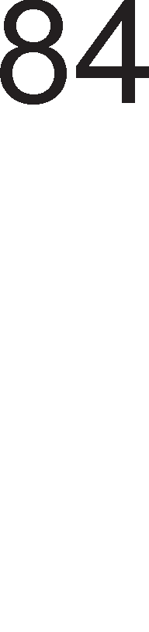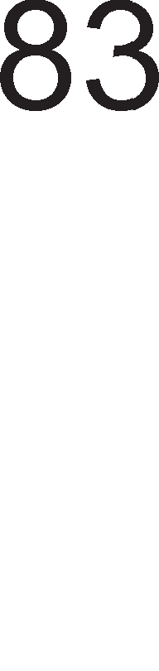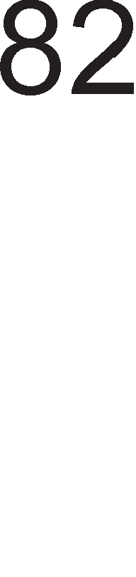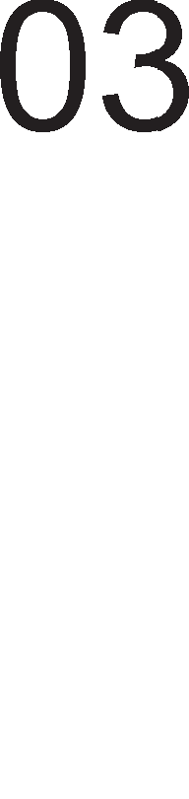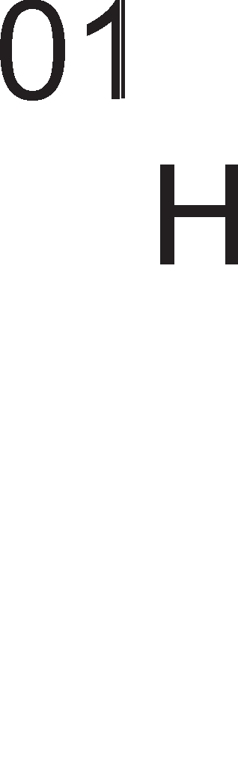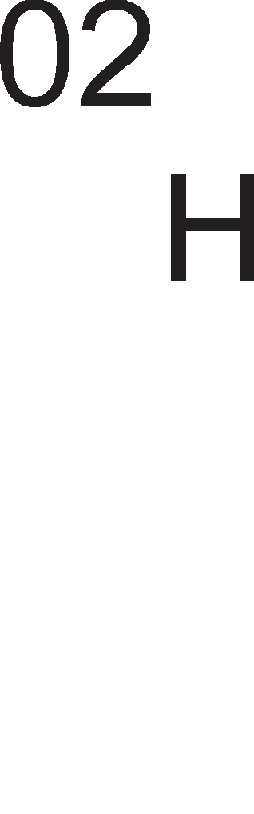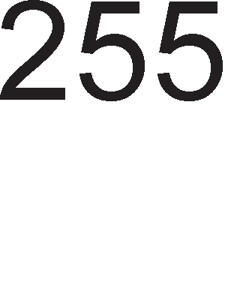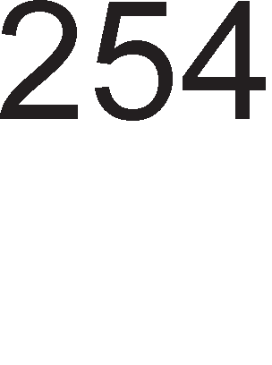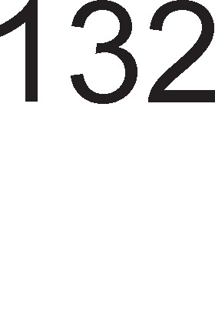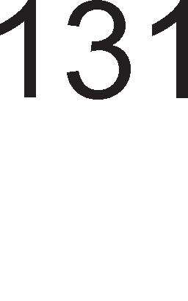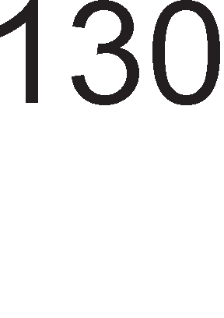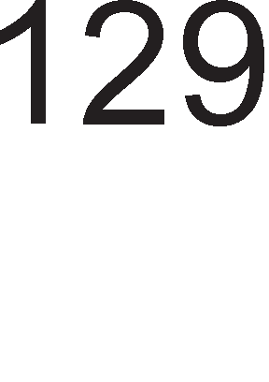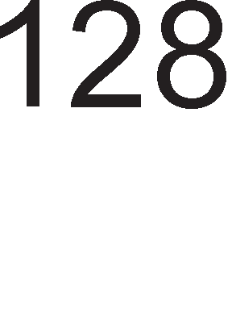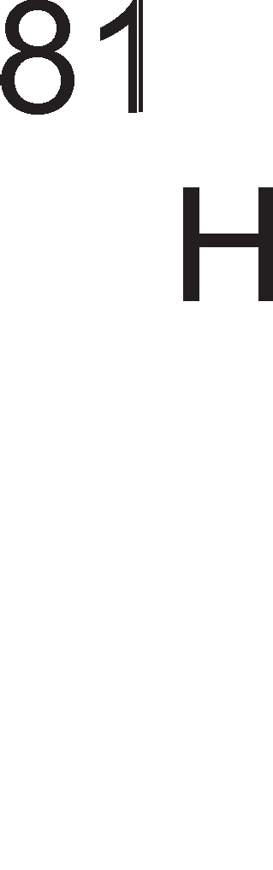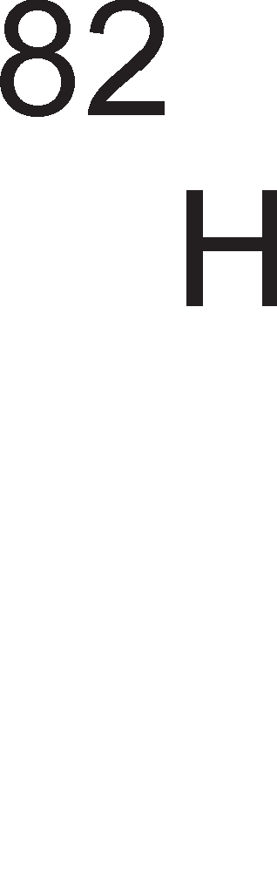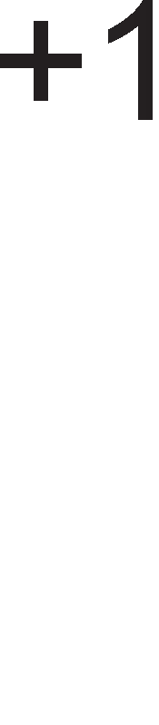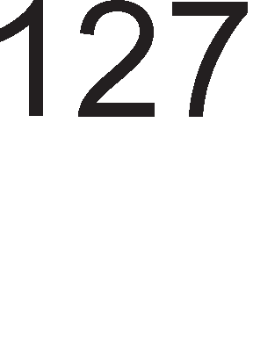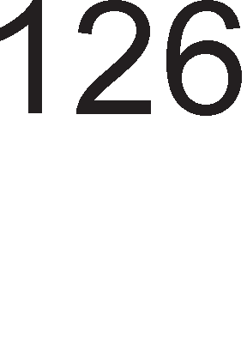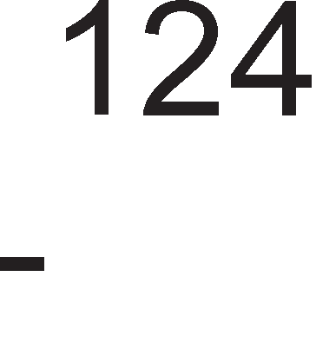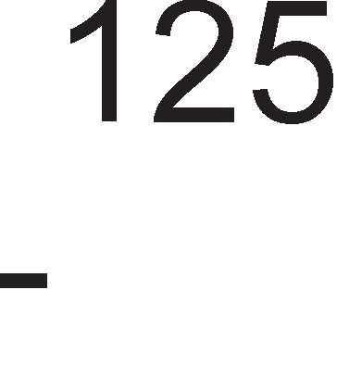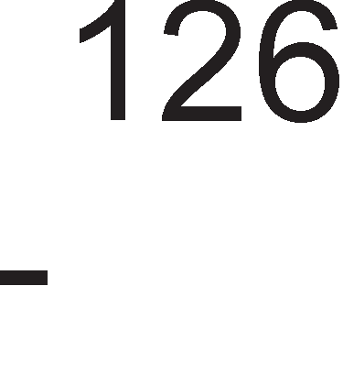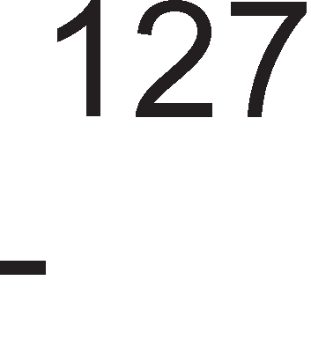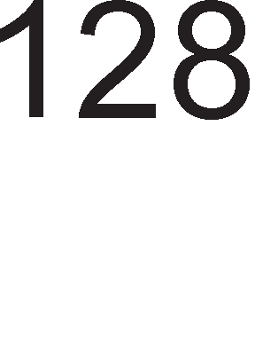



Cn1Ka 3.2. npeTcTaByBal-be Ha 6poeB1 co 1 6e3 npep3HaK Bo XeKcapeL1ManeH 6poeH c1cTeM

nopaToL1Te Ko1 fl1 o6pa6oTyBa M1KponpoLecopoT Mo>Ke pa ce nopenaT 1 cnopep H1BHaTa **ro11eMMHa**. 8-61TH1Te nopaToL1 ce B1KaaT 6ajT1. 16-61TH1Te 6poeB1 ce no3HaT1 nop 1MeTo 36opoB1. Co epeH 36op Mo>KaT pa ce npecTaBaT 6poeB1Te op Hyna po +65535 6e3 npep3HaK 1 6poeB1Te op -32768 po +32767 co npep3HaK. 32-61TH1Te nopaToL1 ce no3HaT1 nop 1MeTo pBojH1 36opoB1 1 3a H1BHo MeMop1pal-be i<e 61paT noTpe6H1 L1eT1p1 MeMop1cK1 noKaL11.

**BCD** KopoT e MHofly L1ecTo Kop1cTeH 61HapeH Kop. Kaj oBoj Kop KopH1Te 36opoB1 He ce po61BaaT npeKy penel-be co pBa 1 3an1wyBal-be Ha ocTaToKoT. Kaj BCD KopoT ceKoja L1cppa op peKapH1oT 6poj ce 3an1wyBa co 4 61HapH1 L1cpp1. Co 4 61Ta Mo>KeMe pa HanpaB1Me 24=16 KoM61HaL11, Ho op H1B Kop1cT1Me caMo

10 KoM61HaL11 Bo npeTcTaByBal-be Ha peKapH1Te 6poeB1 op 0 po 9. WecT

KoM61HaL11 ocTaHyBaaT He1cKop1cTeH1. OBaa nocTanKa peL11c1 e 1peHT1L1Ha co nocTanKaTa 3a npeM1H op XeKcapeL1ManeH Bo 61HapeH 6poeH c1cTeM, co Toa wTo TaMy ce Kop1cTaT c1Te 16 KoM61HaL11. Bo np1Mep 3.2 e npeTcTaBeH peKapH1oT 6poj 1944 Bo BCD Kop 1 61HapeH 6poeH c1cTeM, Kop1cTeji<1 16 61Ta 1 Bo pBaTa cnyL1aja.

##### npMMep 3.2:

AeKapeH 6poeH c1cTeM: 1944

61HapeH 6poeH c1cTeM: 00000111100110000 BCD Kop: 0001 1001 0100 0100

Co 16 61Ta Bo BCD Kop Mo>Ke pa ce npeTcTaBaT 6poeB1Te op 0 po 9999, a Bo 61HapeH 6poeH c1cTeM Mo>Ke pa ce npeTcTaBaT 6poeB1Te op 0 po 65536. OL11flnepHo e peKa 61HapH1oT 6poeH c1cTeM e noecpeKT1BeH op BCD KopoT, Ho eneKTp1L1H1Te Kona 3a npeTBopal-be op peKapeH 6poeH c1cTeM Bo BCD Kop ce MHofly noepHocTaBH1 1 no6p31 op KonaTa 3a npeTBopal-be Bo 61HapeH.

PeanH1Te 6poeB1 ce no3HaT1 nop 1MeTo **6poeeM co no,qeM>KHa 3anMpKa**. C1Te MopepH1 M1KponpoLecop1 Kop1cTaT cneL1janeH HyMep1L1K1 KonpoLecop 1 cneL1janH1 1HcTpyKL11 3a o6pa6oTKa Ha 6poeB1Te co nopB1>KHa 3an1pKa. Ha cn1Ka 3.3. np1Ka>KaH1 ce Tp1Te cpopMaT1 Ha 6poeB1Te co nopB1>KHa 3an1pKa Bo 61HapeH 6poeH c1cTeM. T1e ce cocTaBeH1 op Tp1 pena: 61T 3a 3HaK-S (sign), eKcnoHeHT 1 MaHT1ca.

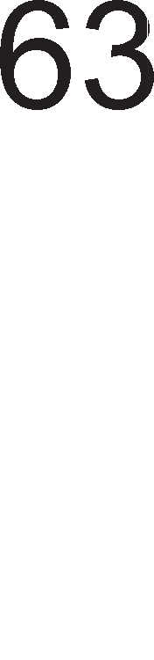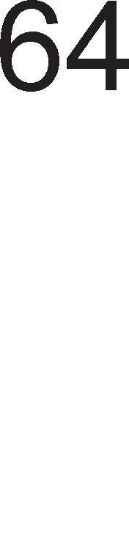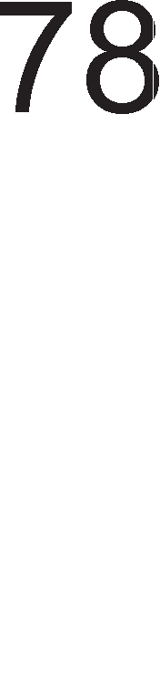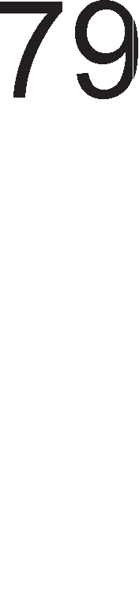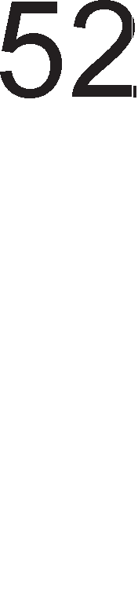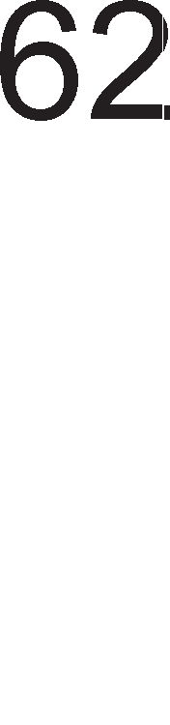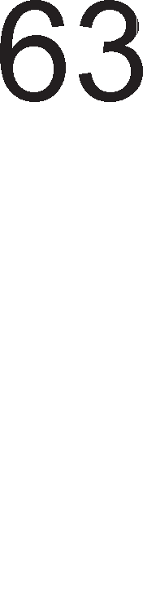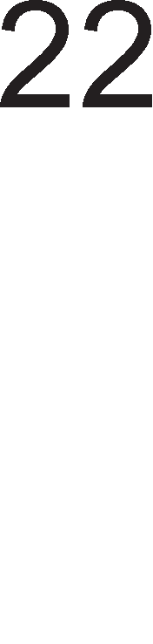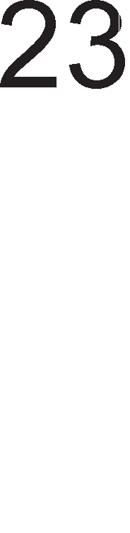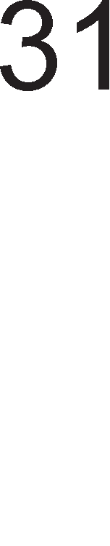

Cn1Ka 3.3. <lopMaT1 Ha 6poeB1 co nopB1>KHa 3an1pKa

AKo 6pojoT e HeflaT1BeH Toflaw 61ToT 3a 3HaK e epeH, a aKo e no31T1BeH Toflaw 61ToT 3a 3HaK e Hyna. nocTanKaTa 3a po61Bal-be Ha eKcnoHeHToT 1 MaHT1caTa e cnepHa:

1. npeTBapal-be Ha 6pojoT Bo 61HapeH 6poeH c1cTeM
2. HopMan13aL1ja Ha 61HapH1oT 6poj. 3an1pKaTa ce noMecTyBa Bo neBo cè popeKa npep 3an1pKaTa He ocTaHe caMo Haj3HaL1ajH1oT 61T op 61HapH1oT 6poj. CTeneHoT e epHaKoB Ha 6pojoT Ha noMecTyBal-ba Ha 3an1pKaTa Bo neBo. 61ToB1Te nocne 3an1pKaTa ja npeTcTaByBaaT MaHT1caTa. Ha MaHT1caTa Mo>Ke pa ce popaBaaT Hyn1 op pecHaTa cTpaHa 3a pa 61pe 3apoBoneH coopBeTH1oT cpopMaT.
3. EKcnoHeHToT ce po61Ba co popaBal-be Ha cTeneHoT Bo 61HapeH o6n1K Ha ocHoBaTa Ha cpopMaToT. 3a npB1oT KpaToK cpopMaT ocHoBa e 6pojoT 7FH, 3a BTop1oT cpopMaT 7FFH 1 3a TpeT1oT cpopMaT 7FFFH. Aa HanoMeHeMe peKa KonKy e nofloneM cpopMaToT TonKy noBei<e ce 3floneMyBa npeL13HocTa co Koja ce np1Ka>KyBa peanH1oT 6poj.

**npMMep 3.3**: PeanH1oT 6poj 100,25 i<e flo npecTaB1Me KaKo 6poj co nopB1>KHa 3an1pKa.

1. 100,25=1100100,01

2. 1100100,01=1,10010001×26

3. 110+01111111=10000101

PeweH1e: 61T 3a 3HaK=0, eKcnoHeHT=10000101, MaHT1ca=10010001000000000000000

3a B13yenHo npeTcTaByBal-be Ha 6poeB1Te op peKapH1oT 6poeH c1cTeM ce Kop1cT1 **ce,qyMcerMeHTeH Ko,q**. CeKoe none op cepyMceflMeHTH1oT p1cnnej e cocTaBeH op 7 ceflMeHT1, KaKo wTo e np1Ka>KaHo Ha cn1Ka 3.4.a.

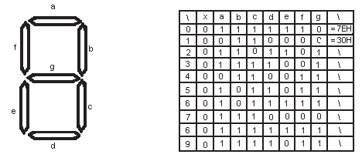

* 1. 6)

Cn1Ka 3.4. CepyMceflMeHTeH p1cnnej 1 KopoB1Te 3a L1cpp1Te op peKapH1oT 6poeH c1cTeM

CeKoj ceflMeHT e cocTaBeH op noBei<e nep p1op1 1 H1BH1oT 6poj e npoMeHn1B. CeflMeHToT i<e cBeTHe aKo po c1Te HefloB1 nep p1op1 1cnpaT1Me 1HcpopMaL1ja op nofl1L1Ka ep1H1La. no31L11Te Ha cepyMTe ceflMeHT1 ce 6ene>KaT co 6yKB1Te a, b, c, d, e, f, g. Ha cn1KaTa 3.4.6. ce papeH1 cepyMceflMeHTH1Te KopoB1 3a peceTTe L1cpp1 op peKapH1oT 6poeH c1cTeM op 0 po 9.

**npMMep 3.4**: Ko1 ceflMeHT1 Tpe6a pa cBeTHaT 3a pa ce np1Ka>KaT 6poeB1Te 2 1 7? PeweH1e: 3a pa ce np1Ka>Ke 6pojoT 2 noTpe6Ho e pa cBeTaT ceflMeHT1Te a, b, g, e 1 d , a 3a 6pojoT 7 ceflMeHT1Te a, b 1 c.

# r11o6a11Ha apxMTeKTypa Ha MMKponpo4ecop

M1KponpoLecopoT e cocTaBeH op p1fl1TanH1 Kona: nofl1L1K1 Kona, peKopep1, pefl1cTp1, Kona 3a op3eMal-be 1 co61pal-be, MeMop11 1TH. OB1e p1fl1TanH1 Kona ja cpopM1paaT apX1TeKTypaTa Ha M1KponpoLecopoT. Op apX1TeKTypaTa 3aB1c1 cpyHKL1oHanHocTa, cnoco6HocTa Ha M1KponpoLecopoT pa 13BpwyBa pa3n1L1H1 B1poB1 1HcTpyKL11. M1KponpoLecop1Te op pa3n1L1H1 npo13Bop1Ten1 1 fleHepaL11 1MaaT pa3n1L1Ha apX1TeKTypa, Ho 80% op XappBepcK1Te KoMnoHeHT1 ce cpei<aBaaT peL11c1 Kaj c1Te B1poB1 M1KponpoLecop1. M1KponpoLecopcKaTa opflaH13aL1ja He 3HaL11 caMo 1MeHyBal-be Ha cocTaBH1Te penoB1 TyKy 1 no3HaBal-be Ha H1BHaTa cpyHKL1ja 1 H1BHo noBp3yBal-be Bo cpyHKL1oHanHa Len1Ha. npep pa ce 3ano3HaeMe co flno6anHaTa apX1TeKTypa Ha epeH onwT M1KponpoLecop pa flo o6jacH1Me **M3epwyea1-eTo Ha MHcTpyK4MMTe** npeKy H1BHo pa3no>KyBal-be Ha noBei<e cpa31. l/lHcTpyKL1jaTa i<e ja pa3no>K1Me Ha neT cpa31:

* npeHoc Ha onepaL1cK1 Kop op MeMop1ja Bo 1HcTpyKL1cK1oT pefl1cTap op M1KponpoLecopoT.
* AeKop1pal-be Ha onepaL1cK1oT Kop Bo ynpaByBaL1KaTa ep1H1La.
* npeHoc Ha nopaToL1 op MeMop1jaTa Bo HeKoj op onwT1Te pefl1cTp1 Ha M1KponpoLecopoT.
* EcpeKT1BHo 13BpwyBal-be Ha 1HcTpyKL1jaTa Bo ap1TMeT1L1Ko nofl1L1KaTa ep1H1La.
* 3an1wyBal-be Ha po61eH1oT pe3ynTaT Bo HeKoj onwT pefl1cTap op M1KponpoLecopoT 1n1 MeMop1cKa noKaL1ja.

CeKoja op neTTe cpa31 aKT1B1pa oppepeH pen op XappBepoT Ha M1KponpoLecopoT, opHocHo e 13BpweHa XappBepcKa nopen6a Ha cpyHKL11Te. Pa3no>KyBal-beTo Ha 1HcTpyKL111Te Mo>Ke pa npopon>K1, np1 wTo e Hajpo6po pa HeMa XappBepcKo Mewal-be Ha 1cT1Te. Ha BaKoB HaL11H ce nopo6pyBa 6p31HaTa Ha pa6oTa, cn1L1Ho KaKo Kaj npo13BopH1Te neHT1 Bo cpa6p1K1Te.

Ho, oTKaKo flo pa3no>K1BMe 13BpwyBal-beTo Ha 1HcTpyKL11Te Ha noBei<e cpa31 noL1HyBaaT pa ce nocTaByBaaT MHofly npawal-ba. KaKo M1KponpoLecopoT ja npoHaora cnepHaTa 1HcTpyKL1ja 3a 13BpwyBal-be? KaKo npeno3HaBa 3a Koja 1HcTpyKL1ja cTaHyBa 36op? KaKo ja 13BpwyBa 1HcTpyKL1jaTa Bo ap1TMeT1L1Ko nofl1L1KaTa ep1H1La? KaKo 3Hae Kape pa fl1 cMecT1 nopaToL1Te 3a o6pa6oTKa 1 po61eH1Te pe3ynTaT1? OpfloBop Ha oB1e 1 ppyfl1 npawal-be i<e po61eMe nocne aHan13aTa Ha apX1TeKTypaTa Ha M1KponpoLecopoT. Ha cn1Ka 2.3. e np1Ka>KaHa ocHoBHaTa 6noK weMa Ha onwT1oT M1KponpoLecop. Aa ce noTceT1Me peKa cocTaBH1 penoB1 Ha ceKoj M1KponpoLecop ce: pefl1cTp1Te, ap1TMeT1L1Ko nofl1L1KaTa ep1H1La 1 ynpaByBaL1KaTa ep1H1La.

3apap1 nofloneMa epHocTaBHocT noce6Ho i<e ja pa3flnepaMe apX1TeKTypaTa Ha ceKoj cocTaBeH pen 1 i<e ja o6jacH1Me H1BHaTa noBp3aHocT.

## 3.3.1.PerMcTpM

Pefl1cTp1Te ce 6p31 MeMop1cK1 noKaL11 Bo BHaTpewHocTa Ha M1KponpoLecopoT 1 cny>KaT 3a L1yBal-be Ha nopaToL1, 1HcTpyKL11 1 1HcpopMaL11 3a cocToj6aTa Ha M1KponpoLecopoT. **0cHoeHa no,qe116a** Ha pefl1cTp1Te e Ha onwT1 pefl1cTp1 1 pefl1cTp1 co cneL1janHa HaMeHa. Ha cn1Ka 3.5. np1Ka>KaH1 ce no3HaL1ajH1Te pefl1cTp1 1 noBp3yBal-beTo co BHaTpewHaTa Mafl1cTpana Ha M1KponpoLecopoT, HapBopewHaTa nopaToL1HaTa 1 appecHa Mafl1cTpana.



Cn1Ka 3.5. Pefl1cTp1 Bo onwT Mopen Ha M1KponpoLecop

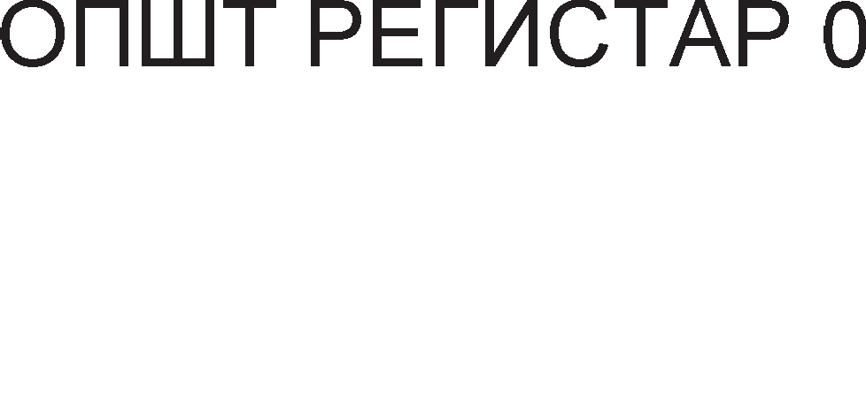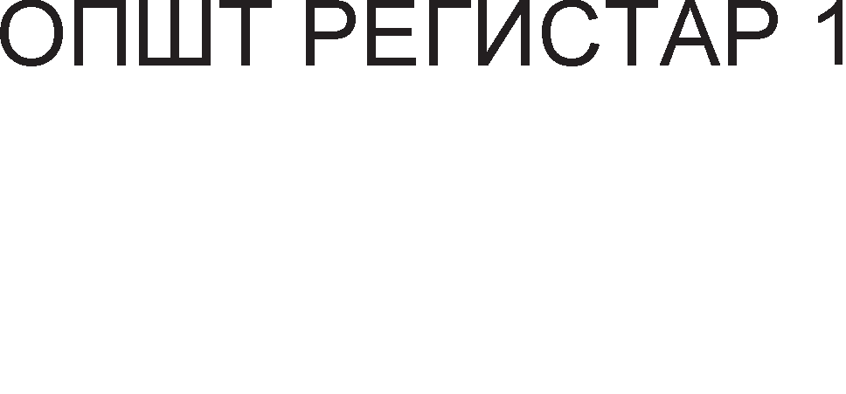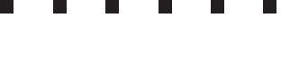

Pefl1cTp1Te co cneL1janHa HaMeHa Mo>KaT pa 61paT Kop1cH1L1K1 (np1cTan 1Ma npoflpaMepoT) 1n1 c1cTeMcK1. Apyfla **no,qe116a Ha perMcTpMTe co cne4Mja11Ha HaMeHa** e cnopep cpyHKL1jaTa. TyKa 61 1cTaKHane Tp1 flpyn1: pefl1cTp1 3a L11Tal-be

1 n1wyBal-be nopaToL1 Bo MeMop1ja (MAR, MDR), pefl1cTp1 3a npeHoc Ha 1HcTpyKL1ja (PC,IR) 1 pefl1cTp1 3a pa6oTa co cTeK MeMop1ja (SP, TOS, LV). 3a ceKoj pefl1cTap nocTojaT KoHTponH1 c1flHan1 Ko1 oBo3Mo>KyBaaT noBp3yBal-be co BHaTpewHaTa Mafl1cTpana 1n1 HapBopewHaTa appecHa 1 nopaToL1Ha Mafl1cTpana. KoHTponH1Te c1flHan1 3a noBp3yBal-be co Mafl1cTpan1Te 1MaaT npecp1Kc in 1n1 out Bo 3aB1cHocT op Toa pan1 caKaMe pa 3an1weMe 1n1 npoL11TaMe nopaToK op pefl1cTapoT, a poKonKy po oB1e npecp1Kc1 cTo1 1 6yKBaTa b Toa 3HaL11 peKa ce pa6oT1 3a HapBopewHa c1cTeMcKa Mafl1cTpana (aHfln1cK1 bus=Mafl1cTpana).

Ha cn1Ka 3.6. e np1Ka>KaHo noBp3yBal-beTo Ha pefl1cTapoT MDR co Mafl1cTpan1Te 1 HefloB1Te KoHTponH1 c1flHan1. rnepaMe peKa e 13BpweHo

6acpep1pal-be Ha nopaToL1H1Te n1H11 np1 wTo ce ynoTpe6eH1 6acpep1 co Tp1 cocToj61.

Cn1Ka 3.6. KoHTponH1 c1flHan1 3a MeMop1cK1oT nopaToL1eH pefl1cTap

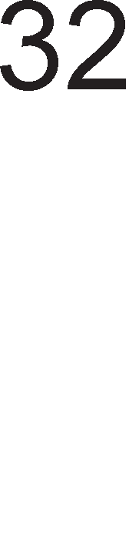

Cefla i<e ja o6jacH1Me cpyHKL1jaTa Ha noBa>KH1Te pefl1cTp1 co cneL1janHa HaMeHa.

* He nocTo1 M1KponpoLecop Koj Bo cBojoT cocTaB He copp>K1 pefl1cTap **nporpaMcKM 6poja"1** (PC=Program Counter). Toj ja copp>K1 appecaTa Ha cnepHaTa 1HcTpyKL1ja. npeTnocTaByBaMe peKa 1HcTpyKL1jaTa e floneMa 32 61Ta. 3a pa ja po61eMe appecaTa Ha cnepHaTa 1HcTpyKL1ja Tpe6a pa popapeMe L1eT1p1 Ha appecaTa Ha 1HcTpyKL1jaTa Koja MoMeHTanHo ce 13BpwyBa. OBa e TaKa 61peji<1 epHa MeMop1cKa noKaL1ja naMT1 1HcpopMaL1ja op epeH 6ajT, na 3a MeMop1pal-be Ha 32-61THa 1HcTpyKL1ja i<e 61paT noTpe6H1 L1eT1p1 MeMop1cK1 noKaL11. npoflpaMcK1oT 6pojaL1 1Ma Tp1 KoHTponH1 c1flHan1: PCbout, PCout 1 PCin. Kofla M1KponpoLecopoT ja 6apa cnepHaTa 1HcTpyKL1ja copp>K1HaTa Ha npoflpaMcK1oT 6pojaL1 ce Hoc1 Ha appecHaTa Mafl1cTpana npeKy aKT1B1pal-be Ha c1flHanoT PCbout. Copp>K1HaTa Ha npoflpaMcK1oT 6pojaL1 Mo>Ke pa ja MeHyBa caMo ynpaByBaL1KaTa ep1H1La np1 wTo HoBaTa copp>K1Ha ce npeHecyBa npeKy BHaTpewHaTa Mafl1cTpana 1 3a pa Taa ce Bn1we Tpe6a pa ce aKT1B1pa c1flHanoT PCin. Aa HanoMeHeMe peKa copp>K1HaTa Ha npoflpaMcK1oT 6pojaL1 Mo>Ke pa ce npeHece 1cToBpeMeHo po HapBopewHaTa appecHa Mafl1cTpana 1 BHaTpewHaTa Mafl1cTpana npeKy aKT1B1pal-be Ha c1flHan1Te PCbout 1 PCout .
* Copp>KHaTa Ha pefl1cTapoT PC ce npeHecyBa po c1cTeMcKaTa appecHa Mafl1cTpana, ce L1eKa MeMop1jaTa pa ja cMecT1 1HcTpyKL1ja Ha nopaToL1HaTa Mafl1cTpana 1 noToa 1HcTpyKL1jaTa ce 3an1wyBa Bo **MHcTpyK4McKMoT perMcTap** IR (Instruction Register). nopap1 epHocTaBHoTo noBp3yBal-be co Mafl1cTpan1Te ce Kop1cTaT pBa KoHTponH1 c1flHan1 IRbin 1 IRout np1 wTo epH1oT ce Kop1cT1 Kofla Tpe6a pa ce 3an1we 1HcTpyKL1jaTa op MeMop1jaTa Bo pefl1cTapoT, a ppyfl1oT Kofla Tpe6a pa ce npeHece 1HcTpyKL1jaTa po ynpaByBaL1KaTa ep1H1La.
* MAR (Memory Address Registar) 1n1 **MeMopMcKMoT a,qpeceH perMcTap** ja L1yBa appecaTa Ha nopaToKoT Koj Tpe6a pa ce o6pa6oT1 Bo M1KponpoLecopoT. HeKo1 1HcTpyKL11 Bo ce6e copp>KaT appeca Ha

MeMop1cKa noKaL1ja op Koja Tpe6a pa ce 3eMe nopaToKoT 3a o6pa6oTKa. OBaa appeca ce BHecyBa Bo MeMop1cK1oT appeceH pefl1cTap npeKy aKT1B1pal-be Ha KoHTponH1oT c1flHan MARin, a Kofla appecaTa Tpe6a pa ce npeHece po MeMop1jaTa 1cTaTa ce 1cnpai<a no appecHaTa Mafl1cTpana npeKy aKT1B1pal-be Ha KoHTponH1oT c1flHan MARbout. Copp>K1HaTa Ha MeMop1cK1oT appeceH pefl1cTap Mo>Ke pa ce npeHece Ha BHaTpewHaTa Mafl1cTpana npeKy aKT1B1pal-be Ha c1flHanoT MARout.

* MDR (Memory Data Register) 1n1 **MeMopMcKMoT no,qaTo"1eH perMcTap** flo L1yBa nopaToKoT Koj Tpe6a pa ce npoL11Ta 1n1 3an1we Bo MeMop1jaTa. noBp3yBal-beTo Ha oBoj pefl1cTap co Mafl1cTpan1Te e pBoHacoL1Ho, na nopap1 Toa i<e H1 Tpe6aaT L1eT1p1 KoHTponH1 c1flHan1: MDRbin, MDRbout, MDRin, MDRout. OBa e np1Ka>KaHo Ha cn1Ka 3.6.
* Co pefl1cTp1Te 3a pa6oTa co cTeK MeMop1ja i<e ce 3ano3HaeMe nopoLHa Kofla peTanHo i<e 61pe o6jacHeTa cTeK MeMop1jaTa 1 nocTanK1Te 3a L11Tal-be 1 n1wyBal-be Bo Hea.

**PerMcTpMTe co onwTa HaMeHa** ce noBp3aH1 caMo co BHaTpewHaTa Mafl1cTpana. MopenoT Ha M1KponpoLecopHa cn1Ka 3.5. copp>K1 32 pefl1cTp1 co onwTa HaMeHa Ko1 ce o6ene>KaH1 co 6yKB1Te op Go po G31 Kape wTo 6yKBaTa G e npBa 6yKBa op aHfln1cK1oT 36op general wTo Bo npeBop 3HaL11 onwT. 3a ceKoj onwT pefl1cTap nocTojaT no pBa KoHTponH1 c1flHan1 Ko1 ce 6ene>KaT co Gxin 1 Gxout. OBe KoHTponH1 c1flHan1 cny>KaT 3a ocnoco6yBal-be Ha Bne3oB1Te opHocHo 13ne31Te Ha onwT1Te pefl1cTp1. npeKy aKT1B1pal-be Ha oB1e KoHTponH1 c1flHan1 M1KponpoLecopoT 61pa op Koj pefl1cTap i<e L11Ta nopaToK 1 Bo Koj pefl1cTap i<e 3an1wyBa nopaToK. YnoTpe6aTa Ha oB1e KoHTponH1 c1flHan1 i<e ja 1nycTp1paMe npeKy 1HcTpyKL1jaTa 3a co61pal-be

add Rd,Rs1,Rs2

Co oBaa 1HcTpyKL1ja ce co61paaT copp>K1H1Te Ha onwT1Te pefl1cTp1 Rs1 1 Rs2 1 361poT ce 3an1wyBa Bo pefl1cTapoT Rd. 6yKBaTa s poara op aHfln1cK1oT 36op source wTo Bo npeBop 3HaL11 13Bop, a 6yKBaTa d poara op aHfln1cK1oT 36op destination wTo Bo npeBop 3HaL11 Len, pecT1HaL1ja. Ha np1Mep, caKaMe pa fl1 co6epeMe copp>K1H1Te Ha pefl1cTp1Te co pepeH 6poj 5 1 7 1 361poT pa flo cMecT1Me Bo pefl1cTapoT 6poj 9. OBa 3HaL11 peKa Tpe6a pa ce 13Bpw1 cnepHaTa 1HcTpyKL1ja

add G9, G5, G7

61peji<1 1MaMe caMo epeHa BHaTpewHa Mafl1cTpana, copp>K1HaTa Ha epeH 13BopeH pefl1cTap Tpe6a pa ce npecppn1 Bo np1BpeMeH1oT pefl1cTap A. noToa copp>K1HaTa Ha ppyfl1oT pefl1cTap ja npeHecyBaMe Ha BHaTpewHaTa Mafl1cTpana A 1 1cT1Te fl1 co61paMe. **AKTMeMpa1-eTo Ha KoHTpo11HMTe 11MHMM** Mo>KeMe pa flo nopen1Me Bo Tp1 cpa31:

1. ro aKT1B1paMe c1flHanoT G5out 3a pa ja npeHeceMe copp>K1HaTa Ha pefl1cTapoT G5 Ha BHaTpewHaTa Mafl1cTpanaTa. l/lcToBpeMeHo flo aKT1B1paMe c1flHanoT Ain 3a pa copp>K1HaTa op BHaTpewHaTa Mafl1cTpanaTa ja npeHeceMe Bo pefl1cTapoT A.
2. Cefla copp>K1HaTa Ha pefl1cTapoT G7 Tpe6a pa ce npeHece po BHaTpewHaTa Mafl1cTpanaTa npeKy aKT1B1pal-be Ha c1flHanoT G7out. CnepeH L1eKop i<e 61pe aKT1B1pal-be Ha KoHTponH1Te c1flHan1 3a ap1TMeT1L1Ko nofl1L1KaTa ep1H1La. CocToj6aTa Ha oB1e KoHTponH1 c1flHan1 Tpe6a pa opfloBapa Ha neTaTa pep1La op Ta6enaTa 3.4. npeKy aKT1B1pal-be Ha c1flHanoT Cin 361poT BneflyBa Bo pefl1cTapoT C.
3. nocnepeH L1eKop e 3an1wyBal-be Ha BpepHocTa Ha pefl1cTapoT C Bo pefl1cTapoT G9. OBoj npeHoc e oBo3Mo>KeH npeKy 1cToBpeMeHo aKT1B1pal-be Ha c1flHan1Te Cout 1 G9in.

Bo Ta6enaTa 3.3. e np1Ka>KaH pepocnepoT Ha aKT1B1pal-be Ha KoHTponH1Te c1flHan1 3a ceKoj L1eKop.

|  |  |
| --- | --- |
| L1eKop1 | KoHTponH1 c1flHan1 |
| 1 | G5out; Ain |
| 2 | G7out; ALU:Fo, F1, ENA, ENB; Cin |
| 3 | Cout; G9in |

Ta6ena 3.3. KoHTponH1 c1flHan1 3a onepaL1jaTa co61pal-be Ha copp>K1HaTa Ha pBa onwT1 pefl1cTp1

## ApMTMeTM"1Ko 11orM"1Ka e,qMHM4a

M1KponpoLecopoT e ,,Mo3oKoT” Ha KoMnjyTepoT, a **apMTMeTM"1Ko 11orM"1KaTa e,qMHM4a e ,,Mo3oKoT” Ha MMKponpo4ecopoT.** npeKy oBaa ep1H1La ce 13BpwyBaaT c1Te 1HcTpyKL11 op 1HcTpyKL1cKoTo MHo>KecTBo. nocno>KeH1Te onepaL11 He ce 13BepyBaaT p1peKTHo TyKy co KoM61H1pal-be Ha noBei<e epHocTaBH1.

HaL11HoT Ha noBp3yBal-be Ha ap1TMeT1L1Ko nofl1L1KaTa ep1H1La co pefl1cTp1Te Ha M1KponpoLecopoT e np1Ka>KaHa Ha cn1Ka 3.5. Op cn1KaTa flnepaMe peKa ap1TMeT1L1Ko nofl1L1KaTa ep1H1La He e noBp3aHa co HapBopewH1Te Mafl1cTpan1 Ha M1KponpoLecopoT TyKy caMo co BHaTpewHaTa Mafl1cTpana, npeKy Koja np1Ma nopaToL1 op pefl1cTp1Te. l/lcTo TaKa, Ha cn1KaTa ce np1Ka>KaH1 pBaTa np1BpeMeH1, pa6oTH1 pefl1cTp1 Ha ap1TMeT1L1Ko nofl1L1KaTa ep1H1La, A 1 C. Pefl1cTapoT A ce Haora Hap ep1H1LaTa 1 cny>K1 3a np1BpeMeHo L1yBal-be Ha nopaToKoT npep Toj pa Bne3e Bo ep1H1LaTa 1 ce o6pa6oT1. Pefl1cTapoT C cny>K1 3a np1BpeMeHo L1yBal-be Ha po61eH1oT pe3ynTaT npep 1cT1oT pa 61pe cMecTeH Bo HeKoj op onwT1Te 1n1 cneL1janH1Te pefl1cTp1 Ha M1KponpoLecopoT.

Ap1TMeT1L1Ko nofl1L1KaTa ep1H1La e noBp3aHa p1peKHo co epeH cneL1janeH pefl1cTap TaKaHapeL1eH **cTaTyc perMcTap**. 61ToB1Te op oBoj pefl1cTap ce HapeKyBaaT **3HaMeH4a** (aHfln1cK1 flag). 3HaMeHLaTa ce 1Hp1KaTop1 Ha cocToj6a opHocHo 1cT1Te paBaaT 1HcpopMaL1ja 3a cocToj6aTa Ha 61ToB1Te Bo nocnepHo po61eH1oT pe3ynTaT. 3a pa ce ,,KpeHe” opHocHo aKT1B1pa HeKoe 3HaMeHLe noTpe6Ho e pa 61pe 1cnonHeT oppepeH ycnoB. Co ceKoja cnepHa fleHepaL1ja Ha

M1KponpoLecop1 6pojoT Ha 3HaMeHLa ce 3floneMyBa, Ho KaKo HajBa>KH1 Ko1 ce cpei<aBaaT peL11c1 Kaj c1Te M1KponpoLecop1 i<e fl1 cnoMeHeMe:

* + 3HaMeHLeTo Hyna Z (aHfln1cK1-zero) ce aKT1B1pa Kofla i<e ce po61e pe3ynTaT epHaKoB Ha Hyna.
  + 3HaMeHLeTo S (aHfln1cK1-sign) ce aKT1B1pa Kofla i<e po61eMe HeflaT1BeH pe3ynTaT
  + 3HaMeHLeTo C (aHfln1cK1-carry) ce aKT1B1pa Kofla 1MaMe npeHoc Ha HajB1coKaTa no31L1ja Bo 61HapH1oT 6poj. Ha np1Mep aKo co61paMe ocyM61TH1 6poeB1 oBa 3HaMeHLe i<e ce aKT1B1pa aKo 1MaMe npeHoc op ocMaTa Ha peBeTaTa no31L1ja. Kaj ocyM61TH1Te nopaToL1 peBeTa no31L1ja He nocTo1 , na 61ToT 3a npeHoc i<e ce 3an1we Bo 3HaMeHLeTo C.
  + 3HaMeHLeTo O (aHfln1cK1-overflow) ce aKT1B1pa np1 npeL1eKopyBal-be opHocHo Kofla i<e ce po61e 6poj nofloneM 1n1 noMan op npepB1peHoTo. OBaa 3HaMeHLe ce Kop1cT1 caMo np1 pa6oTa co 6poeB1 co npep3HaK. AKo ja noflnepHeMe cn1Ka 3.2. i<e 3aKnyL11Me peKa oBa 3HaMeHLe ce aKT1B1pa aKo po61eMe pe3ynTaT nofloneM op

+127 1n1 noMan op -128. Kaj 6poeB1Te 6e3 npep3HaK 1Hp1KaTop 3a HacTaHaTo npeL1eKopyBal-be e 3HaMeHLeTo 3a npeHoc C.

Co cTpyKTypaTa Ha ap1TMeT1L1Ko nofl1L1KaTa ep1H1La Bei<e ce 3ano3HaBMe Bo npBaTa TeMa Kofla 36opyBaBMe 3a KoM61HaL1cK1 Kona 1 1cTaTa 6ewe np1Ka>KaHa Ha cn1Ka 1.20. 6ea o6jacHeT1 cpyHKL11Te Ha c1Te nofl1L1K1 Kona, pBaTa nopaToL1H1 Bne3a A 1 B 1 KoHTponH1Te c1flHan1 3a 136op Ha onepaL1ja F0 1 F1. Ho, noKpaj oB1e pBa **KoHTpo11HM cMrHa11M** nocTojaT ywTe L1eT1p1: ENA (enable A), ENB (enable B), INVA (invert A) 1 INC (increase). C1flHan1Te ENA 1 ENB cny>KaT 3a ocnoco6yBal-be Ha nopaToL1H1Te Bne3oB1. Co c1flHanoT INVA ce 1HBepT1pa 61ToT Ha Bne3oT A. C1flHanoT INC cny>K1 3a popaBal-be Ha ep1H1La Ha 61HapH1oT 6poj. Co wecTe KoHTponH1 c1flHan1 Mo>KaT pa ce HanpaBaT 64 pa3n1L1H1 KoM61HaL11, Ho He ce Kop1cTaT c1Te. HeKo1 op no1HTepecH1Te KoM61HaL11 ce np1Ka>KaH1 Bo Ta6enaTa 3.4. Bo HaBepeH1Te cpyHKL11 ap1TMeT1L1KoTo co61pal-be e HajL1ecTo Kop1cTeHa onepaL1ja. Ha np1Mep Kaj onepaL1jaTa A+1, ENB e epHaKoB Ha Hyna 61peji<1 nopaToL1H1oT Bne3 B BoonwTo He H1 e noTpe6eH, Ho c1flHanoT INC e epHaKoB Ha epeH 61peji<1 co Heflo popaBaMe ep1H1La. AKo c1flHan1Te INVA 1 INC ce epHaKB1 Ha epeH Toflaw npecMeTyBaMe BTop KoMnneMeHT op BpepHocTa Ha A opHocHo ja npecMeTyBaMe HeflaT1BHaTa BpepHocT Ha A, -A. AKo flo ocnoco61Me nopaToL1H1oT Bne3 B Toflaw i<e ja po61eMe cpyHKL1jaTa B+(-A)=B-A, op3eMal-be Ha npB1oT nopaToL1eH Bne3 op BTop1oT. Mo>Ke61 HeKoj i<e ce 3anpawa 3owTo ce noTpe6H1 npB1Te pBe cpyHKL11 op Ta6enaTa 3.4. Kofla Ha 13ne3 op ap1TMeT1L1Ko nofl1L1KaTa ep1H1La ce po61Ba 1cToTo oHa wTo e 1 Ha Haj31H1oT Bne3. OBaa cpyHKL1ja MHofly L1ecTo ce Kop1cT1 np1 npeHocoT Ha nopaToL1 op epeH Bo ppyfl pefl1cTap 61peji<1 pefl1cTp1Te He ce p1peKHo noBp3aH1 Mery ce6e. Ha np1Mep, nopaToKoT He Mo>Ke p1peKHo pa noM1He op epeH Bo ppyfl onwT pefl1cTap, TyKy Mery H1B nocpepyBa ap1TMeT1L1Ko nofl1L1KaTa

ep1H1La. Copp>K1HaTa Ha npB1oT pefl1cTap ce Hoc1 Ha Bne3 op ap1TMeT1L1Ko nofl1L1KaTa ep1H1La, a 13ne3oT op ap1TMeT1L1Ko nofl1L1KaTa ep1H1LaTa ce Hoc1 Bo BTop1oT pefl1cTap wTo npeTcTaByBa pecT1HaL1ja. Op npB1Te pBe pep1L1 Ha Ta6enaTa flnepaMe peKa 3a pa npecn1KaMe epeH op nopaToL1H1Te Bne3oB1 Ha 13ne3 op ap1TMeT1L1Ko nofl1L1KaTa ep1H1La ce Kop1cT1 onepaL1ja nofl1L1Ko co61pal-be (l/lnl/l) np1 wTo caMo epeH op c1flHan1Te 3a ocnoco6yBal-be e aKT1BeH.

|  |  |  |  |  |  |  |
| --- | --- | --- | --- | --- | --- | --- |
| F0 | F1 | ENA | ENB | INVA | INC | cpyHKL1ja |
| 0 | 1 | 1 | 0 | 0 | 0 | A |
| 0 | 1 | 0 | 1 | 0 | 0 | B |
| 0 | 1 | 1 | 0 | 1 | 0 | HeflaL1ja A |
| 1 | 0 | 1 | 1 | 0 | 0 | HeflaL1ja B |
| 1 | 1 | 1 | 1 | 0 | 0 | A+B |
| 1 | 1 | 1 | 1 | 0 | 1 | A+6+1 |
| 1 | 1 | 1 | 0 | 0 | 1 | A+1 |
| 1 | 1 | 0 | 1 | 0 | 1 | B+1 |
| 1 | 1 | 1 | 1 | 1 | 1 | B-A |
| 1 | 1 | 0 | 1 | 1 | 0 | B-1 |
| 1 | 1 | 1 | 0 | 1 | 1 | -A |
| 0 | 0 | 1 | 1 | 0 | 0 | A VB |
| 0 | 1 | 1 | 1 | 0 | 0 | A/\B |
| 0 | 1 | 0 | 0 | 0 | 0 | 0 |
| 0 | 1 | 0 | 0 | 0 | 1 | 1 |
| 0 | 1 | 0 | 0 | 1 | 0 | -1 |

Ta6ena 3.4. Ta6ena Ha B1cT1H1TocT 3a epHo61THa ap1TMeT1L1Ko nofl1L1Ka ep1H1La

## Ynpaeyea"1Ka e,qMHM4a

HajBa>KHa cpyHKL1ja Ha ynpaByBaL1KaTa ep1H1La e 13BpwyBal-be Ha 1HcTpyKL11Te epHa no epHa ce popeKa He 3aBpw1 3anoL1HaTaTa npoflpaMa. YnpaByBaL1KaTa ep1H1La flo Bpw1 13BpwyBal-beTo Ha 1HcTpyKL1jaTa npeKy fleHep1pal-be Ha KoHTponH1 c1flHan1 3a pefl1cTp1Te, ap1TMeT1L1Ko nofl1L1KaTa ep1H1La, MeMop1jaTa 1n1 nep1cpepH1Te ypep1. Ha cn1Ka 3.7. e np1Ka>KaHa ocHoBHaTa 6noK weMa Ha ynpaByBaL1KaTa ep1H1La.

Ha Bne3 op ynpaByBaL1KaTa ep1H1La ce Hoc1 copp>K1HaTa Ha 1HcTpyKL1cK1oT pefl1cTap, cTaTyc pefl1cTapoT 1 p1fl1TcK1oT TaKT. npB1Te ocyM 61ToB1 op 1HcTpyKL1jaTa npeTcTaByBaaT onepaL1cK1 Kop 1 Toj cny>K1 3a npeno3HaBal-be Ha 1HcTpyKL1jaTa. Aa ce noTceT1Me Ha nopen6a Ha 1HcTpyKL11Te Bo L1eT1p1 flpyn1: 1HcTpyKL11 3a npeHoc, ap1TMeT1L1K1, nofl1L1K1 1HcTpyKL11 1 1HcTpyKL11 3a KoHTpona Ha TeKoT Ha npoflpaMaTa. KoHTponH1Te 1HcTpyKL11 Mo>KaT pa 61paT ycnoBH1. 3a pa T1e ce 13BpwaT noTpe6Ha e 1HcpopMaL1ja 3a cocToj6aTa

Ha 3HaMeHLaTa Bo cTaTyc pefl1cTapoT. Copp>K1HaTa Ha 1HcTpyKL1cK1oT pefl1cTap 1 cTaTyc pefl1cTapoT npeTcTaByBaaT BcywHocT Bne3oB1 Ha appecH1oT fleHepaTop, Koj fleHep1pa appec1 3a np1cTan po M1KponpoflpaMaTa.

Cn1Ka 3.7. YnpaByBaL1Ka ep1H1La Ha onwT Mopen Ha M1KponpoLecop

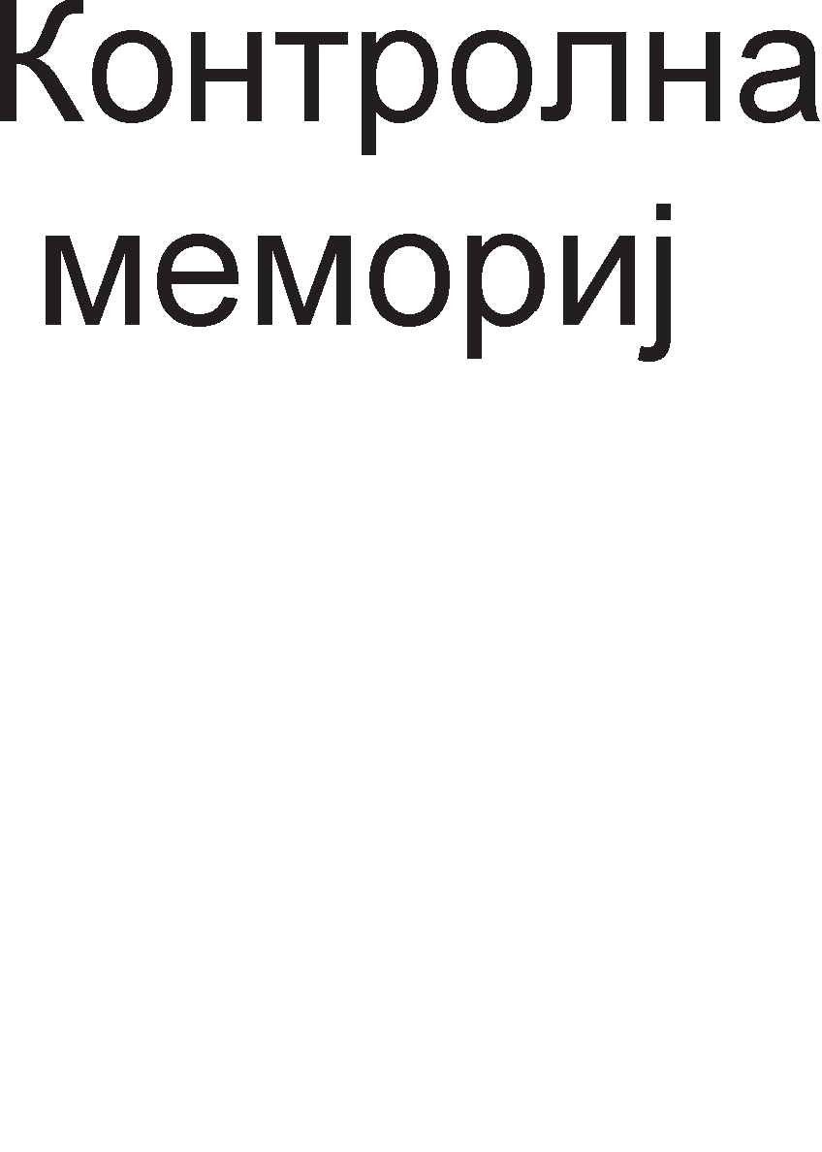

HajBa>KeH pen op ynpaByBaL1KaTa ep1H1La e **MMKponporpaMaTa.** M1KponpoflpaMaTa ce Haora Bo BHaTpewHocTa Ha M1KponpoLecopoT, Bo noce6Ha ROM MeMop1ja, HapeL1eHa KoHTponHa MeMop1ja. M1KponpoflpaMaTa e cocTaBeHa op M1KpoKopoB1. 6pojoT Ha M1KpoKopoB1 e epHaKoB Ha 6pojoT Ha 1HcTpyKL11 Bo 1HcTpyKL1cKoTo MHo>KecTBo Ha M1KponpoLecopoT. 3a ceKoja 1HcTpyKL1ja 1Ma no epeH M1KpoKop. M1KpoKopoB1Te ce cocTaBeH1 op M1Kpo1HcTpyKL11. 6pojoT Ha M1Kpo1HcTpyKL11 Bo epeH M1KpoKop e epHaKoB Ha 6pojoT Ha cpa31, L1eKop1 Ha Ko1 e nopeneHo 13BpwyBal-beTo Ha 1HcTpyKL1jaTa. 3a ceKoj L1eKop 1Ma no epHa M1Kpo1HcTpyKL1ja. BaKBaTa n1HeapHa opflaH13aL1ja Ha M1KponpoflpaMaTa e np1Ka>KaHa Ha cn1Ka 3.8.

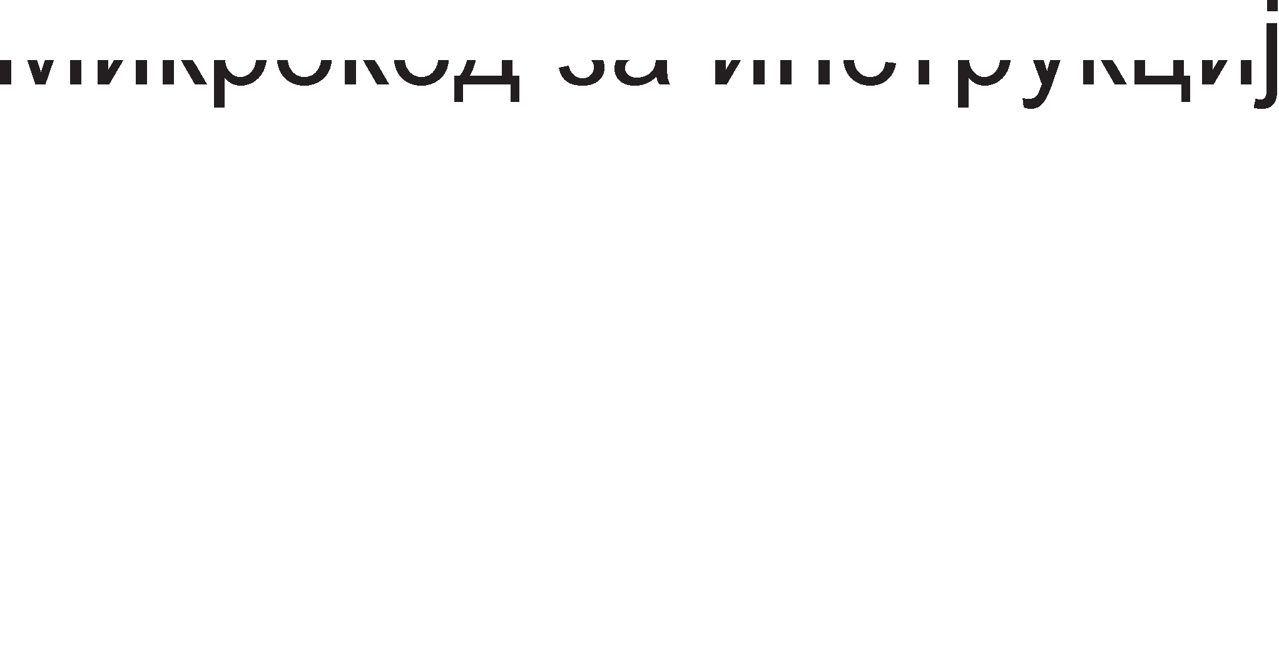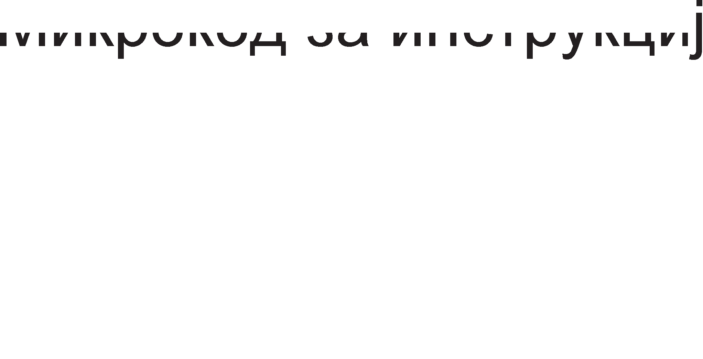





Cn1Ka 3.8. OpflaH13aL1ja Ha M1KponpoflpaMaTa M1KponpoLecopoT fleHep1pa KoHTponH1 c1flHan1. 3a ceKoj KoHTponeH

c1flHan nocTo1 noce6eH 61T Bo **MMKpoMHcTpyK4MjaTa**. KoHTponH1oT c1flHan 1 HefloB1oT 61T Bo M1Kpo1HcTpyKL1jaTa 1MaaT 1cTa BpepHocT, nofl1L1Ka Hyna 1n1 ep1H1La. AKo 1MaMe 32 onwT1 pefl1cTp1 1 aKo 3a ceKoj pefl1cTap Tpe6aaT no pBe KoHTponH1 c1flHan1 Toa 3HaL11 peKa 64 61ToB1 op M1Kpo1HcTpyKL1jaTa i<e 61paT 3a KoHTpona Ha onwT1Te c1flHan1. Bo cocTaB Ha M1Kpo1HcTpyKL1jaTa BneflyBaaT 1 61ToB1Te 3a KoHTpona Ha ap1TMeT1L1Ko nofl1L1KaTa ep1H1La 1 pefl1cTp1Te co

cneL1janHa HaMeHa. M1Kp1HcTpyKL1jaTa Mo>Ke pa 1Ma noBei<e op 90 61ToB1. Aa 1cTaKHeMe peKa c1Te M1Kpo1HcTpyKL11 ce co 1cTa floneM1Ha. KonKy e nofloneMa M1Kpo1HcTpyKL1jaTa TonKy e no6p3o 13BpwyBal-beTo Ha 1HcTpyKL11Te. Ce pa361pa nofloneMaTa M1Kpo1HcTpyKL1ja 3HaL11 nofloneM 6poj KoHTponH1 n1H11 opHocHo Tpowel-be Ha XappBep.

Bo Ta6enaTa 3.3. 6ea papeH1 KoHTponH1Te c1flHan1 3a c1Te L1eKop1 np1 13BpwyBal-beTo Ha 1HcTpyKL1jaTa add G9, G5, G7. 61peji<1 1Ma Tp1 L1eKop1 3HaL11 peKa M1KpoKopoT 3a oBaa 1HcTpyKL1ja i<e copp>K1 Tp1 M1Kpo1HcTpyKL11. Bo npBaTa M1Kpo1HcTpyKL1ja Ha B1coKo H1Bo i<e 61paT caMo 61ToB1Te G5out 1 Ain, Bo BTopaTa G7out, ALU, Fo, F1, ENA, ENB, Cin 1 Bo TpeTaTa Cout 1 G9in. C1Te ocTaHaHT1 61ToB1 Bo M1Kpo1HcTpyKL1jaTa i<e 61paT epHaKB1 Ha Hyna.

BpeMeTpael-beTo Ha epHa M1Kpo1HcTpyKL1ja 13HecyBa epeH p1fl1TcK1 TaKT. nopap1 Toa e noTpe6Ho p1fl1TcK1oT TaKT pa ce poHece Ha Bne3 op ynpaByBaL1KaTa ep1H1La. npeKy Heflo BcywHocT ce Bpw1 6poel-be Ha M1Kpo1HcTpyKL11Te op M1KponpoflpaMaTa.

# ae,qHM"1KM KapaKTepMcTMKM Ha

**MMKponpo4ecop**

XappBepcK1 M1KponpoLecopoT Mo>Ke pa 13BpwyBa MHofly epHocTaBH1 onepaL11, Ho co oflpoMHa 6p31Ha. Cno>KeH1Te 1HcTpyKL11 ce po61BaaT co KoM61H1pal-be Ha noBei<e epHocTaBH1 1HcTpyKL11. 6p31HaTa Ha M1KponpoLecopoT ce 13pa3yBa Bo MIPS (M1n1oH1 1HcTpyKL11 Bo epHa ceKyHpa). Ho, Toj e caMo epHa op KoMnoHeHT1Te wTo np1poHecyBaaT 3a BKynHaTa 6p31Ha Ha Len1oT KoMnjyTep. 3a pa M1KponpoLecopoT 6p3o fl1 13BpwyBa 1HcTpyKL11Te, T1e Tpe6a 6p3o pa My ce pocTaByBaaT, a Toa 3aB1c1 op 6p31HaTa Ha pa6oTaTa Ha Mafl1cTpan1Te 1 Ha MeMop11Te. Ke HaBepeMe HeKonKy cpaKTop1 wTo Bn1jaaT Bp3 6p31HaTa Ha pa6oTaTa Ha M1KponpoLecopoT, Ho 1Ma 1 MHofly ppyfl1 3a Ko1 i<e cTaHe 36op HaTaMy.

##### Pa6oTHa cppeKeeH4Mja

HajepHocTaBHo 61 61no Kofla 6p31HaTa Ha pa6oTaTa Ha M1KpoKoMnjyTepoT

61 ce 13pa3yBana Bo 6poj Ha 13BpweH1 onepaL11 Bo 1 ceKyHpa. MeryToa, npo6neM e wTo pa3n1L1H1 onepaL11 TpaaT pa3n1L1Ho BpeMe. 6p31HaTa Ha pa6oTaTa Ha M1KponpoLecopoT ce 13pa3yBa Bo XepL1 [Hz].

l/lMeHo, Bo caM1oT M1KponpoLecop (Ho Mo>Ke 1 HapBop op Heflo) 1Ma BflpapeHo KBapLeH Kp1cTan, Koj nocTojaHo co KoHcTaHTHa 6p31Ha fleHep1pa npaBoaflonH1 1Mnync1. OBoj Kp1cTan ce B1Ka fleHepaTop Ha TaKT 1 fl1 paBa p1fl1TcK1Te TaKToB1 Bo M1KponpoLecopoT. Op cppeKBeHL1jaTa Ha oB1e 1Mnync1

3aB1c1 6p31HaTa Ha pa6oTaTa Ha M1KponpoLecopoT, a co Toa 1 Ha caM1oT KoMnjyTep.

Cn1Ka 3.9. l/l3ne3eH c1flHan op fleHepaTopoT Ha p1fl1TcK1 TaKT



OcHoBHa KapaKTep1cT1Ka Ha nep1op1L1HaTa noBopKa npaBoaflonH1 1Mnync1 e nep1opaTa (BpeMeTpael-be Ha epHa ocL1naL1ja). nep1opaTa ce npecMeTyBa KaKo peL1npoL1Ha BpepHocT op cppeKBeHL1jaTa. <lpeKBeHL1jaTa, BcywHocT, H1 noKa>KyBa KonKy nep1op1 1Ma Bo epHa ceKyHpa.

Kaj ocyM61TH1Te M1KponpoLecop1 Kp1cTanoT eM1TyBa op 1.000.000 op

4.000.000 1Mnync1 Bo ceKyHpa (op 1MHz po 4MHz). Kaj neHT1yM 3 oBaa cppeKBeHL1ja 13HecyBa 1GHz. AeHewH1Te M1KponpoLecop1 1MaaT pa6oTHa cppeKBeHL1ja op 2 po 4 GHz. Bei<e 1cTaKHaBMe peKa pa3n1L1H1 onepaL11 TpaaT pa3n1L1Ho BpeMe. Ha np1Mep, 3a pa ce 13Bpw1 TpaHccpep Ha epeH ocyM61TeH nopaToK op RAM MeMop1jaTa po M1KponpoLecopoT noTpe6H1 ce Tp1 TaKTa, a 3a pa ce 13Bpw1 ap1TMeT1L1Ko co61pal-be Ha pBa 6poja noTpe6H1 ce L1eT1p1 TaKTa. 61THo e pa ce 3anaMT1 peKa BpeMeTpael-beTo Ha c1Te onepaL11 ce 13pa3yBa Bo Len 6poj Ha p1fl1TcK1 TaKTa. Mo>Ke61 papeHa onepaL1ja Tpae 3.2 TaKTa, Ho M1KponpoLecopoT cMeTa peKa Ha Taa onepaL1ja ce noTpoweH1 4 TaKTa, wTo 3HaL11

0.8 TaKT e 3anypHo noTpoweH. OBoj npeHoc ce B1Ka c1HXpoH npeHoc. AoKonKy ceKoj ypep 61 1Man cBoj noce6eH HaL11H Ha Mepel-be Ha BpeMeTpael-beTo Ha onepaL11Te (ce M1cn1 Ha pa3n1L1Ho BpeMeTpael-be Ha TaKToB1Te), Toflaw MHofly necHo Mo>Ke pa HacTaHe Xaoc. M1KponpoLecopoT Tpe6a pa naMT1 KonKaBa e 6p31HaTa Ha ceKoj ypep 1 pa fl1 c1HXpoH131pa, wTo 3HaL11 floneMo fly6el-be BpeMe.

##### ro11eMMHa Ha no,qaTo4M

Cnopep floneM1HaTa Ha o6pa6oTyBaH1Te nopaToL1, M1KponpoLecop1Te ce penaT Ha 8, 16, 32, 64 1 128-61TH1 M1KponpoLecop1. M1KponpoLecop1Te wTo o6pa6oTyBaaT nofloneM1 nopaToL1 ce noMoi<H1. Ho, ce pa361pa, 3a pa ce nocT1flHe Toa, noTpe6H1 ce Bno>KyBal-ba Bo XappBepcK1Te pecypc1. TaKa, Ha np1Mep, Kaj ocyM61TH1Te M1KponpoLecop1 nocTojaT 8 n1Ha 3a npeHoc Ha nopaToL1, Ha MaT1L1HaTa nnoL1a 1Ma 8 nopaToL1H1 BopoB1, ceKoj onwT pefl1cTap Bo M1KponpoLecopoT copp>K1 no 8 cpn1n-cpnona. Kaj 16-61TH1Te M1KponpoLecop1 c*è* e pBanaT1 nofloneMo. AKo, Ha np1Mep, 16-61TH1oT M1KponpoLecop 1Ma caMo 8 nopaToL1H1 n1Ha, Toflaw 16-61TH1Te nopaToL1 i<e Tpe6a pa ce npeHecyBaaT Ha pBanaT1, a Toa 3HaL11 fly6el-be BpeMe.

##### npoTo"1eH KoH4enT (PIPELINE)

KoHLenToT Pipeline 3HaL11 npoToL1Ho, nocnepoBaTenHo 13BpwyBal-be Ha noBei<e 1HcTpyKL11 Bo M1KponpoLecopoT, Ho ceKoja 1HcTpyKL1ja Tpe6a pa 61pe Bo

pa3n1L1Ha cpa3a. Ha cn1KaTa 3.10. ce np1Ka>KaH1 neTTe cpa31 Ha 13BpwyBal-be Ha epHa 1HcTpyKL1ja 1 XappBepcK1Te KoMnoHeHT1 noTpe6H1 3a ceKoja cpa3a.

|  |  |  |  |  |  |  |  |  |
| --- | --- | --- | --- | --- | --- | --- | --- | --- |
| npeHoc Ha onepaL1cK1 Kop (1HcTpyKL1cK1 pefl1cTap) |  | AeKop1pal-be (AeKopep 1 ynpaByBaL1Ka ep1H1La) |  | npeHoc Ha nopaToL1 (onwT1 pefl1cTp1) |  | EcpeKT1BHo 13BpwyBal-be (ALU) |  | npeHoc Ha pe3ynTaT (onwT1 pefl1cTp1) |
|  |  |  |  |

<la3a 1

<la3a 2

<la3a 3

<la3a 4

<la3a 5

Cn1Ka 3.10. <la31 Ha 13BpwyBal-be Ha 1HcTpyKL1ja Bo M1KponpoLecopoT

Ha cn1KaTa 3.11. co KBappaTL11l-ba ce o3HaL1eH1 1HcTpyKL11Te, a 6pojKaTa BHaTpe e pepeH 6poj Ha 1HcTpyKL1jaTa, op Kape necHo ce BooL1yBa nocnepoBaTenHocTa Ha 13BpwyBal-beTo Ha 1HcTpyKL1jaTa.

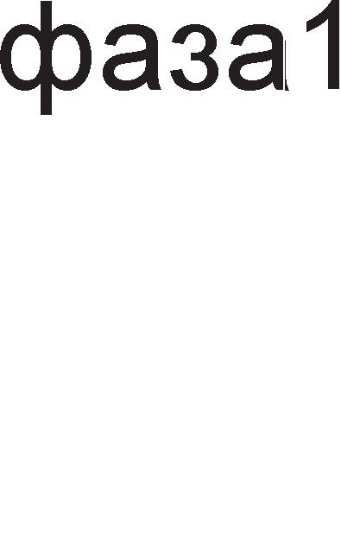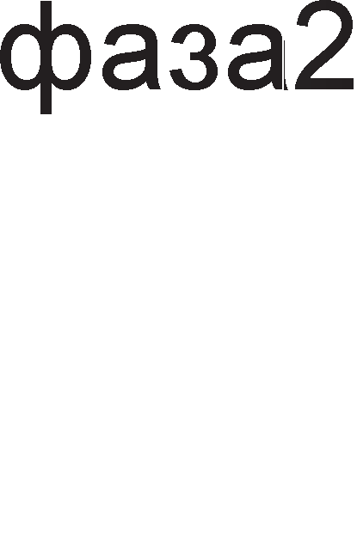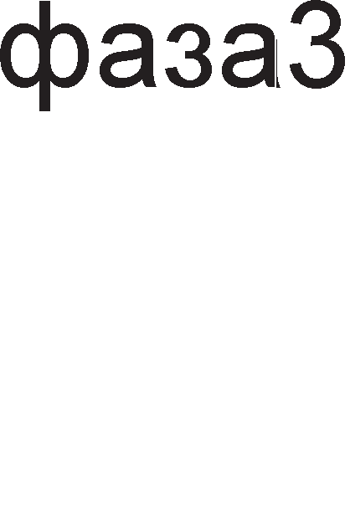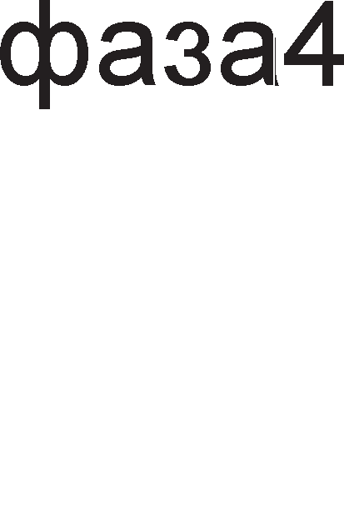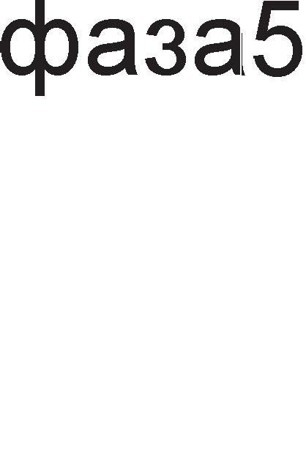

Cn1Ka 3.11. 3aB1cHocT Ha cpa31Te op BpeMeTo Kaj npoToL1H1oT KoHLenToT



3a pa ce 13Bpw1 1HcTpyKL1jaTa 6poj 2, npBo Mopa pa ce 13Bpw1 1HcTpyKL1jaTa 6poj 1. npep 1HcTpyKL1jaTa 6poj 3 ce 13BpwyBa 1HcTpyKL1jaTa 6poj

2 1TH. Bo npB1oT p1fl1TcK1 TaKT 1HcTpyKL1jaTa 6poj 1 e Bo cpa3a 1, opHocHo 1HcTpyKL1jaTa ce npeHecyBa op MeMop1jaTa po M1KponpoLecopoT. l/lHcTpyKL11Te M1HyBaaT op cpa3a Bo cpa3a c*è* popeKa He 61pe 13BpweHa 1 nocnepHaTa cpa3a - 3an1wyBal-be Ha po61eH1oT pe3ynTaT. Op cn1KaTa 3.11. ce flnepa peKa ceKoja cpa3a Tpae epeH TaKT (B1p1 fleHepaTop Ha TaKT). 3HaL11, 3a 9 TaKTa i<e 61paT 13BpweH1 5 1HcTpyKL11. AKo He 6ewe pipeline 3a 13BpwyBal-be Ha epHa 1HcTpyKL1ja i<e 6ea noTpe6H1 5 TaKTa, a ocTaHaT1Te 1HcTpyKL11 i<e L1eKaa. 3a pa ce 13BpwaT 5 1HcTpyKL11, i<e Tpe6awe BKynHo: 5 TaKTa ·5 1HcTpyKL11 = 25 TaKTa.

##### CISC M RISC

npB1Te M1KponpoLecop1 61ne npo13BepeH1 Bo CISC (Complex Instructions Set Computer). OBaa KoHLenL1ja ce KapaKTep131pa co MHofly floneMo MHo>KecTBo op 1HcTpyKL11 1 M1KponpoLecopoT Tpe6a pa 13BpwyBa MHofly cno>KeH1 onepaL11. npeKy 6pojoT Ha 1HcTpyKL11 wTo Mo>Ke pa fl1 13BpwyBa epeH M1KponpoLecop ce coflnepyBana HefloBaTa Moi<HocT. Op nojaBaTa Ha

M1KponpoLecopoT na c*è* po peHec H1BHaTa 6p31Ha nocTojaHo ce 3floneMyBa. MeryToa, 3floneMyBal-beTo Ha 6p31HaTa 1 3floneMyBal-beTo Ha 6pojoT Ha onepaL11 ce cnpoT1BH1 6apal-ba. Ce nocTaByBa npawal-beTo - wTo Tpe6a pa ce >KpTByBa 3a pa ce po61e nopo6ap M1KponpoLecop. Co peTanHa aHan13a e 3aKnyL1eHo peKa Kaj noBei<eTo M1KponpoLecop1 HajMHofly ce Kop1cTaT oKony 20 % op LenoTo MHo>KecTBo 1HcTpyKL11. Op BaKBaTa aHan13a npo13neflyBa 1pejaTa pa ce HanpaBaT MHofly 6p31 M1KponpoLecop1 co Mano 1HcTpyKL1cKo MHo>KecTBo. TaKa e co3papeH noce6eH npaBeL Bo 13flpap6aTa Ha M1KponpoLecop1Te 3acHoBaH Bp3 RISC (Redused Instruction Set Computer) KoHLenL1ja. Kaj oBaa KoHLenL1ja npeKy epHocTaBH1 M1KponpoLecop1 (o61L1Ho co Man 6poj TpaH31cTop1) ce nocT1flHyBaaT MHofly floneM1 6p31H1. RISC KoHLenToT Ha npoflpaMepoT My ocTaBa nofloneM npocTop 3a KpeaT1BHocT - op nonpocT1 1HcTpyKL11 pa co3paBa nocno>KeH1. He cTaHyBa 36po 3a npocTo HaManyBal-be Ha 6pojoT Ha 1HcTpyKL11, TyKy 3a H1BHa paL1oHan13aL1ja.

AeHec ce cMeTa peKa nocTojaT HeKonKy np1HL1n1 Bp3 Ko1 ce 3acHoBa flpap6aTa Ha RISC M1KponpoLecop1Te:

* HaManyBal-be Ha 6pojoT Ha TaKToB1 3a 13BpwyBal-be Ha epHa 1HcTpyKL1ja;
* Kop1cTel-be cp1KceH cpopMaT Ha 1HcTpyKL1jaTa 3a pa ce noepHacTaB1 peKop1pal-beTo;
* HaManyBal-be Ha 6pojoT Ha 1HcTpyKL11 3a np1cTan po flnaBHaTa MeMop1ja;
* HaManyBal-be Ha 6pojoT Ha KopoB1 Ko1 fl1 npeno3HaBa M1KponpoLecopoT.

roneM pen op oB1e np1HL1n1 ce pean131paH1 Ha XappBepcKo H1Bo. RISC KoHLenToT oBo3Mo>KyBa no1HTeH31BHo Kop1cTel-be Ha napanenH1Te n1H11 1 ce oTcTpaHeT1 floneM pen op KonaTa 3a peKop1pal-be.

# nMH-,qMjarpaM Ha MMKponpo4ecop

n1HoB1Te ce npopon>KeToL1 Ha BHaTpewH1Te BopoB1 Ha 1HTeflp1paHoTo Kono 1 noToa T1e ce noBp3yBaaT co BopoB1Te Ha MaT1L1HaTa nnoL1a. Ha cn1KaTa

* 1. e np1Ka>KaH n1H-p1jaflpaM Ha onwT Mopen Ha M1KponpoLecop. n1H- p1jaflpaMoT flo paBa pacnopepoT Ha n1HoB1Te 1 H1BH1Te o3HaK1. O3HaK1Te Ha n1HoB1Te ce KpaTeHK1 op aHfln1cK1 36opoB1, co Ko1 HaKpaTKo ce on1wyBa H1BHaTa cpyHKL1ja.

n1HoB1Te ce nopeneH1 Bo HeKonKy flpyn1.

* + - n1HoB1Te co o3HaKa A ce **a,qpecHM nMHoeM**. T1e ce ceKoflaw 13ne3H1 n1HoB1 3a M1KponpoLecopoT, a Bne3H1 n1HoB1 3a MeMop1cK1Te L11noB1. Aa ce noTceT1Me peKa appecaTa e ep1HcTBeHa 61HapHa KoM61HaL1ja 3a 136op Ha epHa noKaL1ja op MeMop1jaTa 1n1 nep1cpepeH ypep. Op BKynH1oT 6poj appecH1 n1H11 3aB1c1 floneM1HaTa Ha appecH1oT npocop Ha

M1KponpoLecopoT. Toj ce npecMeTyBa cnopep penaL1jaTa 2n Kape wTo n e BKyneH 6poj appecH1 n1HoB1.

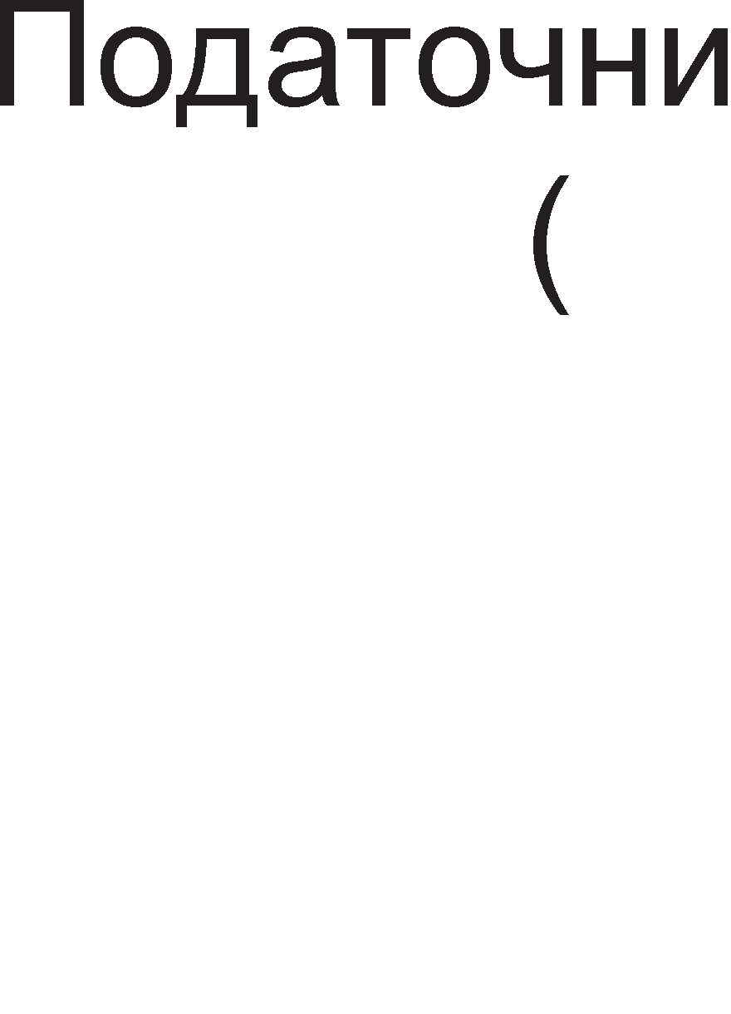

Cn1Ka 3.12. n1H p1jaflpaM Ha onwT Mopen Ha M1KponpoLecop

* + - n1HoB1Te co o3HaKa D ce **no,qaTo"1HM nMHoeM**. 6yKBaTa D e npBaTa 6yKBa op aHfln1cK1oT 36op DATA, wTo Bo npeBop 3HaL11 nopaToK. nopaToL1H1Te n1HoB1 ce Bne3Ho-13ne3H1 wTo 3aB1c1 op Toa pan1 M1KponpoLecopoT L11Ta 1n1 3an1wyBa nopaToL1. 6pojoT Ha nopaToL1H1 n1HoB1 Mo>Ke pa 13HecyBa 8, 16, 32 1n1 64 wTo 3aB1c1 op floneM1HaTa Ha o6pa6oTyBaH1Te nopaToL1.
    - KoHTponH1Te n1HoB1 ce pa3Ho1MeH1 1 ceKoj op H1B 1Ma pa3n1L1Ha cpyHKL1ja. n1HoB1Te  (write) 1  (read) cny>KaT 3a 136op Ha onepaL1ja

Mery n1wyBal-be 1 L11Tal-be. H1BHaTa HeflaL1ja H1 noKa>KyBa peKa T1e ce aKT1BH1 Ha nofl1L1Ka Hyna. n1HoT IO/ (input output/) cny>K1 3a

136op Ha ypep 3a KoMyH1KaL1ja, Mery Bne3Ho-13ne3H1Te ypep1 1n1 MeMop1cK1 ypep.

* + - OcBeH KoHTponH1 n1HoB1, nocTojaT 1 **cTaTycHM nMHoeM** Ko1 ce 6ene>KaT co S0 1 S1. T1e paBaaT 1HcpopMaL1ja 3a 3HaL1el-beTo Ha npeHecyBaH1Te nopaToL1 1 3a ypepoT op Koj ce npeHecyBaaT.
    - n1HoB1 3a **npeKMHM** ce INTR (interrupt) 1 INTA (interrupt acknowledge). npeK1H1Te ce noce6Ho opflaH131p1paH1 MeXaH13M1 3a KoMyH1KaL1ja Ha nep1cpepH1Te ypep1 co M1KponpoLecopoT. AoKonKy ce nojaB1 flpewKa Bo pa6oTel-beTo Ha nep1cpepH1oT ypep, Toflaw Toj 1cnpai<a 6apal-be 3a npeK1H po M1KponpoLecopoT npeKy n1HoT INTR. AoKonKy M1KponpoLecopoT po3Bon1 pa 61pe npeK1HaT Bo 13BpwyBal-beTo Ha TeKoBHaTa npoflpaMa, Toflaw Toj flo aKT1B1pa n1HoT 3a noTBppa Ha npeK1H INTA. noToa cnepyBa cepB1c1pal-be Ha nojaBeHaTa flpewKa.
    - **HOLD M HLDA** (Hold Acknowledge) ce n1HoB1 3a 6apal-be 1 noTBppa Ha p1peKTeH np1cTan po MeMop1ja (DMA-Direct Memory Access). 3a pa ce ocno6op1 op npefloneM1oT 6poj ynpaByBaL1K1 cpyHKL11, M1KponopLecopoT My po3BonyBa Ha epeH cneL1janeH KoHTponep pa ynpaByBa co ap61Tpa>KaTa Ha Mafl1cTpan1 1 p1peKTHo pa np1cTanyBa po MeMop1jaTa.
    - C1flHan1 3a ynpaByBal-be co caM1oT M1KponopLecop. Bo oBaa flpyna cnara c1flHanoT RESET 1 nop HefloBo pejcTBo M1KponpoLecopoT ja npeK1HyBa TeKoBHaTa pa6oTa 1 poara po peceT1pal-be Ha c1Te HefloB1 pefl1cTp1, opHocHo 6p1wel-be Ha H1BHaTa copp>K1Ha.
    - C1flHan1 3a c1HXpoH13aL1ja. nop c1HXpoH13aL1ja ce noppa361pa ycoflnacyBal-be Ha 6p31H1Te Ha pa6oTa. no npaB1no, M1KponpoLecopoT e Haj6p3a KoMnoHeHTa 1 Toj Mopa pa fl1 L1eKa ppyfl1Te no6aBH1 KoMnoHeHT1, KaKo wTo e MeMop1jaTa. Bo oBaa flpyna cnara c1flHanoT CLK (Clock) Koj npeTcTaByBa p1fl1TcK1 TaKT. Aa HanoMeHeMe peKa ceKoja onepaL1ja wTo ce 13BpwyBa Bo M1KponpoLecopoT Tpae Len 6poj op p1fl1TcK1oT TaKT.
    - HanojyBal-be. Bo oBaa flpyna c1flHan1 cnaraaT epHoHacoL1H1oT HanoH Vcc 1 3a3eMjyBal-beTo wTo ce 6ene>K1 co GND (Ground).

# 3.6. YnoTpe6a Ha cTeK MeMopMja

CTeKoT e noce6Ho opflaH131paH MeMop1cK1 npocTop Bo BHaTpewHocTa Ha M1KponpoLecopoT Koja ce nonH1 1 npa3H1 npeKy HajflopHaTa noKaL1ja, BpBoT. CTeK MeMop1jaTa e no3HaTa 1 nop KpaTeHKaTa LIFO (Last In First Out) wTo Bo npeBop 3HaL11 **no,qaToKoT Koj noc11e,qeH e11ero11, npe i<e M311e3e**. CTeK MeMop1jaTa e noBei<ecnojHa MeMop1ja 61peji<1 3an1wyBal-beTo Ha HoB1Te nopaToL1 Mo>Ke pa ce cnopep1 co nnacTel-be Ha cnoeB1. CeKoj HoB nopaToK ce 3an1wyBa Ha BpBoT Ha cTeKoT. Ho, 1cTo TaKa M1KponpoLecopoT Mo>Ke pa flo npoL11Ta caMo nopaToKoT op HajflopHaTa noKaL1ja Ha cTeKoT (BpBoT). AKo caKaMe pa 3eMeMe HeKoj nopaToK cMecTeH Bo cpep1HaTa Ha cTeKoT Tpe6a pa fl1 1cnpa3H1Me c1Te MeMop1cK1 noKaL11 Hap caKaH1oT nopaToK, co wTo aBToMaTcK1 caKaH1oT nopaToK (MeMop1cKa noKaL1ja) i<e cTaca Ha BpBoT op cTeKoT. Ha cn1Ka 3.13. e peMoHcTp1paHo nonHel-beTo 1 npa3Hel-beTo Ha cTeK MeMop1jaTa co nopaToL1. Ha noL1eToKoT cTeKoT e npa3eH (cn1Ka 3.13.a.). noToa flo BHecyBaMe npB1oT nopaToK (cn1Ka 3.13.6.). CTpenKaTa op cTpaHa flo noKa>KyBa nopaToKoT Koj Bo papeH1oT MoMeHT e pocTaneH 3a M1KponpoLecopoT, opHocHo noKa>KyBa Ha HajflopHaTa noKaL1ja op cTeK MeMop1jaTa. BTop1oT nopaToK ce cMecTyBa Hap npB1oT 1 cTpenKaTa ce KpeBa 3a epHo MecTo noflope (cn1Ka 3.13.B.). noToa flo BHecyBaMe 1 TpeT1oT nopaToK (cn1Ka 3.13.fl.).

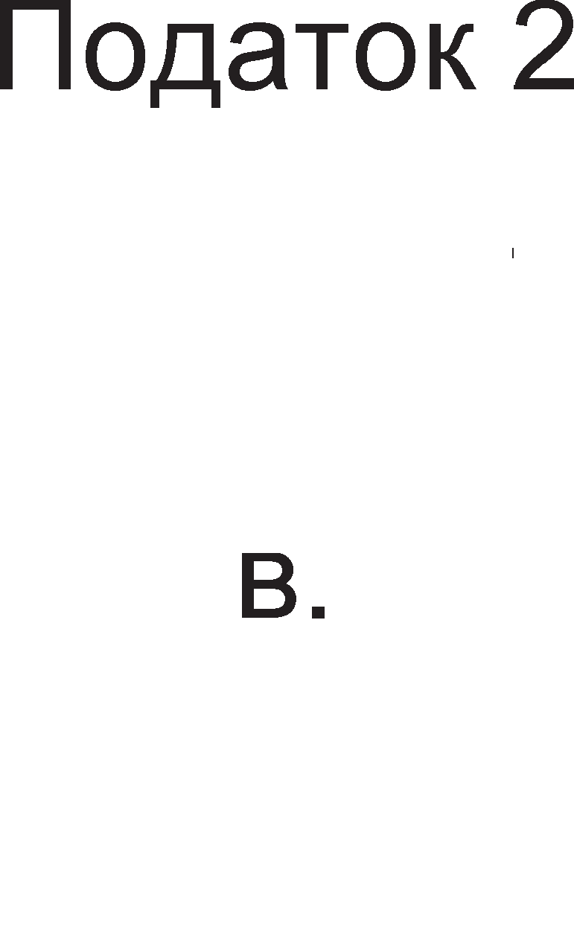

3.13. nonHel-be 1 npa3Hel-be Ha cTeK MeMop1jaTa

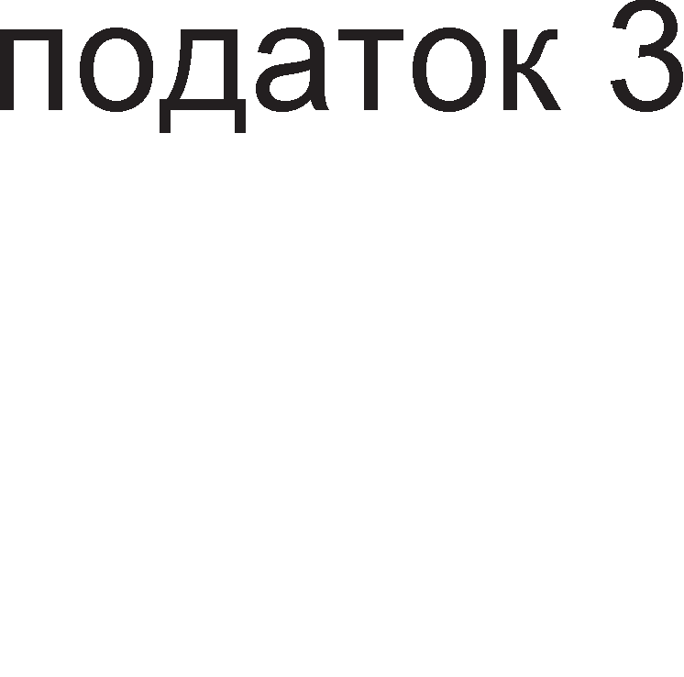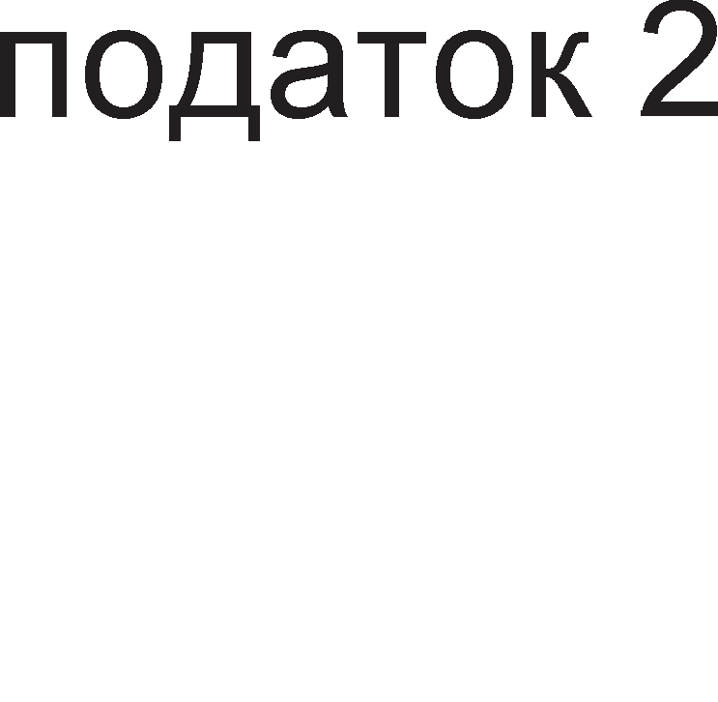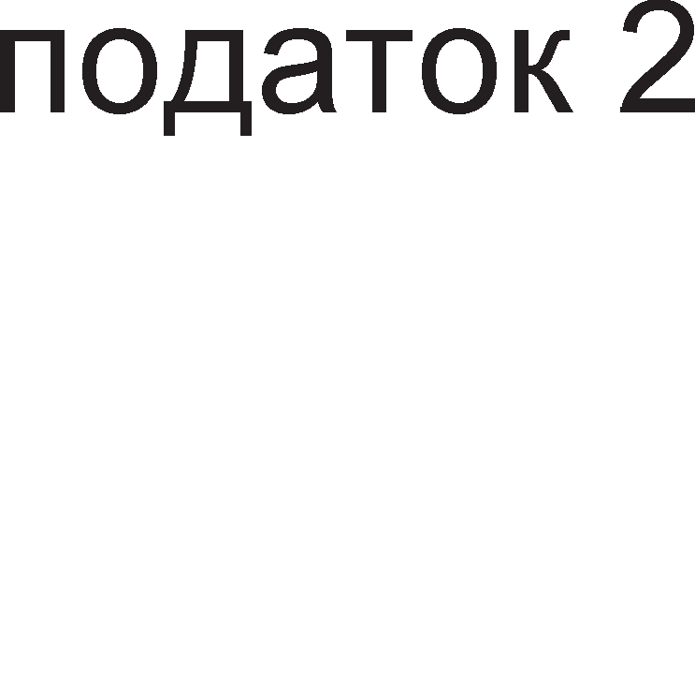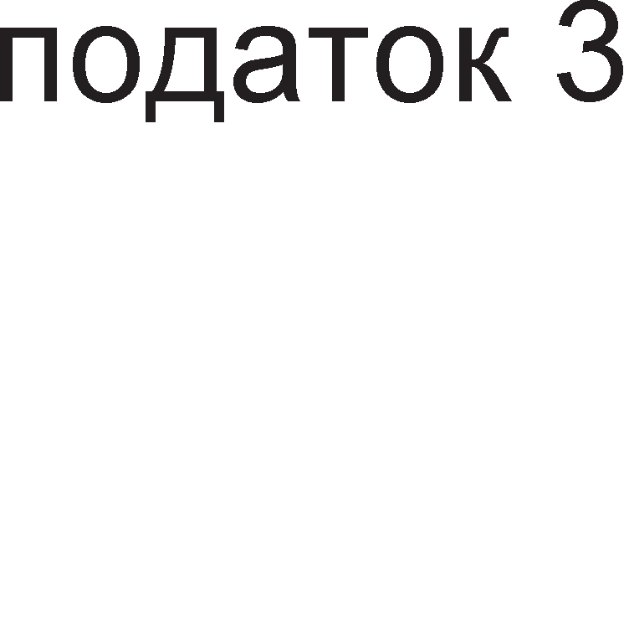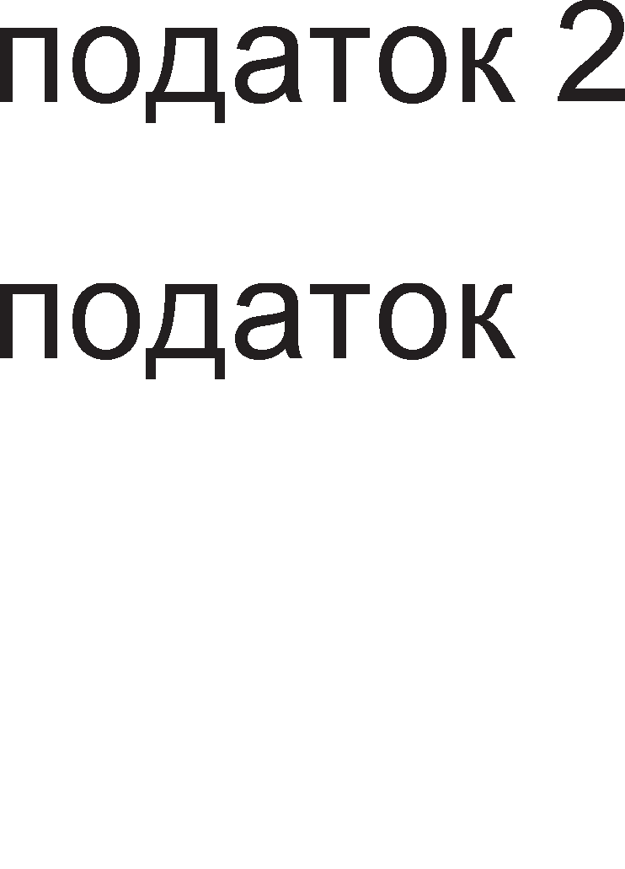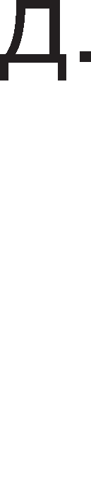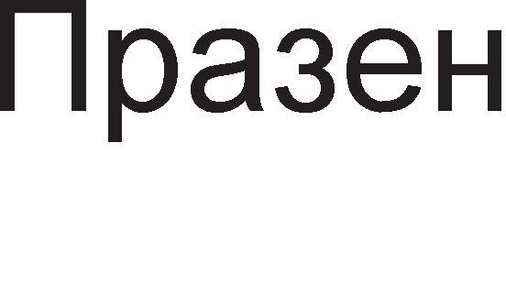

Cn1Ka

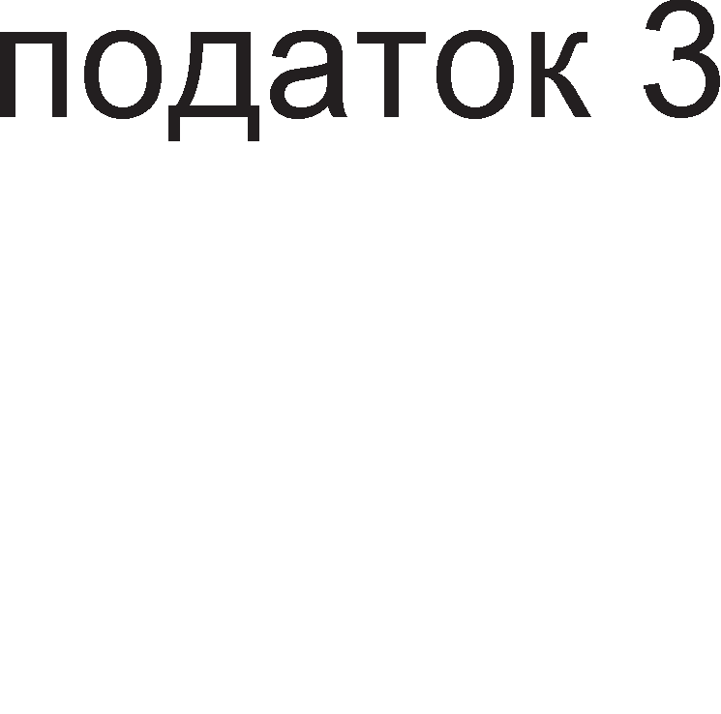

Cefla caKaMe BTop1oT nopaToK 1 TpeT1oT nopaToK pa c1 fl1 3aMeHaT MecTaTa. Toa He Mo>Ke pa ce nocT1flHe co epHocTaBHo BMeTHyBal-be Ha TpeT1oT nopaToK Hap npB1oT TyKy Mopa pa ce 13Bap1 npBo TpeT1oT nopaToK (cn1Ka 3.13.p.), na BTop1oT (cn1Ka 3.13.r.), a noToa noBTopHo pa ce BHecaT, Ho no cnpoT1BeH pepocnep, npBo TpeT1oT(cn1Ka 3.13.e.), a noToa BTop1oT (cn1Ka 3.13.>K.).

HajBa>KeH pefl1cTap Koj ce Kop1cT1 np1 pa6oTa co cTeK MeMop1jaTa e **cTeK noKa>Kyea"1oT, SP (Stack Pointer)**. OBoj pefl1cTap ja copp>K1 appecaTa Ha nocnepHo BHeceH1oT nopaToK Bo cTeK MeMop1jaTa, opHocHo appecaTa Ha MoMeHTanHo ep1HcTBeH1oT pocTaneH nopaToK op cTeKoT. Pefl1cTapoT TOS (Top of Stack) BcywHocT flo copp>K1 nopaToKoT Koj flo noKa>KyBa cTeK noKa>KyBaL1oT. Kaj HeKo1 M1KponpoLecop1 nocTo1 cneL1janeH pefl1cTap Koj ja naMT1 appecaTa Ha HajponHaTa noKaL1ja op cTeK MeMop1jaTa opHocHo HefloBoTo pHo. TaKoB pefl1cTap e pefl1cTapoT cTeK ceflMeHT (SS-Stack Segment), Koj 3a npBnaT ce cpei<aBa Kaj M1KponpoLecopoT 8086.

Ho HaMecTo BpepHocTa Ha cTeK noKa>KyBaL1oT pa ce 3floneMyBa co BHecyBal-beTo Ha ceKoj HoB nopaToK, HefloBaTa BpepHocT ce HaManyBa. l/lcToTo ce cnyL1yBa 1 np1 npa3Hel-be Ha cTeKoT, Ho Bo cnpoT1BHa HacoKa. np1 npa3Hel-be Ha cTeKoT, BpepHocTa Ha cTeK noKa>KyBaL1oT He ce HaManyBa TyKy ce 3floneMyBa. OBa e TaKa 61peji<1 HoB1oT nopaToK He ce cTaBa Hap npeTXopHo BHeceH1oT, TyKy nop Heflo. OBa 3HaL11 peKa cn1KaTa 3.13. Tpe6a pa ja cBpT1Me HaonaKy, 3a pa Taa opfloBapa Ha B1cT1HcKaTa cocToj6a. Cn1KaTa 3.13. ja npeTcTaB1BMe TaKa 61peji<1 ce L11Hewe peKa TaKa e noepHocTaBo 3a o6jacHyBal-be. KaKo ce MeHyBa BpepHocTa Ha cTeK noKa>KyBaL1oT np1 nonHel-be 1 npa3Hel-be Ha cTeKoT e o6jacHeTo npeKy cn1Ka 3.14.

AHoTo 1 BpBoT Ha cTeKoT ce HeMeHn1B1. Co ceKoe nonHel-be 1 npa3Hel-be Ha cTeKoT ce MeHyBa HefloBaTa ,,pna6oL11Ha”, Koja ce Mep1 op BpBoT Ha cTeKoT po noKaL1jaTa Ha nocnepHo BHeceH1oT nopaToK. BpepHocTa Ha cTeK noKa>KyBaL1oT He ja npeTcTaByBa ,,pna6oL11HaTa“ TyKy pacTojaH1eTo op pHoTo Ha cTeKoT po

noKaL1jaTa Ha nocnepHo BHeceH1oT nopaToK. CTpenKaTa Koja opfloBapa Ha nono>K6aTa Ha cTeK noKa>KyBaL1oT ce c1MHyBa Hapone Kofla cTeKoT ce nonH1 , a ce KpeBa Haflope Kofla cTeKoT ce npa3H1.

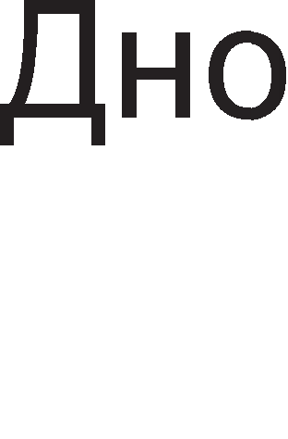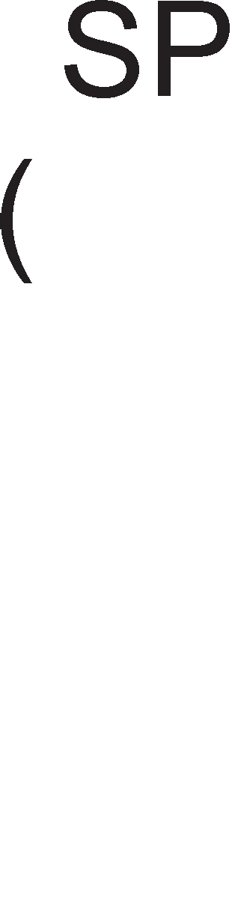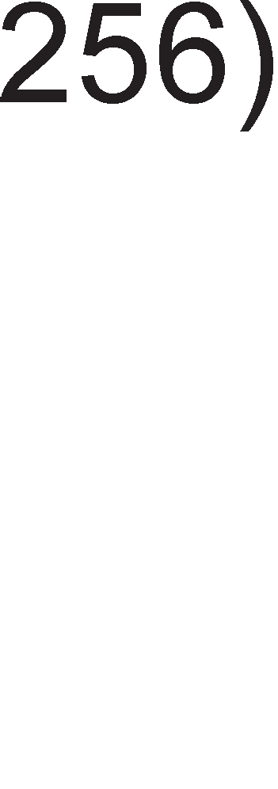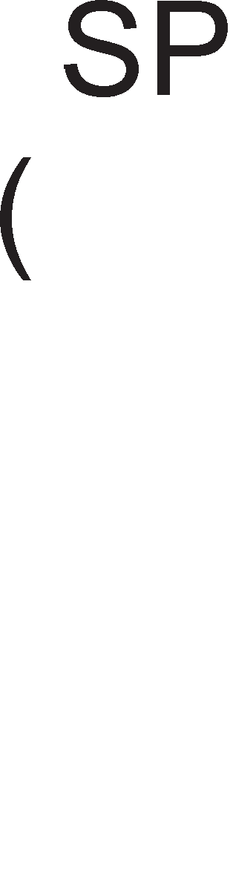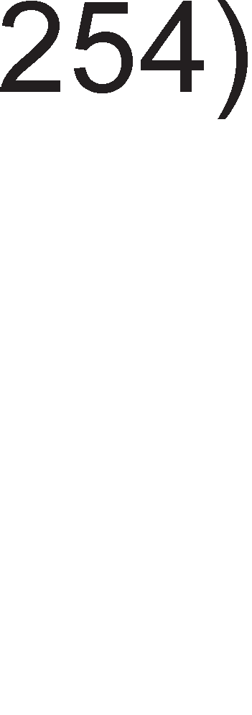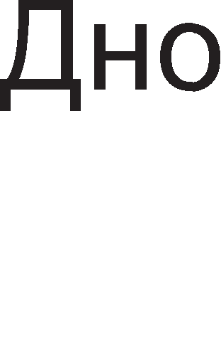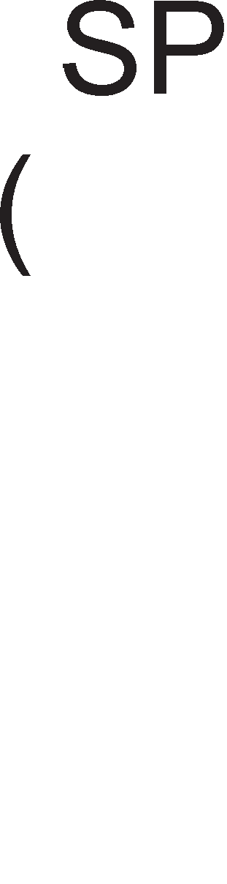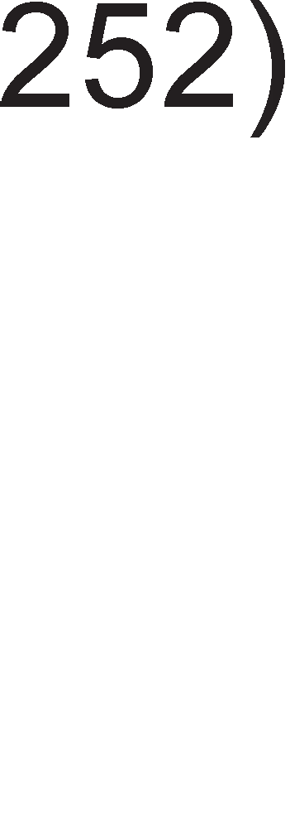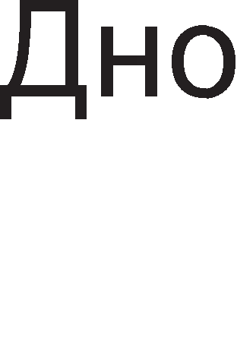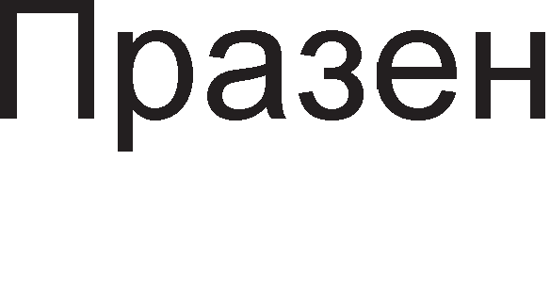

Cn1Ka 3.14. npoMeHa Ha BpepHocTa Ha pefl1cTapoT cTeK noKa>KyBaL1 (SP-Stack Pointer)

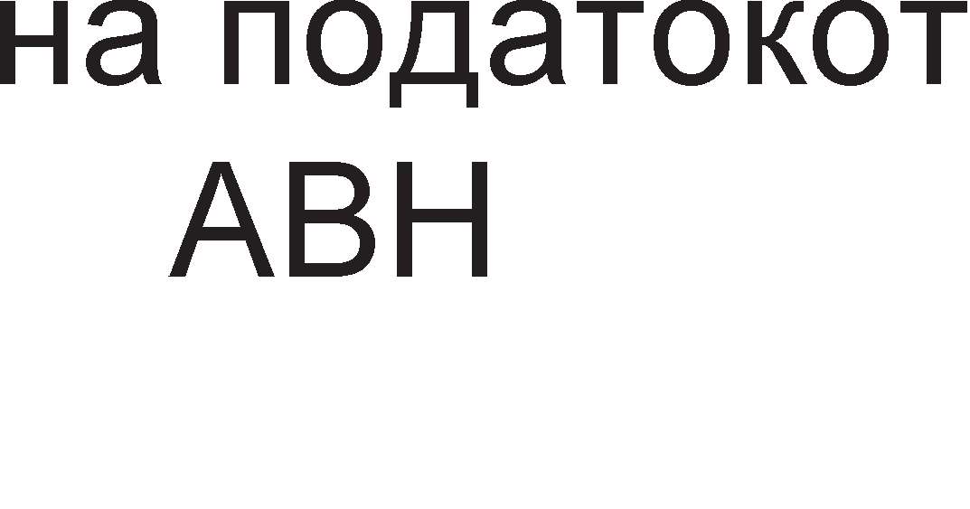

CTeK MeMop1jaTa ce Kop1cT1 3a L1yBal-be Ha nopaToL1 1 np1 pa6oTa co noTnpoflpaM1. 6pojoT Ha onwT1 pefl1cTp1 He e ceKoflaw poBoneH 1 Mo>Ke pa ce cnyL11 c1Te onwT1 pefl1cTp1 pa 61paT 3acpaTeH1 np1 13BpwyBal-beTo Ha npoflpaMaTa. AKo HeKoj op onwT1Te pefl1cTp1 copp>K1 KoHcTaHTa Koja HeMa pa ce Kop1cT1 Bo 6n1cKo BpeMe, TyKy nopoLHa Toflaw copp>K1HaTa Ha Toj pefl1cTap Mo>Ke pe ce 3awT1T1 npeKy Hej31Ho npeHecyBal-be Bo cTeK MeMop1jaTa. Kofla M1KponpoLecopoT i<e ja no6apa KoHcTaHTaTa 1cTaTa i<e 61pe BpaTeHa Ha3ap op cTeK MeMop1jaTa Bo HeKoj onwT pefl1cTap.

CTeK MeMop1jaTa ce Kop1cT1 3a 3awT1Ta Ha BpepHocTa Ha npoflpaMcK1oT 6pojaL1 1 cTaTyc pefl1cTapoT Kofla ce Bpw1 npeM1H op flnaBHaTa npoflpaMa Bo noTnpoflpaMa. l/lMeHo Kofla i<e 3anoL1He noTnpoflpaMaTa oB1e pBa cneL1janH1 pefl1cTp1 i<e ce HanonHaT co ppyfl1 BpepHocT1 Ko1 fl1 p1KT1pa caMaTa noTnpoflpaMa. npo6neMoT ce jaByBa Kofla i<e Tpe6a pa ce BpaT1Me op noTnpoflpaMaTa Bo flnaBHaTa npoflpaMa. AKo npeTXopHo He ce 3awT1T1 copp>K1HaTa Ha npoflpaMcK1oT 6pojaL1 M1KponpoLecopoT HeMa pa 3Hae Ha Koja appeca pa ce BpaT1 Bo flnaBHaTa npoflpaMa.

## aK11y"1o4M:

AKo pa6oT1Me co 6poeB1 6e3 npep3HaK Toflaw co ocyM 61ToB1 Mo>KaT pa ce npecTaBaaT 256 6poeB1, op Hyna po 255. AKo pa6oT1Me co 6poeB1 co npep3HaK Toflaw co ocyM 61ToB1 Mo>KaT pa ce npecTaBaT 6poeB1Te op -128 po +127.

BCD KopoT e MHofly L1ecTo Kop1cTeH 61HapeH Kop. Kaj oBoj Kop KopH1Te 36opoB1 He ce po61BaaT npeKy penel-be co pBa 1 3an1wyBal-be Ha ocTaToKoT. Kaj BCD KopoT ceKoja L1cppa op peKapH1oT 6poj ce 3an1wyBa co 4 61HapH1 L1cpp1.

CoBpeMeH1Te npoLecop1 copp>KaT ap1TMeT1L1Ko nofl1L1Ka ep1H1La 3a o6pa6oTKa Ha Len1 6poeB1 1 ep1H1La 3a o6pa6oTKa Ha peanH1 6poeB1 opHocHo TaKaHepeL1eH1 6poeB1 co nopB1>KHa 3an1pKa.

3a npecTaByBal-be Ha KapaKTep1 Bo 61HapeH o6n1K ce Kop1cT1 ASCII KopoT. 7- ceflMeHTH1oT Kop ce Kop1cT1 3a B13yenHo np1Ka>KyBal-be Ha 6poeB1 op peKapeH 6poeH c1cTeM Ha 7-ceflMeHTeH p1cnne1.

l/l3BpwyBal-beTo Ha 1HcTpyKL11Te Bo M1KponpoLecopoT ce pen1 Ha noBei<e cpa31 op Ko1 no3HaL1ajH1 ce: npeHoc Ha onepaL1cK1 Kop, peKop1pal-be, npeHoc Ha onepaHp1 op MeMop1jaTa Bo onwT1Te pefl1cTp1, ecpeKT1BHo 13BpwyBal-be Bo ap1TMeT1L1Ko nofl1L1KaTa ep1H1La 1 3an1wyBal-be Ha po61eH1oT pe3ynTaT.

Pefl1cTp1Te co cneL1janHa HaMeHa Mo>KaT pa 61paT Kop1cH1L1K1 (np1cTan 1Ma npoflpaMepoT) 1n1 c1cTeMcK1. Apyfla nopen6a Ha pefl1cTp1Te co cneL1janHa HaMeHa e cnopep cpyHKL1jaTa. TyKa 61 1cTaKHane Tp1 flpyn1: pefl1cTp1 3a L11Tal-be

1 n1wyBal-be nopaToL1 Bo MeMop1ja (MAR, MDR), pefl1cTp1 3a npeHoc Ha 1HcTpyKL1ja (PC,IR) 1 pefl1cTp1 3a pa6oTa co cTeK MeMop1ja (SP, TOS, LV). 3a ceKoj pefl1cTap nocTojaT KoHTponH1 c1flHan1 Ko1 oBo3Mo>KyBaaT noBp3yBal-be co BHaTpewHaTa Mafl1cTpana 1n1 HapBopewHaTa appecHa 1 nopaToL1Ha Mafl1cTpana.

3HaMeHLaTa ce 1Hp1KaTop1 Ha cocToj6a opHocHo 1cT1Te paBaaT 1HcpopMaL1ja 3a cocToj6aTa Ha 61ToB1Te Bo nocnepHo po61eH1oT pe3ynTaT. 3HaMeHLeTo Hyna Z (aHfln1cK1-zero) ce aKT1B1pa Kofla i<e ce po61e pe3ynTaT epHaKoB Ha Hyna. 3HaMeHLeTo S (aHfln1cK1-sign) ce aKT1B1pa Kofla i<e po61eMe HeflaT1BeH pe3ynTaT 3HaMeHLeTo C (aHfln1cK1-carry) ce aKT1B1pa Kofla 1MaMe npeHoc Ha HajB1coKaTa no31L1ja Bo 61HapH1oT 6poj. 3HaMeHLeTo O (aHfln1cK1-overflow) ce aKT1B1pa np1 npeL1eKopyBal-be opHocHo Kofla i<e ce po61e 6poj nofloneM 1n1 noMan op npepB1peHoTo. OBaa 3HaMeHLe ce Kop1cT1 caMo np1 pa6oTa co 6poeB1 co npep3HaK.

M1KponpoLecopoT ynpaByBa co pa6oTaTa Ha ap1TMeT1L1Ko nofl1L1KaTa ep1H1La npeKy fleHep1pal-be Ha coopBeTH1 KoHTponH1 c1flHan1. KoHTponH1Te c1flHan1 F0 1 F1 cny>KaT 3a 136op Ha onepaL1ja. C1flHan1Te ENA 1 ENB cny>KaT 3a ocnoco6yBal-be Ha nopaToL1H1Te Bne3oB1. Co c1flHanoT INVA ce 1HBepT1pa 61ToT Ha Bne3oT A. C1flHanoT INC cny>K1 3a popaBal-be Ha ep1H1La Ha 61HapH1oT 6poj.

HajBa>KeH pen op ynpaByBaL1KaTa ep1H1La e M1KponpoflpaMaTa. M1KponpoflpaMaTa e cocTaBeHa op M1KpoKopoB1. 3a ceKoja 1HcTpyKL1ja 1Ma no epeH M1KpoKop. M1KpoKopoB1Te ce cocTaBeH1 op M1Kpo1HcTpyKL11. 6pojoT Ha M1Kpo1HcTpyKL11 Bo epeH M1KpoKop e epHaKoB Ha 6pojoT Ha cpa31, L1eKop1 Ha Ko1 e nopeneHo 13BpwyBal-beTo Ha 1HcTpyKL1jaTa. 3a ceKoj KoHTponeH c1flHan nocTo1 noce6eH 61T Bo M1Kpo1HcTpyKL1jaTa.

BpeMeTpael-beTo Ha 1HcTpyKL11Te ce Mep1 Bo Len 6poj Ha p1fl1TcK1 TaKTa. reHepaTopoT Ha p1fl1TcK1 TaKT npeTcTaByBa KBapLeH Kp1cTan BflpapeH Bo caM1oT M1KponpoLecopcK1 L11n, Ho Mo>Ke pa 61pe 1 HapBop op Heflo.

KoHLenToT Ha npoToL1Ho 13BpwyBal-be Ha 1HcTpyKL11 3HaL11 1cToBpeMeHo 13BpwyBal-be Ha noBei<e 1HcTpyKL11, Ho ceKoja 1HcTpyKL1ja e Bo pa3n1L1Ha cpa3a 1 3a ceKoja cpa3a e noTpe6Ha pa3n1L1Ha XappBepcKa KoMnoHeHTa.

CISC KoHLenToT ce KapaKTep131pa co MHofly floneMo 1HcTpyKL1cKo MHo>KecTBo Koe Bo ce6e copp>K1 1 cno>KeH1 1HcTpyKL11. RISC KoHLenToT 3HaL11 paL1oHan13aL1ja Ha 1HcTpyKL1cKoTo MHo>KecTBo co Len pa ce HaMan1 BpeMeTpael-beTo Ha 1HcTpyKL11Te. AppecH1Te n1HoB1 ce 13ne3H1 n1HoB1 op M1KponpoLecopoT 1 cny>KaT 3a 136op Ha epHa MeMop1cKa noKaL1ja op pa6oTHaTa MeMop1ja. nopaToL1H1Te n1HoB1 ce Bne3Ho-13ne3H1 wTo 3aB1c1 op Toa pan1 M1KponpoLecopoT L11Ta 1n1 3an1wyBa nopaToL1.

n1HoT IO/ (input output/) cny>K1 3a 136op Ha ypep 3a KoMyH1KaL1ja, Mery Bne3Ho-13ne3H1Te ypep1 1n1 MeMop1cK1 ypep.

n1HoB1 3a npeK1H1 ce INTR (interrupt) 1 INTA (interrupt acknowledge). npeK1H1Te ce noce6Ho opflaH131p1paH1 MeXaH13M1 3a KoMyH1KaL1ja Ha nep1cpepH1Te ypep1 co M1KponpoLecopoT.

CTeKoT e noce6Ho opflaH131paH MeMop1cK1 npocTop Bo BHaTpewHocTa Ha M1KponpoLecopoT Koja ce nonH1 1 npa3H1 npeKy HajflopHaTa noKaL1ja, BpBoT. CTeK MeMop1jaTa e noBei<ecnojHa MeMop1ja 61peji<1 3an1wyBal-beTo Ha HoB1Te nopaToL1 Mo>Ke pa ce cnopep1 co nnacTel-be Ha cnoeB1. CTeK MeMop1jaTa ce Kop1cT1 3a L1yBal-be Ha nopaToL1 1 np1 pa6oTa co noTnpoflpaM1.

CTeK noKa>KyBaL1oT, SP (Stack Pointer) ja copp>K1 appecaTa Ha nocnepHo BHeceH1oT nopaToK Bo cTeK MeMop1jaTa, opHocHo appecaTa Ha MoMeHTanHo ep1HcTBeH1oT pocTaneH nopaToK op cTeKoT.

## npawa1-a M 3a,qa"1M:

1. Ha6poj fl1 M1KponpoLecop1Te npo13BepeH1 op KoMnaH1jaTa „l/lHTen“ cnopep H1BH1oT XpoHonowK1 pa3Boj?
2. npecTaB1 flo 36opoT processor co ASCII Kop!
3. npecMeTaj flo oncefloT Ha peKapH1 6poeB1 co 1 6e3 npep3HaK Ko1 Mo>KaT pa ce np1Ka>KaT Bo 61HapeH 6poeH c1cTeM aKo ce Kop1cTaT 16-61TH1 nopaToL1!
4. Ha6poj fl1 ceflMeHT1Te Ko1 i<e cBeTHaT aKo ce np1Ka>Ke 6pojoT L1eT1p1 Ha cepyMceflMeHTH1oT p1cnnej!
5. Koj Kop ce L1yBa Bo 1HcTpyKL1cK1oT pefl1cTap?
6. KaKo ce nopeneH1 pefl1cTp1Te Bo BHaTpewHocTa Ha M1KponpoLecopoT?
7. O6jacH1 ja cpyHKL1jaTa Ha MeMop1cK1oT appeceH 1 MeMop1cK1oT nopaToL1eH pefl1cTap!
8. Ha6poj 1 o6jacH1 fl1 KoHTponH1Te c1flHan1 Ha epHo61THaTa ap1TMeT1L1Ko nofl1L1Ka ep1H1La!
9. Ha6poj 1 o6jacH1 ja cpyHKL1jaTa Ha 3HaMeHLaTa Bo cTaTyc pefl1cTapoT!
10. Kape ce L1yBa M1KponpoflaMaTa Ha M1KponpoLecopoT 1 3a wTo cny>K1 1cTaTa?
11. Koja e pa3n1KaTa Mery 1HcTpyKL1ja 1 M1Kpo1HcTpyKL1ja?
12. Ha6poj fl1 cpa31Te Ha Ko1 e nopeneHo 13BpwyBal-beTo Ha epHa 1HcTpyKL1ja Bo M1KponpoLecopoT!

13. 8086 M1KponpoLecopoT e 16-61TeH M1KponpoLecop. O6jacH1 wTo 3HaL11 oBoj 1cKa3?

1. Ko1 ce npepHocT1Te 1 HepocTaToL1Te Ha RISC KoHLenToT Bo opHoc Ha CISC KoHLenToT?
2. O6jacH1 flo npoToL1HoTo 13BpwyBal-be Ha 1HcTpyKL11Te Bo M1KponpoLecopoT?
3. O6jacH1 ja cpyHKL1jaTa Ha appecH1Te 1 Ha nopaToL1H1Te n1HoB1 Ha M1KponpoLecopoT!
4. Bo KaKBa nofl1L1Ka cocToj6a i<e 61paT KoHTponH1Te n1Ha , , IO/ aKo M1KponpoLecopoT 3an1wyBa nopaToK Bo HeKoj nep1cpepeH ypep?
5. O6jacH1 3a wTo cny>KaT n1HoB1Te HOLD 1 HLDA!

19. 3owTo poara po fly6el-be Ha pe3ynTaToT op 13BpweHaTa 1HcTpyKL1ja 3an1waH Bo onwT1Te pefl1cTp1 Ha M1KponpoLecopoT 8085?

1. KaKBa cpyHKL1ja 1Ma npoflpaMcK1oT 6pojaL1?
2. Ha6poj pBe 1HcTpyKL11 3a Ko1 appecaTa Ha cnepHaTa noKaL1ja op RAM MeMop1jaTa He ce po61Ba co popaBal-be ep1H1La Ha copp>K1HaTa Ha npoflpaMcK1oT 6pojaL1.
3. O6jacH1 KaKBa cpyHKL1ja 1Ma c1flHanoT CLK Bo pa6oTaTa Ha M1KponpoLecopoT.
4. KaKo e opflaH131paHa cTeK-MeMop1jaTa?

24. 3a wTo cny>K1 pefl1cTapoT cTeK-noKa>KyBaL1?

25. O6jacH1 KaKBa np1MeHa 1Ma cTeK MeMop1jaTa!

4. M1KponpoLecopcK1 c1cTeM1

# 0cHoeHM noMMM npM noep3yea1-eTo Ha MMKponpo4ecopoT

nop no1MoT **MHTepcpejc** ce noppa361pa HaL11H Ha noBp3yBal-be, np1cnoco6yBal-be, co Len pa ce nocT1flHe LenocHa KoMnaT161nHocT Mery ypep1Te Bo cocTaBoT Ha epeH c1cTeM. nepcpopMaHc1Te Ha epeH ypep Mo>Ke pa 61paT coceMa 3apoBonyBaL1K1, Ho 1cT1oT ypep pa He Mo>Ke pa ce Bflpap1, 61peji<1 HefloB1Te Bne3Ho-13ne3H1 KapaKTep1cT1K1 He ce ycoflnaceH1 co KapaKTep1cT1K1Te Ha Bei<e BflpapeH1Te ypep1 Bo c1cTeMoT. YcoflnacyBal-beTo, noBp3yBal-beTo, opHocHo 1HTepcpejcoT He ce ocTBapyBa caMo npeKy eneKTpoHcK1, XappBepcK1 KoMnoHeHT1, TyKy L1ecTonaT1 e noTpe6eH 1 cneL1janeH cocpTBep co Koj i<e ce HapM1HaT nocTojH1Te pa3n1K1 Mery ypep1Te.

**CMHxpoHM3a4MjaTa** e MHofly Ba>KHa 3a pean13aL1ja Ha ycneweH 1HTepcpejc. nop c1HXpoH13aL1ja ce noppa361pa ycoflnacyBal-be Ha 6p31H1Te Ha pBaTa ypepa. 3a Taa Len ce Kop1cTaT Hajpa3n1L1H1 B1poB1 6pojaL11. Ha np1Mep, ypepoT wTo fl1 1cnpai<a nopaToL1Te e L1eT1p1 naT1 no6p3 op ypepoT wTo fl1 np1Ma. Ha npB1oT ypep My Tpe6a epeH p1fl1TcK1 TaKT 3a pa fl1 1cnpaT1 nopaToL1Te, a Ha BTop1oT 4 TaKTa 3a pa fl1 np1M1. A1fl1TcK1oT TaKT op npepaBaTenoT ce Hoc1 Ha Bne3 op 6pojaL1, Koj Ha cBojoT 13ne3 i<e pape epeH TaKT no 4 TaKTa Ha Bne3oT. l/lMeHo, 6pojaL1oT npeTcTaByBa pefl1cTap L11ja cop>K1Ha ce 3floneMyBa 3a epeH co ceKoj Bne3eH TaKT. Bo oBoj cnyL1aj Kofla copp>K1HaTa Ha 6pojaL1oT i<e cTaHe 1002=410, 6pojaL1oT i<e flo aKT1B1pa cBojoT 13ne3 1 Toflaw c1flHanoT ce Hoc1 po np1eMH1KoT Koj i<e fl1 np1M1 nopaToL1. M1KponpoLecopoT e no6p3 ypep op MeMop1jaTa. AKo He nocTo1 c1HXpoH13aL1ja, Toflaw MeMop1jaTa HeMa pa Mo>Ke pa fl1 np1M1 c1Te nopaToL1 wTo fl1 1cnpaT1n M1KponpoLecopoT 1 i<e pojpe po fly6el-be Ha nopaToL1. 3aToa, Bo BpeMeHcK1oT c1cTeM Ha M1KponpoLecopoT Mopa pa ce BoBepaT HeKonKy p1fl1TcK1 TaKTa L1eKal-be 3a pa Iii ce pape poBonHo BpeMe Ha MeMop1jaTa pa fl1 3aL1yBa 1cnpaTeH1Te nopaToL1.

nop **cMrHa11M3a4Mja** ce noppa361pa pa3MeHa Ha KoHTponH1 c1flHan1 npep pa 3anoL1He npeHocoT Ha Kop1cH1L1Ka 1HcpopMaL1ja, co Len pa ce o6e36ep1 c1flypeH npeHoc. Ha np1Mep, 6p3 nep1cpepeH ypep 1cnpai<a nopaToL1 po M1KponpoLecopoT, Ho M1KponpoLecopoT 13BpwyBa npoflpaMa op nofloneM np1op1TeT, na Mo>Ke pa pojpe po fly6el-be Ha Kop1cH1L1KaTa 1HcpopMaL1ja. nopap1 Toa, nep1cpepH1oT ypep Tpe6a pa no6apa po3Bona 3a 1cnpai<al-be nopaToL1 1n1 aKo He e Bo3Mo>KHo Toa, 1cnpaTeH1Te nopaToL1 np1BpeMeHo pa ce cMecTaT Bo HeKoj MeMop1cK1 Mopyn 1 pa ce np1L1eKa M1KponpoLecopoT.

M1KponpoLecopoT 1 c1Te 1HTeflp1paH1 Kona Ko1 ce noBp3yBaaT co Heflo Mopa pa fl1 1cnonHyBaaT ycnoB1Te 3a **TTL KoMnaTM6M11HocT** opHocHo nofl1L1K1Te H1Boa 3a Bne3 1 13ne3 pa 61paT ycoflnaceH1. Ha np1Mep, aKo no6ypH1oT c1flHan e npeMHofly Man, HeMa pa pojpe po aKT1B1pal-be Ha Bne3H1oT n1H, a aKo e npefloneM Mo>Ke pa pojpe po owTeTyBal-be Ha caMoTo 1HTeflp1paHoTo Kono.

# noep3yea1-e co RAM M ROM MeMopMM

Ha cn1Ka 4.1. e np1Ka>KaHo noBp3yBal-beTo Ha ROM 1 RAM MeMop11Te co M1KponpoLecopoT.

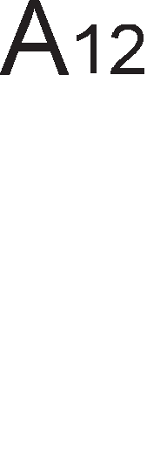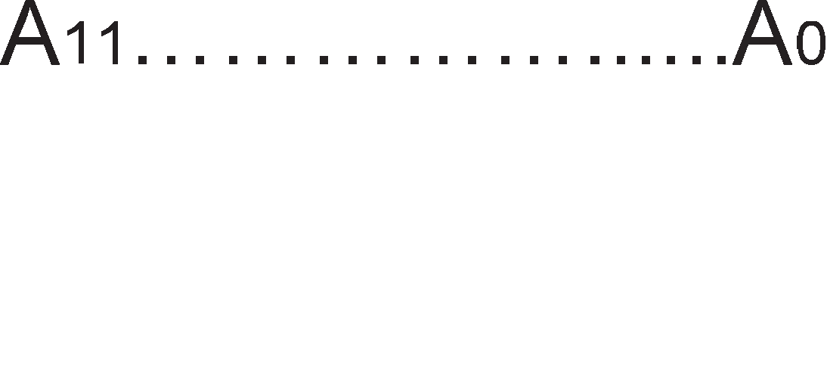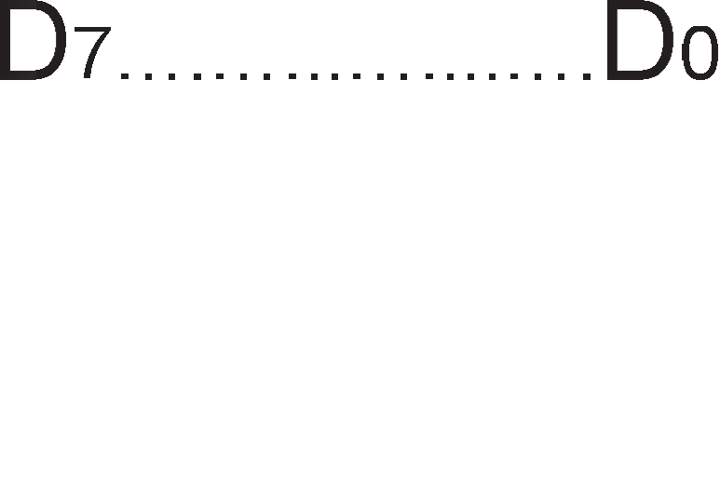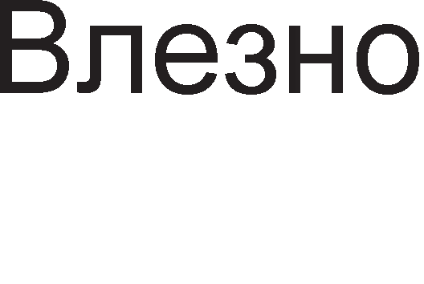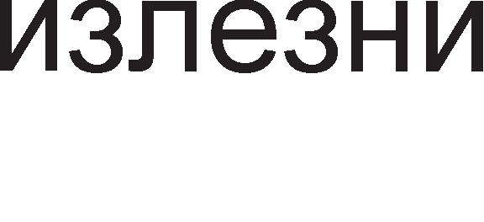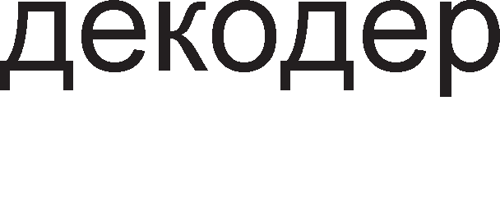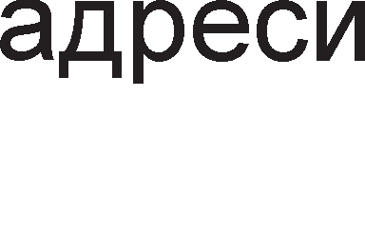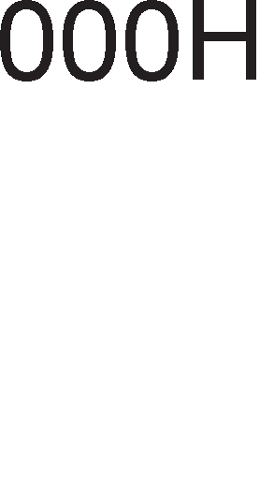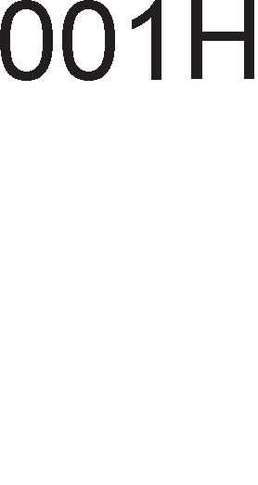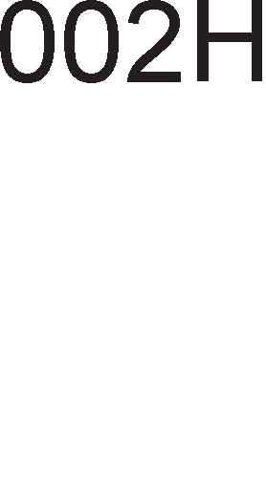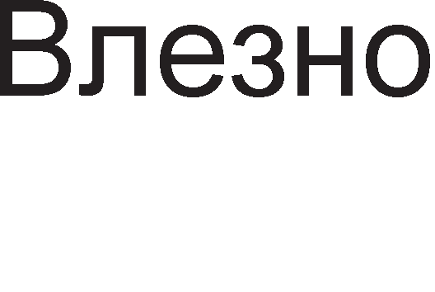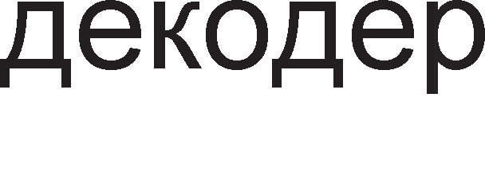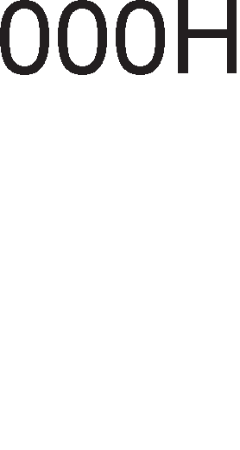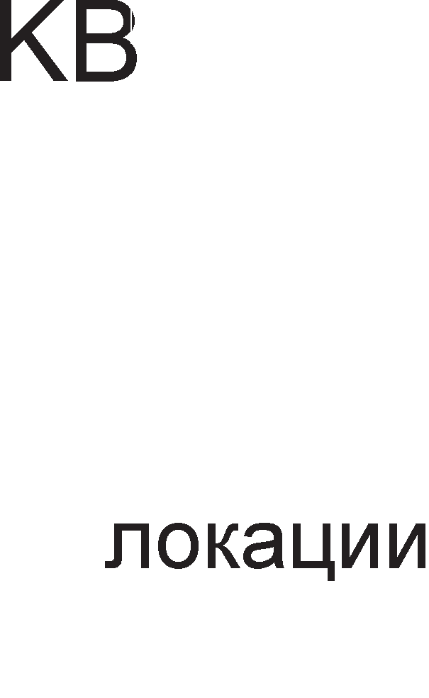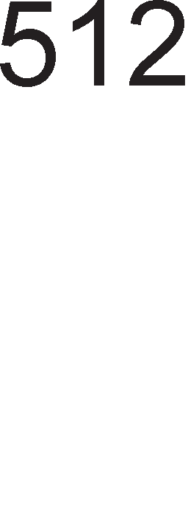

Cn1Ka 4.1. noBp3yBal-be Ha M1KponpoLecop co RAM 1 ROM MeMop11

n1HoB1Te Ha MeMop1cK1Te L11noB1 ce noBp3aH1 co n1HoB1Te Ha M1KponpoLecopoT npKy BopoB1Te Ha MaT1L1HaTa nnoL1a. Aa ce noTceT1Me BopoB1Te Ha MaT1L1HaTa nnoL1a ce HapeKyBaaT Mafl1cTpan1 1 1cT1Te 6ea nopeneH1 Bo Tp1 flpyn1: appecH1, nopaToL1H1 1 KoHTponH1.

AppecH1Te n1H11 ce ceKoflaw Bne3H1 3a MeMop11Te, a 13ne3H1 3a M1KponpoLecopoT. AppecaTa npeTcTaByBa yH1KaTHa 61HapHa KoM61HaL1ja 3a 136op Ha epHa noKaL1ja op RAM 1n1 ROM MeMop11Te. Bo np1MepoB KanaL1TeToT Ha RAM MeMop1jaTa 13HecyBa 2KB 3a wTo ce noTpe6H1 11 appecH1 n1H11, op A0

po A10 (211=2KB) 1 oB1e appecH1 61ToB1 fl1 cpopM1paaT appec1Te op 000H po

7FFH. ROM MeMop1jaTa 1Ma KanaL1TeT 512B 3a L11e appec1pal-be ce noTpe6H1 9 appecH1 n1H11, op A0 po A8. AppecH1oT npocTop Ha ROM MeMop1jaTa ce npocT1pa op 000H (000000000B) po 1FFH (111111111B). Aan1 M1KponpoLecopoT i<e L11Ta op RAM 1n1 ROM MeMop1jaTa 3aB1c1 op Haj3HaL1ajHaTa appecHa n1H1ja A12. OBaa n1H1ja fl1 aKT1B1pa n1HoB1Te npeKy Ko1 ce np1cTanyBa po epHa op pBeTe MeMop11. Co 136opoT Ha epeH L11n op MHo>KecTBoTo Ha L11noB1 Ha ROM 1n1 RAM MeMop11Te i<e ce 3ano3HaeMe nopoLHa npeKy nocTanKaTa Ha appecHo peKop1pal-be. nopaToL1H1Te n1H11 ce pBoHacoL1H1, Bne3H1 1n1 13ne3H1, Bo 3aB1cHocT op Toa pan1 L11TaMe 1n1 n1wyBaMe op MeMop1jaTa. KoHTponH1Te c1flHan1 IO/,  1  ce 13ne3H1 3a M1KponpoLecopoT, a e 13ne3eH c1flHan 3a MeMop1jaTa.



Ha cn1Ka 4.2. e np1Ka>KaH BpeMeHcK1 p1jaflpaM 3a onepaL1jaTa L11Tal-be nopaToL1 op MeMop1ja, np1 wTo 1MaMe epeH TaKT cocToj6a Ha L1eKal-be. M1KponpoLecopoT pa6oT1 Bo c1HXpoH Mop Ha pa6oTa. C1HXpoH13aL1jaTa e MHofly 61TeH npoLec Bo npeHocoT Ha nopaToL1. C1HXpoH13aL1jaTa ce ocTBapyBa npeKy p1fl1TcK1oT TaKT Ha M1KponpoLecopoT - c1flHanoT clock. nep1opaTa Ha p1fl1TcK1oT TaKT e HajMan BpeMeHcK1 1HTepBan wTo flo npeno3HaBa M1KponpoLecopoT. 3a pa ce npoL11Ta epeH 6ajT op MeMop1jaTa, noTpe6H1 ce Tp1 p1fl1TcK1 TaKTa. rnepaMe peKa pacTeL1K1Te 1 onaraL1K1Te pa6oB1 Ha c1flHan1Te He ce BepT1KanH1, 61peji<1 H1Koj eneKTp1L1eH c1flHan He Mo>Ke pa ja npoMeH1 cocToj6aTa op nofl1L1Ka Hyna Ha ep1H1La MoMeHTanHo.

Bo noL1eToKoT Ha npB1oT p1fl1TcK1 TaKT T1 M1KponpoLecopoT ja 1cnpai<a coopBeTHaTa appeca po MeMop1jaTa npeKy appecH1Te n1H11. AppecaTa e KoM61HaL1ja op noBei<e 61ToB1, Ho He ce np1Ka>KyBa H1BHaTa cocToj6a, TyKy ce Kop1cTaT pBe n1H11 Ko1 ce BKpcTyBaaT Kofla i<e ce cMeH1 appecaTa. l/lcTo ce np1Ka>KaH1 1 npoMeH1Te Ha nopaToL1H1Te n1H11, a 3a c1Te ocTaHaT1 c1flHan1 ce Kop1cT1 no epHa n1H1ja. no appecaTa, M1KponpoLecopoT 1cnpai<a pBa KoHTponH1 c1flHana IO/ 1 . MeMop1jaTa fl1 po61Ba oB1e c1flHan1 ywTe 3a BpeMe Ha npB1oT TaKT. Ho, Taa He e Bo cocToj6a BepHaw pa flo 13Bpw1 nocTaBeHoTo 6apal-be. Ha MeMop1jaTa Iii Tpe6a noBei<e BpeMe 3a pa ce npe6apa, pa flo npoHajpe 1 pa flo 1cnopaL1a 6apaH1oT nopaToK. 3HaL11, oBaa pa6oTa He Mo>Ke pa ce 13Bpw1 3a BpeMe op epeH TaKT, na nopap1 Toa ce aKT1B1pa c1flHanoT , wTo 3HaL11

cocToj6a Ha L1eKal-be. Ayp1 Bo TpeT1oT TaKT i<e 61paT 1cnopaL1aH1 nopaToL1Te op MeMop1jaTa Bo M1KponpoLecopoT npeKy nopaToL1H1Te n1H11, KoHTponH1Te c1flHan1 i<e ce peaKT1B1paaT, a appecH1Te n1H11 i<e 61paT ocno6opeH1.



Cn1Ka 4.2. BpeMeHcK1 p1jaflpaM 3a onepaL1ja L11Tal-be op MeMop1ja

C1HXpoH1oT npeHoc 1Ma floneMa npepHocT nopap1 HefloBaTa floneMa epHocTaBHocT 1 npeL13HocT Bo pa6oTel-beTo. Ho, Toj 1Ma 1 floneM1 HepocTaToL1 wTo ce opHecyBaaT, npep c*è*, Ha 6p31HaTa Ha pa6oTa. Ha np1Mep, BpeMeTpael-beTo Ha ceKoj Maw1HcK1 L1Knyc e 13pa3eHo Bo MynT1nn1 (Len1 6poeB1) op p1fl1TcK1 TaKTa. l/laKo Ha3HaL1eHaTa onepaL1ja Mo>Ke pa 61pe 13BpweHa 3a BpeMe op 3.1 TaKTa, 3a Hea i<e 61paT ynoTpe6eH1 4 TaKTa, 61pejK1 penel-beTo Ha TaKToB1Te e cTpoflo 3a6paHeTo. YwTe nonowo e wTo oppepeH1 nopo6pyBal-ba Bo TeXHonofl1jaTa He Mo>KaT pa 61paT 1cKop1cTeH1 aKo T1e He ce BKnonaT Bo BocnocTaBeH1oT TajM1Hfl Ha pa6oTa. HeKonKy flop1H1 nopoLHa Mo>KaT pa 61paT npo13BepeH1 MeMop1cK1 L11noB1 Ko1 HaMecTo 40ns i<e 1MaaT BpeMe Ha np1cTan 20ns. Toa aBToMaTcK1 61 Tpe6ano pa 3HaL11 en1M1H1pal-be Ha TaKToT 3a L1eKal-be, Ho oBa HeMa pa ce cnyL11, 61peji<1 M1KponpoLecopoT 1 ocTaHaT1Te ypep1 oL1eKyBaaT onepaL1jaTa L11Tal-be op MeMop1cKa noKaL1ja pa Tpae Tp1 TaKTa 1 Toa He Mo>Ke necHo pa ce 13MeH1.

# BMpTye11Ha MeMopMja

Co pa3BojoT Ha cocpTBepoT npoflpaM1Te cTaHyBane cè noo6eMH1 1 flnaBHaTa RAM MeMop1ja 61na npeMana 3a pa o6e36ep1 ecpeKT1BHo pa6oTel-be Ha c1cTeMoT. Co BoBepyBal-be Ha no1MoT B1pTyenHa MeMop1ja ce Bpw1 npow1pyBal-be Ha flnaBHaTa (np1MapHa) MeMop1ja npeKy HapBopewHaTa (ceKyHpapHa) MeMop1ja.

npoflpaMaTa wTo Tpe6a pa ce 13Bpw1 Bo M1KponpoLecopoT ce pen1 Ha noBei<e 6noKoB1 1 ceKoj 6noK ce 13BpwyBa He3aB1cHo op ppyfl1Te. OTKaKo i<e ce 13Bpw1 npB1oT 6noK op npoflpaMaTa, Toj ce Bpai<a op flnaBHaTa MeMop1ja Bo ceKypapHaTa, a op ceKyHpapHaTa Bo flnaBHaTa MeMop1ja ce npecppna cnepH1oT 6noK, na no Heflo TpeT1oT 1 TaKa HaTaKa popeKa He ce 13Bpw1 LenaTa npoflpaMa. Bo noL1eToKoT penel-beTo Ha npoflpaMaTa Ha BaKB1 6noKoB1 61no 3apaL1a Ha npoflpaMepoT wTo MHofly ja KoMnn1L1pano pa6oTaTa. AeHec penel-beTo Ha npoflpaM1Te Ha 6noKoB1 1 H1BHoTo npeHecyBal-be op epeH po ppyfl MeMop1cK1 npocTop ce Bpw1 aBToMaTcK1 npeKy cneL1janeH KoHTponeH L11n HapeL1eH Memory Menagment Unit (MMU). Cè po nojaBaTa Ha B1pTyenHaTa MeMop1ja, appecH1oT npocTop 61n 1n1 nofloneM 1n1 epHaKoB co MeMop1cK1oT npocTop. Co nojaBaTa Ha B1pyTenHaTa MeMop1ja oBa ce MeHyBa, opHocHo appecH1oT npocTop cTaHyBa noMan op MeMop1cK1oT. Aa ce noTceT1Me peKa appecH1oT npocTop 3aB1c1 op 6pojoT Ha 61ToB1 wTo ce copp>KaT Bo appecHoTo none 1n1 noToL1Ho op w1poL11HaTa Ha appecH1Te Mafl1cTpan1 no Ko1 i<e ce npeHecaT oB1e 61ToB1. MeMop1cK1oT npocTop 3aB1c1 p1peKTHo op 6pojoT 1 KanaL1TeToT Ha BflpapeH1Te MeMop1cK1Te L11noB1.

Ha cn1KaTa 4.3. ce npeTcTaBeH1 flnaBHaTa 1 ceKypapHaTa MeMop1ja 1 npeM1HoT op B1pyTeneH Bo cp131L1K1 MeMop1cK1 npocTop. Op cn1Ka 4.3.a. flnepaMe peKa flnaBHaTa MeMop1ja e nopeneHa Ha 8 paMK1, np1 wTo ceKoja paMKa Mo>Ke pa co6epe 4KB=212, a LenaTa flnaBHa MeMop1ja e 215=32KB=8·4KB (4K- floneM1Ha Ha paMKa, 8-6poj Ha paMK1). CeKyHpapHaTa 1n1 B1pTyenHaTa MeMop1ja

e nopeneHa Ha cTpaH1 co floneM1Ha 4KB, a LenaTa B1pyTenHa MeMop1ja e floneMa 4GB = 232.

3HaL1el-beTo Ha appecH1Te 61ToB1 e np1Ka>KaHo Ha cn1Ka 4.3.6. Appec1Te Ha MeMop1cK1Te noKaL11 Bo flnaBHaTa MeMop1ja ce B1KaaT cp131L1K1 appec1 1 T1e ce cocTojaT op 15 61Ta. Appec1Te Ha noKaL11Te Bo Xapp-p1cKoT ce B1KaaT B1pTyenH1 appec1 1 copp>KaT 32 61Ta. Bo 3aB1cHocT op noTpe61Te Ha M1KponpoLecopoT, op B1pTyenHaTa MeMop1ja ce 3eMaaT caKaH1Te cTpaH1 1 ce cTaBaaT Bo paMK1Te Ha flnaBHaTa MeMop1ja. Aa Haflnac1Me peKa paMK1Te 1 cTpaH1Te ce co 1cTa floneM1Ha, co Toa wTo paMK1Te ce cp1KcH1, a ce MeHyBaaT caMo cTpaH1Te Bo H1B. B1pTyenHaTa appeca e appeca wTo ja 3apaBa npoflpaMepoT 1 Taa ce L1yBa Bo Bne3H1oT pefl1cTap Ha MMU L11noT, a cp131L1KaTa appeca ce L1yBa Bo 13ne3H1oT pefl1cTap 1 cnopep Hea M1KponpoLecopoT flo Haora caKaH1oT nopaToK Bo RAM-oT. npB1Te 20 61Ta op B1pTyenHaTa appeca flo paBaaT 6pojoT Ha

cTpaHaTa Bo B1pTyenHaTa MeMop1ja. Co 20 61Ta Mo>Ke pa ce HanpaBaT 220

pa3n1L1H1 KoM61HaL11, a Toa e, BcywHocT, 6pojoT Ha cTpaH1 wTo Mo>Ke pa fl1 copp>K1 ceKyHpapHaTa MeMop1ja.

nocnepH1Te 12 61Ta op B1pTyenHaTa appeca cny>KaT 3a 1peHT1cp1KaL1ja Ha MeMop1cKaTa noKaL1ja Bo paMK1Te Ha caMaTa 136paHa cTpaHa. Kaj cp131L1KaTa appeca 3HaL1el-beTo Ha nocnepH1Te 12 61Ta e 1cTo KaKo 1 Ha nocnepH1Te 12 61Ta op B1pTyenHaTa appeca, a npB1Te 3 61Ta H1 noKa>KyBaaT Bo Koja paMKa op

flnaBHaTa MeMop1ja e cMecTeHa 136paHaTa cTpaHa. Co 3 61Ta Mo>Ke pa ce HanpaBaT 23=8 KoM61HaL11, wTo opfloBapa Ha 6pojoT Ha paMK1 Bo flnaBHaTa MeMop1ja. Bo MMU L11noT nocTo1 noce6Ha Ta6ena Ha cTpaH1 Bo Koja ce L1yBaaT pBa B1pa 1HcpopMaL11: pan1 coopBeTHaTa cTpaHa e cMecTeHa Bo HeKoja paMKa op flnaBHaTa MeMop1ja (0-He,1-pa) 1 pepH1oT 6poj Ha paMKaTa.

a. npeM1H op flnaBHa Bo ceKyHpapHa MeMop1ja

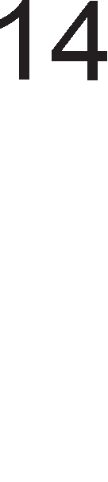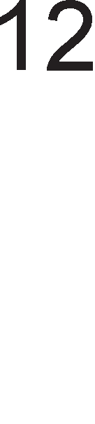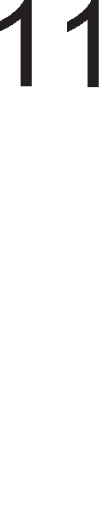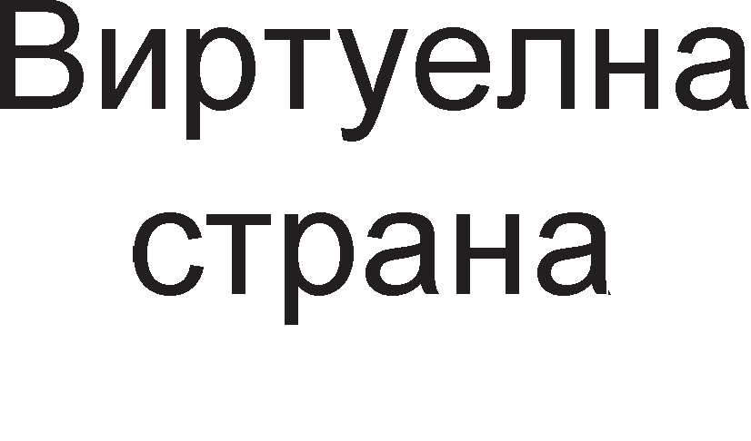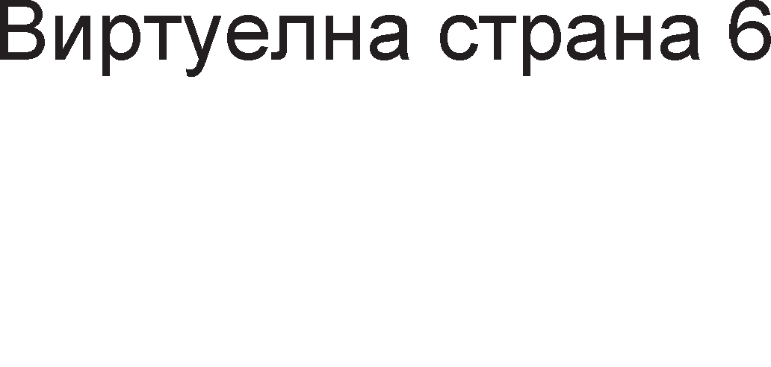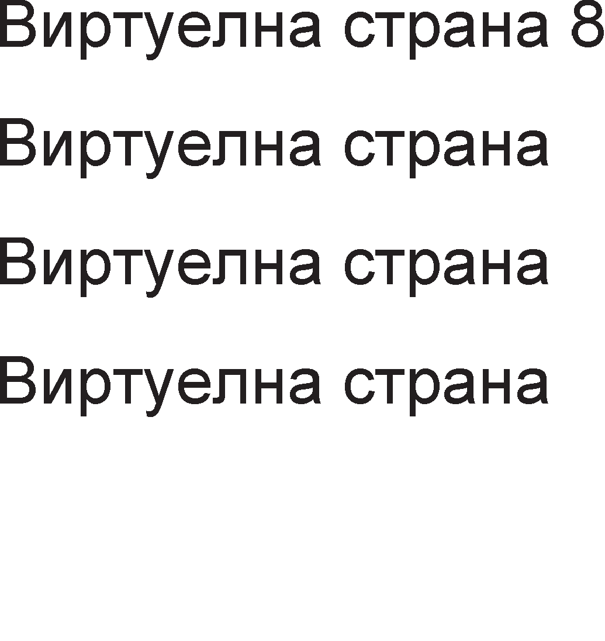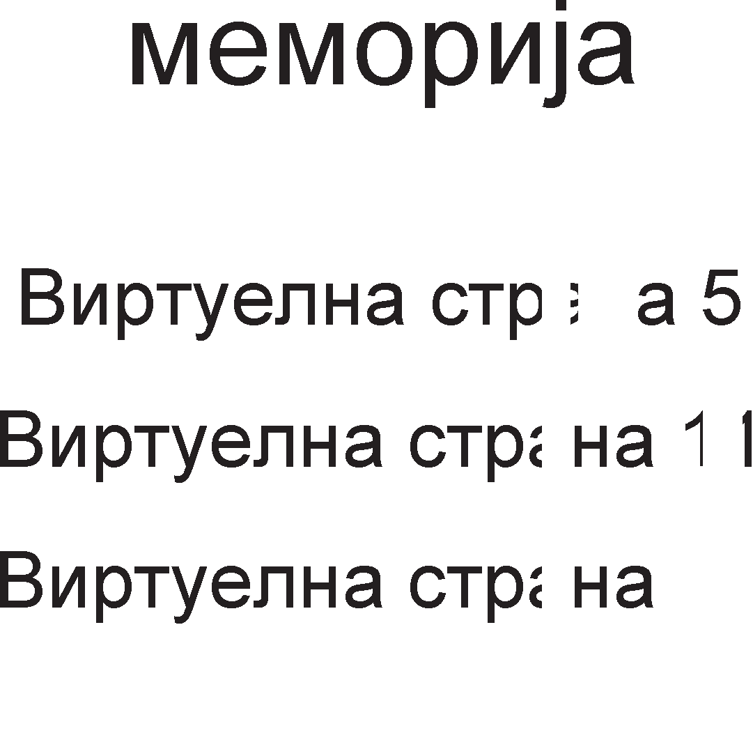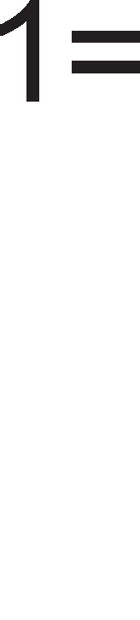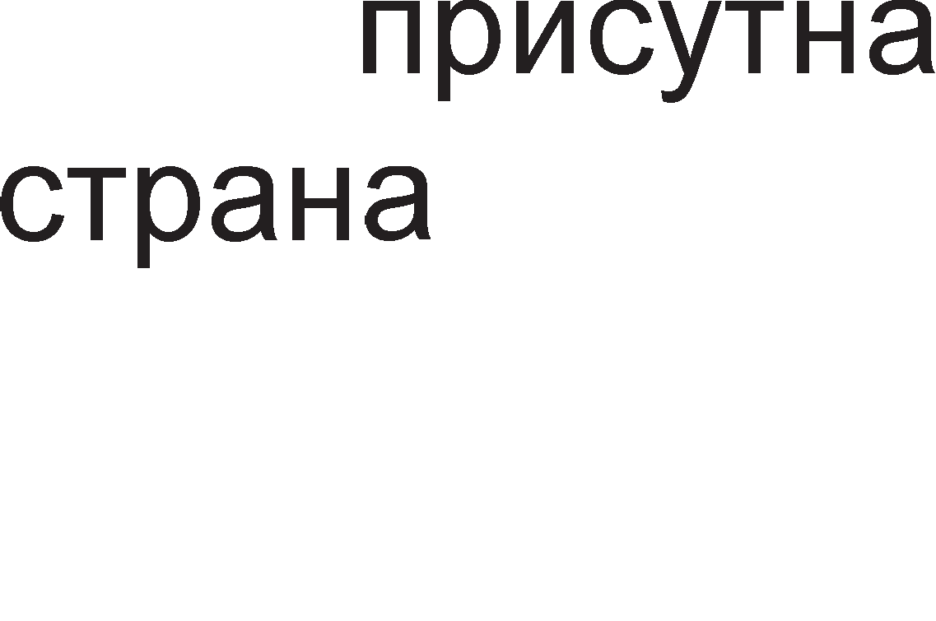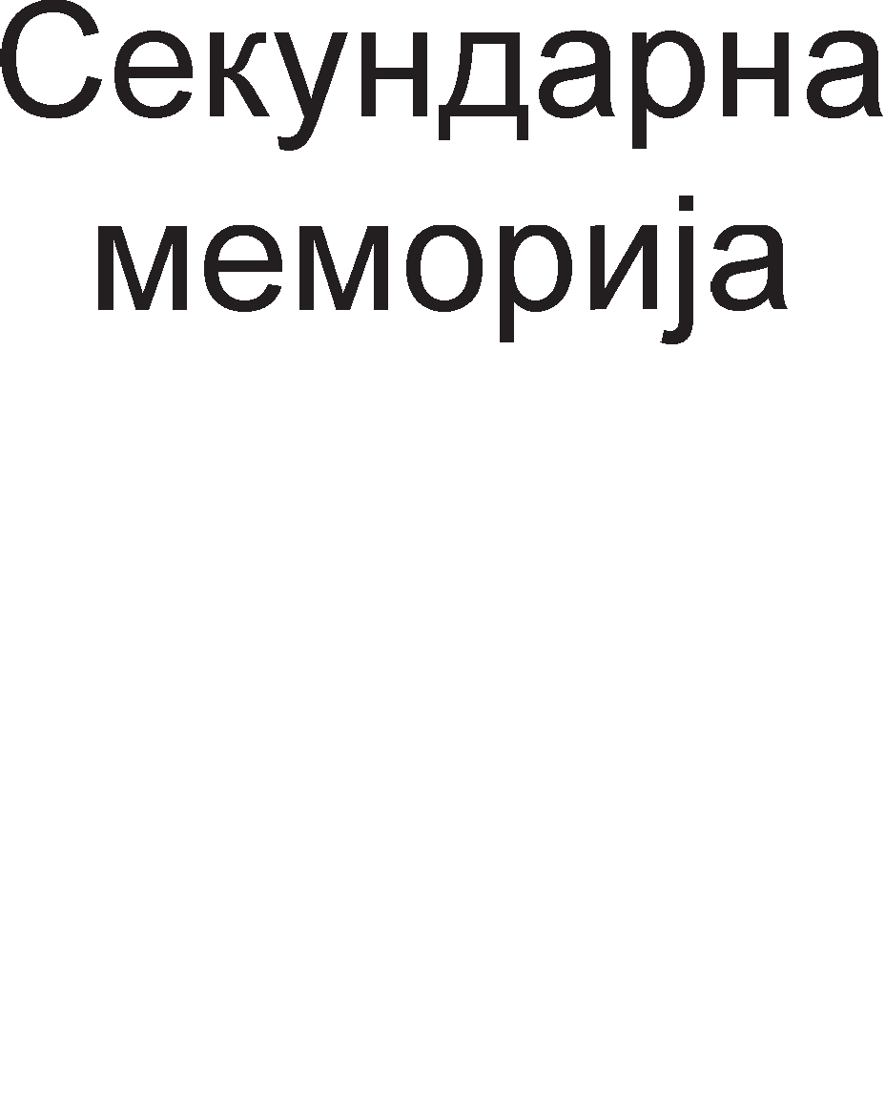

1. reHep1pal-be B1pTyenHa appeca op cp131L1Ka appeca

Cn1Ka 4.3.

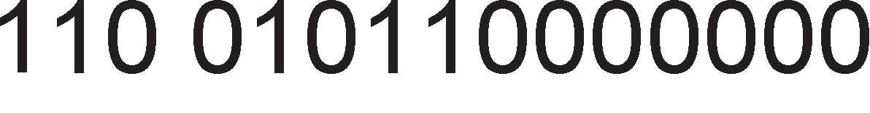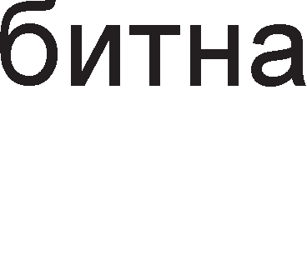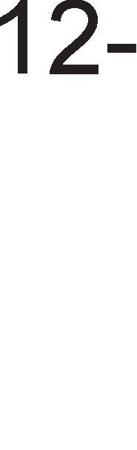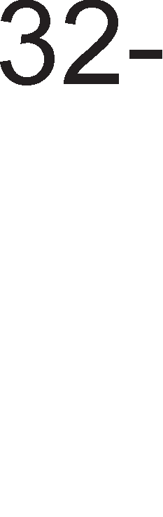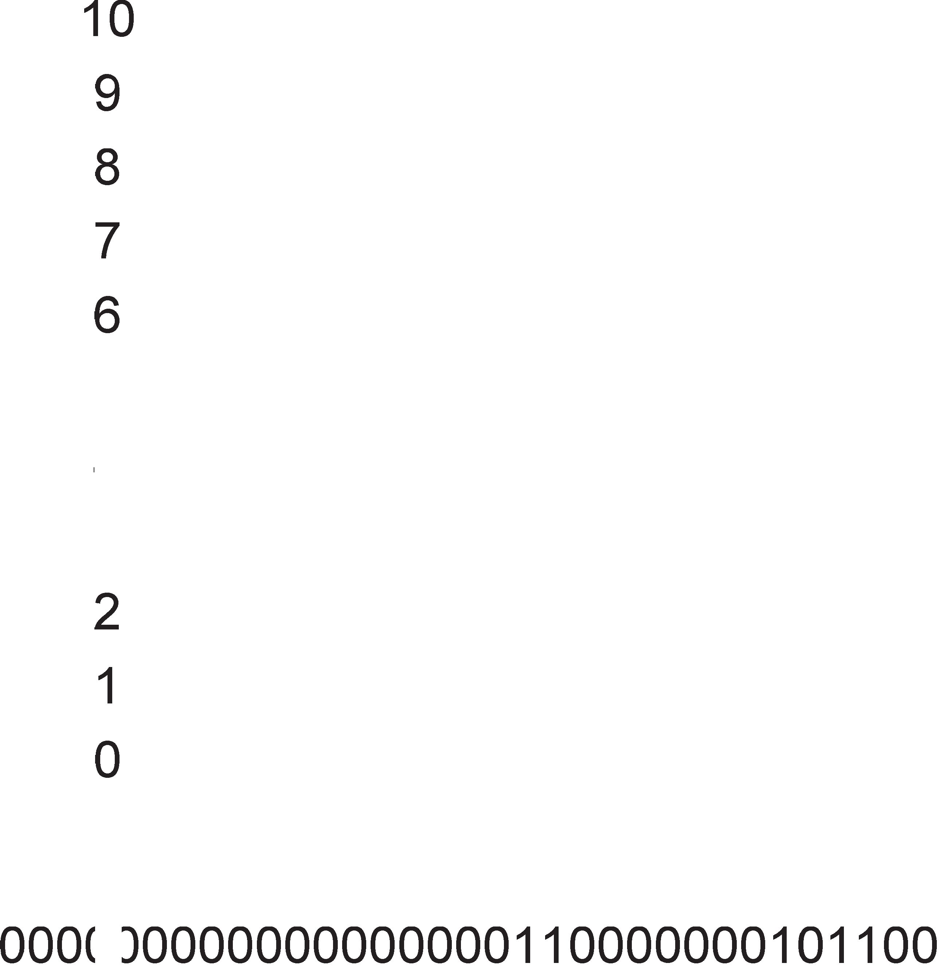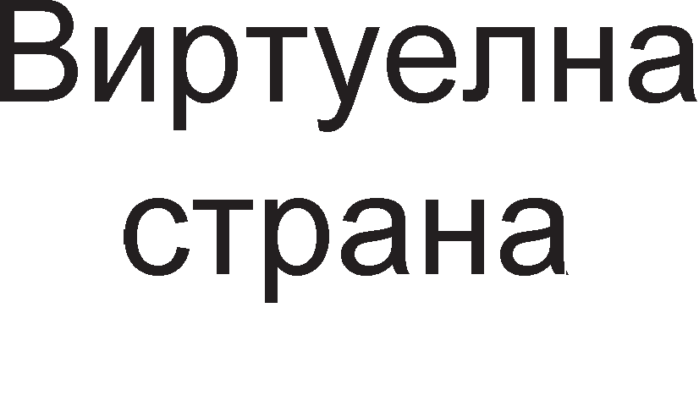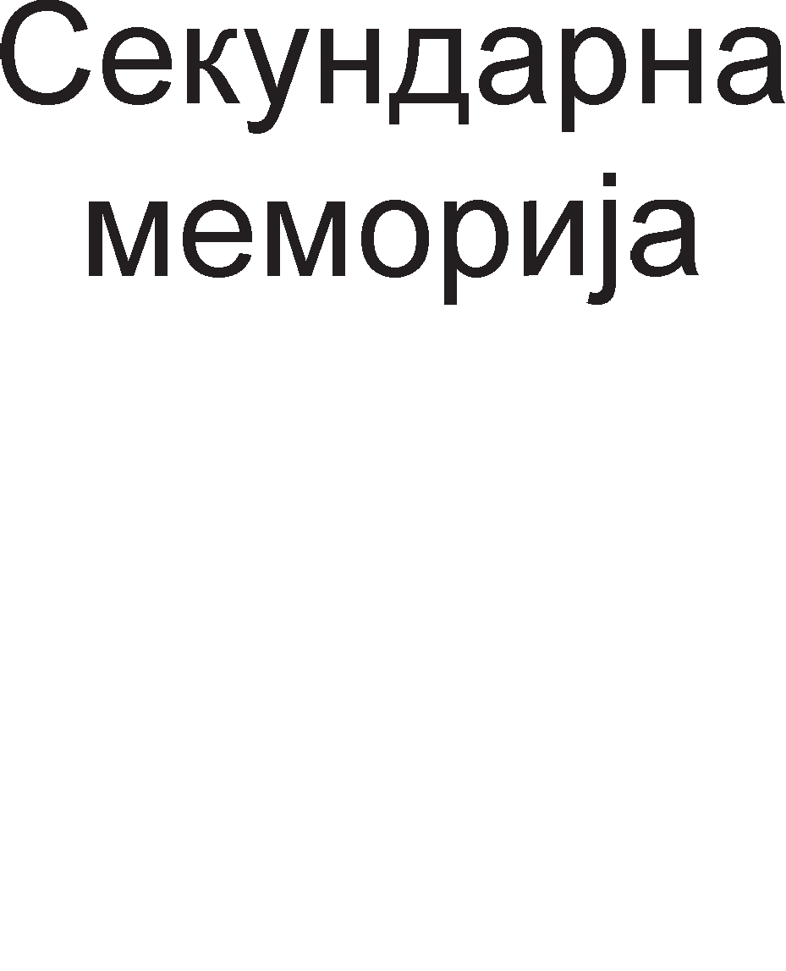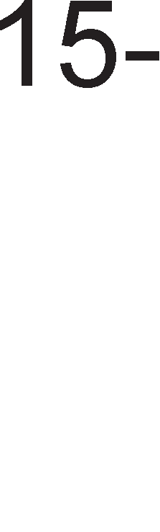

nocTojaT Hajpa3n1L1H1 anflop1TM1 3a BHecyBal-be HoB1 cTpaH1 Bo flnaBHaTa MeMop1ja. AKo c1Te paMK1 Bo flnaBHaTa MeMop1ja ce nonH1 co cTpaH1, ce nocTaByBa npawal-beTo Koja cTpaHa pa ce 13Bap1 3a pa ce cTaB1 HoBa Ha Hej31Ho MecTo. Hajpo6po 61 61no pa ce 3Hae KaKB1 no6apyBal-ba Ha cTpaH1 i<e 1Ma M1KponpoLecopoT Bo 6n1cKa 1pH1Ha, na T1e wTo i<e 61paT HajpaHo no6apaH1, pa ce cTaBaT Bo paMKaTa, a oH1e wTo i<e 61paT HajpoLHa no6apaH1, pa ce oTcTpaHaT 3a pa ce ocno6op1 MecTo 3a HoB1 cTpaH1. Ho, BaKB1 npeTnocTaBK1 e MHofly TewKo pa ce HanpaBaT. AocTa L1ecTo Kop1cTeH anflop1TaM e LRU (Least Recently Used), cnopep Koj, op flnaBHaTa MeMop1ja ce Bap1 oHaa cTpaHa wTo 61na HeopaMHa Kop1cTeHa. Kaj oBoj MeTop ce jaByBaaT oppepeH1 aHoMan11 1 epHa TaKBa e np1Ka>KaHa Ha Ta6enaTa 4.1.

|  |  |  |  |  |  |
| --- | --- | --- | --- | --- | --- |
| B1pTyenHa cTpaHa | 7 | B1pTyenHa cTpaHa | 7 | B1pTyenHa cTpaHa | 7 |
| B1pTyenHa cTpaHa | 6 | B1pTyenHa cTpaHa | 6 | B1pTyenHa cTpaHa | 6 |
| B1pTyenHa cTpaHa | 5 | B1pTyenHa cTpaHa | 5 | B1pTyenHa cTpaHa | 5 |
| B1pTyenHa cTpaHa | 4 | B1pTyenHa cTpaHa | 4 | B1pTyenHa cTpaHa | 4 |
| B1pTyenHa cTpaHa | 3 | B1pTyenHa cTpaHa | 3 | B1pTyenHa cTpaHa | 3 |
| B1pTyenHa cTpaHa | 2 | B1pTyenHa cTpaHa | 2 | B1pTyenHa cTpaHa | 2 |
| B1pTyenHa cTpaHa | 1 | B1pTyenHa cTpaHa | 1 | B1pTyenHa cTpaHa | 0 |
| B1pTyenHa cTpaHa | 0 | B1pTyenHa cTpaHa | 8 | B1pTyenHa cTpaHa | 8 |

a 6 B Ta6ena 4.1. LRU anflop1TaM 3a 3aMeHa Ha cTpaH1

l/lMeHo, M1KponpoLecopoT 1Ma noTpe6a op BHecyBal-be Ha npB1Te ocyM cTpaH1 op B1pTyenHaTa MeMop1ja (0-7). noToa Tpe6a pa ce BHece peBeTaTa cTpaHaTa co pepeH 6poj 8. Ho, 3a Hea HeMa MecTo. HeopaMHa Kop1cTeHa cTpaHa e oHaa co pepeH 6poj 0 1 Taa ce Bap1 3a pa Ha Hej31Ho MecTo pojpe cTpaHaTa co 6poj 8. Ancypp e wTo Bo HapepH1oT L1eKop M1KponpoLecopoT naK i<e ja no6apa cTpaHaTa 6poj 0 1 3a pa ja BHeceMe Tpe6a pa ja 13Bap1Me cTpaHaTa 6poj 1. OBa 3HaL11 peKa Bo npeTXopH1oT L1eKop 3aMeHaTa Ha cTpaHaTa 0 61no Ha HeKoj HaL11H flpeweH noTefl, Ho Toa H1 flo Hanafla LRU anflop1TaMoT. Apyfl Kop1cTeH anflop1TaM e FIFO (First In First Out), 1n1 Bo npeBop „Koj npB Bneflon npB 1 i<e 13ne3e“. OBpe Kp1Tep1yM 3a 3aMeHyBal-be Ha cTpaH1Te He e HajponfloTo BpeMe noM1HaTo op nocnepHaTa ynoTpe6a, TyKy HajponfloTo BpeMe noM1HaTo op BHecyBal-beTo Ha Taa cTpaHa Bo flnaBHaTa MeMop1ja.

3a npoflpaMepoT MHofly 61TeH cpaKTop e 6p31HaTa co Koja i<e ce 3aMeHyBaaT cTpaH1Te Bo flnaBHaTa MeMop1ja. l/lcTo TaKa, 61TeH napaMeTap e floneM1HaTa Ha cTpaH1Te, opHocHo paMK1Te. T1e He Tpe6a pa ce npeMHofly Man1 H1 npeMHofly floneM1. AKo ce npeMHofly floneM1, Toflaw Bo RAM MeMop1jaTa i<e 61paT cMecTeH1 Man 6poj cTpaH1 1 T1e Tpe6a pa 61paT noL1ecTo 3aMeHyBaH1 3a pa 61paT 3apoBoneH1 6apal-baTa Ha M1KponpoLecopoT. AoKonKy cTpaH1Te ce npeMan1, Toflaw ce 3floneMyBa 6pojoT Ha TpaHccpep1 wTo Tpe6a pa ce 13BpwaT 3a pa ce nononH1 LenaTa RAM MeMop1ja, Ho np1 nofloneM 6poj paMK1 Bo RAM MeMop1jaTa i<e 1MaMe 1 nofloneM 136op 3a Bapel-be Ha HeKoja cTapa cTpaHa 1 Hej31Ho 3aMeHyBal-be co HoBa. Bo ceKoj cnyL1aj, Tpe6a pa ce Hajpe KoMnpoM1cHo peweH1e, 1Maji<1 npepB1p peKa floneM1HaTa Ha cTpaHaTa 1 H1BH1oT 6poj Bo RAM MeMop1jaTa ce Bo o6paTHo nponopL1oHaneH opHoc.

# 0praHM3a4Mja Ha Kew MeMopMja

Kew MeMop1jaTa nocpepyBa Mery M1KponpoLecopoT 1 flnaBHaTa MeMop1ja. Cnopep HaMeHaTa Kew MeMop11Te Mo>KaT pa 61paT 1HcTpyKL1cK1 1 nopaToL1H1. Bo 1HcTpyKL1cKaTa Kew MeMop1ja ce L1yBaaT 1HcTpyKL11Te Ko1 ce opHanpep poHeceH1 op flnaBHaTa MeMop1ja 1 L1eKaaT pa 61paT noB1KaH1 3a 13BpwyBal-be op cTpaHa Ha M1KponpoLecopoT. nopaToL1HaTa Kew MeMop1ja fl1 L1yBa nopaToL1Te Ko1 M1KponpoLecopoT noL1ecTo fl1 noB1KyBa, a 3a 1cT1Te HeMa MecTo Bo onwT1Te pefl1cTp1 Ha M1KponpoLecopoT.

Bo nococp1cT1L1paH1Te MeMop1cK1 opflaH13aL11 nocTojaT HeKonKy H1Boa Ha Kew MeMop1ja. nocTojaT Tp1 H1Boa Ha Kew MeMop1ja. Kew MeMop1jaTa op npBo H1Bo ce Haora Bo caM1oT M1KponpoLecopcK1 L11n, Kew MeMop1jaTa op BTopo H1Bo ce Haora Bo caMoTo naKyBal-be Ha M1KponpoLecopoT 1 Kew MeMop1jaTa op TpeTo H1Bo ce Haora Ha MaT1L1HaTa nnoL1a.

l/lMnneMeHTaL1jaTa Ha c1Te B1poB1 Kew MeMop1ja ce Bpw1 Ha cnepH1oB HaL11H. rnaBHaTa MeMop1ja e nopeneHa Ha 6noKoB1 co KoHcTaHTHa floneM1Ha, HapeL1eH1 Kew n1H11. Kew n1H11Te ce cocTaBeH1 op 4 po 64 nocnepoBaTenH1 6ajT1. AKo n1H11Te ce cocTaBeH1 op 32 6ajT1 Toflaw HynTaTa n1H1ja i<e fl1 copp>K1 6ajT1Te co appec1 op 0 po 31 , npBaTa n1H1ja 6ajT1Te co appec1 op 32 po 63, BTopaTa op 64 po 95 1TH. HeKo1 op oB1e n1H11 ce HaoraaT Bo Kew MeMop1jaTa. npep pa np1cTan1 M1KponpoLecopoT po MeMop1jaTa, KoHTponepoT Ha Kew MeMop1jaTa npoBepyBa pan1 6apaH1oT nopaToK e Bo Kew MeMop1jaTa. AoKonKy caKaH1oT nopaToK e Bo Kew MeMop1jaTa M1KponpoLecopoT HeMa pa np1cTan1 po flnaBHaTa MeMop1ja. Bo Toj cnyL1aj appecHaTa 1 nopaToL1HaTa Mafl1cTpana i<e ocTaHaT cno6opH1 1 1cT1Te Mo>KaT pa ce 1cKop1cTaT 3a HeKoja ppyfla onepaL1ja KaKo Ha np1Mep p1peKTeH npeHoc Ha nopaToL1 op MeMop1jaTa 6e3 nocpepcTBo Ha M1KponpoLecopoT. Ho poKonKy caKaH1oT nopaToK He ce Haora Bo Kew MeMop1jaTa Toflaw HeKoja op npeTXopHo BHeceH1Te Kew n1H11 Tpe6a pa ce 13Bap1 1 Ha Hej31Ho MecTo Tpe6a pa ce 3an1we 6apaHaTa n1H1ja.

Ha cn1Ka 4.4. e np1Ka>KaHa flnaBHaTa MeMop1ja co KanaL1TeT op 4GB, Koja e nopeneHa Ha 6noKoB1 op no 32 6ajT1. Ha 1cTaTa cn1Ka e np1Ka>KaHa Kew MeMop1jaTa co 2048 Bne3oB1. CeKoj Bne3 op Kew MeMop1jaTa Mo>Ke pa co6epe epHa Kew n1H1ja op no 32 6ajT1, wTo 3HaL11 KanaL1TeToT Ha Kew MeMop1ja i<e 13HecyBa 2K·32B=64KB.

CeKoj Bne3 op Kew MeMop1jaTa ce cocTo1 op Tp1 pena.

1. 61ToT 3a Ban1pHocT H1 noKa>KyBa pan1 Bne3oT Ha Kew MeMop1jaTa e HanonHeT nocne cTapTyBal-beTo Ha c1cTeMoT 1n1 He. Kofla c1cTeMoT i<e ce cTapTyBa c1Te Bne3oB1 Bo Kew MeMop1jaTa ce MapK1paH1 KaKo HeBan1pH1.
2. TaKaHapeL1eHoTo none Tafl (aHfln1cK1 tag=o3HaL1yBal-be) flo copp>K1 pepH1oT 6poj Ha Kew n1H1jaTa op flnaBHaTa MeMop1ja op Kape wTo e 3eMeH nopaToKoT.
3. nopaToL1HoTo none flo copp>K1 nopaToKoT npeHeceH op Kew n1H1jaTa Bo Kew Bne3oT.



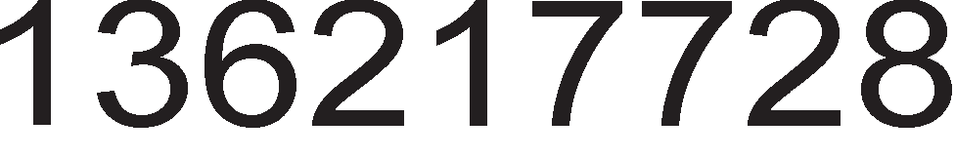



Cn1Ka 4.4. np1Ka3 Ha flnaBHaTa MeMop1ja (nopeneHa Ha 6noKoB1) 1 Kew MeMop1jaTa co 2048 Bne3oB1

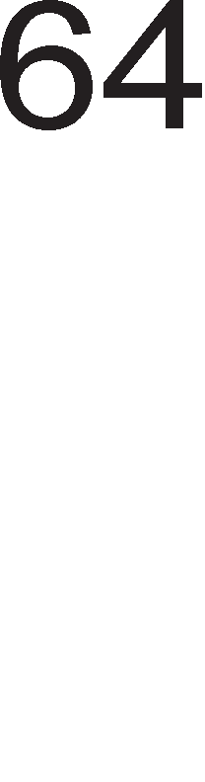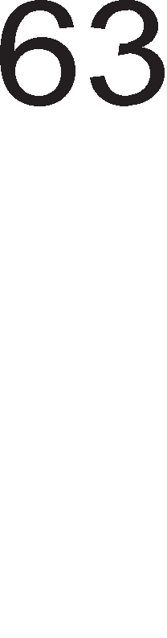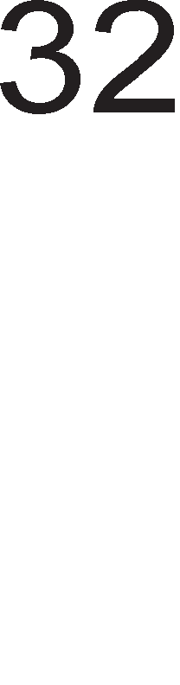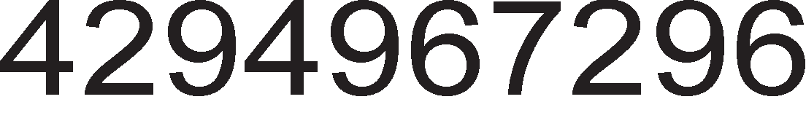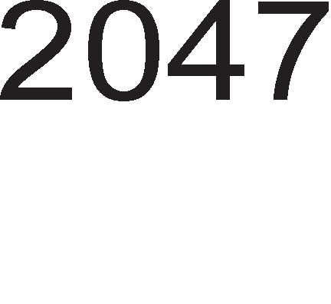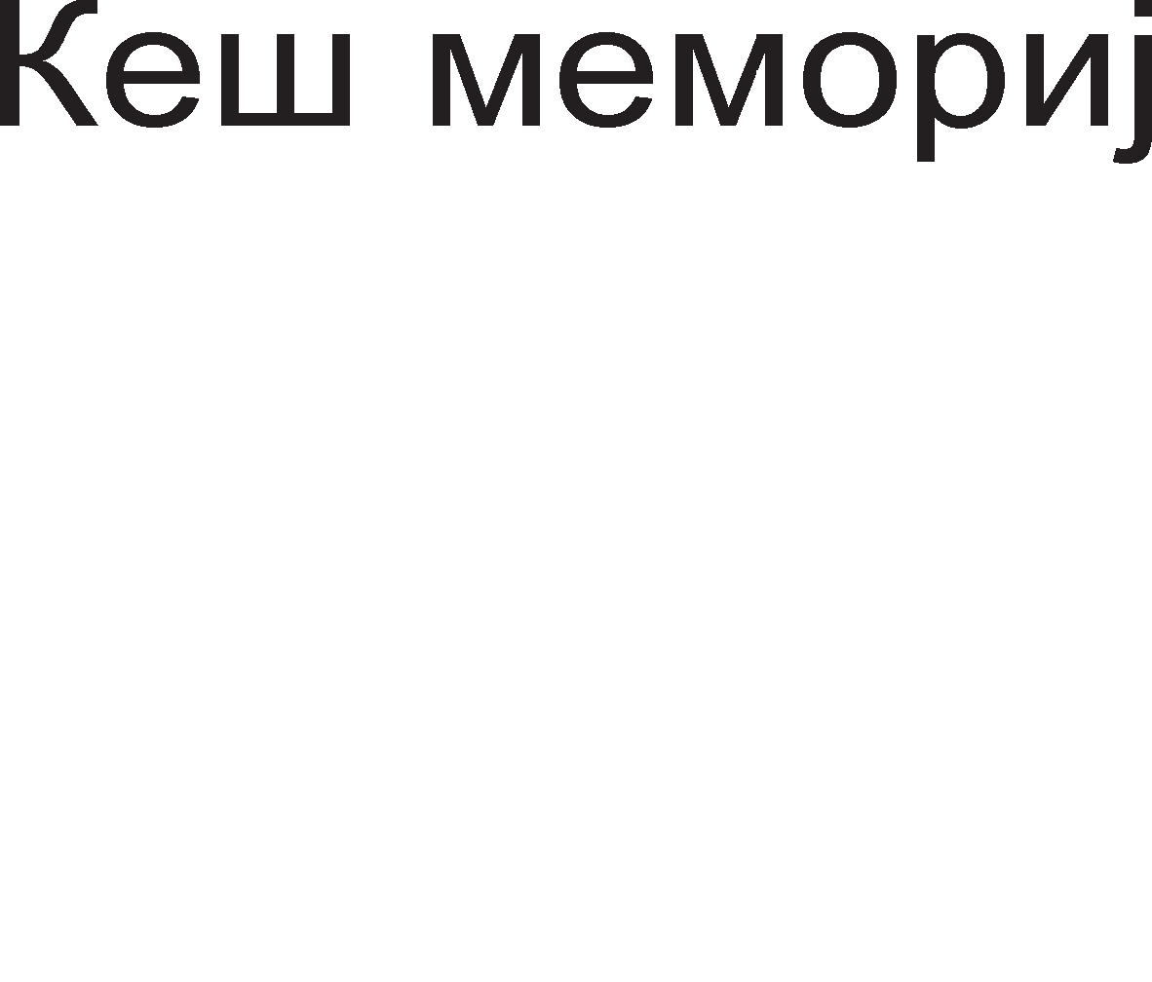

Ha cn1Ka 4.5. np1Ka>KaHa e B1pTyeHaTa appeca co L11ja noMow Kew KoHTponepoT flo npoHaora caKaH1oT nopaToK. rnepaMe peKa B1pTyenHaTa appeca e nopeneHa Ha Tp1 pena, 1cTo KaKo 1 Bne3oB1Te Ha Kew MeMop1jaTa.

1. noneTo Tafl opfloBapa Ha 1cTo1MeHoTo none op Kew Bne3oT
2. noneTo 3a n1H1ja flo paBa pepH1oT 6poj Ha Kew Bne3oT Bo Koj ce Haora caKaH1oT nopaToK
3. noneTo 3a 6ajT flo paBa pepH1oT 6poj Ha 6ajToT Bo 136paH1oT Kew Bne3.

Cn1Ka 4.5. B1pTyenHa appeca 3a npoHaoral-be Ha nopaToK op Kew MeMop1ja

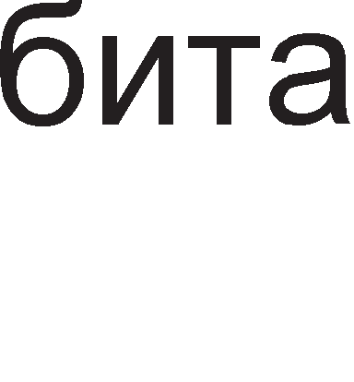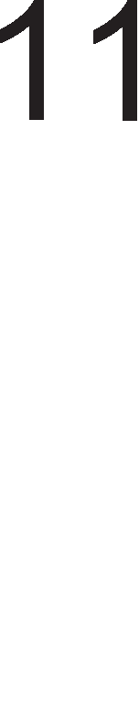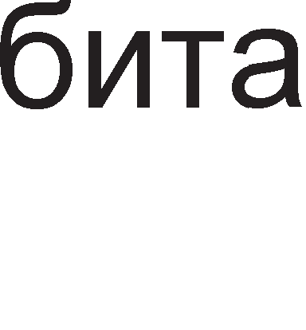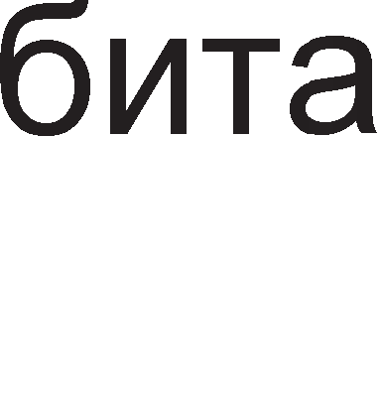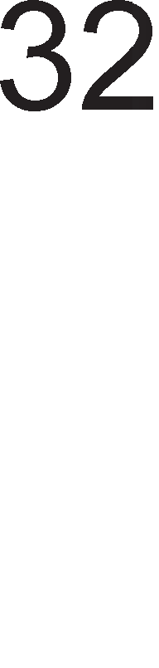

roneM1HaTa Ha ceKoe none op B1pTyenHaTa appeca ce oppepyBa Ha cnepH1oB HaL11H. 61peji<1 flnaBHaTa MeMop1ja e co KanaL1TeT 4GB B1pTyeHaTa appeca i<e 61pe 32 61THa. 6pojoT Ha 61ToB1 Bo noneTo 3a 6ajT 3aB1c1 op floneM1HaTa Ha Kew n1H1jaTa wTo ceKaKo e epHaKBa co floneM1HaTa Ha Kew Bne3oB1Te. Ha np1Mep aKo floneM1HaTa Ha Kew n1H1jaTa 13HecyBa 32 6ajT1 Toflaw

noneTo 3a 6ajT i<e 61pe floneMo neT 61ToB1 (25=32). roneM1HaTa Ha noneTo 3a

n1H1ja 3aB1c1 op Toa KonKy Bne3oB1 copp>K1 Kew MeMop1jaTa. Bo Haw1oT np1Mep Toj 6poj 13HecyBawe 2048=211 wTo 3HaL11 noneTo 3a n1H1ja i<e copp>K1 11 61ToB1. OcTaHaT1Te 16 61ToB1 op 32 61THaTa B1pTyenHa appeca flo npeTcTaByBaaT noneTo Ha TafloT.

Kofla M1KponpoLecopoT fleHep1pa appeca, ce 13pBojyBa noneTo 3a n1H1ja 1 1cToTo ce Kop1cT1 3a npoHaoral-be Ha epeH op 2048-Te Kew Bne3oB1. AKo 61ToT 3a Ban1pHocT e epHaKoB Ha ep1H1La Toflaw ce cnopepyBaaT noneTo 3a Tafl op B1pTyenHaTa appeca 1 noneTo 3a Tafl op Kew Bne3oT. AKo T1e ce noKnonyBaaT Toflaw Ben1Me peKa Kew MeMop1jaTa flo copp>K1 caKaH1oT nopaToK 1 BaKBaTa c1TyaL1ja ce HapeKyBa Kew noflopoK. CaKaH1oT nopaToK i<e ce npoL11Ta op Kew MeMop1jaTa 1 i<e ce op6eflHe npeHocoT op flnaBHaTa MeMop1ja. noneTo 3a 6ajT H1 oBo3Mo>KyBa pa 13pBo1Me caMo epeH 6ajT 6e3 pa ja npeHecyBaMe LenaTa copp>K1Ha Ha Kew Bne3oT. AKo 61ToT 3a Ban1pHocT e epHaKoB Ha Hyna 1n1 non1l-baTa 3a Tafl He ce coBnaraaT Toflaw Ben1Me peKa caKaH1oT nopaToK He ce Haora Bo Kew MeMop1jaTa. BaKBaTa c1TyaL1ja e no3HaTa nop 1MeTo Kew npoMawyBal-be. Bo Toj cnyL1aj Tpe6a pa ce op1 po flnaBHaTa MeMop1ja, op TaMy pa ce 3eMe caKaHaTa Kew n1H1ja 1 pa ce BHece Bo Kew MeMop1jaTa.

l/l noKpaj BaKBaTa ManKy ponfla nocTanKa Ha npe6apyBal-be Ha Kew MeMop1jaTa, Taa 1Ma MHofly Mano BpeMe Ha np1cTan Koe e op pep Ha Ben1L11Ha HaHoceKypa. rnaBeH npo6neM npeTcTaByBaaT Kew npoMawyBal-baTa 61peji<1 Toflaw Tpe6a pa ce 13BpwaT npe6apyBal-ba Ha pBe MeMop11, Kew MeMop1jaTa 1 flnaBHaTa MeMop1ja.

# noep3yea1-e co e11e3Ho/M311e3HM ype,qM

Bne3Ho 13ne3H1Te ypep1 cny>KaT 3a KoMyH1KaL1ja Ha KoMnjyTepoT co HapBopewH1oT cBeT. T1e Mo>KaT pa 61paT Bne3H1 (TacTaTypa, flnyweL) , 13ne3H1 (MoH1Top, neL1aTaL1) 1n1 Bne3Ho 13ne3H1 (CD p1cKoT). Bne3Ho 13ne3H1Te ypep1 ce no3HaT1 1 nop 1MeTo nep1cpepH1 ypep1. noKpaj 3a KoMyH1KaL1ja co HapBopewH1oT cBeT HeKo1 op H1B ce Kop1cTaT 1 3a L1yBal-be Ha nopaToL1. He3flopHo e wTo 3a npeHoc Ha nopaToL1 Bne3Ho 13ne3H1Te ypep1 fl1 Kop1cTaT appecHaTa 1 nopaToL1HaTa Mafl1cTpana 1cTo KaKo 1 MeMop1cK1Te ypep1. 3a pa nopo6po flo pa36epeMe npeHocoT Ha nopaToL1 Mery Bne3Ho 13ne3H1Te ypep1 1 M1KponpoLecopoT i<e pa3flnepaMe pBa MHofly epHocTaBH1 np1Mep1.

Ha cn1Ka 4.6. e papeH np1Mep 3a noBp3yBal-be co ocyM napanenH1 npeK1HyBaL11. npeK1HyBaL11Te ce noBp3aH1 co nopaToL1HaTa Mafl1cTpana npeKy 6acpep 74ALS244. Ha Bne3 op 6acpepoT ce np1KnyL1eH1 npeK1HyBaL11Te, a Ha 13ne3 ocyMTe n1H11 op nopaToL1HaTa Mafl1cTpana. Kofla HeKoj op npeK1HyBaL11Te e 3aTBopeH no nopaToL1HaTa n1H1ja ce 1cnpai<a nofl1L1Ka Hyna 61peji<1 npeK1HyBaL1oT flo Bp3yBa Bne3H1oT n1H Ha 6acpepoT Ha Maca. Kofla npeK1HyBaL1oT e oTBopeH Toflaw ce 1cnpai<a nofl1L1Ka ep1H1La. Bo npBaTa TeMa, Kofla 36opyBaBMe 3a ocHoBH1 nofl1L1K1 Kona 1cTaKHaBMe peKa 6acpepoT He Bpw1 o6pa6oTKa Ha c1flHan1Te TyKy Toj Bpw1 XapBepcKo noBp3yBal-be Ha nep1cpepH1Te ypep1 co nopaToL1HaTa Mafl1cTpana.

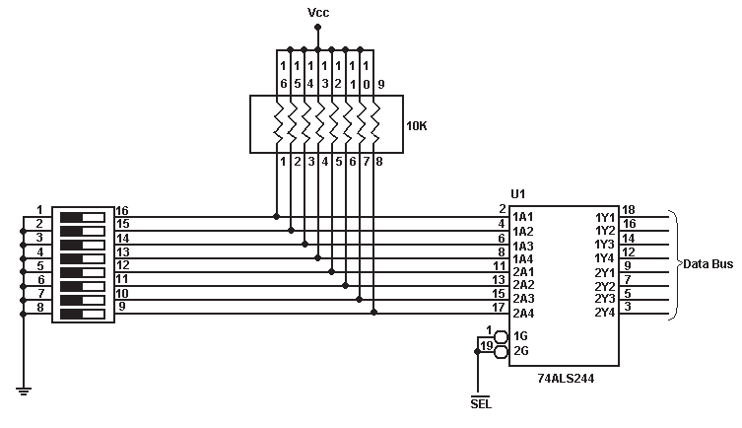

Cn1Ka 4.6. noBp3yBal-be Ha M1KponpoLecop co 8 napanenH1 npeK1HyBaL11 Aan1 6acpepoT i<e fl1 nponywTa 61ToB1Te Ko1 fl1 1cnpai<aaT npeK1HyBaL11Te

3aB1c1 op cocToj6aTa Ha c1flHanoT . AKo oBoj c1flHan e Ha B1coKo H1Bo 6acpepoT i<e 61pe Bo cocToj6a Ha B1coKa 1MneHpaHca, a aKo e Ha H1cKo H1Bo Toflaw i<e ce aKT1B1TaaT pBaTa n1Ha 3a ceneKL1ja Ha 6acpepoT 1G 1 2G (G – gate). BpepHocTa Ha c1flHanoT ce po61Ba co peKop1pal-be Ha 1HTepcpejc appecaTa Ha nep1cpepH1oT ypep 3a wTo i<e cTaHe 36op nopoLHa.



Ha cn1Ka 4.7. e np1Ka>KaH np1Mep 3a noBp3yBal-be co 13ne3eH ypep. OcyMTe napanenHo nocTaBeH1 nep p1op1 cBeTaT Kofla M1KponpoLecopoT i<e 1cnpaT1 nofl1L1Ka 0. Mery nopaToL1HaTa Mafl1cTpana 1 LED p1op1Te e nocTaBeH cneL1janeH ypep, TaKaHapeL1eH neL1 (latch) cn1L1Ho KaKo 6acpepoT Kaj Bne3H1oT 1HTepcpejc. neL1oT e ypep cocTaBeH op TaKT1paL1K1 cpn1n-cpnonoB1 L11ja 3apaL1a e pa flo npopon>KaT BpeMeTpael-beTo Ha no6ypH1oT c1flHan. C1flHan1Te wTo fl1 1cnpai<a M1KponpoLecopoT TpaaT caMo 1 μs. OBa BpeMe He e poBonHo 3a pa ce no6ypaT nep p1op1Te. 3aToa BepHaw nocne np1cT1flHyBal-beTo Ha c1flHanoT Ha Bne3 op TaKT1paL1K1oT cpn1n cpnon p1fl1TcK1oT TaKT ce cnywTa Ha H1cKo H1Bo, ce

oHecnoco6yBaaT Bne3oB1Te, Ho 1cnpaTeH1oT c1flHan ocTaHyBa Ha 13ne3oT op cpn1n cpnonoT.

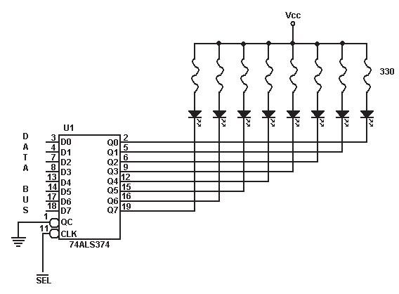

Cn1Ka 4.7. noBp3yBal-be Ha M1KponpoLecop co 8 napanenH1 nep p1op1

Op oB1e pBa epHocTaBH1 np1Mep1 Mo>Ke pa ce B1p1 peKa Bne3Ho 13ne3H1Te ypep1 He ce p1peKTHo noBp3aH1 Ha c1cTeMcKaTa Mafl1cTpana. KonaTa Ko1 nocpepyBaaT Bo KoMyH1KaL1jaTa Mery nep1cpepH1Te ypep1 1 c1cTeMcKaTa Mafl1cTpana ce HapeKyBaaT Bne3Ho/13ne3H1 KoHTponep1 1n1 1HTepcpejc KoHTponep1. nocTojaT noBei<e po6p1 np1L11H1 3a ynoTpe6a Ha oB1e KoHTponep1. npep cè T1e My ja onecHyBaaT ynpaByBaL1KaTa cpyHKL1ja Ha M1KponpoLecopoT. M1KponpoLecopoT i<e 61pe nocno6opeH 1 no6p3o i<e fl1 13BpwyBa Kop1cH1L1K1Te npoflpaM1. l/lHTepcpejc KoHTponep1Te fleHep1paaT epHocTaBH1 KoHTponH1 c1flHan1 3a ynpaByBal-be co nep1cpepH1Te ypep1. 3a 1cnpai<al-be Ha c1flHan1Te no c1cTeMcKaTa Mafl1cTpana ce Tpow1 MHofly ManKy eHepfl1ja. AKo He ce Kop1cTaT 1HTepcpejc KoHTponep1 1 1cT1Te He fl1 3ac1naT 1cnpaTeH1Te c1flHan1 Toflaw Ka6n1Te 3a noBp3yBal-be Ha nep1cpepH1Te ypep1 co KoMnjyTepoT 61 61ne ponfl1 caMo HeKonKy caHT1MeTp1.

Bne3Ho/13ne3H1Te KoHTponep1 copp>KaT Tp1 B1poB1 Ha BHaTpewH1 pefl1cTp1: nopaToL1H1, KoMaHpH1 1 cTaTycH1. Pefl1cTp1Te Ha Bne3Ho 13ne3H1oT KoHTponep ce np1Ka>KaH1 Ha cn1Ka 4.8. nopaToL1H1Te pefl1cTp1 fl1 L1yBaaT nopaToL1Te Ko1 ce npoL11TaH1 1n1 Tpe6a pa ce 3an1waT Bo HeKoj op nep1cpepH1Te ypep1. CTaTyc pefl1cTapoT copp>K1 1HcpopMaL1ja 3a MoMeHTanHaTa cocToj6a Ha nep1cpepH1Te ypep1. 3HaL1el-beTo Ha oB1e pefl1cTp1 i<e flo o6jacH1Me npeKy np1Mep 3a noBp3yBal-be Ha KoMnjyTepoT co neL1aTaL1. npep pa 1cnpaT1 M1KponpoLecopoT KapaKTep po neL1aTaL1oT Toj flo npoBepyBa cTaTyc pefl1cTapoT Ha KoHTponepoT Koj ynpaByBa co neL1aTaL1oT. LleTBpT1oT 61T op cTaTyc pefl1cTapoT paBa 1HcpopMaL1ja 3a Toa pan1 neL1aTaL1oT e np1KnyL1eH 1n1 He 3a KoMnjyTepoT, cepM1oT 61T paBa 1HcpopMaL1ja 3a 3acpaTeHocTa Ha neL1aTaL1oT 1 neTToT 61T pan1 1Ma 1n1 HeMa XapT1ja 3a neL1aTel-be. nopaToL1H1oT pefl1cTap flo L1yBa KapaKTepoT Koj Tpe6a pa

61pe 1cneL1aTeH, a npeKy KoMaHpH1oT pefl1cTap M1KponpoLecopoT ja 3apaBa onepaL1jaTa Koja Tpe6a pa ja 13Bpw1 neL1aTaL1oT.

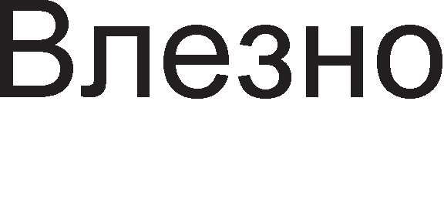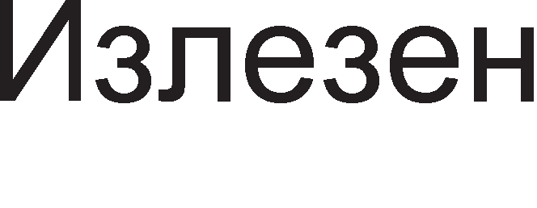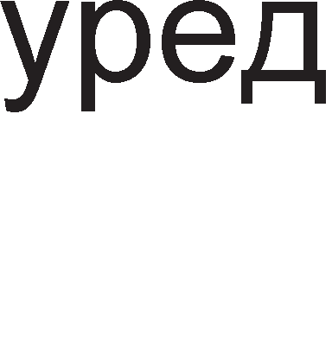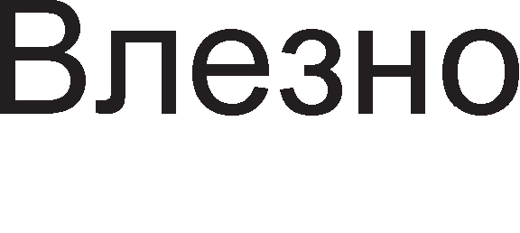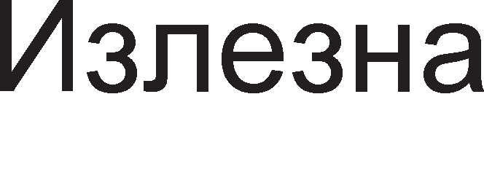

Cn1Ka 4.8. 6noK p1jaflpaM Ha Bne3Ho 13ne3eH KoHTponep

C1Te pefl1cTp1 Bo Bne3Ho/13ne3H1Te KoHTponep1 1MaaT cBoja appeca TaKaHapeL1eHa 1HTepcpejc appeca. l/lHTepcpejc appec1Te ce 1cnpai<aaT npeKy appecH1Te n1HoB1 Ha M1KponpoLecopoT, 1cTo KaKo 1 MeMop1cK1Te appec1. Ce nocTaByBa npawal-beTo, Kofla appecH1Te 61ToB1 i<e npeTcTaByBaaT MeMop1cKa appeca, a Kofla 1HTepcpejc appeca.

**A,qpecMpa1-eTo Ha nepMcpepHMTe ype,qM** Mo>Ke pa ce pean131pa Ha pBa HaL11Ha:

* + 13on1paH Bne3/13ne3
  + MeMop1cK1 npecn1KaH Bne3/13ne3

Kaj 13on1paH1oT Bne3/13ne3 ce Kop1cT1 c1flHanoT IO/ (input output/ ) 3a opBojyBal-be Ha MeMop1jaTa op Bne3Ho-13ne3H1Te ypep1.



Kaj MeMop1cK1 npecn1KaH1oT Bne3/13ne3 c1flHanoT IO/ He ce Kop1cT1. Kaj oBoj np1cTan 3a opBojyBal-be Ha MeMop1jaTa op nep1cpepH1Te ypep1 ce Kop1cT1 appeceH 61T, o61L1Ho Haj3HaL1ajH1oT. AKo 1MaMe 16 appecH1 n1H11, Toflaw Kofla 61ToT A15=0 appecaTa i<e 61pe MeMop1cKa. AKo A15=1 Toflaw appecaTa op M1KponpoLecopoT i<e 61pe 1HTepcpejc appeca 3a nep1cpepeH ypep. npepHocT1 Ha MeMop1cK1 npecn1KaH1oT Bne3/13ne3 e wTo 3a npeHoc po 1n1 op nep1cpepH1Te ypep1 ce Kop1cTaT 1cT1Te 1HcTpyKL11 3a npeHoc KaKo 1 3a MeMop1jaTa. OBa npeTcTaByBa 3HaL11TenHo npow1pyBal-be Ha 1HcTpyKL1cKoTo MHo>KecTBo 3a pa3n1Ka op 13on1paH1oT Bne3/13ne3, Kape wTo 3a KoMyH1KaL1ja Mery M1KponpoLecopoT 1 nep1cpepH1oT ypep Mo>Ke pa ce Kop1cTaT caMo cneL1janH1 1HcTpyKL11 3a npeHoc. Ho, npecn1KaH1oT Bne3/13ne3 1Ma 1 cBo1 HepocTaToL1. TyKa e, npep c*è,* Tpowel-beTo appecH1 61ToB1 3a Bne3Ho-13ne3H1Te ypep1. ABToMaTcK1 MeMop1cK1oT npocTop i<e ce HaMan1. Apyfl HepocTaToK e wTo np1MeHeT1Te 1HcTpyKL11 TpaaT noponflo BpeMe nopap1 noponfl1Te 1HcTpyKL1cK1 KopoB1.

npep pa 3anoL1He npeHocoT Ha nopaToL1 Mery M1KponpoLecopoT 1 HeKoj nep1cpepeH ypep, T1e c1 1cnpai<aaT KoHTponH1 c1flHan1, co Len pa ce o6e36ep1 c1flypeH npeHoc. Bo 3aB1cHocT op B1poT Ha KoHTponH1Te c1flHan1, pa3n1KyBaMe **"1eTMpM pe>KMMM Ha napa11e11eH npeHoc**: epHocTaBeH, cTpo61paH, pe>K1M Ha no3ppaB 1 pBoeH no3ppaB. Ha cn1KaTa 4.9. papeH1 ce KoHTponH1Te c1flHan1 3a npB1Te Tp1 pe>K1M1 1 H1BH1Te 6noK weM1. Co KpyflL11l-ba e o6ene>KaH pepocnepoT Ha 1cnpai<al-be Ha c1flHan1Te.

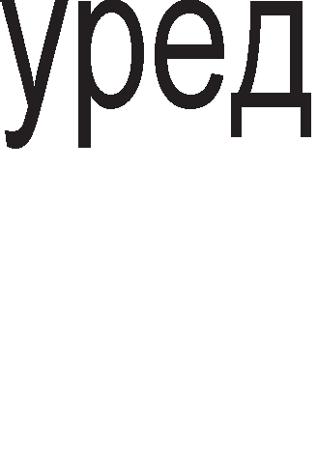

1. epHocTaBeH pe>K1M 6) cTpo61paH pe>K1M B) pe>K1M Ha no3ppaB Cn1Ka 4.9. 6noK p1jaflpaM1 Ha pe>K1M1Te Ha napaneneH npeHoc

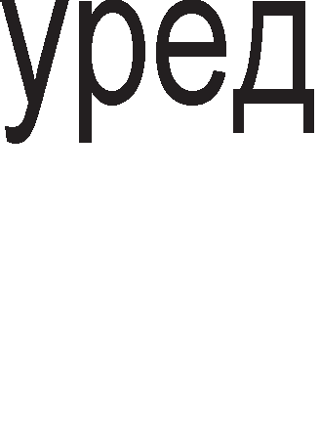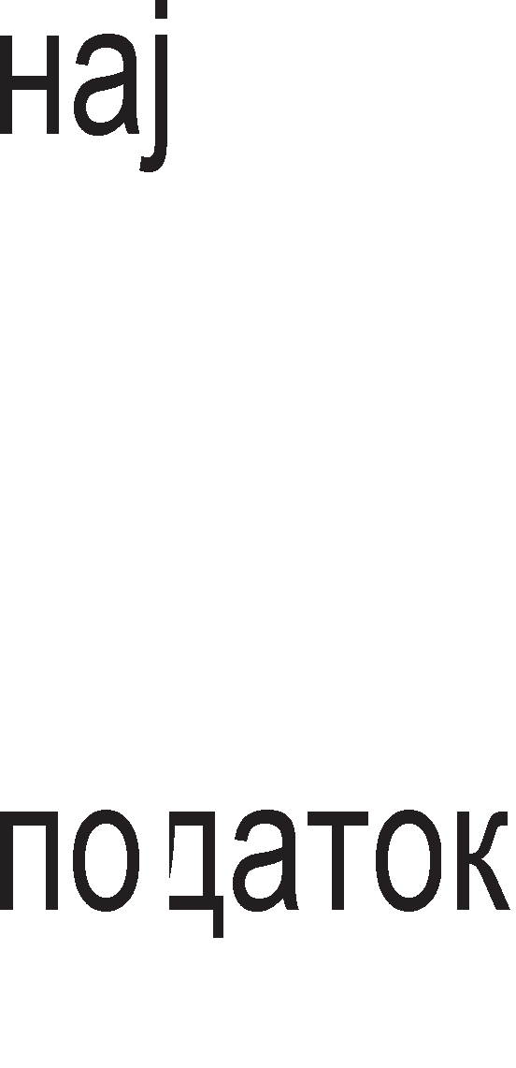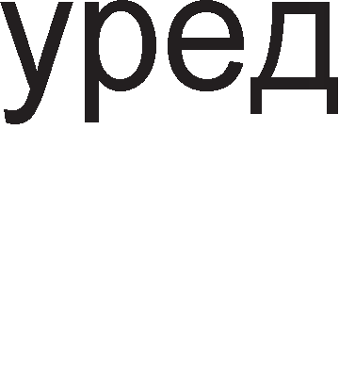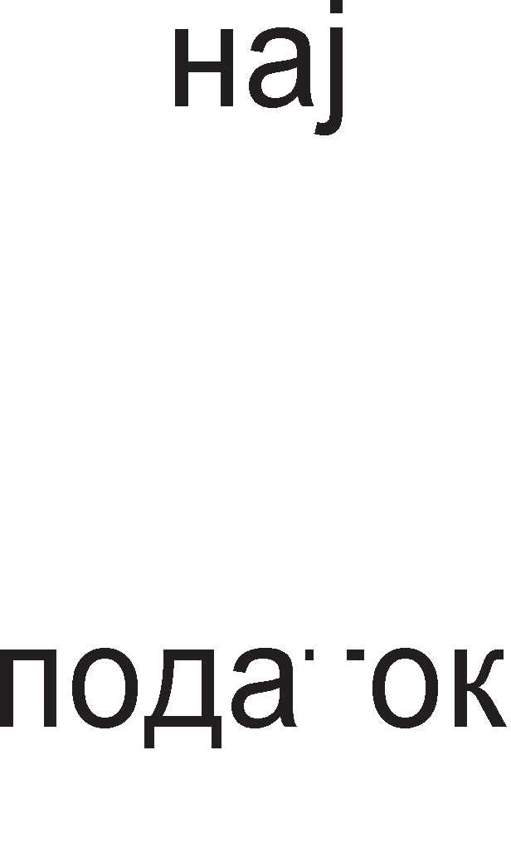

YpepoT Koj 1cnpai<a nopaToL1 Mo>Ke pa 1cnpaT1 c1flHan 3a HajaBa (aHfln1cK1-strobe), a ypepoT Koj np1Ma nopaToL1 Mo>Ke pa 1cnpaT1 noTBppa peKa ja np1M1n HajaBaTa (aHfln1cK1-acknowledge). Kaj pe>K1MoT Ha epHocTaBeH npeHoc M1KponpoLecopoT 1 Bne3Ho 13ne3H1Te ypep1 He pa3MeHyBaaT KoHTponH1 c1flHan1 npep pa 3anoL1He npeHocoT Ha Kop1cH1L1Ka 1HcpopMaL1ja. OBoj B1p Ha npeHoc e HajHec1flypeH 61peji<1 Mo>Ke pa pojpe po necHo fly6el-be Ha Kop1cH1L1KaTa 1HcpopMaL1ja. EpHocTaBH1oT pe>K1M e HajHec1flypeH, Ho e HajeKoHoM1L1eH 61peji<1 ce wTep1 Bo XappBep. Kaj cTpo61paH1oT pe>K1M ypepoT Koj 1cnpai<a nopaToL1 flo HajaByBa npeHocoT npeKy aKT1B1pal-be Ha c1flHanoT 3a HajaBa (strobe). CTpo61paH1oT pe>K1M ce Kop1cT1 Bo KoMyH1KaL1jaTa Mery M1KponpoLecopoT 1 TacTaTypaTa. Kaj pe>K1MoT Ha no3ppaB (handshaking) ypep1Te c1 pa3MeHyBaaT KoHTponH1 c1flHan1, c1flHan 3a HajaBa (strobe) 1 c1flHan 3a noTBppa (acknowledge). Pe>K1MoT Ha pBoeH no3ppaB e Hajc1flypeH, Ho e HajcKan, 61peji<1 L1eT1p1Te 6aKapH1 Bopa i<e ce ynoTpe6aT 3a 1cnpai<al-be KoHTponH1 c1flHan1. l/lcTo TaKa, KonKy noBei<e c1flHan1 nocTojaT, TonKy noponflo i<e Tpae npeHocoT.

# npaKTM"1HM e11e3Ho M311e3HM nopTM

HajL1ecTo Kop1cTeH1 KoMnjyTepcK1 nopT1 ce: napanenHaTa nopTa, cep1cKaTa nopTa 1 USB nopT1Te. 3a pa Mo>KeMe pa noBp3yBaMe nep1cpepH1 ypep1 Ba>KHo e pa flo no3HaBaMe pacnopepoT Ha n1HoB1Te Ha nopT1Te 1 3HaL1el-beTo Ha H1BH1Te c1flHan1.

**napa11e11HaTa nopTa** ce Kop1cT1 3a noBp3yBal-be Ha neL1aTaL11, a nopoLHa i<e B1p1Me peKa ce Kop1cT1 1 np1 npoflpaM1pal-be Ha M1KpoKoHTponep1. napanenHaTa nopTa 1Ma HajfloneM 6poj Ha n1HoB1. KoMnjyTepoT Mo>Ke pa 1Ma Tp1 napanenH1 nopT1: LPT1, LPT2 1 LPT3, Ho HajL1ecT1 1Ma epHa nopTa LPT1.

napanenHaTa nopTa ce KoHTpon1pa npeKy Tp1 pefl1cTp1: nopaToL1eH, KoMaHpeH 1 cTaTyceH. OB1e pefl1cTp1 Kop1cTaT Tp1 nocnepoBaTenH1 1HTepcpejc appec1. CTaHpappH1Te XeKcapeL1ManH1 appec1 Ha oB1e pefl1cTp1 ce np1Ka>KaH1 Bo Ta6enaTa 4.2 .

|  |  |  |  |
| --- | --- | --- | --- |
| nopTa | nopaToL1Ha nopTa | CTaTycHa nopTa | KoMaHpHa nopTa |
| LPT1 | 378H | 379H | 37AH |
| LPT2 | 278H | 279H | 27AH |
| LPT3 | 3BCH | 3BDH | 3BEH |

Ta6ena 4.2. CTaHpappH1 1HTepcpejc appec1 3a pefl1cTp1Te Ha napanenHaTa nopTa

Ka6enoT 3a noBp3yBal-be Ha KoMnjyTepoT co neL1aTaL1oT 1Ma pBa KoHeKTop1 DB25 1 CENT39. KoHeKTopoT DB25 npeTcTaByBa 13ne3 Ha KoMnjyTepoT, a KoHeKTopoT CENT39 Bne3 3a neL1aTaL1oT. PacnopepoT Ha H1BH1Te n1HoB1 e papeH Ha cn1Ka 4.10..

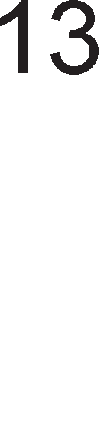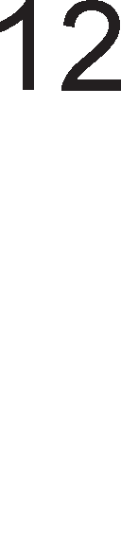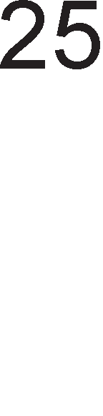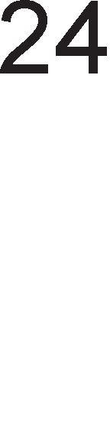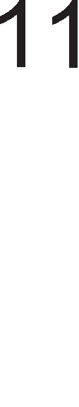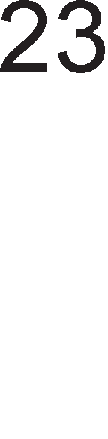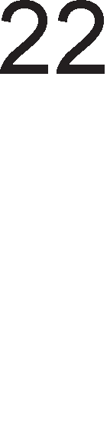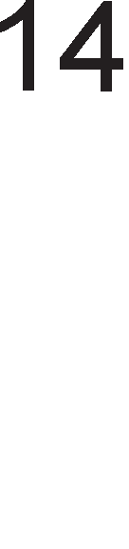

Cn1Ka 4.10. napanenHa nopTa DB25

Bo Ta6enaTa 4.3. ce np1Ka>KaH1 c1flHan1Te 3a ceKoj op n1HoB1Te.

|  |  |  |  |
| --- | --- | --- | --- |
| 6poj Ha n1H | | c1flHan | cpyHKL1ja |
| DB25 | CENT39 |
| 1 | 1 |  | M1KponpoLecopoT 1cnpai<a c1flHan 3a HajaBa |
| 2 | 2 | Data 0 | npB 61T op nopaToKoT |
| 3 | 3 | Data1 | BTop 61T op nopaToKoT |
| 4 | 4 | Data2 | TpeT 61T op nopaToKoT |
| 5 | 5 | Data3 | LleTBpT1 61T op nopaToKoT |
| 6 | 6 | Data4 | neTT1 61T op nopaToKoT |
| 7 | 7 | Data5 | WecT1 61T op nopaToKoT |
| 8 | 8 | Data6 | CepM1 61T op nopaToKoT |
| 9 | 9 | Data7 | OcM1 61T op nopaToKoT |
| 10 | 10 |  | neL1aTaL1oT 1cnpai<a c1flHan 3a noTBppa paKa flo np1M1n nopaToKoT |
| 11 | 11 | Busy | neL1aTaL1oT e 3acpaTeH |
| 12 | 12 | Paper empty | HaMa XapT1ja |
| 13 | 13 | Select | neL1aTaL1oT e np1KnyL1eH |
| 14 | 14 | Afd | noMecTyBal-be Ha neL1aTaL1oT 3a epeH pep nopone |

|  |  |  |  |
| --- | --- | --- | --- |
| 15 | 32 |  | rpewKa np1 neL1aTel-beTo |
| 16 | - | Int | neL1aTaL1oT ce 1H1L1pa pa flo 1cneL1aT1 KapaKTepoT , a noToa ce peceT1pa |
| 17 | 31 | Select in | l/l36paH e neL1aTaL1 |
| 18-25 | 19-30 | 3a3eMjyBal-be | / |
| - | 17 | 3a3eMjyBal-be | / |
| - | 16 | 3a3eMjyBal-be | / |
| - | 33 | 3a3eMjyBal-be | / |

Ta6ena 4.3. <lyHKL1cK1 on1c Ha n1HoB1Te Ha napanenHaTa nopTa DB25

**CepMcKaTa nopTa** Ha KoMnjyTepoT (COM) ce Kop1cT1 3a noBp3yBal-be Ha HapBopewH1 MopeM1, flnyBL1e, nnoTep 1 pp. l/lcTo TaKa npeKy Hea Mo>Ke pa ce 13flpap1 Mana noKanHa Mpe>Ka Koja Kop1cT1 onepaT1BeH c1cTeM Windows. Cep1cKaTa nopTa Kop1cT1 pBa B1pa Ha KoHeKTop1: D-SUB (25 n1HcK1) 1 D-SUB (9 n1HcK1). O6n1KoT Ha KoHeKTopoT 1 pacnopepoT Ha n1HoB1Te ce np1Ka>KaH1 Ha cn1Ka 4.11.

Cn1Ka 4.11. Cep1cK1 nopT1

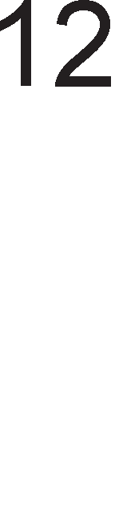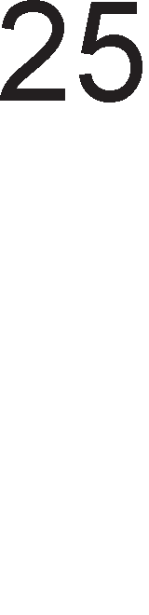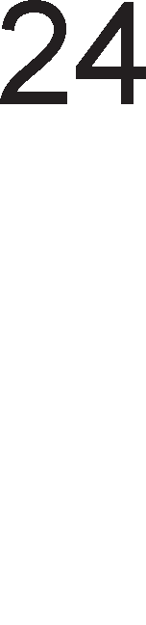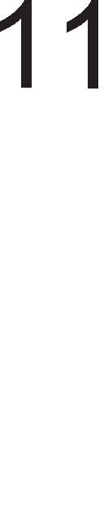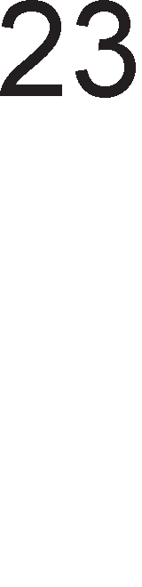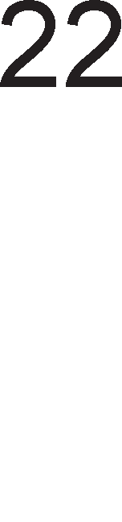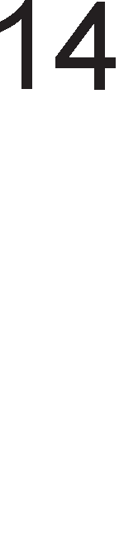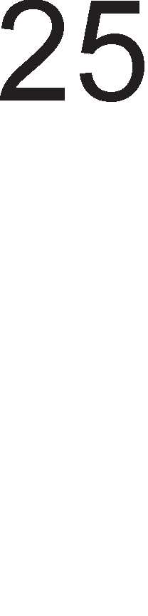

Bo Ta6enaTa 4.4. o6jacHeTo e 3HaL1el-beTo Ha noBa>KH1Te c1flHan1 op oB1e pBa KoHeKTop1.

|  |  |  |  |
| --- | --- | --- | --- |
| D-SUB 25 | D-SUB 9 | C1flHan | <lyHKL1ja |
| n1H 2 | n1H 2 | TD-Transmit Data | Cep1cK1 Bne3 Ha npaToL1 |
| n1H3 | n1H 3 | RD-Receive Data | Cep1cK1 13ne3 Ha nopaToL1 |
| n1H 4 | n1H 7 | RTS-Request To Send | l/lH1L1pa cnpeMHocT Ha MopeMoT 3a pa3MeHa Ha nopaToL1 |
| n1H 5 | n1H 8 | CTS-Clear To Send | Ce aKT1B1pa nocne np1eMoT Ha c1flHanoT CD |
| n1H 6 | n1H 6 | DSR-Data Set Ready | l/lH1L1pa cnpeMHocT 3a pa6oTa |
| n1H 7 | n1H 5 | SG-Signal Ground | Maca |
| n1H 8 | n1H 1 | CD-Carrier Detect | BpcKaTa e BocnocTaBeHa |
| n1H 20 | n1H 4 | DTR-Data Terminal Ready | nocne np1eMoT Ha c1flHanoT DSR 1H1L1pa cnpeMHocT Ha DTR |
| n1H 22 | n1H 9 | RI-Ring Indicator | AeTeKT1paH c1flHan Ha TenecpoHcKaTa n1H1ja |

Ta6ena 4.4. <lyHKL1cK1 on1c Ha n1HoB1Te Ha cep1cK1Te nopT1

npoToKonoT 3a 1cnpai<al-be Ha nopaToL1 i<e flo o6jacH1Me npeKy np1Mep 3a pa3MeHa Ha nopaToL1 Mery pBa KoMnjyTep1 A 1 B. npoToKonoT 3a npeHoc Mo>KeMe pa flo nopen1Me Bo Tp1 cpa31: BocnocTaByBal-be Ha BpcKa, npeHoc Ha nopaToL1 1 pacK1HyBal-be Ha BpcKa.

<la3aTa Ha BocnocTaByBal-be Ha BpcKa Mo>KeMe pa ja nopen1Me Bo Tp1 L1eKop1:

1. KoMnjyTepoT A flo aKT1B1pa c1flHanoT DTR co wTo My 1H1L1pa Ha MopeMoT A peKa caKa pa npeHecyBa nopaToL1. noToa flo npeHecyBa TenecpoHcK1oT 6poj Ha np1eMH1KoT po MopeMoT B npeKy n1HoT TD.
2. Kofla MopeMoT A i<e BocnocTaB1 BpcKa co MopeMoT B, MopeMoT B My flo HajaByBa Ha cBojoT KoMnjyTep pojpoBH1oT noB1K npeKy aKT1B1pal-be Ha n1HoT RI. AKo KoMnjyTepoT B e cnpeMeH 3a np1eM Ha nopaToL1 Toflaw Toj i<e flo aKT1B1pa c1flHanoT DTR. nocne po61Bal-beTo Ha 3eneHo cBeTno MopeMoT B flo aKT1B1pa c1flHanoT DSR peKa e cnpeMeH pa np1M1 nopaToL1 op KoMnjyTepoT A.
3. nocne np1eMoT Ha noBpaTHaTa 1HcpopMaL1ja MopeMoT A flo 1HcpopM1pa cBojoT KoMnjyTep npeKy aKT1B1pal-be Ha n1HoT CD. l/lcTo TaKa flo aKT1B1pa n1HoT DSR co wTo 3BpwyBa cpa3aTa Ha BocnocTaByBal-be Ha BpcKa.

3a cpa3aTa Ha npeHoc Ha nopaToL1 ce Kop1cT1 pe>K1MoT Ha no3ppaByBal-be np1 wTo KoHTponH1Te c1flHan1 ce pa3MeHyBaaT npeKy n1HoB1Te RTS 1 CTS. CaM1Te nopaToL1 ce 1cnpai<aaT npeKy n1HoT TD.

PacK1HyBal-beTo Ha BpcKaTa ce Bpw1 npeKy epHocTaBHo peaKT1B1pal-be Ha c1flHan1Te RTS (Request To Send) Ha pBeTe cTpaH1, wTo op ppyfla cTpaHa noBneKyBa peaKT1B1pal-be Ha c1flHan1Te CTS.

# CMcTeMM co npeKMHM (interrupt)

LlecTonaT1 ce cnyL1yBa HeKoj op nep1cpepH1Te ypep1 pa no6apa op M1KponpoLecopoT pa flo npeK1He 13BpwyBal-beTo Ha TeKoBHaTa npoflpaMa 1 pa npeM1He KoH 13BpwyBal-be Ha noTnpoflpaMaTa 3a cepB1c1pal-be Ha Toj nep1cpepeH ypep.npeK1H1Te He Mopa pa 61paT npep13B1KaH1 caMo op nep1cpepH1Te ypep1. Ao npeK1H poara 1 Kofla i<e HacTan1 Hepo3BoneHa c1TyaL1ja Bo BHaTpewHocTa Ha caM1oT M1KponpoLecop. OB1e npeK1H1 ce HapeKyBaaT BHaTpewH1 npeK1H1. H1B M1KponpoLecopoT fl1 TpeT1pa KaKo 1 HapBopewH1Te npeK1H1. nep1cpepH1Te ypep1 1cnpai<aaT po M1KponpoLecopoT noce6H1 6apal-ba 3a npeK1H. 3a Taa Len ce aKT1B1pa cneL1janeH n1H INTR (interrupt). no 13BpwyBal-beTo Ha ceKoja 1HcTpyKL1ja op TeKoBHaTa npoflpaMa, M1KponpoLecopoT npoBepyBa pan1 nocTo1 6apal-be 3a npeK1H. AKo TaKBo 6apal-be nocTo1, Toflaw M1KponpoLecopoT Mo>Ke pa ja npeK1He TeKoBHaTa pa6oTa 1 pa npeM1He KoH o6pa6oTKa Ha npeK1HoT, np1 wTo

ce aKT1B1pa n1HoT INTA (Interrupt acknowledge). Ha BaKoB HaL11H M1KponpoLecopoT flo 13BecTyBa nep1cpepH1oT ypep peKa HefloBoTo 6apal-be 3a npeK1H e np1cpaTeHo. OBa e np1Ka>KaHo Ha cn1Ka 4.12. AKo npeK1HoT He e 1TeH, Toflaw Mo>Ke pa 61pe oTcppneH 1n1 pa 61pe cTaBeH Bo cocToj6a Ha L1eKal-be.

AoKonKy M1KponpoLecopoT flo np1cpaT1 6apal-beTo 3a npeK1H, Toflaw i<e 61paT npe3eMeH1 cnepH1Be aKT1BHocT1:

1. nep1cpepH1oT ypep 1cnpai<a TaKaHapeL1eH npeK1HyBaL1K1 BeKTop (Kop cocTaBeH op 8 61Ta) po M1KponpoLecopoT 3apap1 1peHT1cp1KaL1ja.
2. npeK1HyBaL1K1oT BeKTop My noMafla Ha M1KponpoLecopoT nonecHo pa ja npoHajpe npoflpaMaTa 3a cepB1c1pal-be Ha npeK1HoT (interrupt service routine).
3. OTKaKo npeK1HoT i<e 61pe o6pa6oTeH, M1KponpoLecopoT npopon>KyBa pa ja 13BpwyBa TeKoBHaTa npoflpaMa oHaMy Kape wTo 3acTaHan npep nojaBaTa Ha npeK1HoT.

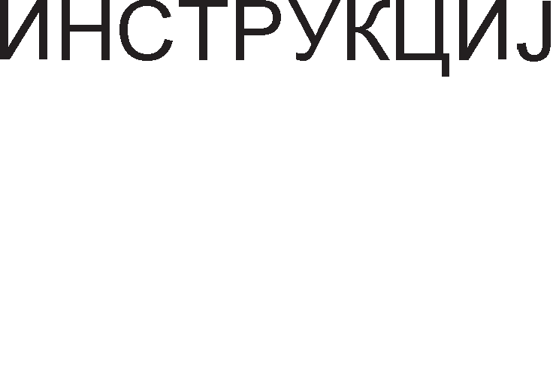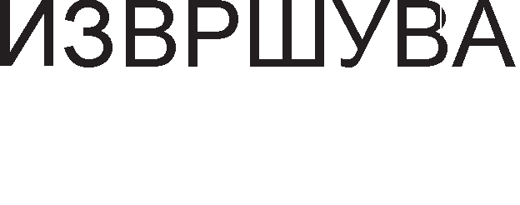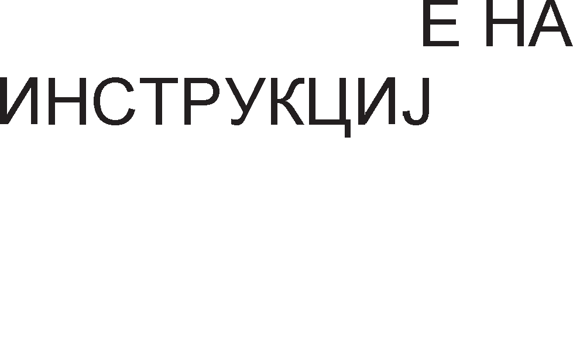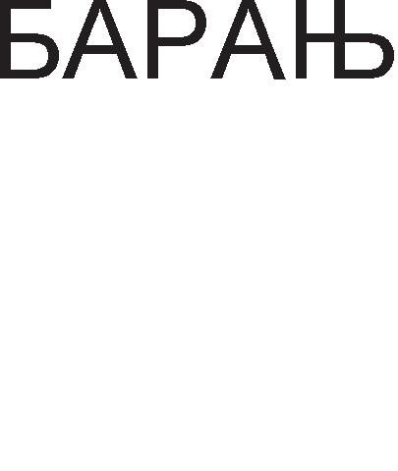

Cn1Ka 4.12. 6noK p1jaflpaM 3a cepB1c1pal-be Ha npeK1H

Ce nocTaByBa npawal-beTo wTo i<e ce cnyL11 poKonKy 1cToBpeMeHo po M1KponpoLecopoT np1cT1flHaT noBei<e 6apal-ba 3a npeK1H op noBei<e nep1cpepH1 ypep1. 3a pa He pojpe po Xaoc Bo o6pa6oTKaTa Ha npeK1H1, Ha HeKo1 nep1cpepH1 ypep1 1M ce paBa nofloneM np1op1TeT Bo opHoc Ha ocTaHaT1Te. Ha cn1KaTa 4.13. e np1Ka>KaH epeH TaKoB np1Mep. Ao M1KponpoLecopoT np1cT1flHyBaaT 6apal-ba 3a npeK1H op 3 ypep1. HajB1coK np1op1TeT 1Ma Mafl1cTpanaTa, noToa poara p1cK- ppajBepoT 1 HajMan np1op1TeT 1Ma neL1aTaL1oT. M1KponpoLecopoT 13BpwyBa HeKoja TeKoBHa npoflpaMa Kofla opepHaw Bo MoMeHToT t=10 ce jaByBa npeK1H, 1H1L1paH op cTpaHa Ha neL1aTaL1oT. M1KponpoLecopoT ja npeK1HyBa TeKoBHaTa npoflpaMa 1 3anoL1HyBa npoflpaMa 3a o6pa6oTKa Ha oBoj npeK1H. OBaa npoflpaMa Tpae 10 BpeMeHcK1 ep1H1L1. Ho, Bo MoMeHToT t=15 Mafl1cTpanaTa pocTaByBa 6apal-be 3a npeK1H. Toflaw M1KponpoLecopoT i<e ja npeK1He noTnpoflpaMaTa Ha neL1aTaL1oT 3a pa npeM1He Ha o6pa6oTKa Ha npeK1HoT op Mafl1cTpanaTa (Taa 1Ma np1op1TeT Bo opHoc Ha neL1aTaL1oT).

Cn1Ka 4.13. O6pa6oTKa Ha npeK1H1 co pa3n1L1eH np1op1TeT

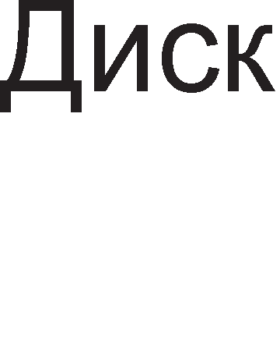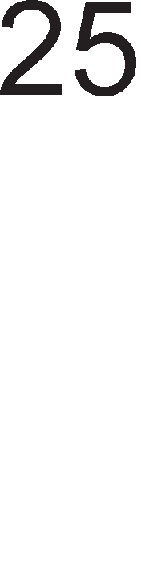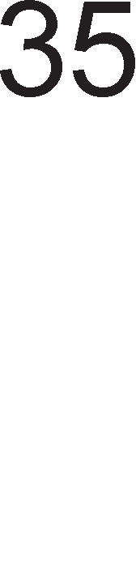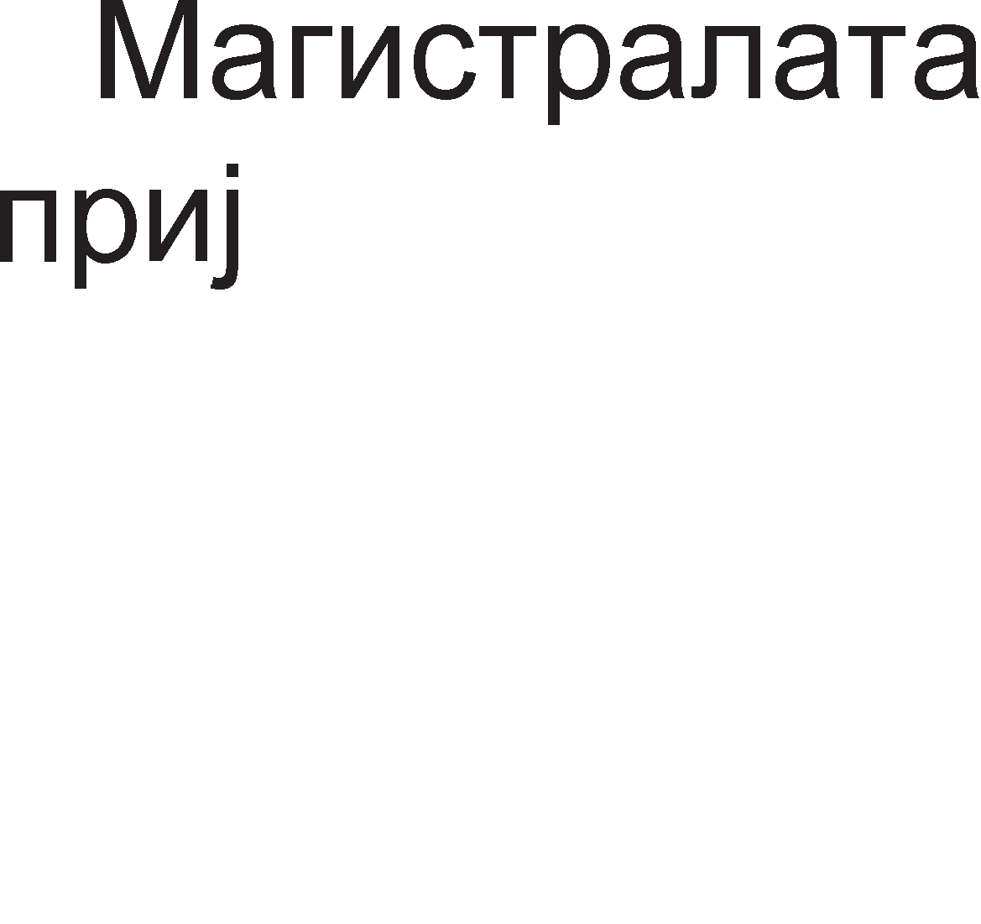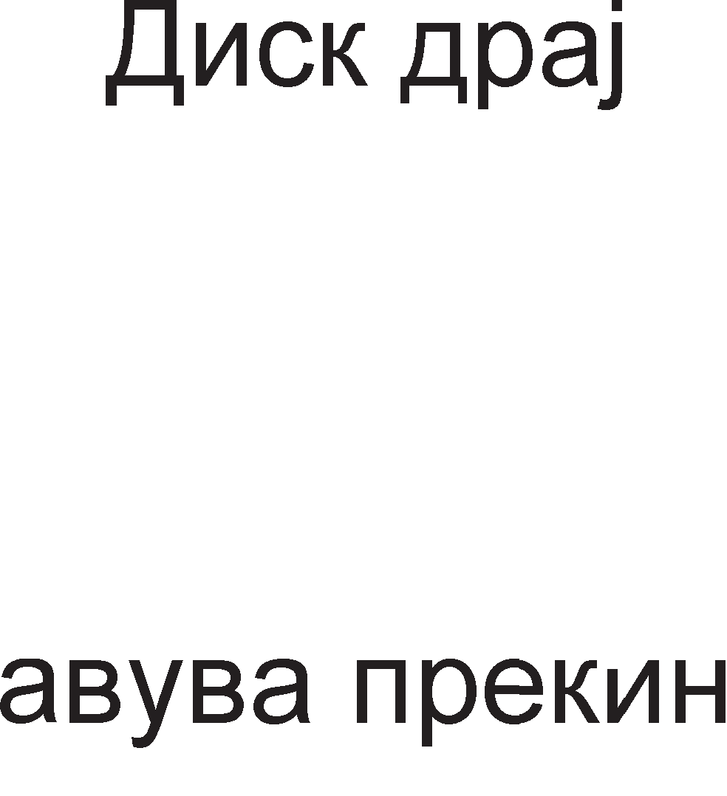

AopeKa ce cepB1c1pa Mafl1cTpanaTa, np1cT1flHyBa HoBo TpeTo 6apal-be 3a npeK1H op cTpaHa Ha p1cK-ppajBepoT. M1KponpoLecopoT npBo i<e ja 3aBpw1 npoflpaMaTa 3a o6pa6oTKa Ha npeK1HoT Ha Mafl1cTpanaTa 1 Toa Tpae po t=25. Bo 1cT1oT MoMeHT M1KponpoLecopoT 3anoL1HyBa npoflpaMa 3a o6pa6oTKa Ha npeK1HoT op p1cK ppajBepoT. Ayp1 oTKaKo i<e 3aBpw1 Bo t=35 M1KponpoLecopoT ce Bpai<a pa ja poBpw1 npoflpaMaTa 3a o6pa6oTKa Ha npeK1HoT op neL1aTaL1oT. 3HaL11, 1aKo neL1aTaL1oT npB pocTaB1 6apal-be 3a npeK1H, Toj i<e 61pe nocnepeH o6pa6oTeH, 61peji<1 neL1aTaL1oT 1Ma HajMan np1op1TeT. OTKaKo M1KponpoLecopoT i<e fl1 o6pa6oT1 c1Te np1MeH1 6apal-ba 3a npeK1H, Toj i<e ce BpaT1 Ha TeKoBHaTa npoflpaMa.

Kaj HajfloneM 6poj M1KponpoLecop1 pa3n1KyBaMe pBa B1pa npeK1H1 – MacK1paH1 1 HeMacK1paH1 npeK1H1. MacK1pal-beTo 3HaL11 3a6paHa 3a M1KponpoLecopoT pa ja npeK1He TeKoBHaTa npoflpaMa nopap1 o6pa6oTKa Ha po61eH1oT npeK1H. Kaj MacK1paH1Te npeK1H1 M1KponpoLecopoT HajnpBo 1cn1TyBa pan1 e cTaBeHa MacKa 1 Bo cnyL1aj pa e nocTaBeHa, M1KponpoLecopoT npeM1HyBa Ha 13BpwyBal-be Ha cnepHaTa 1HcTpyKL1ja 6e3 pa nocBeT1 BH1MaH1e Ha po61eHoTo 6apal-be 3a npeK1H. 3a nocTaByBal-be MacK1 Ha npeK1H1Te nocTo1 cneL1janHa 1HcTpyKL1ja SIM (Set Interrupt Mask). 3a L11Tal-be Ha MacKaTa 3a npeK1H1 ce Kop1cT1 1HcTpyKL1jaTa RIM (Read Interrupt Mask).

# DMA npeHoc

noHeKoflaw M1KponpoLecopoT Tpow1 20% op cBoeTo pa6oTel-be Ha npeHoc Ha nopaToL1. KpaTeHKaTa DMA (Direct Memory Access) BcywHocT 3HaL11 p1peKTeH np1cTan po MeMop1ja, 6e3 nocpepcTBo Ha M1KponpoLecopoT. DMA npeHocoT npeTcTaByBa noce6eH KoHLenT co Koj M1KponpoLecopoT ce ocno6opyBa op npeHocoT Ha nopaToL1 Mery MeMop1jaTa 1 Bne3Ho 13ne3H1Te ypep1. Co oBoj

KoHLenT He caMo wTo He ce onToBapyBa M1KponpoLecopoT TyKy ce o6e36epyBa 1 noc1flypeH npeHoc opHocHo ce HaManyBa fly6el-beTo Ha nopaToL1. OBa noce6Ho ce opHecyBa Ha npeHocoT op HeKoj MHofly 6p3 nep1cpepeH ypep. KoHLenToT DMA e 1MnneMeHT1paH npeKy ynoTpe6a Ha cneL1janeH DMA KoHTponep. OBa e np1Ka>KaHo Ha cn1Ka 4.14.

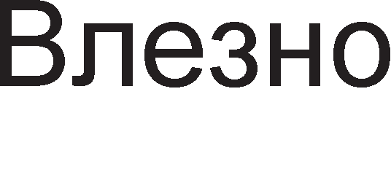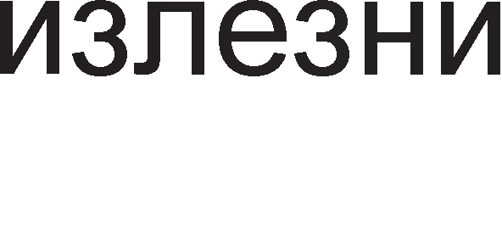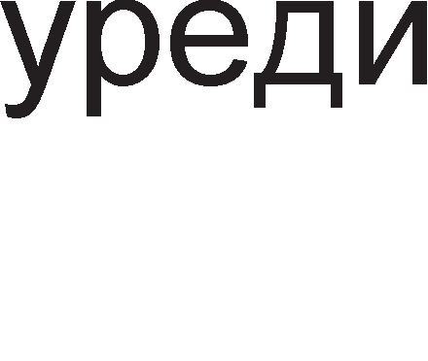

Cn1Ka 4.14. Cnopep6a Mery c1cTeM co 1 6e3 DMA KoHLeoT

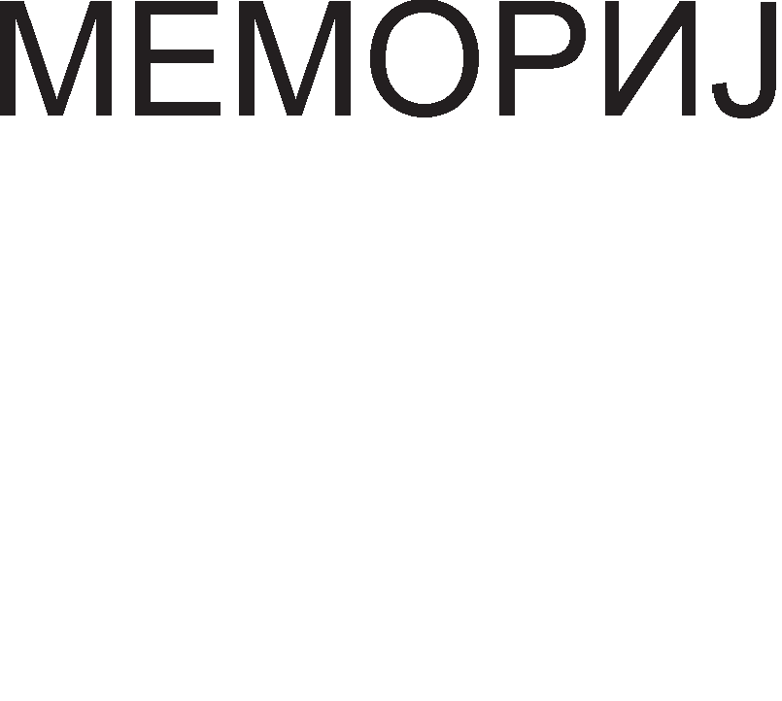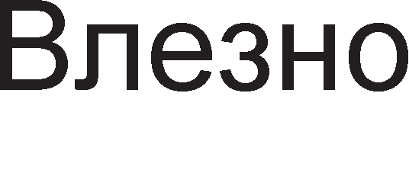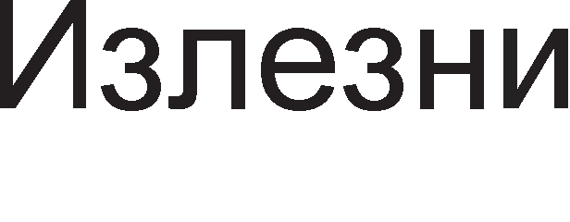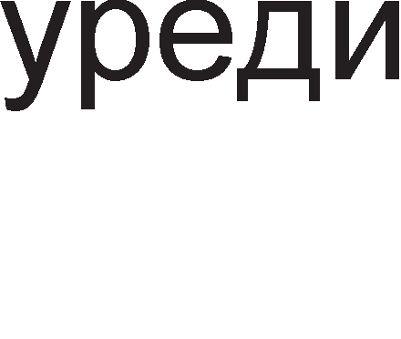

DMA KoHTponepoT npeTcTaByBa po6 (slave) 3a M1KponpoLecopoT. Kofla Tpe6a pa ce npeHece 6noK op nopaToL1 op HeKoj Bne3Ho 13ne3eH ypep po MeMop1jaTa 1 o6paTHo, M1KponpoLecopoT fl1 1cnpai<a: 1HTepcpejc appecaTa Ha ypepoT, MeMop1cKaTa appeca, 6pojoT Ha 6ajT1 Ko1 Tpe6a pa ce npeHecaT 1 KoHTponeH c1flHan 3a B1poT Ha npeHoc (Bne3eH 1n1 13ne3eH). OTKaKo i<e ja np1M1 1HcTpyKL1jaTa 3a npeHoc, DMA KoHTponepoT cTaHyBa flocnopap (master) Ha Mafl1cTpan1Te 1 noL1HyBa pa fleHep1pa KoHTponH1 c1flHan1 3a pa flo pean131pa npeHocoT. DMA KoHTponepoT Bpw1 pacnpepen6a (ap61Tpa>Ka) Ha Mafl1cTpan1Te, npeB3eMal-be Ha MeMop1cKaTa appeca, 1 fleHep1pal-be Ha RD 1 WR KoHTponH1 c1flHan1. nocne 13BpweH1oT npeHoc fl1 ocno6opyBa Mafl1cTpan1Te, Bpw1 o6HoByBal-be Ha MeMop1cKaTa appeca 1 6pojoT Ha 6ajT1 1 poKonKy 1Ma ywTe 6ajT1 3a npeHoc ja noBTopyBa LenaTa nocTanKa. Ha KpajoT op npeHocoT M1KponpoLecopoT po61Ba HoB npeK1H nocne wTo Mo>Ke pa flo npoBep1 cTaTycoT Ha npeHocoT (ycneweH 1n1 He). AoKonKy ce pa6oT1 3a 6p3 npeHoc Ha nofloneMo Kon1L1ecTBo nopaToL1 Toflaw DMA KoHTponepoT He Mopa pa 6apa Kop1cTel-be Ha Mafl1cTpan1Te nocne ceKoj 3aBpweH npeHoc Ha epeH 6ajT 1n1 36op.

3a 1nycTpaL1ja Ha DMA npeHocoT i<e o6jacH1Me epeH epHocTaBeH np1Mep np1Ka>KaH Ha cn1Ka 4.15. Ha cn1Ka 4.15. e np1Ka>KaHo noBp3yBal-beTo Mery c1Te 1HBonB1paH1 ypep1 Bo DMA npeHocoT: M1KponpoLecopoT, DMA KoHTponepoT, MeMop1jaTa 1 Bne3Ho/13ne3H1oT KoHTponep. Ao appecHaTa 1 nopaToL1HaTa Mafl1cTpana 1MaaT np1cTan M1KponpoLecopoT 1 DMA KoHTponepoT, Ho nopap1 nofloneMa epHocTaBHocT He e np1Ka>KaHo noBp3yBal-beTo Ha M1KponpoLecopoT co Mafl1cTpan1Te. EpeH DMA KaHan ce Kop1cT1 3a npeHoc Ha nopaToL1 po caMo epeH Bne3Ho/13ne3eH ypep. He Mo>Ke pa ce cnyL11 DMA KaHanoT pa flo penaT noBei<e ypep1 1 npeHecyBaH1oT nopaToK pa np1cT1flHe po noBei<e ypep1.

npeTnocTaByBaMe peKa ce pa6oT1 3a onepaL1ja L11Tal-be (Bne3eH ypep) 1 peKa Tpe6a pa ce npeHece 1HcpopMaL1ja op pBa 36opa (pBa 16-61TH1 nopaToL1).

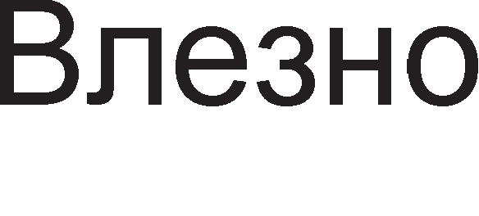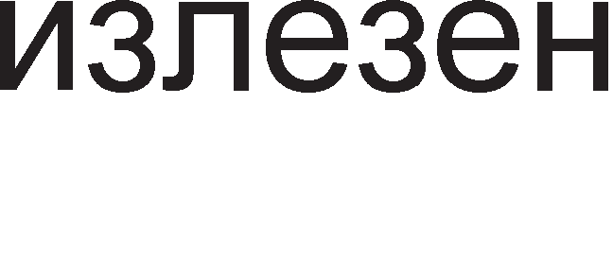

Cn1Ka 4.15. HaL11H Ha noBp3yBal-be Ha DMA KoHTponepoT

Ha cn1Ka 4.16. np1Ka>KaH e BpeMeHcK1oT p1jaflpaM 3a onepaL1jaTaTa DMA npeHoc. Kofla Bne3H1oT ypep e cnpeMeH 3a npeHoc Toj 1cnpai<a 6apal-be po DMA KoHTponepoT npeKy DREQ (DMA request) n1H1jaTa. nocne np1eMoT Ha oBoj c1flHan DMA KoHTponepoT flo nop1fla Ha B1coKo H1Bo HOLD c1flHanoT co wTo My HajaByBa Ha M1KponpoLecopoT peKa caKa pa 13Bpw1 npeHoc Ha nopaToL1. M1KponpoLecopoT paBa po3Bona npeKy aKT1B1pal-be Ha c1flHanoT HLDA (Hold Acknowledge) co wTo DMA KoHTponepoT cTaHyBa flocnopap Ha Mafl1cTpan1Te. noToa DMA KoHTponepoT flo 1cnpai<a c1flHanoT DACK (DMA Acknowledge) 3a pa flo 1HcpopM1pa Bne3H1oT ypep peKa DMA npeHocoT Mo>Ke pa noL1He. C1flHanoT DACKnpecTaByBa opfloBop, noTBppa 3a 1cnpaTeHoTo 6apal-be DREQ. DMA KoHTponepoT fl1 fleHep1pa KoHTponH1Te c1flHan1 3a L11Tal-be op Bne3H1oT ypep  1 n1wyBal-be Bo MeMop1jaTa . Bne3H1oT ypep peafl1pa Ha KoHTponH1Te c1flHan1 1 fl1 nocTaByBa nopaToL1Te Ha nopaToL1HaTa Mafl1cTpana. Kofla i<e ce npeHece nopaToKoT BpepHocTa Ha MeMop1cKaTa appeca ce 3floneMyBa, 6pojoT Ha 6ajT1Te ce HaManyBa 1 aKo Toj 6poj He e Hyna Mo>Ke pa 3anoL1He HoB npeHoc. nocne 3aBpwyBal-beTo Ha npeHocoT Ha c1Te 6ajT1 DMA KoHTponepoT flo 1cnpai<a c1flHanoT EOP (End Of Process). l/lcTo TaKa poara po flacHel-be Ha c1flHan1Te DACK 1 HOLD, nocne wTo M1KponpoLecopoT noBTopHo cTaHyBa flocnopap Ha Mafl1cTpan1Te, a DMA KoHTponepoT po6.



Cn1Ka 4.16. BpeMeHcK1 p1jaflpaM Ha KoHTponH1Te c1flHan1 Ha DMA KoHTponepoT

AoKonKy ce pa6oT1 3a 6aBeH Bne3eH ypep Toflaw HeMa noTpe6a op LenocHo op3eMal-be Ha Mafl1cTpan1Te op M1KponpoLecopoT. HaMecTo DMA 6apal-beTo pa Ba>K1 3a c1Te 6ajT1 Ko1 Tpe6a pa ce npeHecaT, Toa i<e Ba>K1 caMo 3a epeH 6ajT 1 nocne 1cnpai<al-beTo Ha ceKoj nopaToK i<e ce aKT1B1pa c1flHanoT DREQ.

# A,qpecHo ,qeKo,qMpa1-e

Bo epeH KoMnjyTep 1Ma floneM 6poj MeMop1cK1 1 nep1cpepH1 ypep1. M1KponpoLecopoT He Mo>Ke 1cToBpeMeHo pa KoMyH1L1pa co pBa 1n1 noBei<e ypepa, TyKy caMo co epeH op H1B. AppecHoTo peKop1pal-be e nocTanKa 3a ceneKL1ja Ha caMo epeH ypep op noBei<eTo. np1 L11Tal-be Ha epeH nopaToK op RAM MeMop1jaTa, npBo ce ceneKT1pa MeMop1cK1oT L11n, a noToa ce 1361pa epHa MeMop1cKa noKaL1ja op Bei<e 136paH1oT L11n. Aa ce noTceT1Me, ceneKL1jaTa Ha MeMop1cK1oT L11n ce Bpw1 npeKy aKT1B1pal-be Ha n1HoB1Te 3a ceneKL1ja ,  1n1 . Aen op appecH1Te n1H11 Ha M1KponpoLecopoT ce Kop1cTaT 3a po61Bal-be Ha c1flHanoT 3a ceneKL1ja Ha epeH MeMop1cK1 L11n, a ocTaHaT1Te n1H11 cny>KaT 3a np1cTan po 6apaHaTa MeMop1cKa noKaL1ja.

nocTanKaTa appecHo peKop1pal-be i<e ja o6jacH1Me npeKy np1MepoT np1Ka>KaH Ha cn1KaTa 4.17.

Cn1Ka 4.17. AppeceH peKopep co pBa appecH1 Bne3a

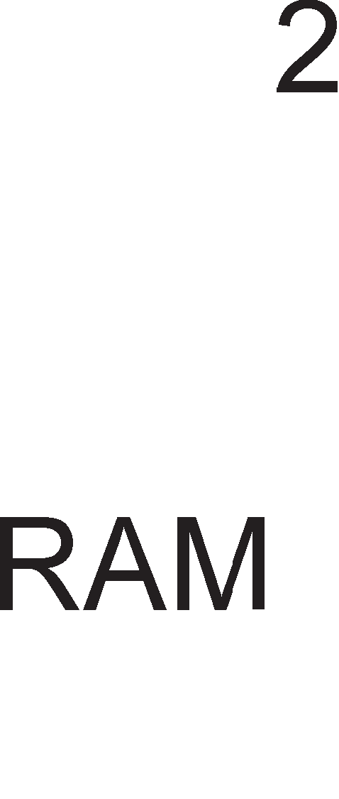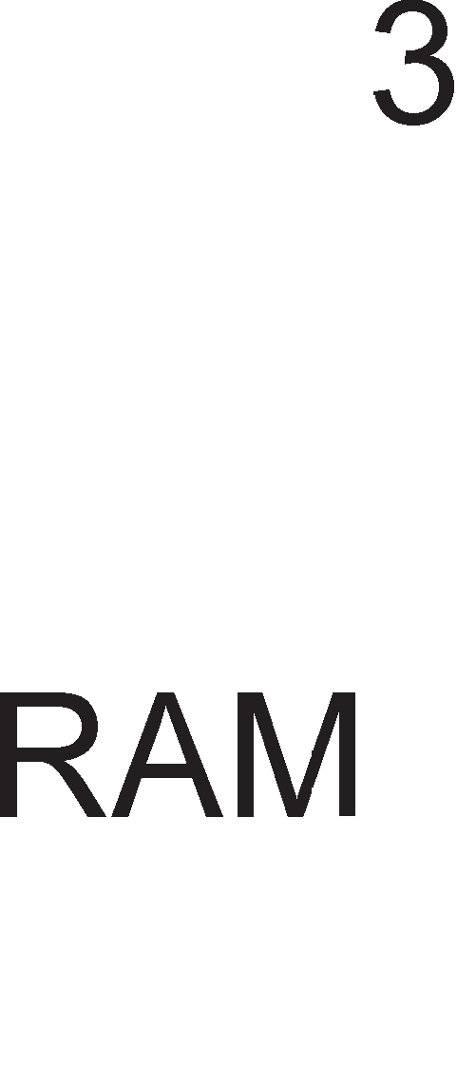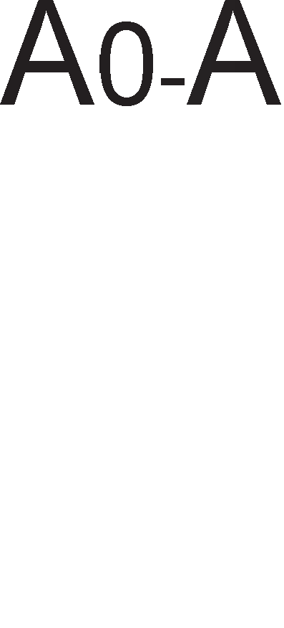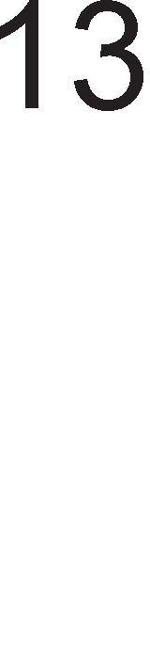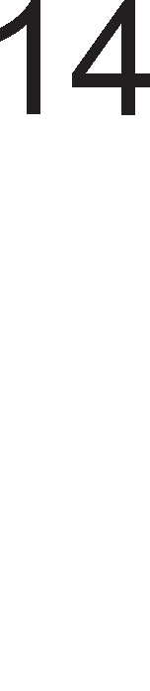

OBoj np1Mep e npeMHofly epHocTaBeH 1 HepeaneH, Ho i<e H1 noMoflHe pa ja pa36epeMe nocTanKaTa Ha appecHo peKop1pal-be. BKynH1oT 6poj appecH1 n1H11

13HecyBa 16, op A0 po A15. Toa 3HaL11 peKa pacnonaflaMe co appeceH npocTop op 216=64KB. AppecH1oT npocTop e nopeneH Mery L1eT1p1 RAM L11noB1. KanaL1TeToT Ha ceKoj L11n 13HecyBa 8KB=64KB:4. 3a 136op Ha epHa noKaL1ja op Koj 61no L11n ce

Kop1cTaT appecH1Te n1H11 op A0 po A13. ABeTe Haj3HaL1ajH1 appecH1 n1H11 A14 1 A15 cny>KaT 3a 136op Ha epeH op L1eT1p1Te L11na. l/l36opoT Ha L11n ce Bpw1 cnopep Ta6ena 4.5.

|  |  |
| --- | --- |
|  | A15 A14 |
| RAM1 | 00 |
| RAM2 | 01 |
| RAM3 | 10 |
| RAM4 | 11 |

Ta6ena 4.5. Ta6ena Ha B1cT1H1TocT 3a appecH1oT peKopep co pBa appecH1 Bne3a

C1Te appec1 Ha npB1oT L11n i<e noL1HyBaaT Ha 00, Ha BTop1oT 01, Ha TpeT1oT 10 1 Ha L1eTBpT1oT 11. OcTaHaT1Te appecH1 61ToB1 ce MeHyBaaT. 61ToB1Te op A13 po A0 ce Hyn1 3a noL1eTH1Te appec1 1 ep1H1L1 3a KpajH1Te appec1. Ha cn1Ka 4.18. ce papeH1 noL1eTH1Te 1 KpajH1Te appec1 Ha c1Te L1eT1p1 L11na, opHocHo MeMop1cKaTa Mana 3a c1Te L1eT1p1 L11na.Bo 3aB1cHocT op BpepHocTa Ha 61ToB1Te A15 1 A14, Mo>KeMe pa oppep1Me Ha Koj MeMop1cK1 L11n np1nara oppepeHa appeca.

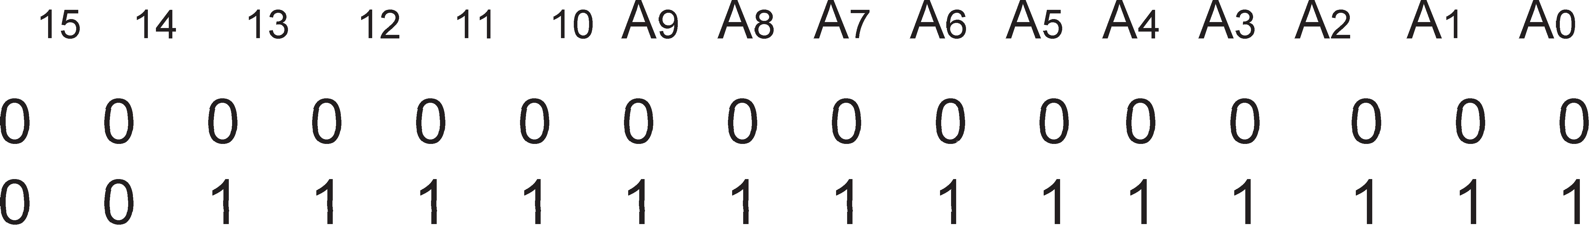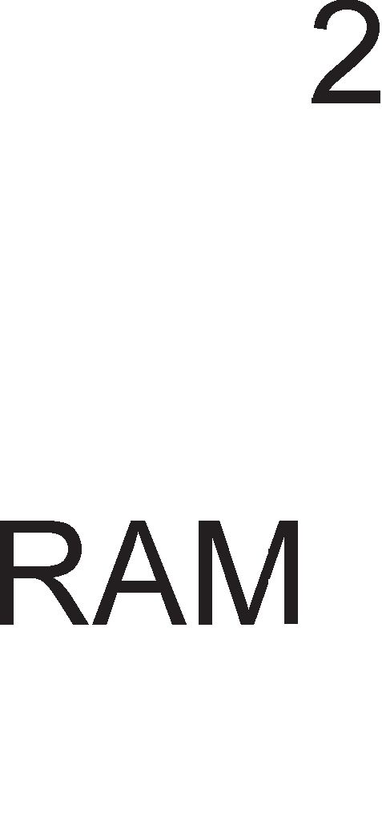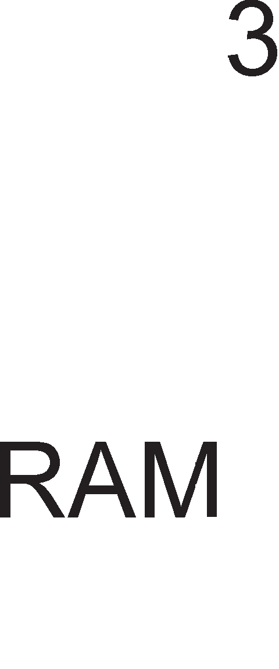

Cn1Ka 4.18. MeMop1cKa Mana Ha RAM MeMop1jaTa, cocTaBeHa op L1eT1p1 L11na op no 16KB

**npMMep 4.1**. M1KponpoLecopoT Kop1cT1 16-61THa appeca A15-A0. 3a ceneKL1ja Ha MeMop1cK1 Mopyn, appecH1Te n1H11 A15 1 A14 ce nocTaBeH1 Ha cnepH1Be nofl1L1K1 H1Boa:

A15 = 1 , A14 = 0

Koja op HaBepeH1Te XeKcapeL1ManH1 appec1 np1naraaT Ha HaBepeH1oT MeMop1cK1 Mopyn?

A) 6100H 6) 9100H B) C100H r) F100H

PeweH1e: npBo Bo pep1La fl1 n1wyBaMe c1Te appecH1 61ToB1 op A15 po A0. BTopo, fl1 npeTBopaMe XeKcapeL1ManH1Te appec1 Bo 61HapeH 1 Toa nop pep1LaTa op appecH1 61ToB1. TpeTo, fl1 3aoKpy>KyBaMe appecH1Te 61ToB1 A15 1 A14 1 flnepaMe Koja appeca flo 1cnonHyBa flopH1oT ycnoB.

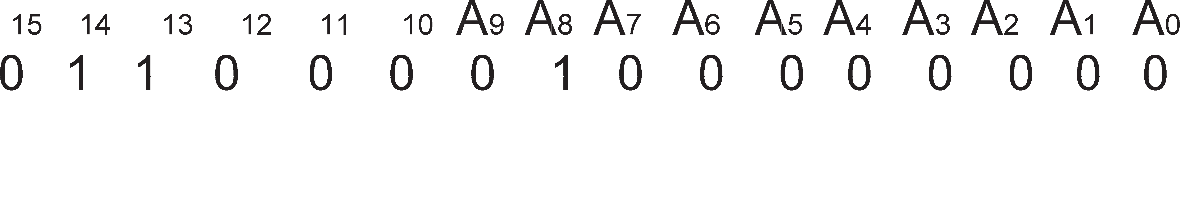

rnepaMe peKa Toa e appecaTa 9100H.

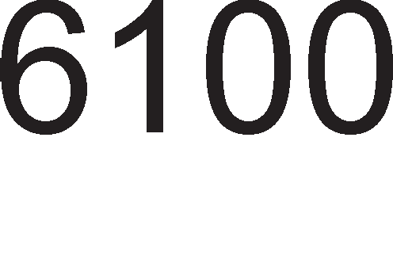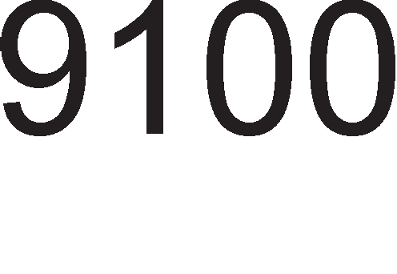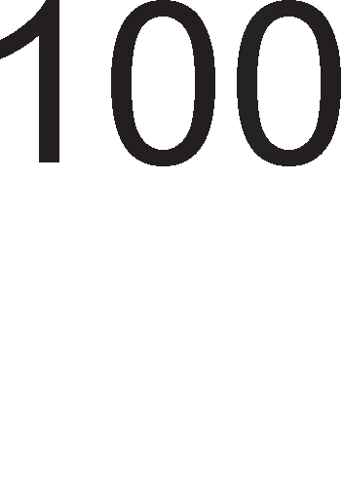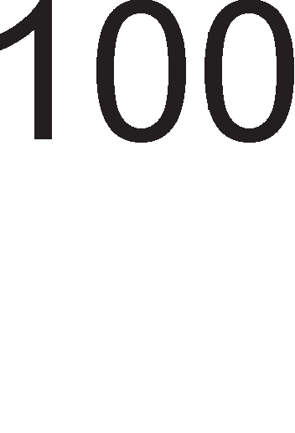

6pojoT Ha appecH1 n1H11 1 6pojoT Ha L11noB1 ce npoMeHn1B1 Ben1L11H1.

**npMMep 4.2**: MeMop1jaTa 1Ma BKyneH KanaL1TeT op 2MB 1 e cocTaBeHa op 8 1peHT1L1H1 L11na. Oppep1 KonKy appecH11 n1H11 ce Kop1cTaT 3a 136op Ha L11n 1 Ko1 appecH1 n1H11 ce Kop1cTaT 3a 136op Ha noKaL1ja op Bei<e 136paH1oT L11n.

PeweH1e: BKynH1oT MeMop1cK1 KanaL1TeT H1 oBo3Mo>KyBa pa flo oppep1Me BKynH1oT 6poj appecH1 n1H11. 2MB= 21·220=221·21 npeTcTaByBa BKyneH 6poj Ha appecH1 n1H11 Ko1 ce 6ene>KaT op A20 po A0.

|  |  |
| --- | --- |
|  | A20A19A18 |
| RAM1 | 000 |
| RAM2 | 001 |
| RAM3 | 010 |
| RAM4 | 011 |
| RAM5 | 100 |
| RAM6 | 101 |
| RAM7 | 110 |
| RAM8 | 111 |

Ta6ena 4.6. AppecH1 61ToB1 3a appecHo peKop1pal-be Ha 8 L11noB1 co KanaL1TeT op no 256KB

61peji<1 ce 8 L11noB1, i<e H1 Tpe6aaT Tp1 appecH1 61ToB1 3a pa HanpaB1Me 8 pa3n1L1H1 KoM61HaL11. CeKoflaw ce 1361paaT Haj3HaL1ajH1Te appecH11 n1H11, 1 Toa Bo oBoj cnyL1aj i<e 61paT n1H11Te A20, A19 1 A18. OcTaHaT1Te appecH1 n1H11 op A17 po A0 i<e ce Kop1cTaT 3a 136op Ha epeH 6ajT op BKynHo 256KB KonKy wTo 13HecyBa KanaL1TeToT Ha epeH MeMop1cK1 L11n. Bo Ta6enaTa 4.6. ce papeH1 BpepHocT1Te Ha Tp1Te appecH1 61ToB1 3a 136op Ha L11n.

Bo M1KponpoLecopcKaTa TeXH1Ka MHofly L1ecTo ce Kop1cTaT 1HTeflp1paH1 Kona - peKopep1. Ha cn1KaTa 4.19. e np1Ka>KaH appeceH peKopep 74LS138. Toj 1Ma Tp1 appecH1 Bne3a wTo 3HaL11 i<e 1Ma ocyM 13ne31. Bne3oB1Te G1, G2A, G2B cny>KaT 3a ceneKL1ja Ha KoMnoHeHTaTa. n1HoT G1 Tpe6a pa 61pe Ha B1coKo H1Bo, a n1HoB1Te G2A, G2B Ha H1cKo H1Bo. n1HoB1Te A, B 1 C cny>KaT 3a ceneKL1ja Ha epeH op 13ne3H1Te n1HoB1. Bo Ta6enaTa 4.7. e papeHa Ta6enaTa Ha B1cT1H1TocT.

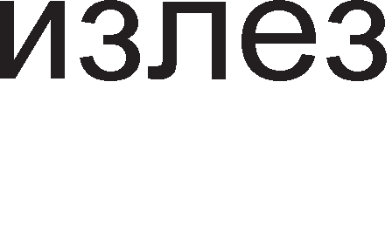

Cn1Ka 4.19. n1H p1jaflpaM Ha peKopep 74LS 138

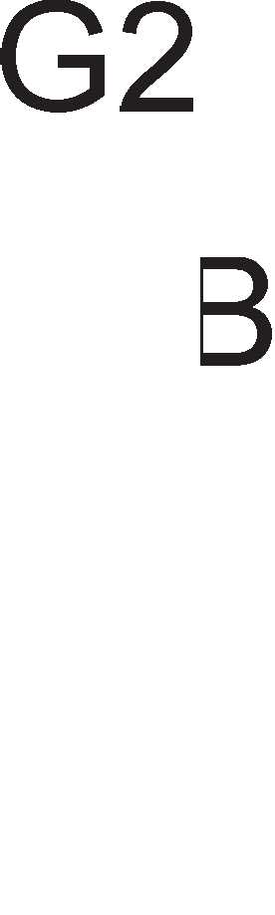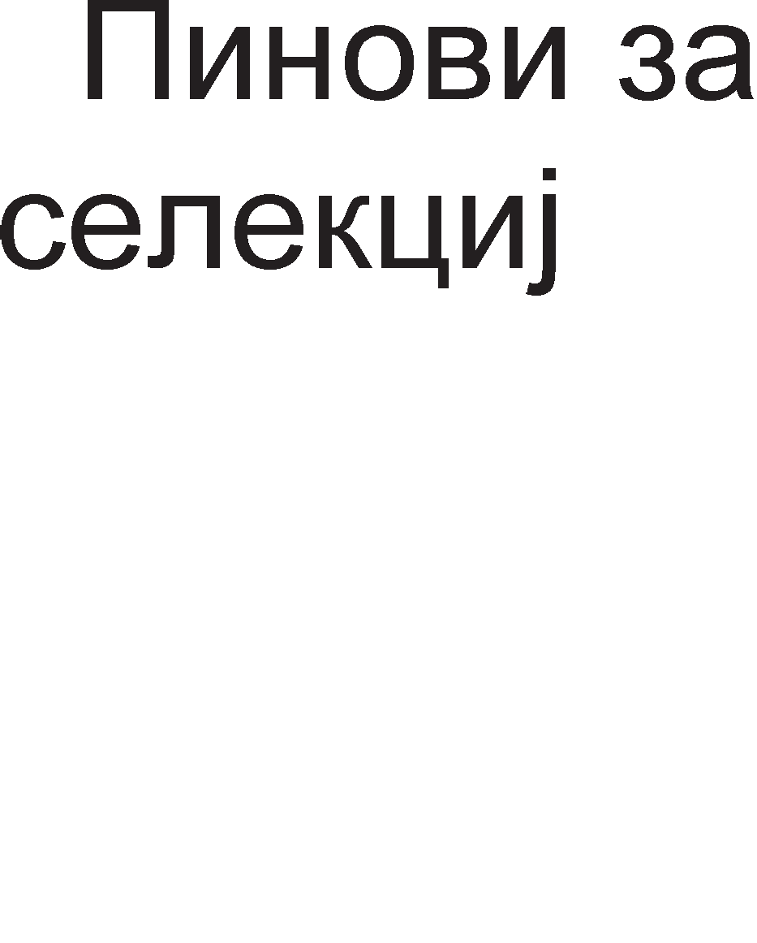

Ta6ena 4.7. Ta6ena Ha B1cT1H1TocT Ha peKopep 74LS138

|  |  |
| --- | --- |
| ABC | fanea |
| 000 | 0 |
| 001 | 1 |
| 010 | 2 |
| 011 | 3 |
| 100 | 4 |
| 101 | 5 |
| 110 | 6 |
| 111 | 7 |

AeKopepoT 74LS138 Mo>Ke pa ce Kop1cT1 3a peKop1pal-be MeMop1cK1 appec1 1 3a peKop1pal-be 1HTepcpejc-appec1. Ha cn1KaTa 4.20. e np1Ka>KaHo

epHocTaBHo Kono 3a peKop1pal-be cocTaBeHo op peKopep 74LS138 1 8 MeMop1cK1 EPROM L11na.

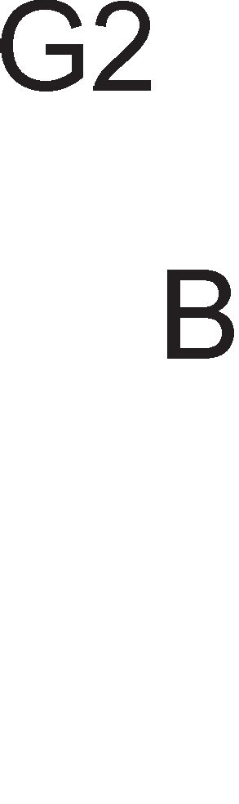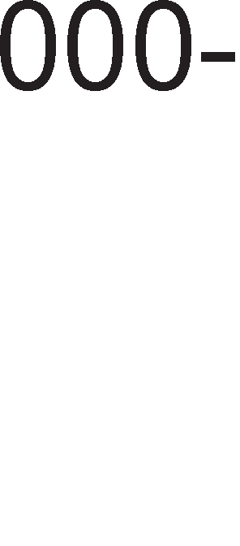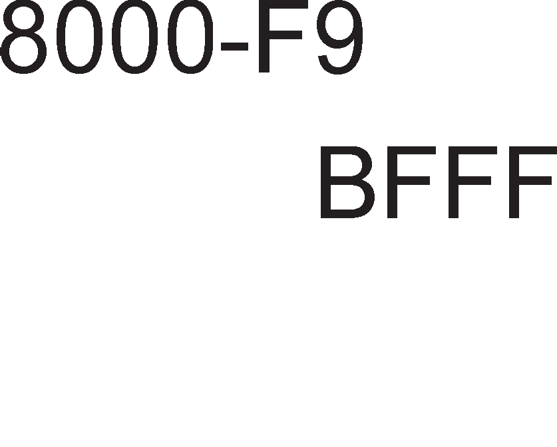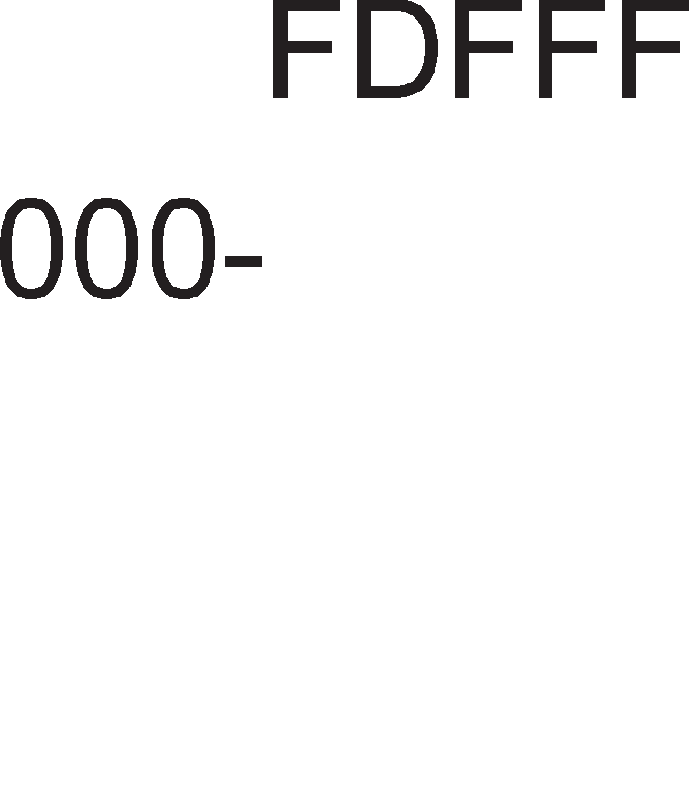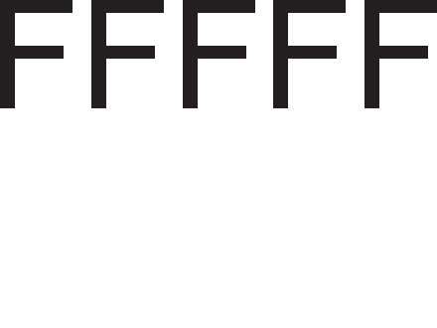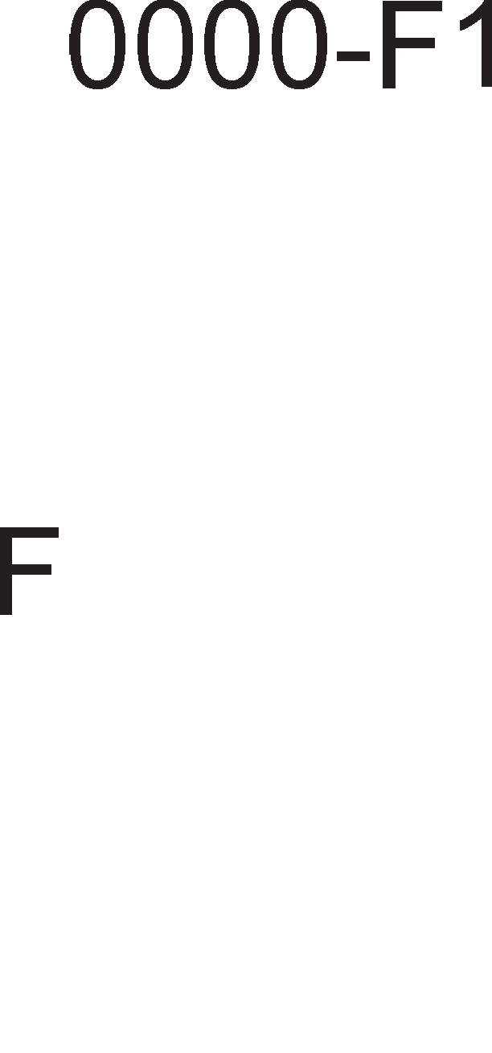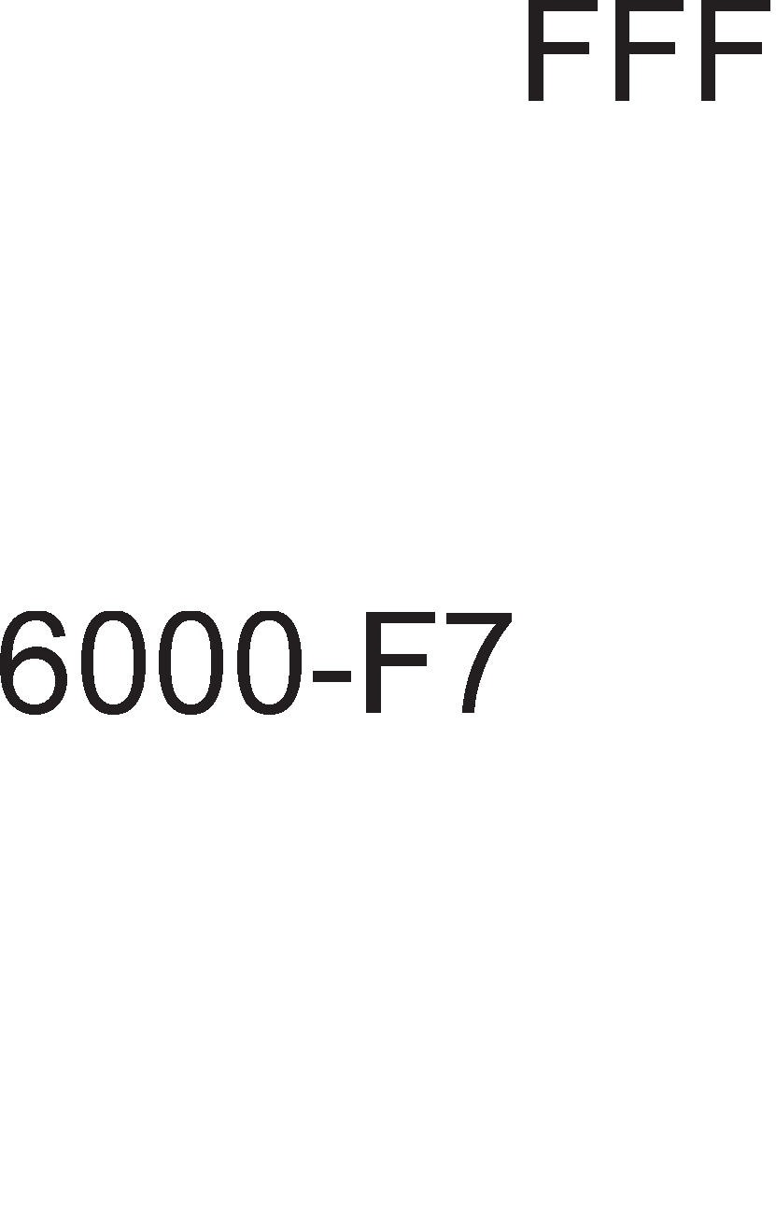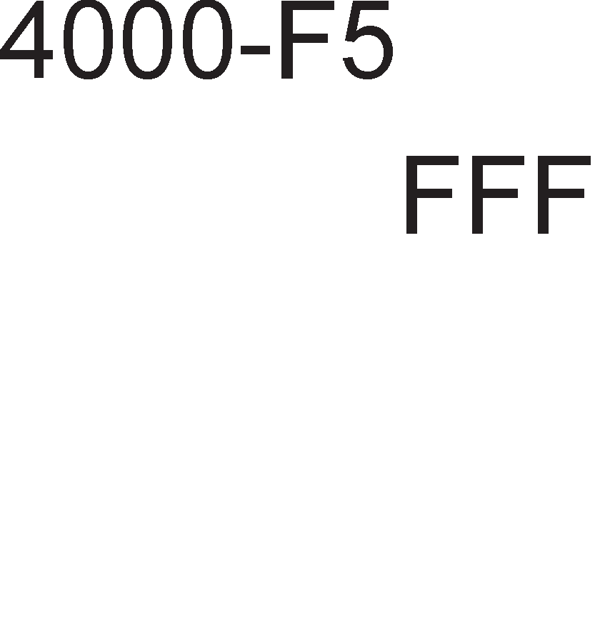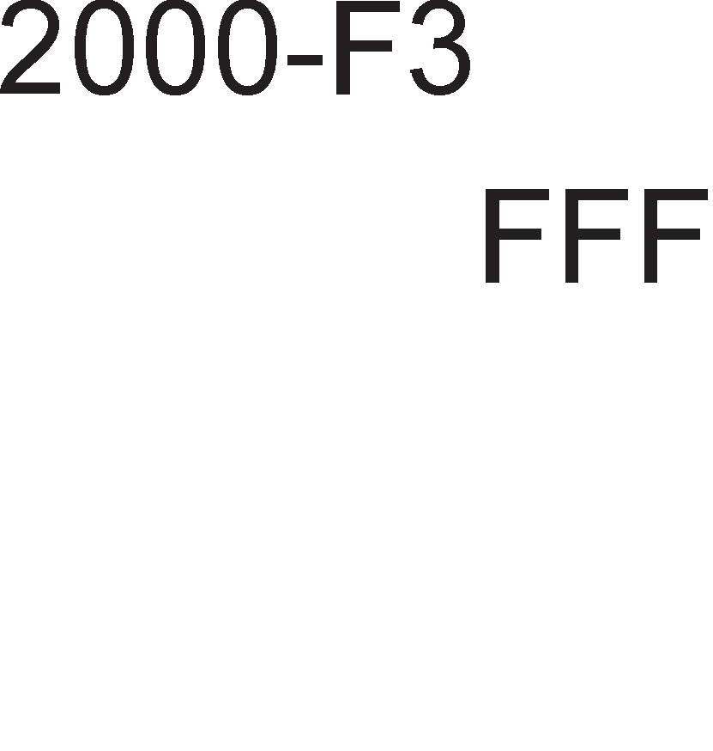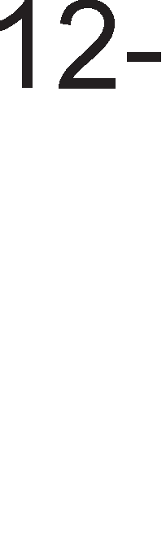

Cn1Ka 4.20. noBp3yBal-be Ha peKopep 74LS38 co MeMop1cK1 L11noB1

CeKoj op L11noB1Te 1Ma KanaL1TeT op 8KB wTo 3HaL11 BKynH1oT KanaL1TeT i<e 13HecyBa 64KB. Ha cn1KaTa 4.20. ce papeH1 1 appecH1Te once31 3a ceKoj op L11noB1Te. AppecH1Te 61ToB1 op A13, A14 1 A15 cny>KaT 3a 136op Ha epeH 13ne3 op peKopepoT, opHocHo epeH MeMop1cK1 L11n op BKynHo ocyM. H1BH1Te BpepHocT1 ce MeHyBaaT cnopep Ta6enaTa 4.7. co Toa wTo A15A14A13=ABC. A16 ceKoflaw e ep1H1La, 61peji<1 n1HoT G1 e aKT1BeH Ha nofl1L1Ka ep1H1La. 61ToB1Te A17, A18 1 A19 Tpe6a pa ce c1Te ep1H1L1 3a pa Ha 13ne3 op Hl/l KonoTo 1MaMe nofl1L1Ka Hyna,noTpe6Ha 3a aKT1B1pal-be Ha n1HoT G2B. AKo Koj 61no 61T op A17, A18, A19 61pe epHaKoB Ha Hyna, Toflaw Ha 13na3 op Hl/l KonoTo i<e po61eMe nofl1L1Ka ep1H1La, n1HoT G2B HeMa pa ce aKT1B1pa, a co Toa 1 peKopepoT 74LS138 i<e ocTaHe HeaKT1BeH.

AeKopepoT 74LS138 1Ma 8 13ne31 1 3aToa co epeH peKopep 74LS138 Mo>Ke pa ce peKop1paaT 8 1HTepcpejc-appec1. Aa ce noTceT1Me, 1HTepcpec-appecaTa e yH1KaTHa KoM61HaL1ja op 8 61Ta 1 cny>K1 3a 136op Ha nep1cpepeH ypep. l/lHTepcpejc-appecaTa ce Hoc1 Ha Bne3 op peKopepoT 74LS138, np1Ka>KaHo Ha cn1KaTa 4.21.

AppecH1Te 61ToB1 op A7 po A4 Tpe6a pa fl1 1cnonHaT ycnoB1Te nop Ko1 i<e pojpe po aKT1B1pal-be Ha n1HoB1Te 3a ceneKL1ja Ha KoMnoHeHTaTa. YcnoBoT wTo Tpe6a pa ce 1cnonH1 3aB1c1 op nofl1L1K1Te Kona nocTaBeH1 npep n1HoB1Te G2A, G2B 1 G1. neTTe 61ToB1, op A7 po A3 ce KoHcTaHTH1 1 Ba>KaT 3a c1Te ocyM nep1cpepH1 ypep1 np1KnyL1eH1 Ha 13ne31Te op peKopepoT 74LS138. 61ToB1Te A2, A1 1 A0 cny>KaT 3a 136op Ha epeH nep1cpepeH ypep. 3a pa ce aKT1B1paaT n1HoB1Te G2A 1 G2B, Tpe6a A3=0 1 A4=0. 3a n1HoT G1 H1 Tpe6a nofl1L1Ka ep1H1La. 3a pa

Ha 13ne3 op l/l-KonoTo po61eMe nofl1L1Ka ep1H1La, c1Te HefloB1 Bne3oB1 Tpe6a pa ce epeH, opHocHo A5=A6=A7=1.

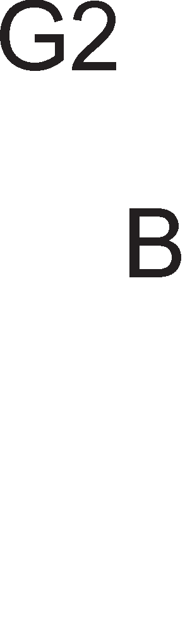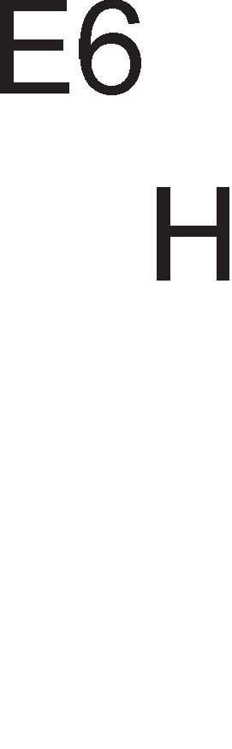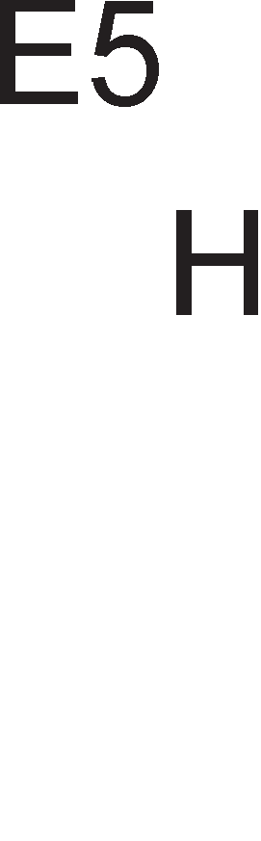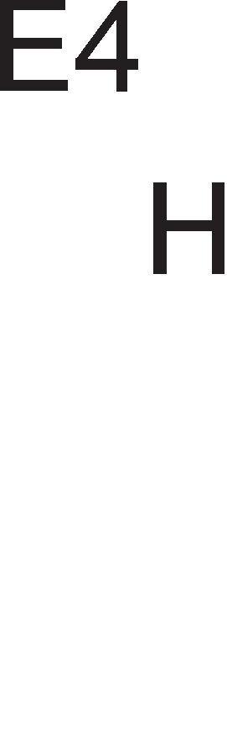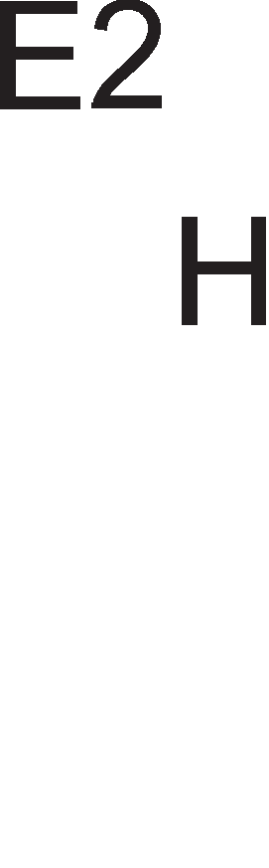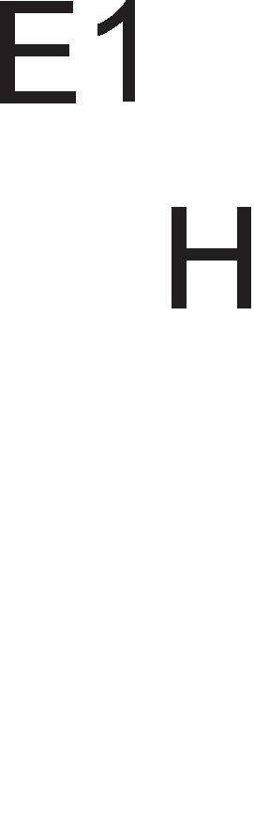

|  |  |  |  |  |  |  |  |  |
| --- | --- | --- | --- | --- | --- | --- | --- | --- |
| A7 1 | A6 1 | A5 1 | A4 0 | A3 0 | A2 0 | A1 0 | A0 0 | =E0H |
| 1 | 1 | 1 | 0 | 0 | 0 | 0 | 1 | =E1H |
| 1 | 1 | 1 | 0 | 0 | 0 | 1 | 0 | =E2H |
| 1 | 1 | 1 | 0 | 0 | 0 | 1 | 1 | =E3H |
| 1 | 1 | 1 | 0 | 0 | 1 | 0 | 0 | =E4H |
| 1 | 1 | 1 | 0 | 0 | 1 | 0 | 1 | =E5H |
| 1 | 1 | 1 | 0 | 0 | 1 | 1 | 0 | =E6H |
| 1 | 1 | 1 | 0 | 0 | 1 | 1 | 1 | =E7H |

Cn1Ka 4.21. Ta6ena Ha B1cT1H1TocT 3a peKopep 74LS138 3a appeceH oncefl op E0H po E7H



KoMeHTap: AoKonKy Ha Bne3 op n1HoT G1 1MaBMe nofl1L1Ko Kono Hl/lnl/l, Toflaw Tp1Te 61Ta A7, A6 1 A5 i<e Tpe6awe pa 61paT Hyn1 3a pa Ha 13ne3 op Hl/lnl/l-KonoTo po61eMe nofl1L1Ka ep1H1La. Appec1Te i<e 6ea op 00H po 07H.

## aK11y"1o4M:

OnepaL1jaTa L11Tal-be op MeMop1ja Tpae Tp1 p1fl1TcK1 TaKTa. Bo npB1oT TaKT M1KponpoLecopoT 1cnpai<a appeca po MeMop1jaTa. BTop1oT p1fl1TcK1 TaKT e TaKT Ha L1eKal-be 1 Toflaw MeMop1jaTa ce npe6apyBa 1 ja npoHaora caKaHaTa MeMop1cKa noKaL1ja. Bo TpeT1oT TaKT MeMop1jaTa flo 1cnpai<a caKaH1oT nopaToK po M1KponpoLecopoT. AoKonKy BpeMeTo Ha np1cTan Ha MeMop1jaTa e nofloneMo Toflaw Mo>Ke pa ce BMeTHaT pBa 1n1 noBei<e TaKTa Ha L1eKal-be.

Cnopep KoHLenToT Ha B1pTyenHa MeMop1ja npoflpaMaTa ce pen1 Ha noBei<e 6noKoB1 1 ceKoj 6noK ce 13BpwyBa Bo M1KponpoLecopoT He3aB1cHo op ppyfl1Te. OTKaKo i<e ce 13Bpw1 npB1oT 6noK op npoflpaMaTa, Toj ce Bpai<a op flnaBHaTa MeMop1ja Bo ceKypapHaTa, a op ceKyHpapHaTa Bo flnaBHaTa MeMop1ja ce npecppna cnepH1oT 6noK, na no Heflo TpeT1oT 1 TaKa HaTaKa popeKa He ce 13Bpw1 LenaTa npoflpaMa.

Co BoBepyBal-be Ha no1MoT B1pTyenHa MeMop1ja ce Bpw1 npow1pyBal-be Ha flnaBHaTa (np1MapHa) MeMop1ja npeKy HapBopewHaTa (ceKyHpapHa) MeMop1ja. CeKyHpapHaTa MeMop1ja e nopeneHa Ha cTpaH1, a flnaBHaTa MeMop1ja Ha paMK1. 6pojoT Ha paMK1 e MHofly noMan op 6pojoT Ha cTpaH1. no noTpe6a ce Bpw1 3aMeHa Ha cTpaH1Te cMecTeH1 Bo paMK1Te.

Cnopep HaMeHaTa Kew MeMop11Te Mo>KaT pa 61paT 1HcTpyKL1cK1 1 nopaToL1H1. Bo 1HcTpyKL1cKaTa Kew MeMop1ja ce L1yBaaT 1HcTpyKL11Te Ko1 ce

opHanpep poHeceH1 op flnaBHaTa MeMop1ja 1 L1eKaaT pa 61paT noB1KaH1 3a 13BpwyBal-be op cTpaHa Ha M1KponpoLecopoT. nopaToL1HaTa Kew MeMop1ja fl1 L1yBa nopaToL1Te Ko1 M1KponpoLecopoT noL1ecTo fl1 noB1KyBa, a 3a 1cT1Te HeMa MecTo Bo onwT1Te pefl1cTp1 Ha M1KponpoLecopoT.

Bo nococp1cT1L1paH1Te MeMop1cK1 opflaH13aL11 nocTojaT HeKonKy H1Boa Ha Kew MeMop1ja. nocTojaT Tp1 H1Boa Ha Kew MeMop1ja. Kew MeMop1jaTa op npBo H1Bo ce Haora Bo caM1oT M1KponpoLecopcK1 L11n, Kew MeMop1jaTa op BTopo H1Bo ce Haora Bo caMoTo naKyBal-be Ha M1KponpoLecopoT 1 Kew MeMop1jaTa op TpeTo H1Bo ce Haora Ha MaT1L1HaTa nnoL1a.

6acpepoT He Bpw1 o6pa6oTKa Ha c1flHan1Te TyKy Toj Bpw1 XapBepcKo noBp3yBal-be Ha nep1cpepH1Te ypep1 co nopaToL1HaTa Mafl1cTpana caMo popeKa Tpae npeHocoT Ha nopaToL1. neL1oT e ypep cocTaBeH op TaKT1paL1K1 cpn1n- cpnonoB1 L11ja 3apaL1a e pa flo npopon>KaT BpeMeTpael-beTo Ha no6ypH1oT c1flHan.

KonaTa Ko1 nocpepyBaaT Bo KoMyH1KaL1jaTa Mery nep1cpepH1Te ypep1 1 c1cTeMcKaTa Mafl1cTpana ce HapeKyBaaT Bne3Ho/13ne3H1 KoHTponep1 1n1 1HTepcpejc KoHTponep1.

Appec1pal-beTo Ha nep1cpepH1Te ypep1 Mo>Ke pa ce pean131pa Ha pBa HaL11Ha: 13on1paH Bne3/13ne3 1 MeMop1cK1 npecn1KaH Bne3/13ne3. Kaj 13on1paH1oT Bne3/13ne3 ce Kop1cT1 c1flHanoT IO/ (input output/) 3a opBojyBal-be Ha MeMop1jaTa op Bne3Ho-13ne3H1Te ypep1. Kaj MeMop1cK1 npecn1KaH1oT Bne3/13ne3 3a opBojyBal-be Ha MeMop1jaTa op nep1cpepH1Te ypep1 ce Kop1cT1 appeceH 61T, o61L1Ho Haj3HaL1ajH1oT. AKo 1MaMe 16 appecH1 n1H11, Toflaw Kofla 61ToT A15=0 appecaTa i<e 61pe MeMop1cKa. AKo A15=1 Toflaw appecaTa op M1KponpoLecopoT i<e 61pe 1HTepcpejc appeca 3a nep1cpepeH ypep.

npep pa 3anoL1He npeHocoT Ha nopaToL1 Bne3H1oT ypep 1cnpai<a c1flHan 3a HajaBa (Strobe), a aKo M1KponpoLecopoT flo opo6p1 npeHocoT Toflaw Toj 1cnpai<a c1flHan 3a noTBppa (Acknowledge).

napanenHaTa nopTa ce Kop1cT1 3a noBp3yBal-be Ha neL1aTaL11, a nopoLHa i<e B1p1Me peKa ce Kop1cT1 1 np1 npoflpaM1pal-be Ha M1KpoKoHTponep1. Cep1cKaTa nopTa Ha KoMnjyTepoT (COM) ce Kop1cT1 3a noBp3yBal-be Ha HapBopewH1 MopeM1, flnyBL1e, nnoTep 1 pp. l/lcTo TaKa npeKy Hea Mo>Ke pa ce 13flpap1 Mana noKanHa Mpe>Ka Koja Kop1cT1 onepaT1BeH c1cTeM Windows.

nep1cpepH1Te ypep1 1cnpai<aaT po M1KponpoLecopoT noce6H1 6apal-ba 3a npeK1H. 3a Taa Len ce aKT1B1pa cneL1janeH n1H INTR (interrupt). no 13BpwyBal-beTo Ha ceKoja 1HcTpyKL1ja op TeKoBHaTa npoflpaMa, M1KponpoLecopoT npoBepyBa pan1 nocTo1 6apal-be 3a npeK1H. AKo TaKBo 6apal-be nocTo1, Toflaw

M1KponpoLecopoT Mo>Ke pa ja npeK1He TeKoBHaTa pa6oTa 1 pa npeM1He KoH o6pa6oTKa Ha npeK1HoT, np1 wTo ce aKT1B1pa n1HoT INTA (Interrupt acknowledge).

DMA npeHocoT npeTcTaByBa noce6eH KoHLenT co Koj M1KponpoLecopoT ce ocno6opyBa op npeHocoT Ha nopaToL1 Mery MeMop1jaTa 1 Bne3Ho 13ne3H1Te ypep1. KoHLenToT DMA e 1MnneMeHT1paH npeKy ynoTpe6a Ha cneL1janeH DMA KoHTponep.

n1HoT HOLD e Bne3eH n1H 3a M1KponpoLecopoT 1 npeKy Heflo DMA KoHTponepoT 1cnpai<a 6apal-be 3a DMA npeHoc. AoKonKy M1KponpoLecopoT flo opo6p1 oBa 6apal-be Toj flo aKT1B1pa 13ne3H1oT n1H HLDA (Hold Acknowledge). DMA KoHTponepoT np1Ma 6apal-be 3a DMA npeHoc op nep1cpepH1oT ypep npeKy n1HoT DREQ, a paBa noTBppa npeKy aKT1B1pal-be Ha c1flHanoT DACK. DMA npeHocoT 3aBpwyBa co aKT1B1pal-be Ha c1flHanoT EOP.

AppecHoTo peKop1pal-be e nocTanKa 3a ceneKL1ja Ha caMo epeH MeMop1cK1 1n1 nep1cpepeH ypep co Koj M1KponpoLecopoT Tpe6a pa ocTBap1 KoMyH1KaL1ja. CeneKL1jaTa Ha MeMop1cK1oT L11n ce Bpw1 npeKy aKT1B1pal-be Ha n1HoB1Te 3a ceneKL1ja ,  1n1 . Aen op appecH1Te n1H11 Ha M1KponpoLecopoT ce Kop1cTaT 3a po61Bal-be Ha c1flHanoT 3a ceneKL1ja Ha epeH MeMop1cK1 L11n, a ocTaHaT1Te n1H11 cny>KaT 3a np1cTan po 6apaHaTa MeMop1cKa noKaL1ja.

AppecH1oT peKopep 74LS138 1Ma Tp1 appecH1 Bne3a 1 ocyM 13ne31. Co Heflo Mo>Ke pa ce peKop1paaT 8 1HTepcpejc-appec1 1n1 MeMop1cK1 appec1. Bne3oB1Te G1, G2A 1 G2B cny>KaT 3a ceneKL1ja Ha KoMnoHeHTaTa.

## npawa1-a M 3a,qa"1M

1. O6jacH1 flo 3HaL1el-beTo Ha TepM1H1Te: c1HXpoH13aL1ja, c1flHan13aL1ja, TTL KoMnaT161nHocT 1 6acpep1pal-be.
2. neL1oT e Kono wTo flo npopon>KyBa BpeMeTpael-beTo Ha no6ypH1oT c1flHan. O6jacH1 KaKo?
3. Ko1 n1HoB1 ce Kop1cTaT 3a noBp3yBal-be Ha MeMop11Te co onwT1oT M1KponpoLecop?
4. O6jacH1 ja cpyHKL1jaTa Ha c1flHanoT wait? Koj ypep flo 1cnpai<a 1 np1Ma oBoj c1flHan?
5. Ko1 KoHTponH1 c1flHan1 ce aKT1B1paaT 3a BpeMe Ha ceKoj op Tp1Te p1fl1TcK1 TaKTa Bo BpeMeHcK1oT p1jaflpaM 3a onepaL1jaTa L11Tal-be op MeMop1ja?
6. Ko1 nep p1op1 i<e cBeTHaT aKo M1KponpoLecopoT 1cnpaT1 1HcpopMaL1ja 54H po ocyMTe nep p1op1 npeKy nopaToL1HaTa Mafl1cTpana? O6jacH1 3owTo!

 



1. O6jacH1 flo HaL11HoT Ha 3floneMyBal-be Ha MeMop1cK1oT npocTop Kaj KoHLenToT Ha B1pTyenHa MeMop1ja?
2. M1KponpoLecopoT Kop1cT1 32-61THa B1pTyenHa appeca. roneM1HaTa Ha epHa cTpaHa 13HecyBa 8KB. KonKy cTpaH1 Mo>Ke pa co6epe B1pTyenH1oT appeceH npocTop?
3. B1pTyenHaTa MeMop1ja copp>K1 16 cTpaH1, Ho caMo L1eT1p1 paMK1 3a cTpaH1. Ha noL1eToKoT flnaBHaTa MeMop1ja 61na npa3Ha. npoflpaMaTa fl1 pocTaByBa 6apal-ba 3a cnepH1Te cTpaH1: 0, 7, 2, 7, 5, 8, 2, 4. Ko1 6apal-ba i<e npep13B1KaaT 3aMeHa Ha cTpaHa aKo ce np1MeHaT KoHLenT1Te LRU 1 FIFO?
4. B1pTyenHaTa MeMop1ja Kop1cT1 ocyM cTpaH1 co floneM1Ha op 1024 36opoB1 1 L1eT1p1 cp131L1K1 B1pTyeH1 paMK1. nopone e np1Ka>KaHa cocToj6aTa Ha B1pTyenHaTa MeMop1ja.

|  |  |
| --- | --- |
| B1pTyeHa cTpaHa | PaMKa Ha cTpaHa |
| 0 | 3 |
| 1 | 1 |
| 2 | He e np1cyTHa |
| 3 | He e np1cyTHa |
| 4 | 2 |
| 5 | He e np1cyTHa |
| 6 | 0 |
| 7 | He e np1cyTHa |

Ko1 B1pTyenH1 appec1 i<e 1H1L1paT 3aMeHa Ha cTapaTa MeMop1cKa cTpaHa co HoBa?

1. Ko1 nopaToL1 ce L1yBaaT Bo Kew MeMop1jaTa?
2. Cnopep1 fl1 no1M1Te Kew n1H1ja 1 Kew Bne3?
3. O6jacH1 flo 3HaL1el-beTo Ha 61ToB1Te Bo Kew Bne3oB1Te?
4. KonKy n1HoB1 1MaaT nopT1Te: DB25, DSUB25 1 DSUB9?
5. Kape ce Kop1cT1 napanenHaTa nopTa Ha cMeTaL1oT?
6. Ko1 c1flHan1 ce fleHep1paaT co nocTanKaTa Ha appecHo peKop1pal-be?
7. M1KponpoLecopoT Kop1cT1 16-61THa appeca A15-A0. 3a ceneKL1ja Ha MeMop1cK1 Mopyn, appecH1Te n1H11 A15 1 A14 ce nocTaBeH1 Ha cnepH1Be nofl1L1K1 H1Boa A15=0 A14=1. Koja op HaBepeH1Te XeKcapeL1ManH1 appec1 My np1nai<a Ha HaBepeH1oT MeMop1cK1 Mopyn?

A) 6500H 6) 5400H B) A700H r) 0100H

1. Ha cn1KaTa e np1Ka>KaHo Kono 3a appecHo peKop1pal-be Ha pBa MeMop1cK1 Mopyna. Ko1 appec1 fl1 3acpai<a MeMop1cK1oT Mopyn M2?

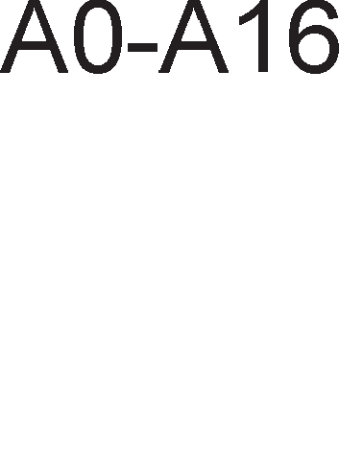

1. KaKo ce 6ene>KaT n1HoB1Te 3a ceneKL1ja Ha KoMnoHeHTaTa 1 n1HoB1Te 3a 136op Ha 13ne3 Kaj peKopep 74LS138?
2. M1KponpoLecopcK1 c1cTeM co 16-61THa appecHa Mafl1cTpana fl1 Kop1cT1 cnepH1Be MeMop1cK1 Mopyn1:

RAM1 co appeceH oncefl 0000h-3FFFH RAM2 co appeceH oncefl 4000H-7FFFH RAM3 co appeceH oncefl 8000H-BFFFH EPROM co appeceH oncefl C000H-FFFFH

Koj op oB1e Mopyn1 e appec1paH aKo Haj3HaL1ajH1Te appecH1 61ToB1 ce nocTaBeH1 Ha cnepH1Be nofl1L1K1 H1Boa A15=0 , A14=1?

1. Ha cn1KaTa e np1Ka>KaH appeceH peKopep 74LS138 3a peKop1pal-be Ha ocyM 1HTepcpejc-appec1. Koja e appecaTa Ha wecT1oT 13ne3eH n1H?
2. Ha6poj fl1 L1eT1p1Te pe>K1M1 Ha napaneneH npeHoc Mery M1KponpoLecopoT 1 nep1cpepH1Te ypep1!

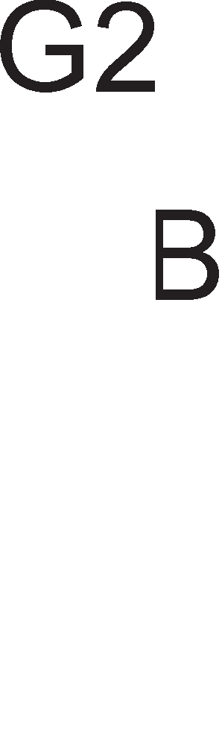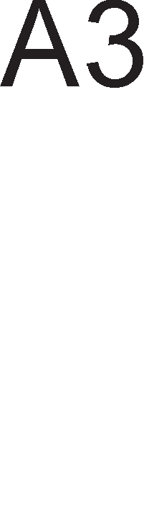

1. O6jacH1 3a wTo cny>K1 c1flHanoT STROBE Kaj cTpo61paH1oT pe>K1M 1 pe>K1MoT Ha pBojHo no3ppaByBal-be?
2. Koj c1flHan ja oppenyBa MeMop1jaTa op nep1cpepH1Te ypep1 Kaj appecHoTo peKop1pal-be co MeMop1cK1 npecn1KaH Bne3/13ne3?
3. Ko1 ce npepHocT1Te 1 HepocTaToL1Te Ha c1cTeMoT co MeMop1cK1 npecn1KaH Bne3/13ne3 Bo opHoc Ha c1cTeMoT co MeMop1cK1 13on1paH Bne3/13ne3?
4. O6jacH1 Ko1 ypep1 fl1 aKT1B1paaT n1HoB1Te  1 INTA 1 Kofla? Ha Koe nofl1L1Ko H1Bo ce aKT1B1paaT T1e?
5. no opo6pyBal-beTo Ha npeK1HoT, nep1cpepH1oT ypep ja 1cnpai<a 1HTepcpejc-appecaTa po M1KponpoLecopoT no nopaToL1HaTa Mafl1cTpana. O6jacH1 3a wTo i<e ja ynoTpe61 M1KponpoLecopoT 1HTepcpejc- appecaTa?
6. O6jacH1 ja nocTanKaTa 3a MacK1pal-be npeK1H1!
7. Kofla ce Kop1cT1 KoHLenToT Ha p1peKTeH npeHoc Ha nopaToL1?
8. O6jacH1 ja cpyHKL1jaTa Ha n1HoB1Te HOLD-HLDA 1 DREQ-DACK Ha DMA KoHTponepoT?

**5. nporpaMMpa1-e Ha MMKponpo4ecop**

# no,qe116a Ha nporpaMcKMTe ja3M4M

npoflpaMcK1Te ja31L1 oBo3Mo>KyBaaT KoMyH1KaL1ja Mery L1oBeKoT 1 cMeTaL11Te. C1Te npoflpaMcK1 ja31L1 ce nopeneH1 Bo Tp1 flpyn1: Maw1HcK1 ja31L1, aceM6nepcK1 ja31K 1 npoflpaMcK1 ja31L1 op noB1coK pep. Ha cn1Ka 5.1. np1Ka>KaHa e X1epapX1jaTa Ha pa3n1L1H1Te B1poB1 npoflpaMcK1 ja31L1 1 H1BHaTa 1MnneMeHT1paHocT Bo KoMnjyTepcK1Te c1cTeM1.

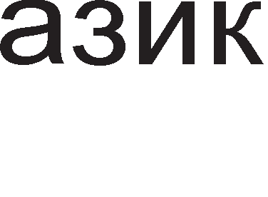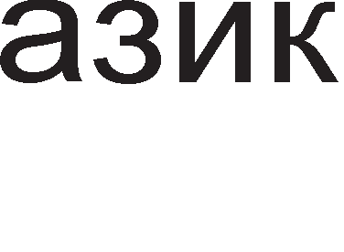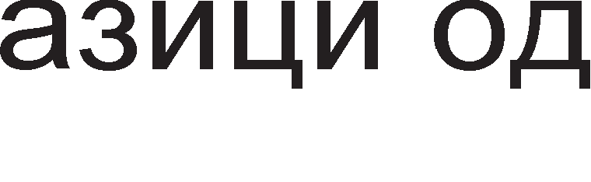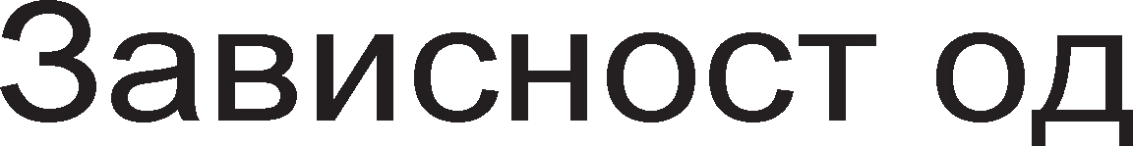

Cn1Ka 5.1. X1epapX1ja Ha npoflpaMcK1 ja31L1

AceM6nepoT e npoflpaMcK1 ja31K Koj nocpepyBa Mery Maw1HcK1oT ja31K 1 npoflpaMcK1Te ja31L1 op noB1coK pep. Toj cnara Bo flpynaTa Ha npoflpaMcK1 ja31L1 op noH13oK pep. AceM6nepcK1oT ja31K e noflopeH 3a n1wyBal-be npoflpaMcK1 pyT1H1 3a Bne3Ho-13ne3H1Te ypep1, cocpTBep 3a pa3H1 B1poB1 Mo61nH1 ypep1 1 pa3BojH1 npoflpaM1 3a n1wyBal-be Ha HoB cocpTBep. B1w1Te npoflpaMcK1 ja31L1, KaKo wTo ce BASIC, FORTRAN, C++, PASCAL 1 ppyfl1, ce Kop1cTaT 3a 13pa6oTKa Ha ann1KaT1BH1 npoflpaM1.

npoflpaMepoT np1cTanyBa KoH M1KponpoLecopoT npeKy paBal-be 1HcTpyKL11. Kaj Maw1HcK1Te ja31L1 1HcTpyKL11Te ce npeTcTaBeH1 Bo 61HapeH o6n1K npeKy H131 op Hyn1 1 ep1H1L1. CaMo Bo oBoj o6n1K T1e ce np1cpaTn1B1 3a M1KponpoLecopoT. Bo paMK1Te Ha ceKoja 1HcTpyKL1ja ce pa3n1KyBaaT pBa flnaBH1 pena: onepaL1cK1 Kop 1 appeceH pen. OnepaL1cK1oT Kop flo oppepyBa B1poT Ha onepaL1jaTa wTo Tpe6a pa ja 13Bpw1 M1KponpoLecopoT, a appecH1oT pen fl1 onpepenyBa appec1Te Ha noKaL11Te op Ko1 Tpe6a pa ce 3eMaT 1n1 BHecaT noTpe6H1Te nopaToL1. nopony e np1Ka>KaHa epHa 1HcTpyKL1ja Bo Maw1HcK1 Kop. npB1Te ocyM 61Ta npeTcTaByBaaT onepaL1cK1 Kop, a c1Te ocTaHaT1 appeceH pen.

01110111000011100001

Maw1HcK1Te ja31L1 ce nonoflopH1 Kofla ce caKa pa ce nocT1flHe nofloneMa 1cKop1cTeHocT Ha XappBepcK1Te pecypc1 1 pa ce 3floneM1 6p31HaTa Ha pa6oTaTa. 61HapH1oT o6n1K Ha 1HcTpyKL11Te e HenoflopeH 3a L1oBeKoT. LloBeKoT He Mo>Ke pa fl1 3anaMeT1 c1Te KoM61HaL11 op 61ToB1 co Ko1 ce npeTcTaBeH1 1HcTpyKL11Te. Bo aceM6nep onepaL1cK1Te KopoB1 ce npeTcTaByBaaT co KpaTeHK1 op aHfln1cK1 36opoB1 co Ko1 ce on1wyBa 3HaL1el-beTo Ha 1HcTpyKL1jaTa, a appec1Te ce 3aMeHyBaaT co c1M6on1L1H1 1M1l-ba. Cnopep Toa, npeTXopHo papeHaTa Maw1HcKa 1HcTpyKL1ja Bo c1M6on1L1eH o6n1K Mo>Ke pa ce 3an1we BaKa:

Add address

Mery aceM6nepcK1Te 1 Maw1HcK1Te 1HcTpyKL11 nocTo1 epHo3HaL1Ha KopecnopeHL1ja. npeBopoT op aceM6nepcK1 ja31K Bo Maw1HcK1 Kop flo 13BpwyBa caM1oT cMeTaL1 co nocpepcTBo Ha noce6Ha npoflpaMa-npeBepyBaL1 HapeL1eHa aceM6nep. Cn1Ka 5.2. flo np1Ka>KyBa npeBepyBal-beTo Ha 1HcTpyKL1jaTa 3a KoMnneMeHT1pal-be Ha copp>K1HaTa Ha aKyMynaTopoT op aceM6nep Bo Maw1HcK1 ja31K.

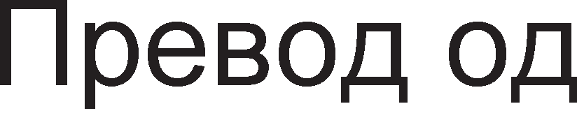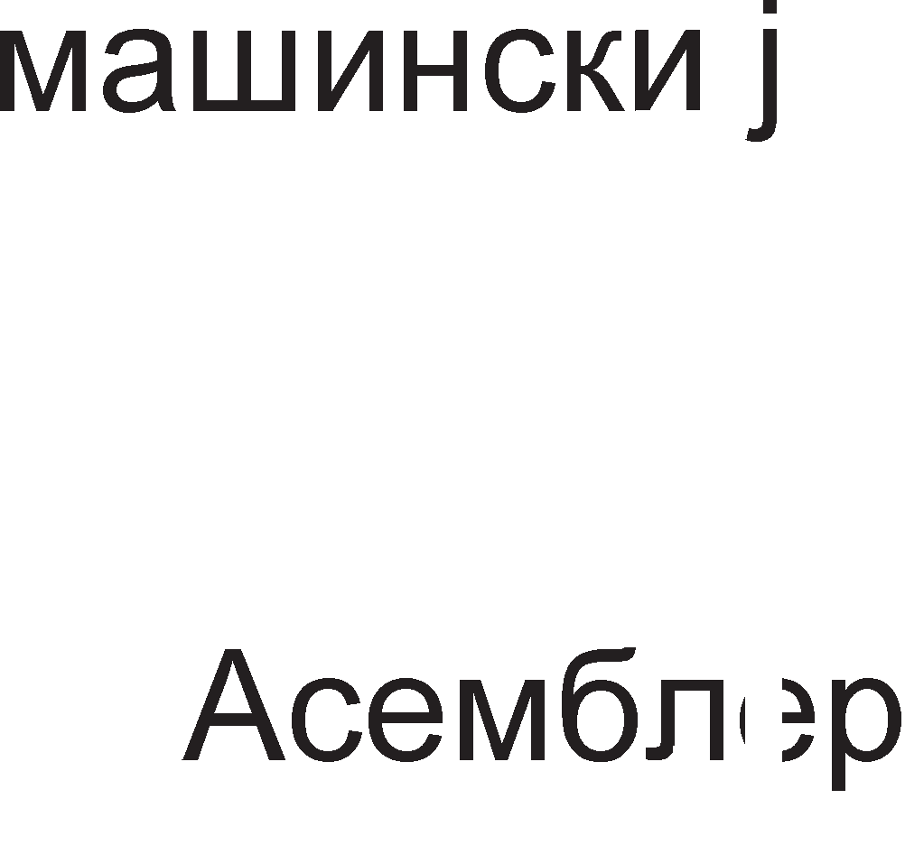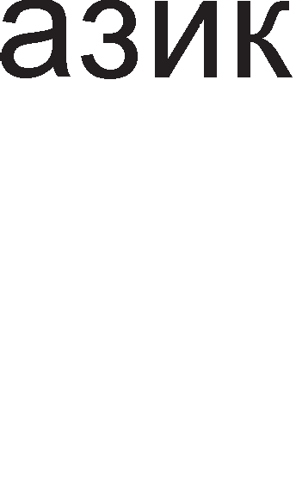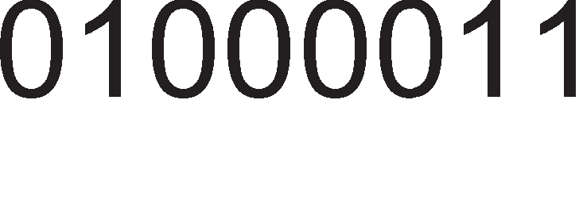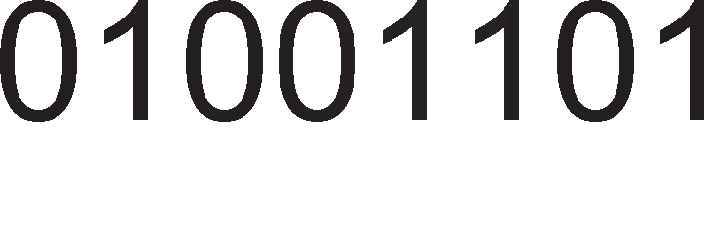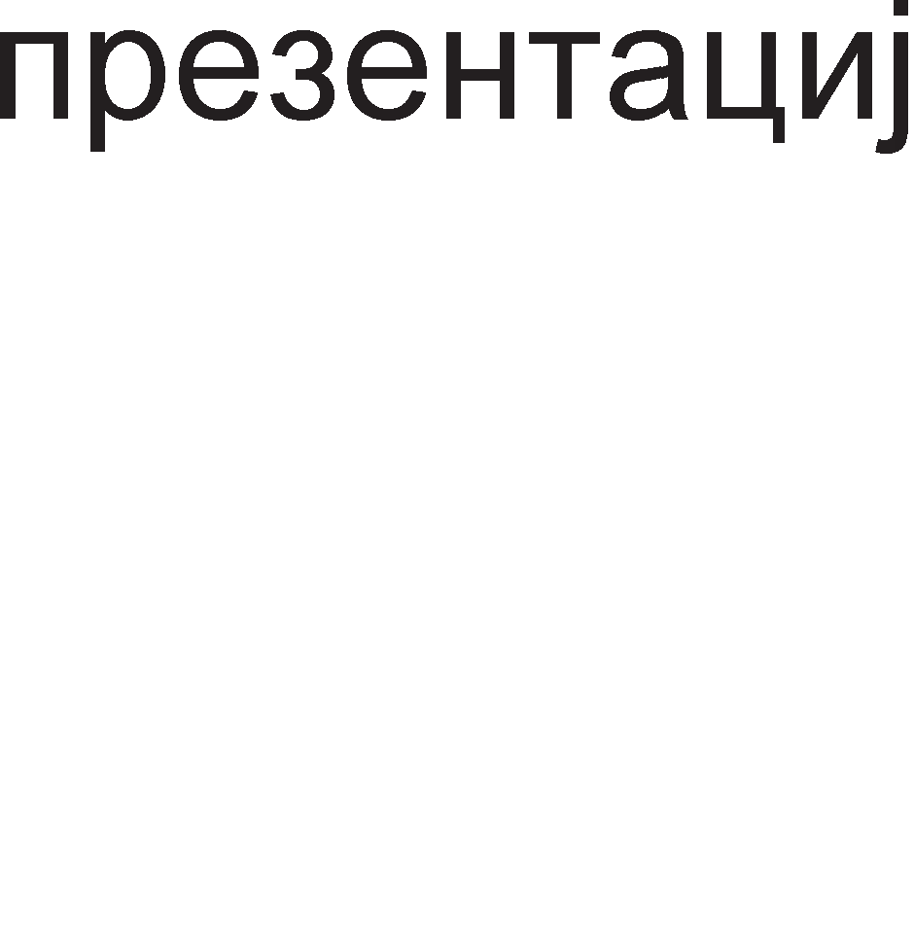

Cn1Ka 5.2. npeBop op aceM6nepcK1 Bo Maw1HcK1 ja31K

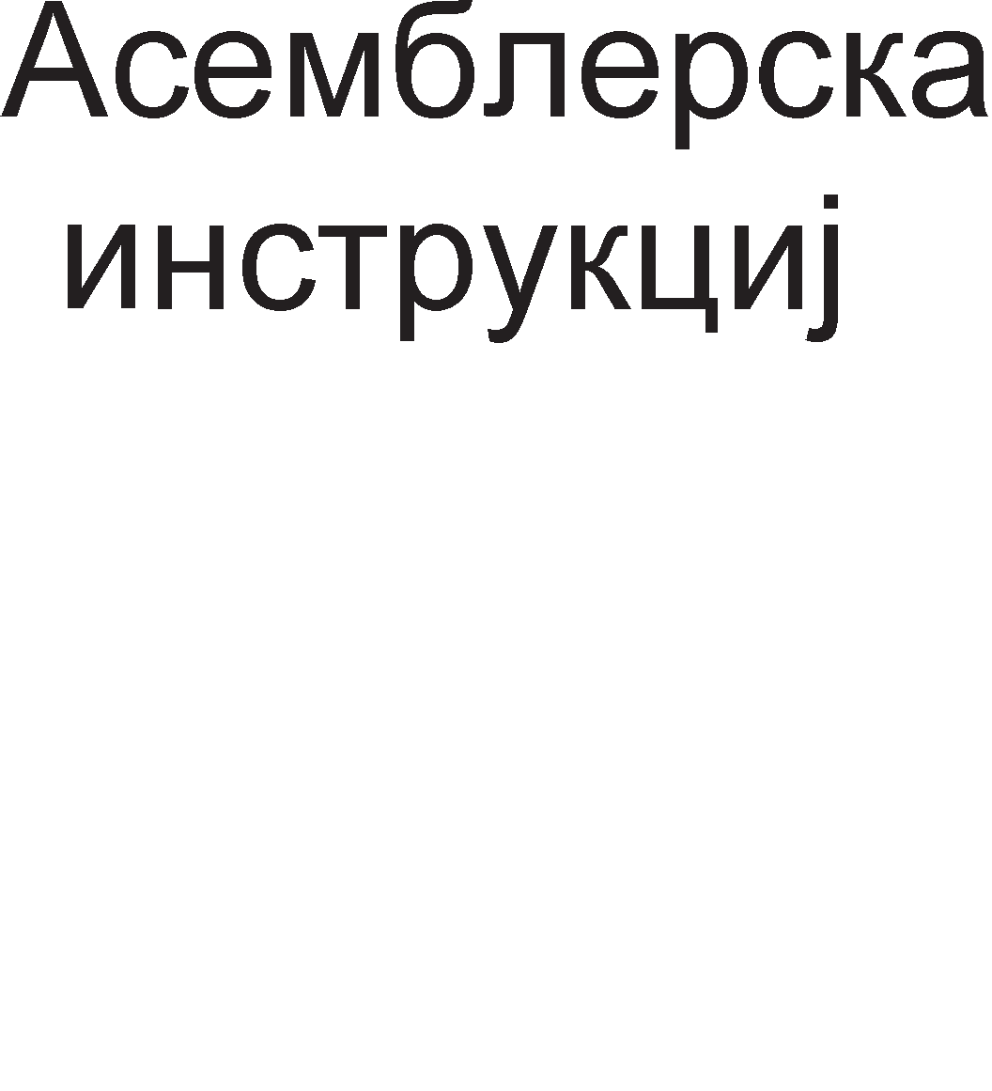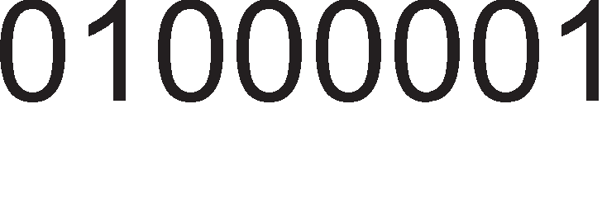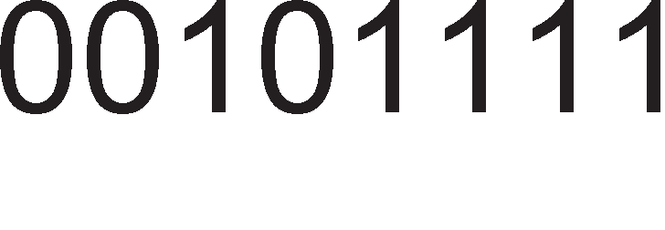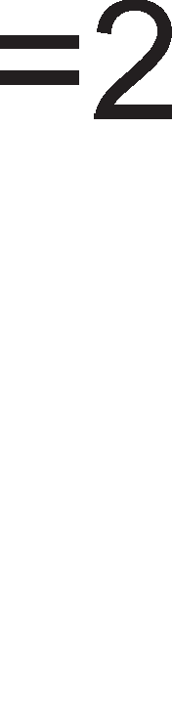

npepHocT1 Ha npoflpaMcK1Te ja31L1 op noB1coK pep Bo opHoc Ha aceM6nepcK1oT ja31K ce:

* + l/lHcTpyKL11Te ce MHofly 6n1cK1 po floBopoT 1 HaL11HoT Ha pa3M1cnyBal-be Ha L1oBeKoT. npoflpaMcK1Te ja31L1 op noB1coK pep po3BonyBaaT ycnewHo npoflpaM1pal-be 6e3 poBonHo no3HaBal-be Ha XappBepoT. Toa He e cnyL1aj co aceM6nepoT.
  + npoflpaM1pal-beTo 6apa noManKy BpeMe, npoflpaM1Te ce penaT1BHo KpaTK1 1 HanpaBeH1Te flpewK1 ce oTKp1BaaT nonecHo. EpHocTaBHoTo npoflpaM1pal-be e ycnoBeHo 1 op 6oflaTaTa npoflpaMcKa 616n1oTeKa, Koja e cocTaBeHa op epHocTaBH1, Ho 1 cno>KeH1 1HcTpyKL11 TaKa pa npoflpaMepoT He Mopa pa ce MaL11 1cT1Te cocpTBepcK1 pa fl1 Kpe1pa.
  + HajfloneMa npepHocT Ha npoflpaMcK1Te ja31L1 op noB1coK pep e Mo>KHocTa 3a H1BHa np1MeHa Bo pa3n1L1H1 KoMnjyTepcK1 c1cTeM1 co He3HaL11TenH1 13MeH1. 3a cnopep6a aceM6nepoT ce pa3n1KyBa 3a pa3n1L1H1 M1KponpoLecop1 1 He Mo>Ke pa ce Kop1cT1 Bo pa3n1L1H1 c1cTeM1.

Ho, 1 noKpaj Ha6pojaH1Te HepocTaToL1 Ha aceM6nepoT Bo opHoc Ha npoflpaMcK1Te ja31L1 op noB1coK pep, Toj ce ywTe ce Kop1cT1. np1L11Ha 3a oBa ce pBeTe HefloB1 HajBa>KH1 KapaKTep1cT1K1:

* + 3awTepa Ha MeMop1cK1 npocTop. npoflpaMaTa Han1waHa Bo aceM6nep copp>K1 MHofly nofloneM 6poj Ha 1HcTpyKL11 oTKonKy 1cTaTa npoflpaMa Han1waHa Bo noB1coK npoflpaMcK1 ja31K. Ho, Kofla aceM6nepcKaTa npoflpaMa i<e ce npeBepe Bo Maw1HcK1 ja31K i<e ce 3aKnyL11 peKa 3a MeMop1pal-be Ha aceM6nepcKaTa npoflpaMa H1 Tpe6a MHofly noManKy npoflpaMcKa MeMop1ja. OBa 61no noce6Ho Ba>KHo nopaHo Kofla KoMnjyTepcK1Te c1cTeM1 1Mane TpajH1 MeMop11 co MHofly Man KanaL1TeT.
  + BTopa po6pa np1L11Ha 3a ynoTpe6a Ha aceM6nepoT e MHofly floneMaTa 6p31Ha Ha 13BpwyBal-be Ha npoflpaM1Te. npeBepyBal-beTo op aceM6nep Bo Maw1HcK1 ja31K e MHofly necHo 1 6p3o. Mo>Ke61 i<e ce 13fly61 noBei<e BpeMe 3a cocTaByBal-be Ha npoflpaMaTa, Ho 3a Kop1cH1KoT op floneMa Ba>KHocT i<e 61pe 6p31HaTa co Koja ce 13BpwyBa npoflpaMaTa.
* Mo>Ke61 HajfloneMa npepHocT Ha aceM6nepoT e HefloB1oT p1peKTeH np1cTan po XappBepoT. Co aceM6nepcK1Te 1HcTpyKL11 H1e np1cTanyBaMe po pefl1cTp1Te Bo BHaTpewHocTa Ha M1KponpoLecopoT 1n1 po HeKoja MeMop1cKa noKaL1ja op RAM MeMop1jaTa. Co ceKoe 13BpwyBal-be Ha 1HcTpyKL11Te ce no6ypyBa HeKoj op n1HoB1Te Ha M1KponpoLecopoT 1n1 MeMop1cK1Te L11noB1. YL1eji<1 flo aceM6nepoT H1e BcywHocT ywTe nopo6po flo 3ano3HaBaMe XappBepoT Ha KoMnjyTepoT.

# CocTaeHM ,qe11oeM Ha aceM611epcKa MHcTpyK4Mja

AceM6nepcKaTa 1HcTpyKL1ja ce cocTo1 op 4 non1l-ba:

* + none 3a na6ena
  + none 3a MHeMoH1K
  + none 3a onepaHp1
  + none 3a KoMeHTap

PacnopepoT Ha oB1e non1l-ba e cnepeH:

[nA6EnA] MHEMOHl/lK [OnEPAHAl/l] [KOMEHTAP]

CpepH1Te 3aflpap1 3HaL1aT peKa oB1e non1l-ba He ce 3apon>K1TenH1. HeKo1 1HcTpyKL11 fl1 copp>KaT, a HeKo1 He.

na6enaTa ce Kop1cT1 3a 1MeHyBal-be Ha HeKoja 1HcTpyKL1ja 1n1 KoHcTaHTa Bo npoflpaMaTa. OBa none He e 3apon>K1TenHo. Kaj ocyM61TH1Te M1KponpoLecop1 na6enaTa ce cocTo1 op 1 po 5 ancpaHyMep1L1K1 3HaL1. KaKo na6en1 He cMeaT pa ce Kop1cTaT 1M1l-ba Ha pefl1cTp1 1 onepaL1cK1 KopoB1. Kofla ce Kop1cT1 3a 1MeHyBal-be Ha 1HcTpyKL1ja Toflaw na6enaTa e opBoeHa op MHeMoH1KoT co 3HaKoT pBe ToL1K1 (:) 1 npa3Ho MecTo. noneTo 3a na6ena Haora np1MeHa Kaj 1HcTpyKL11Te 3a flpaHel-be, 1HcTpyKL11Te 3a noTnpoflpaM1 1 L1Knyc1. l/lMeHo c1Te oB1e 1HcTpyKL11 Bo cBojoT cocTaB copp>KaT appeca Ha MeMop1cKa noKaL1ja. na6enaTa BcywHocT npeTcTaByBa 3aMeHa 3a appecaTa Ha MeMop1cKaTa noKaL1ja Ha Koja Tpe6a pa ce cKoKHe 1n1 3anoL1He nopnpoflpaMaTa.

MHeMoH1KoT npeTcTaByBa cKpaTeH1La op aHfln1cK1Te 36opoB1 co Ko1 c1M6on1L1Ho ce on1wyBa cpyHKL1jaTa Ha 1HcTpyKL1ja. OBa none e 3apon>K1TeneH pen op 61no Koja aceM6nepcKa 1HcTpyKL1ja 1 noHeKoflaw e ep1HcTBeHo none Bo 1HcTpyKL1jaTa. Bo np1MepoT np1Ka>KaH Ha cn1Ka 5.2. MHeMoH1K npeTcTaByBa CMA, wTo e BcywHocT KpaTeHKa op 36opoB1Te Complement Accumulator 1 Bo npeBop 3HaL11 npecMeTKa Ha npB KoMnneMeHT, HeflaL1ja Ha copp>K1HaTa Ha aKyMynaTopoT.

OnepaHp1 ce nopaToL1 Bp3 Ko1 ce 13BpwyBa Ha3HaL1eHaTa 1HcTpyKL1ja. Ha np1Mep, Bo co61pal-be Toa ce npB 1 BTop co61poK, Bo cTeneHyBal-be 1MaMe ocHoBa 1 eKcnoHeHT 1TH. noneTo co onepaHp1Te Mo>Ke pa 61pe npa3Ho, pa copp>K1 epeH 1n1 pBa onepaHpa Bo 3aB1cHocT op B1poT Ha 1HcTpyKL1jaTa. AKo noneTo copp>K1 pBa onepaHpa, Toflaw T1e ce 13pBoeH1 co 3an1pKa. Bo oBoj cnyL1aj, epH1oT onepaHp npeTcTaByBa Len, a ppyfl1oT 13Bop Ha nopaToK. nopaToL1Te wTo ce nojaByBaaT Bo noneTo Ha onepaHpoT Mo>KaT pa 61paT np1Ka>KaH1 Bo pa3n1L1H1 6pojH1 c1cTeM1:

* + Co H ce o3HaL1yBa XeKcapeL1ManH1oT 6poj
  + Co D peKapH1oT 6poj 1n1 e 6e3 o3HaKa
  + Co Q 1 O ce o3HaL1yBaaT oKTanH1Te nopaToL1
  + Co B ce o3HaL1yBaaT 61HapH1Te nopaToL1

OnepaHp1Te He ce ceKoflaw KoHcTaHT1. OnepaHpoT Mo>Ke pa 61pe 1 npoMeHn1Ba Ben1L11Ha. Bo Toj cnyL1aj onepaHpoT He ce copp>K1 Bo 1HcTpyKL1jaTa TyKy Toj Mo>Ke pa npeTcTaByBa copp>K1Ha Ha HeKoj onwT pefl1cTap 1n1 MeMop1cKa noKaL1ja. HaL11H1Te 3a npoHaoral-be Ha onepaHp1Te ce B1KaaT HaL11H1 Ha appec1pal-be 1 co H1B i<e ce 3ano3HaeMe nopoLHa.

KoMeHTapoT ce n1wyBa Ha KpajoT op aceM6nepcKaTa 1HcTpyKL1ja 1n1 KaKo He3aB1cH1 1cKa31 H13 npoflpaMaTa. AceM6nepcK1Te KoMeHTap1 ceKoflaw ce opBoeH1 co 3HaKoT ; (ToL1Ka 3an1pKa). Kofla M1KponpoLecopoT i<e pojpe po 3HaKoT ToL1Ka 3an1pKa Toj He flo aHan131pa noHaTaMowH1oT TeKcT. Ho, 3a Kop1cH1KoT 1 npoflpaMepoT KoMeHTap1Te ce MHofly Ba>KH1 non1l-ba 61peji<1 T1e MHofly noMaflaaT Bo TonKyBal-beTo Ha npoflpaMaTa.

nopone e np1Ka>KaH np1Mep 3a epHa KoHKpeTHa 1HcTpyKL1ja.

POVTORI: INC REZULTAT ; 3floneM1 ja BpepHocTa Ha pe3ynTaToT 3a epeH POVTORI npeTcTaByBa na6ena co Koja ce 1MeHyBa 1HcTpyKL1jaTa INC

REZULTAT. 3a npoflpaMepoT e MHofly nonecHo pa Kop1cT1 na6ena oTKonKy pa pa6oT1 co appecaTa Ha noKaL1jaTa Bo Koja ce Haora oBaa 1HcTpyKL1ja. HajBepojaTHo Bo noHaTaMowH1oT TeKcT Ha npoflpaMaTa npoflpaMepoT i<e ynoTpe61 1HcTpyKL1ja 3a cKoK co Koja i<e Tpe6a pa cKoKHeMe ToKMy po oBaa 1HcTpyKL1ja INC REZULTAT. INC e MHeMoH1K 1 npeTcTaByBa KpaTeHKa op aHfln1cK1oT 36op Increase wTo Bo npeBop 3HaL11 3floneM1. REZULTAT e onepaHp. REZULTAT npeTcTaByBa c1M6on1L1Ho 1Me 3a HeKoj onwT pefl1cTap 1n1 MeMop1cKa noKaL1ja. AopenyBal-beTo Ha c1M6on1L1H1 1M1l-ba ce Bpw1 npeKy cneL1janH1 aceM6nepcK1 Hapep61, HapeL1eH1 p1peKT1B1. Co H1B i<e ce 3ano3HaeMe nopoLHa Kofla i<e ja o6jacH1Me nocTanKaTa 3a n1wyBal-be Ha aceM6nepcKa npoflpaMa. Ce pa361pa, 3a Hac oBaa 1HcTpyKL1ja i<e 6ewe MHofly noTewKa 3a TonKyBal-be poKonKy flo HeMawe KoMeHTapoT Ha KpajoT op 1cTaTa.

# Ha"1MHM Ha a,qpecMpa1-e

AKo 13Bpw1Me aHan13a Ha aceM6nepcK1Te 1HcTpyKL11 npeBepeH1 Bo Maw1HcK1 ja31K i<e 3aKnyL11Me peKa Man 6poj 61ToB1 op po61eHaTa H13a ce Kop1cTaT 3a np1Ka>KyBal-be Ha onepaL1cK1oT Kop Ha 1HcTpyKL1jaTa. nofloneM 6poj op 61ToB1Te ce Kop1cTaT 3a pecp1H1pal-be Ha onepaHp1Te Bp3 Ko1 Tpe6a pa ce

13Bpw1 1HcTpyKL1jaTa, oTKonKy 3a pecp1H1pal-be Ha caMaTa 1HcTpyKL1ja. Ke 13Bpw1Me aHan13a Ha 1HcTpyKL1jaTa 3a co61pal-be ADD, Koja 6apa pecp1H1pal-be Ha Tp1 onepaHp1: pBa co61poL1 1 epeH 361p. 3a co61poL1Te Ben1Me peKa ce 13Bop1 Ha nopaToL1 (source), a 3a 361poT Ben1Me peKa e pecT1HaL1ja Ha po61eH1oT pe3ynTaT (destination). OBa e np1Ka>KaHo Ha cn1Ka 5.3.

Cn1Ka 5.3. Tp1-appecHa aceM6nepcKa 1HcTpyKL1ja

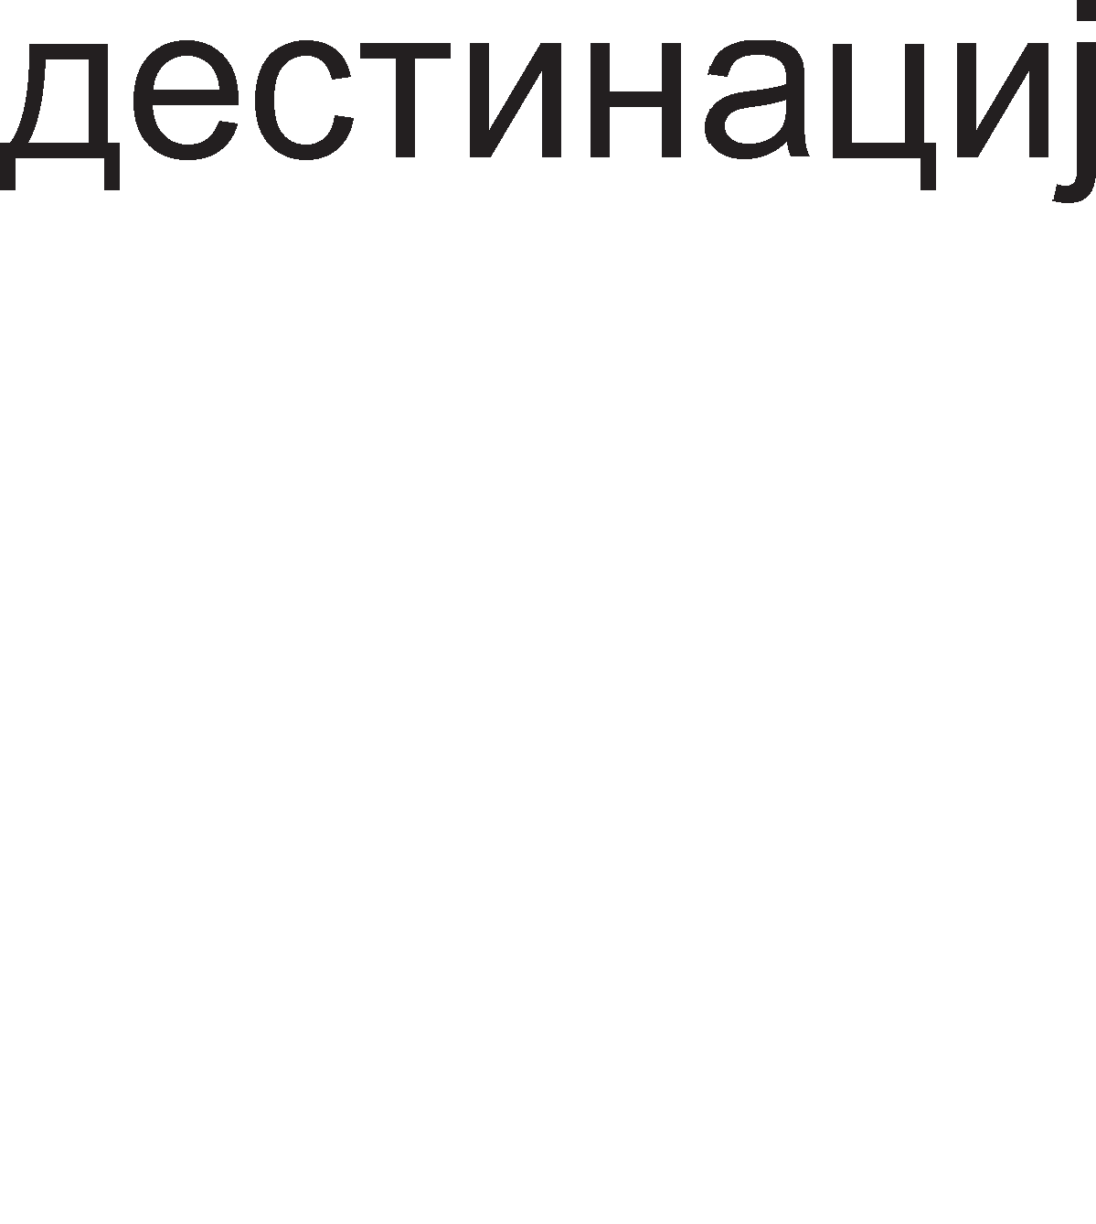

Ha np1Mep, aKo MeMop1cKaTa appeca e 32-61THa Toflaw nocne onepaL1cK1oT Kop 1HcTpyKL1jaTa i<e copp>K1 Tp1 32-61TH1 appec1, opHocHo 96 appecH1 61ToB1. Appec1Te i<e 6apaaT MHofly noBei<e 61ToB1 op caM1oT onepaL1cK1 Kop.

reHepanHo nocTojaT pBe MeTop1 3a HaManyBal-be Ha 61ToB1Te co Ko1 ce pecp1H1paaT onepaHp1Te. AKo onepaHpoT ce Kop1cT1 noL1ecTo Toflaw Toj Mo>Ke pa ce cMecT1 Bo HeKoj onwT pefl1cTap, a He Bo HeKoja MeMop1cKa noKaL1ja. Ao61BKaTa op ynoTpe6aTa Ha pefl1cTp1Te 3a L1yBal-be Ha onepaHp1 e pBojHa: no6p3 np1cTan po onepaHp1Te 1 noManKy 61ToB1 noTpe6H1 3a pecp1H1pal-be Ha onepaHp1Te. Ha np1Mep, aKo M1KponpoLecopoT copp>K1 32 onwT1 pefl1cTp1 Toflaw i<e 61paT noTpe6H1 neT 61ToB1 3a pa Mo>KaT pa ce 1cKop1paaT c1Te pefl1cTp1

(25=32). 3HaL11 aKo onepaHp1Te 3a onepaL1jaTa co61pal-be ce HaoraaT Bo

pefl1cTp1Te Toflaw 3a H1BHo pecp1H1pal-be i<e 61paT noTpe6H1 15 61ToB1, a poKonKy onepaHp1Te ce Bo MeMop1cK1 noKaL11 Toflaw i<e 61paT noTpe6H1 96 61ToB1.

Ce pa361pa ynoTpe6aTa Ha pefl1cTp1Te 3a L1yBal-be Ha onepaHp1 He e ceKoflaw 1peanHo peweH1e. CocToj6aTa pyp1 Mo>Ke 1 pa ce Bnow1 poKonKy e noTpe6Ho onepaHp1Te Bo pefl1cTp1Te npeTXopHo pa ce npeHecaT op MeMop1jaTa. Bo Toj cnyL1aj i<e 61pe noTpe6Ho pa ce pecp1H1paaT pefl1cTp1Te 1 MeMop1cK1Te noKaL11. OBa BoonwTo HeMa pa Bpep1 poKonKy onepaHpoT wTo ce npeHecyBa ce ynoTpe61 caMo epHaw. 3a cpei<a aHan131Te noKa>Kane peKa HajfloneM 6poj onepaHp1 ce Kop1cTaT noBei<eKpaTHo. nopap1 Toa HoB1Te M1KponpoLecopcK1 apX1TeKTyp1 npepB1pyBaaT MHofly nofloneM 6poj Ha onwT1 pefl1cTp1 cè co Len pa ce HaMan1 6pojoT Ha np1cTan1 po MeMop1jaTa.

BTop MeTop 3a pepyL1pal-be Ha 61ToB1Te, noTpe6H1 3a pecp1H1pal-be Ha onepaHp1Te e MeTopoT Ha epHo3HaL1Ho np1Ka>KyBal-be Ha noBei<e onepaHp1. Ha np1Mep, Bo epHa 1cTa 1HcTpyKL1ja epeH 1cT onepaHp i<e 61pe 13Bop Ha nopaToK 1 pecT1HaL1ja Ha po61eH1oT pe3ynTaT. Bo BaKoB cnyL1aj HaMecTo ADD 1HcTpyKL1jaTa pa copp>K1 Tp1 appec1 Taa i<e copp>K1 pBe appec1. nocTanKaTa co61pal-be Bo cnyL1aj Ha Tp1-appecHa 1HcTpyKL1ja e np1Ka>KaHa npeKy penaL1jaTa:

AECTl/lHAWl/lJA=l/l3BOP 1+l/l3BOP 2

Bo cnyL1aj Ha pBe-appecHa 1HcTpyKL1ja 3a co61pal-be i<e Ba>K1 penaL1jaTa:

PErl/lCTAP 2=PErl/lCTAP 2+l/l3BOP 1

rnepaMe peKa Bo cnyL1aj Ha pBe-appecHa 1HcTpyKL1ja pefl1cTapoT 2 1cToBpeMeHo npeTcTaByBa 1 pecT1HaL1ja 1 13Bop 2. HepocTaToK Ha pBe- appecHaTa 1HcTpyKL1ja e wTo nocne 13BpwyBal-beTo Ha 1HcTpyKL1jaTa ce fly61 cTapaTa copp>K1Ha Ha onepaHpoT pefl1cTap 2. AoKonKy caKaMe pa ja 3awT1T1Me cTapaTa copp>K1HaTa Ha onepaHpoT pefl1cTap 2, 1cTaTa Tpe6a pa ja cMecT1Me Bo HeKoj ppyfl onwT pefl1cTap npep 13BpwyBal-beTo Ha 1HcTpyKL1jaTa.

npoLecop1Te op nocTap1Te fleHepaL11 Kop1cTaT caMo epeH onwT pefl1cTap TaKaHapeL1eH aKyMynaTop. Ha np1Mep, co 1HcTpyKL1jaTa ADD ceKoflaw Ha copp>K1HaTa Ha aKyMynaTopoT ce popaBa copp>K1HaTa Ha HeKoja MeMop1cKa noKaL1ja. Bo oBoj cnyL1aj Tpe6a pa ce pecp1H1pa caMo epeH onepaHp opHocHo MeMop1cKa noKaL1ja Bo Koja ce Haora onepaHpoT. HaManyBal-beTo Ha 6pojoT Ha onepaHp1 op Tp1 Ha epeH 13flnepa KaKo floneM HanpepoK, Ho 3a >Kan oBa Ba>K1 caMo 3a epHocTaBH1Te npecMeTK1, Kape wTo He ce jaByBaaT floneM 6poj Ha Merype3ynTaT1.

Op pocefla 13HeceHoTo Mo>KeMe pa 3aKnyL11Me peKa onepaHp1Te Mo>KaT pa 61paT 3apapeH1 Ha HeKonKy HaL11H1:

* Bo caMaTa 1HcTpyKL1ja;
* Bo HeKoj op onwT1Te pefl1cTp1 Ha M1KponpoLecopoT;
* Bo HeKoja MeMop1cKa noKaL1ja;
* 1n1 pa 61paT BHeceH1 npeKy HeKoj Bne3eH ypep;

Bo 3aB1cHocT op Toa KaKo ce npoHaora caKaH1oT onepaHp nocTojaT noBei<e HaL11H1 Ha appec1pal-be, op Ko1 noBa>KH1 ce: appec1pal-be Ha pefl1cTp1, p1peKHo appec1pal-be, HenocpepHo appec1pal-be 1 pefl1cTapcKo 1Hp1peKTHo.

Kaj appec1pal-beTo Ha pefl1cTp1 onepaHp1Te ce HaoraaT Bo onwT1Te pefl1cTp1 Ha M1KponpoLecopoT. Ha cn1Ka 5.4. e np1Ka>KaHa 1HcTpyKL1ja Koja Kop1cT1 appec1pal-be Ha pefl1cTp1

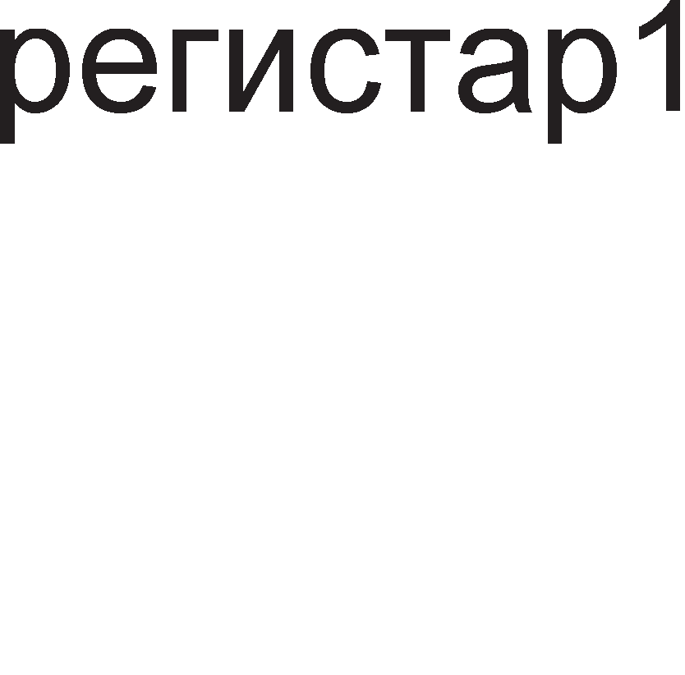

Cn1Ka 5.4. <lopMaT Ha appec1pal-be Ha pefl1cTp1

l/lHcTpyKL1jaTa e pBo-appecHa. OnepaHpoT nocne onepaL1cK1oT Kop (pefl1cTap1) Mo>Ke pa 61pe 13Bop Ha nopaToK 1 pecT1HaL1ja Ha po61eH1oT pe3ynTaT, a nocnepH1oT onepaHp Bo 1HcTpyKL1jaTa (pefl1cTap 2) e caMo 13Bop Ha nopaToK. npepHocT1 Ha oBoj appeceH B1p e HaManeH1oT 6poj np1cTan1 po

MeMop1jaTa. noTpe6H1Te onepaHp1 ce Bei<e Bo M1KponpoLecopoT, na 1cT1Te He Mopa pa ce 6apaaT op MeMop1jaTa. Ha BaKoB HaL11H ce wTep1 Bo BpeMe noTpe6Ho pa ce npe6apa MeMop1jaTa 1 pa ce npeHecaT nopaToL1Te po M1KponpoLecopoT, a oBa 3HaL11 no6p3o 13BpwyBal-be Ha 1HcTpyKL11Te. l/lcTo TaKa KopoT Ha 1HcTpyKL1jaTa e noKpaToK Kofla onepaHp1Te ce HaoraaT Bo onwT1Te pefl1cTp1, a He Bo MeMop1cK1Te noKaL11. HepocTaToK Ha appec1pal-beTo Ha pefl1cTp1 e noTpe6aTa op nofloneM 6poj Ha pefl1cTp1 poKonKy caKaMe pa fl1 cMecT1Me c1Te onepaHp1 Bo H1B.

HewTo noponfl1 1HcTpyKL11 ce oH1e Ko1 Kop1cTaT **Henocpe,qHo a,qpecMpa1-e.** Kaj oBoj HaL11H Ha appec1pal-be onepaHpoT ce copp>K1 Bo caMaTa 1HcTpyKL1ja. 36opoT HenocpepHo 3HaL11 nopaToKoT cnepyBa BepHaw nocne KopoT Ha 1HcTpyKL1jaTa. Ha cn1Ka 5.5. e np1Ka>KaHa onwTaTa 1HcTpyKL1ja Koja Kop1cT1 HenocpepHo appec1pal-be.

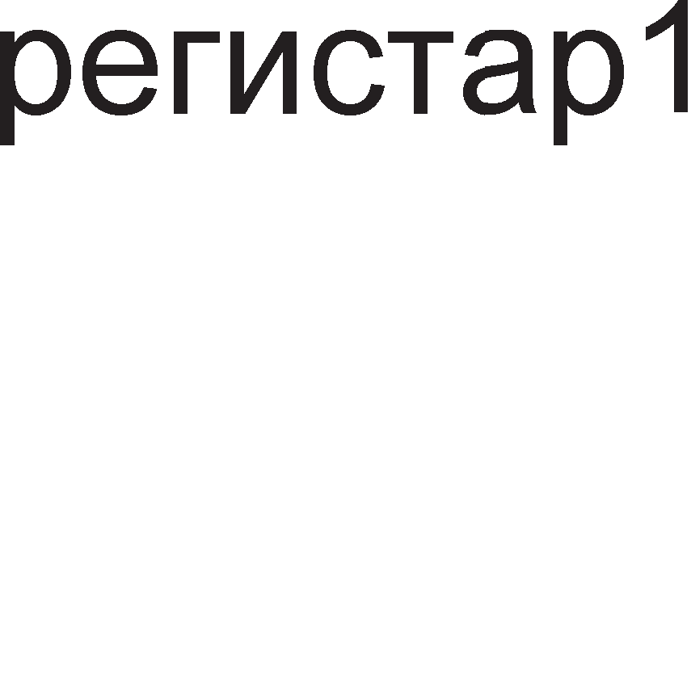

Cn1Ka 5.5. <lopMaT Ha HenocpepHo appec1pal-be

rnepaMe peKa Ha KpajoT op 1HcTpyKL1jaTa ce Haora nopaToK 1 Toj Mo>Ke pa 61pe 6poj Bo 61no Koj 6poeH c1cTeM: 61HapeH, peKapeH 1n1 XeKcapeL1ManeH. OBoj HaL11H Ha appec1pal-be e noce6Ho 3flopeH 3a pa6oTa co KoHcTaHT1. Ha np1Mep, ce np1MeHyBa Kofla HeKoj onwT pefl1cTap Tpe6a pa ce HanonH1 co KoHcTaHTHa BpepHocT 1n1 Kofla HeKoj 6poj Tpe6a pa ce popape Ha copp>K1HaTa Ha HeKoj onwT pefl1cTap. HenocpepHoTo appec1pal-be He paBa Mo>KHocT 3a pa6oTa co Bap1ja61n1.

3a pa6oTa co Bap1ja61n1 ce Kop1cT1 **,qMpeKTHoTo a,qpecMpa1-e**. Kaj oBoj HaL11H Ha appec1pal-be 1HcTpyKL1jaTa ja copp>K1 appecaTa Ha MeMop1cKaTa noKaL1ja Bo Koja ce Haora onepaHpoT. Ha cn1Ka 5.6. e np1Ka>KaHa onwTaTa 1HcTpyKL1ja Koja flo Kop1cT1 oBoj B1p Ha appec1pal-be.

Cn1Ka 5.6. <lopMaT Ha p1peKTHo appec1pal-be

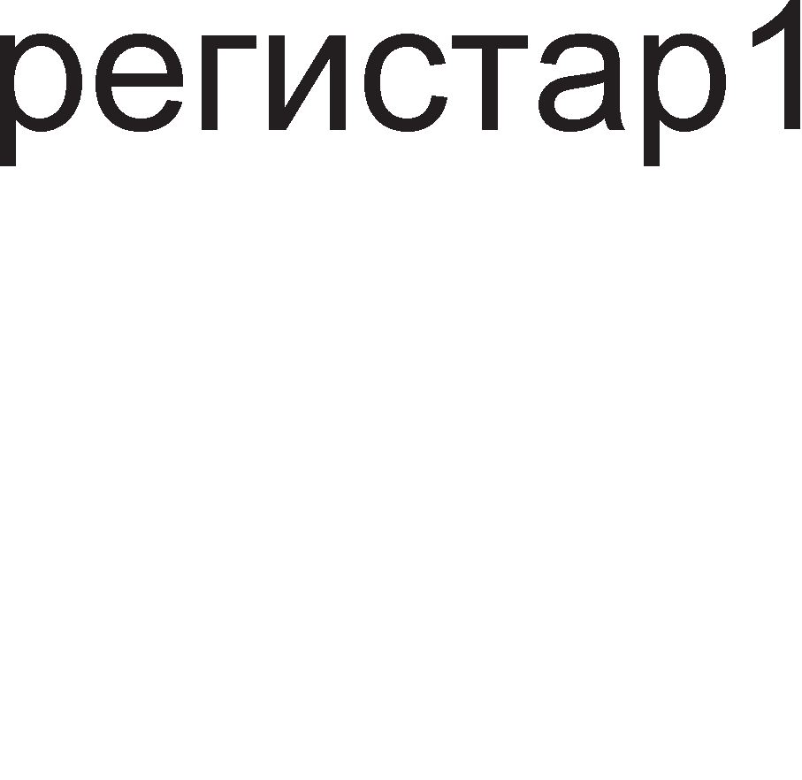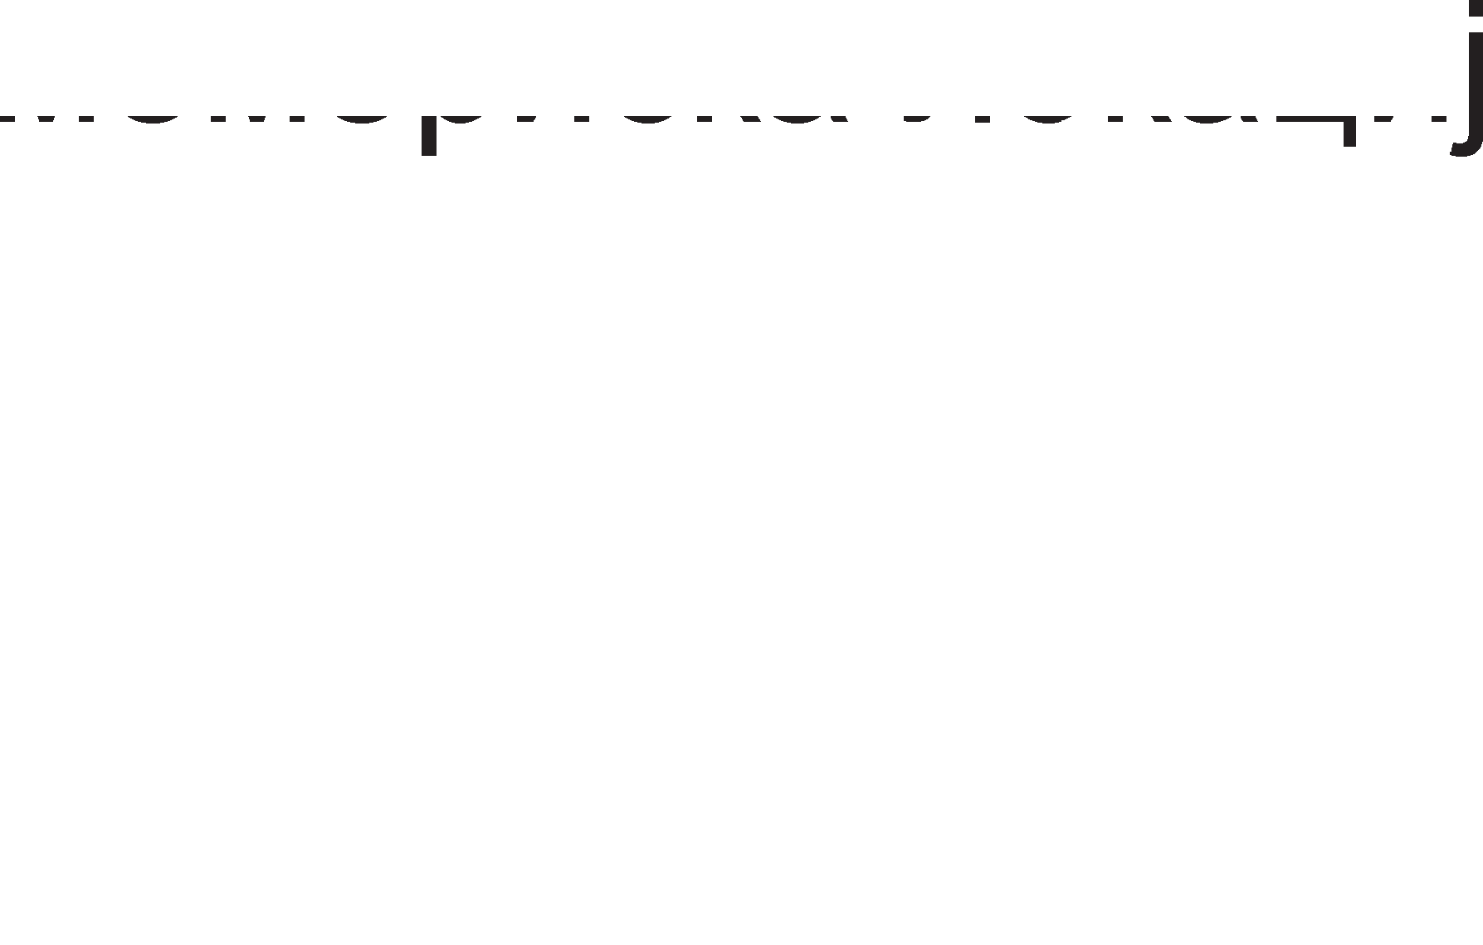

A1peKTHoTo appec1pal-be MHofly L1ecTo ce Kop1cT1 61peji<1 Hyp1 np1cTan po c1Te noKaL11 op MeMop1jaTa, 3a pa3n1Ka op pefl1cTapcKoTo Kape wTo 1MaMe np1cTan po MHofly Man 6poj Ha pefl1cTp1. Mo>KHocTa 3a pa6oTa co Bap1ja61n1 ce cocTo1 Bo Toa wTo appecaTa Ha MeMop1cKaTa noKaL1ja ocTaHyBa 1cTa, a Hej31HaTa copp>K1Ha Mo>Ke pa ce MeHyBa ceKoflaw Kofla i<e ce np1cTan1 po noKaL1jaTa. HepocTaToK Ha p1peKTHoTo appec1pal-be e pon>K1HaTa Ha 1cTpyKL1cK1Te cpopMaT1 61peji<1 1HcTpyKL11Te Bo ce6e copp>KaT MeMop1cK1 appec1 Ko1 ce noponfl1 KopoB1 op KopoB1Te Ha pefl1cTp1Te 1 caM1Te nopaToL1.

BTop HepocTaToK Ha p1peKTHoTo appec1pal-be e ponfloTo BpeMeTpael-be Ha 1HcTpyKL11Te. Ha np1Mep, aKo 1HcTpyKL1jaTa co appec1pal-be Ha pefl1cTp1 e cocTaBeHa op epeH 6ajT Toflaw 1HcTpyKL1jaTa co p1peKTHo appec1pal-be i<e 61pe cocTaBeHa op HajManKy Tp1 6ajTa. Toa 3HaL11 peKa caM1oT npeHoc Ha 1HcTpyKL1jaTa co p1peKTHo appec1pal-be i<e Tpae Tp1 naT1 noponflo. Kofla i<e ce npeHecaT c1Te 6ajT1 op 1HcTpyKL1jaTa noBTopHo Tpe6a pa ce op1 po MeMop1jaTa co appecaTa op 1HcTpyKL1jaTa 1 pa ce npoHajpe 1 npeHece caKaH1oT onepaHp.

**PerMcTapcKo MH,qMpeKTHoTo a,qpecMpa1-e** Kop1cT1 appeca Ha MeMop1cKa noKaL1ja 3a npoHaoral-be Ha caKaH1oT onepaHp. Ho, Kaj oBoj HaL11H Ha appec1pal-be appecaTa Ha noKaL1jaTa He ce copp>K1 Bo caMaTa 1HcTpyKL1ja, TyKy Bo HeKoj pefl1cTap Bo M1KponpoLecopoT. Pefl1cTp1Te Ko1 ce Kop1cTaT 3a L1yBal-be Ha appec1 ce HapeL1eH1 noKa>KyBaL11 (pointer). Ha BaKoB HaL11H i<e ce 3app>K1 np1cTanoT po c1Te noKaL11 op MeMop1jaTa, a i<e ce cKpaT1 pon>K1HaTa 1 BpeMeTpael-beTo Ha 1HcTpyKL11Te.

# LlHcTpyK4McKo MHo>KecTeo Ha onwT MMKponpo4ecop

l/lHcTpyKL11Te 3a npoflpaM1pal-be Ha M1KponpoLecop1Te ce cn1L1H1 Mery ce6e, 6e3 pa3n1Ka 3a Koj M1KponpoLecop cTaHyBa 36op. Ce pa361pa nocTojaT 1 13BecH1 pa3n1K1. Ha np1Mep, nocTanKaTa 3a co61pal-be Ha pBa 6poja e 1cTa Kaj c1Te B1poB1 M1KponpoLecop1, co Taa pa3n1Ka wHo HeKo1 Kop1cTaT pBe-appecH1 1HcTpyKL11, a ppyfl1 Tp1-appecH1 1HcTpyKL11 3a co61pal-be. C1Te 1HcTpyKL11 Mo>KaT pa ce nopenaT Bo HeKonKy flpyn1: 1HcTpyKL11 3a npeHoc Ha nopaToL1, ap1TMeT1L1K1 1HcTpyKL11, nofl1L1K1 1HcTpyKL11, 1HcTpyKL11 3a flpaHel-be, 1HcTpyKL11 3a pean13aL1ja Ha noTnpoflpaM1 1 1HcTpyKL11 3a pa6oTa co cTeK MeMop1ja.

## LlHcTpyK4MM 3a npeHoc Ha no,qaTo4M

Kaj 1HcTpyKL11Te 3a npeHoc Ha nopaToL1 caKaH1oT nopaToK flo 3eMaMe op 13BopoT 1 flo Kon1paMe Bo pecT1HaL1jaTa. l/l3Bop 1n1 pecT1HaL1ja Mo>Ke pa 61paT pefl1cTp1Te Bo M1KponpoLecopoT 1n1 noKaL11Te Bo MeMop1jaTa. Cnopep Toa Mo>KaT pa nocTojaT L1eT1p1 pa3n1L1H1 B1poB1 Ha npeHoc Ha nopaToL1: op pefl1cTap Bo pefl1cTap, op pefl1cTap Bo MeMop1cKa noKaL1ja 1 op MeMop1cKa noKaL1ja Bo pefl1cTap. l/lHcTpyKL11 3a L1eTBpT1oT B1p Ha npeHoc, op epHa MeMop1cKa noKaL1ja Bo ppyfla MeMop1cKa noKaL1ja, He nocTojaT. Aa He 3a6opaB1Me peKa nopaToKoT Mo>Ke pa 61pe papeH 1 HenocpepHo.

HajL1ecTo Kop1cTeH MHeMoH1K 3a npeHoc e MOV wTo npeTcTaByBa KpaTeHKa op aHfln1cK1oT 36op Move. OBoj MHeMoH1K Bo npeBop 3HaL11 noMecT1, 1aKo nopo6ap 36op 3a o6jacHyBal-be Ha npeHocoT Ha nopaToL1 61 61n 36opoT Kon1paj (copy). Kofla i<e Ka>KeMe noMecT1 flo nopaToKoT noM1cnyBaMe peKa 13BopoT op Koj flo 3eMaMe nopaToKoT i<e ce 1cnpa3H1, a pecT1HaL1jaTa i<e ce HanonH1 co Toj nopaToK. Ho, He e TaKa. nocne 1HcTpyKL1jaTa MOV nopaToKoT op 13BopoT i<e ce 1cKon1pa Bo pecT1HaL1jaTa, TaKa pa 13BopoT 1 pecT1HaL1jaTa i<e 1MaaT 1cT1 copp>K1H1. nocne 1HcTpyKL1jaTa MOV Bo pecT1HaL1jaTa i<e 1MaMe pynn1KaT Ha nopaToKoT op 13BopoT. He3flopHo e wTo pecT1HaL1jaTa flo fly61 nopaToKoT wTo flo 1Mana npep 1HcTpyKL1jaTa MOV. Kaj pa3n1L1H1 M1KponpoLecop1 13BopoT 1 pecT1HaL1jaTa 1MaaT pa3n1L1H1 nono>K61 Bo aceM6nepcKaTa 1HcTpyKL1ja. Ha np1Mep, Bo 1HcTpyKL11Te 3a npeHoc Kaj l/lHTenoB1Te M1KponpoLecop1 nocne MHeMoH1KoT ce 3an1wyBaa pecT1HaL1jaTa, a noToa 13BopoT Ha nopaToK. OBa e np1Ka>KaHo Bo cnepHaBa 1HcTpyKL1ja.

MOV pecT1HaL1ja, 13Bop.

AecT1HaL1jaTa 1 13BopoT Mery ce6e ce pa3peneH1 co 3an1pKa. nopone ce papeH1 pBe aceM6nepcK1 1HcTpyKL11 3a npeHoc 1 H1BH1Te KoMeHTap1.

MOV pefl1cTap, appeca ;nopaToKoT op MeMop1cKaTa noKaL1ja co

;papeHaTa appeca flo Kon1paMe Bo pefl1cTapoT.

MOV appeca , pefl1cTap ;nopaToKoT op pefl1cTapoT flo Kon1paMe Bo

;MeMop1cKaTa noKaL1ja co 3apapeHaTa appeca.

MOV pefl1cTap, 65H ;nopaToKoT 65H ce BHecyBa Bo pefl1cTapoT.

Kaj nofloneM 6poj Ha M1KponpoLecop1 nocTojaT cneL1janH1 1HcTpyKL11 3a npeHoc Ha nopaToL1 op 1n1 KoH MeMop1ja:

* LOAD- OBoj aHfln1cK1 36op Bo npeBop 3HaL11 HanonH1 1 cny>K1 3a npeHoc Ha nopaToK op MeMop1cKaTa noKaL1ja co 3apapeHaTa appeca Bo aKyMynaTopoT.
* STORE- OBoj aHfln1cK1 36op Bo npBop 3HaL11 cKnap1paj 1 cny>K1 3a npeHoc Ha nopaToK op aKyMynaTopoT Bo MeMop1cKa noKaL1ja co HaBepeHaTa appeca.

OBa flpacp1L1K1 e np1Ka>KaHo Ha cn1Ka 5.7. rnepaMe peKa nocne 13BpwyBal-beTo Ha pBeTe 1HcTpyKL11, LOAD 1n1 STORE, copp>K1HaTa Ha pefl1cTapoT 1 MeMop1cKaTa noKaL1ja ce 1peHT1L1H1, Ho pa3n1L1H1 e 13BopoT Ha nopaToKoT 3344H. Kaj 1HcTpyKL1jaTa LOAD 13Bop Ha nopaToK e MeMop1cKaTa noKaL1ja, a Kaj 1HcTpyKL1jaTa STORE 13Bop e pefl1cTapoT. l/lcTo TaKa, Kaj 1HcTpyKL1jaTa LOAD ce fly61 cTapaTa copp>K1Ha Ha pefl1cTapoT, a Kaj 1HcTpyKL1jaTa STORE ce fly61 copp>K1HaTa Ha MeMop1cKaTa noKaL1ja.

Cn1Ka 5.7. l/l3BpwyBal-be Ha 1HcTpyKL11Te LOAD 1 STORE

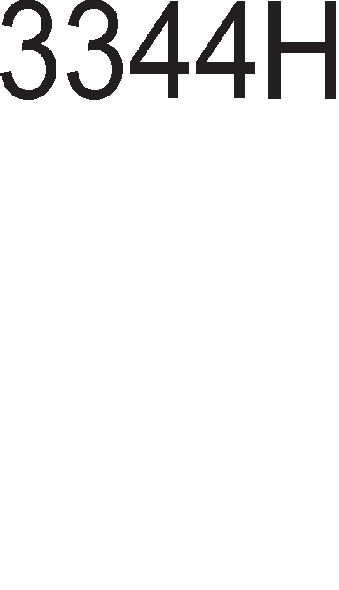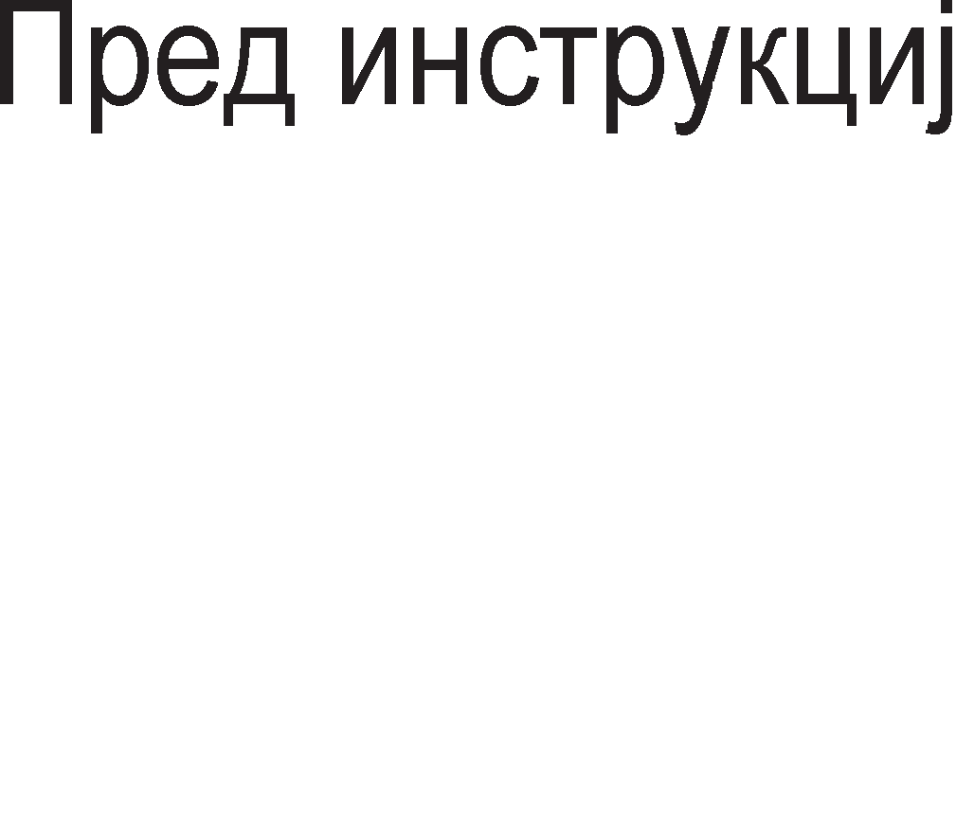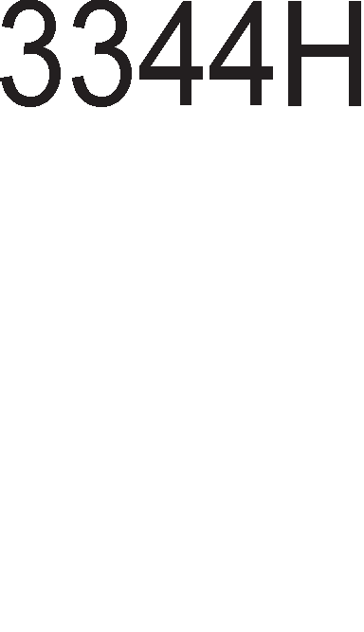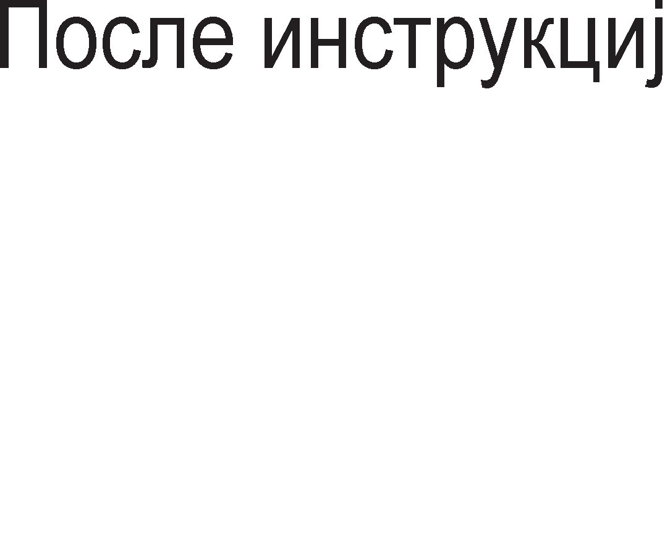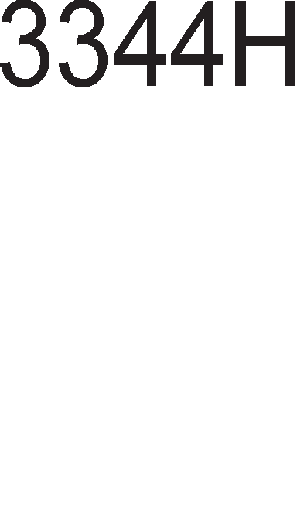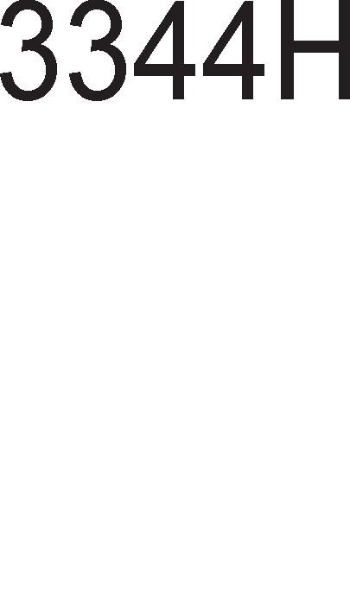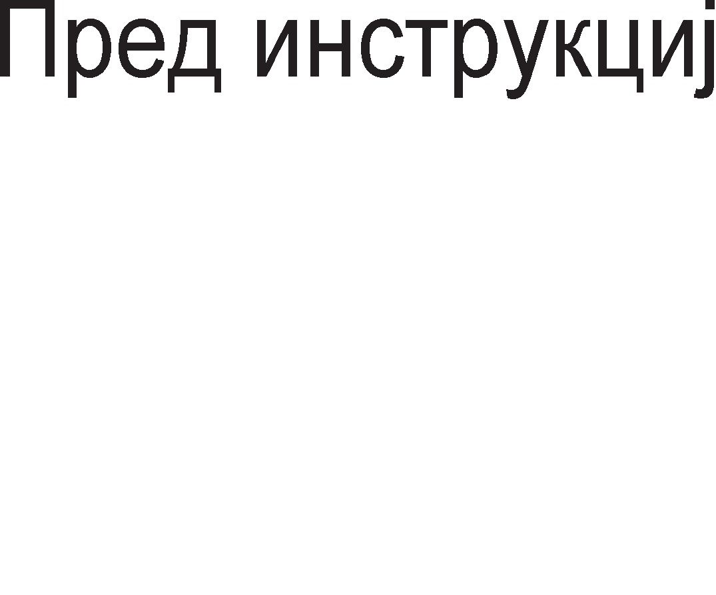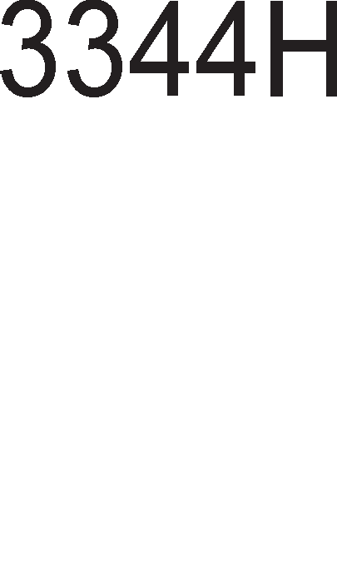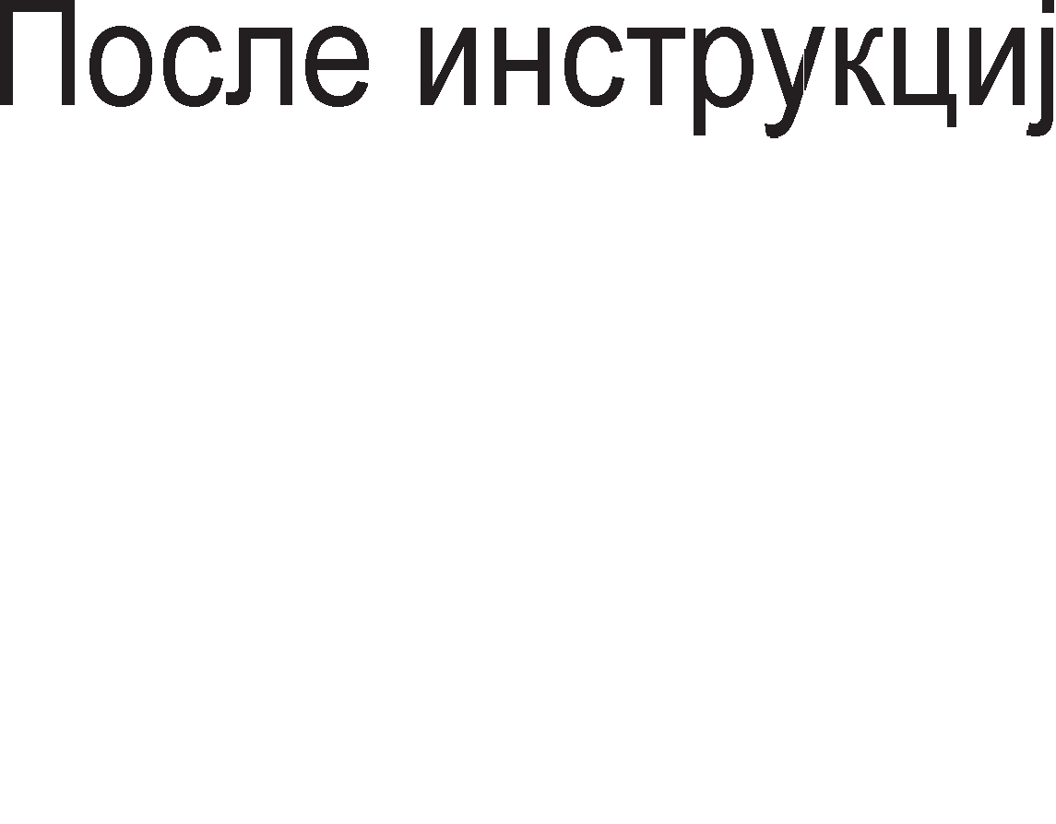

Bo flpynaTa Ha 1HcTpyKL11 3a npeHoc Ha nopaToL1 cnaraaT 1 1HcTpyKL11Te 3a pa6oTa co Bne3Ho 13ne3H1 ypep1. nofloneM pen op M1KponpoLecop1Te 1MaaT epHa 1HcTpyKL1ja 3a npeHoc op Bne3eH ypep KoH pefl1cTap Bo M1KponpoLecopoT 1 epHa 1HcTpyKL1ja 3a npeHoc op pefl1cTap KoH 13ne3eH ypep. MHeMoH1K 3a Bne3HaTa 1HcTpyKL1ja e IN, a 3a 13ne3HaTa OUT. nopone ce papeH1 pBe 1HcTpyKL11 3a npeHoc Ha nopaToL1 op Bne3Ho 13ne3H1 ypep1.

IN pefl1cTap, 1HTepcpejc appeca ;npeHoc op Bne3eH ypep Bo pefl1cTap. OUT 1HTepcpejc appeca, pefl1cTap ;npeHoc op pefl1cTap Bo 13ne3eH ypep.

l/lHTepcpejc appecaTa npeTcTaByBa 61HapeH Kop 3a npeno3HaBal-be Ha nep1cpepH1oT ypep. CeKoj Bne3eH 1n1 13ne3eH ypep c1 1Ma cBoja 1HTepcpejc appeca 1 npeKy Hea M1KponpoLecopoT po3HaBa co Koj ypep i<e KoMyH1L1pa. KaKo wTo noKaL11Te 1MaaT MeMop1cK1 appec1 TaKa Bne3Ho 13ne3H1Te ypep1 1MaaT 1HTepcpejc appeca. l/lcTo TaKa op papeH1Te 1HcTpyKL11 IN 1 OUT Mo>KeMe pa 3aKnyL11Me peKa pecT1HaL1jaTa Ha nopaToKoT ce n1wyBa nocne MHeMoH1KoT Ha 1HcTpyKL1jaTa, a 13BopoT Ha nopaToKoT nocne 3an1pKaTa, 1cTo KaKo wTo 6ewe 1 Kaj MOV 1HcTpyKL1jaTa.

Ha KpajoT pa cnoMeHeMe peKa Kaj 1HcTpyKL11Te 3a npeHoc Tpe6a pa Bop1Me cMeTKa 3a floneM1HaTa Ha npeHecyBaH1oT nopaToK. Ha np1Mep, He Mo>KeMe pa npeHecyBaMe 16 61TeH nopaToK Bo 8 61TeH pefl1cTap 61peji<1 epHocTaBHo 3a nopaToKoT i<e HeMa poBonHo MecTo. l/lcTo TaKa He ce npenopaL1yBa npeHoc Ha 8-61TeH nopaToK Bo 16-61TeH pefl1cTap 3aToa wTo HeMa pa 61pe 1cKop1cTeH Len1oT KanaL1TeT Ha pefl1cTapoT.

## ApMTMeTM"1KM MHcTpyK4MM

HajL1ecTo Kop1cTeH1 ap1TMeT1L1K1 1HcTpyKL11 ce 1HcTpyKL11Te 3a co61pal-be 1 op3eMal-be. l/lHcTpyKL1ja 3a co61pal-be e ADD, a 3a op3eMal-be SUB. SUB e BcywHocT KpaTeHKa op aHfln1cK1oT 36op Subtract wTo Bo npeBop 3HaL11 op3eMal-be. nocTojaT HeKonKy Bap1jaHT1 Ha oB1e 1HcTpyKL11. Kaj HeKo1

M1KponpoLecop1 1HcTpyKL1jaTa 3a co61pal-be copp>K1 pBa onepaHp1, a Kaj ppyfl1 M1KponpoLecop1 Tp1 onepaHp1. OBa e 1nycTp1paHo npeKy cnepH1Be pBe 1HcTpyKL11:

ADD pecT1HaL1ja, 13Bop ;l/l3BopoT ce popaBa Ha pecT1HaL1jaTa.

ADD 13Bop1, 13Bop2, pecT1HaL1ja ;AecT1HaL1ja=13Bop1+13Bop2

l/lHcTpyKL11Te 3a co61pal-be ce pa3n1KyBaaT 1 no Toa pan1 ce 3eMa 1n1 He Bo npepB1p 3HaMeHLeTo 3a npeHoc (Carry). nopone ce papeH1 pBe TaKB1 1HcTpyKL11:

ADD 13Bop, pecT1HaL1ja ; Ha pecT1HaL1jaTa ce popaBa caMo 13BopoT. ADC 13Bop pecT1HaL1ja ;(Add Carry) Ha pecT1HaL1jaTa ce popaBa

;13BopoT 1 BpepHocTa Ha 3HaMeHLeTo 3a

;npeHoc.

l/lcToTo wTo Ba>K1 3a 1HcTpyKL1jaTa 3a co61pal-be Ba>K1 1 3a 1HcTpyKL1jaTa 3a op3eMal-be.

nocne co61pal-beTo 1 op3eMal-beTo poaraaT 1HcTpyKL11Te 3a MHo>Kel-be 1 penel-be. l/lHcTpyKL1ja 3a MHo>Kel-be e MUL wTo e KpaTeHKa op aHfln1cK1oT 36op 3a MHo>Kel-be, multiply. l/lHcTpyKL1ja 3a penel-be e DIV wTo e KpaTeHKa op aHfln1cK1oT 36op 3a penel-be-divide. Aa HanoMeHeMe peKa np1 onepaL1jaTa MHo>Kel-be npo13BopoT i<e 61pe pBanaT1 noponfl op MHo>K1Ten1Te, a Kaj onepaL1jaTa penel-be noKpaj MecTo 3a Kon1L1H1KoT Tpe6a pa ce oppep1 1 MecTo 3a ocTaToKoT. Ha np1Mep, aKo MHo>K1Me pBa 8 61TH1 6poeB1 Toflaw npo13BopoT Mo>Ke pa 61pe 16 61TeH. nopone ce papeH1 pBe 1HcTpyKL11 3a MHo>Kel-be.

MUL 13Bop1, 13Bop2, pecT1HaL1ja ;pecT1HaL1ja=13Bop1·13Bop2

MUL 13Bop ;Copp>K1HaTa Ha pa6oTH1oT pefl1cTap ce

;MHo>K1 co 13BopoT 1 npo13BopoT ce cMecTyBa

;noBTopHo Bo pa6oTH1oT pefl1cTap.

Kaj 1HcTpyKL1jaTa co Tp1 onepaHp1, pen1TenoT, peneH1KoT 1 Kon1L1H1KoT Mo>Ke pa 61paT Bo 61no Koj pefl1cTap 1n1 MeMop1cKa noKaL1ja. Kaj 1HcTpyKL1jaTa co epeH onepaHp peneH1KoT 1 Kon1L1H1KoT ceKoflaw ce HaoraaT Bo pa6oTH1oT pefl1cTap, a pen1TenoT Mo>Ke pa 61pe Bo 61no Koj pefl1cTap 1n1 MeMop1cKa noKaL1ja. Ce pa361pa peKa pen1TenoT Mo>Ke pa 61pe 3apapeH 1 HenocpepHo, KaKo KoHcTaHTa. Aa cnoMeHeMe peKa nocTojaT cneL1janH1 1HcTpyKL11 3a MHo>Kel-be 1 penel-be Ha 6poeB1 co npep3HaK 1 H1BH1Te MHeMoH1L1 ce IMUL 1 IDIV.

MHofly npaKT1L1Ha np1MeHa HaoraaT 1HcTpyKL11Te 3a HaManyBal-be 1n1 3floneMyBal-be 3a epeH. OB1e 1HcTpyKL11 ce Kop1cTaT Kofla e noTpe6Ho pa ce

13Bpw1 6poel-be Ha HeKoja Ben1L11Ha. l/lHcTpyKL1ja 3a 3floneMyBal-be co epeH e INC (Increase) , a 3a HaManyBal-be co epeH DEC (Decrease). OB1e pBe 1HcTpyKL11 1MaaT epeH onepaHp, pefl1cTap 1n1 MeMop1cKa noKaL1ja.

## norM"1KM MHcTpyK4MM

HajBa>KH1 nofl1L1K1 1HcTpyKL11 ce 1HcTpyKL11Te: AND (nofl1L1Ko MHo>Kel-be), OR (nofl1L1Ko co61pal-be) 1 NOT (HeflaL1ja 1n1 npB KoMnneMeHT). HeKo1 M1KponpoLecop1 fl1 Kop1cTaT 1 1HcTpyKL11Te XOR (eKcKny31BHo 1n1), NOR (Hl/lnl/l Kono) 1 NAND (Hl/l Kono). Co 3HaL1el-beTo Ha nofl1L1K1Te cpyHKL11 ce 3ano3HaBMe Bo npBaTa TeMa, OcHoBH1 nofl1L1K1 Kona. Cn1L1Ho KaKo ap1TMeT1L1K1Te 1HcTpyKL11, 1 nofl1L1K1Te 1HcTpyKL11 1MaaT no pBa 13Bop1 Ha onepaHp1 1 pecT1HaL1ja 3a po61eH1oT pe3ynTaT. Kaj HeKo1 M1KponpoLecop1 epeH op 13Bop1Te ce Kop1cT1 1 KaKo pecT1HaL1ja. nopone ce np1Ka>KaH1 HeKonKy nofl1L1K1 1HcTpyKL11 1 H1BH1Te KoMeHTap1.

AND pecT1HaL1ja,13Bop ;nofl1L1Ko MHo>Kel-be Ha 13BopoT 1 pecT1HaL1jaTa

;1 pe3ynTaToT ce 3an1wyBa Bo pecT1HaL1jaTa.

NOT pecT1HaL1ja ;3aMeHa Ha pecT1HaL1jaTa co HefloB1oT npB

;KoMnneMeHT.

OR 13Bop1, 13Bop2, pecT1HaL1ja ;nofl1L1Ko co61pal-be Ha pBaTa 13Bop1 1

;3an1wyBal-be Ha pe3ynTaToT Bo pecT1HaL1jaTa.

Aa ce noTceT1Me peKa 13Bop1Te 1 pecT1HaL1jaTa Mo>KaT pa 61paT onwT1 pefl1cTp1 1n1 MeMop1cK1 noKaL11, a epeH op 13Bop1Te Mo>Ke pa 61pe 3apapeH 1 HenocpepHo KaKo 6poj Bo 61HapeH, peKapeH 1n1 XeKcapeL1ManeH 6poeH c1cTeM.

MHofly L1ecTo epeH op onepaHp1Te Ha nofl1L1K1Te 1HcTpyKL11 npeTcTaByBa MacKa. MacKaTa npeTcTaByBa opHanpep pecp1H1paHa KoM61HaL1ja op Hyn1 1 ep1H1L1. KaKoB i<e 61pe pacnopepoT Ha 61ToB1Te 3aB1c1 op HeMeHaTa Ha MacKaTa. Ha np1Mep, nofl1L1KaTa 1HcTpyKL1ja AND ce Kop1cT1 Kofla Tpe6a pa ce 13pBo1 epeH 6ajT op 16, 32 1n1 64-61TeH nopaToK. nopone e np1Ka>KaH epeH BaKoB np1Mep, Kofla op 32-61TH1oT nopaToK Tpe6a pa ce 13pBo1 BTop1oT 6ajT op pecHo. 3a Taa Len i<e ce ynoTpe61 MacKa Koja i<e 61pe cocTaBeHa op Hyn1 Ha no31L1jaTa op oH1e 6ajT1 Ko1 Tpe6a pa ce 13fly6aT, a Ha MecToTo op BTop1oT 6ajT op pecHo i<e ce nocTaBaT caMo ep1H1L1.

##### npMMep 5.1:

00110010 00011100 10111001 11100010--- 32-61TeH nopaToK

AND 00000000 00000000 11111111 00000000---MacKa

00000000 00000000 10111001 00000000---13pBoeH 6ajT

nofl1L1KaTa 1HcTpyL1ja OR ce Kop1cT1 Kofla Tpe6a pa ce TecT1pa HeKoj 61T op nopaToKoT. Bo MacKaTa Ha no31L1jaTa op Toj 61T i<e 61pe nocTaBeHa ep1H1La, a Ha c1Te ocTaHaT1 no31L11 nofl1L1Ka Hyna. AKo nocne 13BpweHoTo nofl1L1Ko co61pal-be He po61eMe pe3ynTaT ep1H1L1 Ha c1Te no31L11, Toa 3HaL11 peKa 1cn1TyBaH1oT 61T 61n nofl1L1Ka Hyna. OBa e np1Ka>KaHa Bo np1MepoT nopone Kape wTo ce TecT1pa npB1oT 61T op pecHo.

##### npMMep 5.2:

xxxxxxxx xxxxxxxx---1cn1TyBaH nopaToK OR 11111111 11111110---MacKa

11111111 1111111x---Pe3ynTaT

## LlHcTpyK4MM 3a poTa4Mja M noMecTyea1-e

l/lHcTpyKL11Te 3a poTaL1ja 1 noMecTyBal-be ce MHofly Kop1cH1 1 fl1 1Ma Bo noBei<e Bap1jaHT1. 3a pa3n1Ka op pocefla 13yL1eH1Te 1HcTpyKL11, oB1e 1MaaT caMo epeH onepaHp opHocHo nopaToKoT ce 3eMa op 13BopoT, ce o6pa6oTyBa 1 ce Bpai<a Ha 1cToTo MecTo. OBa 3HaL11 peKa 13BopoT 1 pecT1HaL1jaTa ce epHo 1cTo.

noTanKaTa Ha poTaL1ja i<e ja o6jacH1Me npeKy np1Mep. 16-61TH1oT nopaToK 10000000 i<e flo poT1paMe 3a epHo MecTo Bo neBo, a noToa 3a epHo MecTo Bo neBo. np1 poTaL1ja Bo neBo c1Te 61ToB1 op nopaToKoT ce noMecTyBaaT 3a epHo MecTo Bo neBo, HynT1oT 61T poara Ha MecToTo op npB1oT, npB1oT Ha MecToTo op BTop1oT,..., wecT1oT Ha MecToTo op cepM1oT. CepM1oT 61T HeMo>Ke pa op1 Bo neBo, Toj i<e 13ne3e op nopaToKoT, i<e Kpy>K1 1 i<e pojpe Ha MecToTo op HynT1oT 61T. np1 poTaL1ja Bo pecHo c1Te 61ToB1 i<e ce noMecTaT 3a epHo MecTo Bo pecHo, cepM1oT Ha MecToTo op wecT1oT, wecT1oT Ha MecToTo op neTT1oT,...., npB1oT Ha MecToTo op HynT1oT 61T. HynT1oT 61T i<e 13ne3e op nopaToKoT, i<e Kpy>K1 op pecHo KoH neBo 1 i<e pojpe Ha MecToTo op cepM1oT 61T.

10000000----nopaToK

00000001---- poTaL1ja Bo neBo 01000000---- poTaL1ja Bo pecHo

PoTaL1jaTa Ha 61ToB1Te Mo>Ke pa ce 13Bpw1 HeKonKy naT1, a oBa ce HaflnacyBa npeKy 6pojoT 3an1waH Ha KpajoT op 1HcTpyKL1jaTa. nopone ce np1Ka>KaH1 HeKonKy 1HcTpyKL11 3a poTaL1ja.

ROL pecT1HaL1ja, 4 ;61ToB1Te Bo pecT1HaL1jaTa ce poT1paaT 3a Tp1

;MecTa Bo neBo.

ROR pecT1HaL1ja, 3 ;61ToB1Te Bo pecT1HaL1jaTa ce poT1paaT 3a Tp1

;MecTa Bo pecHo.

ROL 13Bop, pecT1HaL1ja, 4 ;61ToB1Te op 13BopoT ce poT1paaT L1eT1p1 naT1 Bo

;neBo 1 pe3ynTaToT ce cMecTyBa Bo pecT1HaL1jaTa.

l/lHcTpyKL11Te 3a noMecTyBal-be (shift) ce MHofly cn1L1H1 co 1HcTpyKL11Te 3a poTaL1ja. Kaj 1HcTpyKL11Te 3a noMecTyBal-be 61ToB1Te op nopaToKoT ce noMecTyBaaT 3a HeKonKy MecTa Bo neBo 1n1 pecHo, Ho oH1e 61ToB1 Ko1 i<e flo HanywTaT nopaToKoT ce fly6aT, He poaraaT op ppyflaTa cTpaHa Ha nopaToKoT. l/lcnpa3HeT1Te MecTa ce HapononHyBaaT co Hyn1. OBa e np1Ka>KaHo Bo np1MepoT nopone np1 wTo 61ToB1Te ce noMecTeH1 3a Tp1 MecTa Bo neBo 1n1 pecHo.

1110001010011101------nopaToK

0001110001010011------noMecTyBal-be Bo pecHo 3a Tp1 MecTa 0001010011101000------noMecTyBal-be Bo neBo 3a Tp1 MecTa

MHeMoH1L1 3a oB1e 1HcTpyKL11 ce SHL (Shift Left) 3a noMecTyBal-be Bo neBo 1 SHR (Shift Right) 3a noMecTyBal-be Bo pecHo. nopone ce papeH1 HeKonKy np1Mep1.

SHL pecT1HaL1ja, 5 ;noMecTyBal-be Ha 61ToB1Te Bo pecT1HaL1jaTa 3a neT

;MecTa Bo neBo.

SHR pecT1HaL1ja,4 ;noMecTyBal-be Ha 61ToB1Te Bo pecT1HaL1jaTa 3a

;L1eT1p1 MecTa Bo pecHo.

SHR 13Bop, pecT1HaL1ja, 2 ;61ToB1Te op 13BopoT ce noMecTyBaaT Bo pecHo pBa

;naT1 1 pe3ynTaToT ce cMecTyBa Bo pecT1HaL1jaTa.

## LlHcTpyK4MM 3a cKoK M rpaHe1-e

np1 13BpwyBal-beTo Ha npoflpaMaTa MHofly L1ecTo ce jaByBa noTpe6a pa ce npoBep1, TecT1pa po61eH1oT pe3ynTaT. Op BpepHocTa Ha po61eH1oT pa3ynTaT 3aB1c1 pan1 i<e ce 13Bpw1 cnepHaTa 1HcTpyKL1ja 1n1 HeKoja ppyfla. Aa ce noTceT1Me, pe3ynTaT1Te op 13BpweH1Te ap1MeT1L1Ko nofl1L1K1 1HcTpyKL11 p1peKHo Bn1jaaT Bp3 cocToj6aTa Ha 3HaMeHLaTa Bo cTaTyc pefl1cTapoT. Co 3HaL1el-beTo Ha 3HaMeHLaTa ce 3ano3HaBaMe Bo TpeTaTa TeMa, ep1H1La Ap1TMeT1L1Ko nofl1L1Ka ep1H1La. 61peji<1 13BpwyBal-beTo Ha 1HcTpyKL1jaTa e ycnoBeHo op cocToj6aTa Ha 3HaMeHLaTa oB1e 1HcTpyKL11 ce no3HaT1 nop 1MeTo ycnoBH1 1HcTpyKL11. 61peji<1 op oB1e 1HcTpyKL11 3aB1c1 TeKoT Ha npoflpaMaTa T1e ce no3HaT1 1 nop 1MeTo KoHTponH1 1HcTpyKL11.

MHofly L1ecTo ce Kop1cTaT 1HcTpyKL11Te 3a cKoK. MHeMoH1K 3a oB1e 1HcTpyKL11 e JMP. Toa e KpaTeHKa op 36opoT Jump wTo Bo npeBop 3HaL11 cKoK. Aa

Haflnac1Me peKa ocBeH ycnoBH1 cKoKoB1 nocTojaT 1 6e3ycnoBH1 cKoKoB1 L11e 13BpwyBal-be He 3aB1c1 op cocToj6aTa Ha 3HaMeHLaTa. OB1e 1HcTpyKL11 Bo ce6e He copp>KaT H1Ty epeH onepaHp, TyKy ja copp>KaT appecaTa Ha MeMop1cKaTa noKaL1ja Ha Koja Tpe6a pa ce cKoKHe. noHeKoflaw appecaTa He e 3apapeHa KaKo 6poj TyKy KaKo na6ena. Ha cn1Ka 5.8. e np1Ka>KaHo 13BpwyBal-beTo Ha 1HcTpyKL1jaTa 3a ycnoBeH cKoK JZ (Jump Zero). 3a appecaTa e ynoTpe6eHa na6ena, opHocHo noKaL1jaTa Ha Koja Tpe6a pa ce cKoKHe 1Ma appeca co c1M6on1L1Ho 1Me SKOKNI. CKoKoT i<e 61pe 13BpweH poKonKy ce aK1B1pa 3HaMeHLeTo Hyna, opHocHo aKo pe3ynTaToT op npeTXopHo 13BpweHaTa 1HcTpyKL1ja e epHaKoB Ha Hyna. AoKonKy He e 1cnonHeT oBoj ycnoB Toflaw HeMa pa ce cKoKHe Ha appecaTa HaBepeHa Bo cKoK 1HcTpyKL1jaTa, TyKy npoflpaMaTa i<e npopon>K1 co cBojoT TeK opHocHo i<e ce 13Bpw1 cnepHaTa 1HcTpyKL1jaTa, Koja ce Haora nop cKoK 1HcTpyKL1jaTa.

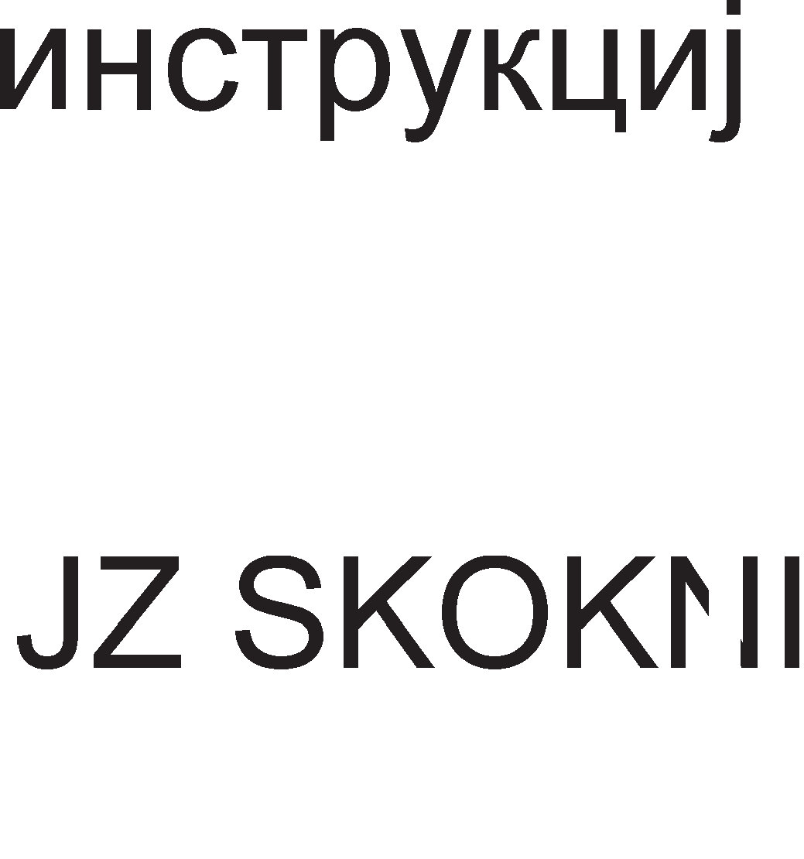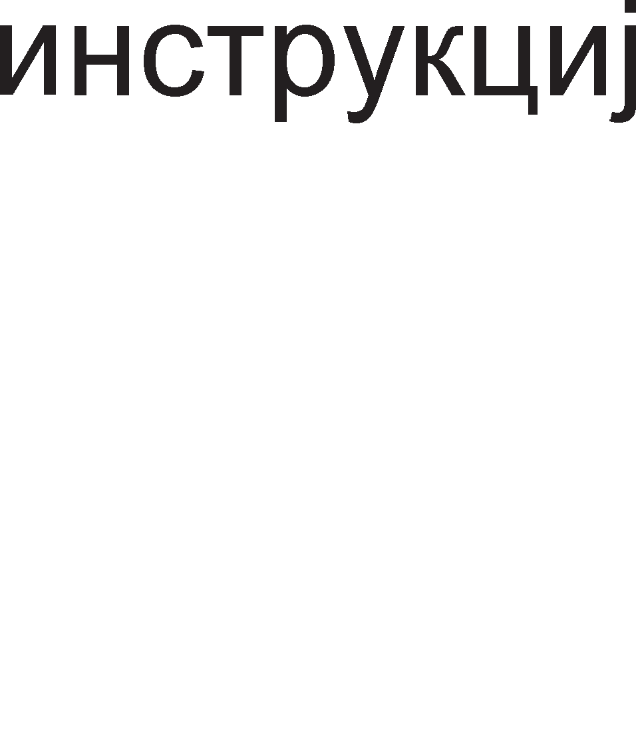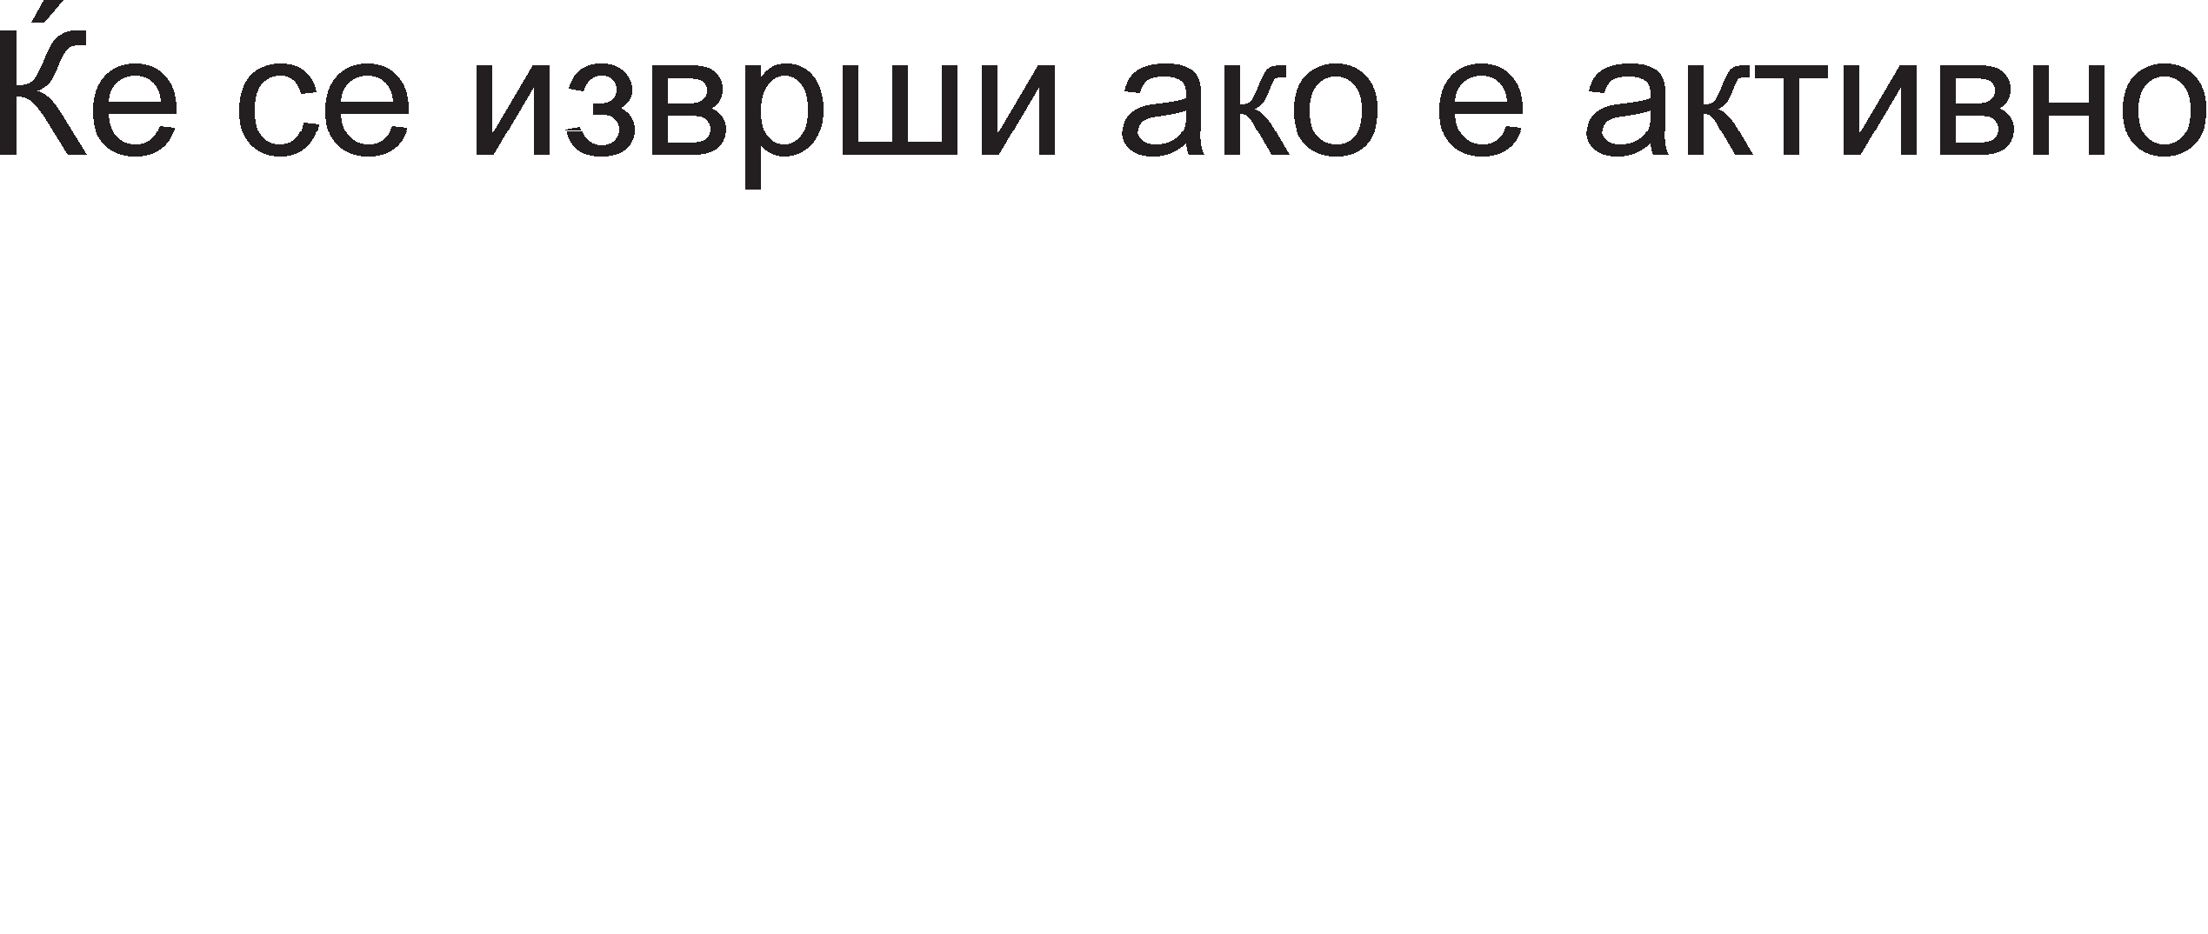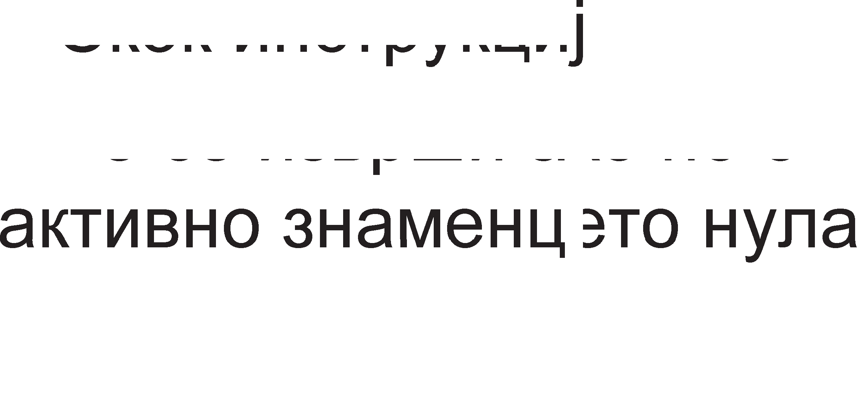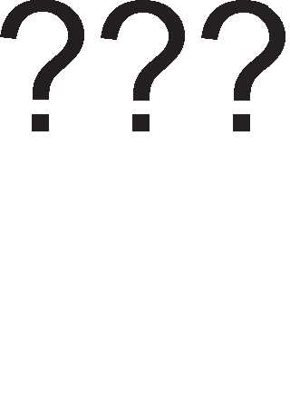





Cn1Ka 5.8. rpacp1L1K1 np1Ka3 3a 13BpwyBal-be Ha cKoK 1HcTpyKL1ja nopone ce np1Ka>KaH1 noBei<e 1HcTyKL11 3a cKoK co H1BH1Te KoMeHTap1.

JMP appeca ;6e3ycnoBeH cKoK

JZ appeca ;CKoKoT i<e ce 13Bpw1 aKo e aKT1BHo 3HaMeHLeTo Hyna (pe3ynTaT ;epHaKoB Ha Hyna).

JS appeca ;CKoKoT i<e ce 13Bpw1 aKo e aKT1BHo 3HaMeHLeTo 3a 3HaK

;(HeflaT1BeH pe3ynTaT).

JC appeca ;CKoKoT i<e ce 13Bpw1 aKo e aKT1BHo 3HaMeHLeTo 3a npeHoc.

JO appeca ;CKoKoT i<e ce 13Bpw1 aKo e aKT1BHo 3HaMeHLeTo 3a

;npeL1eKopyBal-be.

l/lHcTpyKL11Te 3a flpaHel-be (branch) ce cn1L1H1 co 1HcTpyKL11Te 3a cKoK. Kaj 1HcTpyKL11Te 3a flpaHel-be ce Bpw1 cnopep6a Mery pBa onepaHp1 1 Bo 3aB1cHocT op po61eH1oT pe3ynTaT i<e ce 13Bpw1 1n1 He cKoKoT Bo HaBepeHaTa 1HcTpyKL1ja. CnopepyBaH1Te onepaHp1 Mo>KaT pa 61paT epHaKB1, npB1oT pa 61pe nofloneM 1n1 noMan op BTop1oT. Bo noHaTaMowH1oT TeKcT ce np1Ka>KaH1 HeKonKy 1HcTpyKL11 3a flpaHel-be

BEQ 13Bop1,13Bop1, appeca ;(Branch Equal) AKo 13Bop1 1 13Bop2 ce epHaKB1 ce

;cKoKa Ha HaBepeHaTa appeca.

BEQZ 13Bop, appeca ;(Branch Equal Zero) AKo 13BopoT e epHaKoB Ha Hyna

;ce cKoKa Ha HaBepeHaTa appeca.

BGT 13Bop1, 13Bop2, appeca ;(Branch Greater Than) AKo 13Bop1 e nofloneM op

;13Bop2 ce cKoKa Ha HaBepeHaTa appeca.

## LlHcTpyK4MM 3a pa6oTa co noTnporpaMM

noTnpoflpaMaTa ce 13BpwyBa He3aB1cHo op flnaBHaTa npoflpaMa 1 Mo>Ke pa 61pe cMecTeHa 61no Kape Bo MeMop1jaTa. noTnpoflpaMaTa Mo>Ke pa 61pe npoflpaMa 3a npecMeTKa Ha sin, KBappaT 1n1 noflap1TaM op HeKoja npoMeHn1Ba Ben1L11Ha 1n1 npoflpaMa 3a BHecyBal-be 1n1 3a 13HecyBal-be nopaToL1 op oppepeH nep1cpepeH ypep. Kofla flnaBHaTa npoflpaMa copp>K1 noTnpoflpaMa, poara po npeK1H Ha flnaBHaTa npoflpaMa c*è* popeKa He 61pe 3aBpweHa noTnpoflpaMaTa. Bo oBoj cnyL1aj, Bo npoflpaMcK1oT 6pojaL1 i<e ce cMecT1 appecaTa Ha npBaTa 1HcTpyKL1ja op noTnpoflpaMaTa 1 HefloBaTa copp>K1Ha i<e ce 3floneMyBa 3a epeH c*è* popeKa He 61pe 13BpweHa nocnepHaTa 1HcTpyKL1ja op noTnpoflpaMaTa. Cefla ce nocTaByBa npawal-beTo: KaKo pa ce BpaT1Me Bo flnaBHaTa npoflpaMa? 3a oBaa Len, npep pa ce cKoKHe Ha noTnpoflpaMaTa, Tpe6a pa ce 3anaMT1 appecaTa Ha cnepHaTa 1HcTpyKL1ja op flnaBHaTa npoflpaMa. npoflpaMcK1oT 6pojaL1 He Mo>Ke pa ce 1cKop1cT1, 61peji<1 e 3acpaTeH co noTnpoflpaMaTa. AppecaTa Ha cnepH1oT 6ajT op flnaBHaTa npoflpaMa ce 3an1wyBa Ha BpBoT op cTeK MeMop1jaTa (nnacT). Kofla M1KponpoLecopoT i<e 3aBpw1 co 13BpwyBal-be Ha noTnpoflpaMaTa, ja npecppna appecaTa op BpBoT Ha cTeKoT Bo npoflpaMcK1oT 6pojaL1 wTo 3HaL11 Bpai<al-be Ha3ap Bo flnaBHaTa npoflpaMa.

LlecTo ce cnyL1yBa caMaTa noTnpoflpaMa pa copp>K1 ppyfla noTnpoflpaMa. Bo Toj cnyL1aj Bpai<al-beTo op npBaTa noTnpoflpaMa Bo flnaBHaTa noTnpoflpaMa ce ocTBapyBa co BHecyBal-be Ha appecaTa Ha cnepH1oT 6ajT op flnaBHaTa npoflpaMa Bo BTopaTa noKaL1ja op cTeKoT (flnepaHo opflope Hapony), a 3a Bpai<al-be op BTopaTa Bo npBaTa noTnpoflpaMa i<e 61pe 1cKop1cTeHa HajflopHaTa MeMop1cKa noKaL1ja op

cTeKoT. KonKy noTnpoflpaM1 1MaMe, TonKy MeMop1cK1 noKaL11 op cTeKoT i<e 61paT 3acpaTeH1.

Ha cn1Ka 5.9 e np1Ka>KaHa nocTanKaTa 3a 3awT1Ta Ha noBpaTHaTa appeca Bo cnyL1aj Ha noB1KyBal-be Ha nopnpoflpaMa 1 Bpai<al-beTo op nopnpoflpaMaTa KoH flnaBHaTa npoflpaMa.

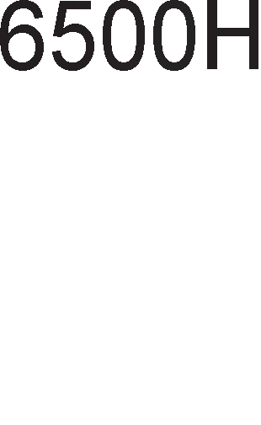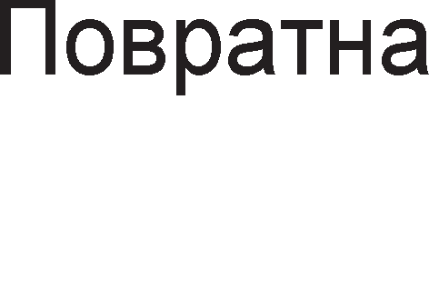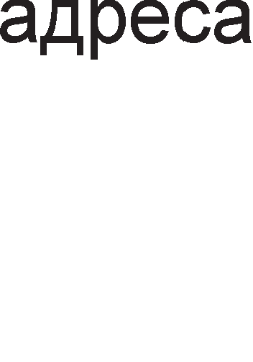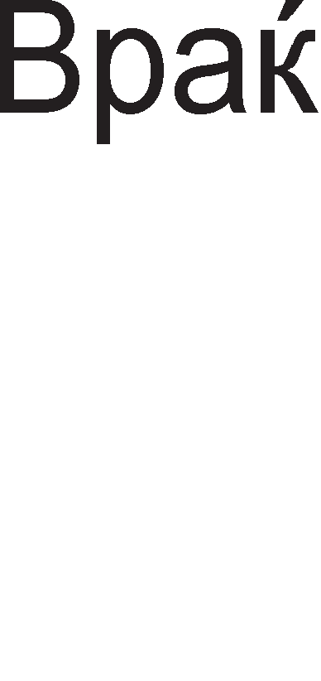

Cn1Ka 5.9. nocTanKa 3a 13BpwyBal-be Ha noTnpoflpaMa

nocTojaT pBe 1HcTpyKL11 3a pa6oTa co noTnpoflpaM1. EpHaTa e 3a noB1KyBal-be Ha noTnpoflpaMa 1 1Ma MHeMoH1K Call wTo Bo npeBop 3HaL11 noB1Kaj. OBaa 1HcTpyKL1ja Bo ce6e ja copp>K1 caMo appecaTa Ha MeMop1cKaTa noKaL1ja op Koja noL1HyBa noTnpoflpaMaTa (Call appeca). BTopa 1HcTpyKL1ja e 1HcTpyKL1jaTa 3a Bpai<al-be op noTnpoflpaMaTa Bo flnaBHaTa npoflpaMa 1 Taa 1Ma MHeMoH1K RET wTo e KpaTeHKa op aHfln1cK1oT 36op Return wTo Bo npeBop 3HaL11 Bpai<al-be. Aa HanoMeHeMe peKa BpepHocTa Ha npoflpaMcK1oT 6pojaL1 aBToMaTcK1 ce Hoc1 Ha BpBoT op cTeKoT Kofla i<e ce nojaB1 Call, a ce Bpai<a Ha3ap Kofla i<e ce nojaB1 RET 1HcTpyKL1jaTa. Toa He e pa6oTa Ha npoflpaMepoT.

# nMwyea1-e Ha nporpaMM

npoflpaMaTa Ha aceM6nepcK1 ja31K ce B1Ka 13BopHa npoflpaMa. HajHanpep e noTpe6Ho 13BopHaTa npoflpaMa pa ce BHece Bo MeMop1jaTa (npeKy HeKoj Bne3eH ypep, HajL1ecTo TacTaTypa) 1 pa ce 3anaMeT1 Bo HeKoja paToTeKa nop oppepeHo 1Me. BHecyBal-beTo Ha npoflpaMaTa ce 13BpwyBa npeKy cneL1janHa npoflpaMa HapeL1eHa ep1Top.

no 3an1wyBal-beTo Ha 13BopHaTa npoflpaMa Bo HeKoja op HapBopewH1Te MeMop11, flo noB1KyBaMe aceM6nepoT 1 My HapepyBaMe pa ja npeBepe npoflpaMaTa. npeBopoT ce Bpw1 op aceM6nepcK1 ja31K Ha Maw1HcK1 ja31K. AceM6nepoT np1cTanyBa KoH npeBepyBal-be 1 poKonKy HeMa flpewK1, Kpe1pa TaKaHapeL1eHa o6jeKT-npoflpaMa, Koja noToa noBTopHo ce 3an1wyBa Bo noce6Ha paToTeKa.

O6jeKT-npoflpaMaTa e npoflpaMa Ha Maw1HcK1 ja31K, Ho H1 oBaa npoflpaMa He e cnpeMHa 3a 13BpwyBal-be. 3a pa Taa cTaHe ynoTpe6n1Ba, Tpe6a pa ce cMecT1 Ha noce6Ho MecTo Bo MeMop1jaTa 1 eBeHTyanHo pa ce noBp3e co ppyfl1 npoflpaM1. OBaa pa6oTa ja Bpw1 cneL1janHaTa npoflpaMa HapeL1eHa noBp3yBaL1 (n1HKep). AoKonKy HeMa npo6neM1 np1 noBp3yBal-beTo (Ha np1Mep, He nocTo1 noTpe6H1oT Mopyn), n1HKepoT cpopM1pa TaKaHapeL1eHa 13BpwHa npoflpaMa. 3a oTcTpaHyBal-beTo flpewK1 Bo aceM6nepcKaTa npoflpaMa ce Kop1cT1 cneL1janHa npoflpaMa HapeL1eHa pe6aflep.

AKo npoflpaMaTa e Han1waHa Bo HeKoj B1w1 npoflpaMcK1 ja31K, Toflaw 3a Hej31Ho npeBepyBal-be Ha Maw1HcK1 ja31K ce Kop1cT1 cneL1janHa npoflpaMa- npeBepyBaL1 HapeL1eHa KoMnajnep. Ep1TopoT, aceM6nepoT, n1HKepoT, pe6aflepoT 1 KoMnajnepoT npeTcTaByBaaT anaTKa npoflpaM1. 3a ceKoja op oB1e noMowH1 npoflpaM1 npoflpaMepoT Tpe6a pa 3Hae KaKo pa fl1 Kop1cT1, T.e. noTpe6Ho e pa ce no3HaBaaT Hapep61Te npeKy Ko1 ce Kop1cTaT anaTKa npoflpaM1Te.

Cnopep cTpyKTypaTa npoflpaM1Te Mo>Ke pa ce nopenaT Bo HeKonKy flpyn1: n1H1cK1 npoflpaM1, npoflpaM1 co flpaHel-be, npoflpaM1 co L1Knyc1, npoflpaM1 co noTnpoflpaM1 1 cno>KeH1 npoflpaM1. Bo noHaTaMowH1oT TeKcT i<e ce 3ano3HaeMe co ceKoja op oB1e cTpyKTyp1.

## nMHMcKM nporpaMM

OB1e npoflpaM1 ce cocTaBeH1 op 1HcTpyKL11 3a npeHoc, ap1TMeT1L1K1, nofl1L1K1 1HcTpyKL11 1 1HcTpyKL11 3a poTaL1ja 1 noMecTyBal-be. l/lHcTpyKL11Te ce HapepeH1 epHa Bp3 ppyfla 1 TaKa ce 13BpwyBaaT. He Mo>Ke pa ce cnyL11 HeKoja 1HcTpyKL1ja pa 61pe npecKoKHaTa 1n1 pa 1Ma npeK1H Bo npoflpaMaTa nopap1 13BpwyBal-be Ha nopnpoflpaMa. l/lcTo TaKa He Mo>Ke pa ce cnyL11 Bpai<al-be Ha3ap Bo npoflpaMaTa. 3HaL11 oTKaKo i<e 3anoL1He n1H1cKaTa npoflpaMa Leno BpeMe ce cnywTaMe Hapony no npoflpaMaTa ce popeKa He pojpeMe po Hej31H1oT Kpaj. BpepHocTa Ha npoflpaMcK1oT 6pojaL1 n1HeapHo ce 3floneMyBa 1 cnepHaTa 1HcTpyKL1ja e ceKoflaw nop TeKoBHaTa.

KaKo np1Mep 3a n1HeapHa npoflpaMa i<e ja o6jacH1Me npoflpaMaTa Koja Bpw1 co61pal-be Ha pBa 6poja. ABaTa co61poL1 ce HaoraaT Bo MeMop1jaTa 1 noTpe6Ho e 1cT1Te pa ce npeHecaT Bo M1KponpoLecopoT, noToL1Ho Bo pBa HefloB1 pefl1cTp1. l/lcTo TaKa pe3ynTaToT ce 3awT1TyBa npeKy HefloBo npeHecyBal-be Bo MeMop1jaTa.

3apap1 nopo6po pa361pal-be Ha npoflpaMaTa papeH e Hej31H1oT 6noK p1jaflpaM, Bo Koj ce o6jacHeT1 c1Te L1eKop1 np1 Kpe1pal-beTo Ha npoflpaMaTa.

Cn1Ka 5.10. 6noK p1jaflpaM 3a n1H1cKa npoflpaMa



MOV R1, appeca1 ;BpepHocTa Ha noKaL1jaTa co HaBepeHaTa appeca ce Kon1pa

;Bo pefl1cTapoT R1.

MOV R2, appeca2 ;BpepHocTa Ha noKaL1jaTa co HaBepeHaTa appeca ce Kon1pa

;Bo pefl1cTapoT R2.

ADD R1,R2 ;BpepHocTa Ha pefl1cTapoT R2 ce popaBa Ha BpepHocTa Ha

;pefl1cTapoT R1.

MOV appeca3, R1 ;Pe3ynTaToT op co61pal-beTo ce 3an1wyBa Ha MeMop1cKa

;noKaL1ja co appeca3.

## nporpaMM co rpaHe1-e

npoflpaM1Te co flpaHel-be Bo cBojoT cocTaB copp>KaT 1HcTpyKL11 3a cKoK (Jump) 1 1HcTpyKL11 3a flpaHel-be (Branch). Aa ce noTceT1Me oB1e 1HcTpyKL11 ce HapeKyBaaT KoHTponH1 1HcTpyKL11 61peji<1 T1e Mo>KaT pa flo cMeHaT TeKoT Ha npoflpaMaTa, opHocHo cnepHaTa 1HcTpyKL1ja He ce Haora ceKoflaw nop TeKoBHaTa 1HcTpyKL1ja. Bo Koja HacoKa i<e ce opB1Ba npoflpaMaTa 3aB1c1 op Toa pan1 e

1cnonHeT ycnoBoT HaBepeH Bo 1HcTpyKL11Te 1n1 He. YcnoBoT ywTe ce HapeKyBa anTepHaT1Ba 1 Bo 6noK p1jaflpaM1Te Taa ce 6ene>K1 co poM6.

KaKo np1Mep i<e ja o6jacH1Me npoflpaMaTa 3a cnopepyBal-be Ha pBa no31T1BH1 6poja 1 noToa i<e ce 13MeMop1pa nofloneM1oT 6poj.

Cn1Ka 5.11. 6noK p1jaflpaM 3a npoflpaMa co flpaHel-be

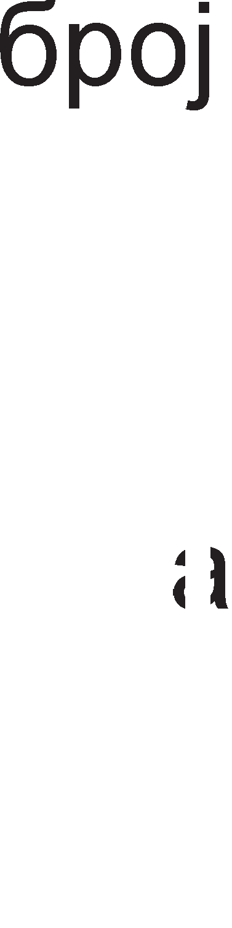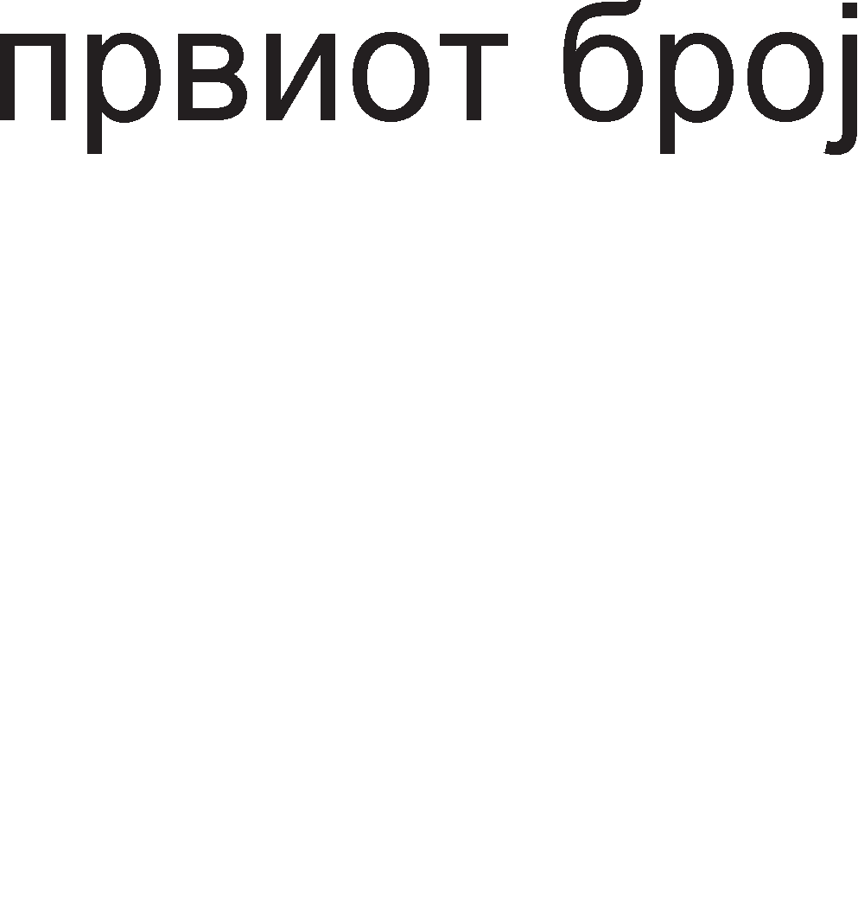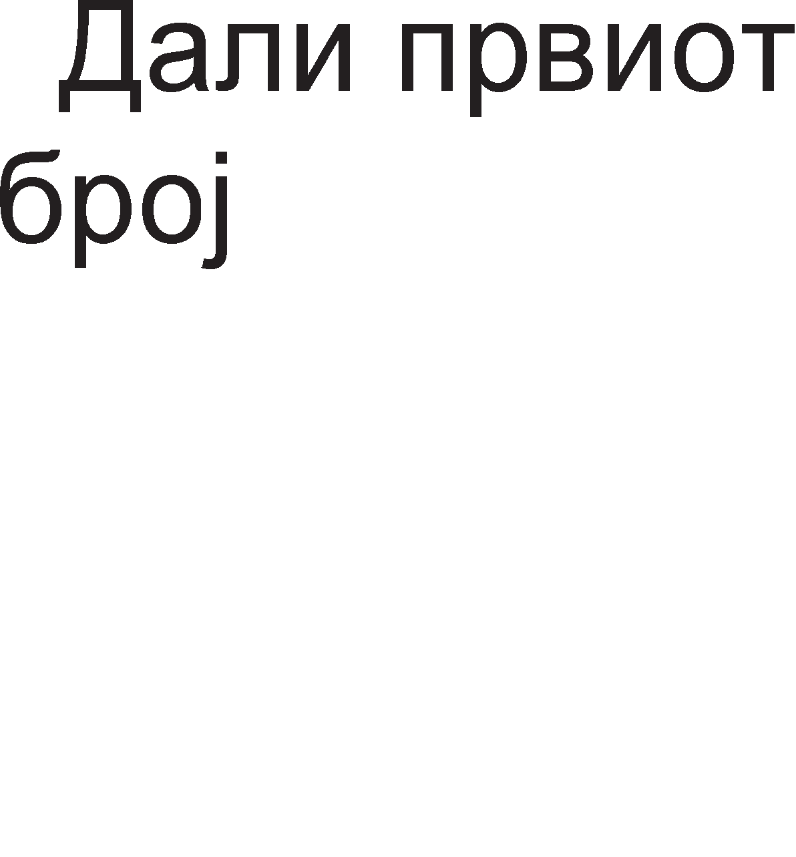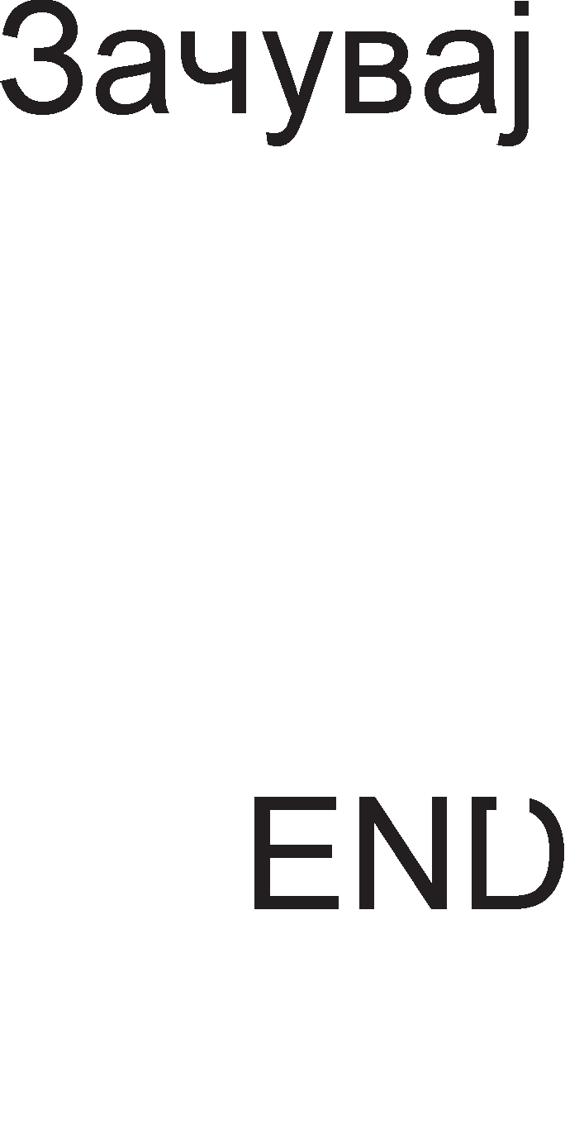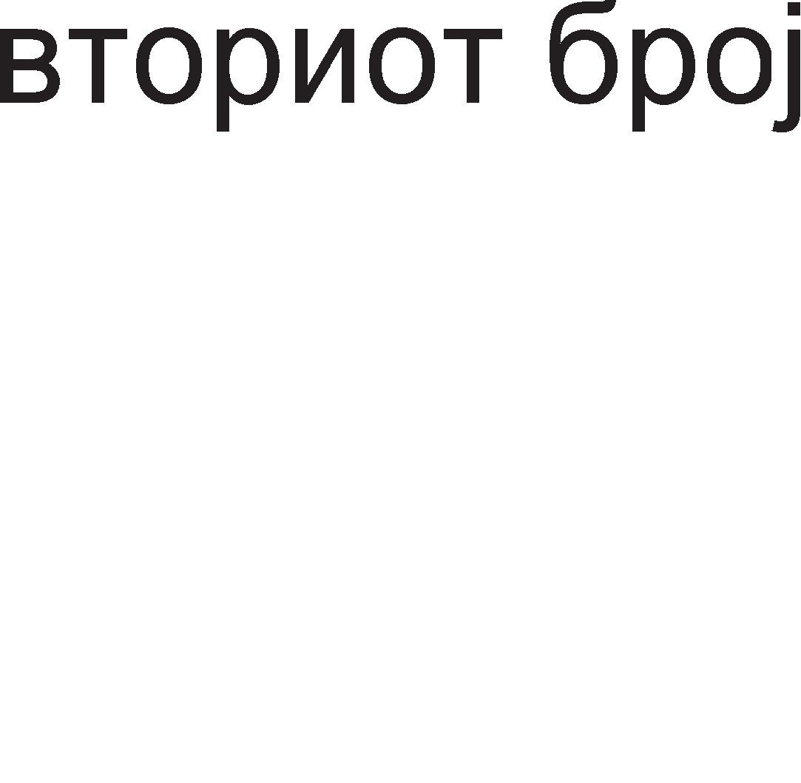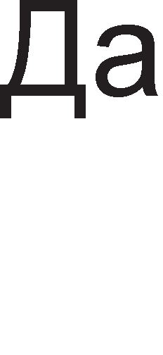

3a cnopep6a Ha pBaTa 6poja ce Kop1cT1 onepaL1jaTa op3eMal-be. AKo np1 op3eMal-beTo ce aKT1B1pa 3HaMeHLeTo 3a npeHoc (carry) Toflaw BTop1oT 6poj e nofloneM op npB1oT, a Bo cnyL1aj pa He ce aKT1B1pa oBa 3HaMeHLe Toflaw npB1oT i<e 61pe nofloneM op BTop1oT. KaKo 1 Kaj n1H1cKaTa npoflpaMa M TyKa pBaTa 6poja ce npeHecyBaaT op MeMop1jaTa 1 ce cMecTyBaaT Bo pBa onwT1 pefl1cTp1.

MOV R1, appeca1 ;BpepHocTa Ha noKaL1jaTa co HaBepeHaTa

;appeca ce Kon1pa Bo pefl1cTapoT R1.

MOV R2, appeca2 ;BpepHocTa Ha noKaL1jaTa co HaBepeHaTa

;appeca ce Kon1pa Bo pefl1cTapoT R2.

SUB R1, R2 ;Op BpepHocTa Ha pefl1cTapoT R1 ce op3eMa

;BpepHocTa Ha pefl1cTapoT R2.

JC VTORIOT ;AKo e aKT1BHo 3HaMeHLeTo 3a npeHoc (Carry) ce

;cKoKa Ha noKaL1jaTa co appeca VTORIOT.

MOV appeca3, R1 ;AKo 3HaMeHLeTo 3a npeHoc He e aKT1BHo Bo

;MeMop1cKaTa noKaL1ja ce npeHecyBa

;copp>K1HaTa Ha pefl1cTapoT R1.

JMP KRAJ ;Ce cKoKa cnepHaTa 1HcTpyKL1ja 3a pa

;pefl1cTapoT R2 He ce 3an1we Bo MeMop1cKaTa

;noKaL1ja.

VTORIOT: MOV appeca3, R2 ;Pefl1cTapoT R2 ce 3an1wyBa Bo MeMop1cKaTa

;noKaL1ja.

KRAJ: /

rnepaMe peKa ynoTpe6aTa Ha na6en1Te VTORIOT 1 KRAJ MHofly ja onecHyBa pa6oTaTa Ha npoflpaMepoT 61peji<1 Ha Toj HaL11H He Mopa pe ce naMTaT appec1Te Ha coopBeTH1Te noKaL11 Ha Ko1 Tpe6a pe ce 13Bpw1 cKoKoT.

## nporpaMM co 4MK11ycM

np1 Kpe1pal-beTo Ha npoflpaM1Te MHofly L1ecTo ce jaByBa noTpe6a op noBei<eKpaTHo 13BpwyBal-be Ha flpyna op 1HcTpyKL11. HeKo1 B1poB1 Ha M1KponpoLecop1 pyp1 1 1MaaT noce6H1 1HcTpyKL11 3a noBTopyBal-be Ha oppepeH1 npoflpaMcK1 ceKBeHL1. MHeMoH1K 3a oB1e 1HcTpyKL11 e LOOP wTo npeBepeHo Ha MaKepoHcK1 3HaL11 jaMKa, L1Knyc. W1Knyc1Te HaL1ecTo 3HaL1aT Bpai<al-be Ha3ap Bo npoflpaMaTa 1 Toa HeKonKy naT1. W1Knyc1Te 6apaaT ynoTpe6a Ha 6pojaL1 Koj BcywHocT noKa>KyBa KonKy naT1 i<e ce noBTop1 L1KnycoT. 6pojaL11Te ce HajL1ecTo pefl1cTp1 1 T1e Mo>KaT pa 6pojaT HaHanpep 1n1 HaHa3ap.

KaKo np1Mep i<e ja o6jacH1Me npoflpaMaTa 3a MHo>Kel-be Ha pBa 6poja. MHo>Kel-beTo ce pean131pa Ha Toj HaL11H wTo npB1oT 6poj flo co61paMe oHonKy naT1 KonKy wTo 13HecyBa BTop1oT 6poj. BcywHocT BTop1oT 6poj i<e npeTcTaByBa 6pojaL1. nocne ceKoe popaBal-be Ha npB1oT 6poj BpepHocTa Ha BTop1oT i<e ce HaManyBa 3a epeH. W1KnycoT i<e ce noBTopyBa ce popeKa BTop1oT 6poj He cTaHe Hyna. 3a npoflpaMaTa e MHofly Ba>KHo npep pa 3anoL1He popaBal-beTo Ha npB1oT 6poj pe3ynTaToT pa ce 13epHaL11 co Hyna. OBa e np1Ka>KaHo Bo 6noK p1jaflpaMoT np1Ka>KaH Ha cn1Ka 5.12.

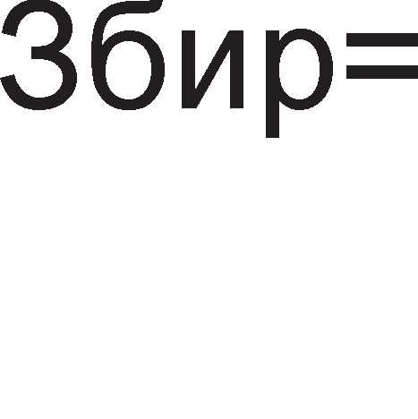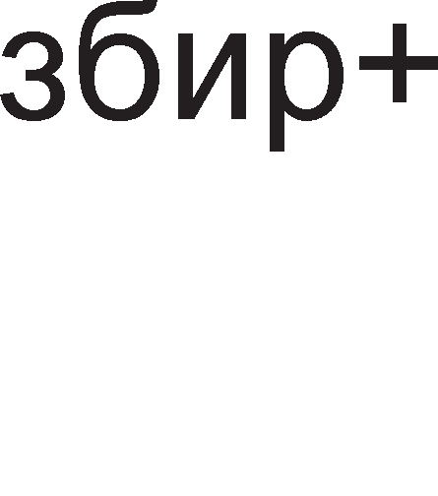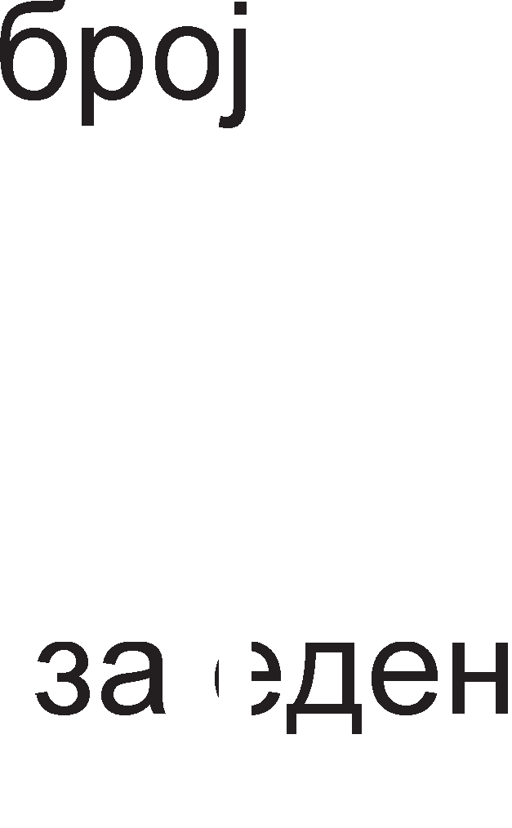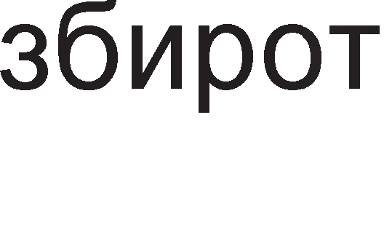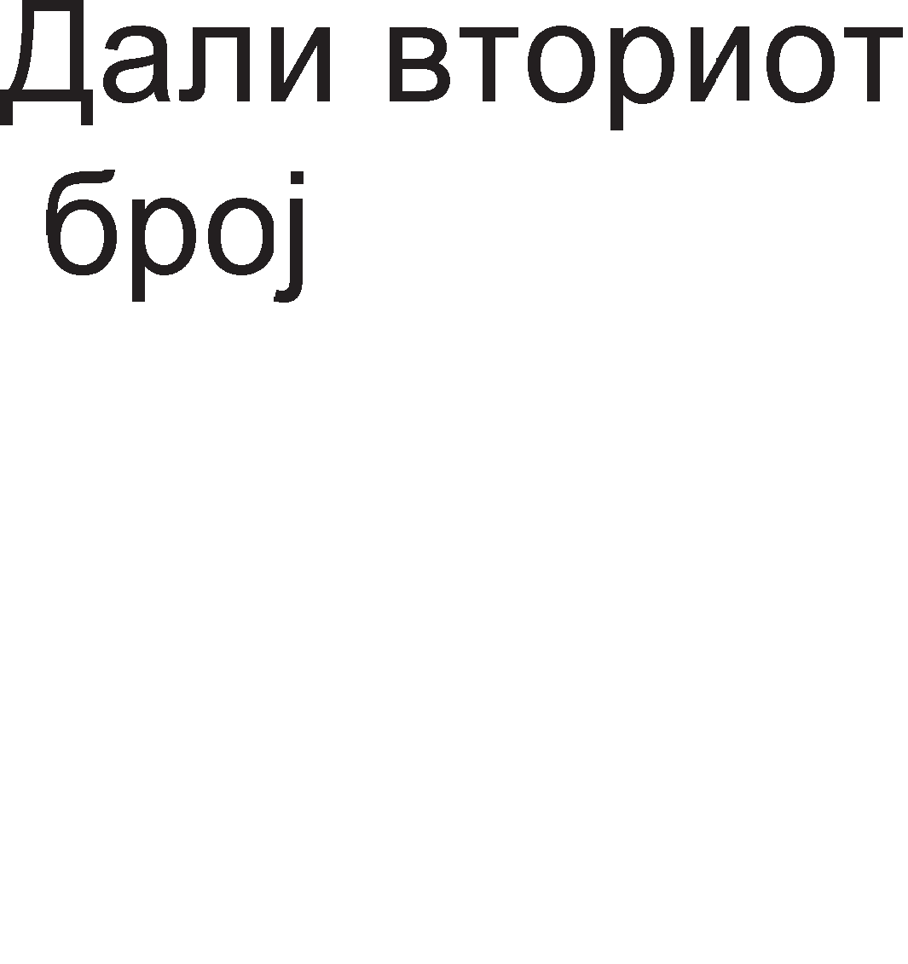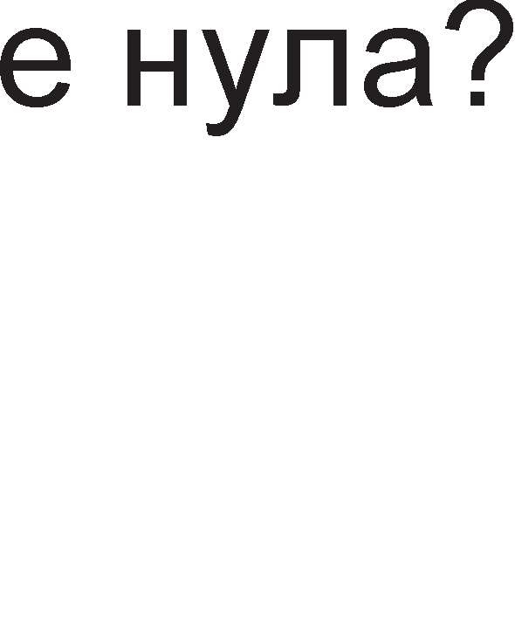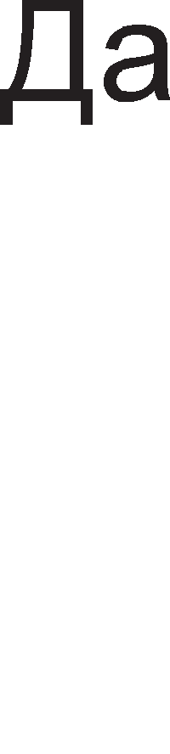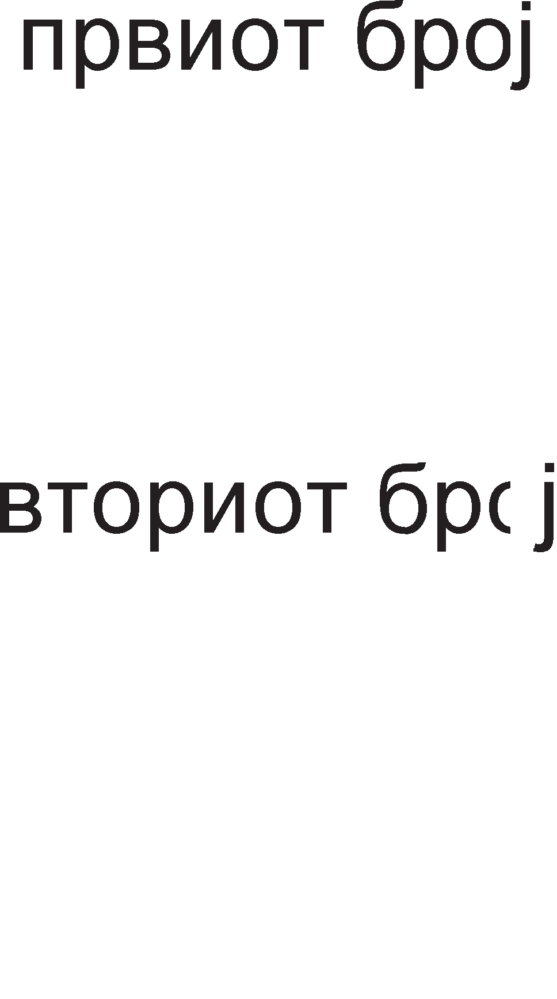

Cn1Ka 5.12. 6noK p1jaflpaM 3a npoflpaMa co L1Knyc

nopone e np1Ka>KaHa npoflpaMaTa co L1Knyc. KaKo 1 Bo npeTXopH1Te pBe npoflpaM1 1 oBpe 6poeB1Te ce npeHecyBaaT op MeMop1jaTa Bo pefl1cTp1Te.

|  |  |  |
| --- | --- | --- |
|  | MOV R1, appeca1 | ;BpepHocTa Ha noKaL1jaTa co HaBepeHaTa appeca  ;ce Kon1pa Bo pefl1cTapoT R1. |
| MOV R2, appeca2 | ;BpepHocTa Ha noKaL1jaTa co HaBepeHaTa appeca  ;ce Kon1pa Bo pefl1cTapoT R2. |
| SUB R3, R3 | ;Op3eMaji<1 flo caM op ce6e flo peceT1paMe  ;pefl1cTapoT R3. |
| BACK: | ADD R3, R1 | ;Ha pefl1cTapoT R3 flo popaBaMe pefl1cTapoT R1. |

DEC R2 ;Pefl1cTapoT R2 flo HaManyBaMe 3a epeH.

JNZ BACK ;AKo pe3ynTaToT op npeTXopHaTa 1HcTpyKL1ja He

;e Hyna ce Bpai<aMe Ha3ap, Ha ywTe epHo

;popaBal-be. AKo pe3ynTaToT e Hyna op1Me Ha

;ponHaTa 1HcTpyKL1ja.

MOV appeca3, R3 ;BpepHocTa Ha pefl1cTapoT R3 flo BHecyBaMe Bo

;MeMop1cKa noKaL1ja co appeca3.

npoflpaM1Te Ko1 npeTcTaByBaaT KoM61HaL1ja op n1H1cK1Te npoflpaM1, npoflpaM1Te 3a flpaHel-be 1 L1Knyc1 ce HapeKyBaaT cno>KeH1 npoflpaM1.

## aK11y"1o4M:

npepHocT1 Ha aceM6nepoT KaKo npoflpaMcK1 ja31K ce: 3awTepa Ha MeMop1cK1 npocTop, floneMa 6p31Ha Ha 13BpwyBal-be Ha npoflpaM1Te, p1peKTeH np1cTan po XappBepoT. HepocTaToL1 ce: ManaTa npoflpaMcKa 616n1oTeKa, 3aB1cHocT op B1poT Ha KoMnjyTepcK1 c1cTeM, npoflpaM1Te ce ponfl1 1 flpewK1Te ce oTKp1BaaT noTewKo.

AceM6nepcKaTa 1HcTpyKL1ja ce cocTo1 op 4 non1l-ba 1 1cT1Te ce 3apapeH1 no cnepH1oB pepocnep: none 3a na6ena, none 3a MHeMoH1K, none 3a onepaHp1 1 none 3a KoMeHTap. na6enaTa ce Kop1cT1 3a 1MeHyBal-be Ha HeKoja 1HcTpyKL1ja 1n1 KoHcTaHTa Bo npoflpaMaTa. MHeMoH1KoT npeTcTaByBa cKpaTeH1La op aHfln1cK1Te 36opoB1 co Ko1 c1M6on1L1Ho ce on1wyBa cpyHKL1jaTa Ha 1HcTpyKL1jaTa

1 oBa none e 3apon>K1TeneH pen op 61no Koja aceM6nepcKa 1HcTpyKL1ja. OnepaHp1 ce nopaToL1 Bp3 Ko1 ce 13BpwyBa Ha3HaL1eHaTa 1HcTpyKL1ja. KoMeHTapoT ce n1wyBa Ha KpajoT op aceM6nepcKaTa 1HcTpyKL1ja 1n1 KaKo He3aB1cH1 1cKa31 H13 npoflpaMaTa. AceM6nepcK1Te KoMeHTap1 ceKoflaw ce opBoeH1 co 3HaKoT ; (ToL1Ka 3an1pKa).

nocTojaT pBa MeTop1 3a HaManyBal-be Ha 61ToB1Te co Ko1 ce pecp1H1paaT onepaHp1Te. npB MeTop e onepaHpoT Koj ce Kop1cT1 noL1ecTo pa ce cMecT1 Bo HeKoj onwT pefl1cTap, a He Bo MeMop1cKa noKaL1ja. BTop MeTop e MeTopoT Ha epHo3HaL1Ho np1Ka>KyBal-be Ha noBei<e onepaHp1. Ha np1Mep, Bo epHa 1cTa 1HcTpyKL1ja epeH 1cT onepaHp Mo>Ke pa 61pe 13Bop Ha nopaToK 1 pecT1HaL1ja Ha po61eH1oT pe3ynTaT.

HaL11H1Te Ha appec1pal-be flo o6jacHyBaaT HaL11HoT Ha npoHaoral-be Ha caKaH1oT onepaHp. Kaj appec1pal-beTo Ha pefl1cTp1 onepaHp1Te ce HaoraaT Bo onwT1Te pefl1cTp1 Ha M1KponpoLecopoT. Kaj HenocpepHoTo appec1pal-be onepaHpoT ce copp>K1 Bo caMaTa 1HcTpyKL1ja. 36opoT HenocpepHo 3HaL11

nopaToKoT cnepyBa BepHaw nocne KopoT Ha 1HcTpyKL1jaTa. Kaj p1peKHoTo appec1pal-be 1HcTpyKL1jaTa ja copp>K1 appecaTa Ha MeMop1cKaTa noKaL1ja Bo Koja ce Haora onepaHpoT.

HajL1ecTo Kop1cTeHa 1HcTpyKL1ja 3a npeHoc e MOV pecT1HaL1ja, 13Bop. AecT1HaL1jaTa 1 13BopoT Mo>KaT pa 61paT: MeMop1cK1 noKaL11, pefl1cTp1 1n1 HenocpepHo 3apapeH1 onepaHp1.

nocTojaT cneL1janH1 1HcTpyKL11 3a npeHoc op 1n1 KoH MeMop1ja. l/lHcTpyKL1jaTa LOAD appeca cny>K1 3a npeHoc Ha nopaToK op MeMop1cKaTa noKaL1ja co 3apapeHaTa appeca Bo aKyMynaTopoT. l/lHcTpyKL1jaTa STORE appeca cny>K1 3a npeHoc Ha nopaToK op aKyMynaTopoT Bo MeMop1cKa noKaL1ja co HaBepeHaTa appeca.

nofloneM pen op M1KponpoLecop1Te 1MaaT epHa 1HcTpyKL1ja 3a npeHoc Ha nopaToK op Bne3eH ypep KoH pefl1cTap Bo M1KponpoLecopoT (IN) 1 epHa 1HcTpyKL1ja 3a npeHoc op pefl1cTap KoH 13ne3eH ypep (OUT).

HajL1ecTo Kop1cTeH1 ap1TMeT1L1K1 1HcTpyKL11 ce 1HcTpyKL11Te 3a co61pal-be 1 op3eMal-be. l/lHcTpyKL1ja 3a co61pal-be e ADD, a 3a op3eMal-be SUB. l/lHcTpyKL1ja 3a MHo>Kel-be e MUL wTo e KpaTeHKa op aHfln1cK1oT 36op 3a MHo>Kel-be, multiply. l/lHcTpyKL1ja 3a penel-be e DIV wTo e KpaTeHKa op aHfln1cK1oT 36op 3a penel-be-divide.

HajBa>KH1 nofl1L1K1 1HcTpyKL11 ce 1HcTpyKL1Te: AND (nofl1L1Ko MHo>Kel-be), OR (nofl1L1Ko co61pal-be) 1 NOT (HeflaL1ja 1n1 npB KoMnneMeHT). HeKo1 M1KponpoLecop1 fl1 Kop1cTaT 1 1HcTpyKL11Te XOR (eKcKny31BHo 1n1), NOR (Hl/lnl/l Kono) 1 NAND (Hl/l Kono).

nofl1L1KaTa 1HcTpyL1ja OR ce Kop1cT1 Kofla Tpe6a pa ce TecT1pa HeKoj 61T op nopaToKoT. Bo MacKaTa Ha no31L1jaTa op Toj 61T i<e 61pe nocTaBeHa ep1H1La, a Ha c1Te ocTaHaT1 no31L11 nofl1L1Ka Hyna. 3a 13pBojyBal-be Ha epeH 6ajT op 16, 32 1n1 64 61TeH nopaToK ce Kop1cT1 1HcTpyKL1jaTa AND 1 MacKa cocTaBeHa op Hyn1 Ha no31L1jaTa Ha oH1e 61ToB1 Ko1 Tpe6a pa ce 13fly6aT.

ROL e 1HcTpyKL1ja 3a poTaL1ja HaneBo, a ROR e 1HcTpyKL1ja 3a poTaL1ja HapecHo. PoTaL1jaTa Ha 61ToB1Te Mo>Ke pa ce 13Bpw1 HeKonKy naT1, a oBa ce HaflnacyBa npeKy 6pojoT 3an1waH Ha KpajoT op 1HcTpyKL1jaTa. Kaj 1HcTpyKL11Te 3a noMecTyBal-be 61ToB1Te op nopaToKoT ce noMecTyBaaT 3a HeKonKy MecTa Bo neBo 1n1 pecHo, Ho oH1e 61ToB1 Ko1 i<e flo HanywTaT nopaToKoT ce fly6aT, He poaraaT op ppyflaTa cTpaHa Ha nopaToKoT.

MHeMoH1K 3a 1HcTpyKL11Te 3a cKoK e JMP. CKoKoB1Te ce penaT Ha ycnoBH1 1 6e3ycnoBH1. OB1e 1HcTpyKL11 Bo ce6e He copp>KaT H1Ty epeH onepaHp, TyKy ja

copp>KaT appecaTa Ha MeMop1cKaTa noKaL1ja Ha Koja Tpe6a pa ce cKoKHe. Kaj 1HcTpyKL11Te 3a flpaHel-be ce Bpw1 cnopep6a Mery pBa onepaHp1 1 Bo 3aB1cHocT op po61eH1oT pe3ynTaT i<e ce 13Bpw1 1n1 He cKoKoT Bo HaBepeHaTa 1HcTpyKL1ja.

Kofla flnaBHaTa npoflpaMa copp>K1 noTnpoflpaMa, poara po npeK1H Ha flnaBHaTa npoflpaMa c*è* popeKa He 61pe 3aBpweHa noTnpoflpaMaTa. Bo oBoj cnyL1aj, Bo npoflpaMcK1oT 6pojaL1 i<e ce cMecT1 appecaTa Ha npBaTa 1HcTpyKL1ja op noTnpoflpaMaTa 1 HefloBaTa copp>K1Ha i<e ce 3floneMyBa 3a epeH c*è* popeKa He 61pe 13BpweHa nocnepHaTa 1HcTpyKL1ja op noTnpoflpaMaTa. nocTojaTa pBe 1HcTpyKL11 3a pa6oTa co noTnpoflpaM1. EpHaTa e 3a noB1KyBal-be Ha noTnpoflpaMa (Call), a ppyflaTa 1HcTpyKL1jaTa 3a Bpai<al-be op noTnpoflpaMaTa Bo flnaBHaTa npoflpaMa (RET).

n1H1cK1Te npoflpaM1 ce cocTaBeH1 op 1HcTpyKL11 3a npeHoc, ap1TMeT1L1K1, nofl1L1K1 1HcTpyKL11 1 1HcTpyKL11 3a poTaL1ja 1 noMecTyBal-be. l/lHcTpyKL11Te ce HapepeH1 epHa Bp3 ppyfla 1 TaKa ce 13BpwyBaaT.

npoflpaM1Te co flpaHel-be Bo cBojoT cocTaB copp>KaT 1HcTpyKL11 3a cKoK (Jump) 1 1HcTpyKL11 3a flpaHel-be (Branch). OB1e 1HcTpyKL11 ce HapeKyBaaT KoHTponH1 1HcTpyKL11 61peji<1 T1e Mo>KaT pa flo cMeHaT TeKoT Ha npoflpaMaTa, opHocHo cnepHaTa 1HcTpyKL1ja He ce Haora ceKoflaw nop TeKoBHaTa 1HcTpyKL1ja.

W1Knyc1Te 3HaL1aT Bpai<al-be Ha3ap Bo npoflpaMaTa 1 Toa HeKonKy naT1. W1Knyc1Te 6apaaT ynoTpe6a Ha 6pojaL1 Koj BcywHocT noKa>KyBa KonKy naT1 i<e ce noBTop1 L1KnycoT. 6pojaL11Te ce HajL1ecTo pefl1cTp1 1 T1e Mo>KaT pa 6pojaT HaHanpep 1n1 HaHa3ap.

## npawa1-a M 3a,qa"1M:

1. AceM6nepoT e npoflpaMcK1 ja31K Haj6n13oK po Maw1HcK1oT. O6jacH1!
2. Ko1 ce npepHocT1 1 HepocTaToL1 Ha aceM6nepoT KaKo npoflpaMcK1 ja31K?
3. Ha6poj fl1 cocTaBH1Te penoB1 Ha epHa aceM6nepcKa 1HcTpyKL1ja 1 o6jacH1 ja H1BHaTa HaMeHa!
4. KaKo ce 6ene>KaT onepaHp1Te np1Ka>KaH1 Bo pa3n1L1H1 6pojH1 c1cTeM1?
5. Bo Ko1 aceM6nepcK1 1HcTpyKL11 ce Kop1cTaT na6en1Te?
6. Cnopep1 fl1 Tp1-appecH1Te 1 pBe-appecH1Te aceM6nepcK1 1HcTpyKL11!
7. Ha6poj fl1 L1eT1p1Te HaL11H1 3a appec1pal-be Bo aceM6nepcKaTa 1HcTpyKL1ja!
8. O6jacH1 Ko1 ce npepHocT1 1 HepocTaToL1 Ha appec1pal-beTo Ha pefl1cTp1!
9. Koj HaL11H Ha appec1pal-be ce Kop1cT1 3a pa6oTa co Bap1ja61n1?
10. KaKo ce B1KaaT pefl1cTp1Te Ko1 fl1 L1yBaaT appec1Te Ha MeMop1cK1Te noKaL11?
11. Ha6poj fl1 flpyn1Te 1HcTpyKL11 Ha Ko1 e nopeneHo 1HcTpyKL1cKoTo MHo>KecTBo Ha onwT1oT M1KponpoLecop!
12. Koja e no31L1jaTa Ha 13BopoT 1 pecT1HaL1jaTa Ha nopaToKoT Bo l/lHTenoB1Te 1HcTpyKL11 3a npeHoc?
13. Ko1 ce cneL1janH1 1HcTpyKL11 3a npeHoc Ha nopaToL1 op MeMop1ja Bo M1KponpoLecop 1 o6paTHo?
14. KoMeHT1paj ja 1HcTpyKL1jaTa IN pefl1cTap, 1HTepcpejc appeca!
15. Kape ce HaoraaT onepaHp1Te Bo 1HcTpyKL1jaTa MUL 13Bop?
16. O6jacH1 ja ynoTpe6aTa Ha MacK1 Kaj nofl1L1K1Te 1HcTpyKL11!
17. Ha6poj HeKonKy 1HcTpyKL11 3a poTaL1ja 1 noMecTyBal-be!
18. nopaToKoT 1000110011010011

a) poT1paj flo 3a Tp1 MecTa Bo neBo

6) noMecT1 flo 3a L1eT1p1 MecTa Bo pecHo

1. Koja e pa3n1KaTa Mery 1HcTpyKL11Te 3a flpaHel-be 1 cKoK 1HcTpyKL11Te?
2. l/lcKoMeHT1paj ja 1HcTpyKL1jaTa BEQZ 13Bop, appeca!
3. O6jacH1 ja np1MeHaTa Ha cTeK MeMop1jaTa Kaj 1HcTpyKL11Te 3a pa6oTa co noTnpoflpaM1!
4. Ko1 npoflpaM1 fl1 B1KaMe 13BopH1, o6jeKT npoflpaM1 1 13BpwH1 npoflpaM1?
5. O6jacH1 ja cTpyKTypaTa Ha n1H1cK1Te npoflpaM1, Ha npoflpaM1Te co flpaHel-be 1 npoflpaM1Te co L1Knyc!
6. Han1w1 npoflpaMcKa ceKBeHLa 3a op3eMal-be Ha copp>K1HaTa Ha epHa MeMop1cKa noKaL1ja op ppyfla!
7. KaKBa cpyHKL1ja 1Ma cnepHaTa npoflpaMcKa ceKBeHLa? MOV R1,80H

POVTORI: ROL R1,1

JMP POVTORI

**6. MMKpoKoHTpo11epM**

# Boee,q eo MMKpoKoHTpo11epM

nocTojaT floneM 6poj Ha pa3n1K1 Mery M1KpoKoHTponepoT 1 M1KponpoLecopoT. npBa 1 HajBa>KHa pa3n1Ka e HefloBaTa cpyHKL1oHanHocT. 3a pa M1KponpoLecopoT cpyHKL1oH1pa noTpe6Ho e pa My ce popapaT ppyfl1 KoMnoHeHT1 KaKo wTo ce MeMop11Te 1 Bne3Ho 13ne3H1Te ypep1. OBa BcywHocT 3HaL11 peKa M1KponpoLecopoT e caMo ,,cpLeTo” Ha KoMnjyTepoT. Op ppyfla cTpaHa **MMKpoKoHTpo11epoT e** p13ajH1paH pa 61pe **ce eo e,qHo**. Co Toa ce wTep1 npocTop

1 BpeMe noTpe6H1 3a p13ajH1pal-be Ha ypep1Te. M1KpoKoHTponepoT e **MMKpoKoMnjyTep eo o611MK Ha MHTerpMpaHo Ko11o**. Toj Bo cBojoT cocTaB copp>K1 c*è* wTo 1Ma epeH cMeTaL1: M1KponpoLecop, MeMop11 1 6aKapH1 BopoB1 3a npeHoc Ha nopaToL1. Ce pa361pa, XappBepoT Ha M1KpoKoHTponepoT e Hecnopepn1Bo Man Bo opHoc Ha oHoj wTo flo 1MaaaT M1KponpoLecop1Te. Ha np1Mep, M1KpoKoHTponepoT PIC16f84 1Ma caMo 18 n1Ha, KanaL1TeToT Ha RAM 13HecyBa caMo 68B, pa6oTHaTa cppeKBeHL1ja My e oKony 4 MHz. Ho, floneM1HaTa BoonwTo He ja oflpaH1L1yBa HefloBaTa cpyHKL1oHanHocT. Mo>KHocTa 3a H1BHo noBei<eKpaTHo npoflpaM1pal-be, H1cKaTa LeHa, 3awTepaTa Ha npocTop np1poHecyBaaT M1KpoKoHTponep1Te pa ce Kop1cTaT Bo MHofly eneKTpoHcK1 cKnonoB1. np1MeHaTa Ha M1KpoKoHTponep1Te ja cpei<aBaMe HaceKape oKony Hac: anapaT1Te Bo poMai<1HcTBoTo, 1HpycTp1jaTa, aBToMo61n1Te, 1flpaL1K1Te 1TH.

AeHec npoLecHoTo 1 aBToMaTcKo ynpaByBal-be He Mo>Ke pa ce 3aM1cn1 6e3 ynoTpe6a Ha M1KpoKoHTponep1. M1KpoKoHTponep1Te np1MaaT 1HcpopMaL11 3a cpep1HaTa wTo fl1 onKpy>KyBa npeKy ceH3op1Te, np1KnyL1eH1 Ha H1BH1Te Bne3H1 n1HoB1. noToa oB1e nopaToL1 ce npoLec1paaT Bo M1KpoKoHTponepoT 1 no 13BpwyBal-beTo Ha npoflpaMaTa ce aKT1B1paaT 13BpwH1Te ep1H1L1 np1KnyL1eH1 Ha 13ne3H1Te n1HoB1 op M1KpoKoHTponepoT (eneKTpoMoTop1, nyMn1, p1cnne1 1TH). Kofla 61 flo noflnepHane 1cTop1cK1oT pa3Boj Ha eneKTpoH1KaTa, 61 Mo>Kene pa Ka>KeMe peKa no aHanoflHaTa eneKTpoH1Ka cnepyBa p1fl1TanHaTa eneKTpoH1Ka, p1fl1TanHaTa eneKTpoH1Ka Bop1 KoH pa3Boj Ha M1KponpoLecopcKaTa TeXH1Ka, op Hea npo13neflyBaaT M1KpoKoHTponep1Te, a T1e, naK, flo ycnoByBaaT HanpepoKoT Ha po6oT1KaTa.

Ha cn1Ka 6.1. e np1Ka>KaHa 6noK weMaTa Ha M1KpoKoHTponep co HefloB1Te cocTaBH1 penoB1 1 H1BHaTa noBp3aHocT.

l/lcTo KaKo Kaj KoMnjyTep1Te, 3a **MeMopMcKaTa e,qMHM4a** Ha M1KpoKoHTponep1Te HajBa>KH1 no1M1 ce appec1pal-beTo 1 MeMop1cKaTa noKaL1ja. MeMop1cK1Te noKaL11 ce HapepeH1 epHa Bp3 ppyfla 1 ceKoja MeMop1cKa noKaL1ja c1 1Ma cBoj pepeH 6poj, Koj ce HapeKyBa MeMop1cKa appeca.



npepaBaTenHo np1eMeH pefl1cTap

pefl1cTap

Bne3eH pefl1cTap

l/l3ne3eH pefl1cTap

MeM.noKaL1ja 0

MeM.noKaL1ja 1

MeM.noKaL1ja 2

PeflocTep 1

Pefl1cTep 2

Pefl1cTep 3

A/A Bne3

**A/.Q**

**KoHeepTop**

nopaToL1

**CepMcKa**

**e,qMHM4a**

nopaToL1

**.**

**.**

**.**

**B11e3Ho**

**M311e3Ha**

**e,qMHM4a**

**MeMopMja**

**.**

**.**

**.**

AAPECl/l

MeM.noKaL1ja 14

L11Taj/n1wyBaj

MeM.noKaL1ja 15

**npo4ecop**

KoHTponH1 n1H11

Cno6opeH 6pojaL1

He3aB1ceH 6pojaL1

**TajMepcKa e,qMHM4a**

**CMrypHoceH TajMep**

Cn1Ka 6.1. 6noK weMa Ha onwT M1KpoKoHTponep

Appec1pal-beTo He e H1wTo ppyflo TyKy 136op Ha epHa MeMop1cKa noKaL1ja. KoHTponH1oT c1flHan R/ opnyL1yBa Koja onepaL1ja i<e ce 13BpwyBa, L11Tal-be op



1n1 n1wyBal-be Bo MeMop1jaTa. nopaToL1Te 1 1HcTpyKL11Te Ko1 ce L1yBaaT Bo MeMop1jaTa fl1 o6pa6oTyBa LeHTpanHo npoLecopcKaTa ep1H1La. Taa Bo cBojoT cocTaB copp>K1 pefl1cTp1, ap1TMeT1L1Ko nofl1L1Ka ep1H1La 1 KoHTponHa ep1H1La.

3a noBp3yBal-be Ha MeMop1jaTa co LeHTpanHo npoLecopcKaTa ep1H1La ce Kop1cTaT cHonoB1 op napanenH1 6aKapH1 npoBopH1L1 HapeL1eH1 **MarMcTpa11M**. 6pojoT Ha npoBopH1L1 13HecyBa 8, 16 1n1 noBei<e. nopaToL1HaTa Mafl1cTpana e w1poKa KonKy 1 o6pa6oTyBaH1Te nopaToL1, a w1poL11HaTa Ha appecHaTa Mafl1cTpana 3aB1c1 op 6pojoT Ha MeMop1cK1 noKaL11.

M1KponpoLecopoT, MeMop11Te 1 Mafl1cTpan1Te cpopM1paaT epHa cpyHKL1oHanHa Len1Ha, Ho Taa HeMa H1KaBa BpcKa co HapBopewH1oT cBeT. nopap1 Toa Ha oBaa cpyHKL1oHanHa Len1Ha ce popaBa ywTe epeH 6noK cocTaBeH op HeKonKy MeMop1cK1 noKaL11, Ko1 op epHa cTpaHa ce noBp3aH1 co nopaToL1HaTa Mafl1cTpana, a op ppyfla cTpaHa co n1HoB1Te Ha M1KpoKoHTpnepoT Ko1 ce B1pn1B1 co flono oKo. OB1e popapeH1 noKaL11 ce B1KaaT **nopTM**. no cBojaTa np1popa nopT1Te Mo>KaT pa 61paT Bne3H1, 13ne3H1 1 pBoHacoL1H1. npep pa 3anoL1He pa6oTaTa co nopTaTa Tpe6a pa ce 136epe 1cTaTa, a noToa pa ce npoL11Ta 1n1 3an1we nopaToKoT. l/lMeHo, nopT1Te ce opHecyBaaT KaKo o61L1H1 MeMop1cK1 noKaL11 co Taa pa3n1Ka wTo T1e p1peKTHo Bn1jaaT Bp3 nofl1L1KaTa cocToj6a Ha n1HoB1Te Ha M1KpoKoHTponepoT.

CenaK 1 oBoj HaL11H Ha KoMyH1KaL1ja c1 1Ma cBo1 HepocTaToL1, noce6Ho Kofla ce pa6oT1 3a npeHoc Ha nopaToL1 Ha floneM1 pacTojaH1ja. 3a pa ce npeHecaT ocyM 61Ta i<e 61paT noTpe61 ocyM n1H11 3a npeHoc co wTo ce fly61 eKoHoM1L1HocTa. nopap1 Toa e noTpe6Ha **e,qMHM4a 3a cepMcKa KoMyHMKa4Mja** Koja oBo3Mo>KyBa npeHoc Ha nopaToL1 npeKy Tp1 n1H11: np1eMHa, npepaBaTenHa 1 KoHTponHa n1H1ja. 3a pa BaKB1oT KoHLenT cpyHKL1oH1pa Mopa pa ce yTBppaT npaB1na 3a pa3MeHa Ha nopaToL1. OB1e npaB1na ce B1KaaT npoToKon. Ha np1Mep, Ha npepaBaTenHaTa n1H1ja e nocTaBeHa nofl1L1Ka ep1H1La ce popeKa He 3anoL1He npeHocoT. Kofla i<e 3anoL1He npeHocoT, npepaBaTenHaTa n1H1ja ce cnywTa Ha nofl1L1Ka Hyna co wTo np1eMHaTa cTpaHa i<e 3Hae peKa 1 ce 1cnpai<a nopaToK. npepaBaTenHaTa cTpaHa fl1 1cnpai<a 61ToB1Te op 61HapH1oT nopaToK np1 wTo npeTnocTaByBaMe peKa 3a ceKoj 61T i<e 61pe noTpe6Ho BpeMe op epeH p1fl1TcK1 TaKT. nocne 1cnpai<al-beTo Ha ocM1oT 61T, opHocHo nocne ocM1oT p1fl1TcK1 TaKT npepaBaTenHaTa n1H1ja noBTopHo ce nop1fla Ha B1coKo H1Bo, co wTo ce o3HaL1yBa Kpaj Ha npeHocoT. 61peji<1 nocTojaT pBe n1H11, npepaBaTenHa 1 np1eMHa, M1KpoKoHTponepoT i<e Mo>Ke 1cToBpeMeHo pa np1Ma 1 pa 1cnpai<a nopaToL1.

**TajMepcKMoT 611oK** e ywTe epeH MowHe Ba>KeH pen op M1KpoKoHTponepoT. TajMepoT H1 paBa 1HcpopMaL1ja 3a 13M1HaToTo BpeMe. TajMepoT BcywHocT npeTcTaByBa **c11o6o,qeH 6poja"1** L11ja BpepHocT ce 3floneMyBa Bo epHaKB1 BpeMeHcK1 1HTepBan1, TaKa pa aKo ce no3HaBaT HefloB1Te BpepHoc1 Bo MoMeHT1Te T1 1 T2, Bp3 ocHoBa Ha H1BHaTa pa3n1Ka Mo>Ke pa ce po61e 1HcpopMaL1ja 3a noM1HaToTo BpeMe.

EpHo op HajBa>KH1Te cBojcTBa Ha M1KpoKoHTponepoT e HefloBaTa npeL13HocT. Aa npeTnocTaB1Me peKa Bo ynpaByBaL1K1oT npoLec ce nojaB1na HeKoja npeL1Ka 1 Haw1oT KoHTponep npeK1Han co 13BpwyBal-beTo Ha npoflpaMaTa 1n1 ywTe nonowo, npopon>K1n pa pa6oT1 HeToL1Ho. 3a pa ce HapM1He oBoj npo6neM M1KpoKoHTponepoT Tpe6a pa ce peceT1pa. LloBeKoT He e Bo Mo>KHocT nocTojaHo pa ja HapflnepyBa pa6oTaTa Ha M1KpoKoHTponepoT. 3a Taa Len ce BoBepyBa epeH pononH1TeneH **cMrypHoceH 6poja"1** TaKaHapeL1eH watchdog wTo Bo npeBop 3HaL11 KyL1e L1yBap. nocne ceKoe npaB1nHo 13BpwyBal-be Ha npoflpaMaTa Taa 3an1wyBa Hyna Bo c1flypHocH1oT 6pojaL1. AoKonKy pojpe po ,,3aflnaByBal-be” Ha HeKoe MecTo Bo npoflpaMaTa, HeMa pa ce 3an1we Hyna, BpepHocTa Ha 6pojaL1oT i<e noL1He pa ce 3floneMyBa 1 Kofla i<e ja pocT1flHe MaKc1ManHaTa BpepHocT caM i<e flo peceT1pa M1KpoKoHTponepoT. Co oBa c1flypHocH1oT 6pojaL1 i<e npep13B1Ka noBTopHo 13BpwyBal-be Ha npoflpaMaTa, Ho oBoj naT npaB1nHo.

61peji<1 HapBopewH1Te c1flHan1 61THo ce pa3n1KyBaaT op oH1e Ko1 fl1 Kop1cT1 M1KpoKoHTponepoT (Hyn1 1 ep1H1L1) T1e Tpe6a pa ce npeTBopaT Bo 61HapeH o6n1K. OBaa 3apaL1a ja 13BpwyBa ep1H1LaTa 3a aHanoflHo p1fl1TanHo npeTBapal-be.

3a npoflpaM1pal-be Ha M1KpoKoHTponep1Te ce Kop1cTaT noBei<e npoflpaMcK1 ja31L1 op Ko1 61 fl1 13pBo1ne aceM6nepoT, C 1 6ej31KoT. AceM6nepoT e npoflpaMcK1 ja31K op noH13oK pep 1 npoflpaM1pal-beTo e MHofly 6aBHo, Ho 3acpai<a noManKy MecTo Bo MeMop1jaTa 1 paBa Hajpo6p1 peweH1ja Bo noflnep Ha 6p31HaTa Ha 13BpwyBal-be Ha npoflpaMaTa.

# MMKpoKoHTpo11ep PIC 16f84

3a pa 61peMe npaKT1L1H1, aHan13aTa Ha M1KpoKoHTponep1Te i<e ja cBepeMe Ha aHan13a Ha epeH peaneH 1 MHofly L1ecTo Kop1cTeH KoHTponep PIC16f84. KpaTeHKaTa PIC 1Ma pBe 3HaL1el-ba. PIC Mo>Ke pa 61pe KpaTeHKa **o,q Programmable Intelligent Computer**. Ho, Bo HeKo1 n1TepaTyp1 PIC ce TonKyBa 1 KaKo KpaTeHKa op 36opoB1Te **Programmable Interrupt Controller** wTo npeBepeHo 3HaL11 npoflpaM161neH KoHTponep Ha npeK1H1. CepB1c1pal-beTo Ha npeK1H1Te Kaj M1KpoKoHTponepoT e MHofly cn1L1Ho co cepB1c1pal-beTo Ha npeK1H1Te Kaj ocyM61TH1Te M1KponpoLecop1. 3a B1poB1Te npeK1H1 1 3a H1BHaTa KoHTpona i<e 61pe o6jacHeTo nopoLHa.

PIC 16f84 pa6oT1 Bo **TpM** pa3n1L1H1 **Mo,qa**: npoflpaMcK1 Mop, pa6oTeH Mop 1 Mop Ha M1pyBal-be. Bo npoflpaMcK1 Mop PIC 16f84 ce npoflpaM1pa, opHocHo ce BHecyBa Kop1cH1L1KaTa npoflpaMa Bo npoflpaMcKaTa MeMop1ja. nocTo1 Mo>KHocT PIC 16f84 pa ce npoflpaM1pa pyp1 1 Kofla e BflpapeH Bo HeKoj eneKTp1L1eH cKnon 6e3 noTpe6a 1cT1oT pa ce 13Bap1 op HefloBoTo nopHo>Kje. OBaa nocTanKa e

no3HaTa nop 1MeTo ISCP (In-Circuit Serial Programming). Bo pa6oTeH Mop KoHTponepoT 13BpwyBa 3apaL11 3a Ko1 e 1 HaMeHeT, o6pa6oTyBa nopaToL1 1 ynpaByBa co pa3H1 npoLec1. M1KpoKoHTponepoT ce nocTaByBa Bo Mop Ha M1pyBal-be (sleep), co Len pa ce 3awTep1 Bo noTpowyBaL1KaTa Ha eHepfl1ja poKonKy HeMa noTpe6a op HefloBo aKT1BHo pa6oTel-be. no noTpe6a, PIC 16f84 Mo>Ke pa ce pa36yp1 1 pa npopon>K1 co 13BpwyBal-be Ha 3anoL1HaTa npoflpaMa 1n1 KoMneTHo pa ce peceT1pa.

Ha cn1Ka 6.2. e np1Ka>KaHa ynpocTeHa 6noK-weMa Ha M1KpoKoHTponepoT PIC 16f84 HaKpaTKo i<e fl1 o6jacH1Me noBa>KH1Te cocTaBH1 penoB1.

**UeHTpa11HaTa npo4ecopcKa e,qMHM4a** e ,,cpLeTo” Ha KoHTponepoT. Taa 1Ma 1cTa cpyHKL1ja KaKo 1 npoLecopoT Bo KoMnjyTepoT 1 cny>K1 3a npecMeTKa Ha appec1Te Ha MeMop1cK1Te noKaL11 1 3a peKop1pal-be 1 13BpwyBal-be Ha 1HcTpyKL11Te 3apapeH1 co npoflpaMaTa. PIC16f84 Kop1cT1 pBa B1pa appec1pal-ba, p1peKTHo 1 1Hp1peKTHo appec1pal-be, Ho co H1B nopo6po i<e ce 3ano3HaeMe Kofla i<e ja 13yL1yBaMe MeMop1cKaTa opflaH13aL1ja Ha KoHTponepoT PIC16f84. **W e pa6oTeH perMcTap** 1 Toj cny>K1 KaKo 13Bop Ha nopaToL1 3a o6pa6oTKa, Ho 1 KaKo pecT1HaL1ja Ha po61eH1oT pe3ynTaT nocne 13BpweHaTa ap1TMeT1L1Ko nofl1L1Ka onepaL1ja. 6yKBaTa W e npBa 6yKBa op aHfln1cK1oT 36op Working wTo Bo npeBop 3HaL11 pa6oTeH. C1Te onepaL11, KaKo wTo ce co61pal-beTo, op3eMal-beTo, noMecTyBal-beTo 1 ppyfl1, ce 13BpwyBaaT Bo ap1TMeT1L1Ko nofl1L1KaTa ep1H1La.

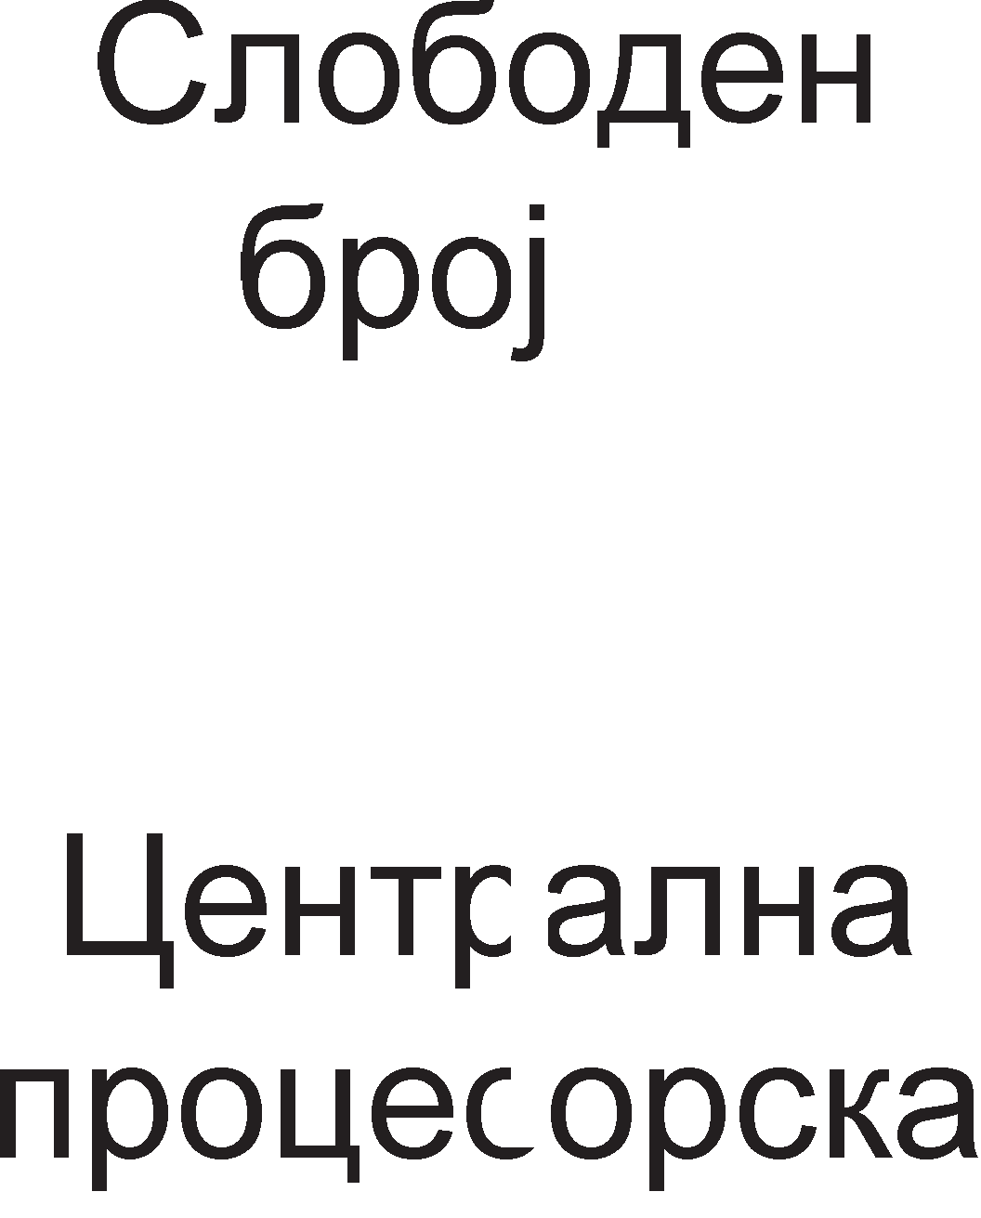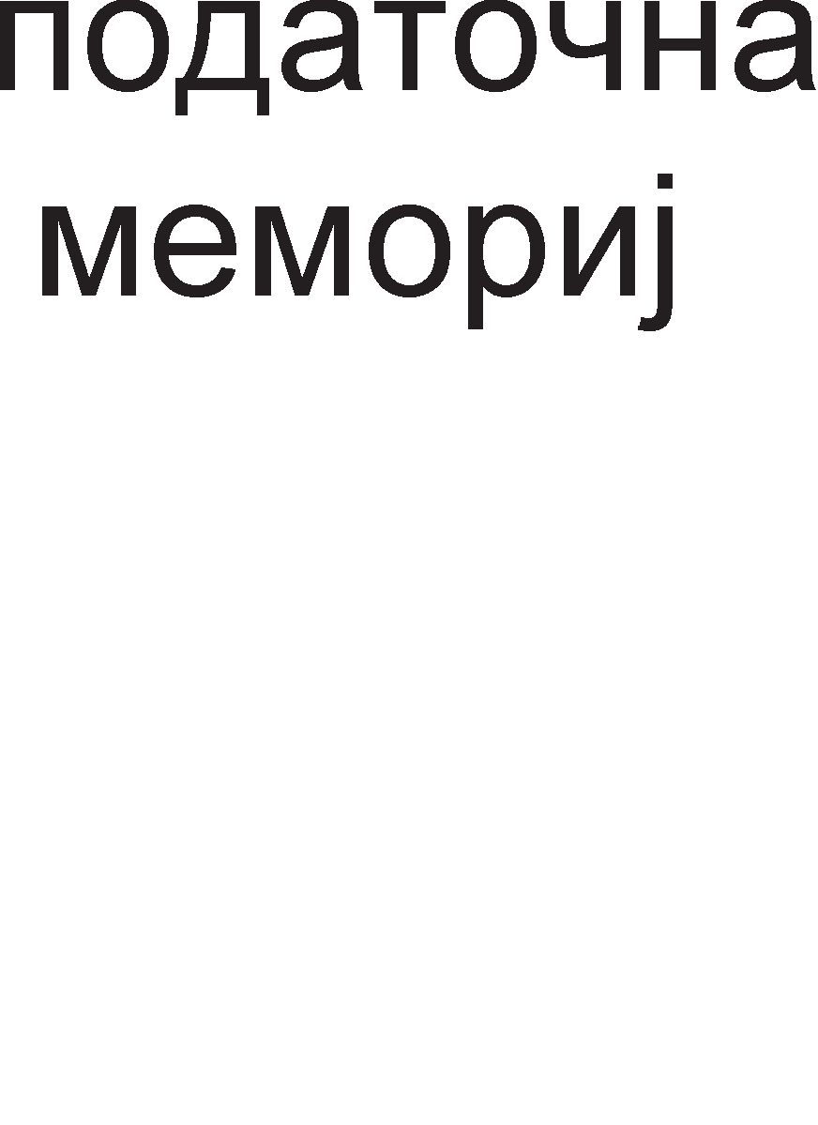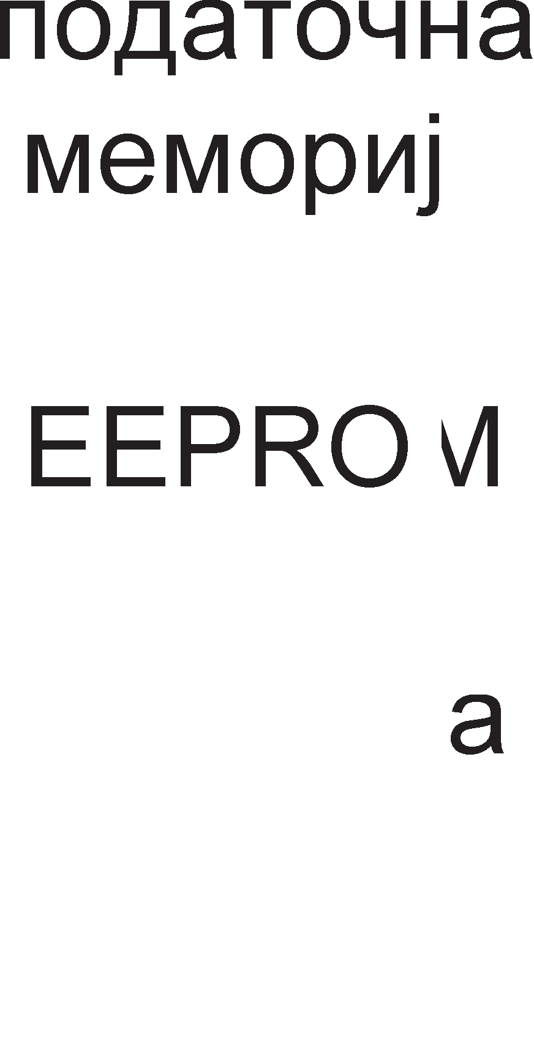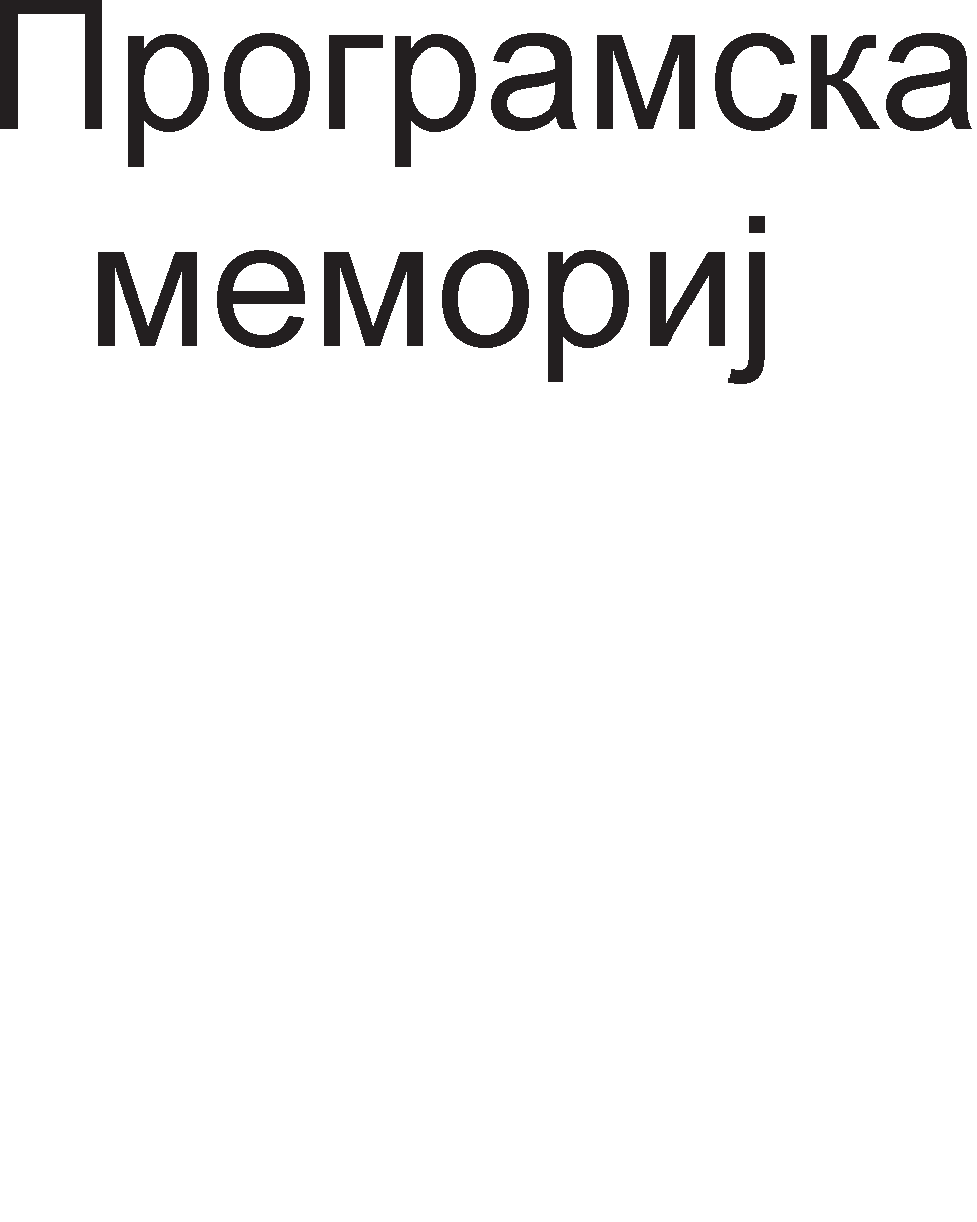

Cn1Ka 6.2. 6noK weMa Ha KoHTponep PIC16f84

Kop1cH1L1KaTa npoflpaMa wTo ja 13BpwyBa M1KpoKoHTponepoT ce Haora Bo npoflpaMcKaTa MeMop1ja. l/lHcTpyKL11Te epHa no epHa ce HocaT Bo 1HcTpyKL1cK1oT pefl1cTap, noToa Bo ynpaByBaL1KaTa ep1H1La, Kape wTo ce peKop1paaT. AeKopepoT

1 ynpaByBaL1KaTa ep1H1La BcywHocT fleHep1paaT KoHTponH1 c1flHan1 3a ap1TMeT1L1Ko nofl1L1KaTa ep1H1La 1 3a ocnoco6yBal-be Ha coopBeTH1Te pefl1cTp1. l/l3BpwyBal-beTo Ha HeKo1 1HcTpyKL11 Mo>Ke pa Bn1jae Bp3 cocToj6aTa Ha 3HaMeHLaTa Bo cTaTyc pefl1cTapoT. Aan1 HeKoe 3HaMeHLe i<e ce aKT1B1pa 1n1 He

3aB1c1 op po61eH1oT pe3ynTaT nocne 13BpwyBal-beTo Ha 1HcTpyKL1jaTa. Co 3HaL1el-beTo Ha 61ToB1Te op cTaTyc pefl1cTapoT i<e ce 3ano3HaeMe nopoLHa Kofla peTanHo i<e fl1 o6jacH1Me c1Te pefl1cTp1 Bo M1KpoKoHTponepoT PIC16f84.

EEPROM **MeMopMjaTa** fl1 L1yBa nopaToL1Te 1 nocne 1cKnyL1yBal-beTo Ha HanojyBal-beTo. Bo Hea ce L1yBaaT nopaToL1 po61eH1 op 13BpwyBal-beTo Ha npoflpaMaTa, Ho 1 KoHcTaHT1 61TH1 3a caMoTo npoLec1pal-be. Ha np1Mep, TaKoB nopaToK 61 61na BpepHocTa Ha TeMnepaTypaTa Kaj TeMnepaTypH1Te peflynaTop1. RAM e np1BpeMeHa MeMop1ja 1 Taa fl1 L1yBa Merype3ynTaT1Te 1 ppyfl1Te nopaToL1 Ko1 He ce co floneMa Ba>KHocT 1 nocne 1cKnyL1yBal-beTo Ha HanojyBal-beTo.

M1KpoKoHTponepoT PIC16f84 pacnonafla co **,qee e11e3Ho M311e3HM nopTM A M B,** npeKy Ko1 Toj KoMyH1L1pa co HapBopewH1oT cBeT. nopoLHa i<e B1p1Me KaKo HeKo1 n1HoB1 Ha nopT1Te A 1n1 B ce Kop1cTaT 3a fleHep1pal-be Ha npeK1H 1n1 KaKo Bne3 3a cno6opH1oT 6pojaL1 Ha M1KpoKoHTponepoT.

Co **reHepaTopoT Ha TaKT M TajMepMTe** Ha M1KpoKoHTponepoT i<e ce 3ano3HaeMe nopoLHa Kofla i<e flo npoyL11Me BpeMeHcK1oT c1cTeM Ha M1KpoKoHTponepoT PIC16f84. Aa cnoMeHeMe peKa oBoj M1KpoKoHTponep Kop1cT1 HapBopeweH 13Bop Ha p1fl1TcK1 TaKT (Kp1cTaneH ocL1naTop 1n1 RC ocL1naTop). Cno6opH1oT 6pojaL1 e 8-61TeH, flo 6po1 ceKoj L1eTBpT1 TaKT op Kp1cTanH1oT ocL1naTop 1 Mo>Ke pa pocT1flHe MaKc1ManHa BpepHocT op 255. l/lcTo TaKa Bo cocTaB Ha TajMepcKaTa ep1H1La ce Haora 1 c1flypHocH1oT 6pojaL1, watchdog.

M1KpoKoHTponepoT PIC16f84 Mo>Ke pa **ce peceTMpa Ha "1eTMpM Ha"1MHM**. Toj ce peceT1pa ceKoflaw nocne BKnyL1yBal-beTo Ha HanojyBal-beTo, co Len c1Te pefl1cTp1 pa ce poBepaT Bo noL1eTHa cocToj6a. M1KpoKoHTponepoT Mo>Ke pa ce peceT1pa co poBepyBal-be Ha nofl1L1Ka Hyna Ha n1HoT MCLR (microcontroller clear). PeceT1pal-be Mo>Ke pa npep13B1Ka npeL1eKopyBal-beTo Ha c1flypHocH1oT 6pojaL1 1n1 npeM1HoT Bo Mop Ha M1pyBal-be. EpeH op HajBa>KH1Te ecpeKT1 Ha peceT1pal-beTo e nocTaByBal-beTo Ha npoflpaMcK1oT 6pojaL1 Ha BpepHocT Hyna (0000H) co wTo npoflpaMaTa noL1HyBa pa ce 13BpwyBa op npBaTa Han1waHa 1HcTpyKL1ja.

# MeMopMM Ha PIC16f84

KanaL1TeToT Ha MeMop11Te e MHofly Man: RAM=68B, EEPROM=64B 1 npoflpaMcKa MeMop1ja=1KB. Ha cn1Ka 6.3. e np1Ka>KaHa MeMop1cKaTa opflaH13aL1ja Ha M1KpoKoHTponepoT PIC16f84 1 MeMop1cK1Te Man1 Ha pa3n1L1H1Te B1poB1 MeMop11.

Cefla nopeTanHo i<e ce 3ano3HaeMe co cpyHKL1jaTa Ha c1Te B1poB1 MeMop11 1 HaL11HoT Ha np1cTanyBal-be po H1B.

### RAM MeMopMja

**RAM** MeMop1jaTa Bo M1KpoKoHTponep1Te ja 1Ma 1cTaTa cpyHKL1ja KaKo 1 RAM MeMop1jaTa Bo c1Te ocTaHaT1 cMeTaL11. Taa e np1BpeMeHa MeMop1ja wTo fl1 fly61 nopaToL1Te no 1cKnyL1yBal-beTo Ha HanojyBal-beTo. Taa e **pa6oTHa MeMopMja**, opHocHo Bo Hea npoLecopoT fl1 L1yBa c1Te noTpe6H1 nopaToL1 3a 13BpwyBal-be Ha 3apapeHaTa npoflpaMa. Ao MeMop1cK1Te noKaL11 npoLecopoT np1cTanyBa npeKy 1cnpai<al-be coopBeTH1 appec1. Ho, Bo cBojaTa opflaH13aL1ja RAM MeMop1jaTa Ha PIC16f84 3HaL11TenHo ce pa3n1KyBa op RAM MeMop1jaTa Ha onwT1oT M1KponpoLecop.

**RAM MeMopMjaTa e no,qe11eHa eo ,qee 6aHKM** o3HaL1eH1 co 6aHKa 0 1 6aHKa

1. Ha 6aHKaTa 0 11 np1naraaT noKaL11Te L11ja appeca noL1HyBa Ha Hyna, (op 00H po 4F), a Ha 6aHKa 1 noKaL11Te co appec1 Ko1 noL1HyBaaT Ha epeH (op 80H po CFH). noKaL11Te co appec1Te op 0CH po 7FH 1 op D0H 1 FFH, cefla 3a cefla, He ce Kop1cTaT 1 co H1BHo L11Tal-be ceKoflaw ce po61Ba pe3ynTaT Hyna. 3a 136op Ha MeMop1cKa 6aHKa ce Kop1cT1 cTaTyc pefl1cTapoT 3a wTo i<e cTaHe 36op Bo noHaTaMowH1oT TeKcT. AopeKa e 136paHa HynTaTa 6aHKa He Mo>Ke pa ce np1cTanyBa po noKaL11Te op npBaTa MeMop1cKa 6aHKa.

Kaj KoMnjyTep1Te **perMcTpMTe co onwTa M cne4Mja11Ha HaMeHa** ce HaoraaT Bo M1KponpoLecopoT, a Kaj PIC 16f84 T1e **ce cMecTeHM eo RAM MeMopMjaTa**. npB1Te 12 MeMop1cK1 noKaL11 op ceKoja 6aHKa Ha RAM MeMop1jaTa npeTcTaByBaaT pefl1cTp1 co cneL1janHa HaMeHa. Pefl1cTp1Te co cneL1janHa HaMeHa cKpaTeHo ce 3an1wyBaaT co KpaTeHKaTa SFR (Special Function Registers). Ha np1Mep cno6opH1oT 6pojaL1 Ha M1KpoKoHTponepoT (TMR0) npeTcTaByBa MeMop1cKa noKaL1ja op HynTaTa 6aHKa co appeca 01H. CTaTyc pefl1cTapoT Mo>Ke pa ce Hajpe Bo pBeTe MeMop1cK1 6aHK1 opHocHo aKo ce HaoraMe Bo HynTaTa 6aHKa cTaTyc pefl1cTapoT ja npeTcTaByBa noKaL1jaTa co appeca O3H, a aKo ce HaoraMe Bo npBaTa 6aHKa Toflaw Toa e noKaL1jaTa co appeca 83H.

**nporpaMcKoT 6poja"1** e 13 61TeH pefl1cTap. HefloB1Te ocyM noHe3HaL1ajH1 61ToB1 PCL (Program Counter Low) ce HaoraaT Bo noKaL1jaTa co appeca 04H Bo HynTaTa 6aHKa 1n1 Bo noKaL1jaTa co appeca 84H Bo npBaTa 6aHKa. OcTaHaT1Te neT no3HaL1ajH1 61ToB1 ce HaoraaT Bo noKaL1jaTa co appeca 0AH Bo HynTaTa 6aHKa 1n1 noKaL1ja co appeca 8AH Bo npBaTa 6aHKa. Aa ce noTceT1Me peKa npoflpaMcK1oT 6pojaL1 ja copp>K1 appecaTa Ha cnepHaTa 1HcTpyKL1jaTa Koja Tpe6a pa ce 13Bpw1. Co 3floneMyBal-be Ha appecaTa Ha 1HcTpyKL1jaTa Koja MoMeHTanHo ce 13BpwyBa 3a epeH, ce po61Ba appecaTa Ha cnepHaTa 1HcTpyKL1ja. Kofla ce pa6oT1 3a cKoK 1HcTpyKL11 Toflaw npoflpaMcK1oT 6pojaL1 cTaHyBa epHaKoB Ha appecaTa HaBepeHa Bo cKoK 1HcTpyKL1jaTa. Kofla pefl1cTp1Te ce np1cyTH1 Bo pBeTe MeMop1cK1 6aHK1, KaKo wTo ce cTaTyc pefl1cTapoT 1n1 npoflpaMcK1oT 6pojaL1, Toflaw e ceepHo Bo Koja 6aHKa ce HaoraMe Bo papeH1oT MoMeHT. noHaTaMy i<e ce

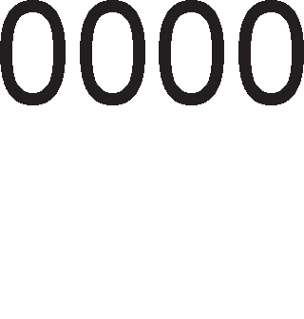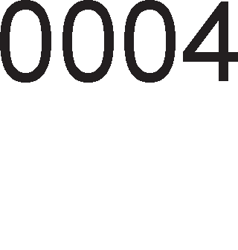

3ano3HaeMe co cpyHKL1jaTa Ha c1Te pefl1cTp1 co cneL1janHa HaMeHa 1 3HaL1el-beTo Ha H1BH1Te KoHTponH1 61ToB1.

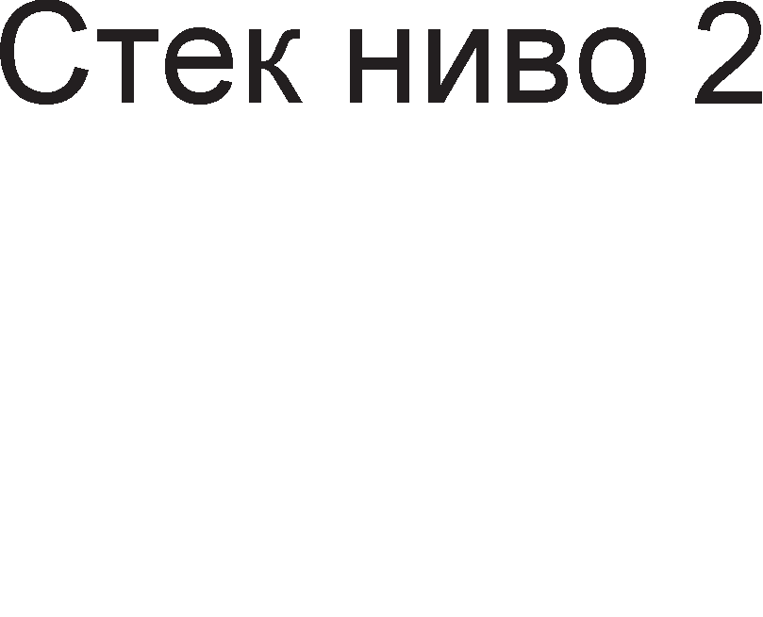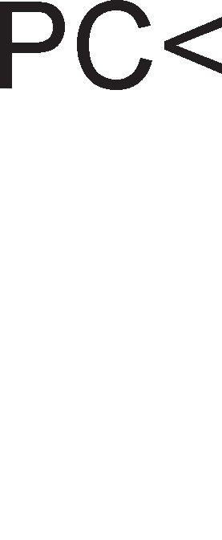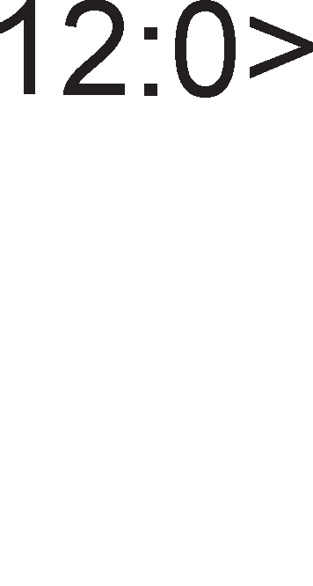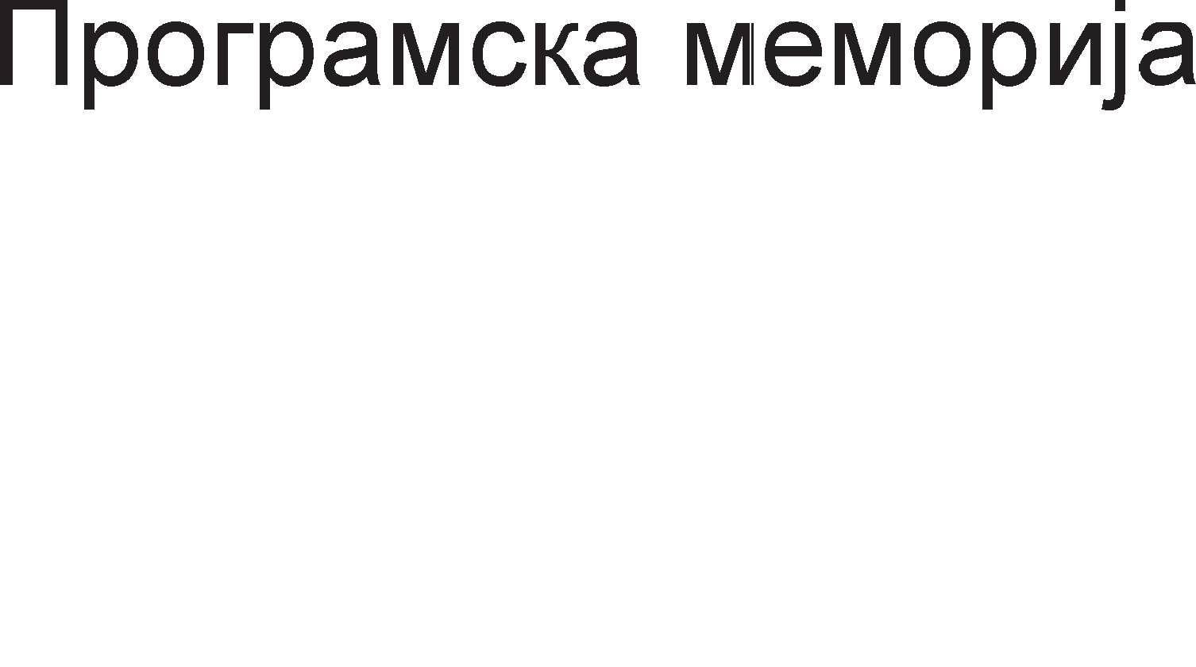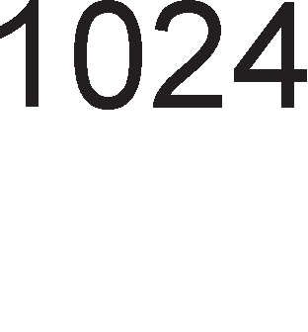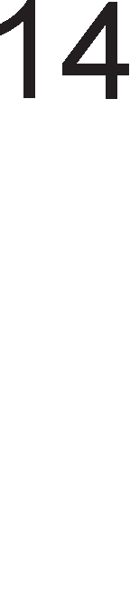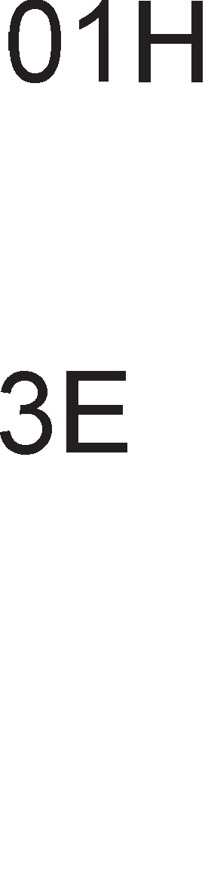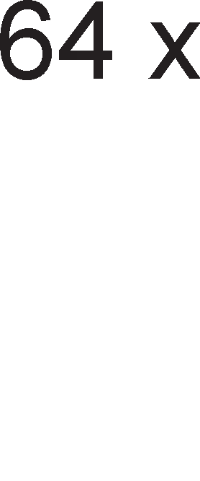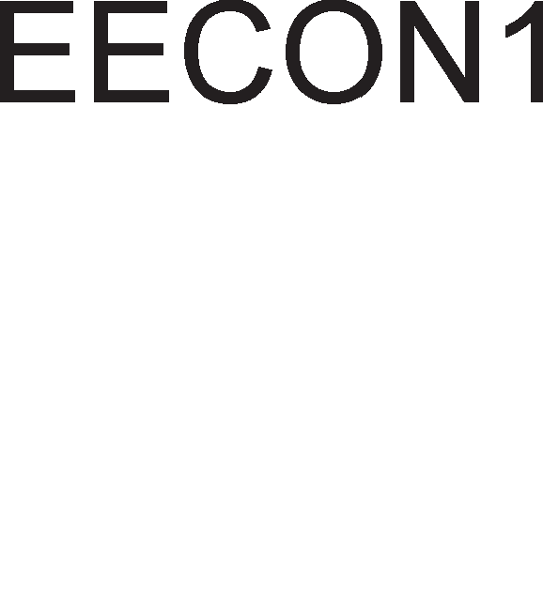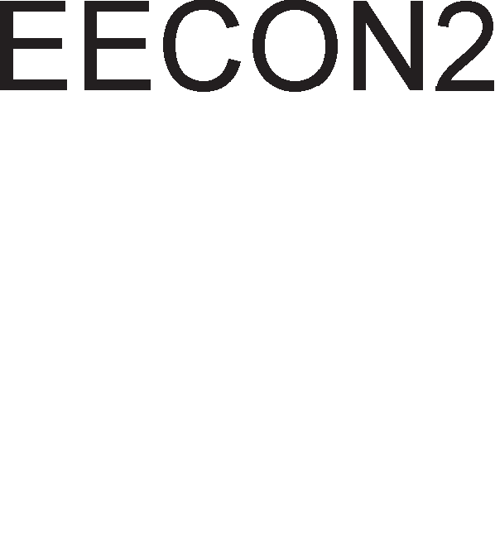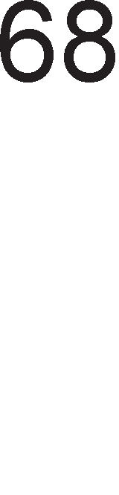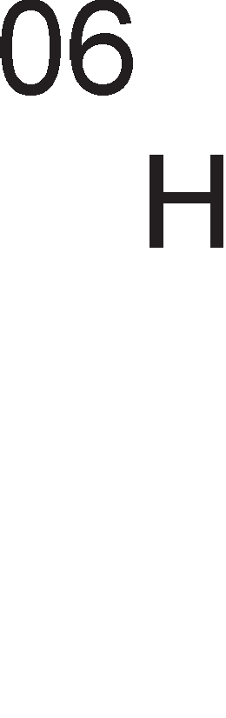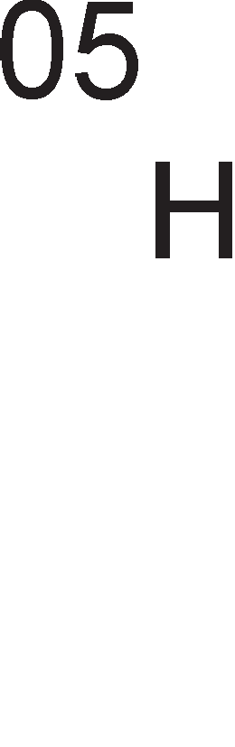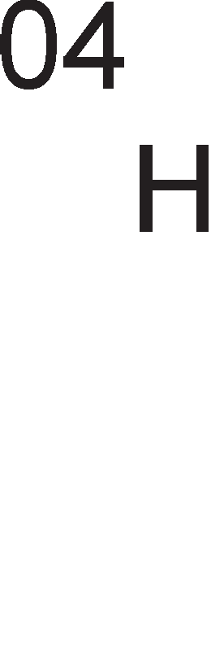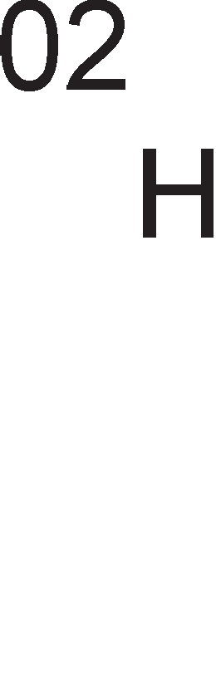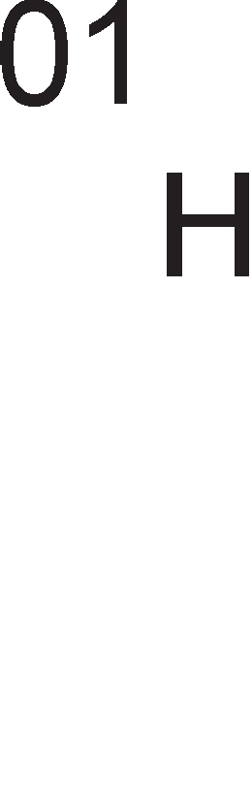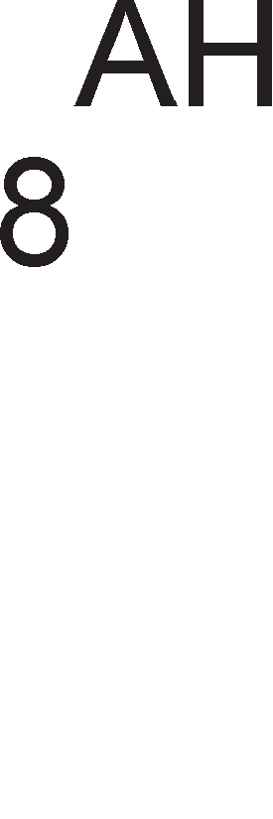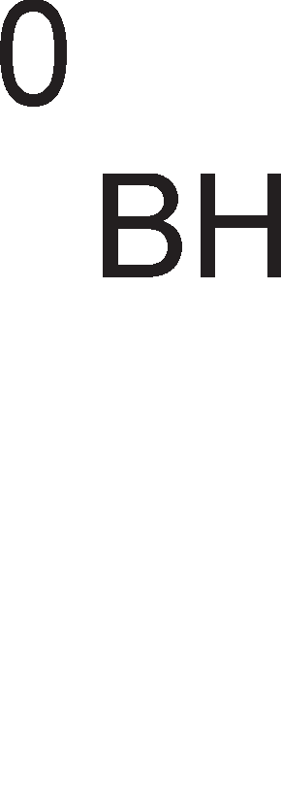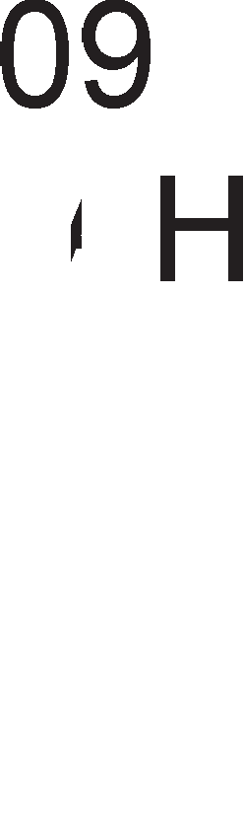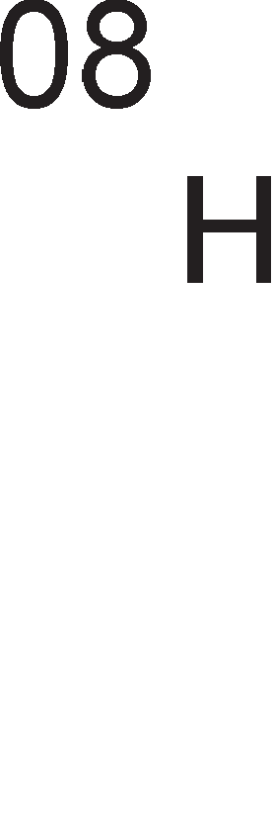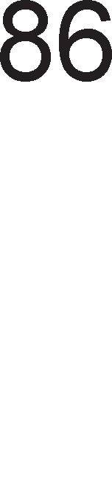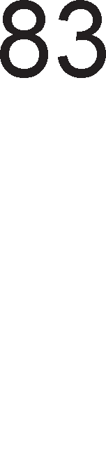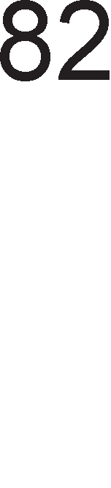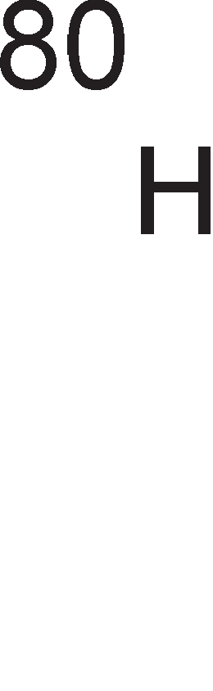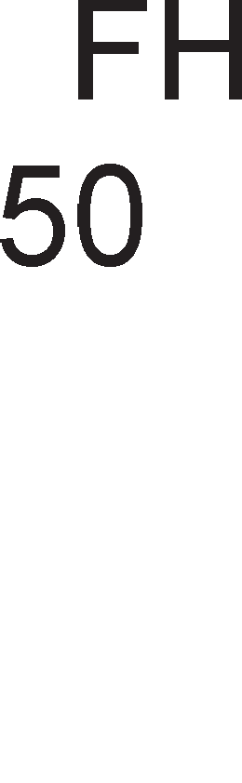

Cn1Ka 6.3. MeMop1cKa opflaH13aL1ja Ha PIC16f84

nop pefl1cTp1Te co cneL1janHa HaMeHa ce HaoraaT pefl1cTp1Te co onwTa HaMeHa (GPR-General Purpose Registers). l/lMa BKynHo **68 perMcTpM co onwTa HaMeHa**. 3a np1cTan po onwT1Te pefl1cTp1 ceepHo e Bo Koja 6aHKa ce HaoraMe. AKo ce HaoraMe Bo HynTaTa 6aHKa Toflaw 3a appec1pal-be Ha onwT1Te pefl1cTp1 ce Kop1cTaT appec1Te op 0CH po 4FH, a aKo ce HaoraMe Bo npBaTa 6aHKa Toflaw Toa ce appec1Te op 8CH po CFH. noHeKoflaw 3a np1cTan po onwT1Te pefl1cTp1 ce Kop1cTaT c1M6on1L1H1 1M1l-ba. l/lMeHo nocTojaT cneL1janH1 Hapep61, TaKaHapeL1eH1 p1peKT1B1, co Ko1 Ha ceKoj onwT pefl1cTap My ce 3apaBa c1M6on1L1Ho 1Me. HaB1cT1Ha MHofly e nonecHo pa ce naMT1 1Me oTKonKy BpepHocT Ha appeca Bo XeKcapeL1ManeH 6poeH c1cTeM. Co p1peKT1B1Te i<e ce 3ano3HaeMe

nopoLHa Kofla i<e ja o6jacHyBaMe nocTanKaTa 3a n1wyBal-be Ha npoflpaMa 3a KoHTponep PIC16f84.

### nporpaMcKa MeMopMja

**nporpaMcKaTa MeMopMja** e TpajHa cpnew MeMop1ja 1 Bo Hea ce L1yBa **KopMcHM"1KaTa nporpaMa.** npoflpaMaTa Bo npoflpaMcKaTa MeMop1ja ce BHecyBa cep1cK1, 61T no 61T, npeKy cepM1oT n1H Ha nopTaTa B. 3a BHecyBl-be Ha npoflpaMaTa Bo PIC16f84, noTpe6eH e KoMnjyTep, npoflpaMaTop, cneL1janeH cocpTBep (MPLAP, FPP...), Ka6en 3a noBp3yBal-be Ha npoflpaMaTopoT co napanenHaTa nopTa Ha KoMnjyTepoT 1 Kop1cH1L1Ka npoflpaMa.

### EEPROM MeMopMja

BTopa nopaToL1Ha 1 TpajHa MeMop1ja e **EEPROM MeMopMjaTa**. Bo Hea ce L1yBaaT **no,qaTo4M ,qo6MeHM KaKo pe3y11TaT o,q M3epwyea1-eTo Ha KopMcHM"1KaTa nporpaMa.** Ha np1Mep, Toa Mo>Ke pa 61paT nopaToL1 po61eH1 op HeKoja oppaneL1eHa MeTeponowKa cTaH1La (TeMnepaTypa, HapBopeweH np1T1coK, Kon1L1ecTBo BpHe>K1) 1n1 nopaToK 3a 6pojoT Ha napK1paH1 Bo31na Ha epeH napK1Hfl 3a epHo peHoHoi<1e 1TH. 3a pa3n1Ka op npoflpaMcKaTa MeMop1ja, nopaToL1Te op EEPROM ce L11TaaT 1 ce n1wyBaaT napanenHo, 8 61Ta opepHaw. Ao EEPROM MeMop1jaTa ce np1cTanyBa 1Hp1peKTHo 1 ce Kop1cT1 noce6Ha npoLepypa co Len pa ce 3awT1T1 EEPROM MeMop1jaTa op cnyL1ajHo, HecaKaH1 3an1wyBal-ba Bo MeMop1jaTa. 3a L11Tal-be 1 3a n1wyBal-be Bo EEPROM MeMop1jaTa ce Kop1cTaT Tp1 cneL1janH1 pefl1cTp1. EEADR ja L1yBa appecaTa Ha noKaL1jaTa Bo Koja ce n1wyBa 1n1 L11Ta. EEDATA flo L1yBa nopaToKoT wTo Tpe6a pa ce Bn1we 1n1 nopaToKoT wTo e npoL11TaH. EECON e 5-61TeH pefl1cTap 1 copp>K1 KoHTponH1 61ToB1 noBp3aH1 co n1wyBal-beTo 1 L11Tal-beTo op EEPROM MeMop1jaTa. 3HaL1el-beTo Ha oB1e 61ToB1 i<e 61pe o6jacHeTo nopoLHa.

### CTeK MeMopMja

PIC16f84 1Ma 13-61THa cTeK MeMop1ja co 8 H1Boa. HefloBa ocHoBHa cpyHKL1ja e pa ja coL1yBa BpepHocTa Ha npoflpaMcK1oT 6pojaL1 Kofla ce npeM1HyBa op flnaBHa npoflpaMa Bo noTnpoflpaMa, 3a pa M1KpoKoHTponepoT 3Hae pa ce BpaT1 Ha MecToTo Ha Koe 61na noB1KaHa noTnpoflpaMaTa. np1 Bpai<al-b e op noTnpoflpaMaTa Bo flnaBHaTa npoflpaMa BpepHocTa op cTeK MeMop1jaTa ce Bpai<a Bo npoflpaMcK1oT 6pojaL1.

# Ha"1MHM Ha a,qpecMpa1-e Kaj PIC16f84

3a np1cTan po noKaL11Te op RAM MeMop1jaTa ce Kop1cTaT pBa HaL11H1 Ha appec1pal-be: p1peKTHo 1 1Hp1peKTHo appec1pal-be.

Kaj **,qMpeKTHoTo a,qpecMpa1-e** appecaTa 3a np1cTan po RAM noKaL1jaTa ce copp>K1 Bo caMaTa 1HcTpyKL1ja, 1cTo KaKo Kaj onwT1oT M1KponpoLecop. Ha cn1Ka

6.4. e np1Ka>KaHa nocTanKaTa Ha p1peKTHo appec1pal-be.

Cn1Ka 6.4. npecMeTKa Ha appeca Kaj p1peKTHo appec1pal-be

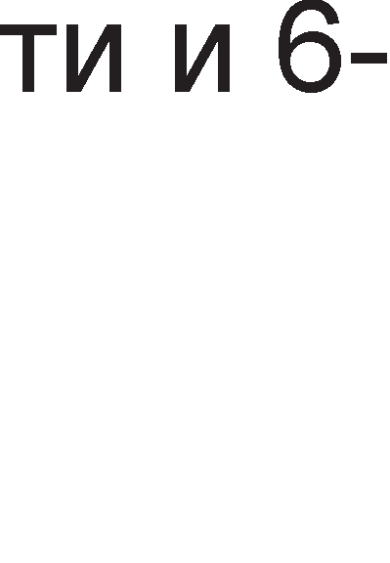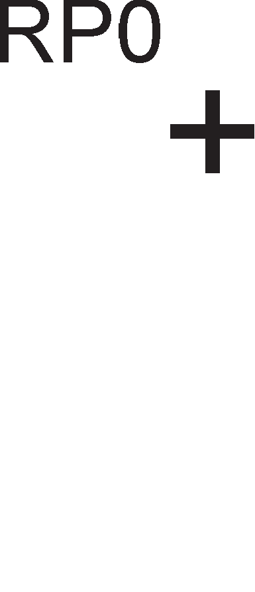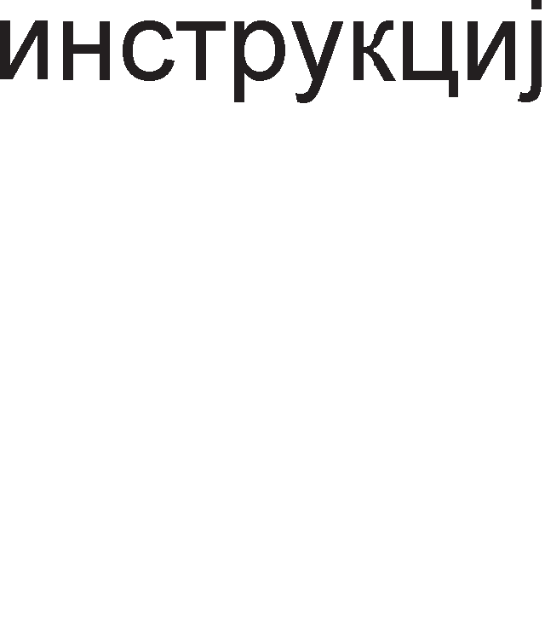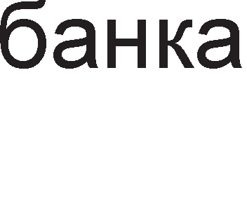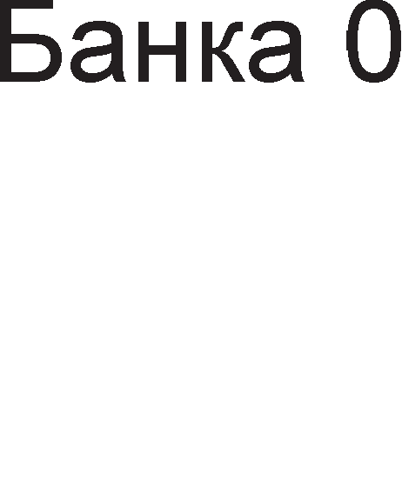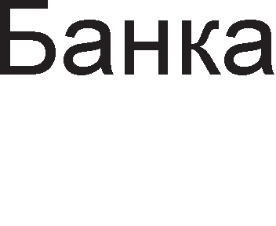

Co p1peKTHoTo appec1pal-be ce po61BaaT 9-61TH1 appec1. npB1Te pBa Haj3HaL1ajH1 61ToB1 ce BcywHocT 61ToB1Te RP1 1 RP0 op cTaTyc pefl1cTapoT, Ko1 cny>KaT 3a 136op Ha epHa op pBeTe MeMop1cK1 6aHK1. OcTaHaT1Te cepyM 61ToB1 ce op caMaTa 1HcTpyKL1ja 1 cny>KaT 3a 136op Ha epHa noKaL1ja op Bei<e ceneKT1paHaTa 6aHKa.

nocTanKaTa 3a cpopM1pal-be Ha MeMop1cKa appeca Kaj **MH,qMpeKTHoTo a,qpecMpa1-e** e np1Ka>KaHo Ha cn1Ka 6.5.

Cn1Ka 6.5. npecMeTKa Ha appeca Kaj 1Hp1peKTHo appec1pal-be

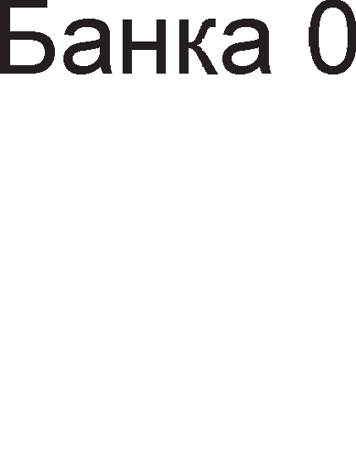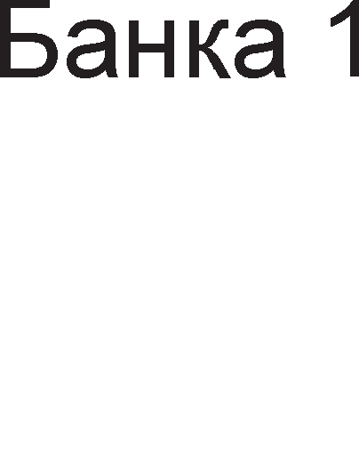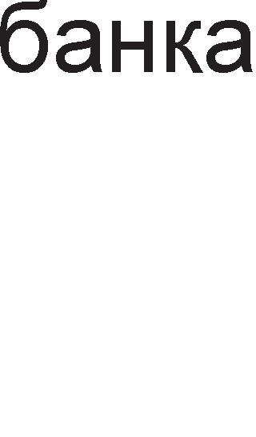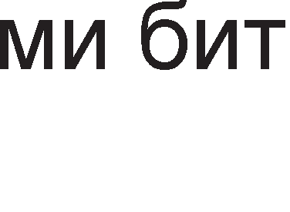

Kaj 1Hp1peKTHoTo apepec1pal-be appecaTa He ce copp>K1 Bo 1HcTpyKL1jaTa, TyKy Bo epeH cneL1janeH pefl1cTap FSR. OBoj pefl1cTap 3aepHo co cepM1oT 61T op

cTaTyc pefl1cTapoT IRP cpopM1paaT appeca 3a ceneKL1ja Ha epHa noKaL1ja op RAM MeMop1jaTa. 3a pa flo npoL11TaMe caKaH1oT nopaToK He Mopa pa ce op1 po 136paHaTa noKaL1ja, TyKy nopaToKoT op Taa noKaL1ja Mo>Ke pa ce npoL11Ta op pefl1cTapoT INDF co appeca 00H Bo HynTaTa 6aHKa 1n1 appeca 80H Bo npBaTa 6aHKa. Ha np1Mep HeKa onw1oT pefl1cTap co appeca 0FH flo copp>K1 nopaToKoT 20H. OBa 3HaL11 peKa co np1MeHa Ha 1Hp1peKTHoTo appec1pal-be pefl1cTapoT FSR i<e ja copp>K1 BpepHocTa 0FH, a pefl1cTapoT INDF BpepHocTa 20H. l/lHp1peKTHoTo appec1pal-be 1Ma np1MeHa np1 pa6oTa co H131.

# nMH-,qMjarpaM Ha PIC16f84

Ha cn1Ka 6.6. e np1Ka>KaH n1H p1jaflpaM Ha PIC 16f84.

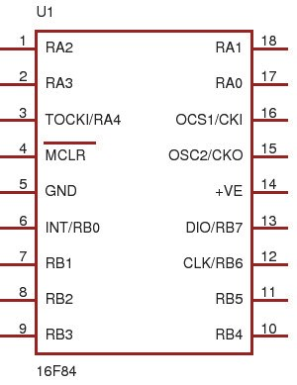

Cn1Ka 6.6. n1H-p1jaflpaM Ha PIC16f84

M1KpoKoHTponepoT HeMa nopaToL1H1 n1HoB1. Ho, 3a KoMyH1KaL1ja co HapBopewH1oT cBeT fl1 Kop1cT1 n1HoB1Te Ha nopT1Te A 1 B. 36opoT nopTa npeTcTaByBa flpyna op n1HoB1 op M1KpoKoHTponepoT po Ko1 Mo>Ke 1cToBpeMeHo pa ce np1cTanyBa 1 pa ce nocTaByBa caKaHaTa KoM61HaL1ja op Hyn1 1 ep1H1L1.

<l131L1K1 nopTaTa npeTcTaByBa pefl1cTap Bo BHaTpewHocTa Ha KoHTponepoT Koj co npoBopH1L1 e noBp3aH co n1HoB1Te Ha KoHTponepoT. nopT1Te npeTcTaByBaaT cp131L1Ka BpcKa Mery LeHTpanHo npoLecopcKaTa ep1H1La 1 HapBopewH1oT cBeT. nofl1L1KaTa cocToj6a Ha n1HoB1Te Mo>Ke pa ce npoL11Ta op pefl1cTp1Te co cneL1janHa HaMeHa PORTA 1 PORTB. Ha cn1Ka 6.6 oB1e n1HoB1 ce o3HaL1eH1 co RA 1 RB. 6yKBaTa R e npBa 6yKBa op aHfln1cK1oT 36op rack wTo Bo npeBop 3HaL11 onToBapyBal-be. **nopTaTa B e ocyMnMHcKa, a nopTaTa A e neTnMHcKa.** T1e Mo>KaT pa 61paT 1n1 Bne3H1 1n1 13ne3H1, Ho He 1 pBoHacoL1H1. Aan1 nopT1Te A 1 B i<e 61paT Bne3H1 1n1 13ne3H1 3aB1c1 op 61ToB1Te Bo pefl1cTp1Te TRISA 1 TRISB. **TRISA M TRISB** ce ocyM61TH1 pefl1cTp1. Ha np1Mep, aKo TRISB =

00001111, Toa 3HaL11 peKa 4, 5, 6 1 7 n1H op nopTaTa B ce 13ne3H1, a 3, 2, 1 1 HynT1oT n1H ce Bne3H1. Ep1H1LaTa 3HaL11 peKa n1HoT e Bne3eH, a HynaTa peKa e 13ne3eH. 3apap1 nonecHo naMTel-be 6pojoT Hyna He acoL1pa Ha npBaTa 6yKBa op aHfln1cK1oT 36op (output), a 6pojoT epeH Ha npBaTa 6yKBa op 36opoT input.

HeKo1 op nopT1Te A 1 B op PIC 16f84 1MaaT pBojHa cpyHKL1ja.

* n1HoT **RA4/TOCKI** e L1eTBpT1 n1H Ha nopTaTa A, Ho Mo>Ke pa ce Kop1cT1 1 KaKo Bne3 3a TaKT Ha cno6opH1oT 6pojaL1. Aan1 oBoj n1H i<e 61pe L1eTBpT1 n1H op nopTa A 1n1 HapBopeweH Bne3 3a cno6opH1oT 6pojaL1 3aB1c1 op nofl1L1KaTa cocToj6a Ha neTT1oT 61T op pefl1cTapoT OPTION, TOSC.
* **RBO/INT** e HynT1 n1H Ha nopTaTa B, Ho Mo>Ke pa ce Kop1cT1 1 KaKo 13Bop Ha HapBopeweH npeK1H. C1Te n1HoB1 3a npeK1H1 ce o6jacHeT1 np1 on1wyBal-be Ha cpyHKL1jaTa Ha pefl1cTapoT INTCON (Interrupt Control).
* n1HoB1Te **RB4, RB5, RB6, RB7** 1MaaT TpojHa cpyHKL1ja. T1e ce Bne3Ho- 13ne3H1 n1HoB1 Ha nopTaTa B, Ho Mo>KaT pa ce Kop1cTaT 1 KaKo 13Bop1 Ha npeK1H np1 npoMeHa Ha nofl1L1KoTo H1Bo. RB6 1 RB7 ce Kop1cTaT Bo npoflpaMcK1 Mop 1 Toa Ha RB6 ce poBepyBaaT TaKT 1Mnync1, a RB7 ce Kop1cT1 3a cep1cKo BHecyBal-be Ha npoflpaMaTa Bo M1KpoKoHTponepoT.

OcTaHaT1Te n1HoB1 Ha M1KpoKoHTponepoT PIC16f84 ja 1MaaT cnepHaBa cpyHKL1ja.

* ce Kop1cT1 3a peceT1pal-be Ha BHaTpewH1Te pefl1cTp1 Kofla i<e ce nocTaB1 Ha H1cKo H1Bo. OBoj n1H ce Kop1cT1 Bo npoflpaMcK1 Mop Ha pa6oTa, np1 wTo ce nocTaByBa Ha HanoH op +12 V po + 14 V.



* 3a np1KnyL1yBal-be Ha ocL1naTop1 KaKo 13Bop1 Ha TaKT ce Kop1cTaT n1HoB1Te **OSC2/CLOCKOUT M OSC1/CLKIN**. Ha cn1Ka 6.7. e np1Ka>KaHo noBp3yBal-beTo Ha PIC 16f84 co Kp1cTaneH ocL1naTop.

Cn1Ka 6.7. noBp3yBal-be Ha PIC16f84 co Kp1cTaneH ocL1naTop M1KpoKoHTponepoT Mo>Ke pa Kop1cT1 noBei<e B1poB1 Ha ocL1naTop1: LP (low

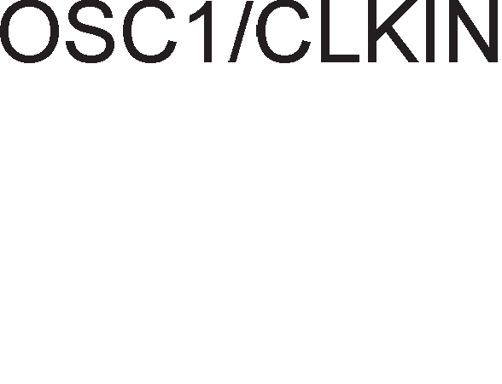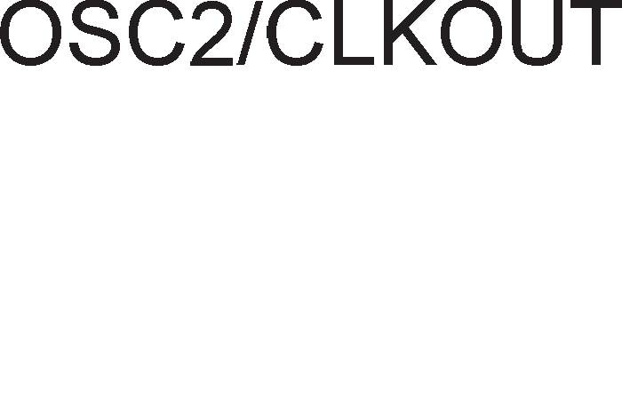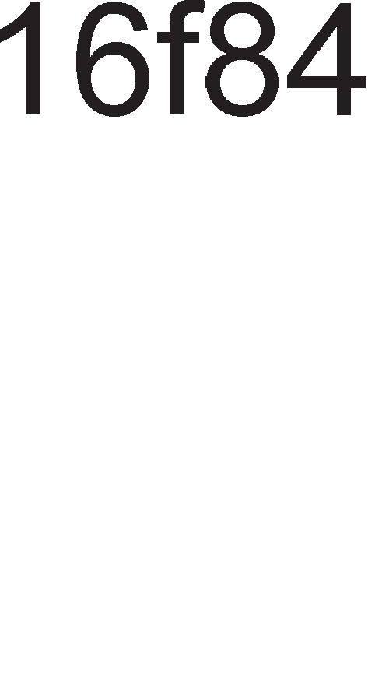

power), XT (crystal resonator), HS (high speed). KaKo 13Bop Ha p1fl1TcK1 TaKT Mo>Ke pa ce Kop1cT1 1 RC ocL1naTop1.

* + GND e Maca, 3a3eMjyBal-be, a +Ve e HanojyBal-be.

# BpeMeHcKM cMcTeM Ha PIC16f84

M1KpoKoHTponepoT pa6oT1 Bo c1HXpoH Mop Ha pa6oTa. 3a pa Mo>Ke pa fl1 13BpwyBa 1cTpyKL11Te noTpe6eH e p1fl1TcK1 TaKT. A1fl1TcK1oT TaKT ce po61Ba op Kp1cTanH1oT ocL1naTop np1KnyL1eH Ha n1HoB1Te op M1KpoKoHTponepoT. **a M3epwyea1-e Ha e,qHa MHcTpyK4Mja noTpe6HM ce "1eTMpM ,qMrMTcKM TaKTa Q1, Q2, Q3 M Q4.** OBa e np1Ka>KaHo Ha cn1Ka 6.8.

Cn1Ka 6.8. BpeMeHcK1 p1jaflpaM 3a 13BpwyBal-be Ha 1HcTpyKL11

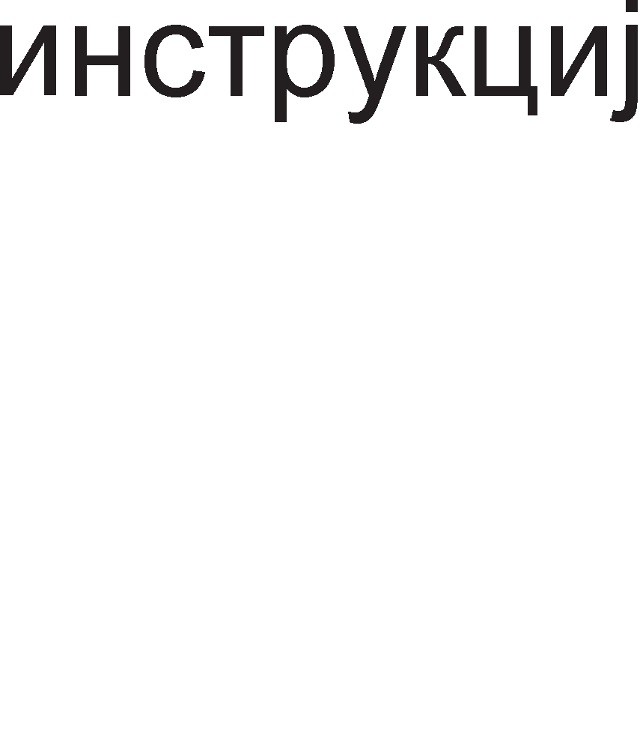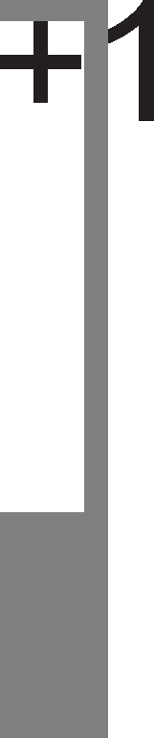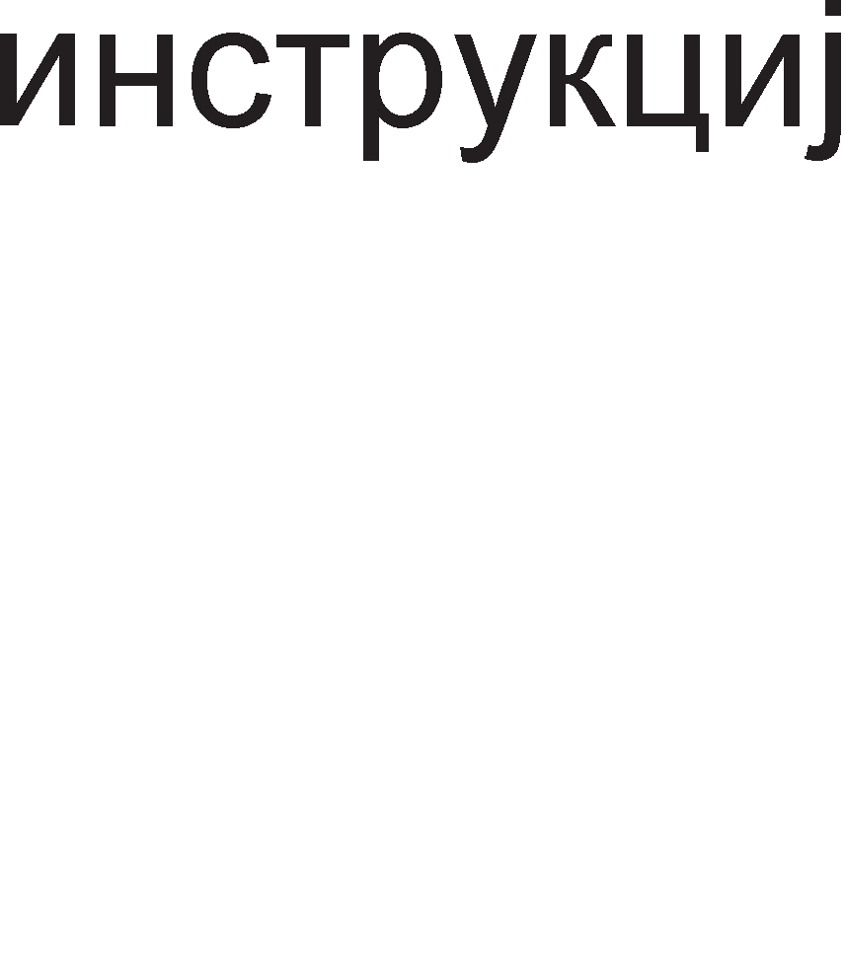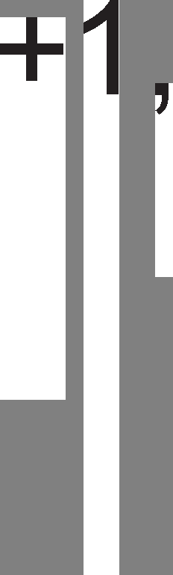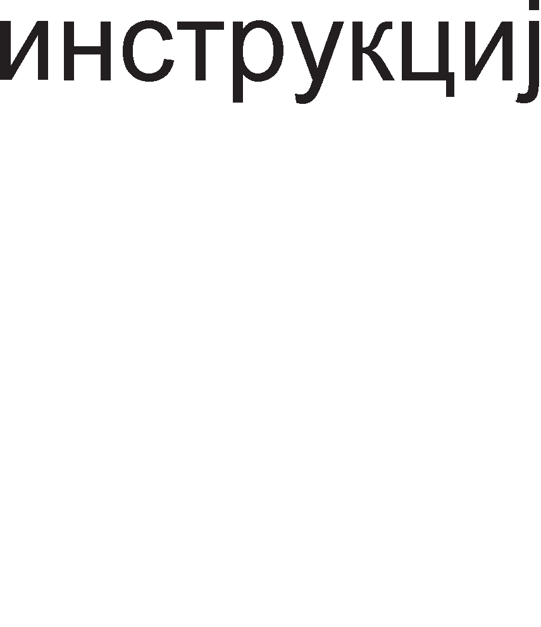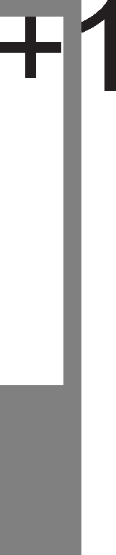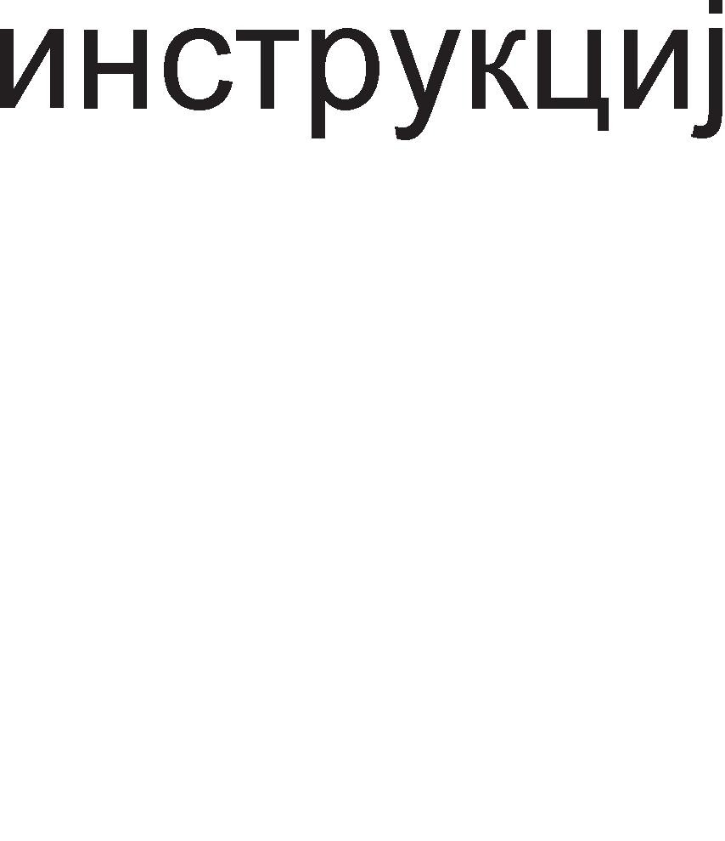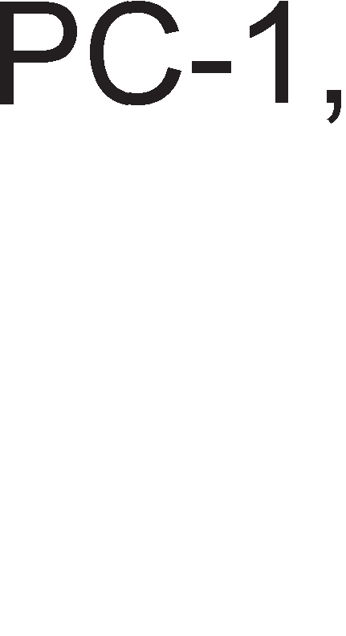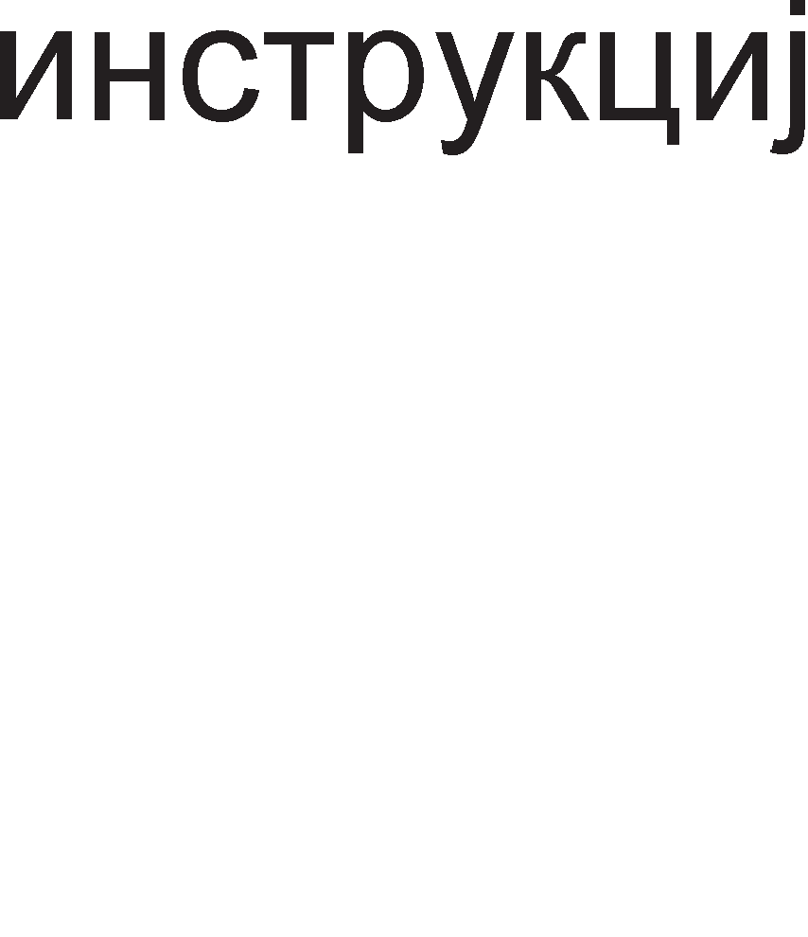

3a BpeMe Ha npB1oT p1fl1TcK1 TaKT Q1 1HcTpyKL1jaTa ce npeHecyBa op npoflpaMcKaTa MeMop1ja Bo 1HcTpyKL1cK1oT pefl1cTap. 3a BpeMe Ha p1fl1TcK1oT TaKT Q2 1HcTpyKL1jaTa ce peKop1pa, a Bo HapepH1Te pBa TaKTa Taa ecpeKT1BHo ce 13BpwyBa. Ha cn1Ka 6.8. ce np1Ka>KaH1 npoMeH1Te Ha copp>K1HaTa Ha pefl1cTapoT npoflpaMcK1 6pojaL1 Koj ja noKa>KyBa appecaTa Ha cnepH1oT 6ajT Koj Tpe6a pa ce npeHece op MeMop1jaTa Bo npoLecopoT.

M1KpoKoHTponepoT PIC-16f84 MHofly L1ecTo ce Kop1cT1 KaKo TajMep 1n1 6pojaL1. **Kora pa6oTM KaKo TajMep, Toraw MMKpoKoHTpo11epoT ce noep3yea co KpMcTa11eH oc4M11aTop**. nep1opaTa e peL1npoL1Ha BpepHocT op cppeKBeHL1jaTa Ha p1fl1TcK1oT TaKT (T=1/f). 6pojoT Ha p1fl1TcK1 TaKTa wTo Tpe6a pa fl1 136po1 TajMepoT ce po61Ba aKo 13M1HaToTo BpeMe ce nopen1 co nep1opaTa Ha Kp1cTanH1oT ocL1naTop. Ha np1Mep aKo cppeKBeHL1jaTa Ha Kp1cTanH1oT ocL1naTopoT 13HecyBa 1KHz Toflaw nep1opaTa i<e 13HecyBa 1ms, na 3a pa po61eMe BpeMe Ha poLHel-be op 1s noTpe6Ho e pa noM1HaT 1000 nep1op1 Ha Kp1cTanH1oT ocL1naTop, 3a BpeMe op 2s noTpe6Ho e pa ce 136pojaT 2000 nep1op1 1TH.

TajMepoT Ha M1KpoKoHTponepoT ce 6ene>K1 co KpaTeHKaTa **TMR0**, wTo e BcywHocT, KpaTeHKa op timer0. Toj e ocyM61TeH pefl1cTap 1 Mo>Ke pa 136po1 op 00H po FFH. Kofla i<e ja pocT1flHe MaKc1ManHaTa BpepHocT, TajMepoT noBTopHo noL1HyBa pa 6po1 op Hyna. OBoj npeM1H Bo 6poel-beTo ce HapeKyBa **npe"1eKopyea1-e Ha c11o6o,qHMoT 6poja"1**. nopoLHa i<e B1p1Me peKa npeL1eKopyBal-beTo Ha 6pojaL1oT TMR0 Mo>Ke pa npep13B1Ka npeK1H (interrupt) Bo pa6oTaTa Ha M1KpoKoHTponepoT. Toflaw ce aKT1B1pa 61ToT TOIF (Timer0 Interrupt Flag) op pefl1cTapoT 3a KoHTpona Ha npeK1H1 INTCON. Co 6poel-be Ha npeL1eKopyBal-baTa Ha cno6opH1oT 6pojaL1 ce 3floneMyBa MaKc1ManH1oT 6poj Ha 136pojaH1 p1fl1TcK1 TaKTa. Ha np1Mep aKo 6pojaL1oT npeL1eKop1n 64 naT1 Toflaw Ben1Me peKa M1KpoKoHTponepoT 136po1n 64·256=16384 p1fl1TcK1 TaKTa. Ha cn1KaTa 6.9. e np1Ka>KaHa BpcKaTa Mery pefl1cTp1Te TMR0 1 INTCON .

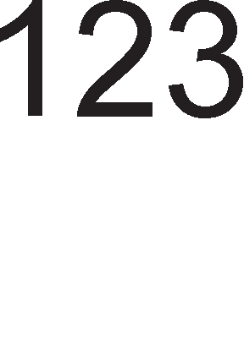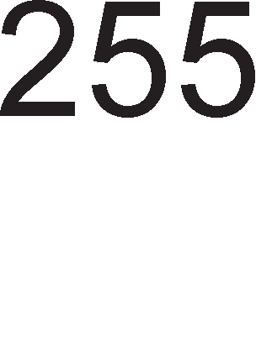

Cn1Ka 6.9. npeK1H-npeL1eKopyBal-be Ha 6pojaL1



l/lHTepecHo e wTo cno6opH1oT 6pojaL1 flo 6po1 ceKoj L1eTBpT1 1Mnync op Kp1cTanH1oT ocL1naTop. <lpeKBeHL1jaTa Ha cno6opH1oT 6pojaL1 e L1eT1p1 naT1 noMana op cppeKBeHL1jaTa Ha Kp1cTanH1oT ocL1naTop. <lpeKBeHL1jaTa Ha cno6opH1oT 6pojaL1 TMR0 Mo>Ke ywTe noBei<e pa ce HaManyBa co ynoTpe6a Ha cneL1janeH pen1Ten Ha cppeKBeHL1ja TaKaHaeL1eH npecKanep. npecKanepoT e BcywHocT 3-61TeH Kop Bo cocTaB Ha pefl1cTapoT 3a KoHTpona Ha 6pojaL11Te OPTION. Bo 3aB1cHocT op BpepHocTa Ha oBoj 3-61TeH Kop pen1TenoT Mo>Ke pa np1Ma BpepHocT1 op 2 po 256. Bn1jaH1eTo Ha npecKanepoT Bp3 cppeKBeHL1jaTa Ha cno6opH1oT 6pojaL1 e np1Ka>KaHa Ha cn1Ka 6.10.

noKpaj p1fl1TcK1 TaKToB1 op Kp1cTanH1oT ocL1naTop, pefl1cTapoT TMRO Mo>Ke pa 6po1 1 npoMeH1 Ha cocToj6aTa Ha n1HoT **RA4/TOCKI** 1 Toflaw Ben1Me peKa M1KpoKoHTponepoT e **6poja"1 Ha Ha,qeopewHM c11y"1ajHM npoMeHM.** nop cnyL1ajH1 npoMeH1 noppa361paMe npoMeH1 L11e nojaByBal-be He Mo>Ke pa ce npepB1p1. Ha np1Mep Bo epHa M1HyTa Mo>KaT pa ce nojaBaT 1njapa npoMeH1, Ho Bo cnepHa M1HyTa pa He ce cnyL11 H1Ty epHa npoMeHa Ha Bne3H1oT HanoH Ha n1HoT RA4/TOCKI. Ha np1Mep, Ha n1HoT RA4/TOCKI Mo>Ke pa noBp3eMe onT1L1K1 ceH3op 1 ceKoflaw Kofla oBoj ceH3op i<e ce aKT1B1pa, BpepHocTa Ha pefl1cTapoT TMRO ce 3floneMyBa 3a epeH. Ha BaKoB HaL11H Mo>KaT pa ce 136pojaT 6poj Ha

BneflyBal-ba 1 13neflyBal-ba Ha Bo31na Ha napK1Hfl, 6poj Ha np1T1cKal-ba Ha TacTep 1TH.

PS2 PS1 PS0 0 0 0

0 0 1

0 1 0

npecKanep 1:2

npecKanep 1:4

npecKanep 1:8

l/l3ne3eH c1flHan Ha ocL1naTopoT

0 1 0

OPTION PS2 PS1 PS0

Cn1Ka 6.10. Bn1jaH1e Ha npecKanepoT Bp3 6pojaL1oT TMR0

Ha cn1Ka 6.11. e np1Ka>KaH np1Mep 3a ynoTpe6a Ha M1KpoKoHTponepoT PIC16f84 KaKo 6pojaL1 Ha BpTe>K1. Ha n1HoT RA4/TOCKI e Bp3aH 1HpyKT1BeH ceH3op. OBoj ceH3op e nocTaBeH Ha HeKonKy M1n1MeTp1 op ocoB1HaTa Koja ce BpT1.

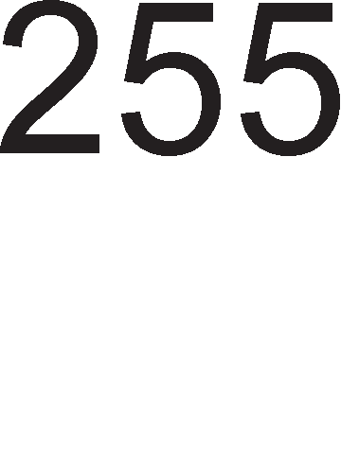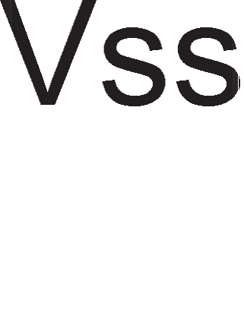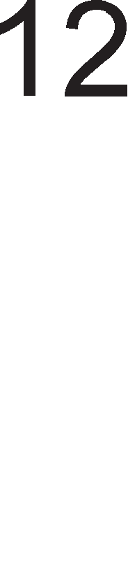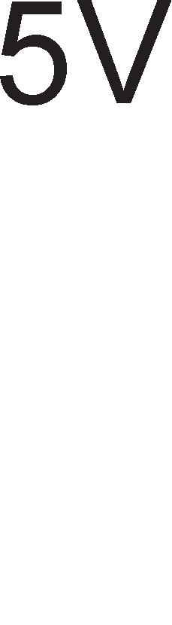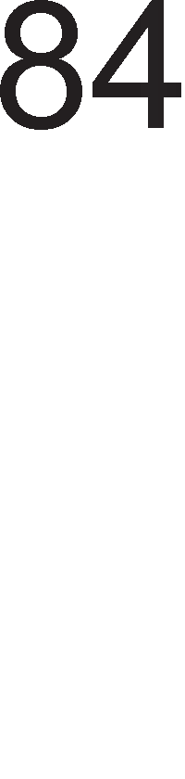

Cn1Ka 6.11. np1KnyL1yBal-be Ha 1HpyKT1BeH ceH3op Ha Bne3 op PIC16f84

Ha ocKaTa op MoTopoT ce nocTaBeH1 L1eT1p1 MeTanH1 1cnynL1yBal-ba. Kofla HeKoe op oB1e 1cnynL1yBal-ba i<e ce po6n1>K1 po ceH3opoT, i<e ce npoMeH1 HefloBaTa 1HpyKT1BHocT, wTo i<e npep13B1Ka nap Ha HanoHoT Ha Bne3H1oT n1H RA4/TOCKI. Op cn1Ka 6.11. flnepaMe peKa aKT1BaTop 3a oBoj n1H i<e 61pe onaraL1K1 pa6 opHocHo nap Ha Bne3H1oT HanoH op epeH Ha Hyna. CeKoj onaraL1K1 pa6 i<e npep13B1Ka 3floneMyBal-be Ha BpepHocTa 3a cno6opH1oT 6pojaL1 3a epeH. Kofla cno6opH1oT 6pojaL1 i<e ja pocT1flHe cBojaTa MaKc1ManHa BpepHocT opHocHo i<e 13Bpw1 256 6poel-ba i<e ce nojaB1 npeK1H-npeL1eKopyBal-be Ha 6pojaL1oT. 3a pa ce po61e 6pojoT Ha BpTe>K1 Bo epHa ceKyHpa BpepHocTa Ha cno6opH1oT 6pojaL1 Tpe6a pa ce nopen1 co 13M1HaToTo BpeMe 1 6pojoT L1eT1p1 (nopap1 L1eT1p1Te MeTanH1 1cnynL1yBal-ba).

noKpaj cno6opH1oT 6pojaL1 Bo cocTaB Ha TajMepcKaTa ep1H1La ce Haora ywTe epeH 6pojaL1 TaKaHapeL1eH1oT **cMrypHoceH 6poja"1**. Watchdog TajMepoT BcywHocT npeTcTaByBa RC ocL1naTop Bo cKnon Ha caM1oT M1KpoKoHTponepcK1 L11n. OBa 3HaL11 peKa c1flypHocH1oT 6pojaL1 i<e pa6oT1 pyp1 1 Kofla HeMa pa 1Ma np1KnyL1eHo ocL1naTop Ha n1HoB1Te OSC2/CLOCKOUT 1 OSC1/CLKIN. Aa ce noTceT1Me **cMrypHocHMoT 6poja"1 ce peceTMpa noc11e M3epwyea1-eTo Ha ceKoja MHcTpyK4Mja**. AKo HeKoja 1HcTpyKL1ja He Mo>Ke pa ce 13Bpw1 BpepHocTa Ha c1flypHocH1oT 6pojaL1 i<e noL1He pa ce 3floneMyBa 1 Kofla i<e flo pocT1flHe cBojoT MaKc1MyM M1KpoKoHTponepoT PIC16f84 ce peceT1pa. npeTnocnocTaByBaMe peKa np1 HoBoTo 13BpwyBal-be Ha npoflpaMaTa HeMa pa ce nojaB1 1cTaTa npeL1Ka wTo npep13B1Kano He13BpwyBal-be Ha 1HcTpyKL1jaTa. nocTo1 Mo>KHocT 3a BKnyL1yBal-be 1n1 1cKnyL1yBal-be Ha c1flypHocH1oT 6pojaL1 npeKy HynT1oT 61T, WDTE (Watchdog Timer Enable) op TaKaHapeL1eH1oT KoHcp1flypaL1oHeH 36op. nep1opaTa Ha c1flypHocH1oT 6pojaL1 13HecyBa 18ms 1 Taa e npoMeHn1Ba Bo 3aB1cHocT op TeMnepaTypaTa 1 HanojyBal-beTo Ha KoHTponepoT. OBaa nep1opa Mo>Ke pa ce 3floneMyBa npeKy ynoTpe6a Ha npecKanepoT op pefl1cTapoT 3a KoHTpona Ha 6pojaL11Te OPTION. l/l36opoT Ha 6pojaL1, watchdog 1n1 TMR0, Koj i<e flo Kop1cT1 npecKanepoT 3aB1c1 op L1eTBpT1oT 61T Bo OPTION pefl1cTapoT, PSA.

# npeno3Haea1-e Ha npeKMHM Kaj PIC16f84

Bo ceKojpHeBH1oT >K1BoT nop npeK1H noppa361paMe nojaBa Koja He cnpeL1yBa pa ja 3aBpw1Me 3anoL1HaTaTa pa6oTa. npeK1H1Te (Interrupt) ce noce6eH HaL11H Ha KoMyH1KaL1ja Ha LeHTpanHaTa npoLecopcKaTa ep1H1La co HapBopewH1oT cBeT.

nocTojaT **npeKMHM "1Mja cocToj6a** npoLecopoT **nocTojaHo ja npoeepyea**. np1Mep 3a BaKoB npeK1H 61 61na KoMyH1KaL1jaTa co TacTaTypaTa. Bo TeKoT Ha 13BpwyBal-beTo Ha npoflpaMaTa, Bo epHaKB1 BpeMeHcK1 1HTepBan1 npoLecopoT

npoBepyBa pan1 e np1T1cHaTo HeKoe KonL1e op TacTaTypaTa. AoKonKy ce yTBpp1 peKa ce cnyL11n npeK1H (np1T1cHaTo KonL1e) Toflaw ce noB1KyBa noTnpoflpaMa co Koja ce yTBppyBa Koe KonL1e op TacTaTypaTa 61no np1T1cHaTo.

**HeKoM npeKMHM ce coceMa c11y"1ajHM HacTaHM**. npoLecopoT ja 13BpwyBa cBojaTa TeKoBHa npoflpaMa 1 poKonKy ce nojaB1 HeKoj op npepB1peH1Te npeK1H1 Toflaw ja npeK1HyBa TeKoBHaTa npoflpaMa 1 flo o6pa6oTyBa npeK1HoT. O6pa6oTKaTa Ha npeK1HoT ce Bpw1 npeKy 13BpwyBal-be Ha noce6Ha noTnpoflpaMa 3a cepB1c1pal-be Ha npeK1HoT. nocne o6pa6oTKaTa Ha npeK1HoT npoLecopoT ja poBpwyBa 3anoL1HaTa noTnpoflpaMa. Ba>KHo e wTo npep pa ce cnyL11 npeK1HoT, npoLecopoT He npeB3eMa H1KaKB1 pejcTBa 3a pa ja npoBep1 cocToj6aTa Ha npeK1H1Te. np1Mep 3a BaKoB npeK1H e pa6oTaTa Ha Maw1HaTa 3a nepel-be. Taa HeMa pa noL1He pa pa6oT1 popeKa He ce 3aTBop1 BpaTaTa. Ho oTKaKo i<e noL1He co pa6oTa cocToj6aTa Ha BpaTaTa BoonwTo He ce 3eMa Bo npepB1p. Ho wTo i<e ce cnyL11 poKonKy HeKoj cnyL1ajHo ja oTBop1 BpaTaTa? Ce pa361pa Bo Toj cnyL1aj Maw1HaTa Mopa pa npeK1He co cBojaTa pa6oTa. Ho oTKaKo i<e ce en1M1H1pa npeL1KaTa, oTKaKo BpaTaTa i<e 61pe noBTopHo 3aTBopeHa, Maw1HaTa Tpe6a pa npopon>K1 co cBojaTa pa6oTa op MecToTo Ha Koe 61na npeK1HaTa. OBa 3HaL11 peKa npep pa 61pe 1cKnyL1eHa Maw1HaTa 3a nepel-be Mopa pe ce 3anaMeT1 po Kape cTacana co 13BpwyBal-beTo Ha cBojaTa npoflpaMa.

M1KpoKoHTponepoT PIC16f84 1Ma **"1eTMpM eM,qa Ha npeKMHM:**

* + - Kpaj Ha 3an1wyBal-be Ha nopaToK Bo EEPROM MeMop1jaTa.
    - TMR0 npeK1H npep13B1KaH op npeL1eKopyBal-be Ha cno6opH1oT 6pojaL1.
    - npeK1H np1 npoMeHa Ha cocToj6aTa Ha cepM1oT, wecT1oT, neTT1oT 1 L1eTBpT1oT n1H op nopTaTa B.
    - HapBopeweH npeK1H Ha n1HoT RB0/INT.

3a ceKoj B1p Ha npeK1H nocTojaT pBa B1pa Ha 61ToB1.

-**Interrupt Enable bit** (IE) - cocpTBepcK1 ce nocTaByBaaT Ha B1coKo H1Bo 3a pa ce oBo3Mo>KaT 4 B1pa npeK1H1. CocpTBepcKo ceT1pal-be 3HaL11 nocTaByBal-be Ha 61ToT Ha B1coKo H1Bo 1 Ha BaKoB HaL11H npoflpaMepoT 1361pa 3a pa6oTa epeH op L1eT1p1Te Mo>KH1 npeK1H1. AoKonKy HeKoj op oB1e 61ToB1 61pe nocTaBeH Ha H1cKo H1Bo, Toflaw 1 pa ce cnyL11 TaKoB B1p npeK1H, Toj HeMa pa 61pe 3a6ene>KaH, 13BpweH.

-**Interrupt Flag bit** (IF) ce ceT1paaT XappBepcK1. M1KpoKoHTponepoT fl1 nocTaByBa Ha B1coKo H1Bo 3a pa flo 13BecT1 Kop1cH1KoT peKa HacTaHan npeK1H. nocne 13BpwyBal-beTo Ha noTnpoflpaMaMTa 3a cepB1c1pal-be Ha npeK1HoT npoflpaMepoT Tpe6a pa flo peceT1pa 3HaMeHLeTo 3a npeK1H.

Co 3HaMeHLaTa 3a npeK1H1 1 61ToB1Te 3a H1BHo ocnoco6yBal-be i<e ce 3ano3HaeMe Kofla i<e flo o6jacH1Me pefl1cTapoT 3a KoHTpona Ha npeK1H1Te INTCON. 3a c1Te B1poB1 Ha npeK1H1 nocTo1 epeH 3aepH1L1K1 61T GIE (General Interrupt Enable) co Koj ce Bpw1 3a6paHa 1n1 ocnoco6yBal-be Ha c1Te B1poB1 npeK1H1 opepHaw. OBoj 61T e MHofly Kop1ceH 61peji<1 oBo3Mo>KyBa np1BpeMeHa 3a6paHa Ha c1Te npeK1H1 KaKo He 61 powno po npeK1HyBal-be Ha HeKoja MHofly Ba>KHa npoflpaMa. Kofla i<e ce peceT1pa 61ToT GIE 61no Koj npeK1H Koj ocTaHan HepeweH ce 1flHop1pa. npeK1H1Te Ko1 ocTaHane HepeweH1, ce o6pa6oTyBaaT nocne noBTopHo ceT1pal-be Ha 61ToT GIE. l/lcTo TaKa Kofla i<e ce opfloBop1 Ha HeKoj npeK1H, GIE 61ToT noBTopHo ce peceT1pa KaKo 61 ce oHeBo3Mo>K1no nojaBa Ha HeKoj ppyfl npeK1H. M1KpoKoHTponepoT PIC16f84 He Mo>Ke 1cToBpeMeHo pa o6pa6oTyBa noBei<e B1poB1 Ha npeK1H1, H1Ty naK pa noB1KyBa noTnpoflpaM1 3a cepB1c1pal-be Ha npeK1H1 epHa Bo ppyfla. npeK1HyBaL1KaTa nofl1Ka Ha M1KpoKoHTponepoT PIC16f84 e np1Ka>KaHa Ha cn1Ka 6.12.

3a BpeMe Ha npeK1HoT, BpepHocTa Ha npoflpaMcK1oT 6pojaL1 ce L1yBa Ha BpBoT op cTeKoT. Aa ce noTceT1Me peKa npoflpaMcK1oT 6pojaL1 ja L1yBa appecaTa Ha 1HcTpyKL1jaTa Koja Tpe6ano pa ce 13Bpw1, Ho He ce 13Bpw1na 61peji<1 ce cnyL11n npeK1HoT. Ho, L1yBal-beTo Ha npoflpaMcK1oT 6pojaL1 He e poBonHo 61peji<1 Bo npeK1HyBaL1KaTa npoflpaMa Mo>KaT pa ce Kop1cTaT HeKo1 pefl1cTp1 Ko1 ce Kop1cTaT 1 Bo flnaBHaTa npoflpaMa. AoKonKy copp>K1HaTa Ha oB1e pefl1cTp1 He ce 3awT1T1, nocne 3aBpwyBal-beTo Ha npeK1HyBaL1KaTa noTnpoflpaMa, flnaBHaTa npoflpaMa i<e po61e pefl1cTp1 co coceMa no1HaKB1 BpepHocT1, wTo ceKaKo i<e npep13B1Ka flpewKa Bo pe3ynTaToT. nopap1 Toa, noKpaj BpepHocTa Ha npoflpaMcK1oT 6pojaL1, Tpe6a pa ce coL1yBaaT BpepHocTa Ha pa6oTH1oT pefl1cTap W 1 Ha cTaTyc pefl1cTapoT.

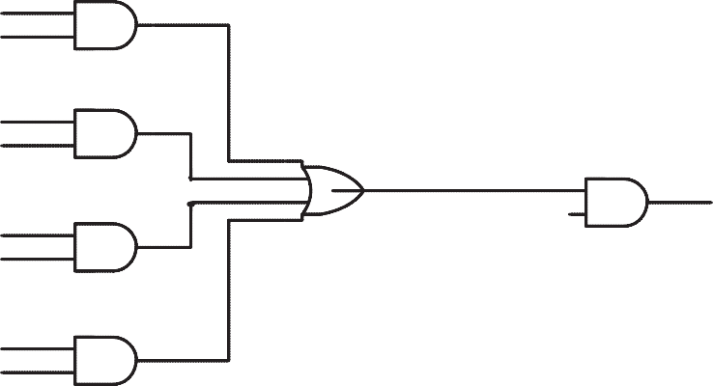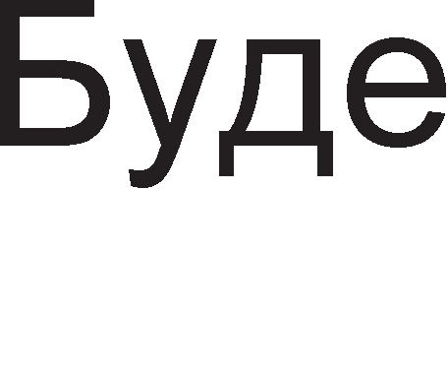

Cn1Ka 6.12. npeK1HyBaL1Ka nofl1Ka 3a PIC16f84

3a >Kan He nocTojaT 1HcTpyKL11 3a BHecyBal-be 1 13HecyBal-be Ha nopaToL1 Bo cTeK MeMop1jaTa. HaMecTo pa ce pa6oT1 co cTeK MeMop1ja ce Kpe1pa noce6Ha noTnpoflpaMa 3a 3awT1Ta Bo Koja ce pecp1H1paaT HoB1 np1BpeMeH1 pefl1cTp1 3a L1yBal-be Ha cTap1Te BpepHocT1 Ha pefl1cTp1Te.

# PerMcTpM eo PIC16f84

##### OPTION perMcTap

3a KoHTpona Ha 6pojaL11Te 1 Ha TajMepoT ce Kop1cT1 pefl1cTapoT OPTION. Ha cn1KaTa 6.13. e np1Ka>KaH OPTION pefl1cTapoT co KpaTeHK1Te op HefloB1Te 61ToB1.

7 61T 6 61T 5 61T 4 61T 3 61T 2 61T 1 61T 0 61T

|  |  |  |  |  |  |
| --- | --- | --- | --- | --- | --- |
| RBPU | INTEDG | TOCS | TOSE | PSA | npecKanep |

Cn1Ka 6.13. Pacnopep Ha 61ToB1 Bo OPTION

Bo Ta6enaTa 6.1. papeH1 ce KpaTeHK1Te Ha c1Te 61ToB1 op OPTION pefl1cTapoT 1 H1BH1Te cpyHKL11. HajnpBo 61 noL1Hane co 136opoT Ha 13Bop Ha TaKT 3a 6pojaL1oT TMRO. 3a oBa cny>K1 61ToT **TOCS.** Kofla oBoj 61T e ep1H1La, ce 6pojaT npoMeH1Te Ha H1BoaTa Ha n1HoT RA4/TOCKI. Kofla 61ToT TOCS e Ha Hyna, ce 6pojaT 1Mnync1Te op ocL1naTopoT. AoKonKy KaKo 13Bop Ha TaKT ce 136epe HapBopewH1oT 13Bop np1KnyL1eH Ha n1HoT RA4/TOCKI, Tpe6a pa ce 136epe Ko1 npoMeH1 i<e ce 6pojaT. AKo 61ToT **TOSE** e epHaKoB Ha epeH, i<e ce 6pojaT onaraL1K1 pa6oB1, a aKo e epHaKoB Ha Hyna, Toflaw i<e ce 6pojaT pacTeL1K1 pa6oB1. noToa cnepyBa 136opoT Ha npecKanepoT.

|  |  |  |
| --- | --- | --- |
| 61T | KpaTeHKa | <lyHKL1ja |
| cepM1 | RBPU (RB Pull Up) | Pull up oTnopH1L1 3a nopTaTa B  1-1cKnyL1eH1 oTnopH1L1, 0-BKnyL1eH1 |
| wecT1 | INTEDG (Interrupt Edge) | l/l36op Ha aKT1BaTop 3a n1HoT RA4/TOCKI  1-onaraL1K1 pa6, 0-pacTeL1K1 pa6 |
| neTT1 | TOCS (Timer0 Clock Select) | l/l36op Ha Bne3eH c1flHan 3a TMR0 1-n1HoT RA4/TOCKI  0-Kp1cTaneH ocL1naTop |
| L1eTBpT1 | TOSE (Timer0 Select Edge) | l/l36op Ha aKT1BaTop 3a TMR0 1-onaraL1K1 pa6, 0-pacTeL11 pa6 |
| TpeT1 | PSA (Prescaler Select Assignment) | l/l36op Ha 6pojaL1 3a npecKanepoT 0-TMR0, 1-Watchdog |
| 2, 1, 0 | 3-61TeH npecKanep | MHo>K1Ten Ha nep1opa 1n1 pen1Ten Ha cppeKBeHL1ja |

Ta6ena 6.1. <lyHKL1cK1 on1c Ha 61ToB1Te Bo OPTION pefl1cTapoT

Tp1Te HajHe3HaL1ajH1 61ToB1 op OPTION pefl1cTapoT ce B1KaaT **npecKa11ep.** npecKanepoT flo copp>K1 pen1TenoT Ha pa6oTHaTa cppeKBeHL1ja. l/lMeHo, aKo Kp1cTanH1oT ocL1naTop 1Ma pa6oTHa cppeKBeHL1ja op pep Ha Ben1L11Ha Ha KHz,

Toa 3HaL11 peKa nep1opaTa e op pep Ha Ben1L11Ha Ha ms. OBa BpeMe e HepeanHo 3a L1oBeKoT 1 Toa Tpe6a pa ce 3floneM1. 3a Taa Len, ce Kop1cT1 npecKanepoT. BpepHocTa Ha pen1TenoT Ha cppeKBeHL1jaTa T.e MHo>K1TenoT Ha nep1opaTa ce po61Ba cnopep Ta6ena 6.2.

|  |  |  |
| --- | --- | --- |
| npecKanep= PS2 PS1 PS0 | Aen1Ten Ha cppeKBeHL1ja 3a cno6opeH 6pojaL1 | Aen1Ten Ha cppeKBeHL1ja 3a c1flypHoceH 6pojaL1 |
| 000 | 2 | 1 |
| 001 | 4 | 2 |
| 010 | 8 | 4 |
| 011 | 16 | 8 |
| 100 | 32 | 16 |
| 101 | 64 | 32 |
| 110 | 128 | 64 |
| 111 | 256 | 128 |

Ta6ena 6.2. 3aB1cHocT Ha pen1TenoT Ha cppeKBeHL1jaTa op npecKanepoT

61ToT **PSA** pewaBa Ha Koj 6pojaL1 i<e 61pe popeneH npecKanepoT. AoKonKy caKaMe pa pa6oT1Me co cno6opH1oT 6pojaL1 (TMRO), BpepHocTa Ha 61ToT PSA Tpe6a pa 61pe Hyna. ABa 61Ta op pefl1cTapoT OPTION He ce Kop1cTaT 3a KoHTpona Ha TajMepoT. Toa ce 6 1 7 61T. 61ToT **INTEDG** cny>K1 3a 136op Ha pa6oT Ha npeK1H Ha n1HoT RBO/INT. Kofla oBoj 61T e ep1H1La, npeK1H HacTaHyBa np1 pacTeL1K1 pa6 Ha oBoj n1H, a Kofla INTEDG=0, npeK1H HacTaHyBa np1 onaraL1K1 pa6. n1HoT RBPU cny>K1 3a 1cKnyL1yBal-be/BKnyL1yBal-be Ha Pull-Up oTnopH1L1Te Ha nopTaTa B npeKy HefloBoTo ceT1pal-be/peceT1pal-be.

##### INTCON perMcTap

3a KoHTpona Ha npeK1H1Te ce Kop1cT1 INTCON pefl1cTapoT. Toj copp>K1 pBa B1pa 61Ta 3a KoHTpona Ha npeK1H1. Ha cn1Ka 6.14. e np1Ka>KaH INTCON pefl1cTapoT co KpaTeHK1Te Ha HefloB1Te 61ToB1.

7 61T 6 61T 5 61T 4 61T 3 61T 2 61T 1 61T 0 61T

|  |  |  |  |  |  |  |  |
| --- | --- | --- | --- | --- | --- | --- | --- |
| GIE | EEIE | TOIE | INTE | RBIE | TOIF | INTF | RBIF |

Cn1Ka 6.14. Pacnopep Ha 61ToB1Te Bo INTCON pefl1cTapoT

Bo Ta6enaTa 6.3. papeH1 ce 3HaL1el-baTa Ha KpaTeHK1Te 3a c1Te 61ToB1 op INTCON pefl1cTapoT 1 H1BH1Te cpyHKL11.

61ToT **RBIF** ce ceT1pa aKo ce cnyL11 npeK1H Ha n1HoB1Te RB4, RB5, RB6, RB7 op nopTaTa B. 3a pa oB1e n1HoB1 61paT oceTn1B1 Ha npeK1H1 1cT1Te Mopa pa 61paT pecp1H1paH1 KaKo Bne3H1 npeKy ynoTpe6a Ha pefl1cTapoT TRISB. 61ToT **INTF** ce ceT1pa aKo ce cnyL11 npeK1H Ha n1HoT RB0/INT. 3a pa 1cT1oT npeK1H He

ce nojaB1 1 nocne Bpai<al-beTo Bo flnaBHaTa npoflpaMa, Tpe6a pa ce 13Bpw1 peceT1pal-be Ha 61ToT INTF ywTe popeKa ce 13BpwyBa noTnpoflpaMaMTa 3a cepB1c1pal-be Ha npeK1H1Te. OBa npoflpaMepoT He cMee pa flo 3a6opaB1 61peji<1 M1KpoKoHTponepoT nocTojaHo i<e ja 13BpwyBa noTnpoflpaMaTa 3a cepB1c1pal-be Ha npeK1HoT. 61ToT **TOIF** ce ceT1pa aKo HacTaHe npeL1eKopyBal-be Ha 6pojaL1oT TMRO.

|  |  |  |
| --- | --- | --- |
| 61T | KpaTeHKa | cpyHKL1ja |
| cepM1 | GIE (General Interrupt Enable) | r1 po3BonyBaMe c1Te B1poB1 npeK1H1 |
| wecT1 | EEIE (EEPROM Interrupt Enable) | Ao3BonyBaMe npeK1H 3a n1wyBal-be Bo EEPROM |
| neTT1 | TOIE (TMR0 Interrupt Enable) | Ao3BonyBaMe npeK1H 3a npeL1eKopyBal-be Ha TMR0 |
| L1eTBpT1 | INTE (Interrupt Enable) | Ao3BonyBaMe npeK1H Ha RB0/INT 1-po3BoneH  0-Hepo3BoneH |
| TpeT1 | RBIE (Port B Interrupt Enable) | Ao3BonyBaMe npeK1H Ha 7, 6, 5, 4 n1H op nopTaTa B  1-po3BoneH  0-Hepo3BoneH |
| BTop1 | TOIF (TMR0 Interrupt Flag) | nojaBa Ha npeK1H-npeL1eKopyBal-be Ha cno6opeH 6pojaL1  1-npeL1eKop1n TMR0 0-He npeL1eKop1n |
| npB1 | INTF (Interrupt Flag) | nojaBa Ha npeK1H Ha HynT1oT n1H op nopTaTa B (RBO/INT)  1-1Ma npeK1H, 0-HeMa npeK1H |
| HynT1 | RBIF (Port B Interrupt Flag) | npeK1H Ha n1HoB1Te 7, 6, 5, 4 op nopTaTa B  1-1Ma npeK1H, 0-HeMa npeK1H |

Ta6ena 6.3. <lyHKL1cK1 on1c Ha 61ToB1Te op INTCON pefl1cTapoT

61ToT **EEIE** ce ceT1pa Kofla Tpe6a pa ce Bn1waT nopaToL1 Bo EEPROM MeMop1jaTa. Bn1wyBal-beTo Ha nopaToK Bo MeMop1jaTa Tpae oKony 10ms, wTo 3a M1KpoKoHTponepoT e np1n1L1Ho MHofly BpeMe. 3a pa He pojpe po fly6el-be Ha 1HcpopMaL1ja 1n1 flpewKa Bo TeKoBHaTa npoflpaMa caMoTo 3an1wyBal-be Bo EEPROM ce TpeT1pa KaKo epeH B1p npeK1H.

61ToT **GIE** (General Interrupt Enable) cny>K1 3a flno6anHo oBo3Mo>KyBal-be Ha c1Te npeK1H1. AoKonKy M1KpoKoHTponepoT opfloBop1 Ha npeK1H, T.e. 13BpwyBa noTnpoflpaMa 3a HefloBo cepB1c1pal-be, 61ToT GIE Tpe6a pa ce peceT1pa co Len pa ce cnpeL11 nojaBa Ha KaKoB 61no HoB npeK1H.

##### EECON perMcTap

OBoj pefl1cTap cny>K1 3a KoHTpona Ha L11Tal-beTo 1 3an1wyBal-beTo Bo EEPROM MeMop1jaTa. Ha cn1Ka 6.15. e np1Ka>KaH oBoj pefl1cTap.

7 61T6 61T 5 61T 4 61T 3 61T 2 61T 1 61T 0 61T

|  |  |  |  |  |  |  |  |
| --- | --- | --- | --- | --- | --- | --- | --- |
| / | / | / | EEIF | WRERR | WREN | WR | RD |

Cn1Ka 6.15. Pacnopep Ha 61ToB1Te Bo EECON pefl1cTapoT

Ha Ta6enaTa e np1Ka>KaHo 3HaL1el-beTo Ha c1Te 61ToB1 op EECON pefl1cTapoT.

|  |  |  |
| --- | --- | --- |
| 61T | KpaTeHKa | cpyHKL1ja |
| cepM1 | X | HeMa 3HaL1el-be |
| wecT1 | X | HeMa 3HaL1el-be |
| neTT1 | X | HeMa 3HaL1el-be |
| L1eTBpT1 | EEIF (EEPROM Interrupt Flag) | 1-n1wyBal-beTo e 3aBpweHo ycnewHo 0-ywTe L11Ta |
| TpeT1 | WRERR (Write Error) | 1-flpewKa np1 n1wyBal-beTo, 0-HeMa flpewKa |
| BTop1 | WREN (Write Enable) | 1-n1wyBal-beTo e oBo3Mo>KeHo  0-n1wyBal-beTo e oHeBo3Mo>KeHo |
| npB1 | WR (Write) | 1-1H1L1pa n1wyBal-be, 0-He 1H1L1pa n1wyBal-be |
| HynT1 | RD (Read) | 1-1H1L1pa L11Tal-be, 0-He 1H1L1pa L11Tal-be |

Ta6ena 6.4. <lyHKL1cK1 on1c Ha 61ToB1Te Bo EECON pefl1cTapoT

npeKy 61ToB1Te **RD** 1 **WR** ce 1361pa epHa op pBeTe onepaL11, L11Tal-be 1n1 3an1wyBal-be. T1e ce ceT1paaT cocpTBepcK1, a ce peceT1paaT XappBepcK1 no 3aBpwyBal-beTo Ha L11Tal-beTo, opHocHo 3an1wyBal-beTo. 61ToT **WREN** ( Write Enable) e 61T co Koj ce po3BonyBa (WREN=1), opHocHo ce 3a6paHyBa (WREN=0) 3an1wyBal-be Bo EEPROM MeMop1jaTa. 61ToT **WRERR** (Write Error) ce ceT1pa Kofla i<e ce nojaB1 flpewKa Bo n1wyBal-beTo. 61ToT **EEIF** e 61T-1Hp1KaTop wTo o3HaL1yBa Kpaj Ha onepaL1jaTa 3an1wyBal-be Bo EEPROM.

##### CTaTyc perMcTap

CTaTyc pefl1cTapoT cny>K1 3a 136op Ha epHa op pBeTe MeMop1cK1 6aHK1, ja cnep1 cocToj6aTa Ha ap1TMeT1L1Ko nofl1L1KaTa ep1H1La 1 peceT cocToj6aTa. Ha cn1Ka 6.16. e np1Ka>KaH pacnopepoT Ha 61ToB1Te Bo cTaTyc pefl1cTapoT 1 H1BH1Te KpaTeHK1. PeceT1pal-beTo 1 ceT1pal-beTo Ha 61ToB1Te Mo>Ke pa ce Bpw1 1 cocpTBepcK1, co 1HcTpyKL11 3a Ko1 nopoLHa i<e cTaHe 36op. l/lcKnyL1oK ce 61ToB1Te TO 1 PD L11ja cocToj6a Mo>Ke pa ce npoL11Ta, Ho He 1 pa ce 3an1we.

7 61T 6 61T 5 61T 4 61T 3 61T 2 61T 1 61T 0 61T

|  |  |  |  |  |  |  |  |
| --- | --- | --- | --- | --- | --- | --- | --- |
| IRP | RP1 | RP0 | TO | PD | Z | DC | C |

Cn1Ka 6.16. Pacnopep Ha 61ToB1 Bo cTaTyc pefl1cTapoT

Bo Ta6enaTa 6.5. e o6jacHeTa cpyHKL1jaTa Ha ceKoj 61T op cTaTyc pefl1cTapoT.

|  |  |  |
| --- | --- | --- |
| 61T | KpaTeHKa | cpyHKL1ja |
| cepM1 | IRP | Ce Kop1cT1 KaKo ocM1 61T np1 1Hp1peKTHoTo appec1pal-be  1-npBaTa 6aHKa 0-HynTa 6aHKa |
| 6,5 | RP1:RP0 | 3a 136op Ha 6aHKa np1 p1peKTHoTo appec1pal-be 01-npBa 6aHKa  00-HynTa 6aHKa |
| L1eTBpT1 | TO (Time Out) | l/lHp1KaTop 3a npeL1eKopyBal-beTo Ha c1flypHocH1oT 6pojaL1  1-nocne BKnyL1yBal-be Ha HanojyBal-beTo, peceT1pal-be Ha c1flypHocH1oT 6pojaL1 1 npeM1H Bo Mop Ha M1pyBal-be  0-nocne npeL1eKopyBal-beTo Ha c1flypHocH1oT 6pojaL1 |
| TpeT1 | PD (Power Down) | 1-nocne BKnyL1yBal-beTo Ha HanojyBal-beTo, ceKoe peceT1pal-be 1n1 nocne peceT1pal-beTo Ha c1flypHocH1oT 6pojaL1  0-nocne npeM1HoT Bo Mop Ha M1pyBal-be |
| BTop | Z (Zero) | Ce aKT1B1pa np1 ap1TMeT1L1Ko co61pal-be 1n1 op3eMal-be  1-po61eH1oT pe3ynTaT e Hyna  0-po61eH1oT pe3ynTaT e pa3n1L1eH op Hyna |
| npB | DC (Digit Carry) | 1-npeHoc op TpeTa Ha L1eTBpTa no31L1ja np1 co61pal-be 1n1 no3ajMyBal-be np1 op3eMal-be  0-HeMa npeHoc |
| HynT1 | C (Carry) | 1-npeHoc 1n1 no3ajMyBal-be Ha Haj3HaL1ajH1oT 61T Bo pe3ynTaToT np1 co61pal-be 1n1 op3eMal-be  0-HeMa npeHoc |

Ta6ena 6.5. <lyHKL1cK1 on1c Ha 61ToB1Te Bo cTaTyc pefl1cTapoT

# LlHcTpyK4McKo MHo>KecTeo Ha PIC 16f84

Kofla flo npoyL1yBaBMe 1HcTpyKL1cKoTo MHo>KecTBo Ha 8085 M1KponpoLecopoT, 1HcTpyKL11Te fl1 nopen1BMe cnopep cpyHKL1jaTa Ha: 1HcTpyKL11 3a npeHoc, nofl1L1K1, ap1TMeT1L1K1 1HcTpyKL11, poTaL1ja, cKoK- 1HcTpyKL11 1TH. OBaa nopen6a HeMa pa ja np1MeH1Me Kaj PIC 16f84, TyKy 1HcTpyKL11Te i<e fl1 nopenMe Ha **"1eTMpM rpynM:** 1HcTpyKL11 3a pa6oTa co

KoHcTaHT1, WF (Working register-File) 1HcTpyKL11, 61T-1HcTpyKL11 1 KoHTponH1 1HcTpyKL11.

### LlHcTpyK4MM 3a pa6oTa co KoHcTaHTa

HajnecH1 ce 1HcTpyKL11Te wTo pa6oTaT co KoHcTaHT1. Kaj H1B ceKoflaw pecT1HaL1jaTa e pa6oTH1oT pefl1cTap W. Ha np1Mep, 1HcTpyKL1jaTa **MOVLW K** 3HaL11 Kon1pal-be (noMecTyBal-be) Ha KoHcTaHTHaTa K Bo pa6oTH1oT pefl1cTap W. 6yKBaTa L e noL1eTHa 6yKBa op aHfln1cK1oT 36op Literal wTo 3HaL11 KoHcTaHTa. Bo oBaa flpyna 1HcTpyKL11 ce: ADDLW K, SUBLW, ANDLW, IORLW, XORLW. EpH1oT

onepaHp ce Haora Bo pefl1cTapoT W, ppyfl1oT e caMaTa KoHcTaHTa K, a pe3ynTaToT ce 3an1wyBa Bo pefl1cTapoT W.

##### npMMep 6.1:

SUBLW 80H ;80H- W ---W

IORLW 10010111B ;10010111B nofl1L1K1 ce co61pa co copp>K1HaTa Ha W 1

;pe3ynTaToT ce 3an1wyBa Bo W

### WF MHcTpyK4MM (Working registar-File MHcTpyK4MM)

WF 1HcTpyKL11Te Mo>KaT pa npep13B1KaaT Hepopa361pal-be oKony 136opoT Ha pecT1HaL1jaTa. CaMo **MOVWF f** e WF 1HcTpyKL1ja Kaj Koja ceKoflaw pecT1HaL1ja e pefl1cTapoT f.

##### npMMep 6.2:

**MOVWF FILE** ;Copp>K1HaTa Ha W ce Kon1pa Bo pefl1cTapoT no3HaT nop

;1MeTo FILE.

AoKonKy caKaMe pa npeHeceMe nopaToK Bo cnpoT1BHa HacoKa op pefl1cTapoT FILE Bo pa6oTH1oT pefl1cTap W, Toflaw ce Kop1cT1 1HcTpyKL1jaTa **M0VF FILE, W**. Kaj c1Te ocTaHaT1 WF 1HcTpyKL11 (ADDWF, ANDWF, SUBWF, IORWF, XORWF)

pecT1HaL1jaTa Mo>Ke pa 61pe pa6oTH1oT pefl1cTap W 1n1 HeKoj ppyfl pefl1cTap FILE, wTo 3aB1c1 op Toa pan1 no pefl1cTapoT FILE 1Ma 3an1pKa 1 HaBepeHa pecT1HaL1ja 1n1 He.

##### npMMepM 6.3:

SUBWF FILE, W ;FILE - W---W, pecT1HaL1jaTa e W.

SUBWF FILE ;FILE-W---W. AecT1HaL1jaTa e pefl1cTapoT FILE.

XORWF PRIKAZI ;Ce 13BpwyBa 1HcTpyKL1jaTa eKcKny31BHo l/lnl/l Bp3

;copp>K1HaTa Ha pefl1cTapoT PRIKAZI 1 pefl1cTapoT W 1

;pe3ynTaToT ce 3an1wyBa Bo pefl1cTapoT PRIKAZI

6.6.

Apyfl1 1HcTpyKL11 co npoMeHn1Ba pecT1HaL1ja ce np1Ka>KaH1 Ha Ta6ena

|  |  |
| --- | --- |
| INCF f,d | (Increase File) Copp>K1HaTa Ha pefl1cTapoT f ce 3floneMyBa 3a epeH 1 pe3ynTaToT ce cMecTyBa Bo pefl1cTapoT d. |
| INCFSZ f,d | (Increase File Skip Zero) CnepHaTa 1HcTpyKL1ja ce cKoKa aKo ce po61e pe3ynTaT Hyna. |
| DECF f,d | (Decrease File) Copp>K1HaTa Ha pefl1cTapoT f ce HaManyBa 3a epeH 1 pe3ynTaToT ce cMecTyBa Bo pefl1cTapoT d. |
| DECFSZ f,d ; | (Decrease File Skip Zero) CnepHaTa 1HcTpyKL1ja ce cKoKa aKo ce po61e pe3ynTaT Hyna. |
| COMF f,d | (Complement File) Copp>K1HaTa Ha pefl1cTapoT f ce KoMnneMeHT1pa 1 pe3ynTaToT ce 3an1wyBa Bo pefl1cTapoT d. |
| SWAP f,d | no3HaL1ajH1Te 4 61Ta op pefl1cTapoT f c1 fl1 3aMeHyBaaT MecTaTa co 4 noHe3HaL1ajH1 61Ta op pefl1cTapoT f 1 pe3ynTaToT ce 3an1wyBa Bo pefl1cTapoT d. |
| RLF f,d | (Rotate Left File) 61ToB1Te op pefl1cTapoT f ce poT1paaT 3a epHo MecTo Bo neBo npeKy 3HaMeHLeTo carry 1 pe3ynTaToT ce cMecTyBa Bo pefl1cTapoT d. |
| RRF f,d | (Rotate Right File) 61ToB1Te op pefl1cTapoT f ce poT1paaT 3a epHo MecTo Bo pecHo npeKy 3HaMeHLeTo carry 1 pe3ynTaToT ce cMecTyBa Bo pefl1cTapoT d. |

Ta6ena 6.6. l/lHcTpyKL11 co npoMeHn1Ba pecT1HaL1ja

YwTe epHaw pa ce noTceT1Me peKa poKonKy He 61pe HaBepeH pefl1cTapoT d, Toflaw pe3ynTaToT ce 3an1wyBa Bo pefl1cTapoT f. Mo>KeMe pa Ka>KeMe peKa pe3ynTaToT ce 3an1wyBa Bo nocnepH1oT pefl1cTap wTo e HaBepeH Bo 1HcTpyKL1jaTa.

### 5MT-MHcTpyK4MM

Co 61T-1HcTpyKL11Te ce Bpw1 ceT1pal-be 1n1 peceT1pal-be Ha epeH 61T op HeKoj pefl1cTap. nopap1 Toa, Bo 1HcTpyKL1jaTa Mopa pa ce HaBepaT pefl1cTapoT 1 pepH1oT 6poj Ha 61ToT Bo Toj pefl1cTap.

##### npMMep 6.4:

BSF FILE, 3 ;(Bit Test File) Ce ceT1pa TpeT1oT 61T op pefl1cTapoT FILE

Bo oBaa flpyna 1HcTpyKL11 cnaraaT:

**BCF** Bit Clear File (PeceT1pal-be 61T)

**BSF** Bit Set File (CeT1pal-be 61T)

**BTFSC** Bit Test File Skip if Clear (AKo 61ToT e Hyna, cKoKH1 ja cnepHaTa l/lHcTpyKL1ja.)

**BTFSS** Bit Test File Skip if Set (AKo 61ToT e ep1H1La, cKoKH1 ja cnepHaTa l/lHcTpyL1ja.)

### KoHTpo11HM MHcTpyK4MM

KoHTponH1Te 1HcTpyKL11 Mo>KaT pa flo cMeHaT TeKoT Ha npoflpaMaTa, opHocHo HaMecTo pa ce 13Bpw1 cnepHaTa 1HcTpyKL1ja, Mo>Ke pa 61pe noB1KaHa noTnpoflpaMa, 13BpweH ycnoBeH 1n1 6e3ycnoBeH cKoK Bo 3aB1cHocT op nofl1L1KaTa cocToj6a Ha HeKoj 61T 1n1 3HaMeHLe.

|  |  |  |
| --- | --- | --- |
| 1HcTpyKL1ja | KoMeHTap | np1Mep |
| CLRF f | 1cL11cT1 (peceT1paj) flo pefl1cTapoT | CLRF PORTA |
| CLRW | peceT1paj flo pa6oTH1oT pefl1cTap W | / |
| CALL address | noB1Kaj noTnpoflpaMa (address e noL1eToK Ha noTnpoflpaMaTa) | CALL DELAY |
| GOTO address | cKoKH1 Ha noKaL1ja co noL1eTHa appeca address | GOTO START |
| RETFIE | Bpai<al-be op noTnpoflpaMa 3a cepB1c1pal-be npeK1H | / |
| RETLW k | Bpai<al-be op noTnpoflpaMa co BHecyBal-be KoHcTaHTa Bo pa6oTH1oT pefl1cTap | RETLW 00110110B |
| RETURN | Bpai<al-be op noTnpoflpaMa | / |
| SLEEP | noM1H1 Bo Mop Ha M1pyBal-be | / |

Ta6ena 6.7. KoHTponH1 1HcTpyKL11

# noep3yea1-e Ha MMKpoKoHTpo11ep PIC16f84

Bei<e 1cTaKHaBMe peKa M1KpoKoHTponepoT PIC16f84 Haora w1poKa np1MeHa Bo npoLecHoTo ynpaByBal-be. Ho, 3a noL1eToK i<e o6jacH1Me epeH MHofly epHocTaBeH np1Mep. **Ha Hy11TMoT nMH Ha nopTaTa A nocTaeyeaMe Kon"1e (TacTep), a Ha Hy11TMoT nMH Ha nopTaTa B 11e,q ,qMo,qa. Kora Kon"1eTo i<e 6M,qe npMTMcHaTo, LED ,qMo,qaTa i<e ceeTM 1 ceKyH,qa, a noToa ce racHe**. npBo i<e flo o6jacH1Me HaL11HoT Ha noBp3yBal-be Ha M1KpoKoHTponepoT, a noToa n1wyBal-beTo Ha npoflpaMa 3a oBoj np1Mep.

Ha cn1Ka 6.17. e np1Ka>KaH XappBepoT Koj e noTpe6eH 3a oBoj np1Mep. Kp1cTanH1oT ocL1naTop 1 KoHpeH3aTop1Te ce noTpe6H1 3a pa My papaT p1fl1TcK1 TaKT Ha M1KpoKoHTponepoT. ABaTa KoHpeH3aTop1 op no 68pF Tpe6a pa o6e36epaT cTa61nHocT Ha c1cTeMoT opHocHo fl1 en1M1H1paaT epHoHacoL1H1Te KoMnoHeHT1. np1 npoeKT1pal-beTo Ha eneKTp1L1H1oT ypep ocL1naTopoT ce nocTaByBa wTo e Mo>KHo no6n1cKy po M1KpoKoHTponepoT 3a pa He pojpe po nojaBa Ha wyM Ha n1H11Te npeKy Ko1 M1KpoKoHTponepoT po61Ba p1fl1TcK1 TaKT. Cn1L1Ha cpyHKL1ja

1Ma 1 KoHpeH3aTopoT nocTaBeH Mery HanojyBal-beTo Ha KoHTponepoT 1 MacaTa.

rnepaMe peKa n1HoT 3a peceT1pal-be e nocTaBeH Ha B1coKo H1Bo, co wTo e oHeBo3Mo>KeHo peceT1pal-be Ha M1KpoKoHTponepoT npeKy oBoj n1H.



l/l3ne3HaTa cTpyja Ha n1HoB1Te op M1KpoKoHTponepoT 13HecyBa 20mA-25mA wTo e poBonHo 3a no6ypa Ha nep p1opa 1n1 noMano pene. 3a nofloneM1 onToBapyBal-ba Ha 13ne3 Tpe6a pa ce 13Bpw1 3ac1nyBal-be Ha cTpyjaTa npeKy ynoTpe6a Ha TpaH31cTop 3a epHoHacoL1H1 cTpy1 1n1 Tp1jaK 3a Ha13MeH1L1H1.

3a pa nep p1opaTa BoonwTo cBeT1 aHopaTa Tpe6a pa 61pe Ha noB1coK noTeHL1jan op KaTopaTa. 3a pa nep p1opaTa MaKc1ManHo cBeT1, 6e3 pa pojpe po owTeTyBal-be, Taa Tpe6a npaB1nHo pa ce noBp3e. 3a Taa Len cep1cK1 co p1opaTa ce noBp3yBa oTnopH1K, L11ja BpepHocT ce npecMeTyBa TaKa pa H13 p1opaTa TeL1e MaKc1ManHaTa cTpyja, Koja e npenopaL1aHa op npo13Bop1Ten1Te.

Cn1Ka 6.17. noBp3yBal-be Ha PIC16f84 co KonL1e 1 nep p1opa

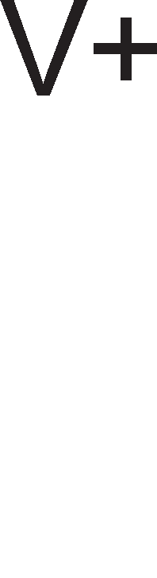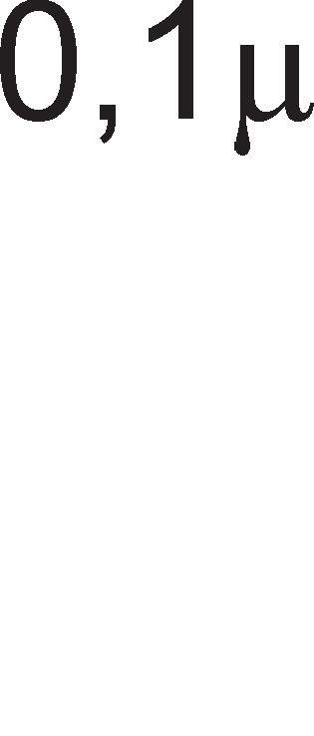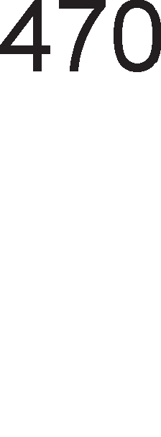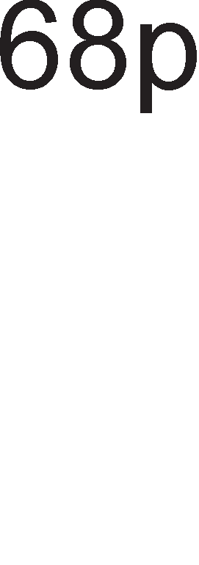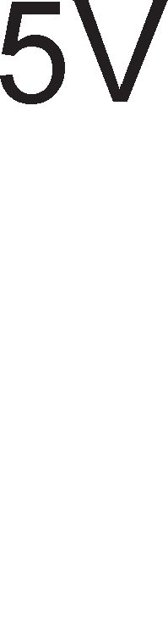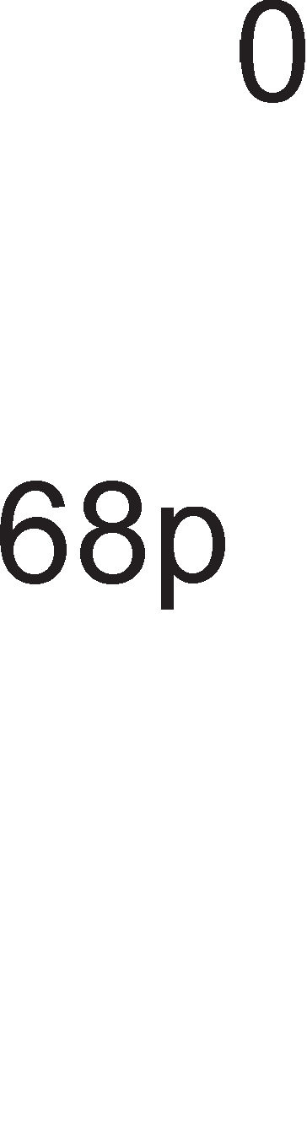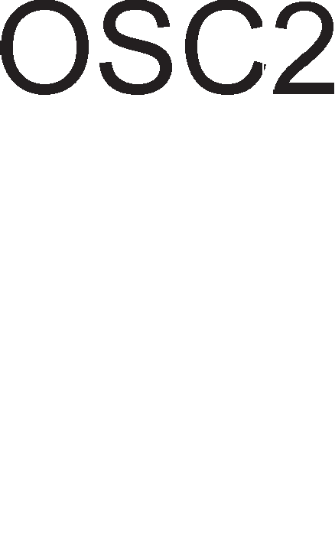

A1op1Te ce noBp3yBaaT co M1KpoKoHTponep1Te Ha pa3n1L1H1 HaL11H1. Bo cnyL1ajoT np1Ka>KaH Ha cn1Ka 6.17. KaTopaTa Ha nep p1opaTa e Bp3aHa Ha Maca, na 3a pa p1opaTa cBeTHe noTpe6Ho e nofl1L1Ka ep1H1La Ha 13ne3H1oT n1H RB0. Ha Toj HaL11H aHopaTa i<e 61pe Ha noB1coK noTeHL1jan op KaTopaTa. AoKonKy p1opaTa e cBpTeHa cnpoT1BHo, co aHopaTa Ha Maca Toflaw Taa i<e cBeT1 Ha nofl1L1Ka Hyna. noKpaj co Maca nep p1opaTa Mo>Ke pa ce noBp3e 1 co HanojyBal-beTo op 5V.

HajL1ecTo Ha Bne3 op M1KpoKoHTponepoT ce noBp3yBa npeK1HyBaL1. noBp3yBal-beTo ce Bpw1 npeKy **pull up oTnopHMK** co Koj ce HaflopyBa Bne3HaTa cTpyja Ha M1KpoKoHTponepoT. Kofla npeK1HyBaL1oT e 3aTBopeH po Bne3H1oT n1H Ha M1KpoKoHTponepoT ce 1cnpai<a nofl1L1Ka Hyna 61peji<1 Toflaw n1HoT p1peKTHo ce Bp3yBa Ha Maca. Kofla npeK1HyBaL1oT e oTBopeH Toflaw Bne3H1oT HanoH Ha n1HoT e Ha B1coKo H1Bo, opHocHo n1HoT ce Bp3yBa Ha HanoHoT Ha HanojyBal-be npeKy

3awT1TeH oTnopH1K (pull up oTnopH1K). npeK1HyBaL1oT 1Ma pBe cTa61nH1 cocToj61, BKnyL1eH 1n1 1cKnyL1eH. 3a pa3n1Ka op npeK1HyBaL1oT, KonL11l-baTa op TacTaTypaTa 1MaaT epHa cTa61nHa cocToj6a 1 epHa npeopHa cocToj6a. Kofla Kop1cH1KoT i<e np1T1cHe HeKoe KonL1e Toflaw Toj 1cnpai<a 1HcpopMaL1ja po M1KpoKoHTponepoT, opHocHo M1KponpoLecopoT. Ho, KonL1eTo ocTaHyBa Bo np1T1cHaTa cocToj6a caMo epHa ceKyHpa 1n1 noManKy. nocne oBa KonL1eTo ce oTnywTa. Ho, BpeMeTo op epHa ceKyHpa e npeponflo 3a M1KpoKoHTponepoT. Toj 3a BpeMe op epHa ceKyHpa Mo>Ke pa HanpaB1 MHofly npoBepK1 Ha KonL1eTo. nopap1 Toa Mery pBe nocnepoBaTenH1 npoBepK1 Ha KonL1eTo Tpe6a pa ce BHece **epeMe Ha ,qo4He1-e** 1 Ha TaKoB HaL11H i<e ce 136eflHe epHo np1T1cKal-be Ha KonL1eTo M1KpoKoHTponepoT pa flo 136po1 MHofly naT1.

# nporpaMMpa1-e Ha PIC16f84

OTKaKo ce 3ano3HaBMe co XappBepoT Ha M1KpoKoHTponepoT PIC16f84 1 HefloBoTo 1HcTpyKL1cKo MHo>KecTBo i<e ja o6jacH1Me nocTanKaTa Ha npoflpaM1pal-be. np1 npoflpaM1pal-beTo Ha M1KpoKoHTponepoT nocTojaT ToL1Ho pecp1H1paH1 npaB1na po Ko1 Mopa pa ce np1pp>KyBaMe. 3apap1 nofloneMa epHocTaBHocT npoflpaMaTa i<e ja nopen1Me Ha HeKonKy penoB1:

* + Aecp1H1pal-be Ha npoMeHn1B1 1 KoHcTaHT1.
  + AeKnapaL1ja Ha M1KpoKoHTponepoT 1 noL1eToKoT Ha npoflpaMaTa.
  + KoHcp1flypaL1ja Ha M1KpoKoHTponepoT .
  + noTnpoflpaM1 3a poLHel-be.
  + l/lH1L1jan13aL1ja Ha nopT1Te.
  + n1wyBal-be Ha flnaBHa npoflpaMa.

CeKoj op oB1e penoB1 i<e 61pe o6jacHeT Bo noHaTaMowH1oT TeKcT.

##### .QecpMHMpa1-e Ha npoMeH11MeM M KoHcTaHTM

3a pecp1H1pal-be Ha npoMeHn1B1Te 1 KoHcTaHT1Te ce **KopMcTM aceM611epcKaTa ,qMpeKTMea EQU.** npoMeHn1B1Te 1 KoHcTaHT1Te ce HaoraaT Bo pefl1cTp1Te co onwTa 1n1 cneL1janHa HaMeHa Bo RAM MeMop1jaTa. Co p1peKT1BaTa EQU Ha ceKoj op oB1e pefl1cTp1 ce popenyBa c1M6on1L1Ho 1Me. Bo p1peKT1BaTa noKpaj 1MeTo Ha pefl1cTapoT e HaBepeHa HefloBaTa appeca Bo RAM MeMop1jaTa. Ha np1Mep, co p1peKT1BaTa NIVO EQU 0DH Ha MeMop1cKaTa noKaL1ja co appeca 0DH ce popenyBa c1M6on1L1Ho 1Me NIVO. Ha BaKoB HaL11H po npoMeHn1BaTa op Taa noKaL1ja ce np1cTanyBa npeKy 1MeTo NIVO wTo e MHofly noBei<e pa361pn1Bo 3a caM1oT npoflpaMep oTKonKy pa ja naMT1 XeKcapeL1ManHaTa appeca Ha noKaL1jaTa.

nopone ce pecp1H1paH1 c1Te pefl1cTp1, Ko1 ce ynoTpe6eH1 Bo npoflpaMaTa 3a BKnyL1yBal-be 1 1cKnyL1yBal-be Ha nep p1opa npeKy KonL1e.

|  |  |  |  |
| --- | --- | --- | --- |
| TMR0 STATUS PORTA PORTB  TRISA | EQU EQU EQU EQU  EQU | 01H  03H  05H  06H  85H | ;Cno6opH1oT 6pojaL1 e pefl1cTap co appeca 01H.  ;CTaTyc pefl1cTapoT e noKaL1ja co appeca 03H.  ;nopTaTa A e pefl1cTap co appeca 05H.  ;nopTaTa B e pefl1cTap co appeca 06H.  ;Pefl1cTapoT 3a 136op Ha Bne3Ho 13ne3H1 n1HoB1 |
|  |  |  | ;op nopTaTa A e pefl1cTap co appeca 85H. |
| TRISB | EQU | 86H | ;Pefl1cTapoT 3a 136op Ha Bne3Ho 13ne3H1 n1HoB1  ;op nopTaTa B e pefl1cTap co appeca 86H |
| OPTION_R | EQU | 81H | ;Pefl1cTapoT 3a KoHTpona Ha 6pojaL11Te 1Ma appeca 81H |
| COUNT | EQU | 0CH | ;COUNT e pefl1cTap co onwTa HaMeHa co appeca  ;0CH. |

Op c1Te HaBepeH1 pefl1cTp1 caMo COUNT e pefl1cTap co onwTa HaMeHa. rnepaMe peKa pefl1cTp1Te co cneL1janHa HaMeHa fl1 3app>Kane cBo1Te 1M1l-ba, a 1M1l-baTa Ha onwT1Te pefl1cTp1 fl1 1361pa npoflpaMepoT Bo 3aB1cHocT op H1BHaTa HaMeHa. l/lcTo TaKa appec1Te Ha cneL1janH1Te pefl1cTp1 ce noKnonyBaaT co H1BH1Te appec1 np1Ka>KaH1 Ha cn1Ka 6.3., wTo e pa361pn1Bo 61peji<1 3a ceKoj op oB1e pefl1cTp1 M1KpoKoHTponepoT c1 1Ma noce6Ha nofl1Ka.

##### eK11apa4Mja Ha MMKpoKoHTpo11epoT M no"1eToKoT Ha nporpaMaTa

nocTojaT pa3n1L1H1 B1poB1 PIC M1KpoKoHTponep1. Ke Ha6po1Me HeKonKy: PIC1f83, PIC16f84, PICf872, PIC16C923, PIC17C42A, PIC18C242 1 ppyfl1. T1e ce

pa3n1KyBaaT no floneM1HaTa Ha MeMop11Te 1 6pojaL11Te, 6pojoT Ha n1HoB1Te 1 pp. np1 n1wyBal-beTo Ha npoflpaMaTa Tpe6a pa ce HaBepe B1poT Ha M1KpoKoHTponepoT. 3a oBa ce Kop1cT1 **,qMpeKTMeaTa LIST.**

Co **,qMpeKTMeaTa ORG** ce oppepyBa noL1eToKoT Ha flnaBHaTa npoflpaMa Bo npoflpaMcKaTa MeMop1ja.

LIST P=16f84 ;l/l361paMe B1p Ha M1KpoKoHTponep.

ORG 0 ;noL1eTHaTa appeca Ha flnaBHaTa npoflpaMa e 0. GOTO START ;CKoKH1 Ha noKaL1ja co c1M6on1L1Ho 1Me START.

##### KoHcpMrypa4Mja Ha MMKpoKoHTpo11epoT

nocne 136opoT Ha M1KpoKoHTponep Mo>KeMe pa np1cTan1Me KoH HefloBo KoHcp1fl1p1pal-be. **KoHcpMrypa4MoHMoT 36op** e 14-61TeH 1 co Heflo ce pecp1H1pa ocL1naTopoT, np1MeHaTa Ha c1flypHocH1oT 6pojaL1 1 TajMepoT 3a BKnyL1yBal-be Ha HanojyBal-beTo. 61ToB1Te op 13 po 4 ce B1KaaT 61ToB1 3a KopHa 3awT1Ta Ha

npoflpaMcKaTa MeMop1ja. TpeT1oT 61T ce 6ene>K1 co PWRTE wTo e KpaTeHKa op Power-Up Timer Enable 1 wTo Bo npeBop 3HaL11 TajMep 3a BKnyL1yBal-be Ha HanojyBal-beTo. OBoj TajMep BHecyBa poLHel-be op 72ms opHocHo 3a Toa BpeMe flo pp>K1 KoHTponepoT Bo peceT1paHa cocToj6a ce popeKa He ce cTa61n131pa HanojyBal-beTo. AKo oBoj 61T e epHaKoB Ha epeH Toflaw TajMepoT e oHecnoco6eH, a aKo e epHaKoB Ha Hyna e ocnoco6eH. BTop1oT 61T ce 6ene>K1 co WDTE wTo e KpaTeHKa op Watchdog Timer Enable wTo Bo npeBop 3HaL11 ocnoco6yBal-be Ha c1flypHocH1oT 6pojaL1. Kofla oBoj 61T e ep1H1La Toflaw c1flypHocH1oT 6pojaL1 pa6oT1, a aKo e Hyna Toflaw Watchdog TajMepoT e oHecnoco6eH. nocnepH1Te pBa 61Ta, npB1oT 1 HynT1oT flo pecp1H1paaT **eM,qoT Ha oc4M11aTop** 1 oBa e np1Ka>KaHo Bo Ta6enaTa 6.8.

|  |  |
| --- | --- |
| 00 | RC ocL1naTop |
| 01 | HS ocL1naTop |
| 10 | XT ocL1naTop |
| 11 | LP ocL1naTop |

Ta6ena 6.8.

**.QMpeKTMea** 3a KoHcp1flyp1pal-be Ha M1KpoKoHTponepoT e **_CONFIG**. nopone e np1Ka>KaHo KoHcp1flyp1pal-beTo 3a HawaTa npoflpaMa 3a BKnyL1yBal-be 1 1cKnyL1yBal-be Ha nep p1opa npeKy KonL1e.

_CONFIG H’3FF0’ ;l/l36paH e LP ocL1naTop, c1flypHocH1oT 6pojaL1 e

;oHecnoco6eH, TajMepoT 3a BKnyL1yBal-be Ha

;HanojyBal-beTo pa6oT1, HeMa KopHa 3awT1Ta.

##### noTnporpaMM 3a ,qo4He1-e

Kofla ce Kop1cT1 Kp1cTaneH ocL1naTop KaKo 13Bop Ha p1fl1TcK1 TaKT, Toflaw cno6opH1oT 6pojaL1 TMRO flo 6po1 ceKoj L1eTBpT1 1Mnync. AKo Kop1cT1Me ocL1naTop co cppeKBeHL1ja 32KHz=32768Hz, 6p31HaTa Ha TajMepoT i<e 61pe epHa L1eTBpT1Ha op 32 KHz, opHocHo 8KHz=8192Hz. 3a pa po61eMe BpeMe op 1 ceKyHpa, 6pojaL1oT TMRO Tpe6a pa 136po1 8192 1Mnync1. Toa e np1n1L1Ho MHofly. TyKa flo 1cKop1cTyBaMe npecKanepoT op pefl1cTapoT OPTICON. AKo npecKanepoT e epHaKoB Ha 111 Toflaw p1fl1TcK1oT TaKT co cppeKBeHL1ja 8KHz flo pen1Me co 6pojoT 256 1 po61BaMe BpepHocT 32. 3HaL11 3a pa po61eMe poLHel-be op epHa ceKyHpa, TajMepoT Tpe6a pa 136po1 32 naT1. Bo noHaTaMowH1oT TeKcT e papeH np1Mep 3a poLHel-be op 1 ceKyHpa.

|  |  |  |  |
| --- | --- | --- | --- |
| DOCNI | CLR | TMRO | ;TMRO=000000000B |
| LOOP | MOVF | TMRO, W | ;TMRO ce Kon1pa Bo W |

SUBLW 32.

BTFSS STATUS, ZEROBIT GOTO LOOP

RETLW 0

Ha noL1eToKoT op noTnpoflpaMaTa 6pojaL1oT TMRO ce peceT1pa co Len Toj pa noL1He pa 6po1 op Hyna. AopeKa Tpae oBaa npoflpaMcKa ceKBeHLa, BpepHocTa Ha 6pojaL1oT nocTojaHo ce 3floneMyBa. 6poel-beTo Ha 6pojaL1oT TMRO Tpae cè popeKa Toj He nocT1flHe BpepHocT 32. Aan1 6pojaL1oT TMRO nocT1flHan 1n1 He BpepHocT 32 npoBepyBaMe TaKa wTo op HefloBaTa copp>K1Ha op3eMaMe 32. Co 1HcTpyKL1jaTa BTFSS Tpe6a pa flo aHan131paMe 3HaMeHLeTo ZERO. AKo op op3eMal-beTo po61eMe pe3ynTaT 0, 3HaMeHLeTo ZERO i<e 61pe 1 (set). Toflaw ce npecKoKHyBa 1HcTpyKL1jaTa GOTO 1 op1Me Ha cnepHaTa 1HcTpyKL1ja RETURN (3aTBopal-be Ha noTnpoflpaMaTa). AKo pe3ynTaToT He e epHaKoB Ha 0, Toflaw 3HaMeHLeTo ZERO e epHaKBo Ha 0. Toflaw ce 13BpwyBa 1HcTpyKL1jaTa GOTO T.e. ce noBTopyBa L1KnycoT co 1Me LOOP.

KaKo pa HanpaB1Me poLHel-be op 5 ceKyHp1? AKo 3a epHa ceKyHpa H1 Tpe6aaT 32 6poel-ba, 3a 5 ceKyHp1 H1 Tpe6aaT 160 6poel-ba. np1MepoT i<e 61pe 1cT KaKo 1 npeTXopH1oT caMo Bo 1HcTpyKL1jaTa 3a op3eMal-be 1MaMe SUBLW 160.

##### LlHM4Mja11M3a4Mja Ha perMcTpM

l/lH1L1jan13aL1jaTa Ha pefl1cTp1Te 3HaL11 H1BHo nocTaByBal-be Bo noL1eTHa cocToj6a HeonXopHa 3a ycnewHo 13BpwyBal-be Ha noTnpoflpaM1Te 1 flnaBHaTa npoflpaMa. npBo Tpe6a pa ce 13Bpw1 **,qecpMHMpa1-e Ha HacoKaTa Ha ,qeM>Ke1-e Ha 6MToeMTe HM3 nMHoeMTe Ha nopTMTe A M B.** Aa ce noTceT1Me, oBaa cpyHKL1ja ja 13BpwyBaaT pefl1cTp1Te TRISA 1 TRISB. Pefl1cTp1Te PORTA 1 PORTB Tpe6a pa ce peceT1paaT, opHocHo pa ce 136p1waT, 3a pa He ce cnyL11 HeKoja H1BHa cTapa copp>K1Ha pa npep13B1Ka flpewKa Bo pa6oTaTa Ha M1KpoKoHTponepoT**. npM nporpaMMpa1-eTo Ha epeMeTo Ha ,qo4He1-e ynoTpe6MeMe npecKa11ep** co BpepHocT 111. 3a Taa Len Tpe6a pa ce noB1Ka OPTION pefl1cTapoT 1 HefloB1Te Tp1 HajHe3HaL1ajH1 61ToB1 pa ce HaflopaT Ha BpepHocT 111. nopone e npoflpaMcKaTa ceKBeHLa co Koja e 13BpweHa oBaa 1H1L1jan13aL1ja Ha nopT1Te 1 pefl1cTp1Te.

|  |  |  |  |
| --- | --- | --- | --- |
| START | BSF  MOVLW | STATUS,5  B’00011111’ | ;Ce noB1KyBa npBaTa MeMop1cKa 6aHKa.  ;nopaToKoT npeKy pa6oTH1oT pefl1cTap |
|  |  |  | ;W ce BHecyBa Bo pefl1cTapoT TRISA. |
|  | MOVWF | TRISA | ;C1Te n1HoB1 Ha nopTaTa A ce Bne3H1 |
|  | MOVLW | B’000000000’ | ;nopaToKoT npeKy pa6oTH1oT pefl1cTap  ;W ce BHecyBa Bo pefl1cTapoT TRISB. |

|  |  |  |
| --- | --- | --- |
| MOVWF  MOVLW | TRISB  B’00000111’ | ;C1Te n1HoB1 Ha nopTaTa B ce 13ne3H1.  ;nopaToKoT npeKy pa6oTH1oT pefl1cTap |
|  |  | ;W ce BHecyBa Bo pefl1cTapoT  ;OPTION_R. |
| MOVWF | OPTION_R | ;npecKanep=111. |
| BCF | STATUS,5 | ;Ce noB1KyBa HynTaTa MeMop1cKa  ;6aHKa. |
| CLRF | PORTA | ;Ce peceT1pa pefl1cTapoT PORTA. |
| CLRF | PORTB | ;Ce peceT1pa pefl1cTapoT PORTB. |

##### r11aeHa nporpaMa

Ha cn1Ka 6.18. e np1Ka>KaH anflop1TaMoT 3a npoflpaMa 3a BKnyL1yBal-be Ha nep p1opa co KonL1e.

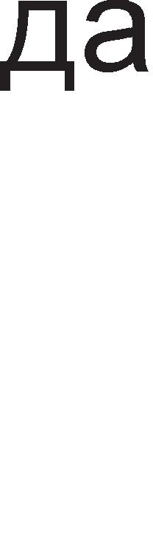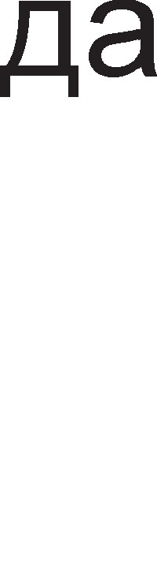

Cn1Ka 6.18. 6noK p1jaflpaM 3a npoflpaMaTa BKnyL1yBal-be Ha nep p1opa co KonL1e

BEGIN BTFSC PORTA ,0 ;npoBepyBaMe pan1 KonL1eTo e np1T1cHaTo. AKo e

;np1T1cHaTo cnepHaTa 1HcTpyKL1ja ce

;npecKoKHyBa.

|  |  |  |
| --- | --- | --- |
|  | GOTO BEGIN | ;AKo KonL1eTo He e np1T1cHaTo ce Bpai<aMe Ha  ;appeca BEGIN 1 flo npoBepyBaMe noBTopHo. |
| BSF PORTB, 0 | ;Ce BKnyL1yBa nep p1opaTa. |
| RELEASE | BTFSS PORTA, 0 | ;AKo KonL1eTo ce oTnywT1no ce cKoKa cnepHaTa  ;1HcTpyKL1ja. |
|  | GOTO RELEASE | ;Ce Bpai<aMe Ha appecaTa RELEASE, 3a pa  ;noBTopHo npoBep1Me pan1 KonL1eTo ce oTnywT1no. |
|  | CALL DOCNI | ;BHecyBaMe poLHel-be op epHa ceKyHpa. |
|  | BCF PORTB,0 | ;nep p1opaTa ce 1cKnyL1yBa. |
|  | GOTO BEGIN | ;nocTanKaTa ja noBTopyBaMe. |
| END |  |  |

**aK11y"1o4M**

M1KpoKoHTponepoT e M1KpoKoMnjyTep Bo o6n1K Ha 1HTeflp1paHo Kono. Toj Bo cBojoT cocTaB copp>K1 c*è* wTo 1Ma epeH cMeTaL1: M1KponpoLecop, MeMop11 1 6aKapH1 BopoB1 3a npeHoc Ha nopaToL1.

KpaTeHKaTa PIC 1Ma pBe 3HaL1el-ba. PIC Mo>Ke pa 61pe KpaTeHKa op Programmable Intelligent Computer. Ho, Bo HeKo1 n1TepaTyp1 PIC ce TonKyBa 1 KaKo KpaTeHKa op 36opoB1Te Programmable Interrupt Controller wTo npeBepeHo 3HaL11 npoflpaM161neH KoHTponep Ha npeK1H1.

PIC 16f84 pa6oT1 Bo Tp1 pa3n1L1H1 Mopa: npoflpaMcK1 Mop, pa6oTeH Mop 1 Mop Ha M1pyBal-be. Bo npoflpaMcK1 Mop ce BHecyBa Kop1cH1L1KaTa npoflpaMa Bo npoflpaMcKaTa MeMop1ja. Bo pa6oTeH Mop M1KpoKoHTponepoT o6pa6oTyBa nopaToL1 1 ynpaByBa co pa3H1 npoLec1. M1KpoKoHTponepoT ce nocTaByBa Bo Mop Ha M1pyBal-be (sleep) co Len pa ce 3awTep1 Bo noTpowyBaL1KaTa Ha eHepfl1ja.

PIC16f84 copp>K1 Tp1 MeMop11: RAM, EEPROM 1 npoflpaMcKa MeMop1ja.

EEPROM MeMop1jaTa fl1 L1yBa nopaToL1Te po61eH1 op 13BpwyBal-beTo Ha npoflpaMaTa, Ho 1 KoHcTaHT1 Ba>KH1 3a caMoTo npoLec1pal-be. 3a L11Tal-be 1 3a n1wyBal-be Bo EEPROM MeMop1jaTa ce Kop1cTaT Tp1 cneL1janH1 pefl1cTp1. EEADR ja L1yBa appecaTa Ha noKaL1jaTa Bo Koja ce n1wyBa 1n1 L11Ta. EEDATA flo L1yBa nopaToKoT wTo Tpe6a pa ce Bn1we 1n1 nopaToKoT wTo e npoL11TaH. EECON e 5-61TeH pefl1cTap 1 copp>K1 KoHTponH1 61ToB1 noBp3aH1 co n1wyBal-beTo 1 L11Tal-beTo op EEPROM MeMop1jaTa.

RAM MeMop1jaTa e nopeneHa Bo pBe 6aHK1 o3HaL1eH1 co 6aHKa 0 1 6aHKa 1. Ha 6aHKaTa 0 II np1naraaT noKaL11Te L11ja appeca noL1HyBa Ha Hyna, (op 00H po 4F), a Ha 6aHKa 1 noKaL11Te co appec1 Ko1 noL1HyBaaT Ha epeH (op 80H po CFH).

Bo M1KpoKoHTponepoT PIC 16f84 pefl1cTp1Te co onwTa 1 cneL1janHa HaMeHa ce HaoraaT Bo RAM MeMop1jaTa. npB1Te 12 MeMop1cK1 noKaL11 op ceKoja 6aHKa Ha RAM MeMop1jaTa npeTcTaByBaaT pefl1cTp1 co cneL1janHa HaMeHa.

3a KoMyH1KaL1ja co HapBopewH1oT cBeT M1KpoKoHTponepoT PIC 16f84 fl1 Kop1cT1 n1HoB1Te Ha nopT1Te A 1 B. nopTaTa B e ocyMn1HcKa, a nopTaTa A e neTn1HcKa. T1e Mo>KaT pa 61paT 1n1 Bne3H1 1n1 13ne3H1, Ho He 1 pBoHacoL1H1. Aan1 nopT1Te A 1 B i<e 61paT Bne3H1 1n1 13ne3H1 3aB1c1 op 61ToB1Te Bo pefl1cTp1Te TRISA 1 TRISB.

M1KpoKoHTponepoT PIC 16f84 MHofly L1ecTo ce Kop1cT1 KaKo TajMep 1n1 6pojaL1. TajMepoT Ha M1KpoKoHTponepoT ce 6ene>K1 co KpaTeHKaTa TMR0, wTo e BcywHocT, KpaTeHKa op timer0. Toj e ocyM61TeH pefl1cTap 1 Mo>Ke pa 136po1 op 00H po FFH. Kofla i<e ja pocT1flHe MaKc1ManHaTa BpepHocT, TajMepoT noBTopHo noL1HyBa pa 6po1 op Hyna. Kofla pa6oT1 KaKo TajMep, Toflaw M1KpoKoHTponepoT ce noBp3yBa co Kp1cTaneH ocL1naTop. noKpaj p1fl1TcK1 TaKToB1 op Kp1cTanH1oT ocL1naTop, pefl1cTapoT TMRO Mo>Ke pa 6po1 1 npoMeH1 Ha cocToj6aTa Ha n1HoT RA4/TOCKI 1 Toflaw Ben1Me peKa M1KpoKoHTponepoT e 6pojaL1 Ha HapBopewH1 cnyL1ajH1 npoMeH1.

M1KpoKoHTponepoT PIC 16f84 1Ma L1eT1p1 B1pa Ha npeK1H1: Kpaj Ha 3an1wyBal-be Ha nopaToK Bo EEPROM MeMop1jaTa, npeK1H npep13B1KaH op npeL1eKopyBal-be Ha cno6opH1oT 6pojaL1, npeK1H np1 npoMeHa Ha cocToj6aTa Ha cepM1oT, wecT1oT, neTT1oT 1 L1eTBpT1oT n1H op nopTaTa B 1 HapBopeweH npeK1H Ha n1HoT RB0/INT.

3a ceKoj B1p Ha npeK1H nocTojaT pBa B1pa Ha 61ToB1: Interrupt Enable bit (IE) 1 Interrupt Flag bit (IF). npB1oT 61T cocpTBepcK1 ce nocTaByBa Ha B1coKo H1Bo 3a pa ce oBo3Mo>KaT npeK1HoT. 3HaMeHLaTa 3a npeK1H1 ce ceT1paaT XappBepcK1. M1KpoKoHTponepoT fl1 nocTaByBa Ha B1coKo H1Bo 3a pa flo 13BecT1 Kop1cH1KoT peKa HacTaHan npeK1H.

3a KoHTpona Ha 6pojaL11Te 1 Ha TajMepoT ce Kop1cT1 pefl1cTapoT OPTION. npeKy Heflo ce pecp1H1pa B1poT Ha 6pojaL1, 13BopoT Ha TaKT 1 pen1TenoT Ha cppeKBeHL1ja (npecKanepoT).

Kaj M1KpoKoHTponepoT PIC16f84 1HcTpyKL11Te 3a pa6oTa co KoHcTaHT1 3aBpwyBaaT co 6yKB1Te LW. EpH1oT onepaHp ce Haora Bo pa6oTH1oT pefl1cTap W, a ppyfl1oT onepaHp e caMaTa KoHcTaHTa. Pe3ynTaToT op 13BpweHaTa 1HcTpyKL1ja ce 3an1wyBa Bo pefl1cTapoT W.

MOVWF f e 1HcTpyKL1ja 3a npeHoc Ha nopaToK np1 wTo 13Bop e pa6oTH1oT pefl1cTap W, a pecT1HaL1ja e pefl1cTapoT f. 3a npeHoc Ha nopaToK Bo cnpoT1BHa HacoKa, op pefl1cTapoT FILE Bo pa6oTH1oT pefl1cTap W, ce Kop1cT1 1HcTpyKL1jaTa MOVF FILE, W.

Co 61T-1HcTpyKL11Te ce Bpw1 ceT1pal-be 1n1 peceT1pal-be Ha epeH 61T op HeKoj pefl1cTap. Bo 1HcTpyKL1jaTa Mopa pa ce HaBepaT pefl1cTapoT 1 pepH1oT 6poj Ha 61ToT Bo Toj pefl1cTap.

3a pecp1H1pal-be Ha npoMeHn1B1Te 1 KoHcTaHT1Te ce Kop1cT1 aceM6nepcKaTa p1peKT1Ba EQU. Bo p1peKT1BaTa EQU noKpaj 1MeTo Ha pefl1cTapoT e HaBepeHa HefloBaTa appeca Bo RAM MeMop1jaTa. Co p1peKT1BaTa LIST ce oppepyBa B1poT Ha M1KpoKoHTponep. Co p1peKT1BaTa ORG ce oppepyBa noL1eToKoT Ha flnaBHaTa npoflpaMa Bo npoflpaMcKaTa MeMop1ja. KoHcp1flypaL1oH1oT 36op e 14-61TeH 1 co Heflo ce pecp1H1pa ocL1naTopoT, np1MeHaTa Ha c1flypHocH1oT 6pojaL1 1 TajMepoT 3a BKnyL1yBal-be Ha HanojyBal-beTo.

M1KpoKoHTponepoT PIC16f84 1cnpai<a c1flHan1 Bo 61HapeH o6n1K po LED p1op1Te co BpeMeTpael-be op HeKonKy M1n1ceKyHp1. npoflpaM1Te 3a poLHel-be ce Kop1cTaT 3a pa ce npopon>K1 BpeMeTpael-beTo Ha no6ypH1Te c1flHan1. OB1e npoflpaM1 ce Kop1cTaT 1 np1 noBp3yBal-be Ha M1KpoKoHTponepoT co KonL11l-ba (TacTep1) co Len pa 1M ce pape poBonHo BpeMe Ha KonL11l-baTa pa ce oTnywTaT npep pa 61paT noBTopHo np1T1cHaT1.

l/lH1L1jan13aL1jaTa Ha pefl1cTp1Te 3HaL11 H1BHo nocTaByBal-be Bo noL1eTHa cocToj6a. HacoKaTa Ha pB1>Kel-be Ha 61ToB1Te H13 n1HoB1Te Ha nopT1Te A 1 B ja oppepyBaaT pefl1cTp1Te TRISA 1 TRISB. Pefl1cTp1Te PORTA 1 PORTB Tpe6a pa ce peceT1paaT, opHocHo pa ce 136p1waT, 3a pa He ce cnyL11 HeKoja H1BHa cTapa copp>K1Ha pa npep13B1Ka flpewKa Bo pa6oTaTa Ha M1KpoKoHTponepoT.

## npawa1-a M 3a,qa"1M

1. Ha6poj HeKonKy np1Mep1 3a npaKT1L1Ha np1MeHa Ha PIC16f84!
2. PIC16f84 Mo>Ke pa pa6oT1 Bo Tp1 Mopa: npoflpaMcK1, pa6oTeH 1 M1pyBal-be. O6jacH1 wTo 3HaL11 ceKoj op H1B!
3. Bo Koj pen op M1KpoKoHTponepoT PIC16f84 ce HaoraaT pefl1cTp1Te co cneL1janHa HaMeHa?
4. KonKy 13HecyBa MaKc1ManHaTa floneM1Ha Ha Kop1cH1L1KaTa npoflpaMa wTo Mo>Ke pa ce BHece Bo npoflpaMcKaTa MeMop1ja Ha PIC16f84?
5. O6jacH1 wTo e noTpe6Ho 3a pa ce 1cnpoflpaM1pa epeH M1KpoKoHTponep!
6. Ko1 nopaToL1 ce L1yBaaT Bo EEPROM MeMop1jaTa?
7. no wTo ce pa3n1KyBaaT appec1Te Ha noKaL11Te op HynTaTa 1 npBaTa MeMop1cKa 6aHKa?
8. Kape ce Haora appecaTa Ha MeMop1cKaTa noKaL1ja Kaj p1peKTHoTo 1 1Hp1peKTHoTo appec1pal-be Kaj PIC16f84?
9. On1w1 fl1 nopT1Te A 1 B Ha M1KpoKoHTponepoT PIC16f84! O6jacH1 3a wTo cny>KaT T1e?
10. 3a wTo cny>KaT n1HoB1Te OSC1 1 OSC2?
11. O6jacH1 KaKBa cpyHKL1ja 1Ma pefl1cTapoT TMRO?
12. n1HoT RA4/TOCKI 1Ma pBojHa cpyHKL1ja. O6jacH1!
13. WTo npeTcTaByBa npecKanepoT 1 KaKBa cpyHKL1ja 1Ma 1cT1oT?
14. O6jacH1 ja cpyHKL1jaTa Ha c1flypHocH1oT 6pojaL1!
15. M1KpoKoHTponepoT PIC16f84 1Ma 4 B1pa npeK1H1. Ha6poj fl1!
16. O6jacH1 KaKBa cpyHKL1ja 1MaaT pefl1cTp1Te TRISA 1 TRISB?
17. Koj pefl1cTap ce Kop1cT1 3a KoHTpona Ha npeK1H1Te?
18. O6jacH1 fl1 TepM1H1Te XappBepcKo 1 cocpTBepcKo peceT1pal-be Ha 61ToB1 Bo KoHTponH1Te pefl1cTp1?

19. 61ToT INTEDG e KpaTeHKa op Interrupt Edge. O6jacH1 3a wTo cny>K1 oBoj 61T!

20. 61ToT EEIF e KpaTeHKa op EEPROM Interrupt Flag. O6jacH1 Kofla ce ceT1pa oBoj 61T?

* 1. Cnopep1 fl1 1HcTpyKL11Te MOVF FILE 1 MOWF FILE!
  2. l/lcKoMeHT1paj fl1 1HcTpyKL11Te: CLRF

BCF INCF

* 1. l/lcKoMeHT1paj fl1 1HcTpyKL11Te: RLF COUNT ,W

DECSZ COUNT ADDWF COUNT BTFSS PORTB,3 INCFSZ TMRO

* 1. Ha HynT1oT 1 Ha npB1oT n1H op nopTaTa B ce np1KnyL1eH1 pBe nep p1op1 co aHop1Te cBpTeH1 KoH n1HoB1Te. O6jacH1 flo ecpeKToT op cnepHaBa npoflpaMcKa ceKBeHLa:

BEGIN BSF PORTB, 0 BCF PORTB, 1 CALL DELAY5

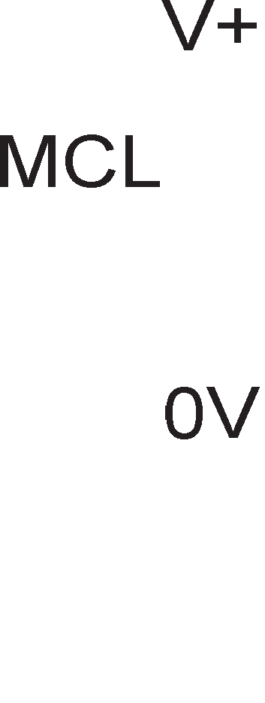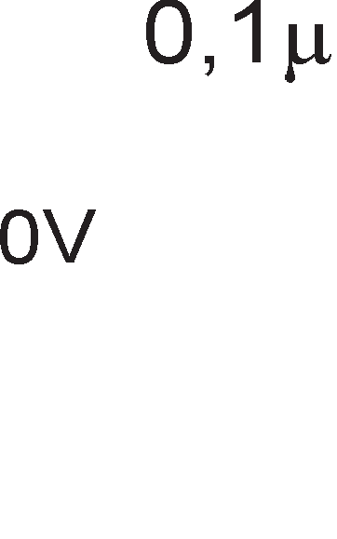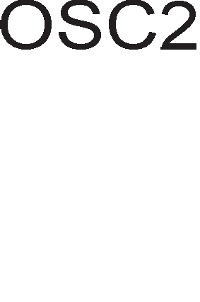

BCF PORTB, 0

BSF PORTB, 1 GOTO BEGIN

* 1. KonKy 13HecyBa pa6oTHaTa cppeKBeHL1ja Ha 6pojaL1oT, aKo M1KpoKoHTponepoT PIC16F84 e np1KnyL1eH Ha Kp1cTaneH ocL1naTop co f=200KHz 1 npecKanepoT 1Ma BpepHocT 011? KonKy TaKTa Tpe6a pa ce 136pojaT 3a pa ce po61e poLHel-be op 0,5 ceKyHp1?
  2. 3owTo e noTpe6Ho pa ce BoBepe BpeMe Ha poLHel-be Mery pBe nocnepoBaTenH1 np1T1cKal-ba Ha KonL1eTo?
  3. 3a wTo cny>K1 p1peKT1BaTa EQU?
  4. Koja p1peKT1Ba ce Kop1cT1 3a 136op Ha B1p Ha M1KpoKoHTponep?
  5. WTo ce pecp1H1pa co KoHcp1flypaL1oH1oT 36op?
  6. Ha ocyMTe n1Ha op nopTa B ce np1KnyL1eH1 ocyM nep p1op1 co aHopaTa cBpTeH1 KoH n1HoB1Te. O6jacH1 KaKoB e ecpeKToT op cnepHaBa npoflpaMcKa ceKBeHLa:

POCETOK MOVLW 11110000B

MOVWF PORTB CALL DALAY5 MOVLW 00001111B MOVWF PORTB CALL DELAY 5

GOTO BEGIN

**7. 0cyM6MTHM MMKponpo4ecopM**

(M1KponpoLecop 8085)

# nMH-,qMjarpaM Ha MMKponpo4ecop 8085

Ha cn1Ka 7.1 e npeTcTaBeH n1H p1jaflpaM Ha M1KponpoLecopoT 8085.

CTpenK1Te wTo BneflyBaaT Bo n1HoT ce Bne3H1 c1flHan1, a oH1e wTo 13neflyBaaT ce 13ne3H1 c1flHan1 (op M1KponpoLecopoT KoH ocTaHaT1Te penoB1 Ha cMeTaL1oT).

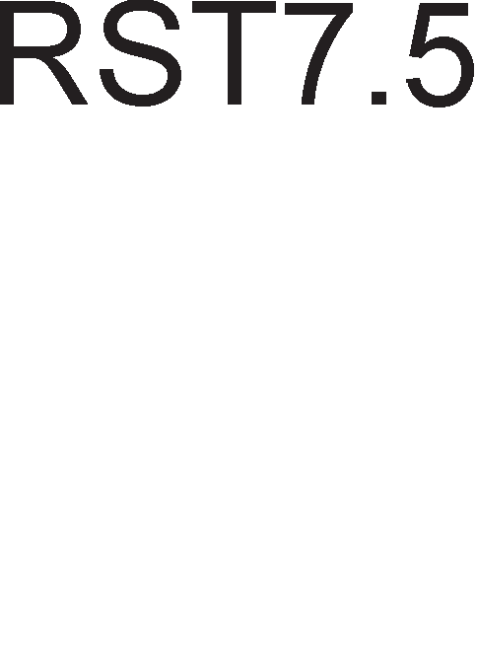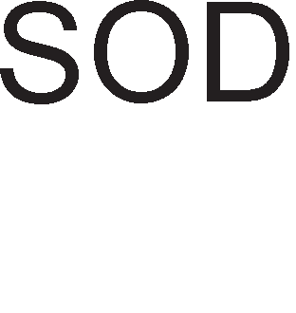

Cn1Ka 7.1. n1H p1jaflpaM Ha M1KponpoLecop 8085

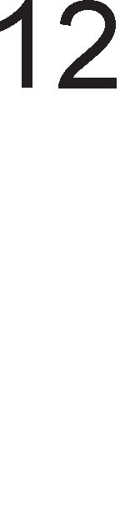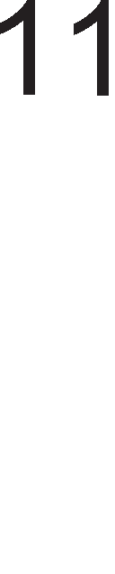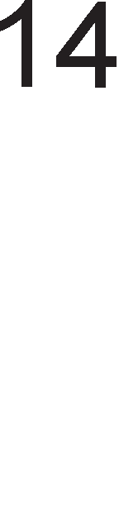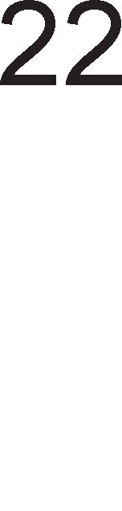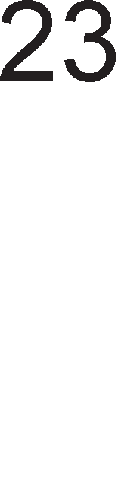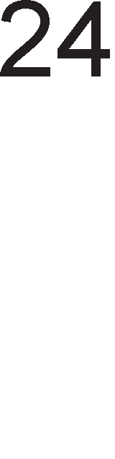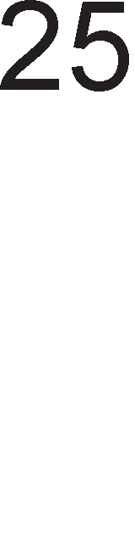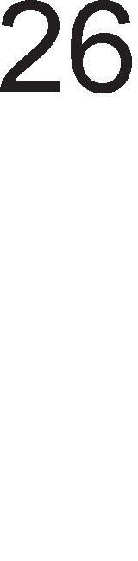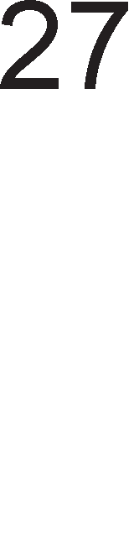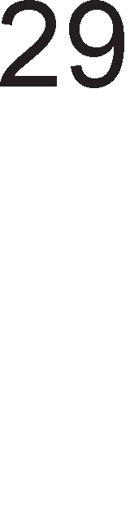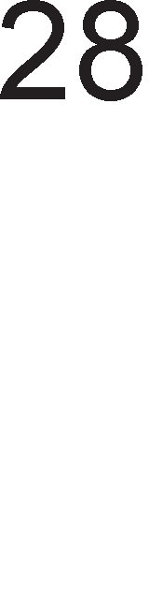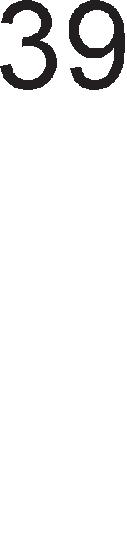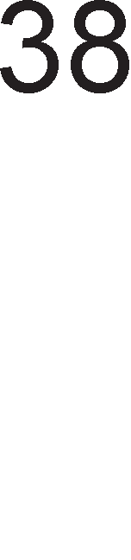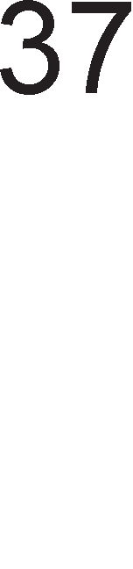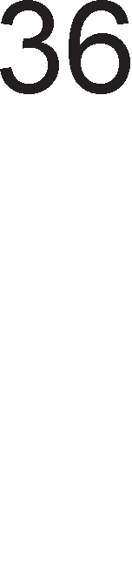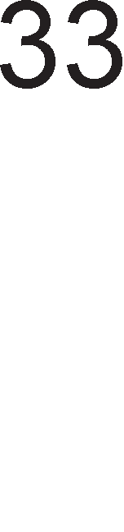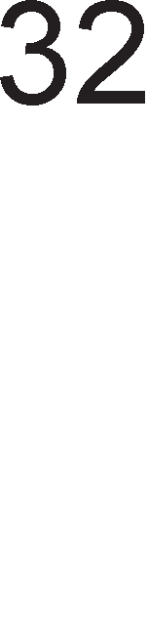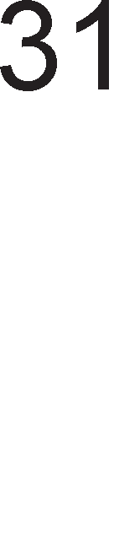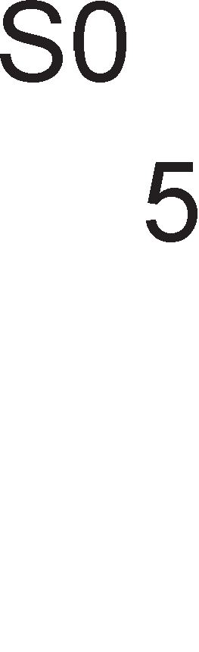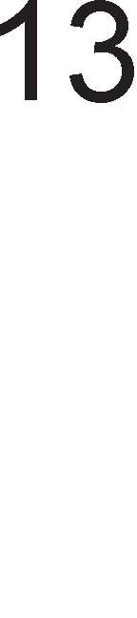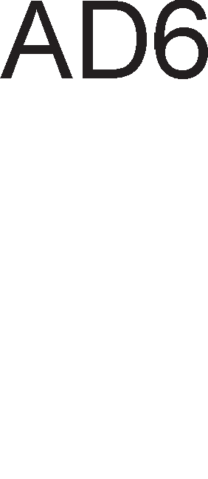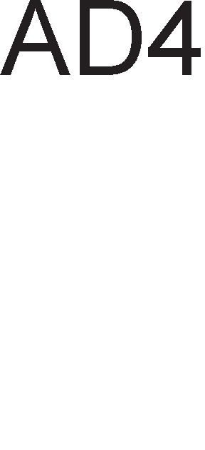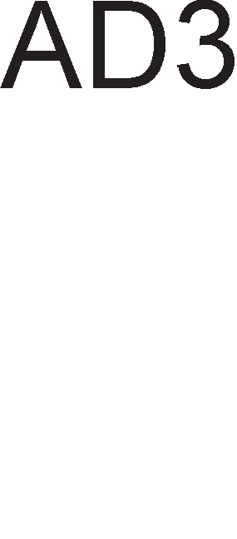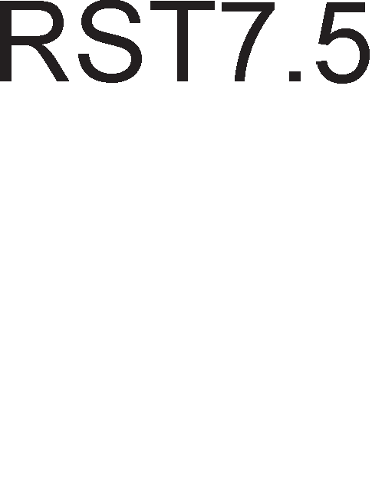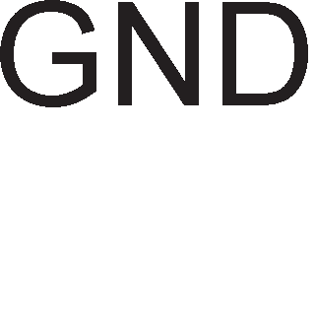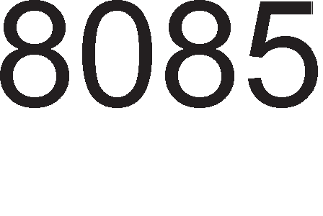

HeKo1 n1HoB1 ce aKT1BH1 Ha B1coKo H1Bo, a HeKo1 Ha H1cKo H1Bo. n1HoB1Te aKT1BH1 Ha H1cKo H1Bo ce o6ene>KaH1 co HeflaL1ja Bp3 H1BHaTa KpaTeHKa. noKpaj oB1e pBe cocToj61, nocTo1 1 TpeTa cocToj6a HapeL1eHa cocToj6a

Ha B1coKa 1MnepaHca. Bo BaKBa cocToj6a n1HoT He peafl1pa Ha H1KaKBa no6ypa, opHocHo Toj e 6noK1paH.

**A15-A8** AppecHa Mafl1cTpana

npeKy Hea ce npeHecyBaaT ocyMTe no3HaL1ajH1 61ToB1 op 16- 61THaTa appeca. OBaa Mafl1cTpana ce Haora Bo cocToj6a Ha B1coKa 1MnepaHca 3a BpeMe Ha cocToj6aTa **HOLD** 1 1HcTpyKL1jaTa **RESET**.

**AD0-7** MynT1nneKc1paHa appecHo/nopaToL1Ha Mafl1cTpana

3a BpeMe Ha npB1oT TaKT Mafl1cTpanaTa ce Kop1cT1 3a npeHoc Ha npB1Te 3HaL1ajH1 8 appecH1 61Ta, a Bo BTop1oT 1 TpeT1oT TaKT Ha Maw1HcK1oT L1Knyc ce 1cnpai<aaT nopaToL1Te.

**ALE** Address Latch Enable-KoHTponeH c1flHan 3a AD Mafl1cTpanaTa

AKo ALE=1 Toflaw appecHo-nopaToL1HaTa Mafl1cTpana npeHecyBa appecH1 61ToB1. AKo ALE=0 Toflaw Mafl1cTpanaTa npeHecyBa nopaToL1H1 n1HoB1.

##### S0,S1,

**IO/ **

CTaTyc-n1HoB1

nop Maw1HcK1 L1Knyc ce noppa361pa BpeMeTo noTpe6Ho pa ce npeHece 1HcpopMaL1ja op epeH 6ajT op M1KponpoLecopoT po MeMop1jaTa 1n1 o6paTHo. Ha noL1eToKoT Ha ceKoj Maw1HcK1 L1Knyc ce aKT1B1paaT cTaTyc-c1flHan1Te. npeKy Tp1Te cTaTycH1 n1H11 M1KponpoLecopoT paBa 1HcpopMaL1ja 3a Toa KaKoB Maw1HcK1 L1Knyc i<e ce pean131pa. Pa3n1KyBaMe wecT B1poB1 Maw1HcK1 L1Knyc1.

 Maw1HcK1 L1Knyc n1wyBal-be Bo MeMop1ja Ll1Tal-be op MeMop1ja n1wyBal-be Bo 13ne3eH ypep Ll1Tal-be op Bne3eH ypep npeHoc Ha onepaL1cK1 Kop O6pa6oTKa Ha npeK1H

|  |  |  |  |  |
| --- | --- | --- | --- | --- |
|  | IO/ |  | S1 | S0 |
| 0 |  | 0 |  | 1 |
| 0 |  | 1 |  | 0 |
| 1 |  | 0 |  | 1 |
| 1 |  | 1 |  | 0 |
| 0 |  | 1 |  | 1 |
| 1 |  | 1 |  | 1 |

CTaTycH1Te n1H11 ce aKT1B1paaT Ha noL1eToKoT Ha Maw1HcK1oT L1Knyc 1 ocTaHyBaaT Bo Taa cocToj6a po HefloB1oT Kpaj. l/lHcTpyKL1cK1oT L1Knyc e cocTaBeH op Tp1 po L1eT1p1 Maw1HcK1 L1Knyc1, Bo 3aB1cHocT op Toa KonKy 6ajT1 Tpe6a pa ce npeHecaT 3a pa LenocHo ce 13Bpw1 1HcTpyKL1jaTa.

 n1H 3a L11Tal-be (Read)

M1KponpoLecopoT flo 1cnpai<a KoHTponH1oT c1flHan  po MeMop1jaTa 1n1 nep1cpepH1Te ypep1 Kofla Tpe6a pa ce npoL11Ta nopaToK op H1B. OBoj n1H e aKT1BeH Ha nofl1L1Ka Hyna.

 n1H 3a n1wyBal-be (Write)

l/lMa o6paTHo 3HaL1el-be op  1 ce aKT1B1pa Kofla M1KponpoLecopoT Tpe6a pa 3an1we nopaToK Bo MeMop1cK1 1n1 nep1cpepeH ypep.

**READY** Kofla oBoj KoHTponeH c1flHan e Ha B1coKo H1Bo, Toa 3HaL11 peKa MeMop1jaTa 1n1 nep1cpepH1oT ypep e cnpeMeH 3a Bn1wyBal-be 1n1 3a L11Tal-be nopaToL1. AKo oBoj c1flHan e Ha H1cKo H1Bo, Toflaw LeHTpanH1oT M1KponpoLecop i<e L1eKa Len 6poj Ha TaKToB1 3a pa c1flHanoT READY ce nop1flHe Ha B1coKo H1Bo npep pa ce 3aBpw1 L11Tal-beTo op 1n1 3an1wyBal-beTo Bo MeMop1jaTa 1n1 nep1cpepH1oT ypep.

**HOLD** n1H 3a 6apal-be p1peKTeH np1cTan po MeMop1ja

OBoj Bne3 ce aKT1B1pa (ce KpeBa Ha B1coKo H1Bo) Kofla HeKoj nep1cpepeH ypep 6apa p1peKTeH np1cTan po MeMop1jaTa (Direct Memory Access). Toflaw LeHTpanH1oT npoLecop He e flocnopap, TyKy e po6. Toj He Mo>Ke pa fl1 Kop1cT1 Mafl1cTpan1Te 3a TpaHccpep Ha nopaToL1, Ho Mo>Ke pa flo 1cKop1cT1 BpeMeTo 3a pa 3aBpw1 HeKoja 1HTepHa pa6oTa. AopeKa Tpae BaKBaTa cocToj6a appecH1Te, nopaToL1H1Te, ,  1 IO/ n1HoB1 ce HaoraaT Bo cocToj6a Ha B1coKa 1MnepaHca.

**HLDA** Hold Acknowledge-n1H 3a po3Bona 3a p1peKTeH np1cTan po MeMop1ja M1KponpoLecopoT flo np1cpaT1n 6apal-beTo 3a p1peKTeH np1cTan po MeMop1ja 1 Kofla oBoj c1flHan i<e ce KpeHe Ha B1coKo H1Bo, M1KponpoLecopoT i<e fl1 ocno6op1 Mafl1cTpan1Te Ha HeKoj nep1cpepeH ypep nopap1 MHofly 6p3 TpaHccpep Ha nopaToL1.

**INTR** 6apal-be 3a npeK1H (Interrupt Request )

M1KponpoLecopoT npoBepyBa pan1 oBoj n1H e aKT1BeH 1n1 He no 3aBpwyBal-beTo Ha ceKoj 1HcTpyKL1cK1 L1Knyc. OBoj n1H e Bne3eH 3a M1KponpoLecopoT.

nop pecTapT1paL1Ka appeca ce noppa361pa appecaTa Ha MeMop1cKaTa noKaL1ja op Koja 3anoL1HyBa noTnpoflpaMaTa 3a cepB1c1pal-be Ha aKT1BH1oT npeK1H. INTR HeMa cp1KcHa pecTapT1paL1Ka appeca. Koja npeK1HyBaL1Ka noTnpoflpaMa i<e ja 13Bpw1 M1KponpoLecopoT, 3aB1c1 op npeK1HyBaL1K1oT BeKTop wTo flo 1cnpai<a nep1cpepH1oT ypep Koj 6apa npeK1H. 6pojoT Ha npeK1HyBaL1K1 BeKTop1 e epHaKoB Ha 6pojoT Ha nep1cpepH1 ypep1 wTo Mo>KaT pa 1H1L1paaT npeK1H.

 n1H 3a po3Bona 3a npeK1H (Interrupt Acknowledge)

OBoj n1H ce aKT1B1pa Kofla M1KponpoLecopoT i<e flo np1cpaT1

6apal-beTo 3a npeK1H. np1Toa poara po aKT1B1pal-be Ha npeK1HyBaL1K1oT L11n 8259 1n1 Ha HeKoja ppyfla npeK1HyBaL1Ka nopTa.

**TRAP** npeK1H op HajB1coK np1op1TeT.

npeK1HoT TRAP e co HajB1coK np1op1TeT. OTKaKo i<e ce aKT1B1pa oBoj n1H, M1KponpoLecopoT Mopa pa flo 13Bpw1 6apal-beTo 3a npeK1H. TRAP He Mo>Ke pa ce MacK1pa, H1Ty pa 61pe oTcppneH. 36opoT trap Bo npeBop 3HaL11 cTan1La, 3aMKa. Toj ce np1MeHyBa Bo cnyL1aj Ha KaTacTpocpanH1 flpewK1, KaKo Ha np1Mep, npo6neM1 co HanojyBal-beTo 1n1 13MewaH npeHoc Ha nopaToL1 no Mafl1cTpanaTa. M1KponpoLecopoT flo npeno3HaBa npeK1HoT TRAP caMo aKo no cKoKoT op H1cKo H1Bo Ha B1coKo (pacTeL1K1 pa6) aKT1BaTopoT ocTaHe Bo TaKBa cocToj6a HajManKy 160 M1KpoceKyHp1. M1KponpoLecopoT HeMa pa flo np1cpaT1 6apal-beTo 3a npeK1H aKo aKT1BaTopoT cKoKHe Ha B1coKo H1Bo, na noBTopHo napHe Ha H1cKo 3a pa nopoLHa no BTopnaT cKoKHe Ha B1coKo H1Bo.

##### RST 5.5

**RST 6.5**

**RST 7.5**

PecTapT1paL1K1 npeK1H1 (Restart )

no 13BpwyBal-beTo Ha noTnpoflpaMaTa 3a cepB1c1pal-be Ha npeK1HoT, M1KponpoLecopoT He ce Bpai<a Ha3ap Ha npeK1HaTaTa npoflpaMa, TyKy Taa noL1HyBa opHoBo. PecTapT1paL1KaTa appeca e cp1KcHa 3a npeK1H1Te TRAP 1 RESET.

RST 6.5 1 RST 5.5 ce MacK1paL1K1 npeK1H1. 3a H1BHo MacK1pal-be 1 L11Tal-be ce Kop1cTaT 1HcTpyKL11Te SIM (set interrupt mask) 1 RIM(read interrupt mask). 3a pa M1KponpoLecopoT fl1 npeno3Hae 6apal-baTa 3a npeK1H Ha n1HoB1Te RST 6.5 1 RST 5.5 aKT1BaTopoT Mopa pa e Ha B1coKo H1Bo c*è* popeKa 6apal-baTa He 61paT np1cpaTeH1.

 Kofla i<e ce aKT1B1pa oBoj n1H, poara po nocTaByBal-be Ha npoflpaMcK1oT 6pojaL1 Bo nono>K6a Hyna 1 peceT1pal-be Ha 3HaMeHLeTo 3a npeK1H 1 Ha HLDA cpn1n- cpnonoT. Bo oppepeH1 cnyL1a1 Mo>Ke pa pojpe 1 po npoMeHa Ha cocToj6aTa Ha cTaTyc- pefl1cTapoT 1 Ha pefl1cTp1Te co onwTa HaMeHa.

##### RESET OUT

npeKy oBoj c1flHan M1KponpoLecopoT fl1 13BecTyBa ocTaHaT1Te cKnonoB1 Bo cMeTaL1oT peKa 61n peceT1paH.

**CLK** A1fl1TcK1 TaKT (H13a op nep1op1L1H1 npaBoaflonH1 1Mnync1) wTo flo paBa fleHepaTopoT Ha TaKT. Pa6oTHaTa cppeKBeHL1ja po61eHa Ha 13ne3 op M1KponpoLecopoT e pBanaT1 noMana op cppeKBeHL1jaTa Ha Kp1cTanH1oT ocL1naTop np1KnyL1eH Ha n1HoB1Te X1 1 X2.

**X1,X2** n1HoB1 3a Bne3 Ha Kp1cTanH1oT ocL1naTop

X1 1 X2 ce no cpa3a cnpoT1BH1 c1flHan1 (popeKa epH1oT e Ha B1coKo H1Bo, ppyfl1oT e Ha H1cKo) 1 ce Kop1cTaT 3a BHaTpeweH TajM1Hfl Ha caM1oT M1KponpoLecop.

**SID** Bne3eH n1H 3a cep1cKa KoMyH1KaL1ja (Serial Input Data)

**SOD** l/l3ne3eH n1H 3a cep1cKa KoMyH1KaL1ja (Serial Otput Data)

# ApxMTeKTypa Ha MMKponpo4ecop 8085

l/lHTenoB1oT M1KponpoLecop **8085** 13ne3e Ha na3apoT Bo 1977 flop. OBoj M1KponpoLecop 6apa MHofly Man 6poj XappBepcK1 KoMnoHeHT1, Ho H1BHaTa nocTaBeHocT 1 cpyHKL1oHanHocT Mo>Ke pa o6e36ep1 MHofly floneMa ecp1KacHocT Bo pa6oTaTa.

KoMnaH1jaTa „l/lHTen“ 1Ma npo13BepeHo Hap 200 M1n1oH1 BaKB1 L11noB1. KoMnaH1jaTa „31nofl“ e BTopa KoMnaH1ja wTo 1Ma npopapeHo Hap 500 M1n1oH1 M1KponpoLecop1, Ko1 ce peL11c1 1peHT1L1H1 co 8085, Ho ce npopaBaaT nop 1MeTo Z-80. M1KponpoLecopoT 8085 no cBojaTa opflaH13aL1ja e MHofly cn1L1eH co M1KpoKoHTponep1Te, KaKo wTo e PIC 16f84, Ko1 HaoraaT floneMa np1MeHa Bo npoLecHoTo ynpaByBal-be. no cBojaTa Moi< 8085 He Mo>Ke pa ce cnopepyBa co M1KponpoLecopoT neHT1yM, Ho Toj ywTe ponflo BpeMe i<e ce npo13BepyBa 61peji<1 Haora floneMa np1MeHa Bo noepHocTaBH1Te eneKTpoHcK1 ypep1, Ko1 1 He 6apaaT TonKy Moi<H1 M1KponpoLecop1. Ha cn1Ka 7.2. e np1Ka>KaHa cpyHKL1oHanHaTa 6noK weMa Ha M1KponpoLecopoT 8085, co c1Te HefloB1 onwT1 1 cneL1janH1 pefl1cTp1. M1KponpoLecopoT 8085 e ocyM61TeH M1KponpoLecop, opHocHo o6pa6oTyBa nopaToL1 co floneM1Ha op 1 6ajT. Pacnonafla co fleHepaTop Ha TaKT Koj npo13BepyBa p1fl1TcK1 TaKT co **cppeKeeH4Mja 8 MHz**, noce6eH KoHTponep 3a pa6oTa co npeK1H1 1 KoHTpona Ha TajM1HfloT. l/lMa np1cTan po **MeMopMja** co KanaL1TeT **64KB**, opHocHo 1Ma **16 a,qpecHM nMHa** HaMeHeT1 3a p1peKTHo

appec1pal-be Ha MeMop1cK1oT npocTop (216 =64K).

Pefl1cTp1Te ce BHaTpewHa MeMop1ja Ha M1KponpoLecopoT, Ho 1MaaT Man KanaL1TeT. nopaToL1Te wTo fl1 o6pa6oTyBa M1KponpoLecopoT ce cMecTeH1 Bo nocnepoBaTenH1 MeMop1cK1 noKaL11. M1KponpoLecopoT ja 1cnpai<a appecaTa Ha npB1oT nopaToK po MeMop1jaTa, a Taa My flo 1cnpai<a caKaH1oT nopaToK. Kofla M1KponpoLecopoT i<e flo o6pa6oT1 npB1oT nopaToK, flo noB1KyBa cnepH1oT 1TH. Pe3ynTaToT op 13BpweHaTa 1HcTpyKL1ja Mo>Ke pa ce cMecT1 Ha pa3n1L1H1 MecTa. AKo po61eH1oT pe3ynTaToT Tpe6a ywTe epHaw pa ce o6pa6oT1 Toflaw Toj i<e ce cMecT1 Bo aKyMynaTopoT. AKo po61eH1oT pe3ynTaT Tpe6a pa ce o6pa6oT1 Bo 6n1cKa 1pH1Ha, Ho He Bo cnepH1oT L1eKop, Toflaw Toj ce cMecTyBa Bo HeKoj op pefl1cTp1Te Ha M1KponpoLecopoT. l/lcTo TaKa, aKo ce pa6oT1 3a 3aBpweH pe3ynTaT

1n1 aKo Toj i<e ce o6pa6oTyBa MHofly nopoLHa, Toflaw pe3ynTaToT Mo>Ke pa ce cMecT1 Ha3ap Bo MeMop1jaTa.

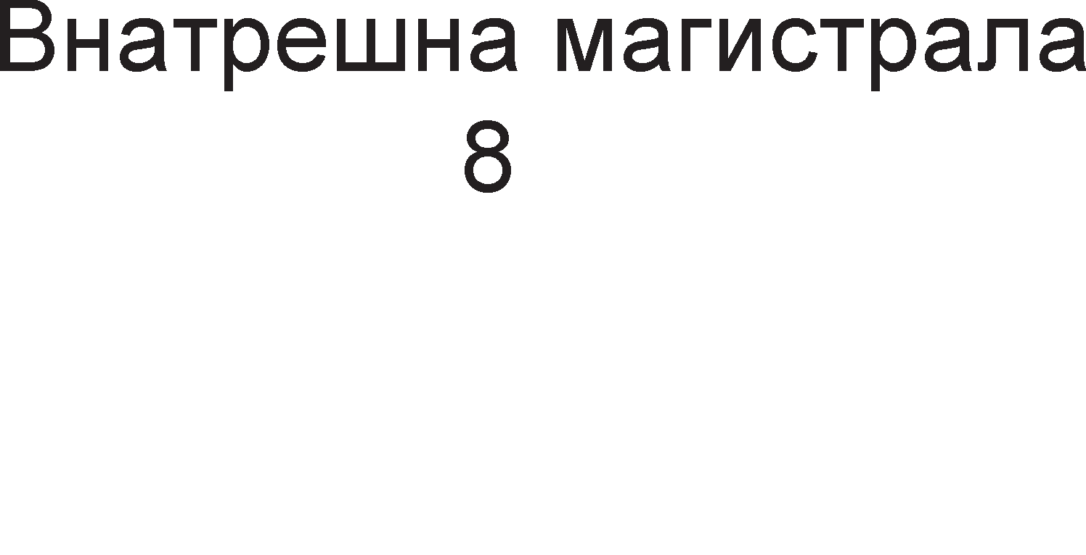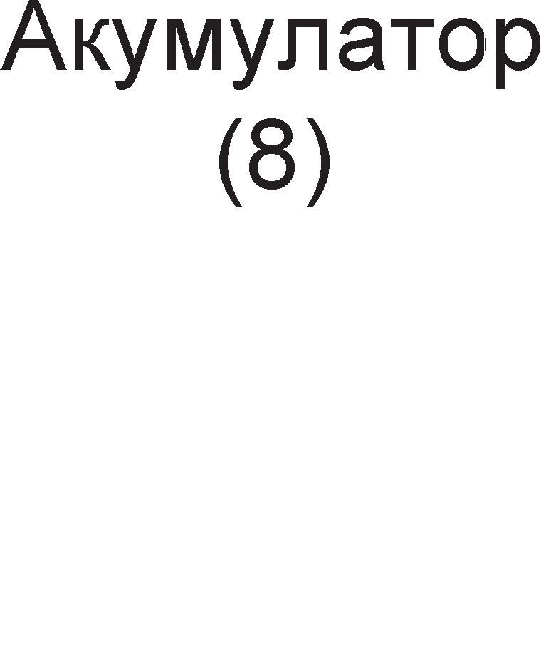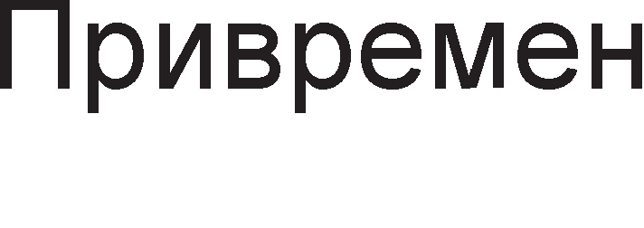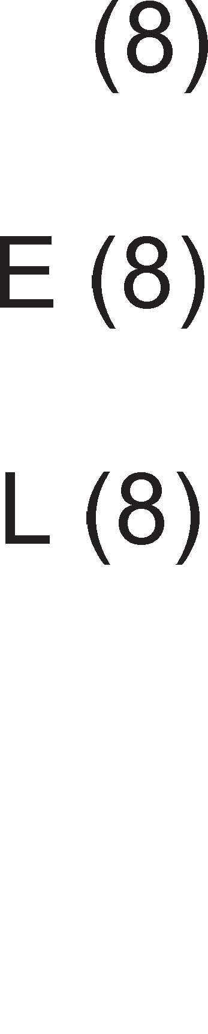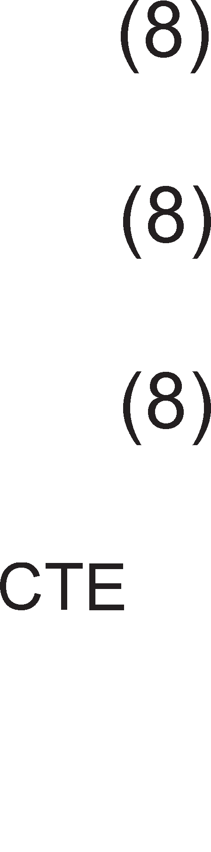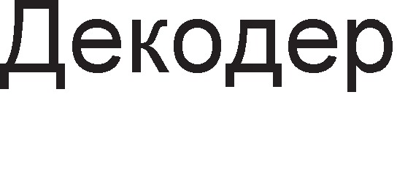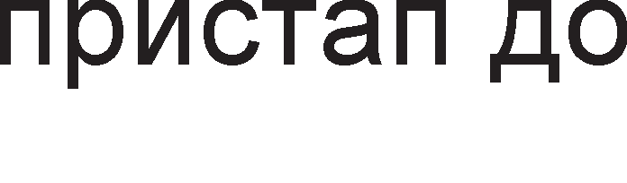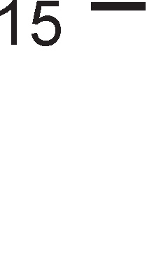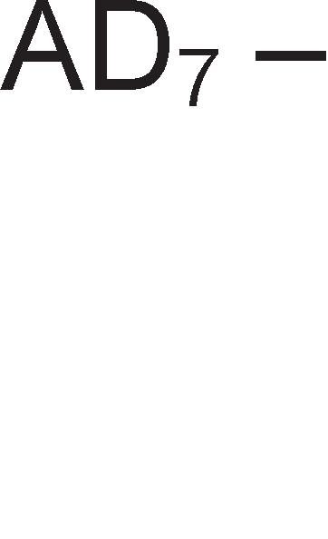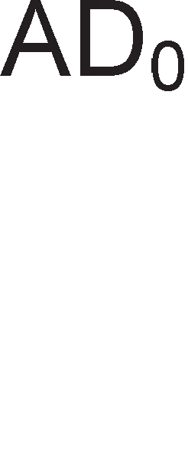

Cn1Ka 7.2. ApX1TeKTypa Ha M1KponpoLecop 8085

AKyMynaTopoT e pa6oTeH pefl1cTap Ha M1KponpoLecopoT 1 ce Haora Ha Bne3 op ap1TMeT1L1Ko nofl1L1KaTa ep1H1La. noKpaj aKyMynaTopoT Bo **perMcTpM co onwTa HaMeHa** BneflyBaT ywTe wecT ppyfl1 pefl1cTp1, Ko1 ce 6ene>KaT co 6yKB1Te B, C, D, E, H, L. OB1e pefl1cTp1 Mo>KaT pa co6epaT 8 61Ta 1 pa 61paT 13Bop Ha nopaToL1 1n1 Len 3a po61eH1oT pe3ynTaT. CeKoj op oB1e pefl1cTp1 ce 1peHT1cp1KyBa co KoM61HaL1ja op 3 61Ta wTo e np1Ka>KaHo Bo Ta6enaTa 7.1.

|  |  |
| --- | --- |
| A | 111 |
| B | 000 |
| C | 001 |
| D | 010 |
| E | 011 |
| H | 100 |
| L | 001 |

Ta6ena 7.1. KopoB1 3a onwT1 pefl1cTp1 Ha M1KponpoLecopoT 8085

LlecTo naT1 onwT1Te pefl1cTp1 ce Kop1cTaT Bo nap 3a cMecTyBal-be 1 L1yBal-be Ha 16-61TH1 appec1. Bo oBoj cnyL1aj ce Kop1cTaT cnepH1Be o3HaK1: BC, DE, HL. Pefl1cTp1Te B, D 1 H fl1 L1yBaaT 61ToB1Te co nofloneMa Te>K1Ha, a pefl1cTp1Te C, E 1 L 61ToB1Te co noMana Te>K1Ha.

npoflpaMaTa npeTcTaByBa MHo>KecTBo op 6ajT1. MeMop1cK1Te noKaL11 Bo Ko1 ce cMecTeH1 6ajT1Te He ce paccppnaH1 cnyL1ajHo H13 LenaTa MeMop1ja, TyKy ce HapepeH1 Bo nocnepoBaTenH1 MeMop1cK1 noKaL11. Ha np1Mep, appecaTa Ha neTT1oT 6ajT i<e ja po61eMe aKo Ha appecaTa Ha L1eTBpT1oT 6ajT popapeMe epeH. np1 13BpwyBal-beTo Ha epHa npoflpaMa, M1KponpoLecopoT fl1 noB1KyBa epeH no epeH, oHaKa KaKo wTo ce HapepeH1 Bo MeMop1jaTa. **nporpaMcKMoT 6poja"1** e pefl1cTap Bo M1KponpoLecopoT, Koj ja naMT1 appecaTa Ha cnepH1oT 6ajT wTo Tpe6a pa ce npeHece op MeMop1jaTa 1 pa ce o6pa6oT1. M1KponpoLecopoT popaBa epeH Ha copp>K1HaTa Ha npoflpaMcK1oT 6pojaL1 no ceKoe poHecyBal-be HoB 6ajT op MeMop1jaTa po M1KponpoLecopoT. npoflpaMcK1oT 6pojaL1 ja copp>K1 appecaTa Ha cnepH1oT, a He Ha 6ajToT wTo MoMeHTanHo ce o6pa6oTyBa Bo M1KponpoLecopoT. l/lcKnyL1oK op oBa npaB1no 1MaMe Kaj cKoK-1HcTpyKL11Te 1 Kaj 1HcTpyKL11Te 3a noB1KyBal-be noTnpoflpaM1. AoKonKy ce 13Bpw1 cKoK-1HcTpyKL1ja, Toflaw copp>K1HaTa Ha npoflpaMcK1joT 6pojaL1 HeMa pa ce 3floneM1 3a epeH, TyKy Toj i<e ja np1M1 BpepHocTa Ha appecaTa HaBepeHa Bo cKoK-1HcTpyKL1jaTa. Kaj cKoK- 1HcTpyKL11Te M1KponpoLecopoT He ce Bpai<a Ha3ap Ha noKaL1jaTa op Koja e 13BpweH cKoKoT.

CTeK MeMop1jaTa ce Kop1cT1 3a pa6oTa co noTnpoflpaM1. CTeKoT e noce6Ho opflaH131paH MeMop1cK1 npocTop. Toj e cocTaBeH op nofloneM 6poj MeMop1cK1 noKaL11. CTeK MeMop1ja ce nonH1 1 ce npa3H1 npeKy BpBoT. CeKoj HoB nopaToK ce 3an1wyBa Ha BpBoT Ha cTeKoT. AKo caKaMe pa 3eMeMe HeKoj nopaToK cMecTeH Bo cpep1HaTa Ha cTeKoT, Tpe6a pa fl1 1cnpa3H1Me c1Te MeMop1cK1 noKaL11 Hap caKaH1oT nopaToK, co wTo aBToMaTcK1 caKaH1oT nopaToK (MeMop1cKa noKaL1ja) i<e cTaca Ha BpBoT op cTeKoT. M1KponpoLecopoT copp>K1 noce6eH pefl1cTap **cTeK- noKa>Kyea"1** (stack pointer), Koj e 16-61TeH pefl1cTap 1 ja copp>K1 appecaTa Ha MeMop1cKaTa noKaL1ja Ha BpBoT op cTeKoT.

CeKoja 1HcTpyKL1ja wTo Mo>Ke pa ja 13Bpw1 M1KponpoLecopoT 1Ma cBoj 8- 61TeH onepaL1cK1 Kop. Co 8 61Ta Mo>Ke pa ce HanpBaT 256 pa3n1L1H1 KoM61HaL11, opHocHo 256 onepaL1cK1 Kopa. OTKaKo 1HcTpyKL1jaTa i<e ce npeHece op MeMop1jaTa Bo M1KponpoLecopoT, Taa ce L1yBa Bo noce6eH pefl1cTap HapeL1eH **MHcTpyK4McKM perMcTap.** Bo Heflo 1HcTpyKL1jaTa ocTaHyBa c*è* popeKa He 61pe onepaT1BHo 13BpweHa. Op 1HcTpyKL1cK1oT pefl1cTap 1HcTpyKL1jaTa ce Hoc1 Bo peKopepoT. AeKopepoT 1Ma 8 Bne3a 1 256 13ne3a. CeKoj op oB1e 13ne31 noTT1KHyBa oppepeHa aKT1BHocT. AeKopepoT e noBp3aH co ynpaByBaL1KaTa ep1H1La Ha M1KponpoLecopoT. BcywHocT, onepaL1cK1oT Kop BneflyBa Bo peKopepoT, a noToa npep13B1KyBa no6ypa Ha ynpaByBaL1K1oT ep1H1La, Koja Ha cBojoT 13ne3 paBa ynpaByBaL1K1 c1flHan1. Ko1 ynpaByBaL1K1 c1flHan1 i<e 61paT

aKT1BH1 3aB1c1 op onepaL1cK1oT Kop, Ho 1 op p1fl1TcK1oT TaKT op Kp1cTanH1oT ocL1naTop (fleHepaTopoT Ha TaKT).

##### AppecH1oT pefl1cTap ja co,qp>KM a,qpecaTa Ha MeMopMcKaTa 11oKa4Mja Ka,qe wTo e cMecTeH onepaH,qoT ep3 Koj Tpe6a ,qa ce M3epwM ,qa,qeHaTa onepa4Mja.

**ApMTMeTM"1Ko-11orM"1KaTa e,qMHM4a** e pen op LeHTpanH1oT npoLecop, Koj fl1 13BpwyBa ap1TMeT1L1Ko-nofl1L1K1Te 1HcTpyKL11 Bp3 61HapH1 6poeB1. CeKoja ap1TMeT1L1Ko-nofl1L1Ka ep1H1La Mopa pa copp>K1 co61paL1, Koj Bpw1 co61pal-be Ha copp>K1H1Te Ha pBa pefl1cTpa Bo coflnacHocT co 61HapHaTa ap1TMeT1Ka. Kop1cTeji<1 flo caMo ocHoBH1oT co61paL1, Mo>Ke pa cocTaBaT npoflpaM1 co Ko1 i<e ce Bpw1 op3eMal-be, MHo>Kel-be 1 penel-be wTo, BcywHocT, ce ocHoBH1Te ap1TMeT1L1K1 onepaL11. Bo npaKT1Ka, noKpaj co61pal-beTo, ap1TMeT1L1Ko-nofl1L1KaTa ep1H1La Mo>Ke pa 13BpwyBa XappBepc1 1 ppyfl1 cpyHKL11, KaKo wTo ce op3eMal-be, 6ynoB1 nofl1L1K1 onepaL11 1 noMecTyBal-be H131. Ha ap1TMeT1L1Ko-nofl1L1KaTa ep1H1La e np1KnyL1eH TaKaHapeL1eH1oT **cTaTyc-perMcTap**. OBoj pefl1cTap copp>K1 1Hp1KaTop1 Ha cocToj61, 3HaMeHLa (flags). 3HaMeHLaTa Mo>Ke pa 1MaaT pa3n1L1H1 ynofl1 1 HajL1ecTo ja noKa>KyBaaT cocToj6aTa Bo ap1TMeT1L1Ko-nofl1L1KaTa ep1H1La no 13BpwyBal-beTo Ha HeKoja 1HcTpyKL1ja. T1n1L1H1 3HaMeHLa ce :

* + **C (carry)** – l/lHp1KaTop Ha npeHoc. OBoj 61T XappBepcK1 ce ceT1pa aKo nocTo1 npeHoc Kaj co61pal-beTo op ocMa Ha peBeTTa no31L1ja Bo 61HapH1Te 6poeB1, opHocHo no3ajMyBal-be Kaj op3eMal-beTo op peBeTTa Ha ocMa no31L1ja. l/lcTo TaKa, 3HaMeHLeTo C ce Kop1cT1 1 np1 onepaL11Te Ha noMecTyBal-be H131. Ha cn1KaTa 7.3. ce papeH1 pBa np1Mepa 3a ynoTpe6a Ha 3HaMeHLeTo C.

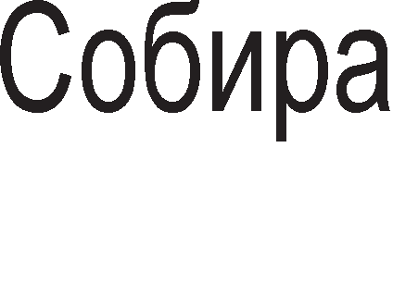

Cn1Ka 7.3. np1Mep1 3a npaKT1L1Ha np1MeHa Ha 3HaMeHLeTo carry-1Hp1KaTop 3a npeHoc



* + **Z (zero)** – 3HaMeHLeTo Hyna e nofl1L1Ka ep1H1La aKo pe3ynTaToT op 13BpweHaTa onepaL1ja e Hyna, a aKo po61eH1oT pe3ynTaT e pa3n1L1eH op Hyna, Toflaw 3HaMeHLeTo Z e nofl1L1Ka Hyna.
  + **S (sign)** – 3HaMeHLe 3a 3HaK. AKo pe3ynTaToT Ha onepaL1ja e HeflaT1BeH, oBa 3HaMeHLe e ep1H1La, a Bo cnpoT1BHo e nofl1L1Ka Hyna .
  + **P (parity)** – 3HaMeHLe 3a napHocT. AKo pe3nyTaToT Ha onepaL1jaTa copp>K1 napeH 6poj ep1H1La 3HaMeHLeTo P e ep1H1La, a Bo cnpoT1BHo e nofl1L1Ka Hyna.
  + **Ax –** OBa e noMowHo 3HaMeHLe 3a npeHoc 1 ce aKT1B1pa Kofla 1MaMe npeHoc op L1eTBpTa Ha neTTa no31L1ja np1 co61pal-beTo 61HapH1 6poeB1 1n1 no3ajMyBal-be op neTTa Ha L1eTBpTa no31L1ja Kaj op3eMal-beTo.

**npMMep 7.1**: Ko1 3HaMeHLa ce aKT1B1paaT np1 co61pal-be Ha 6poeB1Te 11101011(2) 1 00010101(2) ?

PeweH1e:

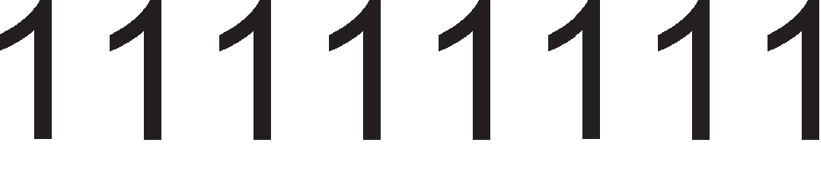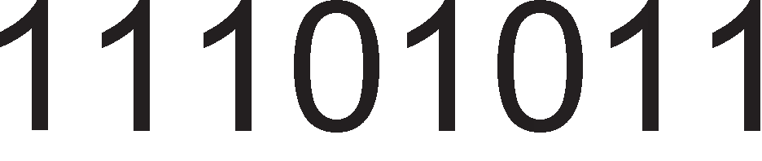

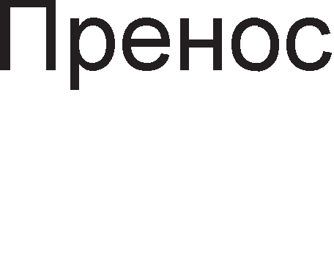 

Ce aKT1B1paaT 3HaMeHLaTa C, Z 1 Ax.

# MawMHcKM 4MK11ycM 3a MMKponpo4ecop 8085

CeKoj 1HcTpyKL1cK1 L1Knyc 3anoL1HyBa co **MawMHcKM 4MK11yc 3a npeHoc Ha onepa4McKM Ko,q.** Bei<e 1cTaKHaBMe peKa Kaj M1KponpoLecopoT 8085 onepaL1cK1oT Kop npeTcTaByBa 8-61THa KoM61HaL1ja Koja e ep1HcTBeHa 3a papeHaTa 1HcTpyKL1ja. OBoj Maw1HcK1 L1Knyc ce pa3n1KyBa op ocTaHaT1Te, no Toa wTo Toj Tpae noBei<e op Tp1 p1fl1TcK1 TaKTa, 61peji<1 Mopa pa ce 13Bpw1 peKop1pal-be 3a pa M1KponpoLecopoT po3Hae wTo Tpe6a pa npaB1 HaTaMy.

Ha cn1Ka 7.4. e papeH BpeMeHcK1 p1jaflpaM 3a Maw1HcK1 L1Knyc-npeHoc Ha onepaL1cK1 Kop. Aa ce noTceT1Me peKa BpeMeHcK1oT p1jaflpaM npeTcTaByBa flpacp1L1K1 np1Ka3 Ha 3aB1cHocTa Mery KoHTponH1Te c1flHan1 wTo ce aKT1B1paaT np1 13BpwyBal-beTo Ha 1HcTpyKL1jaTa. Ha noL1eToKoT op ceKoj Maw1HcK1 LyKnyc M1KponpoLecopoT 8085 fl1 aKT1B1pa cTaTyc-n1H11Te co Len pa flo pecp1H1pa B1poT Ha Maw1HcK1oT L1Knyc. Kofla ce npeHecyBa onepaL1cK1 Kop op MeMop1jaTa po M1KponpoLecopoT, Toflaw cTaTycH1Te n1H11 fl1 1MaaT cnepH1Be BpepHocT1:

IO/ =0 -npoLecopoT i<e KoMyH1L1pa co MeMop1jaTa (He co nep1cpepeH ypep)

S1=1 -i<e ce Bpw1 onepaL1ja L11Tal-be (He n1wyBal-be)

S0=1 –6ajToT wTo ce npeHecyBa e onepaL1cK1 Kop (He e nopaToK, onepaHp)

3a BpeMe Ha npB1oT p1fl1TcK1 TaKT M1KponpoLecopoT 8085 1cnpai<a 16- 61THa appeca co Len pa ja 1peHT1cp1KyBa MeMop1cKaTa noKaL1ja 1n1 Bne3Ho- 13ne3HaTa nopTa po Koja ce o6pai<a. Bo cnyL1aj Ha npeHoc Ha onepaL1cK1 Kop no appecHaTa Mafl1cTpana ce 1cnpai<a copp>K1HaTa Ha npoflpaMcK1oT 6pojaL1. no3HaL1ajH1oT 6ajT (PCH- Program Counter High) ce npeHecyBa no n1H11Te op A8- A15 1 Toj 6ajT ocTaHyBa Ha H1B c*è* po 3aBpwyBal-be Ha L1eTBpT1oT p1fl1TcK1 TaKT. noHe3HaL1ajH1oT 6ajT op npoflpaMcK1oT 6pojaL1 (PCL- Program Counter Low) ce npeHecyBa no n1H11Te ADo-AD7 1 Toj ocTaHyBa Ha H1B caMo epeH p1fl1TcK1 TaKT. l/lMeHo, no npB1oT p1fl1TcK1 TaKT, n1H11Te AD0-AD7 Tpe6a pa 61paT cno6opH1 3a pa npeKy H1B ce npeHece onepaL1cK1oT Kop npoL11TaH op HeKoja MeMop1cKa noKaL1ja. C1flHanoT ALE e Ha B1coKo H1Bo caMo 3a BpeMe Ha npB1oT p1fl1TcK1 TaKT Kofla appecHo-nopaToL1HaTa Mafl1cTpana ce Kop1cT1 3a npeHoc Ha appecH1 61ToB1. C1flHanoT ALE (Adress Latch Enable) ce Kop1cT1 3a ocnoco6yBal-be Ha appecH1oT neL1 8212. OTKaKo M1KponpoLecopoT i<e fl1 1cnpaT1 cTaTycH1Te c1flHan1 1 appecaTa po MeMop1jaTa, KoHTponH1oT c1flHan  ce cnywTa Ha H1cKo H1Bo, co Len pa ja nopfloTB1 MeMop1jaTa 3a L11Tal-be.

01 (OF)

01

T1

T2

T3

T4

T5

T6

T1

CLK

IO/M S1, S0

A8-A15 AD0-AD7 ALE

RD

IO/M = 0, S1 =

1, S0 = 1

Hepecp1H1paH

1

C1flHan

PCH

OUT PCL

IN

D0-D7 (DCX)

Cn1Ka 7.4. BpeMeHcK1 p1jaflpaM Ha Maw1HcK1 L1Knyc 3a npeHoc Ha onepaL1cK1 Kop

Bo BTop1oT p1fl1TcK1 TaKT MeMop1jaTa i<e noL1He pa ce npe6apyBa 1 no 13BecHo poLHel-be i<e flo cTaB1 6apaH1oT 6ajT-onepaL1cK1 Kop Ha appecHo- nopaToL1HaTa Mafl1cTpana. KonKy i<e 13HecyBa poLHel-beTo, 3aB1c1 op BpeMeTo Ha np1cTan Ha MeMop1jaTa.

3a BpeMe Ha TpeT1oT p1fl1TcK1 TaKT T3, M1KponpoLecopoT 8085 i<e flo 3eMe onepaL1cK1oT Kop op AD Mafl1cTpanaTa 1 i<e flo cMecT1 Bo 1HcTpyKL1cK1oT pefl1cTap. M1KponpoLecopoT i<e flo nop1flHe c1flHanoT Ha B1coKo H1Bo co wTo i<e flo oHecnoco61 noB1KaH1oT MeMop1cK1 ypep.



3a BpeMe Ha L1eTBpT1oT p1fl1TcK1 TaKT T4 ce Bpw1 peKop1pal-be Ha onepaL1cK1oT Kop 1 M1KponpoLecopoT opnyL1yBa pan1 co cnepH1oT p1fl1TcK1 TaKT

i<e Bne3e Bo T5 1n1, naK, Bo T1 Ha cnepHaTa 1HcTpyKL1ja. 3a BpeMe Ha T5 1 T6 appecH1Te 61ToB1 op Ao-A7 Mo>KaT pa ce npoMeHaT 1 nopap1 Toa e Ba>KHo 3a BpeMe Ha oB1e p1fl1TcK1 TaKTa c1Te MeMop1cK1 1 Bne3Ho-13ne3H1 ypep1 pa 61paT oHecnoco6eH1 co nocTaByBal-be Ha c1flHanoT  Ha B1coKo H1Bo. Bo cnpoT1BHo, Mo>Ke pa ce cnyL11 co appecH1Te 61ToB1 Ao-A7 pa ce ceneKT1pa HeKoj ypep wTo 61 npeTcTaByBano flpewKa.

Ha cn1Ka 7.5. ce np1Ka>KaH1 pBa nocnepoBaTenH1 **MawMHcKM 4MK11yc 3a "1MTa1-e o,q MeMopMja**, np1 wTo npB1oT e 6e3 cocToj6a Ha L1eKal-be (T-wait), a BTop1oT e co epHa cocToj6a Ha L1eKal-be. 3a Maw1HcK1 L1Knyc L11Tal-be op MeMop1ja cTaTycH1Te c1flHan1 fl1 1MaaT cnepH1Be BpepHocT1: IO/=0, S1=1, So=0.

MEMORY READ 1n1 INPUT OUTPUT READ

MEMORY READ 1n1 INPUT OUTPUT READ

T2

T3

Twait

M=1(IOR),S1=1,S

IN

D0-D7

T1

T1

T2

T3

CLK

IO/M S0,S1

IO/M=0(MR) 1n1 IO/M=1(IOR),S1=1,S0=0

IO/M=0(MR) 1n1 IO/

0=0

A8-A15

OUT

IN

OUT

AD0-AD7

A0-A7

D0-D7

A0-A7

ALE

RD READY

Cn1Ka 7.5. BpeMeHcK1 p1jaflpaM 3a Maw1HcK1 L1Knyc 3a L11Tal-be op MeMop1ja

Bo cnopep6a co Maw1HcK1oT L1Knyc-npeHoc Ha onepaL1cK1 Kop, caMo c1flHanoT So e pa3n1L1eH. Aa HanoMeHeMe peKa Kaj Toj B1p Maw1HcK1 L1Knyc npeHeceH1oT 6ajT e onepaL1cK1 Kop, a Kaj Maw1HcK1oT L1Knyc L11Tal-be op MeMop1ja npeHeceH1oT 6ajT e nopaToK, onepaHp Bp3 Koj Tpe6a pa ce 13Bpw1 coopBeTHa 1HcTpyKL1ja. BTopa pa3n1Ka Mery Maw1HcK1Te L1Knyc1 3a npeHoc Ha onepaL1cK1 Kop 1 L11Tal-be op MeMop1ja e wTo npB1oT Tpae M1H1MyM 4 TaKTa, a BTop1oT 3 TaKTa. OBa e nofl1L1Ho, 61peji<1 TyKa He e noTpe6Ho peKop1pal-be. TpeTa pa3n1Ka e Toa wTo Kaj npeHocoT Ha onepaL1cK1 Kop appecaTa ceKoflaw ce 3eMa op npoflpaMcK1oT 6pojaL1, a Kaj L1KnycoT L11Tal-be op MeMop1ja MeMop1cKaTa appeca Mo>Ke pa noTeKHyBa op pa3n1L1H1 13Bop1. Taa Mo>Ke pa 61pe 3apapeHa Bo caMaTa 1HcTpyKL1ja (MOV addr) 1n1 pa ce copp>K1 Bo pefl1cTapcK1oT nap HL.

OnepaHp1Te ce cMecTyBaaT Bo HeKoj op onwT1Te pefl1cTp1 1n1 Bo aKyMynaTopoT aKo He e no1HaKy HaflnaceHo. Kofla Maw1HcK1oT L1Knyc copp>K1 cocToj6a Ha L1eKal-be (Twait), Toflaw 3apon>K1TenHo ce aKT1B1pa c1flHanoT READY..Bo BTop1oT TaKT M1KponpoLecopoT ceKoflaw flo npoBepyBa c1flHanoT READY. AKo oBoj c1flHan e Ha B1coKo H1Bo, M1KponpoLecopoT i<e npopon>K1 Bo

cocToj6a T3 1 i<e 3aBpw1 co L1KnycoT. AKo READY e Ha H1cKo H1Bo, Toflaw M1KponpoLecopoT i<e BMeTHe cocToj6a Ha L1eKal-be Twait. M1KponpoLecopoT Mo>Ke pa BMeTHe noBei<e BaKB1 cocToj61 Ha L1eKal-be Bo 3aB1cHocT op BpeMeTo Ha np1cTan Ha MeMop1jaTa. Kaj Maw1HcK1oT L1Knyc L11Tal-be op Bne3Ho-13ne3H1 ypep1 (I/O read) BpeMeHcK1oT p1jaflpaM 3a 3aB1cHocTa Mery KoHTponH1Te c1flHan1 e 1cT KaKo 1 BpeMeHcK1oT p1jaflpaM Kaj Maw1HcK1oT L1Knyc L11Tal-be op MeMop1ja, co Taa pa3n1Ka wTo cTaTycH1oT c1flHan IO/=1. np1 3an1wyBal-be Ha nopaToK Bo MeMop1ja HaMecTo KoHTponH1oT c1flHan  ce Kop1cT1 c1flHanoT  1 nopaToL1Te wTo ce 3an1wyBaaT Ha Mafl1cTpanaTa AD ocTaHyBaaT Ha Hea po KpajoT Ha T3 1 He 3aB1caT op H1BoTo Ha c1flHanoT  KaKo wTo Toa 6ewe cnyL1aj co  Kaj L1KnycoT L11Tal-be op MeMop1ja.

# Ha"1MHM Ha a,qpecMpa1-e Kaj MMKponpo4ecop 8085

Bo 3aB1cHocT op Toa KaKo ce npoHaoraaT nopaToL1Te 3a o6pa6oTKa (onepaHp1Te), Kaj M1KponpoLecopoT 8085 pa3n1KyBaMe **4 Ha"1MHM 3a a,qpecMpa1-e**: HenocpepHo, pefl1cTapcKo p1peKTHo, p1peKTHo 1 pefl1cTapcKo 1Hp1peKTHo.

Kaj **perMcTapcKoTo ,qMpeKHoTo a,qpecMpa1-e** nopaToL1Te 3a o6pa6oTKa ce HaoraaT Bo onwT1Te pefl1cTp1 Bo M1KponpoLecopoT. l/lHcTpyKL11Te Ko1 flo Kop1cTaT oBoj HaL11H Ha appec1pal-be copp>KaT epeH 6ajT 1 Toj npeTcTaByBa onepaL1cK1 Kop Ha 1HcTpyKL1jaTa. l/lHcTpyKL1jaTa He fl1 copp>K1 onepaHp1Te 1 poBoneH e caMo onepaL1cK1oT Kop 3a pa M1KponpoLecopoT po3Hae KaKBo pejcTBo pa npeB3eMe. l/lHcTpyKL11Te Ko1 flo Kop1cTaT pefl1cTapcKoTo appec1pal-be ce HapeKyBaaT 1HcTpyKL11 op npB cpopMaT. T1e 3acpai<aaT MeMop1cK1 npocTop op epeH 6ajT, opHocHo epHa MeMop1cKa noKaL1ja.

**npMMep 7.2:** Ha cn1KaTa 7.6. e npeTcTaBeHa 1HcTpyKL1jaTa MOV H, L Bo Maw1HcK1 ja31K 1 Taa e op npB cpopMaT. OBaa 1HcTpyKL1ja 3HaL11 npeHoc Ha nopaToKoT op pefl1cTapoT L Bo pefl1cTapoT H. ABaTa pefl1cTpa ce HaoraaT Bo BHaTpewHocTa Ha M1KponpoLecopoT.

Cn1Ka 7.6. npB 1HcTpyKL1cK1 cpopMaT 3a 1HcTpyKL1jaTa MOV H,L



CepM1oT 1 wecT1oT 61T ja pecp1H1paaT 1HcTpyKL1jaTa. Bo Maw1HcK1 ja31K caMo 1HcTpyKL1jaTa MOV 3anoL1HyBa co 61ToB1Te 01 1 H1epHa ppyfla 1HcTpyKL1ja. neTT1oT, L1eTBpT1oT 1 TpeT1oT 61T npeTcTaByBaaT Kop 3a pefl1cTapoT H 1

pefl1cTapoT H npecTaByBa Len 3a npeHecyBaH1oT onepaHp. BTop1oT, npB1oT 1 HynT1oT 61T npeTcTaByBaaT Kop 3a pefl1cTapoT L 1 Toj e 13Bop Ha nopaToKoT 3a npeHoc. KopoB1Te Ha onwT1Te pefl1cTp1 6ea np1Ka>KaH1 Bo Ta6enaTa 7.1.

Kaj **Henocpe,qHoTo a,qpecMpa1-e** onepaHpoT ce Haora Bo caMaTa 1HcTpyKL1ja. Kaj oBoj HaL11H Ha appec1pal-be HenocpepHo no onepaL1cK1oT Kop cnepyBa nopaToKoT. 3a oB1e 1HcTpyKL11 Ben1Me peKa ce op BTop 1HcTpyKL1cK1 cpopMaT. BTop1oT 1HcTpyKL1cK1 cpopMaT copp>K1 pBa 6ajTa. npB1oT 6ajT e ceKoflaw onepaL1cK1 Kop, a BTop1oT npeTcTaByBa ocyM61TeH nopaToK wTo Tpe6a pa ce o6pa6oT1. 3an1waH1 Bo aceM6nep oB1e 1HcTpyKL11 copp>KaT ocyM61TeH 6poj, T.e. pBoL1cppeH 6poj Bo XeKcapeL1ManeH 6poeH c1cTeM.

**npMMep 7.3**: Ha cn1KaTa 7.7. e np1Ka>KaH 1HcTpyKL1cK1oT cpopMaT Ha 1HcTpyKL1jaTa MVI A, 9EH. Co oBaa 1HcTpyKL1ja nopaToKoT 9EH=10011110B ce BHecyBa Bo aKyMynaTopoT A.

Cn1Ka 7.7. BTop 1HcTpyKL1cK1 cpopMaT 3a 1HcTpyKL1jaTa MVI A,9EH



neTT1oT, L1eTBpT1oT 1 TpeT1oT 61T op npB1oT 6ajT npeTcTaByBaaT Kop Ha pefl1cTapoT A. OcTaHaT1Te 61ToB1 op npB1oT 6ajT ce KopoT Ha 1HcTpyKL1jaTa MVI. BTop1oT 6ajT flo npeTcTaByBa 61HapH1oT 6poj wTo Tpe6a pa ce BHece Bo aKyMynaTopoT 10001110B=9EH

Kaj **,qMpeKHoTo a,qpecMpa1-e** He flo 3HaeMe nopaToKoT, Ho 1HcTpyKL1jaTa H1 ja paBa appecaTa Ha MeMop1cKaTa noKaL1ja op Kape wTo Mo>Ke pa flo npoL11TaMe caKaH1oT nopaToK. rnepaHo Bo opHoc Ha npeTXopH1Te pBa HaL11H1 Ha appec1pal-be Kaj p1peKHoTo appec1pal-be 1Ma HajfloneM 6poj Ha npeHoc1 op MeMop1ja npep onepaHpoT pa np1cT1flHe Bo M1KponpoLecopoT. l/lHcTpyKL11Te Ko1 flo Kop1cTaT oBoj HaL11H Ha appec1pal-be ce op TpeT 1HcTpyKL1cK1 cpopMaT. **TpeTMoT MHcTpyK4McKM cpopMaT** copp>K1 Tp1 6ajT1. npB1oT 6ajT e onepaL1cK1 Kop, a BTop1oT 1 TpeT1oT 6ajT 3aepHo ja npeTcTaByBaaT 16-61THa appeca Ha MeMop1cKa noKaL1ja. OBoj cpopMaT ce Kop1cT1 Kofla nopaToKoT 3a o6pa6oTKa Tpe6a pa npoL11Ta 1n1 pa ce 3an1we Bo HeKoja MeMop1cKa noKaL1ja op RAM MeMop1jaTa. AceM6nepcK1Te 1HcTpyKL11Te op TpeT cpopMaT copp>KaT 16- 61TeH 6poj 1n1 L1eT1p1L1cppeH 6poj Bo XeKcapeL1ManeH 6poeH c1cTeM.

**npMMep 7.4:** Ha cn1KaTa 7.8. e np1Ka>KaH 1HcTpyKL1cK1oT cpopMaT Ha 1HcTpyKL1jaTa STA 8FFFH. Co oBaa 1HcTpyKL1ja nopaToKoT ce npeHecyBa Bo aKyMynaTopoT op MeMop1cKa noKaL1ja co appeca 8FFFFH. npB1oT 6ajT 32H=00110010B npeTcTaByBa onepaL1cK1 Kop Ha 1HcTpyKL1jaTa STA. BTop1oT

6ajT 11111111B=FFH ce noHe3HaL1ajH1Te 61ToB1 op MeMop1cKaTa appeca A7-A0. TpeT1oT 6ajT 8FH=10001111B ce no3HaL1ajH1Te appecH1 61ToB1 A15-A8.

Cn1Ka 7.8. TpeT 1HcTpyKL1cK1 cpopMaT 3a 1HcTpyKL1jaTa STA 8FFFH



Ha cn1Ka 7.9. ce np1Ka>KaH1 L1eT1p1Te Maw1HcK1 L1Knyc1 3a 13BpwyBal-be Ha 1HcTpyKL1jaTa STA 8FFFH.

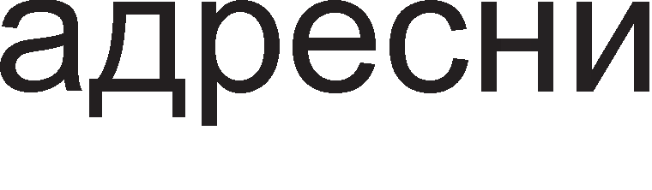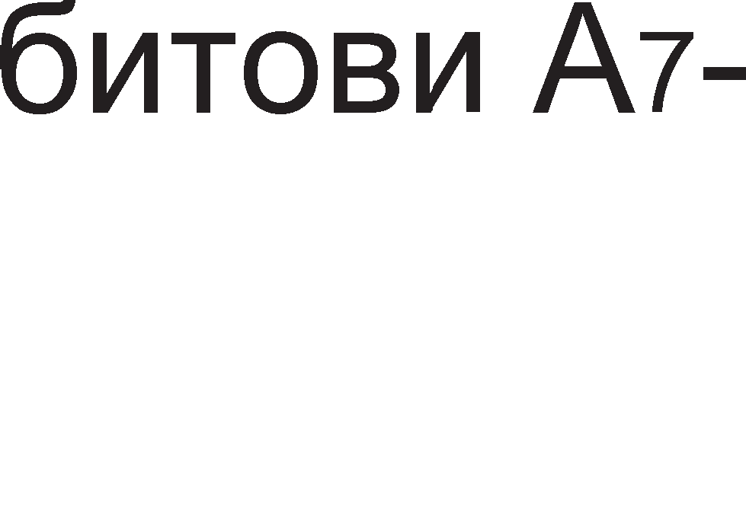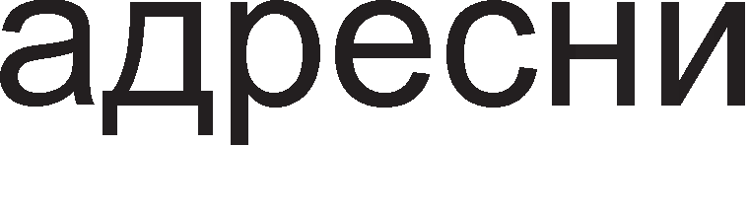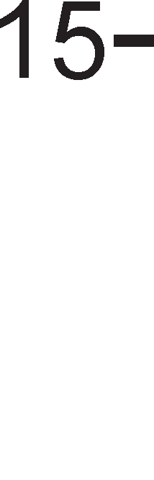

Cn1Ka 7.9. l/lHcTpyKL1cK1 L1Knyc 3a 1HcTpyKL1jaTa STA 8FFFH

Bo npB1oT Maw1HcK1 L1Knyc ce npeHecyBa onepaL1cK1oT Kop (npB1oT 6ajT) op MeMop1jaTa Bo M1KponpoLecopoT. Toj ce cMecTyBa Bo 1HcTpyKL1cK1oT pefl1cTap 1 ce Bpw1 peKop1pal-be. Bo BTop1oT Maw1HcK1 L1nKyc ce npeHecyBaaT appecH1Te 61ToB1 op A0 po A7 (BTop1oT 6ajT) op MeMop1jaTa Bo M1KponpoLecopoT. T1e ce cMecTyBaaT Bo appecH1oT pefl1cTap (address latch). Bo TpeT1oT Maw1HcK1 L1Knyc 1cTaTa nocTanKa ce noBTopyBa caMo 3a noB1coK1Te appecH1 61ToB1 op A8 po A15 (TpeT1oT 6ajT). KoHeL1Ho Bo L1eTBpT1oT Maw1HcK1 L1Knyc copp>K1HaTa op aKyMynaTopoT ce npeHecyBa Bo Ha3HaL1eHaTa MeMop1cKa noKaL1ja.

Kaj **perMcTapcKoTo MH,qMpeKTHo a,qpecMpa1-e** pefl1cTapcK1oT nap HL ja copp>K1 appecaTa Ha MeMop1cKaTa noKaL1ja Bo Koja e cMecTeH caKaH1oT nopaToK. np1Mep 3a pefl1cTapcKo 1Hp1peKTHo appec1pal-be e 1HcTpyKL1jaTa MOV A, M, co Koja ce 3eMa nopaToKoT op MeMop1cKaTa noKaL1ja co appeca Bo pefl1cTapcK1oT nap HL 1 ce Kon1pa Bo aKyMynaTopoT.

# LlHcTpyK4McKo MHo>KecTeo

l/lHcTpyKL1cKo MHo>KecTBo Ha 8085 M1KponpoLecopoT e cocTaBeHo op 246 1HcTpyKL11, Ho 3a noL1eToK i<e ce 3ano3HaeMe caMo co 40 noBa>KH1 1HcTpyKL11. 3a ceKoja op HaBepeH1Te 1HcTpyKL11 ce papeH1 cnepH1Be 1HcpopMaL11: ecpeKToT wTo flo npep13B1KyBa Taa 1HcTpyKL1ja, onepaL1cK1oT Kop, floneM1HaTa Ha 1HcTpyKL1jaTa 13pa3eHo Bo 6poj Ha 6ajT1 1 HaL11HoT Ha np1MeHeTo appec1pal-be. l/lcTo TaKa, no o6jacHyBal-beTo Ha 1HcTpyKL1jaTa, papeH e Man np1Mep-13BapoK op HeKoja aceM6nepcKa npoflpaMa. Bo oB1e np1Mep1 ce papeH1 cnepH1Be 1HcpopMaL11:

* + - Appeca Ha MeMop1cKa noKaL1ja 3apapeHa Bo XeKcapeL1ManeH c1cTeM (epHa L1cppa Bo XeKcapeL1ManeH c1cTeM e eKB1BaneHTHo Ha 4 L1cpp1 Bo 61HapeH 6poeH c1cTeM).
    - Copp>K1HaTa Ha MeMop1cKaTa noKaL1ja Koja e npeTXopHo appec1paHa.
    - l/lHcTpyKL1ja 3apapeHa Bo aceM6nep
    - KoMeHTap

## LlHcTpyK4MM 3a npeHoc Ha no,qaTo4M

Co epeH npeHoc Mo>Ke pa ce npeHece 1HcpopMaL1ja op caMo epeH 6ajT. Kaj oB1e 1HcTpyKL11 ce cpei<aBaaT no1M1Te 13Bop (source) 1 Len (destination). Op 13BopoT ce 3eMa nopaToKoT 1 ce cTaBa Bo LenTa. npeHocoT Ha nopaToL1 Mo>Ke pa ce Bpw1 Ha penaL1ja pefl1cTap-pefl1cTap, pefl1cTap-MeMop1cKa noKaL1ja 1n1 MeMop1cKa noKaL1ja-pefl1cTap. npeKy aceM6nepcKa 1HcTpyKL1ja He Mo>Ke pa ce 13Bpw1 p1peKTeH npeHoc op epHa MeMop1cKa noKaL1ja Bo ppyfla, opHocHo co ppyfl1 36opoB1, nopaToKoT op npBaTa noKaL1ja Mopa pa ce npecppn1 Bo HeKoj pefl1cTap Bo M1KponpoLecopoT, a noToa op M1KponpoLecopoT Bo BTopaTa noKaL1ja. np1 npeHocoT nopaToKoT ocTaHyBa He13MeHeT. l/lHTepecHo e pa ce Haflnac1 peKa no 13BpweH1oT TpaHccpep copp>K1HaTa Ha 13BopoT Ha nopaToK e 1cTa co copp>K1HaTa Ha LenTa. BcywHocT, Mo>KeMe pa Ka>KeMe peKa HaMecTo npeHoc Bpw1Me Kon1pal-be Ha nopaToKoT. CenaK, KaKo TepM1H He ce Kop1cT1 36opoT Kon1pal-be, TyKy 36opoT npeHoc.

##### MVI r, no,qaToK

|  |  |
| --- | --- |
| <lyHKL1ja | nopaToKoT ce cMecTyBa Bo pefl1cTapoT r |
| OnepaL1cK1 Kop | 00DDD110 |
| 6poj Ha 6ajT1 | 2 6ajT1 |
| AppeceH HaL11H | HenocpepHo appec1pal-be |

6yKBaTa D e npBa 6yKBa op aHfln1cK1oT 36op destination wTo Bo npeBop 3HaL11 Len, pecT1HaL1ja. Kaj oBaa 1HcTpyKL1ja Len 3a nopaToKoT npecTaByBa HeKoj onwT pefl1cTap, L11j Tp1-61TeH Kop DDD flo oppepyBaMe co noMow Ha Ta6enaTa 7.1.

##### npMMep 7.5:

8200 3E MVI A ,9EH ;XeKcapeL1ManH1oT 6poj 9EH cMecT1 flo Bo

**;**aKyMynaTopoT

8201 9E ;nopaToK

**MOV r2, r1** 1n1 MOV destination, source

|  |  |
| --- | --- |
| <lyHKL1ja | Copp>K1HaTa op pefl1cTapoT r1 ce Kon1pa Bo pefl1cTapoT r2 |
| OnepaL1cK1 Kop | 01DDDSSS (D-destination , S-source) |
| 6poj Ha 6ajT1 | 1 6ajT |
| AppeceH HaL11H | Pefl1cTapcKo p1peKTHo |

##### npMMep 7.6:

8150 26 MVI H, 00H ;Pefl1cTapoT H flo nonH1Me co BpepHocT Hyna. 8151 00 ;nopaToK

8152 6C MOV L, H ;Copp>K1HaTa op pefl1cTapoT H ce Kon1pa Bo

; pefl1cTapoT L.

**LDA adr (LOAD** –nonHel-be)

|  |  |
| --- | --- |
| <lyHKL1ja | Copp>K1HaTa op noKaL1jaTa co appeca adr ce npeHecyBa Bo aKyMynaTopoT |
| OnepaL1cK1 Kop | 00111010 |
| 6poj Ha 6ajT1 | 3 6ajTa |
| AppeceH HaL11H | A1peKTHo appec1pal-be |

##### npMMep 7.7:

8200 3A LDA 81C0H ;Copp>K1HaTa op noKaL1jaTa co appeca 81C016 ce

;Kon1pa Bo aKyMynaTopoT.

8201 C0 ;Appeca A7-A0

8202 81 ;Appeca A15-A8

8203 6F MOV L,A ;Copp>K1HaTa op aKyMynaTopoT ce Kon1pa Bo

;pefl1cTapoT L.

**STA adr** (**STORE**- cKnap1pa, o6paTHo op **LDA**)

|  |  |
| --- | --- |
| <lyHKL1ja | Copp>K1HaTa op aKyMynaTopoT ce Kon1pa Bo MeMop1cKa noKaL1ja co appeca adr |
| OnepaL1cK1 Kop | 00110010 |
| 6poj Ha 6ajT1 | 3 6ajTa |
| AppeceH HaL11H | A1peKTHo appec1pal-be |

##### npMMep 7.8 :

8200 3E MVI A,55H ;AKyMynaTopoT ce nonH1 co nopaToK 55H. 8201 55 ;nopaToK

8202 32 STA 8330H ;Copp>K1H1Te op aKyMynaTopoT ce Kon1paaT Bo

; noKaL1jaTa co appeca 8330.

8203 30 ; A7-A0

8204 83 ; A15-A8

##### IN adr

|  |  |
| --- | --- |
| <lyHKL1ja | 6ajToT op Bne3H1oT ypep co 1HTepcpejc appeca „adr“ ce npeHecyBa Bo aKyMynaTopoT |
| OnepaL1cK1 Kop | 11011011 |
| 6poj Ha 6ajT1 | 2 6ajTa |
| AppeceH HaL11H | HenocpepHo |

|  |  |  |  |
| --- | --- | --- | --- |
| **npMMep 7.9**  8000 | DB | IN 01H | ;nopaToKoT op Bne3H1oT ypep co 1HTepcpejc |
|  |  |  | ;appeca01H Kon1paj flo Bo aKyMynaTopoT. |
| 8001 | 01 |  | ;l/lHTepcpejc appeca |
| 8002 | 67 | MOV H,A | ;Copp>K1HaTa op aKyMynaTopoT Kon1paj ja Bo |
|  |  |  | ;pefl1cTapoT H. |

**OUT adr** (o6paTHo op **IN**)

|  |  |
| --- | --- |
| <lyHKL1ja | Copp>K1HaTa op aKyMynaTopoT ce Kon1pa Bo 13ne3H1oT ypep co 1HTepcpejc appeca „adr“ |
| OnepaL1cK1 Kop | 11010011 |
| 6poj Ha 6ajT1 | 2 6ajTa |
| AppeceH HaL11H | HenocpepHo appec1pal-be |

##### npMMep 7.10:

|  |  |  |  |
| --- | --- | --- | --- |
| 8200 | 3E | MVI A,55H | ;nopaToKoT 55H ce cMecTyBa Bo aKyMynaTopoT. |
| 8201 | 55 |  | ;nopaToK |
|  | 8202 | D3 OUT 02H | ;Copp>K1HaTa Ha aKyMynaTopoT ce Kon1pa Bo |
|  |  |  | ;ypep co 1HTepcpejc appeca 02. |
| 8203 | 02 |  | ;l/lHTepcpejc appeca |

* + 1. **ApMTMeTM"1KM MHcTpyK4MM**

XappBepcK1 Mo>KaT pa ce 13BpwaT pBe ap1TMeT1L1K1 onepaL11: co61pal-be 1 op3eMal-be. np1 13BpwyBal-beTo Ha oB1e onepaL11 epeH op onepaHp1Te ce Haora Bo aKyMynaTopoT, a ppyfl1oT Bo HeKoj ppyfl pefl1cTap Bo M1KponpoLecopoT. l/lcTo

TaKa, no 13BpwyBal-beTo Ha 1HcTpyKL1jaTa, po61eH1oT pe3ynTaT ce 3an1wyBa Bo aKyMynaTopoT co wTo ce fly61 epeH op onepaHp1Te.

##### ADD r (apMTMeTM"1Ko co6Mpa1-e)

|  |  |
| --- | --- |
| <lyHKL1ja | Copp>K1HaTa Ha pefl1cTapoT r ce popaBa Ha copp>K1HaTa Ha aKyMynaTopoT |
| OnepaL1cK1 Kop | 10000SSS |
| 6poj Ha 6ajT1 | 1 6ajT |
| AppeceH HaL11H | Pefl1cTapcKo p1peKTHo |
| 3HaMeHLa | Zero, carry |

**npMMep 7.11:**

8200 7C MOV A,H ;Copp>K1HaTa Ha pefl1cTapoT H ce Kon1pa Bo

;aKyMynaTopoT.

8201 85 ADD L ;Copp>K1HaTa Ha pefl1cTapoT L ce popaBa Ha

;copp>K1HaTa Ha aKyMynaTopoT.

8202 67 MOV H, A ;Copp>K1HaTa Ha aKyMynaTopoT ce Kon1pa Bo

;pefl1cTapoT H.

**SUB r** (**substract**-op3eMal-be)

|  |  |
| --- | --- |
| <lyHKL1ja | Copp>K1HaTa Ha pefl1cTapoT r ce op3eMa op copp>K1HaTa Ha aKyMynaTopoT |
| OnepaL1cK1 Kop | 10010SSS |
| 6poj Ha 6ajT1 | 1 6ajT |
| AppeceH HaL11H | Pefl1cTapcKo p1peKTHo |
| 3HaMeHLa | Zero, carry |

**INR r (increment** – 3floneM1) 1 **DCR r (decrrement** – HaMan1)

|  |  |
| --- | --- |
| <lyHKL1ja | Copp>K1HaTa Ha pefl1cTapoT ce 3floneMyBa/HaManyBa 3a epeH |
| OnepaL1cK1 Kop | 000DDD0100/00DDD101 |
| 6poj Ha 6ajT1 | 16ajT |
| AppeceH HaL11H | Pefl1cTapcKo p1peKTHo |

##### npMMep 7.12 :

8000 3A LDA 81D8H ;Copp>K1HaTa Ha noKaL1jaTa co appeca

;81D8H ce Kon1pa Bo aKyMynaTopoT.

8001 D8 ; A7-A0

8002 81 ; A15-A8

8003 3C INR A ;Copp>K1HaTa Ha aKyMynaTopoT ce

;3floneMyBa 3a epeH.

|  |  |  |  |
| --- | --- | --- | --- |
| 8004 | 32 | STA 81D8H | ;Copp>K1HaTa Ha aKyMynaTopoT ce Hoc1 co |
|  |  |  | ;appeca 81D8H. |
| 8005 | D8 |  | ; A7-A0 |
| 8006 | 81 |  | ; A15-A8 |

## norM"1KM onepa4MM

##### ANA r ( AND ACCUMULATOR)

|  |  |
| --- | --- |
| <lyHKL1ja | Bp3 copp>K1HaTa Ha aKyMynaTopoT 1 copp>K1HaTa Ha pefl1cTapoT „r“ ce np1MeHyBa nofl1L1KaTa onepaL1ja „l/l“ 1 pe3ynTaToT ce 3an1wyBa Bo aKyMynaTopoT |
| OnepaL1cK1 Kop | 10100SSS |
| 6poj Ha 6ajT1 | 1 6ajT |
| AppeceH HaL11H | Pefl1cTapcKo p1peKTHo |

**ORA r (OR ACCUMULATOR)**

|  |  |
| --- | --- |
| <lyHKL1ja | Bp3 copp>K1HaTa Ha aKyMynaTopoT 1 copp>K1HaTa Ha pefl1cTapoT „r” ce np1MeHyBa nofl1L1KaTa onepaL1ja „l/lnl/l“ |
| OnepaL1cK1 Kop | 10110SSS |
| 6poj Ha 6ajT1 | 1 6ajT |
| AppeceH HaL11H | Pefl1cTapKo p1peKTeH |

**CMA (Complement accumulator)**

|  |  |
| --- | --- |
| <lyHKL1ja | C1Te 61ToB1 Bo aKyMynaTopoT ce 1HBepT1paaT |
| OnepaL1cK1 Kop | 00101111 |
| 6poj Ha 6ajT1 | 1 6ajT |
| AppeceH HaL11H | Pefl1cTapcKo p1peKTHo |

**npMMep 7.13:**

8000 3A LDA 8250H ;Copp>K1HaTa op noKaL1jaTa co appeca 8250

;ce Kon1pa Bo aKyMynaTopoT.

8001 50 ; A7-A0

8002 82 ; A15-A8

8003 6F MOV L,A ;Copp>K1HaTa op aKyMynaTopoT ce Kon1pa Bo

;pefl1cTapoT L.

8004 3A LDA 8251H ;Copp>K1HaTa Ha noKaL1jaTa co appeca 8251

;ce Kon1pa Bo aKyMynaTopoT.

8005 51 ; A7-A0

8006 82 ; A15-A8

8007 A5 ANA L ;Ce npeMeHyBa nofl1L1Ka onepaL1ja „l/l“ Bp3

;copp>K1H1Te Ha aKyMynaTopoT 1 pefl1cTapoT L. 8008 32 STA 8252H ;Copp>K1HaTa op aKyMynaTopoT ce cMecTyBa Bo

; noKaL1ja co appeca 8252.

800A 52 ; A7-A0

800B 82 ; A15-A8

BcywHocT, co oBaa ceKBeHLa op 1HcTpyKL11 Bpw1Me nofl1L1Ka onepaL1ja

„Hl/l“ Bp3 copp>K1H1Te Ha noKaL11Te co appec1 8250H 1 8251H 1 po61eH1oT pe3ynTaT flo 3an1wyBaMe Bo noKaL1ja co appeca 8252H.

## LlHcTpyK4MM 3a poTa4Mja

Cnopep HacoKaTa, nocTojaT pBa B1pa poTaL11: poTaL1ja BneBo 1 poTaL1ja Bo pecHo. Bo 3aB1cHocT op Toa pan1 e BKnyL1eHo 3HaMeHLeTo C 1n1 He, poTaL1jaTa Mo>Ke pa 61pe npeKy 3HaMeHLeTo C 1n1 6e3 Heflo. Kaj c1Te 1HcTpyKL11 3a poTaL1ja ce poT1pa copp>K1HaTa Ha aKyMynaTopoT 1 H1epeH ppyfl pefl1cTap. nocTojaT pBe 1HcTpyKL11 3a poT1pal-be Ha pecHo.

**ROL(Rotate Left)** - PoTaL1jaTa HaneBo 3HaL11 noMecTyBal-be Ha c1Te 61ToB1 HaneBo, a HajneB1oT 1 Haj3HaL1aeH 61T ce 3aBpTyBa 1 ce Hoc1 Ha MecToTo op HaHej3HaL1ajH1oT, HajpecH1oT 61T. OBaa 1HcTpyKL1ja e np1Ka>KaHa Ha cn1Ka 7.10.

Cn1Ka 7.10. PoTaL1ja Ha aKyMynaTopoT HaneBo



**RRC (Rotate Right Carry)**PoTaL1jaTa HapecHo npeKy 3HaMeHLeTo C (carry) 3HaL11 noMecTyBal-be Ha 61ToB1Te HapecHo 3a epHo MecTo, co Toa wTo HajpecH1oT, HajHe3HaL1aeH 61T BneflyBa Bo 3HaMeHLeTo C, A BpepHocTa Ha 3HaMeHLeTo C ce Hoc1 Ha MecToTo op Haj3HaL1ajH1oT, HajneB 61T. OBa e np1K>KaHo Ha cn1Ka 7.11.

Cn1Ka 7.11. PoTaL1ja Ha aKyMynaTopoT HapecHo



##### npMMep 7.14 :

8140 DB IN 01H ;npeHec1 flo 6ajToT op Bne3H1oT ypep Bo

;aKyMynaTopoT.

8141 01 ;l/lHTepcpejc appea Ha Bne3HaTa nopTa

|  |  |  |  |
| --- | --- | --- | --- |
| 8142 | 0F | RRC | ;PoT1paj ja copp>K1HaTa Ha aKyMynaTopoT HapecHo. |
| 8143 | D3 | OUT 02 | ;npeHec1 ja copp>K1HaTa Ha aKyMynaTopoT Bo |
|  |  |  | ;ypepoT co 1HTepcpejc appca 02H. |
| 8143 | 02 |  | ;l/lHTepcpejc appeca |

## CKoK- MHcTpyK4MM (Jump-cKoK)

Pa3n1KyBaMe ycnoBH1 1 6e3ycnoBH1 cKoKoB1. Kofla M1KponpoLecopoT i<e po61e 1HcTpyKL1ja 3a 6e3ycnoBeH cKoK, Toj p1peKTHo cKoKa Ha MeMop1cKaTa noKaL1ja L11ja appeca e HaBepeHa Bo 1HcTpyKL1jaTa. Kaj ycnoBH1Te cKoKoB1, 3a pa ce 13Bpw1 cKoK, noTpe6Ho e npeTXopHo pa 61pe 1cnonHeT HeKoj ycnoB (Ha np1Mep, HeKoe op 3HaMeHLaTa pa 61pe Ha B1coKo H1Bo)

##### JMP adr

|  |  |
| --- | --- |
| <lyHKL1ja | HaBepeHaTa appeca ce Kon1pa Bo npoflpaMcK1oT 6pojaL1 |
| OnepaL1cK1 Kop | 11000011 |
| 6poj Ha 6ajT1 | 3 6ajTa |
| AppeceH HaL11H | A1peKTHo appec1pal-be |

**npMMep 7.15** :

8100 3E MVI A, 01H ;AKyMynaTopoT ce nonH1 co nopaToKoT

;0116=000000012.

8101 01 ;nopaToK

8102 D3 OUT 02H ;Copp>K1HaTa Ha aKyMynaTopoT ce Kon1pa

;Bo 13ne3Ha nopTa.

8103 02 ;l/lHTepcpejc appeca Ha Bne3HaTa nopTa 8104 07 ROL ;Copp>K1HaTa Ha aKyMynaTopoT ce poT1pa

;Bo neBo.

8105 C3 JMP 8102 H ;CKoK Ha noKaL1ja co appeca 81202 (ce

;Bpai<aMe Ha3ap).

8106 02 ; A7-A0

8107 81 ; A15-A8

OBaa npoflpaMcKa ceKBeHLa ce Kop1cT1 3a nocT1flHyBal-be Ha ecpeKToT

„nopB1>KHo cBeTno“ Kaj p1cnnej cocTaBeH op 8 non1l-ba.

**JZ adr** (JUMP if ZERO-cKoKH1 aKo 3HaMeHLeTo Hyna e ep1H1La-ycnoBeH cKoK)

|  |  |
| --- | --- |
| <lyHKL1ja | HaBepeHaTa appeca Bo 1HcTpyKL1jaTa ce Kon1pa Bo npoflpaMcK1oT 6pojaL1 aKo 3HaMeHLeTo Hyna e 1. |
| OnepaL1cK1 Kop | 11001010 |
| 6poj Ha 6ajT1 | 3 6ajT1 |
| AppeceH HaL11H | A1peKTHo appec1pal-be |

##### npMMep 7.16 :

8200 7C MOV A, H ;Copp>K1HaTa Ha pefl1cTapoT H Kon1paj ja Bo

;aKyMynaTopoT.

8201 95 SUB L ;Copp>K1HaTa Ha pefl1cTapoT L ce op3eMa op

;aKyMynaTopoT.

8202 CA JZ 8266H ;aKo pe3ynTaToT e Hyna, cKoKH1 Ha appecaTa

;8266.

8203 66 ; A7-A0

8204 82 ; A15-A8

8205 XX

Bo oBaa npoflpaMcKa ceKBeHLa ce Bpw1 cnopep6a Mery copp>K1H1Te Ha pefl1cTp1Te 1 aKo oB1e pBe copp>K1H1 ce epHaKB1, ce Bpw1 cKoK.

**JNZ adr** (jump if not zero)

|  |  |
| --- | --- |
| <lyHKL1ja | CKoK ce Bpw1 aKo 3HaMeHLeTo Ha Hyna e Ha H1cKo H1Bo |
| OnepaL1cK1 Kop | 11000010 |
| 6poj Ha 6ajT1 | 3 6ajTa |
| AppeceH HaL11H | A1peKTHo appec1pal-be |

##### npMMep 7.17:

|  |  |  |  |
| --- | --- | --- | --- |
| 8300 | 26 | MVI H,47H | ;HanonH1 flo pefl1cTapoT H co BpepHocTa 4716 |
| 8301 | 47 |  | ;nopaToK (BpepHocT). |
| 8302 | 25 | DCR H | ;HaMan1 ja copp>K1HaTa Ha pefl1cTapoT 3a epeH. |
| 8303 | C2 | JNZ 8302H | ;AKo po61eH1oT pe3ynTaT cè ywTe He e Hyna, |
|  |  |  | ;BpaT1 ce Ha noKaL1jaTa co appeca 8302H. |
| 8304 | 02 |  | ; A7-A0 |
| 8305 | 83 |  | ; A15-A8 |

OBaa npoflpaMcKa ceKBeHLa, BcywHocT, npeTcTaByBa 6pojaL1, L11ja BpepHocT Bo ceKoj L1eKop ce HaManyBa 3a epeH.

## LlHcTpyK4MM 3a pa6oTa co noTnporpaMM

noTnpoflpaMaTa 3HaL11 He3aB1cHa npoflpaMcKa Len1Ha Koja 13BpwyBa oppepeHa cpyHKL1ja. OB1e noTnpoflpaM1 Mo>Ke pa 61paT ynoTpe6H1 Bo noBei<e flnaBH1 npoflpaM1.

**RET** – OBaa 1HcTpyKL1ja o3HaL1yBa Kpaj Ha noB1KaHaTa noTnpoflpaMa 1 Bpai<al-be KoH flnaBHaTa noTnpoflpaMa.

**HLT** (halt) – OBaa 1HcTpyKL1ja Tpe6a ceKoflaw pa 61pe nocnepHa 1HcTpyKL1ja Bo npoflpaMaTa 3a pa M1KponpoLecopoT npaB1nHo ce nopfloTB1 3a 13BpwyBal-be Ha npoflpaMaTa. 6e3 oBaa 1HcTpyKL1ja, M1KponpoLecopoT i<e ce o61pyBa pa fl1

npoTonKyBa copp>K1H1Te 1 Ha cnepH1Te MeMop1cK1 noKaL11 1 Toflaw Mo>Ke pa pojpe po Xaoc.

##### CALL adr

|  |  |
| --- | --- |
| <lyHKL1ja | Co oBaa 1HcTpyKL1ja flnaBHaTa npoflpaMa ja noB1KyBa noTnpoflpaMaTa pa 61pe 13BpeweHa Bo M1KponpoLecopoT. HaBepeHaTa appeca npeTcTaByBa appeca 3a npBaTa noKaL1ja op Koja noL1HyBa noTnpoflpaMaTa. |
| OnepaL1cK1 Kop | 11001101 |
| 6poj Ha 6ajT1 | 3 6ajTa |
| AppeceH HaL11H | A1peKTHo appec1pal-be |

**npMMep 7.18:**

rnaBHa npoflpaMa

8000 26 MVI H,33H ;HanonH1 flo pefl1cTapoT H co nopaToKoT 33H 8001 33 ;nopaToK.

8002 2F MVI L,8FH ;HanonH1 flo pefl1cTapoT L co nopaToKoT 8FH 8003 8E ;nopaToK.

8004 CD CALL 8081H ;noB1KyBal-be Ha noTnpoflpaMaTa co noL1eTHa

;appeca 8010H.

8005 10 ; A7-A0

8006 80 ; A15-A8

8007 32 STA 8300H ;BHec1 flo po61eH1oT pe3ynTaT Bo noKaL1jaTa

;8300H.

8008 00 ; A7-A0

8009 83 ; A15-A8

800A 76 HLT ;Kpaj Ha npoflpaMaTa 800B XX

noTnpoflpaMa

8010 7C MOV A,H ;Copp>K1HaTa Ha pefl1cTapoT ce Kon1pa Bo

; aKyMynaTopoT.

8011 85 ADD L ;Ha copp>K1HaTa Ha aKyMynaTopoT popaj ja BpepHocTa

; pefl1cTapoT L.

8012 C9 RET ;BpaT1 ce Ha flnaBHaTa npoflpaMa.

## LlHcTpyK4MM 3a pa6oTa Ha cTeK MeMopMja

OB1e 1HcTpyKL11 ce Kop1cTaT Kofla caKaMe pa npeM1HeMe op flnaBHa npoflpaMa Bo HeKoja noTnpoflpaMa. AKyMynaTopoT 1 cTaTyc-pefl1cTapoT ce paBaaT Ha pacnonaflal-be Ha noTnpoflpaMaTa. npep pa noL1He 13BpwyBal-beTo Ha

noTnpoflpaMaTa, BpepHocTa Ha oB1e pBa pefl1cTpa Tpe6a pa ce 3aL1yBa, 61peji<1 T1e i<e 61paT noTpe6H1 Kofla M1KponpoLecopoT i<e ce BpaT1 Bo flnaBHaTa npoflpaMa. BpepHocTa Ha aKyMynaTopoT 1 cTaTyc-pefl1cTapoT ce cMecTyBaaT Ha BpBoT op cTeKoT. Kofla M1KponpoLecopoT i<e 3aBpw1 co noTnpoflpaMaTa, T1e i<e 61paT naK BpaTeH1 Bo M1KponpoLecopoT.

**PUSH PSW** – BpepHocTa Ha aKyMynaTopoT 1 cTaTyc-pefl1cTapoT ce cMecTyBa Ha BpBoT op cTeKoT

**POP PSW** - 3aL1yBaH1Te copp>K1H1 Ha aKyMynaTopoT 1 Ha cTaTyc-pefl1cTapoT ce c1MHyBaaT op BpBoT Ha cTeKoT Bo pefl1cTp1Te Bo M1KponpoLecopoT.

##### npMMep 7.19:

|  |  |  |  |
| --- | --- | --- | --- |
| 823C | F5 | PUSH PSW | ;3aL1yBaj ja copp>K1HaTa Ha |
|  |  |  | ;aKyMynaTopoT 1 cTaTyc pefl1cTapoT |
|  |  |  | ;Ha BpBoT op cTeKoT. |
| 823D | CD | CALL 82E0H | ;noB1Kaj ja noTnpoflpaMaTa co noL1eTHa |
|  |  |  | ;appeca 82E0H. |
| 823E  823F  8240 | E0 82 F1 | POP PSW | ; A7-A0  ;A15-A8  ;BpaT1 fl1 copp>K1H1Te Ha |
|  |  |  | ;aKyMynaTopoT 1 cTaTyc pefl1cTapoT. |

* 1. **nMwyea1-e Ha nporpaMM 3a MMKponpo4ecop 8085**

no ceKoja 1HcTpyKL1ja, **e,qeH o,q onwTMTe perMcTpM i<e ja cMeHM ceojaTa co,qp>KMHa**. Kaj nofloneM 6poj 1HcTpyKL11 Toa e aKyMynaTopoT (LDA ,STA, ADD, SUB, ANA, ORA, CMA, ROL, RRC) , Ho Mo>Ke pa 61pe 1 HeKoj ppyfl pefl1cTap (INC r, DCR r , MOV r1,r2 MVI r,data). Bo np1Mep1Te wTo cnepyBaaT no 13BpwyBal-beTo Ha ceKoja 1HcTpyKL1ja ce yTBppyBa copp>K1HaTa Ha ynoTpe6eH1Te onwT1 pefl1cTp1.

**npMMep 7.20:** AapeH1 ce copp>K1H1Te Ha pefl1cTp1Te A=76H 1 B=D4H. npecMeTaj ja H1BHaTa copp>K1Ha no 13BpwyBal-beTo Ha cnepH1Be 1HcTpyKL11:

AND B CMA DCR B

PeweH1e:

Bp3 copp>K1H1Te Ha pefl1cTp1Te A= 01110110B , B=11010100H ce np1MeH1Ba nofl1L1Ka onepaL1ja l/l.

 



MoMeHTanHa copp>K1Ha Ha pefl1cTp1Te: A=01010100B, B=11010100B (pefl1cTapoT B ocTaHan 1cT)

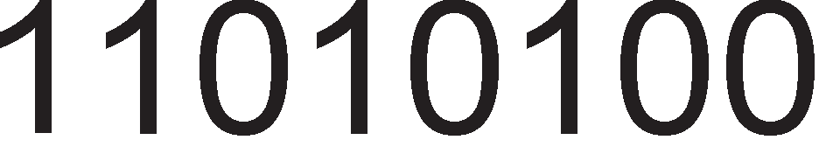

Ce npecMeTyBa npB KoMnneMeHT Ha copp>K1HaTa Ha pefl1cTapoT A=01010100B.

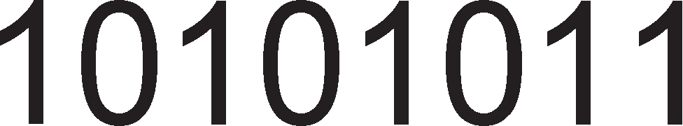



MoMeHTanHa copp>K1Ha Ha pefl1cTp1Te : A= 10101011B ,B=11010100B

BpepHocTa Ha pefl1cTapoT B=11010100B ce HaManyBa 3a epeH

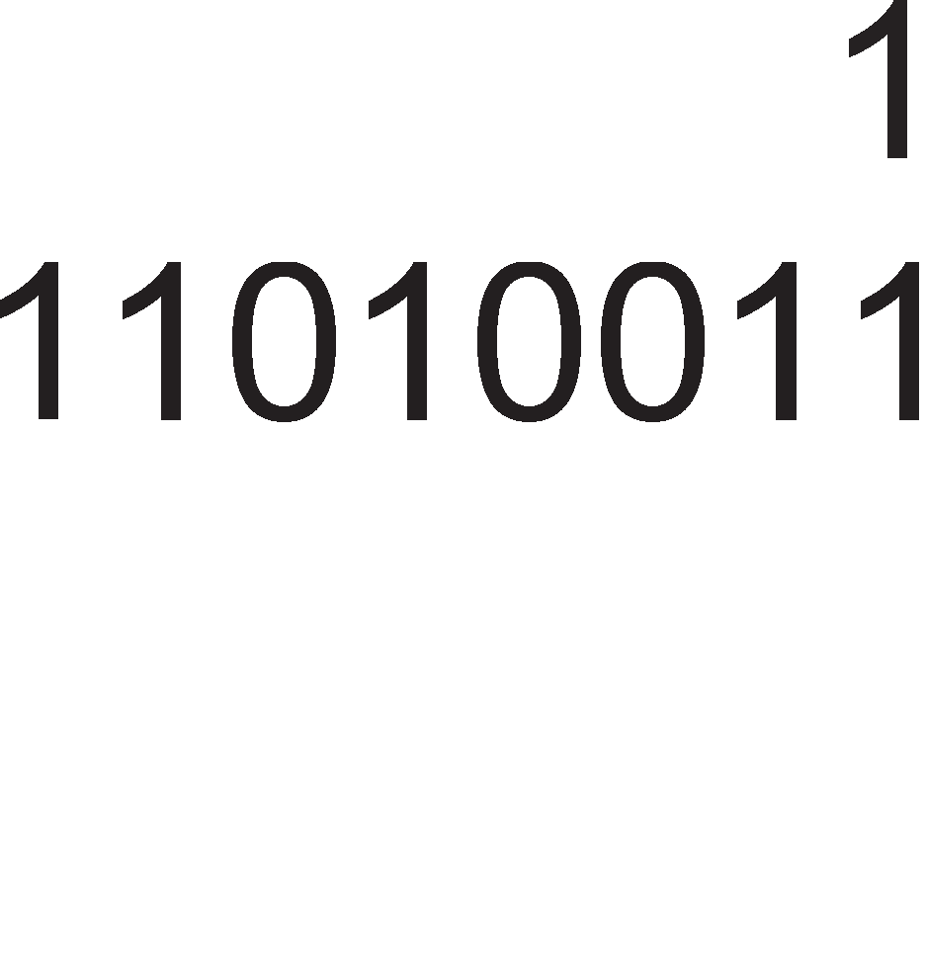

 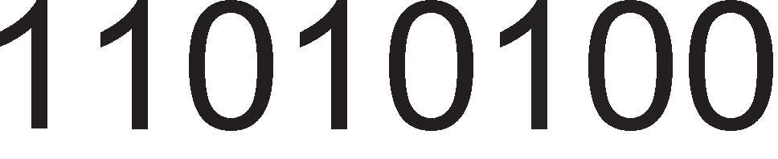

KpajHo peweH1e: A=100101011B, B=11010011B

**npMMep 7.21**: npecMeTaj ja copp>K1HaTa Ha pefl1cTp1Te A 1 E nocne 13BpwyBal-beTo Ha cnepH1Te 1HcTpyKL11!

MVI A,A3H MVI E,9EH SUB E

PeweH1e:

Ha noL1eToKoT copp>K1HaTa Ha pefl1cTp1Te e Heno3HaTa. npeKy 1HcTpyKL1jaTa MVI Ha pefl1cTp1Te 1M ce 3apaBaaT oppepeH1 BpepHocT1.

MVI A, A3H MVI E,9EH

A=A3H=10100011B, E=9EH=10011110B

Op copp>K1HaTa Ha pefl1cTapoT A ce op3eMa copp>K1HaTa Ha pefl1cTapoT E.

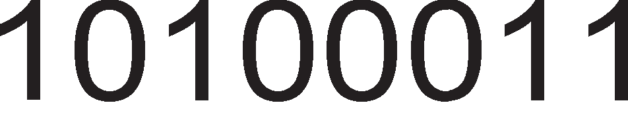



KpajHo peweH1e: A=00000101B, E=10011110B (ocTaHano 1cTo)



**npMMep 7.22**: npecMeTaj ja copp>K1HaTa Ha npoflpaMcK1oT 6pojaL1 no 13BpwyBal-beTo Ha cnepHaBa npoflpaMcKa ceKBeHLa. Ha noL1eToKoT op npoflpaMcKaTa ceKBeHLa BpepHocTa Ha npoflpaMcK1oT 6pojaL1 13HecyBa 8000H.

MVI A,65H MVI B,D8H ORA B

STA 1234H

PeweH1e:

Bo oBoj np1Mep e Ba>KHo pa ce no3HaBaaT 1HcTpyKL1cK1Te cpopMaT1 Ha np1MeHeT1Te 1HcTpyKL11. AKo TeKoBHaTa 1HcTpyKL1ja e op npB cpopMaT, Toflaw Ha copp>K1HaTa Ha npoflpaMcK1oT 6pojaL1 ce popaBa epeH 3a pa ce po61e appecaTa Ha cnepHaTa 1HcTpyKL1ja. AKo TeKoBHaTa 1HcTpyKL1ja e op BTop cpopMaT, Toflaw ce popaBa pBa, a aKo e op TpeT cpopMaT, ce popaBa Tp1.

copp>K1Ha Ha npoflpaMcK1 6pojaL1

1HcTpyKL1ja KoMeHTap

8000H MVI A,65H OBaa 1HcTpyKL1ja e op BTop cpopMaT. Ha

copp>K1HaTa Ha npoflpaMcK1oT 6pojaL1 popaBaMe pBa. 8000+2=8002H

8002H MVI B,D8H 8002+2=8004H

8004H ORA B OBaa 1HcTpyKL1ja e op npB cpopMaT. AopaBaMe epeH. 8004+1=8005H

8005H

8008H

STA 1234H OBaa 1HcTpyKL1ja e op TpeT cpopMaT. AopaBaMe Tp1. 8005+3=8008H

3HaL11 no 13BpwyBal-beTo Ha papeHaTa npoflpaMcKa ceKBeHLa, BpepHocTa Ha npoflpaMcK1oT 6pojaL1 13HecyBa 8008H.

## CocpTeep 3a pery11a4Mja Ha coo6pai<aj Ha e,qHocTaeHa pacKpcHM4a

C1Te cMe 3a6ene>Kane co KaKBa p1HaM1Ka ce nanaT cBeTnaTa Ha ceMacpop1Te. no LpBeHoTo cBeTno 3aepHo cBeTaT LpBeHo 1 >KonTo cBeTno, a noToa ce nan1 3aneHoTo. no 3eneHoTo cBeTno cBeT1 caMo >KonToTo 3a noToa pa cBeTHe LpBeHoTo. WTo ce opHecyBa po ceMacpop1Te 3a newaL1 3eneHoTo cBeTno cBeT1 caMo Kofla Ha ceMacpopoT 3a aBToMo61n1 cBeT1 LpBeHo cBeTno. 3a pa 61pe noKp1eHa LenaTa pacKpcH1La, noTpe6eH e ywTe epeH BaKoB c1cTeM Koj i<e ce nocTaB1 p1jafloHanHo Ha c1cTeMoT np1Ka>KaH Ha cn1KaTa 7.12.

npoflpaMaTa wTo ce Kop1cT1 e cocTaBeHa op pBa pena. npB1oT pen e co floneM1Ha op 6B 1 fl1 copp>K1 **no,qaTo4MTe wTo Tpe6a ,qa ce npeHecaT Ha M311e3HaTa nopTa.** n1HoB1Te op 13ne3HaTa nopTa ce noBp3aH1 co cBeTnaTa Ha ceMacpop1Te 1 Kofla Ha n1HoT i<e pojpe nofl1L1Ka ep1H1La, cBeTnoTo cBeT1.

LIGHT_LOC npeTcTaByBa c1M6on1L1Ho 1Me, na6ena 3a appecaTa Ha npBaTa noKaL1ja Bo Koja e cMecTeH npB1oT nopaToK.



Cn1Ka 7.12. np1Ka3 Ha cBeTnaTa Ha ceMacpopoT 1 H1BHoTo 6ene>Kel-be

3a6enewKa: AoKonKy BawaTa c1MynaL1ja He noppp>KyBa na6en1, Toflaw 3apapeTe ja appecaTa KaKo 16-61TeH 6poj 1n1 L1eT1p1L1cppeH XeKcapeL1ManeH 6poj.

|  |  |  |  |  |  |
| --- | --- | --- | --- | --- | --- |
| ceMacpop1 1 newaL1  6o1 Ha cBeTna | S1 CZZ | S2 CZZ | P1 C | P2 C |  |
| Light_loc: | 001 | 100 | 1 | 0 | (1min) |
|  | 010 | 100 | 1 | 1 | (3sec) |
|  | 100 | 110 | 1 | 1 | (3sec) |
|  | 100 | 001 | 0 | 1 | (1min) |
|  | 100 | 010 | 1 | 1 | (3sec) |
|  | 110 | 100 | 1 | 1 | (3sec) |

**BTopMoT ,qe11** op npoflpaMaTa **rM co,qp>KM MHcTpyK4MMTe** wTo Tpe6a pa fl1 npeHecaT nopaToL1Te op npB1oT pen po 13ne3H1Te n1HoB1. Ha noL1eToKoT, co pBeTe 1HcTpyKL11 MVI ce BHecyBa appecaTa Ha npB1oT 6ajT op nopaToL1H1oT pen Bo pefl1cTapcK1oT nap HL. Co 1HcTpyKL1jaTa MOV A,M appecaTa op HL napoT ce Hoc1 po MeMop1jaTa, ce npoHaora caKaH1oT 6ajT 1 ce cMecTyBa Bo aKyMynaTopoT. Co 1HcTpyKL1jaTa CALL DOCNI 1 M1H. ce 3app>KyBa copp>K1HaTa Ha aKyMynaTopoT epHa M1HyTa KonKy wTo Tpe6a pa cBeT1 LpBeHoTo 1 3eneHoTo cBeTno. AKo He ce noB1Ka oBaa noTnpoflpaMa, copp>K1HaTa Ha aKyMynaTopoT MHofly 6p3o i<e ce npoMeH1 (3a BpeMe op HeKonKy ns) wTo He e poBonHo BpeMe pa ce 3ananaT cBeTnaTa Ha ceMacpopoT. Bo cnepH1oT L1eKop (INX H) copp>K1HaTa Ha

pefl1cTpacK1oT nap ce 3floneMyBa 3a epeH, co wTo ja po61BaMe appecaTa Ha BTop1oT 6ajT 01010011 op nopaToL1H1oT pen. nocTanKaTa 3a npeHoc Ha 6ajT op MeMop1jaTa Bo aKyMynaTopoT, a noHaTaKa po 13ne3HaTa nopTa ce noBTopyBa wecTnaT1 (3a ceKoj 6ajT op nopaToL1H1oT pen noce6Ho). Ha KpajoT, co 1HcTpyKL1jaTa JUMP VRTI ceBo oBa noBTopHo ce noBTopyBa, opHocHo Ha ceMacpopoT S1 i<e cBeT1 3eneHoTo cBeTno, a Ha S2 LpBeHoTo cBeTno.

vrti: MVI H,LIGHT

MVI L,LOC MOV A,M OUT PORT A JNX H

MOV A,M OUT PORT A CALL DOCNI_3sec

.

------- INX H MOV A,M

OUT PORT A CALL DOCNI_3sec JUMP VRTI

## 7.6.2 KoMnapa4Mja Ha Ko,qoeM

Ha 13ne3HaTa nopTa op KoMnjyTepoT ce noBp3aH1 8 nep p1op1. A1op1Te ce 3eneH1 1 LpBeH1, Ha13MeH1L1Ho HapepeH1 epHa po ppyfla.

RGRGRGRG G-green R-red

A1op1Te cBeTHyBaaT aKo Ha H1BH1Te n1HoB1 ce poHecaT nofl1L1K1 ep1H1L1. Ha Bne3HaTa nopTa op cMeTaL1oT napanenHo ce noBp3aH1 8 npeK1HyBaL11. AKo npeK1HyBaL1oT e 3aTBopeH, Toflaw n1HoT ce noBp3yBa co Maca 1 1MaMe cocToj6a Ha nofl1L1Ka Hyna, a Kofla Toj e oTBopeH n1HoT e noBp3aH Ha HanojyBal-be 1 1MaMe cocToj6a Ha nofl1L1Ka ep1H1La. 8-61THaTa KoM61HaL1ja op Bne3HaTa nopTa ce cnopepyBa co copp>K1HaTa Ha MeMop1cKaTa noKaL1ja co appeca 8250. AKo pBaTa 6ajTa ce epHaKB1, Toflaw ce nanaT 3eneH1Te p1op1, a aKo He, LpBeH1Te. KoMnapaL1jaTa ce Bpw1 npeKy op3eMal-be Ha pBaTa 6poja. AKo T1e ce 1cT1, Toflaw pe3ynTaToT e Hyna 1 ce aKT1B1pa 3HaMeHLeTo ZERO.

LDA 8250 ;Op noKaL1jaTa co appeca 8250 nopaToKoT ce npeHecyBa

MOV H,A

;Bo aKyMynaTopoT.

;nopaToKoT op aKyMynaTopoT ce npeHecyBa Bo

;pefl1cTapoT H co Len pa ce 3awT1T1.Co cnepHaTa

;1HcTpyKL1ja copp>K1HaTa Ha aKyMynaTopoT Mo>Ke pa ce

;cMeH1 1 nopaToKoT pa 61pe 13fly6eH.

8204 IN 01H ;nopaToKoT ce npeHecyBa op aKyMynaTopoT po 13ne3HaTa

;nopTa co appeca 01H.

SUB H JZ 8211 MVI A,AA OUT 02

JMP 8204

8211 MVI A,55

OUT 02

RST7

;AKo 61pe ycnewHa KoMnapaL1jaTa ce aKT1B1pa

;3HaMeHLeTo ZERO 1 ce Bpw1 cKoK Ha noKaL1ja co

;appeca 821. CBeTHyBaaT 3eneH1Te p1op1 1 npoflpaMaTa

;3aBpwyBa.

;AKo KoMnapaL1jaTa e HeycnewHa, 3HaMeHLeTo ocTaHyBa

;Ha H1cKo H1Bo, He ce Bpw1 cKoK, TyKy ce 13BpwyBa

;cnepHaTa 1HcTpyKL1ja MVI A,AAH. 6pojoT AAH=

;10101010B ce npeHecyBa Bo aKyMynaTopoT, a oTTaMy Ha

;13ne3HaTa nopTa. Ep1H1L1Te Bo 6pojoT 10101010 1MaaT

;1cT1 no31L11 KaKo 1 LpBeH1Te p1op1 Ha 13ne3HaTa

;nopTa. Kofla i<e ce 3ananaT LpBeH1Te nep p1op1 ce Bpw1

;6e3ycnoBeH cKoK 8204 1 noBTopHo ce poHecyBa HoBa

;KoM61HaL1ja npeKy Bne3H1Te npeK1HyBaL11.

# LlHTerpMpaHM KoMnoHeHTM 3a MMKpoKoMnjyTepcKM cMcTeM 8085

no nojaBaTa Ha M1KponpoLecopoT 8085, „l/lHTen“ p13ajH1pawe HoB1 1HTeflp1paH1 KoMnoHeHT1, Ko1 6ea LenocHo KoMnaT161nH1 co M1KponpoLecopoT 8085. OB1e 1HTeflp1paH1 KoMnoHeHT1 nocpepyBaaT Bo KoMyH1KaL1jaTa Mery M1KponpoLecopoT 1 nep1cpepH1Te ypep1. T1e ce no3HaT1 nop 1MeTo KoHTponep1, 61pejK1 flo KoHTpon1paaT npeHocoT Ha nopaToL1 op nep1cpepH1oT ypep po M1KponpoLecopoT 1n1 o6paTHo. KpajHo HenpaKT1L1Ho 61 61no M1KponpoLecopoT 1 nep1cpepH1oT ypep pa 61paT p1peKTHo noBp3aH1. l/lHTepcpejc-KoMnoHeHT1Te Mo>KaT pa 61paT HenpoflpaM161nH1 1 npoflpaM161nH1. **nporpaMM6M11HMTe** KoMnoHeHT1 copp>KaT HeKonKy 6ajT1 MeMop1ja (epeH 1n1 noBei<e), L11ja copp>K1Ha ja oppepyBa caM1oT npoflpaMep. Ha np1Mep, nocTo1 61T wTo oppepyBa pan1 ocyMTe n1Ha Ha nopTaTa A op 1HTepcpejc-KoMnoHeHTaTa i<e 61paT Bne3H1 1n1 13ne3H1 (ep1H1La 3a Bne3 1n1 Hyna 3a 13ne3). np1 noBp3yBal-beTo Ha Bne3H1Te ypep1 co M1KponpoLecopoT Mopa pa ce o6e36ep1 nopaToL1Ho 6acpep1pal-be. 6acpep1pal-beTo 3HaL11 noBp3yBal-be Ha nep1cpepH1oT ypep co nopaToL1HaTa

Mafl1cTpana Ha M1KponpoLecopoT caMo 3a BpeMe Ha 1HcTpyKL1jaTa IN. 6acpep1Te Mo>KaT pa 61paT pen op npoflpaM161nH1Te 1HTepcpejc-KoMnoHeHT1 1n1 pa 61paT noce6H1 1HTeflp1paH1 Kona. np1 noBp3yBal-beTo Ha 13ne3H1Te ypep1 co M1KponpoLecopoT ce Kop1cTaT neL1oB1 Ko1 Tpe6a pa flo npopon>KaT BpeMeTpael-beTo Ha nopaToL1Te MHofly noponflo op BpeMeTpael-beTo Ha 1HcTpyKL1jaTa OUT. OBaa nocTanKa e HeonXopHa aKo ce 3Hae peKa 1HcTpyKL1jaTa Tpae noManKy op 100ms. HajL1ecTo neL1oT e Bo BHaTpewHocTa Ha caM1Te 1HTepcpejc-KoHTponep1.

## LlHTepcpejc-KoMnoHeHTa 8212

8212 e epHocTaBHa, noBei<eHaMeHcKa, HenpoflpaM161nHa KoMnoHeHTa 1 ce Kop1cT1 Bo ceKoj M1KponpoLecopcK1 c1cTeM 8085. OBa 1HTeflp1paHo Kono Mo>Ke pa ce ynoTpe61 1 3a noKanH1 noTpe61 Bo ppyfl1 c1cTeM1. Taa e epHoHacoL1Ha, opHocHo Mo>Ke pa npeHecyBa nopaToL1 caMo op neBo Ha pecHo.

##### nMHoeM Ha KoMnoHeHTa 8212

Ha cn1KaTa 7.13. e np1Ka>KaH n1H-p1jaflpaM Ha KoMnoHeHTaTa 8212.

* + OcyMTe n1Ha DI (Data In) cny>KaT 3a Bne3 Ha nopaToL1Te op M1KponpoLecopoT 1n1 op nep1cpepH1oT ypep, a n1HoB1Te DO (Data Out) cny>KaT caMo 3a 13ne3 Ha nopaToL1Te op KoMnoHeHTaTa 8212.
  + STB (Strobe) e Bne3eH n1H 1 npeKy Heflo M1KponpoLecopoT 1n1 nep1cpepH1oT ypep HajaByBaaT npeHoc Ha nopaToL1 3a KoMnoHeHTaTa 8212. AoKonKy KoMnoHeHTaTa pa6oT1 Bo cTpo61paH pe>K1M, Toflaw 6e3 STB= 1 Bne3H1Te nopaToL1H1 n1H11 He i<e Mo>Ke pa np1MaT nopaToL1.
  + CLR(Clear) cny>K1 3a peceT1pal-be Ha ocyMTe TaKT1paL1K1 cpn1n-cpnona Bo BHaTpewHocTa Ha KoMnoHeHTaTa 8212.
  + INT e 13ne3eH n1H 1 cny>K1 3a fleHep1pal-be npeK1H Ha M1KponpoLecopoT 8085.

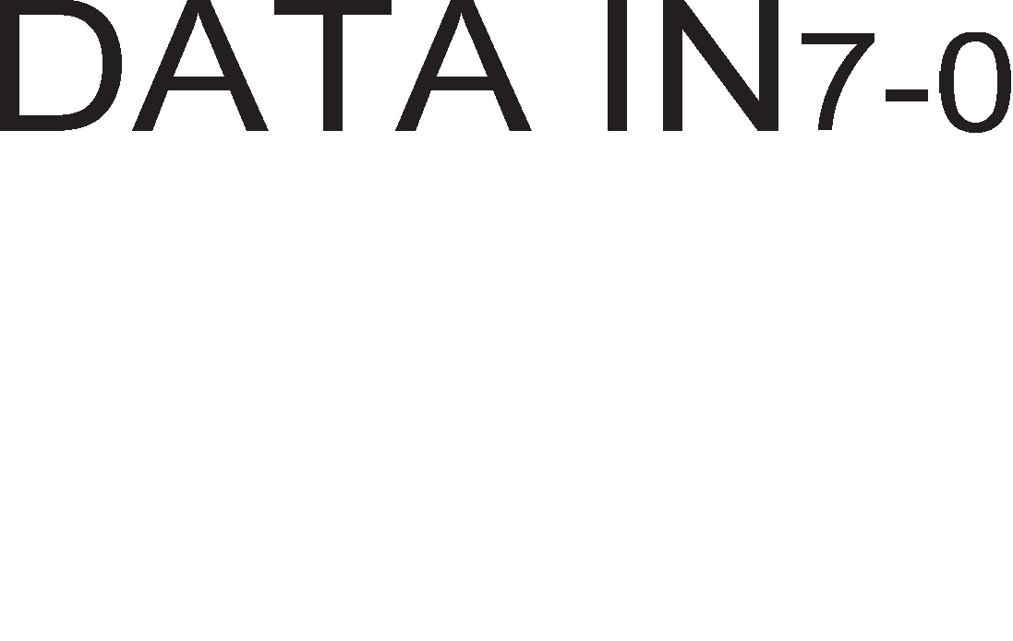 

Cn1Ka 7.13. n1H p1jaflpaM Ha KoMnoHeHeTaTa 8212



* + MD e Bne3eH n1H 1 cny>K1 3a ceneKL1ja Ha pe>K1MoT Ha pa6oTa. Kofla MD e Ha B1coKo H1Bo, KoMnoHeHTaTa 8212 pa6oT1 KaKo T1n1L1eH **6acpep**. nopaToL1Te M1HyBaaT p1peKTHo H13 KoMnoHeHTaTa, TpaH31THo, 6e3 pa ce 3app>KyBaaT. CaMo wTo i<e Bne3aT nopaToL1Te Bo 8212 npeKy nopTaTa DATA IN i<e Mo>KaT pa 13ne3aT Ha DATA OUT. Kofla MD e Ha H1cKo H1Bo, Toflaw KoMnoHeHTaTa 8212 pa6oT1 KaKo **11e"1.** nopaToL1Te np1BpeMeHo ce L1yBaaT Bo D cpn1n-cpnonoB1Te. Co noMow Ha c1flHanoT STB, nopaToL1Te ce BL11TyBaaT npeKy n1HoB1Te DI7 – DI0, a ce L11TaaT no aKT1B1pal-beTo Ha n1HoB1Te  1 DS2.
  + 3a ocnoco6yBal-be Ha 13ne3HaTa nopaToL1Ha nopTa ce Kop1cT1 epeH op n1HoB1Te  1n1 DS2. n1HoT  e aKT1BeH Ha nofl1L1Ka Hyna, a n1HoT

DS2 Ha nofl1L1Ka ep1H1La. AoKonKy M1KponpoLecopoT ja 1cnpaT1 noTBppaTa 3a npeK1H po n1HoT , Toflaw n1HoT DS2 Tpe6a pa ce noBp3e 3a

HanojyBal-beTo Vcc, a aKo M1KponpoLecopoT ja 1cnpai<a noTBppaTa po n1HoT DS2, Toflaw  Tpe6a pa ce noBp3e Ha Maca.

Cn1Ka 7.14. Pepocnep Ha 1cnpai<al-be Ha nopaToL1 Ha KoMnoHeHTaTa 8212

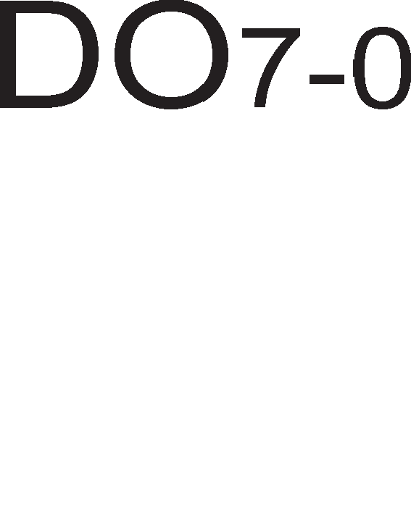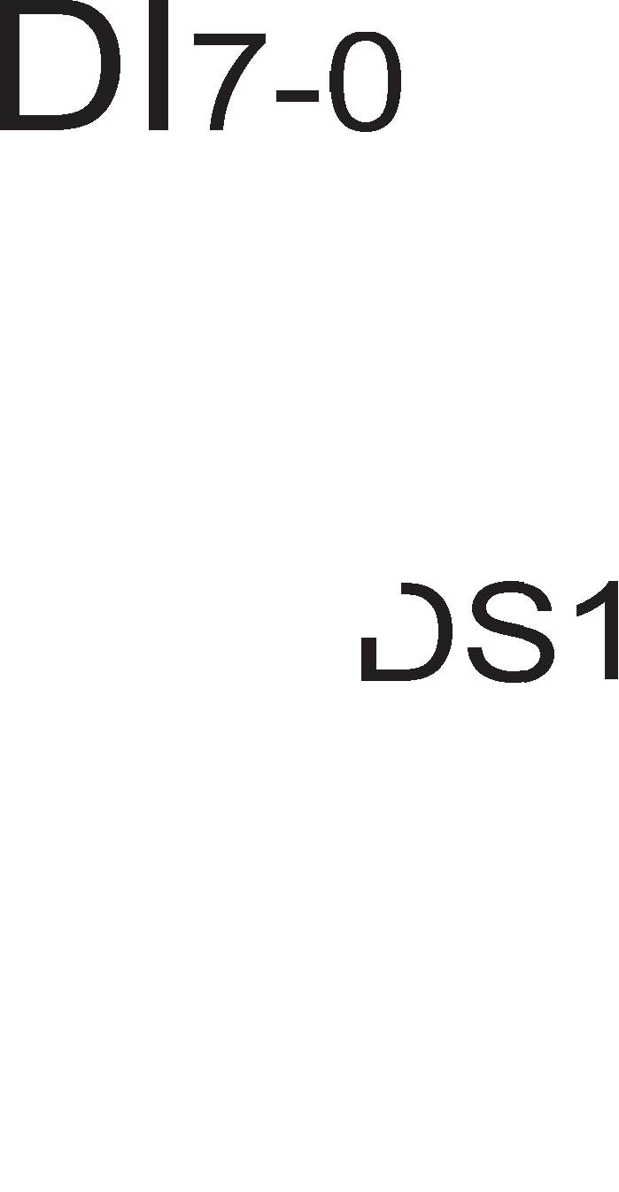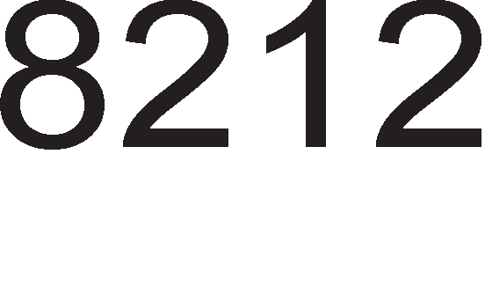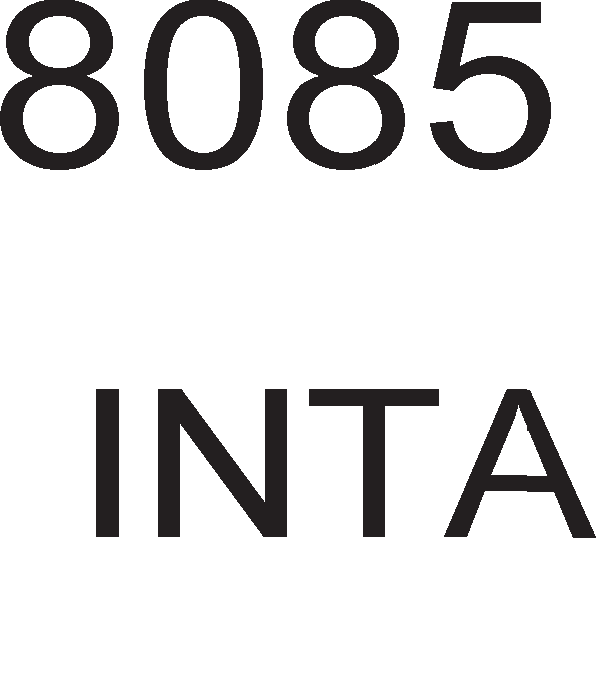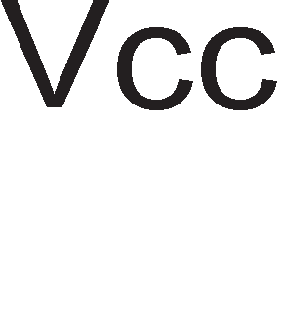

Kofla 8212 pa6oT1 KaKo Bne3Ha nopTa (np1Ma nopaToL1 op HeKoj Bne3eH nep1cpepeH ypep 1 fl1 npenpai<a po M1KponpoLecopoT), Toflaw pepocnepoT Ha 1cnpai<al-be c1flHan1 e cnepeH. Bne3H1oT ypep flo aKT1B1pa n1HoT 3a HajaBa (strobe). no po61eHaTa HajaBa, 8212 ja oTBopa Bne3HaTa nopaToL1Ha nopTa DATA IN 1 nopapoL1Te BneflyBaaT Bo 8212 . Bo 8212 nopaToL1Te ocTaHyBaaT c*è* popeKa 8212 He no6apa npeK1H op M1KponpoLecopoT npeKy aKT1B1pal-be Ha n1HoT INT. AKo M1KponpoLecopoT po3Bon1 npeK1H, Toflaw ce ocnoco6yBa 13ne3HaTa nopaToL1Ha nopTa (DATA OUT) 1 KoHeL1Ho nopaToL1Te np1cT1flHyBaaT po M1KponpoLecopoT. Ha cn1Ka 7.14. e np1Ka>KaHo noBp3yBal-beTo Ha KoHTponepoT 8212 Kofla Toj pa6oT1 KaKo Bne3Ha nopTa. Co KpyflL11l-ba e o6ene>KaH **pe,qoc11e,qoT Ha Mcnpai<a1-e cMrHa11M**.

## nporpaMM6M11Ha KoMnoHeHTa 8255

8255 e npoflpaM161nHa 1HTepcpejc-KoMnoHeHTa. Taa HeMa M1KponpoLecop

1 RAM MeMop1ja 3a pa 13BpwyBa cocpTBepcK1 npoflpaM1, Ho 1Ma KoMaHpeH pefl1cTap L11ja copp>K1Ha ja oppepyBa caM1oT npoflpaMep. OBaa KoMnoHeHTa Haora np1MeHa Bo MHofly M1KponpoLecopcK1 c1cTeM1, KaKo wTo ce c1cTeM1Te co neHT1yM M1KponpoLecop1. KoHTponepoT 8255 ce Kop1cT1 3a noBp3yBal-be Ha nepcoHanH1Te KoMnjyTep1 co TacTaTypaTa 1 co np1HTep.

Ha cn1Ka 7.15 e np1Ka>KaH **nMH-,qMjarpaMoT** Ha KoHTponepoT 8255.

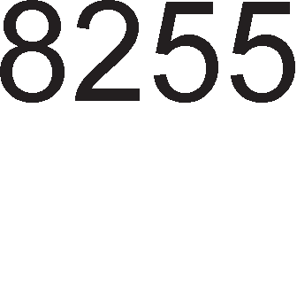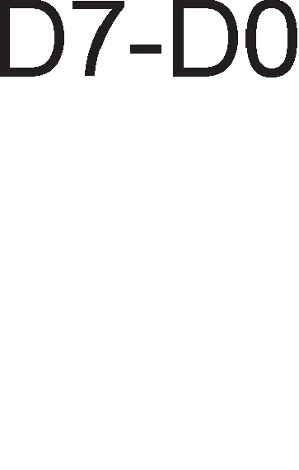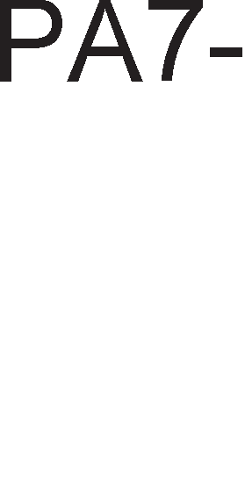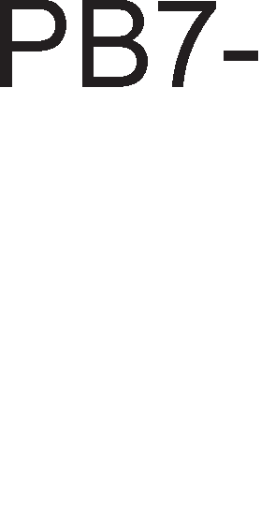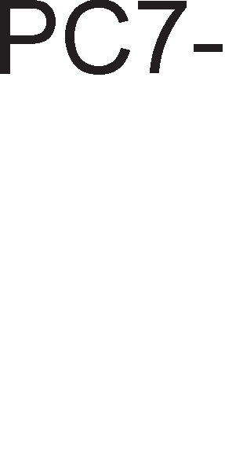

Cn1Ka 7.15. n1H p1jaflpaM Ha KoMnoHeHeTa 8255

PA, PB 1 PC ce 8-n1HcK1 nopT1 1 cny>KaT 3a noBp3yBal-be Ha 8255 co nep1cpepH1Te ypep1. 3a noBp3yBal-be Ha 8255 co M1KponpoLecopoT ce Kop1cTaT nopaToL1H1Te n1HoB1 (D7-D0). 3a 136op Ha onepaL1ja (L11Tal-be 1n1 n1wyBal-be) ce Kop1cTaT KoHTponH1Te n1HoB1  1  .

3a pa M1KponpoLecopoT np1cTan1 po KoMnoHeHTaTa 8255, n1HoT  Mopa pa ce aKT1B1pa. Aa ce noTceT1Me peKa oBoj c1flHan ce fleHep1pa npeKy nocTanKaTa Ha appecHo peKop1pal-be. OTKaKo i<e ce np1cTan1 po KoMnoHeHTaTa 8255 ce Bpw1 136op Ha epeH BHaTpeweH pefl1cTap. nop BHaTpewH1 pefl1cTp1 ce cMeTaaT Tp1Te nopT1 Ha KoHTponepoT 1 KoMaHpH1oT pefl1cTap. nopT1Te cny>KaT 3a L11Tal-be 1 3a n1wyBal-be op nep1cpepH1Te ypep1, a npeKy KoMaHpH1oT pefl1cTap ce Bpw1 npoflpaM1pal-be Ha KoHTponepoT. l/l36opoT Ha BHaTpeweH pefl1cTap ce Bpw1 npeKy appecH1Te n1HoB1 A1 1 A0. OBa 3HaL11 peKa M1KpoKoHTponepoT i<e Kop1cT1 L1eT1p1 appec1. AKo KoMnoHeHTaTa 8255 ce noBp3e co M1KponpoLecop 8085, Toflaw 61ToB1Te op A15 po A2 i<e 61paT 1cT1 3a c1Te L1eT1p1 appec1 1 T1e, BcywHocT, i<e yL1ecTByBaaT Bo fleHep1pal-beTo Ha c1flHanoT . 61ToB1Te A1 1 A0 i<e 61paT pa3n1L1H1 Bo ceKoja op L1eT1p1Te appec1 3a pa ce HanpaB1 opBojyBal-be Ha BHaTpewH1Te pefl1cTp1. Ha np1Mep, Kape i<e ce 3an1waT 61ToB1Te wTo fl1 1cnpaT1n M1KponpoLecopoT no nopaToL1HaTa Mafl1cTpana 3aB1c1 op cocToj6aTa Ha 61ToB1Te A1 1 A0.

|  |  |  |
| --- | --- | --- |
| A1 | A0 |  |
| 0 | 0 | nopTa A |
| 0 | 1 | nopTa B |
| 1 | 0 | nopTa C |
| 1 | 1 | KoMaHpeH pefl1cTap |

KoMnoHeHTaTa 8255 ce npoflpaM1pa npeKy KoMaHpH1oT pefl1cTap. **KoMaH,qHMoT perMcTap** e 8-61TeH pefl1cTap 1 oppepyBaji<1 ja HefloBaTa copp>K1Ha, npoflpaMepoT opnyL1yBa Bo Koj pe>K1M i<e pa6oTaT nopT1Te Ha KoHTponepoT. Aa ce noTceT1Me peKa nocTojaT L1eT1p1 pe>K1M1 Ha npeHoc: epHocTaBeH, cTpo61paH, pe>K1M Ha no3ppaB 1 pe>K1M Ha pBojHo no3ppaByBal-be.

7 6 5 4 3 2 1 0

|  |  |  |  |  |  |  |  |  |  |  |  |  |  |  |  |  |
| --- | --- | --- | --- | --- | --- | --- | --- | --- | --- | --- | --- | --- | --- | --- | --- | --- |
| 1 |  | |  | |  | |  | |  | |  | |  | |  | |
|  | nopTa C (PC3-PC0)  1-Bne3 0-13ne3 |
|  | |  | |  | |  | |  | |  | |  | |  | |
|  | | | |
|  | | |  | | |
|  | | | | |
|  | | | | nopTa B 1-Bne3 0-13ne3 |
|  | | | | | |
|  | | | | | | |
|  | | | | | | nopTa B  0-epHocTaBeH 1-cTpo61paH |
|  | | | | | | | |
|  | | | | | | | | |
|  | | | | | | | | nopTa C (PC7-PC4)  1-Bne3 0-13ne3 |
|  | | | | | | | | | |
|  | | | | | | | | | | |
|  | | | | | | | | | | nopTa A 1-Bne3 0-13ne3 |
|  | | | | | | | | | | | | |
|  | | | | | | | | | | | | | |
|  | | | | | | | | | | | | | nopTa A  00-epHocTaBeH 01-cTpo61paH 10-pBoHacoL1Ha |
|  | | | | | | | | | | | | | | | |

Cn1Ka 7.16. <lyHKL1cK1 on1c Ha 61ToB1Te Ha KoMaHpH1oT pefl1cTap op

KoMnoHeHTaTa 8255

nopTaTa A Mo>Ke pa 61pe Bne3Ha, 13ne3Ha 1n1 pBoHacoL1Ha nopTa 1 pa pa6oT1 Bo epHocTaBeH 1n1 cTpo61paH pe>K1M. nopTaTa 6 Mo>Ke pa 61pe Bne3Ha 1n1 13ne3Ha (Ho He 1 pBoHacoL1Ha) 1 Mo>Ke pa pa6oT1 Bo epHocTaBeH 1n1 Bo cTpo61paH pe>K1M.

nopTaTa C Mo>Ke pa 61pe Kop1cH1L1Ka 1n1 KoHTponHa nopTa. nopaTa C Mo>Ke pa 61pe Kop1cH1L1Ka nopTa caMo Kofla nopT1Te A 1 B pa6oTaT Bo epHocTaBeH pe>K1M. Toflaw Mo>Ke pa 1361paMe KaKB1 i<e 61paT n1HoB1Ta Ha PC, Bne3H1 1n1 13ne3H1. AKo 61no Koja nopTa, A 1n1 B, He pa6oT1 Bo epHocTaBeH pe>K1M, Toflaw nopTaTa C i<e 61pe KoHTponHa 1 Hej31H1Te n1HoB1 i<e ce Kop1cTaT 3a npeHoc Ha c1flHan1Te 3a HajaBa 1 3a noTBppa. Ha cn1Ka 7.16. e np1Ka>KaHa copp>K1HaTa Ha KoMaHpH1oT pefl1cTap 1 3HaL1el-beTo Ha ceKoj 61T op Heflo. AKo nopTaTa C e KoHTponHa, Toflaw e ceepHo pan1 TpeT1oT 1 HynT1oT 61T op KoMaHpH1oT pefl1cTap

ce 0 1n1 1. Toflaw H1B fl1 6ene>K1Me co X, Hepecp1H1paHa cocToj6a. l/lcTo TaKa, 1 L1eTBpT1oT 61T i<e 61pe X aKo PA e pBoHacoL1Ha.

**npMMep 7.23**: Oppep1 ja copp>K1HaTa Ha KoMaHpH1oT pefl1cTap Ha KoMnoHeHTaTa 8255 aKo nopTaTa A e pBoHacoL1Ha, a nopTaTa B e Bne3Ha 1 pa6oT1 Bo epHocTaBeH pe>K1M.

PeweH1e:



Cn1Ka 7.17. Copp>K1Ha Ha KoMaHpeH pefl1cTap Kofla nopTaTa A e pBoHacoL1Ha 1 nopTaTa B e Bne3Ha 1 cTpo61paHa

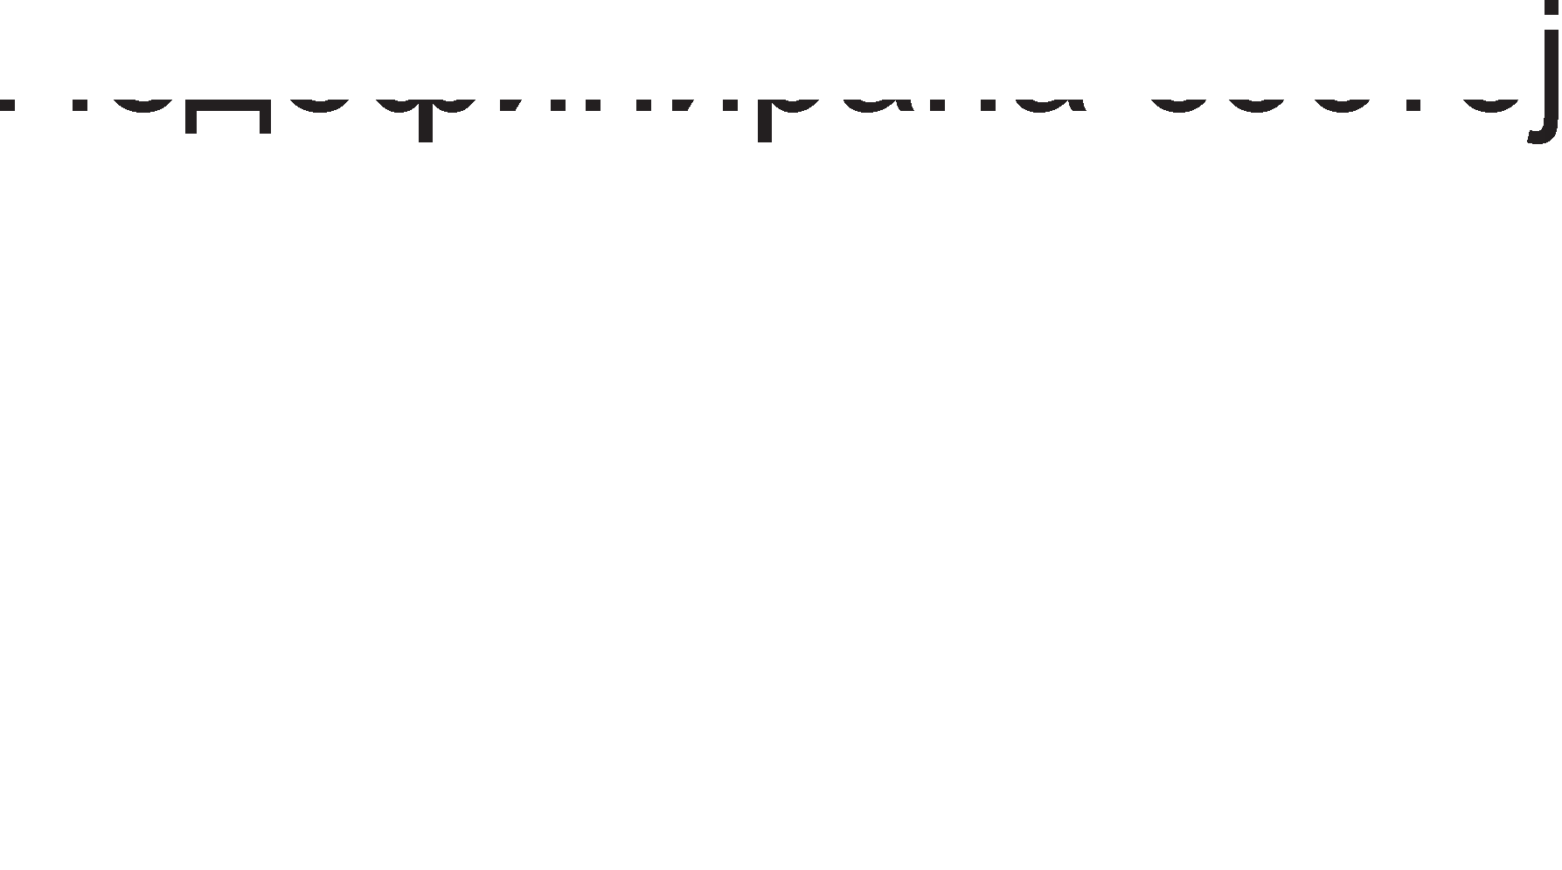

nopTaTa C e KoHTponHa, 61peji<1 nopTaTa A He e Bo epHocTaBeH pe>K1M. Kofla nopTaTa C ce Kop1cT1 KaKo **KoHTpo11Ha nopTa**, Toflaw HaMecTo Kop1cH1L1Ka 1HcpopMaL1ja, Hej31H1Te n1HoB1 i<e npeHecyBaaT KoHTponH1 c1flHan1. Toa ce c1flHan1 co Ko1 ce HajaByBa npeHocoT Ha Kop1cH1L1K1 nopaToL1 no nopT1Te A 1 B 1 nopaToL1HaTa Mafl1cTpana. OcBeH 3a HajaBa Ha npeHocoT, nocTojaT KoHTponH1 c1flHan1 co Ko1 ce noTBppyBa po61Bal-beTo Ha 1cnpaTeH1Te nopaToL1. Bo Ta6ena

* 1. ce papeH1 o3HaK1Te Ha c1Te KoHTponH1 c1flHan1 op nopTaTa C 3a c1Te pe>K1M1 Ha npeHoc Ha nopT1Te A 1 B.



|  |  |  |  |
| --- | --- | --- | --- |
| n1H | CTpo61paH pe>K1M | | ABoHacoL1Ha |
| Bne3 | l/l3ne3 |
| 0 | INTRB | INTRB | INTRB |
| 1 | IBFB | B | IBFB |
| 2 |  |  | B |
| 3 | INTRA | INTRA | INTRA |
| 4 | IBFA | / | STBA |
| 5 | A | / | IBFA |
| 6 | / |  | A |
| 7 | / |  | A |

Ta6ena 7.2. 6ene>Kel-be Ha n1HoB1Te op nopTaTa C Kofla Taa pa6oT1 KaKo KoHTponHa nopTa



C1flHan1Te co 1HpeKc A ce opHecyBaaT Ha nopTaTa A, a oH1e co 1HpeKc B Ha nopTaTa B.

* + - INTR (Interrupt) e c1flHan co Koj KoHTponepoT 8255 6apa npeK1H Bo TeKoBHaTa pa6oTa Ha M1KponpoLecopoT. OBoj npeK1H e noTpe6eH 3a pa KoHTponepoT My fl1 1cnpaT1 nopaToL1Te Ha M1KponpoLecopoT, po61eH1 op nep1cpepeH ypep. AoKonKy M1KponpoLecopoT flo opo6p1 6apal-beTo 3a npeK1H, i<e ce aKT1B1pa n1HoT  Ha KoMnoHeHTaTa 8255.

•   (strobe) e c1flHan wTo flo HajaByBa npeHocoT Ha nopaToL1 1 flo 1cnpai<a Bne3H1oT ypep po KoMnoHeHTaTa 8255. C1flHanoT  fl1 ocnoco6yBa n1HoB1Te Ha nopTaTa A 1n1 nopTaTa B 3a np1eM Ha 1cnpaTeH1Te nopaToL1.

* + - IBF (Input Buffer Full ) e c1flHan wTo ce aKT1B1pa Kofla nopaToL1Te i<e np1cT1flHaT Bo KoMnoHeHTaTa 8255. C1flHanoT IBF flo 1cnpai<a KoMnoHeHTaTa 8255 po Bne3H1oT ypep.

•   (Acknowledge) e c1flHan wTo ce Kop1cT1 Kofla nopTaTa A 1n1 nopTaTa B ce 13ne3H1 nopT1. n1HoT flo aKT1B1pa ypepoT oTKaKo i<e fl1 np1M1 nopaToL1Te op KoMnoHeHTaTa 8255.

* + - OBF (Output Buffer Full) e c1flHan wTo flo 1cnpai<a KoMnoHeHTaTa 8255 po 13ne3H1oT ypep, co Len pa flo HajaB1 npeHocoT Ha nopaToL1. OB1e nopaToL1 KoMnoHeHTaTa 8255 fl1 np1M1na op M1KponpoLecopoT, Ho T1e Tpe6a pa ce 1cnpaTaT po 13ne3H1oT ypep.

Ha cn1Ka 7.18. e np1Ka>KaH BpeMeHcK1 p1jaflpaM Ha c1flHan1Te Kofla epHa op pBeTe nopT1 A 1n1 B pa6oT1 KaKo **e11e3Ha nopTa**.

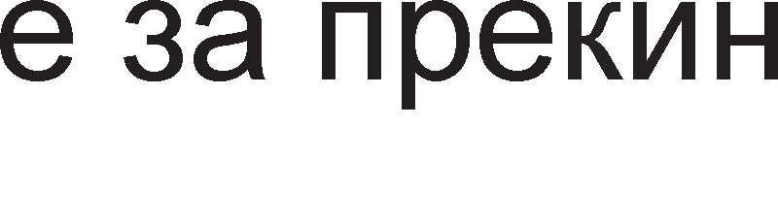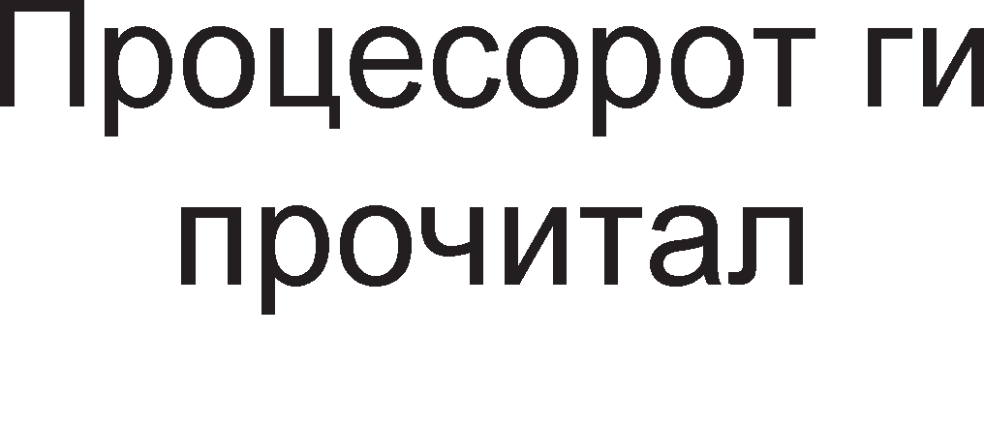

Cn1Ka 7.18. BpeMeHcK1 p1jaflpaM Kofla 8255 pa6oT1 KaKo Bne3Ha nopTa

PepocnepoT Ha aKT1B1pal-be Ha c1flHan1Te e cnepeH:

1. Bne3H1oT ypep flo aKT1B1pa n1HoT 1 fl1 ocnoco6yBa n1HoB1Te Ha nopTaTa A 1n1 B 3a np1eM Ha nopaToL1.



1. nopaToL1Te BneflyBaaT Bo KoMnoHeHTaTa 8255 npeKy n1HoB1Te Ha nopTaTa A 1n1 B.
2. Kofla 8255 i<e fl1 np1M1 nopaToL1Te i<e flo aKT1B1pa n1HoT IBF 1 My noTBppyBa Ha Bne3H1oT ypep peKa nopaToL1Te np1cT1flHane po 8255.
3. Ho, nopaToL1Te He Tpe6a pa ocTaHaT Bo 8255. T1e Tpe6a pa ce npenpaTaT po M1KponpoLecopoT. nopap1 Toa 8255 1cnpai<a 6apal-be 3a npeK1H po M1KponpoLecopoT npeKy n1HoT INTR.
4. AKo M1KponpoLecopoT flo opo6p1 6apal-beTo 3a npeK1H, Toj i<e flo aKT1B1pa KoHTponH1oT n1H .
5. nopaToL1Te npeKy nopaToL1HaTa Mafl1cTpana i<e np1cT1flHaT po M1KponpoLecopoT.

## aK11y"1o4M:

8085 M1KponpoLecopoT e 8 61TeH, pacnonafla co fleHepaTop Ha TaKT Koj npo13BepyBa p1fl1TcK1 TaKT co cppeKBeHL1ja 8 MHz, noce6eH KoHTponep 3a pa6oTa co npeK1H1 1 KoHTpona Ha TajM1HfloT. l/lMa np1cTan po MeMop1ja co KanaL1TeT

64KB, opHocHo 1Ma 16 appecH1 n1Ha HaMeHeT1 3a p1peKTHo appec1pal-be Ha MeMop1cK1oT npocTop (216 =64K).

ALE e KoHTponeH c1flHan 3a appecHo nopaToL1HaTa Mafl1cTpanaTa. AKo ALE=1 Toflaw appecHo-nopaToL1HaTa Mafl1cTpana npeHecyBa appecH1 61ToB1. AKo ALE=0 Toflaw Mafl1cTpanaTa npeHecyBa nopaToL1H1 n1HoB1.

Kaj M1KponpoLecopoT 8085 nocTojaT neT B1poB1 npeK1H1: TRAP, RST7.5, RST6.5, RST5.5 1 INTR. TRAP e npeK1H op HajfloneM np1op1TeT. Tp1Te pecTcTapT1paL1K1 npeK1H1 1MaaT cp1KcHa pecTapT1paL1Ka appeca. INTR npeK1HoT HaMa cp1KcHa pecTapT1paL1Ka appeca TyKy Koja npeK1HyBaL1Ka nopnpoflpaMa i<e ce 13Bpw1 3aB1c1 op B1poT Ha nep1cpepH1oT ypep Koj fleHep1pan npeK1H.

npeKy Tp1Te cTaTycH1 n1H11 S0,S1, IO/  M1KponpoLecopoT paBa 1HcpopMaL1ja 3a Toa KaKoB Maw1HcK1 L1Knyc i<e ce pean131pa. Pa3n1KyBaMe wecT B1poB1 Maw1HcK1 L1Knyc1: n1wyBal-be Bo MeMop1ja, L11Tal-be op MeMop1ja, n1wyBal-be Bo 13ne3eH ypep, L11Tal-be op 13ne3eH ypep, npeHoc Ha onepaL1cK1 Kop 1 o6pa6oTKa Ha npeK1H1.

AKyMynaTopoT e pa6oTeH pefl1cTap Ha M1KponpoLecopoT 1 ce Haora Ha Bne3 op ap1TMeT1L1Ko nofl1L1KaTa ep1H1La. noKpaj aKyMynaTopoT Bo pefl1cTp1 co onwTa HaMeHa BneflyBaT ywTe wecT ppyfl1 pefl1cTp1, Ko1 ce 6ene>KaT co 6yKB1Te B, C, D, E, H, L.

npoflpaMcK1oT 6pojaL1 e pefl1cTap Bo 8085 M1KponpoLecopoT, Koj ja naMT1 appecaTa Ha cnepH1oT 6ajT wTo Tpe6a pa ce npeHece op MeMop1jaTa 1 pa ce

o6pa6oT1. M1KponpoLecopoT popaBa epeH Ha copp>K1HaTa Ha npoflpaMcK1oT 6pojaL1 no ceKoe poHecyBal-be HoB 6ajT op MeMop1jaTa po M1KponpoLecopoT.

M1KponpoLecopoT copp>K1 noce6eH pefl1cTap cTeK-noKa>KyBaL1 (stack pointer), Koj e 16-61TeH pefl1cTap 1 ja copp>K1 appecaTa Ha MeMop1cKaTa noKaL1ja Ha BpBoT op cTeKoT.

CTaTyc-pefl1cTapoT copp>K1 1Hp1KaTop1 Ha cocToj61, 3HaMeHLa (flags). 3HaMeHLaTa Mo>Ke pa 1MaaT pa3n1L1H1 ynofl1 1 HajL1ecTo ja noKa>KyBaaT cocToj6aTa Bo ap1TMeT1L1Ko-nofl1L1KaTa ep1H1La no 13BpwyBal-beTo Ha HeKoja 1HcTpyKL1ja. T1n1L1H1 3HaMeHLa ce : 3HaMeHLeTo 3a npeHoc, 3HaMeHLe 3a napHocT, 3HaMeHLe 3a Hyna, 3HaMeHLe 3a 3HaK 1 3HaMeHLe 3a noMoweH npeHoc.

Kaj pefl1cTapcKoTo p1peKHoTo appec1pal-be nopaToL1Te 3a o6pa6oTKa ce HaoraaT Bo onwT1Te pefl1cTp1 Bo M1KponpoLecopoT. l/lHcTpyKL11Te Ko1 flo Kop1cTaT pefl1cTapcKoTo appec1pal-be ce HapeKyBaaT 1HcTpyKL11 op npB cpopMaT. T1e 3acpai<aaT MeMop1cK1 npocTop op epeH 6ajT, opHocHo epHa MeMop1cKa noKaL1ja.

Kaj HenocpepHoTo appec1pal-be onepaHpoT ce Haora Bo caMaTa 1HcTpyKL1ja. 3a oB1e 1HcTpyKL11 Ben1Me peKa ce op BTop 1HcTpyKL1cK1 cpopMaT. BTop1oT 1HcTpyKL1cK1 cpopMaT copp>K1 pBa 6ajTa. npB1oT 6ajT e ceKoflaw onepaL1cK1 Kop, a BTop1oT npeTcTaByBa ocyM61TeH nopaToK wTo Tpe6a pa ce o6pa6oT1.

Kaj p1peKHoTo appec1pal-be 1HcTpyKL1jaTa ja copp>K1 appecaTa Ha MeMop1cKaTa noKaL1ja op Kape wTo Mo>Ke pa flo npoL11TaMe caKaH1oT nopaToK. l/lHcTpyKL11Te Ko1 flo Kop1cTaT oBoj HaL11H Ha appec1pal-be ce op TpeT 1HcTpyKL1cK1 cpopMaT. TpeT1oT 1HcTpyKL1cK1 cpopMaT copp>K1 Tp1 6ajT1. npB1oT 6ajT e onepaL1cK1 Kop, a BTop1oT 1 TpeT1oT 6ajT 3aepHo ja npeTcTaByBaaT 16- 61THa appeca Ha MeMop1cKa noKaL1ja.

npeHocoT Ha nopaToL1 Mo>Ke pa ce Bpw1 Ha penaL1ja pefl1cTap-pefl1cTap (MOV), aKyMynaTop-MeMop1cKa noKaL1ja (STA), MeMop1cKa noKaL1ja-aKyMynaTop (LDA), aKyMynaTop-13ne3eH ypep (OUT) 1 Bne3eH ypep-aKyMynaTop (IN). npeKy aceM6nepcKa 1HcTpyKL1ja He Mo>Ke pa ce 13Bpw1 p1peKTeH npeHoc op epHa MeMop1cKa noKaL1ja Bo ppyfla.

Kaj ap1TMeT1L1K1Te 1HcTpyKL11 3a co61pal-be 1 op3eMal-be epH1oT onepaHp ce Haora Bo aKyMynaTopoT, a BTop1oT onepaHp ce Haora Bo HeKoj op onwT1Te pefl1cTp1 Ha M1KponpoLecopoT 8085. Ao61eH1op pe3ynTaT ce 3an1wyBa Bo aKyMynaTopoT co Toa wTo ce fly61 HefloBaTa cTapa copp>K1Ha. l/lcToTo Ba>K1 1 3a nofl1L1K1Te 1HcTpyKL11 AND 1 ORA.

Cnopep HacoKaTa, nocTojaT pBa B1pa poTaL11: poTaL1ja BneBo 1 poTaL1ja Bo pecHo. Bo 3aB1cHocT op Toa pan1 e BKnyL1eHo 3HaMeHLeTo C 1n1 He, poTaL1jaTa Mo>Ke pa 61pe npeKy 3HaMeHLeTo C 1n1 6e3 Heflo.

l/lHcTpyKL11Te 3a cKoK 1 nopnpoflpaM1 ceKoflaw copp>KaT appeca Ha noKaL1ja Ha Koja Tpe6a pa ce cKoKHe 1n1 3anoL1He noTnpoflpaMaTa.

8212 e epHocTaBHa, noBei<eHaMeHcKa, HenpoflpaM161nHa KoMnoHeHTa 1 ce Kop1cT1 Bo ceKoj M1KponpoLecopcK1 c1cTeM 8085. Kofla 1HTepcpejc KoMnoHeHTaTa pa6oT1 KaKo Bne3Ha nopTa Toflaw np1Ma 6apal-ba 3a npeHoc op np1cpepH1oT ypep npeKy n1HoT 3a HajaBa (strobe). 8212 KoMnoHeHTaTa Mo>Ke pa npep13B1Ka npeK1H Bo pa6oTaTa Ha M1KponpoLecopoT npeKy aKT1B1pal-be Ha n1HoT 3a npeK1H INT. AoKonKy 8085 M1KponpoLecopoT flo np1cpaT1 6apal-beTo 3a npeK1H Toflaw fl1 aKT1B1pa n1HoB1Te 3a ceneKL1ja Ha 8212 KoMnoHeHTaTa,  1 DS2.

KoMnoHeHTaTa 8255 ce npoflpaM1pa npeKy KoMaHpH1oT pefl1cTap. KoMaHpH1oT pefl1cTap e 8-61TeH pefl1cTap 1 oppepyBaji<1 ja HefloBaTa copp>K1Ha, npoflpaMepoT opnyL1yBa Bo Koj pe>K1M i<e pa6oTaT nopT1Te Ha KoHTponepoT. nopTaTa A Mo>Ke pa 61pe Bne3Ha, 13ne3Ha 1n1 pBoHacoL1Ha nopTa 1 pa pa6oT1 Bo epHocTaBeH 1n1 cTpo61paH pe>K1M. nopTaTa 6 Mo>Ke pa 61pe Bne3Ha 1n1 13ne3Ha (Ho He 1 pBoHacoL1Ha) 1 Mo>Ke pa pa6oT1 Bo epHocTaBeH 1n1 Bo cTpo61paH pe>K1M. nopTaTa C Mo>Ke pa 61pe Kop1cH1L1Ka 1n1 KoHTponHa nopTa.

## npawa1-a M 3a,qa"1M

* 1. npoLecopoT 8085 e 8-61TeH. O6jacH1!
  2. KonKy 13HecyBa w1poL11HaTa Ha appecHaTa 1 Ha nopaToL1HaTa Mafl1cTpana Ha M1KponpoLecop 8085?
  3. O6jacH1 KaKo c1flHanoT ALE (Address Latch Enable) flo KoHTpon1pa MynT1nneKcoT Ha appecHo-nopaToL1HaTa Mafl1cTpana?
  4. KaKBa onepaL1ja i<e 13Bpw1 M1KponpoLecopoT 8085 aKo KoHTponH1Te c1flHan1 ce Ha cnepH1Be nofl1L1K1 H1Boa =1, =0, IO/=1?
  5. Ko1 c1flHan1 ce Kop1cTaT 3a pecp1H1pal-be Maw1HcK1 L1Knyc?
  6. Ko1 ypep1 flo aKT1B1paaT n1HoT INTR, a Koj ypep paBa po3Bona 3a npeK1H?
  7. O6jacH1 flo KoHLenToT Ha p1peKTeH np1cTan po MeMop1ja (Direct Memory Access)?
  8. KaKo ce 6ene>K1 n1HoT 3a p1fl1TcK1 TaKT Ha M1KponpoLecopoT 8085? KonKy 13HecyBa cppeKBeHL1jaTa Ha p1fl1TcK1oT TaKT Ha M1KponpoLecopoT 8085?
  9. Ha6poj fl1 pefl1cTp1Te co cneL1janHa HaMeHa Ha M1KponpoLecopoT 8085?
  10. KaKo ce 6ene>KaT onwT1Te pefl1cTp1 Ha M1KponpoLecopoT 8085?
  11. Ha6poj fl1 B1poB1Te Maw1HcK1 L1Knyc1 Kaj M1KponpoLecopoT 8085!
  12. Ko1 ce pa3n1K1Te Mery Maw1HcK1Te L1Knyc1:
      1. npeHoc Ha onepaL1cK1 Kop 1 L11Tal-be op MeMop1ja

6) L11Tal-be op MeMop1ja 1 L11Tal-be op nep1cpepeH ypep

* 1. O6jacH1 op Kape poara 1MeTo pecTapT1paL1K1 npeK1H?
  2. Koj HaL11H Ha appec1pal-be e np1MeHeT aKo 1HcTpyKL1jaTa copp>K1 appeca Ha MeMop1cKa noKaL1ja?
  3. WTo npeTcTaByBa BTop1oT 6ajT op TpeT1oT 1HcTpyKL1cK1 cpopMaT Kaj 8085 M1KponpoLecop?
  4. npecMeTaj ja noL1eTHaTa appeca Ha cnepHaTa 1HcTpyKL1ja aKo TeKoBHaTa e op BTop cpopMaT 1 noL1HyBa Ha appeca 4500H?
  5. O6jacH1 ja pa3n1KaTa Mery 1HcTpyKL11Te ROR 1 RRC!
  6. no3HaT1 ce copp>K1H1Te Ha pefl1cTp1Te A=D6H 1 C=2AH. Ko1 3HaMeHLa i<e ce aKT1B1paaT no 13BpwyBal-beTo Ha 1HcTpyKL1jaTa ADD C?
  7. AapeH1 ce copp>K1H1Te Ha pefl1cTp1Te A=EDH 1 L=669H. npecMeTaj ja copp>K1HaTa Ha aKyMynaTopoT no 13BpwyBal-beTo Ha 1HcTpyKL1jaTa SUB L!
  8. no3HaTa e copp>K1HaTa Ha aKyMynaTopoT, A = 3AH 1 cocToj6aTa Ha 3HaMeHLeTo 3a npeHoc, C=1. npecMeTaj fl1 no 13BpwyBal-beTo Ha 1HcTpyKL1jaTa.
     1. ROL 6) RLC
  9. no3HaT1 ce copp>K1H1Te Ha pefl1cTp1Te A=12H 1 E=DEH. npecMeTaj fl1 H1BH1Te copp>K1H1 no 13BpwyBal-beTo Ha cnepHaTa npoflpaMcKa ceKBeHLa:

ADD E CMA MOV E,A

* 1. MeMop1cKaTa noKaL1ja co appeca 1234H copp>K1 nopaToK 7CH, aKyMynaTopoT A= 9EH 1 pefl1cTapoT B=38H. npecMeTaj ja copp>K1HaTa Ha aKyMynaTopoT no 13BpwyBal-beTo Ha cnepH1Be 1HcTpyKL11:

SUB B INC A

LDA 1234H

* 1. MeMop1cKaTa noKaL1ja co appeca 8FFFH copp>K1 nopaToK 4CH, pefl1cTapoT A= 12H 1 pefl1cTapoT L=4DH. npecMeTaj ja copp>K1HaTa Ha aKyMynaTopoT no 13BpwyBal-beTo Ha cnepH1Be 1HcTpyKL11:

LDA 8FFFH ANA L MOVA,L STA 8FFFH

* 1. KaKBa cpyHKL1ja 1MaaT 1HTepcpejc-KoMnoHeHT1Te Bo M1KponpoLecopcK1Te c1cTeM1?

25. 8212 e HenpoflpaM161nHa, epHoHacoL1Ha KoMnoHeHTa. O6jacH1 !

1. Ko1 n1HoB1 op KoHTponepoT 8212 fl1 ocnoco6yBaaT nopT1Te DATA IN 1 DATA OUT Kofla KoHTponepoT 8212 pa6oT1 KaKo neL1?
2. O6jacH1 3a wTo cny>K1 n1HoT MD Ha KoHTponepoT 8212?
3. O6jacH1 flo appec1pal-beTo Ha nopT1Te A,B 1 C 1 KoMaHpH1oT pefl1cTap Ha KoHTponepoT 8255?
4. Ko1 n1HoB1 op KoHTponepoT 8212 ce Kop1cTaT 3a npeHoc Ha nopaToL1 Mery KoHTponepoT 1 M1KponpoLecopoT 1 3a npeHoc Ha nopaToL1 Mery KoHTponepoT 1 nep1cpepH1Te ypep1?
5. Kofla nopTaTa C Ha KoHTponepoT 8212 ce Kop1cT1 KaKo KoHTponHa, a Kofla KaKo Kop1cH1L1Ka nopTa?
6. Onpepen1 ja copp>K1HaTa Ha KoMaHpH1oT pefl1cTap Ha KoHTponepoT 8255 aKo nopTaTa A pa6oT1 Bo pe>K1M Ha no3ppaByBal-be 1 e Bne3Ha nopTa 1 nopTaTa B e 13ne3Ha nopTa 1 pa6oT1 Bo epHocTaBeH pe>K1M!
7. noppep1 fl1 n1HoB1Te DATA, INTR, RD, PORTA, IBF, STB cnopep pepocnepoT Ha H1BHoTo aKT1B1pal-be Kofla KoHTponepoT 8255 ce Kop1cT1 KaKo Bne3Ha nopTa!

**8. 16 M 32 6MTHM MMKponpo4ecopM**

# 0cHoeHM KapaKTepMcTMKM Ha MMKponpo4ecop 8086

8086/8088 ce M1KponpoLecop1 op TpeTaTa fleHepaL1ja. **8088** e p13ajH1paH co **8-6MTHa no,qaTo"1Ha MarMcTpa11a** po MeMop1jaTa 1 Bne3Ho-13ne3H1Te ypep1, popeKa **8086** 1Ma **16-6MTHa no,qaTo"1Ha MarMcTpa11a**. Bo ceKoj ppyfl noflnep M1KponpoLecop1Te ce 1peHT1L1H1 1 cocpTBepoT Han1waH 3a epH1oT M1KponpoLecop i<e cpyHKL1oH1pa 1 3a ppyfl1oT. M1KponpoLecop1Te 8086/8088 1MaaT MeMop1ja co KanaL1TeT op 1MB 1 3a appec1pal-be Ha MeMop1cK1Te noKaL11 ce Kop1cTaT 20-61TH1 appec1.

C1Te M1KponpoLecop1 13BpwyBaaT npoflpaM1 1HcTpyKL1ja no 1HcTpyKL1ja co nocTojaHo pB1>Kel-be H13 cnepH1Be cpa31:

* npeHoc Ha onepaL1cK1 Kop op MeMop1jaTa Bo M1KponpoLecopoT (Opcode fetch)
* npeHoc Ha onepaHpoT poKonKy Toj e no6apaH (READ)
* ecpeKT1BHo 13BpwyBal-be (EXECUTION)
* Bpai<al-be Ha pe3ynTaToT Bo MeMop1jaTa (WRITE)

npoLecopoT 8086 copp>K1 noce6H1 ep1H1L1 Ko1 napanenHo 13BpwyBaaT HeKo1 op HaBepeH1Te cpa31. l/l3BpwHaTa ep1H1La (execution unit) fl1 13BpwyBa 1HcTpyKL11Te, a ep1H1LaTa 3a Mafl1cTpaneH 1HTepcpejc (bus interface unit) Bpw1 npeHoc Ha onepaL1cK1Te KopoB1, onepaHp1Te 1 pe3ynTaT1Te. ABeTe ep1H1L1 pa6oTaT 1cToBpeMeHo.

Ha cn1Ka 8.1. e 13BpweHa cnopep6a Mery pa6oTaTa Ha M1KponpoLecopoT 8085

1 M1KponpoLecop1Te 8086/88. napanenHoTo pa6oTel-be Ha pBeTe cocTaBH1 ep1H1L1 Ha M1KponpoLecopoT 8086 o6e36epyBa MaKc1ManHo 1cKop1cTyBal-be Ha XappBepcK1Te pecypc1 1 nofloneMa 6p31Ha.

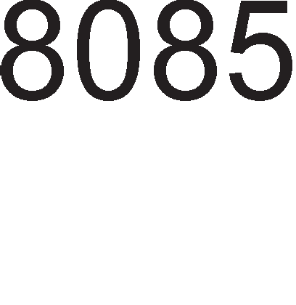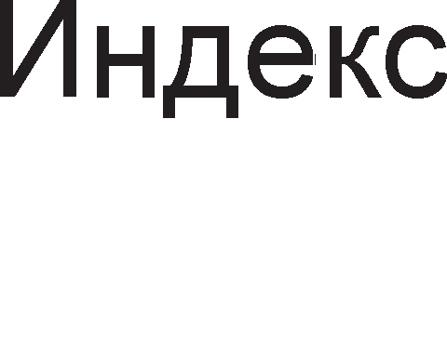

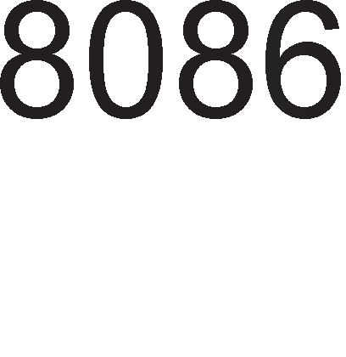

Cn1Ka 8.1. Cnopep6a Bo 13BpwyBal-beTo Ha 1HcTpyKL1cK1Te cpa31 3a M1KponpoLecop1 8085 1 8086



Ha cn1Ka 8.2. e np1Ka>KaHa **cpyHK4MoHa11Ha 611oK-weMa** Ha pBeTe ep1H1L1.

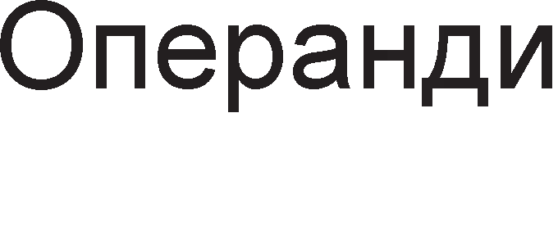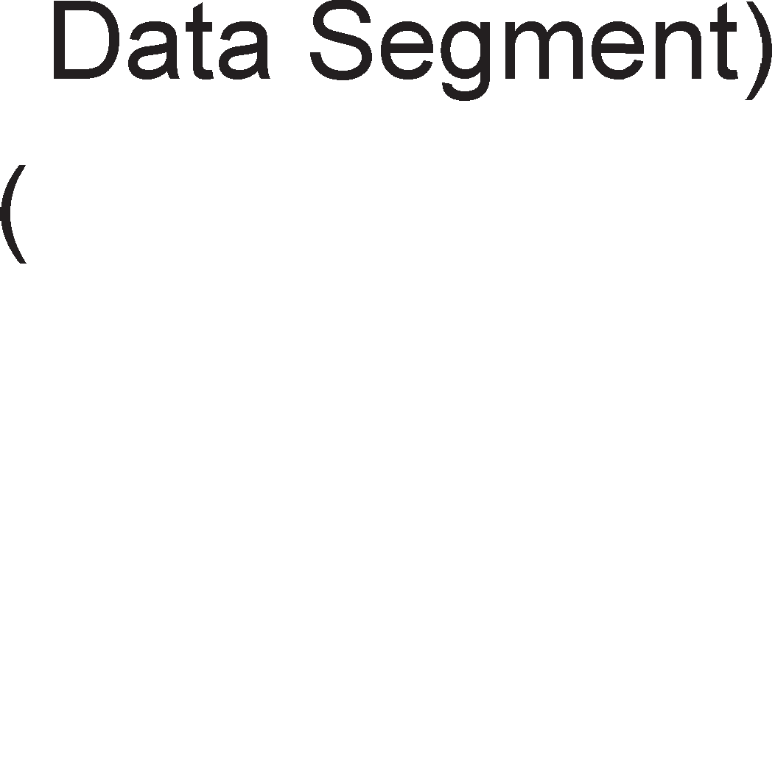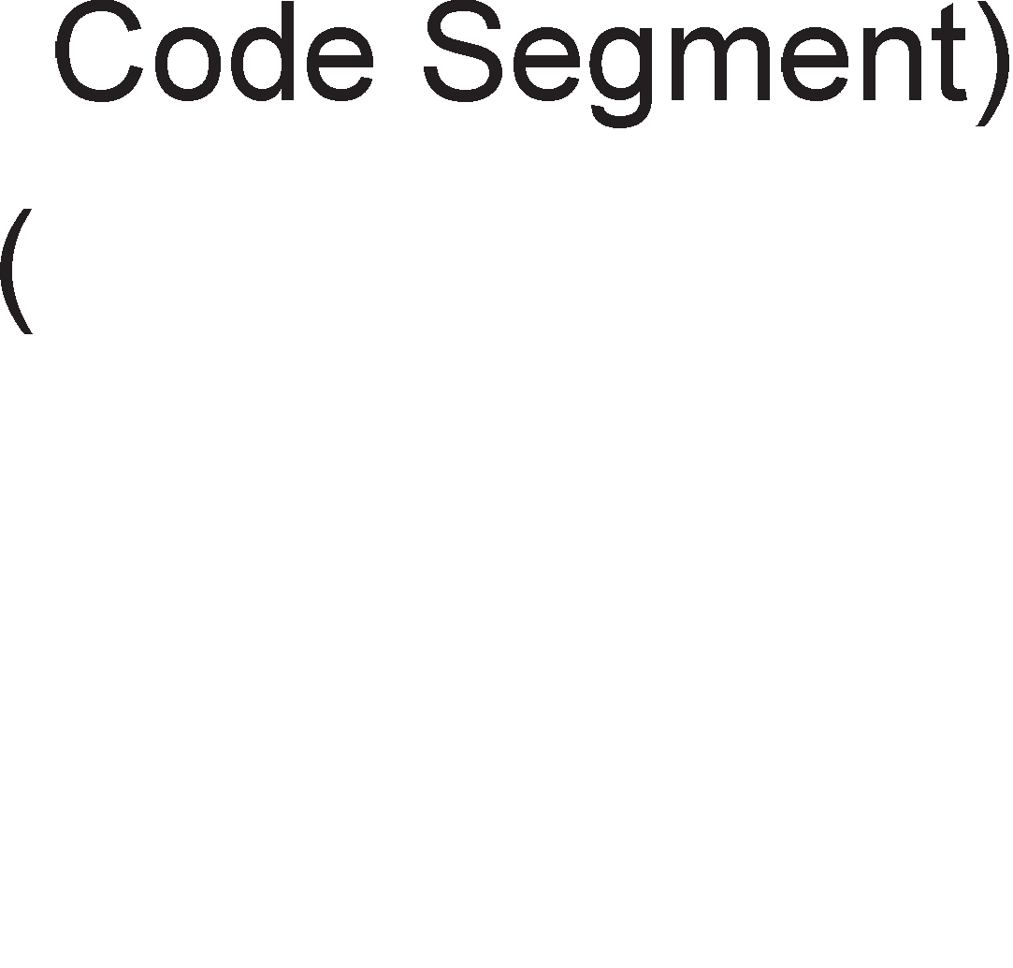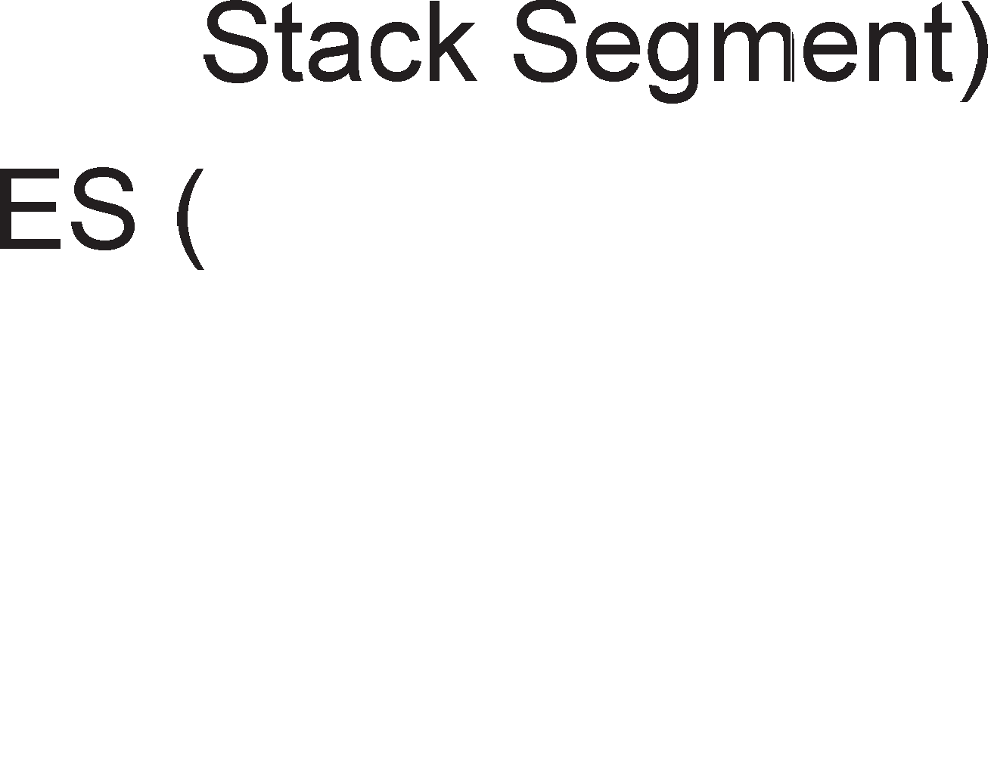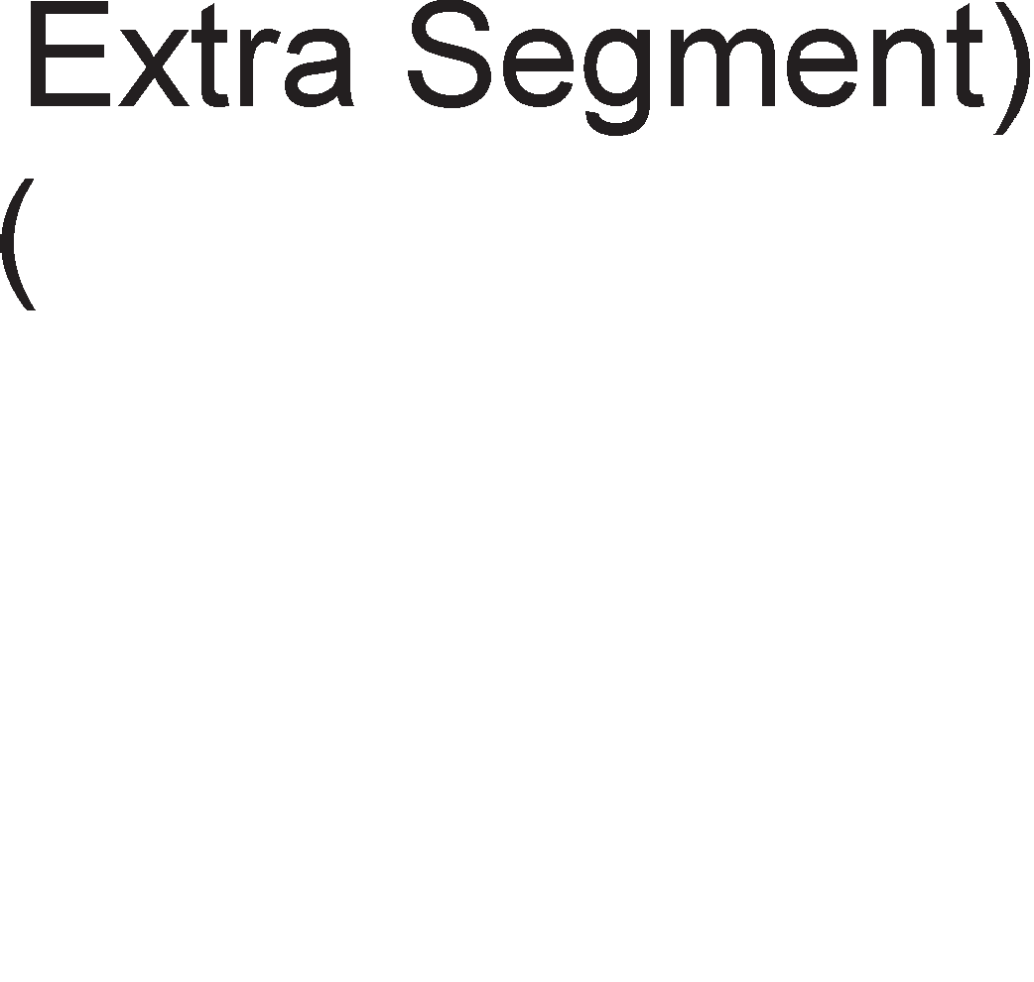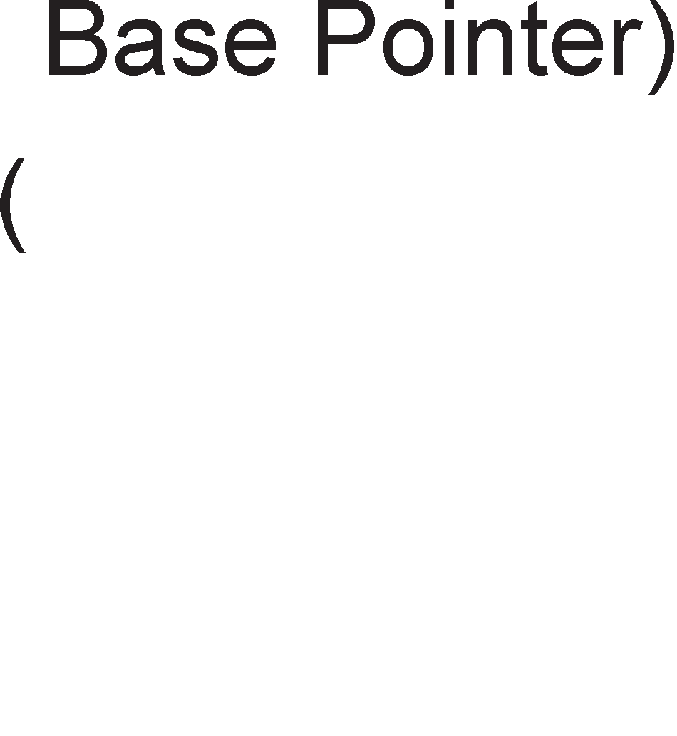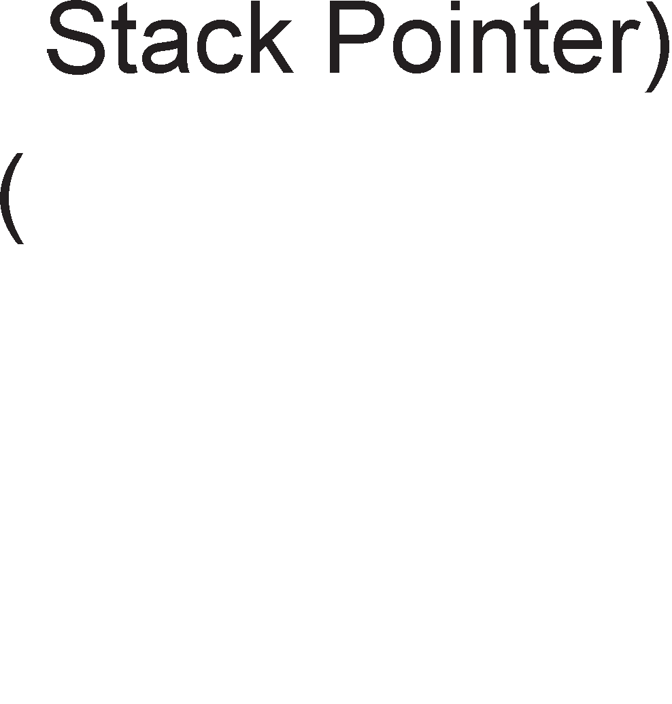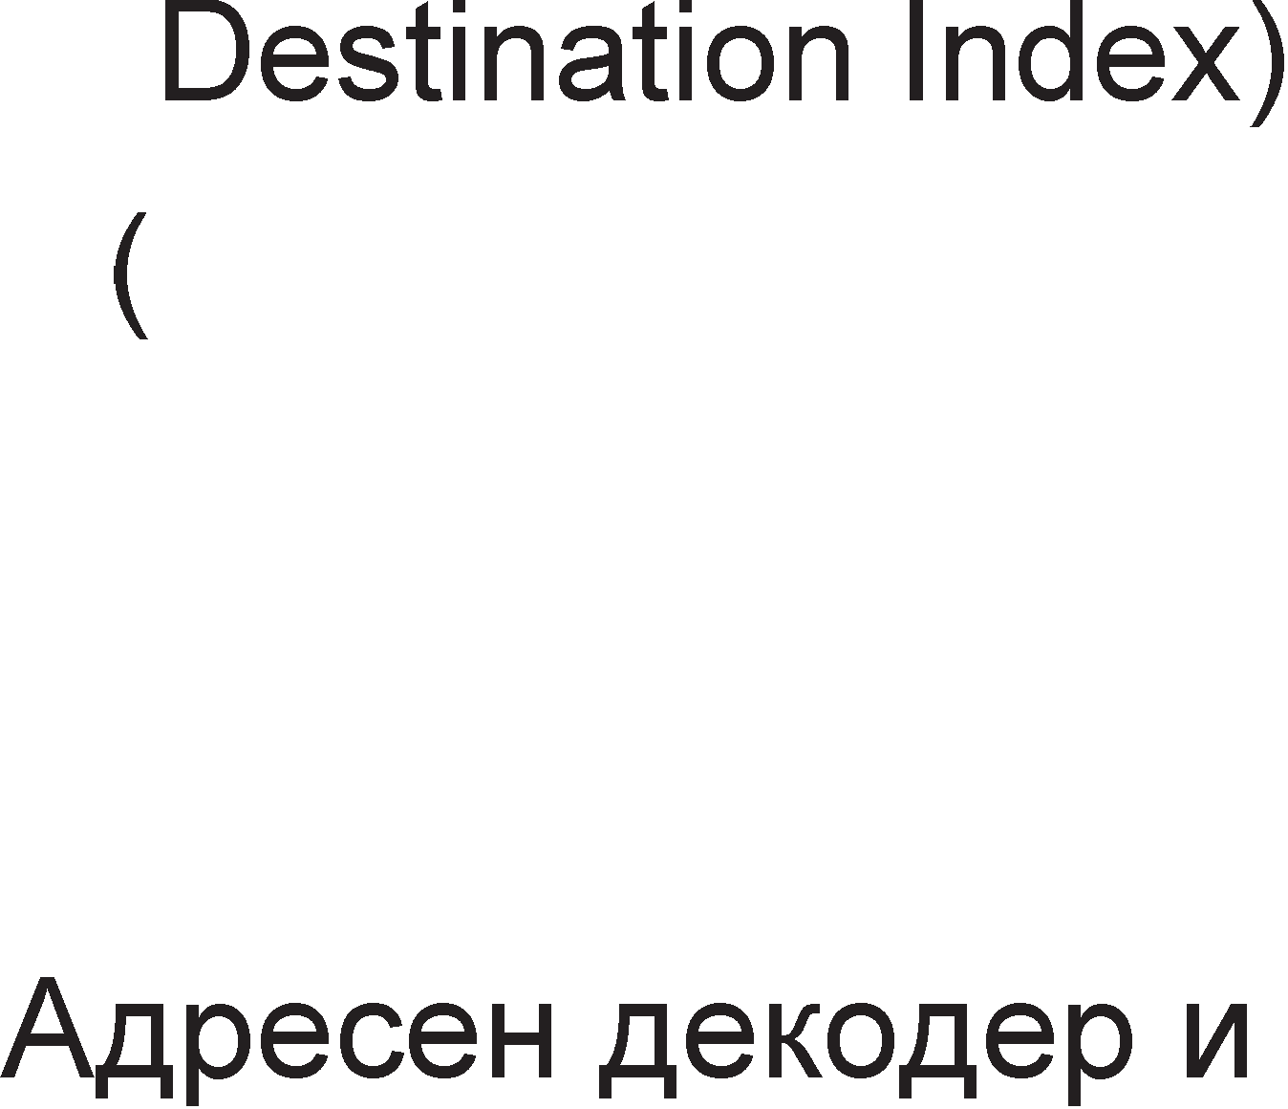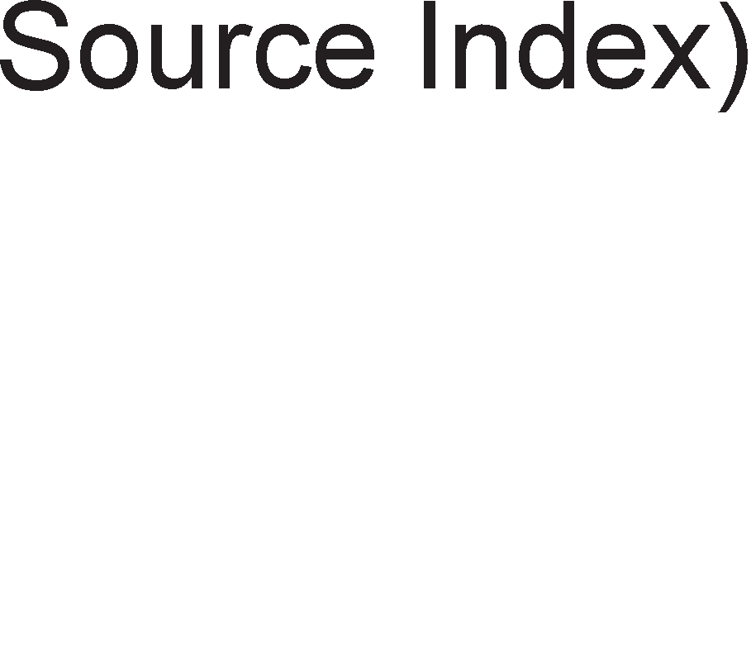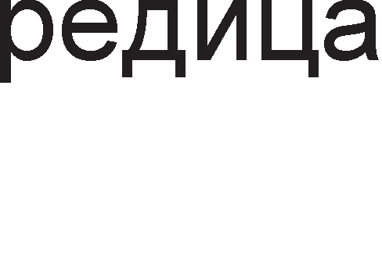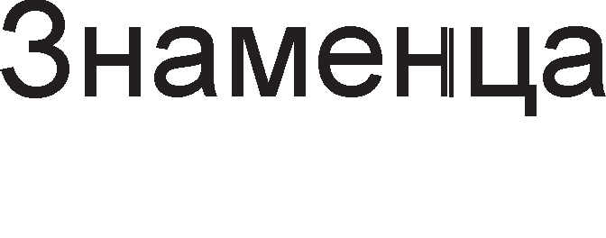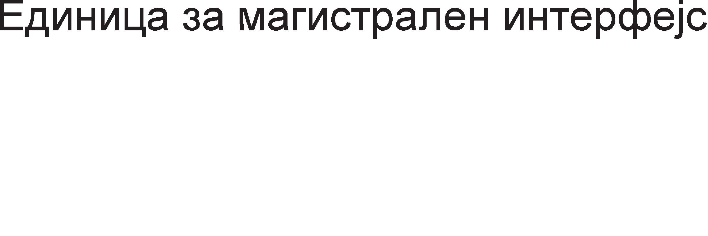

Cn1Ka 8.2. <lyHKL1oHanHa 6noK weMa Ha M1KponpoLecop 8086

##### Ll3epwHa e,qMHM4a

16-61THaTa ap1TMeT1L1Ko-nofl1L1Ka ep1H1La Bn1jae Bp3 cocToj61Te Ha cTaTycH1Te 1 Ha KoHTponH1Te 3HaMeHLa 1 MaH1nyn1pa co onwT1Te pefl1cTp1 1 1HcTpyKL1cK1Te onepaHp1. C1Te pefl1cTp1 1 1HTepH1 Mafl1cTpan1 Bo 13BpwHaTa ep1H1La ce 16-61TH1 co Len pa ce o6e36ep1 6p3 npeHoc Ha nopaToL1. l/l3BpwHaTa ep1H1La HeMa H1KaKBa BpcKa co HapBopewH1oT cBeT 1 1HcTpyKL11Te fl1 po61Ba op ep1H1LaTa 3a Mafl1cTpaneH 1HTepcpejc. Kofla HeKoja 1HcTpyKL1ja 6apa np1cTan po MeMop1jaTa 1n1 po nep1cpepeH ypep, 13BpwHaTa ep1H1La

1cnpai<a 6apal-be po ep1H1LaTa 3a Mafl1cTpaneH 1HTepcpejc pa np1M1 1n1 pa 1cnpaT1 nopaToK. l/l3BpwHaTa ep1H1La Kop1cT1 16-61TH1 appec1. **E,qMHM4aTa 3a MarMcTpa11HMoT MHTepcpejc epwM a,qpecHa pe11oKa4Mja (reHepMpa cpM3M"1Ka a,qpeca) wTo M oeo3Mo>Kyea Ha M3epwHaTa e,qMHM4a npMcTan ,qo 1MB MeMopMja.**

##### E,qMHM4a 3a MarMcTpa11eH MHTepcpejc

Ep1H1LaTa 3a Mafl1cTpaneH 1HTepcpejc ja 13BpwyBa LenaTa KoMyH1KaL1ja Ha 13BpwHaTa ep1H1La co nep1cpepH1Te ypep1 1 MeMop1jaTa. AopeKa 13BpwHaTa ep1H1La e 3acpaTeHa, ep1H1LaTa 3a Mafl1cTpaneH 1HTepcpejc flnepa Hanpep 1 MeMop1pa po 4 6ajT1 opHanpep. l/lHcTpyKL11Te wTo Tpe6a pa ce 13BpwaT Bo 13BpwHaTa ep1H1La ce cTaBaaT Bo TaKaHapeL1eHa **MH,qycTpMcKa pe,qM4a Ha "1eKa1-e.** Ep1H1LaTa 3a Mafl1cTpaneH 1HTepcpejc 1H1L1pa npeHoc Ha HoBa 1HcTpyKL1ja Kofla 6apeM pBa 6ajT1 op 1HcTpyKL1cKaTa pep1La ce cno6opH1. AoKonKy 13BpwHaTa ep1H1La 13Bpw1 1HcTpyKL1ja Koja ja MeHyBa KoHTponaTa Ha npoflpaMaTa (1HcTpyKL11 CALL 1 JUMP), Toflaw ep1H1LaTa 3a Mafl1cTpaneH 1HTepcpejc Bpw1 peceT1pal-be Ha 1HcTpyKL1cKaTa pep1La, Bpw1 npeHoc Ha onepaL1cK1 Kop op HoBaTa appeca 1 ja npepaBa Ha 13BpwHaTa ep1H1La, no wTo npopon>KyBa pa ja nonH1 pep1LaTa co HoB1Te appec1. no 6apal-be Ha Bne3Ho- 13ne3H1Te ypep1, ep1H1LaTa 3a Mafl1cTpaneH 1HTepcpejc flo nay31pa nonHel-beTo Ha 1HcTpyKL1cKaTa pep1La.

##### PerMcTpM

Pefl1cTp1 AX, BX, CX, DX ce HapeKyBaaT **onwTM perMcTpM**. OnwT1Te pefl1cTp1 ce Kop1cTaT KaKo nopaToL1H1 pefl1cTp1 opHocHo 3a np1BpeMeHo L1yBal-be Ha nopaToL1Te wTo Tpe6a pa ce o6pa6oTaT. nopaToL1H1Te pefl1cTp1 ce ep1HcTBeH1 no Toa wTo Mo>KaT pa ce Kop1cTaT 3a L1yBal-be nopaToL1 co pa3n1L1Ha floneM1Ha op 8 1n1 16 61Ta. AoKonKy caKaMe pa L1yBaMe 8-61TH1 nopaToL1, 16- 61TH1Te pefl1cTp1 ce penaT Ha nonoB1Ha. npB1Te noManKy 3aHaL1ajH1 61ToB1 op 0 po 7 ce 6ene>KaT co AL, BL, CL, DL (L-low H1cKo), a noBei<e 3HaL1ajH1Te nopaToL1H1Te 61ToB1 op 8 po 15 ce 6ene>KaT co AH, BH, CH, DH (H-high B1coKo).

noKa>KyBaL1K1Te 1 **MH,qeKc-perMcTpMTe** ce Kop1cTaT np1 ap1TMeT1L1K1Te 1 nofl1L1K1 onepaL11, Ho 1 np1 npecMeTyBal-be Ha cp131L1K1Te appec1 3a wTo nopoLHa i<e cTaHe 36op. nopony H1 e papeHo 3HaL1el-beTo Ha KpaTeHK1Te 3a onwT1Te 1 noKa>KyBaL1K1Te pefl1cTp1.

A – aKyMynaTop B – ocHoBa (base) C – 6pojaL1 (counter) D – nopaToK (data)

DI – Destination Index – 1HpeKc Ha Len SI – Source Index – 1HpeKc Ha 13Bop BP – Base Pointer – 6a3eH noKa>KyBaL1

SP – Stak Pointer– cTeK-noKa>KyBaL1

CeflMeHTa31L1jaTa npeTcTaByBa nopen6a Ha MeMop1jaTa Ha noBei<e penoB1 HapeL1eH1 ceflMeHT1. nocTo1 pa3n1Ka Mery no1M1Te ceflMeHT 1 **cerMeHTeH perMcTap**. CeflMeHToT e pen op MeMop1jaTa, a ceflMeHTH1oT pefl1cTap e MeMop1cKa noKaL1ja Bo M1KponpoLecopoT, Koj noMafla pa ce npoHajpe noL1eToKoT Ha caKaH1oT ceflMeHT. noL1eTHaTa appeca Ha ceflMeHToT ce po61Ba Kofla copp>K1HaTa Ha ceflMeHTH1oT pefl1cTap i<e ce noMHo>K1 co 6pojoT 16, opHocHo Ha copp>K1HaTa Ha

ceflMeHTH1oT pefl1cTap ce popaBaaT 4 Hyn1 op pecHaTa cTpaHa. MaKc1ManHaTa floneM1HaTa Ha ceflMeHToT 13HecyBa 216 = 64 KB. nocTojaT **"1eTMpM eM,qa cerMeHTM**. KpaTeHK1Te Ha ceflMeHT1Te 1 H1BHoTo 3HaL1el-be ce cnepH1Be:

DS-Data Segment- nopaToL1eH ceflMeHT CS-Code Segment-KopeH ceflMeHT

ES- Extra Segment-EKcTpa ceflMeHT SS- Stack Segment- CTeK-ceflMeHT

KopH1oT ceflMeHT fl1 copp>K1 1HcTpyKL11Te Ha npoflpaMaTa. nopaToL1H1oT ceflMeHT fl1 copp>K1 nopaToL1Te, onepaHp1Te wTo Tpe6a pa ce npoLec1paaT. EKcTpa ceflMeHToT ce Kop1cT1 np1 pa6oTa co H131 1 Toj ja copp>K1 LenHaTa H13a. CTeK-ceflMeHToT ce nonH1 1 ce npa3H1 npeKy HefloBaTa HajflopHa noKaL1ja.

CeKoja npoflpaMa 1Ma cBo1 ceflMeHT1. KonKy npoflpaM1 1MaMe TonKy KopH1 ceflMeHT1 i<e nocTojaT. Ho, Bo MoMeHToT i<e 61pe aKT1BeH caMo KopH1oT ceflMeHT Ha TeKoBHaTa npoflpaMa 1 HefloBaTa noL1eTHa appeca i<e ja po61eMe npeKy copp>K1HaTa Ha KopH1oT pefl1cTap. AoKonKy ce cMeH1 npoflpaMaTa wTo ce o6pa6oTyBa, Toflaw i<e ce cMeH1 1 copp>K1HaTa Ha ceflMeHTH1Te pefl1cTp1.

# nMH ,qMjarpaM Ha MMKponpo4ecop 8086

M1KponpoLecopoT 8086 1Ma **40-nMHcKo Kyi<MwTe** 1 Kop1cT1 HanojyBal-be op

+5V. Ha cn1Ka 8.3. e np1Ka>KaH n1H p1jaflpaMoT Ha M1KponpoLecopoT 8086. Bo 3aB1cHocT op floneM1HaTa 1 cno>KeHocTa Ha npoflpaM1Te, M1KponpoLecopoT 8086 Mo>Ke pa pa6oT1 Bo **,qea Mo,qa: MMHMMa11eH M MaKcMMa11eH**. Co oB1e pBa pe>K1M1 i<e ce 3ano3HaeMe nopoLHa. Aen op 40-Te n1Ha 1MaaT pa3n1L1H1 cpyHKL11 np1 M1H1ManeH 1 MaKc1ManeH pe>K1M Ha pa6oTa. npBo i<e ce 3ano3HaeMe co n1HoB1Te Ko1 1MaaT 1cTa cpyHKL1ja Bo pBaTa pe>K1M1 Ha pa6oTa.

**AD15-AD0** MynT1nneKcHa appecHo nopaToL1Ha Mafl1cTpana

**A19/S6-A16/S3** MynT1nneKcHa appecHo cTaTycHa Mafl1cTpana. CTaTycH1oT 61T S0 ceKoflaw e Ha H1cKo H1Bo, 61ToT S1 ja paBa cocToj6aTa Ha 3HaMeHLeTo 3a npeK1H (IF-Interrupt Flag). 61ToB1Te S2 1 S3

noKa>KyBaaT Koj op L1eT1p1Te ceflMeHT1 Ha npoflpaMaTa e MoMeHTanHo aKT1BeH.



Cn1Ka 8.3. n1H p1jaflpaM Ha M1KponpoLecop 8086

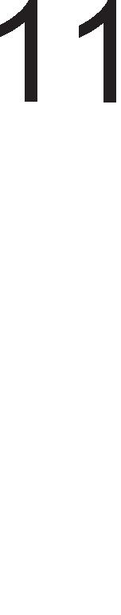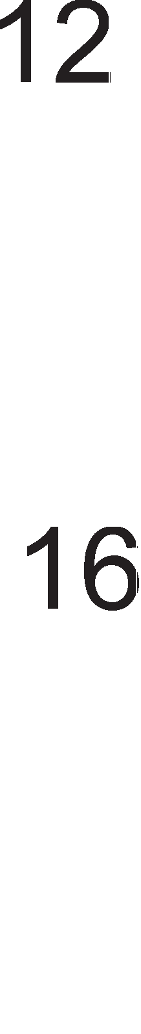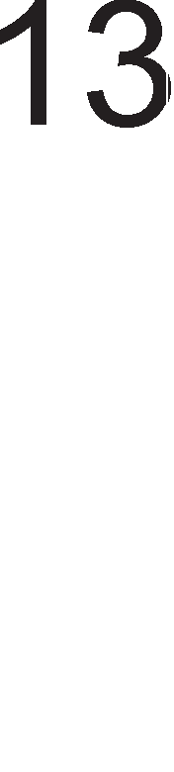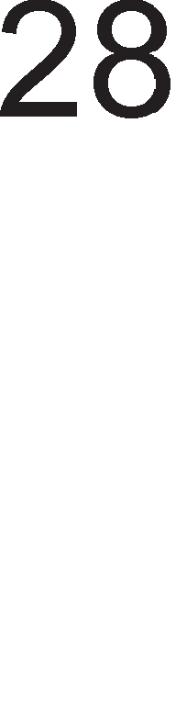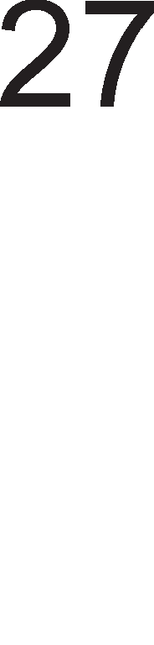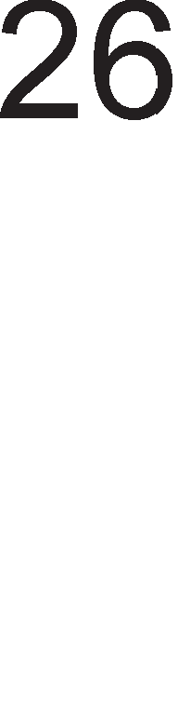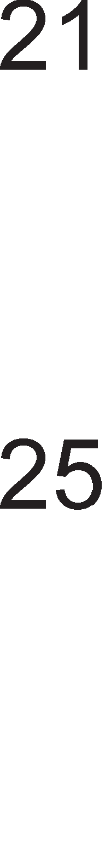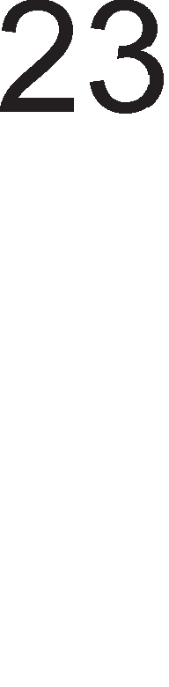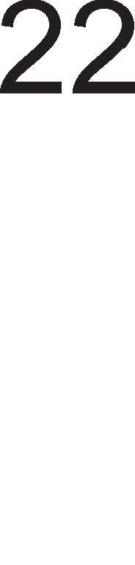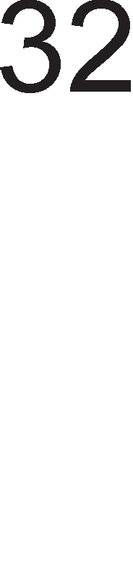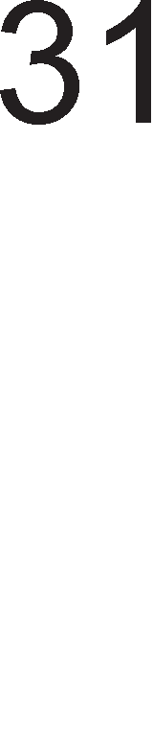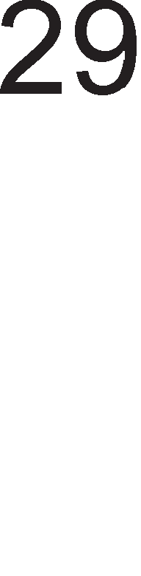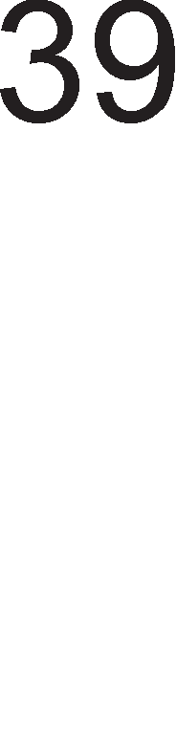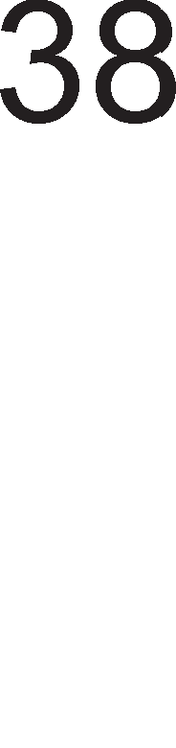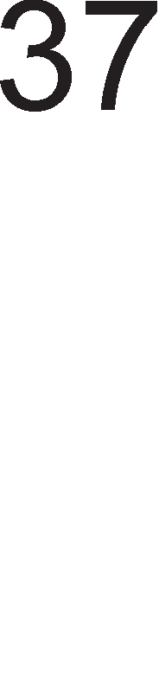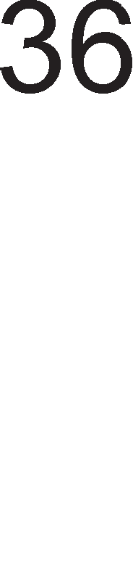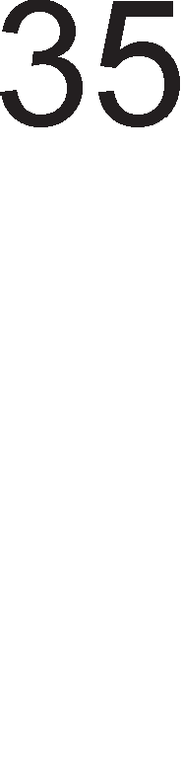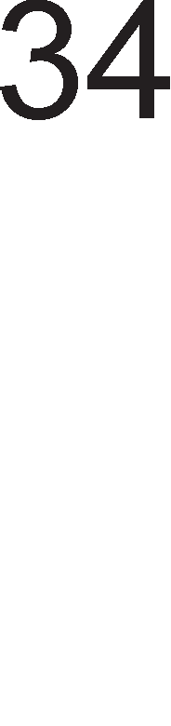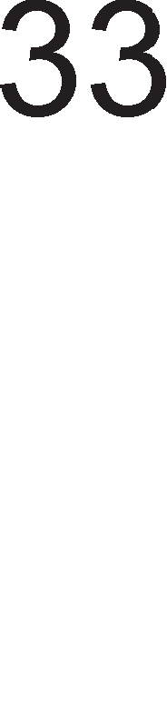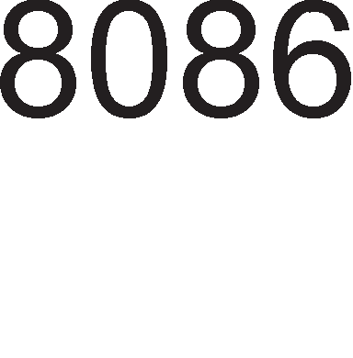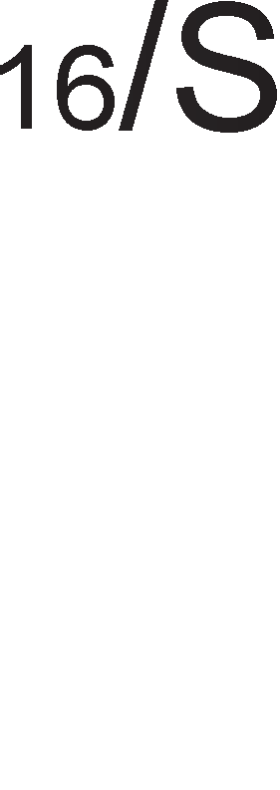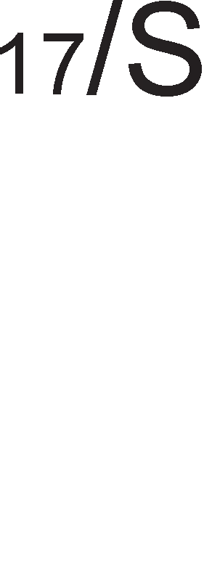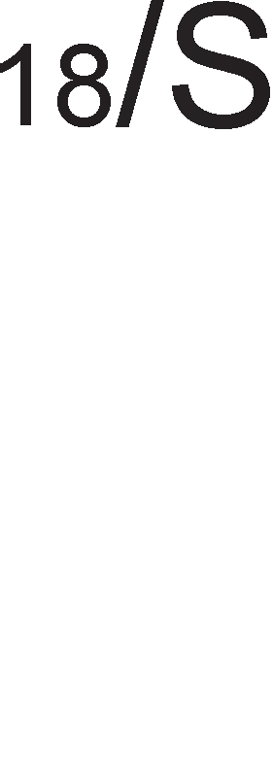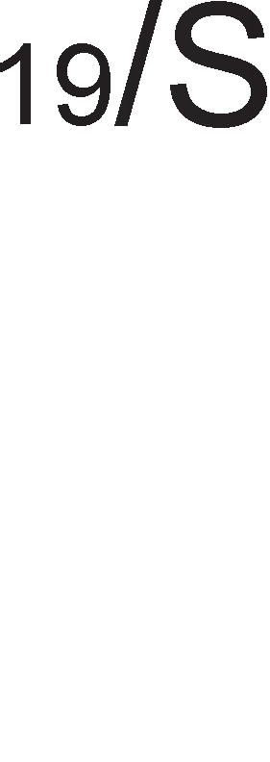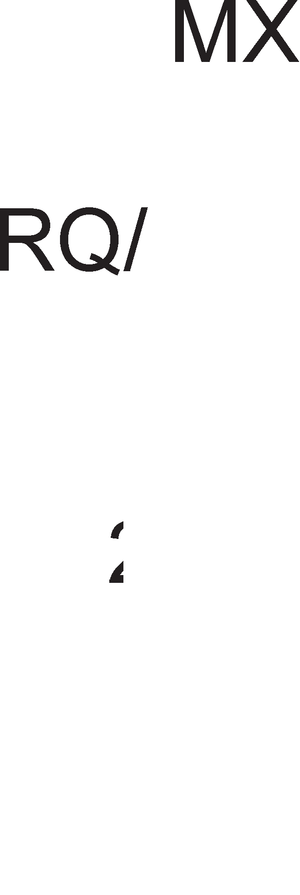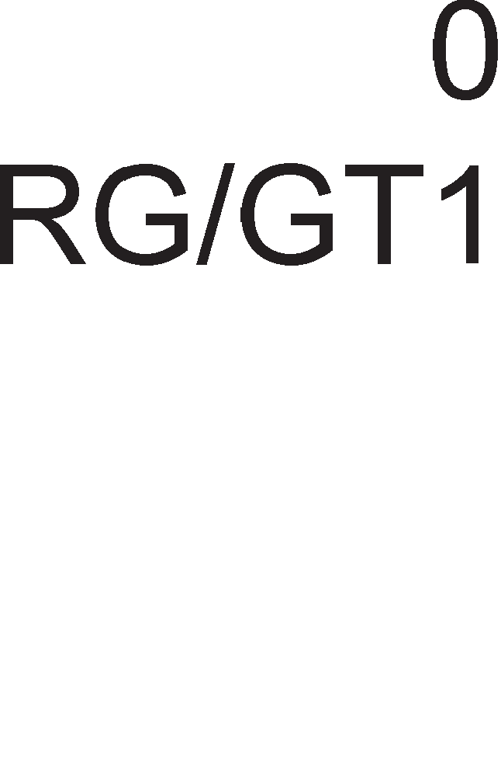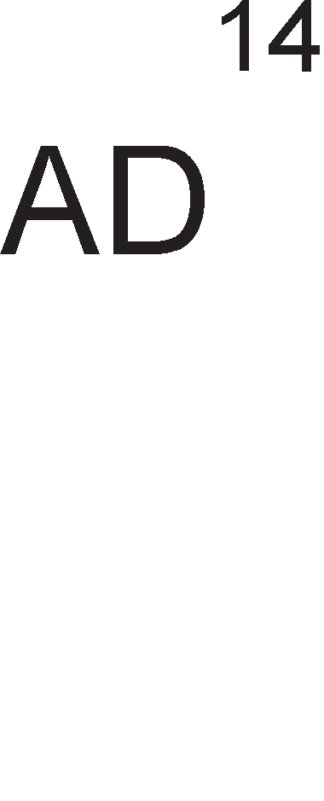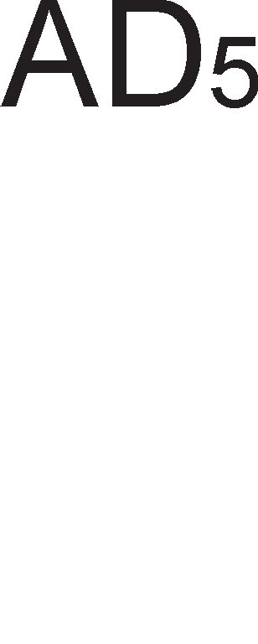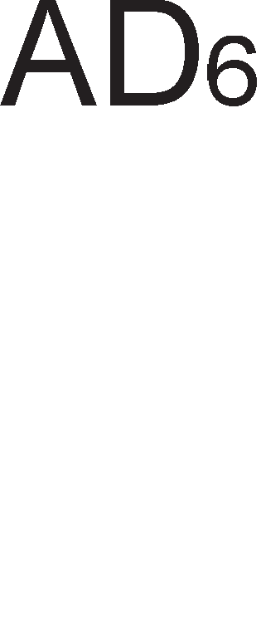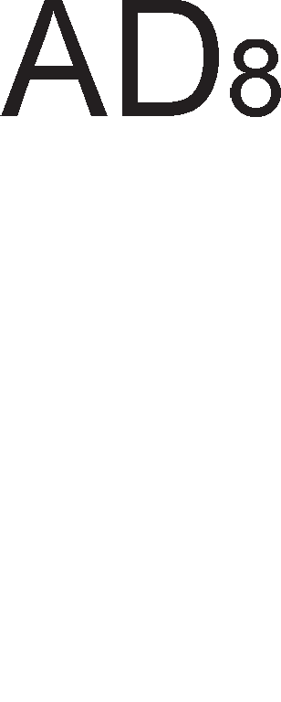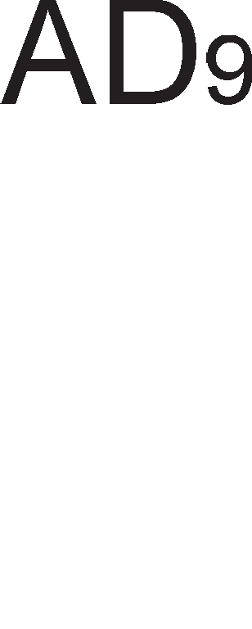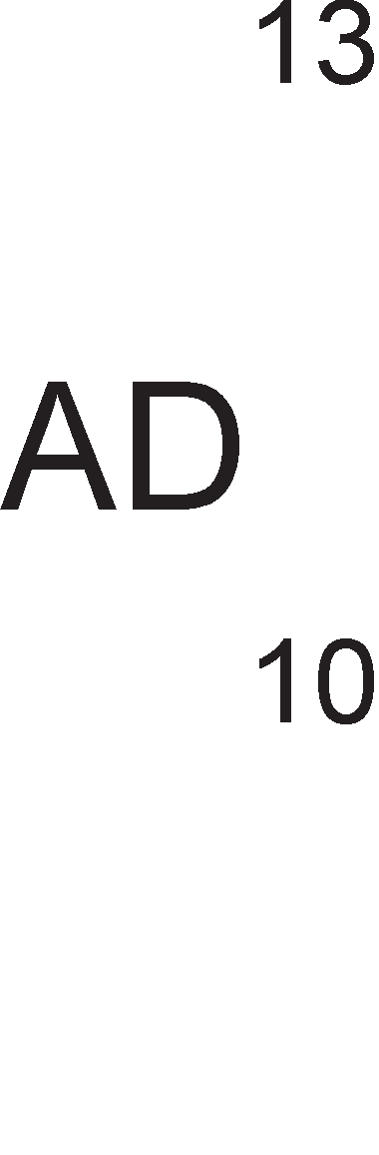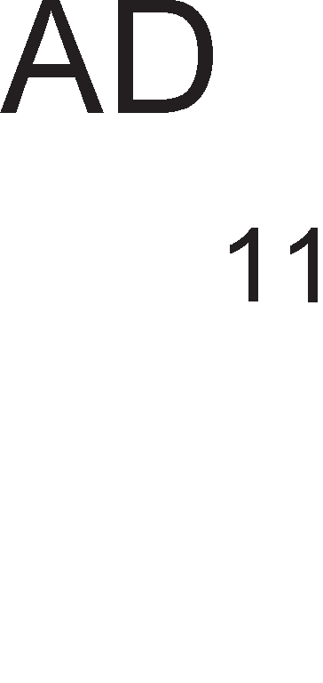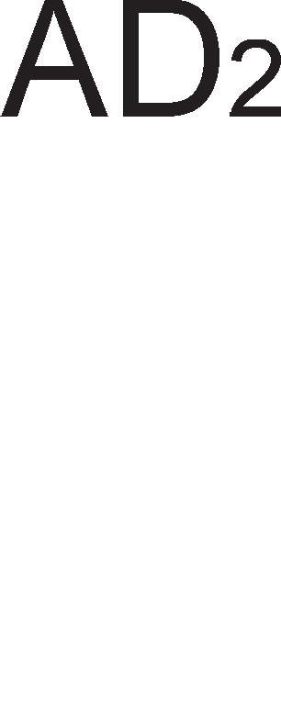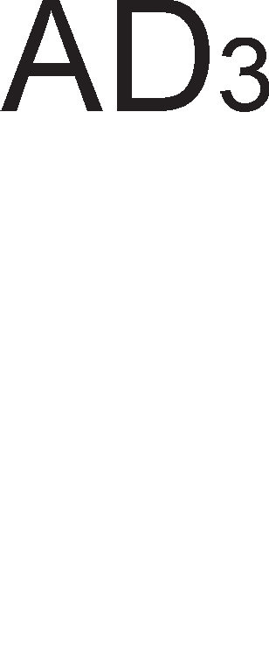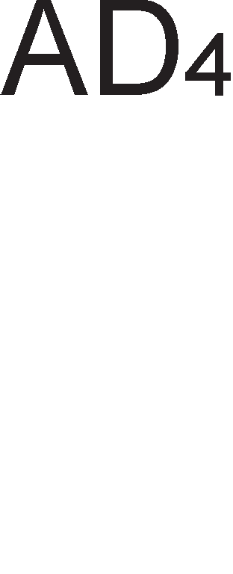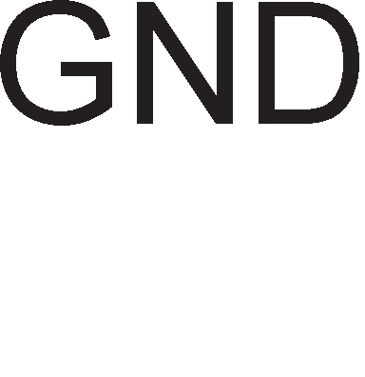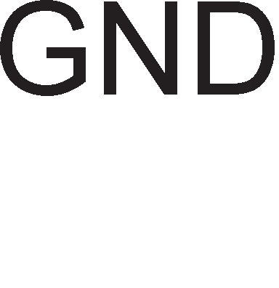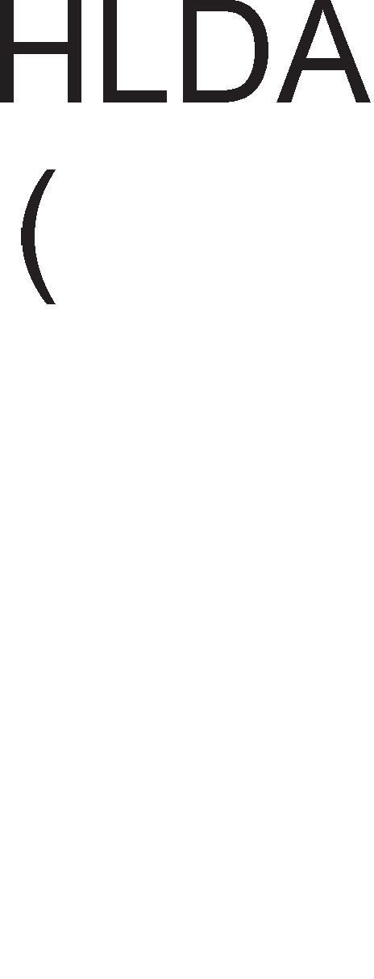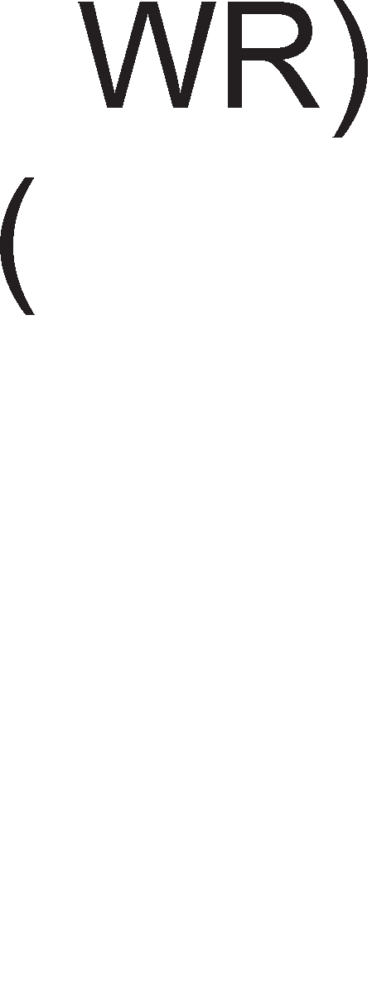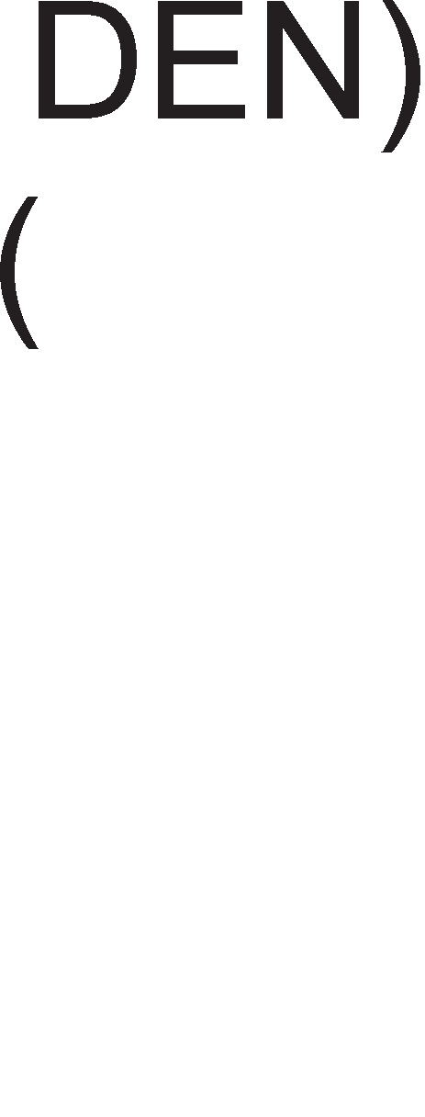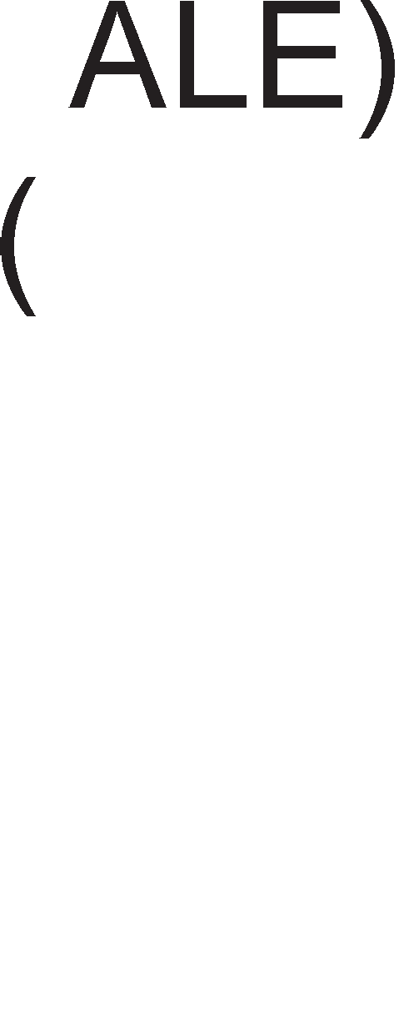

OBoj 13ne3eH n1H e aKT1BeH Ha nofl1L1Ka Hyna 1 Toj 1H1L1pa onepaL1ja L11Tal-be op HeKoj nep1cpepeH ypep 1n1 MeMop1ja.



**READY** AKo oBoj n1H e Ha H1cKo H1Bo Toflaw M1KponpoLecopoT BneflyBa Bo cocToj6a Ha L1eKal-be 1 ocTaHyBa Bo Hea ce popeKa He pojpe po npoMeHa Ha cocToj6aTa Ha n1HoT.

**INTR** Bne3eH n1H npeKy Koj M1KponpoLecopoT fl1 np1Ma 6apal-baTa 3a XappBepcK1 npeK1H1.

 OBoj n1H ce TecT1pa 3a BpeMe Ha WAIT 1HcTpyKL1jaTa. OBoj n1H e HajL1ecTo noBp3aH co HyMep1L1K1oT KonpoLecop 8087.

**NMI** KpaTeHKaTa Ha oBoj n1H poai<a op 36opoB1Te Non Maskable Interrupt wTo Bo npeBop 3HaL11 HeMacK1paL1K1 npeK1H.

**RESET** OBoj Bne3eH n1H cny>K1 3a peceT1pal-be Ha M1KponpoLecopoT nocne wTo Toj npopon>KyBa pa fl1 13BpwyBa 1HcTpyKL11Te op noKaL1ja co appeca FFFF0H.

**MN/** AKo oBoj n1H e Ha H1cKo H1Bo Toflaw M1KponpoLecopoT 8086 pa6oT1 Bo MaKc1ManeH pe>K1M, a aKo e Ha B1coKo H1Bo Toflaw Toj



pa6oT1 Bo M1H1ManeH pe>K1M.

**/S7** OBoj n1H ce 6ene>K1 co KpaTeHKaTa Ha 36opoB1Te Bus High Enable 1 aKo e Hyna Toflaw M1KponpoLecopoT 1Ma np1cTan po no3HaL1ajH1Te nopaToL1H1 61ToB1 op D8 po D15, 6e3 pa3n1Ka pan1 T1e ce pen op 16 61TeH nopaToK 1n1 noce6eH 6ajT.



Bo M1H1ManeH pe>K1M M1KponpoLecopoT fl1 fleHep1pa 1 npeHecyBa KoHTponH1Te c1flHan1 po MeMop1jaTa po nep1cpepH1Te ypep1.

**M/ ** Kofla oBoj n1H e Ha B1coKo H1Bo M1KponpoLecopoT KoMyH1L1pa co MeMop1jaTa, a Kofla e Ha H1cKo H1Bo Toflaw co nep1cpepH1Te ypep1.

 OBa e 13ne3eH n1H 1 1H1L1pa onepaL1ja n1wyBal-be.

 OBoj c1flHan cny>K1 KaKo noTBppa Ha 6apal-beTo 3a npeK1H opHocHo npecTaByBa opfloBop Ha c1flHanoT INTR.

**ALE** Kofla oBoj Bne3eH n1H e aKT1BeH Toflaw no appecHo nopaToL1HaTa Mafl1cTpana i<e ce npeHecyBaaT appecH1 61ToB1

**DT/ ** O3HaKaTa Ha oBoj n1H e KpaTeHKa op 36opoB1Te Data Transmit

/Receive wTo Bo npeBop 3HaL11 1cnpaTeH1/ np1MeH1 nopaToL1. OBoj c1flHan ja paBa HacoKaTa Ha pB1>Kal-be Ha nopaToL1Te, KoH M1KponpoLecopoT 1n1 op Heflo.

O3HaKaTa e KpaTeHKa op 36opoB1Te Data Enable wTo Bo npeBop 3HaL11 ocnoco6yBal-be Ha nopaToL1. OBoj n1H e Ha H1cKo H1Bo ceKoflaw Kofla Tpe6a pa ce pean131pa npeHoc Ha nopaToL1 no Mafl1cTpanaTa.



**HOLD** OBa e Bne3eH n1H npeKy Koj DMA KoHTponepoT pocTaByBa

6apal-be 3a npeB3eMal-be Ha Mafl1cTpan1Te op M1KponpoLecopoT.

**HLDA** OBa e 13ne3eH c1flHan npeKy Koj M1KponpoLecopoT opfloBapa Ha 6apal-beTo 3a p1peKTeH npeHoc Ha nopaToL1

 OBoj cTaTyceH c1flHan 3aepHo co c1flHan1Te /M 1 DT/ cny>K1 3a pecp1H1pal-be Ha B1poT Ha Maw1HcK1 L1Knyc Bo M1H1ManeH pe>K1M Ha pa6oTa.

Bo MaKc1ManeH pe>K1M Ha pa6oTa 1cT1Te n1HoB1 cny>KaT 3a noBp3yBal-be Ha M1KponpoLecopoT co MaTeMaT1L1K1oT KonpoLecop. Bo Toj cnyL1aj KoHTponH1Te cpyHKL11 fl1 13BpwyBa KoHTponepoT Ha Mafl1cTpan1Te.

**,  M ** CTaTycH1Te 61ToB1 flo pecp1H1paaT B1poT Ha Maw1HcK1

L1Knyc Bo MaKc1ManeH pe>K1M Ha pa6oTa.OB1e c1flHan1 ce 13ne3H1 3a M1KponpoLecopoT, a Bne3H1 3a KoHTponepoT Ha Mafl1cTpan1. Co oBoj KoHTponep i<e ce 3ano3HaeMe nopoLHa.

**RO/GT1 M RO/GT0** KpaTeHKaTa Ha oB1e n1HoB1 poara op 36opoB1Te Request

/Grant wTo Bo npeBop 3HaL11 6apal-be/popenyBal-be. OB1e n1HoB1 ce pBoHacoL1H1 1 ce Kop1cTaT 3a ynpaByBal-be co p1peKH1oT np1cTan po MeMop1jaTa (DMA).

OBoj n1H cny>K1 3a 3aKnyL1yBal-be Ha nep1cpepH1Te ypep1 Bo c1cTeMoT. n1HoT ce aKT1B1pa co popaBal-be Ha npecp1KcoT LOCK Ha 1HcTpyKL1jaTa.



**QS1 M QS0** OB1e n1HoB1 ce 6ene>KaT co KpaTeHKaTa op 36opoB1Te queue status 1 cny>KaT 3a pecp1H1pal-be Ha cocToj6aTa Ha 1HcTpyKL1cKaTa pep1La. l/lHcTpyKL1cKaTa pep1La Mo>Ke pa 61pe HapBop op ynoTpe6a 1n1 npa3Ha, npB1oT 6ajT op Hea pa 61pe onepaL1cK1 Kop 1n1 6ajToT Koj cnepyBa nocne Heflo.

# MMHMMa11eH M MaKcMMa11eH pe>KMM Ha pa6oTa

Kofla ja o6jacHyBaBMe cpyHKL1jaTa Ha n1HoB1Te Ha M1KponpoLecopoT 8086 cnoMHaBMe peKa Toj Mo>Ke pa pa6oT1 Bo pBa pe>K1M1, M1H1ManeH 1 MaKc1ManeH. **Ll36opoT Ha pe>KMM ce epwM npeKy nMHoT MN/ .** Kofla oBoj n1H e Ha H1cKo H1Bo Toflaw M1KponpoLecopoT pa6oT1 Bo MaKc1ManeH pe>K1M, a Kofla e Ha B1coKo H1Bo Toflaw Bo M1H1ManeH pe>K1M. M1H1ManH1oT pe>K1M e MHofly cn1L1eH co HaL11HoT Ha pa6oTa Ha 8-61TH1oT M1KponpoLecop 8085 1 c1Te npoflpaM1 Ko1 fl1 Kop1cT1 M1KponpoLecopoT 8085 Mo>KaT pa ce ynoTpe6aT 1 3a M1KponpoLecopoT 8086. Ha cn1Ka 8.4. e np1Ka>KaH **MMHMMa11eH MMKpoKoMnjyTepcKM cMcTeM** Ha M1KponpoLecopoT 8086. OBaa Bap1jaHTa e MHofly noeBT1Ha 61peji<1 **MMKponpo4ecopoT caM rM reHepMpa KoHTpo11HMTe cMrHa11M**. C1flHan1Te IO/M, RD 1 WR 1361paaT MeMop1cK1 1n1 np1cpepeH ypep 3a KoMyH1KaL1ja 1 B1p Ha onepaL1ja, L11Tal-be 1n1 n1wyBal-be. ALE Bpw1 ocnoco6yBal-be Ha appecH1oT neL1 Kofla no appecHo nopaToL1HaTa Mafl1cTpana ce npeHecyBaaT appecH1 61ToB1. C1flHan1Te DEN 1 DT/R ja oppepyBaaT HacoKaTa Ha pB1>Kel-be Ha nopaToL1Te 1 flo ocnoco6yBaaT nopaToL1H1oT 6acpep. TyKa e 1 c1flHanoT INTA npeKy Koj ce opo6pyBa npeK1HoT Koj flo no6apan KoHTponepoT Ha npeK1H1. C1flHan1Te Ko1 fl1 Kop1cT1 M1KponpoLecopoT 8086 ce peL11c1 1peHT1L1H1 co oH1e Ko1 fl1 Kop1cT1 M1KponpoLecopoT 8085.

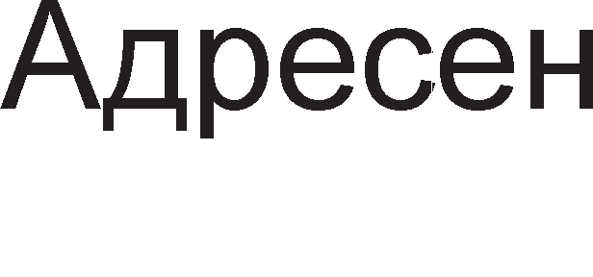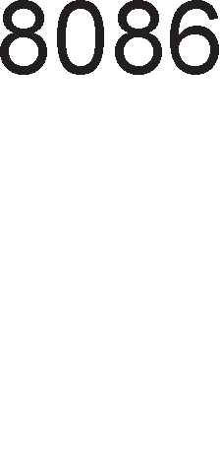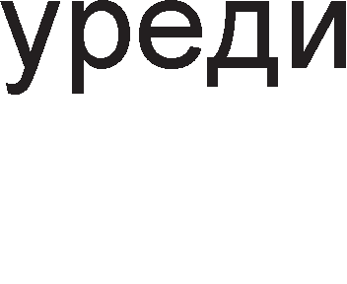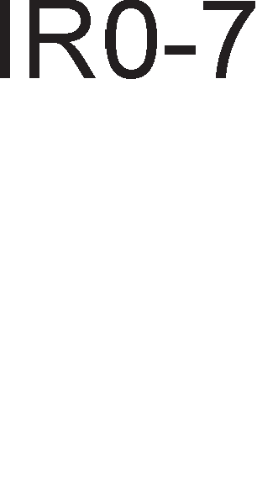

Cn1Ka 8.4. M1H1ManeH M1KpoKoMnjyTepcK1 c1cTeM 8086



**MaKcMMa11HMoT pe>KMM ce KopMcTM Kora eo cMcTeMoT e eK11y"1eH e,qeH M11M noeei<e apMTMaTM"1Ko Konpo4ecopM**. 61peji<1 M1KponpoLecopoT 8086 HeMa poBonHo n1HoB1 3a ynpaByBal-be co Mafl1cTpan1Te oBaa cpyHKL1ja ja Bpw1 KoHTponepoT Ha Mafl1cTpan1 co cep1cK1 6poj 8288. Ha cn1Ka 8.5. e np1Ka>KaH 8086 M1KpoKonpoLecopcK1oT c1cTeM Kofla M1KponpoLecopoT pa6oT1 Bo MaKc1ManeH pe>K1M. AKo flo noflnepHeMe KoHTponepoT Ha Mafl1cTpan1 i<e B1p1Me peKa Toj fl1 fleHep1pa 1cT1Te KoHTponH1 c1flHan1 Ko1 M1KponpoLecopoT 8086 fl1 fleHep1pa Bo M1H1ManeH pe>K1M.

Bo M1H1ManeH pe>K1M cTaTycHaTa n1H1ja S0 6ewe ceKoflaw Ha H1cKo H1Bo, S1 ja paBawe cocToj6aTa Ha 3HaMeHLeTo 3a npeK1H 1 S2 noKa>KyBawe Koj e aKT1BeH ceflMeHT op TeKoBHaTa npoflpaMa .Bo MaKc1ManeH pe>K1M oB1e **cTaTycHM 11MHMM** cny>KaT 3a pecp1H1pal-be Ha B1poT Ha Maw1HcK1 L1Knyc : npeHoc Ha onepaL1cK1 Kop , L11Tal-be 1n1 n1wyBal-be op MeMop1ja, L11Tal-be 1n1 n1wyBal-be op nep1cpepeH ypep, o6pa6oTKa Ha npeK1H. 61ToB1Te   1 ce peKop1paaT 1 Bo 3aB1cHocT op H1BHaTa KoM61HaL1ja ce aKT1B1paaT HeKo1 op 13ne3H1Te KoHTponH1 c1flHan1. HaMecTo c1flHan1Te , , IO/ ce Kop1cTaT KoHTponH1 c1flHan1 co cn1L1Ha cpyHKL1ja, Ho pa3n1L1Ha o3HaKa:



* – Input Output Write Control e c1flHan co Koj ce 1H1L1pa n1wyBal-be Bo nep1cpepeH ypep



• – Input Output Read Control ce aKT1B1pa Kofla Tpe6a pa ce npoL11Ta nopaToK op nep1cpepeH ypep

•  – Memory Write Control cny>K1 3a n1wyBal-be Bo MeMop1ja

•  – Memory Read Control ce aKT1B1pa np1 L11Tal-be op MeMop1ja.

WE OE

RAM

OE

ROM

T

OE

CS WR RD

nep1cpepH1 ypep1

CLK MRDC

MWTC

DEN IORC

DT/R IOWC

ALE INTA

STB OE

MN/MX GND

S0

CLK S1 READY

S2

RESET

reHepaTop

Ha TaKT

8086

KoHTponop Ha

Mafl1cTpan1

GND

AppecHa Mafl1cTpana

ADDRESS DATA

INT

AppeceH

neL1

nopaToL1Ha Mafl1cTpana

6acpep

IR0-7

KoHTponep Ha npeK1H1

Cn1Ka 8.5. MaKc1ManeH M1KpoKoMnjyTepcK1 c1cTeM 8086

nocToel-beTo Ha MaKc1ManH1oT pe>K1M 3aBpwyBa co nojaBaTa Ha 16 61TH1oT M1KponpoLecop 80286.

# Pea11eH Mo,q Ha pa6oTa

80286 1 c1Te M1KponpoLecop1 wTo cnepyBaaT no Heflo Mo>KaT pa pa6oTaT Bo pBa Mopa Ha pa6oTa: 3awT1TeH 1 peaneH. Ep1HcTBeHo, M1KponpoLecopoT 8086 pa6oT1 1cKnyL11Bo Bo peaneH Mop Ha pa6oTa. PeanH1oT Mop Ha pa6oTa My oBo3Mo>KyBa Ha M1KponpoLecopoT np1cTan po MeMop1cK1 npocTop op 1MB. npB1oT 1MB op MeMop1cK1oT npocTop e no3HaT no 1MeTo peanHa MeMop1ja. OnepaT1BH1oT c1cTeM DOS cpyHKL1oH1pa Bo peaneH Mop Ha pa6oTa. PeanH1oT Mop Ha pa6oTa oncTaHan, npep ce 3a pa ce o6e36ep1 KoMnaT161nHocT Ha cTap1oT cocpTBep co HoB1Te M1KponpoLecop1. 3a pa npoflpaM1Te Han1waH1 Bo peaneH

Mop cpyHKL1oH1paaaT Bo 3awT1TeH Mop, T1e Tpe6a pa ce npepa6oTaT wTo 6apa Bno>KyBal-be floneM Tpyp. 3a appec1pal-be Ha 1MB MeMop1ja noTpe6H1 ce 20 appecH1 61Ta (220 = 1MB).

**Bo pea11eH Mo,q Ha pa6oTa 3a cpopMMpa1-e Ha cpM3M"1KaTa a,qpeca, noTpe6HM ce ,qea ,qe11a: no"1eTHa a,qpeca Ha cerMeHToT M noMecTyea1-e**. noL1eTHaTa appeca Ha ceflMeHToT ce po61Ba aKo 16-61THaTa BpepHocT Ha ceflMeHTH1oT pefl1cTap ce noMecT1 4 MecTa BneBo 1 op pecHaTa cTpaHa ce popapaT 4 Hyn1. l/lcT1oT ecpeKT ce po61Ba aKo copp>K1HaTa Ha ceflMeHTH1oT pefl1cTap ce noMHo>K1 co 1616=100010. AoKonKy copp>K1HaTa Ha ceflMeHTH1oT pefl1cTap e 3apapeHa Bo XeKcapeL1ManeH 6poeH c1cTeM, noL1eTHaTa appeca Ha ceflMeHToT ce po61Ba aKo Ha XeKcapeL1ManHaTa copp>K1Ha Ha ceflMeHTH1oT pefl1cTap ce noMecT1 3a epHo MecTo BneBo 1 op pecHaTa cTpaHa ce popape epHa Hyna. TaKa Ha np1Mep, aKo ceflMeHTpH1oT pefl1cTap copp>K1 BpepHocT 1000H. Toa 3HaL11 peKa npB1oT 6ajT op Toj ceflMeHT i<e 1Ma appeca 10000H. noMecTyBal-beTo e 16-61THa BpepHocT wTo ce popaBa Ha noL1eTHaTa appeca 1 cny>K1 3a 1peHT1cp1KaL1ja 1 6ajT op BKynHo 64KB. BpepHocTa **64KB** npeTcTaByBa **MaKcMMa11Ha ro11eMMHa Ha MeMopMcKM cerMeHT** 1 ce po61Ba npeKy paBeHKaTa

216 = 64 KB, Kape wTo 16 e 6poj Ha 61ToB1 Bo noMecTyBal-beTo. noMecTyBal-beTo

1Ma M1H1ManHa floneM1Ha 0000H 1 Toflaw Toa nocoL1yBa Ha npB1oT 6ajT op ceflMeHToT. MaKc1ManHaTa BpepHocT Ha noMecTyBal-beTo 13HecyBa FFFFH 1 Toflaw Toa nocoL1yBa Ha nocnepH1oT 6ajT op ceflMeHToT. 61peji<1 Bo peaneH Mop Ha pa6oTa pon>K1HaTa Ha ceflMeHToT 13HecyBa 64KB, KpajHa appeca Ha ceflMeHToT ce po61Ba aKo Ha HefloBaTa noL1eTHa appeca ce popape BpepHocT FFFFH. Ha cn1Ka

8.6. e np1Ka>KaHo KaKo M1KponpoLecopoT 8086 np1cTanyBa po RAM MeMop1jaTa.

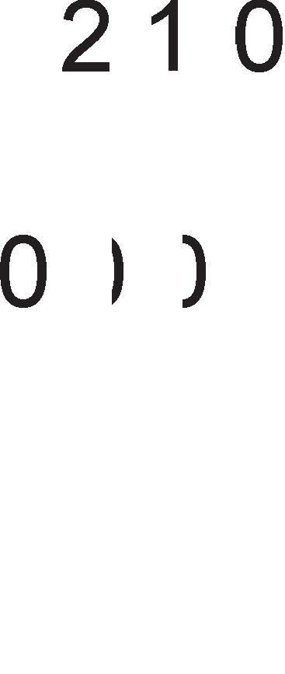

Cn1Ka 8.6. npecMeTKa Ha cp131L1Ka MeMop1cKa appeca Kaj M1KponpoLecop 8086

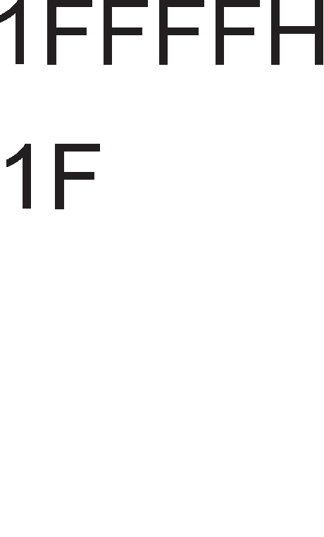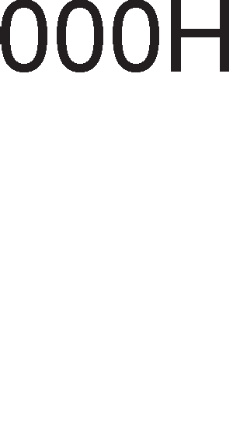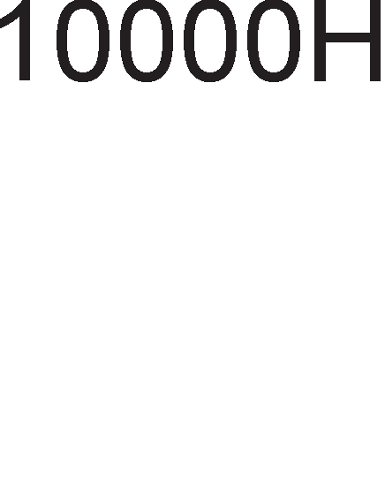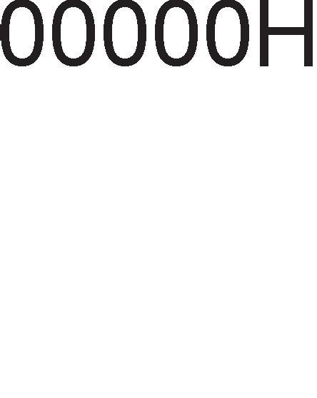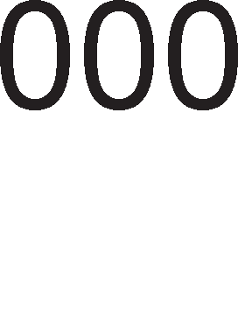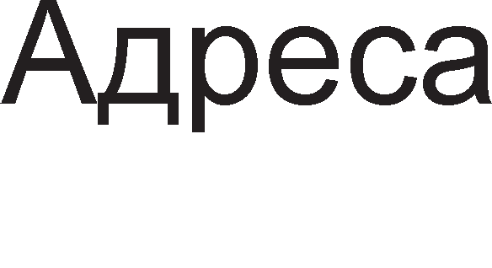

noMecTyBal-beTo wTo ce popaBa Ha noL1eTHaTa appeca Ha ceflMeHToT Mo>Ke pa ce copp>K1 Bo HeKoj pefl1cTap 1n1 pa 61pe 3apapeHo KaKo 16-61TeH 6poj. nocTojaT cTpofl1 npaB1na 3a pecp1H1pal-be Ha noMecTyBal-beTo. TaKa, Ha np1Mep, Kofla pa6oT1Me co KopH1oT ceflMeHT, noMecTyBal-beTo ceKoflaw ce copp>K1 Bo

1HcTpyKL1cK1oT noKa>KyBaL1, a Kofla pa6oT1Me co cTeK-MeMop1jaTa, Toflaw noMecTyBal-beTo Mo>Ke pa ce copp>K1 Bo epeH op pBaTa pefl1cTpa SP 1 BP. Bo Ta6enaTa 8.1. ce papeH1 c1Te **,qo3eo11eHM KoM6MHa4MM 3a cerMeHTHMoT perMcTapT – 16-6MTHo noMecTyea1-e**.

|  |  |  |
| --- | --- | --- |
| CeflMeHT | noMecTyBal-be | np1MeHa |
| CS | IP | npoHaoral-be Ha cnepHaTa 1HcTpyKL1ja |
| SS | SP 1n1 BP | np1cTan po noKaL1jaTa Bo cTeKoT |
| DS | BX,DI,SI 1n1 16 61TeH  6poj | npoHaoral-be Ha onepaHpoT |
| ES | DI 3a pa6oTa co H131 | Aecp1H1pal-be Ha appecaTa Ha LenTa |

Ta6ena 8.1.

Bo peaneH Mop Ha pa6oTa ceKoj ceflMeHT Mo>Ke pa 1Ma MaKc1ManHa floneM1Ha op 64KB. CeflMeHT1Te Mo>KaT pa ce coBnaraaT. AKo HeKoj ceflMeHT He fl1 Kop1cT1 c1Te 64KB wTo My np1naraaT, Toflaw HeKoj ppyfl ceflMeHT Mo>Ke pa ce coBnapHe co Heflo, opHocHo BTop1oT ceflMeHT Mo>Ke pa fl1 Kop1cT1 He1cKop1cTeH1Te 6ajT1 op npB1oT. Ha BaKoB HaL11H npoflpaMepoT Mo>Ke pa ja M1H1M13a1pa cp131L1KaTa MeMop1ja noTpe6Ha 3a pean13aL1ja Ha npoflpaMaTa.

# Ha"1MHM 3a a,qpecMpa1-e Kaj MMKponpo4ecop 8086

AppecH1Te B1poB1 i<e fl1 o6jacH1Me npeKy 1HcTpyKL1jaTa MOV. Co 1HcTpyKL1jaTa MOV ce npeHecyBaaT nopaToL1 op epHo MecTo po ppyflo. nopaToL1Te wTo ce npeHecyBaaT Mo>KaT pa 61paT 6ajT1 (8 61Ta), 36opoB1 (16 61Ta), pynn1 36opoB1 (32 61Ta) 1TH. npeHocoT Mo>Ke pa ce Bpw1 op epeH pefl1cTap po ppyfl 1n1 op pefl1cTap po MeMop1ja 1 o6paTHo. MecToTo op Koe ce 3eMaaT nopaToL1 ce B1Ka **M3eop Ha onepaH,qM**, a MecToTo Kape wTo 3aBpwyBaaT caKaH1Te nopaToL1 ce B1Ka **,qecTMHa4Mja.** Ha cn1Ka 8.7. papeHa e MOV 1HcTpyKL1ja 1 HacoKaTa Ha pB1>Kel-be Ha nopaToL1Te 3a pa3n1L1H1 HaL11H1 Ha appec1pal-be. BepHaw po onepaL1cK1oT Kop e papeHa pecT1HaL1jaTa, a noToa cnepyBa 13BopoT. l/l3BopoT 1 pecT1HaL1jaTa ce pa3peneH1 co 3an1pKa.

noL1HyBaji<1 op 8086 po 80286 Bo ynoTpe6a ce cnepH1Be HaL11H1 Ha appec1pal-be: appec1pal-be Ha pefl1cTp1, HenocpepHo, p1peKTHo, pefl1cTapcKo 1Hp1peKTHo, 6a3Ho 1Hp1peKTHo, pefl1cTapcKo penaT1BHo 1 6a3Ho penaT1BHo 1HpeKcHo. Kaj 80836 1 c1Te nopoLHe>KH1 M1KponpoLecop1 nocTo1 ywTe epeH B1p appec1pal-be cKanapHo 1HpeKcHo appec1pal-be.

##### PerMcapcKo a,qpecMpa1-e

nopaToKoT ce npeHecyBa op epeH pefl1cTap Bo ppyfl 6e3 pa flo HanywT1 M1KponpoLecopoT. He e po3BoneHo npeHoc op epeH ceflMeHTeH pefl1cTap Bo ppyfl, npeHoc Mery pefl1cTp1 co pa3n1L1Ha floneM1Ha 1 KopH1oT ceflMeHT He cMee pa 61pe pecT1HaL1ja.

##### Henocpe,qHo a,qpecMpa1-e

Ha MecToTo op 13BopoT ce HaBepyBa nopaToKoT wTo Tpe6a pa ce npeHece po pecT1HaL1jaTa. AKo nopaToKoT e papeH Bo 61HapeH 6poeH c1cTeM, Toflaw no 6pojoT cTo1 6yKBaTa B, a aKo nopaToKoT e papeH Bo XeKcapeL1ManeH 6poeH c1cTeM, Toflaw no 6pojoT cTo1 6yKBaTa H. AoKonKy nopaToKoT e papeH Bo peKapeH 6poeH c1cTeM, no 6pojoT Mo>Ke pa cTo1 6yKBaTa D, Ho Iii He Mopa.

##### MpeKTHo a,qpecMpa1-e

Kaj oBoj HaL11H Ha appec1pal-be 1HcTpyKL1jaTa ja copp>K1 appecaTa Ha MeMop1cKaTa noKaL1ja. <l131L1KaTa appeca Ha MeMop1cKaTa noKaL1ja ce npecMeTyBa aKo BpepHocTa Ha ceflMeHTH1oT pefl1cTap ce noMHo>K1 co XeKcapeL1ManH1oT 6poj 10H 1 Ha Toj npo13Bop ce popape noMecTyBal-beTo. Bo aceM6nepcK1Te 1HcTpyKL11 noMecTyBal-be KaKo BpepHocT e cTaBeHo Bo cpepHa 3aflpapa [ ].

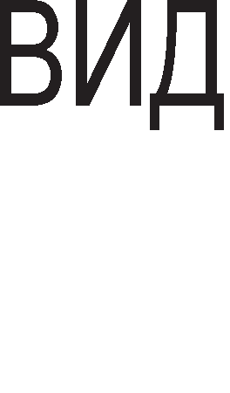











Cn1Ka 8.7. HaL11H1 Ha

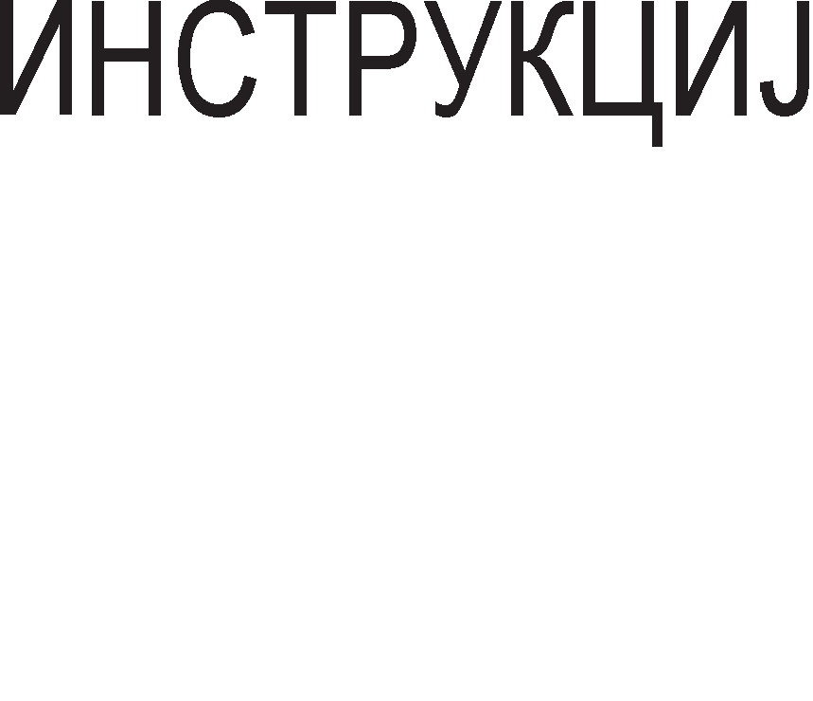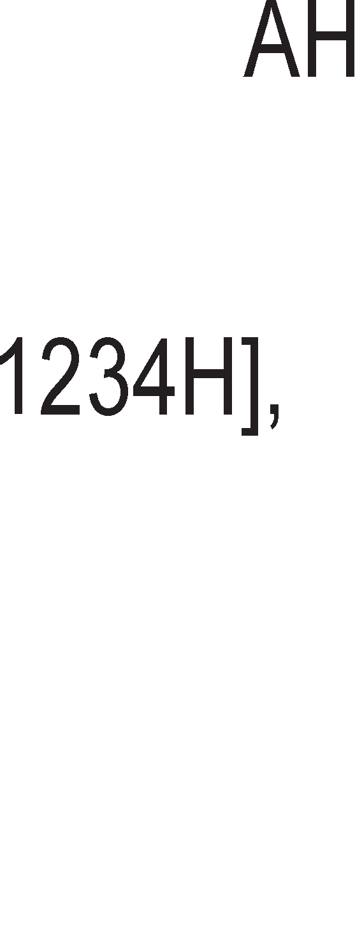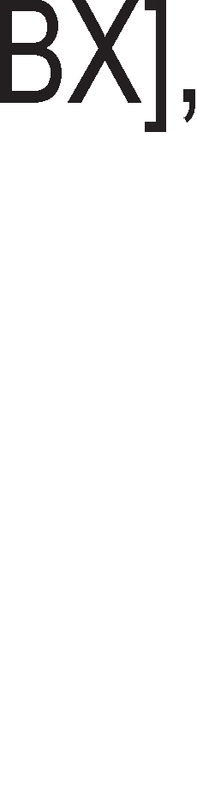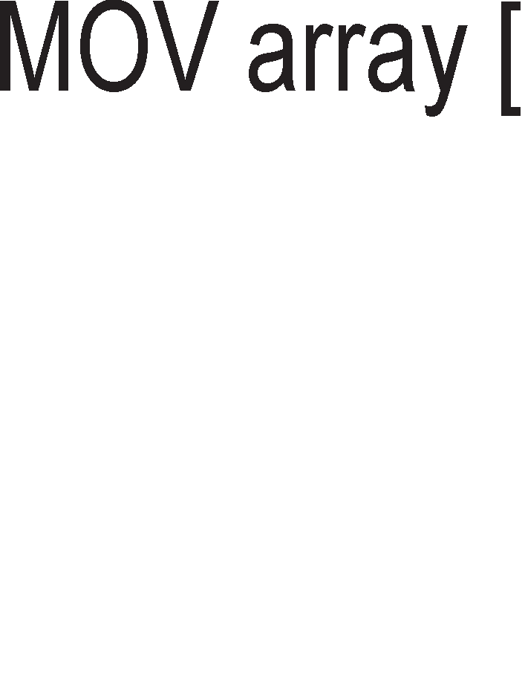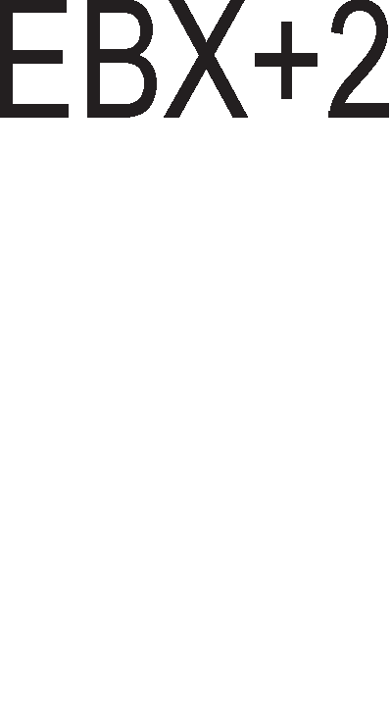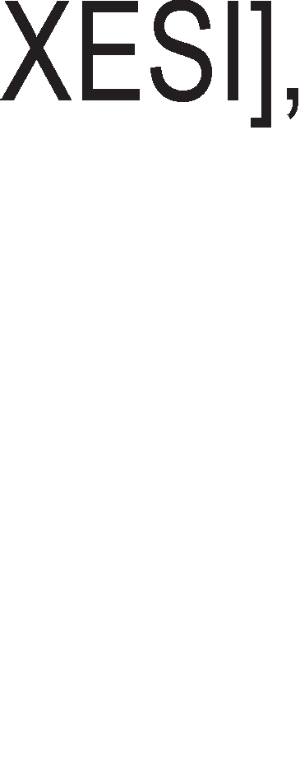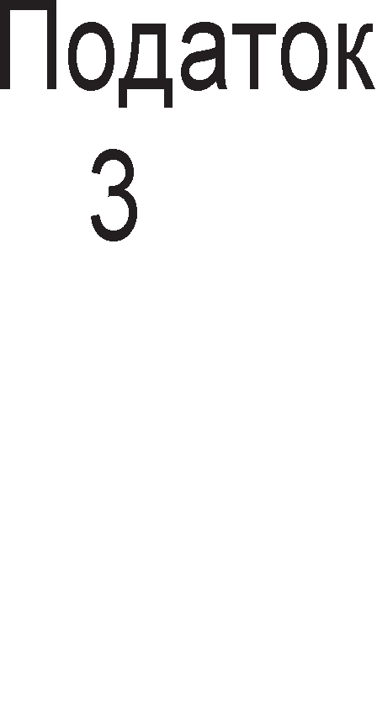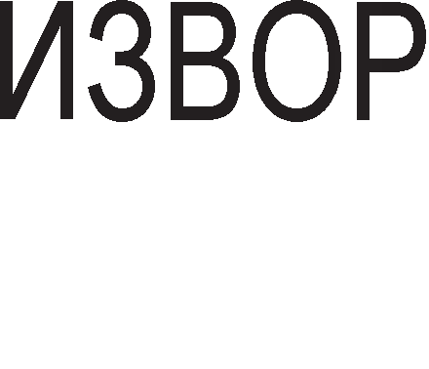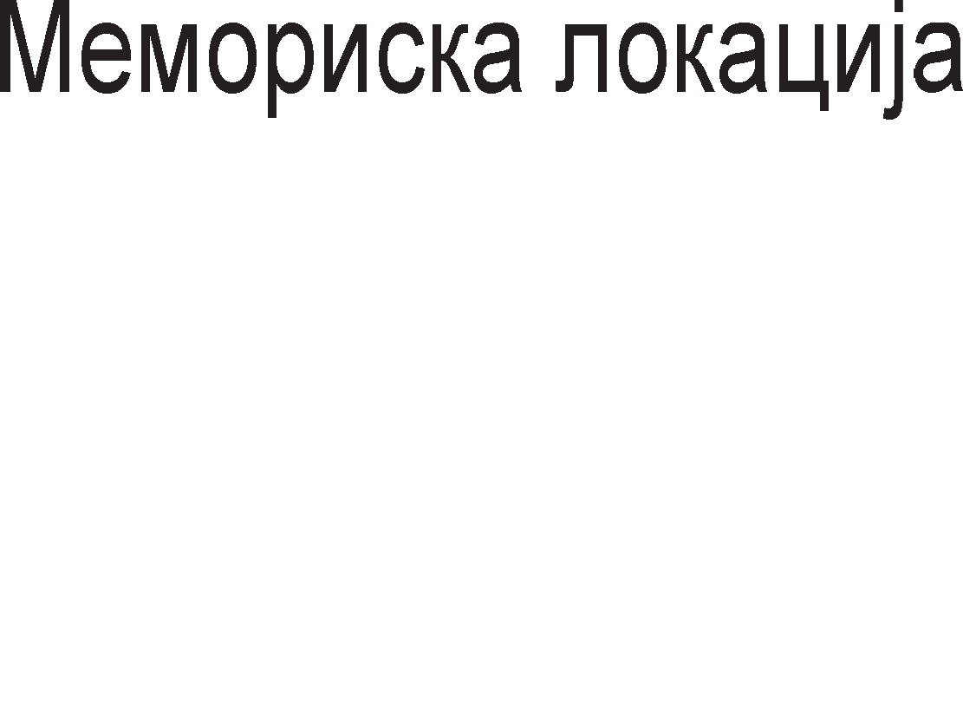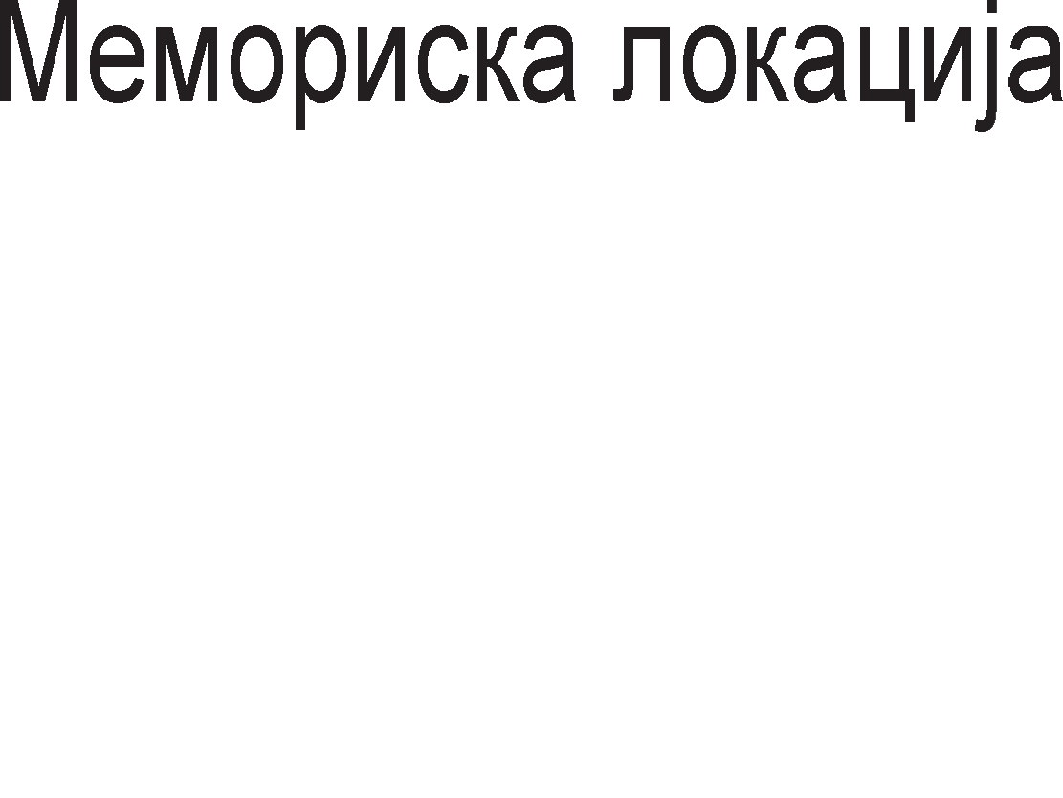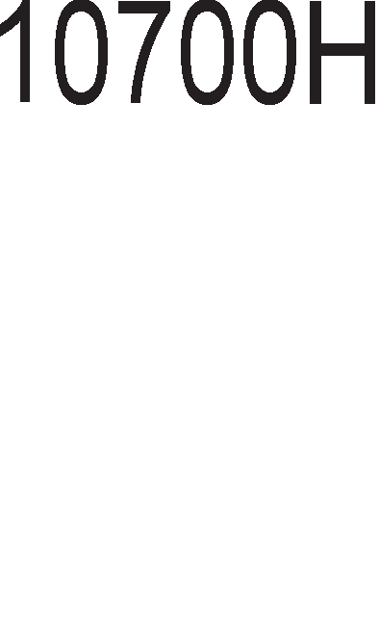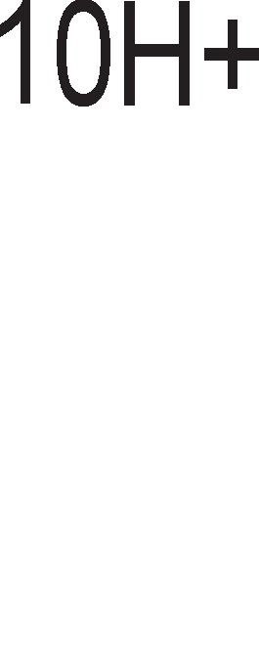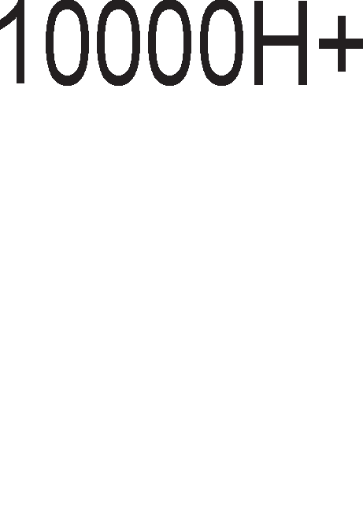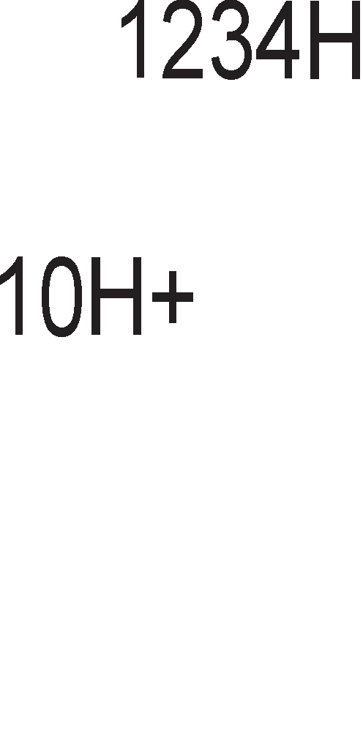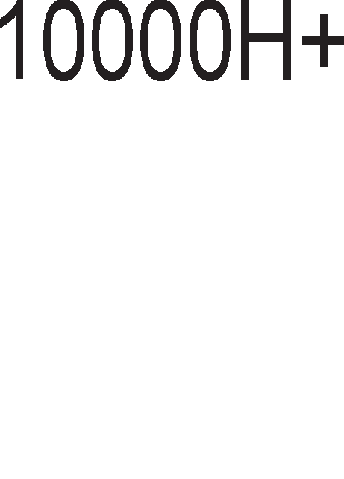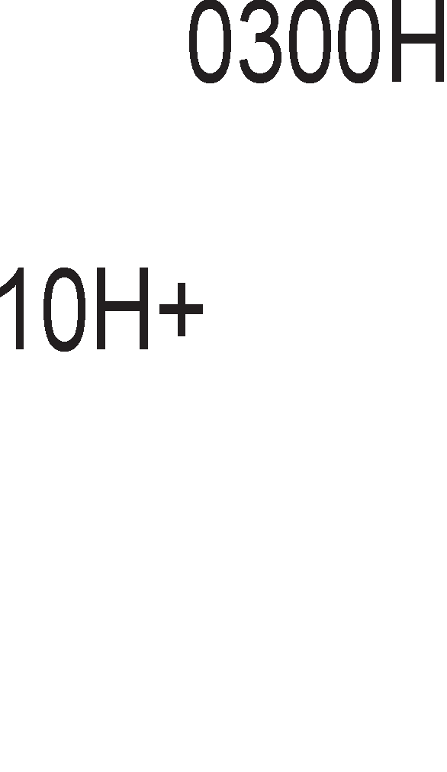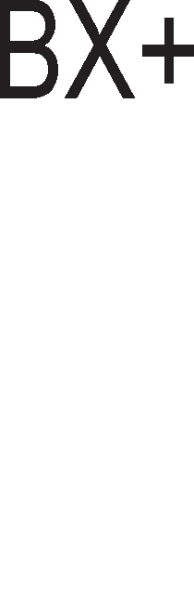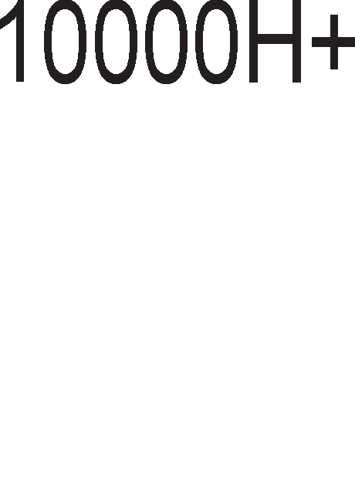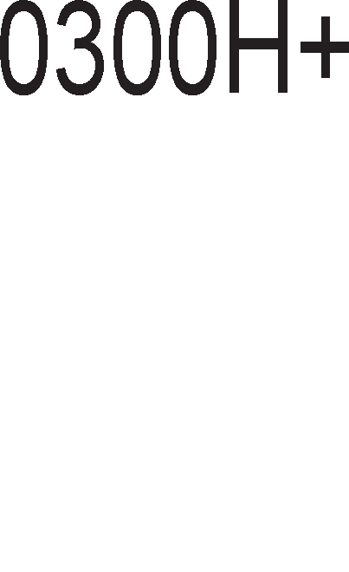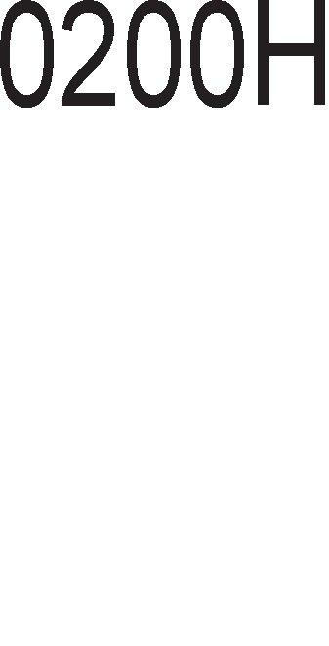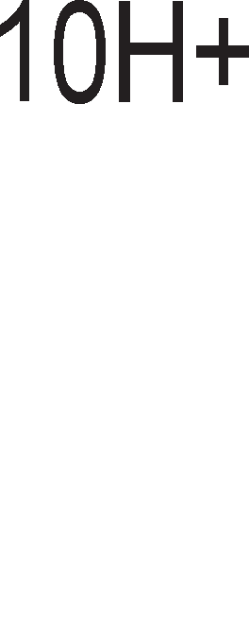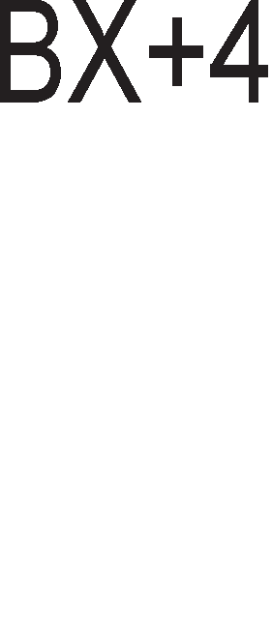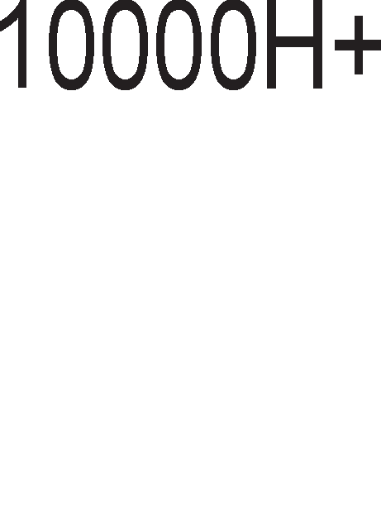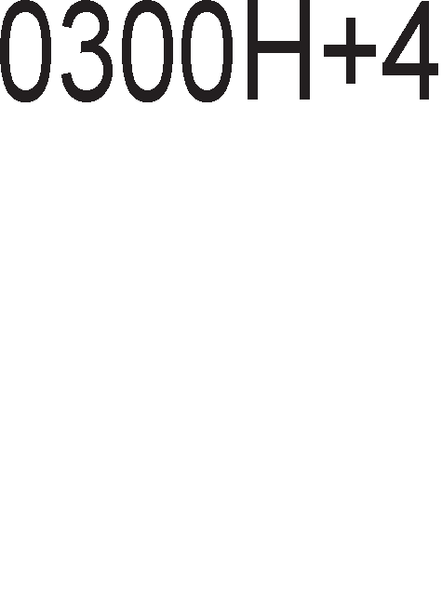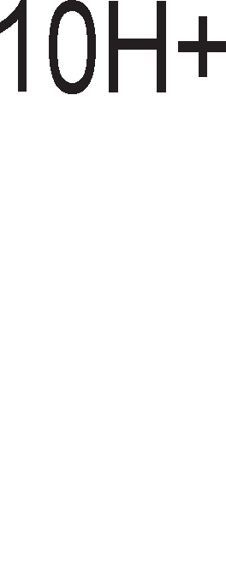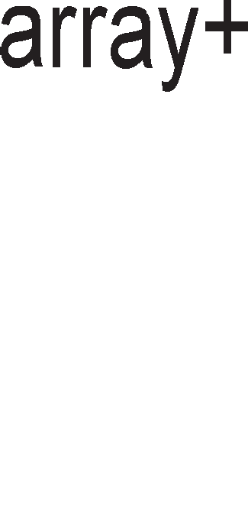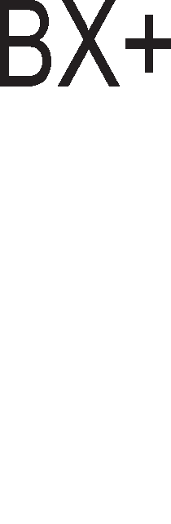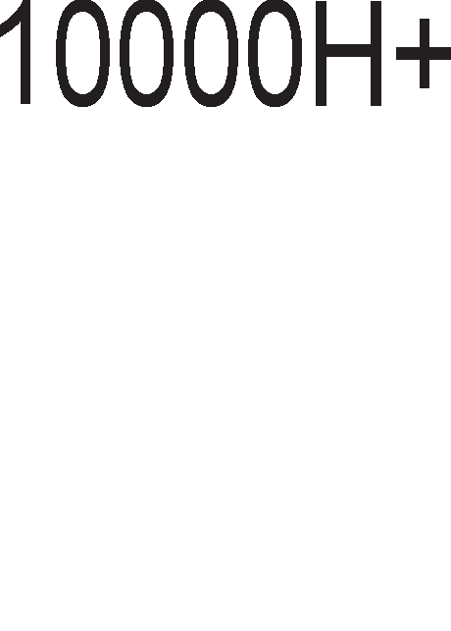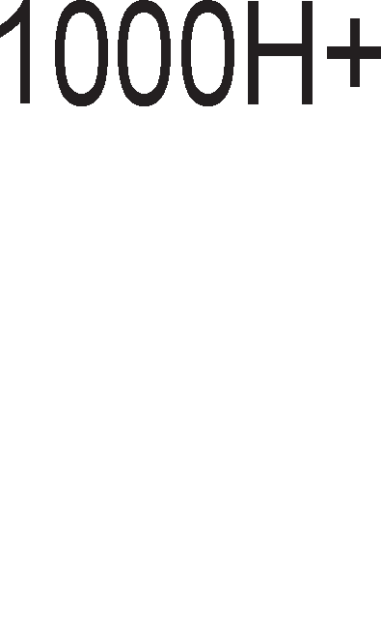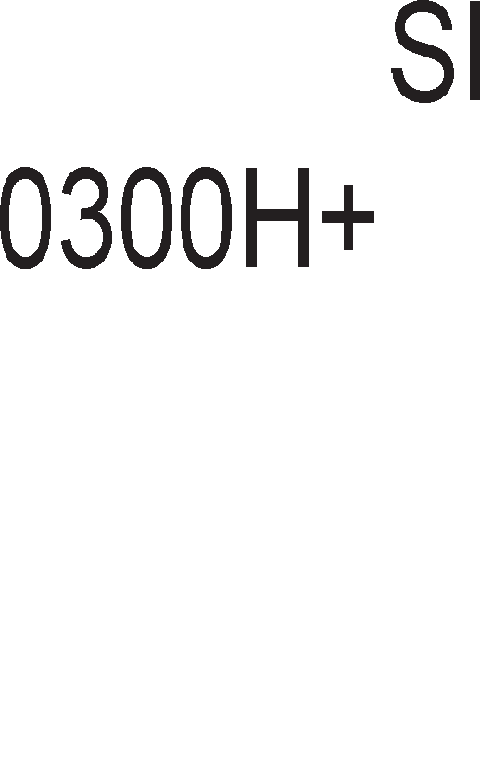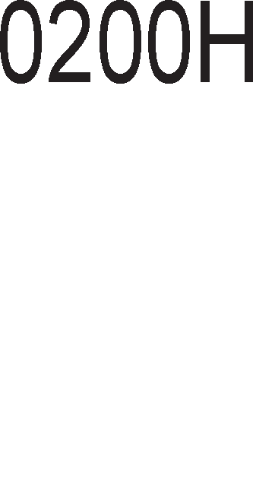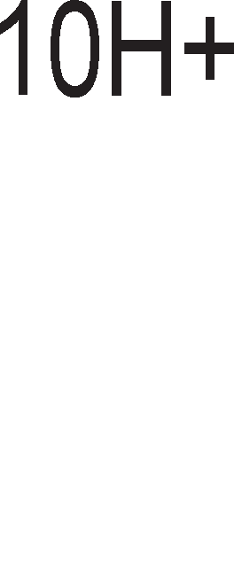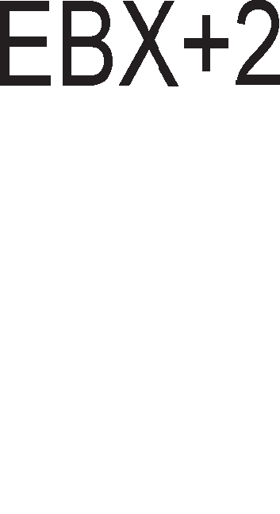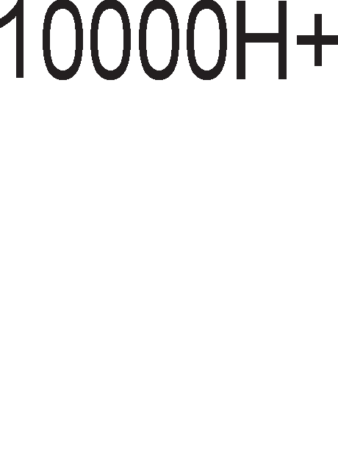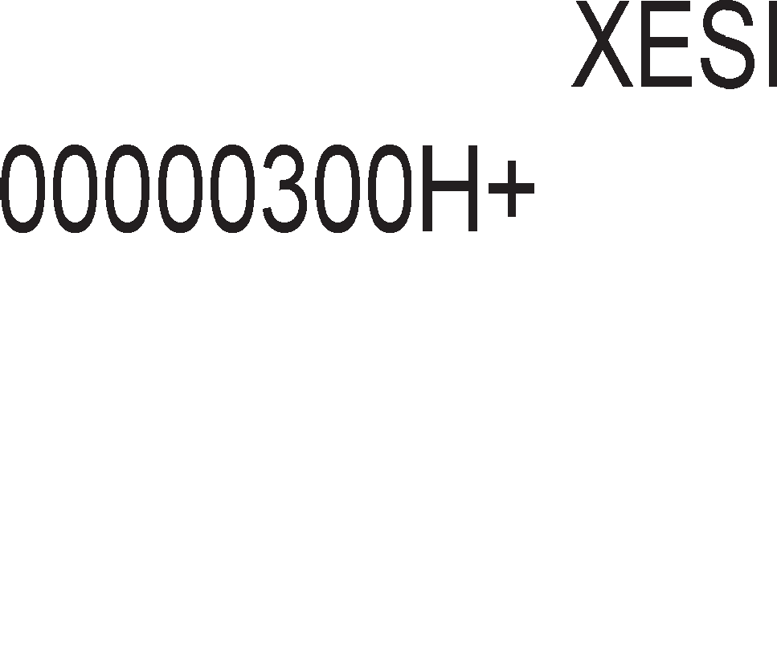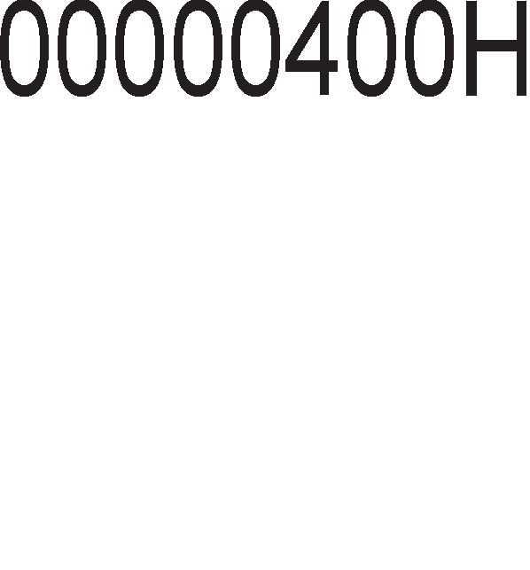

appec1pal-be 3a M1KponpoLecop 8086

Ha np1Mep, 1HcTpyKL1jaTa MOV AL, DS:[1234H] 3HaL11 Kon1pal-be Ha epeH 6ajT op nopaToL1H1oT ceflMeHT co noMecTyBal-be 1234H Bo pefl1cTapoT AL. OBaa 1HcTpyKL1ja Mo>Ke pa ce 3an1we BaKa: MOV AL, [1234H]. CeKoflaw Kofla He e no1HaKy HaflnaceHo Bo 1HcTpyKL1jaTa ce Kop1cT1 nopaToL1H1oT ceflMeHT.

npoflpaMepoT Kofla flo pecp1H1pa nopaToL1H1oT ceflMeHT Toj Ha MeMop1cK1Te noKaL11 Mo>Ke pa 1M 3apaBa c1M6on1L1H1 1M1l-ba npeKy cneL1janH1 nceypo1HcTpyKL11 HapeL1eH1 p1peKT1B1. 3a npoflpaMepoT e MHofly noepHocTaBHo pa naMT1 c1M6on1L1H1 1M1l-ba oTKonKy XeKcapeL1ManH1 appec1 Ha MeMop1cK1 noKaL11. Ha np1Mep, 1HcTpyKL1jaTa MOV AL, NUMBER 3HaL11 pa ce Kon1pa 6ajToT op MeMop1cKaTa noKaL1ja Bo nopaToL1H1oT ceflMeHToT co c1M6on1L1Ho 1Me NUMBER Bo pefl1cTapoT AL.

##### PerMcTapcKo MH,qMpeKTHo a,qpecMpa1-e

Co oBoj B1p appec1pal-be e po3BoneH np1cTan po Koja 61no MeMop1cKa noKaL1ja, np1 wTo noMecTyBal-beTo ce copp>K1 Bo HeKoj op cnepH1Be pefl1cTp1: BP, BX, DI 1n1 SI. 3a Koj ceflMeHT cTaHyBa 36op, Tpe6a pa 3aKnyL11Me op 1HpeKc- pefl1cTapoT cnopep Ta6enaTa op cn1Ka 8.5. Pefl1cTapoT Bo Koj ce Haora noMecTyBal-beTo e Bo 3aflpapa [ ]. Ha np1Mep, co 1HcTpyKL1jaTa MOV CX, [BX] 36opoT op nopaToL1H1oT ceflMeHT co noMecTyBal-be Bo pefl1cTapoT BX ce Kon1pa Bo pefl1cTapoT CX. np1Toa, npB1oT 6ajT co appeca DSH·10H + BX ce cMecTyBa Bo pefl1cTapoT CL, a BTop1oT 6ajT co appeca DSH·10H + BX + 1 Bo pefl1cTapoT CH. Kon1pal-be nopaToL1 op epHa Bo ppyfla MeMop1cKa noKaL1ja He e po3BoneHo. Ha np1Mep, 1HcTpyKL1jaTa MOV [DI], [BX] He e po3BoneHa.

##### 5a3Ho MH,qeKcHo a,qpecMpa1-e

Kaj oBoj HaL11H Ha appec1pal-be noMecTyBal-beTo ce po61Ba co co61pal-be Ha copp>K1HaTa Ha epeH 6a3eH pefl1cTap (BX 1n1 BP) 1 epeH 1HpeKc-pefl1cTap (DI 1 SI). OBoj B1p appec1pal-be ce Kop1cT1 np1 pa6oTa co H131. 6a3H1oT pefl1cTap flo copp>K1 noMecTyBal-beTo op noL1eToKoT Ha ceflMeHToT po noL1eToKoT Ha H13aTa, a 1HpeKc-pefl1cTapoT flo copp>K1 noMecTyBal-beTo op noL1eToKoT Ha H13aTa po caKaHaTa noKaL1ja. Ha np1Mep, 1HcTpyKL1jaTa MOV [BP + DI], AH cny>K1 3a Kon1pal-be Ha 36opoT op pefl1cTapoT AH Bo MeMop1cKaTa noKaL1ja op cTeK- ceflMeHToT, np1 wTo noMecTyBal-beTo ce po61Ba co co61pal-be Ha copp>K1H1Te Ha BP·10H 1 DI. l/l oBpe KaKo 1 Kaj npeTXopH1oT HaL11H Ha appec1pal-be poKonKy flo Kop1cT1Me pefl1cTapoT BP, Toa 3HaL11 peKa nopaToKoT ce Haora Bo cTeK-ceflMeHToT, a poKonKy ce Kop1cT1 pefl1cTapoT BX Toa 3HaL11 peKa nopaToKoT ce Haora Bo nopaToL1H1oT ceflMeHT.

##### PerMcTapcKo pe11aTMeHo a,qpecMpa1-e

OBoj HaL11H Ha appec1pal-be 1Ma cn1L1HocT1 co 6a3Ho 1HpeKcHoTo 1 p1peKTHoTo appec1pal-be. Kaj pefl1cTapcKo-penaT1BHoTo appec1pal-be 3a pa ce np1cTan1 po HeKoja noKaL1ja op paTa-ceflMeHToT Tpe6a 6pojoT Bo cpepHaTa 3aflpapa pa ce popape Ha copp>K1HaTa Ha HeKoj 6a3eH 1n1 1HpeKc-pefl1cTap (BP, BX , DI 1n1 SI). Ha cn1KaTa 8.8. e papeH np1Mep 3a pefl1cTapcKo penaT1BHo appec1pal-be. Co 1HcTpyKL1jaTa MOV AX, [BX+1000H] ce Kon1pa epeH 36op op nopaToL1H1oT ceflMeHToT, Koj e appec1paH npeKy 6a3H1oT pefl1cTap BX·10H, Ha Koj ce popaBa 6pojoT 1000H. Aa 3a6ene>K1Me peKa 1 Kaj oBoj B1p appec1pal-be ce

Kop1cTaT 3aflpap1 [ ]. AoKonKy fl1 HeMa oB1e 3aflpap1, Mo>Ke pa poHece noflpeweH 3aKnyL1oK peKa 361poT op copp>K1HaTa Ha pefl1cTapoT BX 1 BpepHocTa 10000H He npeTcTaByBa appeca Ha MeMop1cKa noKaL1ja op nopaToL1H1oT ceflMeHT, TyKy nopaToK. Aa Haflnac1Me peKa BpepHocTa Ha pefl1cTapoT DS 13HecyBa 0200H.

Cn1Ka 8.8. npecMeTKa Ha appeca Kaj pefl1cTapcKo penaT1BHo appec1pal-be

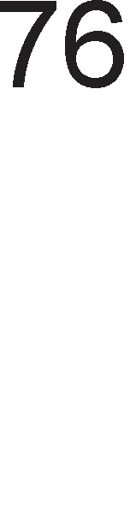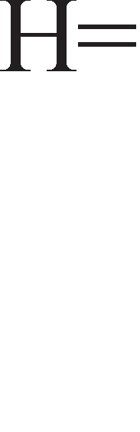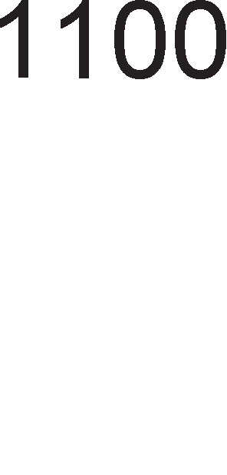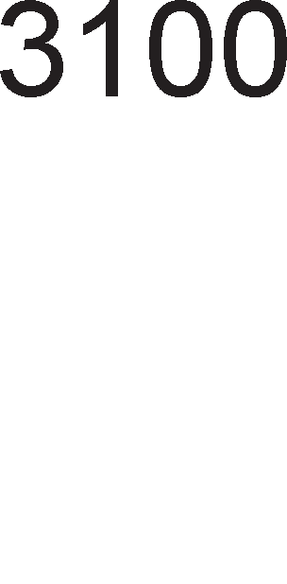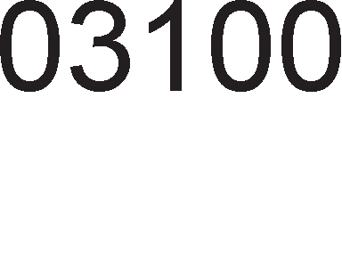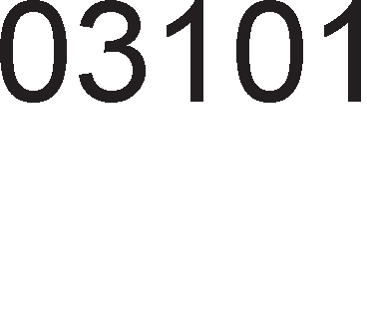

##### 5a3Ho pe11aTMeHo MH,qeKcHo a,qpecMpa1-e

6a3HoTo penaT1BHo 1HpeKcHo appec1pal-be e cn1L1Ho co 6a3HoTo 1HpeKcHo appec1pal-be, caMo wTo TyKa 3a pa ce po61e pacTojaH1eTo Mery noL1eToKoT Ha ceflMeHToT 1 caKaHaTa noKaL1ja ce co61pa BpepHocTa Ha 1HpeKc pefl1cTapoT co 16-61TH1oT 6poj. np1Mep 3a 1HcTpyKL1ja op BaKoB HaL11H Ha appec1pal-be e 1HcTpyKL1jaTa MOV AX, [BX+SI+1000H].

# LlHcTpyK4McKo MHo>KecTeo 3a MMKponpo4ecop 8086

npoLecopoT 8086 pacnonafla co cToT1Ha 1HcTpyKL11, Ko1 Mo>KaT pa ce nopenaT Bo HeKonKy flpyn1:

* + l/lHcTpyKL11 3a npeHoc Ha nopaToL1
  + Ap1TMeT1L1K1 1HcTpyKL11
  + l/lHcTpyKL11 3a noMecTyBal-be 1 poTaL11
  + nofl1L1K1 1HcTpyKL11
  + YnpaByBaL1K1 cKoK 1HcTpyKL11
  + l/lHcTpyKL11 3a pa6oTa co H131
  + l/lHcTpyKL11 3a pa6oTa co noTnpoflpaM1 1 npeK1H1
  + l/lHcTpyKL11 3a KoHTpona Ha M1KponpoLecopoT

## LlHcTpyK4MM 3a npeHoc Ha no,qaTo4M

Co 3HaL1el-beTo Ha 1HcTpyKL1jaTa **MOV** ce 3ano3HaBMe Kofla fl1 npoyL1yBaBMe appecH1Te B1poB1 Ha M1KponpoLecopoT 8086. 3a pa ce noTceT1Me, i<e HaBepeMe HeKonKy KoHKpeTH1 np1Mep1:

##### npMMep 8.1.

MOV BX, AX - p1peKTeH npeHoc Ha nopaToK op epeH pefl1cTap Bo ppyfl MOV BX, 1234H - npeHoc Ha nopaToKoT 1234H Bo pefl1cTapoT BX

MOV BX , [1234H] - npeHoc Ha nopaToK Bo pefl1cTap BX op MeMop1cKa

noKaL1ja op nopaToL1H1oT ceflMeHT oppaneL1eHa op noL1eToKoT 3a pacTojaH1e 1234H

MOV [1234H] , BX - npeHoc Ha nopaToK op pefl1cTap BX Bo MeMop1ja nocTojaT 13BecH1 oflpaH1L1yBal-ba Bo ynoTpe6aTa Ha MOV. Co oBaa

1HcTpyKL1ja He Mo>Ke pa ce Bpw1 npeHoc op epHa MeMop1cKa noKaL1ja Bo ppyfla, TyKy co nocpepcTBo Ha onwT1Te pefl1cTp1. He Mo>Ke pa ce npeHece nopaToK Bo HeKoj ceflMeHTeH pefl1cTap, H1Ty pa ce npeHecyBaaT nopaToL1 op epeH ceflMeHTeH pefl1cTap Bo ppyfl.

M1KponpoLecopoT 8086 1Ma wecT pa3n1L1H1 B1poB1 Ha **PUSH** 1 **POP** 1HcTpyKL11. nopaToKoT wTo ce npeHecyBa Bo cTeK-MeMop1jaTa Mo>Ke pa 61pe cMecTeH Ha pa3n1L1H1 MecTa.

##### npMMep 8.2.

PUSH BX - nopaToKoT e Bo HeKoj onwT pefl1cTap

PUSH [BX] - nopaToKoT e Bo MeMop1cKa noKaL1ja oppaneL1eHa op noL1eToKoT Ha nopaToL1H1oT ceflMeHT 3a pacTojaH1e epHaKBo Ha BpepHocTa Ha BX

PUSH 1225H - nopaToKoT e papeH HenocpepHo

PUSH DS - nopaToKoT e Bo HeKoj ceflMeHTeH pefl1cTap

PUSH A - ce 3awT1TyBaaT nopaToL1Te Bo c1Te 16-61TH1 onwT1 pefl1cTp1

PUSH F - ce 3awT1TyBa cTaTyc-pefl1cTapoT co HefloB1Te 3HaMeHLa

Kaj M1KponpoLecopoT 8086 nocTojaT cneL1janH1 1HcTpyKL11 3a npeHoc Ha ecpeKT1BH1 appec1. nop ecpeKT1BH1 appec1 ce noppa361pa noMecTyBal-beTo (pacTojaH1eTo), Koe H1 noKa>KyBa KonKy e oppaneL1eH nopaToKoT op noL1eToKoT Ha ceflMeHToT. Co 1HcTpyKL1jaTa **LEA** (Load Effective Address) ecpeKT1BHaTa appeca Ha nopaToKoT ce npeHecyBa Bo HeKoj 16-61TeH pefl1cTap. Ha np1Mep, co 1HcTpyKL1jaTa LEA BX, [DI] copp>K1HaTa Ha pefl1cTapoT DI ce npeHecyBa Bo

pefl1cTapoT BX, a co 1HcTpyKL1jaTa MOV BX, [DI] nopaToKoT co ecpeKT1BHa appeca Bo pefl1cTapoT DI ce npeHecyBa Bo pefl1cTapoT BX.

l/lHcTpyKL11Te **LDS** 1 **LES** cny>KaT 3a npeHoc Ha 32 61Ta op MeMop1jaTa, np1 wTo npB1Te pBa no3HaL1ajH1 6ajTa ce npeHecyBaaT Bo ceflMeHTH1Te pefl1cTp1 DS 1n1 ES, a BTop1Te pBa noHe3HaL1ajH1 6ajTa Bo HeKoj 16-61TeH onwT pefl1cTap. Co 1HcTpyKL1jaTa LDS BX, [DI] pefl1cTapoT BX ce nonH1 op noKaL11Te co appec1 11000 1 11001 a pefl1cTapoT DI op noKaL11Te co appec1 11002 1 11003. no 13BpwyBal-beTo Ha noKaL1jaTa, DS i<e flo copp>K1 6pojoT 3000H, a BX 6pojoT 127AH. OBa e np1Ka>KaHo Ha cn1Ka 8.9.

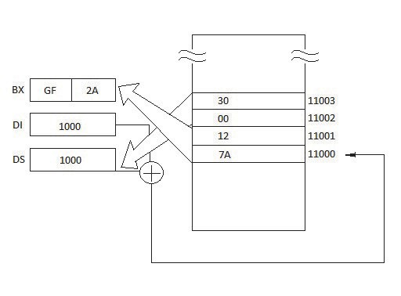

Cn1Ka 8.9. np1Ka3 Ha 1HcTpyKL1jaTa LDS BX, [DI]

**XLAT** (Translate) OBaa 1HcTpyKL1ja ce Kop1cT1 np1 KoHBep31ja op epeH Kop Bo ppyfl, KaKo, Ha np1Mep, op BCD Bo cepyMceflMeHTeH Kop. Bo nopaToL1H1oT ceflMeHT e Kpe1paHa H13a op 10 6ajT1, Ko1 fl1 copp>KaT cepyMceflMeHTH1Te KopoB1 3a 6poeB1Te op 0 po 9. Ha cn1Ka 8.10. ce np1Ka>KaH1 cepyMceflMeHTH1oT p1cnnej 1 HefloB1Te KopoB1. Co 1HcTpyKL1jaTa XLAT copp>K1HaTa Ha AL ce popaBa Ha npo13BopoT BX·10H 3a pa ce po61e MeMop1cKa appeca Ha noKaL1jaTa Bo nopaToL1H1oT ceflMeHT, a noToa copp>K1HaTa op Taa MeMop1cKa noKaL1ja ce Kon1pa Bo pefl1cTapoT AL.

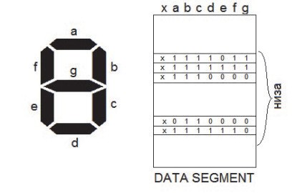

Cn1Ka 8.10. nopaToL1Ha H13a 3a aKT1B1pal-be Ha cepyMceflMeHTeH p1cnnej

**XCHG** ( Exchange ) OBaa 1HcTpyKL1ja cny>K1 3a pa3MeHa Ha copp>K1H1Te Ha epeH pefl1cTap co ppyfl 1n1 co HeKoja MeMop1cKa noKaL1ja. OBaa 1HcTpyKL1ja He Mo>Ke pa ce ynoTpe61 3a pa3MeHa Ha copp>K1H1Te Ha pBe MeMop1cK1 noKaL11 1n1 ceflMeHTH1 pefl1cTp1.

l/lHcTpyKL11Te **IN M OUT** ce Kop1cTaT np1 pa6oTa co Bne3Ho-13ne3H1 nopT1. Co 1HcTpyKL1jaTa IN nopaToKoT op Bne3HaTa nopTa ce npeHecyBa Bo aKyMynaTopoT, a co 1HcTpyKL1jaTa OUT nopaToKoT op aKyMynaTopoT ce npeHecyBa po 13ne3HaTa nopTa. nocTojaT pBa T1na 1HcTpyKL11 3a pa6oTa co nopT1. Kaj **npeMoT TMn** nopT1Te 1MaaT cp1KcH1 appec1. l/lHTepcpejc-appecaTa npeTcTaByBa 8- 61THa KoM61HaL1ja 1 Taa ce npow1pyBa po 16 61ToB1 co popaBal-be Ha ocyM Hyn1 op neBaTa cTpaHa. Ha np1Mep, co 1HcTpyKL1jaTa OUT 19H, AX copp>K1HaTa op pefl1cTapoT AX ce npeHecyBa po 13ne3HaTa nopTa co cp1KcHa appeca 0019H. Kaj **eTopMoT TMn** 1HcTpyKL11 3a pa6oTa co nopT1, nopT1Te 1MaaT Bap1ja61nHa appeca. AppecaTa Ha nopTaTa ce L1yBa Bo pefl1cTapoT DX, a nopaToKoT wTo Tpe6a pa ce npeHece 1n1 pa ce np1M1 op nopTaTa Bo pefl1cTapoT AL 1n1 AX. 3a BpeMe Ha 13BpwyBal-be Ha npoflpaMaTa copp>K1HaTa Ha DX, opHocHo appecaTa Ha nopTaTa Mo>Ke pa ce npoMeH1.

##### npMMep 8.3:

OUT DX, AL ;nopaToKoT op pefl1cTapoT AL ce npeHecyBa po

; 13ne3HaTa nopTa co appeca Bo pefl1cTapoT DX.

IN AL, DX ;nopaToKoT op Bne3HaTa nopTa co appeca Bo pefl1cTapoT

; DX ce npeHecyBa Bo pefl1cTapoT AL M1KponpoLecopoT.

## 8.6.2 0nepa4MM co HM3M (cTpMHroeM)

H13aTa npeTcTaByBa MHo>KecTBo op nopaToL1 cMecTeH1 Bo nocnepoBaTenH1 MeMop1cK1 noKaL11 op nopaToL1H1oT 1n1 eKcTpa ceflMeHToT. Bo epH1oT ceflMeHT ce cMecTeH1 nopaToL1Te wTo Tpe6a pa ce o6pa6oTaT, a Bo ppyfl1oT ceflMeHT nopaToL1Te po61eH1 KaKo pe3ynTaT1 op 13BpweH1Te onepaL11. l/lHpeKc-pefl1cTp1Te DI 1 SI ce pefl1cTp1 wTo flo copp>KaT noMecTyBal-beTo. Pefl1cTapoT DI ce Kop1cT1 Bo nap co ceflMeHTH1oT pefl1cTap ES, a SI Bo nap co DS. 3a 13BpwyBal-beTo Ha onepaL11Te co H131 MHofly e Ba>KHo **3HaMeH4eTo D**. AKo D=0, BpepHocTa Ha pefl1cTp1Te DI 1 SI aBToMaTcK1 i<e ce HaManyBa 3a epeH, a aKo D=1 i<e ce 3floneMyBa 3a epeH. l/lHcTpyKL1jaTa **CLD** ( Clear D ) flo peceT1pa oBa 3HaMeHLe, a 1HcTpyKL1jaTa **STD** (Set D) flo ceT1pa.

##### LODS M STOS

Co 1HcTpyKL1jaTa LODS pefl1cTapoT AX 1n1 AL ce nonH1 co nopaToK op nopaToL1H1oT ceflMeHT co noMecTyBal-be Bo 1HpeKc pefl1cTapoT SI. BcywHocT,

nocTojaT pBe Bap1jaHT1 Ha oBaa 1HcTpyKL1ja. l/lHcTpyKL1jaTa **LODSB** (Load Byte)ce Kop1cT1 3a npeHoc Ha 8-61TH1 nopaToL1, a 1HcTpyKL1jaTa **LODSW** (Load Word) 3a npeHoc Ha 16-61TH1 nopaToL1. l/lHcTpyKL1jaTa STOS 1Ma o6paTeH ecpeKT op LODS, opHocHo nopaToKoT op pefl1cTapoT AX 1 AL ce npeHecyBa Bo noKaL1ja op eKcTpa ceflMeHToT co noMecTyBal-be Bo DI. Ha 1HcTpyKL1jaTa **STOS** Mo>Ke pa ce popape 1 npecp1KcoT REP Koj poara op aHfln1cK1oT 36op Repeat wTo Bo npeBop 3HaL11 noBTop1. Co npecp1KcoT REP 1HcTpyKL1jaTa STOS ce 13BpwyBa oHonKy naT1 KonKy wTo 13HecyBa BpepHocTa Ha pefl1cTapoT CX. **MOVS** 1HcTpyKL1jaTa e MHofly Kop1cHa, 61peji<1 oBo3Mo>KyBa npeHoc Ha nopaToK op epHa MeMop1cKa noKaL1ja Bo ppyfla. Aa Haflnac1Me peKa oBa e Mo>KHo caMo poKonKy nopaToL1Te ce noppepeH1 Bo H13a. Co 1HcTpyKL1jaTa MOVS nopaToKoT op paTa-ceflMeHToT co noKa>KyBaL1 Bo pefl1cTapoT SI ce npeHecyBa Bo eKcTpa ceflMeHToT co noKa>KyBaL1 DI.

Co 1HcTpyKL1jaTa **SCAS** (String scan instruction) ce Bpw1 cnopep6a Mery copp>K1HaTa Ha pefl1cTapoT AL 1 6noKoT op 6ajT1 Bo eKcTpa ceflMeHToT (SCASB) 1n1 Mery copp>K1HaTa Ha AX 1 6noKoT op 36opoB1 Bo eKcTpa ceflMeHToT (SCASW). npep oB1e pBe 1HcTpyKL11 Mo>Ke pa ce cTaB1 npecp1KcoT REPNE (repeat while not equal) wTo 3HaL11 1HcTpyKL1jaTa SCAS i<e ce noBTopyBa cè popeHKa He ce po61e ycnewHa KoMnapaL1ja (epHaKB1 copp>K1H1) 1n1 BpepHocTa Ha CX He cTaHe Hyna. Apyfl BaKoB npecp1Kc 61 61n REPE (repeat while equal).

Co 1HcTpyKL1jaTa **CMPS** (compare string) ce cnopepyBaaT pBa 6noKa op nopaToL1, op Ko1 epH1oT 6noK ce Haora Bo nopaToL1H1oT ceflMeHToT co noMecTyBal-be Bo SI, a ppyfl1oT 6noK Bo eKcTpa ceflMeHToT co noMecTyBal-be Bo DI. nocTojaT pBe Bap1jaHT1 Ha oBaa 1HcTpyKL1ja CMPSB - 3a cnopep6a Ha 6noKoB1 op 6ajT1 1 CMPSW - 3a cnopep6a Ha 6noKoB1 op 36opoB1. l/l npep oB1e 1HcTpyKL11 Mo>Ke pa ce cTaBaT npecp1Kc1Te REPNE 1 REPE.

## ApMTMeTM"1KM MHcTpyK4MM

npoLecopoT 8086 pacnonafla co cnepH1Be ap1TMeT1L1K1 1HcTpyKL11: co61pal-be, op3eMal-be, MHo>Kel-be, KoMnapaL1ja, HeflaL1ja, HaManyBal-be 1 3floneMyBal-be 3a epeH.

##### Co6Mpa1-e M o,q3eMa1-e

nocTojaT HeKonKy B1poB1 3a co61pal-be. l/lMeHo, c1Te appecH1 MopoB1 np1MeHeT1 Kaj 1HcTpyKL11Te ce np1MeHyBaaT 1 Kaj 1HcTpyKL1jaTa **ADD**. Ke HaBepeMe HeKonKy np1Mep1:

##### npMMep 8.4.

ADD AL, BL ;Pefl1cTapcKo co61pal-be, AL=AL+BL.

ADD CL, 44H ;HenocpepHo co61pal-be CL=CL+44H.

ADD [BX], AL ;Copp>K1HaTa op pefl1cTapoT AL ce popaBa Ha

;noKaL1jaTa op paTa-ceflMeHToT co noMecTyBal-be

;Bo BX 1 361poT ce cMecTyBa Bo 1cTaTa noKaL1ja.

ADD DL , [ BX + DI] ;Copp>K1HaTa Ha noKaL1jaTa op paTa-ceflMeHToT

;co noMecTyBal-be BX+DI ce popaBa Ha

;copp>K1HaTa Ha DL 1 361poT ce 3an1wyBa

;Bo 1cT1oT pefl1cTap DL.

ADD AL, ARRAY [SI] ;Ha copp>K1HaTa Ha pefl1cTapoT AL ce popaBa

;copp>K1HaTa Ha epeH 6ajT op H13aTa ARRAY

;oppaneL1eH op noL1eToKoT Ha H13aTa

;3a pacTojaH1e SI. ARRAY e na6ena co Koja ce

;o3HaL1yBa noL1eToKoT Ha H13aTa.

ADC AL, AH ;co61pal-be npeKy Carry, AL=AL+AH+Carry.

Ap1TMeT1L1KoTo co61pal-be Bn1jae Bp3 cocToj6aTa Ha cTaTyc-pefl1cTapoT 1n1 noToL1Ho Bp3 3HaMeHLaTa Z, C, A, S, P 1 D.

Ap1TMeT1L1KoTo op3eMal-be ce pean131pa npeKy 1HcTpyKL1jaTa **SUB (Substract).** CeTo oHa wTo 6ewe peL1eHo 3a 1HcTpyKL1jaTa ADD Ba>K1 1 3a 1HcTpyKL1jaTa SUB. Copp>K1HaTa Ha pefl1cTapoT 1n1 MeMop1cKaTa noKaL1ja no 3an1pKaTa ce op3eMa op copp>K1HaTa Ha pefl1cTapoT 1n1 noKaL1jaTa npep 3an1pKaTa 1 Bo Heflo ce 3an1wyBa pe3ynTaToT, pa3n1KaTa. Op3eMal-beTo co no3ajMyBal-be SBB (Subtraction with borrow) ce pean131pa TaKa wTo Ha Kpaj op po61eHaTa pa3n1Ka ce op3eMa BpepHocTa Ha 3HaMeHLeTo Carry.

##### CMP (Compare) KoMnapa4Mja

OBaa 1HcTpyKL1ja Bn1jae Bp3 cocToj6aTa Ha 3HaMeHLaTa, np1 wTo BpepHocTa Ha onepaHp1Te ocTaHyBa 1cTa. HajL1ecTo no 1HcTpyKL1jaTa CMP cnepyBa 1HcTpyKL1jaTa 3a ycnoBeH cKoK, KaKo wTo ce 1HcTpyKL11Te JA (jump above) 1 JB (jump below).

##### npMMep 8.5:

CMP AL, 10H ;Op copp>K1HaTa Ha pefl1cTapoT AL ce

;op3eMa BpepHocTa 10H. Copp>K1HaTa

;Ha AL HeMa pa ce npoMeH1, TyKy Mo>Ke

;pa ce npoMeH1 BpepHocTa Ha

;3HaMeHLeTo C. AKo AL>10H, Toflaw

;C=1, aKo AL<10H Toflaw C=0.

JA START ;CKoKoT i<e ce 13Bpw1 aKo 3HaMeHLeTo

;3a npeHoc He e aKT1BHo, opHocHo aKo

;AL>10H.

3a pa3n1Ka op M1KponpoLecopoT 8085, 1HcTpyKL1cKoTo MHo>KecTBo Ha 8086 copp>K1 1HcTpyKL11 3a ap1TMeT1L1Ko **MHo>Ke1-e** 1 **,qe11e1-e**. Pa3n1KyBaMe 8-61THo

1 16-61THo MHo>Kel-be . Kaj 8-61THoTo MHo>Kel-be epH1oT MHo>K1Ten ceKoflaw ce Haora Bo pefl1cTapoT AL, a ppyfl1oT MHo>K1Ten Bo HeKoj ppyfl onwT pefl1cTap 1n1 MeMop1cKa noKaL1ja. npo13BopoT e 16-61TeH 1 ce cMecTyBa Bo pefl1cTapoT AX.

Kaj 16-61THoTo MHo>Kel-be epH1oT MHo>K1Ten ce Haora Bo pefl1cTapoT AX, a ppyfl1oT Bo HeKoj 16-61TeH pefl1cTap 1n1 pBe nocnepoBaTenH1 MeMop1cK1 noKaL11. npo13BopoT e 32-61TeH 6poj np1 wTo npB1Te 16 noHe3HaL1ajH1 61Ta ce 3an1wyBaaT Bo pefl1cTapoT AX, a BTop1Te 16 no3HaL1ajH1 61Ta Bo DX. AceM6nepcKa 1HcTpyKL1ja 3a MHo>Kel-be e **MUL** wTo e KpaTeHKa op 36opoT multiplay.

##### npMMep 8.6:

MUL CL ;Copp>K1H1Te Ha pefl1cTp1Te AL 1 CL ce

;MHo>KaT 1 pe3ynTaToT ce 3an1wyBa Bo

;AX.

MUL CX ;Copp>K1H1Te Ha pefl1cTp1Te AX 1 CX

;ce MHo>KaT 1 pe3ynTaToT ce 3an1wyBa

;Bo pefl1cTapcK1oT nap AX 1 DX.

MUL BYTE PTR [BX] ;Ce MHo>K1 copp>K1HaTa Ha AL 1

;copp>K1HaTa Ha 6ajToT oppaneL1eH op

;noL1eToKoT Ha nopaToL1H1oT ceflMeHT

;opaneL1eH op HefloB1oT noL1eToK 3a

;pacTojaH1e Bo BX.

l/lcTo KaKo onepaL1jaTa MHo>Kel-be TaKa 1 onepaL1jaTa **,qe11e1-e** Mo>Ke pa 61pe 8-61THa 1 16-61THa. Kaj 8-61THoTo penel-be peneH1KoT e 16-61TeH 6poj, cMecTeH Bo pefl1cTapoT AX, a pen1TenoT e 8-61TeH 6poj cMecTeH Bo HeKoj 8-61TeH onwT pefl1cTap 1n1 MeMop1cKa noKaL1ja 3apapeHa co caMaTa 1HcTpyKL1ja. no 13BpweHoTo penel-be Kon1L1H1KoT ce cMecTyBa Bo pefl1cTapoT AL, a ocTaToKoT Bo AH. Bo aceM6nep 1HcTpyKL1jaTa 3a penel-be e **DIV**.

##### npMMep 8.7:

DIV CL ;AX:CL = AL (AH ocTaToK)

Kaj 16-61THoTo penel-be peneH1KoT e 32-61TeH 6poj cMecTeH Bo pefl1cTapcK1oT nap DX 1 AX, a pen1TenoT 61TeH 6poj cMecTeH Bo HeKoj pefl1cTap

1n1 MeMop1cKa noKaL1ja 3apapeHa co caMaTa 1HcTpyKL1ja. Kon1L1H1KoT ce cMecTyBa Bo AX, a ocTaToKoT Bo DX.

## norM"1KM MHcTyK4MM

l/lHcTpyKL1cKoTo MHo>KecTBo Ha M1KponpoLecopoT 8086 fl1 copp>K1 cnepH1Be nofl1L1K1 1HcTpyKL11: AND, OR, eKcKny31BHo OR, NOT, TEST 1 NEG.

**AND** 1HcTpyKL1jaTa Bpw1 nofl1L1Ko MHo>Kel-be 1 ce po3BoneH1 c1Te appecH1 MopoB1.

##### npMMep 8.8:

AND AL, BL ;AL=AL AND BL AND DI, 4FFFH ;DI=DI AND 4FFFH

AND AX, [DI] ;Copp>K1HaTa Ha pefl1cTapoT AX nofl1L1K1 co MHo>K1 co

;nopaToKoT oppaneL1eH op noL1eToKoT Ha nopaToL1H1oT

;ceflMeHToT 3a pacTojaH1e Bo DI.

AND [BX+SI], AL ;nofl1L1Ko MHo>Kel-be Mery copp>K1HaTa Ha AL 1

;copp>K1HaTa Ha noKaL1jaTa oppaneL1eHa op noL1eToKoT

;Ha nopaToL1H1oT ceflMeHToT 3a pacTojaH1e BX+SI.

;Pe3ynTaToT ce 3an1wyBa Bo 1cTaTa MeMop1cKa noKaL1ja.

AND onepaL1jaTa ce Kop1cT1 3a **MacKMpa1-e Ha** HeKo1 **6MToeM** op epeH 6poj npeKy MHo>Kel-be Ha oB1e 61ToB1 co Hyna. MacK1paH1Te 61ToB1 cTaHyBaaT Hyna. A HeMacK1paH1Te (oH1e noMHo>KeH1 co ep1H1La) c1 ja 3app>KyBaaT cBojaTa BpepHocT.

##### npMMep 8.9:

x x x x x x x x Heno3HaT 6poj AND 0 0 0 0 0 0 0 1 MacKa

0 0 0 0 0 0 0 x Pe3ynTaT

l/lHcTpyKL1jaTa **OR** Bpw1 nofl1L1Ko co61pal-be

##### npMMep 8.10:

|  |  |  |
| --- | --- | --- |
| OR | AX,BX | AX=AX OR BX |
| OR | AX, [BP] | ;nofl1L1K1 ce co61paaT copp>K1HaTa Ha |
|  |  | ;pefl1cTapoT AX 1 36opoT oppaneL1eH op |
|  |  | ;noL1eToKoT Ha cTeK ceflMeHToT 3a pacTojaH1e Bo |
|  |  | ;BP. Pe3ynTaToT ce 3an1wyBa Bo AX. |
| OR | CL, [2555H] | ;nofl1L1K1 ce co61paaT copp>K1HaTa Ha CL 1 |

;nopaToKoT oppaneL1eH op noL1eToKoT Ha

;nopaToL1H1oT ceflMeHToT 3a pacTojaH1e 2555H.

;Pe3ynTaToT ce 3an1wyBa Bo pefl1cTapoT CL.

l/l co onepaL1jaTa OR Mo>Ke pa ce 13Bpw1 MacK1pal-be, np1 wTo MacK1paH1Te 61ToB1 ce co61paaT co epeH 1 co Toa ce ceT1paaT.

##### npMMep 8.11:

x x x x x x x x Heno3HaT 6poj

+ 1 1 1 1 1 1 1 0 MacKa

1 1 1 1 1 1 1 x Pe3ynTaT

Ep1HcTBeHa pa3n1Ka Mery onepaL1jaTa OR 1 eKcKny31BHo OR, **XOR** e wTo Kaj BTopaTa onepaL1ja 361poT op pBe ep1H1L1 e epHaKoB Ha Hyna. nofl1L1KoTo Kono 3a Bpwel-be onepaL1ja eKcKny31BHo OR ce B1Ka 1 KoMnapaTop, 61peji<1 Toa Ha cBojoT 13ne3 paBa Hyna aKo pBaTa Bne3H1 61Ta ce 1cTo1MeH1, a ep1H1La aKo ce pa3Ho1MeH1.

OBaa onepaL1ja ce Kop1cT1 3a MacK1pal-be aKo Tpe6a pa ce 1HBepT1paaT HeKo1 61ToB1 op Heno3HaT1oT 6poj.

##### npMMep 8.12:

XXXXXXXX Heno3HaT 6poj

+ 0 0 0 0 1 1 1 1 MacKa XXXXXXXX Pe3ynTaT

##### npMMep 8.13:

XOR CH, CL ;Copp>K1HaTa Ha pefl1cTapoT CH eKcKny31BHo ceco61pa

;co copp>K1HaTa Ha pefl1cTapoT CL 1 pe3ynTaToT ce

;3an1wyBa Bo pefl1cTapoT CH. XOR AH, EEH ;Pefl1cTap AH=pefl1cTap AH+EEH.

XOR DX, [SI] ;Copp>K1HaTa Ha pefl1cTapoT DX eKcKny31BHo ce co61pa

;co nopaToK oppaneL1eH op noL1eToKoT Ha nopaToL1H1oT

;ceflMeHToT 3a pacTojaH1e epHaKBo Ha BpepHocTa Ha

;pefl1cTapoT SI. Pe3ynTaToT ce 3an1wyBa Bo pefl1cTapoT

;DX.

l/lHcTpyKL1jaTa **TEST** e cn1L1Ha co 1HcTpyKL1jaTa AND co Taa pa3n1Ka wTo He ce MeHyBa BpepHocTa Ha onepaHp1Te, TyKy caMo cocToj6aTa Ha 3HaMeHLaTa.

l/lHcTpyKL1jaTa **CMP** cny>K1 3a cnopep6a Ha copp>K1HaTa Ha pBa pefl1cTp1, a 1HcTpyKL1jaTa TEST 3a TecT1pal-be Ha HeKo1 61ToB1 op HeKoj pefl1cTap. Ha np1Mep, co 1HcTpyKL1jaTa TEST AL, 01H ce TecT1pa 61ToT co HajMana Te>K1Ha (npB1oT op pecHa cTpaHa). AKo oBoj 61T e epeH, Toflaw 3HaMeHLeTo Z i<e 61pe Hyna 61pji<1 pe3ynTaToT op AND onepaL1jaTa 61 61n 01H. AKo TecT1paH1oT 61T e Hyna, Toflaw Z=1 (pe3ynTaToT=00H). Ha np1Mep, co 1HcTpyKL1jaTa TEST AL,80H ce TecT1pa 61ToT op AL co HajfloneMa Te>K1Ha (npB1oT op neBo).

l/lHcTpyKL1jaTa **NOT** cny>K1 3a npecMeTKa Ha npB1oT KoMnneMeHT Ha copp>K1HaTa Ha HeKoj pefl1cTap 1n1 MeMop1cKa noKaL1ja, a 1HcTpyKL1jaTa **NEG** cny>K1 3a npecMeTKa Ha BTop KoMnneMeHT opHocHo MeHyBal-be Ha 3HaKoT. OB1e pBe 1HcTpyKL11 copp>KaT caMo epeH onepaHp.

##### npMMep 8.14:

|  |  |  |
| --- | --- | --- |
| NOT | CH | ; npB KoMnneMeHT Ha pefl1cTapoT CH |
| NEG | AX | ; BTop KoMnneMeH Ha pefl1cTapoT AX |
| NOT | BYTE PTR [BGX] | ; Ce KoMnneMeHT1pa 6ajToT op paTa-ceflMeHToT |
|  |  | ; oppaneL1eH op HefloB1oT noL1eToK 3a pacTojaH1e |
|  |  | ; epHaKBo Ha BpepHocTa BX. |

* + 1. **noMecTyea1-e M poTa4Mja**

l/lHcTpyKL11Te 3a noMecTyBal-be ce no3HaT1 nop 1MeTo **Shift** 1HcTpyKL11 (Shift-noMecTyBal-be, npeHecyBal-be). Co oB1e 1HcTpyKL11 61ToB1Te Bo HeKoj pefl1cTap 1n1 MeMop1cKa noKaL1ja ce noMecTyBaaT 3a HeKonKy MecTa Bo neBo 1n1 Bo pecHo, a Ha 1cnpa3HeT1Te MecTa op pecHa 1n1 op neBa cTpaHa ce BHecyBaaT Hyn1. Pa3n1KyBaMe **"1eTMpM eM,qoeM MHcTpyK4MM 3a noMecTyea1-e**: nofl1L1Ka Shift 1HcTpyKL1ja Bo neBo (SHL), nofl1L1Ka Shift 1HcTpyKL1ja Bo pecHo (SHR), ap1TMeT1L1Ka Shift 1HcTpyKL1ja Bo neBo (SAL), ap1TMeT1L1Ka Shift 1HcTpyKL1ja Bo pecHo (SAR). Kaj nocnepHaBa e 61THo pa ce 3aL1yBa BpepHocTa Ha 61ToT 3a 3HaK.

##### npMMep 8.15:

|  |  |  |
| --- | --- | --- |
| SHL | AX, 1 | ;nofl1L1Ko noMecTyBal-be Ha 61ToB1Te Bo |
|  |  | ;pefl1cTapoT AX 3a epHo MecTo Bo neBo. |
| SHR | BH, 12 | ;nofl1L1Ko noMecTyBal-be Ha 61ToB1Te Bo BX 3a 12 |
|  |  | ;MecTa Bo pecHo. |
| SAR | SI, 2 | ;Ap1TMeT1L1Ko noMecTyBal-be Ha 61ToB1Te Bo SI 3a |
|  |  | ;pBe MecTa Bo pecHo. |

l/lHcTpyKL11Te 3a poTaL1ja BpwaT poTaL1ja Ha 61ToB1Te Bo epeH pefl1cTap 1n1 MeMop1cKa noKaL1ja op epeH Bo ppyfl Kpaj npeKy 3HaMeHLeTo CARRY. nocTojaT **"1eTMpM eM,qoeM MHcTpyK4MM 3a poTa4Mja**: poTaL1ja Bo neBo (ROL), poTaL1ja Bo pecHo (ROR), poTaL1ja Bo neBo npeKy Carry 1 poTaL1ja Bo pecHo npeKy Carry.

##### npMMep 8.16:

ROL SI, 14 ;61ToB1Te Bo pefl1cTapoT ce poT1paaT Bo neBo 14 naT1 RRC BL, 6 ; 61ToB1Te Bo pefl1cTapoT BL poT1paaT Bo neBo 6 naT1

; npeKy 3HaMeHLeTo Carry



## LlHcTpyK4MM 3a cKoK M noTnporpaMM

l/lcTo KaKo Kaj M1KponpoLecopoT 8085 TaKa 1 Kaj M1KponpoLecopoT 8086 cKoKoB1Te Mo>KaT pa 61paT ycnoBH1 1 6e3ycnoBH1. 3a pa3n1Ka op 8085, Kaj M1KponpoLecopoT 8086 nocTojaT noBei<e B1poB1 ycnoBH1 cKoKoB1. Ha Ta6enaTa

8.2. ce np1Ka>KaH1 c1Te B1poB1 ycnoBH1 cKoKoB1, noTpe6H1Te cocToj61 Ha 3HaMeHLaTa 1 Ha1BHaTa cpyHKL1ja.

|  |  |  |
| --- | --- | --- |
| **LlHcTpyK4Mja** | **HaMeH4a** | **<lyHK4Mja** |
| JA (Jump if above) | Z=0, C=0 | CKoK aKo e Hap (cnep1 no 1HcTpyKL1jaTa CMP) |
| JAE (Jump if above or equal) | C=0 | CKoK aKo e Hap 1n1 epHaKBo |
| JB (Jump if below) | C=1 | CKoK aKo e nop |
| JBE ( Jump if below or equal) | Z=1 or C=1 | CKoK aKo e nop 1n1 epHaKBo |
| JC (Jump if carry) | C=1 | CKoK aKo e ceT1paHo 3HaMeHLeTo 3a npeHoc |
| JE or JZ | Z=1 | CKoK aKo e ceT1paHo 3HaMeHLeTo Hyna (pe3ynTaToT = Hyna ) |
| JG ( Jump if greater than) | Z=0, S=0 | CKoK aKo e nofloneMo |
| JGE (Jump if greater than or equal) | SF=OF | CKoK aKo e nofloneMo 1n1 epHaKBo |
| JL (Jump if less than) | SF OF | CKoK aKo e noMano |
| JLE (Jump if less or equal) | Z=1 1n1 SF OF | CKoK aKo e noMano 1n1 epHaKBo |
| JNC (Jump if not carry) | C=0 | CKoK aKo He e aKT1B1paHo 3HaMeHLeTo 3a npeHoc |
| JNE or JNZ (Jump if not equal or jump if not zero) | Z=0 | CKoK aKo He e epHaKBo 1n1 He e aKT1B1paHo 3HaMeHLeTo Hyna |
| JNO (Jump if no overlow) | OF=0 | CKoK aKo HeMa npeL1eKopyBal-be |
| JNS (Jump if no sign) | S=0 | CKoK aKo He e aKT1B1paHo 3HaMeHLeTo 3a 3HaK (no31T1BeH pe3ynTaT) |
| JNP or JPO (Jump if not parity or jump if parity odd) | P=0 | HenapeH pe3ynTaT |
| JO (Jump if overlow) | O=1 | CKoK aKo nocTo1 npeL1eKopyBal-be |
| JP or JPE (Jump if parity or jump parity even) | P=1 | napeH pe3ynTaT |
| JS (Jump if sign set) | S=1 | HeflaT1BeH pe3ynTaT |

Ta6ena 8.2. YcnoBH1 1 6e3ycnoBH1 cKoKoB1 3a M1KponpoLecop 8086

Aa Haflnac1Me peKa 1HcTpyKL11Te **JG**, **JL, JGE, JLE, JE M JNE** ce Kop1cTaT 3a 6poeB1 co npep3HaK, a 1HcTpyKL11Te **JA, JB, JAE, JBE, JE M11M JNE** ce Kop1cTaT 3a 6poeB1 6e3 npep3HaK. AKo 6poeB1Te ce 8-61TH1, Toflaw 6poeB1 co

npep3HaK i<e 61paT op –128 po +127, a 6e3 npep3HaK op 0 po 255. Ha np1Mep, aKo Ha 6pojoT + 127 (7FH) My ce popape 6pojoT epeH (01H) ce po61Ba pe3ynTaT 80H(- 128). Ce aKT1B1paaT pBe 3HaMeHLa OF 1 SF opHocHo 1 pBeTe ce ceT1paaT. OL11flnepHo peKa no 13BpwyBal-beTo Ha oBaa onepaL1ja, Mo>Ke pa ce ynoTpe61 1HcTpyKL1jaTa JGE (+127>+1).

nocTojaT Tp1 B1pa 1HcTpyKL11 3a 6e3ycnoBH1 cKoKoB1: **KpaToK, 611M3oK M**

**,qa11e"1eH cKoK**. Co 1HcTpyKL11Te 3a KpaTK1 cKoKoB1 ce BpwaT cKoKoB1 He nofloneM1 op +127 1 -128 6ajT1. Co 1HcTpyKL11Te 3a 6n13oK cKoK ce BpwaT cKoKoB1 po +/- 32 KB, opHocHo cKoKoB1 Bo paMK1Te Ha epeH MeMop1cK1 ceflMeHT. Kaj 6n1cK1oT cKoK noMecTyBal-beTo e 16-61THo. l/lHcTpyKL1jaTa 3a paneL1eH cKoK po3BonyBa cKoK po Koja 61no noKaL1ja Bo MeMop1jaTa Ha M1KponpoLecopoT.

nop **4MK11yc** ce noppa361pa nep1op1L1Ho noBTopyBal-be Ha HeKonKy 1HcTpyKL11 cè popeKa e 1cnonHeT 6apaH1oT ycnoB. W1Knyc Mo>Ke pa ce pean131pa co noMow Ha 1HcTpyKL11Te 3a ycnoBH1 cKoKoB1. 3a pa3n1Ka op 8085 Kaj 8086 nocTojaT cneL1janH1 1HcTpyKL11 3a pean13aL1ja Ha L1Knyc1. l/lHcTpyKL1jaTa **LOOP** flo Kop1cT1 pefl1cTapoT CX KaKo 6pojaL1. Co ceKoe 13BpwyBal-be Ha 1HcTpyKL1jaTa LOOP BpepHocTa Ha pefl1cTapoT CX ce HaManyBa 3a epeH. Kofla CX i<e cTaHe Hyna, ce 13neflyBa op L1KnycoT.

##### npMMep 8.17:

MOV CX,50 ;3apaBal-be noL1eTHa BpepHocT Ha 6pojaL1oT. CIKL: …………….

……………. ;l/lHcTpyKL11 op L1KnycoT

LOOP CIKL ;AKo CX He e Hyna ce cKoKa Ha CIKL, Bo cnpoT1BHo, ce

;npopon>KyBa co cnepHaTa 1HcTpyKL1ja no LOOP.

Kaj 1HcTpyKL11Te LOOPE 1 LOOPNE noKpaj pefl1cTapoT CX ce aHan131pa 1 cocToj6aTa Ha 3HaMeHLeTo Hyna (Z). Kaj 1HcTpyKL1jaTa LOOPE ycnoB 3a pean13aL1ja Ha L1Knyc e CX;t0 1 Z=1. Kaj 1HcTpyKL1jaTa LOOPNE ycnoB 3a L1Knyc e CX;t0 1 ZF;t0.

l/lHcTpyKL11 3a pa6oTa co noTnpoflpaM1 ce 1HcTpyKL11Te **CALL** 1 **RET**. Co CALL ce Bpw1 npeM1H op flnaBHaTa npoflpaMa Bo noTnpoflpaMaTa, a co 1HcTpyKL1jaTa RET ce Bpw1 Bpai<al-be op noTnpoflpaMa Bo flnaBHaTa npoflpaMa. l/lHcTpyKL1jaTa CALL npeTcTaByBa KoM61HaL1ja op 1HcTpyKL11Te JMP 1 PUSH. npep pa ce noL1He 13BpwyBal-beTo Ha noTnpoflpaMaTa, copp>K1HaTa Ha pefl1cTapoT 1HcTpyKL1cK1 noKa>KyBaL1 ce 3an1wyBa Bo cTeKoT. l/lHcTpyKL1cK1oT noKa>KyBaL1 ja copp>K1 appecaTa Ha cnepHaTa 1HcTpyKL1ja no 13BpwyBal-beTo Ha noTnpoflpaMaTa. OBaa appeca ce B1Ka noBpaTHa appeca 1 e noTpe6Ha 3a no 13BpwyBal-beTo Ha noTnpoflpaMaTa pa ce BpaT1Me KoH flnaBHaTa npoflpaMa Ha MecToTo Kape wTo cMe 3acTaHane npep noB1KyBal-beTo Ha noTnpoflpaMaTa. AKo npoflpaMaTa e 6n1cKa

(NEAR), Toflaw Bo cTeKoT ce 3awT1TyBa copp>K1HaTa Ha pefl1cTapoT IP, a aKo noTnpoflpaMaTa e paneL1Ha (FAR), Toflaw Bo cTeKoT ce 3awT1TyBaaT copp>K1H1Te Ha IP 1 CS.

# nMwyea1-e Ha nporpaMa 3a MMKponpo4ecop 8086

npoflpaM1pal-beTo Ha M1KponpoLecopoT 8086 ce pa3n1KyBa op npoflpaM1pal-beTo Ha M1KponpoLecopoT 8085 npep ce nopap1 **cerMeHTM3a4MjaTa**. noTepe6Ho e pa **ce ,qecpMHMpaaT** c1Te **cerMeHTM** Ko1 i<e ce Kop1cTaT Bo npoflpaMaTa. Bo nopaToL1H1oT ceflMeHT fl1 BHecyBaMe KoHcTaHT1Te 1 npoMeHn1B1Te, ja pecp1H1paMe floneM1HaTa Ha cTeK ceflMeHToT, 1HcTpyKL11Te ce copp>KaT Bo KopH1oT ceflMeHT. 3a pecp1H1pal-be Ha ceflMeHT1Te ce Kop1cTaT cneL1janH1 Hapep61 HapeL1eH1 p1peKT1B1. Co 1HcTpyKL11Te Bpw1Me o6pa6oTKa Ha nopaToL1Te, a p1peKT1B1Te ce Hapep61, HacoK1 co Ko1 ce ypepyBa aceM6nepcKaTa npoflpaMaTa. HajL1ecTo Kop1cTeH1 p1peKT1B1 ce cnepH1Be: DB (Define Byte), DW (Define Word), DD (Define Doubleword), DUP (Duplicate), EQU (Equate), SEGMENT, ASSUME, PROC, ENDP, USES.

Co **,qMpeKTMeMTe DB, DW M DD** npoMeHn1B1Te 1 Bap1ja61n1Te po61BaaT c1M6on1L1H1 1M1l-ba. Co oB1e p1peKT1B1 ce Bpw1 pe3epB1pal-be Ha npocTop Bo nopaToL1H1oT ceflMeHT 1 Toa 3a 8 1 16 61TH1 nopaToL1. HaMecTo pa ce naMT1 appecaTa Ha MeMop1cKaTa noKaL1ja Bo Koja ce Haora caKaH1oT nopaToK nonecHo i<e ce 3anaMT1 c1M6on1L1HoTo 1Me Ha nopaToKoT. nopone e papeH np1Mep 3a ynoTpe6a Ha oB1e p1peKT1B1. noKpaj p1peKT1BaTa, op neBaTa cTpaHa ce papeH1 copp>K1H1Te Ha MeMop1cK1Te noKaL11 1 H1BH1Te appec1. Appec1Te ce Bo npBaTa KonoHa 1 T1e ce BcywHocT 16 61THoTo noMecTyBal-be Koe H1 noKa>KyBa KonKy e opaneL1eHa noKaL1jaTa op noL1eToKoT Ha nopaToL1H1oT ceflMeHT. rnepaMe peKa Kofla pe3epB1paMe npocTop 3a 8-61TH1 nopaToL1 cnepHaTa appeca ce po61Ba co popaBal-be Ha epeH Ha TeKoBHaTa appeca , a 3a 16-61TH1 nopaToL1 popaBaMe 2 Ha TeKoBHaTa appeca.

##### npMMep 8.18:

0000 FE DATA1 DB 254 ;Bo npBaTa noKaL1ja op nopaToL1H1oT

;ceflMeHT BHecyBaMe peL1ManeH nopaToK

;256D=FEH 1 flo 1MeHyBaMe co 1MeTo

;DATA1

0002 (??) DATA2 DB (?) ;Pe3epB1pal-be Ha MeMop1cK1 npocTop op

;epeH 6ajT 3a npoMeHn1BaTa DATA2.

;npawanH1KoT o3HaL1yBa Heno3HaTa

;copp>K1Ha.

0004 09F0 DATA 3 DW 2544 ;MeMop1cK1Te noKaL11 co appec1 0004H

;1 0005H flo copp>KaT 16-61TH1oT nopaToK

;2544D=09F0H co c1M6on1L1Ho 1Me

;DATA4.

0008 (??) LIST DB 100 DUP (?) ;A1peKT1BaTa DUP 3HaL11 pynn1pal-be Ha

;pe3epB1paH1oT MeMop1cK1 npocTop.

;6pojoT Ha pynn1pal-ba e papeH nocne

;p1peKT1BaTa DUP. Co oBaa KoHKpeTHa

;p1peKT1Ba ce pe3epB1pa MeMop1cK1

;npocTop op 100 6ajT1 co Heno3HaTa

;copp>K1Ha. DUP p1peKT1BaTa HajL1ecTo ;ce Kop1cT1 np1 pa6oTa co H131.

A1peKT1BaTa **EQU** ce Kop1cT1 3a Kpe1pal-be Ha na6en1. na6en1Te ce c1M6on1L1H1 1M1l-ba Ha MeMop1cK1 noKaL11 1 HaL1ecTo ce Kop1cTaT Bo 1HcTpyKL11Te 3a cKoK 1 noTnpoflpaM1. A1peKT1BaTa **SEGMENT** flo o3HaL1yBa noL1eToKoT Ha ceflMeHToT, a **ENDS** Hej31H1oT Kpaj. A1peKT1BaTa **ASSUME** cny>K1 3a o3HaL1yBal-be Ha nopaToL1H1oT, KopH1oT, cTeK 1 eKcTpa ceflMeHToT Ko1 i<e ce ynoTpe6aT Bo npoflpaMaTa. Aa ce noTceT1Me epeH 1cT ceflMeHT Mo>Ke pa 61pe ynoTpe6eH Bo noBei<e npoflpaM1. 3a o3HaL1yBal-be Ha KpajoT 1 noL1eToKoT Ha noTnpoflpaM1Te ce Kop1cTaT p1peKT1B1Te **PROC** 1 **ENDP**. Co p1peKT1BaTa **USES** aBToMaTcK1 ce 3awT1TyBaaT copp>K1H1Te Ha pefl1cTp1Te Ha BpBoT op cTeK MeMop1jaTa.

nopone Han1waHaTa noTnpoflpaMa Bpw1 co61pal-be Ha copp>K1H1Te Ha onwT1Te pefl1cTp1 1 6pojoT 100. Ha KpajoT pe3ynTaToT op co61pal-beTo ce 3aL1yByBa Bo noKaL1ja op nopaToL1H1oT ceflMeHT HapeL1eHa ZBIR.

TITLE SOBERI ;36opoT TITLE 3HaL11 HacnoB.

;npoflpaMepoT flo 1361pa 1MeTo Ha

;npoflpaMaTa no cBoja >Ken6a.

SSEG SEGMENT STACK

DB 256 (?) SSEG ENDS

##### ;ro ,qecpMHMpaMe cTeK cerMeHToT co

;floneM1Ha op 256 6ajT1.

DSAG SEGMENT

BROJ DB 100 ZBIR DB ?

DSEG ENDS

;ro pecp1H1paMe **no,qaTo"1HMoT cerMeHT**.

;Toj Bo ce6e copp>K1 epHa KoHcTaHTa 100

;1 epHa npoMeHn1Ba co Heno3HaTa

;copp>K1Ha HapeL1eHa ZBIR.

CSEG SEGMENT ;ro pecp1H1paMe **Ko,qHMoT cerMeHT.**

ASSUME CS:CSEG, DS:DSAG, SS:SSEG

SOBERI PROC FAR

PUSH DS MOV AX,0 PUSH AX

MOV BX, DSEG MOV DS, BX

;HaflnacyBaMe Ko1 ceflMeHT1 i<e ce

;Kop1cTaT Bo npoflpaMaTa.

;Ja 1MeHyBaMe noTnpoflpaMaTa

;ro 3awT1TyBaMe nopaToL1H1oT ceflMeHTeH

;pefl1cTap 1 aKyMynaTopoT Ha BpBoT op

;cTeKoT.

;ro BHecyBaMe HoB1oT nopaToL1eH ceflMeHT

MOV AL, BROJ ADD AL, BL ADD AL, CL ADD AL, DL MOV ZBIR, AL

;Ha copp>K1HaTa Ha AL npBo flo popaBaMe

;6pojoT 100 , a noToa 1 BpepHocT1Te Ha

;ppyfl1Te pefl1cTp1 BL, CL 1 DL.

;Ao61eH1oT pe3ynTaT flo 3an1wyBaMe Bo

;noKaL1jaTa co c1M6on1L1Ho 1Me ZBIR.

RET

SOBERI ENDP CSEG ENDS

END SOBERI

;l/lHcTpyKL1ja 3a Bpai<al-be op

;noTnpoflpaMaTa Bo flnaBHaTa npoflpaMa.

;Kpaj Ha noTnpoflpaMaTa.

;Kpaj Ha KopH1oT ceflMeHT.

;Kpaj Ha npoflpaMaTa

# LlHTerpMpaHM Ko11a 3a cpopMMpa1-e MMKpoKoMnjyTepcKM cMcTeM 8086

## YnoTpe6a Ha MHTerpMpaHo Ko11o 8255

3a noBp3yBal-be Ha M1KponpoLecopoT 8086 co Bne3Ho-13ne3H1Te ypep1 ce Kop1cT1 npoflpaM161nHaTa 1HTepcpejc-KoMnoHeHTa 8255. Co n1H-p1jaflpaMoT, npoflpaM1pal-beTo 1 pe>K1M1Te Ha pa6oTa Ha oBaa KoMnoHeHTa ce 3ano3HaBMe ywTe Kofla 36opyBaBMe 3a M1KponpoLecopoT 8085. KonoTo **8255 Haofa npMMeHa M eo MMKpoKoMnjyTepcKMTe cMcTeMM Ha neHTMyM MMKponpo4ecopMTe.** 3a ja pa36epeMe cpyHKL1jaTa Ha oBa 1HTeflp1paHo Kono i<e pa3flnepaMe pBa KoHKpeTH1 np1Mep1: noBp3yBal-be co cepyM ceflMeHTeH p1cnnej 1 noBp3yBal-be co TacTaTypa

Ha cn1KaTa 8.11. e npeTcTaBeHo **Ko11o 3a noep3yea1-e Ha MMKponpo4ecopoT 8086 co ce,qyMcerMeHTeH ,qMcn11ej**. CepyMceflMeHTH1oT p1cnnej e cocTaBeH op ocyM non1l-ba. 3a 1cnpai<al-be nopaToL1 po p1cnnejoT ce

Kop1cT1 nocTanKaTa Ha MynT1nneKc1pal-be. **no,qaTo4MTe** po c1Te non1l-ba op p1cnnejoT **ce Mcnpai<aaT npeKy** n1HoB1Te Ha **nopTaTa A**, Ho He 1cToBpeMeHo, TyKy Bo pa3n1L1H1 BpeMeHcK1 1HTepBan1. **Ll36opoT Ha no11e ce epwM npeKy nopTaTa**

1. n1HoB1Te Ha nopTaTa B ce noBp3aH1 co 6a31Te Ha PNP TpaH31cTop1, Ko1 pa6oTaT KaKo npeK1HyBaL11.

CaMo epeH n1H op nopTaTa B i<e 61pe Ha H1cKo H1Bo, a ocTaHaT1Te n1HoB1 i<e 61paT Ha B1coKo H1Bo. n1HoT co H1Bo Ha nofl1L1Ka Hyna i<e flo BKnyL11 npeK1HyBaL1oT (PNP TpaH31cTopoT) 1 i<e flo ceneKT1pa Toa none op p1cnnejoT. OcTaHaT1Te cepyM non1l-ba op p1cnnejoT ce HeaKT1BH1. Ha nopTaTa B ce 1cnpai<a nopaToK cocTaBeH op epHa Hyna 1 cepyM ep1H1L1. HynaTa Bo Toj nopaToK nocTojaHo ce poT1pa npeKy 1HcTpyKL11Te 3a poTaL1ja Bo neBo 1n1 Bo pecHo. non1l-ba Bo p1cnnejoT ce aKT1B1paaT nocnepoBaTenHo, epeH no ppyfl, noL1HyBaji<1 op neBo KoH pecHo 1n1 o6paTHo wTo 3aB1c1 op np1MeHeTaTa 1HcTpyKL1ja 3a poTaL1ja. H1e He Mo>KeMe pa 3a6ene>K1Me peKa c1Te non1l-ba op p1cnnejoT He cBeTaT 1cToBpeMeHo, 61peji<1 6p31HaTa co Koja ce aKT1B1paaT non1l-baTa e MHofly floneMa, na 1MaMe BneL1aToK peKa c1Te non1l-ba cBeTaT 1cToBpeMeHo.

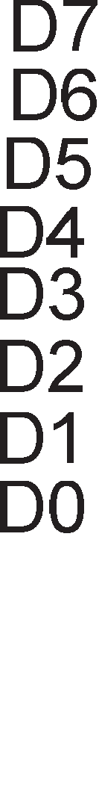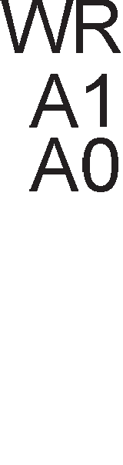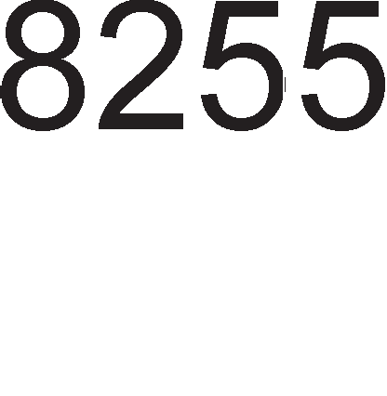

Cn1Ka 8.11. noBp3yBal-be Ha M1KponpoLecop 8086 co cepyMceflMeHTeH p1cnnej

npep pa 3anoL1HeMe co aHan13a Ha noTnpoflpaMaTa Koja Bpw1 MynT1nneKc1pal-be Ha cepyMceflMeHTH1oT p1cnnej co ocyM non1l-ba, pa ce noTceT1Me Ha cepyMceflMeHTH1Te KopoB1, 61peji<1 ToKMy T1e ce 1cnpai<aaT npeKy nopTaTa A po p1cnnejoT.

Bo nopaToL1H1oT ceflMeHT e Kpe1paHa H13a op 8 6ajT1 Ko1 fl1 copp>KaT ocyMTe **7-cerMeHTHM Ko,qoeM** wTo Tpe6a pa ce npeHecaT po ocyMTe non1l-ba op p1cnnejoT. OBaa H13a Bo nopaToL1H1oT ceflMeHT ja npoHaoraMe co noMow Ha pefl1cTapoT SI, Koj BcywHocT, flo paBa pacTojaH1eTo op noL1eToKoT Ha nopaToL1H1oT ceflMeHToT po noL1eToKoT Ha H13aTa. npB1oT 6ajT, Kop op H13aTa Tpe6a pa ce BHece Bo npBoTo none neBo, BTop1oT 6ajT Bo noneTo po Heflo, TpeT1oT 6ajT Bo noneTo TpeTo op neBo 1TH. Pefl1cTapoT BX cny>K1 3a pB1>Kel-be no H13aTa op 8 6ajT1, 1 Toa noL1HyBaji<1 op pHoTo KoH BpBoT. BpepHocTa Ha pefl1cTapoT BX ce HaManyBa 3a

epeH cè popeKa He po61e BpepHocT Hyna. nopaToL1H1oT ceflMeHT co H13aTa op 8 6ajT1 e np1Ka>KaHa Ha cn1Ka 8.12.

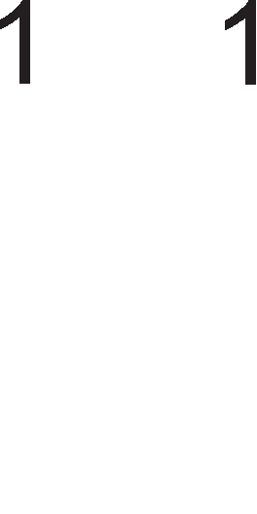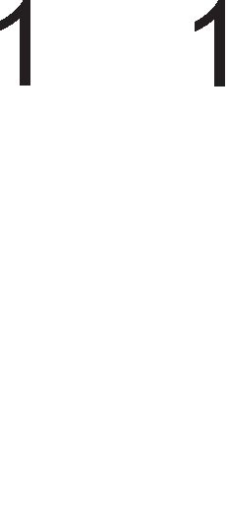

Cn1Ka 8.12. nopaToL1eH ceflMeHT co cepyMceflMeHTH1 KopoB1

Bo noTnpoflpaMaTa 3a MynT1nneKc1pal-be Ha p1cnnejoT ce noB1KyBa HoBa **noTnporpaMa DELAY**. Co oBaa noTnpoflpaMa ce BHecyBa poLHel-be op 1ms Mery aKT1B1pal-beTo Ha pBe cocepH1 non1l-ba op p1cnnejoT. l/l36opoT Ha BpeMeTo Ha poLHel-be e Bo coflnacHocT co npenopaK1Te Ha HeKo1 npo13Bop1Ten1 Ha nep p1cnne1.

Bo noTnpoflpaMaTa 3a MynT1nneKc1pal-be nopTaTa A 1Ma appeca 700H, a nopTaTa B 701H.

DISP PROC

PUSHF

MOV BX,8 MOV AH,7FH

MOV DX ,701H MOV SI, POCETOK

DISP1 MOV AL, AH

OUT DX,AL DEC DX

MOV AL,(BX+SI) OUT DX,AL CALL DELAY ROR AH,1

INC DX DEC BX JNZ DISP

;Copp>KH1HaTa Ha cTaTyc-pefl1cTapoT ce cMecTyBa ;Ha BpBoT op cTeK=MeMop1jaTa

;6pojaL1oT ce nonH1 co BpepHocT 8

;Ce 1361pa 61T MacKaTa =01111111B 3a

ceneKL1ja Ha non1l-baTa.

;Appec1pal-be Ha nopTaTa B

;npoHaoral-be Ha H13aTa op 8 6ajT1 Bo

;nopaToL1H1oT ceflMeHT

;CeneKL1ja Ha none

;Appec1pal-be Ha nopTa A

;Ce 1cnpai<a 7-ceflMeHTH1oT Kop

;Ce L1eKa 1ms

;np1cTan po cnepHoTo none BpecHo

;Appec1pal-be Ha nopTaTa B

;HaManyBal-be Ha 6pojaL1oT 3a epeH

;noBTop1 ocyM naT1

POPF RET

DISP ENDP

;Bpai<al-be Ha cTaTyc-pefl1cTapoT

;Kpaj Ha noTnpoflpaMaTa

Cefla i<e ja o6jacH1Me **npMMeHaTa Ha 8255 KoMnoHeHTaTa npM noep3yea1-e co TacTaTypa**. TacTaTyp1Te Mo>KaT pa 61paT co Hajpa3n1L1H1 floneM1H1. CTaHpappHaTa TacTaTypa copp>K1 101 KonL11l-ba. Bo np1MepoT wTo e np1Ka>KaH Ha cn1Ka 8.13. TacTaTypaTa copp>K1 16 KonL11l-ba. 16 KonL11l-ba ce pacnopepeH1 Bo L1eT1p1 pep1L1 1 L1eT1p1 KonoH1. Ha BaKoB HaL11H ce cpopM1pa MaTp1La co floneM1Ha 4×4. **nopTaTa A** e Bne3Ha nopTa 1 **c11y>KM 3a "1MTa1-e Ha cocToj6aTa Ha Kon"1M1-aTa o,q pe,qM4MTe**.

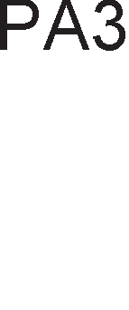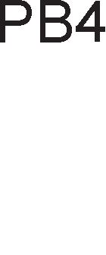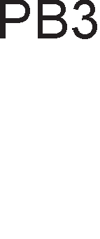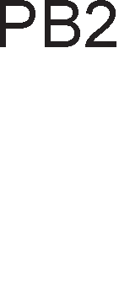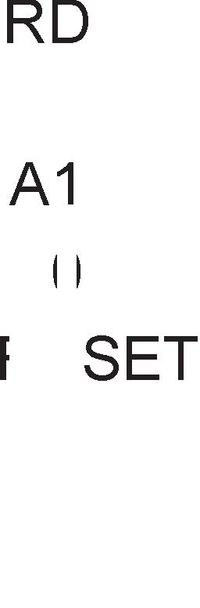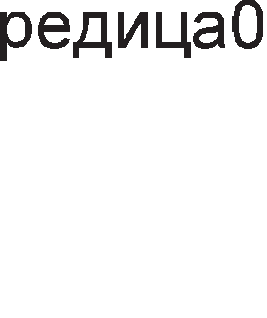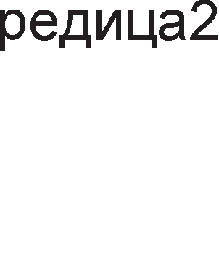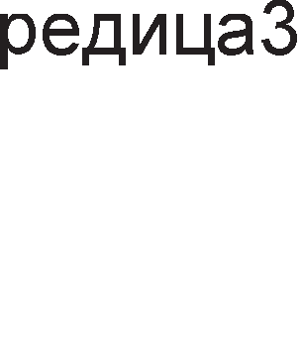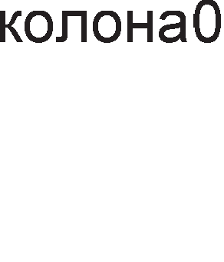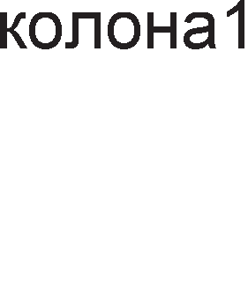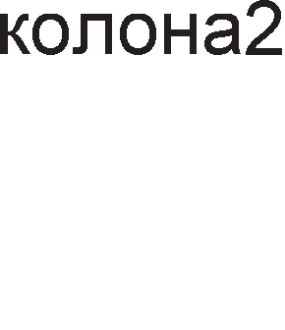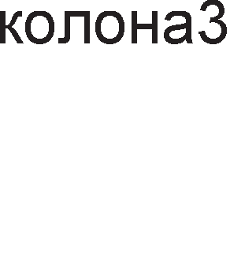

Cn1Ka 8.13. noBp3yBal-be Ha M1KponpoLecop 8086 co TacTaTypa

61peji<1 1Ma L1eT1p1 pep1L1, i<e 61paT ynoTpe6eH1 L1eT1p1 n1Ha op nopTaTa A (PA0-PA3). CeKoja pep1La e noBp3aHa Ha HanoH Vcc=5V npeKy pull up oTnopH1L1 op 10KO. AKo H1epHo KonL1e op Ha6IbypyBaHaTa pep1La He e np1T1cHaTo, Toflaw n1HoT op nopTaTa A i<e 61pe Ha H1Bo Ha nofl1L1Ka ep1H1La. **nopTaTa B e M311e3Ha nopTa M c11y>KM 3a ce11eK4Mja Ha e,qHa Ko11oHa** . 61peji<1 1Ma L1eT1p1 KonoH1, i<e 61paT ynoTpe6eH1 L1eT1p1 n1Ha op nopTaTa B (PB0-PB3). CeneKL1jaTa Ha KonoHa i<e ja o6jacH1Me npeKy np1Mep. AKo 1110 e 13ne3eH nopaToK 3a L1eT1p1Te n1Ha PB3-PB0, Toflaw i<e 61pe ceneKT1paHa HynTaTa KonoHa. Op L1eT1p1Te n1Ha Ha nopTaTa B caMo n1HoT PB0 e Ha H1Bo Ha nofl1L1Ka Hyna. AKo HeKoe op KonL11l-baTa op 0 po 3 61pe np1T1cHaTo, Toflaw aBToMaTcK1 ce Hoc1 nofl1L1Ka Hyna Ha Toj n1H op nopTaTa A. KonL11l-baTa op ppyfl1Te pep1L1 Mo>KaT pa 61paT np1T1cHaT1, Ho oBa HeMa pa Bn1jae Bp3 nofl1L1KaTa cocToj6a Ha n1HoB1Te op nopTaTa A. AKo 1101 e 13ne3eH nopaToK 3a nopTaTa B, Toflaw i<e 61paT ceneKT1paH1 KonL11l-baTa wTo np1nai<aaT Ha KonoHaTa 6poj epeH.

KonL11l-baTa op TacTaTypaTa He ce npeK1HyBaL11, TyKy ce TacTep1. OTKaKo KonL1eTo i<e ce np1T1cHe, Toa He ocTaHyBa Bo Taa nono>K6a, TyKy ce Bpai<a Ha3ap opHocHo ce oTnywTa**. 0TnywTa1-eTo Ha Kon"1eTo Tpae HeKo11Ky ,qe11oeM o,q ceKyH,qaTa.** 3a Hac Toa e HepeanHo BpeMe, Ho 3a M1KponpoLecopoT Toa Mo>Ke pa

61pe ponfl BpeMeHcK1 1HTepBan. Mo>Ke pa ce cnyL11 M1KponpoLecopoT pa ja 1cn1Ta cocToj6aTa Ha np1T1cHaToTo KonL1e npep pa ce ocno6op1 Toa. M1KponpoLecopoT i<e flo 3a6ene>K1 oBa KaKo BTopo np1T1cKal-be wTo, ce pa361pa, HeMa pa 61pe ToL1Ho. nopap1 Toa Tpe6a pa ce BoBepe poLHel-be Mery pBe nocnepoBaTenH1 npoBepK1 Ha KonL11l-baTa 3a pa He poara po BaKB1 flpewK1.

## nporpaMM6M11eH TajMep 8254

npoLecHoTo ynpaByBal-be 6apa p1fl1TcK1 TaKTa co MHofly noMan1 cppeKBeHL11 op oH1e wTo ce Kop1cTaT Bo M1KponpoLecopcK1Te c1cTeM1. Bne3HaTa cppeKBeHL1ja e 8MHz. **nporpaMepoT Mo>Ke ,qa rM MeHyea cppeKeeH4MjaTa M o611MKoT Ha MMny11cMTe Ha ,qMrMTcKMoT TaKT**. npoflpaM161nH1oT TajMep 8254 ce Kop1cT1 3a co3paBal-be p1fl1TcK1 TaKT 3a npoBepKa Ha n1HoT INTR (18.2 Hz) 1 TaKToT 3a ocBe>KyBal-be Ha DRAM MeMop1jaTa. Ha cn1KaTa 8.14. e np1Ka>KaH 6noK-p1jaflpaMoT Ha oBoj TajMep.

TajMepoT 8254 1Ma L1eT1p1 BHaTpewH1 pefl1cTp1: 6pojaL1 0, 6pojaL1 1, 6pojaL1 2 1 KoMaHpeH pefl1cTap. 3a appec1pal-be Ha oB1e pefl1cTp1 ce Kop1cTaT appecH1Te Bne3oB1 A1 1 A0. Appec1pal-beTo ce Bpw1 KaKo wTo e np1Ka>KaHo Ha Ta6ena 8.3.

|  |  |  |
| --- | --- | --- |
| A1 | A0 | pefl1cTap |
| 0 | 0 | 6pojaL10 |
| 0 | 1 | 6pojaL11 |
| 1 | 0 | 6pojaL12 |
| 1 | 1 | KoHTponeH pefl1cTap |

Ta6ena 8.3. Appec1pal-be Ha BHaTpewH1 pefl1cTp1 Bo npoflpaM161neH TajMep 8254

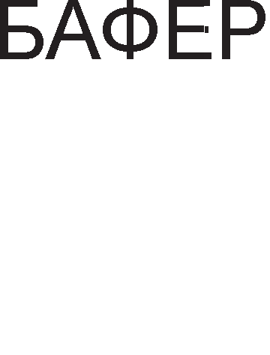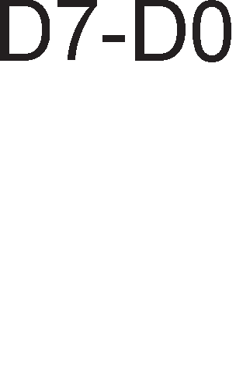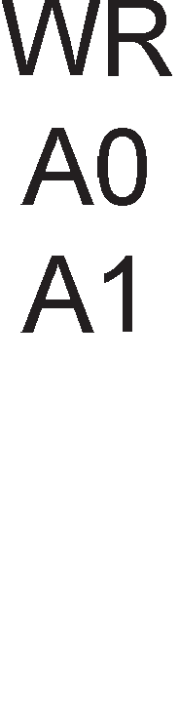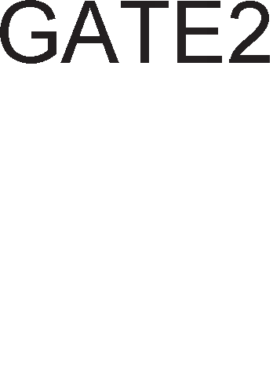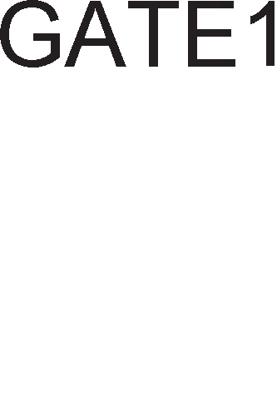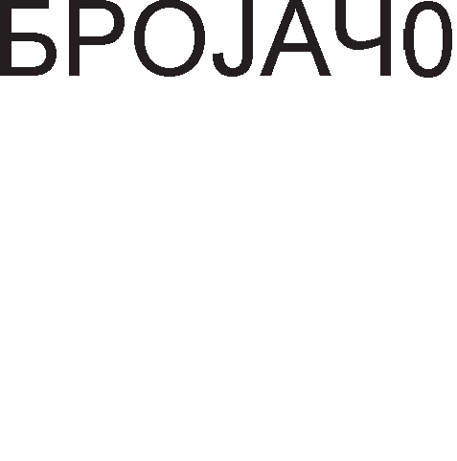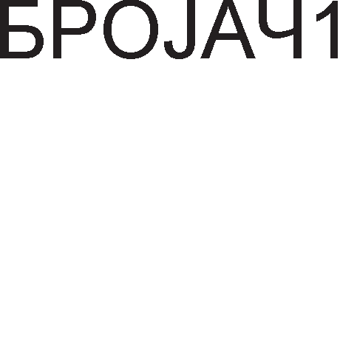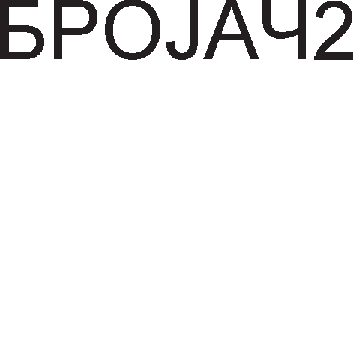

Cn1Ka 8.14 6noK weMa Ha npoflpaM161neH TajMep 8254

CeKoj 6pojaL1 1Ma no 3 n1Ha. CLK e 3a Bne3H1oT p1fl1TcK1 TaKT, OUT e 3a 13ne3H1oT 1 G (gate) e n1H 3a KoHTpona 1 ocnoco6yBal-be Ha 6pojaL1oT. 6pojaL11Te

ce 16-61TH1. MaKc1M1ManHaTa BpepHocT Ha Koja Mo>Ke pa ce 1cnpoflpaM1pa epeH 6pojaL1 e FFFFH.

npoflpaM1pal-beTo ce Bpw1 npeKy KoMaHpH1oT pefl1cTap. npeKy KoMaHpH1oT pefl1cTap ce 1361paaT MopoT 1 6pojaL1oT. MopoT flo pecp1H1pa o6n1KoT Ha 13ne3H1oT c1flHan Bo 3aB1cHocT op 13ne3H1oT. Ha cn1KaTa 8.15. e papeHo 3HaL1el-beTo Ha ceKoj 61T op oBoj pefl1cTap.

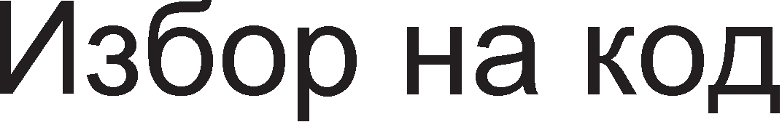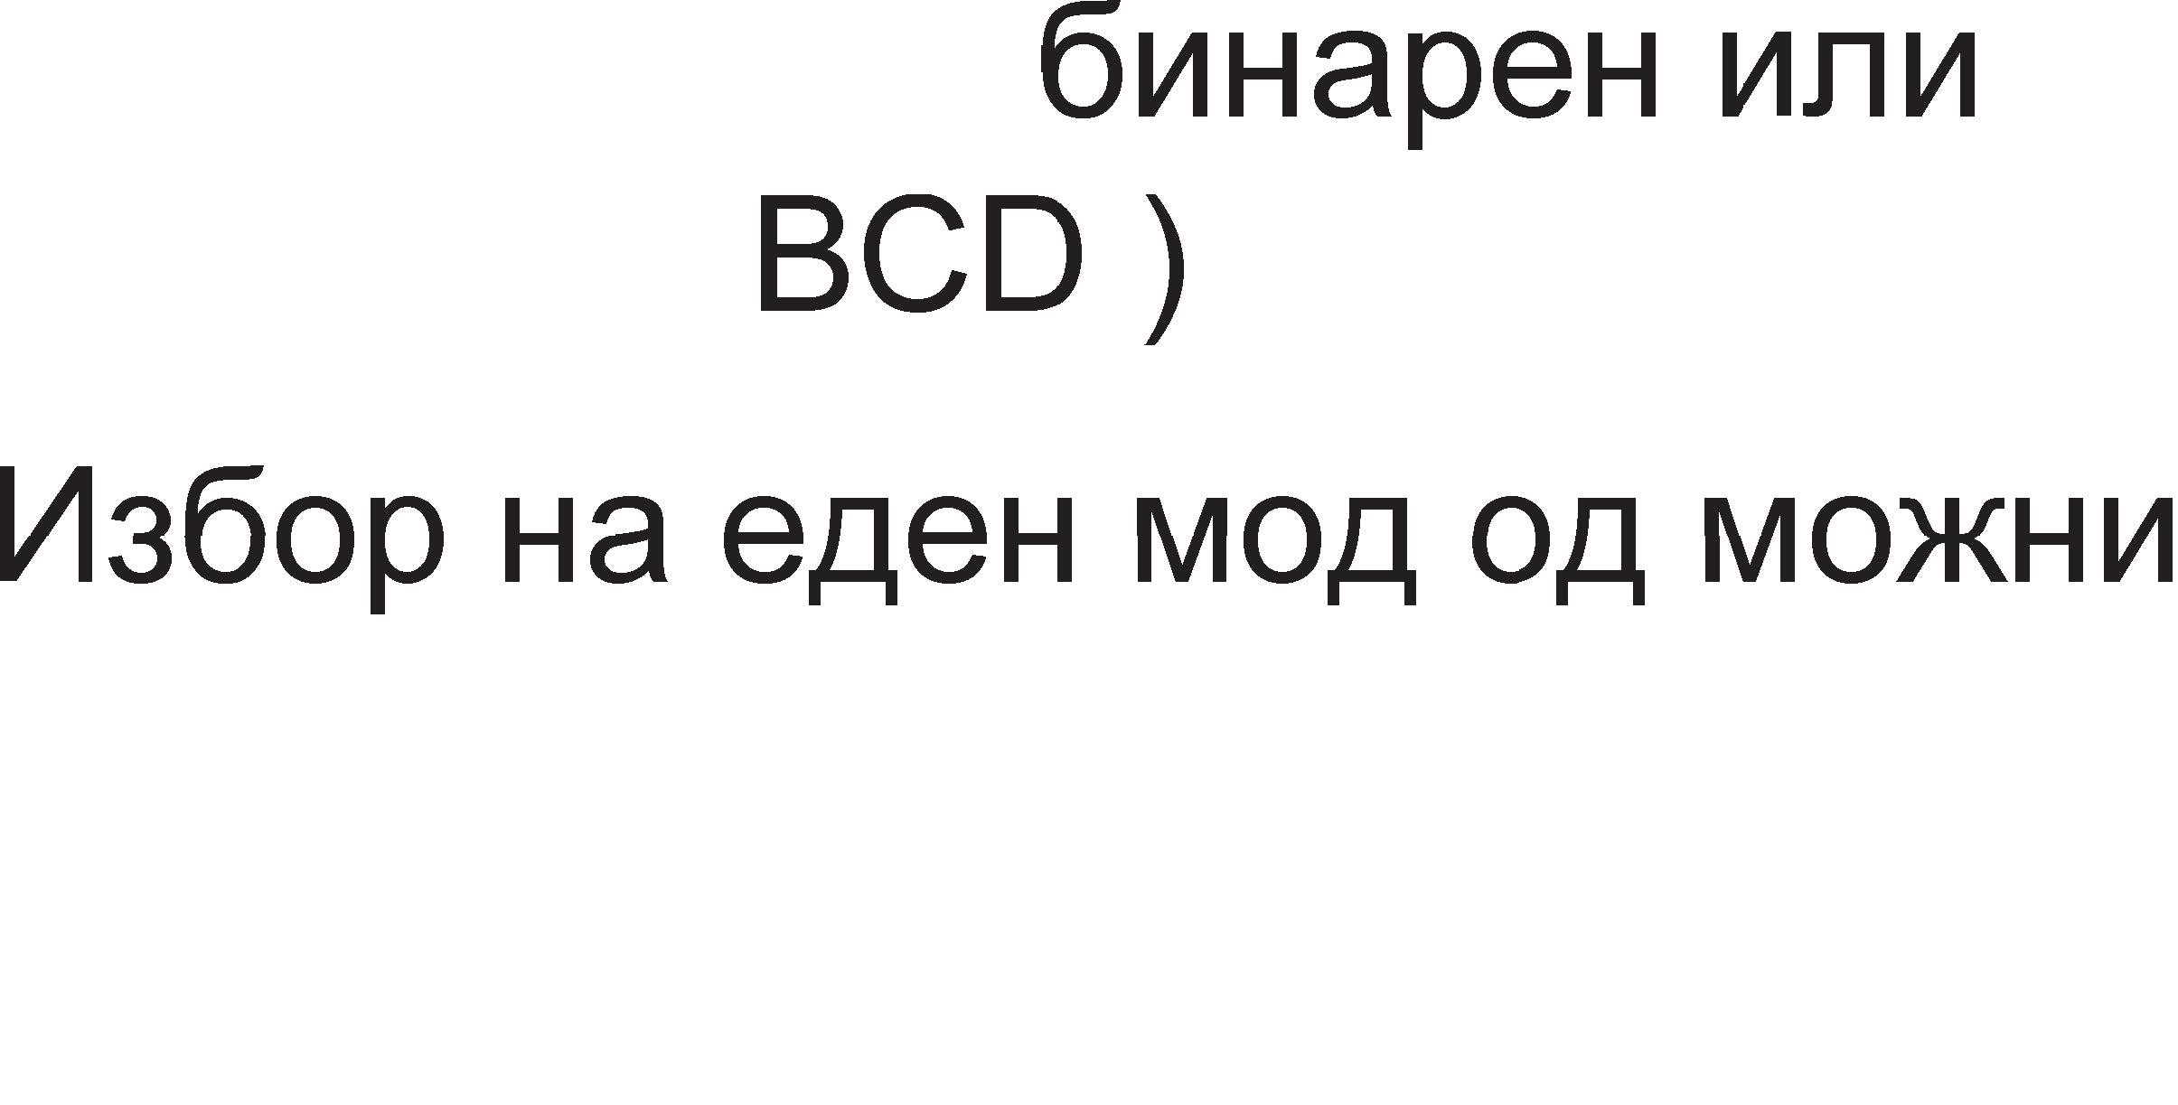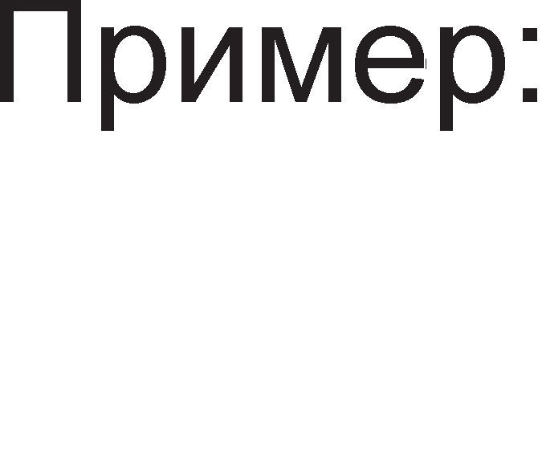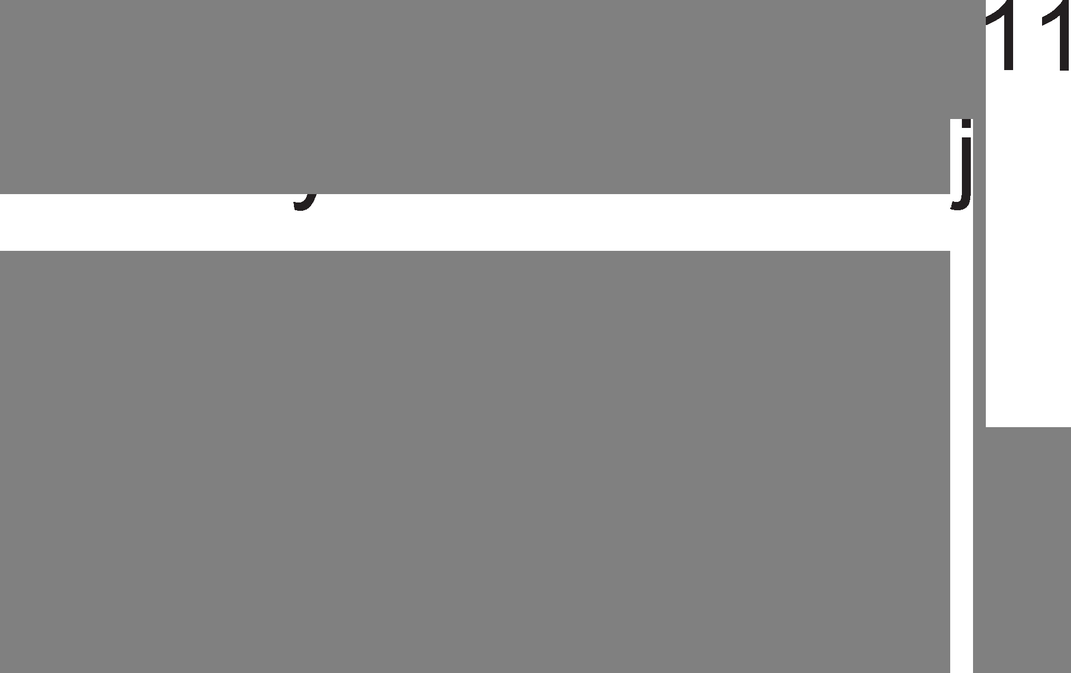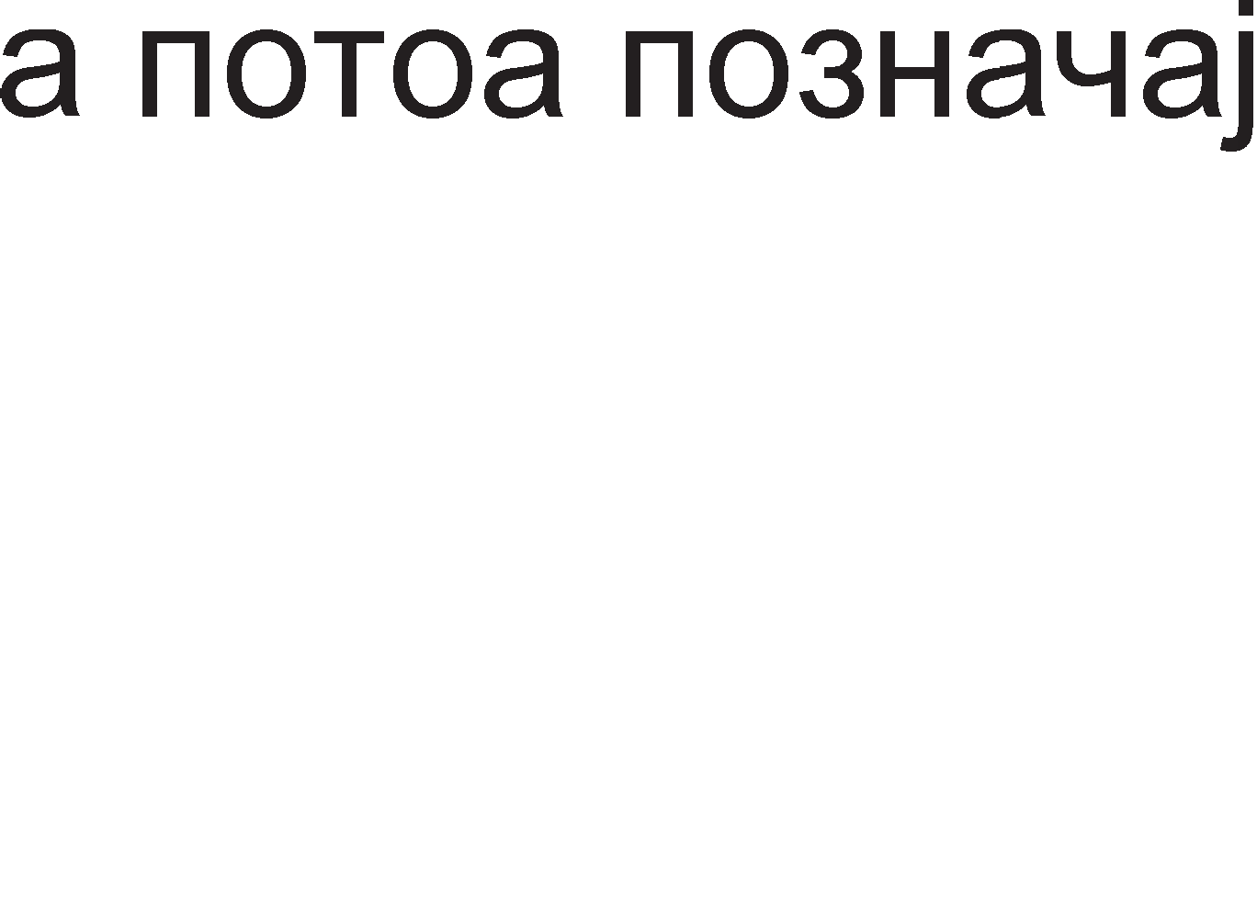





Cn1Ka 8.15. <lyHKL1cK1 on1c Ha 61ToB1Te Bo KoMaHpH1oT pefl1cTap Ha npoflpaM161nH1oT TajMep 8254

TajMepoT 8254 Mo>Ke pa pa6oT1 Bo 6 pa3n1L1H1 Mopa 1 T1e ce np1Ka>KaH1 Ha cn1Ka 8.16. co BpeMeHcK1 p1jaflpaM1.

Mop 0 – Bo oBoj Mop Ha pa6oTa n1HoT OUT i<e 61pe nofl1L1Ka ep1H1La c# popeKa Tpae 6poel-beTo. 6poel-beTo 3anoL1HyBa Bo MoMeHToT Kofla i<e

ce 3an1we BpepHocTa Ha KoMaHpH1oT pefl1cTap. AopeKa Tpae 6poel-beTo, n1HoT G Tpe6a pa 61pe Ha B1coKo H1Bo. AKo popeKa Tpae 6poel-beTo n1HoT G napHe Ha H1cKo H1Bo, Toflaw 6poel-beTo i<e 61pe npeK1HaTo 1 i<e npopon>K1 Kofla c1flHanoT Ha n1HoT G naK i<e cTaHe nofl1L1Ka ep1H1La.

Mop 1 – 6pojaL1oT ce npoflpaM1pa 1 L1eKa 1Mnync Ha n1HoT G 3a pa noL1He

6poel-beTo. AKo ce nojaB1 ywTe epeH 1Mnync Ha n1HoT G popeKa Tpae 6poel-beTo, Toflaw wToM i<e 3aBpw1 TeKoBHoTo 6poel-be, i<e noL1He HoBo .

Mop 2 – Kaj oBoj Mop Ha pa6oTa c1flHanoT Ha n1HoT G Tpe6a pa 61pe Ha B1coKo H1Bo Leno BpeMe. Ha np1Mep, aKo 6pojaL1oT ce 1cnpoflpaM1pa Ha BpepHocT 10, Toflaw Ha n1HoT OUT c1flHanoT i<e 61pe nofl1L1Ka ep1H1La peBeT p1fl1TcK1 TaKTa, a Bo peceT1oT TaKT i<e 61pe Hyna. noBopKaTa op 1Mnync1 Tpae cè popeKa He ce 13Bpw1 penpoflpaM1pal-be 1n1 c1flHanoT Ha

n1HoT G He cTaHe nofl1L1Ka Hyna. BaKBaTa noBopKa ce B1Ka noBopKa op KoHT1Hy1paH1 1Mnync1.

Mop 3 – l/lcTo KaKo 1 Kaj npepXopH1oT Mop, TaKa 1 oBpe e noTpe6Ho flejToT pa 61pe Ha B1coKo H1Bo. Ha np1Mep, aKo COUNT = 4, Toflaw c1flHanoT Ha n1HoT OUT i<e 61pe nofl1L1Ka ep1H1La pBa TaKTa, a ppyfl1 pBa TaKTa i<e 61pe Hyna. OBoj c1flHan ce HapeKyBa KBappaTeH c1flHan.

N 1 2 3 4 5 6 7

clk

out

BpepHocT Ha 6pojaL1oT=7, G=1

1 2 3 4 5

Mop 1

clk G

out

BpepHocT Ha 6pojaL1oT=5, G=1Mnync

1 2 3 4 5 1 2 3 4 5 1 2 3 4 5

clk

out

BpepHocT Ha 6pojaL1oT=5, G=1

Mop 3 clk

out

1 2 3 4

5 6 1 2

3 4 5 6 1 2 3

BpepHocT Ha 6pojaL1oT=6, G=1

clk out

1 2 3 4

5 6 7 8

BpepHocT Ha 6pojaL1oT=8, G=1

1 2 3 4 5

Mop 5

clk

G

ut

o

BpepHocT Ha 6pojaL1oT=,5 G=nay3a

Cn1Ka 8.16. BpeMeHcK1 p1jaflpaM 3a 3aB1cHocTa Ha 13ne3H1oT c1flHan op Bne3H1Te c1flHan1 Kaj npoflpaM161neH TajMep 8254

Mop 4 – KaKo Kaj npeTXopH1Te pBa Mopa 1 oBpe e noTpe6Ho flejToT pa 61pe Ha B1coKo H1Bo. Ha n1HoT OUT i<e ce nojaB1 caMo epeH 1Mnync oTKaKo i<e 61paT 136poeH1 oHonKy TaKTa Ha KonKy wTo e npoflpaM1paH 6pojaL1oT.

Mop 5 – OBoj Mop e 1cT KaKo 1 Mop 4, co Taa pa3n1Ka wTo 3a pa noL1He 6poel-beTo Ha n1HoT G Mopa pa ce nojaB1 1Mnync opHocHo c1flHanoT op 1 pa napHe Ha Hyna, a noToa noBTopHo pa cKoKHe Ha 1.

Ha cn1Ka 8.17. e np1Ka>KaHa weMaTa 3a noBp3yBal-be Ha TajMepoT 8254 co M1KponpoLecop 8086 co pa6oTHa cppeKBeHL1ja 8MHz.

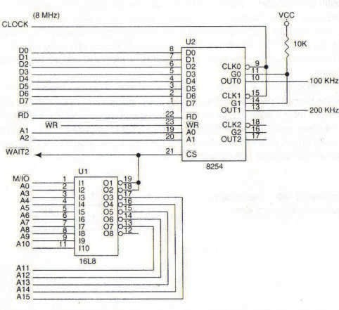

Cn1Ka 8.17. noBp3yBal-be Ha TajMep 8254 co M1KponpoLecop 8086

##### npMMep 8.20:

Oppep1 fl1 copp>K1H1Te Ha KoMaHpH1oT pefl1cTap 1 6pojaL11Te Bo TajMepoT 8254 TaKa wTo Ha 13ne3 op HynT1oT 6pojaL1 pa ce po61e KBappaTeH c1flHan co cppeKBeHL1ja 100KHz, a Ha 13ne3 op 6pojaL1oT 1 pa ce po61e noBopKa op KoHT1Hy1paH1 1Mnync1 co cppeKBeHL1ja 200KHz.

PeweH1e:

Copp>K1HaTa Ha KoMaHpH1oT pefl1cTap i<e 61pe pa3n1L1Ha 3a ceKoj 6pojaL1 noce6Ho. 3a 6pojaL1oT 0 flo Kop1cT1Me Mop 3 1 6pojaL1oT 0 flo npoflpaM1paMe Ha BpepHocT 80 (8MHz : 80 = 100KHz) . 3a 6pojaL1oT 1 Kop1cT1Me Mop 2 1 6pojaL1oT flo npoflpaM1paMe Ha BpepHocT 40 (8MHz : 40 = 200KHz).

noTnpoflpaMaTa 3a pean13aL1ja Ha o6jacHeTaTa Len ce B1Ka TIME. TajMepoT 8254 fl1 Kop1cT1 1HTepcpejc-appec1Te 0700H, 07002H, 0704H 1 0706H.

|  |  |  |  |
| --- | --- | --- | --- |
| TIME | PROC | NEAR |  |
|  | PUSH | AX | ;ja 3awT1TyBaMe copp>K1HaTa Ha |
|  | PUSH | DX | pefl1cTp1Te |

|  |  |  |
| --- | --- | --- |
| MOV | DX, 706H | ;appeca Ha KoMaHpeH pefl1cTap |
| MOV | AL,00110110B | ;copp>K1Ha Ha KoMaHpeH pefl1cTap |

|  |  |  |  |
| --- | --- | --- | --- |
|  | OUT MOV OUT | DX,AL AL,01110100B  DX,A L | ; 3a 6pojaL1 0  ; copp>K1Ha Ha KoMaHpeH pefl1cTap  ; 3a 6pojaL1 0 |
| MOV MOV OUT | DX,700H AL,80 DX,AL | ;appeca Ha 6pojaL1 0  ;npoflpaM1pal-be Ha 6pojaL1 0 |
| MOV MOV OUT | DX,702H AL,40 DX,AL | ;appeca Ha 6pojaL1 1  ;npoflpaM1pal-be Ha 6pojaL1 1 |
| TIME | POP POP RET ENDP | DX AX |  |

# 0cHoeHM KapaTepMcTMKM Ha MMKponpo4ecop 80286

npoLecopoT 80286 e HanpepHa Bep31ja Ha M1KponpoLecopoT 8086, co Mo>KHocT 3a napanenHo 13BpwyBal-be Ha noBei<e 3apaL11 1 Kop1cH1L1K1 ycnyfl1. M1KponpoLecopoT 80286 pacnonafla co cp131L1Ka MeMop1ja op 16MB 1 B1pTyenHa MeMop1ja op 1GB, npeKy ynoTpe6a Ha cneL1janHa ep1H1La 3a MeMop1cK1 MeHa1,MeHT. 6pojoT Ha p1fl1TcK1 TaKTa 3a 13BpwyBal-be Ha 1HcTpyKL11Te e HaManeH. 80286 M1KponpoLecopoT noBei<e He ce Kop1cT1 Bo nepcoHanH1Te KoMnjyTep1, Ho Toj ce ywTe Haora np1MeHa Bo KoMnjyTepcK1Te c1cTeM1 3a npoLecHo ynpaByBal-be.

Ha cn1Ka 8.18. e np1Ka>KaHa **apxMTeKTypaTa** Ha oBoj M1KponpoLecop. Ep1H1LaTa 3a MeMop1cK1 MeHa1,MeHT e 1MeHyBaHa KaKo appecHa ep1H1La.

Cn1L1Ho KaKo Kaj M1KponpoLecopoT 8086, 3a npecMeTKa Ha cp131L1KaTa appeca ce Kop1cTaT ceflMeHTH1Te pefl1cTp1 1 noMecyBal-beTo (pacTojaH1e op noL1eToKoT Ha ceflMeHToT po caKaHaTa noKL1ja). Ap1TMeT1L1Ko nofl1L1KaTa ep1H1La 1 onwT1Te pefl1cTp1 ce 16-61TH1. Ep1H1LaTa 3a ynpaByBal-be co Mefl1cTpan1Te fl1 fleHep1pa cTaTycH1Te c1flHan1 3a 136op Ha Maw1HcK1 L1Knyc (S0,S1), 3a ynpaByBal-be co DMA KoHTponepoT (HOLD, HLDA) 1 npeK1H1Te (INTR, COD/INTA). 3a pa3n1Ka op 8086 M1KponpoLecopoT, M1KponpoLecopoT 80286 copp>K1 pBe 1HcTpyKL1cK1 pep1L1, epHa npep 1HcTpyKL1cK1oT peKopep 1 ppyfla co peKop1paH1 1HcTpyKL11. AppecHaTa Mafl1cTana e 24-61THa 1 ce Kop1cT1 3a appec1pal-be Ha peaneH

MeMop1cK1 npocTop op 16MB. Aa Haflnac1Me peKa M1KponpoLecopoT 80286 He Kop1cT1 MynT1nneKcHa appecHo nopaToL1Ha Mafl1cTpana.

Ep1H1La 3a Mafl1cTpaneH 1HTepcpejc

AppecHa ep1H1La

|  |  |
| --- | --- |
| npoBepKa Ha floneM1Ha Ha ceflMeHT | CeflMeHTHa floneM1Ha |
| CeflMeHTH1 ocHoB1 |

Co61paL1 Ha noMecTyBal-be

Co61paL1 3a po61Bal-be Ha cp131L1Ka appeca

AppeceH KoHTponep

KoMyH1KaL1ja co HyMep1L1K1 KonpoLecop

KoHTpona Ha Mafl1cTpan1

nopaToL1eH KoHTponep

A23-A0, BHE,M/IO

PEACK PEREQ

READY, HOLD

S0, S1, COD/INTA, LOCK, HLDA

D15-D0

8 6ajT1 npeTnpeHocHa pep1La

|  |  |  |  |  |
| --- | --- | --- | --- | --- |
| ALU  OnwT1  pefl1cTp1 KoHTpona | | | | |
|  |  |  |  |  |
| 3BpwHa ep1H1La NMI | | BUSY | |

Pep1La co Tp1 l/lHcTpyKL1cK1

RESET CLK

l/l

peKop1paH1

1HcTpyKL11

pefl1cTap

CAP

NMI ERROR

l/lHcTpyKL1cKa ep1H1La

Cn1Ka 8.18. ApX1TeKTypa Ha M1KponpoLecop 80286

**nMHoeMTe** BUSY, ERROR, PEREQ 1 PEACK ce HoB1 1 T1e ce Kop1cTaT 3a

KoMyH1KaL1ja Ha M1KponpoLecopoT 80286 co MaTeMaT1L1K1Te KonpoLecop1. 3HaL1el-beTo Ha n1HoT BUSY ja 1Ma 1cTaTa cpyHKL1ja KaKo 1 n1HoT TEST Ha M1KponpoLecopoT 8086 1 ce Kop1cT1 3a BMeTHyBal-be Ha Len 6poj TaKToB1 3a L1eKal-be. n1HoT ERROR ce aKT1B1pa poKonKy ce nojaB1 flpewKa Bo KoHTponaTa Ha napHocT. npeKy n1HoB1Te PEREQ 1 PEACK MaTeMaT1L1K1oT KonpoLecop nopHecyBa 6apal-be 1 po61Ba po3Bona 3a pa6oTa.

Ha cn1Ka 8.19. e np1Ka>KaH HaL11HoT Ha noBp3yBal-be Ha M1KponpoLecopoT 80286 co **KoHTpo11epoT Ha MarMcTpa11M 82288 M reHepaTopoT Ha TaKT 82884**. OB1e pBe **MHTerpMpaHM Ko11a** ce pen op M1KpoKoMnjyTepcK1oT c1cTeM Ha M1KponpoLecopoT 80286. 3a nopo6po pa361pal-be Ha oBoj c1cTeM, 1cT1oT Tpe6a pa flo cnopep1Me co c1cTeMoT Ha M1KponpoLecopoT 8086 Kofla Toj pa6oT1 Bo MaKc1ManeH pe>K1M, cn1Ka 8.5. Ha Taa cn1Ka e ynoTpe6eH KoHTponep Ha Mafl1cTpan1 8288 wTo e MHofly cn1L1eH co KoHTponepoT 82288 np1Ka>KaH Ha

cn1KaTa 8.19. HaL11HoT Ha fleHep1pal-be Ha KoHTponH1Te c1flHan1 e 1cT. M1KponpoLecopoT fl1 1cnpai<a cTaTycH1Te 61ToB1 S0, S1 1 IO/, T1e ce peKop1paaT 1 Ha 13ne3 op KoHTponepoT ce po61BaaT c1flHan1Te 3a KoHTpona Ha MeMop1jaTa (MRDC, MWTC) 1 KoHTpona Ha nep1cpepH1Te ypep1 (IORC, IOWC).



Cn1Ka 8.19. noBp3yBal-be Ha M1KponpoLecop 80286 co fleHepaTop Ha p1fl1TcK1 TaKT 82884 1 KoHTponop Ha Mafl1cTpan1 82288

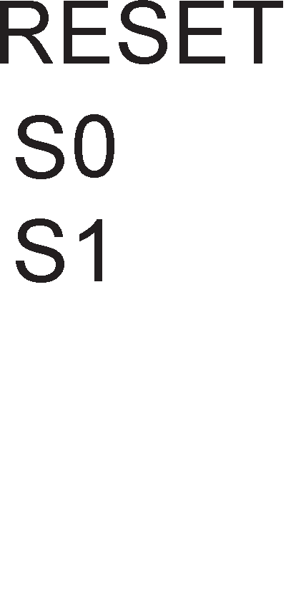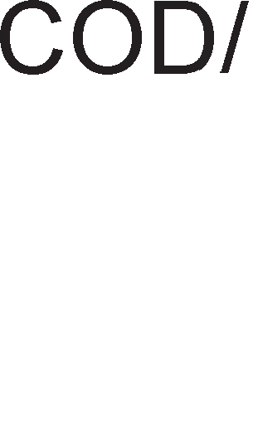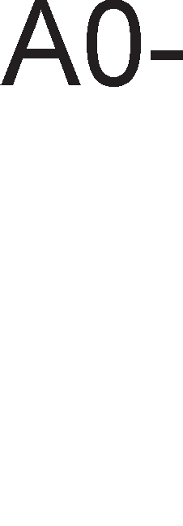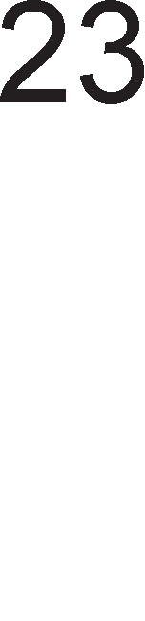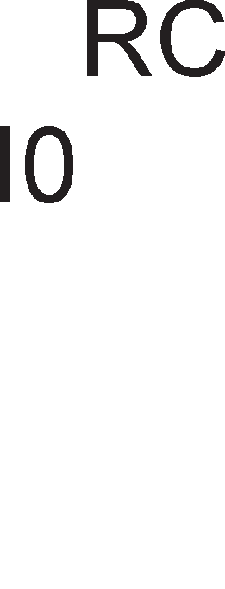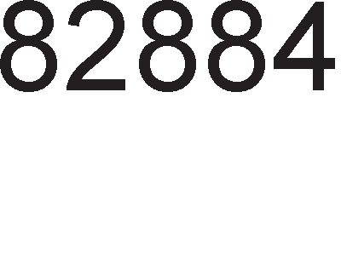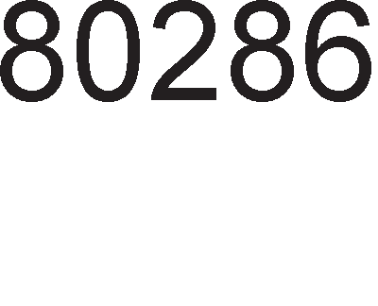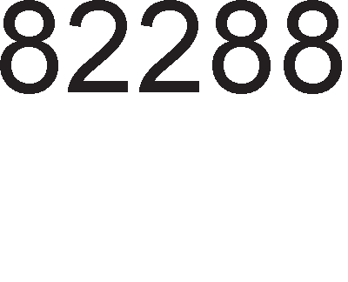

reHepaTopoT Ha p1fl1TcK1 TaKT 82284 e MHofly cn1L1eH co fleHepaTopoT Ha TaKT 8284. l/l3ne3H1 n1HoB1 ce:

1. CLK (clock)- OBoj c1flHan e Bne3eH c1flHan 3a M1KponpoLecopoT 1 ppyfl1Te ypep1 Bo c1TeMoT
2. READY-Kofla oBoj n1H e Ha H1cKo H1Bo M1KponpoLecopoT BneflyBa Bo cocToj6a Ha L1eKal-be. Kofla oBoj n1H e Ha B1coKo H1Bo Toj HeMa Bn1jaH1e Bp3 a6oTaTa Ha M1KponpoLecopoT
3. RESET-OBoj n1H cny>K1 3a peceT1pal-be Ha M1KponpoLecopoT.
4. PCLK (Peripheral Clock)-OBoj 13ne3eH p1fl1TcK1 TaKT 1Ma pBa naT1 noMana cppeKBeHL1ja op cppeKBeHL1jaTa Ha p1fl1TcK1oT TaKT Ha n1HoT EFI

Bne3H1 n1HoB1 Ha fleHepaTopoT Ha TaKT 82284ce:

* + X1, X2-OB1e pBa n1Ha cny>KaT 3a np1KnyL1yBal-be Ha Kp1cTanH1oT ocL1naTop
  + EFI(External Frequency Input)-OBoj n1H cny>K1 3a np1KnyL1yBal-be Ha HapBopeweH 13Bop Ha p1fl1TcK1 TaKT.
  + RES (Reset)- npeKy oBoj n1H ce Bpw1 peceT1pal-be Ha HanojyBal-beTo 1 1cT1oT e noBp3aH co RC Kono.
  + F/  (Frequency Crystal Select)-npeKy oBoj n1H ce 1361pa 13BopoT Ha p1fl1TcK1oT TaKT: X1, X2 1n1 EFI.
  + ARDY, SRDY (Asynchronous Ready Enable, Synchronous Ready Enable)- OB1e n1HoB1 cny>KaT 3a 136op Ha epeH op Mo>KH1Te pBa 13Bop1 Ha c1flHanoT READY.
  + AYEN, SYEN (Asynchronous Ready, Synchronous Ready)- Kofla epeH op oB1e n1HoB1 e Ha H1cKo H1Bo ce aKT1B1pa 13ne3H1oT c1flHan READY
  + S0, S1-CTaTycH1Te n1HoB1 fl1 1cnpai<a M1KponpoLecopoT 1 cny>KaT 3a pecp1H1pal-be Ha B1p Ha Maw1HcK1 L1Knyc.

# 0cHoeHM KapaKTepMcTMKM Ha MMKponpo4ecop 80386

npoLecopoT 80386 e 32-61THa Bep31ja Ha M1KponpoLecopoT 8086. noKpaj pynn1pal-beTo Ha floneM1HaTa Ha nopaToL1Te, Kaj M1KponpoLecopoT 80386 nocTojaT H13a ppyfl1 nopo6pyBal-ba Bo MynT1npoLec1pal-beTo, MeMop1cKaTa opflaH13aL1ja, B1pTyenHaTa MeMop1ja, 3awT1Ta Ha cocpTBepoT 1TH. Co 3awT1TH1oT 1 B1pTyenH1oT Mop Ha pa6oTa i<e ce 3ano3HaeMe Bo cnepHaTa TeMa. **no,qaTo"1HaTa M a,qpecHaTa MarMcTpa11a ce 32-6MTHM.** roneM1HaTa Ha MeMop1cK1oT npocTop 13HecyBa 4GB. M1KponpoLecopoT 80386 o6e36epyBa npeM1H op peaneH Bo 3awT1TeH pe>K1M Ha pa6oTa 6e3 peceT1pal-be Ha M1KponpoLecopoT, wTo He 6ewe cnyL1aj co npeTXopH1Te fleHepaL11 Ha M1KponpoLecop1.

Ha cn1Ka 8.20. e np1Ka>KaHa apX1TeKTypaTa Ha M1KponpoLecopoT 80386 1 HefloB1Te **e11e3HM M M311e3HM cMrHa11M**.

M1KponpoLecopoT 80386DX 1Ma 30 appecH1 n1H11, op A2 po A32 1 cny>KaT 3a 136op Ha 32-61THa noKaL1ja op BKynHo 1G noKaL11. HaMecTo appecH1Te n1H11 A0 1 A1 ce Kop1cTaT L1eT1p1Te KoHTponH1 c1flHan1 -  3a 136op Ha epeH 6ajT op L1eT1p1Te 6ajT1 Bo 136paHaTa noKaL1ja. n1HoT M/ ce Kop1cT1 3a 136op Ha ypep (1-MeMop1ja, 0-nep1cpepeH ypep), a n1HoT W/ 3a 136op Ha onepaL1ja (1- n1wyBal-be, 0-L11Tal-be). n1HoT  (Address Data Strobe) ce aKT1B1pa ceKoflaw Kofla ce 1cnpai<a Ban1pHa MeMop1cKa 1n1 1HTepcpejc appeca. n1HoT CLK2 paBa c1flHan co pBa naT1 nofloneMa cppeKBeHL1ja op oHaa Ha M1KponpoLecopoT. Co aKT1B1pal-be Ha n1HoT RESET M1KponpoLecopoT 3anoL1HyBa 13BpwyBal-be Ha cocpTBep op noKaL1ja co appeca FFFFFFF0H. C1flHanoT flo KoHTpon1pa 6pojoT Ha cocToj61 Ha L1eKal-be. Kofla n1HoT D*/* (data/control) e Ha B1coKo H1Bo Toflaw ce npeHecyBa nopaToK, a aKo e Ha H1cKo H1Bo Toflaw M1KponpoLecopoT 13BpwyBa Maw1HcK1 L1Knyc 3a o6pa6oTKa Ha npeK1H. n1HoT  (Bus Select

16) 1361pa Mery 16 1n1 32-61THa Mafl1cTpana. C1flHanoT  (Next Address) ce Kop1cT1 Kaj pipeline KoHLenToT 3a 1cnpai<al-be Ha appecaTa Ha cnepHaTa 1HcTpyKL1ja. Co n1HoB1Te HOLD 1 HLDA ce KoHTpon1pa DMA npeHocoT. Ap1TMeT1L1K1oT KonpoLecop 6apa po3Bona 3a pa6oTa op M1KponpoLecopoT 80386 npeKy aKT1B1pal-be Ha n1HoT  (Coprocessor Request). n1HoT  e Bne3eH n1H 3a M1KponpoLecopoT 1 e aKT1BeH Kofla KonpoLecopoT e 3acpaTeH. AoKonKy ce nojaB1 flpewKa Bo pa6oTel-beTo Ha KonpoLcopoT ce aKT1B1pa n1HoT  n1HoB1Te INTR 1 NMI ce aKT1B1paaT Bo cnyL1aj Ha XappBepcK1 npeK1H 1n1 HeMacK1paL1K1 npeK1H.

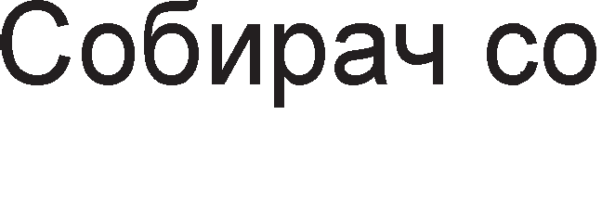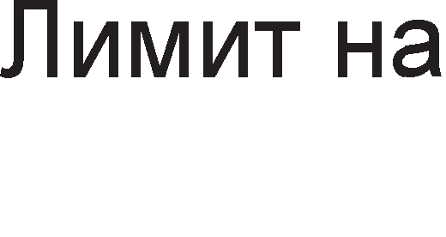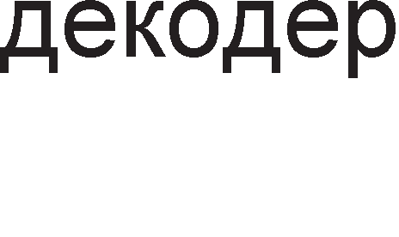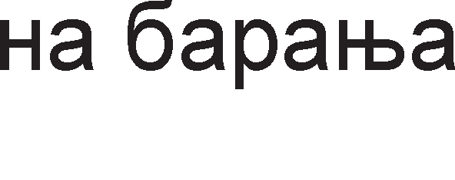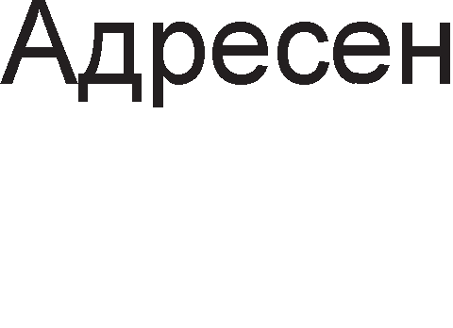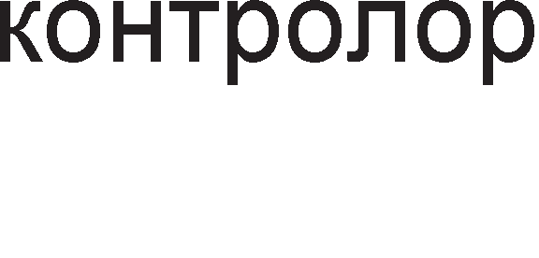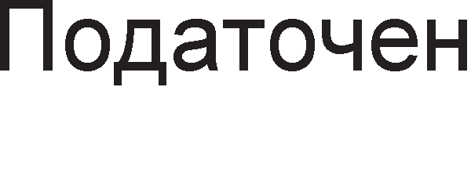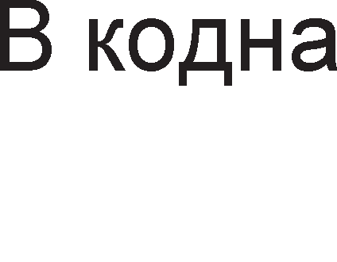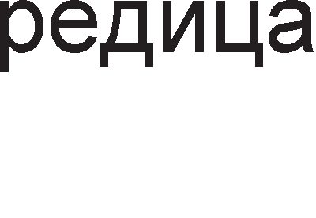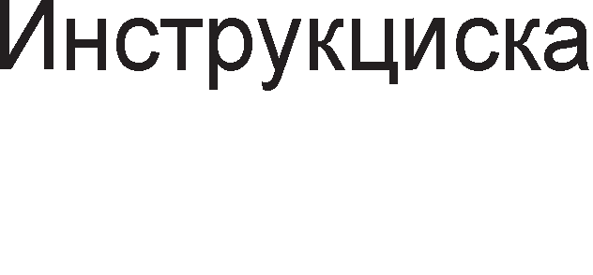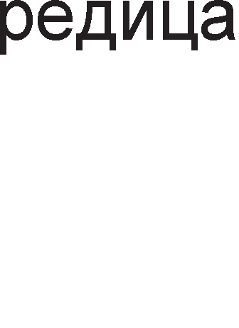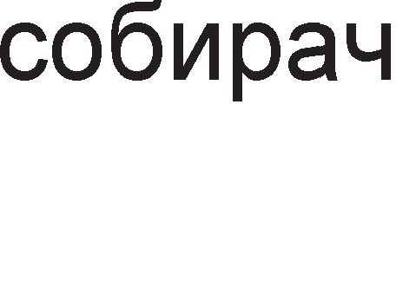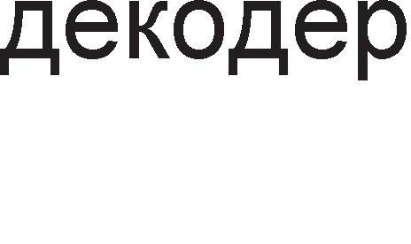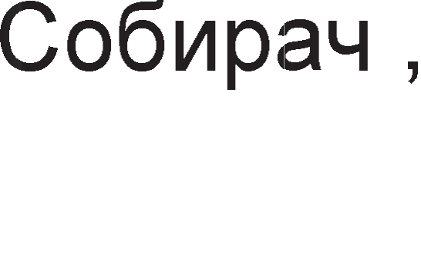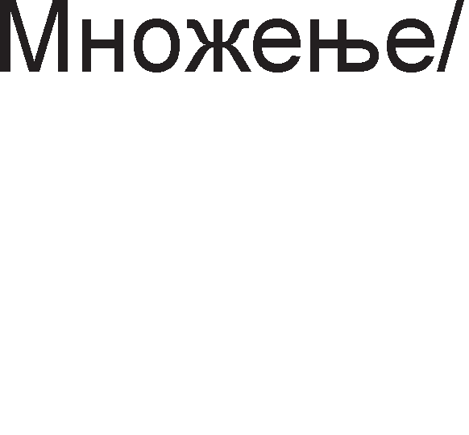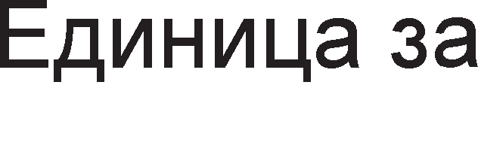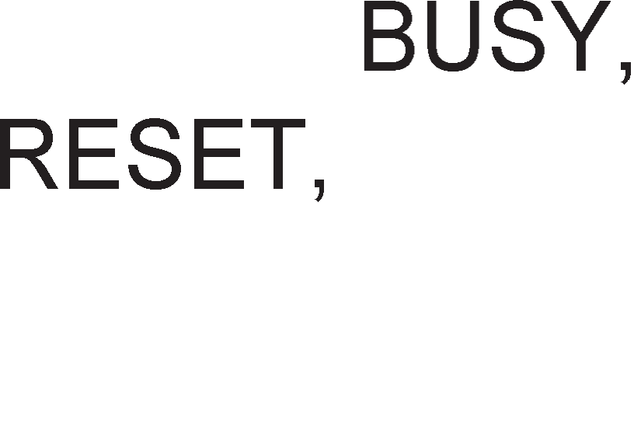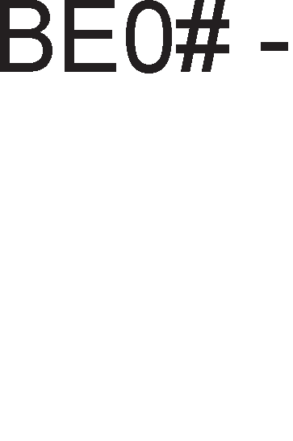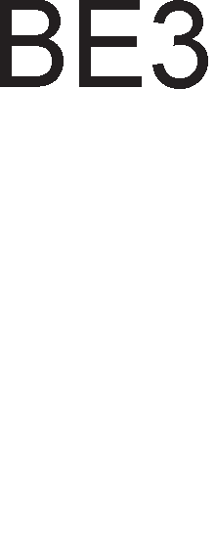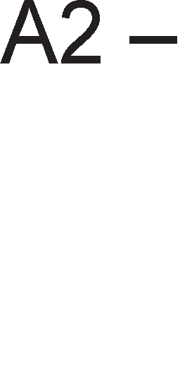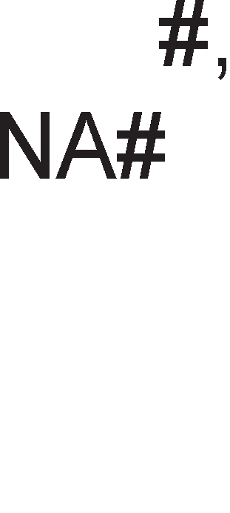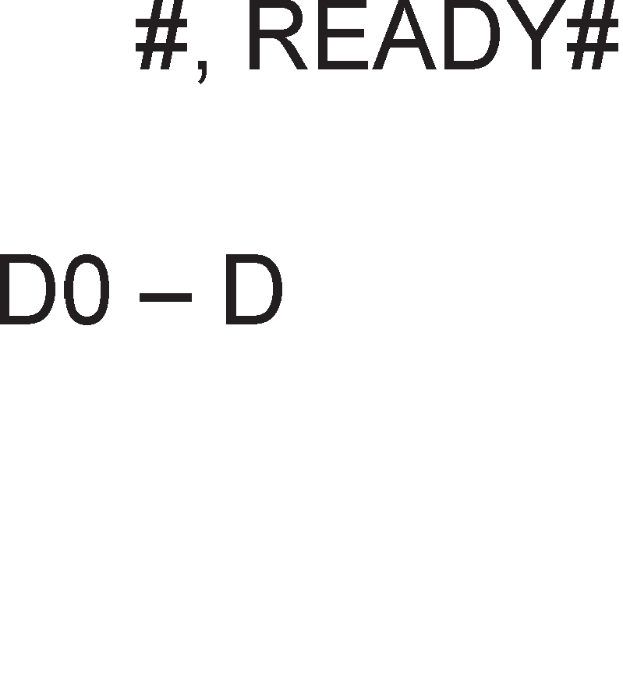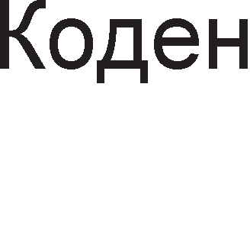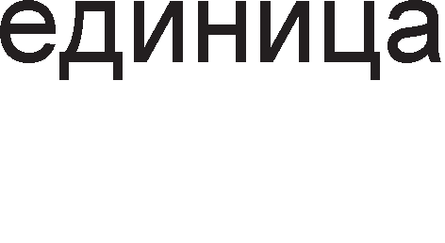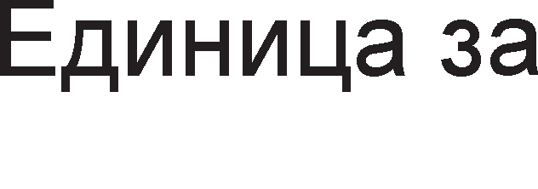

8.20. ApX1TeKTypa Ha M1KponpoLecop 80386

Pefl1cTp1Te Bo M1KponpoLecopoT 80386 ce nopeneH1 Bo HeKonKy flpyn1: onwT1 pefl1cTp1, 1HcTpyKL1cK1 noKa>KyBaL1, cTaTyc pefl1cTap, ceflMeHTH1 pefl1cTp1, ceflMeHTH1 p1cKp1nTop pefl1cTp1, KoHTponH1 pefl1cTp1, c1cTeM appecH1 pefl1cTp1

1 pefl1cTp1 3a TecT1pal-be 1 oTcTpaHyBal-be flpewK1 (pe6afl1pl-be-Ha aHfln1cK1 36opoT debug 3HaL11 oTcTpaHyBal-be cocpTBepcK1 flpewK1). OnwT1Te pefl1cTp1, 1HcTpyKL1cK1oT noKa>KyBaL1, cTaTyc pefl1cTapoT 1 ceflMeHTH1Te pefl1cTp1 1MaaT 1cTa cpyHKL1ja KaKo Kaj M1KponpoLecopoT 8086. **0nwTMTe perMcTpM** Mo>KaT pa 61paT 8,16, 1 32-61TH1. 8-61TH1Te pefl1cTp1 1MaaT HacTaBKa L(low) 1 H (high). 16- 61TH1Te pefl1cTp1 1MaaT HacTaBKa X: AX, BX, CX, DX. 32-61TH1Te pefl1cTp1 ce o3HaL1yBaaT co popaBal-be Ha 6yKBaTa E (extended) npep 16-61TH1Te pefl1cTp1: EAX, EBX ,ECX, EDX. l/lHcTpyKL1cK1oT 1 cTaTyc pefl1cTapoT ce 1cTo TaKa 32 61TH1, a ceflMeHTH1Te pefl1cTp1 ce 16-61TH1. **.QMcKpMnTopMTe Ha cerMeHTMTe** ce pefl1cTp1 Ko1 paBaaT 1HcpopMaL1ja 3a noL1eTHaTa cp131L1Ka appeca Ha ceflMeHT1Te, floneM1HaTa 1 ppyfl1 H1BH1 KapaKTep1cT1K1. T1e ce HenpoflpaM161nH1, HeB1pn1B1

3a npoflpaMepoT, Ho MHofly Ba>KH1 3a pa ce pa36epe appec1pal-beTo Kaj M1KponpoLecopoT 80386. nocTojaT **TpM KoHTpo11HM perMcTpM** CR0, CR2 1 CR3. CR1 nocTo1, Ho He ce ynoTpe6yBa 1 Toj e pe3epB1paH 3a 1pH1Te l/lHTenoB1 M1KponpoLecop1. WecHaeceTe noHe3HaL1ajH1 61ToB1 op pefl1cTapoT CR0 flo copp>KaT TaKaHepeL1eH1oT Maw1HcK1 cTaTyc 36op, Koj copp>K1 1HcpopMaL11 3a B1poT Ha Maw1HcK1 L1Knyc. KoHTponH1oT pefl1cTap CR2 ja copp>K1 32-61THaTa n1HeapHa appeca Ha nocnepHo noB1KaHaTa cTpaH1La, a pefl1cTapoT CR3 ja copp>K1 cp131L1KaTa ocHoBHa appeca Ha p1peKTop1yMoT Ha cTaH1L1. C1cTeMcK1Te appecH1 pefl1cTp1 cny>KaT 3a np1cTan po L1eT1p1Te cneL1janH1 Ta6en1 3a noppwKa Ha ceflMeHT1Te: flno6anHa Ta6ena Ha p1cKp1nTop1, npeK1HyBaL1Kaa Ta6ena Ha p1cKp1nTop1, noKanHa Ta6ena Ha p1cKp1nTop1 1 ceflMeHT 3a cocoToj6aTa Ha MoMeHTanHo 13BpwyBaHaTa 3apaL1a. Co cpyHKL1jaTa Ha oB1e Ta6en1 i<e ce 3ano3HaeMe nopoLHa. Aa HanoMeHeMe peKa 1cT1Te ce Kop1cTaT Kaj appec1pal-beTo Bo neHT1yM npoLecop1Te.

MeMop1jaTa Ha M1KponpoLecopoT 80386 e nopeneHa Bo **"1eTMpM MeMopMcKM 6aHKM** 1 ceKoja 6aHKa 1Ma KanaL1TeT op 1GB. Bo3Mo>KeH e p1peKTeH np1cTan po 8, 16 1 32-61TH1 nopaToL1. 3a L11Tal-be Ha 32-61TeH nopaToK Ha M1KponpoLecopoT 80386, noTpe6eH My e epeH Maw1HcK1 L1Knyc.

Cn1Ka 8.21. OpflaH13aL1ja Ha RAM MeMop1ja 3a M1KponpoLecop 80386

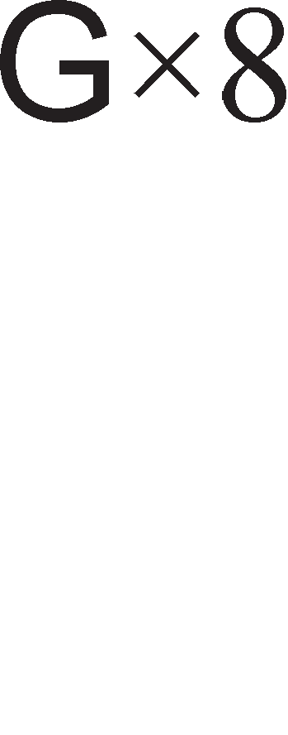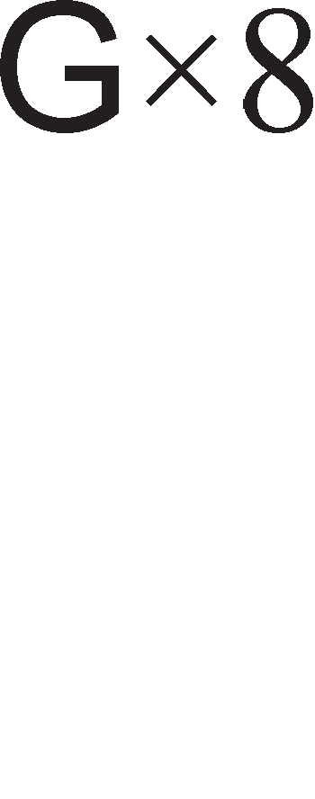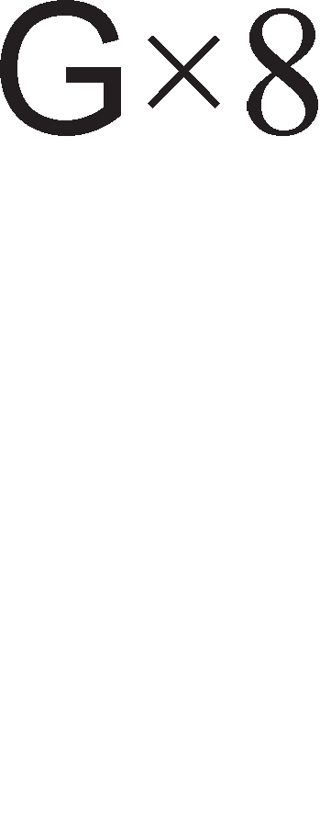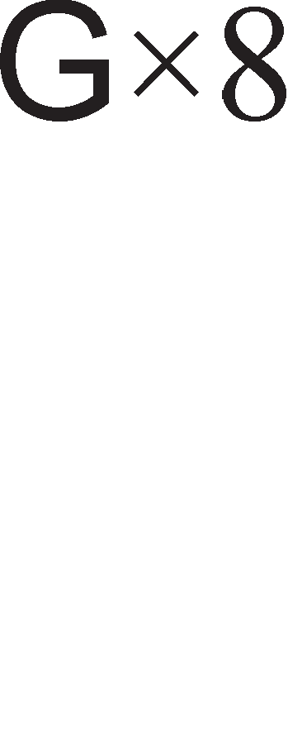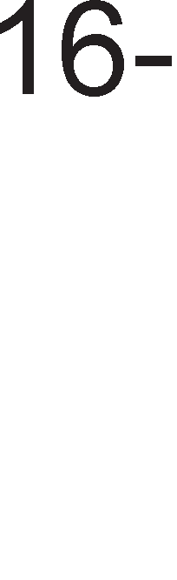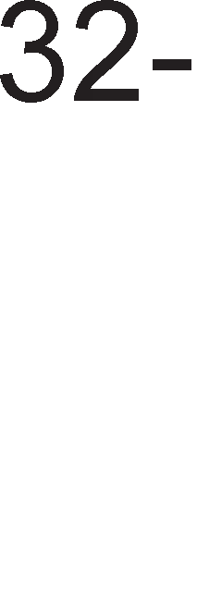

Aa ce noTceT1Me peKa Ha M1KponpoLecopoT 8086 My 6ea noTpe6H1 L1eT1p1 Maw1HcK1 L1Knyc1. CeKoja noKaL1ja op MeMop1jaTa 1Ma cBoja 32-61THa appeca, op 00000000H po FFFFFFFFH. Ha cn1KaTa 8.21. ce np1Ka>KaH1 L1eT1p1Te MeMop1cK1 6aHK1. 3a 136op Ha 6aHKa ce Kop1cTaT KoHTponH1Te c1flHan1 - (Bank Enable). 3a np1cTan po epeH 6ajT Tpe6a pa 61pe ceneKT1paHa epHa 6aHKa, a 3a np1cTan po 16-61TeH nopaToK Tpe6a pa ce ceneKT1paH1 pBe 6aHK1. HajL1ecTo 36opoB1Te (16-61TeH nopaToK ) ce cMecTeH1 Bo pBe cocepH1 6aHK1, 6aHKa 0 1 1



1n1 6aHKa 2 1 3. noKaL1jaTa co appeca 00000000H e cMecTeHa Bo 6aHKaTa 0, noKaL1jaTa co appeca 00000001H Bo 6aHKa 1, 00000002H Bo 6aHKa 2 1TH.

3a pa M1KponpoLecopoT 80386 ce c1HXpoH131pa co MeMop1jaTa, Tpe6a pa ce BoBepaT TaKToB1 Ha L1eKal-be Bo TajM1HfloT 1n1 pa ce np1MeHaT HoB1 TeXH1K1 wTo i<e flo 3a6p3aaT npeHocoT Ha nopaToL1. TaKB1 TeXH1K1 ce: pipeline, Kew- MeMop11Te 1 MeMop1ja co BHaTpewHa po3Bona (interleaved memory).

**Kew-MeMopMjaTa** cny>K1 3a L1yBal-be Ha nopaToL1Te wTo fl1 Kop1cT1 M1KponpoLecopoT noL1ecTo. Kew-MeMop1jaTa e SRAM MeMop1ja co BpeMe Ha np1cTan op 25ns 1 Taa nocpepyBa Mery DRAM MeMop1jaTa 1 M1KponpoLecopoT. Kaj M1KponpoLecopT 80386 Kew-MeMop1jaTa He e BflpapeHa MeMop1ja Bo L11noT Ha M1KponpoLecopoT 1 Taa e no3HaTa nop 1MeTo Kew-MeMop1ja op BTopo H1Bo (level two cache). nopoLHa i<e B1p1Me peKa nocTojaT Kew-MeMop11 op npBo H1Bo (level one cache) Ko1 ce 1HTeflp1paH1 Bo caM1oT M1KponpoLecopcK1 L11n.

**MeMopMjaTa co eHaTpewHa ,qo3eo11a (**interleaved memory) e ywTe epeH MeTop 3a nopo6pyBal-be Ha 6p31HaTa Ha M1KponpoLecopcK1Te c1cTeM1. Ho, oBoj MeTop L11H1 noBei<e, 61peji<1 6apa pBe appecH1 Mafl1cTpan1 1 noce6eH KoHTponep wTo i<e ynpaByBa co H1B. Kaj MeMop1jaTa co BHaTpewHa po3Bona caMaTa MeMop1ja e nopeneHa Ha pBa noce6H1 pena. npB1oT pen i<e fl1 copp>K1 noKaL11Te co appec1 00000000H-00000001H, 00000004H - 00000005H, 1TH, a BTop1oT pen noKaL11Te co appec1 00000002H-00000003H, 00000006H-00000007H 1TH. OBa oBo3Mo>KyBa

pa ce np1cTan1 po 16-61TH1oT nopaToK co appeca 00000002H- 00000003H popeKa M1KponpoLecopoT flo o6pa6oTy6a 16-61TH1oT nopaToK co appeca 00000000H- 00000001H. Ha BaKoB HaL11H 3HaL11TenHo ce nopo6pyBaaaT nepcpopMaHc1Te Ha MeMop1cK1oT c1cTeM.

WTo ce opHecyBa po **e11e3Ho M311e3HMoT** c1cTeM Toj e 1cT co Bne3Ho 13ne3H1oT c1cTeM Ha M1KponpoLecopoT 8086. M1KponpoLecopoT 80386 pacnonafla co 64KB MeMop1cK1 npocTop HaMeHeT 3a appec1pal-be Ha Bne3Ho 13ne3H1 ep1H1L1. Bne3Ho 13ne3H1oT c1cTeM Mo>Ke pa 61pe MeMop1cK1 13on1paH 1 3a npeHoc Ha nopaToL1 ce Kop1cTaT 1HcTpyKL11Te IN 1 OUT. 3a appec1pal-be Ha Bne3Ho 13ne3H1Te ep1H1L1 ce Kop1cTaT appecH1Te n1H11 op A15 po A 2 1 KoHTponH1Te c1flHan1 BE3-BE0 3a 136op Ha epeH 6ajT, 16 61ToB1 1n1 32 61ToB1 op nopaToKoT.

Ha cn1Ka 8.22. np1Ka>KaHo e epHocTaBHo **MHTerpMpaHo Ko11o 3a reHepMpa1-e Ha KoHTpo11HMTe cMrHa11M** 3a MeMop1jaTa 1 nep1cpepH1Te ypep1. Bne3H1Te c1flHan1 op oBa Kono fl1 1cnpai<a M1KponpoLecopoT, a 13ne3H1Te c1flHan1 ce npeHecyBaaT po MeMop1jaTa 1 nep1cpepH1Te ypep1. O6ene>KyBal-beTo Ha KoHTponH1Te c1flHan1 e 1cTo KaKo 1 Kaj KoHTponH1Te c1flHan1 Ha KoHTponepoT Ha Mafl1cTpan1 Kaj M1KponpoLecopoT 80286.

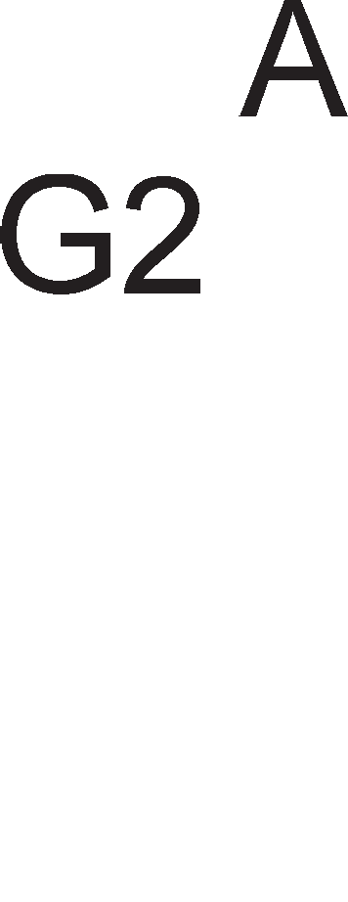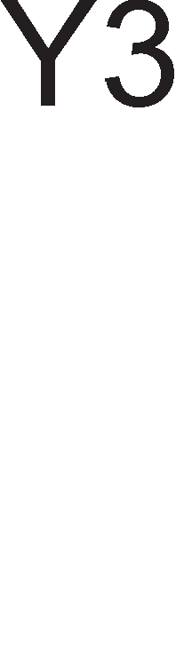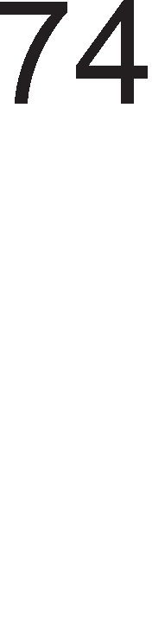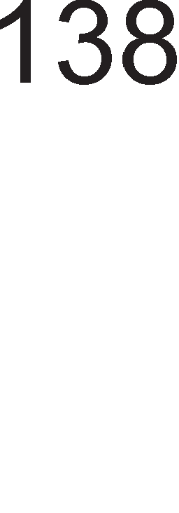

Cn1Ka 8.22. Kono 3a fleHep1pal-be Ha KoHTponH1 c1flHan1 3a MeMop1ja 1 Bne3Ho 13ne3H1 ep1H1L1 3a 80386, 80486 1 neHT1yM M1KponpoLecop1

CocToj61Te Ha L1eKal-be ce noTpe6H1 nopap1 floneMoTo BpeMe Ha np1cTan Ha MeMop11Te. Kaj M1KponpoLecopoT 80386 np1 pa6oTHa cppeKBeHL1ja op 33MHz BpeMeTo Ha np1cTan Tpe6a pa 13HecyBa 46ns. 61peji<1 DRAM 1Ma BpeMe Ha np1cTan op 60ns Toa 3HaL11 peKa Tpe6a pa ce BoBepe epHa cocToj6a Ha L1eKal-be. EPROM MeMop1jaTa 1Ma BpeMe Ha np1cTan op 100ns wTo 3HaL11 BoBepyBal-be Ha pBe cocToj61 Ha L1eKal-be. C1flHanoT READY flo KoHTpon1pa 6pojoT Ha cocToj61 Ha L1eKal-be Bo TajM1HfloT Ha M1KponpoLecopoT. Ha cn1Ka 8.23. e np1Ka>KaHo **MHTerpMpaHoTo Ko11o 3a reHepMpa1-e Ha cMrHa11oT READY**. KonoTo 74164 e noMecTyBaL1K1 pefl1cTap. OBa Kono ce peceT1pa ceKoflaw Kofla c1flHanoT ADS e Ha H1cKo H1Bo, a c1flHanoT D/C e Ha B1coKo H1Bo. noMecTyBal-beTo 3anoL1HyBa Kofla c1flHanoT ADS i<e cTaHe nofl1L1Ka ep1H1La, nocne wTo noL1HyBaaT pa ce jaByBaaT nofl1L1K1 ep1H1L1 noL1HyBaji<1 op 13ne3oT QA po QH. LleT1p1Te 13ne31 op noMecTyBaL1K1oT pefl1cap ce noBp3aH1 co 1HBepT1paL1K1oT MynT1nneKcep. AKT1B1pal-beTo Ha c1flHanoT READY 3aB1c1 op c1flHan1Te 3a 136op Ha epeH op MeMop1cK1Te L11noB1 (DRAM 1n1 EPROM).

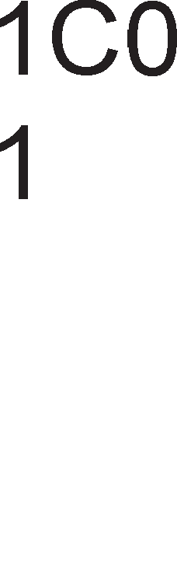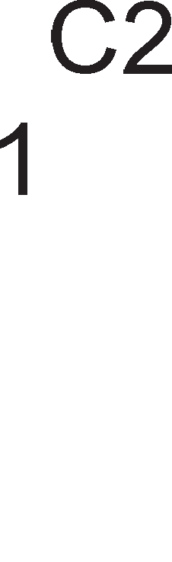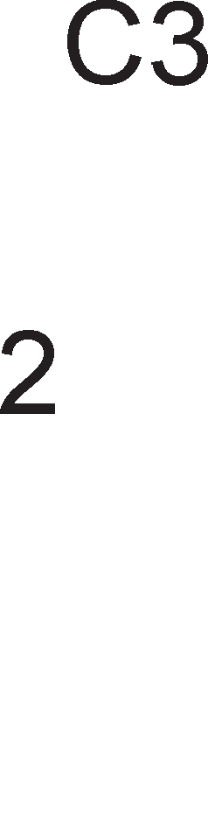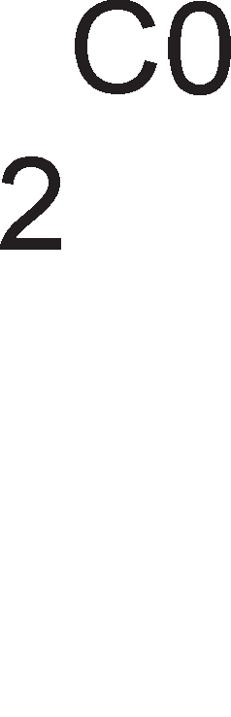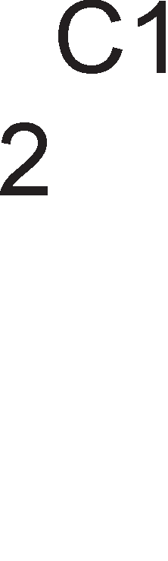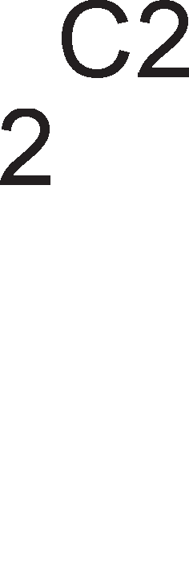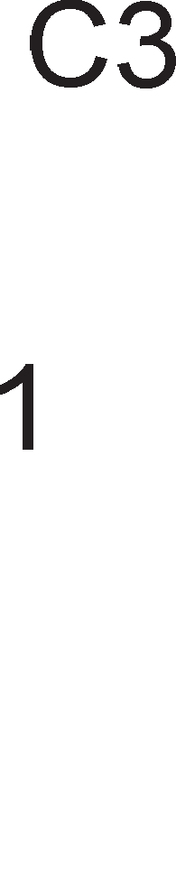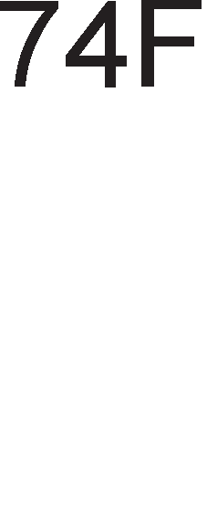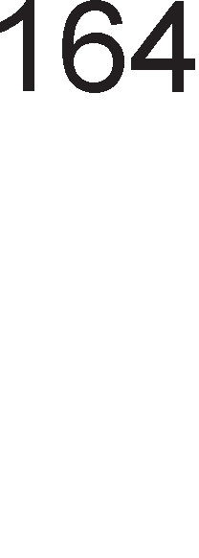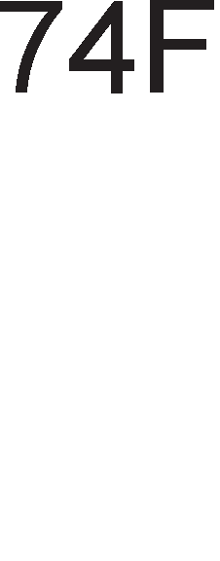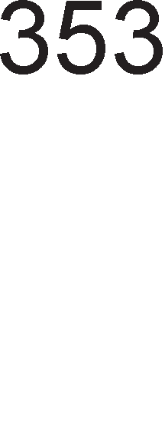

Cn1Ka 8.23. l/lHTeflp1paHo Kono 3a fleHep1pal-be Ha c1flHanoT READY

# 0cHoeHM KapaKTepMcTMKM Ha MMKponpo4ecop 80486

npoLecopoT 80486 e Kono co B1coK cTeneH Ha 1HTeflp1paHocT 1 Toj e HanpaBeH op 1,2 M1n1oH1 TpaH31cTop1. 6p31HaTa Ha pa6oTa Ha M1KponpoLecopoT e pa3n1L1Ha 1 13HecyBa: 25MHz, 33MHz, 50MHz, 66MHz 1n1 100MHz. nocTojaT pBe Bap1jaHT1 Ha oBoj M1KponpoLecop 80486DX 1 80486SX. Pa3n1KaTa Mery H1B e wTo M1KponpoLecopoT 80486SX Bo cBojoT cocTaB He copp>K1 HyMep1L1K1 KonpoLecop. Ha cn1Ka 8.24. np1Ka>KaHa e apX1TeKTypaTa Ha M1KponpoLecopoT 80486. Toj Bo cBojoT cocTaB copp>K1: ep1H1LaTa 3a MeMop1cK1 MeHa1,MeHT, 8KB Kew MeMop1ja op npBo H1Bo, ap1TMeT1L1Ko nofl1L1KaTa ep1H1La, **HyMepM"1KMoT Konpo4ecop** 1 KoHTponH1 ep1H1L1.

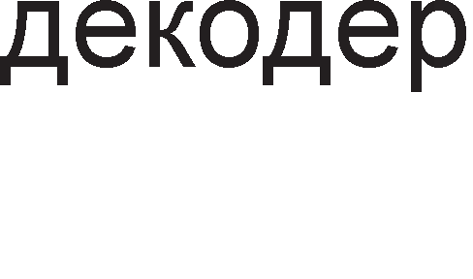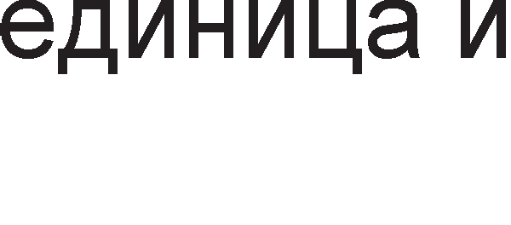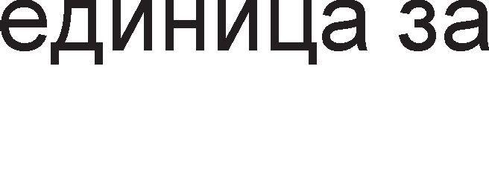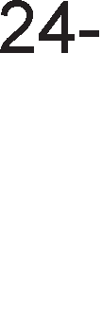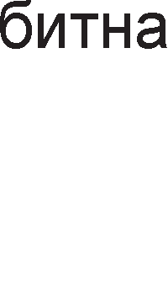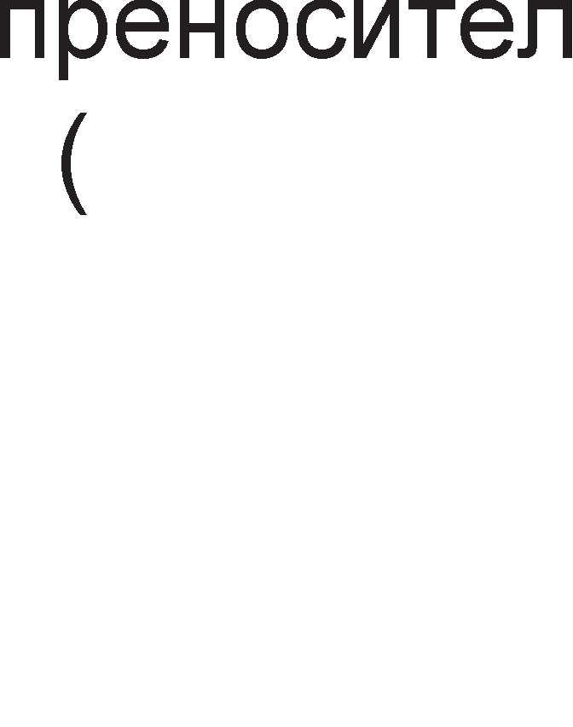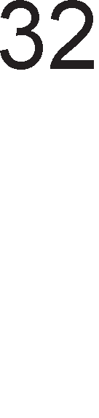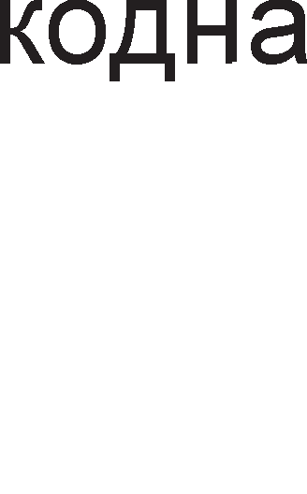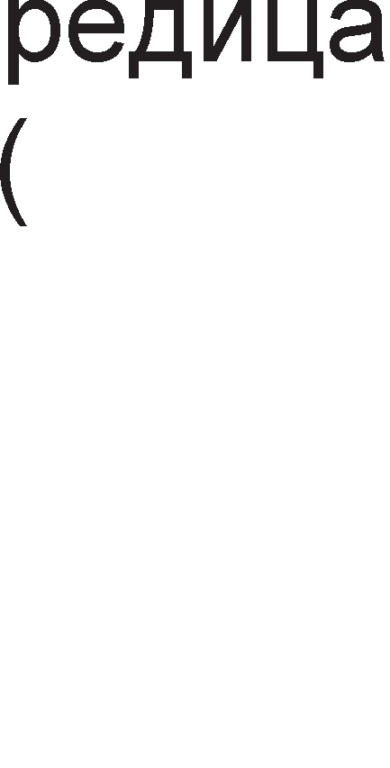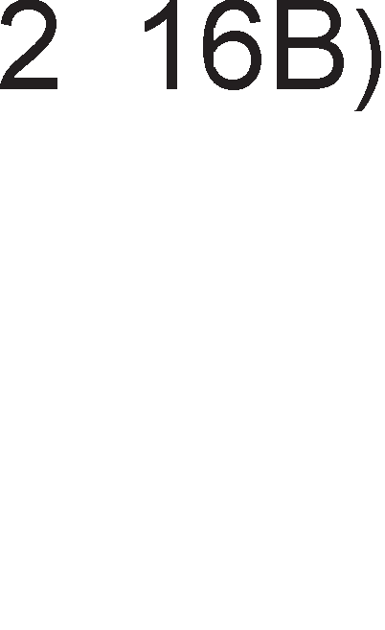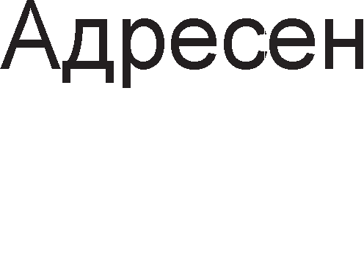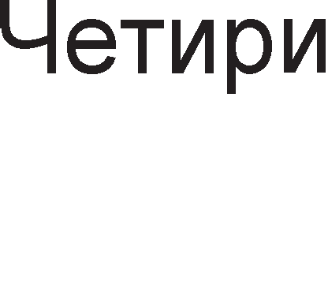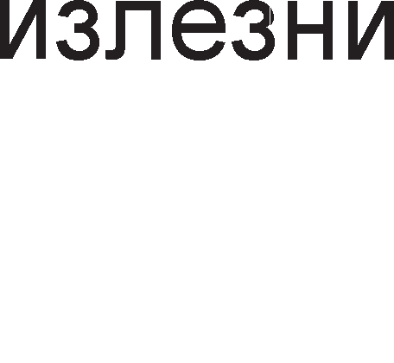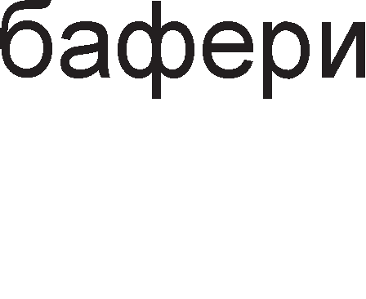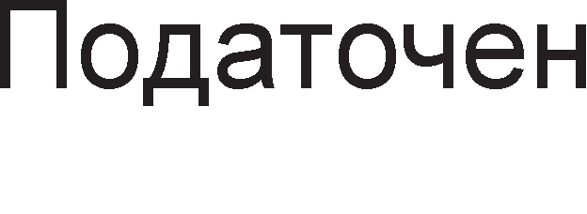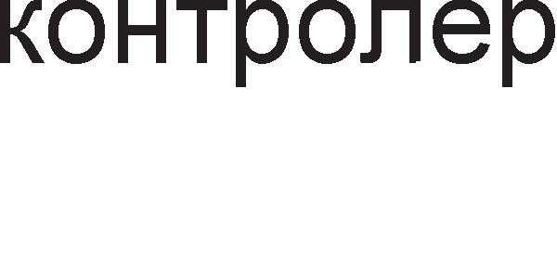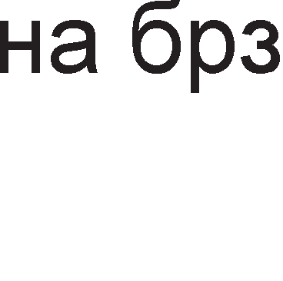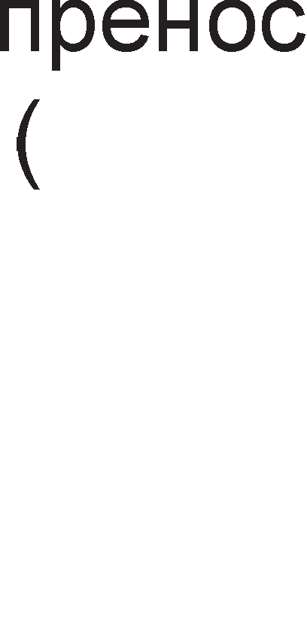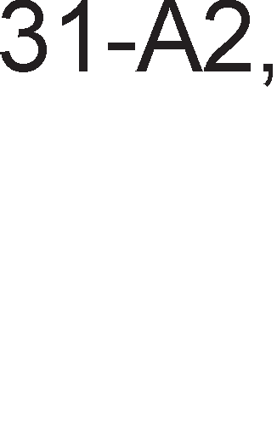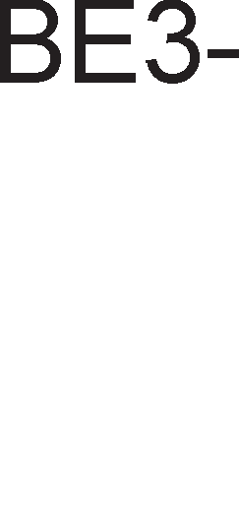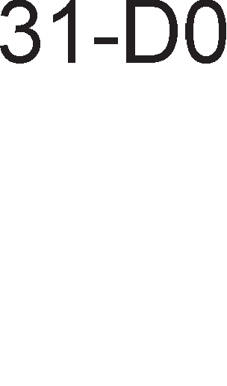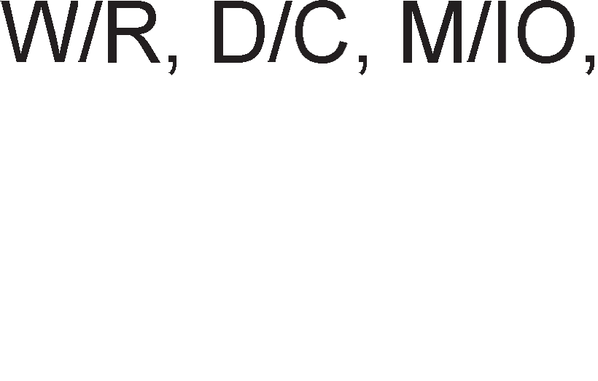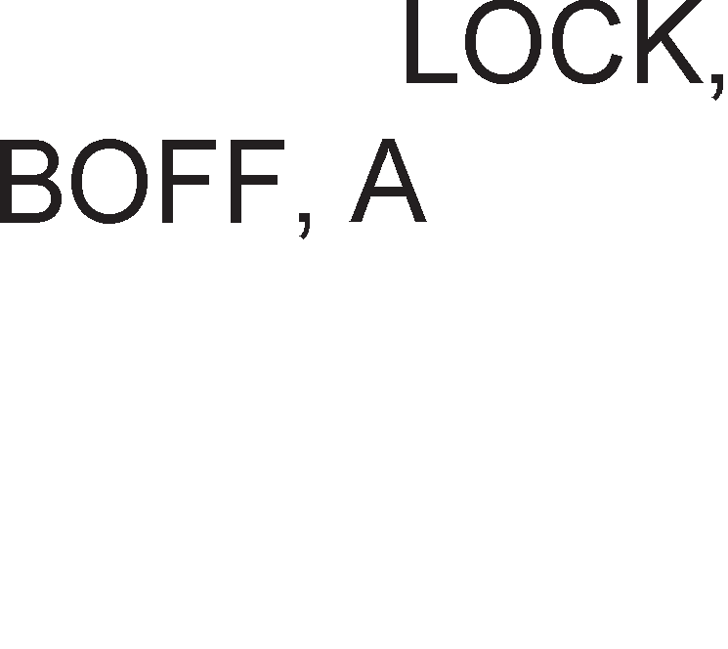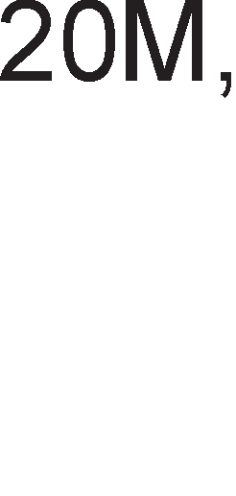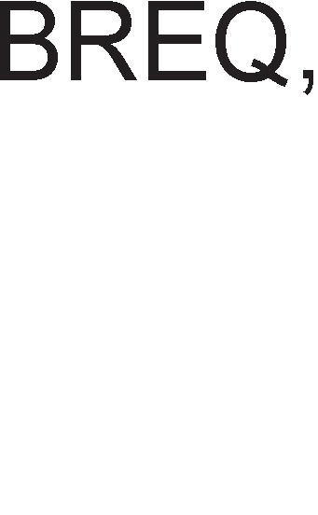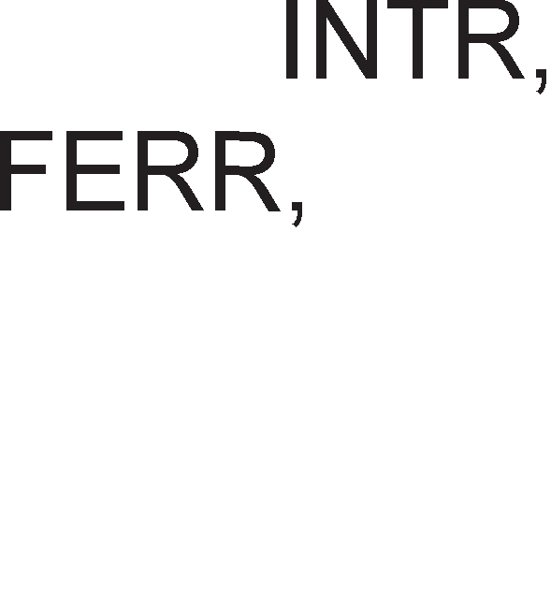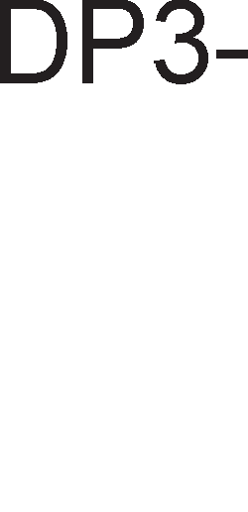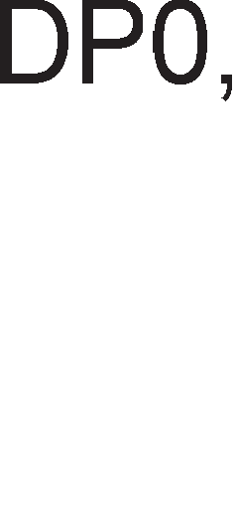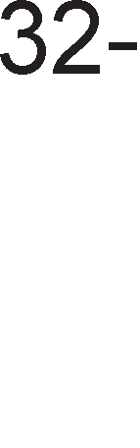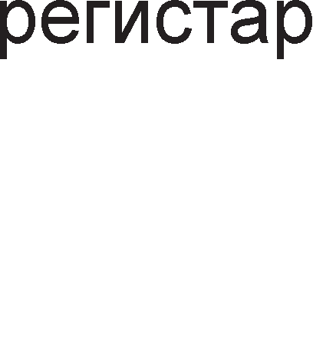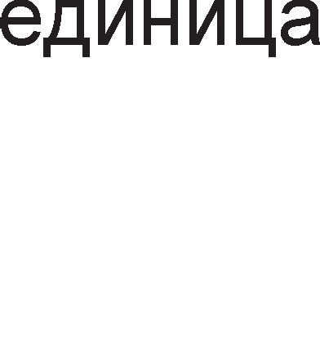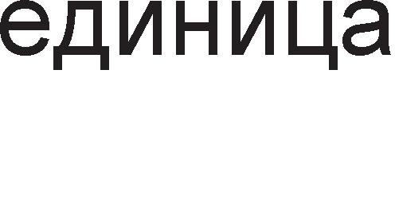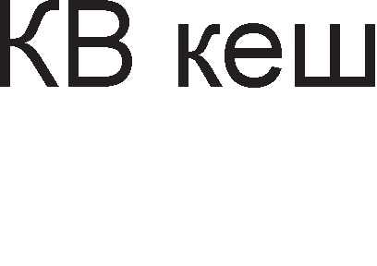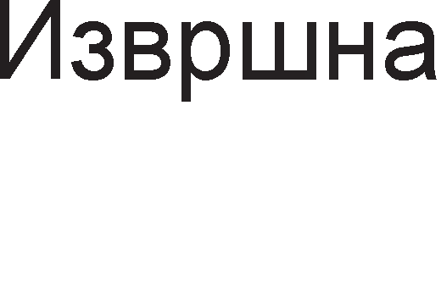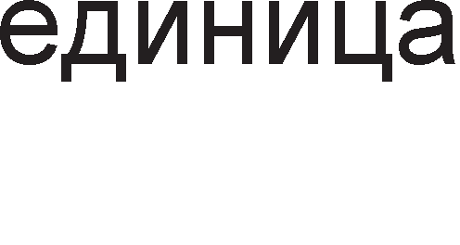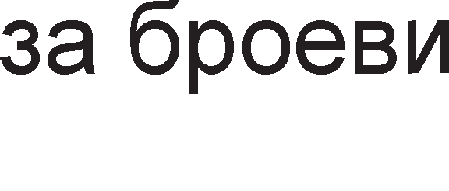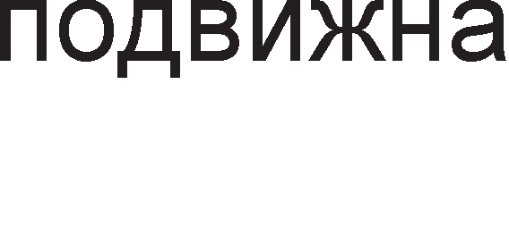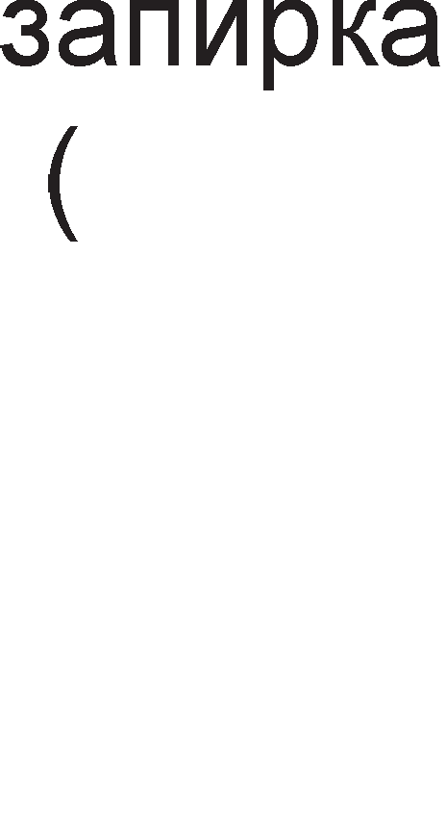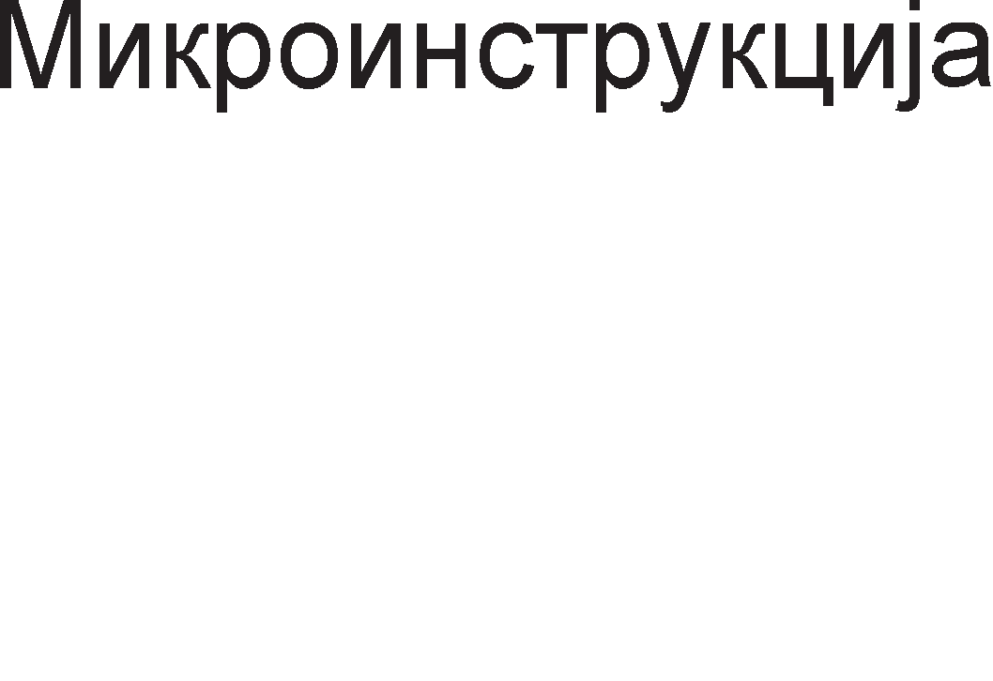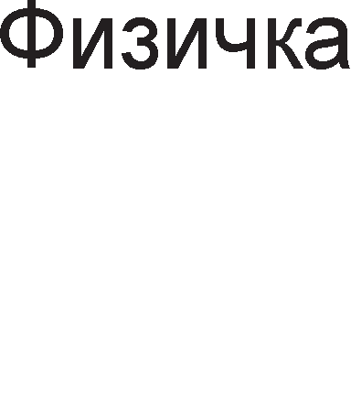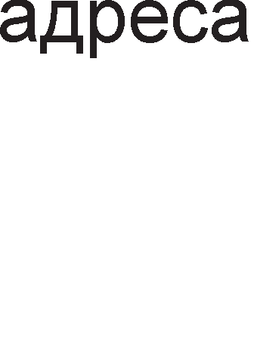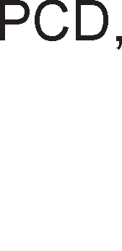

Cn1Ka 8.24. ApX1TeKTypa Ha M1KponpoLecop 80486

Ep1H1LaTa 3a MeMop1cK1 MeHa1,MeHT MMU (Memory Menagement Unit) e cocTaBeHa op pBa pena: ceflMeHTHa ep1H1La 1 ep1H1La 3a pa6oTa co cTpaH1L1. Bo cocTaBoT Ha ceflMeHTHaTa ep1H1La ce HaoraaT ceflMeHTH1Te p1cKp1nTop1 Ko1 ja L1yBaaT 1HcpopMaL1jaTa 3a floneM1HaTa 1 appecaTa Ha npoflpaMcK1Te ceflMeHT1.

Kew MeMop1jaTa fl1 ,,XpaH1” co 1HcpopMaL11 ceflMeHTHaTa ep1H1La 1 1HcTpyKL1cK1oT peKopep. npep 1HcTpyKL1cK1oT peKopep ce Haora 1HcTpyKL1cKaTa pep1La op 32B Koja fl1 L1yBa HepeKop1paH1Te onepaL1cK1 KopoB1.

nocTojaT pBe ep1H1L1 3a ecpeKT1BHo 13BpwyBal-be, ap1TMeT1L1Ko nofl1L1KaTa ep1H1La 1 HyMep1L1K1oT KonpoLecop. Ap1TMeT1L1Ko nofl1L1KaTa ep1H1La cny>K1 3a pa6oTa co Len1 6poeB1, a HyMep1L1K1oT KonpoLecop co 6poeB1 co nopB1>KHa 3an1pKa (peanH1 6poeB1). Kaj M1KponpoLecopoT 80386 HyMep1L1K1oT KonpoLecop He ce Haora Bo BHaTpewHocTa Ha M1KponpoLecopoT TyKy Ha MaT1L1HaTa nnoL1a.

Op pecHaTa cTpaHa Ha cn1Ka ce np1Ka>KaH1 KoHTponH1Te ep1H1L1. H1BHaTa cpyHKL1ja i<e ja o6jacH1Me npeKy H1BH1Te **KoHTpo11HM cMrHa11M**:

* AppecH1oT KoHTponop ynpaByBa co appecH1Te n1H11, op A31 po A2 (3a 136op Ha noKaL1ja op L1eT1p1Te MeMop1cK1 6aHK1) 1 c1flHan1Te - 3a 136op Ha epeH, 2 1n1 4 6ajT1 op 32-61TH1oT nopaToK. l/l3ne3H1Te 6acpep1 fl1 1cnpai<a nopaToL1Te KoH MeMop1jaTa 1 nep1cpepH1Te ypep1

npeKy 32-Ta nopaToL1H1 n1Ha D31-D0.

* HajMHofly6pojH1 ce KoHTponH1Te c1flHan1 3a ynpaByBal-be co Mafl1cTpan1Te. Kaj M1KponpoLecopoT 80486 n1HoB1Te , W/, D/, M/ , , HOLD, HLDA, RESET, INTR, NMI 1MaaT 1cTo 3HaL1el-be KaKo

Kaj M1KponpoLecop1Te 8086, 80286 1 80486. C1flHanoT  (Address bit 20 Mask) npep13B1KyBa penel-be Ha MeMop1jaTa op noKaL1ja co appeca 000FFFFFH po 00000000H 1 ce Kop1cT1 Kofla M1KponpoLecopoT 80486 Tpe6a pa pa6oT1 Bo peaneH Mop co 1MB MeMop1ja, 1cTo KaKo 1 M1KponpoLecopoT 8086. n1HoB1Te PCD (Page Cache Disable) 1 PWT (Page Write Through) ce Kop1cTaT np1 npeHoc Ha cTpaH1L1. n1HoT



1Ma 1cTo 3HaL1el-be KaKo 1 n1HoT READY opHocHo flo KoHTpon1pa 6pojoT Ha cocToj61 Ha L1eKal-be. (Pseudo Lock) e 13ne3eH n1H 1 ce aKT1B1pa Kofla HyMep1L1K1oT KonpoLecop 6apa 64 1n1 80 61TeH nopaToK. (back off) e Bne3eH c1flHan co Koj Mafl1cTpan1Te Ha M1KponpoLecopoT ce cTaBaaT Bo cocToj6a Ha B1coKa 1MneHpaHca. C1flHanoT  (Bus Request) ce aKT1B1pa Kofla M1KponpoLecopoT 80486 fl1 Kop1cT1 caMo cBo1Te BHaTpewH1 Mafl1cTpan1.  (Floating Point Error) ce aKT1B1pa Kofla HyMep1L1K1oT KonpoLecop i<e oTKp1e flpewKa. AKo oTKp1eHaTa flpewKa ce 1flHop1pa ce aKT1B1pa n1HoT  (Ignore



Numeric Error).

* C1flHan1Te  (Burst Ready) 1  (Burst Last Output) ce Kop1cTaT np1 6p3 npeHoc Ha nopaToL1 no Mafl1cTpanaTa.
* 3a pa6oTa co Kew MeMop1jaTa ce Kop1cTaT n1HoB1Te: , , 

1 .  (Cache Enable) ce aKT1B1pa Kofla nopaToKoT Koj MoMeHTanHo ce npeHecyBa no Mafl1cTpanaTa Tpe6a pa ce cMecT1 Bo Kew



MeMop1jaTa.  (Cache Flush) cny>K1 3a 6p1wel-be Ha copp>K1HaTa Ha Kew MeMop1jaTa. Co c1flHanoT  (Address Hold) appecHaTa Mafl1cTpana ce cTaBa Bo cocToj6a Ha B1coKa 1MneHpaHca, a ocTaHaT1Te Mafl1cTpan1 ce aKT1BH1. OBa ce np1MeHyBa Kofla HeKoj ppyfl MacTep Ha Mafl1cTpan1Te caKa pa 1Ma np1cTan po Kew MeMop1jaTa. (External Address Strobe) ce aKT1B1pa 1cToBpeMeHo co c1flHanoT  1 c1flHan131pa HapBopeweH np1cTan po Kew MeMop1jaTa.



* 3a KoHTpona Ha napHocT ce Kop1cTaT L1eT1p1 n1Ha DP3-DO0 (Data

Parity) 1 poKonKy ce oTKp1e flpewKa ce aKT1B1pa n1HoT  (Parity Check).

## aK11y"1o4M:

M1KponpoLecopoT 8086 1Ma MeMop1ja co KanaL1TeT op 1MB 1 3a appec1pal-be Ha MeMop1cK1Te noKaL11 ce Kop1cTaT 20-61TH1 appec1. npoLecopoT 8086 copp>K1 pBe noce6H1 ep1H1L1. l/l3BpwHaTa ep1H1La (execution unit) fl1 13BpwyBa 1HcTpyKL11Te, a ep1H1LaTa 3a Mafl1cTpaneH 1HTepcpejc (bus interface unit) Bpw1 npeHoc Ha onepaL1cK1Te KopoB1, onepaHp1Te 1 pe3ynTaT1Te.

Pefl1cTp1 AX, BX, CX, DX ce onwT1 pefl1cTp1 Ha 8086 npoLecopoT. AoKonKy caKaMe pa L1yBaMe 8-61TH1 nopaToL1, 16-61TH1Te pefl1cTp1 ce penaT Ha nonoB1Ha. npB1Te noManKy 3aHaL1ajH1 61ToB1 op 0 po 7 ce 6ene>KaT co AL, BL, CL, DL (L-low, H1cKo), a noBei<e 3HaL1ajH1Te nopaToL1H1Te 61ToB1 op 8 po 15 ce 6ene>KaT co AH, BH, CH, DH (H-high, B1coKo).

CeflMeHTa31L1jaTa npeTcTaByBa nopen6a Ha MeMop1jaTa Ha noBei<e penoB1 HapeL1eH1 ceflMeHT1. nocTojaT L1eT1p1 B1pa ceflMeHT1: nopaToL1eH , KopeH, cTeK 1 eKcTpa ceflMeHT. nocTo1 pa3n1Ka Mery no1M1Te ceflMeHT 1 ceflMeHTeH pefl1cTap. CeflMeHToT e pen op MeMop1jaTa, a ceflMeHTH1oT pefl1cTap e Bo M1KponpoLecopoT 1 noMafla pa ce npoHajpe noL1eToKoT Ha caKaH1oT ceflMeHT.

Bo peaneH Mop Ha pa6oTa 3a cpopM1pal-be Ha cp131L1KaTa appeca noTpe6H1 ce pBa pena: noL1eTHa appeca Ha ceflMeHToT 1 noMecTyBal-be. noMecTyBal-beTo wTo ce popaBa Ha noL1eTHaTa appeca Ha ceflMeHToT Mo>Ke pa ce copp>K1 Bo HeKoj pefl1cTap 1n1 pa 61pe 3apapeHo KaKo 16-61TeH 6poj. Bo aceM6nepcK1Te 1HcTpyKL11 noMecTyBal-be KaKo BpepHocT e cTaBeHo Bo cpepHa 3aflpapa [ ].

M1KponpoLecopoT 8086 Mo>Ke pa pa6oT1 Bo pBa pe>K1M1, M1H1ManeH 1 MaKc1ManeH. l/l36opoT Ha pe>K1M ce Bpw1 npeKy n1HoT MN/. Bo M1H1ManeH pe>K1M M1KponpoLecopoT caM fl1 fleHep1pa KoHTponH1Te c1flHan1. Bo MaKc1ManeH

pe>K1M ynpaByBaL1KaTa cpyHKL1ja ja Bpw1 KoHTponepoT Ha Mafl1cTpan1 co cep1cK1 6poj 8288.

noL1HyBaji<1 op 8086 po 80286 Bo ynoTpe6a ce cnepH1Be HaL11H1 Ha appec1pal-be: appec1pal-be Ha pefl1cTp1, HenocpepHo, p1peKTHo, pefl1cTapcKo 1Hp1peKTHo, 6a3Ho 1Hp1peKTHo, pefl1cTapcKo penaT1BHo 1 6a3Ho penaT1BHo 1HpeKcHo. Kaj p1peKHoTo appec1pal-be noMecTyBal-beTo npeTcTaByBa 16-61TeH 6poj, a Kaj pefl1cTapcKoTo 1Hp1peKHo appec1pal-be noMecTyBal-beTo ce copp>K1 Bo HeKoj onwT 1n1 1HpeKc pefl1cTap.

Co 1HcTpyKL1jaTa MOV BX, 1234H ce npeHecyBa nopaToKoT 1234H Bo pefl1cTapoT BX. Bo 1HcTpyKL1jaTa MOV BX, [1234H] 13Bop Ha nopaToK e MeMop1cKaTa noKaL1ja oppaneL1eHa op noL1eToKoT Ha nopaToL1H1oT ceflMeHToT 3a pacTojaH1e 1234H, a pecT1HaL1ja 3a nopaToKoT e pefl1cTapoT BX.

H13aTa npeTcTaByBa MHo>KecTBo op nopaToL1 cMecTeH1 Bo nocnepoBaTenH1 MeMop1cK1 noKaL11 op nopaToL1H1oT 1n1 eKcTpa ceflMeHToT. Bo nopaToL1H1oT ceflMeHT ce cMecTeH1 nopaToL1Te wTo Tpe6a pa ce o6pa6oTaT, a Bo eKcTpa ceflMeHToT nopaToL1Te po61eH1 KaKo pe3ynTaT1 op 13BpweH1Te onepaL11. l/lHcTpyKL11Te 3a pa6oTa co H131 3aBpwyBaaT Ha 6yKBaTa S (string).

l/lHcTpyKL1jaTa CMP (Compare) cny>K1 3a cnopep6a Ha copp>K1HaTa Ha pBa pefl1cTp1 1 Bn1jae Bp3 cocToj6aTa Ha 3HaMeHLaTa, np1 wTo BpepHocTa Ha onepaHp1Te ocTaHyBa 1cTa. HajL1ecTo no 1HcTpyKL1jaTa CMP cnepyBa 1HcTpyKL1jaTa 3a ycnoBeH cKoK, KaKo wTo ce 1HcTpyKL11Te JA (jump above) 1 JB (jump below).

l/lHcTpyKL1jaTa TEST cny>K1 3a TecT1pal-be Ha 61ToB1 op HeKoj pefl1cTap. Ha np1Mep, co 1HcTpyKL1jaTa TEST AL, 01H ce TecT1pa 61ToT co HajMana Te>K1Ha (npB1oT op pecHa cTpaHa).

l/lHcTpyKL11Te JG, JL, JGE, JLE, JE 1 JNE ce ycnoBH1 cKoKoB1 3a 6poeB1 co npep3HaK, a 1HcTpyKL11Te JA, JB, JAE, JBE, JE 1n1 JNE ce Kop1cTaT 3a 6poeB1 6e3 npep3HaK. AKo 6poeB1Te ce 8-61TH1, Toflaw 6poeB1 co npep3HaK i<e 61paT op –128 po +127, a 6e3 npep3HaK op 0 po 255.

A1peKT1B1Te ce Hapep61, HacoK1 co Ko1 ce ypepyBa aceM6nepcKaTa npoflpaMaTa. Co p1peKT1B1Te DB, DW 1 DD npoMeHn1B1Te 1 Bap1ja61n1Te po61BaaT c1M6on1L1H1 1M1l-ba. Co oB1e p1peKT1B1 ce Bpw1 pe3epB1pal-be Ha npocTop Bo nopaToL1H1oT ceflMeHT 1 Toa 3a 8 1 16 61TH1 nopaToL1. A1peKT1BaTa EQU ce Kop1cT1 3a Kpe1pal-be Ha na6en1. A1peKT1BaTa SEGMENT flo o3HaL1yBa noL1eToKoT Ha ceflMeHToT, a ENDS Hej31H1oT Kpaj. 3a o3HaL1yBal-be Ha KpajoT 1 noL1eToKoT Ha noTnpoflpaM1Te ce Kop1cTaT p1peKT1B1Te PROC 1 ENDP.

npoflpaM161nHaTa KoMnoHeHTa 8255 ce Kop1cT1 np1 noBp3yBal-be Ha M1KponpoLecopoT 8086 co cepyMceflMeHTeH p1cnnej cocTaBeH op ocyM non1l-ba. 3a 1cnpai<al-be nopaToL1 po p1cnnejoT ce Kop1cT1 nocTanKa Ha MynT1nneKc1pal-be. l/l36opoT Ha none ce Bpw1 npeKy ocyMTe n1HoB1 Ha nopTaTa B. CaMo epeH n1H op nopTaTa B i<e 61pe aKT1BeH 1 i<e 136epe epHo none op p1cnnejoT. Ko1 ceflMeHT1 i<e cBeTHaT op 136paHoTo none 3aB1c1 op cocToj6aTa Ha n1HoB1Te Ha nopTaTa A.

npoflpaM161nHaTa KoMnoHeHTa 8255 ce Kop1cT1 np1 noBp3yBal-be Ha M1KponpoLecopoT 8086 co TacTaTypa cocTaBeHa op 16 KonL11l-ba pacnopepeH1 Bo L1eT1p1 pep1L1 1 L1eT1p1 KonoH1. nopTaTa B e 13ne3Ha nopTa 1 cny>K1 3a ceneKL1ja Ha epHa KonoHa. nopTaTa A e Bne3Ha nopTa 1 cny>K1 3a L11Tal-be Ha cocToj6aTa Ha KonL11l-baTa op pep1L1Te.

TajMepoT 8254 1Ma L1eT1p1 BHaTpewH1 pefl1cTp1: 6pojaL1 0, 6pojaL1 1, 6pojaL1 2 1 KoMaHpeH pefl1cTap. npoflpaM1pal-beTo ce Bpw1 npeKy KoMaHpH1oT pefl1cTap. npeKy KoMaHpH1oT pefl1cTap ce 1361paaT MopoT 1 6pojaL1oT. MopoT flo pecp1H1pa o6n1KoT Ha 13ne3H1oT c1flHan Bo 3aB1cHocT op 13ne3H1oT.

M1KponpoLecopoT 80286 pacnonafla co cp131L1Ka MeMop1ja op 16MB 1 B1pTyenHa MeMop1ja op 1GB. CocTaBeH e op L1eT1p1 cpyHKL1oHanH1 ep1H1L1: 13BpwHa ep1H1La, appecHa ep1H1La, 1HcTpyKL1cKa ep1H1La 1 ep1H1La 3a Mafl1cTpaneH 1HTepcpejc. M1KponpoLecopoT 80286 copp>K1 pBe 1HcTpyKL1cK1 pep1L1, epHa npep 1HcTpyKL1cK1oT peKopep 1 ppyfla co peKop1paH1 1HcTpyKL11.

n1HoB1Te BUSY, ERROR, PEREQ 1 PEACK Kop1cTaT 3a KoMyH1KaL1ja Ha

M1KponpoLecopoT 80286 co MaTeMaT1L1K1Te KonpoLecop1.

npoLecopoT 80386 e 32-61THa Bep31ja Ha M1KponpoLecopoT 8086. nopaToL1HaTa 1 appecHaTa Mafl1cTpana ce 32-61TH1. roneM1HaTa Ha MeMop1cK1oT npocTop 13HecyBa 4GB. MeMop1jaTa Ha M1KponpoLecopoT 80386 e nopeneHa Bo L1eT1p1 MeMop1cK1 6aHK1 1 ceKoja 6aHKa 1Ma KanaL1TeT op 1GB. Bo3Mo>KeH e p1peKTeH np1cTan po 8, 16 1 32-61TH1 nopaToL1. LleT1p1Te KoHTponH1 c1flHan1

-  ce Kop1cTaT 3a 136op Ha epeH 6ajT op L1eT1p1Te 6ajT1 Bo 136paHaTa noKaL1ja.



Pefl1cTp1Te Bo M1KponpoLecopoT 80386 ce nopeneH1 Bo HeKonKy flpyn1: onwT1 pefl1cTp1, 1HcTpyKL1cK1 noKa>KyBaL1, cTaTyc pefl1cTap, ceflMeHTH1 pefl1cTp1, ceflMeHTH1 p1cKp1nTop pefl1cTp1, KoHTponH1 pefl1cTp1, c1cTeM appecH1 pefl1cTp1 1 pefl1cTp1 3a TecT1pal-be 1 oTcTpaHyBal-be flpewK1.

M1KponpoLecopoT 80486 copp>K1: ep1H1LaTa 3a MeMop1cK1 MeHa1,MeHT, 8KB Kew MeMop1ja op npBo H1Bo, ap1TMeT1L1Ko nofl1L1KaTa ep1H1La, HyMep1L1K1oT KonpoLecop 1 KoHTponH1 ep1H1L1. Ep1H1LaTa 3a MeMop1cK1 MeHa1,MeHT MMU (Memory Menagement Unit) e cocTaBeHa op pBa pena: ceflMeHTHa ep1H1La 1

ep1H1La 3a pa6oTa co cTpaH1L1. Ap1TMeT1L1Ko nofl1L1KaTa ep1H1La cny>K1 3a pa6oTa co Len1 6poeB1, a HyMep1L1K1oT KonpoLecop co 6poeB1 co nopB1>KHa 3an1pKa (peanH1 6poeB1). Kaj M1KponpoLecopoT 80486 HyMep1L1K1oT KonpoLecop ce Haora Bo BHaTpewHocTa Ha M1KponpoLecopoT , a He Ha MaT1L1HaTa nnoL1a KaKo wTo 6ewe cnyL1aj co npoLecopoT 80386.

## npawa1-a M 3a,qa"1M:

1. Koja e ocHoBHaTa pa3n1Ka Mery M1KponpoLecopoT 8088 1 M1KponpoLecopoT 8086?
2. npoLecopoT 8086 Mo>Ke pa pa6oT1 Bo M1H1ManeH 1 Bo MaKc1ManeH pe>K1M Ha pa6oTa. O6jacH1!
3. Koja e cpyHKL1jaTa Ha 13BpwHaTa ep1H1La 1 ep1H1LaTa 3a Mafl1cTpaneH 1HTepcpejc Ha M1KponpoLecopoT 8086?
4. Ko1 1HcTpyKL11 npep13B1KyBaaT peceT1pal-be Ha 1HcTpyKL1cKaTa pep1La Bo ep1H1LaTa 3a Mafl1cTpaneH 1HTepcpejc?
5. Koj n1H op M1KponpoLecopoT 8086 ce Kop1cT1 3a 136op Ha M1H1ManeH 1n1 MaKc1ManeH pe>K1M Ha pa6oTa?
6. KaKBa cpyHKL1ja 1Ma n1HoT DT/ Ha M1KponpoLecopoT 8086?
7. O6jacH1 flo 3HaL1el-beTo Ha cTaTycH1Te 61ToB1 Bo MaKc1ManeH 1 M1H1ManeH pe>K1M Ha pa6oTa Ha M1KponpoLecopoT 8086?
8. O6jacH1 KaKo ce 6ene>KaT ocyM61TH1Te 1 wecHaeceT61TH1Te onwT1 pefl1cTp1 Bo M1KponpoLecopoT 8086!
9. KaKBa cpyHKL1ja 1MaaT 1HpeKc-pefl1cTp1Te Bo M1KponpoLecopoT 8086? Ha6poj fl1 1HpeKc-pefl1cTp1Te!
10. WTo ce Toa ceflMeHT1? 3a wTo cny>KaT ceflMeHTH1Te pefl1cTp1?
11. O6jacH1 ja nocTanKaTa 3a npecMeTKa Ha cp131L1KaTa appeca Ha MeMop1cKa noKaL1ja Bo peaneH Mop Ha pa6oTa Ha M1KponpoLecopoT 8086!
12. npecMeTaj fl1 appec1Te Ha MeMop1cK1Te noKaL11 Ha cnepH1Be KoM61HaL11 ceflMeHTeH pefl1cTap – noMecTyBal-be

a) DS = 3400H BX = 2000H 6) CS = 4900H IP = 1002H B) SS = 6500H SP = 3200H

fl) ES = 7600H DI = 3A00H

1. Ha6poj fl1 appecH1Te B1poB1 wTo ce Kop1cTaT Kaj M1KponpoLecop 8086!
2. WTo H1 noKa>KyBa BpepHocTa Bo cpepHaTa 3aflpapa Bo 1HcTpyKL1jaTa MOV BX, [1234]?
3. Han1w1 1HcTpyKL1ja co Koja nopaToKoT C8H i<e ce BHece Bo pefl1cTapoT CL?
4. nononH1 ja ponHaTa Ta6ena.

|  |  |  |  |  |
| --- | --- | --- | --- | --- |
| l/lHcTpyKL1ja | HaL11H Ha  appec1pal-be | roneM1Ha Ha nopaToK | l/l3Bop Ha nopaToK | Wen Ha nopaToK |
| MOV AL,[BP+DI] |  |  |  |  |
| MOV CX,[DI] |  |  |  |  |
| MOV [1000H],DL |  |  |  |  |
| MOV AL,35 |  |  |  |  |
| MOV DL,[SP+2345] |  |  |  |  |
| MOV [SI+1000H],AX |  |  |  |  |

1. O6jacH1 3a wTo cny>K1 3HaMeHLeTo D Bo cTaTyc-pefl1cTapoT Ha M1KponpoLecopoT 8086!
2. Han1w1 fl1 KoMeHTap1Te Ha cnepH1Be 1HcTpyKL11:
   * RET
   * MOVSW
   * IN AL,DX
   * JE ZBIR
   * POP [BX]
   * MOV CX,[SP]
3. l/lHcTpyKL1jaTa TEST BL,AL e noflpewHa. O6jacH1 3owTo.
4. CL=98H,DL=6AH. npecMeTaj ja copp>K1HaTa Ha pefl1cTp1Te no 13BpwyBal-beTo Ha cnepH1Be 1HcTpyKL11:

AND CH,DL SAR DL,2

1. AX=ABCDH,BX=2288H. npecMeTaj ja copp>K1HaTa Ha pefl1cTp1Te no 13BpwyBal-beTo Ha cnepH1Be 1HcTpyKL11:

XOR BH,79H ROL AL,2 SUB AX,BX

1. Aan1 i<e 61pe 13BpweHa 1HcTpyKL1jaTa 3a ycnoBeH cKoK Bo cnepH1Be np1Mep1. O6jacH1 3owTo.
2. MOV CL,80H ADD CL,01H JO POVTORI

6) MOV CX,7589H XOR CL,76H NOT CL

1. MOV AL,7FH SUB AL,8AH JC AJDE
2. Koja e pa3n1KaTa Mery 1HcTpyKL11Te CMP 1 TEST?
3. O6jacH1 ja 1HcTpyKL1jaTa OUT 0002H,AX.
4. Koj pefl1cTap op M1KponpoLecopoT 8086 ce Kop1cT1 3a L1yBal-be Ha nopaToKoT wTo flo np1M1n M1KponpoLecopoT op HeKoj Bne3eH ypep?
5. O6jacH1 KaKo e 13BpweHo appec1pal-beTo Ha BHaTpewH1Te pefl1cTp1 Ha 1HTepcpejc-KoMnoHeHTaTa 8255?
6. l/lHTepcpejc-KoMnoHeHTaTa 8255 ce Kop1cT1 np1 noBp3yBal-be Ha M1KponpoLecop 8086 1 cepyMceflMeHTeH p1cnnej. O6jacH1 KaKBa cpyHKL1ja 1MaaT nopT1Te A 1 B?
7. KaKoB i<e 61pe B13yenH1oT ecpeKT po61eH Ha cepyMceflMeHTH1oT p1cnnej aKo PA=x1111001B 1 PB= 10111111B?
8. KoHTponH1oT pefl1cTap Ha 1HTepcpejc-KoMnoHeHTaTa 8255 1Ma 1HTepcpejc- appeca 011H. l/lcnpoflpaM1paj fl1 nopT1Te A 1 B TaKa wTo pa cBeTHe BTopoTo none oppecHo Ha cepyMceflMeHTH1oT p1cnnej, co 6pojoT 5!
9. KaKBa cpyHKL1ja 1MaaT n1HoB1Te Ha nopT1Te A 1 B np1 noBp3yBal-be Ha 1HTepcpejc-KoMnoHeHTaTa 8255 1 TacTaTypa?

31. 3owTo e noTpe6Ho pa ce BoBepe poLHel-be op 1ms Mery pBe nocnepoBaTenH1 cH1Mal-ba Ha KonL11l-baTa op TacTaTypaTa np1Ka>KaHa Ha cn1Ka 8.12.?

32. KonKy 6pojaL11 copp>K1 npoflpaM161nH1oT TajMep 8254? O6jacH1 ja cpyHKL1jaTa Ha Tp1Te n1Ha op ceKoj 6pojaL1!

33. 3a wTo cny>K1 KoHTponH1oT pefl1cTap Ha TajMepoT 8254?

1. Bne3HaTa cppeKBeHL1ja Ha TajMepoT 8254 13HecyBa 8MHz. Ha Koja BpepHocT Tpe6a pa ce 1cnpoflpaM1pa 6pojaL1oT 1 KoHTponH1oT pefl1cTap 3a pa Ha 13ne3 op TajMepoT 8254 ce po61e noBopKa op KoHT1Hy1paH1 1Mnync1 co cppeKBeHL1ja 200KHz?
2. Ha6poj fl1 cocTaBH1Te ep1H1L1 Ha M1KponpoLecopoT 80286 1 o6jacH1 ja H1BHaTa cpyHKL1ja?
3. Ko1 c1flHan1 ce Bne3H1, a Ko1 13ne3H1 3a fleHepaTopoT Ha KoHTponH1 c1flHan1 82288?
4. O6jacH1 ja cpyHKL1jaTa Ha n1HoB1Te F/ 1 EFI Ha fleHepaTopoT Ha p1fl1TcK1 TaKT 82884?



1. KonKy 13HecyBa w1poL11HaTa Ha appecHaTa 1 nopaToL1HaTa Mafl1cTpana Kaj M1KponpoLecop1Te 80286, 80386 1 80486?
2. Ko1 n1HoB1 ce Kop1cTaT 3a 136op Ha MeMop1cKa 6aHKa Kaj M1KponpoLecop1Te 80386-neHT1yM?
3. KaKo ce 6ene>KaT onwT1Te pefl1cTp1 Bo M1KponpoLecopoT 80386?

41. 3a wTo cny>KaT p1cKp1nTop1Te Ha ceflMeHT1 1 KoHTponH1Te pefl1cTp1 Kaj M1KponpoLecopoT 80386?

1. O6jacH1 flo KoHLenToT Ha MeMop1ja co BHaTpewHa po3Bona?
2. HanpaB1 cnopep6a Mery 1HTeflp1paH1Te Kona 3a fleHep1pal-be Ha p1fl1TcK1 TaKT 1 KoHTponH1 c1flHan1 3a MeMop1jaTa 1 np1cpepH1Te ypep1 Kaj M1KponpoLecop1Te 80286 1 80386?
3. O6jacH1 KaKo ce fleHep1pa c1flHanoT READY Kaj M1KponpoLecopoT 80386?
4. Koj e npB M1KponpoLecop Koj Bo ce6e copp>K1 HyMep1L1K1 KonpoLecop? Ko1 1HcTpyKL11 fl1 13BpwyBa KonpoLecopoT?
5. Ha6poj fl1 n1HoB1Te Ha M1KponpoLecopoT 80486 Ko1 ce Kop1cTaT 3a KoHTpona Ha Kew MeMop1jaTa. O6jacH1 ja H1BHaTa HaMeHa!

**9. neHTMyM MMKponpo4ecopM**

# neHTMyM 1 MMKponpo4ecop

Kaj neHT1yM M1KponpoLecop1Te 1Ma floneM1 nopo6pyBal-ba Bo opHoc Ha M1KponpoLecopoT 80486, KaKo wTo ce: nopo6peHaTa Kew-MeMop1ja, now1poKaTa 64- 61THa nopaToL1Ha Mafl1cTpana, no6p31oT HyMep1L1K1 KonpoLecop, pynn1oT M1KponpoLecop 3a Len1 6poeB1 1 nofl1KaTa 3a npepB1pyBal-be Ha pa3flpaHyBal-baTa. ApX1TeKTypaTa Ha neHT1yM M1KponpoLecopoT e np1Ka>KaHa Ha cn1Ka 9.1.

**Kew-MeMopMjaTa** op npBo H1Bo L1 e nopeneHa Ha pBe Kew MeMop11 op no 8KB, op Koj npBaTa e 1HcTpyKL1cKa, a BTopaTa e nopaToL1Ha Kew-MeMop1ja. 32- 61THaTa nopaToL1Ha Mafl1cTpana Kaj M1KponpoLecopoT 80486 e 3aMeHeTa co 64-61THa. **HyMepM"1KMoT Konpo4ecop** cny>K1 3a o6pa6oTKa Ha nopaToL1 co nopB1>KHa 3an1pKa 1 e neT naT1 no6p3 op HyMep1L1K1oT KonpoLecop 80486. **.Qyn11MoT MMKponpo4ecop 3a 4e11M 6poeeM** Mo>Ke pa 13BpwyBa pBe 1HcTpyKL11 Bo epeH p1fl1TcK1 TaKT. nofl1KaTa 3a npepB1pyBal-be ja 3floneMyBa ecp1KacHocTa Bo 13BpwyBal-beTo Ha 1HcTpyKL11Te 3a flpeHel-be (branch). **norMKaTa 3a npe,qeM,qyea1-e Ha rpaHe1-aTa** np1poHecyBa pa ce HaMan1 BpeMeTo Ha L1eKal-be 3a 13BpwH1Te ep1H1L1. WToM i<e ce nojaB1 cKoK 1HcTpyKL1ja M1KponpoLecopoT 3anoL1HyBa npepBpeMeH npeHoc Ha cnepH1Te 1HcTpyKL11 op appecaTa HaBepeHa Bo cKoK 1HcTpyKL1jaTa. l/lHcTpyKL11Te Ko1 Tpe6a pa ce 13BpwaT ce L1yBaaT Bo 1HcTpyKL1cKaTa Kew MeMop1ja, na wToM i<e ce pojpe Ha pep cKoK 1HcTpyKL1jaTa Taa i<e ce 13Bpw1 Bo epeH p1fl1TcK1 TaKT. AKo ycnoBoT 3a cKoK He 61pe 1cnonHeT Toflaw 3a cKoK 1HcTpyKL1jaTa i<e 61paT noTpe6H1 pononH1TenH1 Tp1 p1fl1TcK1 TaKTa. 3a cpei<a npepB1pyBal-baTa ce o61L1Ho ToL1H1.

**CynepcKa11apHaTa apxMTeKTypa** Ha neHT1yM M1KponpoLecop1Te npo13neflyBa op nocToel-beTo Ha Tp1Te 13BpwH1 ep1H1L1: epHa 3a 6poeB1 co nopB1>KHa 3an1pKa 1 pBe 3a Len1 6poeB1 (U pipe, V pipe). OBa 3HaL11 peKa napanenHo Mo>Ke pa ce 13BpwyBaaT Tp1 pa3n1L1H1 1HcTpyKL11.

**MeMopMjaTa Ha neHTMyM MMKponpo4ecopoT** e floneMa 4GB 1 Taa e nopeneHa Bo 8 MeMop1cK1 6aHK1 no 512MB. CeKoja MeMop1cKa noKaL1ja Mo>Ke pa 3anaMT1 nopaToK op epeH 6ajT 1 epeH 61T 3a KoHTpona Ha napHocT. AKo 6pojoT Ha ep1H1L1 Bo

MeMop1paH1T 6ajT e napeH 61ToT 3a napHocT i<e 61pe epeH , a aKo 6pojoT Ha ep1H1L1 e HenapeH Toflaw Toj 61T e Hyna.

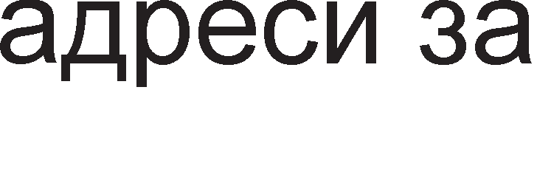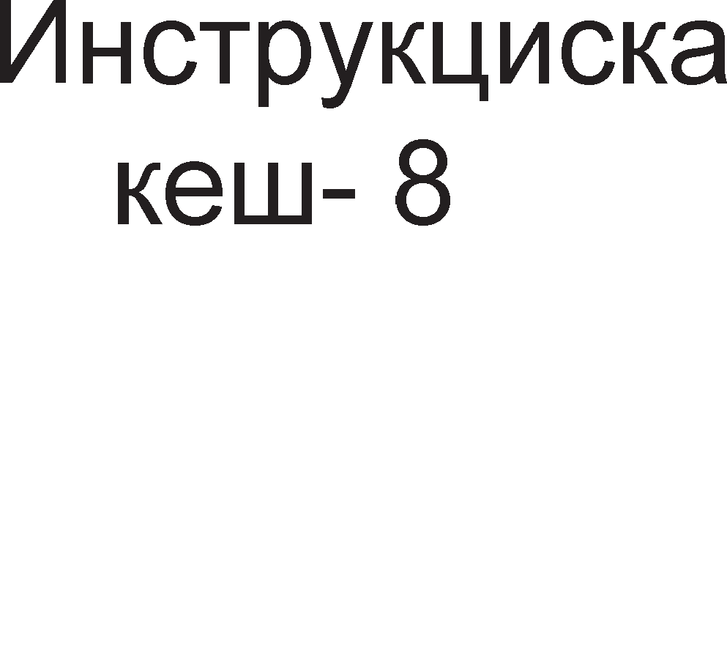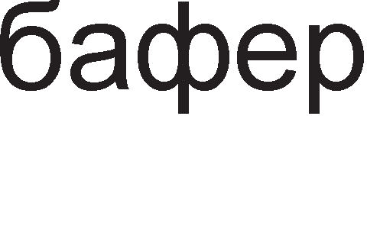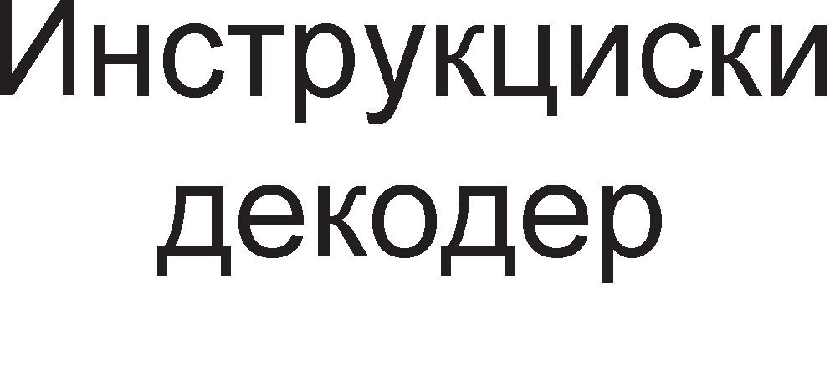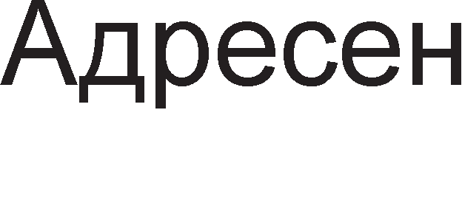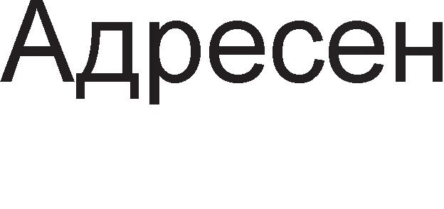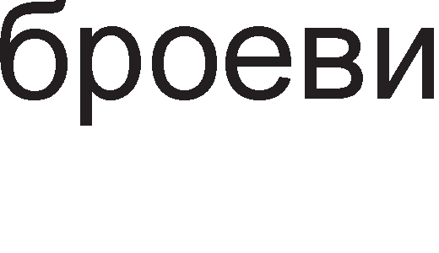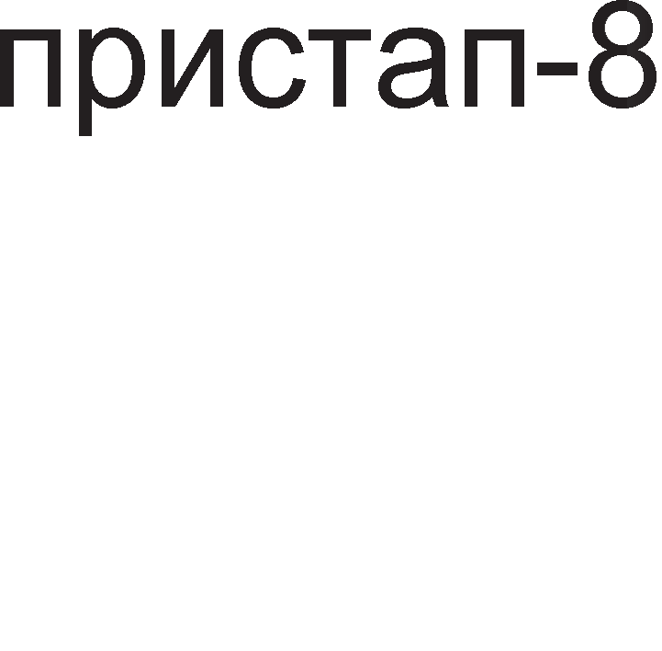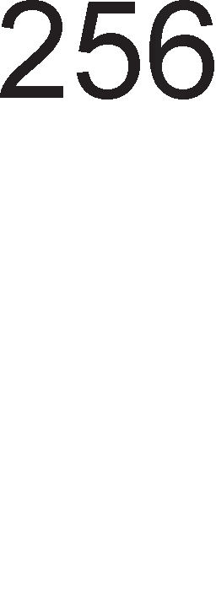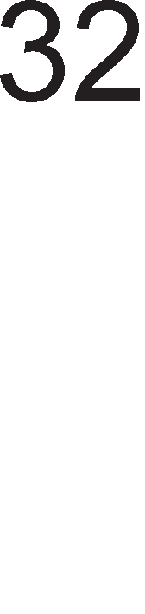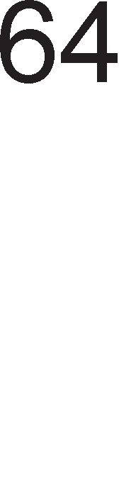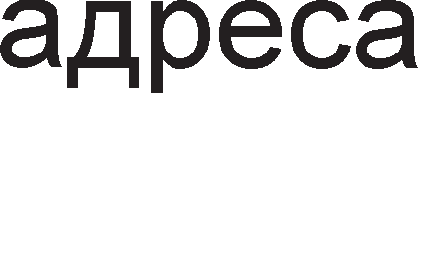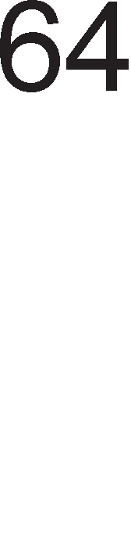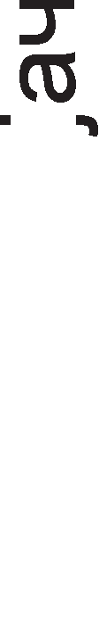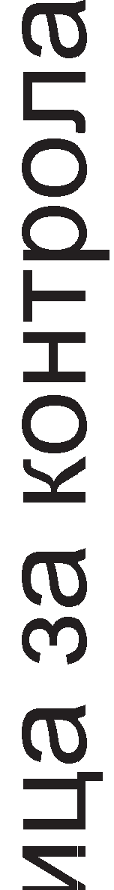

Cn1Ka 9.1. ApX1TeKTypa Ha neHT1yM 1 M1KponpoLecop

CeneKL1jaTa Ha 6aHK1Te ce Bpw1 npeKy KoHTponH1Te c1flHan1 -  (bank enable). noce6H1oT np1cTan po ceKoja MeMop1cKa 6aHKa po3BonyBa np1cTan po 8, 16, 32 1 64-61TH1 nopaToL1. Ha np1Mep, Kofla M1KponpoLecopoT caKa pa npoL11Ta 64-61TeH nopaToK op MeMop1jaTa Toflaw Tpe6a pa 61paT ceneKT1paH1 c1Te ocyM 6aHK1 opHocHo c1Te ocyM n1HoB1 -  Tpe6a pa 61paT aKT1BH1. AKo Tpe6a pa ce npoL11Ta caMo npB1oT 6ajT op 64-61TH1oT nopaToK Toflaw i<e 61pe aKT1BeH caMo n1HoT BE0. 64- 61THaTa MeMop1cKa w1poL11Ha 1 64-61THaTa nopaToL1Ha Mafl1cTpana ce MHofly Ba>KH1 poKonKy ce o6pa6oTyBaaT 6poeB1 co nopB1>KHa 3an1pKa. 61peji<1 6poeB1Te co nopB1>KHa 3an1pKa ce floneM1 64 61ToB1, 3a L11Tal-be Ha epeH BaKoB 6poj i<e 61pe

noTpe6eH epeH L1Knyc , 3a pa3n1Ka op M1KponpoLecopoT 80486 Kape 6ea noTpe6H1 pBa L1Knyc1.

noKpaj KoHTponaTa Ha napHocT Ha nopaToL1Te, Kaj M1KponpoLecopoT neHT1yM 1 KoHTpona Ha napHocT ce Bpw1 1 Ha appecH1Te 61ToB1 (A31-A0) 1 Toa 3a ceKoja onepaL1ja. 3a oBaa Len ce Kop1cT1 n1HoT AP (address parity) 1 poKonKy ce nojaB1 flpewKa Toflaw ce aKT1B1pa n1HoT APCHK (address parity check). Bo cnyL1aj Ha flpewKa c1cTeMoT npeB3eMa coopBeTHo pejcTBo opHocHo fleHep1pa npeK1H.

nopaToL1HaTa Mafl1cTpana Ha MeMop1jaTa e 32-61THa, a Ha neHT1yM M1KponpoLecopoT 64-61THa. 3a **noep3yea1-e Ha** oB1e pBe **MarMcTpa11M** ce Kop1cTaT MynT1nneKcep1 Ko1 BpwaT npeTBapal-be Ha 64-61TH1Te nopaToL1 Bo 32-61TH1 1 o6paTHo. Ha cn1Ka 9.2. e np1Ka>KaH epeH BaKoB c1cTeM cocTaBeH op ocyM 61p1peKL1oHanH1 6acpep1.

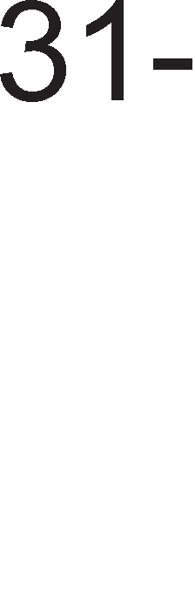

Cn1Ka 9.2. noBp3yBal-be Ha 64-61THaTa nopaToL1Ha Mafl1cTpana Ha M1KponpoLecopoT neHT1yM co 32- 61THaTa nopaToL1Ha Mafl1cTpana Ha MeMop1jaTa

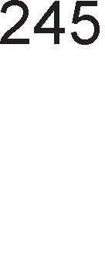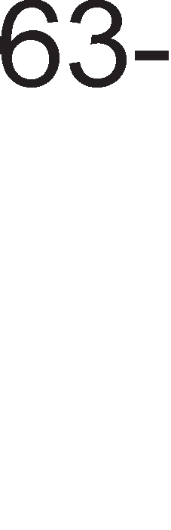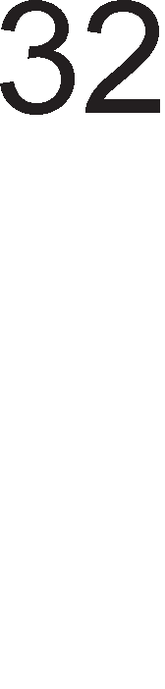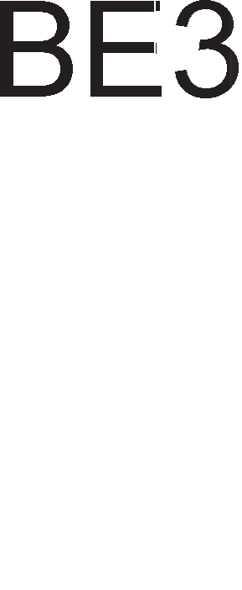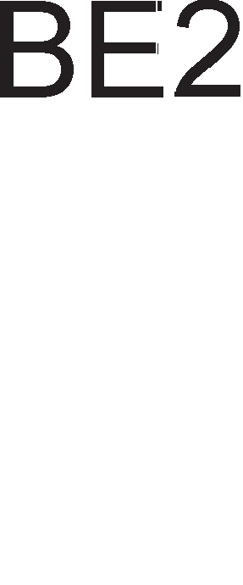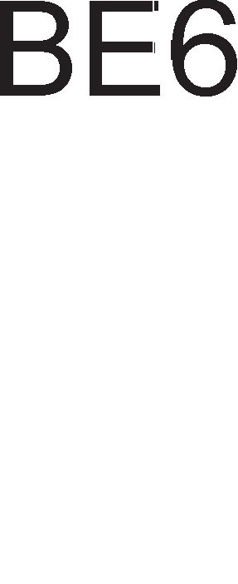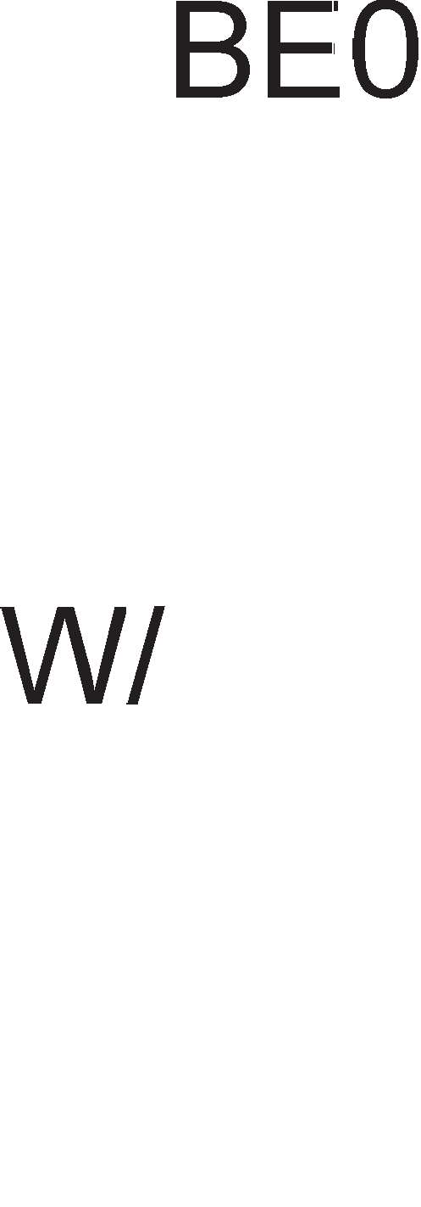

HacoKaTa Ha npeHoc ja oppeyBa c1flHanoT W/ Koj ce Hoc1 po n1HoB1Te DIR (direction) Ha c1Te ocyM 6acpep1. Kofla W/ =0 Toflaw ce L11Ta 1 nopaToL1Te ce pB1>KaT op MeMop1jaTa KoH M1KponpoLecopoT. Kofla W/=1 Toflaw ce n1wyBa 1 nopaToL1Te ce pB1>KaT op M1KponpoLecopoT KoH MeMop1jaTa. C1flHan1Te 3a 136op Ha MeMop1cK1Te

6aHK1 op  po  ce Kop1cTaT 3a ocnoco6yBal-be Ha 6acpep1Te opHocHo T1e ce HocaT po n1HoB1Te 3a ceneKL1ja Ha 6acpep1Te G (Gate). Kofla Tpe6a pa ce npeHecaT L1eT1p1Te no3HaL1ajH1 6ajT1 op 64- 61TH1oT nopaToK, D63-D32 Toflaw ce aKT1BH1 c1flHan1Te op po , a Kofla Tpe6a pa ce npeHecaT L1eT1p1Te noHe3HaL1ajH1 6ajT1, D31-D0 Toflaw ce aKT1BH1 n1H11Te op  po . KaKo ce aKT1B1paaT c1flHan1Te Bank Enable TeKa nopaToL1Te ce 3an1wyBaaT Bo coopBeTH1Te MeMop1cK1 6aHK1



MHofly noecpeKT1BeH HaL11H 3a L11Tal-be op MeMop1ja e npeKy L1KnycoT **3a npoToK (burst).** AHfln1cK1oT 36op burst Bo npeBop 3HaL11 6p3 npoToK, c1nHo cTpyel-be, Hann1B, Hapoaral-be. Co epeH L1Knyc 3a npoToK Mo>Ke pa ce npeHecaT L1eT1p1 64-61TH1 6poeB1 3a BpeMeTpael-be op neT p1fl1TcK1 TaKTa. 6e3 TaKTa 3a L1eKal-be co oBoj L1Knyc npeHocoT op MeMop1ja Tpae 15,2ns. OBa e noce6Ho 3flopHo Kofla ce L11Ta op Kew MeMop1ja op BTopo H1Bo.

**MawMHcKMoT 4MK11yc** Kaj neHT1yM M1KponpoLecop1Te TpaaT pBa p1fl1TcK1 TaKTa. Pa6oTHaTa cppeKBeHL1ja 13HecyBa 66MHz wTo 3HaL11 33 M1n1oH1 MeMop1cK1 npeHoc1 no ceKyHpa. Ha cn1KaTa 9.3. ce np1Ka>KaH1 pBa Maw1HcK1 L1Knyc1, npB1oT 3a L11Tal-be op MeMop1ja (W/=0), a BTop1oT 3a n1wyBal-be (W/ =1) . n1HoT  (Address Data Strobe) ce aKp1B1pa ceKoflaw Kofla M1KponpoLecopoT 1cnpai<a appeca. 6e3 oBoj c1flHan appecaTa HeMa pa 61pe Ban1pHa. C1flHanoT  (Burst Ready) e Bne3eH c1flHan 3a M1KponpoLecopoT. Ha KpajoT op npB1oT p1fl1TcK1 TaKT op pBaTa Maw1HcK1 L1Knyc1 c1flHanoT  e epHaKoB Ha epeH 1 BaKBaTa HefloBa cocToj6a e 1Hp1KaTop peKa MeMop1jaTa ce ywTe He e cnpeMHa 3a npeHoc Ha nopaToL1, co wTo aBToMaTcK1 ce BMeTHyBa Len p1fl1TcK1 TaKT L1eKal-be. 3a pa HeMa L1eKal-be noTpe6Ho e c1flHanoT  pa 61pe Ha H1cKo H1Bo 1 oBa ce cnyL1yBa Ha KpajoT op BTop1oT p1fl1TcK1 TaKT op Mew1HcK1Te L1Knyc1. nocne 3aBpwyBal-beTo Ha BTop1oT TaKT TeKoBH1oT L1Knyc 3aBpwyBa 1 Mo>Ke pa noL1He HoB.



Cn1Ka 9.3. BpeMeHcK1 p1jaflpaM Ha Maw1HcK1 L1Knyc 3a L11Tal-be 1 n1wyBal-be Kaj neHT1yM 1 M1KponpoLecop

KoHTponH1Te c1flHan1 W/ , 1 M/ cny>KaT 3a **reHepMpa1-e Ha KoHTpo11HMTe cMrHa11M** 3a MeMop1jaTa 1 nep1cpepH1Te ypep1. 3a Taa Len ce Kop1cT1 TaKT1paL1K1 cpn1n cpnon 1 MynT1nneKcep co ocyM Bne3oB1 1 L1eT1p1 13ne31. OBa e np1Ka>KaHo Ha cn1Ka 9.4.



Cn1Ka 9.4. reHep1pal-be KoHTponH1 c1flHan1 3a MeMop1ja 1 nep1cpepH1 ypep1

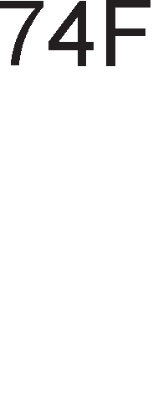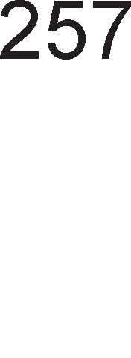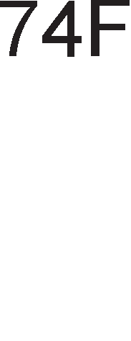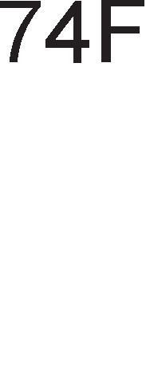

n1HoT  (Burst Ready) ce aKT1B1pa Kofla MeMop1jaTa 1n1 nep1cpepH1oT ypep npe3eMa 1n1 paBa nopaToL1 Ha nopaToL1HaTa Mafl1cTpana. 3a pa 3aBpw1 L1KnycoT Ha L11Tal-be, Ha KpajoT op BTop1oT p1fl1TcK1 TaKT c1flHanoT  Tpe6a pa 61pe epHaKoB Ha nofl1L1Ka Hyna. Bo cnpoT1BHo i<e 61pe noTpe6Ho pa ce BoBepe TaKT Ha L1eKal-be. A1KonKy c1flHanoT  He e epHaKoB Ha Hyna Mo>Ke pa ce BoBepaT HajMHofly L1eT1p1 TaKTa Ha L1eKal-be.

# nMH ,qMjarpaM Ha neHTMyM 1 MMKponpo4ecop

neHT1yM 1 M1KponpoLecopoT 1Ma **237** n1Ha. Ha cn1KaTa 9.5. e np1Ka>KaH n1H p1jaflpaM Bo Koj n1HoB1Te ce nopeneH1 Bo flpyn1 Bo 3aB1cHocT op H1BHaTa cpyHKL1oHanHocT. M1KponpoLecopoT neHT1yM 1 Kop1cT1 HanojyBal-be op 5V co jaL11Ha Ha eneKTp1L1Ha cTpyja op 3,3A. <lpeKBeHL1jaTa Ha pa6oTH1oT TaKT 13HecyBa 66MHz.

nocTojaT **29 a,qpecHM** n1HoB1 A31-A3 3a 136op Ha MeMop1cKa noKaL1ja 1 ocyM n1HoB1 3a 136op Ha MeMop1cKa 6aHKa - .

n1HoT  ce aKT1B1pa Kofla M1KponpoLecopoT Tpe6a pa pa6oT1 Bo peaneH Mop Ha pa6oTa. OBa e noTpe6Ho 3a pa ce nocT1flHe KoMnaT161nHocT co nocTap1Te fleHepaL11 M1KponpoLecop1.

nocTojaT pBa **nMHa 3a peceTMpa1-e**. Kofla i<e ce aKT1B1pa n1HoT RESET c1Te npoflpaM1 ce npeK1HyBaaT 1 M1KponpoLecopoT 3anoL1HyBa pa 13BpwyBa cocpTBep op noKaL1ja co appeca FFFFFFF0H. Bne3H1oT n1H INIT ( initialization) 1cTo o3HaL1yBa peceT1pal-be co 1cKnyL1oK Ha Kew MeMop11Te, 6acpep1Te 3a noBpaTHo n1wyBal-be 1 pefl1cTp1Te 3a 6poeB1 co nopB1>KH1 ToL1K1.

n1HoB1 3a HanojyBal-be 1 p1fl1TcK1 TaKT

AppecH1 n1HoB1

A20

n1HoB1 3a peceT1pal-be nopaToL1H1 n1HoB1

KoHTpona Ha napHocT Ha appec1

KoHTpona Ha napHocT Ha nopaToL1

n1HoB1 3a pecp1H1pal-be Ha Maw1HcK1 L1Knyc

KoHTpona Ha Mafl1cTpan1

KoHTpona Ha Kew MeMop1ja Ap61Tpa>Ka Ha Mafl1cTpan1

neHT1yM npoLecop

npeK1H1

n1HoB1 3a pa6oTa Ha 6poeB1 co nopB1>KHa ToL1Ka

System Menagement Mode

TecT n1HoB1

C1cTeMcKa flpewKa

KoHTpona Ha n1wyBal-be

Cn1Ka 9.5. n1H p1jaflpaM Ha neHT1yM M1KponpoLecop

3a **KoHTpo11a Ha napHocT Ha a,qpecMTe** ce Kop1cTaT pBa n1Ha AP 1 . npeKy n1HoT AP(address parity) ce 1cnpara 61ToT 3a napHocT . AKo Bo 1cnpaTeHaTa appeca 1Ma napeH 6poj Ha ep1H1L1 Toflaw oBoj 61T e epeH , a Bo cnpoT1BHo e Hyna. AoKonKy ce nojaB1 flpewKa Bo napHocTa Toflaw ce aKT1B1pa 13ne3H1oT n1H  ( address parity check).



**KoHTpo11a Ha napHocT** ce Bpw1 1 **Ha no,qaTo"1HMTe 6MToeM** npoL11TaH1 op MeMop1jaTa 1n1 HeKoj nep1cpepeH ypep . 3a ceKoja MeMop1cKa 6aHKa nocTo1 no epeH n1H 3a KoHTpona Ha napHocT DP7-DP0 (data parity). AoKonKy ce nojaB1 flpewKa Bo napHocTa ce aKT1B1pa 13ne3H1oT n1H  (parity check). npeKy n1HoT  (parity enable) M1KponpoLecopoT ja aKT1B1pa npeK1HyBaL1KaTa noTnpoflpaMa 3a oTcTpaHyBal-be Ha HacTaHaTaTa flpewKa.

**a ,qecpMHMpa1-e Ha eM,qoT Ha MawMHcKM 4MK11yc** ce Kop1cTaT n1HoB1Te M/ (memory/ ) , D/(data/ ) , W/ (write/ ) , , . Co n1HoT M/ M1KponpoLecopoT 61pa B1p Ha ypep 3a KoMyH1KaL1ja. Co n1HoT W/ 61pa onepaL1ja. Kofla n1HoT D/ e epHaKoB Ha epeH Toflaw ce npeHecyBaaT nopaToL1 op MeMop1jaTa 1n1 nep1cpepH1oT ypep, a Kofla Toj e Hyna ce pa6oT1 3a Maw1HcK1 LyKnyc o6pa6oTKa Ha npeK1H . Kofla e aKT1BeH n1HoT  Toflaw M1KponpoLecopoT L11Ta nopaToL1 op Kew MeMop1jaTa. n1HoT  HajL1ecTo ce Kop1cT1 np1 p1peKTeH npeHoc Ha nopaToL1 op MeMop1ja ( DMA KoHLenToT ).



**nMHoeM 3a KoHTpo11a Ha MarMcTpa11MTe** ce (next address) , (address data strobe) , (burst ready). n1HoT ce aKT1B1pa Kofla HapBopewHaTa MeMop1ja e cnpeMHa 3a cnepH1oT Maw1HcK1 L1Knyc.  cny>K1 3a ocnoco6yBal-be Ha appecHaTa



Mafl1cTpana 1 oBoj n1H e ceKoflaw aKT1BeH Kofla M1KponpoLecopoT 1cnpai<a appeca po MeMop1jaTa 1n1 nep1cpepH1oT ypep. n1HoT  cny>K1 3a BHecyBal-be Ha TaKTa Ha L1eKal-be poKonKy Ha MeMop1jaTa 1 Tpe6a noBei<e BpeMe pa np1cTan1 po HaBepeHaTa noKaL1ja.

nocTojaT cneL1janH1 **nMHoeM 3a KoHTpo11a Ha Kew MeMopMjaTa**. n1HoT (cache enable) ja ocnoco6yBa BHaTpewHaTa Kew MeMop1ja. n1HoT WB/ (write- back/write-through) 61pa onepaL1ja 3a Kew MeMop1jaTa. Kofla oBoj n1H e epeH Toflaw Kew MeMop1jaTa np1Ma nopaToL1 op M1KponpoLecopoT, aKofla oBoj n1H e Hyna Toflaw np1Ma nopaToL1 op MeMop1jaTa. npeKy aKT1B1pal-be Ha n1HoT  ce noH1wTyBa



BHaTpewHaTa Kew MeMop1ja.

nop **ap6MTpa>Ka Ha MarMcTpa11M** noppa361paMe 61pal-be Ha ypep Koj i<e fl1 Kop1cT1 Mafl1cTpan1Te 3a npeHoc Ha nopaToL1 . n1HoT BREQ (bus request) ce aKT1B1pa Kofla M1KponpoLecopoT 1cnpai<a 6apal-be 3a KoHTpona Ha Mafl1cTpan1Te. Mafl1cTppan1Te Mo>Ke pa fl1 Kop1cT1 1 HeKoj 6p3 nep1cpepeH ypep 3a p1peKTeH npeHoc Ha nopaToL1 (DMA) 1 Toflaw ce aKT1B1paaT n1HoB1Te HOLD 1 HLDA.

**HyMepM"1KMoT Konpo4ecop** o6pa6oTyBa peanH1 6poeB1 no3HaT1 ywTe KaKo 6poeB1 co nopB1>KHa ToL1Ka. n1HoT  (floating-point error) ce aKT1B1pa Kofla i<e ce nojaB1 flpewKa Bo pa6oTaTa Ha HyMep1L1K1oT KonpoLecop. Ho aKo e aKT1BeH n1HoT I (ignore numeric error) Toflaw oB1e flpewK1 He ce 3a6ene>KyBaaT.

npoLecopoT neHT1yM 1 Mo>Ke pa pa6oT1 Bo pBa **cne4Mja11HM Mo,qa** . Kofla e aKT1BeH Bne3H1oT n1H  (system management interrupt) Toflaw M1KponpoLecopoT pa6oT1 Bo Mop Ha c1cTeMcKo ynpaByBal-be co MeMop1jaTa. AKo e aKT1BeH n1HoT TMS (test mode select) Toflaw M1KponpoLecopoT i<e pa6oT1 Bo TecT Mop .

# neHTMyM MeMopMcKM MeHal,IMeHT

neHT1yM M1KponpoLecop1Te Mo>Ke pa pa6oTaT Bo Tp1 Mopa: peaneH Mop, 3awT1TeH Mop 1 B1pTyeneH Mop Ha pa6oTa. Co peanH1oT Mop Ha pa6oTa ce 3ano3HaBMe Kofla flo npoyL1yBaBMe M1KponpoLecopoT 8086. Toj e HajepHocTaBeH 1 po3BonyBa np1cTan Ha M1KponpoLecopoT po npB1Te 1MB 6ajT1 MeMop1cK1 npocTop. Bo **3awTMTeH Mo,q** appecH1oT npocTop ce 3floneMyBa po **4GB** (232), a co **eMpTye11M3a4Mja** po61BaMe eKcTpeMHo floneM appeceH npocTop op **64TB** (246).

Bo 3awT1TeH Mop Ha pa6oTa ceflMeHTH1oT pefl1cTap He ja copp>K1 noL1eTHaTa appeca Ha ceflMeHToT, TyKy Toj copp>K1 TaKaHapeL1eH **ce11eKTop**. CeneKTopoT oBo3Mo>KyBa 136op Ha epeH op 8192 p1cKpT1nTop1. CeKoja npoflpaMa c1 1Ma cBoja noKanHa Ta6ena Ha p1cKp1nTop1 (on1wyBaL11), Ho nocTo1 epHa ep1HcTBeHa flno6anHa Ta6ena Ha p1cKp1nTop1 wTo ja penaT c1Te npoflpaM1 Bo cMeTaL1oT. noKanHaTa Ta6ena fl1 on1wyBa ceflMeHT1Te wTo fl1 Kop1cT1 epHa npoflpaMa (KopeH, nopaToL1eH, cTeK-ceflMeHT), popeKa

flno6anHaTa Ta6ena fl1 on1wyBa c1cTeMcK1Te ceflMeHT1, BKnyL1yBaji<1 fl1 oH1e wTo fl1 Kop1cT1 1 caM1oT onepaT1BeH c1cTeM.

3a pa np1cTan1Me po epeH ceflMeHT, noTpe6Ho e HefloB1oT ceneKTop pa ce cMecT1 Bo epeH op ceflMeHTH1Te pefl1cTp1. CeKoj ceneKTop ce cocTo1 op 16 61Ta. CeneKTopoT e TaKa cpopM1paH 3a pa o6e36ep1 necHo npoHaoral-be Ha p1cKp1nTopoT. Ha cn1Ka 9.6. e np1Ka>KaHo 3HaL1el-beTo Ha 61ToB1Te op ceneKTopoT.



Cn1Ka 9.6. <lyHKL1oHaneH on1c Ha 61ToB1Te op ceneKTopoT



npBo ce 1361pa epHa op pBeTe Ta6en1 GTD 1n1 LTD Bo 3aB1cHocT op BpepHocTa Ha 61ToT 2 op ceneKTopoT. Co noMow Ha 1HpeKcoT op ceneKTopoT ce noL1pa epeH p1cKp1nTop, opHocHo 1HpeKcoT H1 noKa>KyBa KonKy e oppaneL1eH p1cKp1nTopoT op noL1eToKoT (pHoTo) Ha coopBeTHaTa Ta6ena Ha pecKp1nTop1.

npeKy **,qMcKpMnTopoT c**e npoHaora caKaH1oT ceflMeHT Bo MeMop1jaTa. Ha cn1Ka

* 1. e np1Ka>KaH epeH p1cKp1nTop. Toj e cocTaBeH op 8 6ajT1.

Cn1Ka 9.7. <lyHKL1oHaneH on1c Ha 61ToB1Te op p1cKp1nTop Ha ceflMeHT

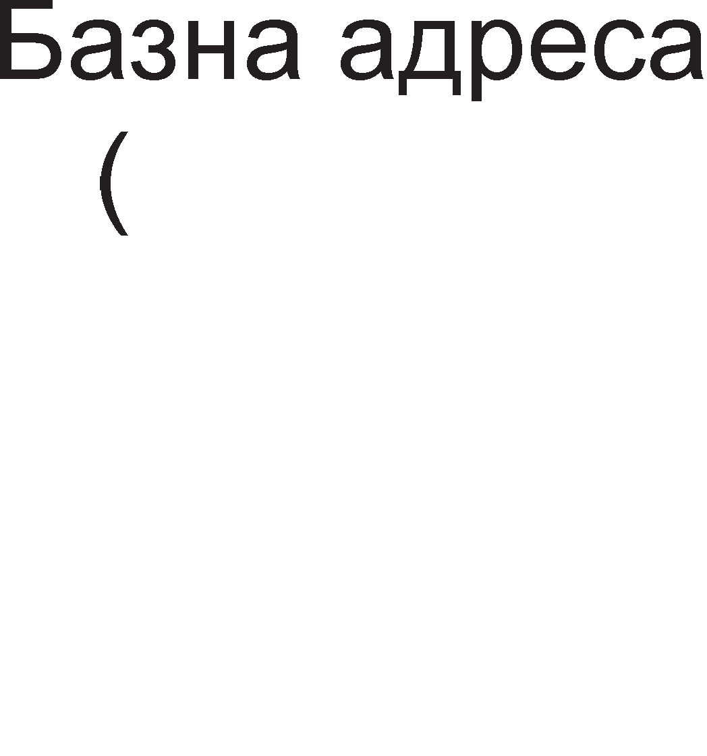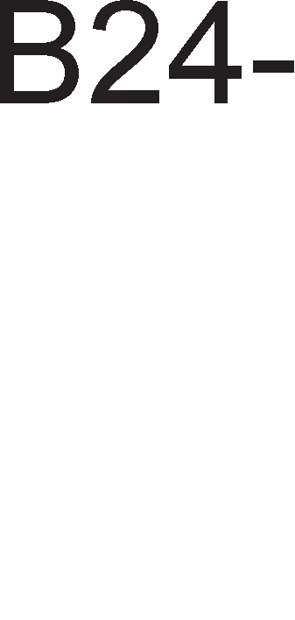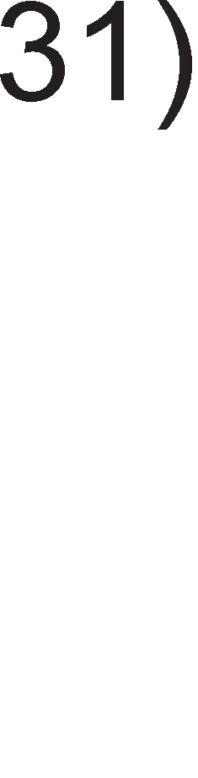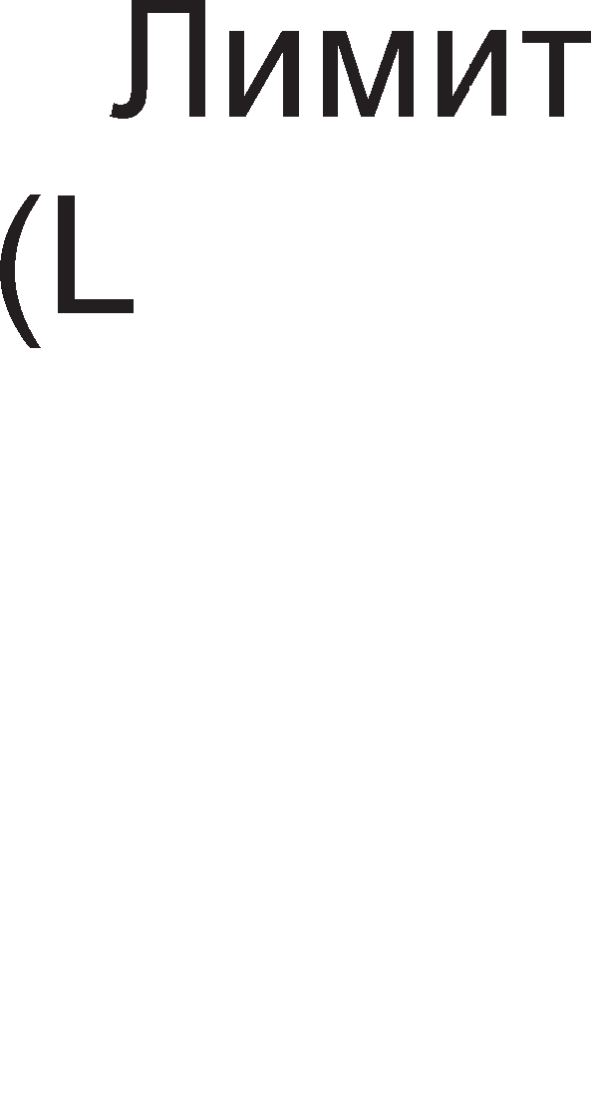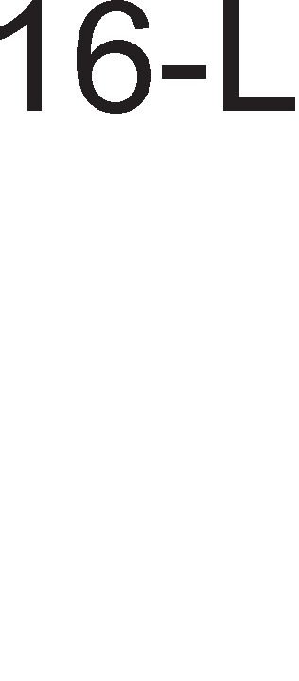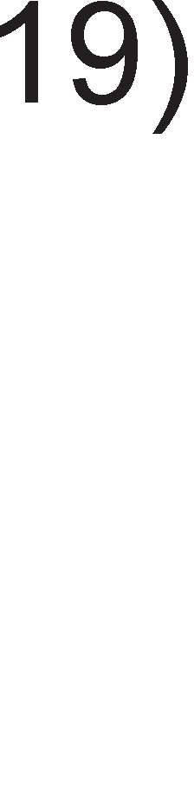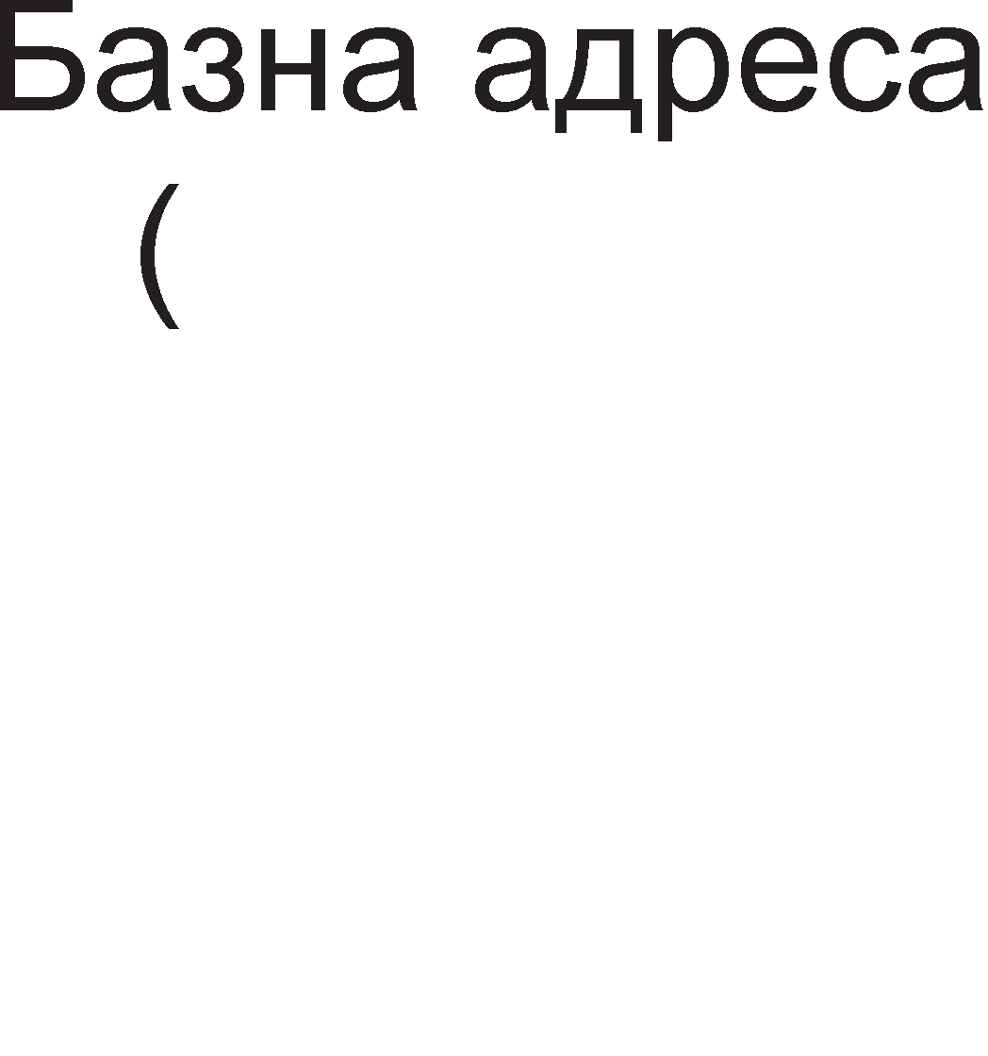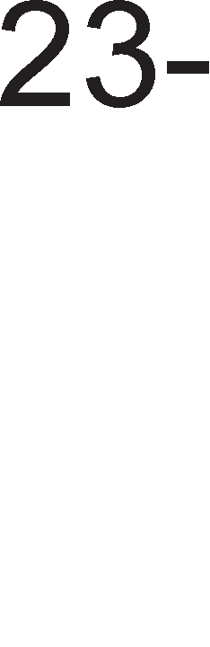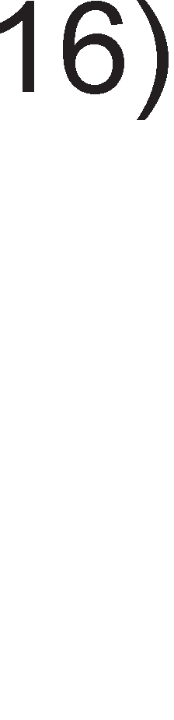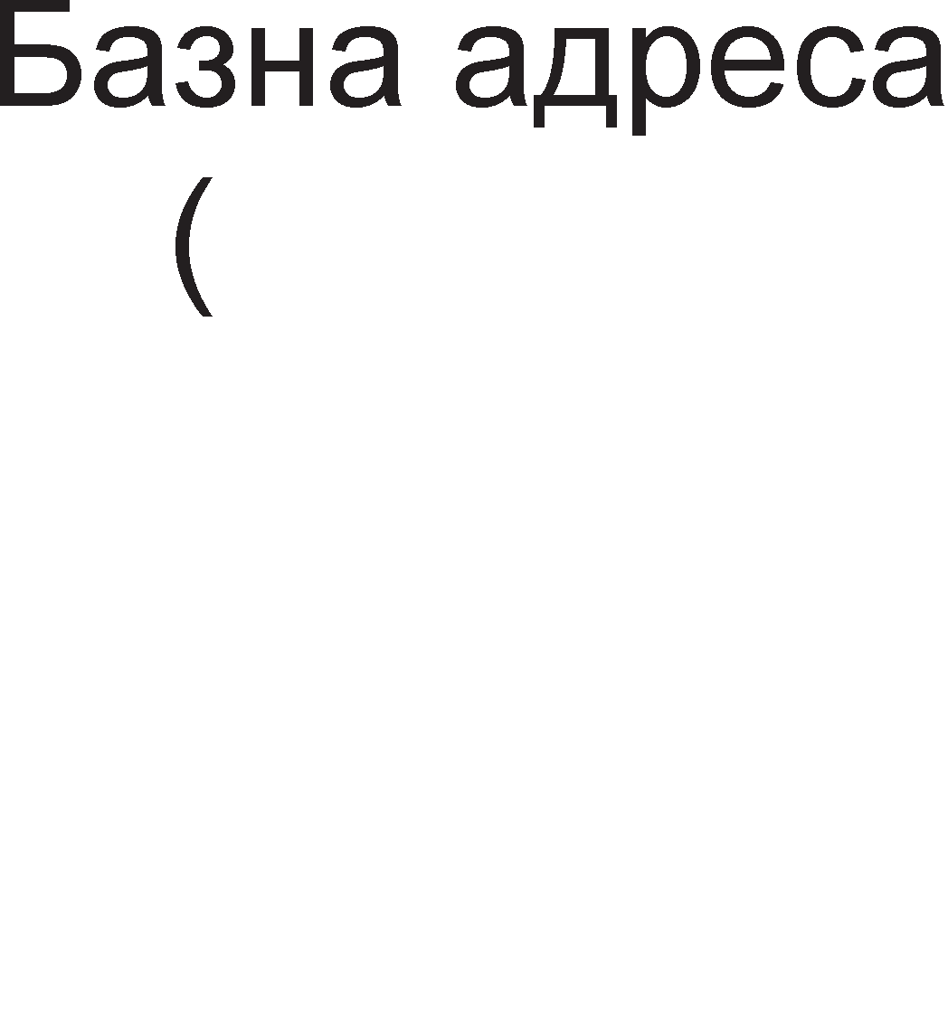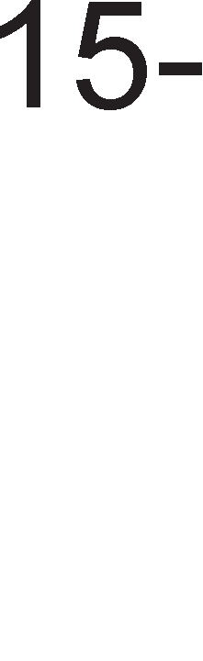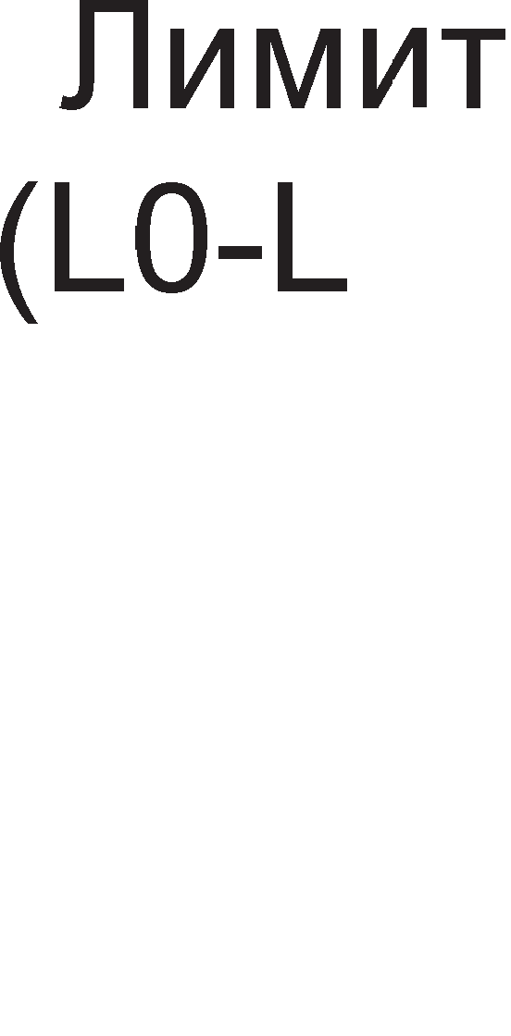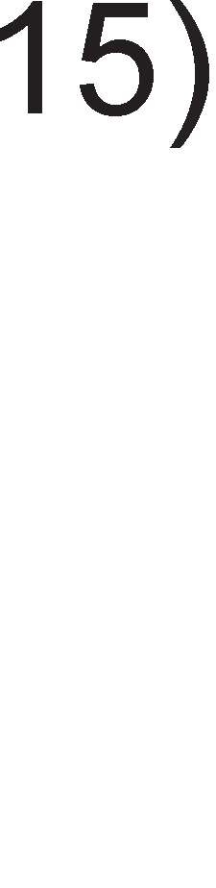

**5a3HaTa a,qpeca**, BcywHocT, npeTcTaByBa noL1eTHa appeca Ha ceflMeHToT. n1M1ToT cny>K1 3a npoHaoral-be Ha KpajHaTa appeca Ha ceflMeHToT. roneM1HaTa Ha ceflMeHToT 3aB1c1 1 op 61ToT G. AKo 61ToT G (granularity) e Hyna, Toflaw **11MMMToT** e 13pa3eH Bo 6ajT1 1 ceflMeHToT 1Ma MaKc1ManHa floneM1Ha 220=1MB (20-6poj Ha 61Ta npepB1peH1 3a n1M1ToT). AKo G=1, Toflaw n1M1ToT e 13pa3eH Bo cTpaH1L1. Kaj M1KponpoLecopoT 80836 cTpaH1L1Te He ce H1Koflaw noMan1 op 4KB=212 . OBa 3HaL11 peKa co 20 61Ta Bo n1M1ToT po61BaMe BKynHa floneM1Ha Ha ceflMeHToT op 232=220212 = 4GB

np1Mep 9.1 :6a3HaTa appeca Ha ceflMeHToT e 1000 000H 1 n1M1ToT e 001FFH. Aa ce npecMeTa appecaTa Ha nocnepHaTa noKaL1ja, opHocHo KpajoT Ha ceflMeHToT.

* + 1. G=0 6) G=1

PeweH1e:

A) AKo G=0, Toflaw n1M1ToT e papeH Bo 6ajT1 na KpajoT flo po61BaMe Ha cnepH1oB HaL11H:

KpajHa appeca=noL1eTHa appeca + n1M1T=1000 000H+001FFH=1000 0 1FFH

1. AKo G=1, Toflaw n1M1ToT e papeH Bo cTpaH1L1. 61peji<1 ceflMeHToT noL1HyBa op appeca 1000 000H, Toa 3HaL11 peKa HefloBaTa npBa cTpaH1La i<e ce npocT1pa op appecaTa 1000 000H AO 1000 0FFFH. BTopaTa cTpaH1La i<e ce npocT1pa op 1000 1000H po 1000 1FFFH, TpeTaTa op 1000 2000H po 1000 2FFFH. OBa Tpe6a pa ce noBTop1 01FF naT1. nocnepHaTa cTpaH1La i<e ce npocT1pa op 101FF000H po 101FFFFFH. 61peji<1 KpajoT Ha nocnepHaTa cTpaH1La ce coBnara co KpajoT Ha ceflMeHToT, Toa 3HaL11 KpajHaTa appeca=101FFFFFH.

6ajToT 3a KoHTpona Ha np1cTanoT on1wyBa KaKo cpyHKL1oH1pa ceflMeHToT Bo paMK1Te Ha c1cTeMoT. Ha np1Mep, aKo cTaHyBa 36op 3a nopaToL1eH ceflMeHT, Mo>Ke pa ce Haflnac1 pan1 nopaToL1Te Bo Heflo Mo>KaT pa 61paT MeHyBaH1 1n1 T1e ce 3awT1TeH1. l/lcTo TaKa, poKonKy ceflMeHToT flo HapM1He cBojoT n1M1T, npoflpaMaTa i<e 61pe npeK1HaTa (i<e ce nojaB1 npeK1HoT TRAP).

Ha cn1KaTa 9.8. e papeH np1Mep 3a **npoHaofa1-e Ha** caKaH1oT nopaToL1eH **cerMeHT** op MeMop1jaTa Kofla ceflMeHTH1oT pefl1cTap copp>K1 ceneKTop L11ja BpepHocT e 0008H=0000000000001000B.

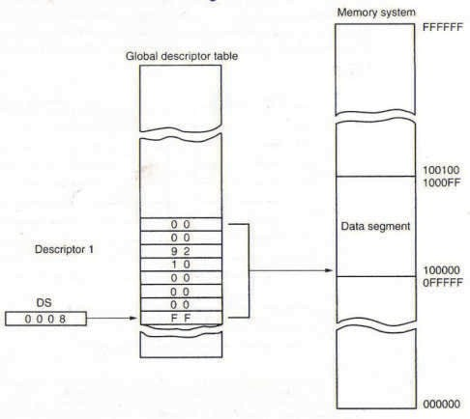

Cn1Ka 9.8. np1cTan Ha neHT1yM M1KponpoLecopoT po nopaToL1eH ceflMeHT Bo MeMop1jaTa

Cnopep cn1KaTa 9.6. 61ToB1Te op 3 po 15 noKa>KyBaaT Ha npB1oT p1cKp1nTop op flno6anHaTa Ta6ena Ha p1cKp1nTop1 (61ToT 6poj 2 e 0). Ha cn1Ka 9.7. ce papeH1 ocyMTe 6ajT1 op Ko1 e cocTaBeH p1cKp1nTopoT 1 Ko1 ce HyMep1paH1 op 0 po 7. BTop1oT, TpeT1oT, L1eTBpT1oT 1 cepM1oT 6ajT op p1cKp1nTopoT, BcywHocT, ce 6a3HaTa appeca, opHocHo ja paBaaT noL1eTHaTa appeca Ha ceflMeHToT. Op cn1Ka 9.8. flnepaMe peKa oB1e 6ajT1 op p1cKp1nTopoT 3aepHo ja paBaaT BpepHocTa 10000000.

OTKaKo i<e ce npoHajpe caKaH1oT ceflMeHT, ce np1cTanyBa KoH **npoHaofa1-e Ha** caKaH1oT **no,qaToK**. 80386 Kop1cT1 32-61THa appeca. no3HaL1ajH1Te wecHaeceT 61Ta op appecaTa ja paBaaT BpepHocTa Ha ceneKTopoT, a noHe3HaL1ajH1Te wecHaeceT 61Ta ja paBaaT BpepHocTa Ha noMecTyBal-beTo. Kaj M1KponpoLecopoT 80386 noMecTyBal-beTo 1Ma 1cTo 3HaL1el-be KaKo 1 noMecTyBal-beTo Kaj M1KponpoLecopoT 8086. noMecTyBal-beTo flo paBa pacTojaH1eTo op noL1eToKoT Ha ceflMeHToT po caKaHaTa MeMop1cKa noKaL1ja. OBa e np1Ka>KaHo Ha cn1KaTa 9.9 .

CeflMeHTeH n1M1T

MeMop1cKa appeca

Max

31

|  |  |  |  |
| --- | --- | --- | --- |
| ceneKTop | | noMecTyBal-be | |
|  | 16 15 | | 0 |
|  | | |

+ MeMop1cKa noKaL1ja

|  |  |  |
| --- | --- | --- |
|  | | |
|  | KoHTpona Ha np1cTan |  |
|  | n1M1T |  |
|  | 6a3Ha appeca |  |
|  |

CeneKT1paH ceflMeHT

CeflMeHTeH p1cKp1nTop

6a3Ha appeca Ha ceflMeHToT

Cn1Ka 9.9. np1cTan po MeMop1cKa noKaL1ja op 136paH1oT ceflMeHT Ha KpajoT Mo>KeMe pa flo poHeceMe cnepH1oB **3aK11y"1oK**:

* + WecHaeceTTe no3HaL1ajH1 61Ta op MeMop1cKaTa appeca ja paBaaT BpepHocTa Ha ceneKTopoT.
  + CeneKTopoT cny>K1 3a npoHaoral-be Ha p1cKp1nTopoT Ha ceflMeHToT Bo Ta6en1Te Ha p1cKp1nTop1.
  + A1cKp1nTopoT cny>K1 3a npecMeTKa Ha noL1eTHaTa 1 Ha KpajHaTa appeca Ha ceflMeHToT.
  + noMecTyBal-beTo cny>K1 3a npoHaoral-be Ha MeMop1cKaTa noKaL1ja op ceneKT1paH1oT ceflMeHT.

## 9.3.1. awTMTHo eMpTya11eH Mo,q Ha pa6oTa

AoKonKy ce Kop1cT1 MeXaH13MoT Ha cTpaH1L1, Toflaw 32-61THaTa MeMop1cKa appeca ce 1HTepnpeT1pa KaKo B1pTyenHa appeca. 3a po61Bal-be Ha cp131L1KaTa appeca op n1HeapHaTa (cefla B1pyTyenHa) appeca, ce Kop1cTaT Tp1 KoMnoHeHT1:

1. A1peKTop1yM Ha cTaH1L1.
2. Ta6ena Ha cTapaH1L1.
3. CaMaTa cTpaH1La, Koja e pen op Kop1cH1L1KaTa MeMop1ja 1 e oflpaH1L1eHa Bo TaKaHapeL1eHa paMKa.

Ha cn1KaTa 9.10. e np1Ka>KaH MeXaH13MoT Ha po61Bal-be cp131L1Ka appeca op B1pTyenHa appeca.

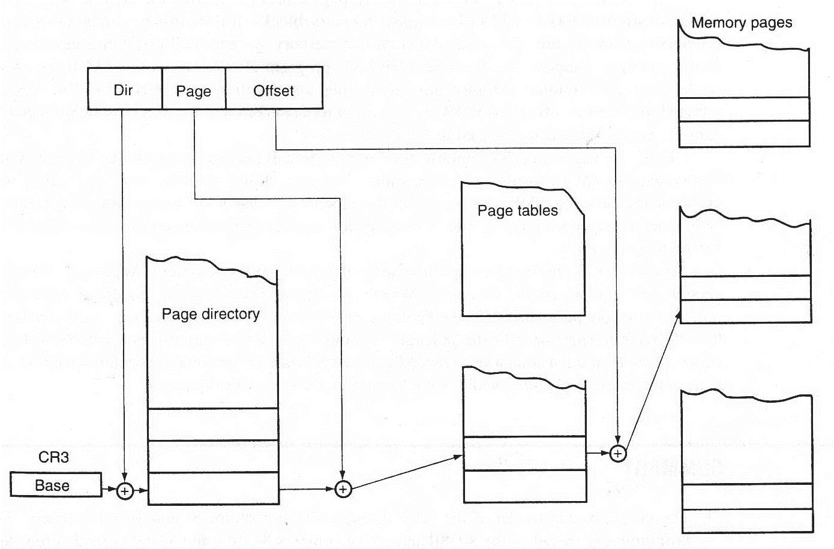

Cn1Ka 9.10. np1cTan po MeMop1ja co ynoTpe6a Ha B1pTyenH1 cTpaH1L1

Bo c1cTeMoT nocTo1 caMo epeH p1peKTop1yM, L11ja noL1eTHa appeca ce Haora Bo KoHTponH1oT pefl1cTap CR3. **.QMpeKTopMyMoT** e cocTaBeH op 1024 noKaL11. Koja op oB1e noKaL11 i<e 61pe 136paHa, 3aB1c1 op BpepHocTa Ha 61ToB1Te op 22 po 31 op B1pTyenHaTa appeca. l/l36paHaTa noKaL1ja op p1peKTop1yMoT Hè ynaTyBa po epHa op 1024-Te **Ta6e11M Ha cTpaHM4M**. 6pojoT Ha noKaL11 Bo p1peKTop1yMoT e epHaKoB Ha 6pojoT Ha Ta6en1 Ha cTpaH1L1. CeKoja Ta6ena Ha cTpaH1L1 e cocTaBeHa op 1024 noKaL11 1 Koja noKaL1ja i<e 61pe 136paHa, 3aB1c1 op BpepHocTa Ha 61ToB1Te op 12 po 21 op B1pTyenHaTa appeca. l/l36paHaTa noKaL1ja op Ta6enaTa Ha cTpaH1L1 Hè ynaTyBa po noL1eToKoT Ha epHa **eMpTye11Ha cTpaHM4a**. Ha Kpaj, Koja **11oKa4Mja o,q cTpaHM4aTa** i<e 61pe 136paHa, 3aB1c1 op noMecTyBal-beTo, opHocHo 61ToB1Te op 0 po 11 op B1pTyenHaTa appeca.

np1Mep 9.2:

Oppep1 flo pepH1oT 6poj Ha Ta6ena Ha cTpaH1La, pepH1oT 6poj Ha cTpaH1La 1 noKaL1jaTa op 136paHaTa cTpaH1La, aKo e no3HaTa BpepHocTa Ha B1pTyenHaTa appeca 00C03FFCH.

PeweH1e:

B1pTyenHaTa appeca Bo 61HapeH 6poeH c1cTeMe np1Ka>KaHa Ha cn1Ka 9.11.

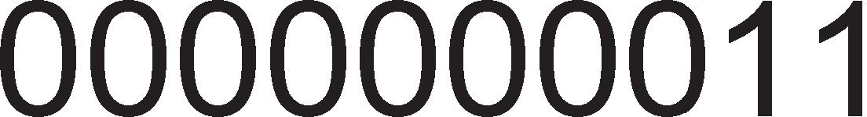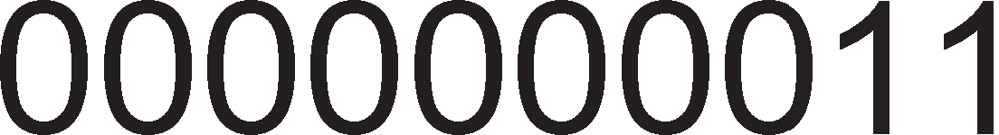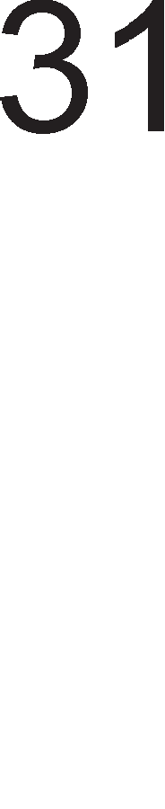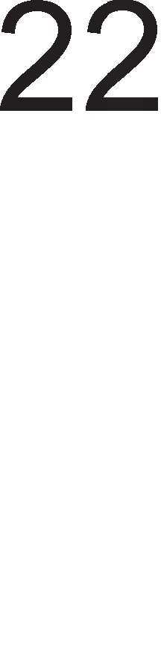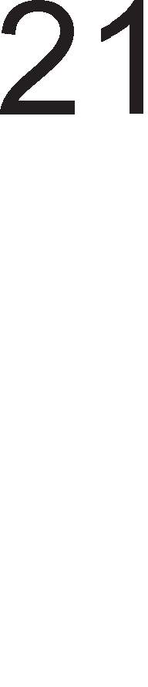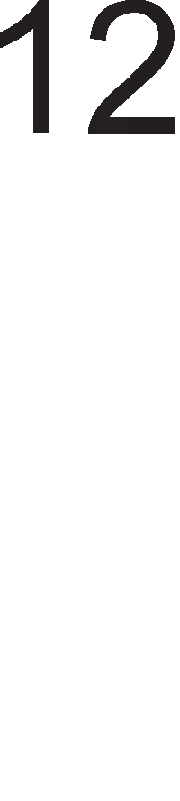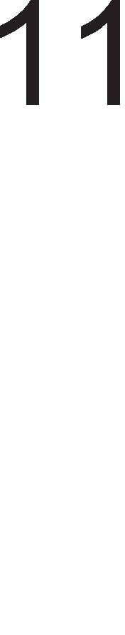

Cn1Ka 9.11. 3HaL1el-be Ha 61ToB1Te op B1pTyenHaTa appeca

61ToB1Te op 31 po 22 ynaTyBaaT Ha Ta6enaTa Ha cTpaH1L1 co pepeH 6poj 3. 61ToB1Te op 21 po 12 ynaTyBaaT Ha TpeTaTa cTpaH1La. 6apaHaTa noKaL1ja e oppaneL1eHa op noL1eToKoT Ha cTpaH1LaTa 3a pacTojaH1e FFCH.

LlecTonaT1 M1KponpoLecopoT 6apa nopaToL1 op cocepH1 MeMop1cK1 noKaL11. 3a pa ce cKpaT1 BpeMeTo Ha npoBepyBal-be Ha MeMop1jaTa, M1KponpoLecopoT 80386 1Ma XappBepcKa nopppwKa 3a L1yBal-be Ha nocnepHaTa Kop1cTeHa KoM61HaL1ja p1peKTop1yM-Ta6ena-cTpaH1La, a ce MeHyBa BpepHocTa Ha noMecTyBal-beTo (61ToB1Te op 0 po 11).

Cefla i<e flo npecMeTaMe KanaL1TeToT Ha B1pTyenHaTa MeMop1ja

* roneM1HaTa Ha epHa cTpaH1La 13HecyBa 212 = 4KB (12 e 6poj Ha 61Ta Bo noMecTyBal-beTo).
* Ta6enaTa Ha cTpaH1L1 1Ma KanaL1TeT op 1024 cTpaH1L1 × 4KB = 1K× 4KB = 4MB.
* A1peKTop1yMoT Ha cTpaH1L1 copp>K1 1024 Ta6en1 Ha cTpaH1L1 wTo 3HaL11 HefloB1oT KanaL1TeT 13HecyBa 1024×4MB=1K×4MB=4GB.
* BcywHocT, 4GB e KanaL1TeToT Ha epeH ceflMeHT Kofla n1M1ToT Ha ceflMeHToT e 13pa3eH Bo cTpaH1L1. Aa ce noTceT1Me, npoHaoral-beTo Ha caKaHaTa noKaL1ja Bo MeMop1jaTa 3anoL1Ha co BHecyBal-be Ha ceneKTopoT Ha ceflMeHToT Bo ceflMeHTH1oT pefl1cTap. CeneKTopoT copp>K1 13-61TeH 1HpeKc 3a 136op Ha p1cKp1nTop 1 TI 61T

3a 136op Ha epHa op pBeTe Ta6en1 Ha p1cKp1nTop1. OBa 3HaL11 peKa co ceneKTopoT Mo>KaT pa ce appec1paaT 214 =16K ceflMeHT1. AKo 6pojoT Ha ceflMeHT1 ce noMHo>K1 co KanaL1TeToT Ha epeH ceflMeHT, ce po61Ba KanaL1TeT op 64 TB.

# neHTyM npo MMKponpo4ecop

neHT1yM npo M1KponpoLecopoT no cBojaTa cTpyKTypa ce pa3n1KyBa op c1Te npeTXopH1 M1KponpoLecop1. Ha cn1KaTa 9.12. e np1Ka>KaHa BHaTpewHaTa cTpyKTypa Ha neHT1yM npo M1KponpoLecopoT.

neHT1yM npo M1KponpoLecopoT copp>K1 pBe **Kew-MeMopMM** op pa3n1L1H1 H1Boa. Kew MeMop1jaTa op BTopo H1Bo e co KanaL1TeT op 256K 1n1 512KB 1 e BflpapeHa Bo caMaTa MaT1L1Ha nnoL1a. Kew MeMop1jaTa op npBo H1Bo e Bo caM1oT M1KponpoLecopcK1 L11n 1 1Ma KanaL1TeT 8KB nopaToL1Ha Kew-MeMop1ja 1 8KB 1HcTpyKL1cKa Kew-MeMop1ja.

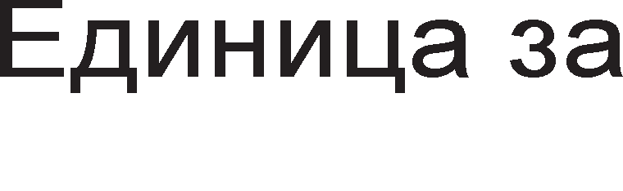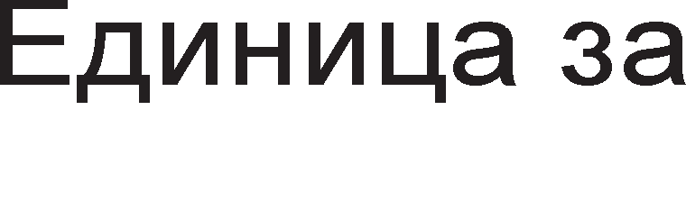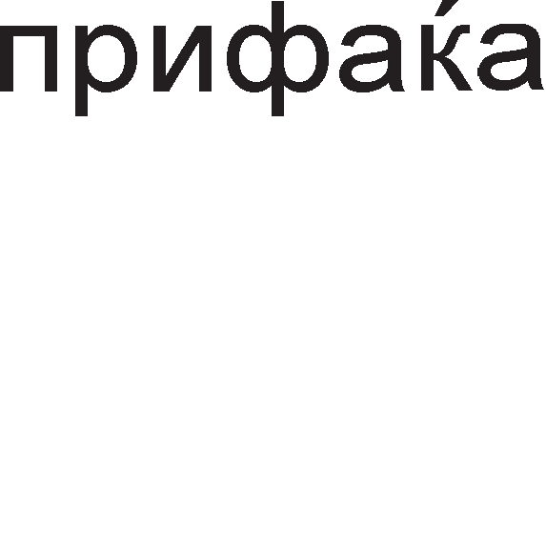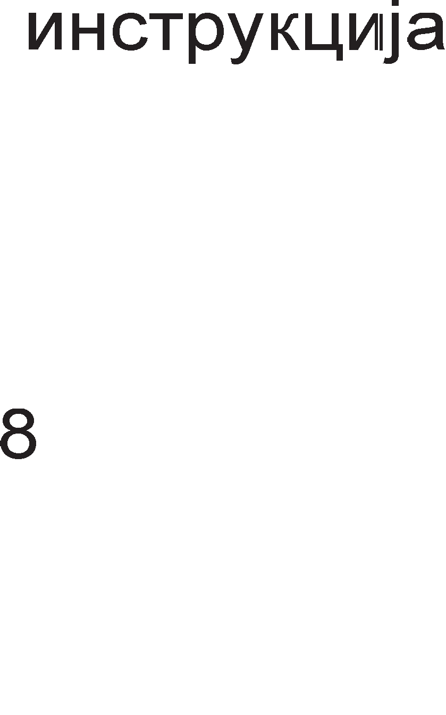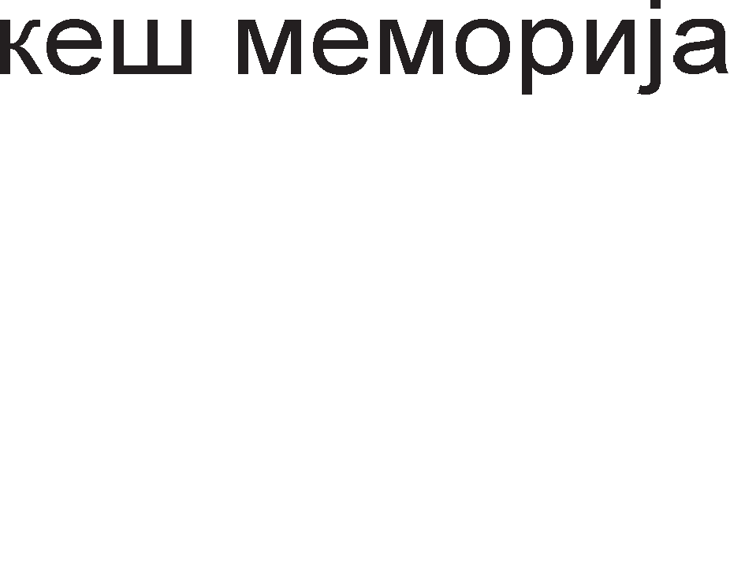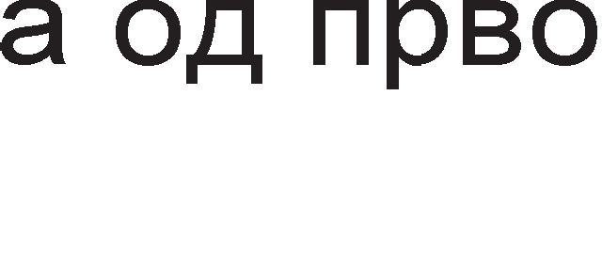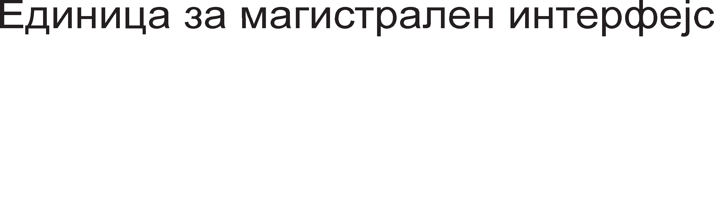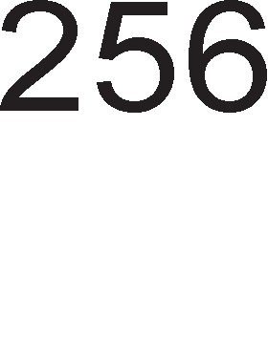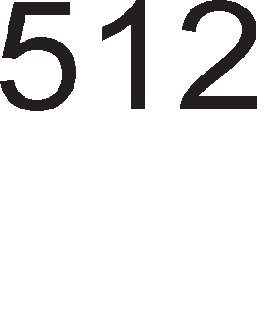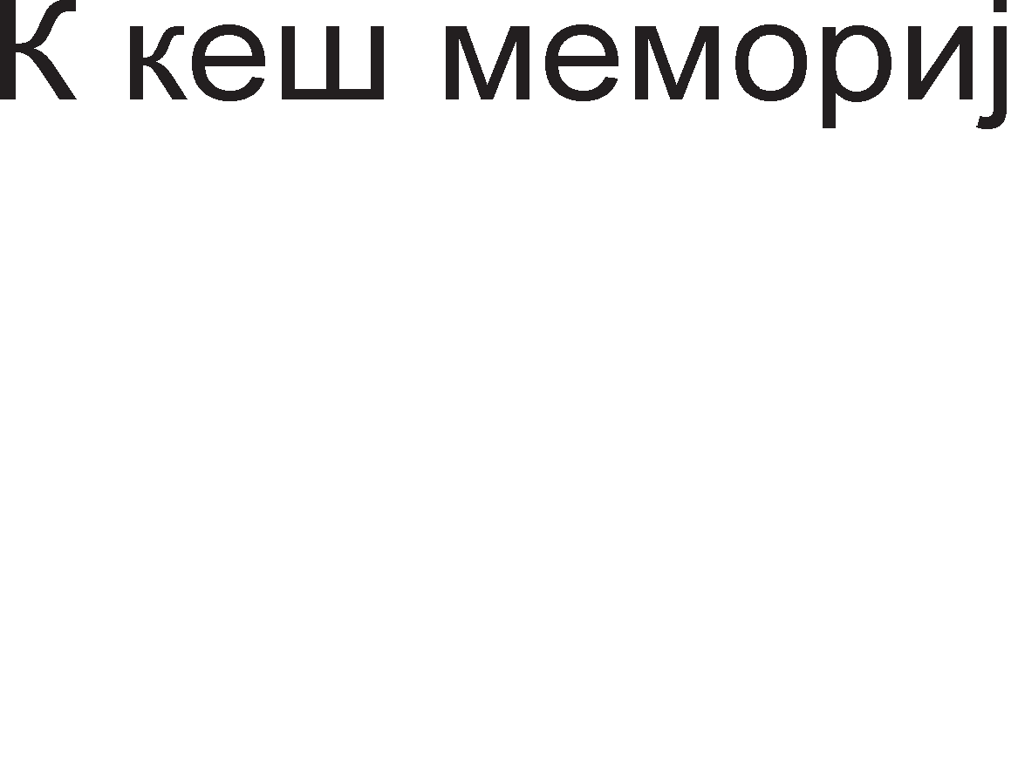

Cn1Ka 9.12. ApX1TeKTypa Ha neHT1yM npo M1KponpoLecop

Ep1H1LaTa 3a Mafl1cTpaneH 1HTepcpejc fl1 fleHep1pa MeMop1cK1Te appec1 1 KoHTponH1Te c1flHan1 1 pocTaByBa nopaToL1 1n1 1HcTpyKL11 po pBeTe Kew-MeMop11 op npBo H1Bo.

**E,qMHM4aTa 3a npMcpai<a1-e Ha MHcTpyK4MjaTa M Hej3MHo ,qeKo,qMpa1-e** ce cocTo1 op Tp1 peKopep1, Ko1 Mo>KaT 1cToBpeMeHo pa peKop1paaT Tp1 pa3n1L1H1

1HcTpyKL11. l/l3ne31Te Ha Tp1Te peKopep1 ce noBp3aH1 co 1HcTpyKL1cK1oT 6a3eH Bo Koj 1HcTpyKL11Te ocTaHyBaaT cè popeKa He fl1 np1cpaT1 13BpwHaTa ep1H1La. Bo ep1H1LaTa 3a np1cpai<al-be Ha 1HcTpyKL11Te 1 H1BHo peKop1pal-be nocTo1 noce6Ha nofl1L1Ka ceKL1ja Koja flo MeHyBa TeKoT Ha npoflpaMaTa poKonKy ce noL1pa 1HcTpyKL1ja 3a cKoK. l/lHcTpyKL1cK1oT 6a3eH Bo BHaTpewHocTa Ha M1KponpoLecopoT e Mana MeMop1ja co appec1 Ha noKaL11Te.

BHaTpewHaTa cTpyKTypa Ha **e,qMHM4aTa 3a** np1cpai<al-be 1 3a **M3epwyea1-e** Ha 1HcTpyKL11Te e np1Ka>KaHa Ha cn1Ka 9.13. Ce 3a6ene>KyBa peKa nocTojaT Tp1 13BpwH1 ep1H1L1: pBe 3a Len1 6poeB1 1 epHa 3a 6poeB1 co nopB1>KHa ToL1Ka.

**E,qMHM4aTa 3a pacnope,qyea1-e** fl1 noppepyBa, npaB1 n1cTa Ha 1HcTpyKL11Te wTo Tpe6a pa ce 13BpwaT. Taa e noBp3aHa co 1HcTpyKL1cK1oT 6a3eH op Kape wTo fl1 3eMa peKop1paH1Te, Ho He13BpweH1 1HcTpyKL11.

Co **MHcTpyK4McKMoT 6a3eH** e noBp3aHa 1 ep1H1LaTa 3a noBneKyBal-be. Taa fl1 3eMa 13BpweH1Te 1HcTpyKL11 1 fl1 npepaBa Ha nopaToL1HaTa Kew-MeMop1ja op npBo H1Bo.

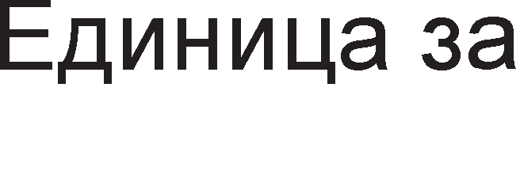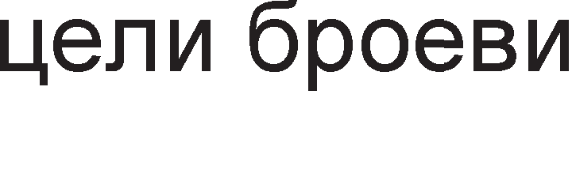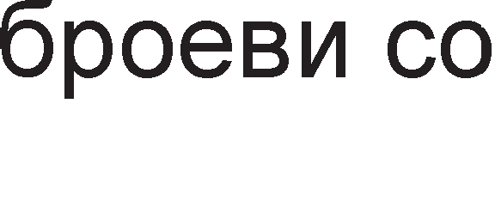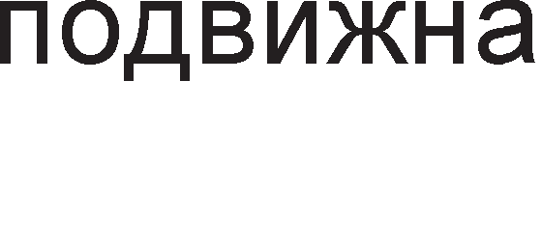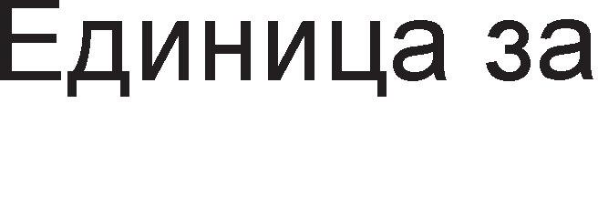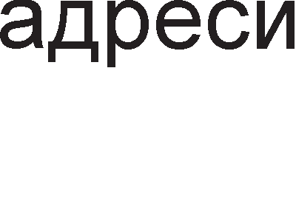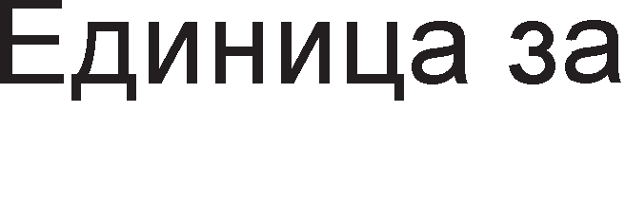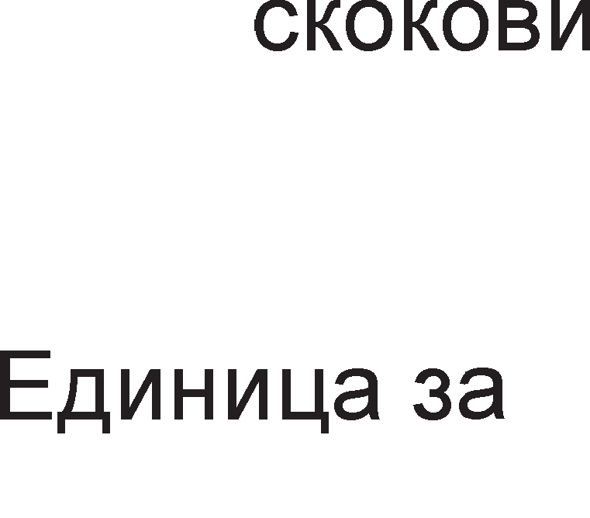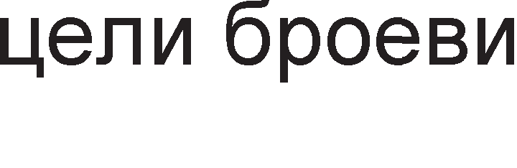



Cn1Ka 9.13. Ep1H1La 3a np1cpai<al-be 1 13BpwyBal-be Ha 1HcTpyKL11Te

**MeMopMjaTa Ha neHTMyM npo** M1KponpoLecopoT e nopeneHa Bo ocyM MeMop1cK1 6aHK1. CeKoja noKaL1ja op 6aHK1Te Mo>Ke pa co6epe 1HcpopMaL1ja op epeH 6ajT 1 ceKoja 6aHKa 1Ma BKyneH KanaL1TeT op 8GB. OBa 3HaL11 peKa KanaL1TeToT Ha MeMop1jaTa 3a neHT1yM npo M1KponpoLecop 13HecyBa 64GB. Appec1pal-beTo e oBo3Mo>KeHo co BoBepyBal-be pononH1TenH1 appecH1 n1H11 op A32 po A35, wTo 3HaL11

BKynHo 36 appecH1 n1H11 (236 = 64GB). neHT1yM npo M1KponpoLecopoT Kop1cT1 64-

61THa nopaToL1Ha Mafl1cTpana Koja cny>K1 3a npeHoc Ha ocyMTe 6ajT1 op ocyMTe MeMop1cK1 6aHK1. 61peji<1 appecH1oT npocTop e 3floneMeH 3floneMeHa e 1 floneM1HaTa Ha cTpaH1L1Te Ha 2MB. l/lcTo KaKo 80476 1 neHT1yM I M1KponpoLecop1Te, neHT1yM npo Kop1cT1 BHaTpewHa KoHTpona Ha napHocT, opHocHo noKpaj ocyHTe 61ToB1 Bo ceKoja MeMop1cKa noKaL1ja popapeH e ywTe epeH 61T 3a KoHTpona Ha napHocTa.

HoB1Ha Kaj neHT1yM npo M1KponpoLecopoT e BHaTpewHoTo **Ko11o 3a KopeK4Mja Ha rpewKM** (EEC Error Correction Circuit). OBa Kono oBo3Mo>KyBa peTeKL1ja Ha pBe 61T flpewK1 1 KopeKL1ja Ha epHa 61T flpewKa. 3a pa ce nocT1flHe oBa noTpe6H1 ce ocyM pononH1TenH1 61ToB1, Ko1 ce popapeH1 Ha 64-61TH1Te 6poeB1. OB1e pononH1TenH1 ocyM 61ToB1 flo copp>KaT KopoT 3a aBToMaTcKa KopeKL1ja Ha flpewKa. EEC KopoB1Te ce MHofly poBepn1B1 1 L1ecTo ce Kop1cTaT Kaj coBpeMeH1Te KoMnjyTep1. Ep1HcTBeH HepocTaToK e LeHaTa Ha SDRAM MeMop1jaTa co w1poL11Ha op 72 61ToB1 (64-61TeH nopaToK+8-61TeH Kop).

# neHTMyM 2 MMKponpo4ecop

Op npeTXopH1Te M1KponpoLecop1, neHT1yM 2 M1KponpoLecopoT ce pa3n1KyBa no Toa wTo Toj He e BflpapeH Bo MaT1L1HaTa nnoL1a, TyKy nocTo1 **cne4Mja11Ho ,qM3ajHMpaHo n11acTM"1Ho no,qHo>Kje** (cnoT) Bo Koe ce nocTaByBa M1KponpoLecopoT. Pa6oTHaTa cppeKBeHL1ja ce pB1>K1 Bo flpaH1L1Te op 233MHz po 450MHz co 6p31Ha Ha Mafl1cTpanaTa op 66MHz po 100MHz. KanaL1TeToT Ha Kew-MeMop1jaTa op BTopo H1Bo Mo>Ke pa 61pe 512KB,1MB 1n1 2MB. neHT1yM 2 M1KponpoLecopoT Kop1cT1 64-**6MTHa no,qaTo"1Ha MarMcTpa11a M 36-6MTHa a,qpecHa MarMcTpa11a.** Kew-MeMop1jaTa op npBo H1Bo e co KanaL1TeT 32KB, Ho **Kew-MeMopMjaTa o,q eTopo HMeo He e eei<e eo McToTo MHTerpMpaHo Ko11o Ha MMKponpo4ecopoT**, 1aKo T1e ce MHofly 6n1cKy epeH po ppyfl, Bo 1cTo naKyBal-be. Ha BaKoB HaL11H ecpeKT1BHocTa 3apoBonyBa, a LeHaTa Ha M1KponpoLecopoT ce HaManyBa. 6p31HaTa Ha Kew-MeMop1jaTa e pBanaT1 noMana op 6p31HaTa Ha neHT1yM 2 M1KponpoLecopoT. AKo M1KponpoLecopoT 1Ma pa6oTHa cppeKBeHL1ja 400MHz, Toflaw Kew-MeMop1jaTa pa6oT1 co 6p31Ha 200MHz. M1KponpoLecopT Celeron e, BcywHocT, Beep31ja Ha neHT1yM 2 M1KponpoLecopoT co Taa pa3n1Ka wTo Toj HeMa Kew-MeMop1ja op BTopo H1Bo. l/lMeHo, oBaa MeMop1ja e noce6Ho 13pBoeHa 1 BflpapeHa Bo MaT1L1HaTa nnoL1a 1 pa6oT1 co 6p31Ha 66MHz. Xeon M1KponpoLecopoT e Hajpo6pa Bep31ja Ha neHT1yM 2 M1KponpoLecopoT, copp>K1 Kew- MeMop1ja op BTopo H1Bo np1 wTo 6p31HaTa Ha Kew-MeMop1jaTa e 1cTa co oHaa Ha M1KponpoLecopoT.

neHT1yM 2 M1KponpoLecopoT 1Ma 242 n1Ha. HaKpaTKo i<e ja o6jacH1Me

**cpyHK4MjaTa Ha** peL11c1 c1Te flpyn1 **nMHoeM** op neHT1yM 2 M1KponpoLecopoT:

r1 MacK1pa no3HaL1ajH1Te appecH1 61ToB1 Hap A20. Ha BaKoB HaL11H ce nocT1flHyBa KoMnaT161nHocT co 8086 M1KponpoLecopoT



* l/l361paaT epHa op ocyMTe MeMop1cK1 6aHK1.



* l/l361paaT noKaL1ja op MeMop1cKaTa 6aHKa.



O3HaL1yBa 1cnpai<al-be Ban1pHa appeca.



 AKT1B1pa KoHTpona Ha napHocT Ha appecaTa.

-  C1flHan131pa nojaBa Ha flpewKa Bo appecaTa.

 OppepyBa cppeKBeHL1ja Ha Mafl1cTpana, 66MHz 1n1 100MHz  C1flHan131pa flpewKa Bo Mafl1cTpanH1oT c1cTeM.

ro peceT1pa Mafl1cTpanH1oT c1cTeM.



 (Bus Not Ready) BMeTHyBa p1fl1TcK1 TaKTa Ha L1eKal-be.

BP[3:2] (Breakpoints) C1flHan131paaT nojaBa Ha coBnaral-be Bo pa6oTaTa Ha pefl1cTp1Te 3a pe6afl1pal-be.

 (Bus Prioriy Reques) Ce Kop1cT1 3a pocTaByBal-be Ha 6apal-be 3a Kop1cTel-be Ha c1cTeMKaTa Mafl1cTpana.

-  (Bus Request) C1flHan131pa peKa neHTy1M 2 1cnpaT1n 6apal-be 3a Mafl1cTpana.

- nopaToL1H1 n1HoB1



C1flHan131pa peKa HapBopewH1oT c1cTeM He Mo>Ke pa flo 1cKoMneT1pa Maw1HcK1oT L1Knyc.



- C1flHan131paaT nojaBa Ha flpewKa Bo npeHocoT Ha nopaToL1.  (Data Ready) C1flHan131pa 1cnpai<al-be Ha Ban1peH nopaToK.  C1flHan131pa flpewKa Bo pa6oTaTa Ha HyMep1L1K1oT



KonpoLecop.

 r1 oHecnoco6yBa Kew n1H11Te 3a L11Tal-be 1 n1wyBal-be.

C1flHan131pa ycnewHo npoHajpeH nopaToK Bo Kew MeMop1jaTa.  (Hit Modified) Ce aKT1B1pa co Len pa ce op6eflHe ppyfl1Te ep1H1L1 pa flo Kop1cTaT KewoT popeKa MeMop1jaTa 3an1wyBa



Bo Heflo.

 C1flHan131pa BHaTpewHa flpewKa Bo c1cTeMoT nocne wTo ce 1H1L1pa npeKoH.

 npep13B1KyBa 1flHop1pal-be Ha flpewKaTa Bo pa6oTaTa Ha HyMep1L1K1oT KonpoLecop.

 Ce pecT1pa c1cTeMoT co 1cKnyL1oK Ha Kew MeMop1jaTa, Bne3Ho 13ne3H1Te 6acpep1 1 pefl1cTp1Te 3a 6poeB1 co nopB1>KHa 3an1pKa.

 Ce aKT1B1pa Kofla HeKoj HapBopeweH ypep 6apa npeK1H.

 CTaHyBa nofl1L1Ka Hyna Kofla ce 13BpwyBa 1HcTpyKL1ja co BaKoB npecp1Kc. Ce ynoTpe6yBa HajL1ecTo np1 p1peKTeH np1cTan po MeMop1ja.

NMI HeMacK1paL1K1 npeK1H

PICCLK reHep1pa p1fl1TcK1 TaKT co cppeKBeHL1ja ¼ op cppeKBeHL1jaTa Ha n1HoT BCLK.

-  (Performance Monitor) Ce Kop1cTaT np1 TecT1pal-be Ha nepcpopMaHc1Te Ha M1KponpoLecopoT.



PRDY (Probe Ready) C1flHan131pa BKnyL1eHo pe6afl1pal-be.

 (Probe Request) Ce aKT1B1pa np1 6apal-be 3a pe6afl1pal-be.

- (Request Signal) Cny>KaT 3a KoMyH1KaL1ja Mery KoHTponepoT Ha Mafl1cTpan1 1 M1KponpoLecopoT.



 l/lH1L1pa 13BpwyBal-be Ha cocpTBep co noL1eTHa appeca

FFFFFFF0H 1n1 000FFFFF0H.

 (Request Parity) Ce aKT1B1pa np1 6apal-be Ha KoHTpona Ha napHocT.

-  (Reguest Status) Ce aKT1B1paaT np1 6apal-be 3a np1Ka>KyBal-be Ha cocToj6aTa Ha M1KponpoLecopoT.



npoLecopoT BneflyBa Bo pe>K1M Ha M1pyBal-be (Sleep).



(System Management Interrupt) M1KponpoLecopoT BneflyBa Bo Mop Ha c1cTeMcK1 MeHa1,MeHT.



(Thermal Sensor Trip) Ce aKT1B1pa aKo TeMnepaTypaTa Ha M1KponpoLecopoT ce 3floneM1 Hap 130oC.



TMS (Test Mode Select) l/l361pa B1p Ha pe>K1M 3a TecT1pal-be.

 (Target Ready) npep13B1KyBa M1KponpoLecopoT pa 3anoL1He onepaL1ja Ha noBpaTHo n1wyBal-be.

-  (Voltage Data) n1HoB1 3a HanojyBal-be 1 3a3eMjyBal-be.



3a KoHTpona Ha npeHocoT Ha nopaToL1 Mery neHT1yM 2 M1KponpoLecopoT 1 MeMop1jaTa ce Kop1cT1 **"1Mn ceT** 440LX 1n1 440BX. Ll1n ceToT e nocpepH1K Bo KoMyH1KaL1jaTa, 3a pa3n1Ka op Tpap1L1oHanH1oT HaL11H Ha KoMyH1KaL1ja Kape M1KponpoLecopoT e p1peKHo noBp3aH 3a MeMop1jaTa. Ha cn1Ka 9.14. e np1Ka>KaHa cTpyKTypaTa Ha **neHTMyM 2 KoMnjyTepcKM cMcTeM** 3aepHo co c1Te B1poB1 Ha Mafl1cTpan1.

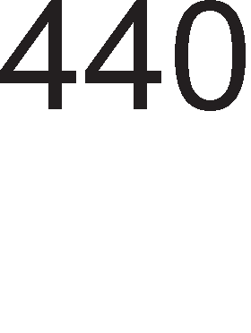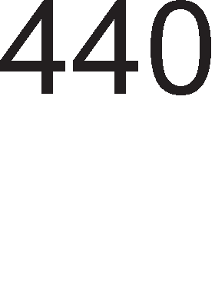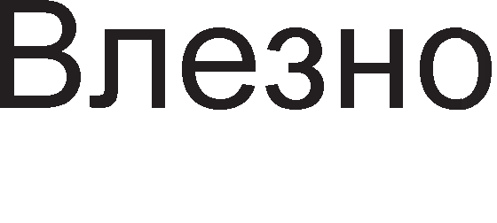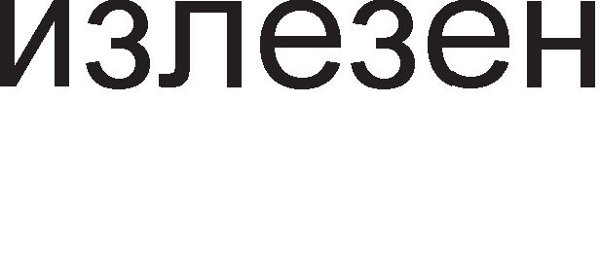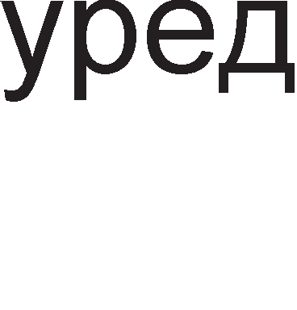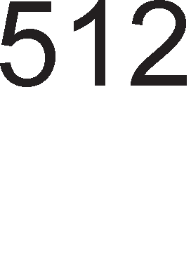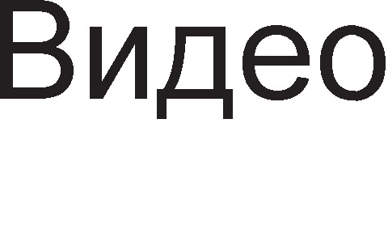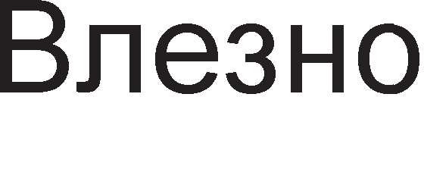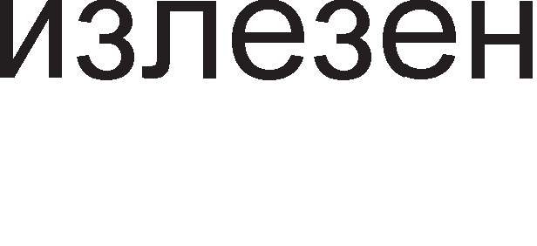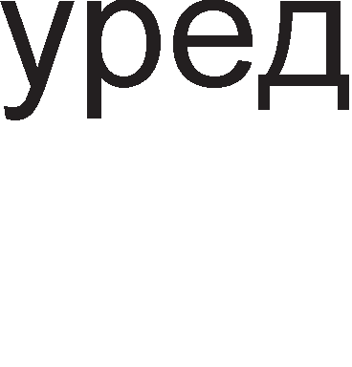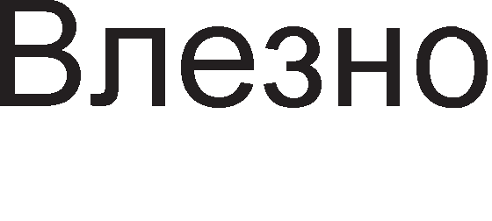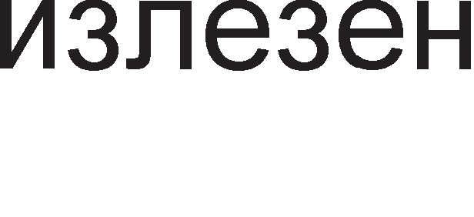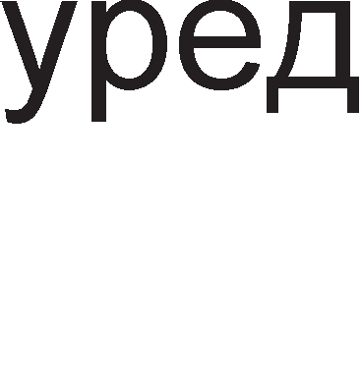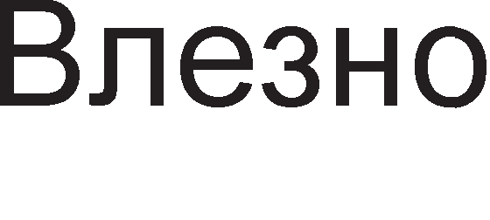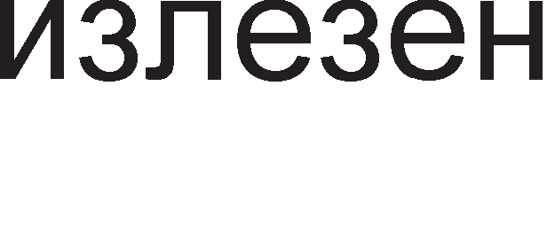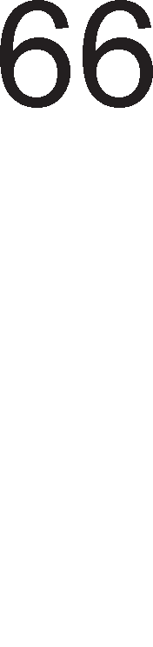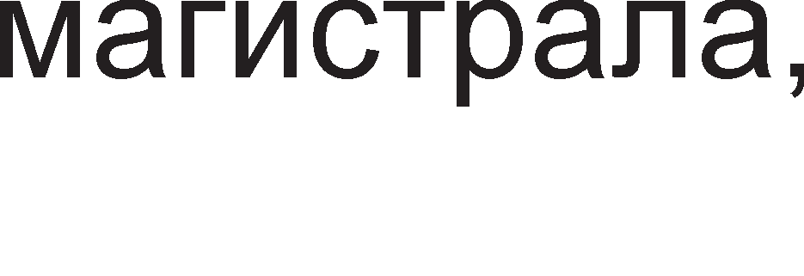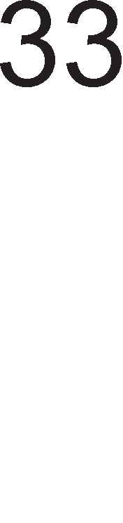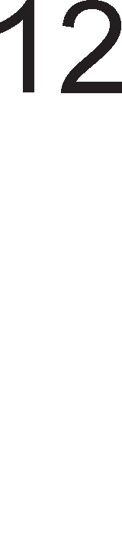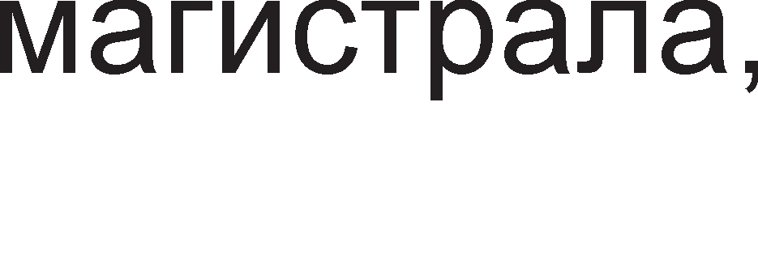

Cn1Ka 9.14. CTpyKTypa Ha neHT1yM 2 KoMnjyTepcK1 c1cTeM

ISA (Industrial Standard Architecture) e HajcTap B1p Ha Mafl1cTpana, co w1poL11Ha op 8 1n116 61ToB1 1 ce Kop1cT1 3a noBp3yBal-be Ha 6aBH1 nep1cpepH1 ypep1 1n1 MeMop11 co pa6oTHa cppeKBeHL1ja po 8MHz. Bo 1pH1Ha oBaa Mafl1cTpana i<e 61pe 3aMeHeTa co USB (Universal Serial Bus) Mafl1cTpanaTa, Koja Mo>Ke pa 61pe co pBa pa3n1L1H1 nponycH1 once31: 1.5Mbps 1n1 12Mbps (bit per second-61T Bo ceKyHpa). PCI (Peripheral Component Interconnect) nopp>KyBa 32 1 64-61TH1 npeHoc1 Mery M1KponpoLecopoT 1 nep1cpepH1Te ypep1 1n1 MeMop1jaTa, co pa6oTHa cppeKBeHL1ja po 33MHz. AGP (Accelerated Graphics Port) Mafl1cTpanaTa 1Ma 1cTa pa6oTHa cppeKBeHL1ja KaKo 1 M1KponpoLecopoT, nponyceH oncefl op 528M 6ajT1 Bo ceKyHpa 1 ce Kop1cT1 1cKnyL11Bo 3a noBp3yBal-be Ha B1peo KapTaTa co MeMop1cK1oT c1cTeM.

# neHTMyM 3 MMKponpo4ecop

OcHoBH1 KapaKTep1cT1K1 Ha neHT1yM 3 M1KponpoLecopoT ce: npeHoc Ha L1eT1p1

64 61TH1 nopaToL1 3a BpeMe op epeH p1fl1TcK1 TaKT np1 pa6oTHa cppeKBeHL1ja op 133MHz, pBe Kew MeMop11 op npBo H1Bo co KanaL1TeT op no 16KB 1 epHa Kew MeMop1ja op BTopo H1Bo co KanaL1TeT op 512 KB, noppwKa Ha SSE 1HcTpyKL11 1 npepB1pyBal-be Ha flpaHel-ba Bo npoflpaM1Te.

Kaj M1KponpoLecopoT neHT1yM 3, 13BpwyBal-beTo Ha 1HcTpyKL1jaTa e nopeneHo Ha **e,qMHaeceT cpa3M.** Bo noHaTaMowH1oT TeKcT ce o6jacHeT1 c1Te cpa31 op 13BpwyBal-beTo Ha 1HcTpyKL1jaTa.

npB1Te Tp1 cpa31 cny>KaT 3a **npeHoc M npee3eMa1-e Ha MHcTpyK4MjaTa**. Ha cn1Ka 9.15. e np1Ka>KaH 6noK p1jaflpaMoT Ha ep1H1LaTa 3a npeHoc Ha 1HcTpyKL1jaTa.

* <la3a 1: Bo 6p31oT 1HcTpyKL1cK1 6acpep ce BHecyBa epHa Kew n1H1ja op 1HcTpyKL1cKaTa Kew MeMop1ja L1. Kew n1H1jaTa e floneMa 256 61ToB1.
* <la3a 2:Op Kew n1H1jaTa ce 13pBojyBa 1HcTpyKL1jaTa. 61peji<1 1HcTpyKL11Te ce co npoMeHn1Ba pon>K1Ha ce 13pBojyBaaT npB1Te 128 61ToB1. AoKonKy ce pa6oT1 3a 1HcTpyKL1ja 3a flpaHel-be (branch) appecaTa ce cMecTyBa Bo 6acpepoT 3a 1HcTpyKL11 3a flpaHel-be op Kape M1KponpoLecopoT nopoLHa i<e ja noB1Ka.
* <la3a 3: 3a TeKoBHaTa 1HcTpyKL1ja ce 61pa epeH op Tp1Te peKopep1.

nocne npeHocoT Ha 1HcTpyKL1jaTa 1cTaTa Tpe6a pa ce peKop1pa 1 3a Taa Len ce noTpe6H1 pBe cpa31.

* <la3a 4: 3a peKop1pal-be Ha 1HcTpyKL1jaTa ce Kop1cT1 epeH op Tp1Te peKopep1 wTo 3HaL11 peKa 1cToBpeMeHo Mo>KaT pa ce peKop1paaT Tp1 1HcTpyKL11. KaKo pe3ynTaT op peKop1pal-beTo ce po61BaaT HeKonKy M1Kpo1HcTpyKL11.
* <la3a 5: M1Kpo1HcTpyKL11Te ce BHecyBaaT Bo 1HcTpyKL1cKaTa pep1La. AKo op epHa 1HcTpyKL1ja ce po61jaT noBei<e op wecT M1Kpo1HcTpyKL11 oBaa cpa3a Tpe6a pa ce noBTop1.

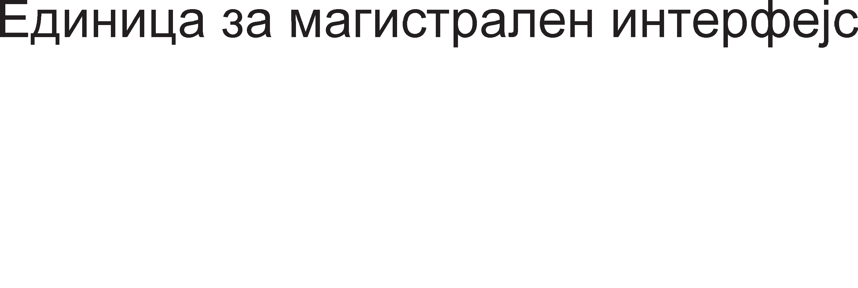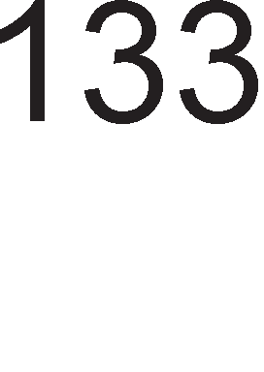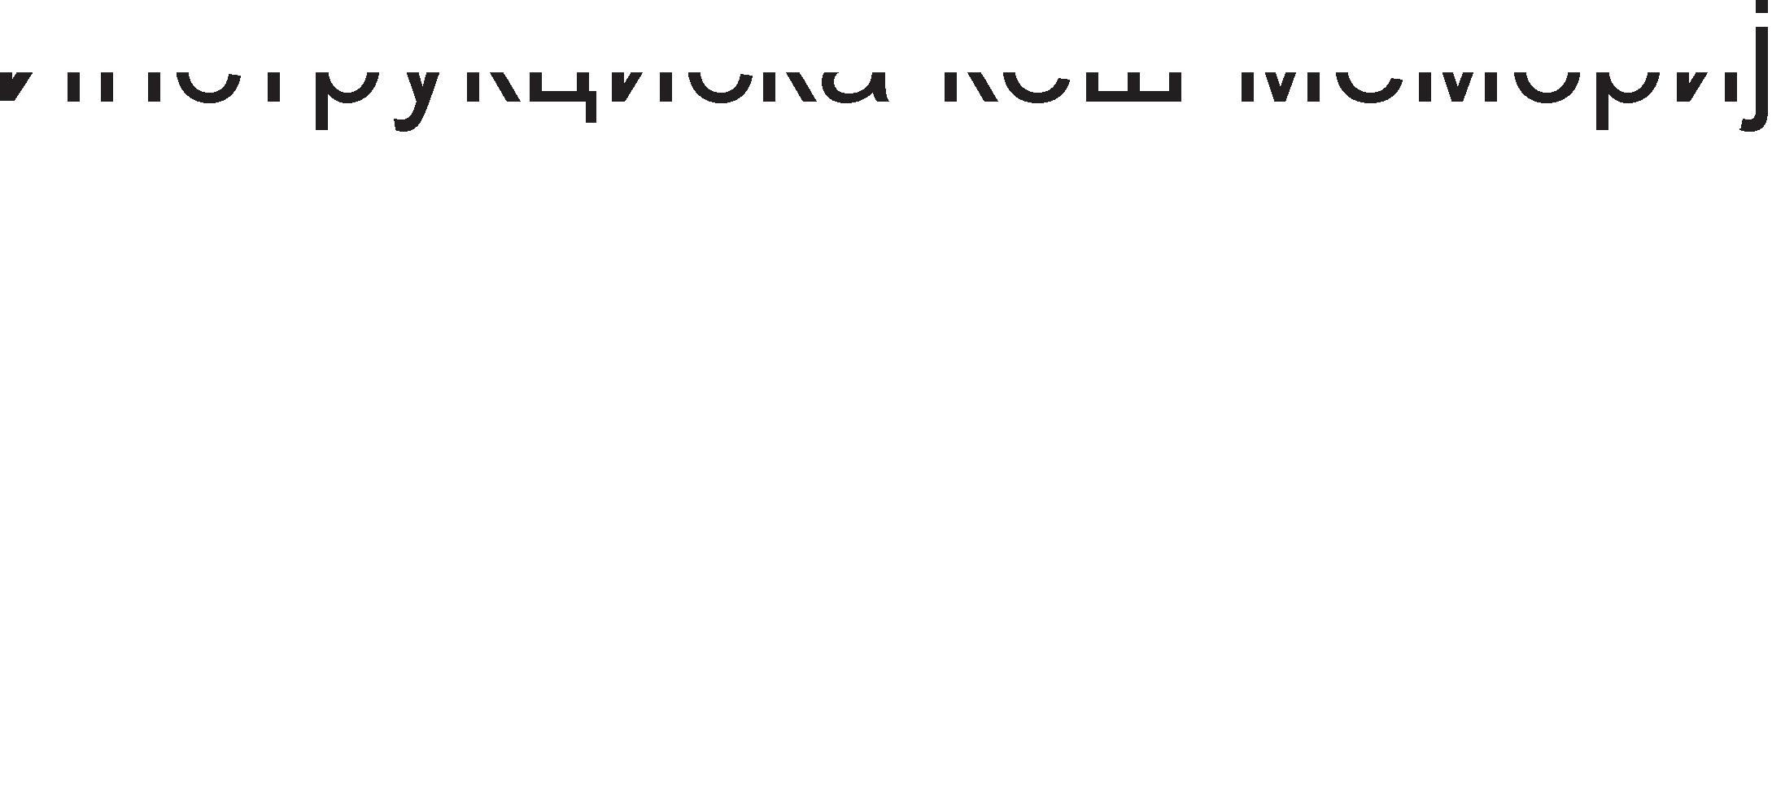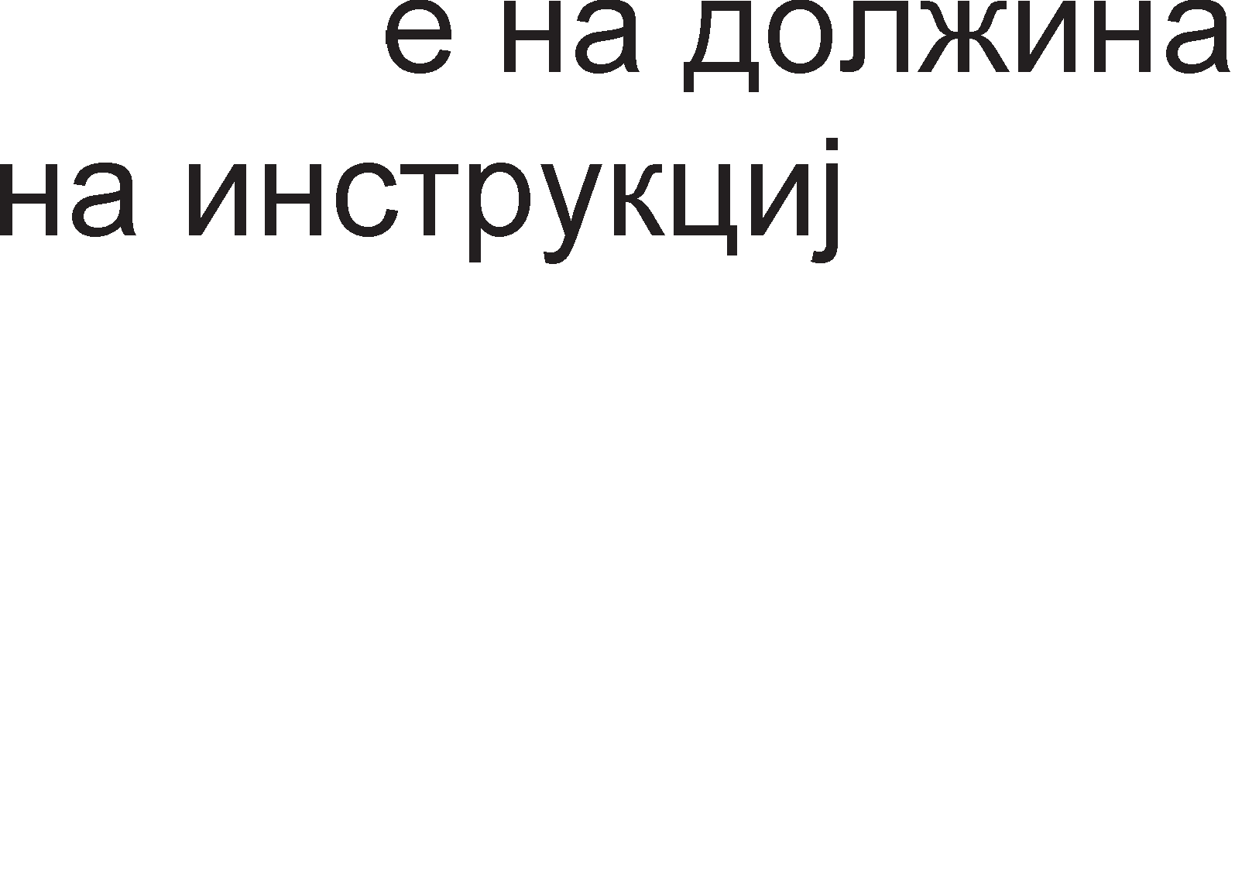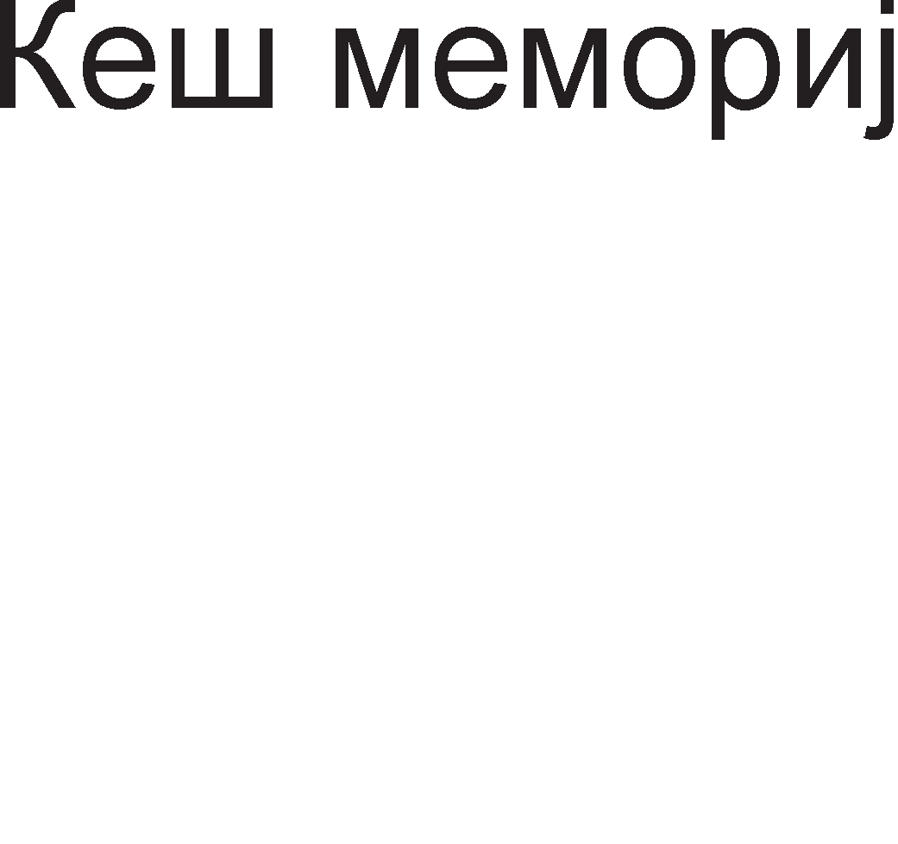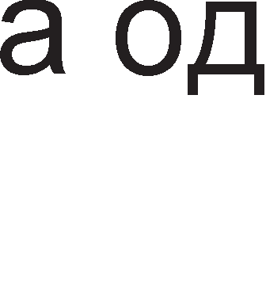

Cn1Ka 9.15. Ep1H1La 3a npeHoc Ha 1HcTpyKL1ja Kaj neHT1yM 3 M1KponpoLecop

Ha cn1Ka 9.16. e np1Ka>KaH 6noK p1jaflpaMoT Ha **e,qMHM4aTa 3a ,qeKo,qMpa1-e M e,qMHM4aTa 3a peMMeHyea1-e.**

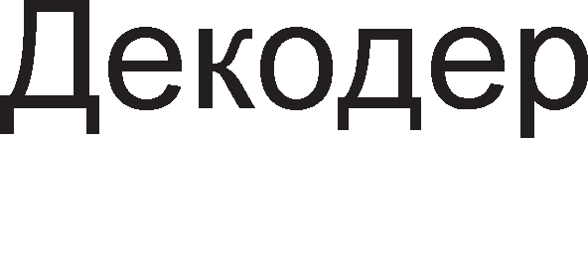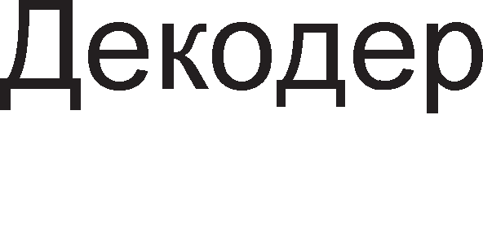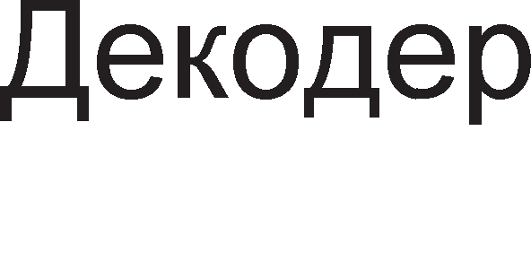

Cn1Ka 9.16. Ep1H1La 3a peKop1pal-be 1 pe1MeHyBal-be Kaj neHT1yM 3 M1KponpoLecop



* <la3a 6: 61peji<1 1HcTpyKL11Te He ce 13BpwyBaaT no 1cT1oT pepocnep no Ko1 ce Han1waH1 Bo npoflpaMaTa TewKo e pa ce npaT1 cocToj6aTa Ha pefl1cTp1Te. nopap1 Toa Ha ceKoja M1Kpo1HcTpyKL1ja 1 ce popenyBa no epeH op 40 BHaTpewH1 pefl1cTp1.
* <la3a 7: M1Kpo1HcTpyKL11Te ce BHecyBaaT Bo 6acpepoT **(reoder buffer**) HenoppepeH1, 6e3 pa ce Bop1 cMeTKa 3a H1BH1oT pepocnep. Op oBoj 6acpep M1Kpo1HcTpyKL11Te ce BHecyBaaT Bo ep1H1LaTa 3a pacnopepyBal-be, nop ycnoB pa ce pocTanH1 c1Te nopaToL1 3a 13BpwyBal-be Ha 1HcTpyKL1jaTa 1 pa 1Ma cno6opeH Bne3 Bo ep1H1LaTa 3a pacnopepyBal-be.
* <la3a 8: Bo oBaa cpa3a M1Kpo1HcTpyKL1jaTa Mopa pa 61pe Bo ep1H1LaTa 3a pacnopepyBal-be 1 Taa ce 1cnpai<a po coopBeTHaTa 13BpwHa ep1H1La. Ep1H1LaTa 3a pacnopepyBal-be e noBp3aHa co 13BpwH1Te ep1H1L1 npeKy L1eT1p1 nopT1.
* <la3a 9: M1KponpoLecopoT neHT1yM 3 1Ma **neT M3epwHM e,qMHM4M**: pBe ep1H1L1 3a Len1 6poeB1, pBe ep1H1L1 3a 6poeB1 co nopB1>KHa 3an1pKa 1 pBe ep1H1L1 3a KoMyH1KaL1ja co MeMop1ja. 3a 13BpwyBal-be Ha ceKoja 1HcTpyKL1ja e noTpe6Ho BpeMe op epeH p1fl1TcK1 TaKT.
* <la3a 10: **E,qMHM4aTa 3a noe11eKyea1-e** npoBepyBa Ko1 M1Kpo1HcTpyKL11 op 6acpepoT 6e3 pepocnep ce 13BpweH1
* <la3a 11: Ep1H1LaTa 3a noBneKyBal-be fl1 Tpfla 13BpweH1Te M1Kpo1HcTpyKL11 op 6acpepoT 6e3 pepocnep 1 fl1 noppepyBa oHaKa KaKo wTo 6one Han1waH1 Bo npoflpaMaTa. OBa e np1Ka>KaHo Ha cn1KaTa 9.17.

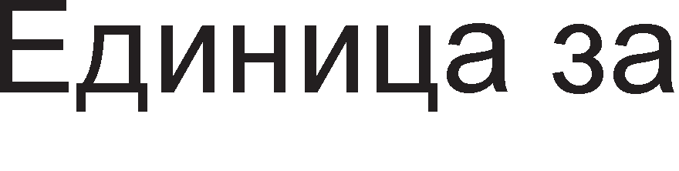

Cn1Ka 9.17. <lyHKL1ja Ha ep1H1LaTa 3a noBneKyBal-be

# neHTMyM 4 MMKponpo4ecop

no apX1TeKTypaTa M1KponpoLecopoT neHT1yM 4 e MHofly cn1L1eH co neHT1yM npo M1KponpoLecopoT. npB1oT neHT1yM 4 M1KponpoLecop 1Man pa6oTHa cppeKBeHL1ja op 1,3GHz, a peHewH1Be M1KponpoLecop1 ce co 3,2,GHz pa6oTHa cppeKBeHL1ja. nocTojaT pBe naKyBal-ba op: 423-n1HcKo PGA 1 478-n1HcKo FC-PGA2.

Ha cn1Ka 9.18. e np1Ka>KaHa **apxMTeKTypaTa Ha neHTMyM 4** M1KponpoLecop. C1cTeMcKaTa Mafl1cTpana e co nponyceH oncefl 3,2GB/s. W1poL11HaTa Ha Mafl1cTpanaTa 13HecyBa 64 61Ta 1 pa6oTHaTa cppeKBeHL1ja e 100MHz. Ho Hej31HaTa 6p31Ha e L1eT1p1 naT1 nofloneMa op cppeKBeHL1jaTa 61peji<1 3a BpeMe op epeH p1fl1TcK1 TaKT ce npeHecyBaaT L1eT1p1 nopaToL1, na peanHo Mafl1cTpanaTa i<e npeHecyBa KaKo pa 1Ma cppeKBeHL1ja op 400MHz. OBa TeXH1Ka e no3HaTa nop 1MeTo Quad Data Rate (QDR) wTo Bo npeBop 3HaL11 **Kea,qpaHTeT no,qaTo"1eH nponyceH oncer**. Kew MeMop1jaTa op BTopo H1Bo Mo>Ke pa 61pe co KanaL1TeT 256KB, 512KB, 1MB 1n1 2MB, a nopaToL1HaTa Kew MeMop1ja op npBo H1Bo 8KB 1n1 16KB.

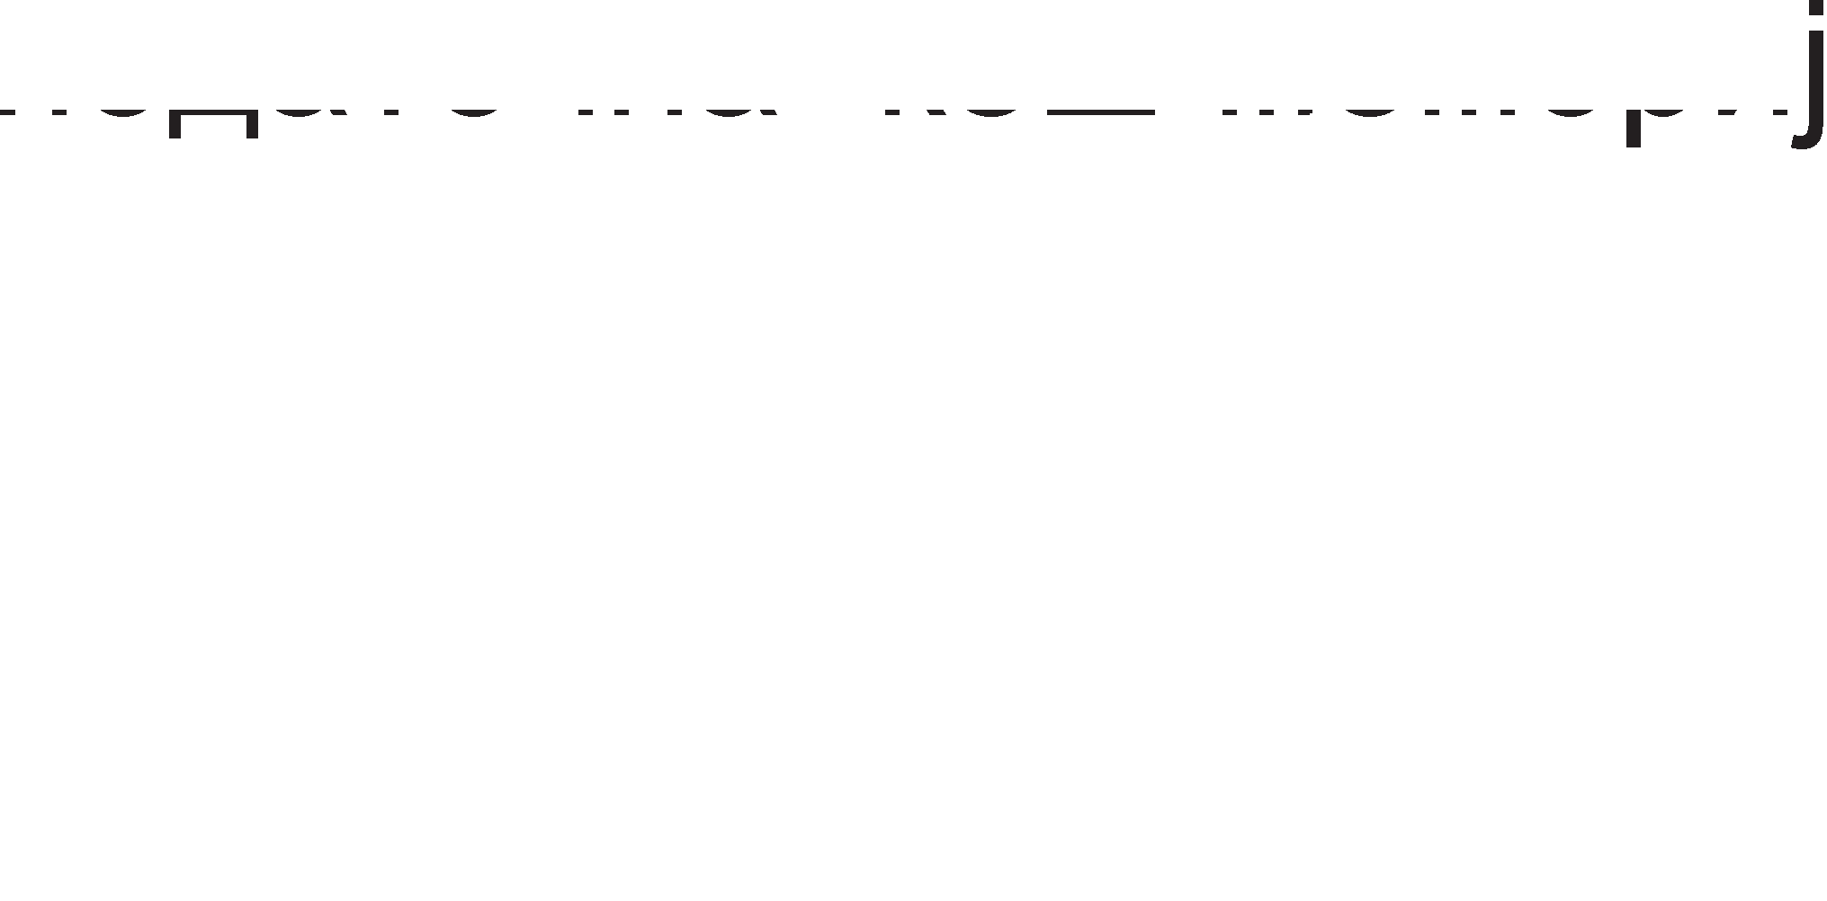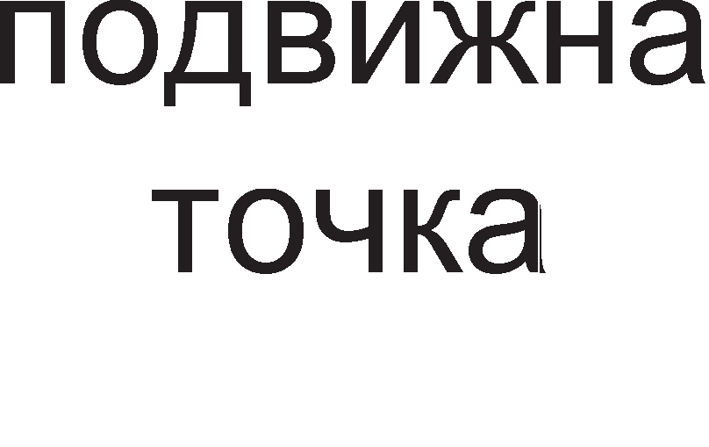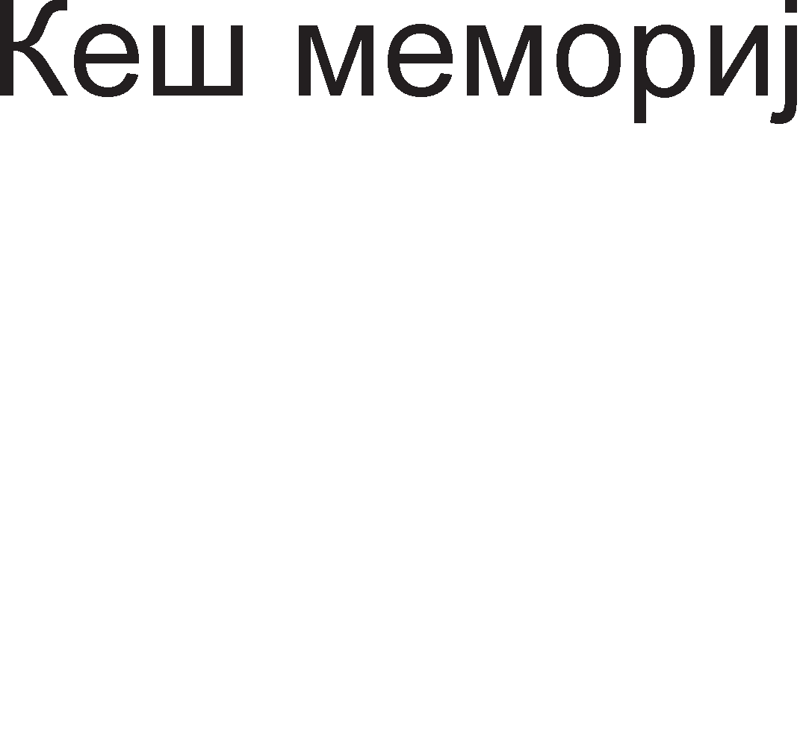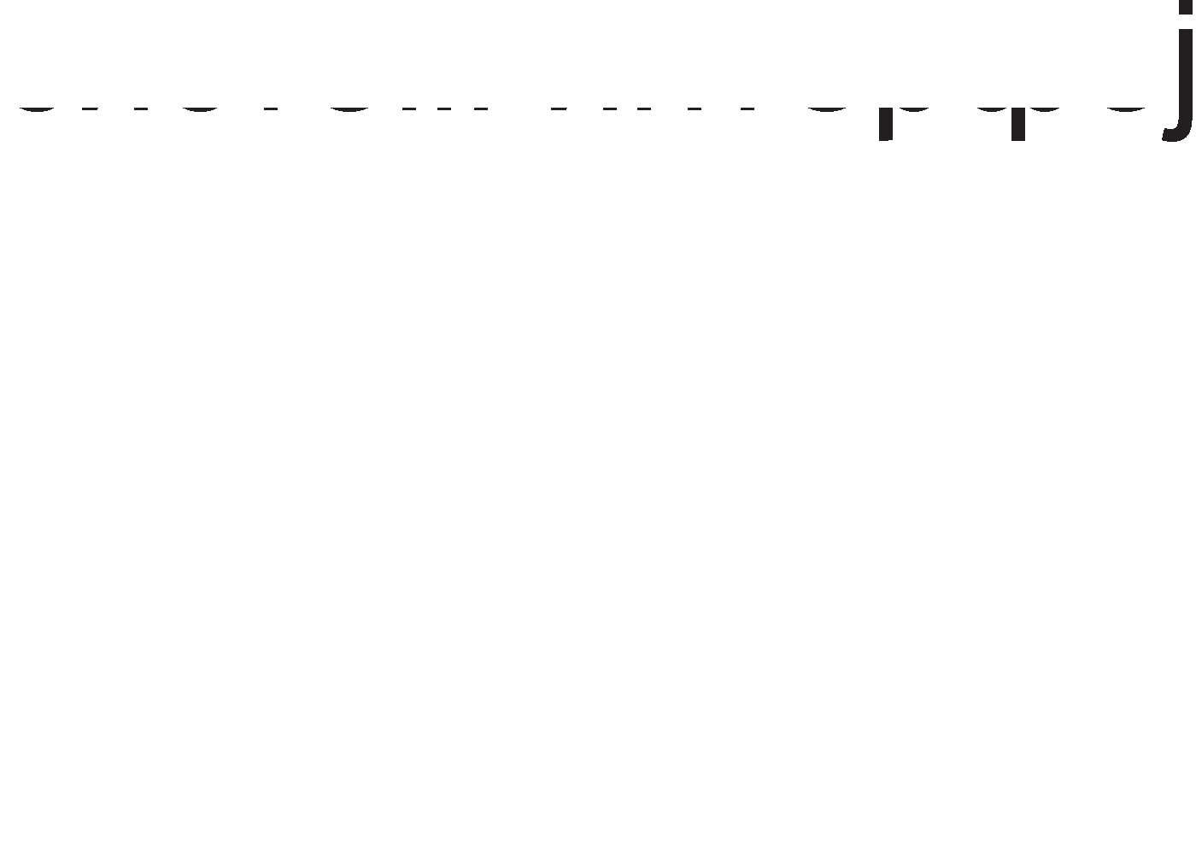

Cn1Ka 9.18. ApX1TeKTypa Ha neHT1yM 4 M1KponpoLecop

Mo>Ke61 HeKoj i<e noM1cn1 peKa neHT1yM 4 M1KponpoLecopoT HeMa 1HcTpyKL1cKa Kew MeMop1ja. TaKBa MeMop1ja nocTo1, Ho Taa ce Haora nocne 1HcTpyKL1cK1oT peKopep 1 e no3HaTa nop 1MeTo **Kew MeMopMja Ha TparoeM**. Taa Bo ce6e Mo>Ke pa L1yBa 12K

M1Kpo1HcTpyKL11. 61peji<1 epHa M1Kpo1HcTpyKL1ja e 100 61ToB1, KanaL1TeToT Ha Kew MeMop1jaTa co TpafloB1 13HecyBa 150KB. nocTaByBal-beTo Ha 1HcTpyKL1cKaTa Kew MeMop1ja nocne peKopepoT flo ,,wTep1” peKopepoT op nocTojaHo peKop1pal-be Ha 1HcTpyKL11 Koj nocTojaHo ce noBTopyBaaT KaKo wTo ce 1HcTpyKL11Te 3a L1Knyc1. npep Kew MeMop1jaTa co TpafloB1 nocTaBeH1 ce pBa 6acpep1: BTB (Branch Target Buffer) 1 TLB (Translation Lookside Buffer). **BTB 6acpepoT** npecTaByBa Mana MeMop1ja Koja fl1 copp>K1 appec1Te noB1KaH1Te cKoK 1n1 1HcTpyKL11 3a flpaHel-be.

AeKopepoT Mo>Ke pa o6pa6oT1 epHa 1HcTpyKL1ja 3a BpeMe op epeH p1fl1TcK1 TaKT. AKo peKop1paHaTa 1HcTpyKL1ja e cno>KeHa Mo>Ke pa ce po61jaT noBei<e op L1eT1p1 M1Kpo1HcTpyKL11. M1Kpo1HcTpyKL11Te ce npenpai<aaT po ROM MeMop1jaTa Koja BcywHocT fl1 paBa KoHTponH1Te c1flHan1 noTpe6H1 pa ce 13Bpw1 1HcTpyKL1ja. Kew MeMop1jaTa Mo>Ke pa 1cnpaT1 no Tp1 M1Kpo1HcTpyKL11 3a BpeMe Ha epeH p1fl1TcK1 TaKT po ep1H1LaTa 3a pe1MeHyBal-be 1 penoKaL1ja.

**E,qMHM4aTa 3a 11o4Mpa1-e** Bpw1 nopfloToBKa Ha pecypc1Te 3a pa ce 61pe cnpeMHo Kofla M1Kpo1HcTpyKL1jaTa i<e np1cT1flHe co 13BpwHaTa ep1H1La. Ep1H1LaTa 3a noL1pal-be pe3epB1pa epeH op 126 6acpep1 3a ceKoja M1Kpo1HcTpyKL1ja, npeKy Koja ja npaT1 Hej31HaTa cocToj6a. M1Kpo1HcTpyKL11Te Mo>Ke pa ce 13BpwyBaaT 6e3 pa ce Bop1 cMeTKa 3a pepocnepoT 61peji<1 oTKaKo i<e ce 13BpwaT M1KponpoLecopoT i<e fl1 noppep1 Kop1cTeji<1 fl1 ToKMy oB1e 6acpep1. Ep1H1LaTa 3a noL1pal-be pe3epB1pa BHaTpewH1 pefl1cTp1 3a cMecTyBal-be Ha pe3ynTaToT po61eH op 13BpwyBal-beTo Ha M1Kpo1HcTpyKL1jaTa. **PerMcTpMTe ce no,qe11eHM eo HeKo11Ky rpynM**: MeMop1cK1, pefl1cTp1 3a pa6oTa co Len1 6poeB1 1 pefl1cTp1 3a 6poeB1 co nopB1>KHa 3an1pa. Ha cn1Ka 9.18. pefl1cTp1Te 3a pa6oTa co nopB1>KHa 3an1pKa ce 6ene>KaT co 6yKB1Te FP wTo e KpaTeHKa op aHfln1cK1Te 36opoB1 Flating Point (npeBop-nopB1>KHa 3an1pKa). AoKonKy ce pa6oT1 3a LOAD 1n1 STORE 1HcTpyKL1ja Toflaw ep1H1LaTa 3a noL1pal-be i<e pe3eB1pa epeH op 48-Te 6acpep1 3a nonHel-be (load) 1n1 epeH op 24-Te 6acpep1 3a cKnap1pal-be (store), Bo 3aB1cHocT op Toa pan1 i<e ce L11Ta 1n1 n1wyBa Bo MeMop1jaTa.

l/lHTepecHa cpyHKL1ja 1Ma 1 **e,qMHM4aTa 3a pe11oKa4Mja**. neHT1yM M1KponpoLecopoT 1Ma 32 pefl1cTp1 Ko1 ce B1pn1B1 3a npoflpaMepoT: EAX, EBX, ECX, EDX, EDI, ESI, EBP 1 ESP. OBoj 6poj e npeMan noce6Ho aKo ce 3eMe Bo npepB1p peKa He nocTo1 nocnepoBaTenHocT Bo 13BpwyBal-beTo Ha 1HcTpyKL11Te. nopap1 Toa oB1e pefl1cTp1 ce pe1MeHyBaaT Bo epeH op 256 BHaTpewH1 pefl1cTp1, 128 pefl1cTp1 3a Len1 6poeB1 1 128 pefl1cTp1 3a 6poeB1 co nopB1>KHa 3an1pKa. Ep1H1LaTa 3a pe1MeHyBal-be Mo>Ke pa o6pa6oTyBa Tp1 M1Kpo1HcTpyKL11 3a epeH p1fl1TcK1 TaKT. Pe1MeHyBaH1Te 1 noL1paH1 M1Kpo1HcTpyKL11 BneflyBaaT Bo pep1LaTa 3a M1Kpo1HcTpyKL11 Kape wTo L1eKaaT pa fl1 npeB3eMe ep1H1LaTa 3a pacnopepyBal-be.

**E,qMHM4aTa 3a pacnope,qyea1-e** fl1 noppepyBa M1Kpo1HcTpyKL11Te no pepocnepoT no Ko1 61ne peKop1paH1. Bo Kew MeMop1jaTa Ha TpafloB1 1 ep1H1LaTa 3a noL1pal-be oB1e 1HcTpyKL11 6ea 13MewaH1 co Len pa ce noT1KHe ceKoj pen op M1KponpoLecopoT nocTojaHo pa pa6oT1. Ep1H1LaTa 3a pacnopepyBal-be fl1 pen1 M1Kpo1HcTpyKL11Te Bo HeKonKy flpyn1: MeMop1cK1 1HcTpyKL11, 6p31 (epHocTaBH1)

1HcTpyKL11, noepHocTaBH1 1HcTpyKL11 3a pa6oTa co 6poeB1 co nopB1>KHa 3an1pKa 1 cno>KeH1 (6aBH1) 1HcTpyKL11. BaKBaTa pacnpepen6a e MHofly Ba>KHa 3a 6p3 npeHoc Ha nopaToL1Te po 13BpwHaTa ep1H1La. Ep1H1LaTa 3a pacnopepyBal-be 1 13BpwHaTa ep1H1La ce noBp3aH1 Mery ce6e co L1eT1p1 nopT1. Op H1B pBe nopT1 npeHecyBaaT no pBe M1Kpo1HcTpyKL11 Bo epeH p1fl1TcK1 TaKT, a pBe nopT1 no epHa M1Kpo1HcTpyKL1ja. nopT1Te 1 13pwHaTa ep1H1La ce np1Ka>KaH1 Ha cn1Ka 9.19. neHT1yM 4 M1KponpoLecopoT 1Ma 5 13BpwH1 ep11H1L1, op Ko1 pBe 3a pa6oTa co Len1 6poeB1 1 pBe 3a pa6oTa co 6poeB1 co nopB1>KHa 3an1pKa 1 pBe ep1H1L1 3a npeHoc Ha nopaToL1 op RAM MeMop1jaTa (load, store). Ha cn1Ka 9.19. nocnepH1Be pBe ep1H1L1 ce o6ene>KaH1 co o3HaKaTa AGU( address Generator Unit) wTo Bo npeBop 3HaL11 **reHepaTop Ha a,qpecM**. rnepaMe peKa nopT1Te 2 1 3 ce noBp3aH1 caMo co ep1H1LaTa 3a KoMyH1KaL1ja co MeMop1jaTa ce co Len pa ce nopo6p1 6p31HaTa Ha npeHocoT Ha noTpe6H1Te nopaToL1.



Cn1Ka 9.19. nopT1 3a noBp3yBal-be Ha ep1H1LaTa 3a pacnopepyBal-be 1 13BpwHaTa ep1H1La

neTTe 13BpwH1 ep1H1L1 pa6oTaT napanenHo. Ha np1Mep, Ha ep1H1LaTa 3a o6pa6oTKa Ha 6poeB1 co nopB1>KHa 3an1pKa 1 Tpe6aaT HeKonKy p1fl1TcK1 TaKTa no epHa M1Kpo1HcTpyKL1ja. Ha popeKa Taa pa6oT1 nopT1Te 0 1 1 i<e 1cnpai<aaT nopaToL1 po ppyfl1Te noepHocTaBH1 ap1TMeT1L1Ko nofl1L1K1 ep1H1L1 ce co Len 13BpwHaTa ep1H1La pa pa6oT1 HoH cTon co nonH KanaL1TeT. ABe op epHocTaBH1Te ap1TMeT1L1Ko nofl1L1K1 ep1H1L1 Mo>KaT pa o6pa6oTyBaaT no pBe M1Kpo1HcTpyKL11 Bo epeH p1fl1TcK1 TaKT na Ha Toj HaL11H po61BaMe BKyneH KanaL1TeT Ha c1Te 13BpwH1 ep1H1L1 op cepyM 1HcTpyKL11 no epeH p1fl1TcK1 TaKT.

# neHTMyM Dual Core MMKponpo4ecop

Kaj Tpap1L1oHanH1oT M1KponpoLecop co epHo jappo LeHTpanHaTa M1KponpoLecopcKa ep1H1La ce flp1>K1 3a npeHocoT, 13BpwyBal-beTo 1 cKnap1pal-beTo Ha nopaToL1Te. Ho npo6neM e 6p31HaTa Ha RAM-oT 1 Mafl1cTpan1Te Koja e MHofly noMana op 6p31HaTa Ha M1KponpoLecopoT 1 Toa npecTaByBa KoL1H1La Bo HefloBoTo pa6oTel-be. npo6neMoT ywTe noBei<e ce 3floneMyBa co MynT1npoLec1pal-beTo, opHocHo 13BpwyBal-be Ha noBei<e ann1KaL11 1cToBpeMeHo. Ha noL1eToKoT npo13Bop1Ten1Te Ha M1KponpoLecopcK1 c1cTeM1 npo6ane pa flo pewaT npo6neMoT co MynT1npoLec1pal-beTo

npeKy 3floneMyBal-be Ha pa6oTHaTa cppeKBeHL1ja Ha M1KponpoLecopoT. Ho Toa 61no MHofly TewKa 1 cKana pa6oTa 61peji<1 nofloneMaTa cppeKBeHL1ja 3HaL11 nofloneMo flpeel-be wTo Mo>Ke pa poBepe po flpewK1 Bo pa6oTaTa 1 owTeTyBal-be. nopap1 Toa noL1Hane pa pa3M1cnyBaaT 3a BflpapyBal-be Ha ywTe epeH M1KponpoLecop Bo caMoTo 1HTeflp1paHo Kono. EpHocTaBHo Ka>KaHo pBe flnaB1 pa3M1cnyBaaT nopo6po op epHa, L1eT1p1 paLe ce noBpepH1 op pBe. ABeTe jappa fl1 penaT ann1KaL11Te Ko1 Tpe6a pa ce 13BpwaT. Ayp1 1 Kofla ce 13BpwyBa epHa npoflpaMa epHoTo M1KponpoLecopcKo jappo i<e fl1 13BpwyBa 1HcTpyKL11Te, a ppyfloTo i<e np1cTanyBa po MeMop1jaTa 1 i<e fl1 peKop1pa npeHeceH1Te 1HcTpyKL11. 61peji<1 nopaToL1Te Ko1 fl1 pa3MeHyBaaT pBeTe M1KponpoLecopcK1 jappa He flo HanywTaaT M1KponpoLecopcK1oT L11n, HeMa noTpe6a op 3ac1nyBal-be Ha c1flHan1Te, wTo ceKaKo poBepyBa po noMana noTpowyBaL1Ka Ha eHepfl1ja 1 noMano flpeel-be. OBa e noce6Ho Ba>KHo Kaj npeHocn1B1Te KoMnjyTep1-nanTonoB1.

3a pa c1cTeMoT fl1 npeno3Hae pBeTe jappa noTpe6eH e cneL1janeH cocpTBep no3HaT nop KpaTeHKaTa SMT (Simultaneous Multi-threading Technology), Koj BcywHocT npecTaByBa pen op onepaT1BH1oT c1cTeM.

Ha cn1Ka 9.20. e np1Ka>KaHa apX1TeKTypaTa Ha pBojappeH M1KponpoLecop.

Cn1Ka 9.20. ApX1TeKTypa Ha pBojappeH M1KponpoLecop

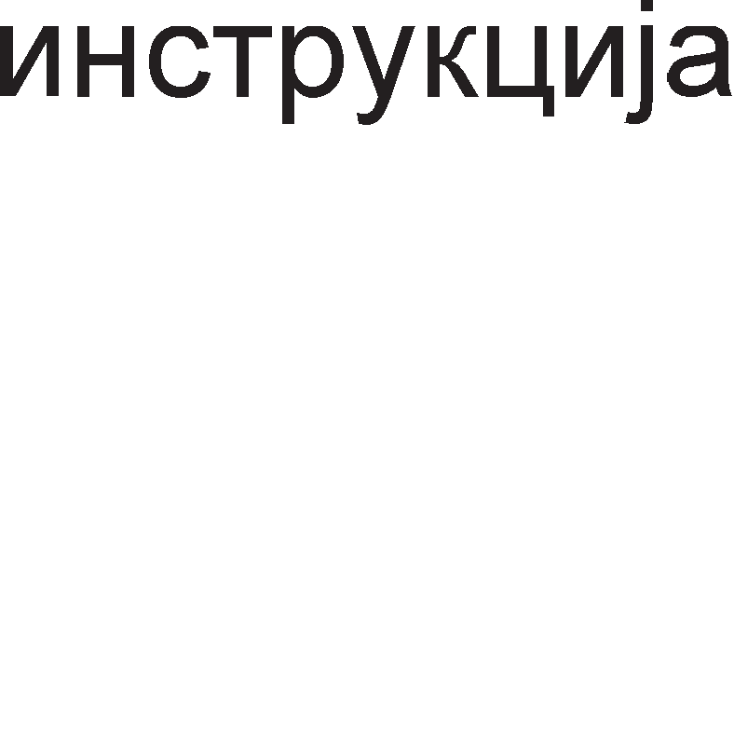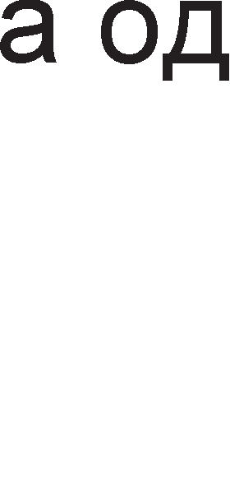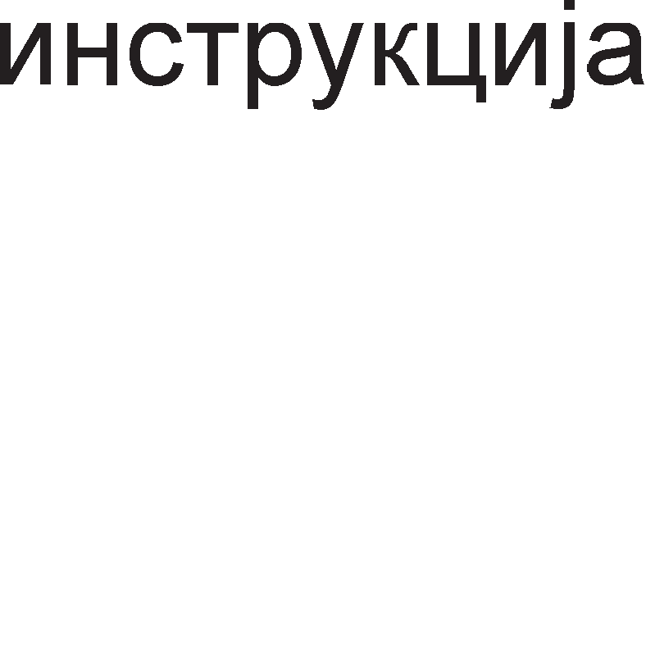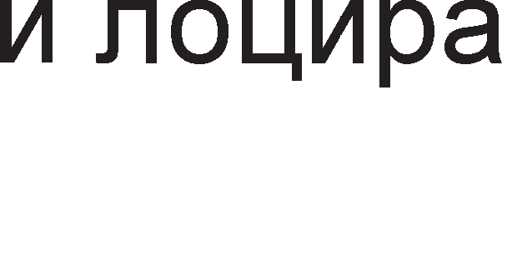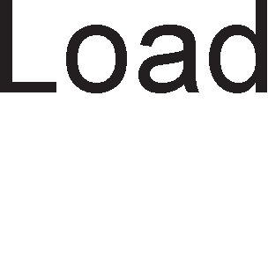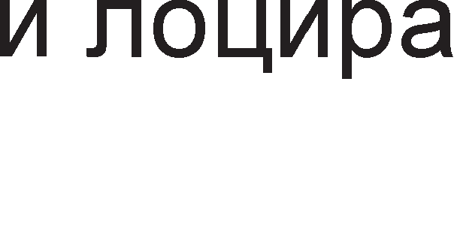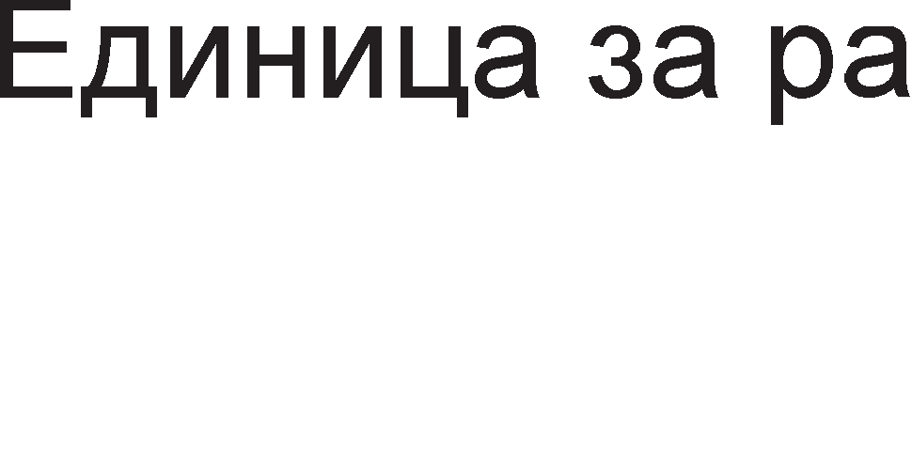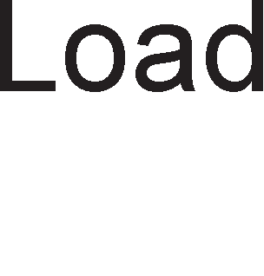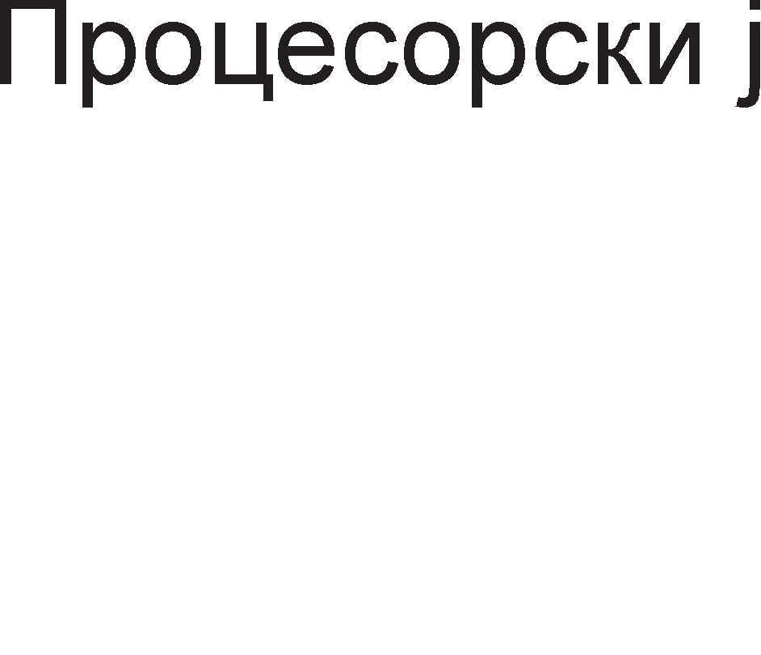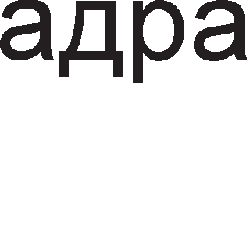

##### npo4ecopcKMTe ja,qpa cM MMaaT concTeeHM no,qaTo"1HM M MHcTpyK4McKM Kew MeMopMM o,q npeo HMeo, noce6HM ,qeKo,qepM M M3epwHM e,qMHM4M, Ho KopMcTaT McT

**KoHTpo11ep Ha MarMcTpa11M M McTa Kew-MeMopMja o,q eTopo HMeo.** ABojappeH1Te M1KponpoLecop1 6apaaT nofloneMa Kew MeMop1ja op epHojappeH1Te 3a pa ce HaMan1 BpeMeTo Ha L1eKal-be. AeHecKa nocTojaT 1 M1KponpoLecop1 co L1eT1p1 jappa, Ho 3a pa 1cT1Te cpyHKL1oH1paaT noTpe6eH e cneL1janeH MeMop1cK1 KoHTponep.

**.Qeoja,qpeHMTe MMKponpo4ecopM ce pa311MKyeaaT o,q My11TMnpo4ecopcKMTe cMcTeMM.** Kaj nocnepH1Be nocTojaT pBa noce6H1 M1KponpoLecop1 co concTBeH1 pecypc1, a Kaj pBojappeH1Te pecypc1Te ce 3aepH1L1K1. MynT1npoLecopcK1Te c1cTeM1 ce no6p31 op c1cTeM1Te co pBojappeH1 M1KponpoLecop1, Ho 1 noTpowyBaL1KaTa e nofloneMa.

AeHec nocTojaT floneM 6poj Ha pBojappeH1 M1KponpoLecop1 Ko1 ce pa3n1KyBaaT no cBojaTa apX1TeKTypa. **neHTMyM .Q** M1KponpoLecopoT e pBojappeH, Ho pBeTe LeHTpanHo M1KponpoLecopcK1 ep1H1L1 He ce Bo epeH L11n, T1e ce noce6H1 L11noB1, Ho nocTaBeH1 MHofly 6n1cKy epeH po ppyfl, Bo 1cTo naKyBal-be. no cBojaTa apX1TeKTypa neHT1yM A M1KponpoLecopoT e MHofly cn1L1eH co neHT1yM 4 M1KponpoLecopoT. l/lMeHo cn1KaTa 9.20. peL11c1 LenocHo opfloBapa Ha apX1TeKTypaTa Ha neHT1yM A M1KponpoLecopoT. noKpaj pBaTa pBojappeH1 M1KponpoLecop1 Bo naKyBal-beTo e cMecTeHa Kew MeMop1jaTa op BTopo H1Bo 1 ep1H1LaTa 3a Mafl1cTpaneH 1HTepcpejc. Mo>Ke61 13BpwHaTa Moi< Ha oBoj M1KponpoLecop e nofloneMa op oHaa Ha epHojappeH1Te M1KponpoLecop1, Ho flpeel-beTo e MHofly floneMo.

OBoj HepocTaToK e HapM1HaT Kaj M1KponpoLecopoT **neHTMyM Dual Core**. Kaj oBoj M1KponpoLecop c1Te ep1H1L1 ce 1MneMeHT1paH1 Bo 1cTo 1HTeflp1paHo Kono (He naKyBal-be). OB1e pBa B1pa pBojappeH1 M1KponpoLecop1 ce np1Ka>KaH1 Ha cn1Ka 9.21.

**neHTMyM Core 2 Duo** e HacnepH1K Ha neHT1yM Dual Core M1KponpoLecopoT. Ho 3a pa3n1Ka op Heflo Kaj Core 2 Duo M1KponpoLecopoT pBeTe M1KponpoLecopcK1 jappa 1MaaT noce6H1 Kew MeMop11 op BTopo H1Bo 1 np1cTan po Mafl1cTpanaTa (FSB-Front Side Bus). Ce pa361pa oBa 3HaL11 pBanaT1 nofloneMa 6p31Ha 1 nopo6p1 nepcpopMaHc1.

naKyBal-be neHT1yM A naKyBal-be Dual Core

CPU

CPU

Kew MeMop1ja L2 KoHTpona Ha Mafl1cTpana

|  |  |
| --- | --- |
| CPU | CPU |
| Kew MeMop1ja | |
| KoHTpona Ha Mafl1cTpana | |

Cn1Ka 9.21. Cnopep6a Mery neHT1yM A 1 Dual Core M1KponpoLecop

nopone ce np1Ka>KaH1 nepcpopMaHc1Te Ha HeKonKy B1pa pBojappeH1 M1KponpoLecop1:

* neHT1yM Dual Core cppeKBeHL1ja 2GHz, Kew op BTopo H1Bo 1MB,

6p31Ha Ha Mafl1cTpana 200MHz

* neHT1yM Core 2 Duo cppeKBeHL1ja 1,86GHz, Kew op BTopo H1Bo

2MB, 6p31Ha Ha Mafl1cTpana 266MHz

* neHT1yM Core 2 Extreme

cppeKBeHL1ja 3,2GHz, Kew op BTopo H1Bo 2×48MB, 6p31Ha Ha Mafl1cTpana 333MHz

Co ceKoj HoB pBojappeH M1KponpoLecop floneM1HaTa Ha Kew MeMop1jaTa ce 3floneMyBa, a 1cTo 1 6p31HaTa Ha c1cTeMcKaTa Mafl1cTpana.

# LlHTerpMpaHM Ko11a 3a cpopMMpa1-e Ha neHTMyM MMKpoKoMnjyTepcKM cMcTeMM

neHT1yM M1KponpoLecop1Te HaoraaT oflpoMHa np1MeHa. HajL1ecTo Kofla i<e Ka>KeMe neHT1yM M1KponpoLecop M1cn1Me Ha nepcoHanH1Te KoMnjyTep1, Ho T1e ce Kop1cTaT 1 Bo Mo61nH1Te TenecpoH1, npeHocH1Te KoMnjyTep1, ayp1o 1 B1peo onpeMaTa 1TH. Ha noL1eToKoT op BTopaTa TeMa, 2.1. BoBep Bo M1KpoKoMnjyTepcK1 c1cTeM 1cTaKHaBMe peKa M1KpoKoMnjyTepcK1oT c1cTeM e cocTaBeH op LeHTpanHa npoLecopcKa ep1H1La, pa6oTHa (np1BpeMeHa) 1 TpajHa MeMop1ja. Co popaBal-be Ha nep1cpepH1 ypep1 ce po61BaaT KoMnjyTepcK1 c1cTeM1. Ha np1Mep, co popaBal-be Ha TacTaTypa 1 MoH1Top Mo>Ke pa ce po61e M1H1ManeH KoMnjyTepcK1 c1cTeM. H1e i<e ce 3app>K1Me Ha noBp3yBal-be Ha neHT1yM M1KponpoLecop1Te co MeMop1jaTa 1 nep1cpepH1Te Kona. Ke flo o6jacH1Me appecHoTo peKop1pal-be 1 ynoTpe6aTa Ha npoflpaM161nH1 peKopep1. l/lcTo TaKa peTanHo i<e ja o6jacH1Me apX1TeKTypaTa 1 n1HoB1Te Ha L11n ceToT, Ko1 ce cneL1janHo p13ajH1paH1 1HTeflp1paH1 Kona 3a noBp3yBal-be Ha neHT1yM M1KponpoLecopoT co MeMop1jaTa 1 nep1cpepH1Te ypep1

## LlHTerpMpaHM Ko11a 3a noep3yea1-e Ha neHTMyM MMKponpo4ecop co MeMopMja

**nporpaMM6M11HMTe ,qeKo,qepM** ce no3HaT1 nop KpaTeHKaTa **PLD** (Programmable Logic Device). nocTojaT noBei<e B1poB1 PLD peKopep1 Ko1 cpyHKL1oH1paaT Ha 1cT HaL11H, Ho 1MaaT no1HaKB1 1M1l-ba: PLA (Programmable Logic Array), (Programmable Array Logic) GAL (Gated Array Logic). npoflpaM1pal-beTo Ha peKopep1Te ce Bpw1 Ha 1cT HaL11H KaKo 1 npoflpaM1pal-beTo Ha PROM MeMop11Te, co Ko1 ce 3ano3HaBMe Bo npBaTa TeMa, 1.7.3. ROM MeMop11. Copp>KHaTa Ha HeKo1 PLD peKopep1 Mo>Ke pa ce MeHyBa, opHocHo pa ce 6p1we 1 noBTopHo penpoflpaM1pa, 1cTo KaKo 1 EPROM MeMop11Te.

Ha cn1Ka 9.22. e np1Ka>KaHa cTpyKTypaTa Ha epeH onwT PLD peKopep. Toj e cocTBaeH op pBa pepa: pep op l/l Kona 1 pep op l/lnl/l Kona. CeKoj Bne3 npecTaByBa nofl1L1Ka Bap1ja61na. CeKoj 13ne3 op peKopepoT 3aB1c1 op cocToj6aTa Ha Bne3oB1Te. 6pojoT Ha Bne3oB1 Ha epHo l/lnl/l Kono e epHaKoB Ha 6pojoT Ha l/l Kona. KaKBa i<e 61pe 3aB1cHocTa Ha 13ne31Te op Bne3oB1Te 3aB1c1 op Toa Ko1 oc1flypyBaL11 ce npeflopeH1, a Ko1 He. npeflopeH1Te oc1flypyBaL11 Ha Bne3 op l/l KonaTa 3HaL1aT cocToj6a Ha nofl1L1Ka Hyna 1 T1e He Bn1jaaT Bp3 cocoToj6aTa Ha 13ne3oT op l/l KonoTo, a npeflopeH1Te oc1flypyBaL11 Ha Bne3 op l/lnl/l KonaTa 3HaL1aT cocToj6a Ha nofl1L1Ka Hyna. C1Te oc1flypyBaL11 Bo cpa6p1L1K1 npo13BepeH1Te peKopep1 ce HenpeflopeH1. T1e ce npeflopyBaaT cnopep noTpe6a npeKy nywTal-be Ha floneMa cTpyja H13 H1B.



Cn1Ka 9.22. CTpyKTypa Ha PAL npoflpaM161neH peKopep

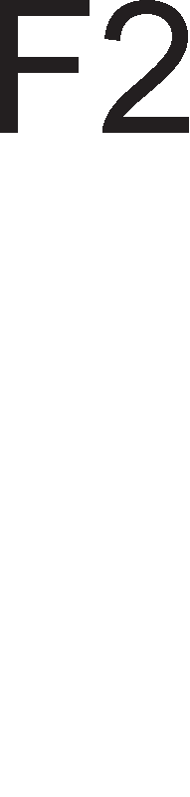

KonoTo 16L8 e PAL peKopep co 10 cp1KcH1 Bne3a, pBa cp1KcH1 13ne31 1 wecT n1HoB1 Ko1 Mo>Ke pa ce npoflpaM1paaT KaKo Bne3H1 1n1 13ne3H1. Ha Bne3 op peKopepoT PAL16L8 poaraaT appecH1Te c1flHan1 op M1KponpoLecopoT, a 13ne3H1Te c1flHan1 op peKopepoT ce HocaT Ha Bne3H1Te n1HoB1 (Chip Enable) op ROM 1n1 RAM L11noB1Te 1 cny>KaT 3a ceneKL1ja Ha MeMop1cK1Te KoMnoHeHeT1.



Ha cn1Ka 9.23. e np1Ka>KaH Man neHT1yM MeMop1cK1 c1cTeM. OBoj c1cTeM ce cocTo1 op ocyM 27512 EPROM MeMop1cK1 L11noB1 (64K×8), co BKyneH KanaL1TeT op 512K 1 appeceH npocTop op FFF80000H po FFFFFFFFH. 3a peKop1pal-be ce ynoTpe6eH1 pBa PAL16L8 peKopep1. 61ToB1Te op A19 po A28 ce Bne3oB1 Ha BTop1oT peKopep. 3aB1cHocTa Ha 13ne3oT U2 op appecH1Te 61ToB1 e papeHa co paBeHKaTa:

=A19 · A20 · A21 · A22 · A23 · A24 · A25 · A26 · A27· A28



Bne3oB1 Ha npB1oT peKopep ce appecH1Te 61ToB1 A31, A30, A29 1 13ne3oT op BTop1oT peKopep. npB1oT peKopep flo fleHep1pa c1flHanoT 3a n1HoT . Kofla oBoj n1H i<e

ce aKT1B1pa co ocnoco6yBaaT c1Te ocyM MeMop1cK1 L11noB1. 3aB1cHocTa Ha 13ne3oT  op Bne3oB1Te Kaj npB1oT PAL16L8 e papeHa co paBeHKaTa:

 =  · A29 · A30 · A29

3a pa ce aKT1B1pa c1flHanoT CE noTpe6Ho e eppecH1Te 61ToB1 op A31 po A19 pa 61paT nofl1L1K1 ep1H1L1. BTop1oT n1H 3a ceneKL1ja Ha MeMop1cK1Te L11noB1  flo aKT1B1pa KoHTponH1oT c1flHan  1 HaL11HoT Ha HefloBo fleHep1pal-be 6ewe np1Ka>KaH Ha cn1KaTa 9.4. 61ToB1Te op A3 po A18 cny>KaT 3a 136op Ha MeMop1cKa noKaL1ja op ceneKT1paH1Te MeMop1cK1 Mopyn1.

nopaToL1HaTa Mafl1cTpana Ha neHT1yM M1KponpoLecopoT e 64 61THa. Kofla i<e ce aKT1B1paaT c1Te ocyM MeMop1cK1 L11noB1 27512 ceKoj op H1B i<e pape no epeH 6ajT 3a pa ce po61e 64-61TeH nopaToK. nopaToL1H1Te 13ne31 op ceKoj MeMop1cK1 L11n ce noBp3aH1 co noce6Ha flpyna op ocyM BopoB1 op nopaToL1HaTa Mafl1cTpana: D7-D0, D8- D15,D16-D23, D24-D31,D32-D39, D40-D47, D48-D55, D56-D63.

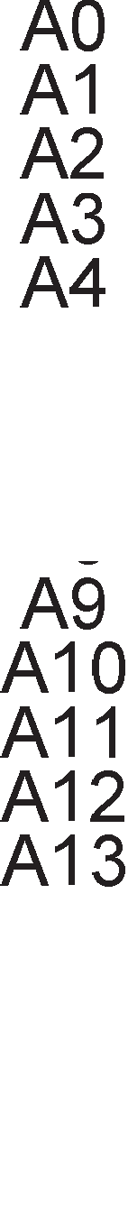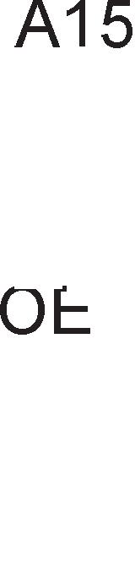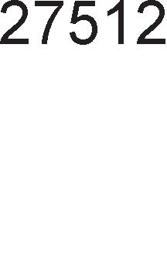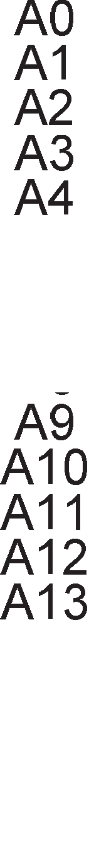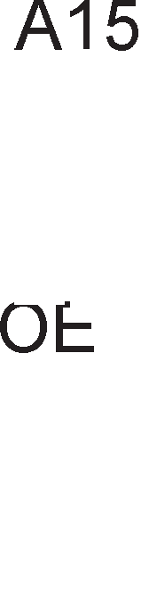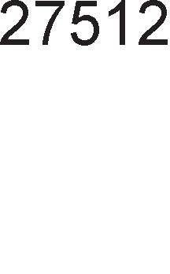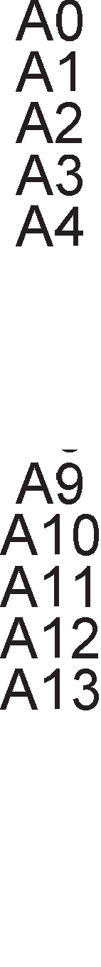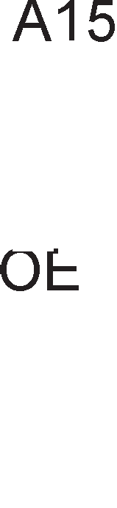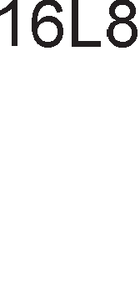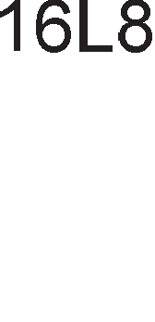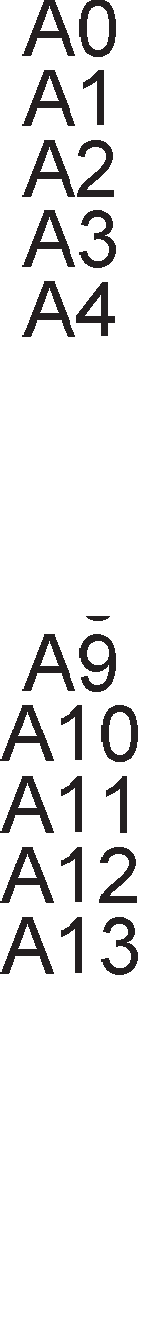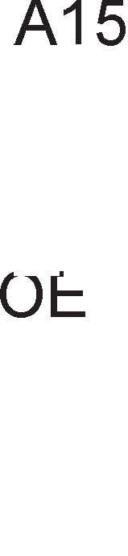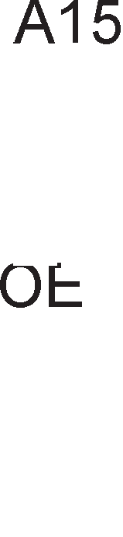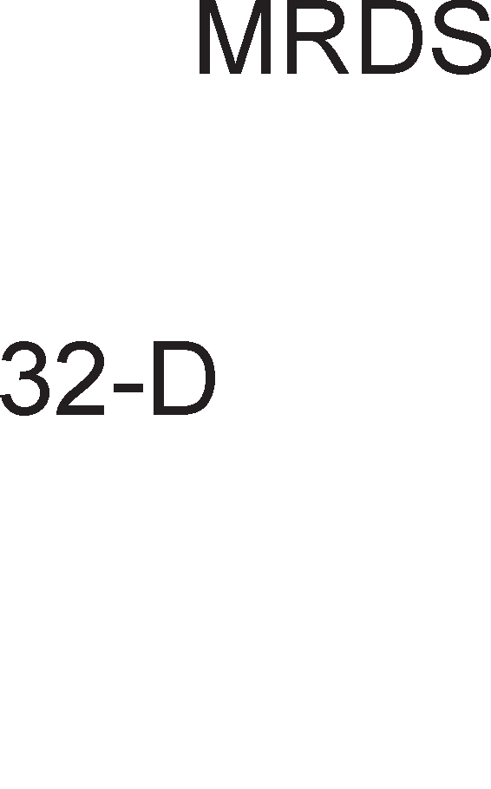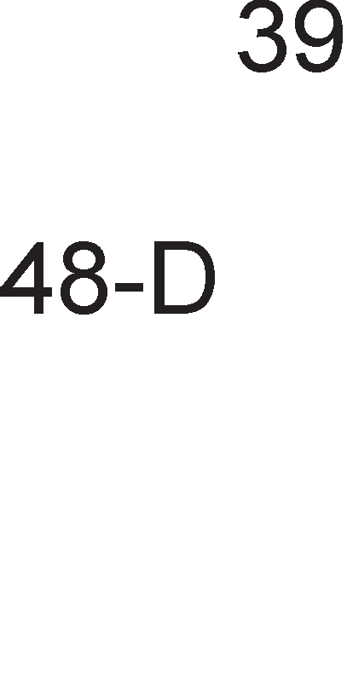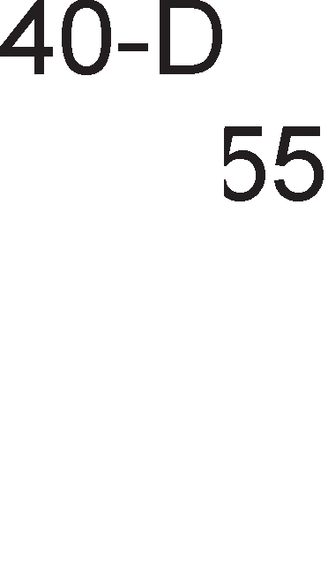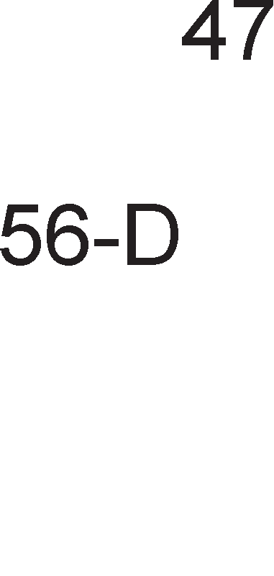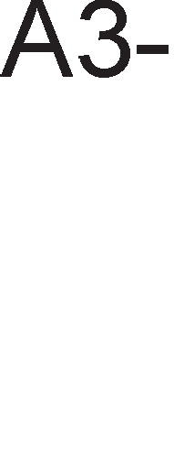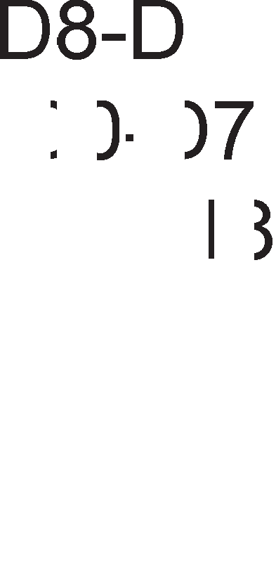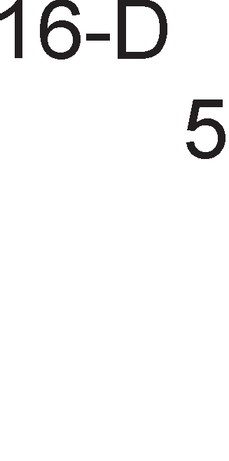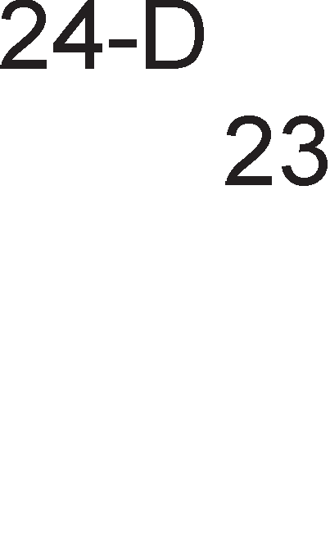

Cn1Ka 9.23. noBp3yBal-be Ha neHT1yM M1KponpoLecop co 64 61THa MeMop1ja

# LlHTerpMpaHo Ko11o LlHTe11 865G "1Mn ceT

Kaj neHT1yM KoMnjyTepcK1Te c1TeM1 M1KponpoLecop1Te 1MaaT noBei<e 13BpwHa cpyHKL1ja, a **KoHTpo11HaTa cpyHK4Mja ja M3epwyeaaT MHo>KecTeo o,q cne4Mja11HM MHTerpMpaHM Ko11a no3HaTM no,q MMeTo "1Mn ceT** (Chip Set). AHfln1cK1oT 36op set Bo npeBop 3HaL11 MHo>KecTBo, a 36opoT chip 3HaL11 L11n 1n1 1HTeflp1paHo Kono. OB1e 1HTeflp1paH1 Kona fl1 fleHep1paaT KoHTponH1Te c1flHan1 3a ynpaByBal-be co MeMop1jaTa 1 nep1cpepH1Te ypep1. Ll1n ceToT e nocpepH1K Bo KoMyH1KaL1jaTa Mery M1KponpoLecopoT 1 ocTaHaT1Te KoMnoHeHeT1 Ha MaT1L1HaTa nnoL1a. Ayp1 1 caMaTa MaT1L1Ha nnoL1a ce 1MeHyBa cnopep B1poT Ha L11n ceToT BflpapeH Bo Hea. AHan131paji<1 ja cpyHKL1jaTa Ha noce6H1Te ep1H1L1 op 6noK p1jaflpaMoT Ha L11n ceToT H1e i<e ce 3ano3HaeMe co c1Te noBa>KH1 penoB1 Ha MaT1L1HaTa nnoL1a.

Ke ce 3app>K1Me Ha epeH KoHKpeTeH L11n ceT l/lHTen 865G. Toj ce Kop1cT1 Bo pecKTon KoMnjyTepcK1Te c1cTeM1 Ko1 1MaaT Bo ce6e neHT1yM 4 M1KponpoLecop co 512KB Kew MeMop1ja op BTopo H1Bo 1 cppeKBeHL1ja Ha c1cTeMcKaTa Mafl1cTpana 400MHz, 533MHz 1n1 800MHz. CeKoj L11n ceT e cocTaBeH op **,qee ocHoeHM KoMnoHeHTM**: flpacp1L1K1 1 MeMop1cK1 KoHTponop (82865G CMCH-Graphics Memory Controller Hub) 1 Bne3Ho 13ne3eH KoHTponop (82801EB ICH-Input/output Controller Hub). AHfln1cK1oT 36op hub Bo npeBop 3HaL11 cpep1wTe, ja3on. Toa ce MecTa Bo c1cTeMoT Kape ce Bpw1 npow1pyBal-be Ha 1cT1oT, pa3flpaHyBal-be, Ha np1Mep op epeH 13ne3 ce po61BaaT noBei<e ppyfl1 13ne31. rpacp1L1K1oT 1 MeMop1cK1oT KoHTponop e noBp3aH co M1KponpoLecopoT, c1cTeMcKaTa MeMop1ja, ep1H1LaTa 3a 6p3a KoMyH1KaL1ja, Bne3Ho-13ne3HoTo cpep1wTe (hub) 1TH. Ha cn1Ka 9.24. e np1Ka>KaH 6noK p1jaflpaMoT Ha L11n ceToT 865G. Cefla HaKpaTKo i<e fl1 o6jacH1Me cpyHKL11Te 1 aHfln1cK1Te TepM1H1 3a c1Te KoMnoHeHT1 op L11n ceToT 865G.

* **VGA** (Video Graphics Array) e MHofly nonynapeH cTaHpapp 3a noBp3yBal-be Ha MoH1Top1oT 1 pa3n1L1H1Te B1poB1 aHanoflH1 p1cnne1. OBoj cTaHpapp o6e36epyBa pe3onyL1ja op 640×480 n1cKen1, cppeKBeHL1ja Ha o6HoByBal-be op 60Hz 1 1cToBpeMeHo np1Ka>KyBal-be Ha 16 6o1. np1 noMana pe3onyL1ja op 320×200 n1cKen1, Mo>KaT pa ce np1Ka>KaT 256 6o1. AeHec oBoj cTaHpapp e 3aMeHeT co SVGA (Super VGA) cTaHpappoT Koj oBo3Mo>KyBa np1Ka>KyBal-be Ha 16 M1n1oH1 6o1 np1 pe3onyL1ja op 800×600 Ha 14- 1HL1eH MoH1Top 1n1 pe3onyL1ja op 1200×1600 Ha 20-1HL1eH MoH1Top. VGA KoHeKTopoT Ha MaT1L1HaTa nnoL1a 1Ma 15 n1HoB1.
* **AGP** (Accelerated Graphics Port) e nopTa 3a np1KnyL1yBal-be Ha flpacp1L1K 1 KapT1L1K1 1 TaKaHapeL1eH1 3D aKcenaTop1 (flpacp1L1K1 3a6p3yBaL11). AGP nopTaTa 1Ma p1peKTeH np1cTan po c1cTeMcKaTa MeMop1ja. AGP Mafl1cTpanaTa e 32- 61THa, co pa6oTHa cppeKBeHL1ja op 66MHz, wTo paBa BKyneH nponyceH oncefl op 2.1GBps. npep nojaBaTa Ha AGP nopT1Te 3a np1KnyL1yBal-be Ha B1peo KapT1L1K1Te ce Kop1cTene PCI nopT1Te co pBanaT1 noMan oncefl.
* nopT1Te DVO (Digital Video Output) cny>KaT 3a noBp3yBal-be Ha epHoKaHanH1 1 pBoKaHanH1 p1fl1TanH1 B1peo ypep1 co nofloneM1 pe3onyL11 1 cppeKBeHL11 Ha o6HoByBal-be (refresh) KaKo wTo ce Ha np1Mep LCD eKpaH1Te.

VGA KoHTponop

AGP 1 DVO

KoHTponop1

2,1GB/s

266GB/s

DDR

DDR

DDR

DDR

0MHz

KaHan A

3,2GB/s

KaHan B

3,2GB/s

CSA, ETepHeT

KoHTponop

|  |  |  |
| --- | --- | --- |
| npoLecop | | |
|  | 400/533/80 | |
| rpacp1L1K1 1 MeMop1cK1 KoHTponep  Intel 82865G GMCH | |  |

8 USB 2.0 nopT1,

480 Mb/s

KoHTpona Ha HanojyBal-be

reHepaTop Ha TaKT

Bne3Ho 13ne3eH KoHTponop

GPIO

KoHTponep Ha Mpe>Ka LAN

Intel 82801EB ICH

ABe cep1cK1 ATA nopT1, 150MB/s

C1cTeM MeHa1,ep

ABe napanenH1 ATA 100 nopT1

Mafl1cTapana Ha c1cTeM MeHa1,epoT

PCI Mafl1cTpana

AC (Audio Codec) ‘ 97

ROM BIOS

LPC

1HTepcpejc

SIO

WecT PCI ypep1

Cn1Ka 9.24. 6noK p1jaflpaM Ha l/lHTen 865G L11n ceT

* **CSA** (Communication Streaming Architecture) e cneL1janHo p13ajH1paH KoHLenT 3a noBp3yBal-be Ha flpacp1L1K1oT 1 MeMop1cK1oT KoHTponop (GMCH) co ETepHeT KoHTponopoT. ETepHeT e npoToKon 3a cpopM1pal-be Ha KoMnjyTepcK1 Mpe>K1. KoHTponopoT 3a 6p3a KoMyH1KaL1ja (CSA) o6e36epyBa npeHoc op 266 M1n1oH1 TpaHccpep1 Bo epHa ceKyHpa np1 pa6oTHa cppeKBeHL1ja op 66 MHz.
* 3a noBp3yBal-be Ha L11n ceToT 865G co c1cTeMcKaTa MeMop1ja ce Kop1cTaT pBa KaHana co nponyceH oncefl op 3,2GB/s. KanaL1TeToT Ha MeMop1jaTa 13HecyBa 4GB, opflaH131paHa e Bo L1eT1p1 6aHK1 1 ce ynoTpe6eH1 DDR SDRAM L11noB1. KpaTeHKaTa DDR (Data Dual Rate) 3HaL11 npeHoc Ha pBa nopaToKa 3a BpeMe op epeH p1fl1TcK1 TaKT.

Bne3Ho 13ne3H1oT KoHTponep 82801EB Bo ce6e fl1 1HTeflp1pa:

* + **ATA** 100 **KoHTpo11opoT** –napanenHaTa ATA nopTa e 3aMeHa 3a 40-n1HcKaTa IDE (Integrated Drive Electronic) nopTa 3a noBp3yBal-be Ha Xapp-p1cK MeMop1jaTa. Aa HanoMeHeMe peKa IDE Ka6enoT e ponfl caMo HeKonKy caHT1MeTp1 wTo e ywTe epeH HepocTaToK Bo opHoc Ha ATA Ka6n1Te 3a noBp3yBal-be.
  + ABa cep1cK1 ATA KoHTponep1 – cep1cKaTa ATA nopTa 1Ma nofloneMa cppeKBeHL1ja op napanenHaTa, Ho noMan wyM Bo pa6oTel-beTo. Taa e cepyM n1HcKa 1 1Ma nponyceH oncefl op 150MB/s
  + EHCI (Enhanced Host Controllor Interface) e KoHTponop 3a USB 2.0. nopT1Te co nponyceH oncefl op 480MB/s
  + UHCI (Universal Host Controllor Interface) e KoHTponop 3a USB 1,1 1 1,0, nopT1Te co nponyceH oncefl op 12MB/s. Aa HanoMeHeMe peKa L11n ceToT 865G HeMa USB 1,1 nopT1 TyKy caMo ocyM USB 2.0 nopT1, Ho T1e ce KoMaT161nH1 co USB 1.1. nopT1Te.
  + KoHTponepoT 3a LPC (Low Pin Count) Mafl1cTpanaTa Koja e 3aMeHa 3a cTapaTa 1 6aBHa ISA Mafl1cTpana. OBaa Mafl1cTpana ce Kop1cT1 3a noBp3yBal-be Ha: EEPROM L11noT Koj Bo ce6e ja copp>K1 BIOS npoflpaMaTa 1 epHocTaBH1Te Bne3Ho 13ne3H1 ypep1 (SIO-Simple Input Output) KaKo wTo ce cep1cKaTa, napanenHaTa nopTa, flnyBL1eTo 1 TacTaTypaTa.
  + **KoHTpo11opoT Ha PCI** (Peripheral Component Interconnect) Mafl1cTpanaTa. Ha np1Mep ypep 3a PCI cnoToT e 3ByL1HaTa KapT1L1Ka.
  + AC’97 (Audio Codec) KoHTponepoT Koj ce Kop1cT1 1 3a aHanoflHo p1fl1TanHo npeTBapal-be Ha 3ByL1H1Te c1flHan1 .
  + **KoHTpo11epoT 3a noep3yea1-e co KoMnyTepcKM Mpe>KM** (LAN-Local Area Network)
  + GPIO (General Purpose Input Output) KoHTponepoT fl1 KoHTpon1pa 8 n1HcK1Te GPIO nopT1 Ko1 ce ocyM n1HcK1 1 ce MHofly 3flopH1 3a noBp3yBal-be Ha epHocTaBH1 ypep1 KaKo wTo ce nep p1op1Te 1n1 npeK1HyBaL11Te. GPIO nopT1Te Mo>KaT pa ce npoflpaM1paaT KaKo Bne3H1 1n1 13ne3H1 nopT1.

OTKaKo ce 3ano3HaBMe co noBa>KH1Te ep1H1L1 op L11n ceToT 865G i<e ce o61peMe pa ja o6jacH1Me cpyHKL1jaTa Ha noKapaKTep1cT1L1H1Te, noonwT1Te n1HoB1 Ha oBa 1HTeflp1paHo Kono. Ke B1p1Me peKa floneM 6poj op n1HoB1Te Ha L11n ceToT 1MaaT cn1L1Ha cpyHKL1ja co n1HoB1Te Ha neHT1yM M1KponpoLecop1Te. nopap1 Toa HeKo1 op n1HoB1Te HeMa pa fl1 o6jacHyBaMe 61peji<1 co H1B ce 3ano3HaBMe Bo 9.2. noflnaBjeTo. n1H p1jaflpaM Ha neHT1yM 1 M1KponpoLecop 1 9.5. neHT1yM 2 M1KponpoLecop. Ha cn1Ka

* 1. ce np1Ka>KaH1 flpyn1Te n1HoB1 Ha 1HTeflp1paHoTo Kono 865G, nopeneH1 cnopep H1BHaTa cpyHKL1ja.

3a KoMyH1KaL1ja Mery flpacp1L1K1oT 1 MeMop1cK1oT KoHTponep (82865G) 1 M1KponpoLecopoT ce Kop1cTaT cnepH1Be c1flHan1:

HD (Host Data)-nopaToL1Ha Mafl1cTpana Ha KoHTponepoT

HA (Host Address)- AppecHa Mafl1cTpana Ha KoHTponepoT

HADSB (Host Address Strobe)- C1flHan 3a HajaBa Ha 1cnpai<al-be Ha appeca

DBSY (Data Bus Busy)- nopaToL1HaTa Mafl1cTpana He 3aBpw1na co npeHocoT

DINV (Dynamic Bus Inversion)- OppepyBa Koj 36op op 64-61TH1oT nopaToK i<e ce npeHecyBa

DRDY (Data Ready)-nopaToKoT np1cT1flHan po caKaHaTa pecT1HaL1ja

CPURESET PeceT1pal-be Ha M1KponpoLecopoT HIT,HITM n1HoB1 3a np1cTan pa Kew MeMop1jaTa

HTRDY (Host Target Ready)- ypepoT e cnpeMeH pa fl1 np1cpaT1 nopaToL1Te

PROCHOT 3floneMyBal-be Ha TeMnepaTypaTa Ha M1KponpoLecopoT AP (Address Parity)-KoHTpona Ha napHocT Ha appecaTa

DP (Data Parity)-KoHTpona Ha napHocT Ha nopaToL1Te

IERR (Internal Error)- BHaTpewHa flpewKa Bo c1cTeMoT

BINIT (Bus Initialization) –PeceT1pal-be Ha Mafl1cTpan1Te

3a KoMyH1KaL1jaTa co c1cTeMcKaTa MeMop1ja DDR SDRAM ce Kop1cTaT cnepH1Be c1flHan1:

SCMDCLOK (Differential DDR Clock)-3a npeB3eMal-be Ha appecH1Te 1 nopaToL1H1Te c1flHan1 noTpe6eH e pacTeL1K1 pa6 Ha oBoj c1flHan

SCS (Chip select)- Ce 1361pa epeH SDRAM L11n

SMAA (Memory Address)-MeMop1cKa appeca

SRAS, SCAS (Row Address Strobe, Column Address Strobe)-flo KoHTpon1paaT MynT1nneKcoT Ha appecHaTa Mafl1cTpana

SBA (Select Bank)-l/l36op Ha MeMop1cKa 6aHKa

SWE (Write Enable)-Ocnoco6yBal-be 3a L11Tal-be

SDQ (Data Lines)-nopaToL1H1 n1HoB1

SDQS (Data line Strobe)-C1flHan 3a HajaBa 3a ceKoj 6ajT op 64- 61TH1oT nopaToK

3a KoMyH1KaL1ja Ha L11n ceToT co KoHTponopoT 3a 6p3a KoMyH1KaL1ja 1 Bne3Ho 13ne3H1oT Xa6 ce Kop1cT1 cTpo61paH pe>K1M np1 wTo ce npeHecyBaaT caMo nopaToL1H1

c1flHan1 1 c1flHan1 3a HajaBa. C1flHan1Te 3a KoMyH1KaL1ja co Bne3Ho 13ne3H1oT Xa6 ce cnepH1:

HI nopaToL1H1 c1flHan1

HISTRS C1flHan1 3a HajaBa (Strobe) Ha npeHocoT Ha nopaToL1 C1flHan1 3a KoMyH1KaL1ja co KoHTponopoT 3a 6p3a KoMyH1KaL1ja (CSA) ce:

CI nopaToL1H1 c1flHan1

CISTRS C1flHan1 3a HajaBa (Strobe) Ha npeHocoT Ha nopaToL1

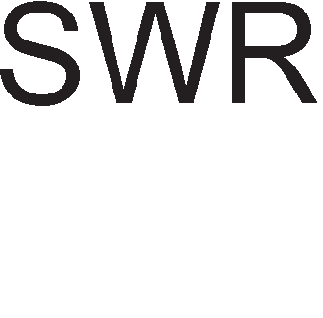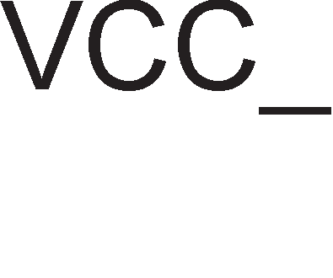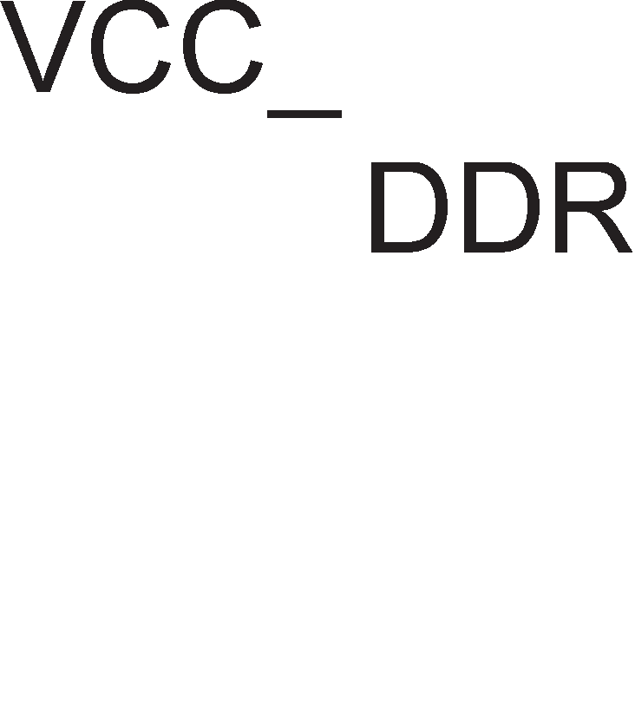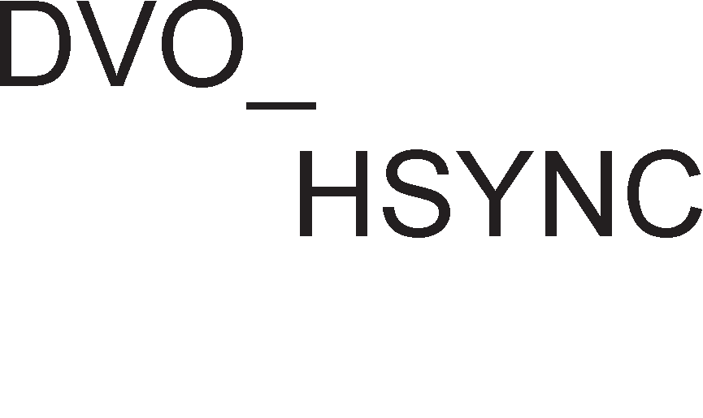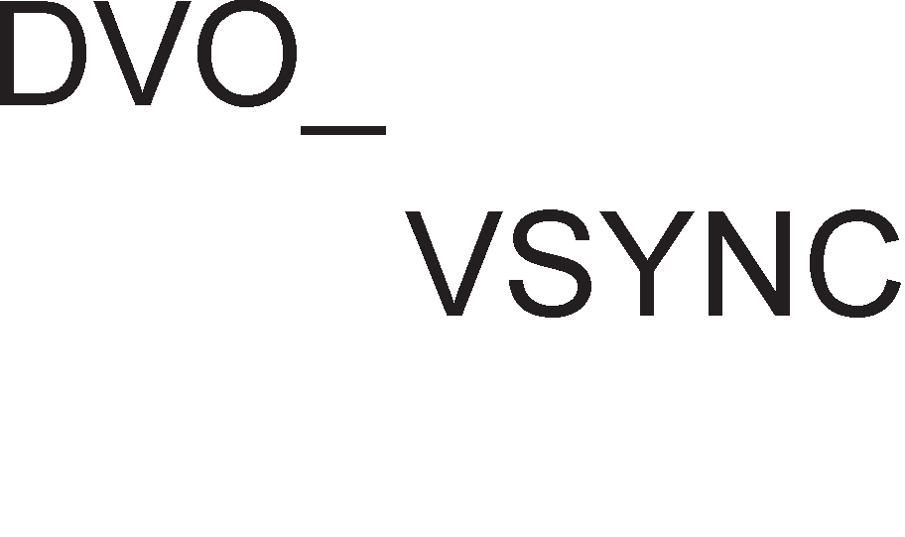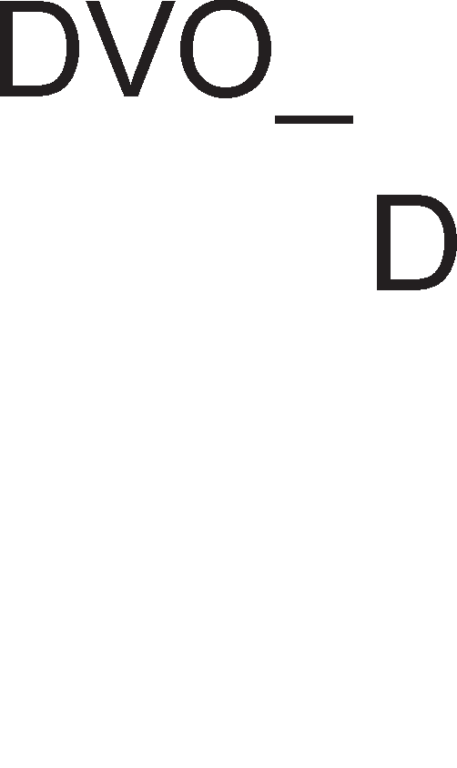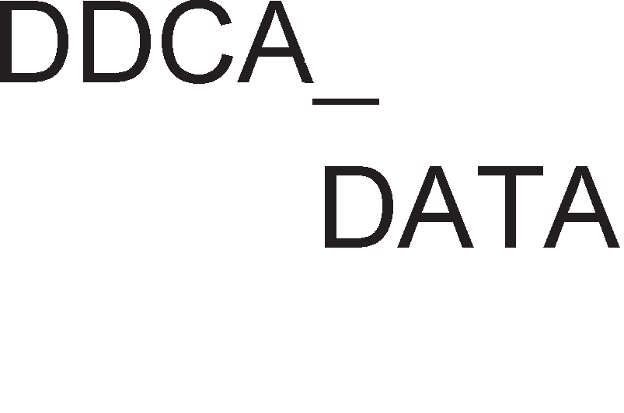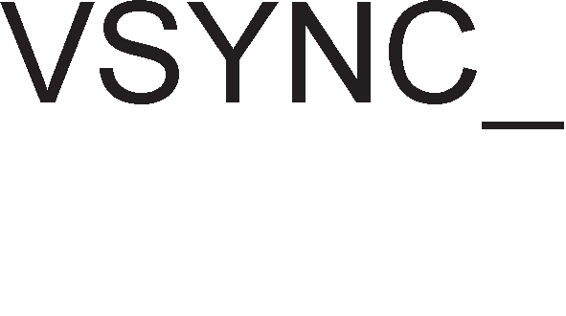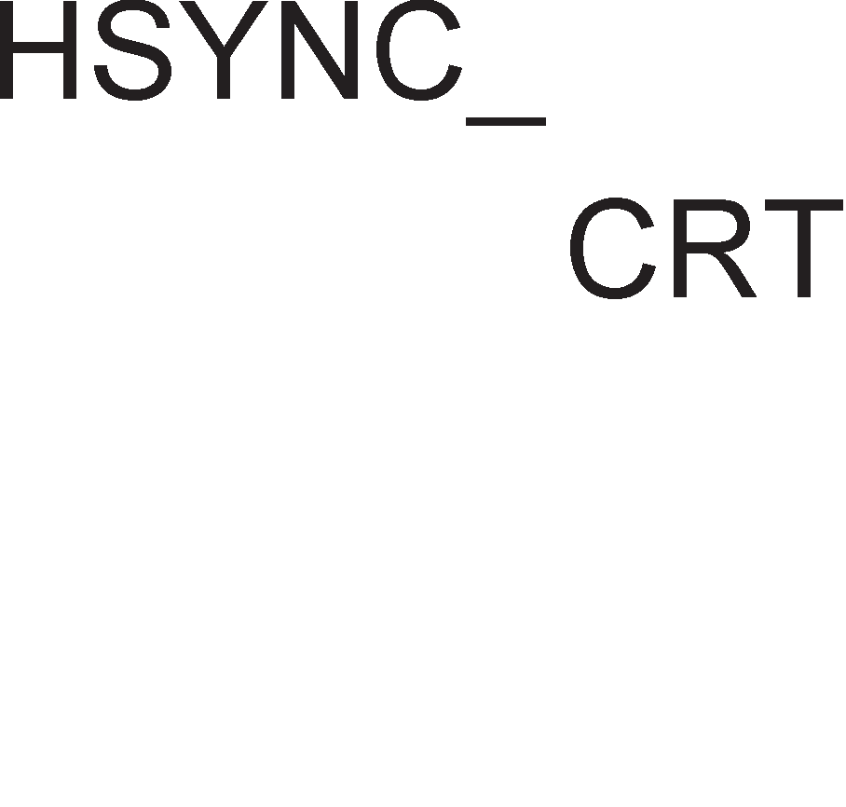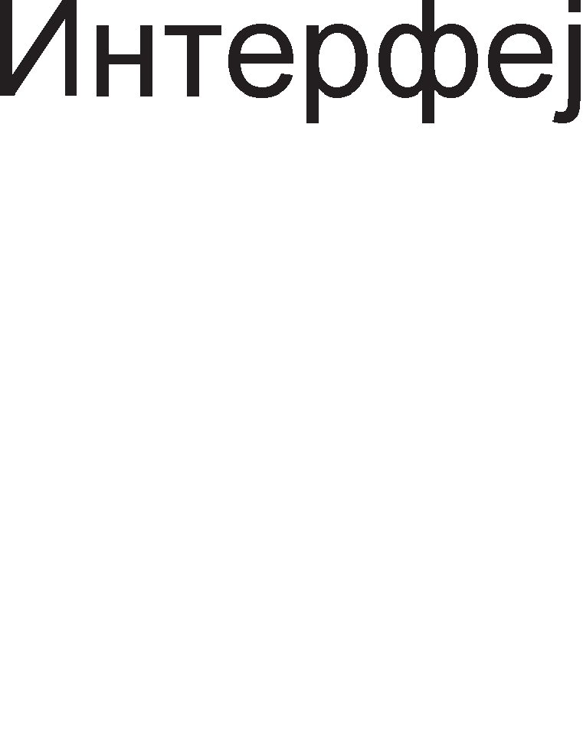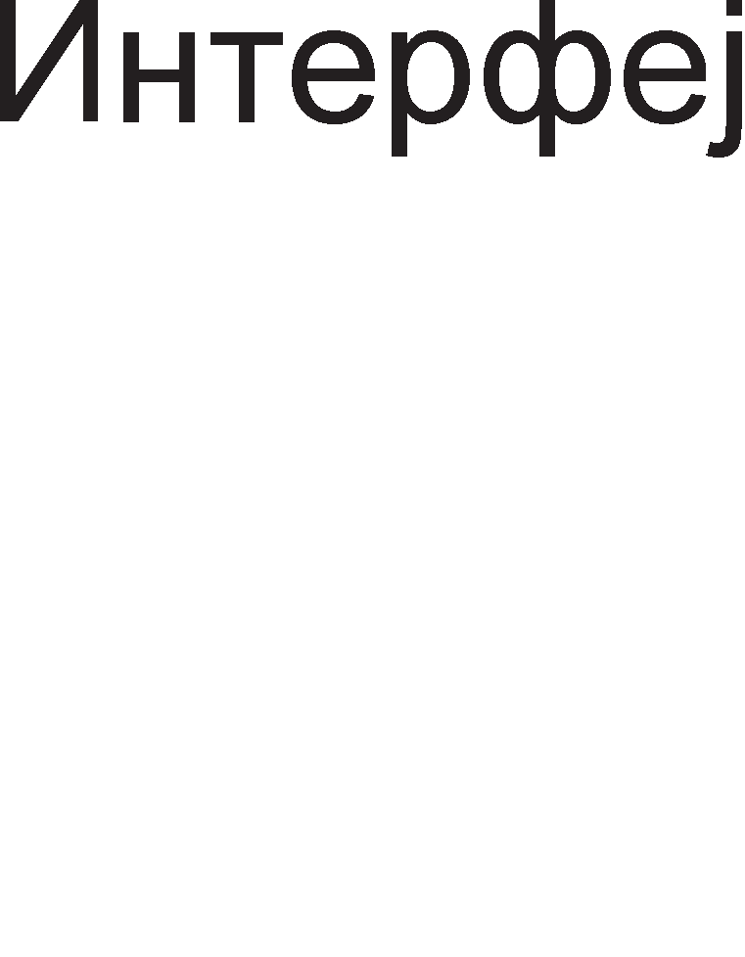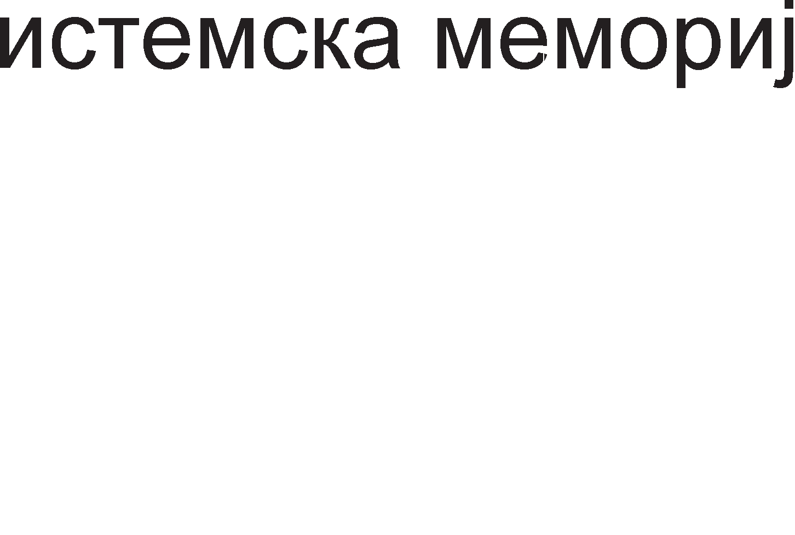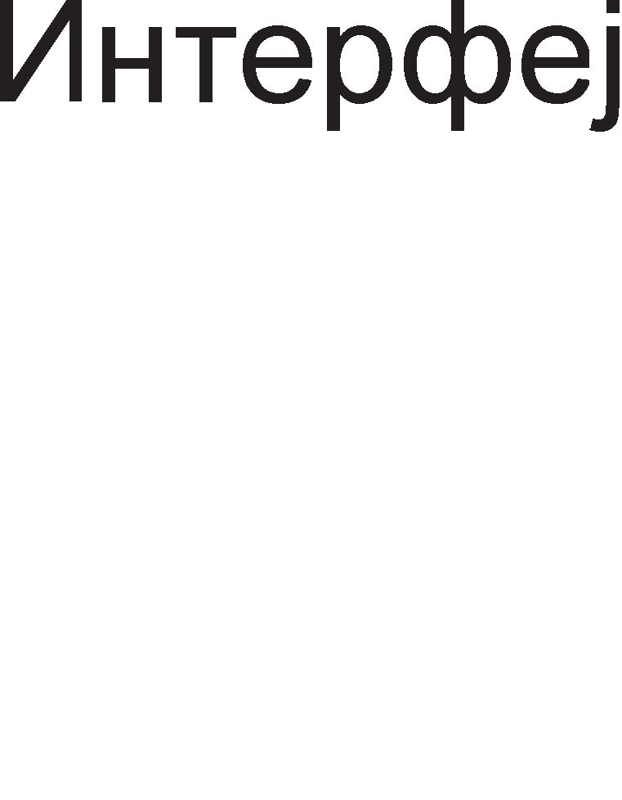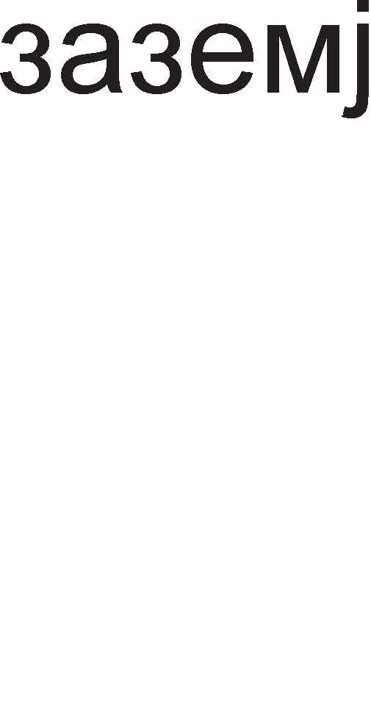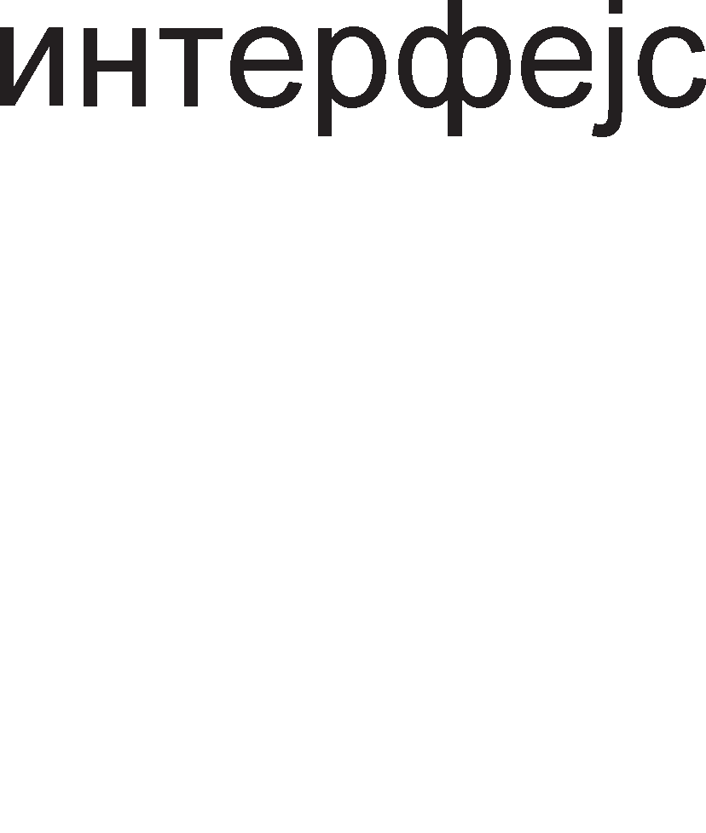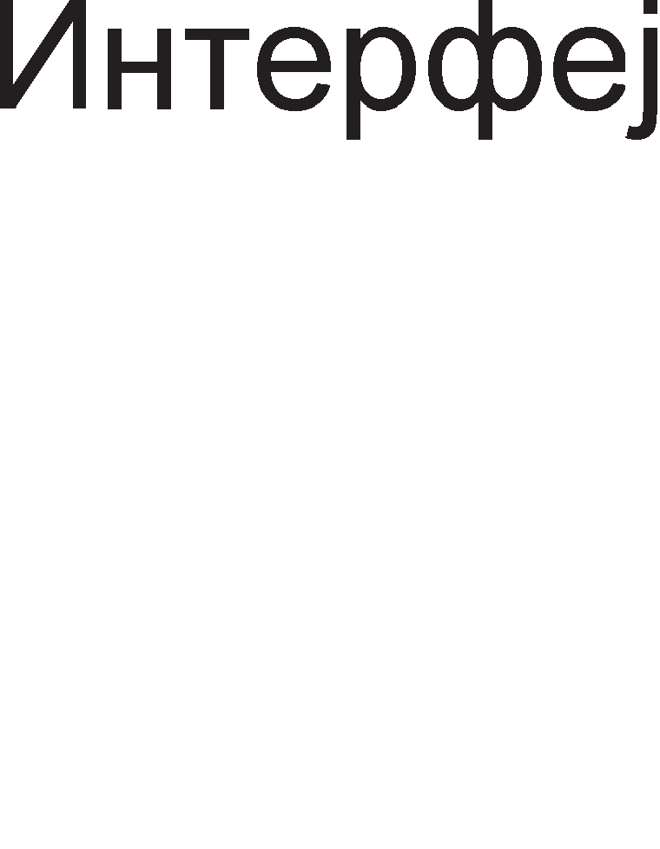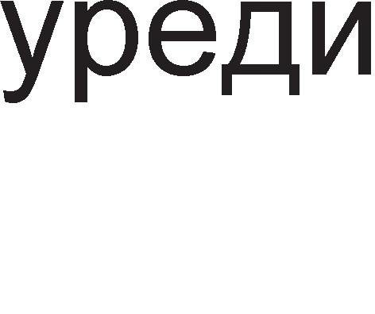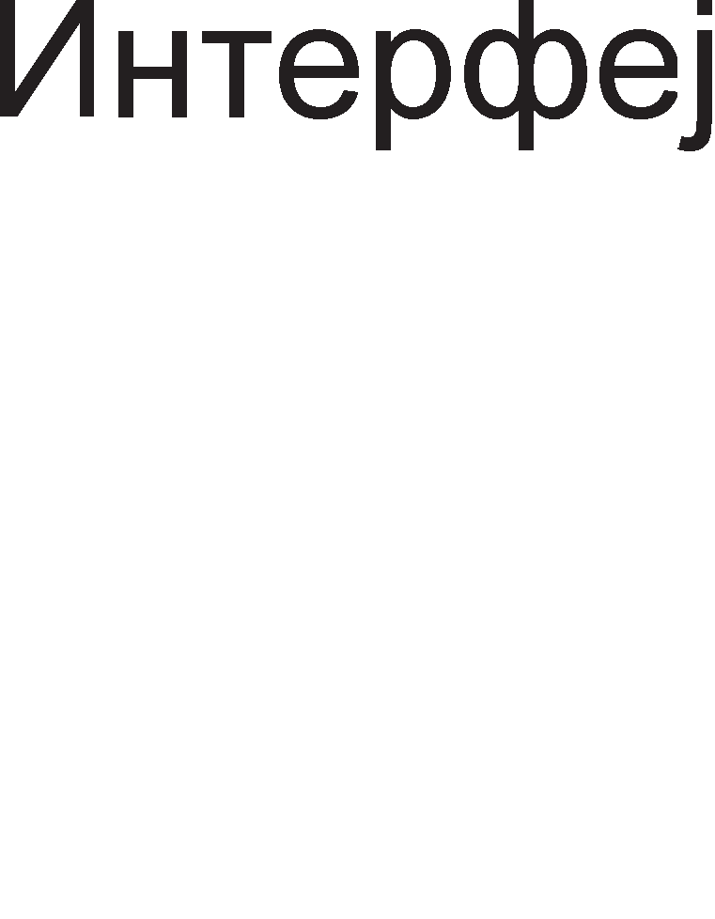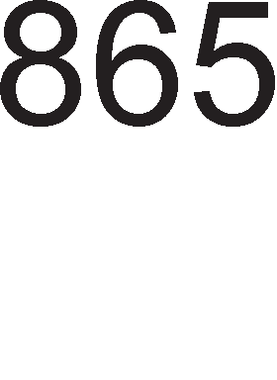

Cn1Ka 9.25. n1H p1jaflpaM Ha L11n ceT l/lHTen 865G

C1flHan1Te 3a KoMyH1KaL1ja co AGP KoHTponepoT Mo>Ke pa ce nopenaT Bo HeKonKy flpyn1: appecH1, KoHTponH1, cTaTycH1 1 c1flHan1 3a HajaBa. nopony e papeHa H1BHaTa cpyHKL1ja.

GPIPE (Pipe read)-Kaj pipeline KoHLenToT HajaByBa npeHoc Ha nopaToL1

GSBA (Sideband Address)- Ce BoBepyBaaT HoB1 pononH1TenH1 appecH1 n1H11

GAD (Address Data)-AppecHo nopaToL1H1 c1flHan1

GRBF (Read Buffer Full)- l/lH1L1pa L11Tal-be

GWRB (Write Buffer Full)- l/lH1L1pa n1wyBal-be

Status CTaTycH1Te 61ToB1 pecp1H1paaT cocToj6a Ha npeHoc

Strobe C1flHan1Te 3a HajaBa ce Kop1cTaT 3a pean13aL1ja Ha TajM1HfloT 3a npeHoc Ha nopaToL1 Koj Tpae L1eT1p1 p1fl1TcK1 TaKTa

GSTP (AGP Stop)-AGP KoHTponopoT flo npeK1HyBa npeHocoT GTRDY (AGP Target Ready)-YpepoT e cnpeMeH pa fl1 np1cpaT1

nopToL1Te

GREQ (AGP Request)-AGP pocTaByBa 6apal-be 3a Kop1cTel-be Ha Mafl1cTpan1Te

C1flHan1 3a KoMyH1KaL1ja Mery L11n ceToT 1 KoHTponopoT Ha DVO nopT1Te ce: DVO_CLOK A1fl1TcK1 TaKT 3a DVO KoHTponopoT

DVO_D nopaToL1Ha Mafl1cTpana 3a npeHoc Ha 12-61TeH n1Kcen nopaToK 3a ceKoj p1fl1TcK1 TaKT

DVO_VSYNC BepT1KanHa c1HXpoH13aL1ja DVO_HSYNC Xop13oHTanHa c1HXpoH13aL1ja

DVO_FLDSTL (TV Field and Flat Panel Stall Signal)–c1flHan 3a 136op Ha p1fl1TaneH B1peo ypep

np1 Kop1cTel-be Ha aHanoflH1 B1peo ypep1 ce Kop1cTaT cnepH1Be KoHTponH1 c1flHan1:

HSYNC, VSYNC BepT1KanHa 1 Xop13oHTanHa c1HXpoH13aL1ja RED, GREEN, BLUE AHanoflH1 c1flHan1 3a 6o1Te

DDCA_CLK A1fl1TcK1 TaKT 3a KoHTponopoT 3a aHanoflH1 B1peo

ypep1

DDCA_DATA nopaToL1H1 c1flHan1 Apyfl1 noonwT1 KoHTponH1 c1flHan1 ce:

GCLKIN (AGP Clock)-A1fl1TcK1 TaKT co cppeKBeHL1ja 68MHz

DREFCLK (Display Clock Input)-A1fl1TcK1 TaKT co cppeKBeHL1ja

48MHz

RSTIN (Reset In) Bne3eH n1H 3a peceT1pal-be Ha L11n ceToT

TESTIN Ll1n ceToT BneflyBa Bo TecT Mop

VCC_AGP HanojyBal-be 3a AGP nopTaTa

VCC_DDR HanojyBal-be 3a c1cTeMcKaTa MeMop1ja

VTT HanojyBal-be 3a c1cTeMcKaTa Mafl1cTpana

Mo>KeMe pa 3aKnyL11Me peKa no cBojaTa cpyHKL1oHanHocT 1 cno>KeHocT Bo pa6oTaTa Ha 1HTeflp1paH1Te Kona 3a cpopM1pal-be Ha neHT1yM KonjyTepcK1 c1cTeM1 ce MHofly cn1L1H1 caM1Te M1KponpoLecop1.

## aK11y"1o4M:

Kaj M1KponpoLecopoT neHT1yM 1 Kew-MeMop1jaTa op npBo H1Bo L1 e nopeneHa Ha pBe Kew MeMop11 op no 8KB, op Koj npBaTa e 1HcTpyKL1cKa, a BTopaTa e nopaToL1Ha Kew-MeMop1ja.

CynepcKanapHaTa apX1TeKTypa Ha neHT1yM M1KponpoLecop1Te npo13neflyBa op nocToel-beTo Ha Tp1Te 13BpwH1 ep1H1L1: epHa 3a 6poeB1 co nopB1>KHa 3an1pKa 1 pBe 3a Len1 6poeB1 (U pipe, V pipe). OBa 3HaL11 peKa napanenHo Mo>Ke pa ce 13BpwyBaaT Tp1 pa3n1L1H1 1HcTpyKL11.

MeMop1jaTa Ha neHT1yM M1KponpoLecopoT e floneMa 4GB 1 Taa e nopeneHa Bo 8 MeMop1cK1 6aHK1 no 512MB. noce6H1oT np1cTan po ceKoja MeMop1cKa 6aHKa po3BonyBa np1cTan po 8, 16, 32 1 64-61TH1 nopaToL1. 3a appec1pal-be Ha MeMop1cK1oT npocTop ce Kop1cT1 64 61THa appecHa Mafl1cTpana.

Kaj M1KponpoLecopoT neHT1yM 1 L11Tal-beTo op MeMop1ja ce Bpw1 npeKy L1KnycoT 3a npoToK (burst). Co epeH L1Knyc 3a npoToK Mo>Ke pa ce npeHecaT L1eT1p1 64- 61TH1 6poeB1 3a BpeMeTpael-be op neT p1fl1TcK1 TaKTa.

n1HoT  (Burst Ready) ce aKT1B1pa Kofla MeMop1jaTa 1n1 nep1cpepH1oT ypep npe3eMa 1n1 paBa nopaToL1 Ha nopaToL1HaTa Mafl1cTpana.

n1HoT  ce aKT1B1pa Kofla M1KponpoLecopoT Tpe6a pa pa6oT1 Bo peaneH Mop Ha pa6oTa.

3a KoHTpona Ha napHocT Ha appec1Te ce Kop1cTaT pBa n1Ha AP 1 . KoHTpona Ha napHocT ce Bpw1 1 Ha nopaToL1H1Te 61ToB1 npoL11TaH1 op MeMop1jaTa 1n1 HeKoj nep1cpepeH ypep . 3a ceKoja MeMop1cKa 6aHKa nocTo1 no epeH n1H 3a KoHTpona Ha napHocT DP7-DP0 (data parity).

nocTojaT cneL1janH1 n1HoB1 3a KoHTpona Ha Kew MeMop1jaTa. n1HoT (cache enable) ja ocnoco6yBa BHaTpewHaTa Kew MeMop1ja. n1HoT WB/ (write-



back/write-through) 61pa onepaL1ja 3a Kew MeMop1jaTa. npeKy aKT1B1pal-be Ha n1HoT  ce noH1wTyBa BHaTpewHaTa Kew MeMop1ja.

neHT1yM M1KponpoLecop1Te Mo>Ke pa pa6oTaT Bo Tp1 Mopa: peaneH Mop, 3awT1TeH Mop 1 B1pTyeneH Mop Ha pa6oTa. Bo 3awT1TeH Mop appecH1oT npocTop ce 3floneMyBa po 4GB (232), a co B1pTyen13aL1ja po61BaMe eKcTpeMHo floneM appeceH npocTop op 64TB (246).

Bo 3awT1TeH Mop Ha pa6oTa ceflMeHTH1oT pefl1cTap copp>K1 TaKaHapeL1eH ceneKTop. CeneKTopoT oBo3Mo>KyBa 136op Ha epeH op 8192 p1cKpT1nTop1. npeKy p1cKp1nTopoT ce npoHaora caKaH1oT ceflMeHT Bo MeMop1jaTa. OTKaKo i<e ce npoHajpe caKaH1oT ceflMeHT, ce np1cTanyBa KoH npoHaoral-be Ha caKaH1oT nopaToK. no3HaL1ajH1Te wecHaeceT 61Ta op appecaTa ja paBaaT BpepHocTa Ha ceneKTopoT, a noHe3HaL1ajH1Te wecHaeceT 61Ta ja paBaaT BpepHocTa Ha noMecTyBal-beTo.

Bo 3awT1THo B1pTyeneH Mop nocTo1 caMo epeH p1peKTop1yM, L11ja noL1eTHa appeca ce Haora Bo KoHTponH1oT pefl1cTap CR3. A1peKTop1yMoT e cocTaBeH op 1024 noKaL11. Koja op oB1e noKaL11 i<e 61pe 136paHa, 3aB1c1 op BpepHocTa Ha 61ToB1Te op 22 po 31 op B1pTyenHaTa appeca. l/l36paHaTa noKaL1ja op p1peKTop1yMoT Hè ynaTyBa po epHa op 1024-Te Ta6en1 Ha cTpaH1L1. Koja noKaL1ja op Ta6enaTa Ha cTpaH1L1 i<e 61pe 136paHa 3aB1c1 op BpepHocTa Ha 61ToB1Te op 12 po 21 op B1pTyenHaTa appeca. l/l36paHaTa noKaL1ja op Ta6enaTa Ha cTpaH1L1 Hè ynaTyBa po noL1eToKoT Ha epHa B1pTyenHa cTpaH1La. Ha Kpaj, Koja noKaL1ja op cTpaH1LaTa i<e 61pe 136paHa, 3aB1c1 op noMecTyBal-beTo, opHocHo 61ToB1Te op 0 po 11 op B1pTyenHaTa appeca.

neHT1yM npo M1KponpoLecopoT no cBojaTa cTpyKTypa ce pa3n1KyBa op c1Te npeTXopH1 M1KponpoLecop1. HoBocT ce pBeTe Kew MeMop11 op pa3n1L1Ho H1Bo, 1HcTpyKL1cK1oT 6a3eH 3a L1yBal-be Ha peKop1paH1Te 1HcTpyKL11, ep1H1LaTa 3a pacnopepyBal-be Ha 1HcTpyKL11Te Ko1 Tpe6a pa ce 13BpwaT 1 ep1H1LaTa 3a noBneKyBal-be Ha Bei<e 13BpweH1Te 1HcTpyKL11.

neHT1yM 2 M1KponpoLecopoT ce pa3n1KyBa no Toa wTo Toj He e BflpapeH Bo MaT1L1HaTa nnoL1a, TyKy nocTo1 cneL1janHo p13ajH1paHo nnact1L1Ho nopHo>Kje (cnoT) Bo Koe ce nocTaByBa M1KponpoLecopoT. Kew-MeMop1jaTa op npBo H1Bo e co KanaL1TeT 32KB, Ho Kew-MeMop1jaTa op BTopo H1Bo He e Bei<e Bo 1cToTo 1HTeflp1paHo Kono Ha M1KponpoLecopoT, 1aKo T1e ce MHofly 6n1cKy epeH po ppyfl, Bo 1cTo naKyBal-be.

M1KponpoLecop1Te neHT1yM 3 1 neHT1yM 4 npoLecop1Te ce cn1L1H1 no cBojaTa apX1TeKTypa. Ep1H1LaTa 3a noL1pal-be Bpw1 nopfloToBKa Ha pecypc1Te 3a pa ce 61pe cnpeMHo Kofla M1Kpo1HcTpyKL1jaTa i<e np1cT1flHe co 13BpwHaTa ep1H1La. Ep1H1LaTa 3a penoKaL1ja fl1 pe1MeHyBa 32-Ta pefl1cTp1 Ko1 ce B1pn1B1 3a npoflpaMepoT 9EAX, EBX, ECX, EDX, EDI, ESI, EBP 1 ESP) Bo epeH op 256 BHaTpewH1 pefl1cTp1, 128 pefl1cTp1 3a Len1 6poeB1 1 128 pefl1cTp1 3a 6poeB1 co nopB1>KHa 3an1pKa. Ep1H1LaTa 3a pacnopepyBal-be fl1 noppepyBa M1Kpo1HcTpyKL11Te no pepocnepoT no Ko1 61ne

peKop1paH1. Bo Kew MeMop1jaTa Ha TpafloB1 1 ep1H1LaTa 3a noL1pal-be oB1e 1HcTpyKL11 6ea 13MewaH1 co Len pa ce noT1KHe ceKoj pen op M1KponpoLecopoT nocTojaHo pa pa6oT1.

neHT1yM 4 M1KponpoLecopoT 1Ma 6 13BpwH1 ep11H1L1, op Ko1 pBe 3a pa6oTa co Len1 6poeB1 1 pBe 3a pa6oTa co 6poeB1 co nopB1>KHa 3an1pKa 1 pBe ep1H1L1 3a npeHoc Ha nopaToL1 op RAM MeMop1jaTa.

neHT1yM A M1KponpoLecopoT e pBojappeH, Ho pBeTe LeHTpanHo M1KponpoLecopcK1 ep1H1L1 He ce Bo epeH L11n, T1e ce noce6H1 L11noB1, Ho nocTaBeH1 MHofly 6n1cKy epeH po ppyfl, Bo 1cTo naKyBal-be. noKpaj pBaTa pBojappeH1 M1KponpoLecop1 Bo naKyBal-beTo e cMecTeHa Kew MeMop1jaTa op BTopo H1Bo 1 ep1H1LaTa 3a Mafl1cTpaneH 1HTepcpejc. Mo>Ke61 13BpwHaTa Moi< Ha oBoj M1KponpoLecop e nofloneMa op oHaa Ha epHojappeH1Te M1KponpoLecop1, Ho flpeel-beTo e MHofly floneMo. OBoj HepocTaToK e HapM1HaT Kaj M1KponpoLecopoT neHT1yM Dual Core. Kaj oBoj M1KponpoLecop c1Te ep1H1L1 ce 1MneMeHT1paH1 Bo 1cTo 1HTeflp1paHo Kono.

CeKoj L11n ceT e cocTaBeH op pBe ocHoBH1 KoMnoHeHT1: flpacp1L1K1 1 MeMop1cK1 KoHTponop (82865G CMCH-Graphics Memory Controller Hub) 1 Bne3Ho 13ne3eH KoHTponop (82801EB ICH-Input/output Controller Hub).

Bne3Ho 13ne3H1oT KoHTponep 82801EB Bo ce6e fl1 1HTeflp1pa: KoHTponopoT 3a noBp3yBal-be co Xapp p1cK MeMop1jaTa, ATA KoHTponop1Te 3a USB nopT1Te, KoHTponop1Te 3a ISA 1 PCI Mafl1cTpan1Te, KoHTponopoT 3a noBp3yBal-be co LAN Mpe>K1, GPIO KoHTponopoT 3a noBp3yBal-be co nep p1op1 1n1 npeK1HyBaL11.

## npawa1-a M 3a,qa"1M:

* + 1. KaKo nofl1KaTa 3a npepB1pyBal-be Ha flpaHel-baTa ja nopo6pyBaaT 6p31HaTa Ha pa6oTa Ha M1KponpoLecopoT?
    2. O6jacH1 wTo 3HaL11 TepM1HoT CynepcKanapHa apX1TeKTypa?
    3. Ko1 n1HoB1 ce Kop1cTaT 3a KoHTpona Ha napHocT Kaj neHT1yM M1KponpoLecop1Te?
    4. Ko1 c1flHan1 ce aKT1B1paaT np1 np3 npeHoc Ha nopaToL1 op MeMop1ja Bo M1KponpoLecop?
    5. KaKBo Kono ce Kop1cT1 3a fleHep1pal-be Ha c1flHan1 3a KoHTpona Ha

MeMop1jaTa 1 nep1cpepH1Te ypep1 Kaj neHT1yM M1KponpoLecop1Te?

* + 1. Ha6poj fl1 n1HoB1Te 3a KoHTpona Ha Kew MeMop1jaTa?
    2. Ko1 n1HoB1 op M1KponpoLecopoT neHT1yM 2 ce Kop1cTaT 3a KoHTpeona Ha HyMep1L1K1oT KonpoLecop?
    3. KonKy 13HecyBa appecH1oT npocTop Ha M1KponpoLecopoT neHT1yM 1 Kofla Toj pa6oT1 Bo:
       1. peaneH Mop

6) 3awT1TeH Mop

* + - 1. B1pTyeneH Mop
    1. O6jacH1 ja nocTanKaTa 3a 136op Ha ceflMeHT op MeMop1jaTa Kofla M1KponpoLecopoT pa6oT1 Bo 3awT1TeH Mop Ha pa6oTa!

10. 3a wTo cny>KaT p1cKp1nTop1Te?

1. KonKy 13HecyBa floneM1HaTa Ha epeH ceflMeHT aKo HefloB1oT n1M1T 13HecyBa 01FFFH 1 61ToT G e epHaKoB Ha epeH?
2. Op KonKy penoB1 e cocTaBeHa B1pTyenHaTa appeca Ha M1KponpoLecop 80386? 3a wTo cny>K1 ceKoj op oB1e penoB1?
3. Oppep1 flo:
   * pepH1oT 6poj Ha Ta6ena Ha cTpaH1L1
   * pepH1oT 6poj Ha cTpaH1La
   * pacTojaH1eTo op noL1eToKoT Ha cTpaH1LaTa po caKaHaTa noKaL1ja

aKo e no3HaTa B1pTyenHaTa appeca 01405FFFH 3a M1KponpoLecopoT 80386?

1. O6jacH1 KaKo e po61eH appeceH npocTop op 64TB Kofla M1KponpoLecopoT 80386 pa6oT1 Bo B1pTyeneH Mop?
2. KonKy 13HecyBa KanaL1TeToT Ha MeMop1jaTa Ha neHT1yM 1 M1KponpoLecop?
3. KonKy 13HecyBa KanaL1TeToT Ha MeMop1jaTa Ha neHT1yM npo M1KponpoLecop?
4. KonKaBa e w1poL11HaTa Ha nopaToL1HaTa Mafl1cTpana 3a neHT1yM 1 M1KponpoLecop?

18. 3a wTo cny>K1 n1HoT AD Ha neHT1yM M1KponpoLecopoT?

1. KonKy 13HecyBa pa6oTHaTa cppeKBeHL1ja Ha neHT1yM 1 M1KponpoLecop?
2. KonKy B1poB1 Kew-MeMop11 1Ma M1KponpoLecopoT neHT1yM npo?
3. O6jacH1 KaKo ce BHecyBa 1 13HecyBa 1HcTpyKL1ja Bo 1HcTpyKL1cK1 6a3eH Bo M1KponpoLecop neHT1yM npo!
4. KaKo e opflaH131paHa MeMop1jaTa Ha M1KponpoLecopoT neHT1yM npo?
5. KonKaBa e w1poL11HaTa Ha appecHaTa 1 nopaToL1HaTa Mafl1cTpana 3a M1KponpoLecop neHT1yM-2?
6. Ko1 ce pBaTa HajfloneM1 HoB1TeT1 Kaj M1KponpoLecopoT neHT1yM 2?
7. On1w1 fl1 Tp1Te HajnonynapH1 Bep311 Ha M1KponpoLecopoT neHT1yM 2!
8. On1w1 ja BHaTpewHaTa cTpyKTypa Ha M1KponpoLecop co pBe jappa?
9. O6jacH1 Kape ce Haora 1HcTpyKL1cKaTa Kew MeMop1ja op npBo H1Bo Kaj neHT1yM 4 M1KponpoLecopoT?
10. O6jacH1 ja cpyHKL1jaTa Ha ep1H1LaTa 3a noL1pal-be 1 pe1MeHyBal-be?
11. KonKy 13BpwH1 ep1H1L1 1MaaT M1KponpoLecop1Te neHT1yM 3 1 neHT1yM 4?
12. Koja e pa3n1KaTa Mery M1KponpoLecop1Te neHT1yM A 1 l/lHTen Dual Core?
13. O6jacH1 KaKBa cpyHKL1ja 1Ma L11n ceToT 3a pa6oTaTa Ha KoMnjyTepcK1oT c1cTeM?
14. Ha6poj Ko1 nopT1 fl1 KoHTpon1pa L11n ceToT l/lHTen 865G Bo neHT1yM KoMnjyTepcK1Te c1cTeM1!

Kop1cTeHa n1TepaTypa

* Structured Computer Organization-Andrew S. Tannenbaum-1998
* Fundamentals of Computer Organization and Design-Sivarama P. Dandamudi-2002

- The Intel Microprocessors 8086/8088, 80186/80188, 80286, 80386, 80486,Pentium and Pentium Pro Processor Architecture, Programming and Inter-facing-2003

* The Essentials of Computer Organization and Architecture-Linda Null and Julia Lobur-2003
* PIC in Practice-D.W.Smith-2002
* Intel 8085 processor –Data Sheet
* Intel 8086 processor –Data Sheet
* Intel 80386 processor –Data Sheet
* Intel 865G Chipset Family –Data Sheet
* Microchip PIC16f84-Data Sheet